SCHEDULE 14A
Proxy Statement Pursuant to Section 14(a) of the
Securities Exchange Act of 1934
Filed by the Registrant ☒
Filed by a party other than the Registrant ☐
Check the appropriate box:
☐ |  |  | Preliminary Proxy Statement

☐ |  |  | Confidential, for Use of the Commission Only (as permitted by Rule 14a-6(e)(2))

☐ |  |  | Definitive Proxy Statement

☒ |  |  | Definitive Additional Materials

☐ |  |  | Soliciting Material under § 240.14a-12
Life360, Inc.
(Name of Registrant as Specified In Its Charter)
(Name of Person(s) Filing Proxy Statement, if other than the Registrant)
Payment of Filing Fee (Check all boxes that apply):
☒ |  |  | No fee required

☐ |  |  | Fee paid previously with preliminary materials

☐ |  |  | Fee computed on table in exhibit required by Item 25(b) per Exchange Act Rules 14a-6(i)(1) and 0-11

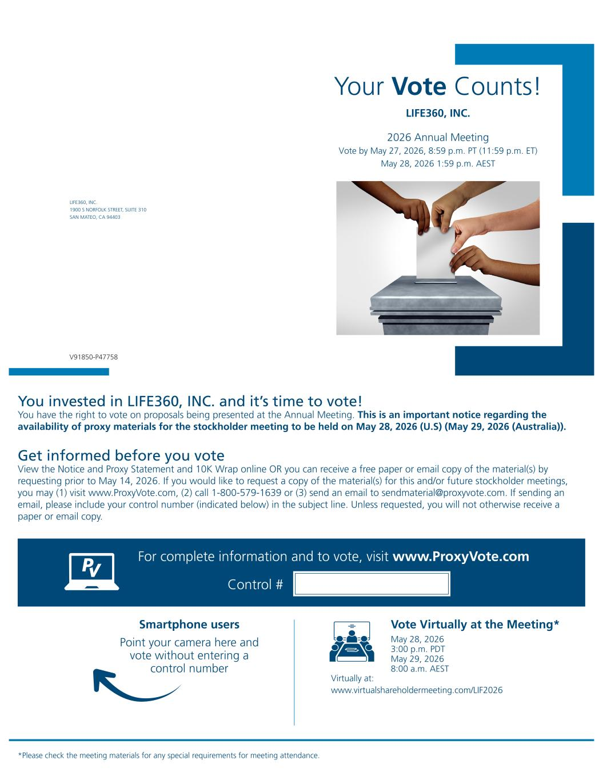
Your Vote Counts! *Please check the meeting materials for any special requirements for meeting attendance. Smartphone users Point your camera here and vote without entering a control number For complete information and to vote, visit www.ProxyVote.com Control # V91850-P47758 LIFE360, INC. 1900 S NORFOLK STREET, SUITE 310 SAN MATEO, CA 94403 LIFE360, INC. 2026 Annual Meeting Vote by May 27, 2026, 8:59 p.m. PT (11:59 p.m. ET) May 28, 2026 1:59 p.m. AEST You invested in LIFE360, INC. and it’s time to vote! You have the right to vote on proposals being presented at the Annual Meeting. This is an important notice regarding the availability of proxy materials for the stockholder meeting to be held on May 28, 2026 (U.S) (May 29, 2026 (Australia)). Vote Virtually at the Meeting* May 28, 2026 3:00 p.m. PDT May 29, 2026 8:00 a.m. AEST Virtually at: www.virtualshareholdermeeting.com/LIF2026 Get informed before you vote View the Notice and Proxy Statement and 10K Wrap online OR you can receive a free paper or email copy of the material(s) by requesting prior to May 14, 2026. If you would like to request a copy of the material(s) for this and/or future stockholder meetings, you may (1) visit www.ProxyVote.com, (2) call 1-800-579-1639 or (3) send an email to sendmaterial@proxyvote.com. If sending an email, please include your control number (indicated below) in the subject line. Unless requested, you will not otherwise receive a paper or email copy.

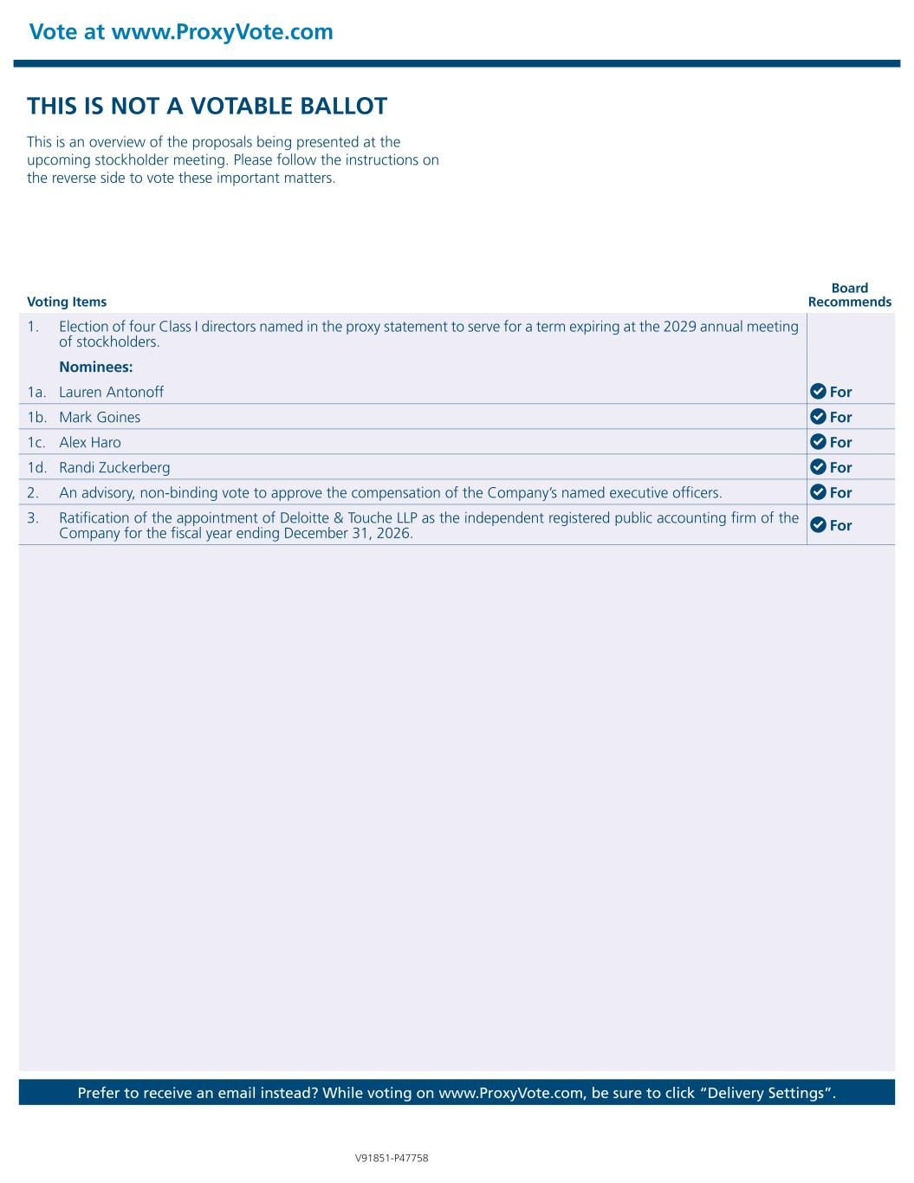
Vote at www.ProxyVote.com Prefer to receive an email instead? While voting on www.ProxyVote.com, be sure to click “Delivery Settings”. Voting Items Board Recommends V91851-P47758 THIS IS NOT A VOTABLE BALLOT This is an overview of the proposals being presented at the upcoming stockholder meeting. Please follow the instructions on the reverse side to vote these important matters. 1. Election of four Class I directors named in the proxy statement to serve for a term expiring at the 2029 annual meeting of stockholders. Nominees: 1a. Lauren Antonoff For 1b. Mark Goines For 1c. Alex Haro For 1d. Randi Zuckerberg For 2. An advisory, non-binding vote to approve the compensation of the Company’s named executive officers. For 3. Ratification of the appointment of Deloitte & Touche LLP as the independent registered public accounting firm of the Company for the fiscal year ending December 31, 2026. For

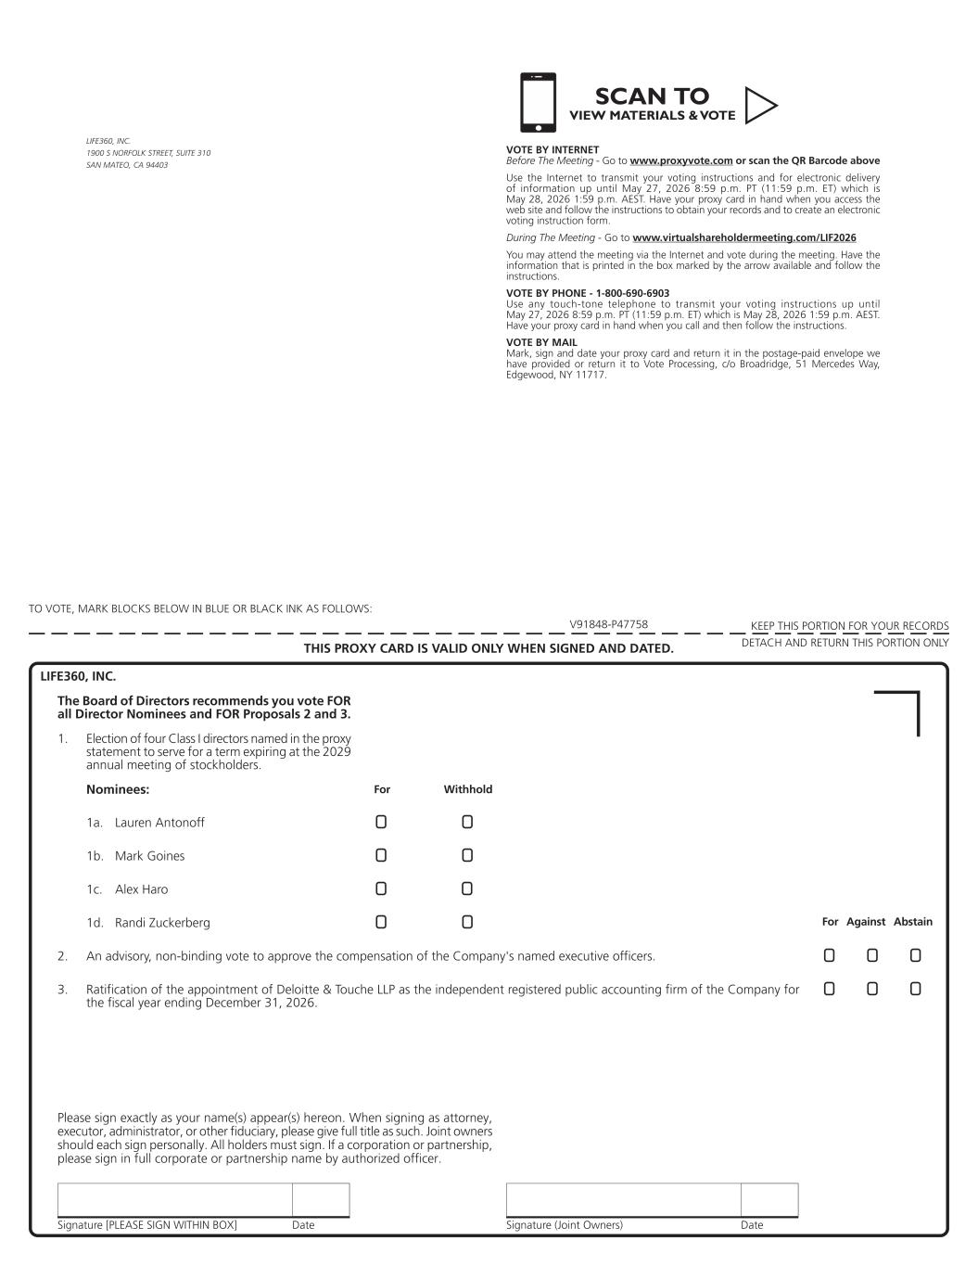
Signature [PLEASE SIGN WITHIN BOX] Date Signature (Joint Owners) Date TO VOTE, MARK BLOCKS BELOW IN BLUE OR BLACK INK AS FOLLOWS: KEEP THIS PORTION FOR YOUR RECORDS DETACH AND RETURN THIS PORTION ONLYTHIS PROXY CARD IS VALID ONLY WHEN SIGNED AND DATED. V91848-P47758 For Against Abstain!! !! !! !! ! !! ! !! Nominees: 3. Ratification of the appointment of Deloitte & Touche LLP as the independent registered public accounting firm of the Company for the fiscal year ending December 31, 2026. 2. An advisory, non-binding vote to approve the compensation of the Company's named executive officers. 1. Election of four Class I directors named in the proxy statement to serve for a term expiring at the 2029 annual meeting of stockholders. 1a. Lauren Antonoff 1b. Mark Goines 1c. Alex Haro 1d. Randi Zuckerberg For Withhold LIFE360, INC. The Board of Directors recommends you vote FOR all Director Nominees and FOR Proposals 2 and 3. Please sign exactly as your name(s) appear(s) hereon. When signing as attorney, executor, administrator, or other fiduciary, please give full title as such. Joint owners should each sign personally. All holders must sign. If a corporation or partnership, please sign in full corporate or partnership name by authorized officer. LIFE360, INC. 1900 S NORFOLK STREET, SUITE 310 SAN MATEO, CA 94403 VOTE BY INTERNET Before The Meeting - Go to www.proxyvote.com or scan the QR Barcode above Use the Internet to transmit your voting instructions and for electronic delivery of information up until May 27, 2026 8:59 p.m. PT (11:59 p.m. ET) which is May 28, 2026 1:59 p.m. AEST. Have your proxy card in hand when you access the web site and follow the instructions to obtain your records and to create an electronic voting instruction form. During The Meeting - Go to www.virtualshareholdermeeting.com/LIF2026 You may attend the meeting via the Internet and vote during the meeting. Have the information that is printed in the box marked by the arrow available and follow the instructions. VOTE BY PHONE - 1-800-690-6903 Use any touch-tone telephone to transmit your voting instructions up until May 27, 2026 8:59 p.m. PT (11:59 p.m. ET) which is May 28, 2026 1:59 p.m. AEST. Have your proxy card in hand when you call and then follow the instructions. VOTE BY MAIL Mark, sign and date your proxy card and return it in the postage-paid envelope we have provided or return it to Vote Processing, c/o Broadridge, 51 Mercedes Way, Edgewood, NY 11717. SCAN TO VIEW MATERIALS & VOTEw

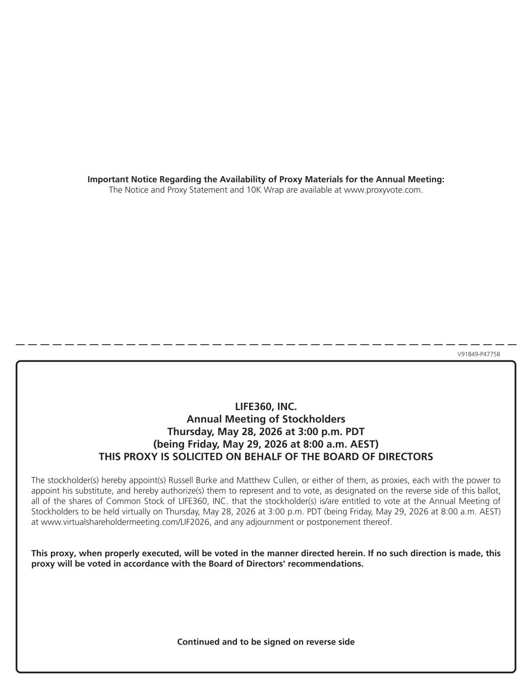
V91849-P47758 Important Notice Regarding the Availability of Proxy Materials for the Annual Meeting: The Notice and Proxy Statement and 10K Wrap are available at www.proxyvote.com. LIFE360, INC. Annual Meeting of Stockholders Thursday, May 28, 2026 at 3:00 p.m. PDT (being Friday, May 29, 2026 at 8:00 a.m. AEST) THIS PROXY IS SOLICITED ON BEHALF OF THE BOARD OF DIRECTORS The stockholder(s) hereby appoint(s) Russell Burke and Matthew Cullen, or either of them, as proxies, each with the power to appoint his substitute, and hereby authorize(s) them to represent and to vote, as designated on the reverse side of this ballot, all of the shares of Common Stock of LIFE360, INC. that the stockholder(s) is/are entitled to vote at the Annual Meeting of Stockholders to be held virtually on Thursday, May 28, 2026 at 3:00 p.m. PDT (being Friday, May 29, 2026 at 8:00 a.m. AEST) at www.virtualshareholdermeeting.com/LIF2026, and any adjournment or postponement thereof. This proxy, when properly executed, will be voted in the manner directed herein. If no such direction is made, this proxy will be voted in accordance with the Board of Directors' recommendations. Continued and to be signed on reverse side

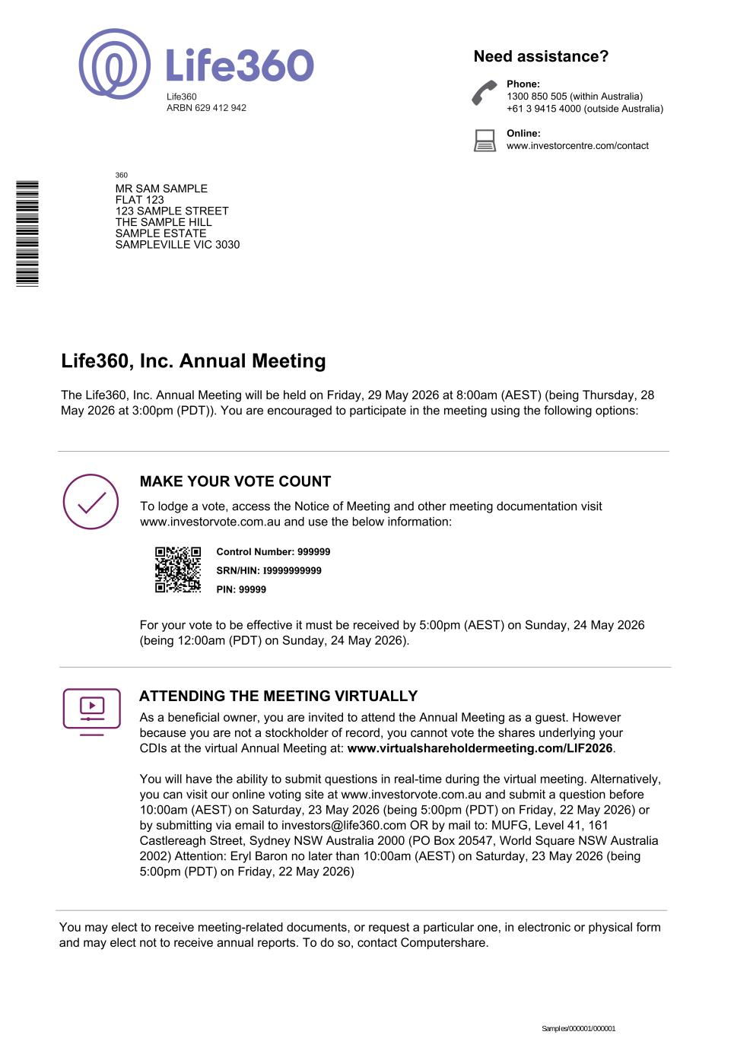
SRN/HIN: I9999999999 Phone: 1300 850 505 (within Australia) +61 3 9415 4000 (outside Australia) Online: www.investorcentre.com/contact Need assistance? Life360 ARBN 629 412 942 Life360, Inc. Annual Meeting Control Number: 999999 PIN: 99999 The Life360, Inc. Annual Meeting will be held on Friday, 29 May 2026 at 8:00am (AEST) (being Thursday, 28 May 2026 at 3:00pm (PDT)). You are encouraged to participate in the meeting using the following options: To lodge a vote, access the Notice of Meeting and other meeting documentation visit www.investorvote.com.au and use the below information: MAKE YOUR VOTE COUNT For your vote to be effective it must be received by 5:00pm (AEST) on Sunday, 24 May 2026 (being 12:00am (PDT) on Sunday, 24 May 2026). ATTENDING THE MEETING VIRTUALLY As a beneficial owner, you are invited to attend the Annual Meeting as a guest. However because you are not a stockholder of record, you cannot vote the shares underlying your CDIs at the virtual Annual Meeting at: www.virtualshareholdermeeting.com/LIF2026. You will have the ability to submit questions in real-time during the virtual meeting. Alternatively, you can visit our online voting site at www.investorvote.com.au and submit a question before 10:00am (AEST) on Saturday, 23 May 2026 (being 5:00pm (PDT) on Friday, 22 May 2026) or by submitting via email to investors@life360.com OR by mail to: MUFG, Level 41, 161 Castlereagh Street, Sydney NSW Australia 2000 (PO Box 20547, World Square NSW Australia 2002) Attention: Eryl Baron no later than 10:00am (AEST) on Saturday, 23 May 2026 (being 5:00pm (PDT) on Friday, 22 May 2026) You may elect to receive meeting-related documents, or request a particular one, in electronic or physical form and may elect not to receive annual reports. To do so, contact Computershare. 360 MR SAM SAMPLE FLAT 123 123 SAMPLE STREET THE SAMPLE HILL SAMPLE ESTATE SAMPLEVILLE VIC 3030 Samples/000001/000001 * L 0 0 0 0 0 1 *

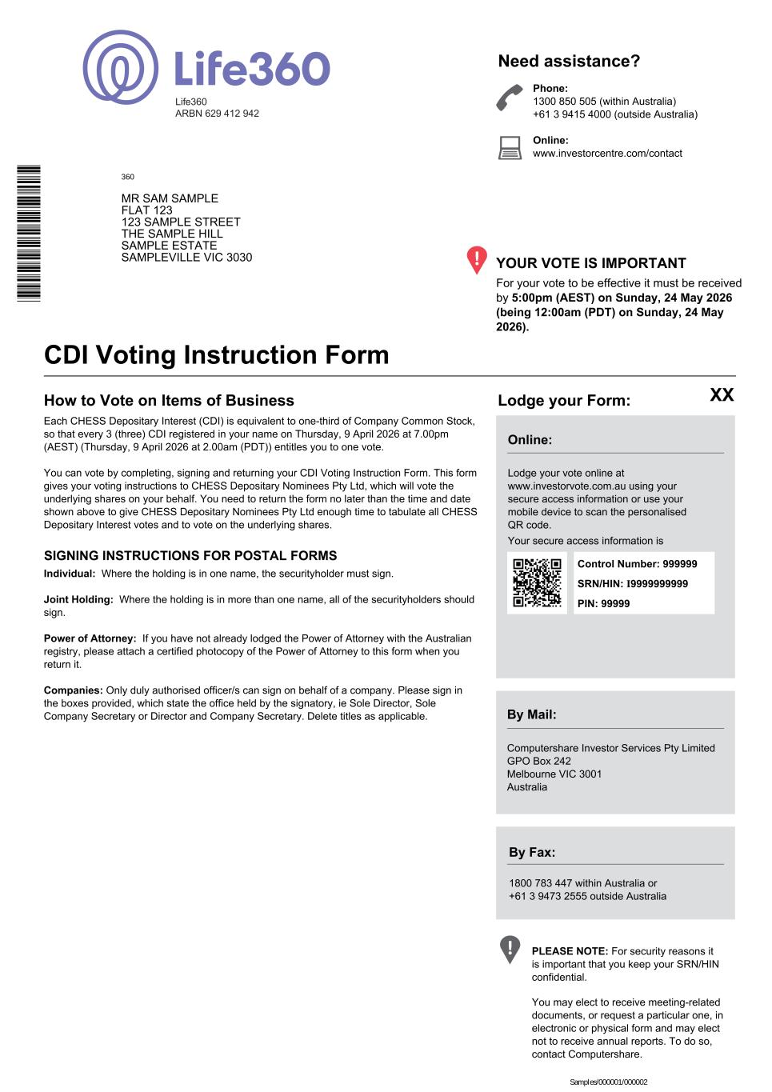
SRN/HIN: I9999999999 360 MR SAM SAMPLE FLAT 123 123 SAMPLE STREET THE SAMPLE HILL SAMPLE ESTATE SAMPLEVILLE VIC 3030 Life360 ARBN 629 412 942 Each CHESS Depositary Interest (CDI) is equivalent to one-third of Company Common Stock, so that every 3 (three) CDI registered in your name on Thursday, 9 April 2026 at 7.00pm (AEST) (Thursday, 9 April 2026 at 2.00am (PDT)) entitles you to one vote. You can vote by completing, signing and returning your CDI Voting Instruction Form. This form gives your voting instructions to CHESS Depositary Nominees Pty Ltd, which will vote the underlying shares on your behalf. You need to return the form no later than the time and date shown above to give CHESS Depositary Nominees Pty Ltd enough time to tabulate all CHESS Depositary Interest votes and to vote on the underlying shares. For your vote to be effective it must be received by 5:00pm (AEST) on Sunday, 24 May 2026 (being 12:00am (PDT) on Sunday, 24 May 2026). YOUR VOTE IS IMPORTANT Phone: 1300 850 505 (within Australia) +61 3 9415 4000 (outside Australia) Online: www.investorcentre.com/contact Need assistance? CDI Voting Instruction Form Lodge your Form: Online: Lodge your vote online at www.investorvote.com.au using your secure access information or use your mobile device to scan the personalised QR code. Your secure access information is By Mail: Computershare Investor Services Pty Limited GPO Box 242 Melbourne VIC 3001 Australia By Fax: 1800 783 447 within Australia or +61 3 9473 2555 outside Australia PLEASE NOTE: For security reasons it is important that you keep your SRN/HIN confidential. How to Vote on Items of Business SIGNING INSTRUCTIONS FOR POSTAL FORMS XX Control Number: 999999 PIN: 99999 Individual: Where the holding is in one name, the securityholder must sign. Joint Holding: Where the holding is in more than one name, all of the securityholders should sign. Power of Attorney: If you have not already lodged the Power of Attorney with the Australian registry, please attach a certified photocopy of the Power of Attorney to this form when you return it. Companies: Only duly authorised officer/s can sign on behalf of a company. Please sign in the boxes provided, which state the office held by the signatory, ie Sole Director, Sole Company Secretary or Director and Company Secretary. Delete titles as applicable. You may elect to receive meeting-related documents, or request a particular one, in electronic or physical form and may elect not to receive annual reports. To do so, contact Computershare. Samples/000001/000002 * I 0 0 0 0 0 1 3 6 *

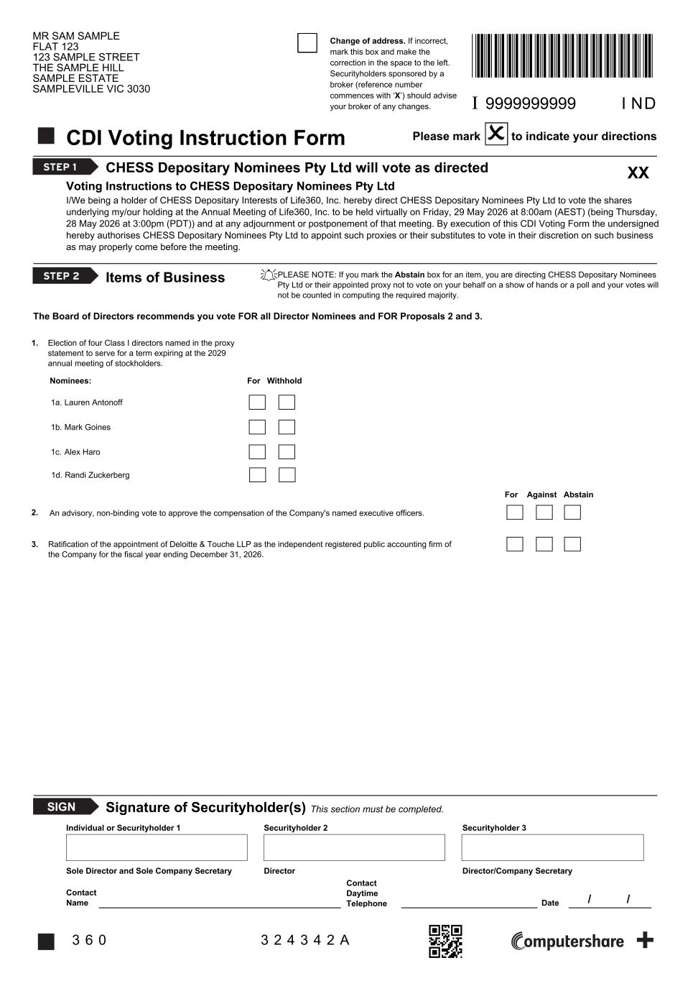
 I 9999999999 Change of address. If incorrect, mark this box and make the correction in the space to the left. Securityholders sponsored by a broker (reference number commences with ‘X’) should advise your broker of any changes. CDI Voting Instruction Form Please mark to indicate your directions CHESS Depositary Nominees Pty Ltd will vote as directed Voting Instructions to CHESS Depositary Nominees Pty Ltd STEP 1 I/We being a holder of CHESS Depositary Interests of Life360, Inc. hereby direct CHESS Depositary Nominees Pty Ltd to vote the shares underlying my/our holding at the Annual Meeting of Life360, Inc. to be held virtually on Friday, 29 May 2026 at 8:00am (AEST) (being Thursday, 28 May 2026 at 3:00pm (PDT)) and at any adjournment or postponement of that meeting. By execution of this CDI Voting Form the undersigned hereby authorises CHESS Depositary Nominees Pty Ltd to appoint such proxies or their substitutes to vote in their discretion on such business as may properly come before the meeting. STEP 2 Items of Business PLEASE NOTE: If you mark the Abstain box for an item, you are directing CHESS Depositary Nominees Pty Ltd or their appointed proxy not to vote on your behalf on a show of hands or a poll and your votes will not be counted in computing the required majority.  SIGN Signature of Securityholder(s) This section must be completed. Individual or Securityholder 1 Securityholder 2 Securityholder 3 Sole Director and Sole Company Secretary Director Director/Company Secretary Contact Name Contact Daytime Telephone Date I ND MR SAM SAMPLE FLAT 123 123 SAMPLE STREET THE SAMPLE HILL SAMPLE ESTATE SAMPLEVILLE VIC 3030 3 6 0 3 2 4 3 4 2 A / / XX The Board of Directors recommends you vote FOR all Director Nominees and FOR Proposals 2 and 3. Election of four Class I directors named in the proxy statement to serve for a term expiring at the 2029 annual meeting of stockholders. Lauren Antonoff1a. 2. Ratification of the appointment of Deloitte & Touche LLP as the independent registered public accounting firm of the Company for the fiscal year ending December 31, 2026. 1. An advisory, non-binding vote to approve the compensation of the Company's named executive officers. 3. Mark Goines1b. Alex Haro1c. For WithholdNominees: For Against Abstain Randi Zuckerberg1d.

