UNITED STATES
SECURITIES AND EXCHANGE COMMISSION
Washington, D.C. 20549
______________

FORM 8-K

CURRENT REPORT
Pursuant to Section 13 or 15(d) of the
Securities Exchange Act of 1934

Date of Report (Date of earliest event reported): May 9, 2024

Life360, Inc.
(Exact name of registrant as specified in its charter)
Delaware |  |  | 000-56424 |  |  | 26-0197666
(State or other jurisdiction of  incorporation or organization) |  |  | (Commission File Number) |  |  | (I.R.S. Employer  Identification No.)

1900 South Norfolk Street, Suite 310
San Mateo, CA 94403
(Address of principal executive offices, including zip code)
(415) 484-5244
(Registrant’s telephone number, including area code)
Not applicable.
(Former name or former address, if changed since last report)
______________

Check the appropriate box below if the Form 8-K filing is intended to simultaneously satisfy the filing obligation of the registrant under any of the following provisions:
☐ |  |  | Written communications pursuant to Rule 425 under the Securities Act (17 CFR 230.425)
☐ |  |  | Soliciting material pursuant to Rule 14a-12 under the Exchange Act (17 CFR 240.14a-12)
☐ |  |  | Pre-commencement communications pursuant to Rule 14d-2(b) under the Exchange Act (17 CFR 240.14d-2(b))
☐ |  |  | Pre-commencement communications pursuant to Rule 13e-4(c) under the Exchange Act (17 CFR 240.13e-4(c))

Title of each class |  |  | Trading Symbol(s) |  |  | Name of each exchange on which registered
None. |  |  | None. |  |  | None.

Indicate by check mark whether the registrant is an emerging growth company as defined in Rule 405 of the Securities Act of 1933 (§230.405 of this chapter) or Rule 12b-2 of the Securities Exchange Act of 1934 (§240.12b-2 of this chapter).

Emerging growth company ☐
If an emerging growth company, indicate by check mark if the registrant has elected not to use the extended transition period for complying with any new or revised financial accounting standards provided pursuant to Section 13(a) of the Exchange Act. ☐

Item 2.02 Results of Operations and Financial Condition.
We are furnishing this Current Report on Form 8-K in connection with the disclosure of information, in the form of textual information from a media release issued on May 9, 2024. A copy of the media release is furnished as Exhibit 99.1 to this Current Report on Form 8-K.
The information in this Item 2.02 (including Exhibit 99.1) of this Current Report on Form 8-K is furnished and shall not be deemed to be “filed” for the purpose of Section 18 of the Securities Exchange Act of 1934, as amended (the “Exchange Act”) or otherwise subject to the liabilities of that section, nor shall it be deemed incorporated by reference into any filing under the Securities Act of 1933, as amended, or the Exchange Act, except as shall be expressly set forth by specific reference in such a filing. The media release included within Item 2.02 of this Current Report on Form 8-K is available on our website located at www.life360.com, although we reserve the right to discontinue that availability at any time.

Item 9.01 Financial Statements and Exhibits.
(d) Exhibits

Exhibit No. |  |  | Description
99.1 |  |  | Media release of the Registrant dated May 9, 2024 (U.S. Time)
104 |  |  | Cover Page Interactive Data File - the cover page XBRL tags are embedded within the Inline XBRL document

SIGNATURES
Pursuant to the requirements of the Securities Exchange Act of 1934, the registrant has duly caused this report to be signed on its behalf by the undersigned hereunto duly authorized.
 |  |  |  |  |  | LIFE360, INC.
Dated: |  |  | May 9, 2024 |  |  | By: |  |  | /s/ Russell Burke
 |  |  |  |  |  |  |  |  | Russell Burke
 |  |  |  |  |  |  |  |  | Chief Financial Officer

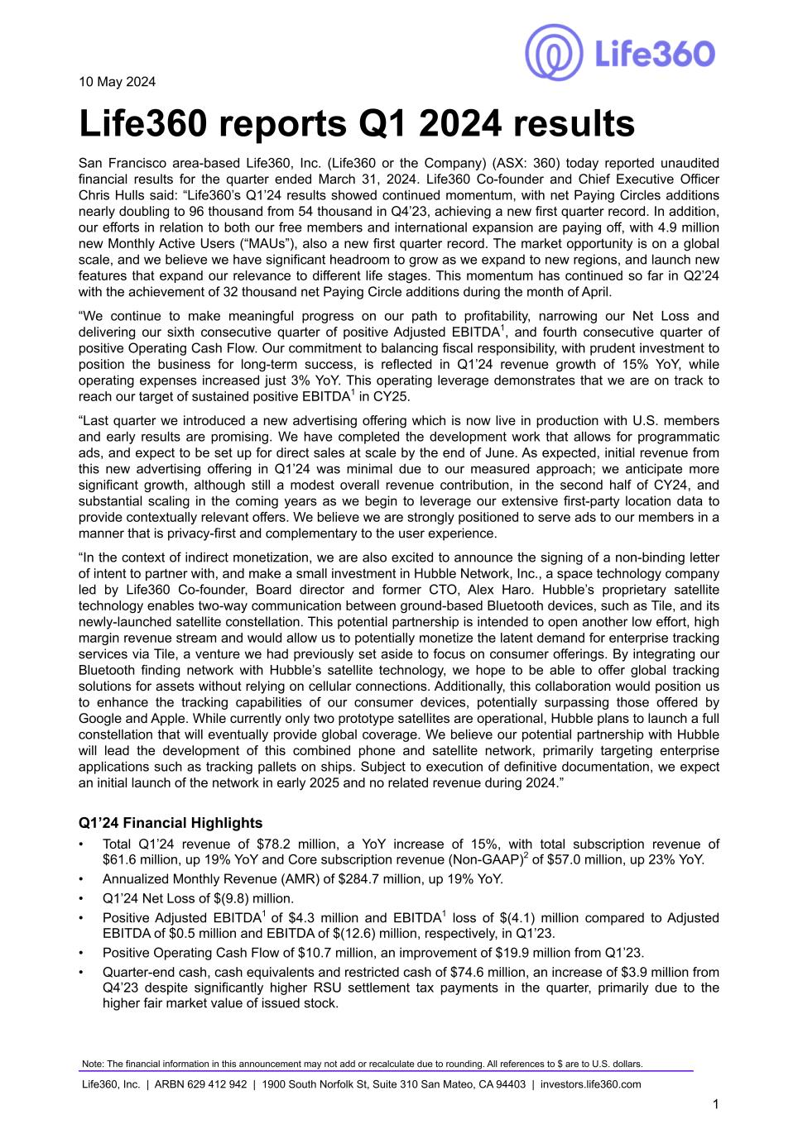

10 May 2024 Life360 reports Q1 2024 results San Francisco area-based Life360, Inc. (Life360 or the Company) (ASX: 360) today reported unaudited financial results for the quarter ended March 31, 2024. Life360 Co-founder and Chief Executive Officer Chris Hulls said: “Life360’s Q1’24 results showed continued momentum, with net Paying Circles additions nearly doubling to 96 thousand from 54 thousand in Q4’23, achieving a new first quarter record. In addition, our efforts in relation to both our free members and international expansion are paying off, with 4.9 million new Monthly Active Users (“MAUs”), also a new first quarter record. The market opportunity is on a global scale, and we believe we have significant headroom to grow as we expand to new regions, and launch new features that expand our relevance to different life stages. This momentum has continued so far in Q2’24 with the achievement of 32 thousand net Paying Circle additions during the month of April. “We continue to make meaningful progress on our path to profitability, narrowing our Net Loss and delivering our sixth consecutive quarter of positive Adjusted EBITDA1, and fourth consecutive quarter of positive Operating Cash Flow. Our commitment to balancing fiscal responsibility, with prudent investment to position the business for long-term success, is reflected in Q1’24 revenue growth of 15% YoY, while operating expenses increased just 3% YoY. This operating leverage demonstrates that we are on track to reach our target of sustained positive EBITDA1 in CY25. “Last quarter we introduced a new advertising offering which is now live in production with U.S. members and early results are promising. We have completed the development work that allows for programmatic ads, and expect to be set up for direct sales at scale by the end of June. As expected, initial revenue from this new advertising offering in Q1’24 was minimal due to our measured approach; we anticipate more significant growth, although still a modest overall revenue contribution, in the second half of CY24, and substantial scaling in the coming years as we begin to leverage our extensive first-party location data to provide contextually relevant offers. We believe we are strongly positioned to serve ads to our members in a manner that is privacy-first and complementary to the user experience. “In the context of indirect monetization, we are also excited to announce the signing of a non-binding letter of intent to partner with, and make a small investment in Hubble Network, Inc., a space technology company led by Life360 Co-founder, Board director and former CTO, Alex Haro. Hubble’s proprietary satellite technology enables two-way communication between ground-based Bluetooth devices, such as Tile, and its newly-launched satellite constellation. This potential partnership is intended to open another low effort, high margin revenue stream and would allow us to potentially monetize the latent demand for enterprise tracking services via Tile, a venture we had previously set aside to focus on consumer offerings. By integrating our Bluetooth finding network with Hubble’s satellite technology, we hope to be able to offer global tracking solutions for assets without relying on cellular connections. Additionally, this collaboration would position us to enhance the tracking capabilities of our consumer devices, potentially surpassing those offered by Google and Apple. While currently only two prototype satellites are operational, Hubble plans to launch a full constellation that will eventually provide global coverage. We believe our potential partnership with Hubble will lead the development of this combined phone and satellite network, primarily targeting enterprise applications such as tracking pallets on ships. Subject to execution of definitive documentation, we expect an initial launch of the network in early 2025 and no related revenue during 2024.” Q1’24 Financial Highlights • Total Q1’24 revenue of $78.2 million, a YoY increase of 15%, with total subscription revenue of $61.6 million, up 19% YoY and Core subscription revenue (Non-GAAP)2 of $57.0 million, up 23% YoY. • Annualized Monthly Revenue (AMR) of $284.7 million, up 19% YoY. • Q1’24 Net Loss of $(9.8) million. • Positive Adjusted EBITDA1 of $4.3 million and EBITDA1 loss of $(4.1) million compared to Adjusted EBITDA of $0.5 million and EBITDA of $(12.6) million, respectively, in Q1’23. • Positive Operating Cash Flow of $10.7 million, an improvement of $19.9 million from Q1’23. • Quarter-end cash, cash equivalents and restricted cash of $74.6 million, an increase of $3.9 million from Q4’23 despite significantly higher RSU settlement tax payments in the quarter, primarily due to the higher fair market value of issued stock. Note: The financial information in this announcement may not add or recalculate due to rounding. All references to $ are to U.S. dollars. Life360, Inc. | ARBN 629 412 942 | 1900 South Norfolk St, Suite 310 San Mateo, CA 94403 | investors.life360.com 1

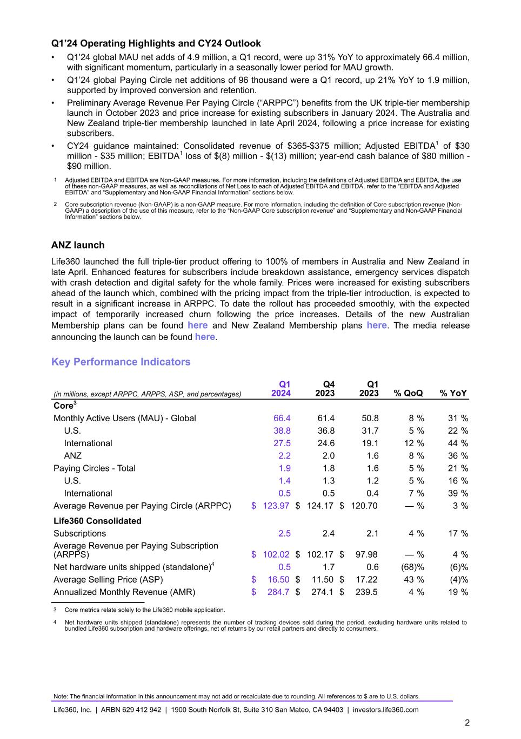
Q1’24 Operating Highlights and CY24 Outlook • Q1’24 global MAU net adds of 4.9 million, a Q1 record, were up 31% YoY to approximately 66.4 million, with significant momentum, particularly in a seasonally lower period for MAU growth. • Q1’24 global Paying Circle net additions of 96 thousand were a Q1 record, up 21% YoY to 1.9 million, supported by improved conversion and retention. • Preliminary Average Revenue Per Paying Circle (“ARPPC”) benefits from the UK triple-tier membership launch in October 2023 and price increase for existing subscribers in January 2024. The Australia and New Zealand triple-tier membership launched in late April 2024, following a price increase for existing subscribers. • CY24 guidance maintained: Consolidated revenue of $365-$375 million; Adjusted EBITDA1 of $30 million - $35 million; EBITDA1 loss of $(8) million - $(13) million; year-end cash balance of $80 million - $90 million. 1 Adjusted EBITDA and EBITDA are Non-GAAP measures. For more information, including the definitions of Adjusted EBITDA and EBITDA, the use of these non-GAAP measures, as well as reconciliations of Net Loss to each of Adjusted EBITDA and EBITDA, refer to the “EBITDA and Adjusted EBITDA” and “Supplementary and Non-GAAP Financial Information” sections below. 2 Core subscription revenue (Non-GAAP) is a non-GAAP measure. For more information, including the definition of Core subscription revenue (Non- GAAP) a description of the use of this measure, refer to the “Non-GAAP Core subscription revenue” and “Supplementary and Non-GAAP Financial Information” sections below. ANZ launch Life360 launched the full triple-tier product offering to 100% of members in Australia and New Zealand in late April. Enhanced features for subscribers include breakdown assistance, emergency services dispatch with crash detection and digital safety for the whole family. Prices were increased for existing subscribers ahead of the launch which, combined with the pricing impact from the triple-tier introduction, is expected to result in a significant increase in ARPPC. To date the rollout has proceeded smoothly, with the expected impact of temporarily increased churn following the price increases. Details of the new Australian Membership plans can be found here and New Zealand Membership plans here. The media release announcing the launch can be found here. Key Performance Indicators (in millions, except ARPPC, ARPPS, ASP, and percentages) Q1 2024 Q4 2023 Q1 2023 % QoQ % YoY Core3 Monthly Active Users (MAU) - Global 66.4 61.4 50.8 8 % 31 % U.S. 38.8 36.8 31.7 5 % 22 % International 27.5 24.6 19.1 12 % 44 % ANZ 2.2 2.0 1.6 8 % 36 % Paying Circles - Total 1.9 1.8 1.6 5 % 21 % U.S. 1.4 1.3 1.2 5 % 16 % International 0.5 0.5 0.4 7 % 39 % Average Revenue per Paying Circle (ARPPC) $ 123.97 $ 124.17 $ 120.70 — % 3 % Life360 Consolidated Subscriptions 2.5 2.4 2.1 4 % 17 % Average Revenue per Paying Subscription (ARPPS) $ 102.02 $ 102.17 $ 97.98 — % 4 % Net hardware units shipped (standalone)4 0.5 1.7 0.6 (68) % (6) % Average Selling Price (ASP) $ 16.50 $ 11.50 $ 17.22 43 % (4) % Annualized Monthly Revenue (AMR) $ 284.7 $ 274.1 $ 239.5 4 % 19 % 3 Core metrics relate solely to the Life360 mobile application. 4 Net hardware units shipped (standalone) represents the number of tracking devices sold during the period, excluding hardware units related to bundled Life360 subscription and hardware offerings, net of returns by our retail partners and directly to consumers. Note: The financial information in this announcement may not add or recalculate due to rounding. All references to $ are to U.S. dollars. Life360, Inc. | ARBN 629 412 942 | 1900 South Norfolk St, Suite 310 San Mateo, CA 94403 | investors.life360.com 2

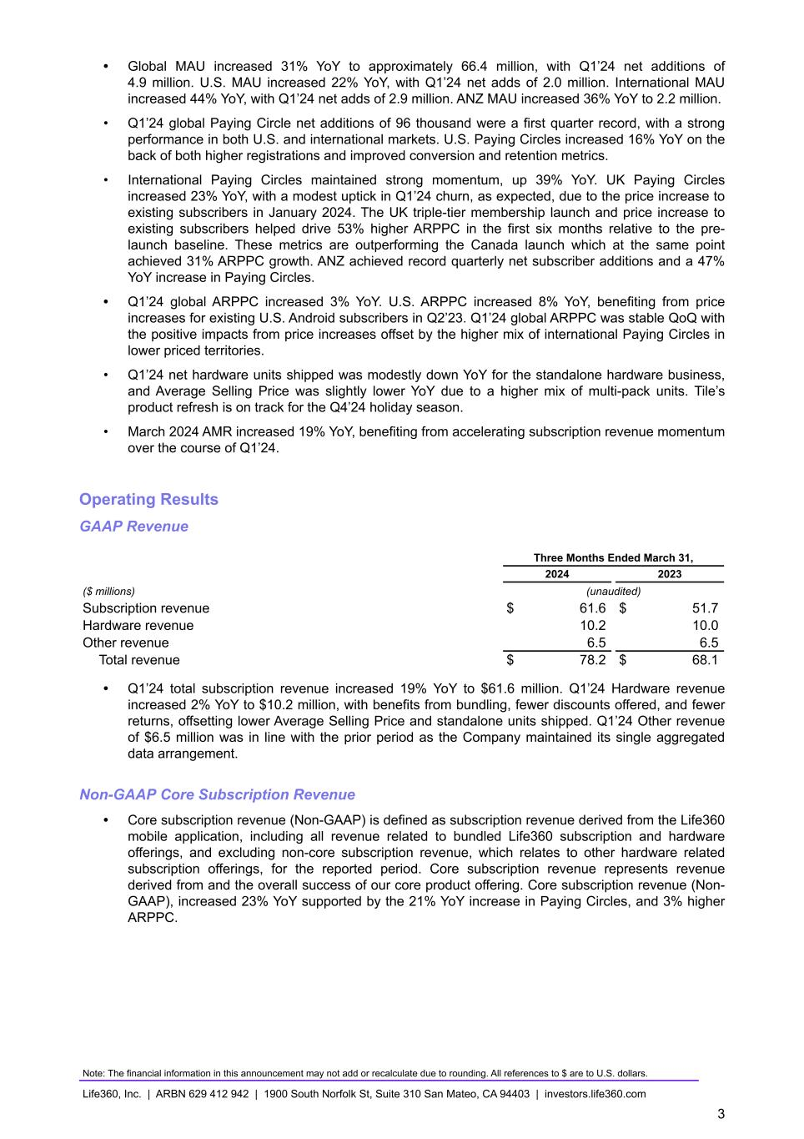
• Global MAU increased 31% YoY to approximately 66.4 million, with Q1’24 net additions of 4.9 million. U.S. MAU increased 22% YoY, with Q1’24 net adds of 2.0 million. International MAU increased 44% YoY, with Q1’24 net adds of 2.9 million. ANZ MAU increased 36% YoY to 2.2 million. • Q1’24 global Paying Circle net additions of 96 thousand were a first quarter record, with a strong performance in both U.S. and international markets. U.S. Paying Circles increased 16% YoY on the back of both higher registrations and improved conversion and retention metrics. • International Paying Circles maintained strong momentum, up 39% YoY. UK Paying Circles increased 23% YoY, with a modest uptick in Q1’24 churn, as expected, due to the price increase to existing subscribers in January 2024. The UK triple-tier membership launch and price increase to existing subscribers helped drive 53% higher ARPPC in the first six months relative to the pre- launch baseline. These metrics are outperforming the Canada launch which at the same point achieved 31% ARPPC growth. ANZ achieved record quarterly net subscriber additions and a 47% YoY increase in Paying Circles. • Q1’24 global ARPPC increased 3% YoY. U.S. ARPPC increased 8% YoY, benefiting from price increases for existing U.S. Android subscribers in Q2’23. Q1’24 global ARPPC was stable QoQ with the positive impacts from price increases offset by the higher mix of international Paying Circles in lower priced territories. • Q1’24 net hardware units shipped was modestly down YoY for the standalone hardware business, and Average Selling Price was slightly lower YoY due to a higher mix of multi-pack units. Tile’s product refresh is on track for the Q4’24 holiday season. • March 2024 AMR increased 19% YoY, benefiting from accelerating subscription revenue momentum over the course of Q1’24. Operating Results GAAP Revenue Three Months Ended March 31, 2024 2023 ($ millions) (unaudited) Subscription revenue $ 61.6 $ 51.7 Hardware revenue 10.2 10.0 Other revenue 6.5 6.5 Total revenue $ 78.2 $ 68.1 • Q1’24 total subscription revenue increased 19% YoY to $61.6 million. Q1’24 Hardware revenue increased 2% YoY to $10.2 million, with benefits from bundling, fewer discounts offered, and fewer returns, offsetting lower Average Selling Price and standalone units shipped. Q1’24 Other revenue of $6.5 million was in line with the prior period as the Company maintained its single aggregated data arrangement. Non-GAAP Core Subscription Revenue • Core subscription revenue (Non-GAAP) is defined as subscription revenue derived from the Life360 mobile application, including all revenue related to bundled Life360 subscription and hardware offerings, and excluding non-core subscription revenue, which relates to other hardware related subscription offerings, for the reported period. Core subscription revenue represents revenue derived from and the overall success of our core product offering. Core subscription revenue (Non- GAAP), increased 23% YoY supported by the 21% YoY increase in Paying Circles, and 3% higher ARPPC. Note: The financial information in this announcement may not add or recalculate due to rounding. All references to $ are to U.S. dollars. Life360, Inc. | ARBN 629 412 942 | 1900 South Norfolk St, Suite 310 San Mateo, CA 94403 | investors.life360.com 3

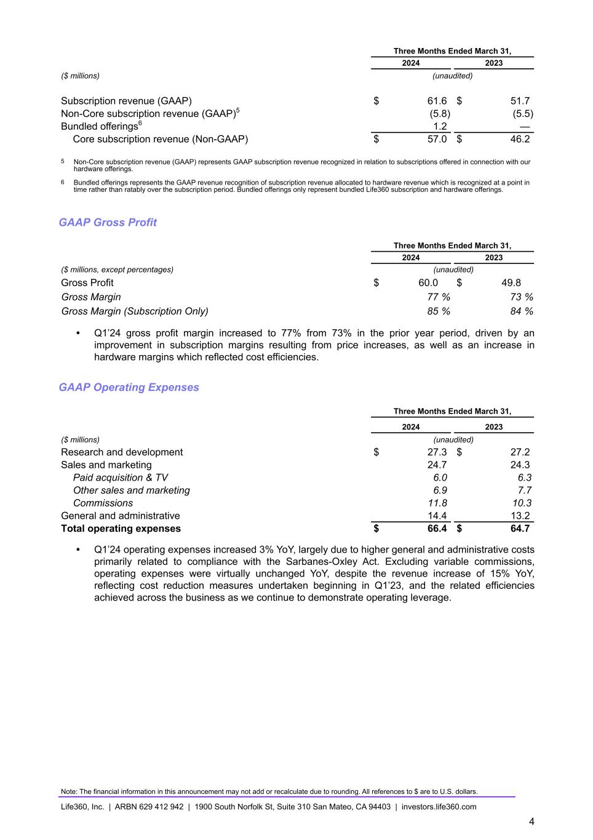
Three Months Ended March 31, 2024 2023 ($ millions) (unaudited) Subscription revenue (GAAP) $ 61.6 $ 51.7 Non-Core subscription revenue (GAAP)5 (5.8) (5.5) Bundled offerings6 1.2 — Core subscription revenue (Non-GAAP) $ 57.0 $ 46.2 5 Non-Core subscription revenue (GAAP) represents GAAP subscription revenue recognized in relation to subscriptions offered in connection with our hardware offerings. 6 Bundled offerings represents the GAAP revenue recognition of subscription revenue allocated to hardware revenue which is recognized at a point in time rather than ratably over the subscription period. Bundled offerings only represent bundled Life360 subscription and hardware offerings. GAAP Gross Profit Three Months Ended March 31, 2024 2023 ($ millions, except percentages) (unaudited) Gross Profit $ 60.0 $ 49.8 Gross Margin 77 % 73 % Gross Margin (Subscription Only) 85 % 84 % • Q1’24 gross profit margin increased to 77% from 73% in the prior year period, driven by an improvement in subscription margins resulting from price increases, as well as an increase in hardware margins which reflected cost efficiencies. GAAP Operating Expenses Three Months Ended March 31, 2024 2023 ($ millions) (unaudited) Research and development $ 27.3 $ 27.2 Sales and marketing 24.7 24.3 Paid acquisition & TV 6.0 6.3 Other sales and marketing 6.9 7.7 Commissions 11.8 10.3 General and administrative 14.4 13.2 Total operating expenses $ 66.4 $ 64.7 • Q1’24 operating expenses increased 3% YoY, largely due to higher general and administrative costs primarily related to compliance with the Sarbanes-Oxley Act. Excluding variable commissions, operating expenses were virtually unchanged YoY, despite the revenue increase of 15% YoY, reflecting cost reduction measures undertaken beginning in Q1’23, and the related efficiencies achieved across the business as we continue to demonstrate operating leverage. Note: The financial information in this announcement may not add or recalculate due to rounding. All references to $ are to U.S. dollars. Life360, Inc. | ARBN 629 412 942 | 1900 South Norfolk St, Suite 310 San Mateo, CA 94403 | investors.life360.com 4

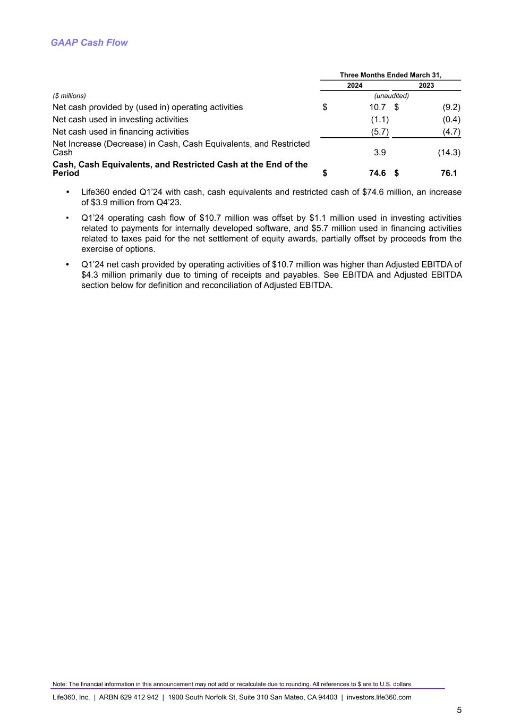
GAAP Cash Flow Three Months Ended March 31, 2024 2023 ($ millions) (unaudited) Net cash provided by (used in) operating activities $ 10.7 $ (9.2) Net cash used in investing activities (1.1) (0.4) Net cash used in financing activities (5.7) (4.7) Net Increase (Decrease) in Cash, Cash Equivalents, and Restricted Cash 3.9 (14.3) Cash, Cash Equivalents, and Restricted Cash at the End of the Period $ 74.6 $ 76.1 • Life360 ended Q1’24 with cash, cash equivalents and restricted cash of $74.6 million, an increase of $3.9 million from Q4’23. • Q1’24 operating cash flow of $10.7 million was offset by $1.1 million used in investing activities related to payments for internally developed software, and $5.7 million used in financing activities related to taxes paid for the net settlement of equity awards, partially offset by proceeds from the exercise of options. • Q1’24 net cash provided by operating activities of $10.7 million was higher than Adjusted EBITDA of $4.3 million primarily due to timing of receipts and payables. See EBITDA and Adjusted EBITDA section below for definition and reconciliation of Adjusted EBITDA. Note: The financial information in this announcement may not add or recalculate due to rounding. All references to $ are to U.S. dollars. Life360, Inc. | ARBN 629 412 942 | 1900 South Norfolk St, Suite 310 San Mateo, CA 94403 | investors.life360.com 5

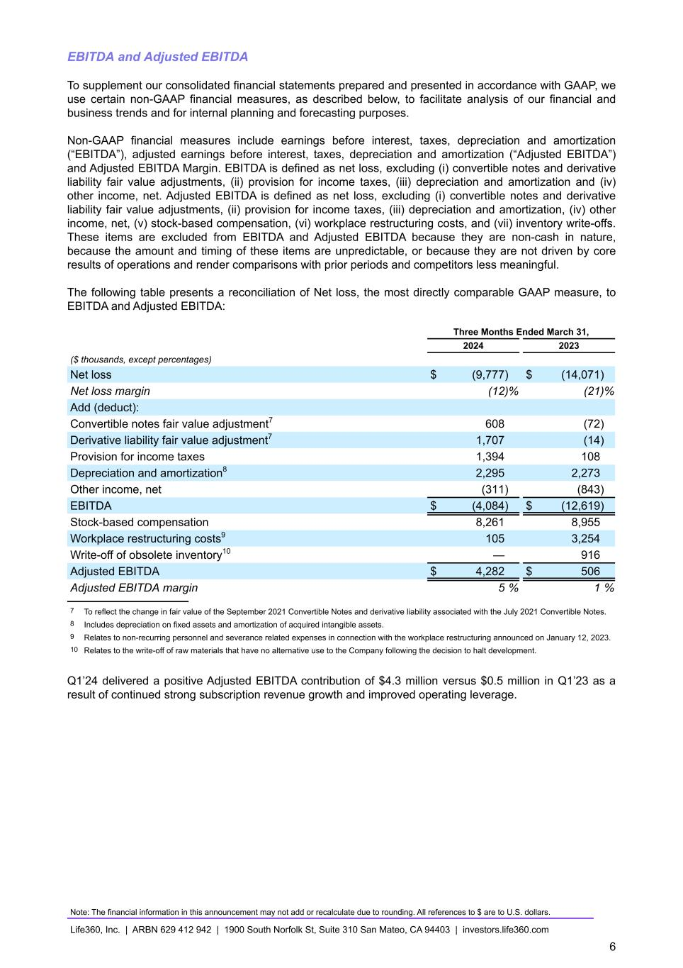
EBITDA and Adjusted EBITDA To supplement our consolidated financial statements prepared and presented in accordance with GAAP, we use certain non-GAAP financial measures, as described below, to facilitate analysis of our financial and business trends and for internal planning and forecasting purposes. Non-GAAP financial measures include earnings before interest, taxes, depreciation and amortization (“EBITDA”), adjusted earnings before interest, taxes, depreciation and amortization (“Adjusted EBITDA”) and Adjusted EBITDA Margin. EBITDA is defined as net loss, excluding (i) convertible notes and derivative liability fair value adjustments, (ii) provision for income taxes, (iii) depreciation and amortization and (iv) other income, net. Adjusted EBITDA is defined as net loss, excluding (i) convertible notes and derivative liability fair value adjustments, (ii) provision for income taxes, (iii) depreciation and amortization, (iv) other income, net, (v) stock-based compensation, (vi) workplace restructuring costs, and (vii) inventory write-offs. These items are excluded from EBITDA and Adjusted EBITDA because they are non-cash in nature, because the amount and timing of these items are unpredictable, or because they are not driven by core results of operations and render comparisons with prior periods and competitors less meaningful. The following table presents a reconciliation of Net loss, the most directly comparable GAAP measure, to EBITDA and Adjusted EBITDA: Three Months Ended March 31, 2024 2023 ($ thousands, except percentages) Net loss $ (9,777) $ (14,071) Net loss margin (12) % (21) % Add (deduct): Convertible notes fair value adjustment7 608 (72) Derivative liability fair value adjustment7 1,707 (14) Provision for income taxes 1,394 108 Depreciation and amortization8 2,295 2,273 Other income, net (311) (843) EBITDA $ (4,084) $ (12,619) Stock-based compensation 8,261 8,955 Workplace restructuring costs9 105 3,254 Write-off of obsolete inventory10 — 916 Adjusted EBITDA $ 4,282 $ 506 Adjusted EBITDA margin 5 % 1 % 7 To reflect the change in fair value of the September 2021 Convertible Notes and derivative liability associated with the July 2021 Convertible Notes. 8 Includes depreciation on fixed assets and amortization of acquired intangible assets. 9 Relates to non-recurring personnel and severance related expenses in connection with the workplace restructuring announced on January 12, 2023. 10 Relates to the write-off of raw materials that have no alternative use to the Company following the decision to halt development. Q1’24 delivered a positive Adjusted EBITDA contribution of $4.3 million versus $0.5 million in Q1’23 as a result of continued strong subscription revenue growth and improved operating leverage. Note: The financial information in this announcement may not add or recalculate due to rounding. All references to $ are to U.S. dollars. Life360, Inc. | ARBN 629 412 942 | 1900 South Norfolk St, Suite 310 San Mateo, CA 94403 | investors.life360.com 6

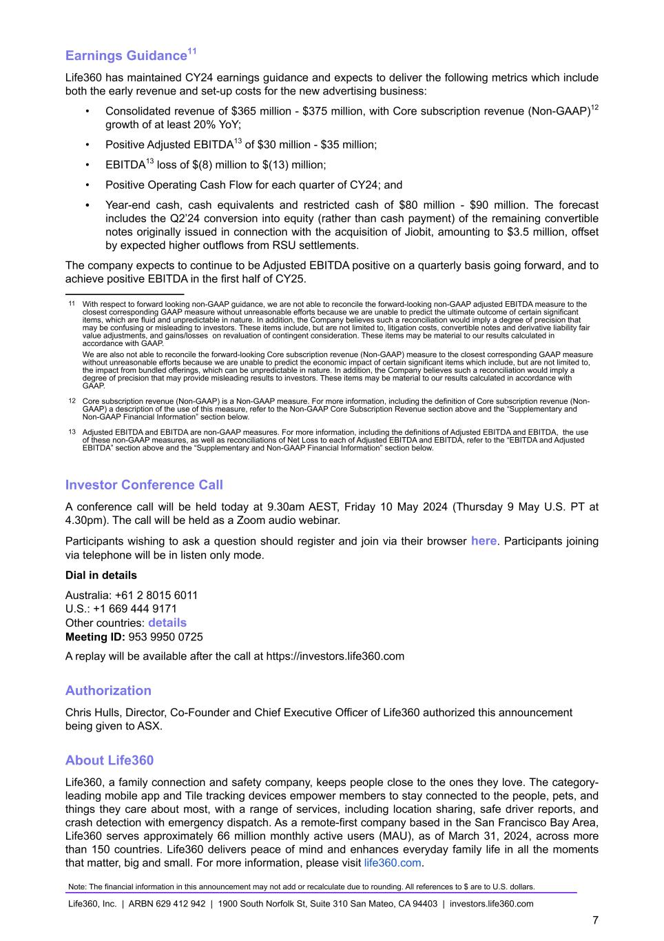
Earnings Guidance11 Life360 has maintained CY24 earnings guidance and expects to deliver the following metrics which include both the early revenue and set-up costs for the new advertising business: • Consolidated revenue of $365 million - $375 million, with Core subscription revenue (Non-GAAP)12 growth of at least 20% YoY; • Positive Adjusted EBITDA13 of $30 million - $35 million; • EBITDA13 loss of $(8) million to $(13) million; • Positive Operating Cash Flow for each quarter of CY24; and • Year-end cash, cash equivalents and restricted cash of $80 million - $90 million. The forecast includes the Q2’24 conversion into equity (rather than cash payment) of the remaining convertible notes originally issued in connection with the acquisition of Jiobit, amounting to $3.5 million, offset by expected higher outflows from RSU settlements. The company expects to continue to be Adjusted EBITDA positive on a quarterly basis going forward, and to achieve positive EBITDA in the first half of CY25. 11 With respect to forward looking non-GAAP guidance, we are not able to reconcile the forward-looking non-GAAP adjusted EBITDA measure to the closest corresponding GAAP measure without unreasonable efforts because we are unable to predict the ultimate outcome of certain significant items, which are fluid and unpredictable in nature. In addition, the Company believes such a reconciliation would imply a degree of precision that may be confusing or misleading to investors. These items include, but are not limited to, litigation costs, convertible notes and derivative liability fair value adjustments, and gains/losses on revaluation of contingent consideration. These items may be material to our results calculated in accordance with GAAP. We are also not able to reconcile the forward-looking Core subscription revenue (Non-GAAP) measure to the closest corresponding GAAP measure without unreasonable efforts because we are unable to predict the economic impact of certain significant items which include, but are not limited to, the impact from bundled offerings, which can be unpredictable in nature. In addition, the Company believes such a reconciliation would imply a degree of precision that may provide misleading results to investors. These items may be material to our results calculated in accordance with GAAP. 12 Core subscription revenue (Non-GAAP) is a Non-GAAP measure. For more information, including the definition of Core subscription revenue (Non- GAAP) a description of the use of this measure, refer to the Non-GAAP Core Subscription Revenue section above and the “Supplementary and Non-GAAP Financial Information” section below. 13 Adjusted EBITDA and EBITDA are non-GAAP measures. For more information, including the definitions of Adjusted EBITDA and EBITDA, the use of these non-GAAP measures, as well as reconciliations of Net Loss to each of Adjusted EBITDA and EBITDA, refer to the “EBITDA and Adjusted EBITDA” section above and the “Supplementary and Non-GAAP Financial Information” section below. Investor Conference Call A conference call will be held today at 9.30am AEST, Friday 10 May 2024 (Thursday 9 May U.S. PT at 4.30pm). The call will be held as a Zoom audio webinar. Participants wishing to ask a question should register and join via their browser here. Participants joining via telephone will be in listen only mode. Dial in details Australia: +61 2 8015 6011 U.S.: +1 669 444 9171 Other countries: details Meeting ID: 953 9950 0725 A replay will be available after the call at https://investors.life360.com Authorization Chris Hulls, Director, Co-Founder and Chief Executive Officer of Life360 authorized this announcement being given to ASX. About Life360 Life360, a family connection and safety company, keeps people close to the ones they love. The category- leading mobile app and Tile tracking devices empower members to stay connected to the people, pets, and things they care about most, with a range of services, including location sharing, safe driver reports, and crash detection with emergency dispatch. As a remote-first company based in the San Francisco Bay Area, Life360 serves approximately 66 million monthly active users (MAU), as of March 31, 2024, across more than 150 countries. Life360 delivers peace of mind and enhances everyday family life in all the moments that matter, big and small. For more information, please visit life360.com. Note: The financial information in this announcement may not add or recalculate due to rounding. All references to $ are to U.S. dollars. Life360, Inc. | ARBN 629 412 942 | 1900 South Norfolk St, Suite 310 San Mateo, CA 94403 | investors.life360.com 7

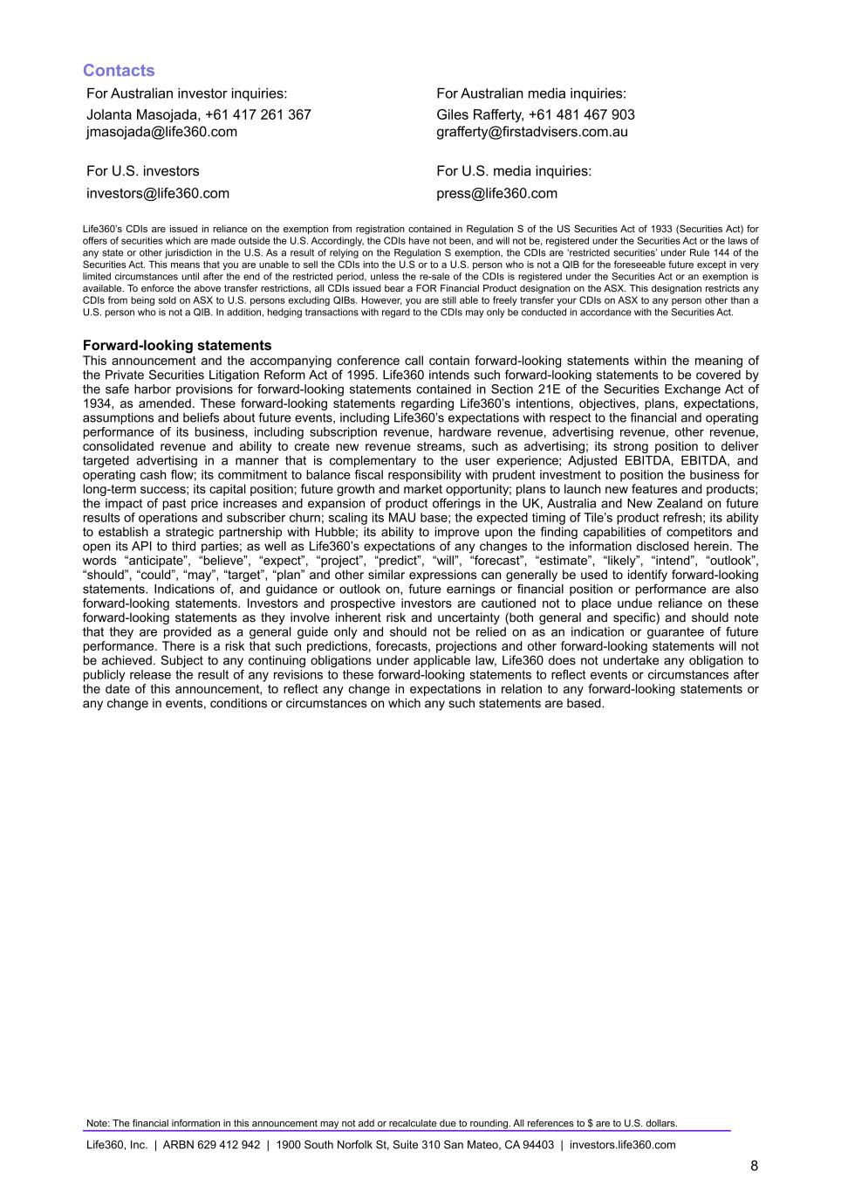
Contacts For Australian investor inquiries: For Australian media inquiries: Jolanta Masojada, +61 417 261 367 Giles Rafferty, +61 481 467 903 jmasojada@life360.com grafferty@firstadvisers.com.au For U.S. investors For U.S. media inquiries: investors@life360.com press@life360.com Life360’s CDIs are issued in reliance on the exemption from registration contained in Regulation S of the US Securities Act of 1933 (Securities Act) for offers of securities which are made outside the U.S. Accordingly, the CDIs have not been, and will not be, registered under the Securities Act or the laws of any state or other jurisdiction in the U.S. As a result of relying on the Regulation S exemption, the CDIs are ‘restricted securities’ under Rule 144 of the Securities Act. This means that you are unable to sell the CDIs into the U.S or to a U.S. person who is not a QIB for the foreseeable future except in very limited circumstances until after the end of the restricted period, unless the re-sale of the CDIs is registered under the Securities Act or an exemption is available. To enforce the above transfer restrictions, all CDIs issued bear a FOR Financial Product designation on the ASX. This designation restricts any CDIs from being sold on ASX to U.S. persons excluding QIBs. However, you are still able to freely transfer your CDIs on ASX to any person other than a U.S. person who is not a QIB. In addition, hedging transactions with regard to the CDIs may only be conducted in accordance with the Securities Act. Forward-looking statements This announcement and the accompanying conference call contain forward-looking statements within the meaning of the Private Securities Litigation Reform Act of 1995. Life360 intends such forward-looking statements to be covered by the safe harbor provisions for forward-looking statements contained in Section 21E of the Securities Exchange Act of 1934, as amended. These forward-looking statements regarding Life360’s intentions, objectives, plans, expectations, assumptions and beliefs about future events, including Life360’s expectations with respect to the financial and operating performance of its business, including subscription revenue, hardware revenue, advertising revenue, other revenue, consolidated revenue and ability to create new revenue streams, such as advertising; its strong position to deliver targeted advertising in a manner that is complementary to the user experience; Adjusted EBITDA, EBITDA, and operating cash flow; its commitment to balance fiscal responsibility with prudent investment to position the business for long-term success; its capital position; future growth and market opportunity; plans to launch new features and products; the impact of past price increases and expansion of product offerings in the UK, Australia and New Zealand on future results of operations and subscriber churn; scaling its MAU base; the expected timing of Tile’s product refresh; its ability to establish a strategic partnership with Hubble; its ability to improve upon the finding capabilities of competitors and open its API to third parties; as well as Life360’s expectations of any changes to the information disclosed herein. The words “anticipate”, “believe”, “expect”, “project”, “predict”, “will”, “forecast”, “estimate”, “likely”, “intend”, “outlook”, “should”, “could”, “may”, “target”, “plan” and other similar expressions can generally be used to identify forward-looking statements. Indications of, and guidance or outlook on, future earnings or financial position or performance are also forward-looking statements. Investors and prospective investors are cautioned not to place undue reliance on these forward-looking statements as they involve inherent risk and uncertainty (both general and specific) and should note that they are provided as a general guide only and should not be relied on as an indication or guarantee of future performance. There is a risk that such predictions, forecasts, projections and other forward-looking statements will not be achieved. Subject to any continuing obligations under applicable law, Life360 does not undertake any obligation to publicly release the result of any revisions to these forward-looking statements to reflect events or circumstances after the date of this announcement, to reflect any change in expectations in relation to any forward-looking statements or any change in events, conditions or circumstances on which any such statements are based. Note: The financial information in this announcement may not add or recalculate due to rounding. All references to $ are to U.S. dollars. Life360, Inc. | ARBN 629 412 942 | 1900 South Norfolk St, Suite 310 San Mateo, CA 94403 | investors.life360.com 8


Although Life360 believes that the expectations reflected in the forward-looking statements and the assumptions upon which they are based are reasonable, Life360 can give no assurance that such expectations and assumptions will prove to be correct and, actual results may vary in a materially positive or negative manner. Forward-looking statements are subject to known and unknown risks, uncertainty, assumptions and contingencies, many of which are outside Life360’s control, and are based on estimates and assumptions that are subject to change and may cause actual results, performance or achievements to differ materially from those expressed or implied by such statements. For example, there is a risk that Life360 will be unable to realize the potential benefits of the proposed collaboration with Hubble because (i) the letter of intent is non-binding and there are no assurances that Life360 will successfully negotiate and executive definitive documentation with Hubble on favorable terms or at all; (ii) if we fail to reach exclusive, definitive agreements with Hubble, our competitors could execute such agreements in lieu of or as well as us; (iii) a competitor of Life360 may gain access to Hubble’s technology, or develop or acquire rights to similar or better technology; (iv) our competitors may develop superior technology; (v) Hubble may not be successful in launching a sufficient number of satellites to provide coverage that is commercially beneficial to Life360; (vi) the functionality of this technology is not expected to be optimized until 2028 when the full expected constellation of satellites is in orbit; and (vii) Hubble’s technology may be unable to support Life360 products or a sufficiently large number of devices to make the Life360 partnership commercially beneficial. Factors that could cause actual results to differ materially from those in the forward- looking statements include risks related to the preliminary nature of financial results, risks related to Life360’s business, market risks, Life360’s need for additional capital, and the risk that Life360’s products and services may not perform as expected, as described in greater detail under the heading “Risk Factors” in Life360’s ASX and SEC filings, including its Annual Report on Form 10-K filed with the Securities and Exchange Commission on February 29, 2024 and other reports filed with the SEC. To the maximum extent permitted by law, responsibility for the accuracy or completeness of any forward-looking statements whether as a result of new information, future events or results or otherwise is disclaimed. This announcement should not be relied upon as a recommendation or forecast by Life360. Past performance information given in this document is given for illustrative purposes only and is not necessarily a guide to future performance and no representation or warranty is made by any person as to the likelihood of achievement or reasonableness of any forward-looking statements, forecast financial information, future share price performance or any underlying assumptions. Nothing contained in this document nor any information made available to you is, or shall be relied upon as, a promise, representation, warranty or guarantee as to the past, present or the future performance of Life360. Note: The financial information in this announcement may not add or recalculate due to rounding. All references to $ are to U.S. dollars. Life360, Inc. | ARBN 629 412 942 | 1900 South Norfolk St, Suite 310 San Mateo, CA 94403 | investors.life360.com 9

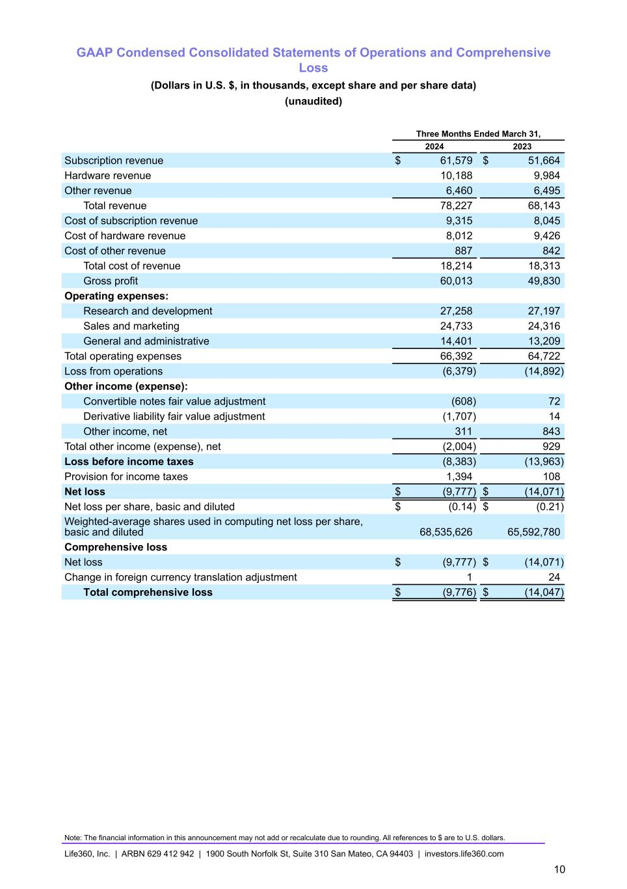
GAAP Condensed Consolidated Statements of Operations and Comprehensive Loss (Dollars in U.S. $, in thousands, except share and per share data) (unaudited) Three Months Ended March 31, 2024 2023 Subscription revenue $ 61,579 $ 51,664 Hardware revenue 10,188 9,984 Other revenue 6,460 6,495 Total revenue 78,227 68,143 Cost of subscription revenue 9,315 8,045 Cost of hardware revenue 8,012 9,426 Cost of other revenue 887 842 Total cost of revenue 18,214 18,313 Gross profit 60,013 49,830 Operating expenses: Research and development 27,258 27,197 Sales and marketing 24,733 24,316 General and administrative 14,401 13,209 Total operating expenses 66,392 64,722 Loss from operations (6,379) (14,892) Other income (expense): Convertible notes fair value adjustment (608) 72 Derivative liability fair value adjustment (1,707) 14 Other income, net 311 843 Total other income (expense), net (2,004) 929 Loss before income taxes (8,383) (13,963) Provision for income taxes 1,394 108 Net loss $ (9,777) $ (14,071) Net loss per share, basic and diluted $ (0.14) $ (0.21) Weighted-average shares used in computing net loss per share, basic and diluted 68,535,626 65,592,780 Comprehensive loss Net loss $ (9,777) $ (14,071) Change in foreign currency translation adjustment 1 24 Total comprehensive loss $ (9,776) $ (14,047) Note: The financial information in this announcement may not add or recalculate due to rounding. All references to $ are to U.S. dollars. Life360, Inc. | ARBN 629 412 942 | 1900 South Norfolk St, Suite 310 San Mateo, CA 94403 | investors.life360.com 10

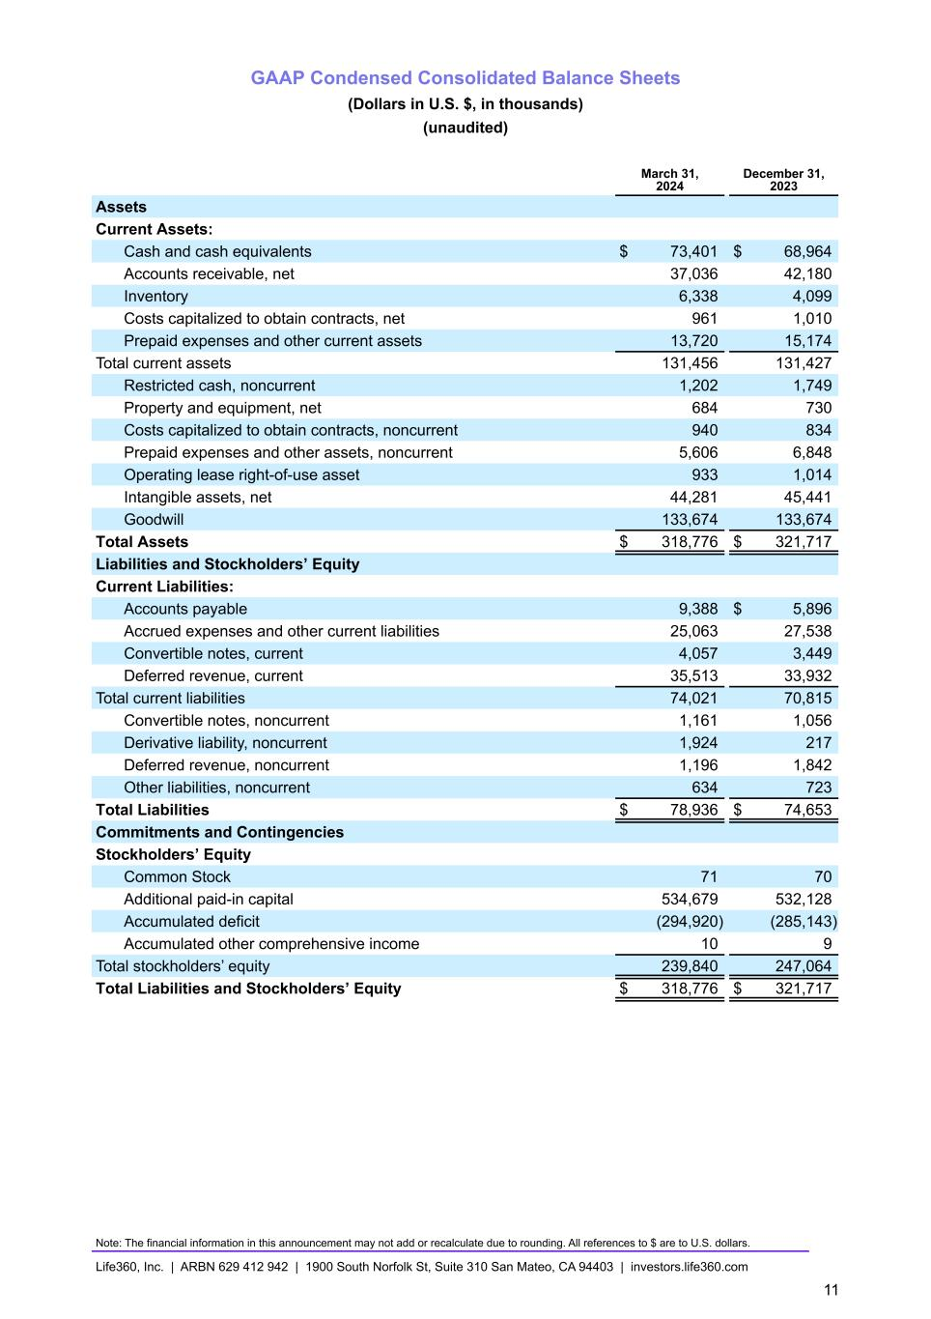
GAAP Condensed Consolidated Balance Sheets (Dollars in U.S. $, in thousands) (unaudited) March 31, 2024 December 31, 2023 Assets Current Assets: Cash and cash equivalents $ 73,401 $ 68,964 Accounts receivable, net 37,036 42,180 Inventory 6,338 4,099 Costs capitalized to obtain contracts, net 961 1,010 Prepaid expenses and other current assets 13,720 15,174 Total current assets 131,456 131,427 Restricted cash, noncurrent 1,202 1,749 Property and equipment, net 684 730 Costs capitalized to obtain contracts, noncurrent 940 834 Prepaid expenses and other assets, noncurrent 5,606 6,848 Operating lease right-of-use asset 933 1,014 Intangible assets, net 44,281 45,441 Goodwill 133,674 133,674 Total Assets $ 318,776 $ 321,717 Liabilities and Stockholders’ Equity Current Liabilities: Accounts payable 9,388 $ 5,896 Accrued expenses and other current liabilities 25,063 27,538 Convertible notes, current 4,057 3,449 Deferred revenue, current 35,513 33,932 Total current liabilities 74,021 70,815 Convertible notes, noncurrent 1,161 1,056 Derivative liability, noncurrent 1,924 217 Deferred revenue, noncurrent 1,196 1,842 Other liabilities, noncurrent 634 723 Total Liabilities $ 78,936 $ 74,653 Commitments and Contingencies Stockholders’ Equity Common Stock 71 70 Additional paid-in capital 534,679 532,128 Accumulated deficit (294,920) (285,143) Accumulated other comprehensive income 10 9 Total stockholders’ equity 239,840 247,064 Total Liabilities and Stockholders’ Equity $ 318,776 $ 321,717 Note: The financial information in this announcement may not add or recalculate due to rounding. All references to $ are to U.S. dollars. Life360, Inc. | ARBN 629 412 942 | 1900 South Norfolk St, Suite 310 San Mateo, CA 94403 | investors.life360.com 11

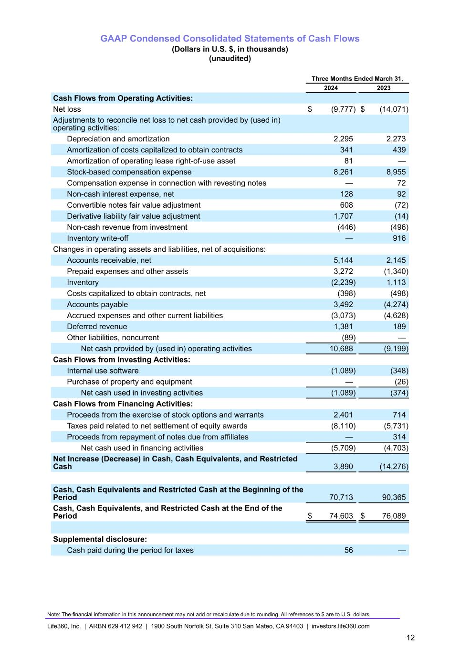
GAAP Condensed Consolidated Statements of Cash Flows (Dollars in U.S. $, in thousands) (unaudited) Three Months Ended March 31, 2024 2023 Cash Flows from Operating Activities: Net loss $ (9,777) $ (14,071) Adjustments to reconcile net loss to net cash provided by (used in) operating activities: Depreciation and amortization 2,295 2,273 Amortization of costs capitalized to obtain contracts 341 439 Amortization of operating lease right-of-use asset 81 — Stock-based compensation expense 8,261 8,955 Compensation expense in connection with revesting notes — 72 Non-cash interest expense, net 128 92 Convertible notes fair value adjustment 608 (72) Derivative liability fair value adjustment 1,707 (14) Non-cash revenue from investment (446) (496) Inventory write-off — 916 Changes in operating assets and liabilities, net of acquisitions: Accounts receivable, net 5,144 2,145 Prepaid expenses and other assets 3,272 (1,340) Inventory (2,239) 1,113 Costs capitalized to obtain contracts, net (398) (498) Accounts payable 3,492 (4,274) Accrued expenses and other current liabilities (3,073) (4,628) Deferred revenue 1,381 189 Other liabilities, noncurrent (89) — Net cash provided by (used in) operating activities 10,688 (9,199) Cash Flows from Investing Activities: Internal use software (1,089) (348) Purchase of property and equipment — (26) Net cash used in investing activities (1,089) (374) Cash Flows from Financing Activities: Proceeds from the exercise of stock options and warrants 2,401 714 Taxes paid related to net settlement of equity awards (8,110) (5,731) Proceeds from repayment of notes due from affiliates — 314 Net cash used in financing activities (5,709) (4,703) Net Increase (Decrease) in Cash, Cash Equivalents, and Restricted Cash 3,890 (14,276) Cash, Cash Equivalents and Restricted Cash at the Beginning of the Period 70,713 90,365 Cash, Cash Equivalents, and Restricted Cash at the End of the Period $ 74,603 $ 76,089 Supplemental disclosure: Cash paid during the period for taxes 56 — Note: The financial information in this announcement may not add or recalculate due to rounding. All references to $ are to U.S. dollars. Life360, Inc. | ARBN 629 412 942 | 1900 South Norfolk St, Suite 310 San Mateo, CA 94403 | investors.life360.com 12

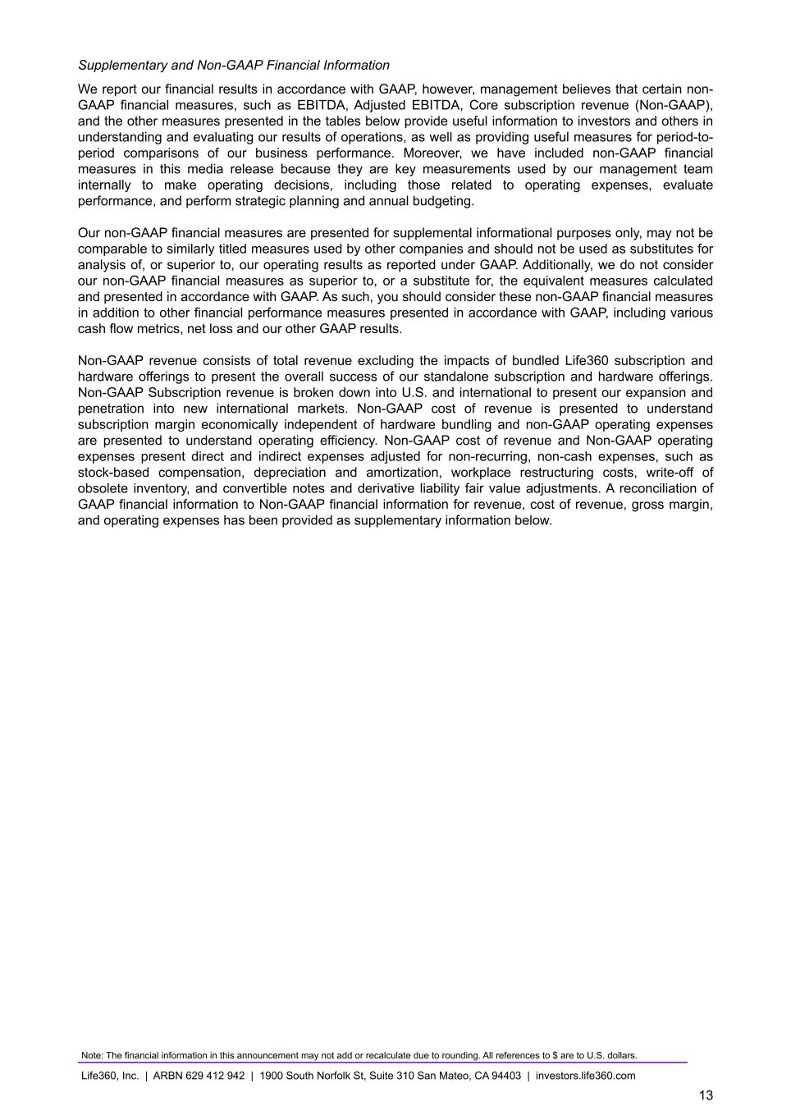
Supplementary and Non-GAAP Financial Information We report our financial results in accordance with GAAP, however, management believes that certain non- GAAP financial measures, such as EBITDA, Adjusted EBITDA, Core subscription revenue (Non-GAAP), and the other measures presented in the tables below provide useful information to investors and others in understanding and evaluating our results of operations, as well as providing useful measures for period-to- period comparisons of our business performance. Moreover, we have included non-GAAP financial measures in this media release because they are key measurements used by our management team internally to make operating decisions, including those related to operating expenses, evaluate performance, and perform strategic planning and annual budgeting. Our non-GAAP financial measures are presented for supplemental informational purposes only, may not be comparable to similarly titled measures used by other companies and should not be used as substitutes for analysis of, or superior to, our operating results as reported under GAAP. Additionally, we do not consider our non-GAAP financial measures as superior to, or a substitute for, the equivalent measures calculated and presented in accordance with GAAP. As such, you should consider these non-GAAP financial measures in addition to other financial performance measures presented in accordance with GAAP, including various cash flow metrics, net loss and our other GAAP results. Non-GAAP revenue consists of total revenue excluding the impacts of bundled Life360 subscription and hardware offerings to present the overall success of our standalone subscription and hardware offerings. Non-GAAP Subscription revenue is broken down into U.S. and international to present our expansion and penetration into new international markets. Non-GAAP cost of revenue is presented to understand subscription margin economically independent of hardware bundling and non-GAAP operating expenses are presented to understand operating efficiency. Non-GAAP cost of revenue and Non-GAAP operating expenses present direct and indirect expenses adjusted for non-recurring, non-cash expenses, such as stock-based compensation, depreciation and amortization, workplace restructuring costs, write-off of obsolete inventory, and convertible notes and derivative liability fair value adjustments. A reconciliation of GAAP financial information to Non-GAAP financial information for revenue, cost of revenue, gross margin, and operating expenses has been provided as supplementary information below. Note: The financial information in this announcement may not add or recalculate due to rounding. All references to $ are to U.S. dollars. Life360, Inc. | ARBN 629 412 942 | 1900 South Norfolk St, Suite 310 San Mateo, CA 94403 | investors.life360.com 13

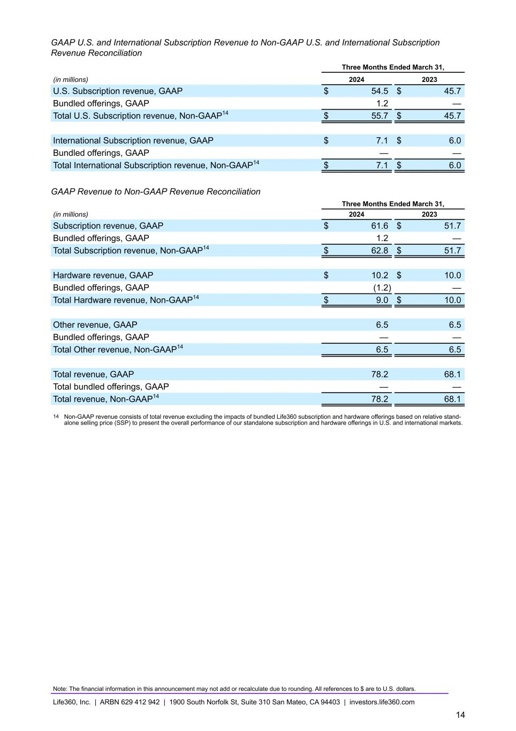
GAAP U.S. and International Subscription Revenue to Non-GAAP U.S. and International Subscription Revenue Reconciliation Three Months Ended March 31, (in millions) 2024 2023 U.S. Subscription revenue, GAAP $ 54.5 $ 45.7 Bundled offerings, GAAP 1.2 — Total U.S. Subscription revenue, Non-GAAP14 $ 55.7 $ 45.7 International Subscription revenue, GAAP $ 7.1 $ 6.0 Bundled offerings, GAAP — — Total International Subscription revenue, Non-GAAP14 $ 7.1 $ 6.0 GAAP Revenue to Non-GAAP Revenue Reconciliation Three Months Ended March 31, (in millions) 2024 2023 Subscription revenue, GAAP $ 61.6 $ 51.7 Bundled offerings, GAAP 1.2 — Total Subscription revenue, Non-GAAP14 $ 62.8 $ 51.7 Hardware revenue, GAAP $ 10.2 $ 10.0 Bundled offerings, GAAP (1.2) — Total Hardware revenue, Non-GAAP14 $ 9.0 $ 10.0 Other revenue, GAAP 6.5 6.5 Bundled offerings, GAAP — — Total Other revenue, Non-GAAP14 6.5 6.5 Total revenue, GAAP 78.2 68.1 Total bundled offerings, GAAP — — Total revenue, Non-GAAP14 78.2 68.1 14 Non-GAAP revenue consists of total revenue excluding the impacts of bundled Life360 subscription and hardware offerings based on relative stand- alone selling price (SSP) to present the overall performance of our standalone subscription and hardware offerings in U.S. and international markets. Note: The financial information in this announcement may not add or recalculate due to rounding. All references to $ are to U.S. dollars. Life360, Inc. | ARBN 629 412 942 | 1900 South Norfolk St, Suite 310 San Mateo, CA 94403 | investors.life360.com 14

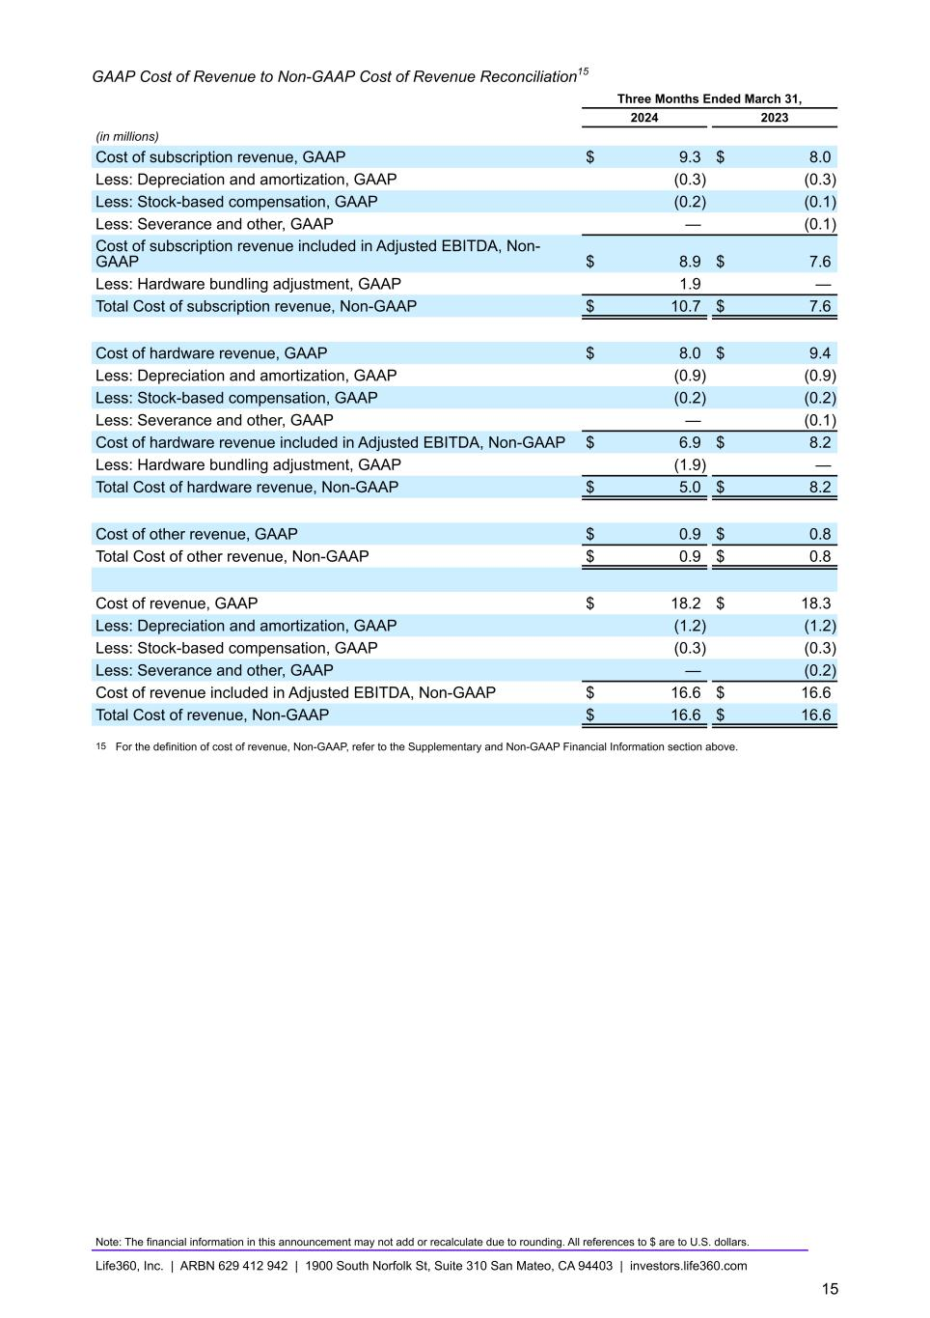
GAAP Cost of Revenue to Non-GAAP Cost of Revenue Reconciliation15 Three Months Ended March 31, 2024 2023 (in millions) Cost of subscription revenue, GAAP $ 9.3 $ 8.0 Less: Depreciation and amortization, GAAP (0.3) (0.3) Less: Stock-based compensation, GAAP (0.2) (0.1) Less: Severance and other, GAAP — (0.1) Cost of subscription revenue included in Adjusted EBITDA, Non- GAAP $ 8.9 $ 7.6 Less: Hardware bundling adjustment, GAAP 1.9 — Total Cost of subscription revenue, Non-GAAP $ 10.7 $ 7.6 Cost of hardware revenue, GAAP $ 8.0 $ 9.4 Less: Depreciation and amortization, GAAP (0.9) (0.9) Less: Stock-based compensation, GAAP (0.2) (0.2) Less: Severance and other, GAAP — (0.1) Cost of hardware revenue included in Adjusted EBITDA, Non-GAAP $ 6.9 $ 8.2 Less: Hardware bundling adjustment, GAAP (1.9) — Total Cost of hardware revenue, Non-GAAP $ 5.0 $ 8.2 Cost of other revenue, GAAP $ 0.9 $ 0.8 Total Cost of other revenue, Non-GAAP $ 0.9 $ 0.8 Cost of revenue, GAAP $ 18.2 $ 18.3 Less: Depreciation and amortization, GAAP (1.2) (1.2) Less: Stock-based compensation, GAAP (0.3) (0.3) Less: Severance and other, GAAP — (0.2) Cost of revenue included in Adjusted EBITDA, Non-GAAP $ 16.6 $ 16.6 Total Cost of revenue, Non-GAAP $ 16.6 $ 16.6 15 For the definition of cost of revenue, Non-GAAP, refer to the Supplementary and Non-GAAP Financial Information section above. Note: The financial information in this announcement may not add or recalculate due to rounding. All references to $ are to U.S. dollars. Life360, Inc. | ARBN 629 412 942 | 1900 South Norfolk St, Suite 310 San Mateo, CA 94403 | investors.life360.com 15

GAAP Gross Profit to Non-GAAP Gross Profit Reconciliation Three Months Ended March 31, 2024 2023 (in millions, except percentages) Gross Profit, GAAP $ 60.0 $ 49.8 Gross Margin %, GAAP 77 % 73 % Bundled offerings, GAAP — — Depreciation and amortization, GAAP 1.2 1.2 Stock-based compensation, GAAP 0.3 0.3 Severance and other, GAAP — 0.2 Gross Profit, Non-GAAP $ 61.6 $ 51.5 Gross Margin %, Non-GAAP 79 % 76 % GAAP Subscription Gross Profit to Non-GAAP Subscription Gross Profit Reconciliation Three Months Ended March 31, 2024 2023 (in millions, except percentages) Subscription Gross Profit, GAAP $ 52.3 $ 43.6 Subscription Gross Margin %, GAAP 85 % 84 % Bundled offerings, GAAP (0.7) — Depreciation and amortization, GAAP 0.3 0.3 Stock-based compensation, GAAP 0.2 0.1 Severance and other, GAAP — 0.1 Subscription Gross Profit, Non-GAAP $ 52.1 $ 44.1 Subscription Gross Margin %, Non-GAAP 83 % 85 % Note: The financial information in this announcement may not add or recalculate due to rounding. All references to $ are to U.S. dollars. Life360, Inc. | ARBN 629 412 942 | 1900 South Norfolk St, Suite 310 San Mateo, CA 94403 | investors.life360.com 16

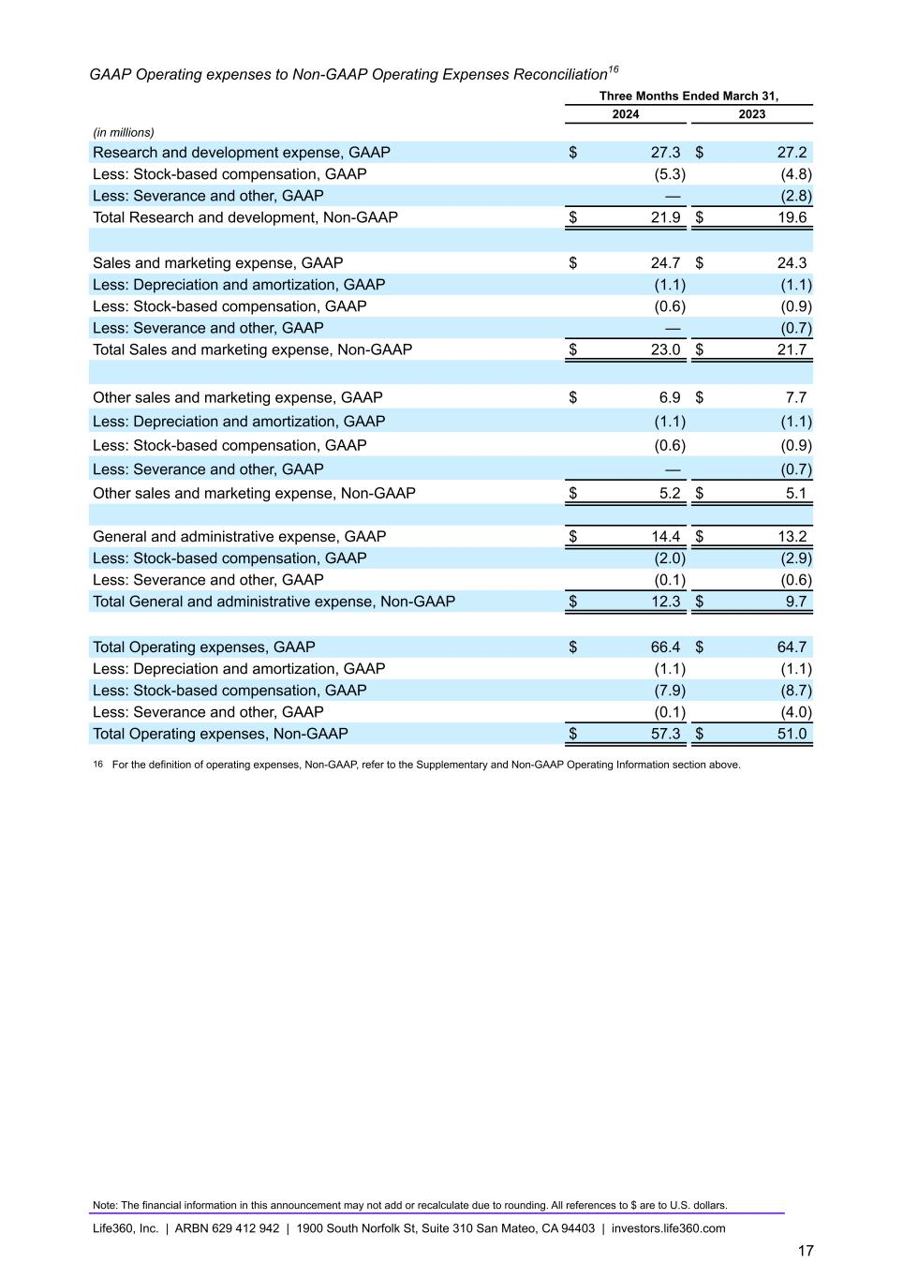
GAAP Operating expenses to Non-GAAP Operating Expenses Reconciliation16 Three Months Ended March 31, 2024 2023 (in millions) Research and development expense, GAAP $ 27.3 $ 27.2 Less: Stock-based compensation, GAAP (5.3) (4.8) Less: Severance and other, GAAP — (2.8) Total Research and development, Non-GAAP $ 21.9 $ 19.6 Sales and marketing expense, GAAP $ 24.7 $ 24.3 Less: Depreciation and amortization, GAAP (1.1) (1.1) Less: Stock-based compensation, GAAP (0.6) (0.9) Less: Severance and other, GAAP — (0.7) Total Sales and marketing expense, Non-GAAP $ 23.0 $ 21.7 Other sales and marketing expense, GAAP $ 6.9 $ 7.7 Less: Depreciation and amortization, GAAP (1.1) (1.1) Less: Stock-based compensation, GAAP (0.6) (0.9) Less: Severance and other, GAAP — (0.7) Other sales and marketing expense, Non-GAAP $ 5.2 $ 5.1 General and administrative expense, GAAP $ 14.4 $ 13.2 Less: Stock-based compensation, GAAP (2.0) (2.9) Less: Severance and other, GAAP (0.1) (0.6) Total General and administrative expense, Non-GAAP $ 12.3 $ 9.7 Total Operating expenses, GAAP $ 66.4 $ 64.7 Less: Depreciation and amortization, GAAP (1.1) (1.1) Less: Stock-based compensation, GAAP (7.9) (8.7) Less: Severance and other, GAAP (0.1) (4.0) Total Operating expenses, Non-GAAP $ 57.3 $ 51.0 16 For the definition of operating expenses, Non-GAAP, refer to the Supplementary and Non-GAAP Operating Information section above. Note: The financial information in this announcement may not add or recalculate due to rounding. All references to $ are to U.S. dollars. Life360, Inc. | ARBN 629 412 942 | 1900 South Norfolk St, Suite 310 San Mateo, CA 94403 | investors.life360.com 17

