UNITED STATES
SECURITIES AND EXCHANGE COMMISSION
Washington, D.C. 20549
______________

FORM 10-Q

x |  |  | QUARTERLY REPORT PURSUANT TO SECTION 13 OR 15(d) OF THE SECURITIES EXCHANGE ACT OF 1934
 |  |  | For the quarterly period ended June 30, 2025
OR
☐ |  |  | TRANSITION REPORT PURSUANT TO SECTION 13 OR 15(d) OF THE SECURITIES EXCHANGE ACT OF 1934
 |  |  | For the transition period from __________ to __________
Commission File Number 001-42120
Life360, Inc.
(Exact name of registrant as specified in its charter)
Delaware |  |  | 26-0197666
(State or other jurisdiction of  incorporation or organization) |  |  | (I.R.S. Employer  Identification No.)
1900 South Norfolk Street, Suite 310  San Mateo, CA |  |  | 94403
(Address of principal executive offices) |  |  | (Zip Code)
Tel: (415) 484-5244
(Registrant's telephone number, including area code)
Not Applicable.
(Former name, former address and former fiscal year, if changed since last report)
Securities registered pursuant to Section 12(b) of the Act:
Title of each class |  |  | Trading Symbol(s) |  |  | Name of each exchange on which registered
Common Stock, $0.001 par value per share |  |  | LIF |  |  | The Nasdaq Stock Market LLC
Indicate by check mark whether the registrant: (1) has filed all reports required to be filed by Section 13 or 15(d) of the Securities Exchange Act of 1934 during the preceding 12 months (or for such shorter period that the registrant was required to file such reports), and (2) has been subject to such filing requirements for the past 90 days. Yes x No o
Indicate by check mark whether the registrant has submitted electronically every Interactive Data File required to be submitted pursuant to Rule 405 of Regulation S-T (§232.405 of this chapter) during the preceding 12 months (or for such shorter period that the registrant was required to submit such files). Yes x No o
Indicate by check mark whether the registrant is a large accelerated filer, an accelerated filer, a non-accelerated filer, a smaller reporting company, or an emerging growth company. See the definitions of “large accelerated filer,” “accelerated filer,” “smaller reporting company” and “emerging growth company” in Rule 12b-2 of the Exchange Act.
Large accelerated filer |  |  | x |  |  |  |  |  | Accelerated filer |  |  | o
Non-accelerated filer |  |  | o |  |  |  |  |  | Smaller reporting company |  |  | o
Emerging growth company |  |  | o
If an emerging growth company, indicate by check mark if the registrant has elected not to use the extended transition period for complying with any new or revised financial accounting standards provided pursuant to Section 13(a) of the Exchange Act. o
Indicate by check mark whether the registrant is a shell company (as defined in Rule 12b-2 of the Exchange Act). Yes o No x
As of August 5, 2025, the registrant had 77,548,651 shares of common stock, par value $0.001 per share, including shares underlying all issued and outstanding Chess Depositary Interests (“CDIs”), outstanding.

Life360, Inc.
Form 10-Q for the Quarter Ended June 30, 2025
Table of Contents
 |  |  |  |  |  | Page
Part I - Financial Information
Item 1. |  |  | Financial Statements (unaudited) |  |  | 1
 |  |  | Condensed Consolidated Balance Sheets |  |  | 2
 |  |  | Condensed Consolidated Statements of Operations and Comprehensive Income (Loss) |  |  | 3
 |  |  | Condensed Consolidated Statements of Stockholders’ Equity |  |  | 4
 |  |  | Condensed Consolidated Statements of Cash Flows |  |  | 6
 |  |  | Notes to Condensed Consolidated Financial Statements (unaudited) |  |  | 8
Item 2. |  |  | Management’s Discussion and Analysis of Financial Condition and Results of Operations |  |  | 26
Item 3. |  |  | Quantitative and Qualitative Disclosures About Market Risk |  |  | 41
Item 4. |  |  | Controls and Procedures |  |  | 41
Part II - Other Information
Item 1. |  |  | Legal Proceedings |  |  | 43
Item 1A. |  |  | Risk Factors |  |  | 43
Item 2. |  |  | Unregistered Sales of Equity Securities and Use of Proceeds |  |  | 46
Item 3. |  |  | Defaults Upon Senior Securities |  |  | 47
Item 4. |  |  | Mine Safety Disclosures |  |  | 47
Item 5. |  |  | Other Information |  |  | 47
Item 6. |  |  | Exhibits |  |  | 48
Signatures |  |  |  |  |  | 49
In this report, unless otherwise stated or the context otherwise indicates, the terms “Life360,” “the Company,” “we,” “us,” “our” and similar references refer to Life360, Inc. and its consolidated subsidiaries. The Life360 logo, and other trademarks, trade names or service marks of Life360, Inc. appearing in this Quarterly Report on Form 10-Q are the property of Life360, Inc. All other trademarks, trade names and service marks appearing in this Quarterly Report on Form 10-Q are the property of their respective owners. Solely for convenience, the trademarks and trade names in this report may be referred to without the ® and ™ symbols, but such references should not be construed as any indicator that their respective owners will not assert their rights thereto.

Table of Contents
FORWARD-LOOKING STATEMENTS
This Quarterly Report on Form 10-Q (this “Quarterly Report”) contains forward-looking statements within the meaning of the Private Securities Litigation Reform Act of 1995 that are based on our management’s beliefs and assumptions and on information currently available to our management. We intend such forward-looking statements to be covered by the safe harbor provisions for forward-looking statements contained in Section 21E of the Securities Exchange Act of 1934, as amended (the “Exchange Act”). These forward-looking statements include statements regarding, among other things, (a) our expectations regarding our results of operations and key performance indicators, (b) key factors affecting our performance (c) our growth strategy, (d) our future financing plans, (e) our anticipated needs for, and use of, working capital and (f) our expectations regarding the effect of the capped call transactions entered into in connection with the pricing of our 0.00% convertible senior notes due June 1, 2030. They are generally identifiable by use of the words: “may,” “might,” “will,” “could,” “would,” “should,” “expect,” “plan,” “anticipate,” “intend,” “seek,” “believe,” “estimate,” “predict,” “potential,” “continue,” “contemplate,” “possible” or the negative of these terms or other comparable terminology, although not all forward-looking statements contain these words. We caution you the foregoing list may not contain all of the forward-looking statements made in this Quarterly Report. These forward-looking statements are subject to risks and uncertainties, many of which are outside of our control, including risks related to our business, market risks, our need for additional capital, and the risk that our products and services may not perform as expected, as described in “Risk Factors” under Part II, Item 1A in this Quarterly Report, Part II, Item 1A in our previous Quarterly Report on Form 10-Q for the quarter ended March 31, 2025, filed with the Securities and Exchange Commission (the “SEC”) on May 12, 2025, and Part I, Item 1A of the Company’s Form 10-K for the year ended December 31, 2024, filed with the SEC on February 27, 2025 (“Annual Report”), as well as in other sections of this report, as such risks may be updated in subsequent filings with the SEC or the Australian Securities Exchange (“ASX”). In light of these risks and uncertainties, there can be no assurance that the forward-looking statements contained in this filing will in fact occur. You should not place undue reliance on these forward-looking statements.
The forward-looking statements are not historical facts, but rather are based on current expectations, estimates, assumptions and projections about our industry, business and future financial results. The forward-looking statements speak only as of the date on which they are made, and, except to the extent required by federal securities laws, we undertake no obligation to update any forward-looking statements to reflect events or circumstances after the date on which the statements are made or to reflect the occurrence of unanticipated events. Our actual results could differ materially from the results contemplated by these forward-looking statements due to a number of factors, including, but not limited to, those discussed in “Risk Factors” under Part II, Item 1A in this Quarterly Report, Part II, Item 1A in our previous Quarterly Report on Form 10-Q for the quarter ended March 31, 2025, and Part I, Item 1A in our Annual Report, and other sections in this Quarterly Report.

PART I - FINANCIAL INFORMATION

Item 1. Financial Statements (unaudited)

1
Table of Contents
Life360, Inc.
Condensed Consolidated Balance Sheets
(Dollars in U.S. $, in thousands, except share and per share data)
(unaudited)
 |  |  | June 30,  2025 |  |  |  |  |  | December 31,  2024
Assets
Current Assets:
Cash and cash equivalents |  |  | $ | 432,710 |  |  |  |  | $ | 159,238
Accounts receivable, net(1) |  |  | 58,854 |  |  |  |  |  | 57,997
Inventory |  |  | 9,673 |  |  |  |  |  | 8,057
Costs capitalized to obtain contracts, net |  |  | 1,231 |  |  |  |  |  | 1,098
Prepaid expenses and other current assets |  |  | 18,741 |  |  |  |  |  | 14,599
Total current assets |  |  | 521,209 |  |  |  |  |  | 240,989
Restricted cash, noncurrent |  |  | 1,518 |  |  |  |  |  | 1,221
Property and equipment, net |  |  | 3,042 |  |  |  |  |  | 1,779
Costs capitalized to obtain contracts, noncurrent |  |  | 965 |  |  |  |  |  | 1,049
Prepaid expenses and other assets, noncurrent(2)(3) |  |  | 49,194 |  |  |  |  |  | 21,611
Operating lease right-of-use asset |  |  | 512 |  |  |  |  |  | 683
Intangible assets, net |  |  | 42,520 |  |  |  |  |  | 40,574
Goodwill |  |  | 134,619 |  |  |  |  |  | 133,674
Total Assets |  |  | $ | 753,579 |  |  |  |  | $ | 441,580
Liabilities and Stockholders’ Equity
Current Liabilities:
Accounts payable |  |  | $ | 2,966 |  |  |  |  | $ | 5,463
Accrued expenses and other current liabilities |  |  | 27,152 |  |  |  |  |  | 32,015
Deferred revenue, current |  |  | 42,833 |  |  |  |  |  | 39,860
Total current liabilities |  |  | 72,951 |  |  |  |  |  | 77,338
Convertible notes, net, noncurrent |  |  | 309,298 |  |  |  |  |  | —
Deferred revenue, noncurrent |  |  | 4,507 |  |  |  |  |  | 5,338
Other liabilities, noncurrent |  |  | 165 |  |  |  |  |  | 359
Total Liabilities |  |  | $ | 386,921 |  |  |  |  | $ | 83,035
Commitments and Contingencies (Note 9)
Stockholders’ Equity
Common Stock, $0.001 par value; 500,000,000 authorized as of June 30, 2025 and December 31, 2024, respectively; 77,516,232 and 75,404,996 issued and outstanding as of June 30, 2025 and December 31, 2024, respectively |  |  | 78 |  |  |  |  |  | 75
Additional paid-in capital |  |  | 644,950 |  |  |  |  |  | 648,124
Accumulated deficit |  |  | (278,314) |  |  |  |  |  | (289,698)
Accumulated other comprehensive (loss) income |  |  | (56) |  |  |  |  |  | 44
Total stockholders’ equity |  |  | 366,658 |  |  |  |  |  | 358,545
Total Liabilities and Stockholders’ Equity |  |  | $ | 753,579 |  |  |  |  | $ | 441,580
(1) Includes related party receivables of $15 and $55 as of June 30, 2025 and December 31, 2024, respectively.
(2) Includes $25,387 and zero measured using the fair value option as of June 30, 2025 and December 31, 2024, respectively related to the Convertible Note Investment. Refer to Note 5, "Fair Value Measurements" for additional information.
(3) The balance as of June 30, 2025 includes the $5,882 Related Party Investment and the $3,898 Related Party Warrant. The balance as of December 31, 2024 includes the $5,000 Related Party SAFE and the $3,898 Related Party Warrant. Refer to Note 5, "Fair Value Measurements" and Note 14, "Related-Party Transactions" for additional information.

See accompanying notes to the condensed consolidated financial statements (unaudited).

2
Table of Contents
Life360, Inc.
Condensed Consolidated Statements of Operations and Comprehensive Income (Loss)
(Dollars in U.S. $, in thousands, except share and per share data)
(unaudited)
 |  |  | Three Months Ended June 30, |  |  |  |  |  |  |  |  |  |  |  | Six Months Ended June 30,
 |  |  | 2025 |  |  |  |  |  | 2024 |  |  |  |  |  | 2025 |  |  |  |  |  | 2024
Subscription revenue |  |  | $ | 88,582 |  |  |  |  | $ | 65,678 |  |  |  |  | $ | 170,456 |  |  |  |  | $ | 127,257
Hardware revenue |  |  | 12,266 |  |  |  |  |  | 11,901 |  |  |  |  |  | 21,173 |  |  |  |  |  | 22,089
Other revenue(1) |  |  | 14,533 |  |  |  |  |  | 7,284 |  |  |  |  |  | 27,376 |  |  |  |  |  | 13,744
Total revenue |  |  | 115,381 |  |  |  |  |  | 84,863 |  |  |  |  |  | 219,005 |  |  |  |  |  | 163,090
Cost of subscription revenue |  |  | 13,049 |  |  |  |  |  | 10,393 |  |  |  |  |  | 23,190 |  |  |  |  |  | 19,708
Cost of hardware revenue |  |  | 10,194 |  |  |  |  |  | 9,922 |  |  |  |  |  | 18,791 |  |  |  |  |  | 17,934
Cost of other revenue |  |  | 1,637 |  |  |  |  |  | 922 |  |  |  |  |  | 2,974 |  |  |  |  |  | 1,809
Total cost of revenue |  |  | 24,880 |  |  |  |  |  | 21,237 |  |  |  |  |  | 44,955 |  |  |  |  |  | 39,451
Gross profit |  |  | 90,501 |  |  |  |  |  | 63,626 |  |  |  |  |  | 174,050 |  |  |  |  |  | 123,639
Operating expenses:
Research and development |  |  | 32,258 |  |  |  |  |  | 27,013 |  |  |  |  |  | 62,661 |  |  |  |  |  | 54,271
Sales and marketing |  |  | 38,873 |  |  |  |  |  | 24,363 |  |  |  |  |  | 74,181 |  |  |  |  |  | 49,096
General and administrative |  |  | 17,378 |  |  |  |  |  | 14,613 |  |  |  |  |  | 33,027 |  |  |  |  |  | 29,014
Total operating expenses |  |  | 88,509 |  |  |  |  |  | 65,989 |  |  |  |  |  | 169,869 |  |  |  |  |  | 132,381
Income (loss) from operations |  |  | 1,992 |  |  |  |  |  | (2,363) |  |  |  |  |  | 4,181 |  |  |  |  |  | (8,742)
Other income (expense):
Convertible notes fair value adjustment |  |  | — |  |  |  |  |  | — |  |  |  |  |  | — |  |  |  |  |  | (608)
Derivative liability fair value adjustment |  |  | — |  |  |  |  |  | — |  |  |  |  |  | — |  |  |  |  |  | (1,707)
Loss on settlement of convertible notes |  |  | — |  |  |  |  |  | (440) |  |  |  |  |  | — |  |  |  |  |  | (440)
Gain on settlement of derivative liability |  |  | — |  |  |  |  |  | 1,924 |  |  |  |  |  | — |  |  |  |  |  | 1,924
Gain on change in fair value of investments(2) |  |  | 1,269 |  |  |  |  |  | — |  |  |  |  |  | 1,269 |  |  |  |  |  | —
Other income (expense), net(3) |  |  | 3,353 |  |  |  |  |  | (4,607) |  |  |  |  |  | 5,328 |  |  |  |  |  | (4,296)
Total other income (expense), net |  |  | 4,622 |  |  |  |  |  | (3,123) |  |  |  |  |  | 6,597 |  |  |  |  |  | (5,127)
Income (loss) before income taxes |  |  | 6,614 |  |  |  |  |  | (5,486) |  |  |  |  |  | 10,778 |  |  |  |  |  | (13,869)
Provision for (benefit from) income taxes |  |  | (392) |  |  |  |  |  | 5,478 |  |  |  |  |  | (606) |  |  |  |  |  | 6,872
Net income (loss) |  |  | $ | 7,006 |  |  |  |  | $ | (10,964) |  |  |  |  | $ | 11,384 |  |  |  |  | $ | (20,741)
Net income (loss) per share, basic (Note 15) |  |  | $ | 0.09 |  |  |  |  | $ | (0.15) |  |  |  |  | $ | 0.15 |  |  |  |  | $ | (0.30)
Net income (loss) per share, diluted (Note 15) |  |  | $ | 0.08 |  |  |  |  | $ | (0.15) |  |  |  |  | $ | 0.14 |  |  |  |  | $ | (0.30)
Weighted-average shares used in computing net income (loss) per share, basic (Note 15) |  |  | 76,797,385 |  |  |  |  |  | 70,760,080 |  |  |  |  |  | 76,254,119 |  |  |  |  |  | 69,647,853
Weighted-average shares used in computing net income (loss) per share, diluted (Note 15) |  |  | 84,476,048 |  |  |  |  |  | 70,760,080 |  |  |  |  |  | 83,980,695 |  |  |  |  |  | 69,647,853
Comprehensive income (loss)
Net income (loss) |  |  | $ | 7,006 |  |  |  |  | $ | (10,964) |  |  |  |  | $ | 11,384 |  |  |  |  | $ | (20,741)
Change in foreign currency translation adjustment |  |  | (101) |  |  |  |  |  | (4) |  |  |  |  |  | (100) |  |  |  |  |  | (3)
Total comprehensive income (loss) |  |  | $ | 6,905 |  |  |  |  | $ | (10,968) |  |  |  |  | $ | 11,284 |  |  |  |  | $ | (20,744)
(1) Includes related party revenue of $195 and $487 for the three and six months ended June 30, 2025, respectively. No related party revenue was recorded during the three and six months ended June 30, 2024.
(2) Includes a related party gain of $882 for the three and six months ended June 30, 2025. No related party gain was recorded during the three and six months ended June 30, 2024.
(3) Includes related party other expense of $5,498 for the three and six months ended June 30, 2024. No related party other expense was recorded during the three and six months ended June 30, 2025.
See accompanying notes to the condensed consolidated financial statements (unaudited).

3
Table of Contents
Life360, Inc.
Condensed Consolidated Statements of Stockholders’ Equity
(Dollars in U.S. $, in thousands, except share and per share data)
(unaudited)

 |  |  | Common Stock |  |  |  |  |  |  |  |  |  |  |  | Additional  Paid-In Capital |  |  |  |  |  |  |  | Accumulated  Deficit |  |  |  |  |  | Accumulated  Other  Comprehensive (Loss)  Income |  |  |  |  |  | Total  Stockholders’  Equity
 |  |  | Shares |  |  |  |  |  | Amount
Balance at December 31, 2024 |  |  | 75,404,996 |  |  |  |  |  | $ | 75 |  |  |  |  | $ | 648,124 |  |  |  |  |  |  | $ | (289,698) |  |  |  |  | $ | 44 |  |  |  |  | $ | 358,545
Exercise of stock options |  |  | 346,874 |  |  |  |  |  | — |  |  |  |  |  | 3,039 |  |  |  |  |  |  |  | — |  |  |  |  |  | — |  |  |  |  |  | 3,039
Vesting of restricted stock units |  |  | 644,538 |  |  |  |  |  | 1 |  |  |  |  |  | (1) |  |  |  |  |  |  |  | — |  |  |  |  |  | — |  |  |  |  |  | —
Taxes paid related to the settlement of equity awards, net of settlement proceeds received |  |  | — |  |  |  |  |  | — |  |  |  |  |  | (856) |  |  |  |  |  |  |  | — |  |  |  |  |  | — |  |  |  |  |  | (856)
Stock-based compensation expense |  |  | — |  |  |  |  |  | — |  |  |  |  |  | 10,173 |  |  |  |  |  |  |  | — |  |  |  |  |  | — |  |  |  |  |  | 10,173
Shares issued in connection with an acquisition |  |  | 22,252 |  |  |  |  |  | — |  |  |  |  |  | 1,000 |  |  |  |  |  |  |  | — |  |  |  |  |  | — |  |  |  |  |  | 1,000
Change in foreign currency translation adjustment |  |  | — |  |  |  |  |  | — |  |  |  |  |  | — |  |  |  |  |  |  |  | — |  |  |  |  |  | 1 |  |  |  |  |  | 1
Net income |  |  | — |  |  |  |  |  | — |  |  |  |  |  | — |  |  |  |  |  |  |  | 4,378 |  |  |  |  |  | — |  |  |  |  |  | 4,378
Balance at March 31, 2025 |  |  | 76,418,660 |  |  |  |  |  | $ | 76 |  |  |  |  | $ | 661,479 |  |  |  |  |  |  | $ | (285,320) |  |  |  |  | $ | 45 |  |  |  |  | $ | 376,280
Exercise of stock options |  |  | 510,285 |  |  |  |  |  | 1 |  |  |  |  |  | 2,762 |  |  |  |  |  |  |  | — |  |  |  |  |  | — |  |  |  |  |  | 2,763
Vesting of restricted stock units |  |  | 587,287 |  |  |  |  |  | 1 |  |  |  |  |  | — |  |  |  |  |  |  |  | — |  |  |  |  |  | — |  |  |  |  |  | 1
Taxes paid related to the settlement of equity awards, net of settlement proceeds received |  |  | — |  |  |  |  |  | — |  |  |  |  |  | (1,142) |  |  |  |  |  |  |  | — |  |  |  |  |  | — |  |  |  |  |  | (1,142)
Stock-based compensation expense |  |  | — |  |  |  |  |  | — |  |  |  |  |  | 15,579 |  |  |  |  |  |  |  | — |  |  |  |  |  | — |  |  |  |  |  | 15,579
Purchase of capped calls related to the June 2025 Convertible Notes |  |  | — |  |  |  |  |  | — |  |  |  |  |  | (33,728) |  |  |  |  |  |  |  | — |  |  |  |  |  | — |  |  |  |  |  | (33,728)
Change in foreign currency translation adjustment |  |  | — |  |  |  |  |  | — |  |  |  |  |  | — |  |  |  |  |  |  |  | — |  |  |  |  |  | (101) |  |  |  |  |  | (101)
Net income |  |  | — |  |  |  |  |  | — |  |  |  |  |  | — |  |  |  |  |  |  |  | 7,006 |  |  |  |  |  | — |  |  |  |  |  | 7,006
Balance at June 30, 2025 |  |  | 77,516,232 |  |  |  |  |  | $ | 78 |  |  |  |  | $ | 644,950 |  |  |  |  |  |  | $ | (278,314) |  |  |  |  | $ | (56) |  |  |  |  | $ | 366,658
4
Table of Contents
Life360, Inc.
 |  |  | Common Stock |  |  |  |  |  |  |  |  |  |  |  | Additional  Paid-In Capital |  |  |  |  |  |  |  | Accumulated  Deficit |  |  |  |  |  | Accumulated  Other  Comprehensive (Loss)  Income |  |  |  |  |  | Total  Stockholders’  Equity
 |  |  | Shares |  |  |  |  |  | Amount
Balance at December 31, 2023 |  |  | 68,155,830 |  |  |  |  |  | $ | 70 |  |  |  |  | $ | 532,128 |  |  |  |  |  |  | $ | (285,143) |  |  |  |  | $ | 9 |  |  |  |  | $ | 247,064
Exercise of stock options |  |  | 277,309 |  |  |  |  |  | — |  |  |  |  |  | 2,307 |  |  |  |  |  |  |  | — |  |  |  |  |  | — |  |  |  |  |  | 2,307
Exercise of warrants |  |  | 41,685 |  |  |  |  |  | — |  |  |  |  |  | 94 |  |  |  |  |  |  |  | — |  |  |  |  |  | — |  |  |  |  |  | 94
Vesting of restricted stock units |  |  | 965,238 |  |  |  |  |  | 1 |  |  |  |  |  | (1) |  |  |  |  |  |  |  | — |  |  |  |  |  | — |  |  |  |  |  | —
Taxes paid related to net settlement of equity awards |  |  | — |  |  |  |  |  | — |  |  |  |  |  | (8,110) |  |  |  |  |  |  |  | — |  |  |  |  |  | — |  |  |  |  |  | (8,110)
Stock-based compensation expense |  |  | — |  |  |  |  |  | — |  |  |  |  |  | 8,261 |  |  |  |  |  |  |  | — |  |  |  |  |  | — |  |  |  |  |  | 8,261
Change in foreign currency translation adjustment |  |  | — |  |  |  |  |  | — |  |  |  |  |  | — |  |  |  |  |  |  |  | — |  |  |  |  |  | 1 |  |  |  |  |  | 1
Net loss |  |  | — |  |  |  |  |  | — |  |  |  |  |  | — |  |  |  |  |  |  |  | (9,777) |  |  |  |  |  | — |  |  |  |  |  | (9,777)
Balance at March 31, 2024 |  |  | 69,440,062 |  |  |  |  |  | $ | 71 |  |  |  |  | $ | 534,679 |  |  |  |  |  |  | $ | (294,920) |  |  |  |  | $ | 10 |  |  |  |  | $ | 239,840
Exercise of stock options |  |  | 129,968 |  |  |  |  |  | — |  |  |  |  |  | 1,006 |  |  |  |  |  |  |  | — |  |  |  |  |  | — |  |  |  |  |  | 1,006
Exercise of warrants |  |  | 88,212 |  |  |  |  |  | — |  |  |  |  |  | 1,055 |  |  |  |  |  |  |  | — |  |  |  |  |  | — |  |  |  |  |  | 1,055
Vesting of restricted stock units |  |  | 428,378 |  |  |  |  |  | — |  |  |  |  |  | — |  |  |  |  |  |  |  | — |  |  |  |  |  | — |  |  |  |  |  | —
Taxes paid related to net settlement of equity awards |  |  | — |  |  |  |  |  | — |  |  |  |  |  | (7,834) |  |  |  |  |  |  |  | — |  |  |  |  |  | — |  |  |  |  |  | (7,834)
Stock-based compensation expense |  |  | — |  |  |  |  |  | — |  |  |  |  |  | 11,159 |  |  |  |  |  |  |  | — |  |  |  |  |  | — |  |  |  |  |  | 11,159
Settlement of convertible notes |  |  | 341,877 |  |  |  |  |  | — |  |  |  |  |  | 5,751 |  |  |  |  |  |  |  | — |  |  |  |  |  | — |  |  |  |  |  | 5,751
Issuance of common stock net of underwriting discounts, commissions, and issuance costs of $13,293 |  |  | 3,703,704 |  |  |  |  |  | 3 |  |  |  |  |  | 86,704 |  |  |  |  |  |  |  | — |  |  |  |  |  | — |  |  |  |  |  | 86,707
Change in foreign currency translation adjustment |  |  | — |  |  |  |  |  | — |  |  |  |  |  | — |  |  |  |  |  |  |  | — |  |  |  |  |  | (4) |  |  |  |  |  | (4)
Net loss |  |  | — |  |  |  |  |  | — |  |  |  |  |  | — |  |  |  |  |  |  |  | (10,964) |  |  |  |  |  | — |  |  |  |  |  | (10,964)
Balance at June 30, 2024 |  |  | 74,132,201 |  |  |  |  |  | $ | 74 |  |  |  |  | $ | 632,520 |  |  |  |  |  |  | $ | (305,884) |  |  |  |  | $ | 6 |  |  |  |  | $ | 326,716
See accompanying notes to the condensed consolidated financial statements (unaudited).

5
Table of Contents
Life360, Inc.
Condensed Consolidated Statements of Cash Flows
(Dollars in U.S. $, in thousands)
(unaudited)
 |  |  | Six Months Ended June 30,
 |  |  | 2025 |  |  |  |  |  | 2024
Cash Flows from Operating Activities:
Net income (loss) |  |  | $ | 11,384 |  |  |  |  | $ | (20,741)
Adjustments to reconcile net income (loss) to net cash provided by operating activities:
Depreciation and amortization |  |  | 5,931 |  |  |  |  |  | 4,661
Amortization of costs capitalized to obtain contracts |  |  | 594 |  |  |  |  |  | 663
Amortization of operating lease right-of-use asset |  |  | 171 |  |  |  |  |  | 163
Stock-based compensation expense, net of amounts capitalized |  |  | 25,118 |  |  |  |  |  | 19,047
Non-cash interest expense, net |  |  | 181 |  |  |  |  |  | 59
Convertible notes fair value adjustment |  |  | — |  |  |  |  |  | 608
Derivative liability fair value adjustment |  |  | — |  |  |  |  |  | 1,707
Loss on settlement of convertible notes |  |  | — |  |  |  |  |  | 440
Gain on settlement of derivative liability |  |  | — |  |  |  |  |  | (1,924)
Gain on change in fair value of investments(1) |  |  | (1,269) |  |  |  |  |  | —
Non-cash revenue from investments |  |  | (636) |  |  |  |  |  | (891)
Provision for credit losses |  |  | 350 |  |  |  |  |  | —
Changes in operating assets and liabilities, net of acquisition:
Accounts receivable, net |  |  | (1,206) |  |  |  |  |  | 1,554
Prepaid expenses and other assets |  |  | (5,456) |  |  |  |  |  | 6,024
Inventory |  |  | (1,616) |  |  |  |  |  | (1,446)
Costs capitalized to obtain contracts, net |  |  | (642) |  |  |  |  |  | (785)
Accounts payable |  |  | (2,585) |  |  |  |  |  | 4,135
Accrued expenses and other current liabilities |  |  | (7,520) |  |  |  |  |  | (783)
Deferred revenue |  |  | 2,778 |  |  |  |  |  | 1,512
Other liabilities, noncurrent |  |  | (194) |  |  |  |  |  | (63)
Net cash provided by operating activities |  |  | 25,383 |  |  |  |  |  | 13,940
Cash Flows from Investing Activities:
Cash paid for acquisition |  |  | (2,825) |  |  |  |  |  | —
Internally developed software |  |  | (3,498) |  |  |  |  |  | (2,272)
Purchase of property and equipment |  |  | (766) |  |  |  |  |  | (51)
Convertible note investment |  |  | (25,000) |  |  |  |  |  | —
Net cash used in investing activities |  |  | (32,089) |  |  |  |  |  | (2,323)
Cash Flows from Financing Activities:
Proceeds related to tax withholdings on restricted stock settlements and the exercise of stock options and warrants |  |  | 29,570 |  |  |  |  |  | 4,461
Taxes paid related to net settlement of equity awards |  |  | (25,767) |  |  |  |  |  | (15,944)
Proceeds from issuance of common stock in U.S. initial public offering, net of underwriting discounts and commissions |  |  | — |  |  |  |  |  | 93,000
Payments of U.S. initial public offering issuance costs |  |  | — |  |  |  |  |  | (1,837)
Proceeds from issuance of convertible senior notes |  |  | 320,000 |  |  |  |  |  | —
Payments of debt issuance costs |  |  | (9,600) |  |  |  |  |  | —
Purchase of capped calls |  |  | (33,728) |  |  |  |  |  | —
Net cash provided by financing activities |  |  | 280,475 |  |  |  |  |  | 79,680
Net Increase in Cash, Cash Equivalents, and Restricted Cash |  |  | 273,769 |  |  |  |  |  | 91,297
Cash, Cash Equivalents and Restricted Cash at the Beginning of the Period |  |  | 160,459 |  |  |  |  |  | 70,713
Cash, Cash Equivalents, and Restricted Cash at the End of the Period |  |  | $ | 434,228 |  |  |  |  | $ | 162,010
6
Table of Contents
Life360, Inc.
Supplemental disclosure:
Cash paid during the period for taxes |  |  | $ | 25 |  |  |  |  | $ | 1,651
Cash paid during the period for interest |  |  | — |  |  |  |  |  | 46
Cash payments included in the measurement of operating lease liabilities |  |  | 194 |  |  |  |  |  | 224
Non-cash investing and financing activities:
Fair value of stock issued in connection with acquisition |  |  | 1,000 |  |  |  |  |  | —
Conversion of September 2021 Convertible Notes to common stock |  |  | — |  |  |  |  |  | 3,548
Conversion of July 2021 Convertible Notes and accrued interest to common stock |  |  | — |  |  |  |  |  | 2,203
Property and equipment included within accrued expenses and other current liabilities |  |  | 799 |  |  |  |  |  | 1,063
Stock-based compensation included in internally developed software |  |  | 634 |  |  |  |  |  | 373
IPO-related transaction costs included in accrued expenses and other current liabilities |  |  | — |  |  |  |  |  | 4,455
Debt issuance costs included in accounts payable |  |  | 200 |  |  |  |  |  | —
Debt issuance costs included in accrued expenses and other current liabilities |  |  | 1,084 |  |  |  |  |  | —
Conversion of Related Party SAFE to Related Party Investment |  |  | 5,000 |  |  |  |  |  | —
(1) Includes a related party gain of $882 and zero for the six months ended June 30, 2025 and 2024, respectively.

The following table presents the cash, cash equivalents, and restricted cash reported within the condensed consolidated statements of cash flows shown above:
 |  |  | June 30,  2025 |  |  |  |  |  | June 30,  2024
Cash and cash equivalents |  |  | $ | 432,710 |  |  |  |  | $ | 160,793
Restricted cash, noncurrent |  |  | 1,518 |  |  |  |  |  | 1,217
Total cash and cash equivalents, and restricted cash |  |  | $ | 434,228 |  |  |  |  | $ | 162,010
See accompanying notes to the condensed consolidated financial statements (unaudited).

7
Table of Contents
Life360, Inc.
Notes to Condensed Consolidated Financial Statements (Unaudited)

1. Nature of Business
Life360, Inc. (the “Company”) is a leading technology platform connecting millions of people throughout the world to the people, pets and things they care about most. The Company has created a new category at the intersection of family, technology, and safety to help keep families connected and safe. The Company’s core offering, the Life360 mobile application, includes features like communications, driving safety, digital safety and location sharing. Beyond the everyday, Life360 also provides much-needed protection and saves lives, which is crucial for families in emergency situations such as natural disasters, vehicle collisions, physical property theft, and digital identity theft. The Life360 mobile application operates under a “freemium” model where its core offering is available to members at no charge, with additional membership subscription options that are available but not required.

In addition to the Life360 mobile application, the Company also offers hardware tracking devices through the sale of Tile, Inc. (“Tile”) and Jio, Inc. (“Jiobit”) products to keep members close to the people, pets and things they care about most.
The Company’s suite of product and service offerings, including the Life360 and Tile mobile applications, and related third-party services, is system and platform-agnostic, allowing its products and services to work seamlessly for its members, regardless of the devices they use.

U.S. Initial Public Offering (“U.S. IPO”)
On June 6, 2024, the Company completed its U.S. IPO and began trading on the Nasdaq Global Select Market under the trading symbol “LIF”. The Company issued and sold 3,703,704 shares of common stock and certain selling securityholders sold 2,908,796.00 shares of common stock (including 862,500 shares sold pursuant to the underwriters’ full exercise of their option to purchase additional shares) in each case at an offering price of $27.00 per share. The Company received net proceeds of $93.0 million after deducting underwriting discounts and commissions of $7.0 million. An additional $5.5 million of expenses were paid on behalf of selling securityholders. Refer to Note 14, "Related-Party Transactions" for further details. The Company did not receive any proceeds from the sale of shares of common stock by the selling securityholders.
In connection with the U.S. IPO, the Company restated its certificate of incorporation to increase the authorized number of shares of its common stock from 100,000,000 shares to 500,000,000 shares.

2. Summary of Significant Accounting Policies
Included below are select significant accounting policies. Refer to Note 2, "Summary of Significant Accounting Policies" in the Company’s Annual Report for a full list of the Company’s significant accounting policies.
Basis of Presentation and Consolidation
The accompanying unaudited condensed consolidated financial statements, which include the accounts of the Company and its wholly owned subsidiaries, have been prepared in conformity with accounting principles generally accepted in the United States of America (“GAAP”) for interim periods and following the requirements of the SEC for interim reporting. As permitted under those rules, certain footnotes or other financial information that are normally required by GAAP can be condensed or omitted. All intercompany balances and transactions have been eliminated in consolidation.
The condensed consolidated balance sheet as of December 31, 2024, included herein, was derived from the audited financial statements as of that date. In the opinion of the Company’s management, the condensed consolidated financial statements reflect all normal recurring adjustments necessary to provide a fair presentation of the Company’s financial position, results of operations, stockholders’ equity, and cash flows for the interim periods presented. Operating results for these interim periods are not necessarily indicative of the Company’s future results of operations.
The condensed consolidated financial statements should be read in conjunction with the audited consolidated financial statements and notes thereto included in the Company’s Annual Report.
8
Table of Contents
Life360, Inc.
Notes to Condensed Consolidated Financial Statements (Unaudited)
Use of Estimates
The preparation of the Company’s condensed consolidated financial statements in conformity with GAAP requires management to make certain estimates, judgments, and assumptions that affect the reported amounts of assets, liabilities, net revenue, and expenses. Significant items subject to such estimates, judgments, and assumptions include:
•revenue recognition, including the determination of selling prices for distinct performance obligations sold in multiple performance obligation arrangements, the period over which revenue is recognized for certain arrangements, and estimated delivery dates for orders with title transfer upon delivery;
•allowance for credit losses and product returns;
•promotional and marketing allowances;
•inventory valuation;
•average useful customer life;
•valuation of stock-based awards;
•achievement of performance-based restricted stock units (“PRSUs”);
•legal contingencies;
•impairment of long-lived assets and goodwill;
•valuation of non-cash consideration, contingent consideration, investments, convertible notes and embedded derivatives;
•useful lives of long-lived assets; and
•income taxes including valuation allowances on deferred tax assets.
The Company bases its estimates and judgments on historical experience and on various assumptions that it believes are reasonable under the circumstances. Actual results could differ significantly from those estimates.
Accounting pronouncements not yet adopted
In November 2024, the Financial Accounting Standards Board (“FASB”) issued Accounting Standards Update (“ASU”) 2024-03, Income Statement - Reporting Comprehensive Income - Expense Disaggregation (Subtopic 220-40): Disaggregation of Income Statement Expenses. The ASU requires the disclosure of additional information related to certain costs and expenses, including amounts of inventory purchases, employee compensation, and depreciation and amortization included in each income statement line item. The ASU is effective for the Company beginning in fiscal year 2027 and interim periods beginning in fiscal year 2028, with early adoption permitted. The Company is currently evaluating the impact of adopting this ASU on its consolidated financial statements and disclosures.
In December 2023, the FASB issued ASU 2023-09, Income Taxes (Topic 740): Improvements to Income Tax Disclosures. ASU 2023-09 requires disaggregated information about a reporting entity’s effective tax rate reconciliation as well as information on income taxes paid. The updates in this ASU are effective for annual periods beginning after December 15, 2024. Early adoption is permitted. The Company does not expect adoption of this ASU will have a material impact on its financial position or results of operations.
Concentrations of Risk and Significant Customers
Major Customers
The Company’s customers primarily consist of individual consumers, who subscribe to the Company’s product offerings through its third-party platforms (each a “Channel Partner”), data revenue customers, and retail partners, who purchase hardware tracking devices from the Company and resell them directly to individual consumers. Any changes in customer preferences and trends or changes in terms of use of Channel Partners’ platforms could have an adverse impact on the Company’s results of operations and financial condition.
The Company derives its accounts receivable from revenue earned from customers located in the United States and internationally. Channel and retail partners account for the majority of the Company’s revenue and accounts receivable for all periods presented.
9
Table of Contents
Life360, Inc.
Notes to Condensed Consolidated Financial Statements (Unaudited)
The following tables set forth the information about the Company’s Channel Partners that processed the Company’s overall revenue transactions and retail partners who represented greater than 10% of the Company’s revenue or accounts receivable, respectively:
 |  |  | Percentage of Revenue
 |  |  | Three Months Ended June 30, |  |  |  |  |  |  |  |  |  |  |  | Six Months Ended June 30,
 |  |  | 2025 |  |  |  |  |  | 2024 |  |  |  |  |  | 2025 |  |  |  |  |  | 2024
Channel Partner (Apple) |  |  | 54 |  | % |  |  |  | 55 |  | % |  |  |  | 55 |  | % |  |  |  | 56 |  | %
Channel Partner (Google) |  |  | 19 |  | % |  |  |  | 18 |  | % |  |  |  | 19 |  | % |  |  |  | 18 |  | %
 |  |  | Percentage of Gross Accounts Receivable
 |  |  | As of June 30, |  |  |  |  |  | As of December 31,
 |  |  | 2025 |  |  |  |  |  | 2024
Channel Partner (Apple) |  |  | 57 |  | % |  |  |  | *
Channel Partner (Google) |  |  | 12 |  | % |  |  |  | 49 |  | %
Data Partner A |  |  | 10 |  | % |  |  |  | 11 |  | %
Retail Partner A |  |  | 12 |  | % |  |  |  | 17 |  | %
* Represents less than 10%

Supplier Concentration
The Company currently outsources the manufacturing of its hardware devices to a sole contract manufacturer. Although there are a limited number of manufacturers, management believes that other suppliers could provide similar manufacturing services on comparable terms.
Cash and Cash Equivalents
The Company considers all highly liquid investment securities with remaining maturities at the date of purchase of three months or less to be cash equivalents. Cash and cash equivalents include deposit and money market funds. Money market mutual funds are valued using quoted market prices and therefore are classified within Level 1 of the fair value hierarchy.
Restricted Cash
The restricted cash, noncurrent balance of $1.5 million and $1.2 million as of June 30, 2025 and December 31, 2024, respectively, relates to cash deposits restricted under letters of credit issued on behalf of the Company in support of indebtedness to trade creditors incurred in the ordinary course of business.

3. Segment and Geographic Revenue
The Company operates as one operating segment. Operating segments are defined as components of an entity for which separate financial information is regularly evaluated by the chief operating decision maker (“CODM”), which is the Company’s Chief Executive Officer, in deciding how to allocate resources and assess performance. The Company’s CODM evaluates financial information and resources and assesses the performance of these resources on a consolidated basis. There is no expense or asset information that is supplemental to information disclosed within the condensed consolidated financial statements, that is regularly provided to the CODM. The allocation of resources and assessment of performance of the operating segment is based on consolidated net income (loss) and functional expenses as reported on our condensed consolidated statements of operations and comprehensive income (loss). Because the Company operates as one operating segment, financial segment information, including expense and asset information, can be found in the condensed consolidated financial statements. All material long-lived assets are based in the United States.

10
Table of Contents
Life360, Inc.
Notes to Condensed Consolidated Financial Statements (Unaudited)
Revenue by geography is generally based on the address of the customer as defined in the contract with the customer. The following table sets forth revenue by geographic region for the periods presented (in thousands):
 |  |  | Three Months Ended June 30, |  |  |  |  |  |  |  |  |  |  |  | Six Months Ended June 30,
 |  |  | 2025 |  |  |  |  |  | 2024 |  |  |  |  |  | 2025 |  |  |  |  |  | 2024
North America |  |  | $ | 100,122 |  |  |  |  | $ | 74,929 |  |  |  |  | $ | 191,507 |  |  |  |  | $ | 145,245
Europe, Middle East and Africa |  |  | 8,818 |  |  |  |  |  | 6,286 |  |  |  |  |  | 15,375 |  |  |  |  |  | 10,919
Other international regions |  |  | 6,441 |  |  |  |  |  | 3,648 |  |  |  |  |  | 12,123 |  |  |  |  |  | 6,926
Total revenue |  |  | $ | 115,381 |  |  |  |  | $ | 84,863 |  |  |  |  | $ | 219,005 |  |  |  |  | $ | 163,090
The Company’s revenues in the United States were $97.7 million, or 85%, of total revenue for the three months ended June 30, 2025 and $73.4 million, or 87%, of total revenue for the three months ended June 30, 2024. The Company’s revenues in the United States were $187.0 million, or 85%, of total revenue for the six months ended June 30, 2025 and $142.3 million, or 87%, of total revenue for the six months ended June 30, 2024.

4. Deferred Revenue
Deferred revenue consists primarily of payments received and accounts receivable recorded in advance of revenue recognition under the Company’s subscription service arrangements and is recognized as the revenue recognition criteria is met. The Company primarily invoices its customers for its subscription services arrangements in advance. Amounts anticipated to be recognized within one year of the balance sheet date are recorded as deferred revenue, current and the remaining portion is recorded as deferred revenue, noncurrent on the condensed consolidated balance sheets.
During the three and six months ended June 30, 2025, the Company recognized revenue of $8.6 million and $31.6 million, respectively, that was included in the deferred revenue balance at December 31, 2024. During the three and six months ended June 30, 2024, the Company recognized revenue of $7.8 million and $26.2 million, respectively, that was included in the deferred revenue balance at December 31, 2023.
Remaining performance obligations represent the amount of contracted future revenue not yet recognized as the amounts relate to undelivered performance obligations, including both deferred revenue and non-cancelable contracted amounts that will be invoiced and recognized as revenue in future periods. Revenue expected to be recognized in connection with remaining performance obligations was $234.6 million as of June 30, 2025, of which the Company expects 38% to be recognized over the next twelve months.

5. Fair Value Measurements
The Company measures and reports certain assets and liabilities at fair value each reporting period using a fair value hierarchy that prioritizes the use of observable inputs and minimizes the use of unobservable inputs when measuring fair value. A financial instrument’s classification within the fair value hierarchy is based upon the lowest level of input that is significant to the fair value measurement.
The three levels of inputs which may be used to measure fair value are as follows:
Level 1 - Observable inputs, such as quoted prices in active markets for identical assets or liabilities.
Level 2 - Observable inputs other than Level 1 prices, such as quoted prices for similar assets or liabilities, or other inputs that are observable or can be corroborated by observable market data for substantially the full term of the assets or liabilities.
Level 3 - Valuations based on unobservable inputs to the valuation methodology and including data about assumptions market participants would use in pricing the asset or liability based on the best information available under the circumstances.
The carrying amounts of certain financial instruments, including cash and cash equivalents, prepaid expenses, accounts receivable, and accounts payable approximate fair value due to their short-term maturities.
11
Table of Contents
Life360, Inc.
Notes to Condensed Consolidated Financial Statements (Unaudited)
Recurring Fair Value Measurements
The Company measures and reports certain assets at fair value on a recurring basis. The fair value of these assets and liabilities as of June 30, 2025 and December 31, 2024 are classified as follows (in thousands):
 |  |  | As of June 30, 2025
 |  |  | Level 1 |  |  |  |  |  | Level 2 |  |  |  |  |  | Level 3 |  |  |  |  |  | Total
Assets:
Money market funds |  |  | $ | 384,706 |  |  |  |  | $ | — |  |  |  |  | $ | — |  |  |  |  | $ | 384,706
Convertible Note Investment |  |  | — |  |  |  |  |  | — |  |  |  |  |  | 25,387 |  |  |  |  |  | 25,387
Total assets |  |  | $ | 384,706 |  |  |  |  | $ | — |  |  |  |  | $ | 25,387 |  |  |  |  | $ | 410,093
 |  |  | As of December 31, 2024
 |  |  | Level 1 |  |  |  |  |  | Level 2 |  |  |  |  |  | Level 3 |  |  |  |  |  | Total
Assets:
Money market funds |  |  | $ | 133,959 |  |  |  |  | $ | — |  |  |  |  | $ | — |  |  |  |  | $ | 133,959
Total assets |  |  | $ | 133,959 |  |  |  |  | $ | — |  |  |  |  | $ | — |  |  |  |  | $ | 133,959

The change in fair value of the Level 3 instruments were as follows (in thousands):
 |  |  | As of June 30, 2025
 |  |  | Convertible Note Investment
Fair value, beginning of the year |  |  | $ | —
Initial investment |  |  | 25,000
Changes in fair value |  |  | 387
Fair value, end of period |  |  | $ | 25,387
Convertible Note Investment
On May 12, 2025, the Company entered into a series of transactions with Aura Consolidated Group, Inc (“Aura”) including (i) a 3 year advertising partnership and revenue sharing agreement intended to expand the Company's other revenue channels and subscription membership offerings, and (ii) a $25.0 million convertible note investment by the Company into Aura (“Convertible Note Investment”). The note bears zero interest and matures on May 12, 2030. The principal is due at maturity and includes both optional and mandatory conversion features, which may result in conversion into the issuer’s equity upon the occurrence of specific events, including financing events, change in control, or at maturity. The Company elected to apply the fair value option in accordance with ASC 825, Financial Instruments, to account for the hybrid instrument as a single financial instrument. As a result, the entire instrument is measured at fair value, with changes in fair value recognized in the condensed consolidated statements of operations and comprehensive income (loss) within other income (expense). The Convertible Note Investment is included within prepaid expenses and other assets, noncurrent on the condensed consolidated balance sheet.
The Company classifies the Convertible Note Investment as Level 3 due to the absence of relevant observable inputs. The fair value of the Convertible Note Investment was estimated using a scenario-based, probability-weighted option pricing model. Significant assumptions include the discount rate as well as the timing and probability weighting of each settlement scenario.
Non-Recurring Fair Value Measurements
The Company measures certain non-marketable equity securities and warrant investments at fair value on a nonrecurring basis in accordance with ASC 321, Investment - Equity Securities, which are included within prepaid expenses and other assets, noncurrent on the condensed consolidated balance sheet. For additional information, refer to Note 7, "Balance Sheet Components". Instruments are remeasured to fair value when observable price changes in orderly transactions for an identical or a similar investment of the same issuer occur are considered Level 2 investments.
12
Table of Contents
Life360, Inc.
Notes to Condensed Consolidated Financial Statements (Unaudited)
Related Party Simple Agreement for Future Equity (“SAFE”) Conversion to Related Party Investment
In December 2024, the Company entered into a SAFE with Hubble Network, Inc., (“Hubble”) and invested $5.0 million (the “Related Party SAFE”). For additional information, refer to Note 14, "Related-Party Transactions". Under the terms of the SAFE, the Company held the right to receive equity upon the occurrence of specified future events. In April 2025, the related party completed a qualified equity financing and the SAFE was converted into shares of preferred stock in the related party (the “Related Party Investment”).
The conversion resulted in an observable price change based on the financing round for identical preferred shares. As a result, a $0.9 million gain on the change in the fair value of the investment was recorded within other income (expense), net on the condensed consolidated statements of operations and comprehensive income (loss) for both the three and six months ended June 30, 2025. The Related Party Investment balance as of June 30, 2025 was $5.9 million and is included within prepaid expenses and other assets, noncurrent on the condensed consolidated balance sheet.

6. Business Combinations
On February 27, 2025, the Company entered into an Asset Purchase Agreement with Fantix, Inc., to purchase certain assets of Fantix, Inc. for total consideration of $4.5 million, consisting of $3.5 million in cash and $1.0 million in common stock. Of the $3.5 million in cash consideration, $2.8 million was paid at closing and $0.7 million, which is payable one year from the closing date, has been recorded in accrued expenses and other current liabilities on the Company’s condensed consolidated balance sheet. The transaction has been accounted for as a business combination.
The Company also recorded $3.6 million to intangible assets, net and $0.9 million to goodwill. Goodwill represents the excess of the purchase price over the fair value of net assets acquired and reflects benefits from assets not individually identifiable, including anticipated synergies and growth opportunities. The goodwill is not deductible for tax purposes.
The Company has not presented the pro forma results of operations for the acquisition as the impact is not material to the Company’s condensed consolidated results of operations.

7. Balance Sheet Components
Accounts receivable, net
Accounts receivable, net consists of the following (in thousands):
 |  |  | As of June 30, |  |  |  |  |  | As of December 31,
 |  |  | 2025 |  |  |  |  |  | 2024
Accounts receivable |  |  | $ | 58,948 |  |  |  |  | $ | 58,391
Allowance for credit losses |  |  | (94) |  |  |  |  |  | (394)
Total accounts receivable, net |  |  | $ | 58,854 |  |  |  |  | $ | 57,997
Accounts receivable, net is presented net of the allowance for credit losses, which represents management’s estimate of expected credit losses based on historical trends, current economic conditions, and other relevant factors as of June 30, 2025 and December 31, 2024, respectively.
Inventory
Inventory consists of the following (in thousands):
 |  |  | As of June 30, |  |  |  |  |  | As of December 31,
 |  |  | 2025 |  |  |  |  |  | 2024
Raw materials |  |  | $ | 50 |  |  |  |  | $ | 24
Finished goods |  |  | 9,623 |  |  |  |  |  | 8,033
Total inventory |  |  | $ | 9,673 |  |  |  |  | $ | 8,057
13
Table of Contents
Life360, Inc.
Notes to Condensed Consolidated Financial Statements (Unaudited)

Prepaid Expenses and Other Current Assets
Prepaid expenses and other current assets consist of the following (in thousands):
 |  |  | As of June 30, |  |  |  |  |  | As of December 31,
 |  |  | 2025 |  |  |  |  |  | 2024
Prepaid expenses |  |  | $ | 14,932 |  |  |  |  | $ | 11,074
Other receivables |  |  | 3,809 |  |  |  |  |  | 3,525
Total prepaid expenses and other current assets |  |  | $ | 18,741 |  |  |  |  | $ | 14,599
Prepaid expenses primarily consist of certain cloud platform costs, customer service program costs, prepaid advertising, and prepaid inventory. Other receivables primarily consist of refunds owed to the Company and other amounts which the Company is expected to receive in less than twelve months.
Property and Equipment, net
Property and equipment, net consists of the following (in thousands):
 |  |  | As of June 30, |  |  |  |  |  | As of December 31,
 |  |  | 2025 |  |  |  |  |  | 2024
Computer equipment |  |  | $ | 297 |  |  |  |  | $ | 297
Leasehold improvements |  |  | 86 |  |  |  |  |  | 101
Production manufacturing equipment |  |  | 2,038 |  |  |  |  |  | 2,026
Construction in progress |  |  | 1,802 |  |  |  |  |  | 362
Furniture and fixtures |  |  | 29 |  |  |  |  |  | 29
Total property and equipment, gross |  |  | 4,252 |  |  |  |  |  | 2,815
Less: accumulated depreciation |  |  | (1,210) |  |  |  |  |  | (1,036)
Total property and equipment, net |  |  | $ | 3,042 |  |  |  |  | $ | 1,779
Construction in progress relates to certain costs incurred with production manufacturing equipment.
For the three and six months ended June 30, 2025, depreciation expense was $95 thousand and $190 thousand, respectively, and for the three and six months ended June 30, 2024, depreciation expense was $49 thousand and $95 thousand, respectively.
There was no impairment of property and equipment or long-lived assets recognized during the three and six months ended June 30, 2025 or 2024.
Prepaid Expenses and Other Assets, noncurrent
Prepaid expenses and other assets, noncurrent consist of the following (in thousands):
 |  |  | As of June 30, |  |  |  |  |  | As of December 31,
 |  |  | 2025 |  |  |  |  |  | 2024
Prepaid expenses, noncurrent |  |  | $ | 3,163 |  |  |  |  | $ | 1,849
Convertible Note Investment |  |  | 25,387 |  |  |  |  |  | —
Data Revenue Partner Warrant |  |  | 10,863 |  |  |  |  |  | 10,863
Related Party Investment |  |  | 5,882 |  |  |  |  |  | —
Related Party Warrant |  |  | 3,899 |  |  |  |  |  | 3,899
Related Party SAFE |  |  | — |  |  |  |  |  | 5,000
Total prepaid expenses and other assets, noncurrent |  |  | $ | 49,194 |  |  |  |  | $ | 21,611
14
Table of Contents
Life360, Inc.
Notes to Condensed Consolidated Financial Statements (Unaudited)
Prepaid expenses, noncurrent primarily consist of cloud platform costs as of June 30, 2025 and December 31, 2024. As of June 30, 2025, other assets consist of investments, including a warrant to purchase shares of preferred stock of a data partner (the “Data Revenue Partner Warrant”), a warrant to purchase shares of common stock of a Related Party (the “Related Party Warrant”), the Related Party Investment, and the Convertible Note Investment. As of December 31, 2024, investments relate to the Data Revenue Partner Warrant, the Related Party Warrant, and the Related Party SAFE. Refer to Note 5, "Fair Value Measurements" and Note 14, "Related-Party Transactions" for additional information.
Leases
The Company leases office space under a non-cancelable operating lease with a remaining lease term of 1.4 years, which includes the option to extend the lease.
The Company did not have any finance leases as of June 30, 2025 or December 31, 2024.
The components of lease expense are as follows (in thousands):
 |  |  | Three Months Ended June 30, |  |  |  |  |  |  |  |  |  |  |  | Six Months Ended June 30,
 |  |  | 2025 |  |  |  |  |  | 2024 |  |  |  |  |  | 2025 |  |  |  |  |  | 2024
Operating lease cost (1) |  |  | $ | 131 |  |  |  |  | $ | 114 |  |  |  |  | $ | 249 |  |  |  |  | $ | 224
(1) Amounts include short-term leases, which are immaterial.
Supplemental balance sheet information related to leases is as follows (in thousands, except lease term):
 |  |  | As of June 30, |  |  |  |  |  | As of December 31,
 |  |  | 2025 |  |  |  |  |  | 2024
Operating lease right-of-use asset |  |  | $ | 512 |  |  |  |  | $ | 683
Operating lease liability, current (included in accrued expenses and other current liabilities) |  |  | 379 |  |  |  |  |  | 364
Operating lease liability, noncurrent (included in other liabilities, noncurrent) |  |  | 165 |  |  |  |  |  | 359
Weighted-average remaining term for operating lease (in years) |  |  | 1.4 |  |  |  |  |  | 1.9
The weighted-average discount rate used to measure the present value of the operating lease liabilities was 5.0% for each period presented.
Maturities of the Company’s operating lease liability, which does not include short-term leases, as of June 30, 2025 were as follows (in thousands):
 |  |  | Operating leases
Remainder of 2025 |  |  | $ | 195
2026 |  |  | 367
Total future minimum lease payments |  |  | 562
Less imputed interest |  |  | (18)
Total operating lease liability |  |  | $ | 544
15
Table of Contents
Life360, Inc.
Notes to Condensed Consolidated Financial Statements (Unaudited)
Goodwill and Intangible Assets, net
Intangible assets, net consists of the following (in thousands):
 |  |  | As of June 30, 2025
 |  |  | Gross |  |  |  |  |  | Accumulated Amortization |  |  |  |  |  | Net
Trade name |  |  | $ | 23,380 |  |  |  |  | $ | (8,269) |  |  |  |  | $ | 15,111
Technology |  |  | 25,985 |  |  |  |  |  | (16,157) |  |  |  |  |  | 9,828
Customer relationships |  |  | 15,290 |  |  |  |  |  | (6,612) |  |  |  |  |  | 8,678
Internally developed software |  |  | 11,208 |  |  |  |  |  | (2,305) |  |  |  |  |  | 8,903
Total |  |  | $ | 75,863 |  |  |  |  | $ | (33,343) |  |  |  |  | $ | 42,520
 |  |  | As of December 31, 2024
 |  |  | Gross |  |  |  |  |  | Accumulated Amortization |  |  |  |  |  | Net
Trade name |  |  | $ | 23,380 |  |  |  |  | $ | (7,100) |  |  |  |  | $ | 16,280
Technology |  |  | 22,430 |  |  |  |  |  | (13,677) |  |  |  |  |  | 8,753
Customer relationships |  |  | 15,290 |  |  |  |  |  | (5,668) |  |  |  |  |  | 9,622
Internally developed software |  |  | 7,076 |  |  |  |  |  | (1,157) |  |  |  |  |  | 5,919
Total |  |  | $ | 68,176 |  |  |  |  | $ | (27,602) |  |  |  |  | $ | 40,574
For the three and six months ended June 30, 2025, the Company capitalized $2.4 million and $4.1 million, respectively, in internally developed software. For the three and six months ended June 30, 2024, the Company capitalized $1.5 million and $2.6 million, respectively, in internally developed software.
For the three and six months ended June 30, 2025, amortization expense was $2.9 million and $5.7 million, respectively. For the three and six months ended June 30, 2024, amortization expense was $2.3 million and $4.6 million, respectively.
During the three and six months ended June 30, 2025 and 2024, there was no impairment of intangible assets recorded.
As of June 30, 2025, the estimated remaining amortization expense for intangible assets by fiscal year is as follows (in thousands):
 |  |  | Amount
Remainder of 2025 |  |  | $ | 6,165
2026 |  |  | 11,965
2027 |  |  | 7,250
2028 |  |  | 5,319
2029 |  |  | 4,935
Thereafter |  |  | 4,898
Total future amortization expense |  |  | 40,532
Internally developed software not yet in service |  |  | 1,988
Total |  |  | $ | 42,520

16
Table of Contents
Life360, Inc.
Notes to Condensed Consolidated Financial Statements (Unaudited)
The weighted-average remaining useful lives of the Company’s acquired intangible assets, excluding internally developed software projects that were not yet in service, are as follows:
 |  |  | Weighted-Average Remaining Useful Life
 |  |  | As of June 30, |  |  |  |  |  | As of December 31,
 |  |  | 2025 |  |  |  |  |  | 2024
Trade name |  |  | 6.5 years |  |  |  |  |  | 7.0 years
Technology |  |  | 2.5 years |  |  |  |  |  | 1.9 years
Customer relationships |  |  | 4.6 years |  |  |  |  |  | 5.1 years
Internally developed software |  |  | 2.5 years |  |  |  |  |  | 2.6 years
As of June 30, 2025 and December 31, 2024, goodwill was $134.6 million and $133.7 million, respectively. Goodwill increased $0.9 million in connection with the Fantix, Inc. acquisition. Refer to Note 6, "Business Combinations" for additional information. No goodwill impairment was recorded during the three and six months ended June 30, 2025 or 2024.
Accrued Expenses and Other Current Liabilities
Accrued expenses and other current liabilities consist of the following (in thousands):
 |  |  | As of June 30, |  |  |  |  |  | As of December 31,
 |  |  | 2025 |  |  |  |  |  | 2024
Accrued vendor expenses |  |  | $ | 15,524 |  |  |  |  | $ | 13,856
Accrued compensation |  |  | 3,652 |  |  |  |  |  | 3,834
Customer related promotions and discounts |  |  | 4,008 |  |  |  |  |  | 9,761
Sales return reserves |  |  | 1,709 |  |  |  |  |  | 2,817
Other current liabilities |  |  | 2,259 |  |  |  |  |  | 1,747
Total accrued expenses and other current liabilities |  |  | $ | 27,152 |  |  |  |  | $ | 32,015
As of June 30, 2025, other current liabilities primarily relate to the Company’s deferred purchase price liability related to the Fantix, Inc. acquisition and sales taxes payable. As of December 31, 2024, other current liabilities primarily relate to the Company’s operating lease liability and sales taxes payable.

8. Convertible Notes
June 2025 Convertible Notes
In June 2025, the Company issued $320.0 million aggregate principal amount of 0.00% convertible senior notes due June 1, 2030. The June 2025 Convertible Notes are senior unsecured obligations and do not bear regular interest. Each $1,000 principal amount of the notes is initially convertible into 12.3501 shares of the Company’s common stock, which represents a conversion price of approximately $80.97 per share, subject to adjustment upon the occurrence of specified events. In certain circumstances, including conversions in connection with a make-whole fundamental change, the conversion rate may be increased, resulting in a conversion price as low as $61.11. However, the maximum number of shares issuable per $1,000 principal amount is capped at 16.3639, which is subject to the same adjustment provisions as the initial conversion rate.
17
Table of Contents
Life360, Inc.
Notes to Condensed Consolidated Financial Statements (Unaudited)
The June 2025 Convertible Notes are convertible at the option of the holders prior to the close of business on the business day immediately preceding March 1, 2030, only under the following circumstances: (1) during any fiscal quarter (and only during such quarter) beginning after September 30, 2025, if the closing price of the Company’s common stock for at least 20 trading days in any 30 consecutive trading day period ending on the last trading day of the prior fiscal quarter is greater than or equal to 130% of the then-applicable conversion price; (2) during the five business days immediately following any 10 consecutive trading day period in which the trading price per $1,000 principal amount of notes was less than 98% of the product of the closing price of the Company’s common stock and the conversion rate on each applicable trading day, following a request for such determination by a holder; (3) if the Company calls the notes for redemption, at any time prior to the close of business on the second scheduled trading day immediately preceding the redemption date; or (4) upon the occurrence of specified corporate events, such as certain mergers, reorganizations, or other changes of control.
The June 2025 Convertible Notes are convertible at the option of the holders on or after March 1, 2030, at any time prior to the close of business on the second scheduled trading day prior to the maturity date. Upon conversion, the Company will settle the principal portion of any June 2025 Convertible Notes in cash. Any amounts due on conversion over the principal portion may be settled, at the Company’s election, in cash, shares of common stock, or a combination thereof.
The Company may not redeem the June 2025 Convertible Notes prior to June 5, 2028. On or after that date, the Company may redeem all or a portion of the notes for cash if the closing price of the Company’s common stock has been at least 130% of the conversion price then in effect for at least 20 trading days (whether or not consecutive) during a 30 consecutive trading day period ending on the trading day immediately preceding the date on which the Company provides notice of redemption. The redemption price will equal the principal amount of the notes to be redeemed, plus any accrued and unpaid interest up to, but excluding, the redemption date.
Upon the occurrence of a fundamental change, which includes certain change-of-control transactions, a delisting of the Company’s common stock, or a liquidation event, holders may require the Company to repurchase up to 100% of their notes, plus accrued and unpaid special interest, if any, to, but excluding, the fundamental change repurchase date for cash.
The Company accounts for the June 2025 Convertible Notes entirely as a liability in accordance with ASC 470-20, Debt with Conversion and Other Options, as amended by ASU 2020-06. The embedded conversion feature is not separately accounted for as it does not require bifurcation under ASC 815, Derivatives and Hedging, as it is considered clearly and closely related to the host debt contract and does not meet the criteria for derivative accounting. The notes were issued at par and are recorded net of debt issuance costs.
As of June 30, 2025, the June 2025 Convertible Notes are classified as noncurrent as the conditions allowing holders of the notes to convert have not been met and the notes are not redeemable until June 5, 2028. The balance has been recorded within convertible notes, net, noncurrent on the Company’s condensed consolidated balance sheet.
The net carrying amount of the June 2025 Convertible Notes consists of the following (in thousands):
 |  |  | As of June 30,
 |  |  | 2025
Principal |  |  | $ | 320,000
Unamortized debt issuance costs |  |  | (10,702)
Net carrying amount |  |  | $ | 309,298
The debt issuance costs are amortized to interest expense over the term of the June 2025 Convertible Notes using the effective interest rate method. The effective interest rate used to amortize the debt issuance costs is 0.68%. Interest expense recognized related to the June 2025 Convertible Notes was $0.2 million for both the three and six months ended June 30, 2025. Interest expense is included within other income (expense), net on the condensed consolidated statements of operations and comprehensive income (loss).
The estimated fair value of the June 2025 Convertible Notes, which we classify as Level 2 financial instruments, was determined using observable market prices. As of June 30, 2025, the estimated fair value of the June 2025 Convertible Notes was $339.4 million.
18
Table of Contents
Life360, Inc.
Notes to Condensed Consolidated Financial Statements (Unaudited)
June 2025 Capped Calls
In connection with the pricing of the June 2025 Convertible Notes, the Company entered into privately-negotiated capped call transactions with certain dealer counterparties (the “June 2025 Capped Calls”). The June 2025 Capped Calls have an initial strike price of approximately $80.97 per share, which corresponds to the initial conversion price of the June 2025 Convertible Notes and is subject to certain adjustments. The June 2025 Capped Calls have a cap price of $122.22 per share, which is also subject to certain adjustments. The cost of $33.7 million incurred in connection with the June 2025 Capped Calls was recorded as a reduction to additional paid-in capital on the Company’s condensed consolidated balance sheet. Conditions triggering adjustments to the initial strike price and the initial cap price of these capped calls are similar to those causing adjustments for the June 2025 Convertible Notes.
The June 2025 Capped Calls are intended to reduce or offset potential dilution to our common stock upon any conversion of the June 2025 Convertible Notes, with this reduction or offset subject to the specified cap price. The June 2025 Capped Calls are separate transactions, and are not part of the terms of the June 2025 Convertible Notes. These transactions are classified as equity in accordance with ASC 815, Derivatives and Hedging, as they are (i) indexed to the Company’s own stock, (ii) settled in shares or permitted net-share settlement, and (iii) do not require net cash settlement. As such, the June 2025 Capped Calls have been recorded within stockholders’ equity and are not accounted for as derivatives.

9. Commitments and Contingencies
Purchase Commitments
The Company has contractual commitments with our cloud platform provider and contract manufacturer that are non-cancellable. As of June 30, 2025, future non-cancellable commitments under these arrangements were as follows (in thousands):
 |  |  | Amount
Remainder of 2025 |  |  | $ | 22,497
2026 |  |  | 25,500
2027 |  |  | 26,000
Total purchase commitments |  |  | $ | 73,997

Contingencies
From time to time, the Company may have certain contingent liabilities that arise in the ordinary course of business activities. The Company accrues a liability for such matters when it is probable that future expenditures will be made, and such expenditures can be reasonably estimated. The Company is not subject to any current pending legal matters or claims that the Company believes could have a material adverse effect on its financial position, results of operations or cash flows.
Indemnification
To date, the Company has not incurred significant costs and has not accrued any material liabilities in the accompanying condensed consolidated financial statements as a result of its indemnification obligations.
Litigation and Arbitration
Occasionally, the Company is involved in various legal proceedings, formal and informal dispute resolution processes, which may include arbitration or litigation, claims and government investigations in the ordinary course of business. The outcome of litigation and other legal matters is inherently uncertain, though the Company intends to vigorously defend any such matters. In making a determination regarding accruals, using available information, the Company evaluates the likelihood of an unfavorable outcome in legal or regulatory proceedings to which the Company is a party and records a loss contingency when it is probable a liability has been incurred and the amount of the loss can be reasonably estimated. When the Company determines an unfavorable outcome is not probable or reasonably estimable the Company does not accrue for any potential litigation loss. Actual outcomes of these legal and regulatory proceedings may materially differ from the Company’s estimates.
19
Table of Contents
Life360, Inc.
Notes to Condensed Consolidated Financial Statements (Unaudited)
On March 12, 2019, a former alleged competitor of Tile, Cellwitch, Inc., filed a patent infringement claim against Tile in the U.S. District Court, Northern District of California, seeking permanent injunction and damages. On December 18, 2019, Tile filed an inter partes review petition with the Patent Trial and Appeal Board (“PTAB”) challenging the validity of the patent. On May 13, 2021, the PTAB issued a Final Written Decision on Tile’s inter partes review petition (the “Final Written Decision”), finding a majority of the claims invalid. The Final Written Decision was affirmed by the U.S. Court of Appeals for the Federal Circuit on May 13, 2022. The case is currently in trial court. As reported in our Quarterly Report on Form 10-Q for the quarter ended March 31, 2025, the claim construction hearing took place on January 18, 2024, and on April 23, 2024, the court released its order which found 10 of the claims invalid, leaving only 2 active claims remaining. On May 16, 2025, the District Court granted Tile’s motion for summary judgment of non-infringement. On June 12, 2025, Cellwitch statutorily disclaimed the asserted patent. In light of the Court’s summary judgment ruling and Cellwitch’s statutory disclaimer of its patent, a loss is not probable, and no litigation reserve has been recorded on our condensed consolidated balance sheet as of June 30, 2025. On August 5, 2025, the parties settled the remaining claims at no cost.
On August 14, 2023, plaintiffs Stephanie Ireland-Gordy and Shannon Ireland-Gordy filed a putative class action lawsuit against Tile, Life360, and Amazon.com, Inc. in the U.S. District Court for the Northern District of California, seeking damages as well as injunctive and declaratory relief. An amended complaint was filed on April 26, 2024, adding named plaintiffs Melissa Broad and Jane Doe. Plaintiffs allege that Tile trackers were used by third parties to monitor their movements without their consent, and assert product liability and other claims. On February 14, 2025, the Company filed a Motion to Dismiss, which is currently pending. At this time, a loss is not probable nor estimable, and as a result, no legal accrual has been recorded on our consolidated balance sheets as of June 30, 2025. As of August 6, 2025, the Ireland-Gordy plaintiffs were dismissed with prejudice and the remaining plaintiffs' claims are stayed pending an appeal of the Court's ruling on the Company's Motion to Compel Arbitration, which was granted-in-part and denied-in-part.

The Company receives claims and other threats of litigation from customers in the ordinary course of business. These claims are arbitrable and the Company accrues various costs for these claims including arbitration fees, legal fees and costs. At this time, a loss is not probable nor estimable from any such claims, and as a result, no legal accruals have been recorded on our condensed consolidated balance sheet as of June 30, 2025.
No material litigation reserve was recorded on our condensed consolidated balance sheets as of June 30, 2025 and December 31, 2024, respectively.

10. Common Stock
The Company has the following potentially outstanding common stock reserved for issuance:
 |  |  | As of June 30, |  |  |  |  |  | As of December 31,
 |  |  | 2025 |  |  |  |  |  | 2024
Issuances under stock incentive plan, stock options |  |  | 4,816,119 |  |  |  |  |  | 5,673,947
Issuances upon exercise of common stock warrants |  |  | 7,761 |  |  |  |  |  | 7,761
Issuances upon vesting of restricted stock units |  |  | 5,216,444 |  |  |  |  |  | 5,091,601
Shares reserved for shares available to be granted but not granted yet |  |  | 15,324,977 |  |  |  |  |  | 12,815,029
 |  |  | 25,365,301 |  |  |  |  |  | 23,588,338

11. Warrants
As of June 30, 2025 and December 31, 2024, the Company had outstanding warrants entitling the holder thereof to purchase 7,761 shares of Company common stock with an exercise price of $6.44 and expiry date of September 2025. Any warrants not exercised prior to expiration will be automatically exercised on the expiration date.

20
Table of Contents
Life360, Inc.
Notes to Condensed Consolidated Financial Statements (Unaudited)
12. Equity Incentive Plan
2011 Equity Incentive Plan
The Company’s equity incentive plan allows the Company to grant restricted stock units (“RSUs”, which includes PRSUs), restricted stock, and stock options to employees and consultants of the Company and any of the Company’s parent, subsidiaries, or affiliates, and to the members of the Board of Directors.
PRSUs are granted primarily to executive officers and, in limited cases, to other senior-level employees. All PRSUs vest upon the attainment of certain financial criteria as established and approved by our Board of Directors. The performance metrics are measured over a one-year performance period. The number of shares that may be issued to the award recipients may be greater or lesser than the target award amount depending on actual performance achieved as compared to the performance targets set forth in the awards.

Compensation cost related to time-based restricted stock awards is measured as of the closing price on the date of grant and is expensed on a straight-line basis over the vesting period of the award. Compensation cost related to performance-based restricted stock unit awards is also measured as of the closing price on the date of grant but is expensed in accordance with ASC 718, Compensation—Stock Compensation, which requires an assessment of the probability of attainment of the performance target. Each quarter, the Company evaluates the most probable outcome of performance and adjusts the cumulative expense accordingly based on the forecasted achievement level. Compensation expense is recognized over the vesting period of the PRSU award using the graded-vesting attribution method and shares attained over target upon vesting will be recognized as awards granted in the period.
Restricted Stock Units, Including PRSUs
RSU activity for the periods presented is as follows:
 |  |  | Number of Shares |  |  |  |  |  | Weighted  average grant  date fair value
Balance as of December 31, 2024 |  |  | 5,091,601 |  |  |  |  |  | $ | 19.22
RSUs granted |  |  | 1,707,016 |  |  |  |  |  | 38.21
RSUs vested and settled |  |  | (1,270,271) |  |  |  |  |  | 19.23
RSUs cancelled/forfeited |  |  | (311,902) |  |  |  |  |  | 20.22
Balance as of June 30, 2025 |  |  | 5,216,444 |  |  |  |  |  | $ | 26.03
As of June 30, 2025, there was unrecognized compensation cost for outstanding RSUs of $120.9 million to be recognized over a period of approximately 2.9 years.
The number of RSUs vested and settled includes shares of common stock that the Company withheld on behalf of employees to satisfy the minimum statutory tax withholding requirements.
21
Table of Contents
Life360, Inc.
Notes to Condensed Consolidated Financial Statements (Unaudited)
Stock Options
The following summary of stock option activity for the periods presented is as follows (in thousands, except share and per share data):
 |  |  | Number of Shares  Underlying  Outstanding Options |  |  |  |  |  | Weighted  Average  Exercise Price  per Share |  |  |  |  |  | Weighted  Average  Remaining  Contractual Life  (in Years) |  |  |  |  |  | Aggregate  Intrinsic Value
Balance as of December 31, 2024 |  |  | 5,673,947 |  |  |  |  |  | $ | 6.16 |  |  |  |  | 3.9 |  |  |  |  |  | $ | 199,239
Options granted |  |  | — |  |  |  |  |  | —
Options exercised |  |  | (857,159) |  |  |  |  |  | 5.43
Options cancelled/forfeited |  |  | (669) |  |  |  |  |  | 5.71
Balance as of June 30, 2025 |  |  | 4,816,119 |  |  |  |  |  | 6.05 |  |  |  |  |  | 3.2 |  |  |  |  |  | 285,104
Exercisable as of June 30, 2025 |  |  | 4,613,599 |  |  |  |  |  | $ | 5.79 |  |  |  |  | 3.2 |  |  |  |  |  | $ | 274,326
As of June 30, 2025, there was total unrecognized compensation cost for outstanding stock options of $1.1 million to be recognized over a period of approximately 0.5 years.
Stock-based Compensation
Stock-based compensation expense was allocated as follows (in thousands):
 |  |  | Three Months Ended June 30, |  |  |  |  |  |  |  |  |  |  |  | Six Months Ended June 30,
 |  |  | 2025 |  |  |  |  |  | 2024 |  |  |  |  |  | 2025 |  |  |  |  |  | 2024
Cost of revenue
Cost of subscription revenue |  |  | $ | 716 |  |  |  |  | $ | 203 |  |  |  |  | $ | 884 |  |  |  |  | $ | 362
Cost of hardware revenue |  |  | 438 |  |  |  |  |  | 224 |  |  |  |  |  | 673 |  |  |  |  |  | 408
Cost of other revenue |  |  | — |  |  |  |  |  | — |  |  |  |  |  | — |  |  |  |  |  | 4
Total cost of revenue |  |  | 1,154 |  |  |  |  |  | 427 |  |  |  |  |  | 1,557 |  |  |  |  |  | 774
Research and development |  |  | 7,780 |  |  |  |  |  | 6,467 |  |  |  |  |  | 13,490 |  |  |  |  |  | 11,793
Sales and marketing |  |  | 2,047 |  |  |  |  |  | 774 |  |  |  |  |  | 3,373 |  |  |  |  |  | 1,406
General and administrative |  |  | 4,247 |  |  |  |  |  | 3,118 |  |  |  |  |  | 6,698 |  |  |  |  |  | 5,074
Total stock-based compensation, net of amounts capitalized |  |  | $ | 15,228 |  |  |  |  | $ | 10,786 |  |  |  |  | $ | 25,118 |  |  |  |  | $ | 19,047
There was $0.3 million and $0.6 million of capitalized stock-based compensation costs recognized during the three and six months ended June 30, 2025, respectively. There was $0.4 million of capitalized stock-based compensation costs recognized during both the three and six months ended June 30, 2024.

13. Income Taxes
The provision for income taxes for interim quarterly reporting periods is based on the Company's estimates of the effective tax rates for the full fiscal year, in accordance with ASC 740-270, Income Taxes, Interim Reporting. ASC 740-270-25-2 requires that an annual effective tax rate be determined and such annual effective rate be applied to year to date income/loss in interim periods. The effective tax rate in any quarter may be subject to fluctuations during the year as new information is obtained, which may positively or negatively affect the assumptions used to estimate the annual effective tax rate, including factors such as valuation allowances against deferred tax assets, the recognition or de-recognition of tax benefits related to uncertain tax position, if any, and changes in or the interpretation of tax laws in jurisdictions where the Company conducts business. In accordance with the Tax Cuts and Jobs Act of 2017, research and experimental (“R&E”) expenses under Internal Revenue Code Section 174 are required to be capitalized beginning in 2022. R&E expenses are required to be amortized over a period of five years for domestic expenses and fifteen years for foreign expenses. The Company has capitalized R&E expenditures in its income tax provision. This is a driver for the annual estimated income tax rate used to calculate the provision for income taxes.
22
Table of Contents
Life360, Inc.
Notes to Condensed Consolidated Financial Statements (Unaudited)
For the three and six months ended June 30, 2025, the Company recorded a benefit from income taxes of $0.4 million and $0.6 million, respectively. For the three and six months ended June 30, 2024, the Company recorded a provision for income taxes of $5.5 million and $6.9 million, respectively.

14. Related-Party Transactions
Hubble Transactions
In 2024, the Company entered into a strategic partnership and series of transactions with Hubble, including (i) a technology exclusivity and revenue share agreement (“Hubble Agreement”), (ii) the Related Party SAFE; and (iii) Hubble’s issuance of the Related Party Warrant. The Hubble Agreement has an initial term of 5 years beginning on November 12, 2024.
As part of this partnership, the Company will leverage Hubble’s global satellite infrastructure to introduce a new global location-tracking network service offering. The partnership agreement includes revenue-share payments in which Hubble will pay the Company a percentage of revenue earned from leveraging the new global location-tracking network service offering. The partnership also allows Hubble to purchase Tile hardware devices at a price equal to the Company’s burdened cost of goods sold plus 12.5%. As of June 30, 2025 and December 31, 2024, the Company had also recorded $15 thousand and $55 thousand, from Hubble within accounts receivable, net on the Company’s condensed consolidated balance sheets, respectively.
The grant of the Related Party Warrant was considered non-cash consideration, which the Company measured at fair value on the date of issuance. The Related Party Warrant includes various performance-based vesting conditions based on revenue and operational milestones to be measured and assessed throughout the term of the agreement. As of June 30, 2025, 2,049,191 shares of the Related Party Warrant have vested. The warrant was valued using a Black Scholes option-pricing model, and the fair value of approximately $3.9 million is also included in prepaid expenses and other assets, noncurrent and deferred revenue on the Company’s condensed consolidated balance sheets. The fair value of the warrant included within deferred revenue is amortized to other revenue over the life of the agreement. The Company recognized $0.2 million and $0.5 million in other revenue on the condensed consolidated statements of operations and comprehensive income (loss) in connection with the Related Party Warrant during the three months and six months ended June 30, 2025, respectively.
In April 2025, the Related Party SAFE converted to the Related Party Investment. The conversion resulted in an observable price change of $0.9 million, which was recorded within gain on change in fair value of investments on the condensed consolidated statement of operations and comprehensive income (loss). As of June 30, 2025, the carrying value of the Related Party Investment was $5.9 million and is included within prepaid expenses and other noncurrent assets on the condensed consolidated balance sheet. Refer to Note 5, "Fair Value Measurements" for additional information.
Alex Haro, the founder, and Chief Executive Officer of Hubble is a co-founder, former executive, and existing member of the Company’s Board of Directors. In addition, as part of the agreement, the Company obtained an observer right to Hubble’s board of directors. As a result, all transactions with Hubble entered into in connection with the strategic partnership are considered related party transactions.

Payments made on behalf of Related Parties in connection with the U.S. IPO
23
Table of Contents
Life360, Inc.
Notes to Condensed Consolidated Financial Statements (Unaudited)
On June 6, 2024, in connection with the Company’s initial public offering in the United States (“U.S. IPO”), the Company issued and sold 3,703,704 shares of common stock and certain selling securityholders including members of the Company’s board of directors, executive officers, non-executive employees, and other shareholders of the Company, sold 2,908,796 shares of common stock (including 862,500 shares sold pursuant to the underwriters’ full exercise of their option to purchase additional shares) in each case at an offering price of $27.00 per share. The Company received net proceeds of $93.0 million after deducting underwriting discounts and commissions of $7.0 million. The Company did not receive any proceeds from the sale of shares of common stock by the selling securityholders. The Company paid the underwriting discounts and commissions in connection with the sale of shares of common stock by the selling securityholders. A summary of the expenses paid on behalf of the selling securityholders is detailed below (in millions):
 |  |  | Three Months Ended June 30,
 |  |  | 2024
Executive Officers(1) |  |  | $ | 0.9
Board of Directors |  |  | 3.9
Non-Executive Employees |  |  | 0.1
Other |  |  | 0.6
Total |  |  | $ | 5.5
(1) Includes $0.7 million in expenses paid on behalf of a securityholder who is both an executive officer and member of the board of directors.
The $5.5 million in total fees paid have been recorded within Other income (expense), net on the condensed consolidated statements of operations for the three and six months ended June 30, 2024.
For additional details regarding this transaction, refer to the prospectus supplement filed with the SEC on June 6, 2024 as well as the registration statement on Form S-3 (File No. 333-279271) filed with the SEC on May 9, 2024, of which the prospectus supplement forms a part.

15. Net Income (Loss) Per Share
Basic net income (loss) per share is calculated by dividing net income (loss) available to common stockholders by the weighted-average number of shares of common stock outstanding for the period. Diluted net income (loss) per share reflects the potential dilution that could occur if options, RSUs, PRSUs, warrants, or other securities with features that could result in the issuance of common stock were exercised or converted to common stock using the treasury-stock method.
In connection with the June 2025 Convertible Notes, the Company applied the if-converted method under ASC 260, Earnings Per Share, to calculate diluted earnings per share. Since the June 2025 Convertible Notes require principal settlement in cash and only the premium is potentially settled in shares, the Company includes the incremental dilutive shares (the conversion spread) in the denominator only when the average stock price exceeds the conversion price.
For the three and six months ended June 30, 2025, the June 2025 Convertible Notes were not dilutive, and therefore no incremental shares were included in diluted EPS.

24
Table of Contents
Life360, Inc.
Notes to Condensed Consolidated Financial Statements (Unaudited)
The following table presents the calculation of basic and diluted net income (loss) per share (in thousands, except share and per share information):

 |  |  | Three Months Ended  June 30, |  |  |  |  |  |  |  |  |  |  |  | Six Months Ended  June 30,
 |  |  | 2025 |  |  |  |  |  | 2024 |  |  |  |  |  | 2025 |  |  |  |  |  | 2024
Net income (loss) |  |  | $ | 7,006 |  |  |  |  | $ | (10,964) |  |  |  |  | $ | 11,384 |  |  |  |  | $ | (20,741)
Weighted-average shares outstanding:
Basic |  |  | 76,797,385 |  |  |  |  |  | 70,760,080 |  |  |  |  |  | 76,254,119 |  |  |  |  |  | 69,647,853
Dilutive effect of outstanding options, RSUs and warrants |  |  | 7,678,663 |  |  |  |  |  | — |  |  |  |  |  | 7,726,576 |  |  |  |  |  | —
Diluted |  |  | 84,476,048 |  |  |  |  |  | 70,760,080 |  |  |  |  |  | 83,980,695 |  |  |  |  |  | 69,647,853
Net income (loss) per share:
Basic |  |  | $ | 0.09 |  |  |  |  | $ | (0.15) |  |  |  |  | $ | 0.15 |  |  |  |  | $ | (0.30)
Diluted |  |  | $ | 0.08 |  |  |  |  | $ | (0.15) |  |  |  |  | $ | 0.14 |  |  |  |  | $ | (0.30)
Certain potential shares of common stock were excluded from the diluted net income (loss) per share calculation as their inclusion would have been antidilutive. Excluded shares are as follows:
 |  |  | Three Months Ended  June 30, |  |  |  |  |  |  |  |  |  |  |  | Six Months Ended  June 30,
 |  |  | 2025 |  |  |  |  |  | 2024 |  |  |  |  |  | 2025 |  |  |  |  |  | 2024
Issuances under stock incentive plan, stock options |  |  | — |  |  |  |  |  | 6,027,441 |  |  |  |  |  | — |  |  |  |  |  | 6,027,441
Issuances upon exercise of common stock warrants |  |  | — |  |  |  |  |  | 7,761 |  |  |  |  |  | — |  |  |  |  |  | 7,761
Issuances upon vesting of restricted stock units |  |  | 24,150 |  |  |  |  |  | 5,892,461 |  |  |  |  |  | 28,814 |  |  |  |  |  | 5,892,461
Issuances upon conversion of convertible notes |  |  | 5,236,448 |  |  |  |  |  | — |  |  |  |  |  | 5,236,448 |  |  |  |  |  | —
Total |  |  | 5,260,598 |  |  |  |  |  | 11,927,663 |  |  |  |  |  | 5,265,262 |  |  |  |  |  | 11,927,663

16. Subsequent Events
On July 4, 2025, the One Big Beautiful Bill Act (“OBBBA”) was enacted in the U.S. The OBBBA includes significant provisions, such as the permanent extension of certain expiring provisions of the Tax Cuts and Jobs Act, modifications to the international tax framework and the restoration of favorable tax treatment for certain business provisions. The legislation has multiple effective dates, with certain provisions effective in 2025 and others implemented through 2027. The Company is currently evaluating the impact the OBBBA will have on its condensed consolidated financial statements and related disclosures.
On August 6, 2025, the Board of Directors of the Company, appointed Lauren Antonoff, the Company’s Chief Operating Officer, as the Company’s Chief Executive Officer, and appointed Chris Hulls, the Company’s Chief Executive Officer, as the Executive Chairman of the Board, both effective August 11, 2025.

25
Table of Contents
Item 2. Management’s Discussion and Analysis of Financial Condition and Results of Operations
The following discussion and analysis of our financial condition and results of operations should be read in conjunction with our condensed consolidated financial statements and related notes appearing elsewhere in this Quarterly Report and our Annual Report on Form 10-K for the year ended December 31, 2024, filed with the SEC on February 27, 2025 (“Annual Report”). In addition to historical financial information, the following discussion contains forward-looking statements that are based upon current plans, expectations and beliefs that involve risks and uncertainties. Our actual results could differ materially from those discussed in the forward-looking statements as a result of a variety of factors, including but not limited to those discussed in “Risk Factors” under Part II, Item 1A in this Quarterly Report, Part II, Item 1A in our previous Quarterly Report on Form 10-Q for the quarter ended March 31, 2025, and Part I, Item 1A in our Annual Report.

Overview
Life360 is a leading technology platform used to locate the people, pets and things that matter most to families. Life360 is creating a new category at the intersection of family, technology, and safety to help keep families connected and safe. Our core offering, the Life360 mobile application, includes features that range from communications to driving safety and location sharing. The Life360 mobile application operates under a “freemium” model where its core offering is available to members at no charge, with three membership subscription options that are available but not required. We also generate revenue through hardware subscription services and the sale of hardware tracking devices. By offering devices and integrated software to members, we have expanded our addressable market to provide members of all ages with a vertically integrated, cross-platform solution of scale.

Key Factors Affecting Our Performance
We believe that our results of operations are affected by a number of factors, such as: the ability to remain a trusted brand; attracting, retaining, and converting members; maintaining efficient member acquisition; the ability to attract new and repeat purchasers of our hardware tracking devices; growth in Average Revenue per Paying Circle (“ARPPC”); expanding offerings on our platform; attracting and retaining talent; seasonality; and international expansion. We discuss each of these factors in more detail under the heading “Item 7. Management’s Discussion and Analysis of Financial Condition and Results of Operations—Key Factors Affecting Our Performance” in our Annual Report. While we do not have control of all factors affecting our results from operations, we work diligently to influence and manage those factors which we can impact to enhance our results of operations.

Key Components of Our Results of Operations
The following discussion describes certain line items in our condensed consolidated statements of operations and comprehensive income (loss).
Revenue
The Company generates revenue from direct and indirect streams. Direct revenue includes subscription and hardware revenue, while indirect revenue consists of all other revenue sources, such as data and partnership, which includes advertising.
Subscription Revenue
We generate revenue primarily from sales of subscriptions on our platform, including Life360, Jio, Inc. (“Jiobit”) and Tile, Inc. (“Tile”). Revenue is recognized ratably over the related contractual term generally beginning on the date that our platform is made available to a customer. Our subscription agreements typically have monthly or annual contractual terms. Our agreements are generally non-cancellable during the contract term. We typically bill in advance for monthly and annual contracts. Amounts that have been billed are initially recorded as deferred revenue until the revenue is recognized.
Hardware Revenue
We generate our hardware revenue from the sale of Jiobit and Tile hardware tracking devices and related accessories. For hardware and accessories, revenue is recognized at the time products are delivered. We sell hardware tracking devices and accessories through a number of channels including our websites, brick and mortar retail, and online retail.
26
Table of Contents
Other Revenue
Other revenue consists of data and partnership revenue, which includes advertising revenue. We generate data revenue primarily through an arrangement with a key data partner that provides location-based analytics to customers in the retail and real estate sectors, municipalities, and other private and public organizations. The agreement permits commercialization of certain aggregated and de-identified data and provides for fixed and variable monthly revenue amounts. We generate partnership revenue through agreements with third parties which grant them access to anonymized data insights or advertising on the Company’s mobile platform, and through the recognition of revenue related to the Related Party Warrant.
Cost of Revenue and Gross Margin
Cost of Subscription Revenue
Cost of subscription revenue primarily consists of expenses related to hosting our services and providing support to our free and paying subscribers. These expenses include personnel-related costs associated with our cloud-based infrastructure and our customer support organization, third-party hosting fees, software, and maintenance costs, outside services associated with the delivery of our subscription services, amortization of acquired intangibles and allocated overhead, such as facilities, including rent, utilities, depreciation on equipment shared by all departments, credit card and transaction processing fees, and shared information technology costs. Personnel-related expenses include salaries, bonuses, benefits, and stock-based compensation for operations personnel.
We plan to continue increasing the capacity and enhancing the capability and reliability of our infrastructure to support member growth and increased use of our platform. We expect that cost of revenue will increase in absolute dollars in future periods.
Cost of Hardware Revenue
Cost of hardware revenue consists of product costs, including hardware production, contract manufacturers for production, shipping and handling, packaging, fulfillment, personnel-related expenses, manufacturing and equipment depreciation, warehousing, tariff costs, customer support costs, credit card and transaction processing fees, warranty replacement, and write-downs of excess and obsolete inventory. Personnel-related expenses include salaries, bonuses, benefits, and stock-based compensation for operations personnel.
Cost of Other Revenue
Cost of other revenue includes cloud-based hosting costs, as well as costs of product operations functions and personnel-related costs associated with our data and advertising platforms. Personnel-related expenses include salaries, bonuses, benefits, and stock-based compensation for operations personnel.
Gross Profit and Gross Profit Margin
Our gross profit has been, and may in the future be, influenced by several factors, including timing of capital expenditures and related depreciation expense, increases in infrastructure costs, component costs, tariffs, contract manufacturing and supplier pricing, and foreign currency exchange rates. Gross profit and gross profit margin may fluctuate over time based on the factors described above.
Operating Expenses
Our operating expenses consist of research and development, selling and marketing, and general and administrative expenses.
Research and Development
Our research and development expenses consist primarily of personnel-related costs for our engineering, product, and design teams, material costs of building and developing prototypes for new products, mobile app development and allocated overhead. We believe that continued investment in our platform is important for our growth. We intend to continue to invest in research and development to bring new customer experiences and devices to market and expand our platform capabilities.
27
Table of Contents
Sales and Marketing
Our sales and marketing expenses consist primarily of commissions to the Company’s third-party platforms (each a “Channel Partner”), personnel-related costs, brand marketing costs, lead generation costs, sales incentives, sponsorships and amortization of acquired intangibles, bad debt expense, and allocated overhead. Commission payments to Channel Partners in connection with annual subscription sales of the Company’s mobile application on third-party store platforms are considered to be incremental and recoverable costs of obtaining a contract with a customer and are deferred and typically amortized over an estimated period of benefit of two to three years depending on the subscription type.
We plan to continue to invest in sales and marketing to grow our member base and increase our brand awareness, including marketing efforts to continue to drive our business model. We expect that sales and marketing expenses will increase in absolute dollars in future periods and will fluctuate as a percentage of revenue. The trend and timing of sales and marketing expenses will depend in part on the timing of marketing campaigns.
General and Administrative
Our general and administrative expenses consist primarily of employee-related costs for our legal, finance, human resources, and other administrative teams, as well as certain executive officers. In addition, general and administrative expenses include allocated overhead, outside legal, accounting and other professional fees, and non-income-based taxes. We expect our general and administrative expenses will increase in absolute dollars as our business grows.
Other Income (Expense)
Convertible Notes Fair Value Adjustment
The Company issued convertible notes to investors in July 2021 (the “July 2021 Convertible Notes”), and as part of the purchase consideration related to the acquisition of Jiobit in September 2021 (the “September 2021 Convertible Notes” and together with the July 2021 Convertible Notes, the “Convertible Notes”). The September 2021 Convertible Notes were recorded at fair value and revalued at each reporting period prior to their conversion to common stock in April 2024.
Derivative Liability Fair Value Adjustment
Derivative liability fair value adjustment relates to the change in the fair value of the embedded conversion and redemption features associated with the July 2021 Convertible Notes prior to their conversion to common stock in June 2024.
Loss on Settlement of Convertible Notes
Loss on settlement of convertible notes relates to the conversion of the July 2021 Convertible Notes into common stock, which resulted in a loss recognized upon settlement.
Gain on Settlement of Derivative Liability
Gain on settlement of derivative liability relates to the conversion by the holders of the July 2021 Convertible Notes, which settled the embedded share-settled redemption features bifurcated from the Company’s July 2021 Convertible Notes.
28
Table of Contents
Gain on Change in Fair Value of Investments
In April 2025, an observable price change took place related to the conversion of the Related Party SAFE into the Related Party Investment. In addition, in May 2025, the Company entered into a series of transactions with Aura Consolidated Group, Inc (“Aura”), which included a convertible note investment by the Company into Aura (“Convertible Note Investment”). The Company elected to apply the fair value option in accordance with ASC 825, Financial Instruments.
Gain on change in fair value of investments relates to the change in fair value associated with the Convertible Note Investment and the observable price change upon the conversion of the Related Party SAFE into the Related Party Investment.
Other Income (expense), net
Other income (expense), net consists of interest income earned on our cash and cash equivalents balances, foreign currency exchange gains/(losses) related to the remeasurement of certain assets and liabilities of our foreign subsidiaries that are denominated in currencies other than the functional currency of the subsidiary and foreign exchange transactions gains/(losses), and interest expense primarily related to the Convertible Notes.
Provision for (Benefit from) Income Taxes
Provision for (benefit from) income taxes consists of U.S. federal and state income taxes and foreign income taxes in jurisdictions in which we conduct business. We maintain a full valuation allowance on our federal and state deferred tax assets as we have concluded that it is not more likely than not that the deferred tax assets will be realized.

29
Table of Contents
Results of Operations
The following tables set forth our condensed consolidated statements of operations and comprehensive income (loss) for the three and six months ended June 30, 2025 and 2024 (in thousands, except percentages).

 |  |  | Three Months Ended  June 30, |  |  |  |  |  |  |  |  |  |  |  |  |  |  |  |  |  | Six Months Ended  June 30,
 |  |  | 2025 |  |  |  |  |  | 2024 |  |  |  |  |  | % Change |  |  |  |  |  | 2025 |  |  |  |  |  | 2024 |  |  |  |  |  | % Change
Subscription revenue |  |  | $ | 88,582 |  |  |  |  | $ | 65,678 |  |  |  |  | 35 |  | % |  |  |  | $ | 170,456 |  |  |  |  | $ | 127,257 |  |  |  |  | 34 |  | %
Hardware revenue |  |  | 12,266 |  |  |  |  |  | 11,901 |  |  |  |  |  | 3 |  | % |  |  |  | 21,173 |  |  |  |  |  | 22,089 |  |  |  |  |  | (4) |  | %
Other revenue |  |  | 14,533 |  |  |  |  |  | 7,284 |  |  |  |  |  | 100 |  | % |  |  |  | 27,376 |  |  |  |  |  | 13,744 |  |  |  |  |  | 99 |  | %
Total revenue |  |  | 115,381 |  |  |  |  |  | 84,863 |  |  |  |  |  | 36 |  | % |  |  |  | 219,005 |  |  |  |  |  | 163,090 |  |  |  |  |  | 34 |  | %
Cost of subscription revenue(1) |  |  | 13,049 |  |  |  |  |  | 10,393 |  |  |  |  |  | 26 |  | % |  |  |  | 23,190 |  |  |  |  |  | 19,708 |  |  |  |  |  | 18 |  | %
Cost of hardware revenue(1) |  |  | 10,194 |  |  |  |  |  | 9,922 |  |  |  |  |  | 3 |  | % |  |  |  | 18,791 |  |  |  |  |  | 17,934 |  |  |  |  |  | 5 |  | %
Cost of other revenue(1) |  |  | 1,637 |  |  |  |  |  | 922 |  |  |  |  |  | 78 |  | % |  |  |  | 2,974 |  |  |  |  |  | 1,809 |  |  |  |  |  | 64 |  | %
Total cost of revenue(1) |  |  | 24,880 |  |  |  |  |  | 21,237 |  |  |  |  |  | 17 |  | % |  |  |  | 44,955 |  |  |  |  |  | 39,451 |  |  |  |  |  | 14 |  | %
Gross profit |  |  | 90,501 |  |  |  |  |  | 63,626 |  |  |  |  |  | 42 |  | % |  |  |  | 174,050 |  |  |  |  |  | 123,639 |  |  |  |  |  | 41 |  | %
Operating expenses(1):
Research and development |  |  | 32,258 |  |  |  |  |  | 27,013 |  |  |  |  |  | 19 |  | % |  |  |  | 62,661 |  |  |  |  |  | 54,271 |  |  |  |  |  | 15 |  | %
Sales and marketing |  |  | 38,873 |  |  |  |  |  | 24,363 |  |  |  |  |  | 60 |  | % |  |  |  | 74,181 |  |  |  |  |  | 49,096 |  |  |  |  |  | 51 |  | %
General and administrative |  |  | 17,378 |  |  |  |  |  | 14,613 |  |  |  |  |  | 19 |  | % |  |  |  | 33,027 |  |  |  |  |  | 29,014 |  |  |  |  |  | 14 |  | %
Total operating expenses |  |  | 88,509 |  |  |  |  |  | 65,989 |  |  |  |  |  | 34 |  | % |  |  |  | 169,869 |  |  |  |  |  | 132,381 |  |  |  |  |  | 28 |  | %
Income (loss) from operations |  |  | 1,992 |  |  |  |  |  | (2,363) |  |  |  |  |  | 184 |  | % |  |  |  | 4,181 |  |  |  |  |  | (8,742) |  |  |  |  |  | 148 |  | %
Other income (expense):
Convertible notes fair value adjustment |  |  | — |  |  |  |  |  | — |  |  |  |  |  | — |  | % |  |  |  | — |  |  |  |  |  | (608) |  |  |  |  |  | 100 |  | %
Derivative liability fair value adjustment |  |  | — |  |  |  |  |  | — |  |  |  |  |  | — |  | % |  |  |  | — |  |  |  |  |  | (1,707) |  |  |  |  |  | 100 |  | %
Loss on settlement of convertible notes |  |  | — |  |  |  |  |  | (440) |  |  |  |  |  | 100 |  | % |  |  |  | — |  |  |  |  |  | (440) |  |  |  |  |  | 100 |  | %
Gain on settlement of derivative liability |  |  | — |  |  |  |  |  | 1,924 |  |  |  |  |  | (100) |  | % |  |  |  | — |  |  |  |  |  | 1,924 |  |  |  |  |  | (100) |  | %
Gain on change in fair value of investments |  |  | 1,269 |  |  |  |  |  | — |  |  |  |  |  | 100 |  | % |  |  |  | 1,269 |  |  |  |  |  | — |  |  |  |  |  | 100 |  | %
Other income (expense), net |  |  | 3,353 |  |  |  |  |  | (4,607) |  |  |  |  |  | 173 |  | % |  |  |  | 5,328 |  |  |  |  |  | (4,296) |  |  |  |  |  | 224 |  | %
Total other income (expense), net |  |  | 4,622 |  |  |  |  |  | (3,123) |  |  |  |  |  | 248 |  | % |  |  |  | 6,597 |  |  |  |  |  | (5,127) |  |  |  |  |  | 229 |  | %
Income (loss) before income taxes |  |  | 6,614 |  |  |  |  |  | (5,486) |  |  |  |  |  | 221 |  | % |  |  |  | 10,778 |  |  |  |  |  | (13,869) |  |  |  |  |  | 178 |  | %
Provision for (benefit from) income taxes |  |  | (392) |  |  |  |  |  | 5,478 |  |  |  |  |  | (107) |  | % |  |  |  | (606) |  |  |  |  |  | 6,872 |  |  |  |  |  | (109) |  | %
Net income (loss) |  |  | $ | 7,006 |  |  |  |  | $ | (10,964) |  |  |  |  | 164 |  | % |  |  |  | $ | 11,384 |  |  |  |  | $ | (20,741) |  |  |  |  | 155 |  | %
Change in foreign currency translation adjustment |  |  | (101) |  |  |  |  |  | (4) |  |  |  |  |  | (2,425) |  | % |  |  |  | (100) |  |  |  |  |  | (3) |  |  |  |  |  | (3,233) |  | %
Total comprehensive income (loss) |  |  | $ | 6,905 |  |  |  |  | $ | (10,968) |  |  |  |  | 163 |  | % |  |  |  | $ | 11,284 |  |  |  |  | $ | (20,744) |  |  |  |  | 154 |  | %
____________________
(1)Includes stock-based compensation expense as follows (in thousands, except percentages):
30
Table of Contents
 |  |  | Three Months Ended  June 30, |  |  |  |  |  |  |  |  |  |  |  |  |  |  |  |  |  | Six Months Ended  June 30,
 |  |  | 2025 |  |  |  |  |  | 2024 |  |  |  |  |  | % Change |  |  |  |  |  | 2025 |  |  |  |  |  | 2024 |  |  |  |  |  | % Change
Cost of revenue
Cost of subscription revenue |  |  | $ | 716 |  |  |  |  | $ | 203 |  |  |  |  | 253 |  | % |  |  |  | $ | 884 |  |  |  |  | $ | 362 |  |  |  |  | 144 |  | %
Cost of hardware revenue |  |  | 438 |  |  |  |  |  | 224 |  |  |  |  |  | 96 |  | % |  |  |  | 673 |  |  |  |  |  | 408 |  |  |  |  |  | 65 |  | %
Cost of other revenue |  |  | — |  |  |  |  |  | — |  |  |  |  |  | — |  | % |  |  |  | — |  |  |  |  |  | 4 |  |  |  |  |  | (100) |  | %
Total cost of revenue |  |  | 1,154 |  |  |  |  |  | 427 |  |  |  |  |  |  |  |  |  |  |  | 1,557 |  |  |  |  |  | 774
Research and development |  |  | 7,780 |  |  |  |  |  | 6,467 |  |  |  |  |  | 20 |  | % |  |  |  | 13,490 |  |  |  |  |  | 11,793 |  |  |  |  |  | 14 |  | %
Sales and marketing |  |  | 2,047 |  |  |  |  |  | 774 |  |  |  |  |  | 164 |  | % |  |  |  | 3,373 |  |  |  |  |  | 1,406 |  |  |  |  |  | 140 |  | %
General and administrative |  |  | 4,247 |  |  |  |  |  | 3,118 |  |  |  |  |  | 36 |  | % |  |  |  | 6,698 |  |  |  |  |  | 5,074 |  |  |  |  |  | 32 |  | %
Total stock-based compensation, net of amounts capitalized |  |  | $ | 15,228 |  |  |  |  | $ | 10,786 |  |  |  |  |  |  |  |  |  |  | $ | 25,118 |  |  |  |  | $ | 19,047
The following table sets forth our results of operations as a percentage of total revenue:
 |  |  | Three Months Ended  June 30, |  |  |  |  |  |  |  |  |  |  |  | Six Months Ended  June 30,
 |  |  | 2025 |  |  |  |  |  | 2024 |  |  |  |  |  | 2025 |  |  |  |  |  | 2024
Subscription revenue |  |  | 77 |  | % |  |  |  | 77 |  | % |  |  |  | 78 |  | % |  |  |  | 78 |  | %
Hardware revenue |  |  | 11 |  | % |  |  |  | 14 |  | % |  |  |  | 10 |  | % |  |  |  | 14 |  | %
Other revenue |  |  | 13 |  | % |  |  |  | 9 |  | % |  |  |  | 13 |  | % |  |  |  | 8 |  | %
Total revenue |  |  | 100 |  | % |  |  |  | 100 |  | % |  |  |  | 100 |  | % |  |  |  | 100 |  | %
Cost of subscription revenue |  |  | 11 |  | % |  |  |  | 12 |  | % |  |  |  | 11 |  | % |  |  |  | 12 |  | %
Cost of hardware revenue |  |  | 9 |  | % |  |  |  | 12 |  | % |  |  |  | 9 |  | % |  |  |  | 11 |  | %
Cost of other revenue |  |  | 1 |  | % |  |  |  | 1 |  | % |  |  |  | 1 |  | % |  |  |  | 1 |  | %
Total cost of revenue |  |  | 22 |  | % |  |  |  | 25 |  | % |  |  |  | 21 |  | % |  |  |  | 24 |  | %
Gross profit |  |  | 78 |  | % |  |  |  | 75 |  | % |  |  |  | 79 |  | % |  |  |  | 76 |  | %
Operating expenses:
Research and development |  |  | 28 |  | % |  |  |  | 32 |  | % |  |  |  | 29 |  | % |  |  |  | 33 |  | %
Sales and marketing |  |  | 34 |  | % |  |  |  | 29 |  | % |  |  |  | 34 |  | % |  |  |  | 30 |  | %
General and administrative |  |  | 15 |  | % |  |  |  | 17 |  | % |  |  |  | 15 |  | % |  |  |  | 18 |  | %
Total operating expenses |  |  | 77 |  | % |  |  |  | 78 |  | % |  |  |  | 78 |  | % |  |  |  | 81 |  | %
Income (loss) from operations |  |  | 2 |  | % |  |  |  | (3) |  | % |  |  |  | 2 |  | % |  |  |  | (5) |  | %
Other income (expense):
Convertible notes fair value adjustment |  |  | — |  | % |  |  |  | — |  | % |  |  |  | — |  | % |  |  |  | — |  | %
Derivative liability fair value adjustment |  |  | — |  | % |  |  |  | — |  | % |  |  |  | — |  | % |  |  |  | (1) |  | %
Loss on settlement of convertible notes |  |  | — |  | % |  |  |  | (1) |  | % |  |  |  | — |  | % |  |  |  | — |  | %
Gain on settlement of derivative liability |  |  | — |  | % |  |  |  | 2 |  | % |  |  |  | — |  | % |  |  |  | 1 |  | %
Gain on change in fair value of investments |  |  | 1 |  | % |  |  |  | — |  | % |  |  |  | 1 |  | % |  |  |  | — |  | %
Other income (expense), net |  |  | 3 |  | % |  |  |  | (5) |  | % |  |  |  | 2 |  | % |  |  |  | (3) |  | %
Total other income (expense), net |  |  | 4 |  | % |  |  |  | (4) |  | % |  |  |  | 3 |  | % |  |  |  | (3) |  | %
Income (loss) before income taxes |  |  | 6 |  | % |  |  |  | (6) |  | % |  |  |  | 5 |  | % |  |  |  | (9) |  | %
Provision for (benefit from) income taxes |  |  | — |  | % |  |  |  | 6 |  | % |  |  |  | — |  | % |  |  |  | 4 |  | %
Net income (loss) |  |  | 6 |  | % |  |  |  | (13) |  | % |  |  |  | 5 |  | % |  |  |  | (13) |  | %
Change in foreign currency translation adjustment |  |  | — |  | % |  |  |  | — |  | % |  |  |  | — |  | % |  |  |  | — |  | %
Total comprehensive income (loss) |  |  | 6 |  | % |  |  |  | (13) |  | % |  |  |  | 5 |  | % |  |  |  | (13) |  | %
31
Table of Contents

Revenue
 |  |  | Three Months Ended  June 30, |  |  |  |  |  |  |  |  |  |  |  | Change |  |  |  |  |  |  |  |  |  |  |  | Six Months Ended  June 30, |  |  |  |  |  |  |  |  |  |  |  | Change
 |  |  | 2025 |  |  |  |  |  | 2024 |  |  |  |  |  | $ |  |  |  |  |  | % |  |  |  |  |  | 2025 |  |  |  |  |  | 2024 |  |  |  |  |  | $ |  |  |  |  |  | %
(in thousands, except percentages)
Subscription revenue |  |  | $ | 88,582 |  |  |  |  | $ | 65,678 |  |  |  |  | $ | 22,904 |  |  |  |  | 35 |  | % |  |  |  | $ | 170,456 |  |  |  |  | $ | 127,257 |  |  |  |  | $ | 43,199 |  |  |  |  | 34 |  | %
Hardware revenue |  |  | 12,266 |  |  |  |  |  | 11,901 |  |  |  |  |  | 365 |  |  |  |  |  | 3 |  | % |  |  |  | 21,173 |  |  |  |  |  | 22,089 |  |  |  |  |  | (916) |  |  |  |  |  | (4) |  | %
Other revenue |  |  | 14,533 |  |  |  |  |  | 7,284 |  |  |  |  |  | 7,249 |  |  |  |  |  | 100 |  | % |  |  |  | 27,376 |  |  |  |  |  | 13,744 |  |  |  |  |  | 13,632 |  |  |  |  |  | 99 |  | %
Total revenue |  |  | $ | 115,381 |  |  |  |  | $ | 84,863 |  |  |  |  | $ | 30,518 |  |  |  |  | 36 |  | % |  |  |  | $ | 219,005 |  |  |  |  | $ | 163,090 |  |  |  |  | $ | 55,915 |  |  |  |  | 34 |  | %
Subscription revenue increased $22.9 million, or 35%, during the three months ended June 30, 2025 as compared to the three months ended June 30, 2024, primarily due to 25% growth in Paying Circles (as defined below) and 18% growth in total subscriptions. Additionally, subscription revenue in the current period benefited from price increases for new and existing Life360 subscriptions implemented during the second half of 2024 and continuing into 2025.
Hardware revenue increased $0.4 million, or 3%, during the three months ended June 30, 2025 as compared to the three months ended June 30, 2024. This was driven by a $2.7 million increase in revenue primarily from online retail sales, which was in line with a 21% increase in net hardware units shipped. This increase was partially offset by a $1.1 million reduction in revenue related to bundled offerings, a $1.0 million increase in discounts, and a $0.2 million increase in returns.
Other revenue increased $7.2 million, or 100%, during the three months ended June 30, 2025 as compared to the three months ended June 30, 2024, due to a $4.9 million increase in partnership revenue, which includes advertising revenue, and a $2.3 million increase in data revenue, which was primarily attributable to the Amended and Restated Data Services and License Agreement with Placer.ai we entered into in July 2024.
Subscription revenue increased $43.2 million, or 34%, during the six months ended June 30, 2025 as compared to the six months ended June 30, 2024, primarily due to 25% growth in Paying Circles and 18% growth in total subscriptions. Additionally, subscription revenue in the current period benefited from price increases for new and existing Life360 subscriptions implemented during the second half of 2024 and continuing into 2025.
Hardware revenue decreased $0.9 million, or 4%, during the six months ended June 30, 2025 as compared to the six months ended June 30, 2024. The decline was primarily driven by a $2.2 million increase in discounts and a $1.9 million reduction in revenue related to bundled offerings. These impacts were partially offset by a $2.7 million increase in revenue primarily from online retail sales, in line with an 8% increase in net hardware units shipped, and a $0.5 million decrease in returns.
Other revenue increased $13.6 million, or 99%, during the six months ended June 30, 2025 as compared to the six months ended June 30, 2024, due to a $9.4 million increase in partnership revenue, which includes advertising revenue, and a $4.2 million increase in data revenue, which was primarily attributable to the Amended and Restated Data Services and License Agreement with Placer.ai we entered into in July 2024.

32
Table of Contents
Cost of Revenue, Gross Profit, and Gross Margin
 |  |  | Three Months Ended  June 30, |  |  |  |  |  |  |  |  |  |  |  | Change |  |  |  |  |  |  |  |  |  |  |  | Six Months Ended  June 30, |  |  |  |  |  |  |  |  |  |  |  | Change
 |  |  | 2025 |  |  |  |  |  | 2024 |  |  |  |  |  | $ |  |  |  |  |  | % |  |  |  |  |  | 2025 |  |  |  |  |  | 2024 |  |  |  |  |  | $ |  |  |  |  |  | %
(in thousands, except percentages)
Cost of subscription revenue |  |  | $ | 13,049 |  |  |  |  | $ | 10,393 |  |  |  |  | $ | 2,656 |  |  |  |  | 26% |  |  |  |  |  | $ | 23,190 |  |  |  |  | $ | 19,708 |  |  |  |  | $ | 3,482 |  |  |  |  | 18%
Cost of hardware revenue |  |  | 10,194 |  |  |  |  |  | 9,922 |  |  |  |  |  | 272 |  |  |  |  |  | 3% |  |  |  |  |  | 18,791 |  |  |  |  |  | 17,934 |  |  |  |  |  | 857 |  |  |  |  |  | 5%
Cost of other revenue |  |  | 1,637 |  |  |  |  |  | 922 |  |  |  |  |  | 715 |  |  |  |  |  | 78% |  |  |  |  |  | 2,974 |  |  |  |  |  | 1,809 |  |  |  |  |  | 1,165 |  |  |  |  |  | 64%
Total cost of revenue |  |  | 24,880 |  |  |  |  |  | 21,237 |  |  |  |  |  | 3,643 |  |  |  |  |  |  |  |  |  |  |  | 44,955 |  |  |  |  |  | 39,451 |  |  |  |  |  | 5,504
Gross profit |  |  | $ | 90,501 |  |  |  |  | $ | 63,626 |  |  |  |  | $ | 26,875 |  |  |  |  |  |  |  |  |  |  | $ | 174,050 |  |  |  |  | $ | 123,639 |  |  |  |  | $ | 50,411
Gross margin:
Subscription |  |  | 85% |  |  |  |  |  | 84% |  |  |  |  |  |  |  |  |  |  |  |  |  |  |  |  |  | 86% |  |  |  |  |  | 85%
Hardware |  |  | 17% |  |  |  |  |  | 17% |  |  |  |  |  |  |  |  |  |  |  |  |  |  |  |  |  | 11% |  |  |  |  |  | 19%
Other |  |  | 89% |  |  |  |  |  | 87% |  |  |  |  |  |  |  |  |  |  |  |  |  |  |  |  |  | 89% |  |  |  |  |  | 87%
Cost of subscription revenue increased $2.7 million, or 26%, during the three months ended June 30, 2025 as compared to the three months ended June 30, 2024, primarily due to increases of $1.7 million in personnel-related and stock-based compensation costs and $0.7 million in technology expenses, attributable to Company growth. In addition, amortization of capitalized internally developed software increased $0.5 million due to the release of new features on our platform. These increases were partially offset by a $0.2 million decrease in costs associated with premium membership offerings.
Subscription gross margin increased to 85% during the three months ended June 30, 2025 from 84% during the three months ended June 30, 2024, primarily due to price increases for new and existing Life360 subscriptions implemented during the second half of 2024.
Cost of hardware revenue increased $0.3 million, or 3%, during the three months ended June 30, 2025 as compared to the three months ended June 30, 2024. This was primarily driven by an increase of $0.8 million in personnel-related and stock-based compensation costs, attributable to Company growth, and a $0.6 million increase in tariff costs. The increases were partially offset by a $0.5 million decrease in hardware freight costs and a $0.6 million decrease in fulfillment and product costs, both associated with a shift in channel mix.
Hardware gross margin remained flat at 17% during the three months ended June 30, 2025 as compared to the three months ended June 30, 2024.
Cost of other revenue increased $0.7 million, or 78%, during the three months ended June 30, 2025 as compared to the three months ended June 30, 2024, due to increases of $0.5 million in technology and other related expenses to support the existing customer base, and $0.2 million in costs associated with the growth in partnership revenue, which includes advertising revenue.
Other gross margin increased to 89% during the three months ended June 30, 2025 from 87% during the three months ended June 30, 2024, primarily due to revenue outpacing the increase in costs.
Cost of subscription revenue increased $3.5 million, or 18%, during the six months ended June 30, 2025 as compared to the six months ended June 30, 2024. The increase was primarily due to $1.8 million in higher personnel-related and stock-based compensation costs and $1.4 million in increased technology expenses, both attributable to Company growth. In addition, amortization of capitalized internally developed software increased $0.9 million due to the release of new features on our platform. These increases were partially offset by a $0.6 million decrease in costs associated with premium membership offerings.
Subscription gross margin increased to 86% during the six months ended June 30, 2025 from 85% during the six months ended June 30, 2024, primarily due to price increases for new and existing Life360 subscriptions implemented during the second half of 2024.
33
Table of Contents
Cost of hardware revenue increased $0.9 million, or 5%, during the six months ended June 30, 2025 as compared to the six months ended June 30, 2024. This increase was primarily driven by increases of $1.1 million in personnel-related and stock-based compensation costs and $0.3 million in technology and other costs, attributable to Company growth, and $0.8 million in tariff costs. These increases were partially offset by a $1.3 million decrease in fulfillment and product costs associated with a shift in channel mix.
Hardware gross margin decreased to 11% during the six months ended June 30, 2025 from 19% during the six months ended June 30, 2024, primarily due to a $2.2 million increase in discounts, an increase in freight costs associated with the shift in channel mix, an increase in tariff costs, and an increase in fixed hardware costs in line with Company growth.
Cost of other revenue increased $1.2 million, or 64%, during the six months ended June 30, 2025 as compared to the six months ended June 30, 2024, due to increases of $0.7 million in technology and other related expenses to support the existing customer base and $0.5 million in costs associated with the growth in partnership revenue, which includes advertising revenue.
Other gross margin increased to 89% during the six months ended June 30, 2025 from 87% during the six months ended June 30, 2024, primarily due to revenue outpacing the increase in costs.

 |  |  | Three Months Ended  June 30, |  |  |  |  |  |  |  |  |  |  |  | Change |  |  |  |  |  |  |  |  |  |  |  | Six Months Ended  June 30, |  |  |  |  |  |  |  |  |  |  |  | Change
 |  |  | 2025 |  |  |  |  |  | 2024 |  |  |  |  |  | $ |  |  |  |  |  | % |  |  |  |  |  | 2025 |  |  |  |  |  | 2024 |  |  |  |  |  | $ |  |  |  |  |  | %
(in thousands, except percentages)
Research and development |  |  | $ | 32,258 |  |  |  |  | $ | 27,013 |  |  |  |  | $ | 5,245 |  |  |  |  | 19 |  | % |  |  |  | $ | 62,661 |  |  |  |  | $ | 54,271 |  |  |  |  | $ | 8,390 |  |  |  |  | 15 |  | %
Research and development expenses increased $5.2 million, or 19%, during the three months ended June 30, 2025 as compared to the three months ended June 30, 2024. This was primarily due to a $4.3 million increase in personnel-related and stock-based compensation costs, and a $1.1 million increase in technology and other costs, attributable to company growth. In addition, capitalized construction in progress costs decreased $0.5 million, in line with our product development roadmap. The increases were partially offset by a $0.6 million increase in capitalized internally developed software related to the development of new features and enhancements to our platform, and a $0.1 million decrease in contractor spend.
Research and development expenses increased $8.4 million, or 15%, during the six months ended June 30, 2025 as compared to the six months ended June 30, 2024. The increase was primarily due to increases of $6.9 million in personnel-related and stock-based compensation costs, $2.1 million in technology and other costs, and $0.5 million in professional and outside services spend, attributable to Company growth. These increases were partially offset by a $1.1 million increase in capitalized construction in progress costs, in line with our product development roadmap.

Sales and Marketing
 |  |  | Three Months Ended  June 30, |  |  |  |  |  |  |  |  |  |  |  | Change |  |  |  |  |  |  |  |  |  |  |  | Six Months Ended  June 30, |  |  |  |  |  |  |  |  |  |  |  | Change
 |  |  | 2025 |  |  |  |  |  | 2024 |  |  |  |  |  | $ |  |  |  |  |  | % |  |  |  |  |  | 2025 |  |  |  |  |  | 2024 |  |  |  |  |  | $ |  |  |  |  |  | %
(in thousands, except percentages)
Sales and marketing |  |  | $ | 38,873 |  |  |  |  | $ | 24,363 |  |  |  |  | $ | 14,510 |  |  |  |  | 60 |  | % |  |  |  | $ | 74,181 |  |  |  |  | $ | 49,096 |  |  |  |  | $ | 25,085 |  |  |  |  | 51 |  | %

Sales and marketing expenses increased $14.5 million, or 60%, during the three months ended June 30, 2025 as compared to the three months ended June 30, 2024. This was primarily due to increases of $5.2 million in growth media spend and $4.2 million in commissions to the Company’s third-party platforms and distribution channels (each a “Channel Partner”), in line with the increase in subscription revenue. Additional increases included $3.3 million in personnel-related and stock-based compensation costs, $1.4 million in other marketing spend, and $0.4 million in technology costs, attributable to Company growth.

34
Table of Contents
Sales and marketing expenses increased $25.1 million, or 51%, during the six months ended June 30, 2025 as compared to the six months ended June 30, 2024. This increase was primarily due to increases of $8.6 million in growth media spend and $8.0 million in commissions to the Company’s Channel Partners, which is in line with the increase in subscription revenue. Additional increases include $5.2 million in personnel-related and stock-based compensation costs, $2.5 million in other marketing spend, and $0.8 million in technology costs, attributable to Company growth.
General and Administrative
 |  |  | Three Months Ended  June 30, |  |  |  |  |  |  |  |  |  |  |  | Change |  |  |  |  |  |  |  |  |  |  |  | Six Months Ended  June 30, |  |  |  |  |  |  |  |  |  |  |  | Change
 |  |  | 2025 |  |  |  |  |  | 2024 |  |  |  |  |  | $ |  |  |  |  |  | % |  |  |  |  |  | 2025 |  |  |  |  |  | 2024 |  |  |  |  |  | $ |  |  |  |  |  | %
(in thousands, except percentages)
General and administrative |  |  | $ | 17,378 |  |  |  |  | $ | 14,613 |  |  |  |  | $ | 2,765 |  |  |  |  | 19 |  | % |  |  |  | $ | 33,027 |  |  |  |  | $ | 29,014 |  |  |  |  | $ | 4,013 |  |  |  |  | 14 |  | %

General and administrative expenses increased $2.8 million, or 19%, during the three months ended June 30, 2025 as compared to the three months ended June 30, 2024. This was primarily due to increases of $3.3 million in personnel-related and stock-based compensation costs and $0.5 million in technology and other expenses, attributable to Company growth. These increases were partially offset by a $0.9 million decrease in professional and outside services, driven by lower Sarbanes-Oxley related compliance costs, and a $0.1 million increase in capitalized internally developed software.
General and administrative expenses increased $4.0 million, or 14%, during the six months ended June 30, 2025 as compared to the six months ended June 30, 2024. This increase was primarily due to a $4.9 million increase in personnel-related and stock-based compensation costs and a $1.3 million increase in technology and other costs, attributable to Company growth. These increases were partially offset by a $1.9 million decrease in professional and outside services spend, primarily driven by lower Sarbanes-Oxley related compliance costs, and a $0.3 million increase in capitalized internally developed software.
Convertible Notes Fair Value Adjustment
In April and June 2024, the September 2021 Convertible Notes and the July 2021 Convertible Notes, respectively, were converted to common stock. As a result, the Company recorded no gain or loss associated with the Convertible Notes fair value adjustment for both the three and six months ended June 30, 2025. For the three and six months ended June 30, 2024, the Company recorded a loss associated with the Convertible Notes fair value adjustment of zero and $0.6 million, respectively.
Derivative Liability Fair Value Adjustment
In June 2024, the holders of the July 2021 Convertible Notes converted their notes and accrued interest to common stock and the embedded derivative liability was settled as a result of the conversion. As such, the Company recorded no gain or loss associated with the derivative liability fair value adjustment for the three and six months ended June 30, 2025. For the three and six months ended June 30, 2024, the Company recorded a loss associated with the derivative liability fair value adjustment of zero and $1.7 million respectively.
Loss on Settlement of Convertible Notes
In April and June 2024, the September 2021 Convertible Notes and the July 2021 Convertible Notes, respectively, were converted to common stock. As a result, the Company recorded no gain or loss related to the settlement of the September 2021 Convertible Notes and July 2021 Convertible Notes for both the three and six months ended June 30, 2025. For the three and six months ended June 30, 2024, the Company recorded a loss of $0.4 million related to the settlement of the July 2021 Convertible Notes and the September 2021 Convertible Notes, which were converted to common stock during the three months ended June 30, 2024.
35
Table of Contents
Gain on Settlement of Derivative Liability
In June 2024, the holders of the July 2021 Convertible Notes converted their notes and accrued interest to common stock and the derivative liability was settled as a result of the conversion. As a result, the Company recorded no gain or loss related to the settlement of the derivative liability upon conversion of the July 2021 Convertible Notes for the three and six months ended June 30, 2025. For both the three and six months ended June 30, 2024, the Company recorded a gain of $1.9 million associated with the settlement of the derivative liability.
Gain on Change in Fair Value of Investments
In April 2025, an observable price change took place related to the conversion of the Related Party SAFE into the Related Party Investment. The observable price change resulted in a fair value adjustment and gain of $0.9 million for both the three and six months ended June 30, 2025.
In addition, in May 2025, the Company entered into a series of transactions with Aura Consolidated Group, Inc (“Aura”), which included a $25.0 million convertible note investment by the Company into Aura (the “Convertible Note Investment”), The Company elected to apply the fair value option in accordance with ASC 825, Financial Instruments. As a result, the Company recorded a gain associated with the change in fair value of the Convertible Note Investment of $0.4 million for both the three and six months ended June 30, 2025.
Other Income (Expense), Net
Other income (expense), net includes interest income, dividend income, foreign exchange gains and losses, and interest expense associated with the July 2021 and June 2025 Convertible Notes.
Other income (expense), net increased $8.0 million, or 173%, during the three months ended June 30, 2025 as compared to the three months ended June 30, 2024. This was primarily driven by a $5.6 million decrease in transaction costs incurred in connection with our U.S. IPO and a $1.4 million increase in dividend and interest income resulting from higher average gross yields primarily due to an increased cash and cash equivalents balance. In addition, a $1.2 million favorable change in the impact of currency revaluation contributed to the increase and was partially offset by a $0.2 million increase in interest expense.
Other income (expense), net increased $9.6 million, or 224%, during the six months ended June 30, 2025 as compared to the six months ended June 30, 2024. This was primarily driven by a $5.6 million decrease in transaction costs incurred in connection with our U.S. IPO and a $2.4 million increase in dividend and interest income resulting from higher average gross yields primarily due to an increased cash and cash equivalents balance. In addition, a $1.6 million favorable change in the impact of currency revaluation contributed to the increase.
Provision for (benefit from) Income Taxes
Benefit from income taxes increased $5.9 million during the three months ended June 30, 2025 as compared to the three months ended June 30, 2024. Benefit from income taxes increased $7.5 million during the six months ended June 30, 2025 as compared to the six months ended June 30, 2024. The changes are due to the estimated growth in the Company’s annual estimated effective tax rate in the U.S. Provision for income taxes which consists of U.S. federal and state income taxes in jurisdictions in which we conduct business. The annual estimated effective tax rate in any quarter may be subject to fluctuations during the year as new information is obtained, which may positively or negatively affect the assumptions used to estimate the annual effective tax rate. We maintain a full valuation allowance on our federal and state deferred tax assets as we have concluded that it is not more likely than not that the deferred tax assets will be realized.
On July 4, 2025, the One Big Beautiful Bill Act (“OBBBA”) was enacted in the U.S., introducing several changes to the U.S. Internal Revenue Code of 1986, as amended. While the enactment of the OBBBA had no impact on our financial results for the three and six months ended June 30, 2025, we are currently evaluating its potential future impact on our condensed consolidated financial statements and related disclosures.

36
Table of Contents
Key Performance Indicators
We review several operating metrics, including the following key performance indicators, to evaluate our business, measure our performance, identify trends affecting our business, develop financial forecasts, and make strategic decisions. We believe these key performance indicators are useful to investors because they allow for greater transparency with respect to key metrics used by management in its financial and operational decision-making, and they may be used by investors to help analyze the health of our business. Key operating metrics are presented in millions, except ARPPC, Average Revenue per Paying Subscription (“ARPPS”) and Average Sales Price (“ASP”), however percentage changes are calculated based on actual results. As a result, percentage changes may not recalculate based on figures presented due to rounding. Please refer to “Results of Operations” for additional metrics management reviews in conjunction with the condensed consolidated financial statements.

Key Operating Metrics
 |  |  | As of and for the Three  Months Ended  June 30, |  |  |  |  |  |  |  |  |  |  |  |  |  |  |  |  |  | As of and for the Six  Months Ended  June 30,
 |  |  | 2025 |  |  |  |  |  | 2024 |  |  |  |  |  | % Change |  |  |  |  |  | 2025 |  |  |  |  |  | 2024 |  |  |  |  |  | % Change
(in millions, except ARPPC, ARPPS and ASP)
AMR |  |  | $ | 416.1 |  |  |  |  | $ | 304.8 |  |  |  |  | 36 |  | % |  |  |  | $ | 416.1 |  |  |  |  | 304.8 |  |  |  |  |  | 36 |  | %
MAUs |  |  | 88.0 |  |  |  |  |  | 70.6 |  |  |  |  |  | 25 |  | % |  |  |  | 88.0 |  |  |  |  |  | 70.6 |  |  |  |  |  | 25 |  | %
Paying Circles |  |  | 2.5 |  |  |  |  |  | 2.0 |  |  |  |  |  | 25 |  | % |  |  |  | 2.5 |  |  |  |  |  | 2.0 |  |  |  |  |  | 25 |  | %
ARPPC(1) |  |  | $ | 135.42 |  |  |  |  | $ | 125.96 |  |  |  |  | 8 |  | % |  |  |  | $ | 134.49 |  |  |  |  | $ | 124.41 |  |  |  |  | 8 |  | %
Subscriptions |  |  | 3.1 |  |  |  |  |  | 2.7 |  |  |  |  |  | 18 |  | % |  |  |  | 3.1 |  |  |  |  |  | 2.7 |  |  |  |  |  | 18 |  | %
ARPPS(1) |  |  | $ | 116.06 |  |  |  |  | $ | 104.00 |  |  |  |  | 12 |  | % |  |  |  | $ | 114.57 |  |  |  |  | $ | 102.60 |  |  |  |  | 12 |  | %
Net hardware units shipped |  |  | 0.8 |  |  |  |  |  | 0.7 |  |  |  |  |  | 21 |  | % |  |  |  | 1.3 |  |  |  |  |  | 1.2 |  |  |  |  |  | 8 |  | %
ASP(2) |  |  | $ | 14.81 |  |  |  |  | $ | 15.92 |  |  |  |  | (7) |  | % |  |  |  | $ | 15.64 |  |  |  |  | $ | 16.18 |  |  |  |  | (3) |  | %
(1) Excludes revenue related to bundled Life360 subscription and hardware offerings of $(0.3) and $(0.7) for the three and six months ended June 30, 2025, respectively, and $(1.3) and $(2.6) for the three and six months ended June 30, 2024, respectively.
(2) Excludes revenue related to bundled Life360 subscription and hardware offerings of $0.3 and $0.6 for the three and six months ended June 30, 2025, respectively, and $1.3 and $2.5 for the three and six months ended June 30, 2024, respectively.
Annualized Monthly Revenue
We use Annualized Monthly Revenue (“AMR”) to identify the annualized monthly value of active customer agreements at the end of a reporting period. AMR includes the annualized monthly value of subscription, data and partnership agreements. All components of these agreements that are not expected to recur are excluded. This does not represent revenue under GAAP on an annualized basis, as the operating metric can be impacted by start and end dates and renewal rates. AMR as of June 30, 2025, and 2024 was $416.1 million and $304.8 million, respectively, representing an increase of 36% year-over-year, which is largely attributable to continued subscriber growth.
Monthly Active Users
We have a large and growing global member base as of June 30, 2025. A Life360 monthly active user (“MAU”) is defined as a unique member who engages with our Life360 branded services each month, which includes both paying and non-paying members, and excludes certain members who have a delayed account setup. As of June 30, 2025 and 2024, we had approximately 88.0 million and approximately 70.6 million MAUs on the Life360 platform, respectively, representing an increase of 25% year-over-year. We believe this has been driven by continued strong new member growth and retention.
Paying Circles
We define a Paying Circle as a group of Life360 members with a paying subscription who have been billed as of the end of period. Each subscription covers all members in the payor’s Circle so everyone in the Circle can utilize the benefits of a Life360 membership, including access to premium location, driving, digital and emergency safety insights and services.
37
Table of Contents
As of June 30, 2025 and 2024, we had approximately 2.5 million and 2.0 million paid subscribers to services under our Life360 brand, respectively, representing an increase of 25% year-over-year. We grow the number of Paying Circles by increasing our free member base, converting free members to subscribers, and retaining them over time with the provision of high-quality family connectivity and safety services.
Average Revenue per Paying Circle
We define ARPPC as annualized subscription revenue recognized and derived from the Life360 mobile application, excluding revenue related to bundled Life360 subscription and hardware offerings, for the reported period, divided by the Average Paying Circles during the same period. Average Paying Circles are calculated by adding the number of Paying Circles as of the beginning of the period to the number of Paying Circles as of the end of the period, and then dividing by two.
For the three months ended June 30, 2025 and 2024, our ARPPC was $135.42 and $125.96, respectively, representing an 8% increase year-over-year. For the six months ended June 30, 2025 and 2024, our ARPPC was $134.49 and $124.41, respectively, representing an 8% increase year-over-year.
ARPPC is a key indicator utilized by the Company to determine our effectiveness at monetizing Paying Circles through tiered product offerings. U.S. ARPPC has benefited from price increases for new and existing annual subscribers implemented in September 2024 and October 2024, respectively, as well as a shift in product mix towards higher priced products. International ARPPC also benefited from price increases for legacy subscribers, as well as the launch of higher priced tiers across select international markets throughout 2024.
Subscriptions
We define Subscriptions as the number of paying subscribers associated with the Life360, Tile, and Jiobit brands who have been billed as of the end of the period.
As of June 30, 2025 and 2024, we had approximately 3.1 million and 2.7 million paid subscribers, respectively, to services under the Life360, Tile, and Jiobit brands, representing an increase of 18% year-over-year.
We grow the number of Subscriptions by selling hardware units and increasing our free member base, converting free members to subscribers, and retaining them over time with the provision of location tracking and high-quality family and safety services.
Average Revenue per Paying Subscription
We define ARPPS as annualized total subscription revenue recognized and derived from Life360, Tile and Jiobit subscriptions, excluding revenue related to bundled Life360 subscription and hardware offerings, for the reported period divided by the average number of paying subscribers during the same period. The average number of paying subscribers is calculated by adding the number of paying subscribers as of the beginning of the period to the number of paying subscribers as of the end of the period, and then dividing by two. Paying subscribers represent subscribers who have been billed as of the end of the period.
ARPPS for the three months ended June 30, 2025 and 2024 was $116.06 and $104.00, respectively, representing an increase of 12% year-over-year. ARPPS for the six months ended June 30, 2025 and 2024 was $114.57 and $102.60, respectively, representing an increase of 12% year-over-year.
ARPPS has increased year-over-year as a result of price increases for new and existing annual U.S. subscribers implemented in September 2024 and October 2024, respectively, as well as a shift in product mix towards higher priced products in the U.S. ARPPS also benefited from price increases for legacy subscribers, as well as the launch of higher priced tiers across select international markets throughout 2024.
Net Hardware Units Shipped
Net hardware units shipped represents the number of tracking devices sold during a period, excluding certain hardware units related to bundled Life360 subscription and hardware offerings, net of returns by our retail partners and directly to consumers. Selling units contributes to hardware revenue and ultimately increases the number of members eligible for a Tile or Jiobit subscription.
38
Table of Contents
For the three months ended June 30, 2025 and 2024, we sold approximately 0.8 million units and 0.7 million units, respectively, representing an increase of 21% year-over-year. The increase in net hardware units shipped was primarily due to an increase in online retail sales. For the six months ended June 30, 2025 and 2024, we sold approximately 1.3 million units and 1.2 million units, respectively, representing an increase of 8% year-over-year. The increase in net hardware units shipped was primarily due to an increase in online retail sales.
Net Average Sales Price (ASP)
To determine the net ASP of a unit, we divide hardware revenue recognized, excluding revenue related to bundled Life360 subscription and hardware offerings, for the reported period by the number of net hardware units shipped during the same period. ASP is largely driven by the price we charge customers, including the price we charge our retail partners, net of customer allowances, and directly to consumers.
For the three months ended June 30, 2025 and 2024, the net ASP per unit was $14.81 and $15.92, respectively, representing a decrease of 7% year-over-year. The decrease in net ASP was primarily due to a shift in channel mix and an increase in promotional discounts. For the six months ended June 30, 2025 and 2024, the net ASP per unit was $15.64 and $16.18, respectively, representing a decrease of 3% year-over-year. The decrease in net ASP was primarily due to a shift in channel mix and an increase in promotional discounts.

Liquidity and Capital Resources
As of June 30, 2025, we had cash and cash equivalents of $432.7 million and restricted cash of $1.5 million. As of December 31, 2024, we had cash and cash equivalents of $159.2 million and restricted cash of $1.2 million.
We believe our existing cash and cash equivalents and cash provided by sales of our subscriptions and hardware devices will be sufficient to support working capital and capital expenditure requirements for at least the next 12 months. We may from time to time seek to raise additional capital based on a variety of factors, including our capital requirements and the relative favorability of conditions in the capital markets. If we are unable to raise additional capital on terms acceptable to us or generate cash flows necessary to expand our operations and invest in continued innovation, we may not be able to compete successfully, which would harm our business, financial condition and results of operations.
Cash Flows
Our cash flow activities were as follows for the periods presented:
 |  |  | Six Months Ended June 30,
 |  |  | 2025 |  |  |  |  |  | 2024
 |  |  | (in thousands)
Net cash provided by operating activities |  |  | $ | 25,383 |  |  |  |  | $ | 13,940
Net cash used in investing activities |  |  | (32,089) |  |  |  |  |  | (2,323)
Net cash provided by financing activities |  |  | 280,475 |  |  |  |  |  | 79,680
Net Increase in Cash, Cash Equivalents, and Restricted Cash |  |  | $ | 273,769 |  |  |  |  | $ | 91,297
Operating Activities
Our largest sources of operating cash are cash collections from our paying members for subscriptions to our platform and hardware device sales. Our primary uses of cash from operating activities are for employee-related expenditures, costs to acquire inventory, infrastructure-related costs, commissions paid to Channel Partners and other marketing expenses.
A number of our members pay in advance for annual subscriptions, while a majority pay in advance for monthly subscriptions. Deferred revenue consists of the unearned portion of customer billings, which is recognized as revenue in accordance with our revenue recognition policy. As of June 30, 2025 and December 31, 2024, we had deferred revenue of $47.3 million and $45.2 million, respectively, of which $42.8 million and $39.9 million is expected to be recorded as revenue in the next 12 months, respectively, provided all other revenue recognition criteria have been met.
39
Table of Contents
For the six months ended June 30, 2025, net cash provided by operating activities was $25.4 million. The primary factors affecting our operating cash flows during this period were our net income of $11.4 million, impacted by $30.4 million of non-cash adjustments, and $16.4 million of cash used by changes in our operating assets and liabilities. The non-cash adjustments primarily consist of stock-based compensation, depreciation and amortization. The cash used by changes in our operating assets and liabilities was primarily due to decreases in accounts payable and accrued expenses and other current liabilities, as well as increases in inventory and prepaid expenses and other assets. These cash outflows were offset by an increase in deferred revenue.
For the six months ended June 30, 2024, net cash provided by operating activities was $13.9 million. The primary factors affecting our operating cash flows during this period were our net loss of $20.7 million, impacted by $24.5 million of non-cash adjustments and $10.1 million of cash provided by changes in our operating assets and liabilities, which was partially offset by a payment of $5.5 million for expenses paid on behalf of the selling stockholders in connection with the secondary offering completed during the second quarter of 2024. The non-cash adjustments primarily consisted of stock-based compensation, depreciation and amortization, and fair value adjustments for our convertible notes and derivative liability, non-cash interest expense, gain on settlement of derivative liability, and loss on settlement of convertible notes. The cash provided by changes in our operating assets and liabilities was primarily due to decreases in accounts receivable, net, and prepaid expenses and other assets, increases in accounts payable and deferred revenue, offset by a decrease in accrued expenses and other current liabilities and increases in costs capitalized to obtain contracts, net and inventory.
Investing Activities
For the six months ended June 30, 2025, net cash used in investing activities was $32.1 million, which primarily related to the $25.0 million Convertible Note Investment. Net cash used in investing activities also included capitalization of internally developed software costs in accordance with ASC 350-40, Intangibles - Goodwill and Other, Internal-Use Software, and cash paid for an acquisition. Refer to Note 6, "Business Combinations" for additional information on the acquisition.
For the six months ended June 30, 2024, net cash used in investing activities was $2.3 million, which primarily related to the capitalization of internally developed software costs in accordance with ASC 350-40, Intangibles — Goodwill and Other, Internal-Use Software.
Financing Activities
For the six months ended June 30, 2025, net cash provided by financing activities was $280.5 million, which primarily related to proceeds of $320.0 million from the issuance of the June 2025 Convertible Notes offset by payments of $9.6 million for debt issuance costs. In connection with the issuance of the June 2025 Convertible Notes, the Company paid $33.7 million in capped call transactions. Refer to Note 8, "Convertible Notes" for more information on the June 2025 Convertible Notes and the June 2025 Capped Calls. Financing activities also included $25.8 million of taxes paid for the net settlement of equity awards, offset by $29.6 million of proceeds related to tax withholdings on restricted stock settlements and the exercise of stock options and warrants.
For the six months ended June 30, 2024, net cash provided by financing activities was $79.7 million, which primarily related to net proceeds of $93.0 million after deducting underwriting discounts and commissions from our U.S. IPO and $4.5 million of proceeds from the exercise of options and warrants, offset by $15.9 million of taxes paid for the net settlement of equity awards, and $1.8 million payment of U.S. IPO costs. As of June 30, 2024, $4.5 million of the incurred U.S. IPO costs were unpaid.

Obligations and Other Commitments
Our principal commitments consist of obligations under our operating leases for office space, and other purchase commitments. Information regarding our non-cancellable lease and other purchase commitments as of June 30, 2025, can be found in Note 7, "Balance Sheet Components" and Note 9, "Commitments and Contingencies" to our condensed consolidated financial statements.

40
Table of Contents
Critical Accounting Policies and Significant Management Estimates
Our condensed consolidated financial statements are prepared in accordance with GAAP. The preparation of condensed consolidated financial statements requires us to make estimates and assumptions that affect the reported amounts of assets, liabilities, revenues, expenses and related disclosures. We base our estimates on historical experiences and on various other assumptions we believe to be reasonable under the circumstances. Actual results could differ materially from the estimates made by our management. Our significant accounting policies are discussed in Note 2, "Summary of Significant Accounting Policies" in our Annual Report. There were no significant changes to these policies during the six months ended June 30, 2025.

Item 3. Quantitative and Qualitative Disclosures About Market Risk
We are exposed to market risk in the ordinary course of our business. Market risk represents the risk of loss that may impact our financial position due to adverse changes in financial market prices and rates. Our market risk exposure is primarily the result of fluctuations in interest rates and foreign currency exchange rates.
Interest Rate Risk
As of June 30, 2025 and December 31, 2024, we had $384.7 million and $134.0 million, respectively, of cash equivalents invested in money market funds. Our cash and cash equivalents are held for working capital purposes. As of June 30, 2025 and December 31, 2024, a hypothetical 10% relative change in interest rates would not have a material impact on our condensed consolidated financial statements.
Foreign Currency Exchange Risk
Our reporting currency and functional currency is the U.S. dollar. The majority of our sales are denominated in U.S. dollars, and therefore our revenue is not currently subject to significant foreign currency risk. Our operating expenses are denominated in the currencies of the countries in which our operations are located, which is primarily in the United States. Our condensed consolidated results of operations and cash flows are, therefore, subject to fluctuations due to changes in foreign currency exchange rates and may be adversely affected in the future due to changes in foreign exchange rates. To date, we have not entered into any active hedging arrangements with respect to foreign currency risk or other derivative financial instruments, although we may choose to do so in the future. We do not believe that a hypothetical 1,000 basis-point increase or decrease in the relative value of the U.S. dollar to other currencies would have a material effect on our operating results.
Inflation Risk
We do not believe that inflation has had a material effect on our business, results of operations, or financial condition. Nonetheless, if our costs were to become subject to significant inflationary pressures, we may not be able to fully offset such higher costs. Our inability or failure to do so could harm our business, results of operations, or financial condition.

Item 4. Controls and Procedures.
Evaluation of Disclosure Controls and Procedures
Our management, with the participation of our Chief Executive Officer and Chief Financial Officer, evaluated the effectiveness of our disclosure controls and procedures as of June 30, 2025 pursuant to Rule 13a-15 under the Securities Exchange Act of 1934, as amended (the “Exchange Act”). The term “disclosure controls and procedures” means controls and other procedures of a company that are designed to ensure that information required to be disclosed by a company in the reports that it files or submits under the Exchange Act is recorded, processed, summarized and reported within the time periods specified in the SEC’s rules and forms. Disclosure controls and procedures include, without limitation, controls and procedures designed to ensure that information required to be disclosed by a company in the reports that it files or submits under the Exchange Act is accumulated and communicated to the Company’s management, including its principal executive and principal financial officers, as appropriate to allow timely decisions regarding required disclosure. Based on such evaluation, our management concluded that our disclosure controls and procedures were effective as of June 30, 2025.
41
Table of Contents
Changes in Internal Control over Financial Reporting
There were no changes in our internal control over financial reporting identified in connection with the evaluation required by Rule 13a-15(d) and 15d-15(d) of the Exchange Act that occurred during the three months ended June 30, 2025 that have materially affected, or are reasonably likely to materially affect, our internal control over financial reporting.
Limitations on the Effectiveness of Controls and Procedures
Our management, including our Chief Executive Officer and Chief Financial Officer, does not expect that our disclosure controls and procedures or internal control over financial reporting will prevent all errors and all fraud. A control system, no matter how well designed and implemented, can provide only reasonable, not absolute, assurance that the control system’s objectives will be met. Further, the design of a control system must reflect the fact that there are resource constraints and the benefits of controls must be considered relative to their costs. Because of the inherent limitations in all control systems, no evaluation of controls can provide absolute assurance that all control issues within a company are detected. The inherent limitations include the realities that judgments in decision-making can be faulty and that breakdowns can occur because of simple errors or mistakes. Controls can also be circumvented by the individual acts of some persons, by collusion of two or more people, or by management override of the controls. Also, projections of any evaluation of effectiveness to future periods are subject to the risk that controls may become inadequate because of changes in conditions or that the degree of compliance with the policies or procedures may deteriorate. Because of the inherent limitations in a cost-effective control system, misstatements due to error or fraud may occur and may not be detected.

42
Table of Contents
PART II - OTHER INFORMATION

Item 1. Legal Proceedings
From time to time, we may be and have been involved in legal proceedings, claims and government investigations in the ordinary course of business. We have received, and may in the future continue to receive, inquiries from regulators regarding our compliance with law and regulations, including those related to data protection and consumer rights, and due to the nature of our business and the rapidly evolving landscape of laws relating to data privacy, cybersecurity, consumer protection and data use, we expect to continue to be the subject of regulatory investigations and inquiries in the future. We have received, and may in the future continue to receive, claims from third parties relating to information or content that is published or made available on our platform, among other types of claims including those relating to, among other things, regulatory matters, commercial matters, intellectual property, competition, tax, employment, pricing, discrimination, and consumer rights. Future litigation may be necessary to defend ourselves, our partners, and our customers by determining the scope, enforceability, and validity of these claims. The results of any current or future regulatory inquiry or litigation cannot be predicted with certainty, and regardless of the outcome, such investigations and litigation can have an adverse impact on us because of defense and settlement costs, diversion of management resources, the potential for enforcement orders or settlements to impose operational restrictions or obligations on our business practices and other factors.
The information set forth under Note 9, "Commitments and Contingencies" in the notes to our condensed consolidated financial statements under the caption “Litigation and Arbitration” is incorporated herein by reference.

Item 1A. Risk Factors
There have been no material changes from the risk factors set forth under the heading “Risk Factors” in Part I, Item 1A in our Annual Report and in Part II, Item 1A in our Quarterly Report on Form 10-Q for the quarter ended March 31, 2025, except for the following risk factors which supplement the risk factors previously disclosed and should be considered in conjunction with the risk factors set forth in our Annual Report and Quarterly Report on Form 10-Q for the quarter ended March 31, 2025. An investment in shares of our common stock involves a high degree of risk. You should carefully consider the risks and uncertainties, described in our Annual Report and Quarterly Report on Form 10-Q for the quarter ended March 31, 2025, together with all of the other information in the Annual Report, and the following information about risks, together with information appearing elsewhere in this Quarterly Report, including our unaudited condensed consolidated financial statements and related notes hereto, and any other documents that we file with the SEC before deciding to invest in our common stock. The occurrence of any of the following risks or of those described in our Annual Report and Quarterly Report on Form 10-Q for the quarter ended March 31, 2025, could have a material adverse effect on our business, financial condition, results of operations and future growth prospects or cause our actual results to differ materially from those contained in forward-looking statements we have made in this report and those we may make from time to time. In these circumstances, the market price of our common stock could decline; and you may lose all or part of your investment. We cannot assure you that any of the events discussed below, in our Annual Report or in our Quarterly Report on Form 10-Q for the quarter ended March 31, 2025, will not occur.
Risks Related to Legal Matters and Our Regulatory Environment
Changes in laws regulating subscription and auto-payment renewals may be unfavorable, which could have a material adverse effect on our business, reputation, financial condition and results of operations.
We are subject to certain federal and state laws that govern the ability of members to cancel subscriptions and auto-payment renewals. These laws require companies to adhere to various consent, notice, disclosure and cancellation requirements when entering into automatically renewing contracts with subscription customers. As this area of the law evolves, we are committed to reviewing and amending our practices accordingly. Regulators and plaintiffs have brought enforcement and litigation actions challenging automatic renewal and subscription programs. Any failure, or perceived failure, by the Company to comply with any of these laws or regulations could result in damage to our reputation, lost business, and proceedings or actions against us by governmental entities or others, which could impact our operating results.
43
Table of Contents
We are subject to taxation related risks in multiple jurisdictions.
We are a U.S.-based multinational company subject to tax in multiple U.S. and foreign tax jurisdictions. Significant judgment is required in determining our global provision for income taxes, deferred tax assets or liabilities and in evaluating our tax positions on a worldwide basis. While we believe our tax positions are consistent with the tax laws in the jurisdictions in which we conduct our business, it is possible that these positions may be challenged by jurisdictional tax authorities, which may have a significant impact on our global provision for income taxes.
Tax laws are being re-examined and evaluated globally. New laws and interpretations of the law are taken into account for financial statement purposes in the quarter or year that they become applicable. Tax authorities are increasingly scrutinizing the tax positions of companies. Many countries in the European Union, as well as a number of other countries and organizations, such as the Organization for Economic Cooperation and Development (“OECD”) and the European Commission, are actively considering changes to existing tax laws that, if enacted, could increase our tax obligations in countries where we do business. These proposals include changes to the existing framework to calculate income tax, as well as proposals to change or impose new types of non-income taxes, including taxes based on a percentage of revenue. For example, several countries in the European Union have proposed or enacted taxes applicable to digital services, which includes business activities on social media platforms and online marketplaces, and would likely apply to our business. Many questions remain about the enactment, form and application of these digital services taxes. The interpretation and implementation of the various digital services taxes (especially if there is inconsistency in the application of these taxes across tax jurisdictions) could have a materially adverse impact on our business, financial condition, results of operations and cash flows. Further, more than 140 countries agreed to enact the Pillar II global minimum tax. While the OECD issued a framework model, each country will enact its own laws to incorporate Pillar II. While Pillar II is a global model, the country by country enactment of different laws to incorporate the framework is complex and there is uncertainty as to how the enactment of these laws will impact us. These changes could increase our total tax burden in the future. Moreover, the U.S. government may enact significant changes to the taxation of business entities including, among others, the imposition of minimum taxes or surtaxes on certain types of income (such as the United States Inflation Reduction Act which, among other changes, introduced a 15% corporate minimum tax on certain United States corporations and a 1% excise tax on certain stock redemptions by the United States corporations).
In July 2025, the U.S. enacted the One Big Beautiful Bill Act (“OBBBA”), which made additional significant changes to the Internal Revenue Code of 1987, as amended. Among other provisions, the OBBBA restored the immediate deductibility of domestic research and experimental (“R&E”) expenditures for tax years beginning after December 31, 2024, while retaining the requirement to capitalize and amortize foreign R&E expenditures. The OBBBA also introduced other complex tax provisions, including changes to provisions relating to income from non-U.S. subsidiaries. Although the full impact of the OBBBA will depend on future regulatory guidance and implementation, these changes may materially affect our effective tax rate, deferred tax balances, and cash taxes.
We continue to evaluate the impacts of these and other recent tax law changes on our business. Changes in or interpretations under the OBBBA or other existing or future tax legislation may increase our tax liabilities or compliance costs. Furthermore, future guidance from the IRS and other tax authorities, or judicial decisions interpreting these laws, could materially impact our provision for income taxes. Additionally, if the U.S. or other foreign tax authorities change applicable tax laws or practices, our overall taxes could increase, and our business, financial condition and results of operations may be adversely impacted.
Risks Related to Our Indebtedness
Servicing our debt requires a significant amount of cash, and we may not have sufficient cash flow from our business to pay our substantial debt. Our indebtedness and liabilities could limit the cash flow available for our operations, expose us to risks that could adversely affect our business, financial condition and results of operations and impair our ability to satisfy our obligations under our 0.00% Convertible Senior Notes due 2030 (the “June 2025 Convertible Notes”).
As of June 30, 2025, we had outstanding indebtedness with a principal amount of $320.0 million. We may also incur additional indebtedness. Our indebtedness could have significant negative consequences for our security holders and our business, results of operations and financial condition by, among other things:
•increasing our vulnerability to adverse economic and industry conditions;
•limiting our ability to obtain additional financing;
44
Table of Contents
•requiring the dedication of a substantial portion of our cash flow from operations to service our indebtedness, which will reduce the amount of cash available for other purposes;
•limiting our flexibility to plan for, or react to, changes in our business;
•diluting the interests of our existing stockholders as a result of issuing shares of our common stock upon conversion of the June 2025 Convertible Notes; and
•placing us at a possible competitive disadvantage with competitors that are less leveraged than us or have better access to capital.
Before March 1, 2030, holders of our June 2025 Convertible Notes will have the right to convert their June 2025 Convertible Notes only upon the occurrence of certain events. From and after March 1, 2030, noteholders may convert their June 2025 Convertible Notes at any time at their election until the close of business on the second scheduled trading day immediately before the maturity date. However, many of the conditions that permit the conversion of the June 2025 Convertible Notes before March 1, 2030 are beyond our control. We could be required to expend a significant amount of cash to settle conversions, which could significantly harm our financial position and liquidity.
Our business may not generate sufficient funds, and we may otherwise be unable to maintain sufficient cash reserves, to pay amounts due under our indebtedness, including the June 2025 Convertible Notes, and our cash needs may increase in the future. In addition, future indebtedness that we may incur may contain financial and other restrictive covenants that limit our ability to operate our business, raise capital or make payments under our other indebtedness. If we fail to comply with these covenants or to make payments under our indebtedness when due, then we would be in default under that indebtedness, which could, in turn, result in that and our other indebtedness becoming immediately payable in full.
We may be unable to raise the funds necessary to repurchase the June 2025 Convertible Notes for cash following a fundamental change (as defined in the indenture governing the June 2025 Convertible Notes) or to pay any cash amounts due upon maturity or conversion of the June 2025 Convertible Notes, and our other indebtedness may limit our ability to repurchase the June 2025 Convertible Notes or to pay any cash amounts due upon their maturity or conversion.
Holders of the June 2025 Convertible Notes may, subject to limited exceptions, require us to repurchase their June 2025 Convertible Notes following a fundamental change (as defined in the indenture governing the June 2025 Convertible Notes) at a cash repurchase price generally equal to the principal amount of the June 2025 Convertible Notes to be repurchased, plus accrued and unpaid special interest or additional interest, if any. Upon maturity of the June 2025 Convertible Notes, we must pay their principal amount and accrued and unpaid interest in cash, unless they have been previously repurchased, redeemed or converted. In addition, all conversions of the June 2025 Convertible Notes will be settled partially or entirely in cash. We may not have enough available cash or be able to obtain financing at the time we are required to repurchase the June 2025 Convertible Notes or pay any cash amounts due upon their maturity or conversion. In addition, applicable law, regulatory authorities and the agreements governing our other indebtedness may restrict our ability to repurchase the June 2025 Convertible Notes or to pay any cash amounts due upon their maturity or conversion, if any. Our failure to repurchase the June 2025 Convertible Notes or to pay any cash amounts due upon their maturity or conversion when required will constitute a default under the indenture governing the June 2025 Convertible Notes. A default under the indenture or the fundamental change itself could also lead to a default under agreements governing our other indebtedness, which may result in that other indebtedness becoming immediately payable in full. We may not have sufficient funds to satisfy all amounts due under the other indebtedness and the June 2025 Convertible Notes, if any.
The capped call transactions entered into in connection with the pricing of the June 2025 Convertible Notes may affect the value of our common stock.
In connection with the pricing of the June 2025 Convertible Notes, we entered into privately negotiated capped call transactions with certain option counterparties. The capped call transactions are expected to generally reduce the potential dilution to our common stock upon any conversion of the June 2025 Convertible Notes and/or offset any potential cash payments we are required to make in excess of the principal amount of converted June 2025 Convertible Notes, as the case may be, with such reduction and/or offset subject to a cap.
In connection with establishing their initial hedges of the capped call transactions, the option counterparties or their respective affiliates purchased shares of our common stock and/or entered into various derivative transactions with respect to our common stock concurrently with or shortly after the pricing of the June 2025 Convertible Notes.
45
Table of Contents
In addition, the option counterparties and/or their respective affiliates may modify their hedge positions by entering into or unwinding various derivatives with respect to our common stock and/or purchasing or selling our common stock or other securities of ours in secondary market transactions following the pricing of the June 2025 Convertible Notes and prior to the maturity of the June 2025 Convertible Notes (and (x) are likely to do so during any observation period related to a conversion of the June 2025 Convertible Notes or following any repurchase of the June 2025 Convertible Notes by us in connection with any redemption or fundamental change (as defined in the indenture governing the June 2025 Convertible Notes) and (y) are likely to do so following any repurchase of the June 2025 Convertible Notes by us other than in connection with any redemption or fundamental change if we elect to unwind a corresponding portion of the capped call transactions in connection with such repurchase). This activity could also cause or avoid an increase or a decrease in the market price of our common stock.
We are subject to counterparty risk with respect to the capped call transactions, and the capped call may not operate as planned.
The option counterparties are, or are affiliates of, financial institutions, and we will be subject to the risk that any or all of them might default under the capped call transactions. Our exposure to the credit risk of the option counterparties will not be secured by any collateral. Global economic conditions have from time to time resulted in the actual or perceived failure or financial difficulties of many financial institutions. If an option counterparty becomes subject to insolvency proceedings, we will become an unsecured creditor in those proceedings with a claim equal to our exposure at that time under our transactions with that option counterparty. Our exposure will depend on many factors, but, generally, the increase in our exposure will be correlated with increases in the market price or the volatility of our common stock. In addition, upon a default by an option counterparty, we may suffer adverse tax consequences and more dilution than we currently anticipate with respect to our common stock. We can provide no assurances as to the financial stability or viability of any option counterparty.
In addition, the capped call transactions are complex, and they may not operate as planned. For example, the terms of the capped call transactions may be subject to adjustment, modification or, in some cases, renegotiation if certain corporate or other transactions occur. Accordingly, these transactions may not operate as we intend if we are required to adjust their terms as a result of transactions in the future or upon unanticipated developments that may adversely affect the functioning of the capped call transactions.
Provisions in the indenture governing the June 2025 Convertible Notes could delay or prevent an otherwise beneficial takeover of us.
Certain provisions in the June 2025 Convertible Notes and the indenture governing the June 2025 Convertible Notes could make a third-party attempt to acquire us more difficult or expensive. For example, if a takeover constitutes a fundamental change (as defined in the indenture governing the June 2025 Convertible Notes), then noteholders will have the right to require us to repurchase their June 2025 Convertible Notes for cash. In addition, if a takeover constitutes a make-whole fundamental change (as defined in the indenture governing the June 2025 Convertible Notes), then we may be required to temporarily increase the conversion rate. In either case, and in other cases, our obligations under the June 2025 Convertible Notes and the indenture governing the June 2025 Convertible Notes could increase the cost of acquiring us or otherwise discourage a third party from acquiring us or removing incumbent management, including in a transaction that noteholders or holders of our common stock may view as favorable.

Item 2. Unregistered Sales of Equity Securities and Use of Proceeds
Unregistered Sales of Equity Securities
None.
46
Table of Contents
Use of Proceeds
On June 6, 2024, we completed our U.S. IPO, in which we issued and sold 3,703,704 shares of common stock and certain selling securityholders sold 2,908,796 shares of common stock (including 862,500 shares sold pursuant to the underwriters’ full exercise of their option to purchase additional shares) at an offering price of $27.00 per share. We received net proceeds of $79.9 million after deducting underwriting discounts and commissions of $7.0 million and total other offering related expenses payable by us of approximately $13.1 million. Other offering related expenses of $6.8 million included on the consolidated statement of operations and comprehensive income (loss) for the twelve months ended December 31, 2024, includes a $5.5 million payment to selling securityholders for certain of their expenses in connection with the offering, including all underwriting discounts and commissions applicable to the sale of shares of common stock by the selling securityholders, including to certain executive officers, members of the board of directors, non-executive employees, and other related parties. We did not receive any proceeds from the sale of shares by the selling securityholders. All shares sold were registered pursuant to an automatically effective registration statement on Form S-3 (File No. 333-279271) filed with the SEC on May 9, 2024 (the “Registration Statement”).
There has been no material change in the expected use of the net proceeds from our U.S. IPO as described in our final prospectus supplement filed as part of the Registration Statement.

Item 3. Defaults Upon Senior Securities
None.

Item 4. Mine Safety Disclosures
Not Applicable.

Item 5. Other Information
(a) None
(b) None
(c) Rule 10b5-1 Trading Plans
Our officers, as defined in Rule 16a-1(f) of the Exchange Act (“Section 16 Officers”), may from time to time enter into plans for the purchase or sale of our common stock that are intended to satisfy the affirmative defense in Rule 10b5-1(c) of the Exchange Act. During the three months ended June 30, 2025, no Section 16 Officers adopted a “Rule 10b5-1 trading arrangement” as defined in Item 408 of Regulation S-K of the Exchange Act.
Below are updated disclosures pertaining to Rule 10b5-1 trading arrangements adopted by Susan Stick, who served as General Counsel at the time of adoption, and Brit Morin, Director, as originally reported on our Annual Report, and our Quarterly Report on Form 10-Q for the quarter ended March 31, 2025, respectively. These updates do not affect any other disclosures in our Annual Report or any subsequent quarterly reports.
Name |  |  | Title |  |  | Action |  |  | Adoption Date |  |  | Expiration Date |  |  | Total number of securities to be sold
Susan Stick |  |  | General Counsel |  |  | Adoption |  |  | 11/27/2024 |  |  | 8/25/2025 |  |  | Up to 17,000 shares
Brit Morin |  |  | Director |  |  | Adoption |  |  | 3/14/2025 |  |  | 3/16/2026 |  |  | Up to 48,032 shares
Additionally, on June 30, 2025, Ms. Morin’s Rule 10b5-1 trading plan terminated in accordance with its terms, following the execution of all scheduled trades. The aggregate number of shares of common stock sold pursuant to Ms. Morin’s 10b5-1 trading plan was 48,032.

47
Table of Contents
Item 6. Exhibits
 |  |  |  |  |  |  |  |  |  |  |  |  |  |  |  |  |  | Incorporated by Reference
Exhibit  No. |  |  |  |  |  | Description |  |  |  |  |  | Filed Herewith |  |  |  |  |  | Form |  |  |  |  |  | File No. |  |  |  |  |  | Filing Date |  |  |  |  |  | Exhibit No.
3.1 |  |  |  |  |  | Restated Certificate of Incorporation of the Company. |  |  |  |  |  |  |  |  |  |  |  | 8-K |  |  |  |  |  | 000-56424 |  |  |  |  |  | June 3, 2024 |  |  |  |  |  | 3.1
3.2 |  |  |  |  |  | Amended and Restated Bylaws of the Company. |  |  |  |  |  |  |  |  |  |  |  | 8-K |  |  |  |  |  | 000-56424 |  |  |  |  |  | June 3, 2024 |  |  |  |  |  | 3.2
4.1 |  |  |  |  |  | Indenture, dated as of June 5, 2025, between Life360, Inc. and U.S. Bank Trust Company, National Association, as trustee. |  |  |  |  |  |  |  |  |  |  |  | 8-K |  |  |  |  |  | 000-42120 |  |  |  |  |  | June 5, 2025 |  |  |  |  |  | 4.1
4.2 |  |  |  |  |  | Form of certificate representing the 0.00% Convertible Senior Notes due 2030 (included as Exhibit A to Exhibit 4.1). |  |  |  |  |  |  |  |  |  |  |  | 8-K |  |  |  |  |  | 000-42120 |  |  |  |  |  | June 5, 2025 |  |  |  |  |  | 4.2
10.1 |  |  |  |  |  | Form of Capped Call Confirmations. |  |  |  |  |  |  |  |  |  |  |  | 8-K |  |  |  |  |  | 000-42120 |  |  |  |  |  | June 5, 2025 |  |  |  |  |  | 10.1
10.2 |  |  |  |  |  | Separation Agreement between Life360, Inc. and Susan Stick. |  |  |  |  |  | X
10.3 |  |  |  |  |  | Consulting Agreement between Life360, Inc. and Susan Stick. |  |  |  |  |  | X
31.1 |  |  |  |  |  | Chief Executive Officer Certification Pursuant to Rule 13a-14(a) of the Exchange Act. |  |  |  |  |  | X
31.2 |  |  |  |  |  | Chief Financial Officer Certification Pursuant to Rule 13a-14(a) of the Exchange Act. |  |  |  |  |  | X
32.1* |  |  |  |  |  | Chief Executive Officer Certification pursuant to 18 U.S.C. Section 1350 as adopted pursuant to Section 906 of the Sarbanes-Oxley Act of 2002. |  |  |  |  |  | X
32.2* |  |  |  |  |  | Chief Financial Officer Certification pursuant to 18 U.S.C. Section 1350 as adopted pursuant to Section 906 of the Sarbanes-Oxley Act of 2002. |  |  |  |  |  | X
101.INS |  |  |  |  |  | Inline XBRL Instance Document |  |  |  |  |  | X
101.SCH |  |  |  |  |  | Inline XBRL Taxonomy Extension Schema With Embedded Linkbase Documents |  |  |  |  |  | X
104 |  |  |  |  |  | Cover Page Interactive Data (formatted as Inline XBRL and contained in Exhibit 101) |  |  |  |  |  | X
_____________________
* This certification is being furnished solely to accompany this Quarterly Report on Form 10-Q pursuant to 18 U.S.C. Section 1350, and is not being filed for purposes of Section 18 of the Exchange Act or otherwise subject to the liability of that section, nor shall it be deemed incorporated by reference into any filing of the registrant under the Securities Act or the Exchange Act, whether made before or after the date hereof, regardless of any general incorporation language in such filing.

48
Table of Contents
SIGNATURES
Pursuant to the requirements of the Securities Exchange Act of 1934, the registrant has duly caused this report to be signed on its behalf by the undersigned thereunto duly authorized.
 |  |  |  |  |  | LIFE360, INC.
Dated: |  |  | August 11, 2025 |  |  | By: |  |  | /s/ Chris Hulls
 |  |  |  |  |  |  |  |  | Chris Hulls
 |  |  |  |  |  |  |  |  | Chief Executive Officer
 |  |  |  |  |  |  |  |  | (Principal Executive Officer)
Dated: |  |  | August 11, 2025 |  |  | By: |  |  | /s/ Russell Burke
 |  |  |  |  |  |  |  |  | Russell Burke
 |  |  |  |  |  |  |  |  | Chief Financial Officer
 |  |  |  |  |  |  |  |  | (Principal Financial Officer)

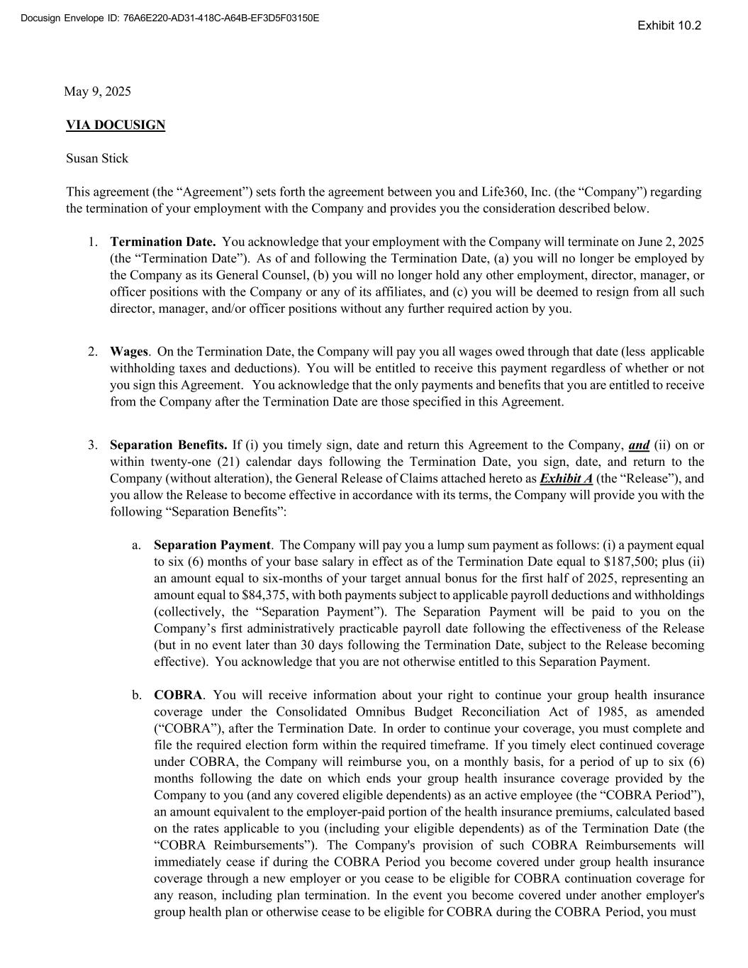
49
Docusign Envelope ID: 76A6E220-AD31-418C-A64B-EF3D5F03150E May 9, 2025 VIA DOCUSIGN Susan Stick This agreement (the “Agreement”) sets forth the agreement between you and Life360, Inc. (the “Company”) regarding the termination of your employment with the Company and provides you the consideration described below. 1. Termination Date. You acknowledge that your employment with the Company will terminate on June 2, 2025 (the “Termination Date”). As of and following the Termination Date, (a) you will no longer be employed by the Company as its General Counsel, (b) you will no longer hold any other employment, director, manager, or officer positions with the Company or any of its affiliates, and (c) you will be deemed to resign from all such director, manager, and/or officer positions without any further required action by you. 2. Wages. On the Termination Date, the Company will pay you all wages owed through that date (less applicable withholding taxes and deductions). You will be entitled to receive this payment regardless of whether or not you sign this Agreement. You acknowledge that the only payments and benefits that you are entitled to receive from the Company after the Termination Date are those specified in this Agreement. 3. Separation Benefits. If (i) you timely sign, date and return this Agreement to the Company, and (ii) on or within twenty-one (21) calendar days following the Termination Date, you sign, date, and return to the Company (without alteration), the General Release of Claims attached hereto as Exhibit A (the “Release”), and you allow the Release to become effective in accordance with its terms, the Company will provide you with the following “Separation Benefits”: a. Separation Payment. The Company will pay you a lump sum payment as follows: (i) a payment equal to six (6) months of your base salary in effect as of the Termination Date equal to $187,500; plus (ii) an amount equal to six-months of your target annual bonus for the first half of 2025, representing an amount equal to $84,375, with both payments subject to applicable payroll deductions and withholdings (collectively, the “Separation Payment”). The Separation Payment will be paid to you on the Company’s first administratively practicable payroll date following the effectiveness of the Release (but in no event later than 30 days following the Termination Date, subject to the Release becoming effective). You acknowledge that you are not otherwise entitled to this Separation Payment. b. COBRA. You will receive information about your right to continue your group health insurance coverage under the Consolidated Omnibus Budget Reconciliation Act of 1985, as amended (“COBRA”), after the Termination Date. In order to continue your coverage, you must complete and file the required election form within the required timeframe. If you timely elect continued coverage under COBRA, the Company will reimburse you, on a monthly basis, for a period of up to six (6) months following the date on which ends your group health insurance coverage provided by the Company to you (and any covered eligible dependents) as an active employee (the “COBRA Period”), an amount equivalent to the employer-paid portion of the health insurance premiums, calculated based on the rates applicable to you (including your eligible dependents) as of the Termination Date (the “COBRA Reimbursements”). The Company's provision of such COBRA Reimbursements will immediately cease if during the COBRA Period you become covered under group health insurance coverage through a new employer or you cease to be eligible for COBRA continuation coverage for any reason, including plan termination. In the event you become covered under another employer's group health plan or otherwise cease to be eligible for COBRA during the COBRA Period, you must Exhibit 10.2

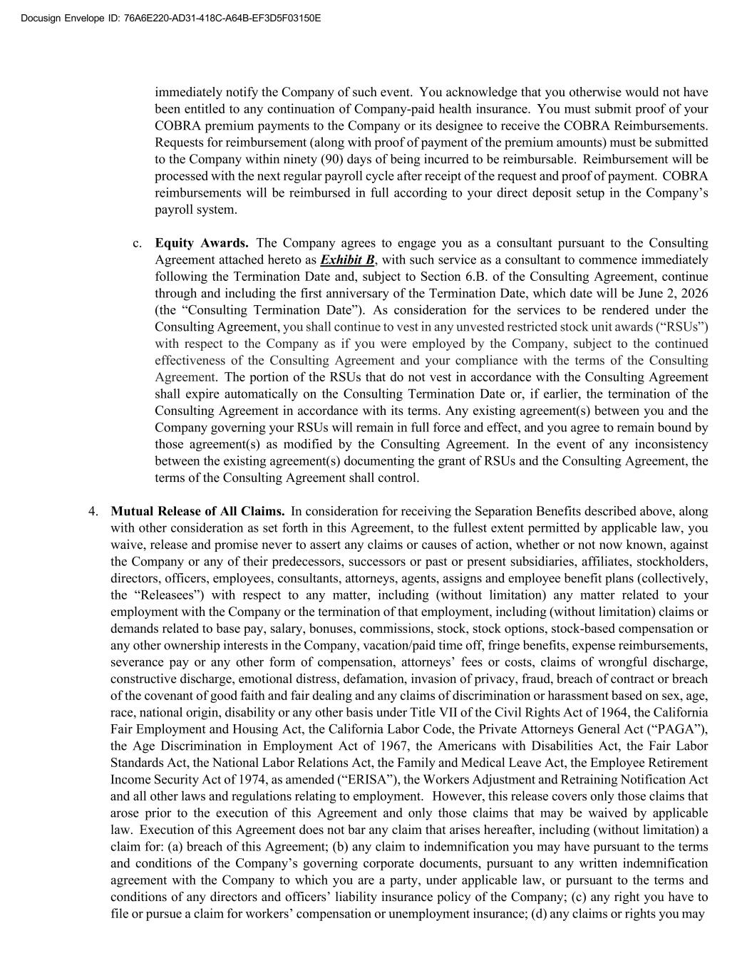
Docusign Envelope ID: 76A6E220-AD31-418C-A64B-EF3D5F03150E immediately notify the Company of such event. You acknowledge that you otherwise would not have been entitled to any continuation of Company-paid health insurance. You must submit proof of your COBRA premium payments to the Company or its designee to receive the COBRA Reimbursements. Requests for reimbursement (along with proof of payment of the premium amounts) must be submitted to the Company within ninety (90) days of being incurred to be reimbursable. Reimbursement will be processed with the next regular payroll cycle after receipt of the request and proof of payment. COBRA reimbursements will be reimbursed in full according to your direct deposit setup in the Company’s payroll system. c. Equity Awards. The Company agrees to engage you as a consultant pursuant to the Consulting Agreement attached hereto as Exhibit B, with such service as a consultant to commence immediately following the Termination Date and, subject to Section 6.B. of the Consulting Agreement, continue through and including the first anniversary of the Termination Date, which date will be June 2, 2026 (the “Consulting Termination Date”). As consideration for the services to be rendered under the Consulting Agreement, you shall continue to vest in any unvested restricted stock unit awards (“RSUs”) with respect to the Company as if you were employed by the Company, subject to the continued effectiveness of the Consulting Agreement and your compliance with the terms of the Consulting Agreement. The portion of the RSUs that do not vest in accordance with the Consulting Agreement shall expire automatically on the Consulting Termination Date or, if earlier, the termination of the Consulting Agreement in accordance with its terms. Any existing agreement(s) between you and the Company governing your RSUs will remain in full force and effect, and you agree to remain bound by those agreement(s) as modified by the Consulting Agreement. In the event of any inconsistency between the existing agreement(s) documenting the grant of RSUs and the Consulting Agreement, the terms of the Consulting Agreement shall control. 4. Mutual Release of All Claims. In consideration for receiving the Separation Benefits described above, along with other consideration as set forth in this Agreement, to the fullest extent permitted by applicable law, you waive, release and promise never to assert any claims or causes of action, whether or not now known, against the Company or any of their predecessors, successors or past or present subsidiaries, affiliates, stockholders, directors, officers, employees, consultants, attorneys, agents, assigns and employee benefit plans (collectively, the “Releasees”) with respect to any matter, including (without limitation) any matter related to your employment with the Company or the termination of that employment, including (without limitation) claims or demands related to base pay, salary, bonuses, commissions, stock, stock options, stock-based compensation or any other ownership interests in the Company, vacation/paid time off, fringe benefits, expense reimbursements, severance pay or any other form of compensation, attorneys’ fees or costs, claims of wrongful discharge, constructive discharge, emotional distress, defamation, invasion of privacy, fraud, breach of contract or breach of the covenant of good faith and fair dealing and any claims of discrimination or harassment based on sex, age, race, national origin, disability or any other basis under Title VII of the Civil Rights Act of 1964, the California Fair Employment and Housing Act, the California Labor Code, the Private Attorneys General Act (“PAGA”), the Age Discrimination in Employment Act of 1967, the Americans with Disabilities Act, the Fair Labor Standards Act, the National Labor Relations Act, the Family and Medical Leave Act, the Employee Retirement Income Security Act of 1974, as amended (“ERISA”), the Workers Adjustment and Retraining Notification Act and all other laws and regulations relating to employment. However, this release covers only those claims that arose prior to the execution of this Agreement and only those claims that may be waived by applicable law. Execution of this Agreement does not bar any claim that arises hereafter, including (without limitation) a claim for: (a) breach of this Agreement; (b) any claim to indemnification you may have pursuant to the terms and conditions of the Company’s governing corporate documents, pursuant to any written indemnification agreement with the Company to which you are a party, under applicable law, or pursuant to the terms and conditions of any directors and officers’ liability insurance policy of the Company; (c) any right you have to file or pursue a claim for workers’ compensation or unemployment insurance; (d) any claims or rights you may

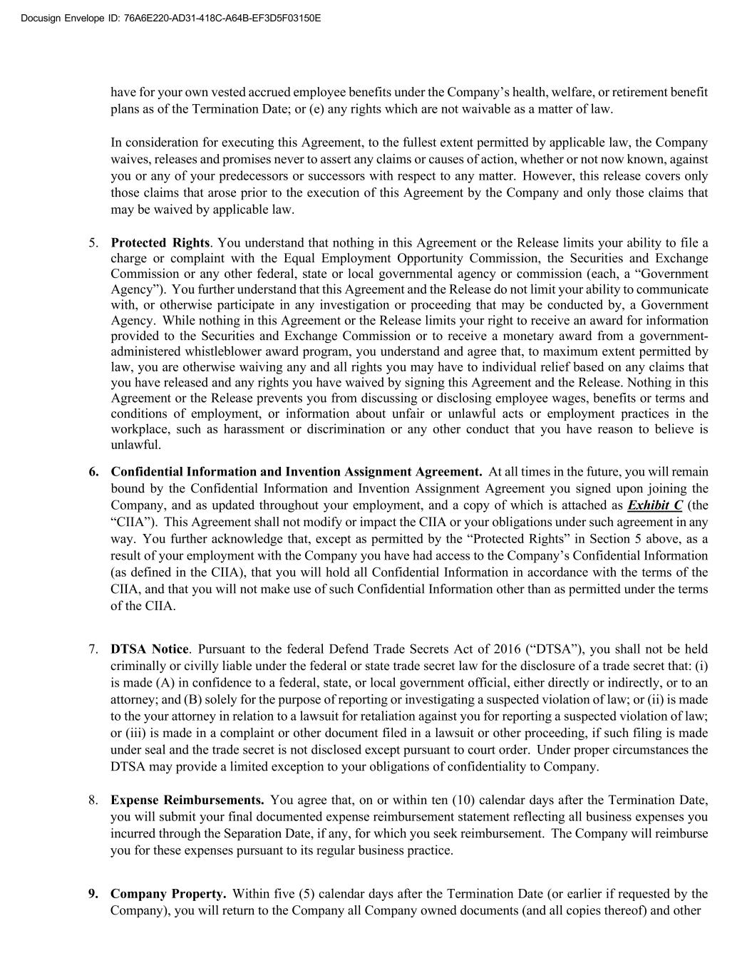
Docusign Envelope ID: 76A6E220-AD31-418C-A64B-EF3D5F03150E have for your own vested accrued employee benefits under the Company’s health, welfare, or retirement benefit plans as of the Termination Date; or (e) any rights which are not waivable as a matter of law. In consideration for executing this Agreement, to the fullest extent permitted by applicable law, the Company waives, releases and promises never to assert any claims or causes of action, whether or not now known, against you or any of your predecessors or successors with respect to any matter. However, this release covers only those claims that arose prior to the execution of this Agreement by the Company and only those claims that may be waived by applicable law. 5. Protected Rights. You understand that nothing in this Agreement or the Release limits your ability to file a charge or complaint with the Equal Employment Opportunity Commission, the Securities and Exchange Commission or any other federal, state or local governmental agency or commission (each, a “Government Agency”). You further understand that this Agreement and the Release do not limit your ability to communicate with, or otherwise participate in any investigation or proceeding that may be conducted by, a Government Agency. While nothing in this Agreement or the Release limits your right to receive an award for information provided to the Securities and Exchange Commission or to receive a monetary award from a government- administered whistleblower award program, you understand and agree that, to maximum extent permitted by law, you are otherwise waiving any and all rights you may have to individual relief based on any claims that you have released and any rights you have waived by signing this Agreement and the Release. Nothing in this Agreement or the Release prevents you from discussing or disclosing employee wages, benefits or terms and conditions of employment, or information about unfair or unlawful acts or employment practices in the workplace, such as harassment or discrimination or any other conduct that you have reason to believe is unlawful. 6. Confidential Information and Invention Assignment Agreement. At all times in the future, you will remain bound by the Confidential Information and Invention Assignment Agreement you signed upon joining the Company, and as updated throughout your employment, and a copy of which is attached as Exhibit C (the “CIIA”). This Agreement shall not modify or impact the CIIA or your obligations under such agreement in any way. You further acknowledge that, except as permitted by the “Protected Rights” in Section 5 above, as a result of your employment with the Company you have had access to the Company’s Confidential Information (as defined in the CIIA), that you will hold all Confidential Information in accordance with the terms of the CIIA, and that you will not make use of such Confidential Information other than as permitted under the terms of the CIIA. 7. DTSA Notice. Pursuant to the federal Defend Trade Secrets Act of 2016 (“DTSA”), you shall not be held criminally or civilly liable under the federal or state trade secret law for the disclosure of a trade secret that: (i) is made (A) in confidence to a federal, state, or local government official, either directly or indirectly, or to an attorney; and (B) solely for the purpose of reporting or investigating a suspected violation of law; or (ii) is made to the your attorney in relation to a lawsuit for retaliation against you for reporting a suspected violation of law; or (iii) is made in a complaint or other document filed in a lawsuit or other proceeding, if such filing is made under seal and the trade secret is not disclosed except pursuant to court order. Under proper circumstances the DTSA may provide a limited exception to your obligations of confidentiality to Company. 8. Expense Reimbursements. You agree that, on or within ten (10) calendar days after the Termination Date, you will submit your final documented expense reimbursement statement reflecting all business expenses you incurred through the Separation Date, if any, for which you seek reimbursement. The Company will reimburse you for these expenses pursuant to its regular business practice. 9. Company Property. Within five (5) calendar days after the Termination Date (or earlier if requested by the Company), you will return to the Company all Company owned documents (and all copies thereof) and other

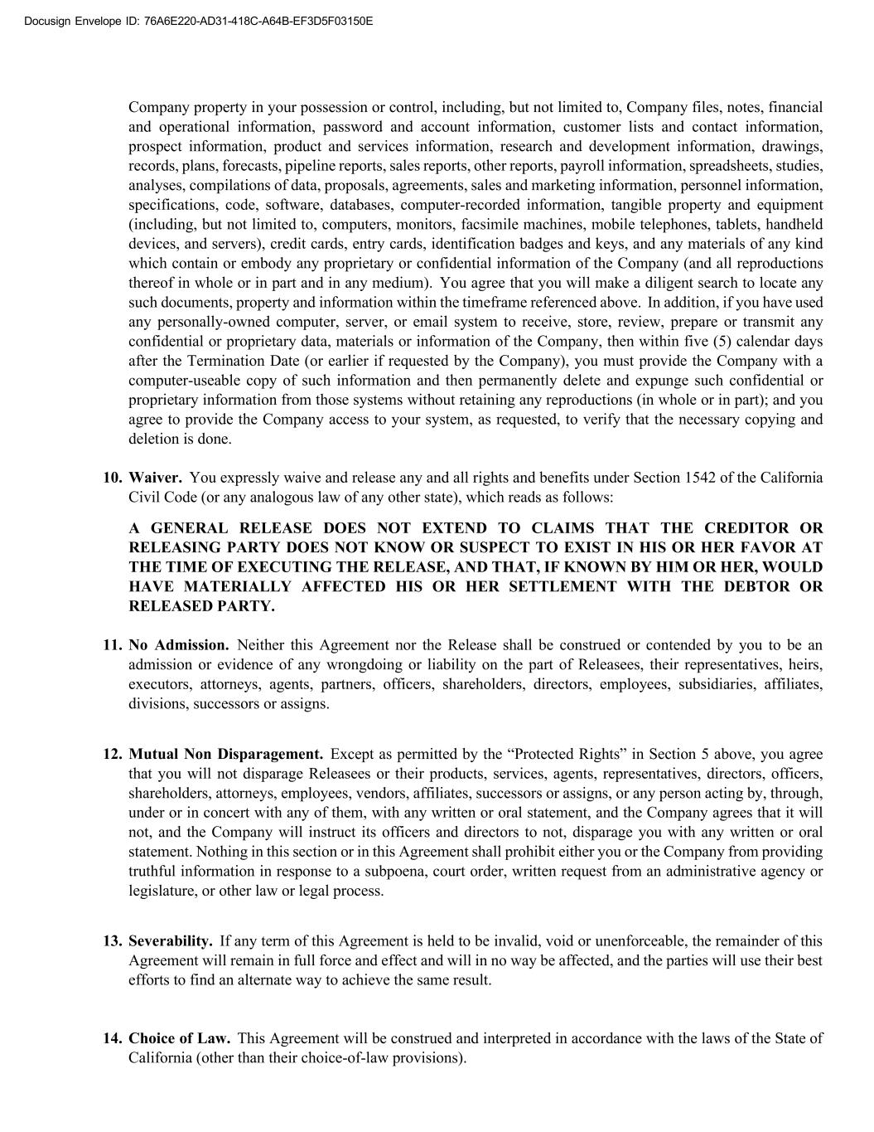
Docusign Envelope ID: 76A6E220-AD31-418C-A64B-EF3D5F03150E Company property in your possession or control, including, but not limited to, Company files, notes, financial and operational information, password and account information, customer lists and contact information, prospect information, product and services information, research and development information, drawings, records, plans, forecasts, pipeline reports, sales reports, other reports, payroll information, spreadsheets, studies, analyses, compilations of data, proposals, agreements, sales and marketing information, personnel information, specifications, code, software, databases, computer-recorded information, tangible property and equipment (including, but not limited to, computers, monitors, facsimile machines, mobile telephones, tablets, handheld devices, and servers), credit cards, entry cards, identification badges and keys, and any materials of any kind which contain or embody any proprietary or confidential information of the Company (and all reproductions thereof in whole or in part and in any medium). You agree that you will make a diligent search to locate any such documents, property and information within the timeframe referenced above. In addition, if you have used any personally-owned computer, server, or email system to receive, store, review, prepare or transmit any confidential or proprietary data, materials or information of the Company, then within five (5) calendar days after the Termination Date (or earlier if requested by the Company), you must provide the Company with a computer-useable copy of such information and then permanently delete and expunge such confidential or proprietary information from those systems without retaining any reproductions (in whole or in part); and you agree to provide the Company access to your system, as requested, to verify that the necessary copying and deletion is done. 10. Waiver. You expressly waive and release any and all rights and benefits under Section 1542 of the California Civil Code (or any analogous law of any other state), which reads as follows: A GENERAL RELEASE DOES NOT EXTEND TO CLAIMS THAT THE CREDITOR OR RELEASING PARTY DOES NOT KNOW OR SUSPECT TO EXIST IN HIS OR HER FAVOR AT THE TIME OF EXECUTING THE RELEASE, AND THAT, IF KNOWN BY HIM OR HER, WOULD HAVE MATERIALLY AFFECTED HIS OR HER SETTLEMENT WITH THE DEBTOR OR RELEASED PARTY. 11. No Admission. Neither this Agreement nor the Release shall be construed or contended by you to be an admission or evidence of any wrongdoing or liability on the part of Releasees, their representatives, heirs, executors, attorneys, agents, partners, officers, shareholders, directors, employees, subsidiaries, affiliates, divisions, successors or assigns. 12. Mutual Non Disparagement. Except as permitted by the “Protected Rights” in Section 5 above, you agree that you will not disparage Releasees or their products, services, agents, representatives, directors, officers, shareholders, attorneys, employees, vendors, affiliates, successors or assigns, or any person acting by, through, under or in concert with any of them, with any written or oral statement, and the Company agrees that it will not, and the Company will instruct its officers and directors to not, disparage you with any written or oral statement. Nothing in this section or in this Agreement shall prohibit either you or the Company from providing truthful information in response to a subpoena, court order, written request from an administrative agency or legislature, or other law or legal process. 13. Severability. If any term of this Agreement is held to be invalid, void or unenforceable, the remainder of this Agreement will remain in full force and effect and will in no way be affected, and the parties will use their best efforts to find an alternate way to achieve the same result. 14. Choice of Law. This Agreement will be construed and interpreted in accordance with the laws of the State of California (other than their choice-of-law provisions).

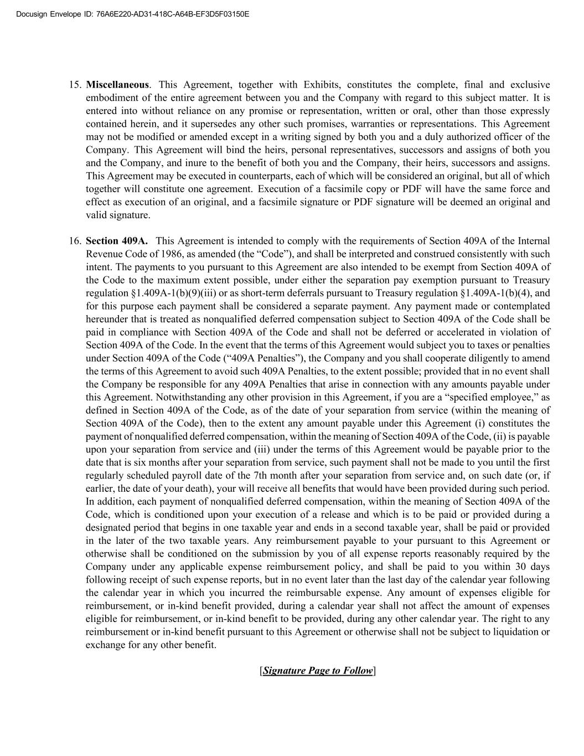
Docusign Envelope ID: 76A6E220-AD31-418C-A64B-EF3D5F03150E 15. Miscellaneous. This Agreement, together with Exhibits, constitutes the complete, final and exclusive embodiment of the entire agreement between you and the Company with regard to this subject matter. It is entered into without reliance on any promise or representation, written or oral, other than those expressly contained herein, and it supersedes any other such promises, warranties or representations. This Agreement may not be modified or amended except in a writing signed by both you and a duly authorized officer of the Company. This Agreement will bind the heirs, personal representatives, successors and assigns of both you and the Company, and inure to the benefit of both you and the Company, their heirs, successors and assigns. This Agreement may be executed in counterparts, each of which will be considered an original, but all of which together will constitute one agreement. Execution of a facsimile copy or PDF will have the same force and effect as execution of an original, and a facsimile signature or PDF signature will be deemed an original and valid signature. 16. Section 409A. This Agreement is intended to comply with the requirements of Section 409A of the Internal Revenue Code of 1986, as amended (the “Code”), and shall be interpreted and construed consistently with such intent. The payments to you pursuant to this Agreement are also intended to be exempt from Section 409A of the Code to the maximum extent possible, under either the separation pay exemption pursuant to Treasury regulation §1.409A-1(b)(9)(iii) or as short-term deferrals pursuant to Treasury regulation §1.409A-1(b)(4), and for this purpose each payment shall be considered a separate payment. Any payment made or contemplated hereunder that is treated as nonqualified deferred compensation subject to Section 409A of the Code shall be paid in compliance with Section 409A of the Code and shall not be deferred or accelerated in violation of Section 409A of the Code. In the event that the terms of this Agreement would subject you to taxes or penalties under Section 409A of the Code (“409A Penalties”), the Company and you shall cooperate diligently to amend the terms of this Agreement to avoid such 409A Penalties, to the extent possible; provided that in no event shall the Company be responsible for any 409A Penalties that arise in connection with any amounts payable under this Agreement. Notwithstanding any other provision in this Agreement, if you are a “specified employee,” as defined in Section 409A of the Code, as of the date of your separation from service (within the meaning of Section 409A of the Code), then to the extent any amount payable under this Agreement (i) constitutes the payment of nonqualified deferred compensation, within the meaning of Section 409A of the Code, (ii) is payable upon your separation from service and (iii) under the terms of this Agreement would be payable prior to the date that is six months after your separation from service, such payment shall not be made to you until the first regularly scheduled payroll date of the 7th month after your separation from service and, on such date (or, if earlier, the date of your death), your will receive all benefits that would have been provided during such period. In addition, each payment of nonqualified deferred compensation, within the meaning of Section 409A of the Code, which is conditioned upon your execution of a release and which is to be paid or provided during a designated period that begins in one taxable year and ends in a second taxable year, shall be paid or provided in the later of the two taxable years. Any reimbursement payable to your pursuant to this Agreement or otherwise shall be conditioned on the submission by you of all expense reports reasonably required by the Company under any applicable expense reimbursement policy, and shall be paid to you within 30 days following receipt of such expense reports, but in no event later than the last day of the calendar year following the calendar year in which you incurred the reimbursable expense. Any amount of expenses eligible for reimbursement, or in-kind benefit provided, during a calendar year shall not affect the amount of expenses eligible for reimbursement, or in-kind benefit to be provided, during any other calendar year. The right to any reimbursement or in-kind benefit pursuant to this Agreement or otherwise shall not be subject to liquidation or exchange for any other benefit. [Signature Page to Follow]

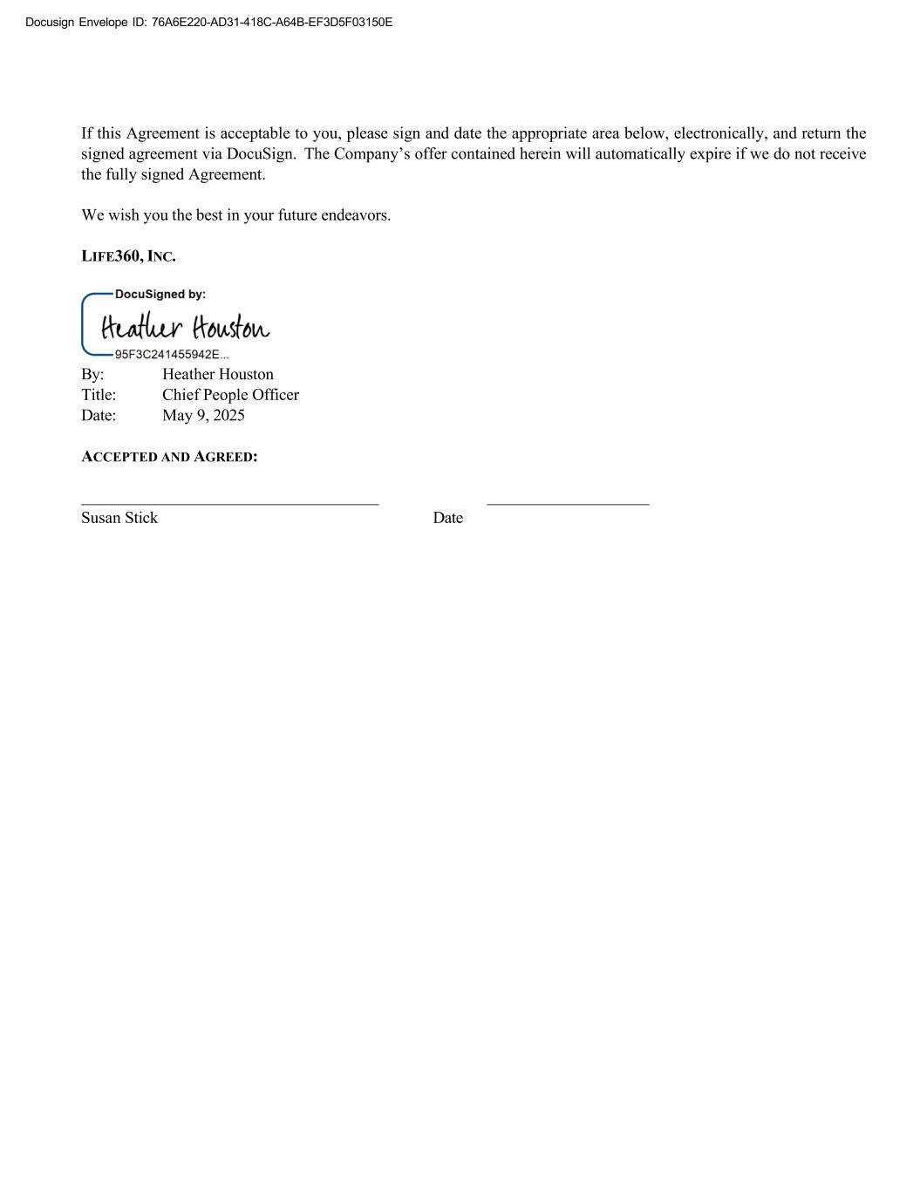
Docusign Envelope ID: 76A6E220-AD31-418C-A64B-EF3D5F03150E If this Agreement is acceptable to you, please sign and date the appropriate area below, electronically, and return the signed agreement via DocuSign. The Company’s offer contained herein will automatically expire if we do not receive the fully signed Agreement. We wish you the best in your future endeavors. LIFE360, INC. By: Heather Houston Title: Chief People Officer Date: May 9, 2025 ACCEPTED AND AGREED: Susan Stick Date

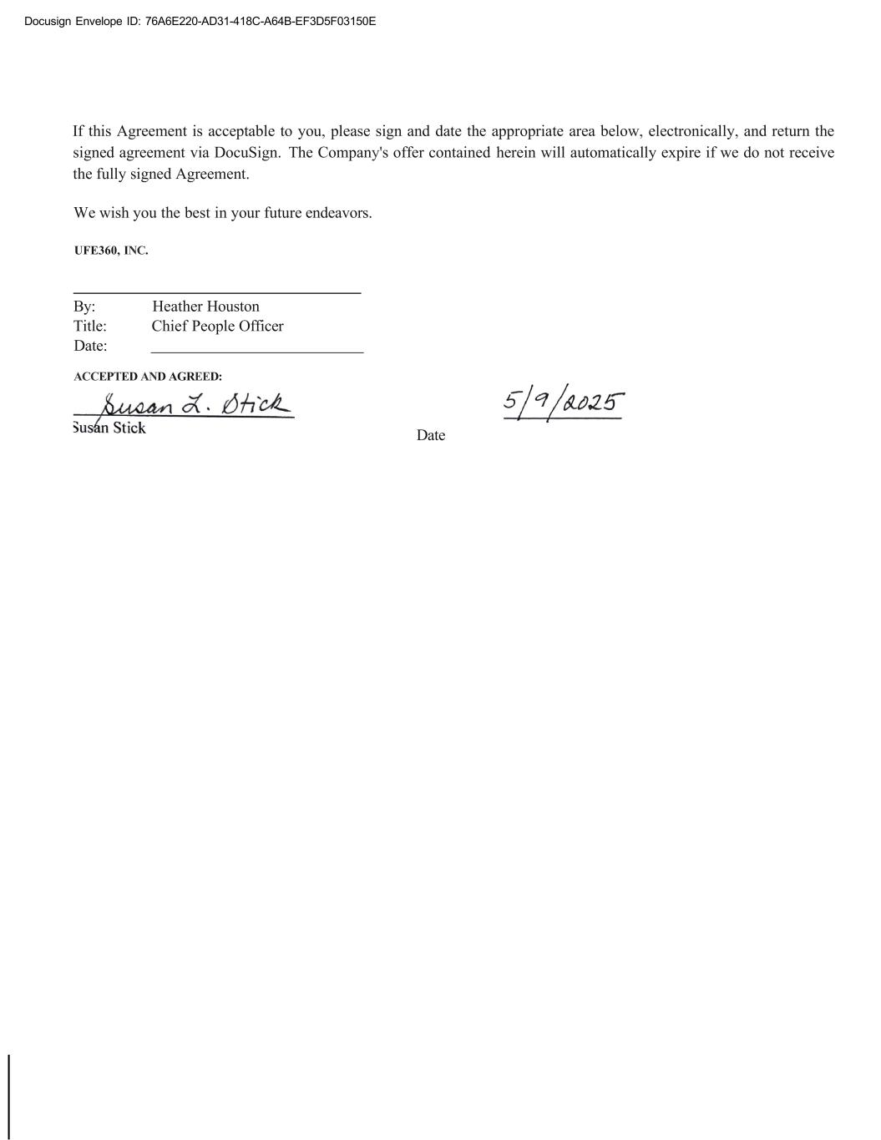
Docusign Envelope ID: 76A6E220-AD31-418C-A64B-EF3D5F03150E If this Agreement is acceptable to you, please sign and date the appropriate area below, electronically, and return the signed agreement via DocuSign. The Company's offer contained herein will automatically expire if we do not receive the fully signed Agreement. We wish you the best in your future endeavors. UFE360, INC. By: Heather Houston Title: Chief People Officer Date: ACCEPTED AND AGREED: Date


Docusign Envelope ID: 76A6E220-AD31-418C-A64B-EF3D5F03150E EXHIBIT A General Release of Claims

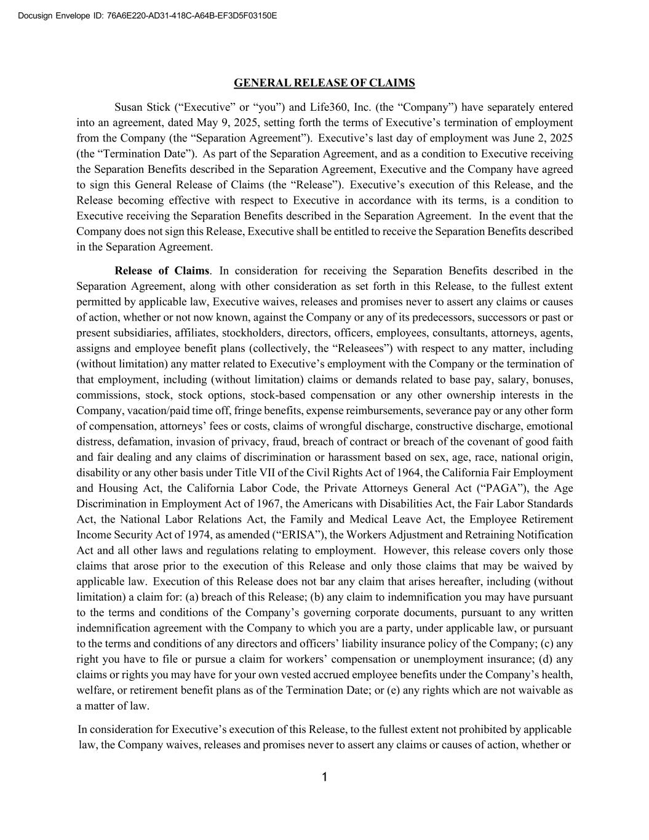
Docusign Envelope ID: 76A6E220-AD31-418C-A64B-EF3D5F03150E GENERAL RELEASE OF CLAIMS Susan Stick (“Executive” or “you”) and Life360, Inc. (the “Company”) have separately entered into an agreement, dated May 9, 2025, setting forth the terms of Executive’s termination of employment from the Company (the “Separation Agreement”). Executive’s last day of employment was June 2, 2025 (the “Termination Date”). As part of the Separation Agreement, and as a condition to Executive receiving the Separation Benefits described in the Separation Agreement, Executive and the Company have agreed to sign this General Release of Claims (the “Release”). Executive’s execution of this Release, and the Release becoming effective with respect to Executive in accordance with its terms, is a condition to Executive receiving the Separation Benefits described in the Separation Agreement. In the event that the Company does not sign this Release, Executive shall be entitled to receive the Separation Benefits described in the Separation Agreement. Release of Claims. In consideration for receiving the Separation Benefits described in the Separation Agreement, along with other consideration as set forth in this Release, to the fullest extent permitted by applicable law, Executive waives, releases and promises never to assert any claims or causes of action, whether or not now known, against the Company or any of its predecessors, successors or past or present subsidiaries, affiliates, stockholders, directors, officers, employees, consultants, attorneys, agents, assigns and employee benefit plans (collectively, the “Releasees”) with respect to any matter, including (without limitation) any matter related to Executive’s employment with the Company or the termination of that employment, including (without limitation) claims or demands related to base pay, salary, bonuses, commissions, stock, stock options, stock-based compensation or any other ownership interests in the Company, vacation/paid time off, fringe benefits, expense reimbursements, severance pay or any other form of compensation, attorneys’ fees or costs, claims of wrongful discharge, constructive discharge, emotional distress, defamation, invasion of privacy, fraud, breach of contract or breach of the covenant of good faith and fair dealing and any claims of discrimination or harassment based on sex, age, race, national origin, disability or any other basis under Title VII of the Civil Rights Act of 1964, the California Fair Employment and Housing Act, the California Labor Code, the Private Attorneys General Act (“PAGA”), the Age Discrimination in Employment Act of 1967, the Americans with Disabilities Act, the Fair Labor Standards Act, the National Labor Relations Act, the Family and Medical Leave Act, the Employee Retirement Income Security Act of 1974, as amended (“ERISA”), the Workers Adjustment and Retraining Notification Act and all other laws and regulations relating to employment. However, this release covers only those claims that arose prior to the execution of this Release and only those claims that may be waived by applicable law. Execution of this Release does not bar any claim that arises hereafter, including (without limitation) a claim for: (a) breach of this Release; (b) any claim to indemnification you may have pursuant to the terms and conditions of the Company’s governing corporate documents, pursuant to any written indemnification agreement with the Company to which you are a party, under applicable law, or pursuant to the terms and conditions of any directors and officers’ liability insurance policy of the Company; (c) any right you have to file or pursue a claim for workers’ compensation or unemployment insurance; (d) any claims or rights you may have for your own vested accrued employee benefits under the Company’s health, welfare, or retirement benefit plans as of the Termination Date; or (e) any rights which are not waivable as a matter of law. In consideration for Executive’s execution of this Release, to the fullest extent not prohibited by applicable law, the Company waives, releases and promises never to assert any claims or causes of action, whether or 1

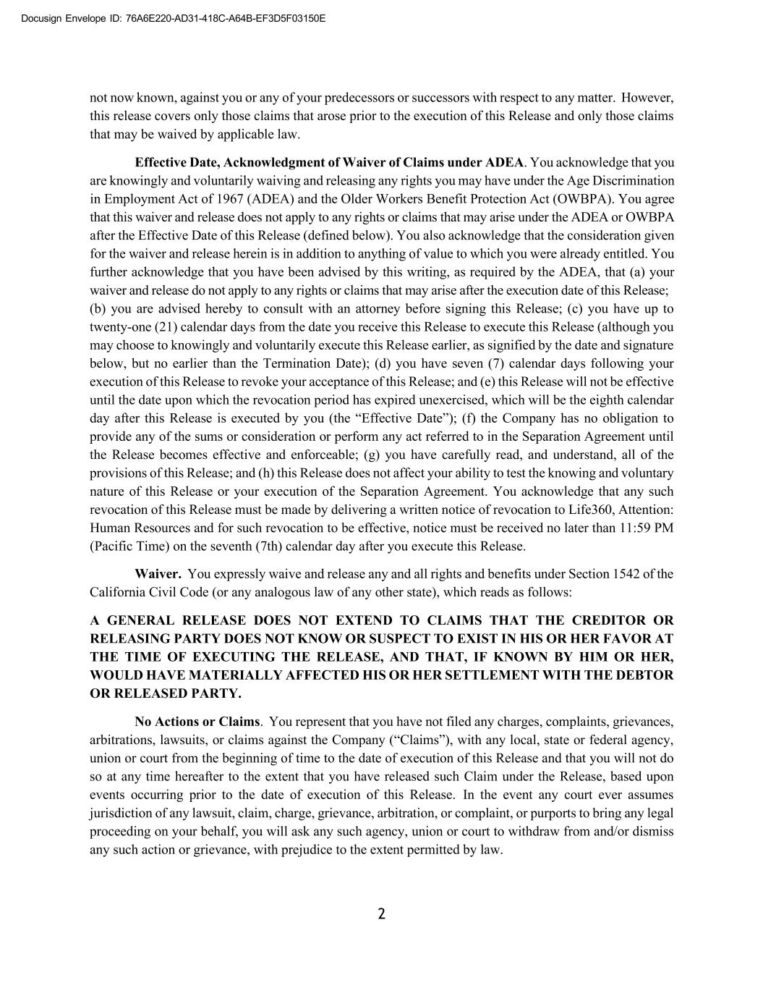
Docusign Envelope ID: 76A6E220-AD31-418C-A64B-EF3D5F03150E not now known, against you or any of your predecessors or successors with respect to any matter. However, this release covers only those claims that arose prior to the execution of this Release and only those claims that may be waived by applicable law. Effective Date, Acknowledgment of Waiver of Claims under ADEA. You acknowledge that you are knowingly and voluntarily waiving and releasing any rights you may have under the Age Discrimination in Employment Act of 1967 (ADEA) and the Older Workers Benefit Protection Act (OWBPA). You agree that this waiver and release does not apply to any rights or claims that may arise under the ADEA or OWBPA after the Effective Date of this Release (defined below). You also acknowledge that the consideration given for the waiver and release herein is in addition to anything of value to which you were already entitled. You further acknowledge that you have been advised by this writing, as required by the ADEA, that (a) your waiver and release do not apply to any rights or claims that may arise after the execution date of this Release; (b) you are advised hereby to consult with an attorney before signing this Release; (c) you have up to twenty-one (21) calendar days from the date you receive this Release to execute this Release (although you may choose to knowingly and voluntarily execute this Release earlier, as signified by the date and signature below, but no earlier than the Termination Date); (d) you have seven (7) calendar days following your execution of this Release to revoke your acceptance of this Release; and (e) this Release will not be effective until the date upon which the revocation period has expired unexercised, which will be the eighth calendar day after this Release is executed by you (the “Effective Date”); (f) the Company has no obligation to provide any of the sums or consideration or perform any act referred to in the Separation Agreement until the Release becomes effective and enforceable; (g) you have carefully read, and understand, all of the provisions of this Release; and (h) this Release does not affect your ability to test the knowing and voluntary nature of this Release or your execution of the Separation Agreement. You acknowledge that any such revocation of this Release must be made by delivering a written notice of revocation to Life360, Attention: Human Resources and for such revocation to be effective, notice must be received no later than 11:59 PM (Pacific Time) on the seventh (7th) calendar day after you execute this Release. Waiver. You expressly waive and release any and all rights and benefits under Section 1542 of the California Civil Code (or any analogous law of any other state), which reads as follows: A GENERAL RELEASE DOES NOT EXTEND TO CLAIMS THAT THE CREDITOR OR RELEASING PARTY DOES NOT KNOW OR SUSPECT TO EXIST IN HIS OR HER FAVOR AT THE TIME OF EXECUTING THE RELEASE, AND THAT, IF KNOWN BY HIM OR HER, WOULD HAVE MATERIALLY AFFECTED HIS OR HER SETTLEMENT WITH THE DEBTOR OR RELEASED PARTY. No Actions or Claims. You represent that you have not filed any charges, complaints, grievances, arbitrations, lawsuits, or claims against the Company (“Claims”), with any local, state or federal agency, union or court from the beginning of time to the date of execution of this Release and that you will not do so at any time hereafter to the extent that you have released such Claim under the Release, based upon events occurring prior to the date of execution of this Release. In the event any court ever assumes jurisdiction of any lawsuit, claim, charge, grievance, arbitration, or complaint, or purports to bring any legal proceeding on your behalf, you will ask any such agency, union or court to withdraw from and/or dismiss any such action or grievance, with prejudice to the extent permitted by law. 2

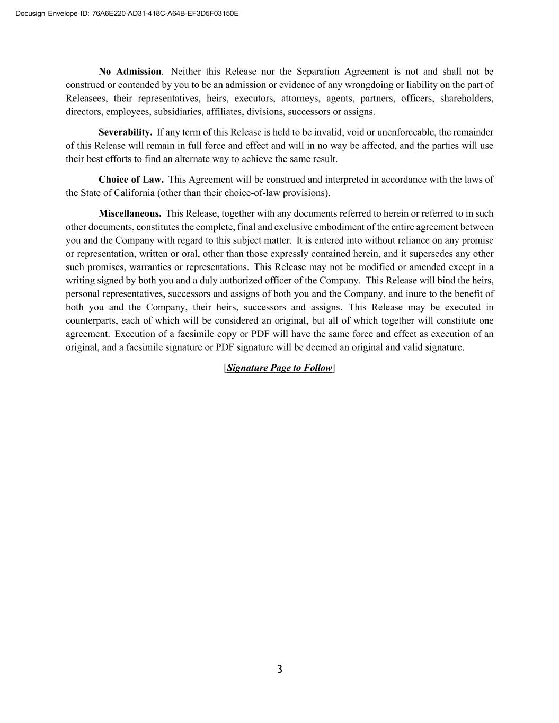
Docusign Envelope ID: 76A6E220-AD31-418C-A64B-EF3D5F03150E No Admission. Neither this Release nor the Separation Agreement is not and shall not be construed or contended by you to be an admission or evidence of any wrongdoing or liability on the part of Releasees, their representatives, heirs, executors, attorneys, agents, partners, officers, shareholders, directors, employees, subsidiaries, affiliates, divisions, successors or assigns. Severability. If any term of this Release is held to be invalid, void or unenforceable, the remainder of this Release will remain in full force and effect and will in no way be affected, and the parties will use their best efforts to find an alternate way to achieve the same result. Choice of Law. This Agreement will be construed and interpreted in accordance with the laws of the State of California (other than their choice-of-law provisions). Miscellaneous. This Release, together with any documents referred to herein or referred to in such other documents, constitutes the complete, final and exclusive embodiment of the entire agreement between you and the Company with regard to this subject matter. It is entered into without reliance on any promise or representation, written or oral, other than those expressly contained herein, and it supersedes any other such promises, warranties or representations. This Release may not be modified or amended except in a writing signed by both you and a duly authorized officer of the Company. This Release will bind the heirs, personal representatives, successors and assigns of both you and the Company, and inure to the benefit of both you and the Company, their heirs, successors and assigns. This Release may be executed in counterparts, each of which will be considered an original, but all of which together will constitute one agreement. Execution of a facsimile copy or PDF will have the same force and effect as execution of an original, and a facsimile signature or PDF signature will be deemed an original and valid signature. [Signature Page to Follow] 3

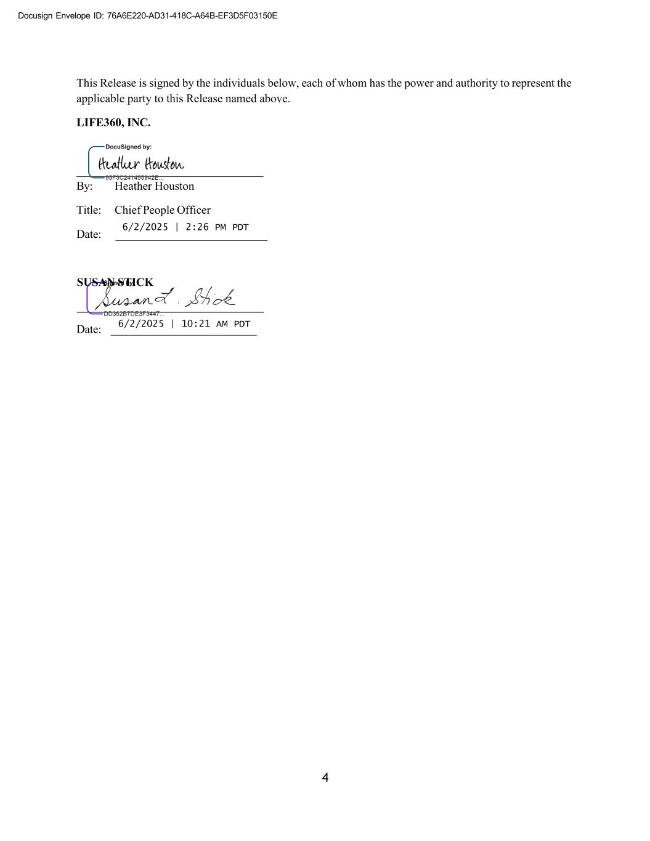
Docusign Envelope ID: 76A6E220-AD31-418C-A64B-EF3D5F03150E This Release is signed by the individuals below, each of whom has the power and authority to represent the applicable party to this Release named above. LIFE360, INC. By: Heather Houston Title: Chief People Officer Date: 6/2/2025 | 2:26 PM PDT Date: 6/2/2025 | 10:21 AM PDT 4 SUSAN STICK


Docusign Envelope ID: 76A6E220-AD31-418C-A64B-EF3D5F03150E EXHIBIT B Consulting Agreement

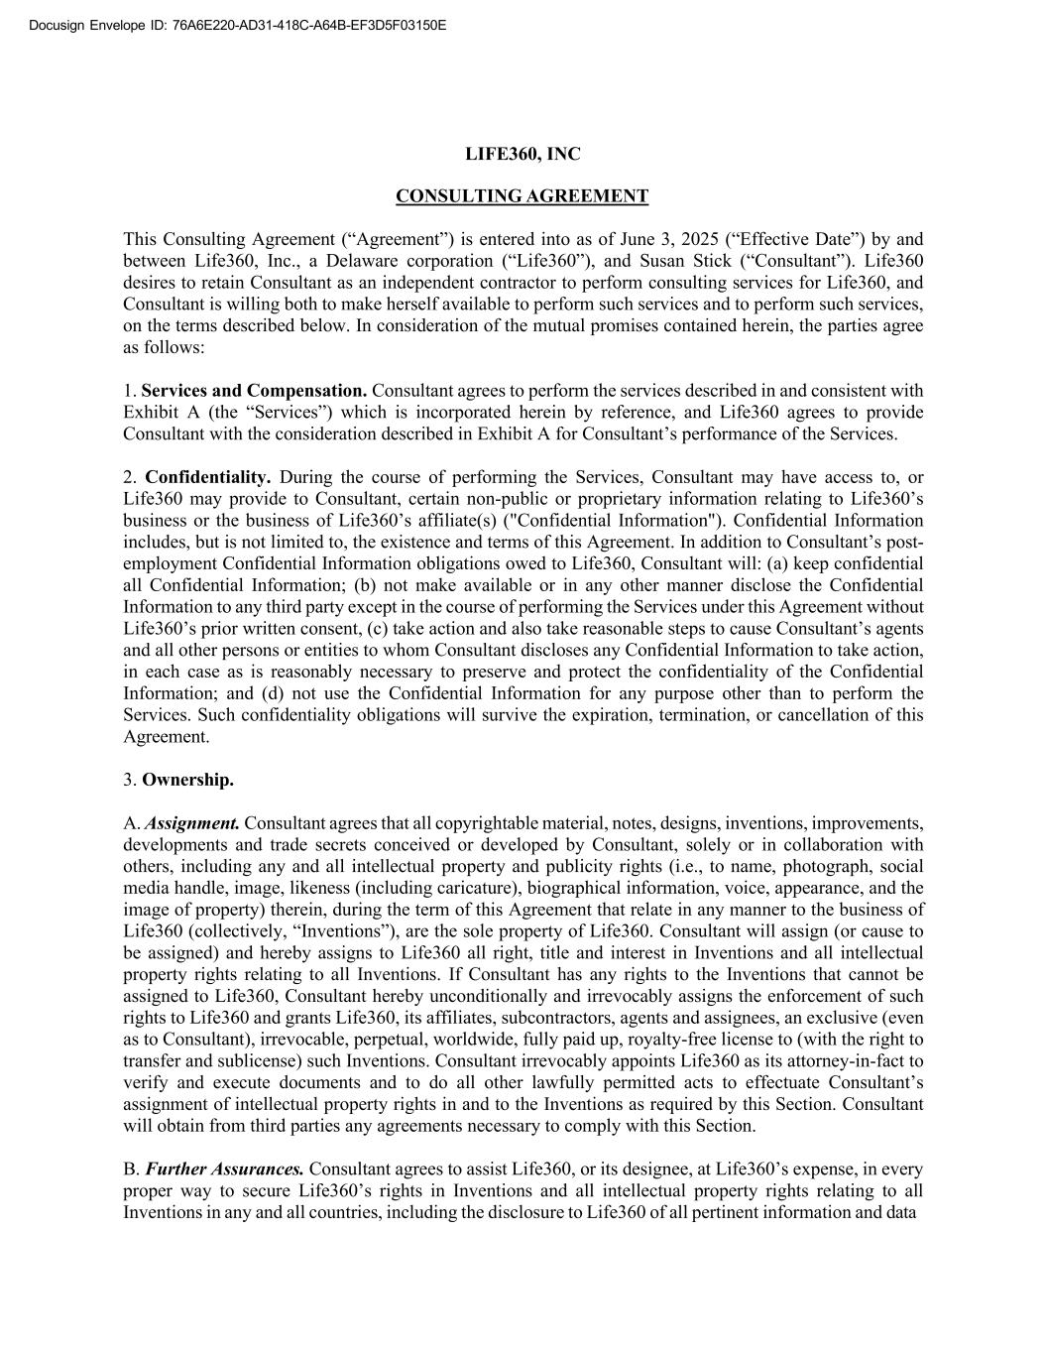
Docusign Envelope ID: 76A6E220-AD31-418C-A64B-EF3D5F03150E LIFE360, INC CONSULTING AGREEMENT This Consulting Agreement (“Agreement”) is entered into as of June 3, 2025 (“Effective Date”) by and between Life360, Inc., a Delaware corporation (“Life360”), and Susan Stick (“Consultant”). Life360 desires to retain Consultant as an independent contractor to perform consulting services for Life360, and Consultant is willing both to make herself available to perform such services and to perform such services, on the terms described below. In consideration of the mutual promises contained herein, the parties agree as follows: 1. Services and Compensation. Consultant agrees to perform the services described in and consistent with Exhibit A (the “Services”) which is incorporated herein by reference, and Life360 agrees to provide Consultant with the consideration described in Exhibit A for Consultant’s performance of the Services. 2. Confidentiality. During the course of performing the Services, Consultant may have access to, or Life360 may provide to Consultant, certain non-public or proprietary information relating to Life360’s business or the business of Life360’s affiliate(s) ("Confidential Information"). Confidential Information includes, but is not limited to, the existence and terms of this Agreement. In addition to Consultant’s post- employment Confidential Information obligations owed to Life360, Consultant will: (a) keep confidential all Confidential Information; (b) not make available or in any other manner disclose the Confidential Information to any third party except in the course of performing the Services under this Agreement without Life360’s prior written consent, (c) take action and also take reasonable steps to cause Consultant’s agents and all other persons or entities to whom Consultant discloses any Confidential Information to take action, in each case as is reasonably necessary to preserve and protect the confidentiality of the Confidential Information; and (d) not use the Confidential Information for any purpose other than to perform the Services. Such confidentiality obligations will survive the expiration, termination, or cancellation of this Agreement. 3. Ownership. A. Assignment. Consultant agrees that all copyrightable material, notes, designs, inventions, improvements, developments and trade secrets conceived or developed by Consultant, solely or in collaboration with others, including any and all intellectual property and publicity rights (i.e., to name, photograph, social media handle, image, likeness (including caricature), biographical information, voice, appearance, and the image of property) therein, during the term of this Agreement that relate in any manner to the business of Life360 (collectively, “Inventions”), are the sole property of Life360. Consultant will assign (or cause to be assigned) and hereby assigns to Life360 all right, title and interest in Inventions and all intellectual property rights relating to all Inventions. If Consultant has any rights to the Inventions that cannot be assigned to Life360, Consultant hereby unconditionally and irrevocably assigns the enforcement of such rights to Life360 and grants Life360, its affiliates, subcontractors, agents and assignees, an exclusive (even as to Consultant), irrevocable, perpetual, worldwide, fully paid up, royalty-free license to (with the right to transfer and sublicense) such Inventions. Consultant irrevocably appoints Life360 as its attorney-in-fact to verify and execute documents and to do all other lawfully permitted acts to effectuate Consultant’s assignment of intellectual property rights in and to the Inventions as required by this Section. Consultant will obtain from third parties any agreements necessary to comply with this Section. B. Further Assurances. Consultant agrees to assist Life360, or its designee, at Life360’s expense, in every proper way to secure Life360’s rights in Inventions and all intellectual property rights relating to all Inventions in any and all countries, including the disclosure to Life360 of all pertinent information and data

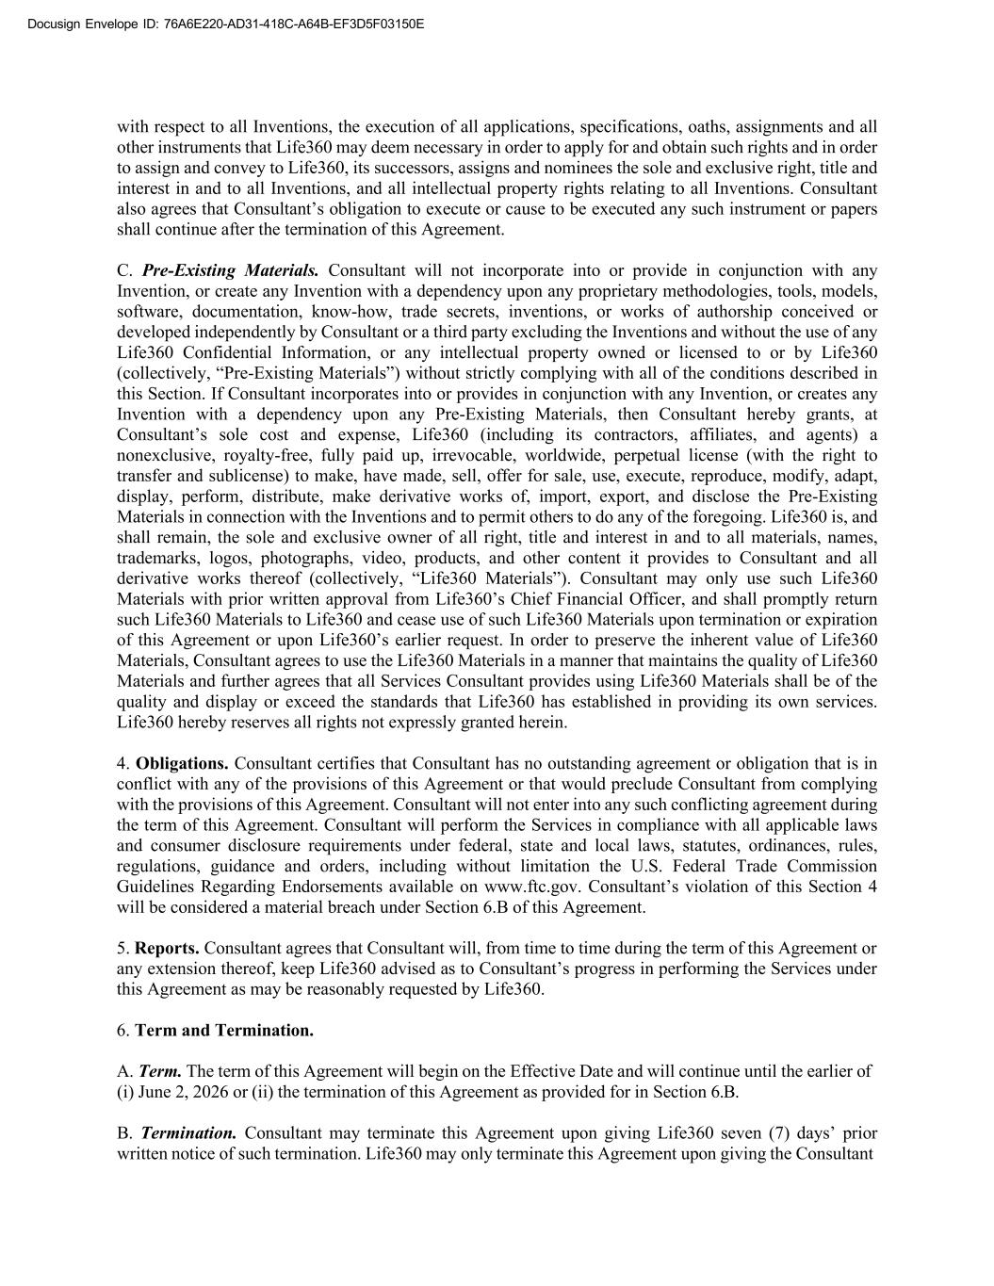
Docusign Envelope ID: 76A6E220-AD31-418C-A64B-EF3D5F03150E with respect to all Inventions, the execution of all applications, specifications, oaths, assignments and all other instruments that Life360 may deem necessary in order to apply for and obtain such rights and in order to assign and convey to Life360, its successors, assigns and nominees the sole and exclusive right, title and interest in and to all Inventions, and all intellectual property rights relating to all Inventions. Consultant also agrees that Consultant’s obligation to execute or cause to be executed any such instrument or papers shall continue after the termination of this Agreement. C. Pre-Existing Materials. Consultant will not incorporate into or provide in conjunction with any Invention, or create any Invention with a dependency upon any proprietary methodologies, tools, models, software, documentation, know-how, trade secrets, inventions, or works of authorship conceived or developed independently by Consultant or a third party excluding the Inventions and without the use of any Life360 Confidential Information, or any intellectual property owned or licensed to or by Life360 (collectively, “Pre-Existing Materials”) without strictly complying with all of the conditions described in this Section. If Consultant incorporates into or provides in conjunction with any Invention, or creates any Invention with a dependency upon any Pre-Existing Materials, then Consultant hereby grants, at Consultant’s sole cost and expense, Life360 (including its contractors, affiliates, and agents) a nonexclusive, royalty-free, fully paid up, irrevocable, worldwide, perpetual license (with the right to transfer and sublicense) to make, have made, sell, offer for sale, use, execute, reproduce, modify, adapt, display, perform, distribute, make derivative works of, import, export, and disclose the Pre-Existing Materials in connection with the Inventions and to permit others to do any of the foregoing. Life360 is, and shall remain, the sole and exclusive owner of all right, title and interest in and to all materials, names, trademarks, logos, photographs, video, products, and other content it provides to Consultant and all derivative works thereof (collectively, “Life360 Materials”). Consultant may only use such Life360 Materials with prior written approval from Life360’s Chief Financial Officer, and shall promptly return such Life360 Materials to Life360 and cease use of such Life360 Materials upon termination or expiration of this Agreement or upon Life360’s earlier request. In order to preserve the inherent value of Life360 Materials, Consultant agrees to use the Life360 Materials in a manner that maintains the quality of Life360 Materials and further agrees that all Services Consultant provides using Life360 Materials shall be of the quality and display or exceed the standards that Life360 has established in providing its own services. Life360 hereby reserves all rights not expressly granted herein. 4. Obligations. Consultant certifies that Consultant has no outstanding agreement or obligation that is in conflict with any of the provisions of this Agreement or that would preclude Consultant from complying with the provisions of this Agreement. Consultant will not enter into any such conflicting agreement during the term of this Agreement. Consultant will perform the Services in compliance with all applicable laws and consumer disclosure requirements under federal, state and local laws, statutes, ordinances, rules, regulations, guidance and orders, including without limitation the U.S. Federal Trade Commission Guidelines Regarding Endorsements available on www.ftc.gov. Consultant’s violation of this Section 4 will be considered a material breach under Section 6.B of this Agreement. 5. Reports. Consultant agrees that Consultant will, from time to time during the term of this Agreement or any extension thereof, keep Life360 advised as to Consultant’s progress in performing the Services under this Agreement as may be reasonably requested by Life360. 6. Term and Termination. A. Term. The term of this Agreement will begin on the Effective Date and will continue until the earlier of (i) June 2, 2026 or (ii) the termination of this Agreement as provided for in Section 6.B. B. Termination. Consultant may terminate this Agreement upon giving Life360 seven (7) days’ prior written notice of such termination. Life360 may only terminate this Agreement upon giving the Consultant

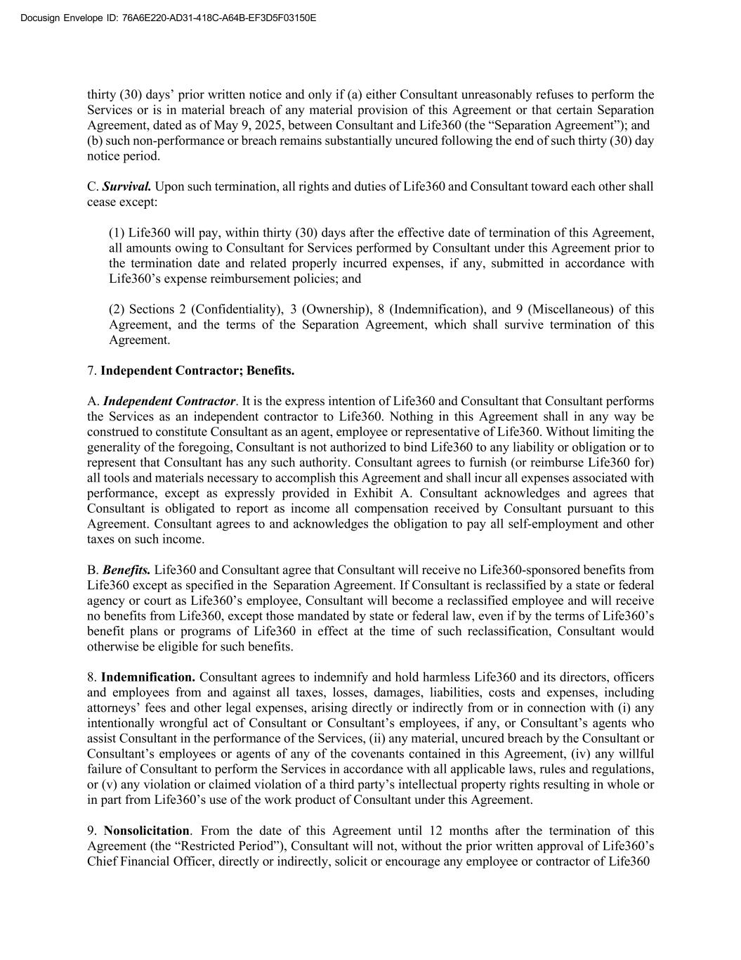
Docusign Envelope ID: 76A6E220-AD31-418C-A64B-EF3D5F03150E thirty (30) days’ prior written notice and only if (a) either Consultant unreasonably refuses to perform the Services or is in material breach of any material provision of this Agreement or that certain Separation Agreement, dated as of May 9, 2025, between Consultant and Life360 (the “Separation Agreement”); and (b) such non-performance or breach remains substantially uncured following the end of such thirty (30) day notice period. C. Survival. Upon such termination, all rights and duties of Life360 and Consultant toward each other shall cease except: (1) Life360 will pay, within thirty (30) days after the effective date of termination of this Agreement, all amounts owing to Consultant for Services performed by Consultant under this Agreement prior to the termination date and related properly incurred expenses, if any, submitted in accordance with Life360’s expense reimbursement policies; and (2) Sections 2 (Confidentiality), 3 (Ownership), 8 (Indemnification), and 9 (Miscellaneous) of this Agreement, and the terms of the Separation Agreement, which shall survive termination of this Agreement. 7. Independent Contractor; Benefits. A. Independent Contractor. It is the express intention of Life360 and Consultant that Consultant performs the Services as an independent contractor to Life360. Nothing in this Agreement shall in any way be construed to constitute Consultant as an agent, employee or representative of Life360. Without limiting the generality of the foregoing, Consultant is not authorized to bind Life360 to any liability or obligation or to represent that Consultant has any such authority. Consultant agrees to furnish (or reimburse Life360 for) all tools and materials necessary to accomplish this Agreement and shall incur all expenses associated with performance, except as expressly provided in Exhibit A. Consultant acknowledges and agrees that Consultant is obligated to report as income all compensation received by Consultant pursuant to this Agreement. Consultant agrees to and acknowledges the obligation to pay all self-employment and other taxes on such income. B. Benefits. Life360 and Consultant agree that Consultant will receive no Life360-sponsored benefits from Life360 except as specified in the Separation Agreement. If Consultant is reclassified by a state or federal agency or court as Life360’s employee, Consultant will become a reclassified employee and will receive no benefits from Life360, except those mandated by state or federal law, even if by the terms of Life360’s benefit plans or programs of Life360 in effect at the time of such reclassification, Consultant would otherwise be eligible for such benefits. 8. Indemnification. Consultant agrees to indemnify and hold harmless Life360 and its directors, officers and employees from and against all taxes, losses, damages, liabilities, costs and expenses, including attorneys’ fees and other legal expenses, arising directly or indirectly from or in connection with (i) any intentionally wrongful act of Consultant or Consultant’s employees, if any, or Consultant’s agents who assist Consultant in the performance of the Services, (ii) any material, uncured breach by the Consultant or Consultant’s employees or agents of any of the covenants contained in this Agreement, (iv) any willful failure of Consultant to perform the Services in accordance with all applicable laws, rules and regulations, or (v) any violation or claimed violation of a third party’s intellectual property rights resulting in whole or in part from Life360’s use of the work product of Consultant under this Agreement. 9. Nonsolicitation. From the date of this Agreement until 12 months after the termination of this Agreement (the “Restricted Period”), Consultant will not, without the prior written approval of Life360’s Chief Financial Officer, directly or indirectly, solicit or encourage any employee or contractor of Life360

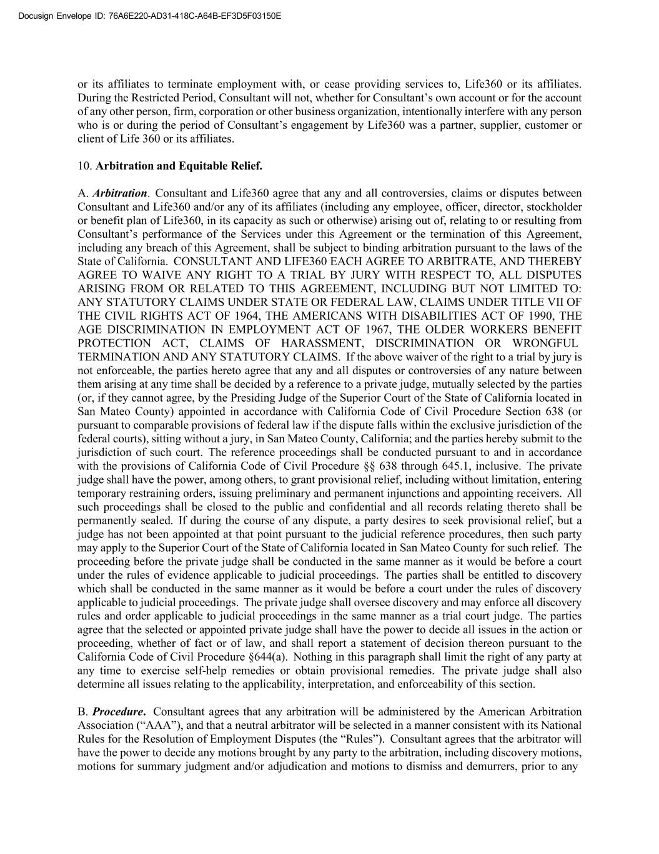
Docusign Envelope ID: 76A6E220-AD31-418C-A64B-EF3D5F03150E or its affiliates to terminate employment with, or cease providing services to, Life360 or its affiliates. During the Restricted Period, Consultant will not, whether for Consultant’s own account or for the account of any other person, firm, corporation or other business organization, intentionally interfere with any person who is or during the period of Consultant’s engagement by Life360 was a partner, supplier, customer or client of Life 360 or its affiliates. 10. Arbitration and Equitable Relief. A. Arbitration. Consultant and Life360 agree that any and all controversies, claims or disputes between Consultant and Life360 and/or any of its affiliates (including any employee, officer, director, stockholder or benefit plan of Life360, in its capacity as such or otherwise) arising out of, relating to or resulting from Consultant’s performance of the Services under this Agreement or the termination of this Agreement, including any breach of this Agreement, shall be subject to binding arbitration pursuant to the laws of the State of California. CONSULTANT AND LIFE360 EACH AGREE TO ARBITRATE, AND THEREBY AGREE TO WAIVE ANY RIGHT TO A TRIAL BY JURY WITH RESPECT TO, ALL DISPUTES ARISING FROM OR RELATED TO THIS AGREEMENT, INCLUDING BUT NOT LIMITED TO: ANY STATUTORY CLAIMS UNDER STATE OR FEDERAL LAW, CLAIMS UNDER TITLE VII OF THE CIVIL RIGHTS ACT OF 1964, THE AMERICANS WITH DISABILITIES ACT OF 1990, THE AGE DISCRIMINATION IN EMPLOYMENT ACT OF 1967, THE OLDER WORKERS BENEFIT PROTECTION ACT, CLAIMS OF HARASSMENT, DISCRIMINATION OR WRONGFUL TERMINATION AND ANY STATUTORY CLAIMS. If the above waiver of the right to a trial by jury is not enforceable, the parties hereto agree that any and all disputes or controversies of any nature between them arising at any time shall be decided by a reference to a private judge, mutually selected by the parties (or, if they cannot agree, by the Presiding Judge of the Superior Court of the State of California located in San Mateo County) appointed in accordance with California Code of Civil Procedure Section 638 (or pursuant to comparable provisions of federal law if the dispute falls within the exclusive jurisdiction of the federal courts), sitting without a jury, in San Mateo County, California; and the parties hereby submit to the jurisdiction of such court. The reference proceedings shall be conducted pursuant to and in accordance with the provisions of California Code of Civil Procedure §§ 638 through 645.1, inclusive. The private judge shall have the power, among others, to grant provisional relief, including without limitation, entering temporary restraining orders, issuing preliminary and permanent injunctions and appointing receivers. All such proceedings shall be closed to the public and confidential and all records relating thereto shall be permanently sealed. If during the course of any dispute, a party desires to seek provisional relief, but a judge has not been appointed at that point pursuant to the judicial reference procedures, then such party may apply to the Superior Court of the State of California located in San Mateo County for such relief. The proceeding before the private judge shall be conducted in the same manner as it would be before a court under the rules of evidence applicable to judicial proceedings. The parties shall be entitled to discovery which shall be conducted in the same manner as it would be before a court under the rules of discovery applicable to judicial proceedings. The private judge shall oversee discovery and may enforce all discovery rules and order applicable to judicial proceedings in the same manner as a trial court judge. The parties agree that the selected or appointed private judge shall have the power to decide all issues in the action or proceeding, whether of fact or of law, and shall report a statement of decision thereon pursuant to the California Code of Civil Procedure §644(a). Nothing in this paragraph shall limit the right of any party at any time to exercise self-help remedies or obtain provisional remedies. The private judge shall also determine all issues relating to the applicability, interpretation, and enforceability of this section. B. Procedure. Consultant agrees that any arbitration will be administered by the American Arbitration Association (“AAA”), and that a neutral arbitrator will be selected in a manner consistent with its National Rules for the Resolution of Employment Disputes (the “Rules”). Consultant agrees that the arbitrator will have the power to decide any motions brought by any party to the arbitration, including discovery motions, motions for summary judgment and/or adjudication and motions to dismiss and demurrers, prior to any

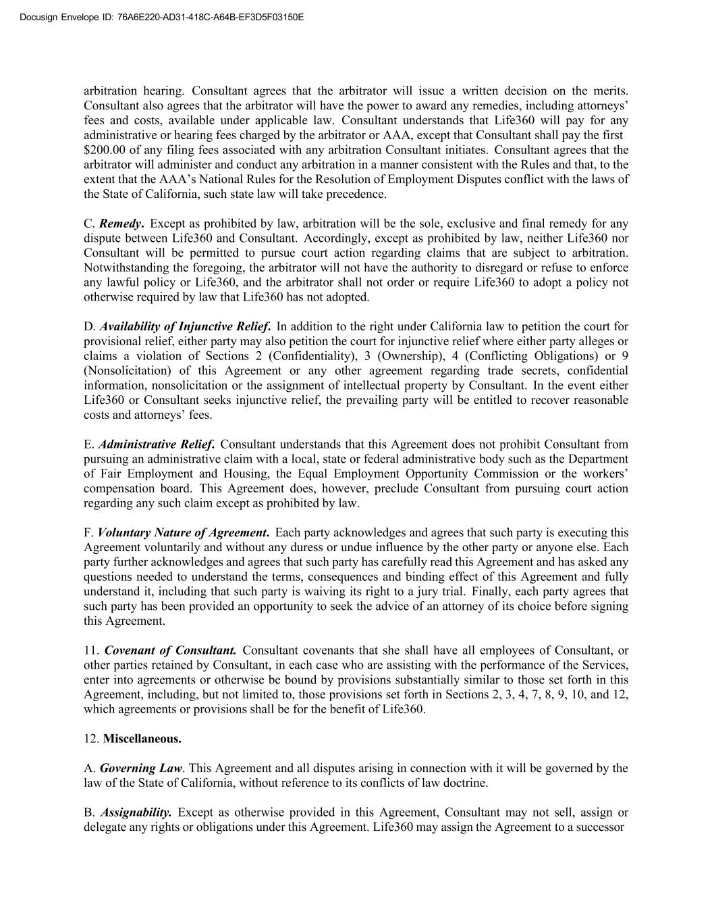
Docusign Envelope ID: 76A6E220-AD31-418C-A64B-EF3D5F03150E arbitration hearing. Consultant agrees that the arbitrator will issue a written decision on the merits. Consultant also agrees that the arbitrator will have the power to award any remedies, including attorneys’ fees and costs, available under applicable law. Consultant understands that Life360 will pay for any administrative or hearing fees charged by the arbitrator or AAA, except that Consultant shall pay the first $200.00 of any filing fees associated with any arbitration Consultant initiates. Consultant agrees that the arbitrator will administer and conduct any arbitration in a manner consistent with the Rules and that, to the extent that the AAA’s National Rules for the Resolution of Employment Disputes conflict with the laws of the State of California, such state law will take precedence. C. Remedy. Except as prohibited by law, arbitration will be the sole, exclusive and final remedy for any dispute between Life360 and Consultant. Accordingly, except as prohibited by law, neither Life360 nor Consultant will be permitted to pursue court action regarding claims that are subject to arbitration. Notwithstanding the foregoing, the arbitrator will not have the authority to disregard or refuse to enforce any lawful policy or Life360, and the arbitrator shall not order or require Life360 to adopt a policy not otherwise required by law that Life360 has not adopted. D. Availability of Injunctive Relief. In addition to the right under California law to petition the court for provisional relief, either party may also petition the court for injunctive relief where either party alleges or claims a violation of Sections 2 (Confidentiality), 3 (Ownership), 4 (Conflicting Obligations) or 9 (Nonsolicitation) of this Agreement or any other agreement regarding trade secrets, confidential information, nonsolicitation or the assignment of intellectual property by Consultant. In the event either Life360 or Consultant seeks injunctive relief, the prevailing party will be entitled to recover reasonable costs and attorneys’ fees. E. Administrative Relief. Consultant understands that this Agreement does not prohibit Consultant from pursuing an administrative claim with a local, state or federal administrative body such as the Department of Fair Employment and Housing, the Equal Employment Opportunity Commission or the workers’ compensation board. This Agreement does, however, preclude Consultant from pursuing court action regarding any such claim except as prohibited by law. F. Voluntary Nature of Agreement. Each party acknowledges and agrees that such party is executing this Agreement voluntarily and without any duress or undue influence by the other party or anyone else. Each party further acknowledges and agrees that such party has carefully read this Agreement and has asked any questions needed to understand the terms, consequences and binding effect of this Agreement and fully understand it, including that such party is waiving its right to a jury trial. Finally, each party agrees that such party has been provided an opportunity to seek the advice of an attorney of its choice before signing this Agreement. 11. Covenant of Consultant. Consultant covenants that she shall have all employees of Consultant, or other parties retained by Consultant, in each case who are assisting with the performance of the Services, enter into agreements or otherwise be bound by provisions substantially similar to those set forth in this Agreement, including, but not limited to, those provisions set forth in Sections 2, 3, 4, 7, 8, 9, 10, and 12, which agreements or provisions shall be for the benefit of Life360. 12. Miscellaneous. A. Governing Law. This Agreement and all disputes arising in connection with it will be governed by the law of the State of California, without reference to its conflicts of law doctrine. B. Assignability. Except as otherwise provided in this Agreement, Consultant may not sell, assign or delegate any rights or obligations under this Agreement. Life360 may assign the Agreement to a successor

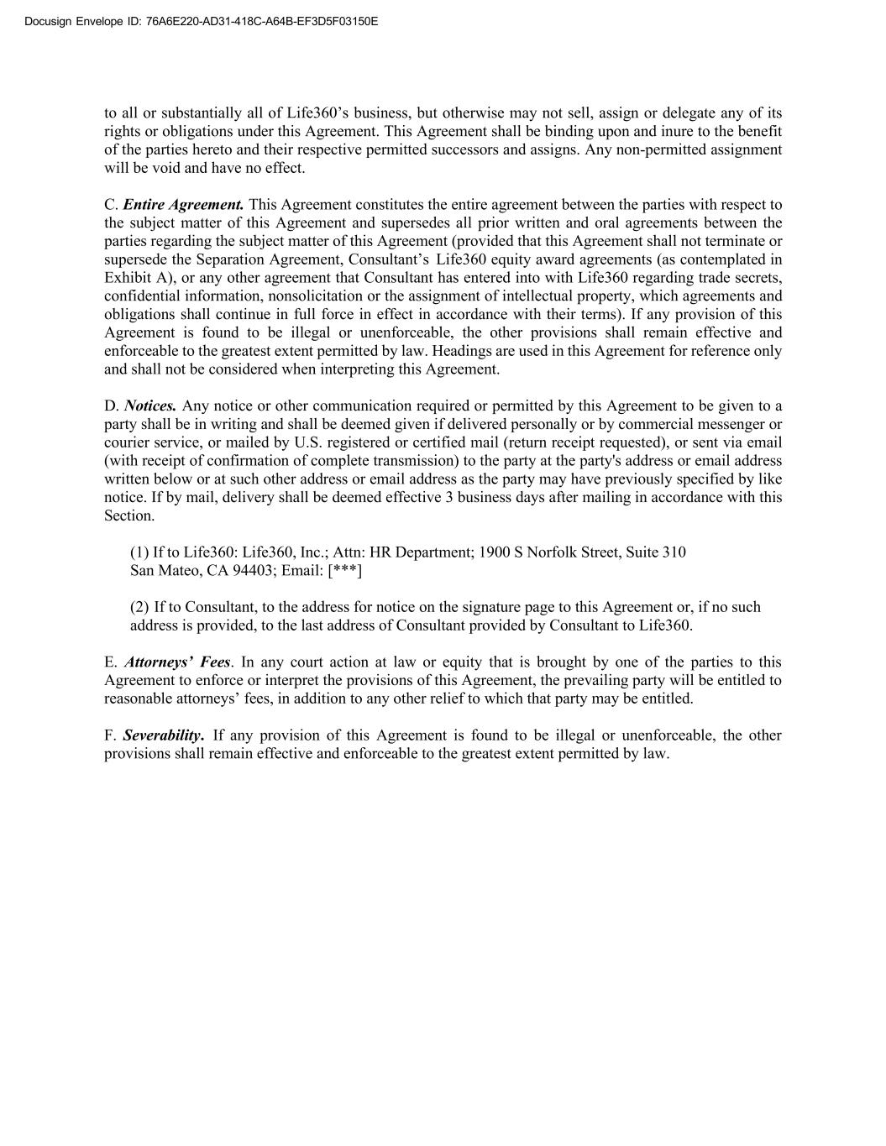
Docusign Envelope ID: 76A6E220-AD31-418C-A64B-EF3D5F03150E to all or substantially all of Life360’s business, but otherwise may not sell, assign or delegate any of its rights or obligations under this Agreement. This Agreement shall be binding upon and inure to the benefit of the parties hereto and their respective permitted successors and assigns. Any non-permitted assignment will be void and have no effect. C. Entire Agreement. This Agreement constitutes the entire agreement between the parties with respect to the subject matter of this Agreement and supersedes all prior written and oral agreements between the parties regarding the subject matter of this Agreement (provided that this Agreement shall not terminate or supersede the Separation Agreement, Consultant’s Life360 equity award agreements (as contemplated in Exhibit A), or any other agreement that Consultant has entered into with Life360 regarding trade secrets, confidential information, nonsolicitation or the assignment of intellectual property, which agreements and obligations shall continue in full force in effect in accordance with their terms). If any provision of this Agreement is found to be illegal or unenforceable, the other provisions shall remain effective and enforceable to the greatest extent permitted by law. Headings are used in this Agreement for reference only and shall not be considered when interpreting this Agreement. D. Notices. Any notice or other communication required or permitted by this Agreement to be given to a party shall be in writing and shall be deemed given if delivered personally or by commercial messenger or courier service, or mailed by U.S. registered or certified mail (return receipt requested), or sent via email (with receipt of confirmation of complete transmission) to the party at the party's address or email address written below or at such other address or email address as the party may have previously specified by like notice. If by mail, delivery shall be deemed effective 3 business days after mailing in accordance with this Section. (1) If to Life360: Life360, Inc.; Attn: HR Department; 1900 S Norfolk Street, Suite 310 San Mateo, CA 94403; Email: [***] (2) If to Consultant, to the address for notice on the signature page to this Agreement or, if no such address is provided, to the last address of Consultant provided by Consultant to Life360. E. Attorneys’ Fees. In any court action at law or equity that is brought by one of the parties to this Agreement to enforce or interpret the provisions of this Agreement, the prevailing party will be entitled to reasonable attorneys’ fees, in addition to any other relief to which that party may be entitled. F. Severability. If any provision of this Agreement is found to be illegal or unenforceable, the other provisions shall remain effective and enforceable to the greatest extent permitted by law.

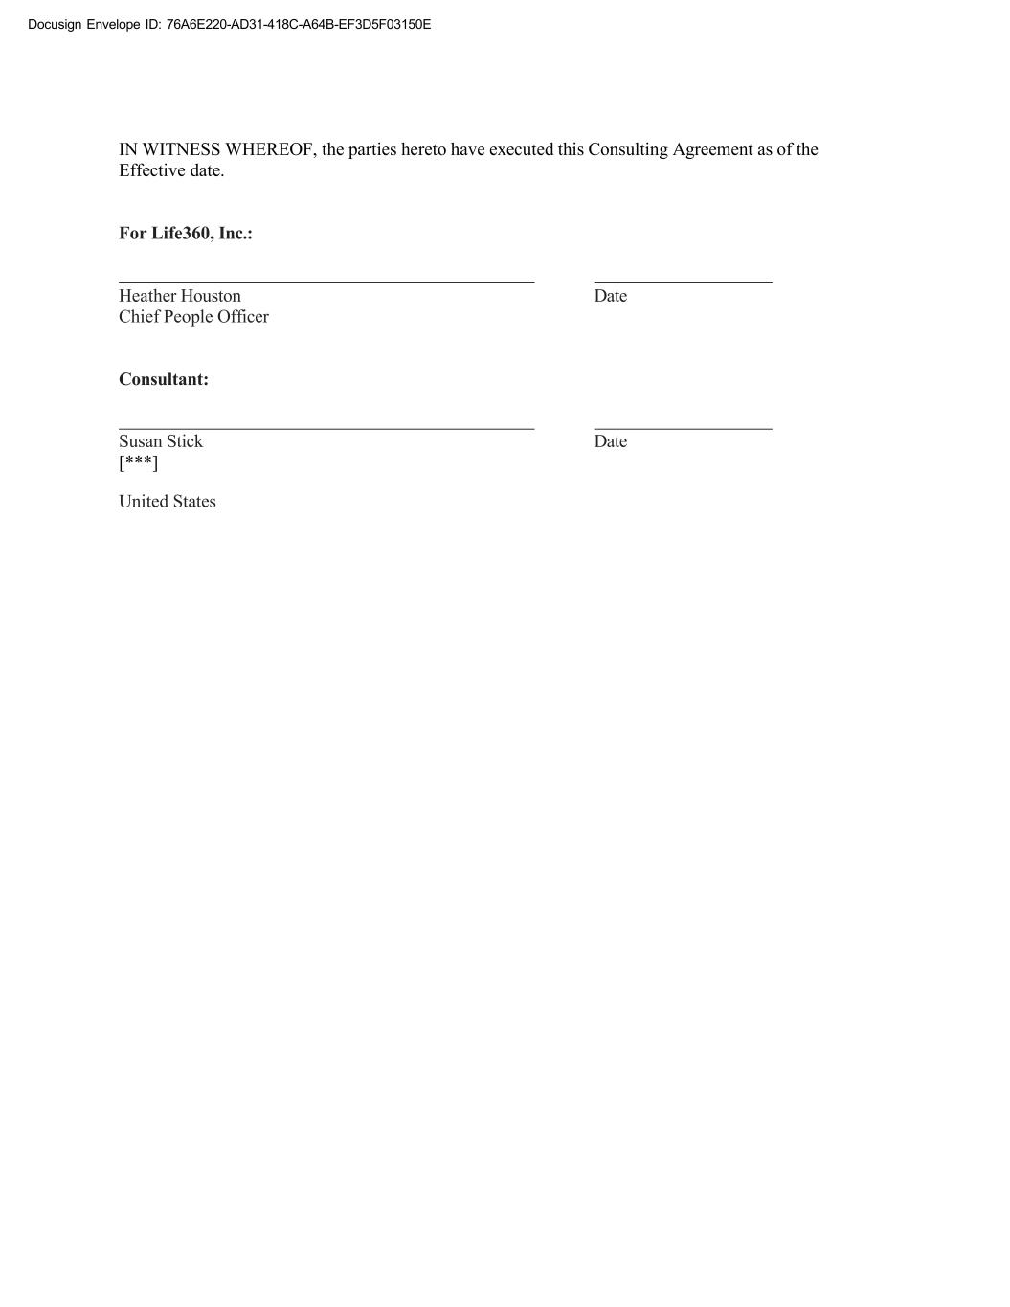
Docusign Envelope ID: 76A6E220-AD31-418C-A64B-EF3D5F03150E IN WITNESS WHEREOF, the parties hereto have executed this Consulting Agreement as of the Effective date. For Life360, Inc.: Heather Houston Date Chief People Officer Consultant: Susan Stick Date [***] United States

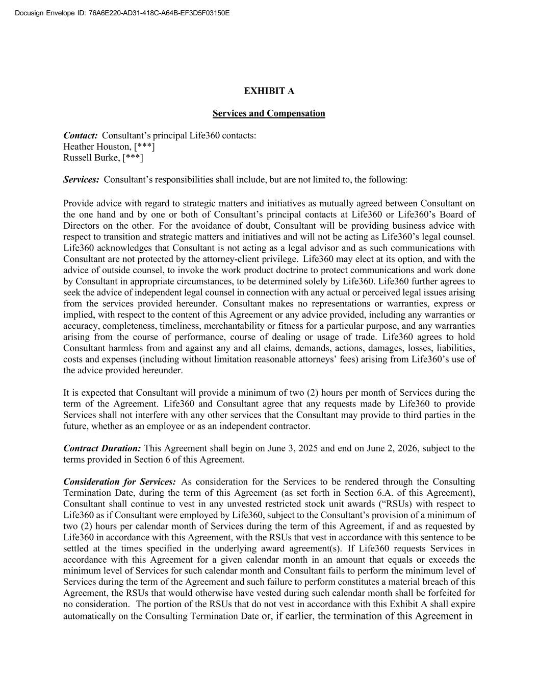
Docusign Envelope ID: 76A6E220-AD31-418C-A64B-EF3D5F03150E EXHIBIT A Services and Compensation Contact: Consultant’s principal Life360 contacts: Heather Houston, [***] Russell Burke, [***] Services: Consultant’s responsibilities shall include, but are not limited to, the following: Provide advice with regard to strategic matters and initiatives as mutually agreed between Consultant on the one hand and by one or both of Consultant’s principal contacts at Life360 or Life360’s Board of Directors on the other. For the avoidance of doubt, Consultant will be providing business advice with respect to transition and strategic matters and initiatives and will not be acting as Life360’s legal counsel. Life360 acknowledges that Consultant is not acting as a legal advisor and as such communications with Consultant are not protected by the attorney-client privilege. Life360 may elect at its option, and with the advice of outside counsel, to invoke the work product doctrine to protect communications and work done by Consultant in appropriate circumstances, to be determined solely by Life360. Life360 further agrees to seek the advice of independent legal counsel in connection with any actual or perceived legal issues arising from the services provided hereunder. Consultant makes no representations or warranties, express or implied, with respect to the content of this Agreement or any advice provided, including any warranties or accuracy, completeness, timeliness, merchantability or fitness for a particular purpose, and any warranties arising from the course of performance, course of dealing or usage of trade. Life360 agrees to hold Consultant harmless from and against any and all claims, demands, actions, damages, losses, liabilities, costs and expenses (including without limitation reasonable attorneys’ fees) arising from Life360’s use of the advice provided hereunder. It is expected that Consultant will provide a minimum of two (2) hours per month of Services during the term of the Agreement. Life360 and Consultant agree that any requests made by Life360 to provide Services shall not interfere with any other services that the Consultant may provide to third parties in the future, whether as an employee or as an independent contractor. Contract Duration: This Agreement shall begin on June 3, 2025 and end on June 2, 2026, subject to the terms provided in Section 6 of this Agreement. Consideration for Services: As consideration for the Services to be rendered through the Consulting Termination Date, during the term of this Agreement (as set forth in Section 6.A. of this Agreement), Consultant shall continue to vest in any unvested restricted stock unit awards (“RSUs) with respect to Life360 as if Consultant were employed by Life360, subject to the Consultant’s provision of a minimum of two (2) hours per calendar month of Services during the term of this Agreement, if and as requested by Life360 in accordance with this Agreement, with the RSUs that vest in accordance with this sentence to be settled at the times specified in the underlying award agreement(s). If Life360 requests Services in accordance with this Agreement for a given calendar month in an amount that equals or exceeds the minimum level of Services for such calendar month and Consultant fails to perform the minimum level of Services during the term of the Agreement and such failure to perform constitutes a material breach of this Agreement, the RSUs that would otherwise have vested during such calendar month shall be forfeited for no consideration. The portion of the RSUs that do not vest in accordance with this Exhibit A shall expire automatically on the Consulting Termination Date or, if earlier, the termination of this Agreement in


Docusign Envelope ID: 76A6E220-AD31-418C-A64B-EF3D5F03150E accordance with its terms. Any agreement(s) between Consultant and Life360 governing Consultant’s RSUs will remain in full force and effect, and Consultant agrees to remain bound by those agreement(s) except to the extent that such agreement(s) are inconsistent with the Agreement. Reporting of Hours of Service: Consultant will report hours of Service performed to Life360 following the end of each calendar month during which this Agreement is in effect for some or all of such calendar month. Such reports of hours of Service performed (including zero (0) hours for a month in which no Services were performed) shall be submitted within an administratively reasonable period of time following the end of the month.


Docusign Envelope ID: 76A6E220-AD31-418C-A64B-EF3D5F03150E EXHIBIT C Confidential Information and Invention Assignment Agreement

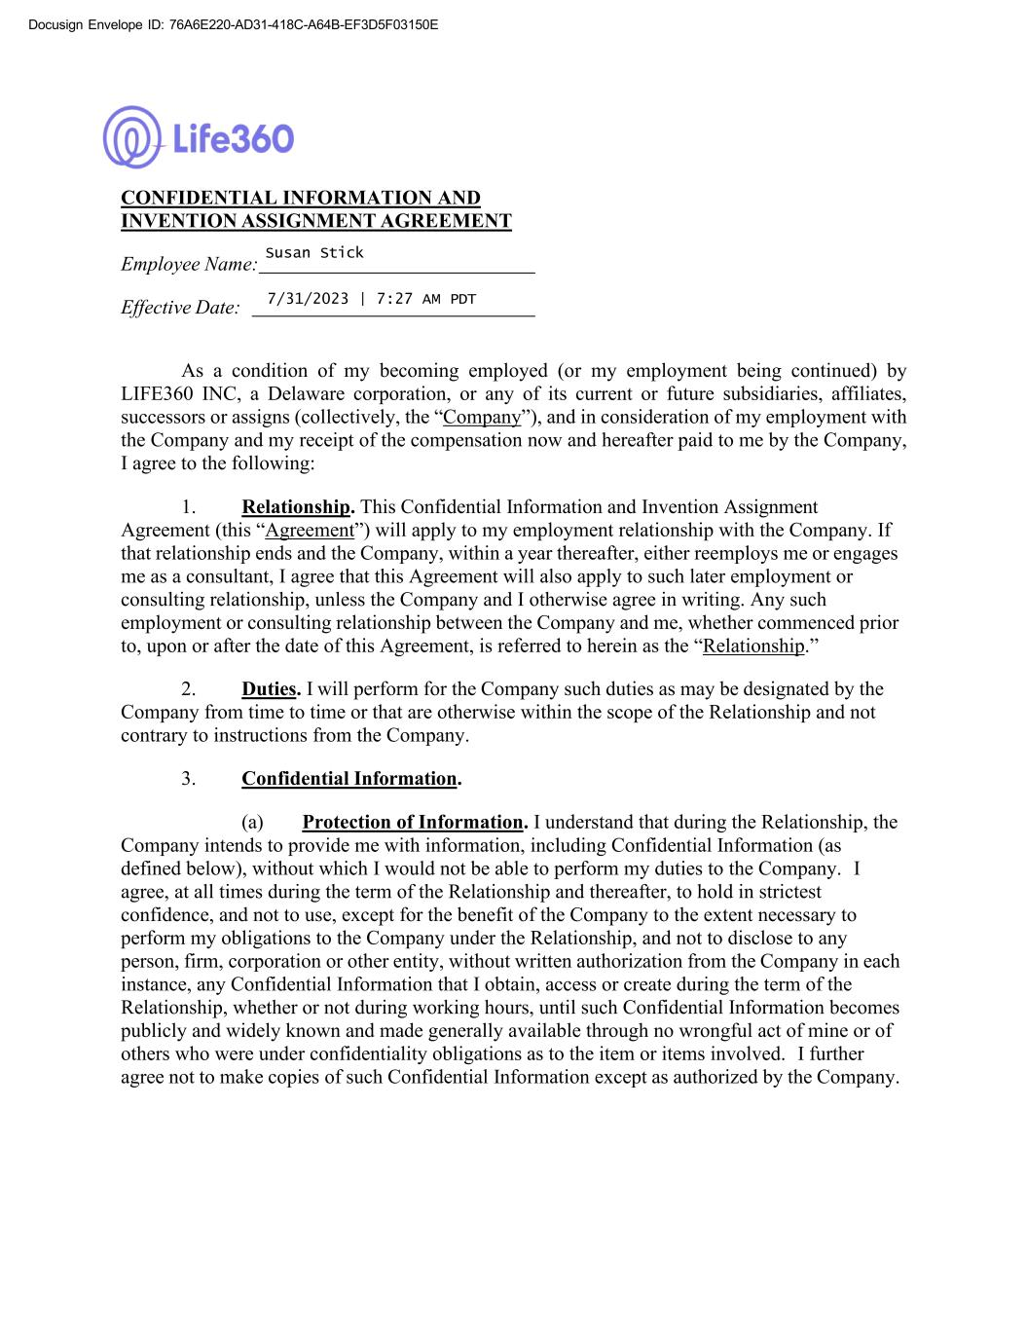
DocuSign Envelope ID: C42F0DD2-1E83-4BFC-AB03-B8EC5294DC62 si v l I : 76A6E220-AD31-418C-A64B-EF3D5F03150E CONFIDENTIAL INFORMATION AND INVENTION ASSIGNMENT AGREEMENT Employee Name: Susan Stick Effective Date: 7/31/2023 | 7:27 AM PDT As a condition of my becoming employed (or my employment being continued) by LIFE360 INC, a Delaware corporation, or any of its current or future subsidiaries, affiliates, successors or assigns (collectively, the “Company”), and in consideration of my employment with the Company and my receipt of the compensation now and hereafter paid to me by the Company, I agree to the following: 1. Relationship. This Confidential Information and Invention Assignment Agreement (this “Agreement”) will apply to my employment relationship with the Company. If that relationship ends and the Company, within a year thereafter, either reemploys me or engages me as a consultant, I agree that this Agreement will also apply to such later employment or consulting relationship, unless the Company and I otherwise agree in writing. Any such employment or consulting relationship between the Company and me, whether commenced prior to, upon or after the date of this Agreement, is referred to herein as the “Relationship.” 2. Duties. I will perform for the Company such duties as may be designated by the Company from time to time or that are otherwise within the scope of the Relationship and not contrary to instructions from the Company. 3. Confidential Information. (a) Protection of Information. I understand that during the Relationship, the Company intends to provide me with information, including Confidential Information (as defined below), without which I would not be able to perform my duties to the Company. I agree, at all times during the term of the Relationship and thereafter, to hold in strictest confidence, and not to use, except for the benefit of the Company to the extent necessary to perform my obligations to the Company under the Relationship, and not to disclose to any person, firm, corporation or other entity, without written authorization from the Company in each instance, any Confidential Information that I obtain, access or create during the term of the Relationship, whether or not during working hours, until such Confidential Information becomes publicly and widely known and made generally available through no wrongful act of mine or of others who were under confidentiality obligations as to the item or items involved. I further agree not to make copies of such Confidential Information except as authorized by the Company.

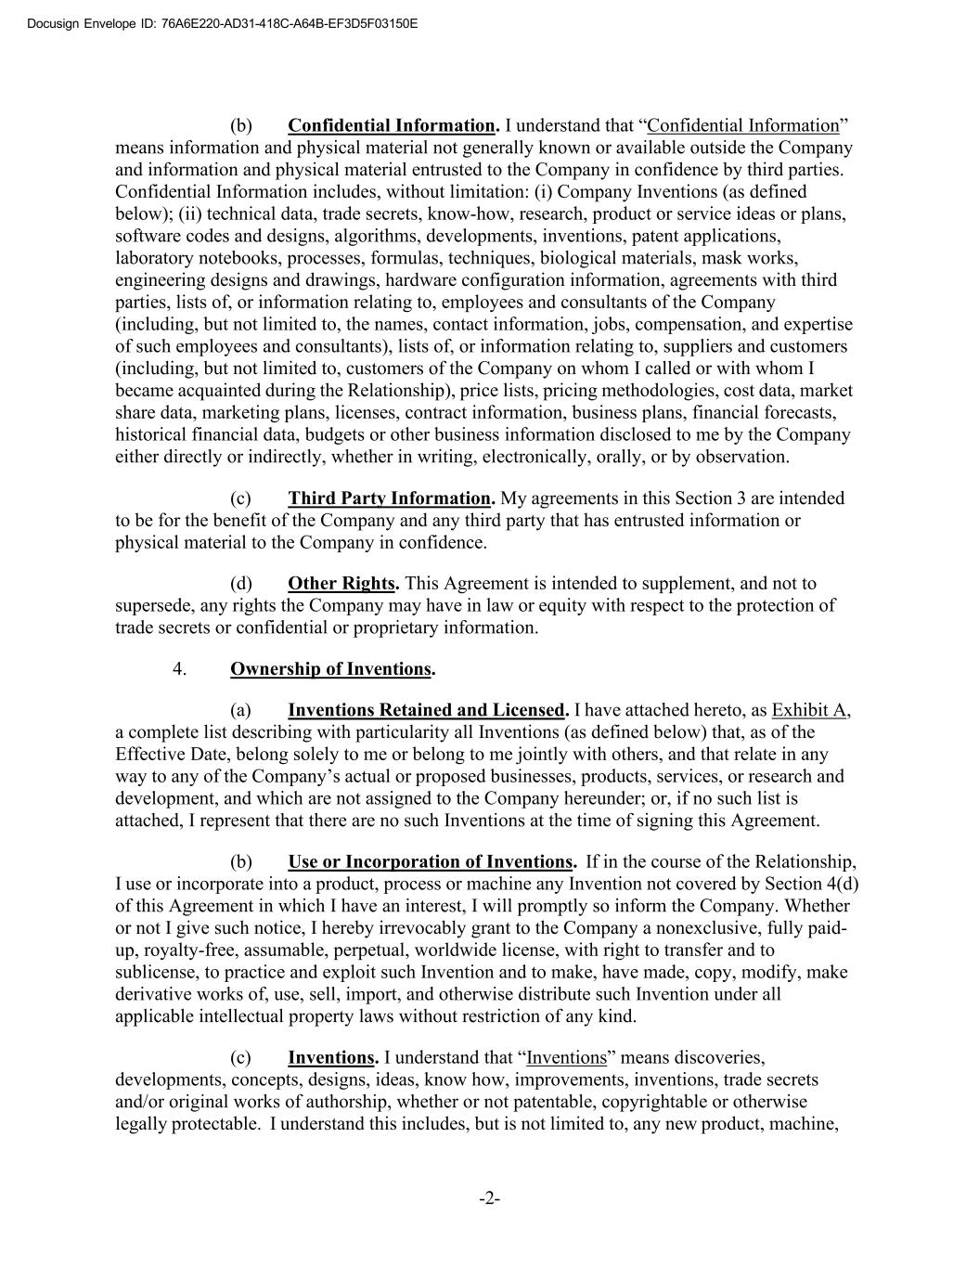
DocuSign Envelope ID: C42F0DD2-1E83-4BFC-AB03-B8EC5294DC62 si v l I : 76A6E220-AD31-418C-A64B-EF3D5F03150E (b) Confidential Information. I understand that “Confidential Information” means information and physical material not generally known or available outside the Company and information and physical material entrusted to the Company in confidence by third parties. Confidential Information includes, without limitation: (i) Company Inventions (as defined below); (ii) technical data, trade secrets, know-how, research, product or service ideas or plans, software codes and designs, algorithms, developments, inventions, patent applications, laboratory notebooks, processes, formulas, techniques, biological materials, mask works, engineering designs and drawings, hardware configuration information, agreements with third parties, lists of, or information relating to, employees and consultants of the Company (including, but not limited to, the names, contact information, jobs, compensation, and expertise of such employees and consultants), lists of, or information relating to, suppliers and customers (including, but not limited to, customers of the Company on whom I called or with whom I became acquainted during the Relationship), price lists, pricing methodologies, cost data, market share data, marketing plans, licenses, contract information, business plans, financial forecasts, historical financial data, budgets or other business information disclosed to me by the Company either directly or indirectly, whether in writing, electronically, orally, or by observation. (c) Third Party Information. My agreements in this Section 3 are intended to be for the benefit of the Company and any third party that has entrusted information or physical material to the Company in confidence. (d) Other Rights. This Agreement is intended to supplement, and not to supersede, any rights the Company may have in law or equity with respect to the protection of trade secrets or confidential or proprietary information. 4. Ownership of Inventions. (a) Inventions Retained and Licensed. I have attached hereto, as Exhibit A, a complete list describing with particularity all Inventions (as defined below) that, as of the Effective Date, belong solely to me or belong to me jointly with others, and that relate in any way to any of the Company’s actual or proposed businesses, products, services, or research and development, and which are not assigned to the Company hereunder; or, if no such list is attached, I represent that there are no such Inventions at the time of signing this Agreement. (b) Use or Incorporation of Inventions. If in the course of the Relationship, I use or incorporate into a product, process or machine any Invention not covered by Section 4(d) of this Agreement in which I have an interest, I will promptly so inform the Company. Whether or not I give such notice, I hereby irrevocably grant to the Company a nonexclusive, fully paid- up, royalty-free, assumable, perpetual, worldwide license, with right to transfer and to sublicense, to practice and exploit such Invention and to make, have made, copy, modify, make derivative works of, use, sell, import, and otherwise distribute such Invention under all applicable intellectual property laws without restriction of any kind. (c) Inventions. I understand that “Inventions” means discoveries, developments, concepts, designs, ideas, know how, improvements, inventions, trade secrets and/or original works of authorship, whether or not patentable, copyrightable or otherwise legally protectable. I understand this includes, but is not limited to, any new product, machine, -2-

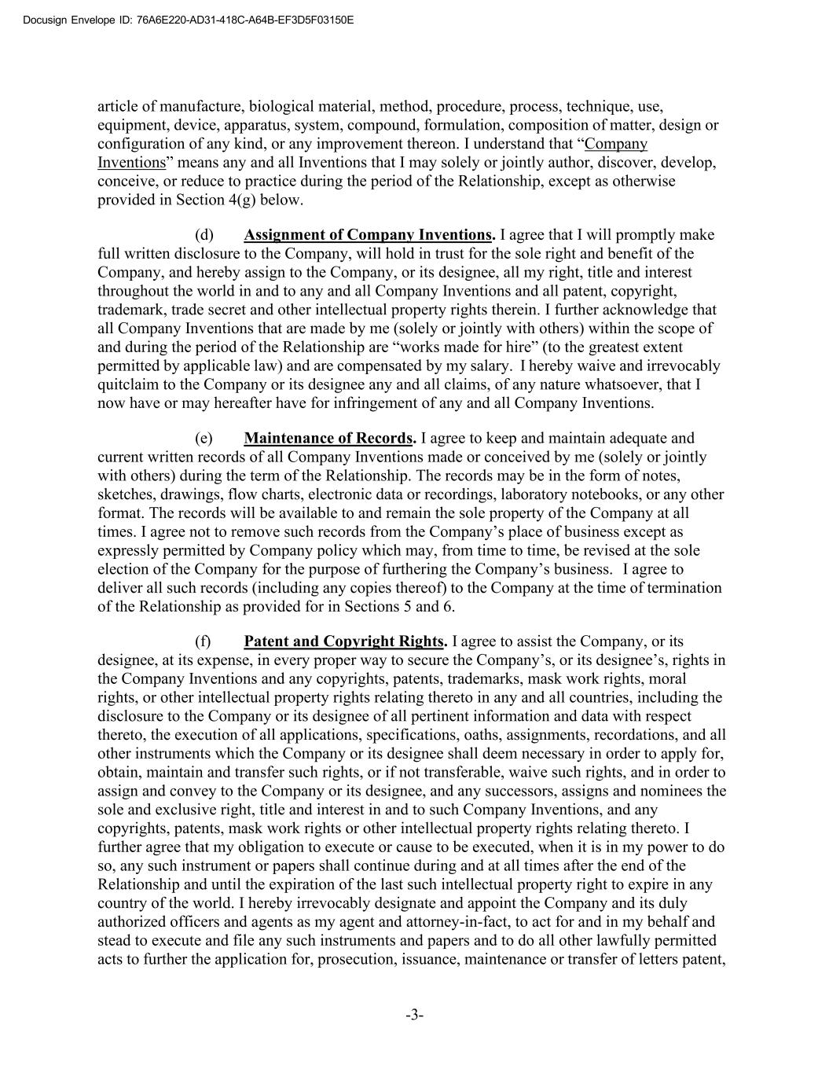
DocuSign Envelope ID: C42F0DD2-1E83-4BFC-AB03-B8EC5294DC62 si v l I : 76A6E220-AD31-418C-A64B-EF3D5F03150E article of manufacture, biological material, method, procedure, process, technique, use, equipment, device, apparatus, system, compound, formulation, composition of matter, design or configuration of any kind, or any improvement thereon. I understand that “Company Inventions” means any and all Inventions that I may solely or jointly author, discover, develop, conceive, or reduce to practice during the period of the Relationship, except as otherwise provided in Section 4(g) below. (d) Assignment of Company Inventions. I agree that I will promptly make full written disclosure to the Company, will hold in trust for the sole right and benefit of the Company, and hereby assign to the Company, or its designee, all my right, title and interest throughout the world in and to any and all Company Inventions and all patent, copyright, trademark, trade secret and other intellectual property rights therein. I further acknowledge that all Company Inventions that are made by me (solely or jointly with others) within the scope of and during the period of the Relationship are “works made for hire” (to the greatest extent permitted by applicable law) and are compensated by my salary. I hereby waive and irrevocably quitclaim to the Company or its designee any and all claims, of any nature whatsoever, that I now have or may hereafter have for infringement of any and all Company Inventions. (e) Maintenance of Records. I agree to keep and maintain adequate and current written records of all Company Inventions made or conceived by me (solely or jointly with others) during the term of the Relationship. The records may be in the form of notes, sketches, drawings, flow charts, electronic data or recordings, laboratory notebooks, or any other format. The records will be available to and remain the sole property of the Company at all times. I agree not to remove such records from the Company’s place of business except as expressly permitted by Company policy which may, from time to time, be revised at the sole election of the Company for the purpose of furthering the Company’s business. I agree to deliver all such records (including any copies thereof) to the Company at the time of termination of the Relationship as provided for in Sections 5 and 6. (f) Patent and Copyright Rights. I agree to assist the Company, or its designee, at its expense, in every proper way to secure the Company’s, or its designee’s, rights in the Company Inventions and any copyrights, patents, trademarks, mask work rights, moral rights, or other intellectual property rights relating thereto in any and all countries, including the disclosure to the Company or its designee of all pertinent information and data with respect thereto, the execution of all applications, specifications, oaths, assignments, recordations, and all other instruments which the Company or its designee shall deem necessary in order to apply for, obtain, maintain and transfer such rights, or if not transferable, waive such rights, and in order to assign and convey to the Company or its designee, and any successors, assigns and nominees the sole and exclusive right, title and interest in and to such Company Inventions, and any copyrights, patents, mask work rights or other intellectual property rights relating thereto. I further agree that my obligation to execute or cause to be executed, when it is in my power to do so, any such instrument or papers shall continue during and at all times after the end of the Relationship and until the expiration of the last such intellectual property right to expire in any country of the world. I hereby irrevocably designate and appoint the Company and its duly authorized officers and agents as my agent and attorney-in-fact, to act for and in my behalf and stead to execute and file any such instruments and papers and to do all other lawfully permitted acts to further the application for, prosecution, issuance, maintenance or transfer of letters patent, -3-

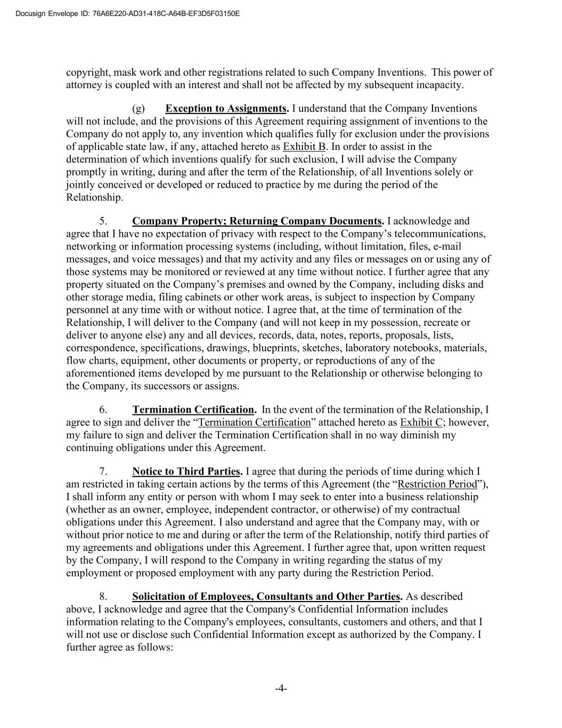
DocuSign Envelope ID: C42F0DD2-1E83-4BFC-AB03-B8EC5294DC62 si v l I : 76A6E220-AD31-418C-A64B-EF3D5F03150E copyright, mask work and other registrations related to such Company Inventions. This power of attorney is coupled with an interest and shall not be affected by my subsequent incapacity. (g) Exception to Assignments. I understand that the Company Inventions will not include, and the provisions of this Agreement requiring assignment of inventions to the Company do not apply to, any invention which qualifies fully for exclusion under the provisions of applicable state law, if any, attached hereto as Exhibit B. In order to assist in the determination of which inventions qualify for such exclusion, I will advise the Company promptly in writing, during and after the term of the Relationship, of all Inventions solely or jointly conceived or developed or reduced to practice by me during the period of the Relationship. 5. Company Property; Returning Company Documents. I acknowledge and agree that I have no expectation of privacy with respect to the Company’s telecommunications, networking or information processing systems (including, without limitation, files, e-mail messages, and voice messages) and that my activity and any files or messages on or using any of those systems may be monitored or reviewed at any time without notice. I further agree that any property situated on the Company’s premises and owned by the Company, including disks and other storage media, filing cabinets or other work areas, is subject to inspection by Company personnel at any time with or without notice. I agree that, at the time of termination of the Relationship, I will deliver to the Company (and will not keep in my possession, recreate or deliver to anyone else) any and all devices, records, data, notes, reports, proposals, lists, correspondence, specifications, drawings, blueprints, sketches, laboratory notebooks, materials, flow charts, equipment, other documents or property, or reproductions of any of the aforementioned items developed by me pursuant to the Relationship or otherwise belonging to the Company, its successors or assigns. 6. Termination Certification. In the event of the termination of the Relationship, I agree to sign and deliver the “Termination Certification” attached hereto as Exhibit C; however, my failure to sign and deliver the Termination Certification shall in no way diminish my continuing obligations under this Agreement. 7. Notice to Third Parties. I agree that during the periods of time during which I am restricted in taking certain actions by the terms of this Agreement (the “Restriction Period”), I shall inform any entity or person with whom I may seek to enter into a business relationship (whether as an owner, employee, independent contractor, or otherwise) of my contractual obligations under this Agreement. I also understand and agree that the Company may, with or without prior notice to me and during or after the term of the Relationship, notify third parties of my agreements and obligations under this Agreement. I further agree that, upon written request by the Company, I will respond to the Company in writing regarding the status of my employment or proposed employment with any party during the Restriction Period. 8. Solicitation of Employees, Consultants and Other Parties. As described above, I acknowledge and agree that the Company's Confidential Information includes information relating to the Company's employees, consultants, customers and others, and that I will not use or disclose such Confidential Information except as authorized by the Company. I further agree as follows: -4-

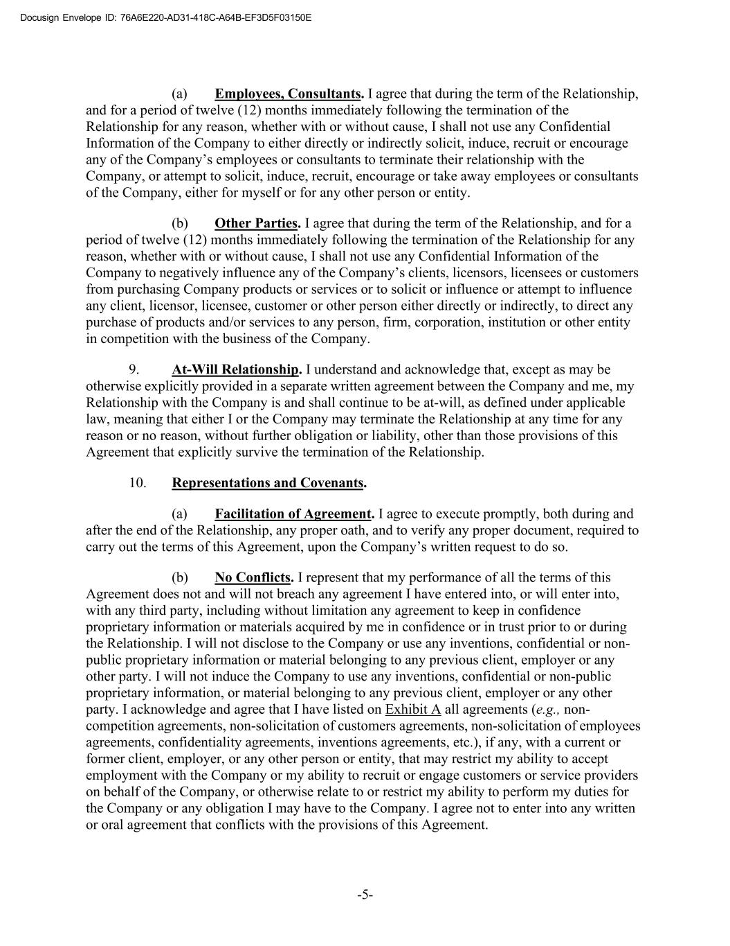
DocuSign Envelope ID: C42F0DD2-1E83-4BFC-AB03-B8EC5294DC62 si v l I : 76A6E220-AD31-418C-A64B-EF3D5F03150E (a) Employees, Consultants. I agree that during the term of the Relationship, and for a period of twelve (12) months immediately following the termination of the Relationship for any reason, whether with or without cause, I shall not use any Confidential Information of the Company to either directly or indirectly solicit, induce, recruit or encourage any of the Company’s employees or consultants to terminate their relationship with the Company, or attempt to solicit, induce, recruit, encourage or take away employees or consultants of the Company, either for myself or for any other person or entity. (b) Other Parties. I agree that during the term of the Relationship, and for a period of twelve (12) months immediately following the termination of the Relationship for any reason, whether with or without cause, I shall not use any Confidential Information of the Company to negatively influence any of the Company’s clients, licensors, licensees or customers from purchasing Company products or services or to solicit or influence or attempt to influence any client, licensor, licensee, customer or other person either directly or indirectly, to direct any purchase of products and/or services to any person, firm, corporation, institution or other entity in competition with the business of the Company. 9. At-Will Relationship. I understand and acknowledge that, except as may be otherwise explicitly provided in a separate written agreement between the Company and me, my Relationship with the Company is and shall continue to be at-will, as defined under applicable law, meaning that either I or the Company may terminate the Relationship at any time for any reason or no reason, without further obligation or liability, other than those provisions of this Agreement that explicitly survive the termination of the Relationship. 10. Representations and Covenants. (a) Facilitation of Agreement. I agree to execute promptly, both during and after the end of the Relationship, any proper oath, and to verify any proper document, required to carry out the terms of this Agreement, upon the Company’s written request to do so. (b) No Conflicts. I represent that my performance of all the terms of this Agreement does not and will not breach any agreement I have entered into, or will enter into, with any third party, including without limitation any agreement to keep in confidence proprietary information or materials acquired by me in confidence or in trust prior to or during the Relationship. I will not disclose to the Company or use any inventions, confidential or non- public proprietary information or material belonging to any previous client, employer or any other party. I will not induce the Company to use any inventions, confidential or non-public proprietary information, or material belonging to any previous client, employer or any other party. I acknowledge and agree that I have listed on Exhibit A all agreements (e.g., non- competition agreements, non-solicitation of customers agreements, non-solicitation of employees agreements, confidentiality agreements, inventions agreements, etc.), if any, with a current or former client, employer, or any other person or entity, that may restrict my ability to accept employment with the Company or my ability to recruit or engage customers or service providers on behalf of the Company, or otherwise relate to or restrict my ability to perform my duties for the Company or any obligation I may have to the Company. I agree not to enter into any written or oral agreement that conflicts with the provisions of this Agreement. -5-

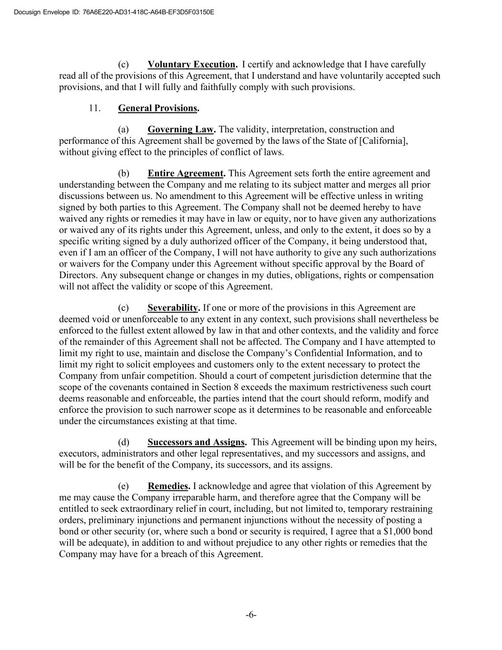
DocuSign Envelope ID: C42F0DD2-1E83-4BFC-AB03-B8EC5294DC62 si v l I : 76A6E220-AD31-418C-A64B-EF3D5F03150E (c) Voluntary Execution. I certify and acknowledge that I have carefully read all of the provisions of this Agreement, that I understand and have voluntarily accepted such provisions, and that I will fully and faithfully comply with such provisions. 11. General Provisions. (a) Governing Law. The validity, interpretation, construction and performance of this Agreement shall be governed by the laws of the State of [California], without giving effect to the principles of conflict of laws. (b) Entire Agreement. This Agreement sets forth the entire agreement and understanding between the Company and me relating to its subject matter and merges all prior discussions between us. No amendment to this Agreement will be effective unless in writing signed by both parties to this Agreement. The Company shall not be deemed hereby to have waived any rights or remedies it may have in law or equity, nor to have given any authorizations or waived any of its rights under this Agreement, unless, and only to the extent, it does so by a specific writing signed by a duly authorized officer of the Company, it being understood that, even if I am an officer of the Company, I will not have authority to give any such authorizations or waivers for the Company under this Agreement without specific approval by the Board of Directors. Any subsequent change or changes in my duties, obligations, rights or compensation will not affect the validity or scope of this Agreement. (c) Severability. If one or more of the provisions in this Agreement are deemed void or unenforceable to any extent in any context, such provisions shall nevertheless be enforced to the fullest extent allowed by law in that and other contexts, and the validity and force of the remainder of this Agreement shall not be affected. The Company and I have attempted to limit my right to use, maintain and disclose the Company’s Confidential Information, and to limit my right to solicit employees and customers only to the extent necessary to protect the Company from unfair competition. Should a court of competent jurisdiction determine that the scope of the covenants contained in Section 8 exceeds the maximum restrictiveness such court deems reasonable and enforceable, the parties intend that the court should reform, modify and enforce the provision to such narrower scope as it determines to be reasonable and enforceable under the circumstances existing at that time. (d) Successors and Assigns. This Agreement will be binding upon my heirs, executors, administrators and other legal representatives, and my successors and assigns, and will be for the benefit of the Company, its successors, and its assigns. (e) Remedies. I acknowledge and agree that violation of this Agreement by me may cause the Company irreparable harm, and therefore agree that the Company will be entitled to seek extraordinary relief in court, including, but not limited to, temporary restraining orders, preliminary injunctions and permanent injunctions without the necessity of posting a bond or other security (or, where such a bond or security is required, I agree that a $1,000 bond will be adequate), in addition to and without prejudice to any other rights or remedies that the Company may have for a breach of this Agreement. -6-


DocuSign Envelope ID: C42F0DD2-1E83-4BFC-AB03-B8EC5294DC62 si v l I : 76A6E220-AD31-418C-A64B-EF3D5F03150E (f) Advice of Counsel. I ACKNOWLEDGE THAT, IN EXECUTING THIS AGREEMENT, I HAVE HAD THE OPPORTUNITY TO SEEK THE ADVICE OF INDEPENDENT LEGAL COUNSEL, AND I HAVE READ AND UNDERSTOOD ALL OF THE TERMS AND PROVISIONS OF THIS AGREEMENT. THIS AGREEMENT SHALL NOT BE CONSTRUED AGAINST ANY PARTY BY REASON OF THE DRAFTING OR PREPARATION HEREOF. [Signature Page Follows] -7-

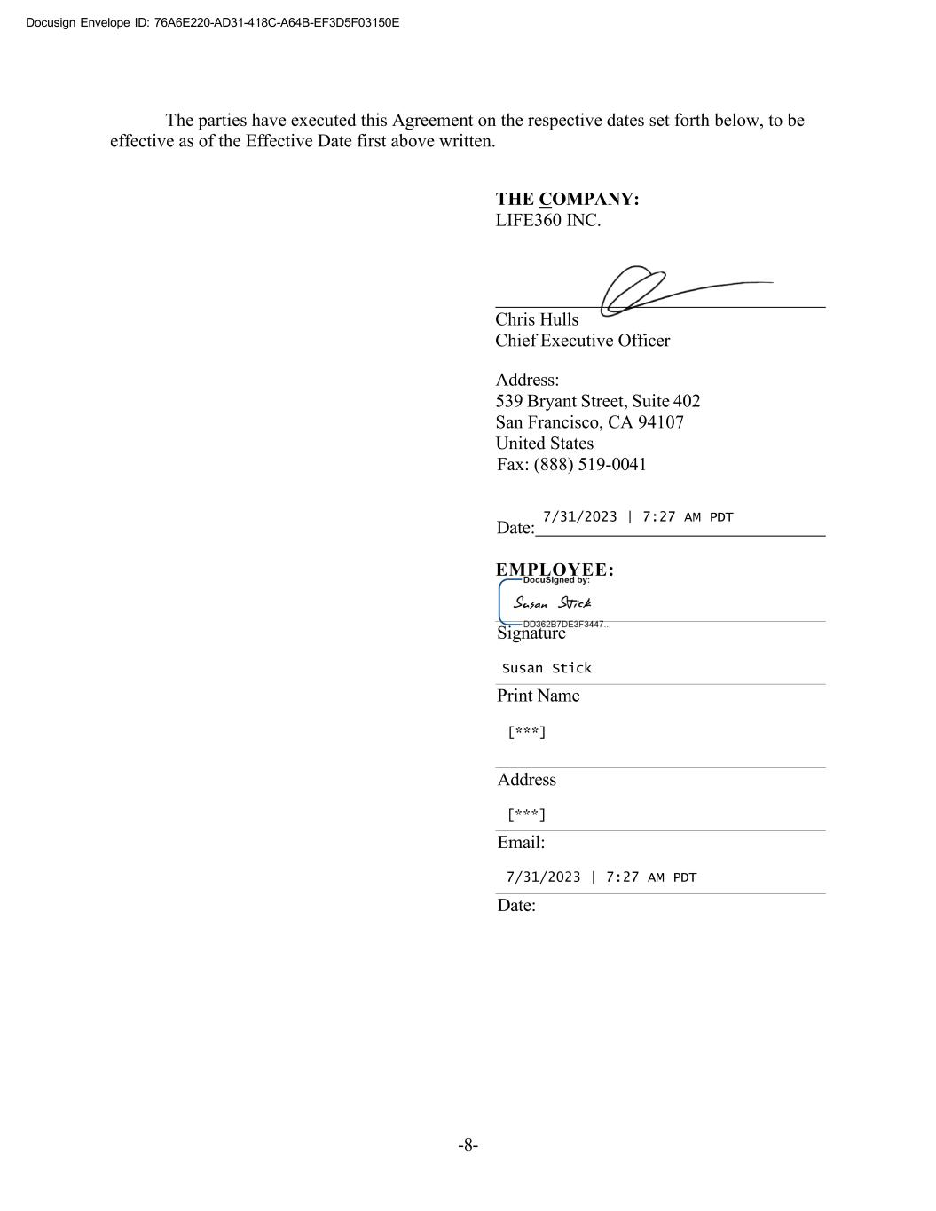
DocuSign Envelope ID: C42F0DD2-1E83-4BFC-AB03-B8EC5294DC62 si v l I : 76A6E220-AD31-418C-A64B-EF3D5F03150E Signature The parties have executed this Agreement on the respective dates set forth below, to be effective as of the Effective Date first above written. THE COMPANY: LIFE360 INC. Chris Hulls Chief Executive Officer Address: 539 Bryant Street, Suite 402 San Francisco, CA 94107 United States Fax: (888) 519-0041 Date: 7/31/2023 | 7:27 AM PDT EMPLOYEE: Susan Stick Print Name [***] Address [***] Email: 7/31/2023 | 7:27 AM PDT Date: -8-

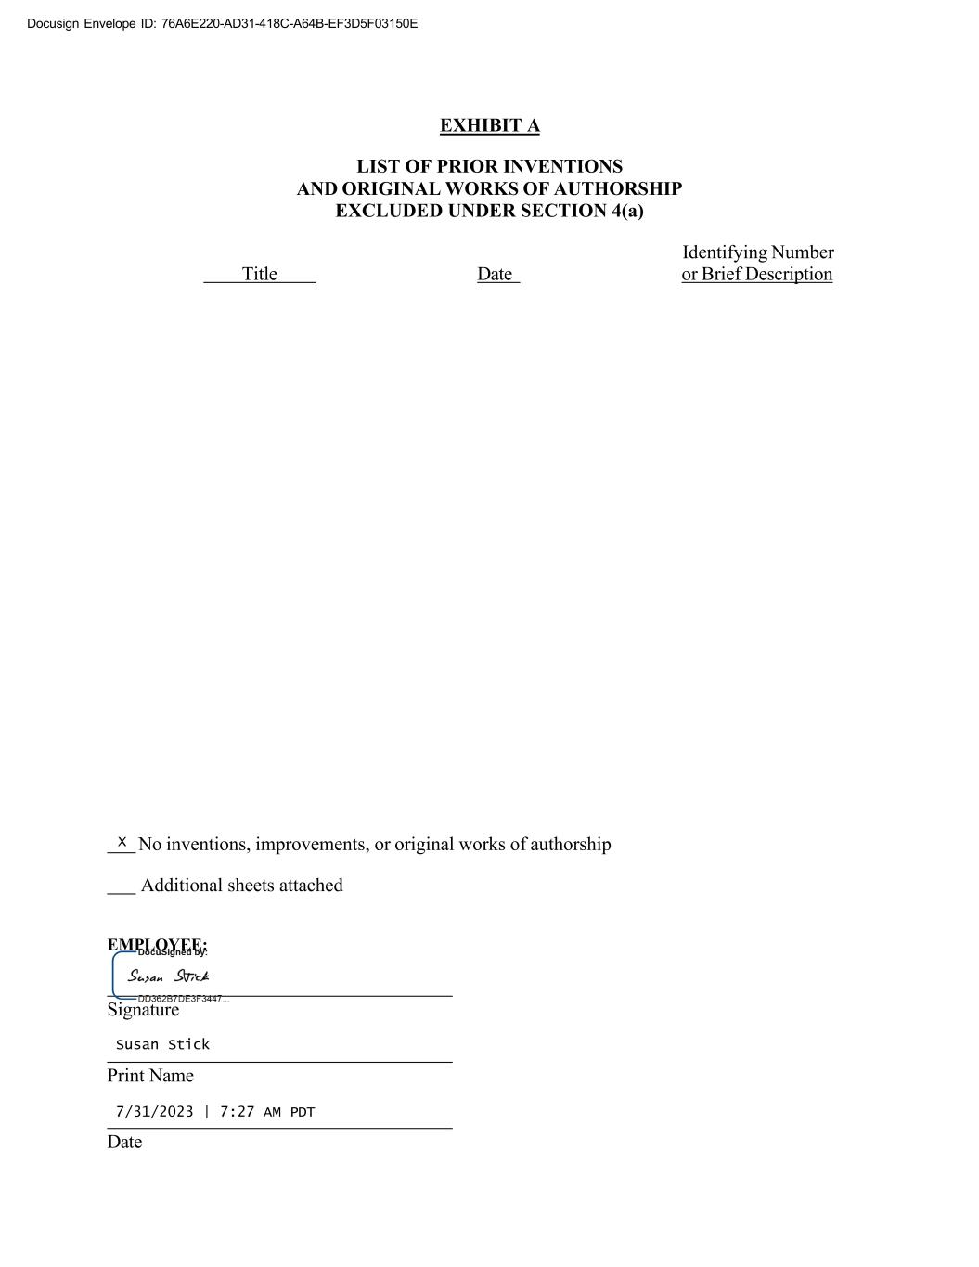
DocuSign Envelope ID: C42F0DD2-1E83-4BFC-AB03-B8EC5294DC62 si v l I : 76A6E220-AD31-418C-A64B-EF3D5F03150E EMPLOYEE: EXHIBIT A LIST OF PRIOR INVENTIONS AND ORIGINAL WORKS OF AUTHORSHIP EXCLUDED UNDER SECTION 4(a) Title Date Identifying Number or Brief Description X No inventions, improvements, or original works of authorship Additional sheets attached Signature Susan Stick Print Name 7/31/2023 | 7:27 AM PDT Date

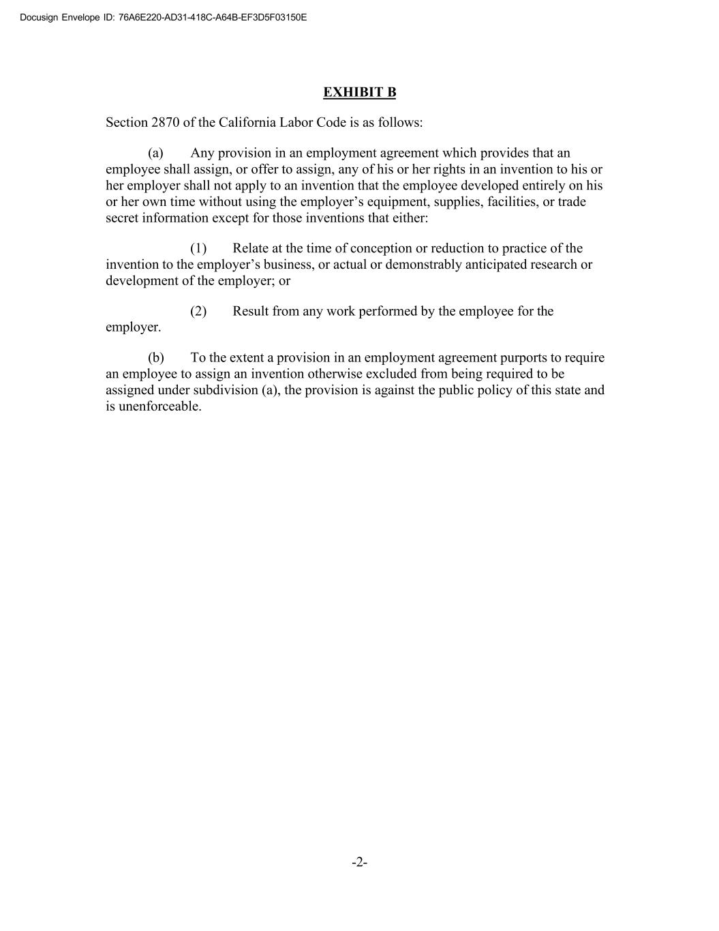
DocuSign Envelope ID: C42F0DD2-1E83-4BFC-AB03-B8EC5294DC62 si v l I : 76A6E220-AD31-418C-A64B-EF3D5F03150E EXHIBIT B Section 2870 of the California Labor Code is as follows: (a) Any provision in an employment agreement which provides that an employee shall assign, or offer to assign, any of his or her rights in an invention to his or her employer shall not apply to an invention that the employee developed entirely on his or her own time without using the employer’s equipment, supplies, facilities, or trade secret information except for those inventions that either: (1) Relate at the time of conception or reduction to practice of the invention to the employer’s business, or actual or demonstrably anticipated research or development of the employer; or (2) Result from any work performed by the employee for the employer. (b) To the extent a provision in an employment agreement purports to require an employee to assign an invention otherwise excluded from being required to be assigned under subdivision (a), the provision is against the public policy of this state and is unenforceable. -2-

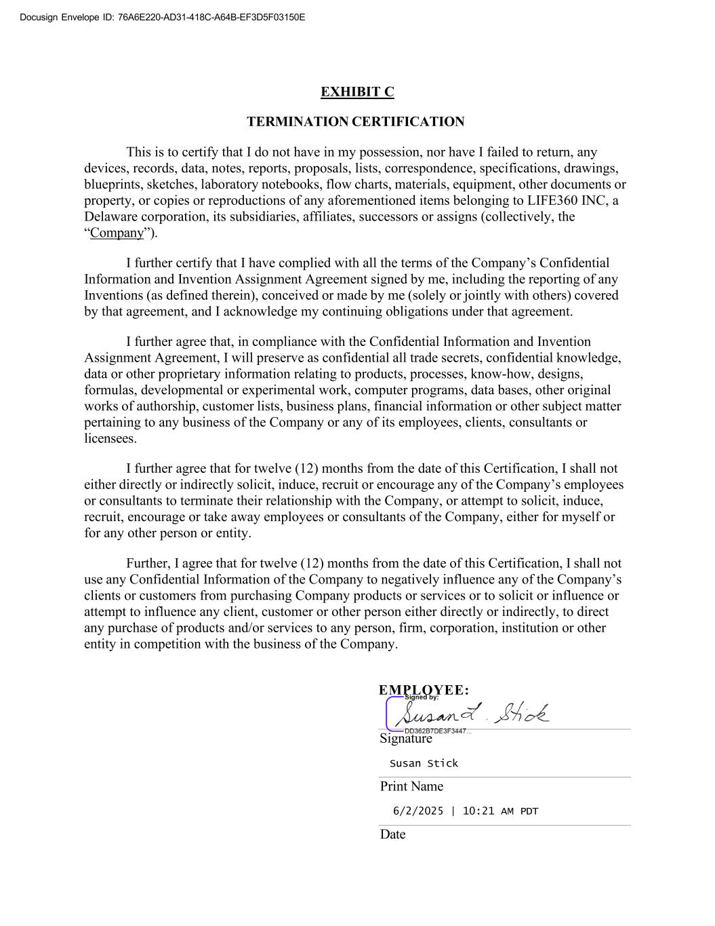
DocuSign Envelope ID: C42F0DD2-1E83-4BFC-AB03-B8EC5294DC62 si v l I : 76A6E220-AD31-418C-A64B-EF3D5F03150E EMPLOYEE: Signature EXHIBIT C TERMINATION CERTIFICATION This is to certify that I do not have in my possession, nor have I failed to return, any devices, records, data, notes, reports, proposals, lists, correspondence, specifications, drawings, blueprints, sketches, laboratory notebooks, flow charts, materials, equipment, other documents or property, or copies or reproductions of any aforementioned items belonging to LIFE360 INC, a Delaware corporation, its subsidiaries, affiliates, successors or assigns (collectively, the “Company”). I further certify that I have complied with all the terms of the Company’s Confidential Information and Invention Assignment Agreement signed by me, including the reporting of any Inventions (as defined therein), conceived or made by me (solely or jointly with others) covered by that agreement, and I acknowledge my continuing obligations under that agreement. I further agree that, in compliance with the Confidential Information and Invention Assignment Agreement, I will preserve as confidential all trade secrets, confidential knowledge, data or other proprietary information relating to products, processes, know-how, designs, formulas, developmental or experimental work, computer programs, data bases, other original works of authorship, customer lists, business plans, financial information or other subject matter pertaining to any business of the Company or any of its employees, clients, consultants or licensees. I further agree that for twelve (12) months from the date of this Certification, I shall not either directly or indirectly solicit, induce, recruit or encourage any of the Company’s employees or consultants to terminate their relationship with the Company, or attempt to solicit, induce, recruit, encourage or take away employees or consultants of the Company, either for myself or for any other person or entity. Further, I agree that for twelve (12) months from the date of this Certification, I shall not use any Confidential Information of the Company to negatively influence any of the Company’s clients or customers from purchasing Company products or services or to solicit or influence or attempt to influence any client, customer or other person either directly or indirectly, to direct any purchase of products and/or services to any person, firm, corporation, institution or other entity in competition with the business of the Company. Susan Stick Print Name 6/2/2025 | 10:21 AM PDT Date

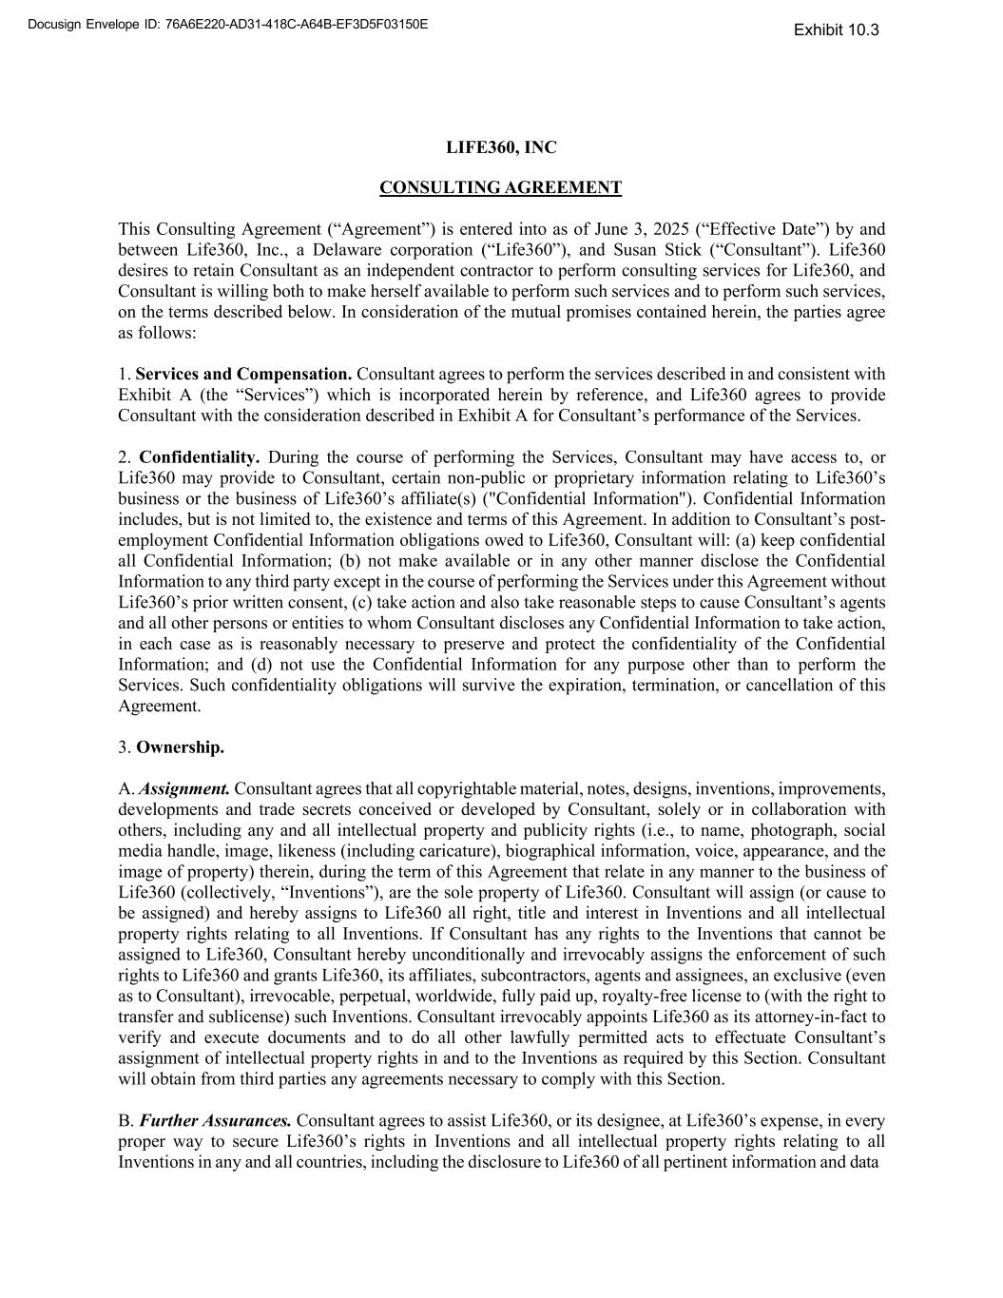
Docusign Envelope ID: 76A6E220-AD31-418C-A64B-EF3D5F03150E LIFE360, INC CONSULTING AGREEMENT This Consulting Agreement (“Agreement”) is entered into as of June 3, 2025 (“Effective Date”) by and between Life360, Inc., a Delaware corporation (“Life360”), and Susan Stick (“Consultant”). Life360 desires to retain Consultant as an independent contractor to perform consulting services for Life360, and Consultant is willing both to make herself available to perform such services and to perform such services, on the terms described below. In consideration of the mutual promises contained herein, the parties agree as follows: 1. Services and Compensation. Consultant agrees to perform the services described in and consistent with Exhibit A (the “Services”) which is incorporated herein by reference, and Life360 agrees to provide Consultant with the consideration described in Exhibit A for Consultant’s performance of the Services. 2. Confidentiality. During the course of performing the Services, Consultant may have access to, or Life360 may provide to Consultant, certain non-public or proprietary information relating to Life360’s business or the business of Life360’s affiliate(s) ("Confidential Information"). Confidential Information includes, but is not limited to, the existence and terms of this Agreement. In addition to Consultant’s post- employment Confidential Information obligations owed to Life360, Consultant will: (a) keep confidential all Confidential Information; (b) not make available or in any other manner disclose the Confidential Information to any third party except in the course of performing the Services under this Agreement without Life360’s prior written consent, (c) take action and also take reasonable steps to cause Consultant’s agents and all other persons or entities to whom Consultant discloses any Confidential Information to take action, in each case as is reasonably necessary to preserve and protect the confidentiality of the Confidential Information; and (d) not use the Confidential Information for any purpose other than to perform the Services. Such confidentiality obligations will survive the expiration, termination, or cancellation of this Agreement. 3. Ownership. A. Assignment. Consultant agrees that all copyrightable material, notes, designs, inventions, improvements, developments and trade secrets conceived or developed by Consultant, solely or in collaboration with others, including any and all intellectual property and publicity rights (i.e., to name, photograph, social media handle, image, likeness (including caricature), biographical information, voice, appearance, and the image of property) therein, during the term of this Agreement that relate in any manner to the business of Life360 (collectively, “Inventions”), are the sole property of Life360. Consultant will assign (or cause to be assigned) and hereby assigns to Life360 all right, title and interest in Inventions and all intellectual property rights relating to all Inventions. If Consultant has any rights to the Inventions that cannot be assigned to Life360, Consultant hereby unconditionally and irrevocably assigns the enforcement of such rights to Life360 and grants Life360, its affiliates, subcontractors, agents and assignees, an exclusive (even as to Consultant), irrevocable, perpetual, worldwide, fully paid up, royalty-free license to (with the right to transfer and sublicense) such Inventions. Consultant irrevocably appoints Life360 as its attorney-in-fact to verify and execute documents and to do all other lawfully permitted acts to effectuate Consultant’s assignment of intellectual property rights in and to the Inventions as required by this Section. Consultant will obtain from third parties any agreements necessary to comply with this Section. B. Further Assurances. Consultant agrees to assist Life360, or its designee, at Life360’s expense, in every proper way to secure Life360’s rights in Inventions and all intellectual property rights relating to all Inventions in any and all countries, including the disclosure to Life360 of all pertinent information and data Exhibit 10.3

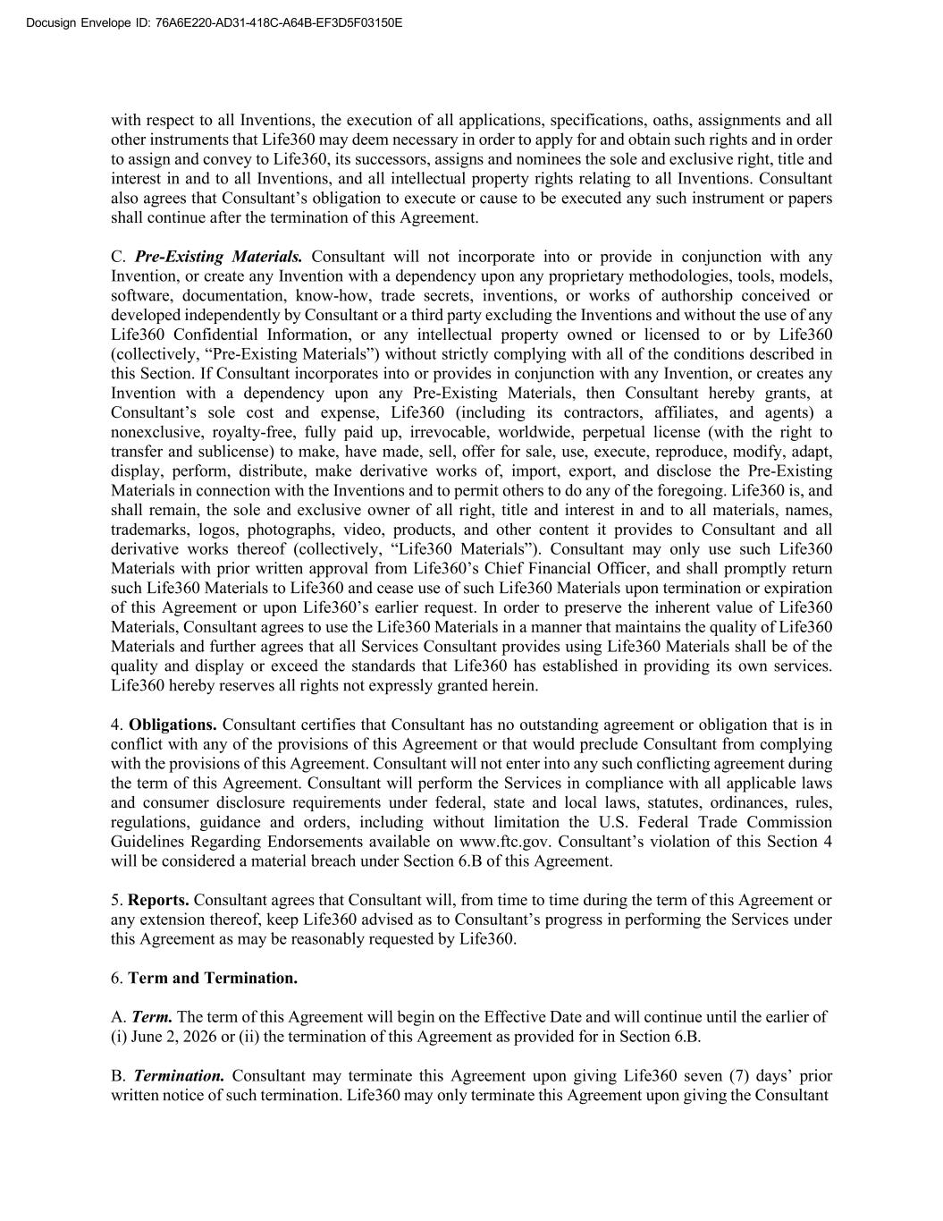
Docusign Envelope ID: 76A6E220-AD31-418C-A64B-EF3D5F03150E with respect to all Inventions, the execution of all applications, specifications, oaths, assignments and all other instruments that Life360 may deem necessary in order to apply for and obtain such rights and in order to assign and convey to Life360, its successors, assigns and nominees the sole and exclusive right, title and interest in and to all Inventions, and all intellectual property rights relating to all Inventions. Consultant also agrees that Consultant’s obligation to execute or cause to be executed any such instrument or papers shall continue after the termination of this Agreement. C. Pre-Existing Materials. Consultant will not incorporate into or provide in conjunction with any Invention, or create any Invention with a dependency upon any proprietary methodologies, tools, models, software, documentation, know-how, trade secrets, inventions, or works of authorship conceived or developed independently by Consultant or a third party excluding the Inventions and without the use of any Life360 Confidential Information, or any intellectual property owned or licensed to or by Life360 (collectively, “Pre-Existing Materials”) without strictly complying with all of the conditions described in this Section. If Consultant incorporates into or provides in conjunction with any Invention, or creates any Invention with a dependency upon any Pre-Existing Materials, then Consultant hereby grants, at Consultant’s sole cost and expense, Life360 (including its contractors, affiliates, and agents) a nonexclusive, royalty-free, fully paid up, irrevocable, worldwide, perpetual license (with the right to transfer and sublicense) to make, have made, sell, offer for sale, use, execute, reproduce, modify, adapt, display, perform, distribute, make derivative works of, import, export, and disclose the Pre-Existing Materials in connection with the Inventions and to permit others to do any of the foregoing. Life360 is, and shall remain, the sole and exclusive owner of all right, title and interest in and to all materials, names, trademarks, logos, photographs, video, products, and other content it provides to Consultant and all derivative works thereof (collectively, “Life360 Materials”). Consultant may only use such Life360 Materials with prior written approval from Life360’s Chief Financial Officer, and shall promptly return such Life360 Materials to Life360 and cease use of such Life360 Materials upon termination or expiration of this Agreement or upon Life360’s earlier request. In order to preserve the inherent value of Life360 Materials, Consultant agrees to use the Life360 Materials in a manner that maintains the quality of Life360 Materials and further agrees that all Services Consultant provides using Life360 Materials shall be of the quality and display or exceed the standards that Life360 has established in providing its own services. Life360 hereby reserves all rights not expressly granted herein. 4. Obligations. Consultant certifies that Consultant has no outstanding agreement or obligation that is in conflict with any of the provisions of this Agreement or that would preclude Consultant from complying with the provisions of this Agreement. Consultant will not enter into any such conflicting agreement during the term of this Agreement. Consultant will perform the Services in compliance with all applicable laws and consumer disclosure requirements under federal, state and local laws, statutes, ordinances, rules, regulations, guidance and orders, including without limitation the U.S. Federal Trade Commission Guidelines Regarding Endorsements available on www.ftc.gov. Consultant’s violation of this Section 4 will be considered a material breach under Section 6.B of this Agreement. 5. Reports. Consultant agrees that Consultant will, from time to time during the term of this Agreement or any extension thereof, keep Life360 advised as to Consultant’s progress in performing the Services under this Agreement as may be reasonably requested by Life360. 6. Term and Termination. A. Term. The term of this Agreement will begin on the Effective Date and will continue until the earlier of (i) June 2, 2026 or (ii) the termination of this Agreement as provided for in Section 6.B. B. Termination. Consultant may terminate this Agreement upon giving Life360 seven (7) days’ prior written notice of such termination. Life360 may only terminate this Agreement upon giving the Consultant

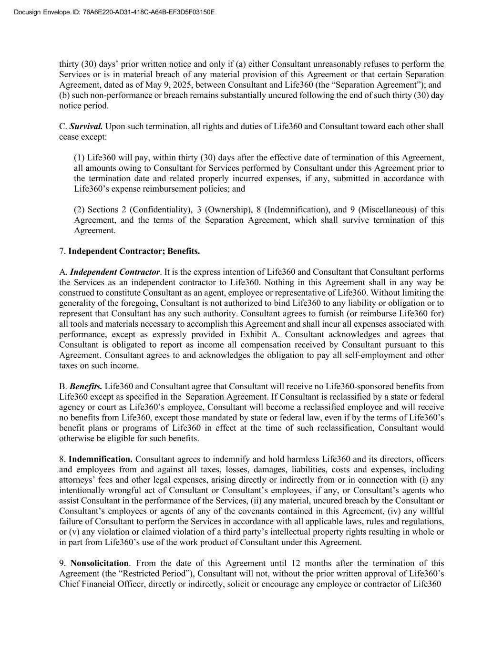
Docusign Envelope ID: 76A6E220-AD31-418C-A64B-EF3D5F03150E thirty (30) days’ prior written notice and only if (a) either Consultant unreasonably refuses to perform the Services or is in material breach of any material provision of this Agreement or that certain Separation Agreement, dated as of May 9, 2025, between Consultant and Life360 (the “Separation Agreement”); and (b) such non-performance or breach remains substantially uncured following the end of such thirty (30) day notice period. C. Survival. Upon such termination, all rights and duties of Life360 and Consultant toward each other shall cease except: (1) Life360 will pay, within thirty (30) days after the effective date of termination of this Agreement, all amounts owing to Consultant for Services performed by Consultant under this Agreement prior to the termination date and related properly incurred expenses, if any, submitted in accordance with Life360’s expense reimbursement policies; and (2) Sections 2 (Confidentiality), 3 (Ownership), 8 (Indemnification), and 9 (Miscellaneous) of this Agreement, and the terms of the Separation Agreement, which shall survive termination of this Agreement. 7. Independent Contractor; Benefits. A. Independent Contractor. It is the express intention of Life360 and Consultant that Consultant performs the Services as an independent contractor to Life360. Nothing in this Agreement shall in any way be construed to constitute Consultant as an agent, employee or representative of Life360. Without limiting the generality of the foregoing, Consultant is not authorized to bind Life360 to any liability or obligation or to represent that Consultant has any such authority. Consultant agrees to furnish (or reimburse Life360 for) all tools and materials necessary to accomplish this Agreement and shall incur all expenses associated with performance, except as expressly provided in Exhibit A. Consultant acknowledges and agrees that Consultant is obligated to report as income all compensation received by Consultant pursuant to this Agreement. Consultant agrees to and acknowledges the obligation to pay all self-employment and other taxes on such income. B. Benefits. Life360 and Consultant agree that Consultant will receive no Life360-sponsored benefits from Life360 except as specified in the Separation Agreement. If Consultant is reclassified by a state or federal agency or court as Life360’s employee, Consultant will become a reclassified employee and will receive no benefits from Life360, except those mandated by state or federal law, even if by the terms of Life360’s benefit plans or programs of Life360 in effect at the time of such reclassification, Consultant would otherwise be eligible for such benefits. 8. Indemnification. Consultant agrees to indemnify and hold harmless Life360 and its directors, officers and employees from and against all taxes, losses, damages, liabilities, costs and expenses, including attorneys’ fees and other legal expenses, arising directly or indirectly from or in connection with (i) any intentionally wrongful act of Consultant or Consultant’s employees, if any, or Consultant’s agents who assist Consultant in the performance of the Services, (ii) any material, uncured breach by the Consultant or Consultant’s employees or agents of any of the covenants contained in this Agreement, (iv) any willful failure of Consultant to perform the Services in accordance with all applicable laws, rules and regulations, or (v) any violation or claimed violation of a third party’s intellectual property rights resulting in whole or in part from Life360’s use of the work product of Consultant under this Agreement. 9. Nonsolicitation. From the date of this Agreement until 12 months after the termination of this Agreement (the “Restricted Period”), Consultant will not, without the prior written approval of Life360’s Chief Financial Officer, directly or indirectly, solicit or encourage any employee or contractor of Life360

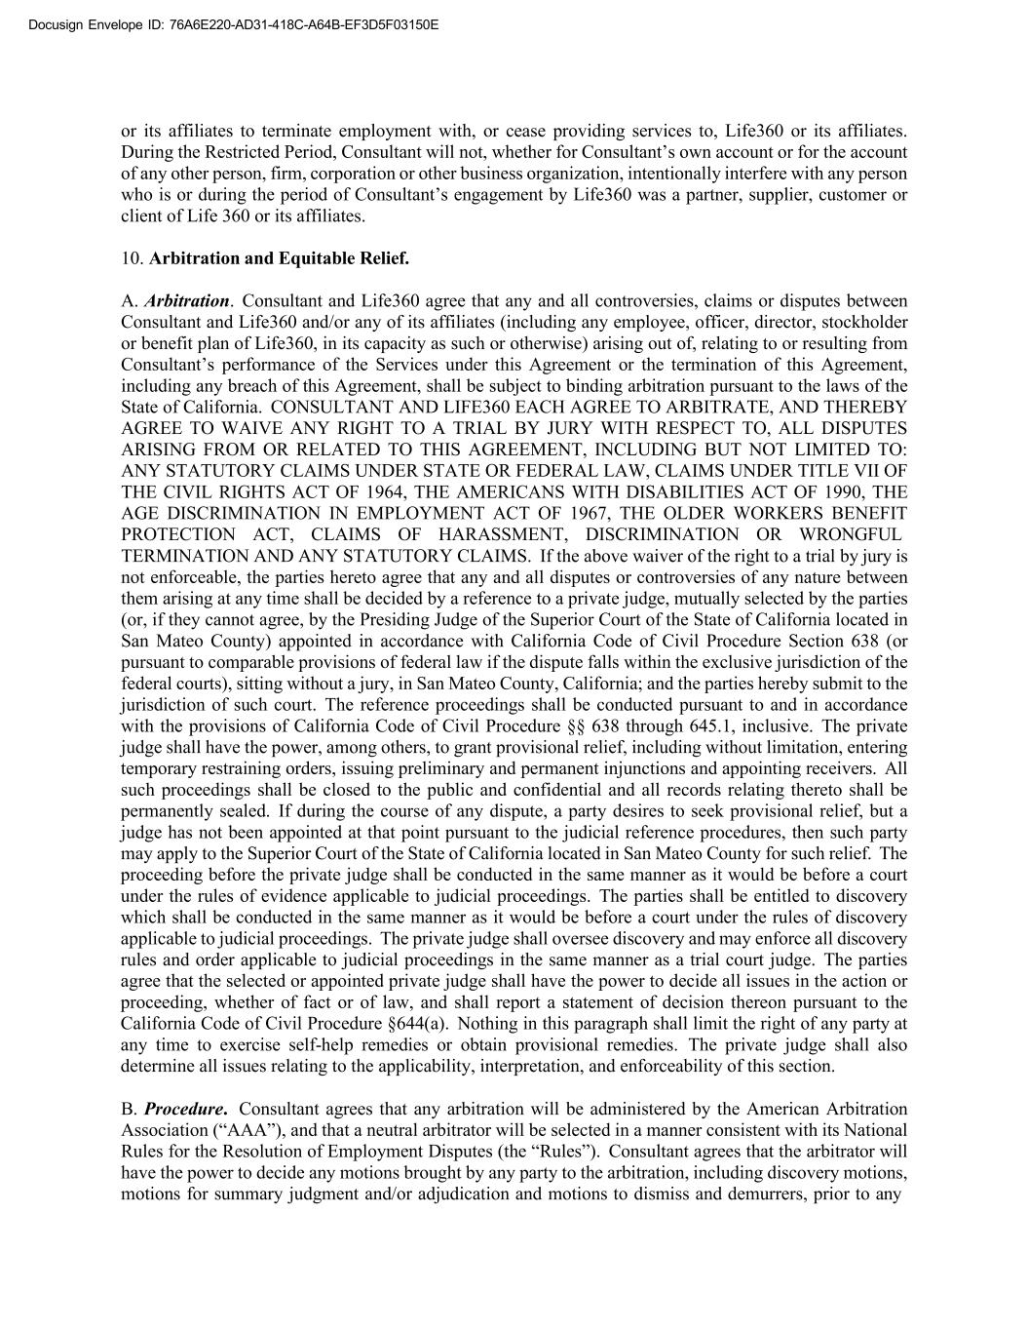
Docusign Envelope ID: 76A6E220-AD31-418C-A64B-EF3D5F03150E or its affiliates to terminate employment with, or cease providing services to, Life360 or its affiliates. During the Restricted Period, Consultant will not, whether for Consultant’s own account or for the account of any other person, firm, corporation or other business organization, intentionally interfere with any person who is or during the period of Consultant’s engagement by Life360 was a partner, supplier, customer or client of Life 360 or its affiliates. 10. Arbitration and Equitable Relief. A. Arbitration. Consultant and Life360 agree that any and all controversies, claims or disputes between Consultant and Life360 and/or any of its affiliates (including any employee, officer, director, stockholder or benefit plan of Life360, in its capacity as such or otherwise) arising out of, relating to or resulting from Consultant’s performance of the Services under this Agreement or the termination of this Agreement, including any breach of this Agreement, shall be subject to binding arbitration pursuant to the laws of the State of California. CONSULTANT AND LIFE360 EACH AGREE TO ARBITRATE, AND THEREBY AGREE TO WAIVE ANY RIGHT TO A TRIAL BY JURY WITH RESPECT TO, ALL DISPUTES ARISING FROM OR RELATED TO THIS AGREEMENT, INCLUDING BUT NOT LIMITED TO: ANY STATUTORY CLAIMS UNDER STATE OR FEDERAL LAW, CLAIMS UNDER TITLE VII OF THE CIVIL RIGHTS ACT OF 1964, THE AMERICANS WITH DISABILITIES ACT OF 1990, THE AGE DISCRIMINATION IN EMPLOYMENT ACT OF 1967, THE OLDER WORKERS BENEFIT PROTECTION ACT, CLAIMS OF HARASSMENT, DISCRIMINATION OR WRONGFUL TERMINATION AND ANY STATUTORY CLAIMS. If the above waiver of the right to a trial by jury is not enforceable, the parties hereto agree that any and all disputes or controversies of any nature between them arising at any time shall be decided by a reference to a private judge, mutually selected by the parties (or, if they cannot agree, by the Presiding Judge of the Superior Court of the State of California located in San Mateo County) appointed in accordance with California Code of Civil Procedure Section 638 (or pursuant to comparable provisions of federal law if the dispute falls within the exclusive jurisdiction of the federal courts), sitting without a jury, in San Mateo County, California; and the parties hereby submit to the jurisdiction of such court. The reference proceedings shall be conducted pursuant to and in accordance with the provisions of California Code of Civil Procedure §§ 638 through 645.1, inclusive. The private judge shall have the power, among others, to grant provisional relief, including without limitation, entering temporary restraining orders, issuing preliminary and permanent injunctions and appointing receivers. All such proceedings shall be closed to the public and confidential and all records relating thereto shall be permanently sealed. If during the course of any dispute, a party desires to seek provisional relief, but a judge has not been appointed at that point pursuant to the judicial reference procedures, then such party may apply to the Superior Court of the State of California located in San Mateo County for such relief. The proceeding before the private judge shall be conducted in the same manner as it would be before a court under the rules of evidence applicable to judicial proceedings. The parties shall be entitled to discovery which shall be conducted in the same manner as it would be before a court under the rules of discovery applicable to judicial proceedings. The private judge shall oversee discovery and may enforce all discovery rules and order applicable to judicial proceedings in the same manner as a trial court judge. The parties agree that the selected or appointed private judge shall have the power to decide all issues in the action or proceeding, whether of fact or of law, and shall report a statement of decision thereon pursuant to the California Code of Civil Procedure §644(a). Nothing in this paragraph shall limit the right of any party at any time to exercise self-help remedies or obtain provisional remedies. The private judge shall also determine all issues relating to the applicability, interpretation, and enforceability of this section. B. Procedure. Consultant agrees that any arbitration will be administered by the American Arbitration Association (“AAA”), and that a neutral arbitrator will be selected in a manner consistent with its National Rules for the Resolution of Employment Disputes (the “Rules”). Consultant agrees that the arbitrator will have the power to decide any motions brought by any party to the arbitration, including discovery motions, motions for summary judgment and/or adjudication and motions to dismiss and demurrers, prior to any

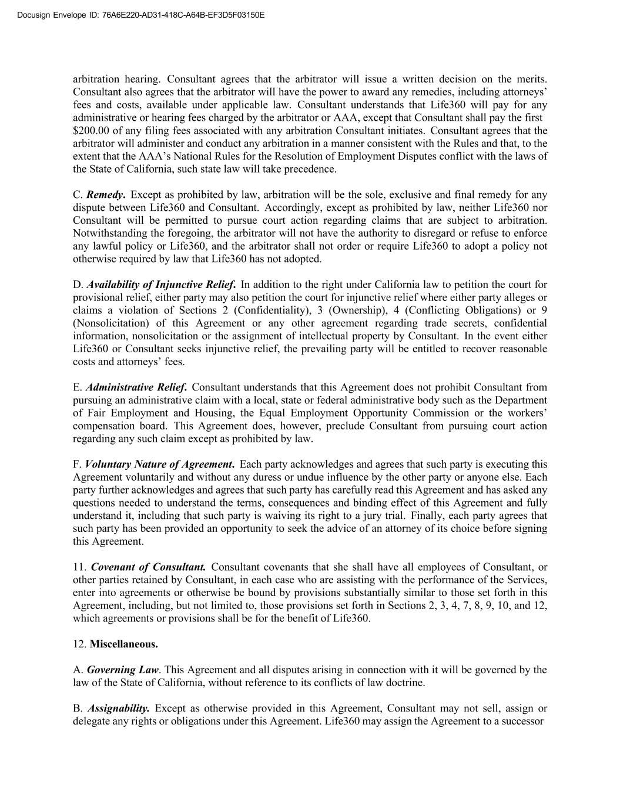
Docusign Envelope ID: 76A6E220-AD31-418C-A64B-EF3D5F03150E arbitration hearing. Consultant agrees that the arbitrator will issue a written decision on the merits. Consultant also agrees that the arbitrator will have the power to award any remedies, including attorneys’ fees and costs, available under applicable law. Consultant understands that Life360 will pay for any administrative or hearing fees charged by the arbitrator or AAA, except that Consultant shall pay the first $200.00 of any filing fees associated with any arbitration Consultant initiates. Consultant agrees that the arbitrator will administer and conduct any arbitration in a manner consistent with the Rules and that, to the extent that the AAA’s National Rules for the Resolution of Employment Disputes conflict with the laws of the State of California, such state law will take precedence. C. Remedy. Except as prohibited by law, arbitration will be the sole, exclusive and final remedy for any dispute between Life360 and Consultant. Accordingly, except as prohibited by law, neither Life360 nor Consultant will be permitted to pursue court action regarding claims that are subject to arbitration. Notwithstanding the foregoing, the arbitrator will not have the authority to disregard or refuse to enforce any lawful policy or Life360, and the arbitrator shall not order or require Life360 to adopt a policy not otherwise required by law that Life360 has not adopted. D. Availability of Injunctive Relief. In addition to the right under California law to petition the court for provisional relief, either party may also petition the court for injunctive relief where either party alleges or claims a violation of Sections 2 (Confidentiality), 3 (Ownership), 4 (Conflicting Obligations) or 9 (Nonsolicitation) of this Agreement or any other agreement regarding trade secrets, confidential information, nonsolicitation or the assignment of intellectual property by Consultant. In the event either Life360 or Consultant seeks injunctive relief, the prevailing party will be entitled to recover reasonable costs and attorneys’ fees. E. Administrative Relief. Consultant understands that this Agreement does not prohibit Consultant from pursuing an administrative claim with a local, state or federal administrative body such as the Department of Fair Employment and Housing, the Equal Employment Opportunity Commission or the workers’ compensation board. This Agreement does, however, preclude Consultant from pursuing court action regarding any such claim except as prohibited by law. F. Voluntary Nature of Agreement. Each party acknowledges and agrees that such party is executing this Agreement voluntarily and without any duress or undue influence by the other party or anyone else. Each party further acknowledges and agrees that such party has carefully read this Agreement and has asked any questions needed to understand the terms, consequences and binding effect of this Agreement and fully understand it, including that such party is waiving its right to a jury trial. Finally, each party agrees that such party has been provided an opportunity to seek the advice of an attorney of its choice before signing this Agreement. 11. Covenant of Consultant. Consultant covenants that she shall have all employees of Consultant, or other parties retained by Consultant, in each case who are assisting with the performance of the Services, enter into agreements or otherwise be bound by provisions substantially similar to those set forth in this Agreement, including, but not limited to, those provisions set forth in Sections 2, 3, 4, 7, 8, 9, 10, and 12, which agreements or provisions shall be for the benefit of Life360. 12. Miscellaneous. A. Governing Law. This Agreement and all disputes arising in connection with it will be governed by the law of the State of California, without reference to its conflicts of law doctrine. B. Assignability. Except as otherwise provided in this Agreement, Consultant may not sell, assign or delegate any rights or obligations under this Agreement. Life360 may assign the Agreement to a successor

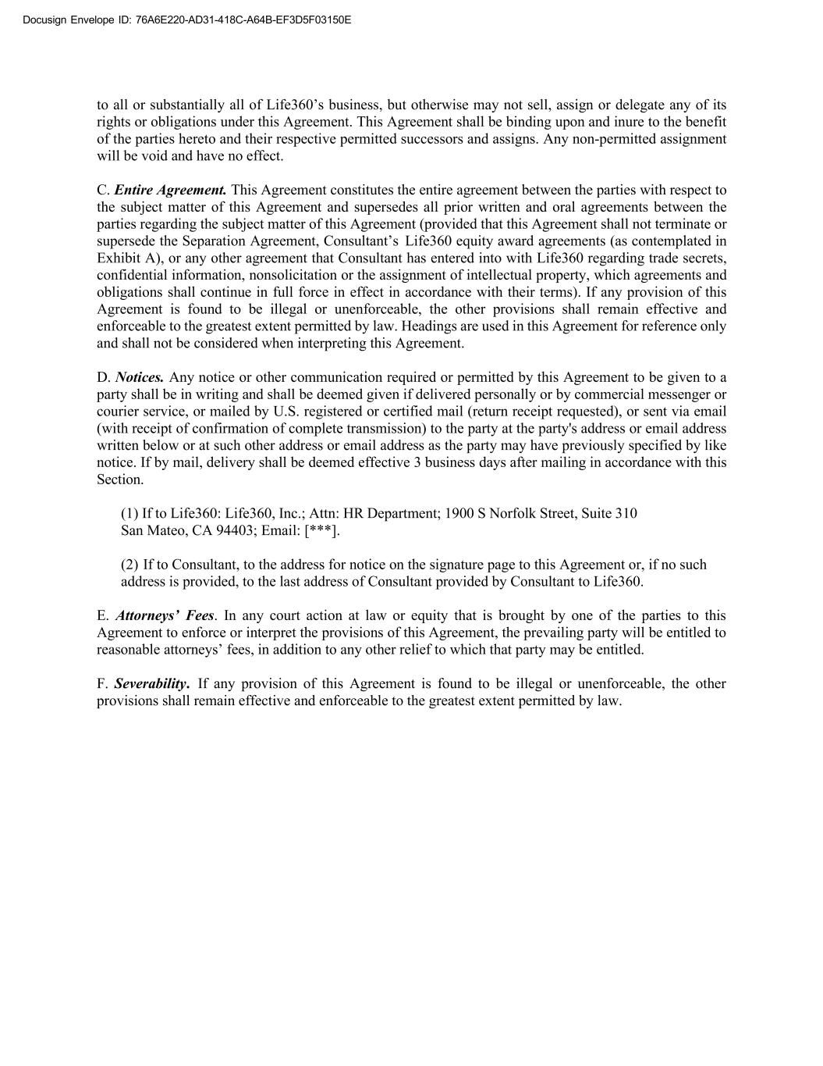
Docusign Envelope ID: 76A6E220-AD31-418C-A64B-EF3D5F03150E to all or substantially all of Life360’s business, but otherwise may not sell, assign or delegate any of its rights or obligations under this Agreement. This Agreement shall be binding upon and inure to the benefit of the parties hereto and their respective permitted successors and assigns. Any non-permitted assignment will be void and have no effect. C. Entire Agreement. This Agreement constitutes the entire agreement between the parties with respect to the subject matter of this Agreement and supersedes all prior written and oral agreements between the parties regarding the subject matter of this Agreement (provided that this Agreement shall not terminate or supersede the Separation Agreement, Consultant’s Life360 equity award agreements (as contemplated in Exhibit A), or any other agreement that Consultant has entered into with Life360 regarding trade secrets, confidential information, nonsolicitation or the assignment of intellectual property, which agreements and obligations shall continue in full force in effect in accordance with their terms). If any provision of this Agreement is found to be illegal or unenforceable, the other provisions shall remain effective and enforceable to the greatest extent permitted by law. Headings are used in this Agreement for reference only and shall not be considered when interpreting this Agreement. D. Notices. Any notice or other communication required or permitted by this Agreement to be given to a party shall be in writing and shall be deemed given if delivered personally or by commercial messenger or courier service, or mailed by U.S. registered or certified mail (return receipt requested), or sent via email (with receipt of confirmation of complete transmission) to the party at the party's address or email address written below or at such other address or email address as the party may have previously specified by like notice. If by mail, delivery shall be deemed effective 3 business days after mailing in accordance with this Section. (1) If to Life360: Life360, Inc.; Attn: HR Department; 1900 S Norfolk Street, Suite 310 San Mateo, CA 94403; Email: [***]. (2) If to Consultant, to the address for notice on the signature page to this Agreement or, if no such address is provided, to the last address of Consultant provided by Consultant to Life360. E. Attorneys’ Fees. In any court action at law or equity that is brought by one of the parties to this Agreement to enforce or interpret the provisions of this Agreement, the prevailing party will be entitled to reasonable attorneys’ fees, in addition to any other relief to which that party may be entitled. F. Severability. If any provision of this Agreement is found to be illegal or unenforceable, the other provisions shall remain effective and enforceable to the greatest extent permitted by law.

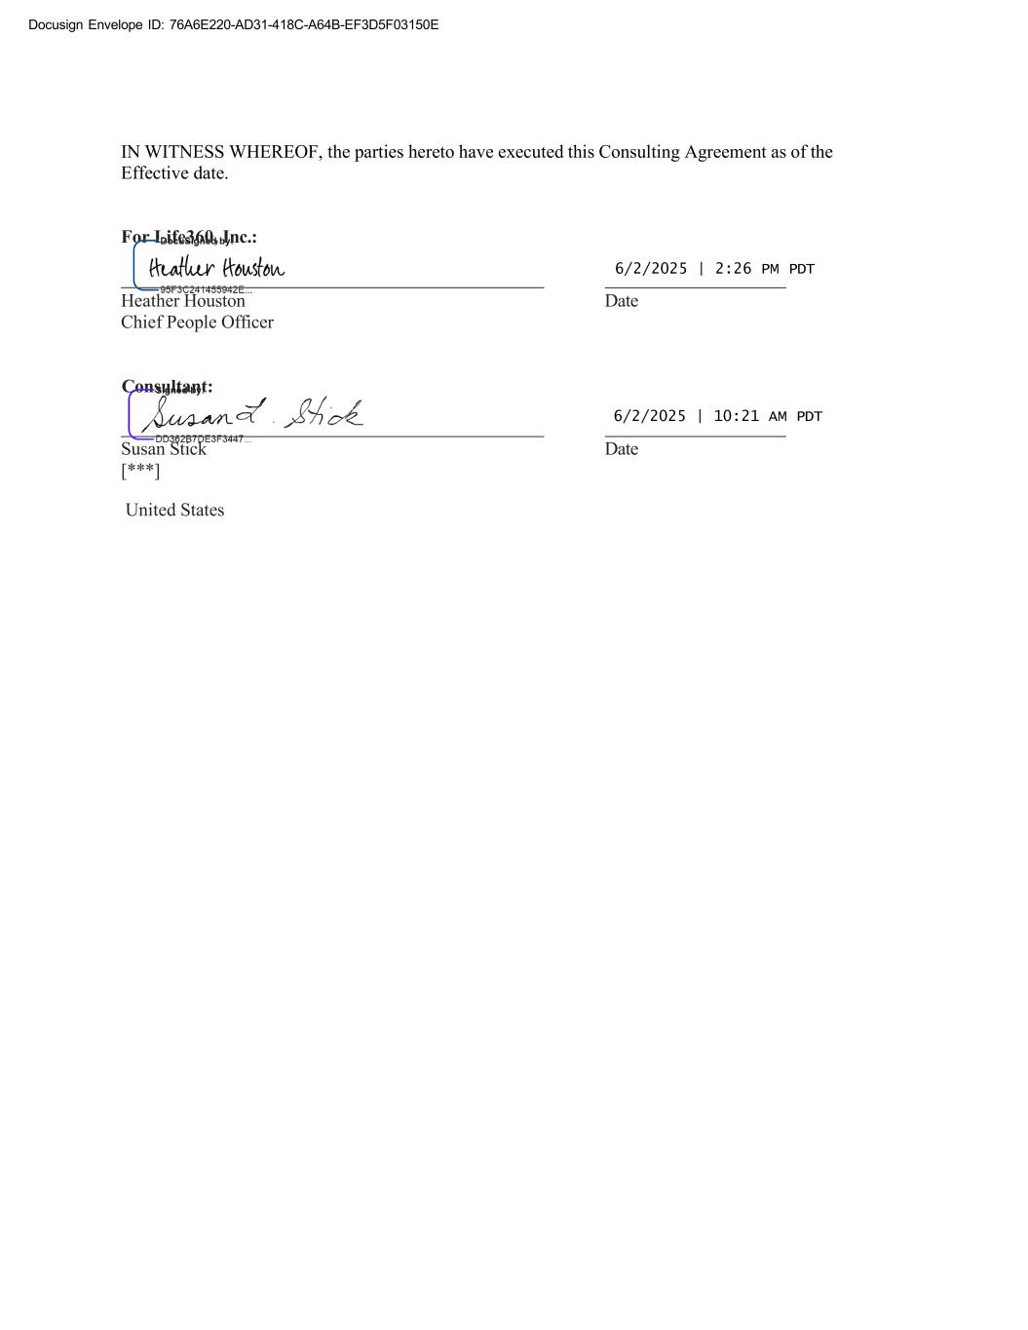
Docusign Envelope ID: 76A6E220-AD31-418C-A64B-EF3D5F03150E Consultant: For Life360, Inc.: IN WITNESS WHEREOF, the parties hereto have executed this Consulting Agreement as of the Effective date. 6/2/2025 | 2:26 PM PDT Heather Houston Date Chief People Officer 6/2/2025 | 10:21 AM PDT Susan Stick Date [***] United States

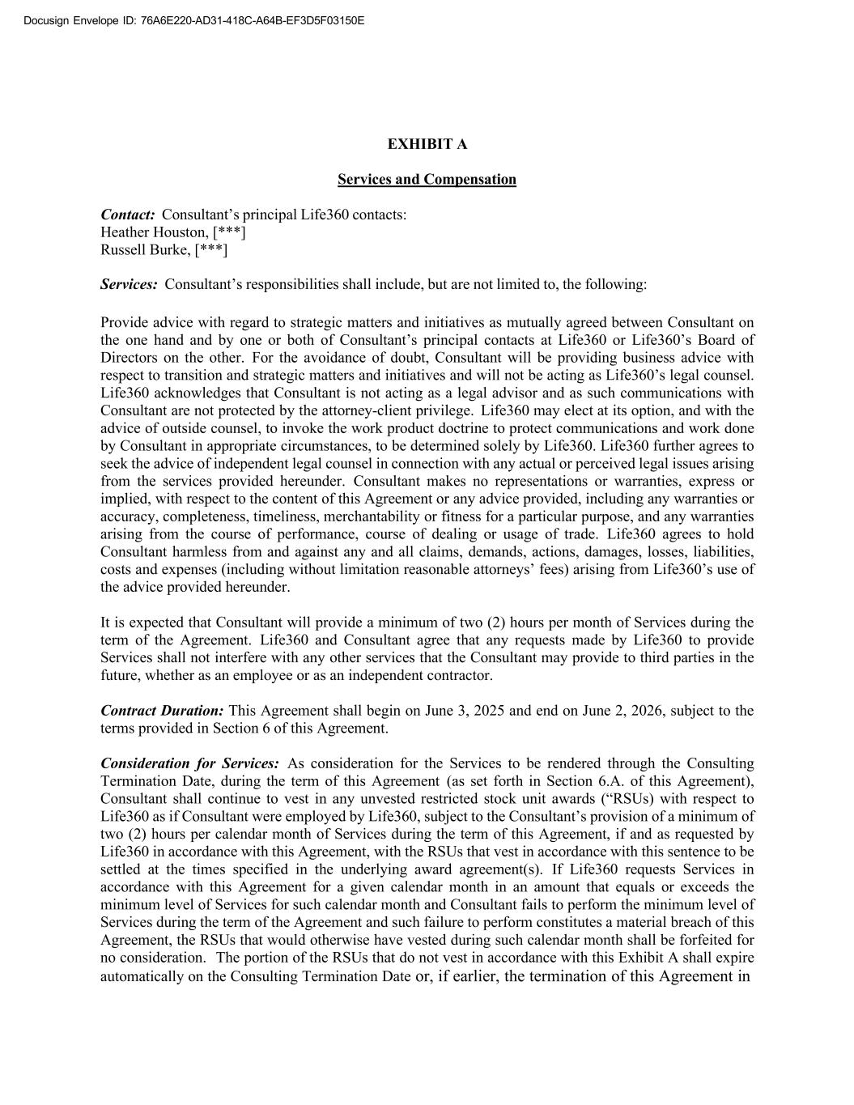
Docusign Envelope ID: 76A6E220-AD31-418C-A64B-EF3D5F03150E EXHIBIT A Services and Compensation Contact: Consultant’s principal Life360 contacts: Heather Houston, [***] Russell Burke, [***] Services: Consultant’s responsibilities shall include, but are not limited to, the following: Provide advice with regard to strategic matters and initiatives as mutually agreed between Consultant on the one hand and by one or both of Consultant’s principal contacts at Life360 or Life360’s Board of Directors on the other. For the avoidance of doubt, Consultant will be providing business advice with respect to transition and strategic matters and initiatives and will not be acting as Life360’s legal counsel. Life360 acknowledges that Consultant is not acting as a legal advisor and as such communications with Consultant are not protected by the attorney-client privilege. Life360 may elect at its option, and with the advice of outside counsel, to invoke the work product doctrine to protect communications and work done by Consultant in appropriate circumstances, to be determined solely by Life360. Life360 further agrees to seek the advice of independent legal counsel in connection with any actual or perceived legal issues arising from the services provided hereunder. Consultant makes no representations or warranties, express or implied, with respect to the content of this Agreement or any advice provided, including any warranties or accuracy, completeness, timeliness, merchantability or fitness for a particular purpose, and any warranties arising from the course of performance, course of dealing or usage of trade. Life360 agrees to hold Consultant harmless from and against any and all claims, demands, actions, damages, losses, liabilities, costs and expenses (including without limitation reasonable attorneys’ fees) arising from Life360’s use of the advice provided hereunder. It is expected that Consultant will provide a minimum of two (2) hours per month of Services during the term of the Agreement. Life360 and Consultant agree that any requests made by Life360 to provide Services shall not interfere with any other services that the Consultant may provide to third parties in the future, whether as an employee or as an independent contractor. Contract Duration: This Agreement shall begin on June 3, 2025 and end on June 2, 2026, subject to the terms provided in Section 6 of this Agreement. Consideration for Services: As consideration for the Services to be rendered through the Consulting Termination Date, during the term of this Agreement (as set forth in Section 6.A. of this Agreement), Consultant shall continue to vest in any unvested restricted stock unit awards (“RSUs) with respect to Life360 as if Consultant were employed by Life360, subject to the Consultant’s provision of a minimum of two (2) hours per calendar month of Services during the term of this Agreement, if and as requested by Life360 in accordance with this Agreement, with the RSUs that vest in accordance with this sentence to be settled at the times specified in the underlying award agreement(s). If Life360 requests Services in accordance with this Agreement for a given calendar month in an amount that equals or exceeds the minimum level of Services for such calendar month and Consultant fails to perform the minimum level of Services during the term of the Agreement and such failure to perform constitutes a material breach of this Agreement, the RSUs that would otherwise have vested during such calendar month shall be forfeited for no consideration. The portion of the RSUs that do not vest in accordance with this Exhibit A shall expire automatically on the Consulting Termination Date or, if earlier, the termination of this Agreement in


Docusign Envelope ID: 76A6E220-AD31-418C-A64B-EF3D5F03150E accordance with its terms. Any agreement(s) between Consultant and Life360 governing Consultant’s RSUs will remain in full force and effect, and Consultant agrees to remain bound by those agreement(s) except to the extent that such agreement(s) are inconsistent with the Agreement. Reporting of Hours of Service: Consultant will report hours of Service performed to Life360 following the end of each calendar month during which this Agreement is in effect for some or all of such calendar month. Such reports of hours of Service performed (including zero (0) hours for a month in which no Services were performed) shall be submitted within an administratively reasonable period of time following the end of the month.

Exhibit 31.1
CERTIFICATION OF CHIEF EXECUTIVE OFFICER
PURSUANT TO EXCHANGE ACT RULE 13a-14(a)/15d-14(a)
AS ADOPTED PURSUANT TO SECTION 302
OF THE SARBANES-OXLEY ACT OF 2002

I, Chris Hulls, certify that:
1. I have reviewed this Quarterly Report on Form 10-Q of Life360, Inc. (the “registrant”);
2. Based on my knowledge, this report does not contain any untrue statement of a material fact or omit to state a material fact necessary to make the statements made, in light of the circumstances under which such statements were made, not misleading with respect to the period covered by this report;
3. Based on my knowledge, the financial statements, and other financial information included in this report, fairly present in all material respects the financial condition, results of operations and cash flows of the registrant as of, and for, the periods presented in this report;
4. The registrant's other certifying officer and I are responsible for establishing and maintaining disclosure controls and procedures (as defined in Exchange Act Rules 13a-15(e) and 15d-15(e)) and internal control over financial reporting (as defined in Exchange Act Rules 13a-15(f) and 15d-15(f)) for the registrant and have:
a) Designed such disclosure controls and procedures, or caused such disclosure controls and procedures to be designed under our supervision, to ensure that material information relating to the registrant, including its consolidated subsidiaries, is made known to us by others within those entities, particularly during the period in which this report is being prepared;
b) Designed such internal control over financial reporting, or caused such internal control over financial reporting to be designed under our supervision, to provide reasonable assurance regarding the reliability of financial reporting and the preparation of financial statements for external purposes in accordance with generally accepted accounting principles;
c) Evaluated the effectiveness of the registrant's disclosure controls and procedures and presented in this report our conclusions about the effectiveness of the disclosure controls and procedures, as of the end of the period covered by this report based on such evaluation; and
d) Disclosed in this report any change in the registrant’s internal control over financial reporting that occurred during the registrant’s most recent fiscal quarter (the registrant’s fourth fiscal quarter in the case of an annual report) that has materially affected, or is reasonably likely to materially affect, the registrant’s internal control over financial reporting; and
5. The registrant's other certifying officer and I have disclosed, based on our most recent evaluation of internal control over financial reporting, to the registrant's auditors and the audit committee of the registrant's board of directors (or persons performing the equivalent functions):
a) All significant deficiencies and material weaknesses in the design or operation of internal control over financial reporting which are reasonably likely to adversely affect the registrant's ability to record, process, summarize and report financial information; and
b) Any fraud, whether or not material, that involves management or other employees who have a significant role in the registrant's internal control over financial reporting.
Dated: |  |  | August 11, 2025 |  |  | /s/ |  |  | Chris Hulls
 |  |  |  |  |  |  |  |  | Chris Hulls
 |  |  |  |  |  |  |  |  | Chief Executive Officer

Exhibit 31.2
CERTIFICATION OF CHIEF FINANCIAL OFFICER
PURSUANT TO EXCHANGE ACT RULE 13a-14(a)/15d-14(a)
AS ADOPTED PURSUANT TO SECTION 302
OF THE SARBANES-OXLEY ACT OF 2002

I, Russell Burke, certify that:
1. I have reviewed this Quarterly Report on Form 10-Q of Life360, Inc. (the “registrant”);
2. Based on my knowledge, this report does not contain any untrue statement of a material fact or omit to state a material fact necessary to make the statements made, in light of the circumstances under which such statements were made, not misleading with respect to the period covered by this report;
3. Based on my knowledge, the financial statements, and other financial information included in this report, fairly present in all material respects the financial condition, results of operations and cash flows of the registrant as of, and for, the periods presented in this report;
4. The registrant's other certifying officer and I are responsible for establishing and maintaining disclosure controls and procedures (as defined in Exchange Act Rules 13a-15(e) and 15d-15(e)) and internal control over financial reporting (as defined in Exchange Act Rules 13a-15(f) and 15d-15(f)) for the registrant and have:
a) Designed such disclosure controls and procedures, or caused such disclosure controls and procedures to be designed under our supervision, to ensure that material information relating to the registrant, including its consolidated subsidiaries, is made known to us by others within those entities, particularly during the period in which this report is being prepared;
b) Designed such internal control over financial reporting, or caused such internal control over financial reporting to be designed under our supervision, to provide reasonable assurance regarding the reliability of financial reporting and the preparation of financial statements for external purposes in accordance with generally accepted accounting principles;
c) Evaluated the effectiveness of the registrant's disclosure controls and procedures and presented in this report our conclusions about the effectiveness of the disclosure controls and procedures, as of the end of the period covered by this report based on such evaluation; and
d) Disclosed in this report any change in the registrant’s internal control over financial reporting that occurred during the registrant’s most recent fiscal quarter (the registrant’s fourth fiscal quarter in the case of an annual report) that has materially affected, or is reasonably likely to materially affect, the registrant’s internal control over financial reporting; and
5. The registrant's other certifying officer and I have disclosed, based on our most recent evaluation of internal control over financial reporting, to the registrant's auditors and the audit committee of the registrant's board of directors (or persons performing the equivalent functions):
a) All significant deficiencies and material weaknesses in the design or operation of internal control over financial reporting which are reasonably likely to adversely affect the registrant's ability to record, process, summarize and report financial information; and
b) Any fraud, whether or not material, that involves management or other employees who have a significant role in the registrant's internal control over financial reporting.
Dated: |  |  | August 11, 2025 |  |  | /s/ |  |  | Russell Burke
 |  |  |  |  |  |  |  |  | Russell Burke
 |  |  |  |  |  |  |  |  | Chief Financial Officer

Exhibit 32.1

CERTIFICATION
PURSUANT TO 18 U.S.C. SECTION 1350
AS ADOPTED PURSUANT TO
SECTION 906 OF THE SARBANES-OXLEY ACT OF 2002

In connection with the accompanying Quarterly Report of Life360, Inc. (the “Company”), on Form 10-Q for the quarter ended June 30, 2025 (the “Report”), I, Chris Hulls, Chief Executive Officer of the Company, hereby certify pursuant to 18 U.S.C. § 1350, as adopted pursuant to § 906 of the Sarbanes-Oxley Act of 2002 that, to my knowledge:
(1)the Report fully complies with the requirements of section 13(a) or 15(d) of the Securities Exchange Act of 1934; and
(2)the information contained in the Report fairly presents, in all material respects, the financial condition and results of operations of the Company.

Dated: |  |  | August 11, 2025 |  |  | /s/ |  |  | Chris Hulls
 |  |  |  |  |  |  |  |  | Chris Hulls
 |  |  |  |  |  |  |  |  | Chief Executive Officer

Exhibit 32.2

CERTIFICATION
PURSUANT TO 18 U.S.C. SECTION 1350
AS ADOPTED PURSUANT TO
SECTION 906 OF THE SARBANES-OXLEY ACT OF 2002

In connection with the accompanying Quarterly Report of Life360, Inc. (the “Company”), on Form 10-Q for the quarter ended June 30, 2025 (the “Report”), I, Russell Burke, Chief Financial Officer of the Company, hereby certify pursuant to 18 U.S.C. § 1350, as adopted pursuant to § 906 of the Sarbanes-Oxley Act of 2002 that, to my knowledge:
(1)the Report fully complies with the requirements of section 13(a) or 15(d) of the Securities Exchange Act of 1934; and
(2)the information contained in the Report fairly presents, in all material respects, the financial condition and results of operations of the Company.

Dated: |  |  | August 11, 2025 |  |  | /s/ |  |  | Russell Burke
 |  |  |  |  |  |  |  |  | Russell Burke
 |  |  |  |  |  |  |  |  | Chief Financial Officer

