UNITED STATES
SECURITIES AND EXCHANGE COMMISSION
Washington, D.C. 20549
______________

FORM 8-K

CURRENT REPORT
Pursuant to Section 13 or 15(d) of the
Securities Exchange Act of 1934

Date of Report (Date of earliest event reported): May 11, 2026

Life360, Inc.
(Exact name of registrant as specified in its charter)
Delaware |  |  | 001-42120 |  |  | 26-0197666
(State or other jurisdiction of  incorporation or organization) |  |  | (Commission File Number) |  |  | (I.R.S. Employer  Identification No.)

1900 South Norfolk Street, Suite 310
San Mateo, CA 94403
(Address of principal executive offices, including zip code)(1)
(415) 484-5244
(Registrant’s telephone number, including area code)
Not applicable.
(Former name or former address, if changed since last report)
______________

Check the appropriate box below if the Form 8-K filing is intended to simultaneously satisfy the filing obligation of the registrant under any of the following provisions:
☐ |  |  | Written communications pursuant to Rule 425 under the Securities Act (17 CFR 230.425)
☐ |  |  | Soliciting material pursuant to Rule 14a-12 under the Exchange Act (17 CFR 240.14a-12)
☐ |  |  | Pre-commencement communications pursuant to Rule 14d-2(b) under the Exchange Act (17 CFR 240.14d-2(b))
☐ |  |  | Pre-commencement communications pursuant to Rule 13e-4(c) under the Exchange Act (17 CFR 240.13e-4(c))

Title of each class |  |  | Trading Symbol(s) |  |  | Name of each exchange on which registered
Common Stock, $0.001 par value per share |  |  | LIF |  |  | The Nasdaq Stock Market LLC

Indicate by check mark whether the registrant is an emerging growth company as defined in Rule 405 of the Securities Act of 1933 (§230.405 of this chapter) or Rule 12b-2 of the Securities Exchange Act of 1934 (§240.12b-2 of this chapter).

Emerging growth company ☐
If an emerging growth company, indicate by check mark if the registrant has elected not to use the extended transition period for complying with any new or revised financial accounting standards provided pursuant to Section 13(a) of the Exchange Act. ☐
____________________
(1)We are a Delaware corporation with a globally distributed workforce and no corporate headquarters. Under the Securities and Exchange Commission's rules, we are required to designate a “principal executive office.” For purposes of this report, we have designated our office in San Mateo, California as our principal executive office.

Item 2.02 Results of Operations and Financial Condition.
Life360, Inc., a Delaware corporation (“the Company”) is furnishing this Current Report on Form 8-K in connection with the disclosure of information, in the form of a media release and shareholder letter issued on May 11, 2026. A copy of the media release and shareholder letter are furnished as Exhibits 99.1 and 99.2, respectively to this Current Report on Form 8-K. A conference call to discuss the Company’s financial results will be held on May 11, 2026 at 6:00 p.m. Eastern Time.

Item 7.01 Regulation FD Disclosure.
The Company is furnishing this Item 7.01 of this Current Report on Form 8-K in connection with the disclosure of information, in the form of an investor presentation issued on May 11, 2026. A copy of the investor presentation is furnished herewith as Exhibit 99.3 to this Current Report on Form 8-K.
The information in Item 2.02 (including Exhibits 99.1 and 99.2) and Item 7.01 (including Exhibit 99.3) of this Current Report on Form 8-K is furnished and shall not be deemed to be “filed” for the purpose of Section 18 of the Securities Exchange Act of 1934, as amended (the “Exchange Act”) or otherwise subject to the liabilities of that section, nor shall it be deemed incorporated by reference into any filing under the Securities Act of 1933, as amended, or the Exchange Act, except as shall be expressly set forth by specific reference in such a filing.
The replay of the conference call and webcast will be available on the Company’s website located at www.investors.life360.com, although the Company reserves the right to discontinue that availability at any time.

Item 9.01 Financial Statements and Exhibits.
(d) Exhibits

Exhibit No. |  |  | Description
99.1 |  |  | Media release dated May 11, 2026
99.2 |  |  | Letter to Shareholders dated May 11, 2026
99.3 |  |  | Investor Presentation dated May 11, 2026
104 |  |  | Cover Page Interactive Data File - the cover page XBRL tags are embedded within the Inline XBRL document

SIGNATURES
Pursuant to the requirements of the Securities Exchange Act of 1934, the registrant has duly caused this report to be signed on its behalf by the undersigned hereunto duly authorized.
 |  |  |  |  |  | LIFE360, INC.
Dated: |  |  | May 11, 2026 |  |  | By: |  |  | /s/ Russell Burke
 |  |  |  |  |  |  |  |  | Russell Burke
 |  |  |  |  |  |  |  |  | Chief Financial Officer
 |  |  |  |  |  |  |  |  | (Principal Financial and Accounting Officer)

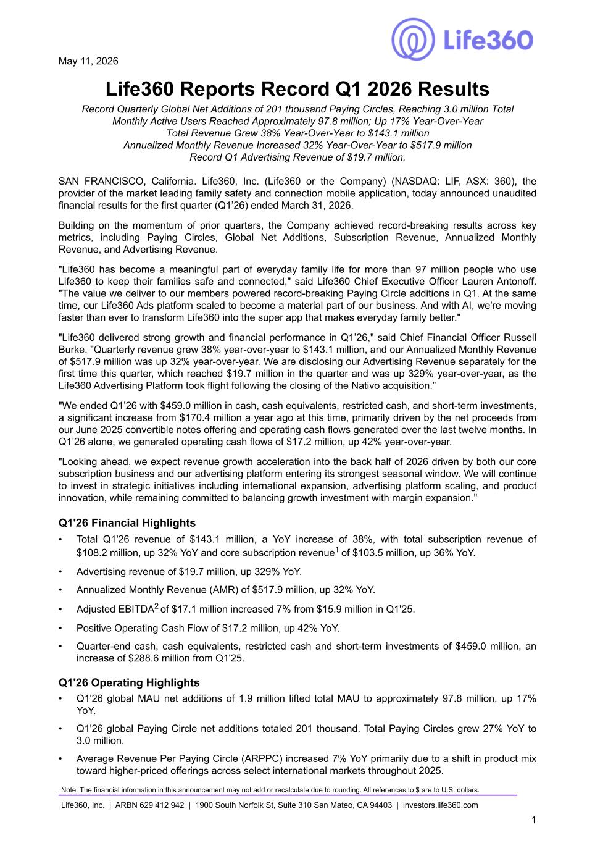

May 11, 2026 Life360 Reports Record Q1 2026 Results Record Quarterly Global Net Additions of 201 thousand Paying Circles, Reaching 3.0 million Total Monthly Active Users Reached Approximately 97.8 million; Up 17% Year-Over-Year Total Revenue Grew 38% Year-Over-Year to $143.1 million Annualized Monthly Revenue Increased 32% Year-Over-Year to $517.9 million Record Q1 Advertising Revenue of $19.7 million. SAN FRANCISCO, California. Life360, Inc. (Life360 or the Company) (NASDAQ: LIF, ASX: 360), the provider of the market leading family safety and connection mobile application, today announced unaudited financial results for the first quarter (Q1’26) ended March 31, 2026. Building on the momentum of prior quarters, the Company achieved record-breaking results across key metrics, including Paying Circles, Global Net Additions, Subscription Revenue, Annualized Monthly Revenue, and Advertising Revenue. "Life360 has become a meaningful part of everyday family life for more than 97 million people who use Life360 to keep their families safe and connected," said Life360 Chief Executive Officer Lauren Antonoff. "The value we deliver to our members powered record-breaking Paying Circle additions in Q1. At the same time, our Life360 Ads platform scaled to become a material part of our business. And with AI, we're moving faster than ever to transform Life360 into the super app that makes everyday family better." "Life360 delivered strong growth and financial performance in Q1’26," said Chief Financial Officer Russell Burke. "Quarterly revenue grew 38% year-over-year to $143.1 million, and our Annualized Monthly Revenue of $517.9 million was up 32% year-over-year. We are disclosing our Advertising Revenue separately for the first time this quarter, which reached $19.7 million in the quarter and was up 329% year-over-year, as the Life360 Advertising Platform took flight following the closing of the Nativo acquisition.” "We ended Q1’26 with $459.0 million in cash, cash equivalents, restricted cash, and short-term investments, a significant increase from $170.4 million a year ago at this time, primarily driven by the net proceeds from our June 2025 convertible notes offering and operating cash flows generated over the last twelve months. In Q1’26 alone, we generated operating cash flows of $17.2 million, up 42% year-over-year. "Looking ahead, we expect revenue growth acceleration into the back half of 2026 driven by both our core subscription business and our advertising platform entering its strongest seasonal window. We will continue to invest in strategic initiatives including international expansion, advertising platform scaling, and product innovation, while remaining committed to balancing growth investment with margin expansion." Q1'26 Financial Highlights • Total Q1'26 revenue of $143.1 million, a YoY increase of 38%, with total subscription revenue of $108.2 million, up 32% YoY and core subscription revenue1 of $103.5 million, up 36% YoY. • Advertising revenue of $19.7 million, up 329% YoY. • Annualized Monthly Revenue (AMR) of $517.9 million, up 32% YoY. • Adjusted EBITDA2 of $17.1 million increased 7% from $15.9 million in Q1'25. • Positive Operating Cash Flow of $17.2 million, up 42% YoY. • Quarter-end cash, cash equivalents, restricted cash and short-term investments of $459.0 million, an increase of $288.6 million from Q1'25. Q1'26 Operating Highlights • Q1'26 global MAU net additions of 1.9 million lifted total MAU to approximately 97.8 million, up 17% YoY. • Q1'26 global Paying Circle net additions totaled 201 thousand. Total Paying Circles grew 27% YoY to 3.0 million. • Average Revenue Per Paying Circle (ARPPC) increased 7% YoY primarily due to a shift in product mix toward higher-priced offerings across select international markets throughout 2025. Note: The financial information in this announcement may not add or recalculate due to rounding. All references to $ are to U.S. dollars. Life360, Inc. | ARBN 629 412 942 | 1900 South Norfolk St, Suite 310 San Mateo, CA 94403 | investors.life360.com 1

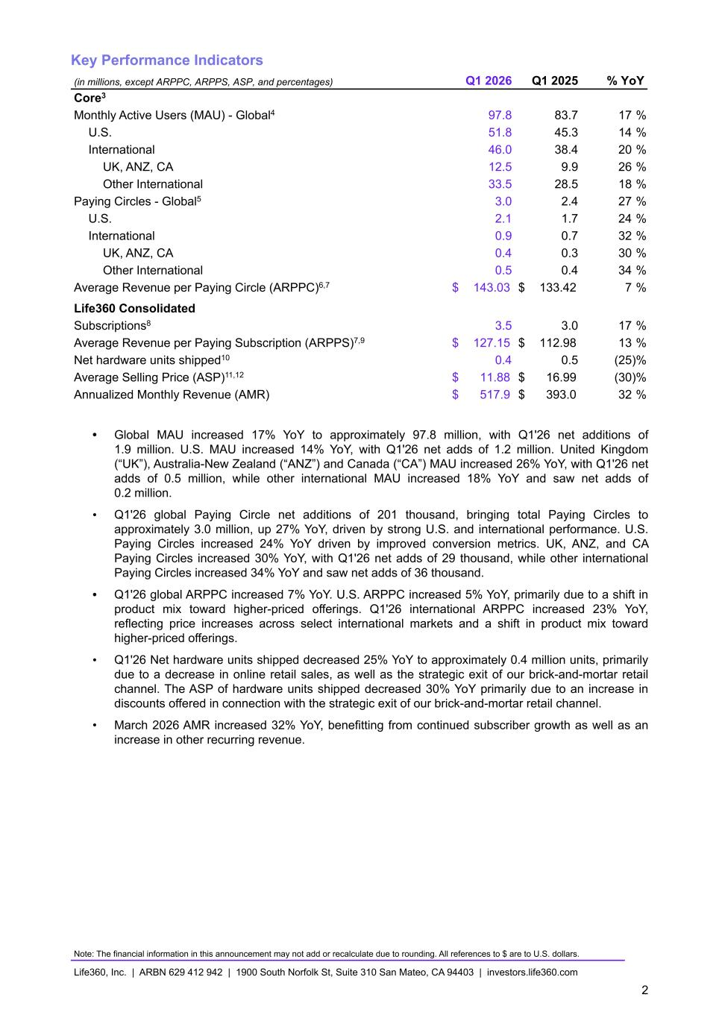
Key Performance Indicators (in millions, except ARPPC, ARPPS, ASP, and percentages) Q1 2026 Q1 2025 % YoY Core3 Monthly Active Users (MAU) - Global4 97.8 83.7 17 % U.S. 51.8 45.3 14 % International 46.0 38.4 20 % UK, ANZ, CA 12.5 9.9 26 % Other International 33.5 28.5 18 % Paying Circles - Global5 3.0 2.4 27 % U.S. 2.1 1.7 24 % International 0.9 0.7 32 % UK, ANZ, CA 0.4 0.3 30 % Other International 0.5 0.4 34 % Average Revenue per Paying Circle (ARPPC)6,7 $ 143.03 $ 133.42 7 % Life360 Consolidated Subscriptions8 3.5 3.0 17 % Average Revenue per Paying Subscription (ARPPS)7,9 $ 127.15 $ 112.98 13 % Net hardware units shipped10 0.4 0.5 (25) % Average Selling Price (ASP)11,12 $ 11.88 $ 16.99 (30) % Annualized Monthly Revenue (AMR) $ 517.9 $ 393.0 32 % • Global MAU increased 17% YoY to approximately 97.8 million, with Q1'26 net additions of 1.9 million. U.S. MAU increased 14% YoY, with Q1'26 net adds of 1.2 million. United Kingdom (“UK”), Australia-New Zealand (“ANZ”) and Canada (“CA”) MAU increased 26% YoY, with Q1'26 net adds of 0.5 million, while other international MAU increased 18% YoY and saw net adds of 0.2 million. • Q1'26 global Paying Circle net additions of 201 thousand, bringing total Paying Circles to approximately 3.0 million, up 27% YoY, driven by strong U.S. and international performance. U.S. Paying Circles increased 24% YoY driven by improved conversion metrics. UK, ANZ, and CA Paying Circles increased 30% YoY, with Q1'26 net adds of 29 thousand, while other international Paying Circles increased 34% YoY and saw net adds of 36 thousand. • Q1'26 global ARPPC increased 7% YoY. U.S. ARPPC increased 5% YoY, primarily due to a shift in product mix toward higher-priced offerings. Q1'26 international ARPPC increased 23% YoY, reflecting price increases across select international markets and a shift in product mix toward higher-priced offerings. • Q1'26 Net hardware units shipped decreased 25% YoY to approximately 0.4 million units, primarily due to a decrease in online retail sales, as well as the strategic exit of our brick-and-mortar retail channel. The ASP of hardware units shipped decreased 30% YoY primarily due to an increase in discounts offered in connection with the strategic exit of our brick-and-mortar retail channel. • March 2026 AMR increased 32% YoY, benefitting from continued subscriber growth as well as an increase in other recurring revenue. Note: The financial information in this announcement may not add or recalculate due to rounding. All references to $ are to U.S. dollars. Life360, Inc. | ARBN 629 412 942 | 1900 South Norfolk St, Suite 310 San Mateo, CA 94403 | investors.life360.com 2

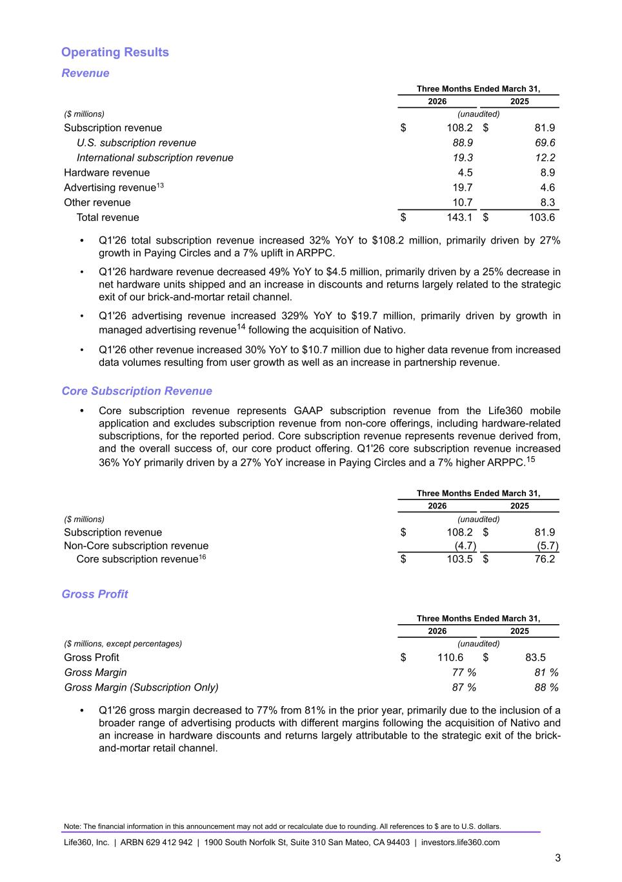
Operating Results Revenue Three Months Ended March 31, 2026 2025 ($ millions) (unaudited) Subscription revenue $ 108.2 $ 81.9 U.S. subscription revenue 88.9 69.6 International subscription revenue 19.3 12.2 Hardware revenue 4.5 8.9 Advertising revenue13 19.7 4.6 Other revenue 10.7 8.3 Total revenue $ 143.1 $ 103.6 • Q1'26 total subscription revenue increased 32% YoY to $108.2 million, primarily driven by 27% growth in Paying Circles and a 7% uplift in ARPPC. • Q1'26 hardware revenue decreased 49% YoY to $4.5 million, primarily driven by a 25% decrease in net hardware units shipped and an increase in discounts and returns largely related to the strategic exit of our brick-and-mortar retail channel. • Q1'26 advertising revenue increased 329% YoY to $19.7 million, primarily driven by growth in managed advertising revenue14 following the acquisition of Nativo. • Q1'26 other revenue increased 30% YoY to $10.7 million due to higher data revenue from increased data volumes resulting from user growth as well as an increase in partnership revenue. Core Subscription Revenue • Core subscription revenue represents GAAP subscription revenue from the Life360 mobile application and excludes subscription revenue from non-core offerings, including hardware-related subscriptions, for the reported period. Core subscription revenue represents revenue derived from, and the overall success of, our core product offering. Q1'26 core subscription revenue increased 36% YoY primarily driven by a 27% YoY increase in Paying Circles and a 7% higher ARPPC.15 Three Months Ended March 31, 2026 2025 ($ millions) (unaudited) Subscription revenue $ 108.2 $ 81.9 Non-Core subscription revenue (4.7) (5.7) Core subscription revenue16 $ 103.5 $ 76.2 Gross Profit Three Months Ended March 31, 2026 2025 ($ millions, except percentages) (unaudited) Gross Profit $ 110.6 $ 83.5 Gross Margin 77 % 81 % Gross Margin (Subscription Only) 87 % 88 % • Q1'26 gross margin decreased to 77% from 81% in the prior year, primarily due to the inclusion of a broader range of advertising products with different margins following the acquisition of Nativo and an increase in hardware discounts and returns largely attributable to the strategic exit of the brick- and-mortar retail channel. Note: The financial information in this announcement may not add or recalculate due to rounding. All references to $ are to U.S. dollars. Life360, Inc. | ARBN 629 412 942 | 1900 South Norfolk St, Suite 310 San Mateo, CA 94403 | investors.life360.com 3

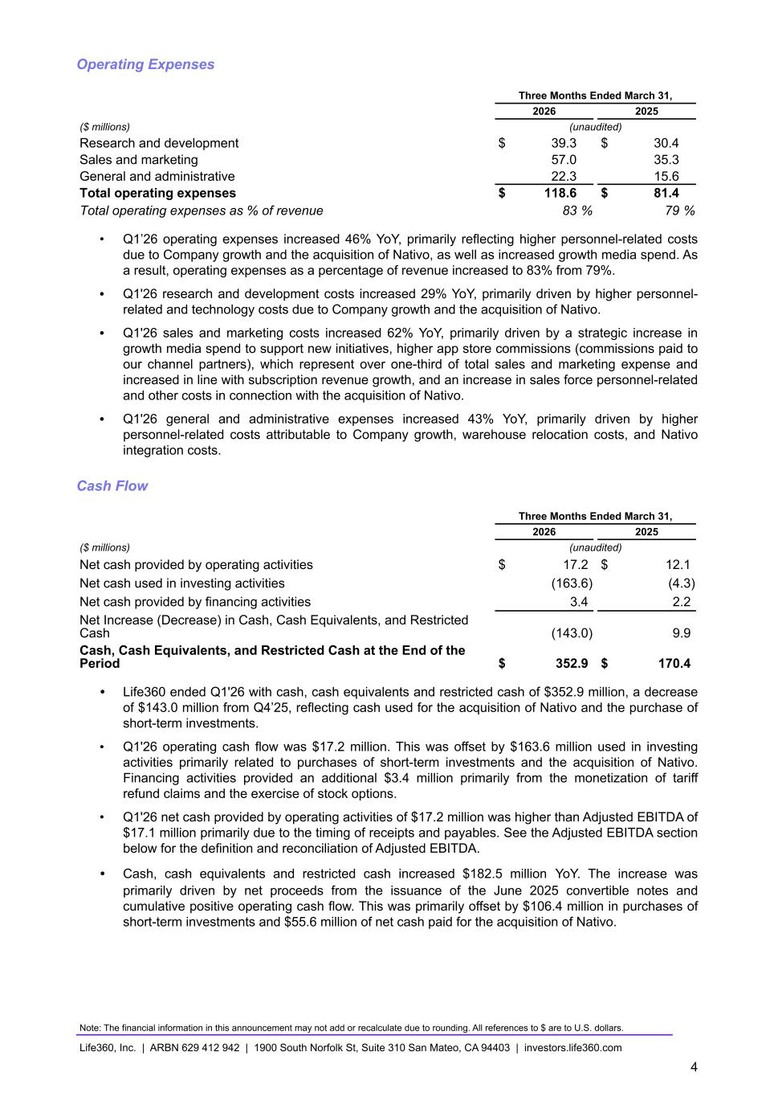
Operating Expenses Three Months Ended March 31, 2026 2025 ($ millions) (unaudited) Research and development $ 39.3 $ 30.4 Sales and marketing 57.0 35.3 General and administrative 22.3 15.6 Total operating expenses $ 118.6 $ 81.4 Total operating expenses as % of revenue 83 % 79 % • Q1’26 operating expenses increased 46% YoY, primarily reflecting higher personnel-related costs due to Company growth and the acquisition of Nativo, as well as increased growth media spend. As a result, operating expenses as a percentage of revenue increased to 83% from 79%. • Q1'26 research and development costs increased 29% YoY, primarily driven by higher personnel- related and technology costs due to Company growth and the acquisition of Nativo. • Q1'26 sales and marketing costs increased 62% YoY, primarily driven by a strategic increase in growth media spend to support new initiatives, higher app store commissions (commissions paid to our channel partners), which represent over one-third of total sales and marketing expense and increased in line with subscription revenue growth, and an increase in sales force personnel-related and other costs in connection with the acquisition of Nativo. • Q1'26 general and administrative expenses increased 43% YoY, primarily driven by higher personnel-related costs attributable to Company growth, warehouse relocation costs, and Nativo integration costs. Cash Flow Three Months Ended March 31, 2026 2025 ($ millions) (unaudited) Net cash provided by operating activities $ 17.2 $ 12.1 Net cash used in investing activities (163.6) (4.3) Net cash provided by financing activities 3.4 2.2 Net Increase (Decrease) in Cash, Cash Equivalents, and Restricted Cash (143.0) 9.9 Cash, Cash Equivalents, and Restricted Cash at the End of the Period $ 352.9 $ 170.4 • Life360 ended Q1'26 with cash, cash equivalents and restricted cash of $352.9 million, a decrease of $143.0 million from Q4’25, reflecting cash used for the acquisition of Nativo and the purchase of short-term investments. • Q1'26 operating cash flow was $17.2 million. This was offset by $163.6 million used in investing activities primarily related to purchases of short-term investments and the acquisition of Nativo. Financing activities provided an additional $3.4 million primarily from the monetization of tariff refund claims and the exercise of stock options. • Q1'26 net cash provided by operating activities of $17.2 million was higher than Adjusted EBITDA of $17.1 million primarily due to the timing of receipts and payables. See the Adjusted EBITDA section below for the definition and reconciliation of Adjusted EBITDA. • Cash, cash equivalents and restricted cash increased $182.5 million YoY. The increase was primarily driven by net proceeds from the issuance of the June 2025 convertible notes and cumulative positive operating cash flow. This was primarily offset by $106.4 million in purchases of short-term investments and $55.6 million of net cash paid for the acquisition of Nativo. Note: The financial information in this announcement may not add or recalculate due to rounding. All references to $ are to U.S. dollars. Life360, Inc. | ARBN 629 412 942 | 1900 South Norfolk St, Suite 310 San Mateo, CA 94403 | investors.life360.com 4

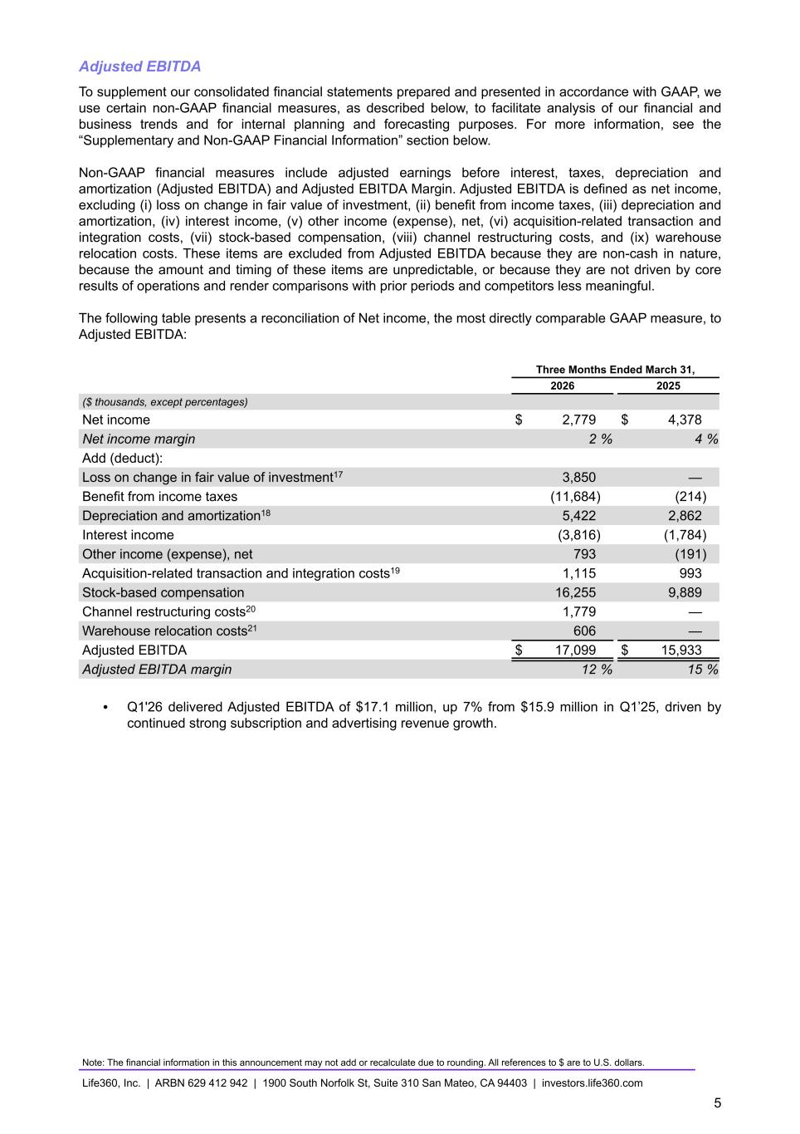
Adjusted EBITDA To supplement our consolidated financial statements prepared and presented in accordance with GAAP, we use certain non-GAAP financial measures, as described below, to facilitate analysis of our financial and business trends and for internal planning and forecasting purposes. For more information, see the “Supplementary and Non-GAAP Financial Information” section below. Non-GAAP financial measures include adjusted earnings before interest, taxes, depreciation and amortization (Adjusted EBITDA) and Adjusted EBITDA Margin. Adjusted EBITDA is defined as net income, excluding (i) loss on change in fair value of investment, (ii) benefit from income taxes, (iii) depreciation and amortization, (iv) interest income, (v) other income (expense), net, (vi) acquisition-related transaction and integration costs, (vii) stock-based compensation, (viii) channel restructuring costs, and (ix) warehouse relocation costs. These items are excluded from Adjusted EBITDA because they are non-cash in nature, because the amount and timing of these items are unpredictable, or because they are not driven by core results of operations and render comparisons with prior periods and competitors less meaningful. The following table presents a reconciliation of Net income, the most directly comparable GAAP measure, to Adjusted EBITDA: Three Months Ended March 31, 2026 2025 ($ thousands, except percentages) Net income $ 2,779 $ 4,378 Net income margin 2 % 4 % Add (deduct): Loss on change in fair value of investment17 3,850 — Benefit from income taxes (11,684) (214) Depreciation and amortization18 5,422 2,862 Interest income (3,816) (1,784) Other income (expense), net 793 (191) Acquisition-related transaction and integration costs19 1,115 993 Stock-based compensation 16,255 9,889 Channel restructuring costs20 1,779 — Warehouse relocation costs21 606 — Adjusted EBITDA $ 17,099 $ 15,933 Adjusted EBITDA margin 12 % 15 % • Q1'26 delivered Adjusted EBITDA of $17.1 million, up 7% from $15.9 million in Q1’25, driven by continued strong subscription and advertising revenue growth. Note: The financial information in this announcement may not add or recalculate due to rounding. All references to $ are to U.S. dollars. Life360, Inc. | ARBN 629 412 942 | 1900 South Norfolk St, Suite 310 San Mateo, CA 94403 | investors.life360.com 5

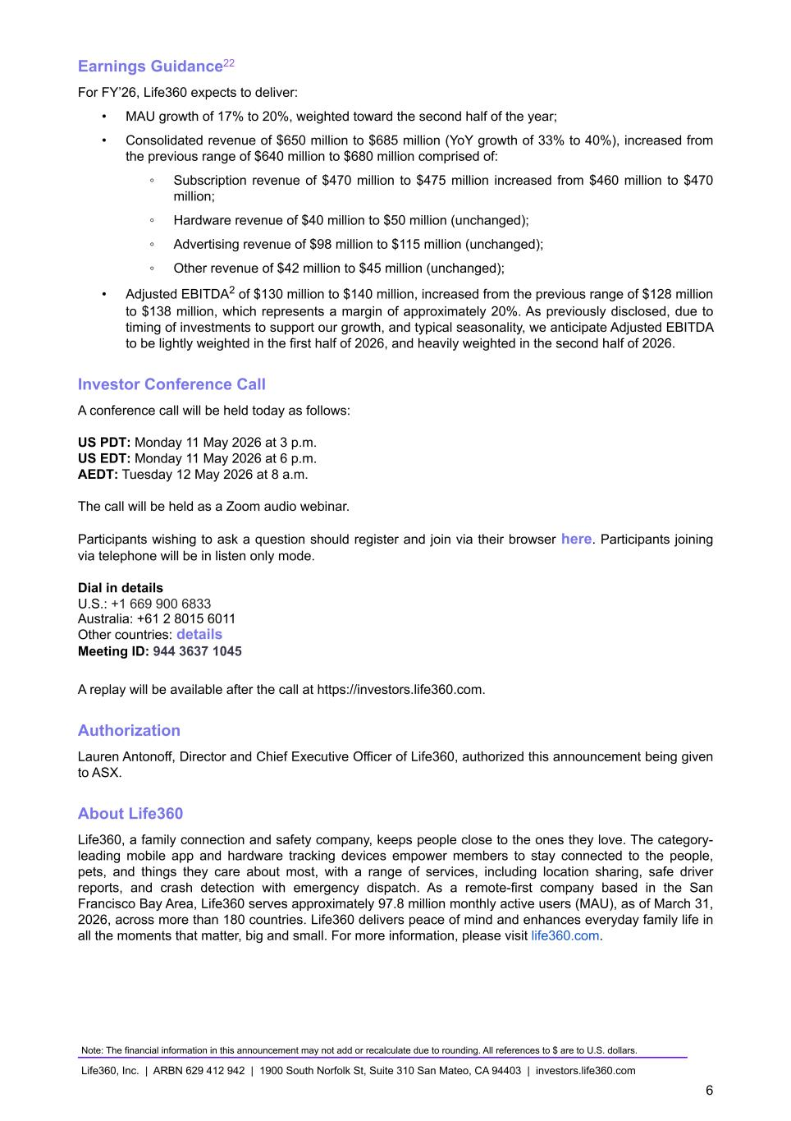
Earnings Guidance22 For FY’26, Life360 expects to deliver: • MAU growth of 17% to 20%, weighted toward the second half of the year; • Consolidated revenue of $650 million to $685 million (YoY growth of 33% to 40%), increased from the previous range of $640 million to $680 million comprised of: ◦ Subscription revenue of $470 million to $475 million increased from $460 million to $470 million; ◦ Hardware revenue of $40 million to $50 million (unchanged); ◦ Advertising revenue of $98 million to $115 million (unchanged); ◦ Other revenue of $42 million to $45 million (unchanged); • Adjusted EBITDA2 of $130 million to $140 million, increased from the previous range of $128 million to $138 million, which represents a margin of approximately 20%. As previously disclosed, due to timing of investments to support our growth, and typical seasonality, we anticipate Adjusted EBITDA to be lightly weighted in the first half of 2026, and heavily weighted in the second half of 2026. Investor Conference Call A conference call will be held today as follows: US PDT: Monday 11 May 2026 at 3 p.m. US EDT: Monday 11 May 2026 at 6 p.m. AEDT: Tuesday 12 May 2026 at 8 a.m. The call will be held as a Zoom audio webinar. Participants wishing to ask a question should register and join via their browser here. Participants joining via telephone will be in listen only mode. Dial in details U.S.: +1 669 900 6833 Australia: +61 2 8015 6011 Other countries: details Meeting ID: 944 3637 1045 A replay will be available after the call at https://investors.life360.com. Authorization Lauren Antonoff, Director and Chief Executive Officer of Life360, authorized this announcement being given to ASX. About Life360 Life360, a family connection and safety company, keeps people close to the ones they love. The category- leading mobile app and hardware tracking devices empower members to stay connected to the people, pets, and things they care about most, with a range of services, including location sharing, safe driver reports, and crash detection with emergency dispatch. As a remote-first company based in the San Francisco Bay Area, Life360 serves approximately 97.8 million monthly active users (MAU), as of March 31, 2026, across more than 180 countries. Life360 delivers peace of mind and enhances everyday family life in all the moments that matter, big and small. For more information, please visit life360.com. Note: The financial information in this announcement may not add or recalculate due to rounding. All references to $ are to U.S. dollars. Life360, Inc. | ARBN 629 412 942 | 1900 South Norfolk St, Suite 310 San Mateo, CA 94403 | investors.life360.com 6

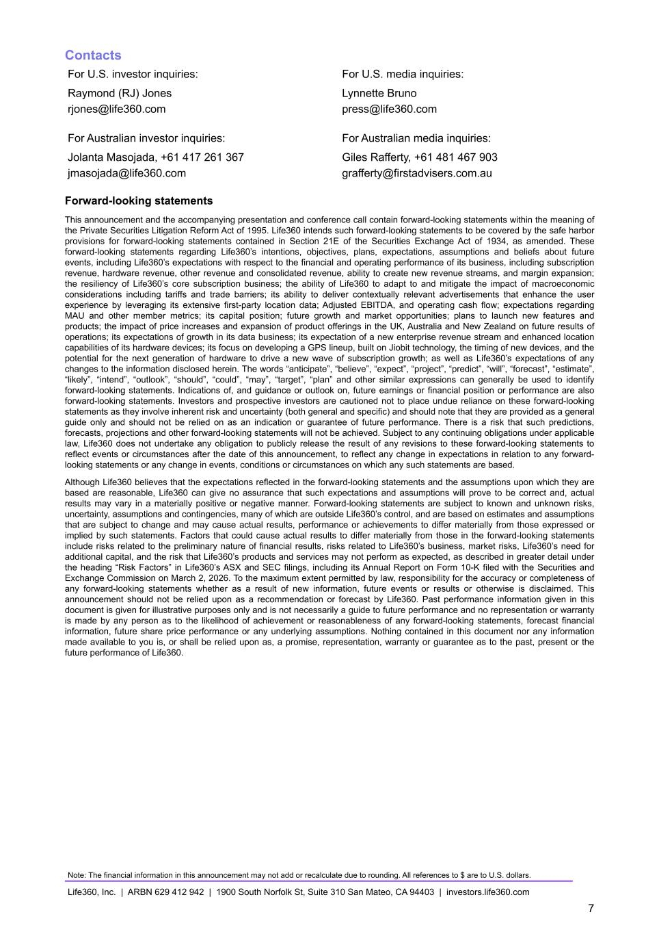
Contacts For U.S. investor inquiries: For U.S. media inquiries: Raymond (RJ) Jones Lynnette Bruno rjones@life360.com press@life360.com For Australian investor inquiries: For Australian media inquiries: Jolanta Masojada, +61 417 261 367 Giles Rafferty, +61 481 467 903 jmasojada@life360.com grafferty@firstadvisers.com.au Forward-looking statements This announcement and the accompanying presentation and conference call contain forward-looking statements within the meaning of the Private Securities Litigation Reform Act of 1995. Life360 intends such forward-looking statements to be covered by the safe harbor provisions for forward-looking statements contained in Section 21E of the Securities Exchange Act of 1934, as amended. These forward-looking statements regarding Life360’s intentions, objectives, plans, expectations, assumptions and beliefs about future events, including Life360’s expectations with respect to the financial and operating performance of its business, including subscription revenue, hardware revenue, other revenue and consolidated revenue, ability to create new revenue streams, and margin expansion; the resiliency of Life360’s core subscription business; the ability of Life360 to adapt to and mitigate the impact of macroeconomic considerations including tariffs and trade barriers; its ability to deliver contextually relevant advertisements that enhance the user experience by leveraging its extensive first-party location data; Adjusted EBITDA, and operating cash flow; expectations regarding MAU and other member metrics; its capital position; future growth and market opportunities; plans to launch new features and products; the impact of price increases and expansion of product offerings in the UK, Australia and New Zealand on future results of operations; its expectations of growth in its data business; its expectation of a new enterprise revenue stream and enhanced location capabilities of its hardware devices; its focus on developing a GPS lineup, built on Jiobit technology, the timing of new devices, and the potential for the next generation of hardware to drive a new wave of subscription growth; as well as Life360’s expectations of any changes to the information disclosed herein. The words “anticipate”, “believe”, “expect”, “project”, “predict”, “will”, “forecast”, “estimate”, “likely”, “intend”, “outlook”, “should”, “could”, “may”, “target”, “plan” and other similar expressions can generally be used to identify forward-looking statements. Indications of, and guidance or outlook on, future earnings or financial position or performance are also forward-looking statements. Investors and prospective investors are cautioned not to place undue reliance on these forward-looking statements as they involve inherent risk and uncertainty (both general and specific) and should note that they are provided as a general guide only and should not be relied on as an indication or guarantee of future performance. There is a risk that such predictions, forecasts, projections and other forward-looking statements will not be achieved. Subject to any continuing obligations under applicable law, Life360 does not undertake any obligation to publicly release the result of any revisions to these forward-looking statements to reflect events or circumstances after the date of this announcement, to reflect any change in expectations in relation to any forward- looking statements or any change in events, conditions or circumstances on which any such statements are based. Although Life360 believes that the expectations reflected in the forward-looking statements and the assumptions upon which they are based are reasonable, Life360 can give no assurance that such expectations and assumptions will prove to be correct and, actual results may vary in a materially positive or negative manner. Forward-looking statements are subject to known and unknown risks, uncertainty, assumptions and contingencies, many of which are outside Life360’s control, and are based on estimates and assumptions that are subject to change and may cause actual results, performance or achievements to differ materially from those expressed or implied by such statements. Factors that could cause actual results to differ materially from those in the forward-looking statements include risks related to the preliminary nature of financial results, risks related to Life360’s business, market risks, Life360’s need for additional capital, and the risk that Life360’s products and services may not perform as expected, as described in greater detail under the heading “Risk Factors” in Life360’s ASX and SEC filings, including its Annual Report on Form 10-K filed with the Securities and Exchange Commission on March 2, 2026. To the maximum extent permitted by law, responsibility for the accuracy or completeness of any forward-looking statements whether as a result of new information, future events or results or otherwise is disclaimed. This announcement should not be relied upon as a recommendation or forecast by Life360. Past performance information given in this document is given for illustrative purposes only and is not necessarily a guide to future performance and no representation or warranty is made by any person as to the likelihood of achievement or reasonableness of any forward-looking statements, forecast financial information, future share price performance or any underlying assumptions. Nothing contained in this document nor any information made available to you is, or shall be relied upon as, a promise, representation, warranty or guarantee as to the past, present or the future performance of Life360. Note: The financial information in this announcement may not add or recalculate due to rounding. All references to $ are to U.S. dollars. Life360, Inc. | ARBN 629 412 942 | 1900 South Norfolk St, Suite 310 San Mateo, CA 94403 | investors.life360.com 7

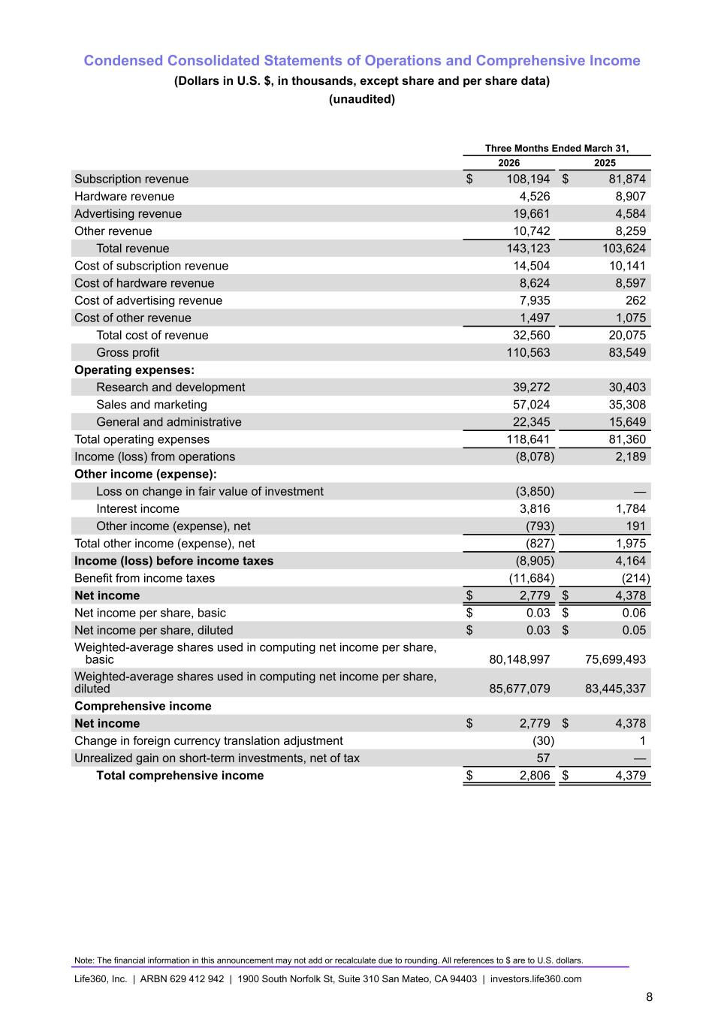
Condensed Consolidated Statements of Operations and Comprehensive Income (Dollars in U.S. $, in thousands, except share and per share data) (unaudited) Three Months Ended March 31, 2026 2025 Subscription revenue $ 108,194 $ 81,874 Hardware revenue 4,526 8,907 Advertising revenue 19,661 4,584 Other revenue 10,742 8,259 Total revenue 143,123 103,624 Cost of subscription revenue 14,504 10,141 Cost of hardware revenue 8,624 8,597 Cost of advertising revenue 7,935 262 Cost of other revenue 1,497 1,075 Total cost of revenue 32,560 20,075 Gross profit 110,563 83,549 Operating expenses: Research and development 39,272 30,403 Sales and marketing 57,024 35,308 General and administrative 22,345 15,649 Total operating expenses 118,641 81,360 Income (loss) from operations (8,078) 2,189 Other income (expense): Loss on change in fair value of investment (3,850) — Interest income 3,816 1,784 Other income (expense), net (793) 191 Total other income (expense), net (827) 1,975 Income (loss) before income taxes (8,905) 4,164 Benefit from income taxes (11,684) (214) Net income $ 2,779 $ 4,378 Net income per share, basic $ 0.03 $ 0.06 Net income per share, diluted $ 0.03 $ 0.05 Weighted-average shares used in computing net income per share, basic 80,148,997 75,699,493 Weighted-average shares used in computing net income per share, diluted 85,677,079 83,445,337 Comprehensive income Net income $ 2,779 $ 4,378 Change in foreign currency translation adjustment (30) 1 Unrealized gain on short-term investments, net of tax 57 — Total comprehensive income $ 2,806 $ 4,379 Note: The financial information in this announcement may not add or recalculate due to rounding. All references to $ are to U.S. dollars. Life360, Inc. | ARBN 629 412 942 | 1900 South Norfolk St, Suite 310 San Mateo, CA 94403 | investors.life360.com 8

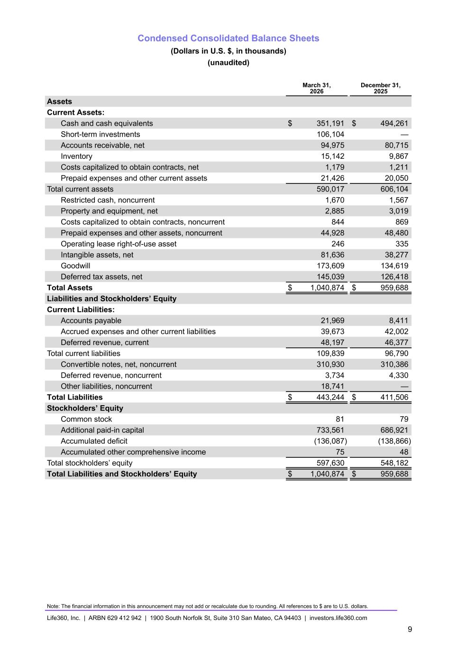
Condensed Consolidated Balance Sheets (Dollars in U.S. $, in thousands) (unaudited) March 31, 2026 December 31, 2025 Assets Current Assets: Cash and cash equivalents $ 351,191 $ 494,261 Short-term investments 106,104 — Accounts receivable, net 94,975 80,715 Inventory 15,142 9,867 Costs capitalized to obtain contracts, net 1,179 1,211 Prepaid expenses and other current assets 21,426 20,050 Total current assets 590,017 606,104 Restricted cash, noncurrent 1,670 1,567 Property and equipment, net 2,885 3,019 Costs capitalized to obtain contracts, noncurrent 844 869 Prepaid expenses and other assets, noncurrent 44,928 48,480 Operating lease right-of-use asset 246 335 Intangible assets, net 81,636 38,277 Goodwill 173,609 134,619 Deferred tax assets, net 145,039 126,418 Total Assets $ 1,040,874 $ 959,688 Liabilities and Stockholders’ Equity Current Liabilities: Accounts payable 21,969 8,411 Accrued expenses and other current liabilities 39,673 42,002 Deferred revenue, current 48,197 46,377 Total current liabilities 109,839 96,790 Convertible notes, net, noncurrent 310,930 310,386 Deferred revenue, noncurrent 3,734 4,330 Other liabilities, noncurrent 18,741 — Total Liabilities $ 443,244 $ 411,506 Stockholders’ Equity Common stock 81 79 Additional paid-in capital 733,561 686,921 Accumulated deficit (136,087) (138,866) Accumulated other comprehensive income 75 48 Total stockholders’ equity 597,630 548,182 Total Liabilities and Stockholders’ Equity $ 1,040,874 $ 959,688 Note: The financial information in this announcement may not add or recalculate due to rounding. All references to $ are to U.S. dollars. Life360, Inc. | ARBN 629 412 942 | 1900 South Norfolk St, Suite 310 San Mateo, CA 94403 | investors.life360.com 9

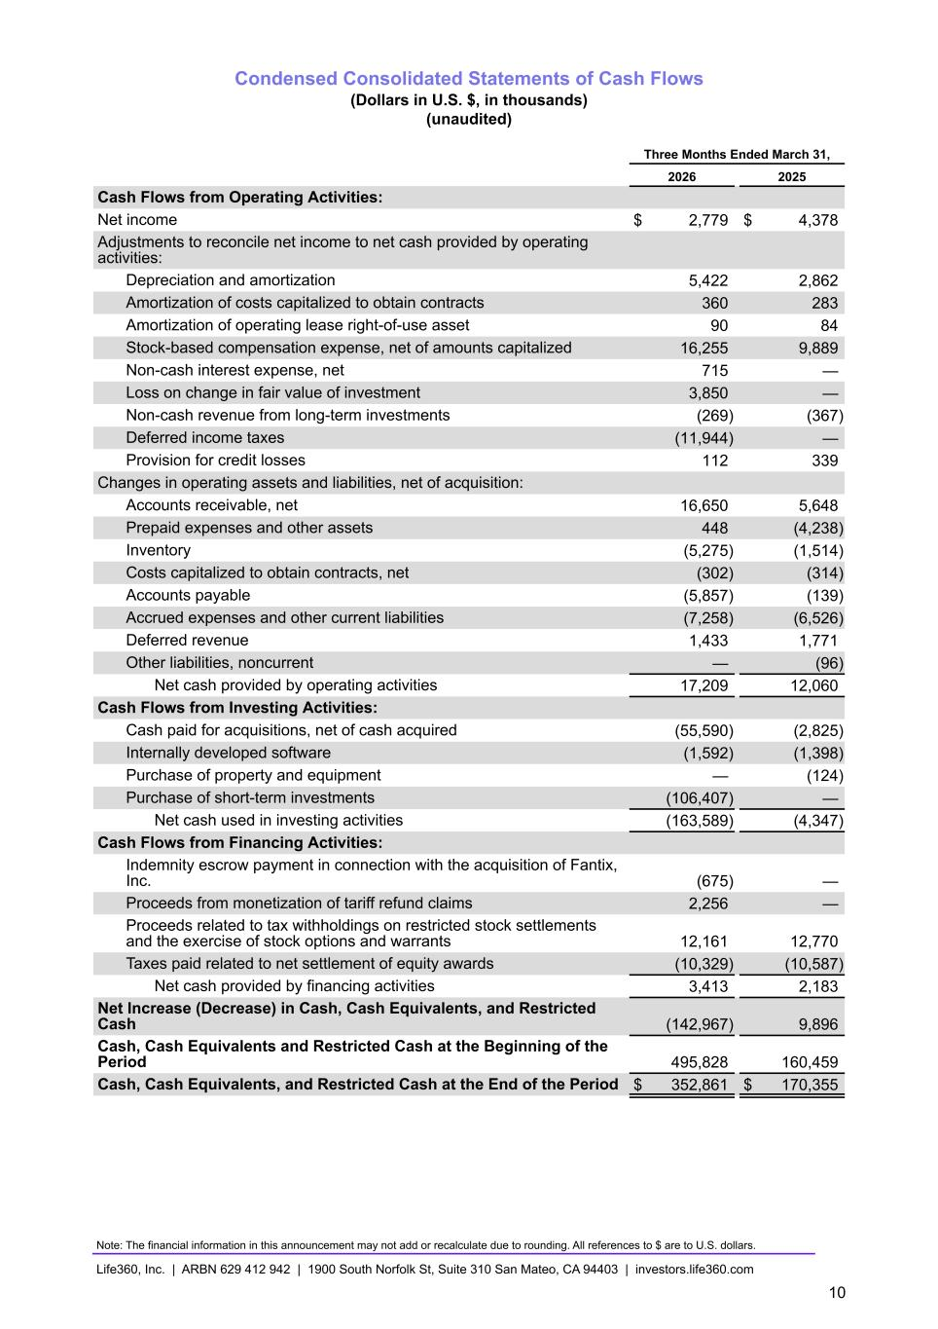
Condensed Consolidated Statements of Cash Flows (Dollars in U.S. $, in thousands) (unaudited) Three Months Ended March 31, 2026 2025 Cash Flows from Operating Activities: Net income $ 2,779 $ 4,378 Adjustments to reconcile net income to net cash provided by operating activities: Depreciation and amortization 5,422 2,862 Amortization of costs capitalized to obtain contracts 360 283 Amortization of operating lease right-of-use asset 90 84 Stock-based compensation expense, net of amounts capitalized 16,255 9,889 Non-cash interest expense, net 715 — Loss on change in fair value of investment 3,850 — Non-cash revenue from long-term investments (269) (367) Deferred income taxes (11,944) — Provision for credit losses 112 339 Changes in operating assets and liabilities, net of acquisition: Accounts receivable, net 16,650 5,648 Prepaid expenses and other assets 448 (4,238) Inventory (5,275) (1,514) Costs capitalized to obtain contracts, net (302) (314) Accounts payable (5,857) (139) Accrued expenses and other current liabilities (7,258) (6,526) Deferred revenue 1,433 1,771 Other liabilities, noncurrent — (96) Net cash provided by operating activities 17,209 12,060 Cash Flows from Investing Activities: Cash paid for acquisitions, net of cash acquired (55,590) (2,825) Internally developed software (1,592) (1,398) Purchase of property and equipment — (124) Purchase of short-term investments (106,407) — Net cash used in investing activities (163,589) (4,347) Cash Flows from Financing Activities: Indemnity escrow payment in connection with the acquisition of Fantix, Inc. (675) — Proceeds from monetization of tariff refund claims 2,256 — Proceeds related to tax withholdings on restricted stock settlements and the exercise of stock options and warrants 12,161 12,770 Taxes paid related to net settlement of equity awards (10,329) (10,587) Net cash provided by financing activities 3,413 2,183 Net Increase (Decrease) in Cash, Cash Equivalents, and Restricted Cash (142,967) 9,896 Cash, Cash Equivalents and Restricted Cash at the Beginning of the Period 495,828 160,459 Cash, Cash Equivalents, and Restricted Cash at the End of the Period $ 352,861 $ 170,355 Note: The financial information in this announcement may not add or recalculate due to rounding. All references to $ are to U.S. dollars. Life360, Inc. | ARBN 629 412 942 | 1900 South Norfolk St, Suite 310 San Mateo, CA 94403 | investors.life360.com 10

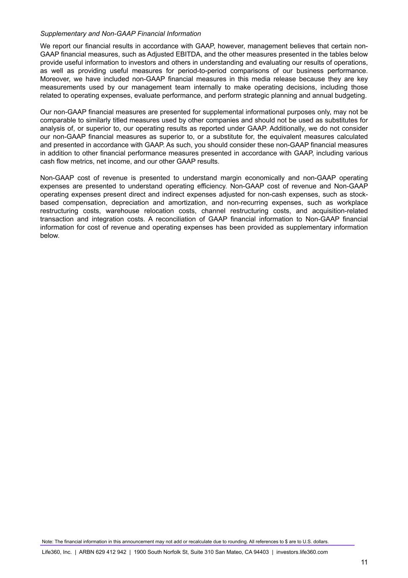
Supplementary and Non-GAAP Financial Information We report our financial results in accordance with GAAP, however, management believes that certain non- GAAP financial measures, such as Adjusted EBITDA, and the other measures presented in the tables below provide useful information to investors and others in understanding and evaluating our results of operations, as well as providing useful measures for period-to-period comparisons of our business performance. Moreover, we have included non-GAAP financial measures in this media release because they are key measurements used by our management team internally to make operating decisions, including those related to operating expenses, evaluate performance, and perform strategic planning and annual budgeting. Our non-GAAP financial measures are presented for supplemental informational purposes only, may not be comparable to similarly titled measures used by other companies and should not be used as substitutes for analysis of, or superior to, our operating results as reported under GAAP. Additionally, we do not consider our non-GAAP financial measures as superior to, or a substitute for, the equivalent measures calculated and presented in accordance with GAAP. As such, you should consider these non-GAAP financial measures in addition to other financial performance measures presented in accordance with GAAP, including various cash flow metrics, net income, and our other GAAP results. Non-GAAP cost of revenue is presented to understand margin economically and non-GAAP operating expenses are presented to understand operating efficiency. Non-GAAP cost of revenue and Non-GAAP operating expenses present direct and indirect expenses adjusted for non-cash expenses, such as stock- based compensation, depreciation and amortization, and non-recurring expenses, such as workplace restructuring costs, warehouse relocation costs, channel restructuring costs, and acquisition-related transaction and integration costs. A reconciliation of GAAP financial information to Non-GAAP financial information for cost of revenue and operating expenses has been provided as supplementary information below. Note: The financial information in this announcement may not add or recalculate due to rounding. All references to $ are to U.S. dollars. Life360, Inc. | ARBN 629 412 942 | 1900 South Norfolk St, Suite 310 San Mateo, CA 94403 | investors.life360.com 11

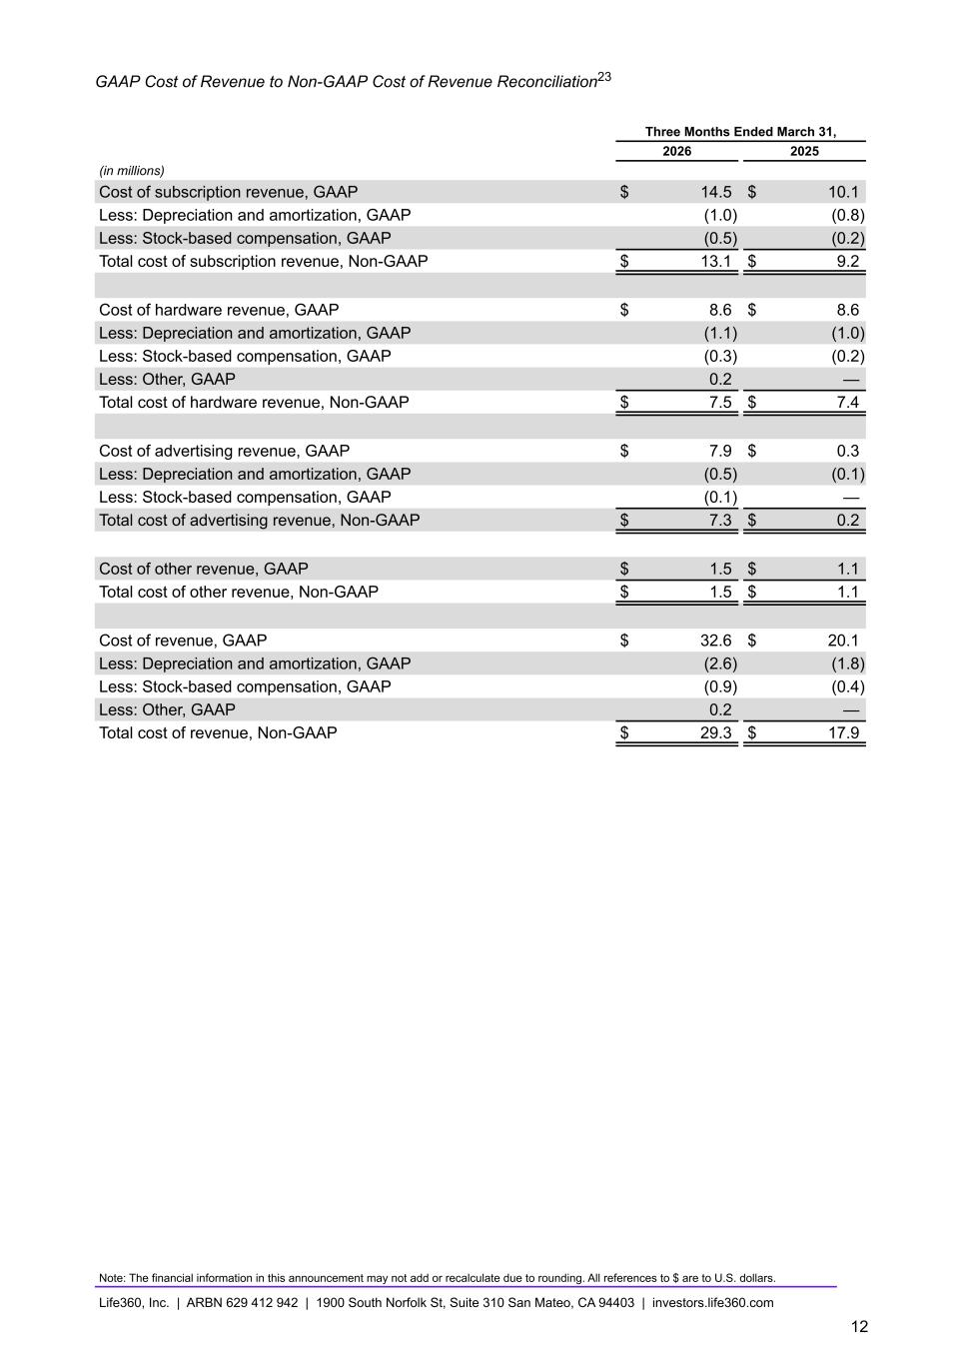
GAAP Cost of Revenue to Non-GAAP Cost of Revenue Reconciliation23 Three Months Ended March 31, 2026 2025 (in millions) Cost of subscription revenue, GAAP $ 14.5 $ 10.1 Less: Depreciation and amortization, GAAP (1.0) (0.8) Less: Stock-based compensation, GAAP (0.5) (0.2) Total cost of subscription revenue, Non-GAAP $ 13.1 $ 9.2 Cost of hardware revenue, GAAP $ 8.6 $ 8.6 Less: Depreciation and amortization, GAAP (1.1) (1.0) Less: Stock-based compensation, GAAP (0.3) (0.2) Less: Other, GAAP 0.2 — Total cost of hardware revenue, Non-GAAP $ 7.5 $ 7.4 Cost of advertising revenue, GAAP $ 7.9 $ 0.3 Less: Depreciation and amortization, GAAP (0.5) (0.1) Less: Stock-based compensation, GAAP (0.1) — Total cost of advertising revenue, Non-GAAP $ 7.3 $ 0.2 Cost of other revenue, GAAP $ 1.5 $ 1.1 Total cost of other revenue, Non-GAAP $ 1.5 $ 1.1 Cost of revenue, GAAP $ 32.6 $ 20.1 Less: Depreciation and amortization, GAAP (2.6) (1.8) Less: Stock-based compensation, GAAP (0.9) (0.4) Less: Other, GAAP 0.2 — Total cost of revenue, Non-GAAP $ 29.3 $ 17.9 Note: The financial information in this announcement may not add or recalculate due to rounding. All references to $ are to U.S. dollars. Life360, Inc. | ARBN 629 412 942 | 1900 South Norfolk St, Suite 310 San Mateo, CA 94403 | investors.life360.com 12

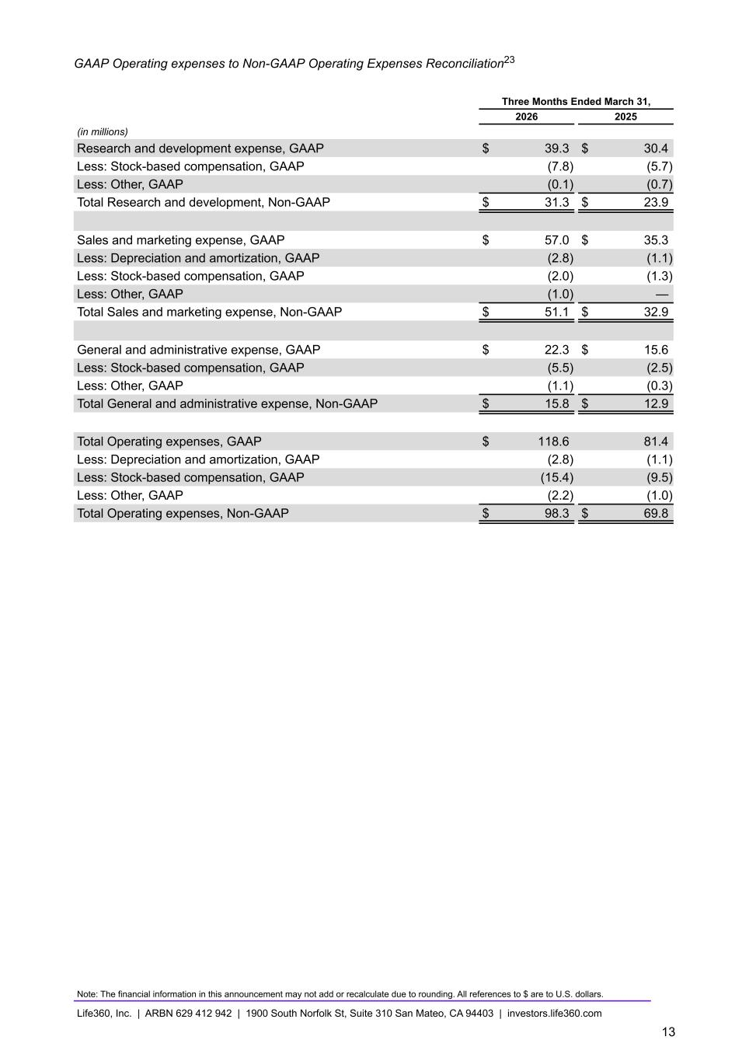
GAAP Operating expenses to Non-GAAP Operating Expenses Reconciliation23 Three Months Ended March 31, 2026 2025 (in millions) Research and development expense, GAAP $ 39.3 $ 30.4 Less: Stock-based compensation, GAAP (7.8) (5.7) Less: Other, GAAP (0.1) (0.7) Total Research and development, Non-GAAP $ 31.3 $ 23.9 Sales and marketing expense, GAAP $ 57.0 $ 35.3 Less: Depreciation and amortization, GAAP (2.8) (1.1) Less: Stock-based compensation, GAAP (2.0) (1.3) Less: Other, GAAP (1.0) — Total Sales and marketing expense, Non-GAAP $ 51.1 $ 32.9 General and administrative expense, GAAP $ 22.3 $ 15.6 Less: Stock-based compensation, GAAP (5.5) (2.5) Less: Other, GAAP (1.1) (0.3) Total General and administrative expense, Non-GAAP $ 15.8 $ 12.9 Total Operating expenses, GAAP $ 118.6 81.4 Less: Depreciation and amortization, GAAP (2.8) (1.1) Less: Stock-based compensation, GAAP (15.4) (9.5) Less: Other, GAAP (2.2) (1.0) Total Operating expenses, Non-GAAP $ 98.3 $ 69.8 Note: The financial information in this announcement may not add or recalculate due to rounding. All references to $ are to U.S. dollars. Life360, Inc. | ARBN 629 412 942 | 1900 South Norfolk St, Suite 310 San Mateo, CA 94403 | investors.life360.com 13

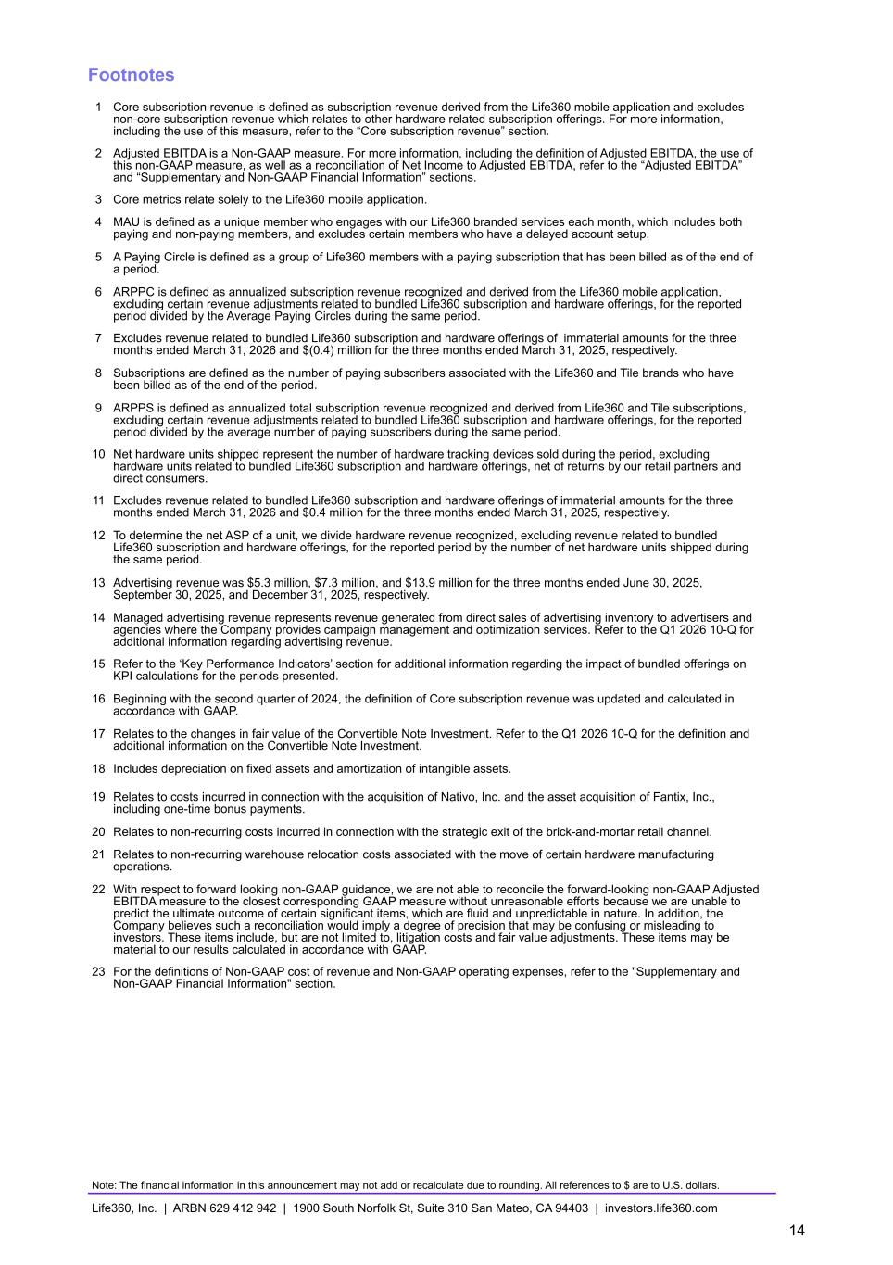
Footnotes 1 Core subscription revenue is defined as subscription revenue derived from the Life360 mobile application and excludes non-core subscription revenue which relates to other hardware related subscription offerings. For more information, including the use of this measure, refer to the “Core subscription revenue” section. 2 Adjusted EBITDA is a Non-GAAP measure. For more information, including the definition of Adjusted EBITDA, the use of this non-GAAP measure, as well as a reconciliation of Net Income to Adjusted EBITDA, refer to the “Adjusted EBITDA” and “Supplementary and Non-GAAP Financial Information” sections. 3 Core metrics relate solely to the Life360 mobile application. 4 MAU is defined as a unique member who engages with our Life360 branded services each month, which includes both paying and non-paying members, and excludes certain members who have a delayed account setup. 5 A Paying Circle is defined as a group of Life360 members with a paying subscription that has been billed as of the end of a period. 6 ARPPC is defined as annualized subscription revenue recognized and derived from the Life360 mobile application, excluding certain revenue adjustments related to bundled Life360 subscription and hardware offerings, for the reported period divided by the Average Paying Circles during the same period. 7 Excludes revenue related to bundled Life360 subscription and hardware offerings of immaterial amounts for the three months ended March 31, 2026 and $(0.4) million for the three months ended March 31, 2025, respectively. 8 Subscriptions are defined as the number of paying subscribers associated with the Life360 and Tile brands who have been billed as of the end of the period. 9 ARPPS is defined as annualized total subscription revenue recognized and derived from Life360 and Tile subscriptions, excluding certain revenue adjustments related to bundled Life360 subscription and hardware offerings, for the reported period divided by the average number of paying subscribers during the same period. 10 Net hardware units shipped represent the number of hardware tracking devices sold during the period, excluding hardware units related to bundled Life360 subscription and hardware offerings, net of returns by our retail partners and direct consumers. 11 Excludes revenue related to bundled Life360 subscription and hardware offerings of immaterial amounts for the three months ended March 31, 2026 and $0.4 million for the three months ended March 31, 2025, respectively. 12 To determine the net ASP of a unit, we divide hardware revenue recognized, excluding revenue related to bundled Life360 subscription and hardware offerings, for the reported period by the number of net hardware units shipped during the same period. 13 Advertising revenue was $5.3 million, $7.3 million, and $13.9 million for the three months ended June 30, 2025, September 30, 2025, and December 31, 2025, respectively. 14 Managed advertising revenue represents revenue generated from direct sales of advertising inventory to advertisers and agencies where the Company provides campaign management and optimization services. Refer to the Q1 2026 10-Q for additional information regarding advertising revenue. 15 Refer to the ‘Key Performance Indicators’ section for additional information regarding the impact of bundled offerings on KPI calculations for the periods presented. 16 Beginning with the second quarter of 2024, the definition of Core subscription revenue was updated and calculated in accordance with GAAP. 17 Relates to the changes in fair value of the Convertible Note Investment. Refer to the Q1 2026 10-Q for the definition and additional information on the Convertible Note Investment. 18 Includes depreciation on fixed assets and amortization of intangible assets. 19 Relates to costs incurred in connection with the acquisition of Nativo, Inc. and the asset acquisition of Fantix, Inc., including one-time bonus payments. 20 Relates to non-recurring costs incurred in connection with the strategic exit of the brick-and-mortar retail channel. 21 Relates to non-recurring warehouse relocation costs associated with the move of certain hardware manufacturing operations. 22 With respect to forward looking non-GAAP guidance, we are not able to reconcile the forward-looking non-GAAP Adjusted EBITDA measure to the closest corresponding GAAP measure without unreasonable efforts because we are unable to predict the ultimate outcome of certain significant items, which are fluid and unpredictable in nature. In addition, the Company believes such a reconciliation would imply a degree of precision that may be confusing or misleading to investors. These items include, but are not limited to, litigation costs and fair value adjustments. These items may be material to our results calculated in accordance with GAAP. 23 For the definitions of Non-GAAP cost of revenue and Non-GAAP operating expenses, refer to the "Supplementary and Non-GAAP Financial Information" section. Note: The financial information in this announcement may not add or recalculate due to rounding. All references to $ are to U.S. dollars. Life360, Inc. | ARBN 629 412 942 | 1900 South Norfolk St, Suite 310 San Mateo, CA 94403 | investors.life360.com 14


Shareholder Letter May 11, 2026 U.S. PT May 12, 2026 AEST


Dear Shareholders, Q1 2026 was a strong start to the year for Life360, as we made everyday family life better for more families around the world and delivered outstanding operational results. Paying Circles crossed three million, powered by over two hundred thousand net additions —the most we have ever added in a single quarter. Total revenue grew 38 percent year over year to $143.1 million. We are sharing advertising revenue separately for the first time: $19.7 million, up 329 percent year over year, reflecting the first full quarter of Life360 Ads following the Nativo acquisition. Our monthly active users (MAU) reached a new record level, but not as high as we expected to be. We have clarity on the temporary issues causing this difference, which gives us confidence in our MAU trajectory, but affects the timing. We expect MAU growth to return to our planned glideslope by Q3. Grow Our User Base Growing our user base is a key priority because it fuels every part of our business. Q1 MAU came in at 97.8 million, with 17 percent year - over - year growth. Back in January, we guided to 20 percent annual MAU growth and later flagged that Q1 would run below the annual trend line, in part because history told us to expect higher churn following a strong acquisition quarter. We also later identified a technical issue quietly accumulating and creating drag on new registrations. Once we addressed that issue, we saw iOS registrations recover, though Android continued to lag. Subsequent investigation revealed a number of interconnected technical problems that impacted Android users on lower - end devices before they fully onboarded. One of those issues caused the Google Play Store to suppress Life360 in its app store searches during our peak Q1 marketing period. The impact was global, but concentrated in populations with low - end devices, with minimal impact on monetization. We have since retooled our monitoring system to ensure full visibility of demand signals across downloads and registrations, and put fixes in place. The Play Store suppression is no longer in effect, and we're tightening the funnel so every potential member has the best chance of becoming an active member. Signals indicate that the fixes are taking hold and we expect to be back on our planned glideslope in Q3. Our iOS - intensive markets have recovered and are demonstrating strong growth. In the back half of the year, we expect Android to recover while we land additional growth initiatives, including improved international localization, new GTM campaigns in Germany, Mexico, and Brazil, Google Sign - In to reduce registration friction, and an array of new experiences that make Life360 better for families in all life stages. As a result of these temporary issues, Q1 MAU growth in the U.S. was 14 percent and 20 percent in international markets year over year. However, the populations that drive the lion's share of our international revenue are growing well, with MAU in the UK growing 25 percent, Canada up 32 percent, and Australia - New Zealand up 24 percent year over year. These are the markets where families convert to paid subscriptions at the highest rates and drive the most revenue, resulting in Paying Circles growth that is outpacing MAU growth. Life360 Inc | Q1 2026 Investor letter | Page 2 LAUREN ANTONOFF, CHIEF EXECUTIVE OFFICER

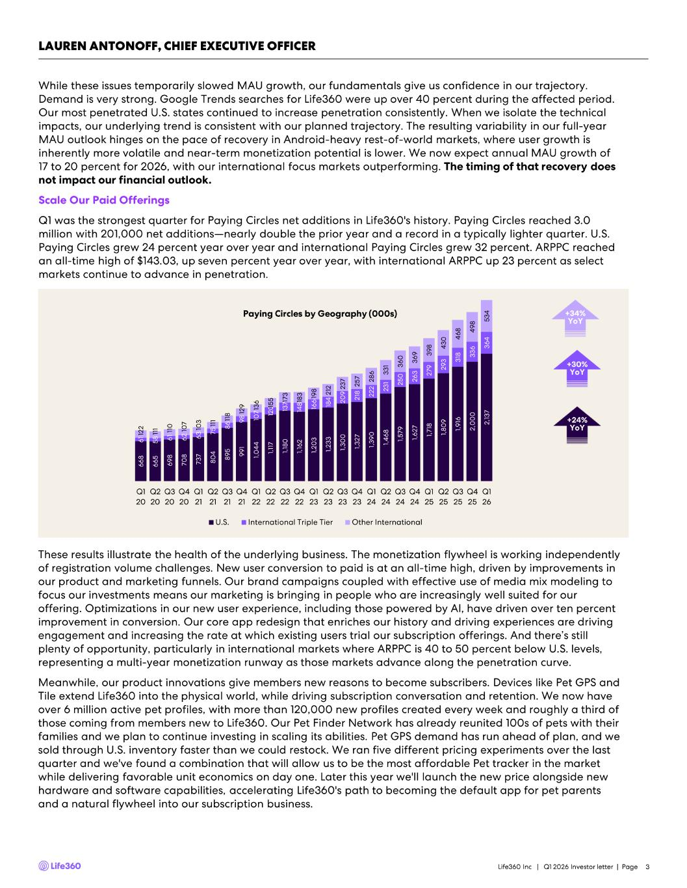
While these issues temporarily slowed MAU growth, our fundamentals give us confidence in our trajectory. Demand is very strong. Google Trends searches for Life360 were up over 40 percent during the affected period. Our most penetrated U.S. states continued to increase penetration consistently. When we isolate the technical impacts, our underlying trend is consistent with our planned trajectory. The resulting variability in our full - year MAU outlook hinges on the pace of recovery in Android - heavy rest - of - world markets, where user growth is inherently more volatile and near - term monetization potential is lower. We now expect annual MAU growth of 17 to 20 percent for 2026, with our international focus markets outperforming. The timing of that recovery does not impact our financial outlook. Scale Our Paid Offerings Q1 was the strongest quarter for Paying Circles net additions in Life360's history. Paying Circles reached 3.0 million with 201,000 net additions —nearly double the prior year and a record in a typically lighter quarter. U.S. Paying Circles grew 24 percent year over year and international Paying Circles grew 32 percent. ARPPC reached an all - time high of $143.03, up seven percent year over year, with international ARPPC up 23 percent as select markets continue to advance in penetration. Life360 Inc | Q1 2026 Investor letter | Page 3 LAUREN ANTONOFF, CHIEF EXECUTIVE OFFICER +30% YoY +24% YoY +34% YoY 6 6 8 6 6 5 6 9 8 7 0 8 7 3 7 8 0 4 8 9 5 9 9 1 1 ,0 4 4 1 ,1 1 7 1 ,1 8 0 1 ,1 6 2 1 ,2 0 3 1 ,2 3 3 1 ,3 0 0 1 ,3 2 7 1 ,3 9 0 1 ,4 6 8 1 ,5 7 9 1 ,6 2 7 1 ,7 1 8 1 ,8 0 9 1 ,9 1 6 2 ,0 0 0 2 ,1 3 7 6 1 5 8 6 1 6 2 6 3 7 5 8 6 9 8 1 0 7 1 2 0 1 3 7 1 4 8 1 6 6 1 8 4 2 0 9 2 1 8 2 2 2 2 3 1 2 5 0 2 6 3 2 7 9 2 9 3 3 1 8 3 3 6 3 6 4 1 2 2 1 1 1 1 1 0 1 0 7 1 0 3 1 1 1 1 1 8 1 2 9 1 3 6 1 5 5 1 7 3 1 8 3 1 9 8 2 1 2 2 3 7 2 5 7 2 8 6 3 3 1 3 6 0 3 6 9 3 9 8 4 3 0 4 6 8 4 9 8 5 3 4 Q1 20 Q2 20 Q3 20 Q4 20 Q1 21 Q2 21 Q3 21 Q4 21 Q1 22 Q2 22 Q3 22 Q4 22 Q1 23 Q2 23 Q3 23 Q4 23 Q1 24 Q2 24 Q3 24 Q4 24 Q1 25 Q2 25 Q3 25 Q4 25 Q1 26 U.S. International Triple Tier Other International Paying Circles by Geography (000s) These results illustrate the health of the underlying business. The monetization flywheel is working independently of registration volume challenges. New user conversion to paid is at an all - time high, driven by improvements in our product and marketing funnels. Our brand campaigns coupled with effective use of media mix modeling to focus our investments means our marketing is bringing in people who are increasingly well suited for our offering. Optimizations in our new user experience, including those powered by AI, have driven over ten percent improvement in conversion. Our core app redesign that enriches our history and driving experiences are driving engagement and increasing the rate at which existing users trial our subscription offerings. And there’s still plenty of opportunity, particularly in international markets where ARPPC is 40 to 50 percent below U.S. levels, representing a multi - year monetization runway as those markets advance along the penetration curve. Meanwhile, our product innovations give members new reasons to become subscribers. Devices like Pet GPS and Tile extend Life360 into the physical world, while driving subscription conversation and retention. We now have over 6 million active pet profiles, with more than 120,000 new profiles created every week and roughly a third of those coming from members new to Life360. Our Pet Finder Network has already reunited 100s of pets with their families and we plan to continue investing in scaling its abilities. Pet GPS demand has run ahead of plan, and we sold through U.S. inventory faster than we could restock. We ran five different pricing experiments over the last quarter and we've found a combination that will allow us to be the most affordable Pet tracker in the market while delivering favorable unit economics on day one. Later this year we'll launch the new price alongside new hardware and software capabilities, accelerating Life360's path to becoming the default app for pet parents and a natural flywheel into our subscription business.

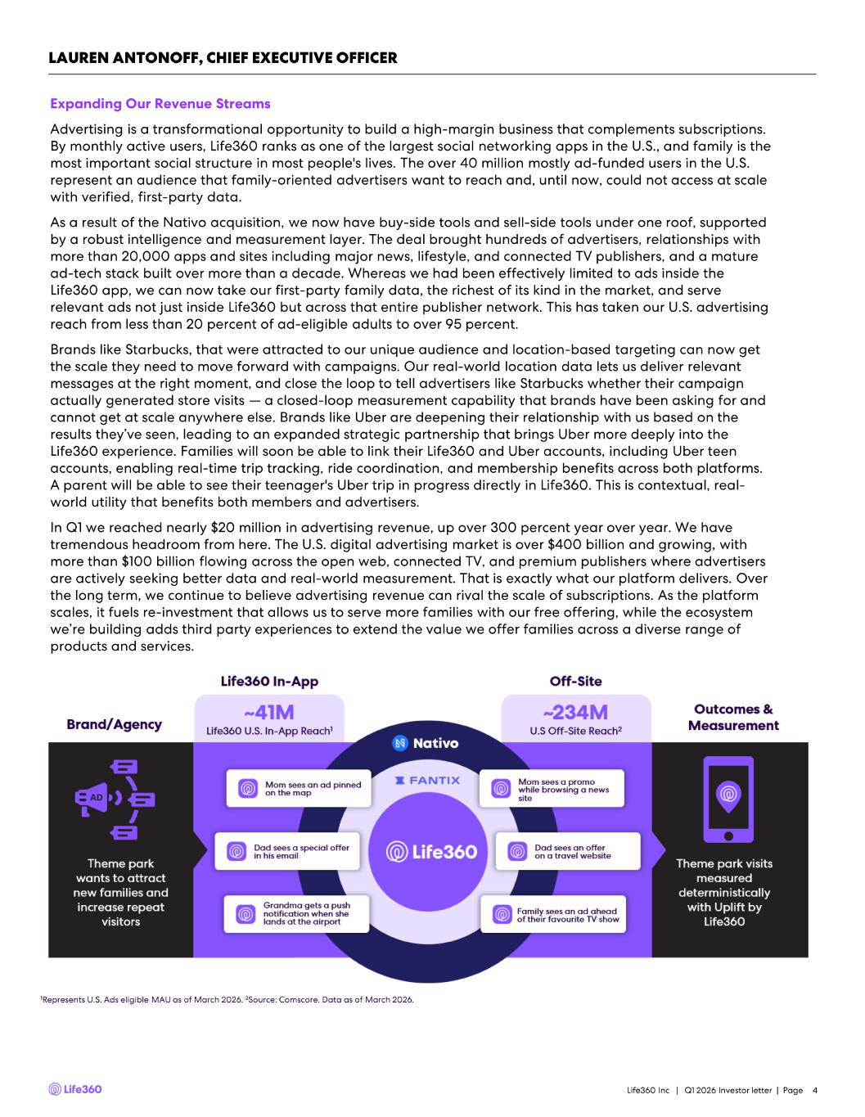
Expanding Our Revenue Streams Advertising is a transformational opportunity to build a high - margin business that complements subscriptions. By monthly active users, Life360 ranks as one of the largest social networking apps in the U.S., and family is the most important social structure in most people's lives. The over 40 million mostly ad - funded users in the U.S. represent an audience that family - oriented advertisers want to reach and, until now, could not access at scale with verified, first - party data. As a result of the Nativo acquisition, we now have buy - side tools and sell - side tools under one roof, supported by a robust intelligence and measurement layer. The deal brought hundreds of advertisers, relationships with more than 20,000 apps and sites including major news, lifestyle, and connected TV publishers, and a mature ad - tech stack built over more than a decade. Whereas we had been effectively limited to ads inside the Life360 app, we can now take our first - party family data, the richest of its kind in the market, and serve relevant ads not just inside Life360 but across that entire publisher network. This has taken our U.S. advertising reach from less than 20 percent of ad - eligible adults to over 95 percent. Brands like Starbucks, that were attracted to our unique audience and location - based targeting can now get the scale they need to move forward with campaigns. Our real - world location data lets us deliver relevant messages at the right moment, and close the loop to tell advertisers like Starbucks whether their campaign actually generated store visits — a closed - loop measurement capability that brands have been asking for and cannot get at scale anywhere else. Brands like Uber are deepening their relationship with us based on the results they’ve seen, leading to an expanded strategic partnership that brings Uber more deeply into the Life360 experience. Families will soon be able to link their Life360 and Uber accounts, including Uber teen accounts, enabling real - time trip tracking, ride coordination, and membership benefits across both platforms. A parent will be able to see their teenager's Uber trip in progress directly in Life360. This is contextual, real - world utility that benefits both members and advertisers. In Q1 we reached nearly $20 million in advertising revenue, up over 300 percent year over year. We have tremendous headroom from here. The U.S. digital advertising market is over $400 billion and growing, with more than $100 billion flowing across the open web, connected TV, and premium publishers where advertisers are actively seeking better data and real - world measurement. That is exactly what our platform delivers. Over the long term, we continue to believe advertising revenue can rival the scale of subscriptions. As the platform scales, it fuels re - investment that allows us to serve more families with our free offering, while the ecosystem we’re building adds third party experiences to extend the value we offer families across a diverse range of products and services. Life360 Inc | Q1 2026 Investor letter | Page 4 LAUREN ANTONOFF, CHIEF EXECUTIVE OFFICER 1Represents U.S. Ads eligible MAU as of March 2026. 2Source: Comscore . Data as of March 2026.

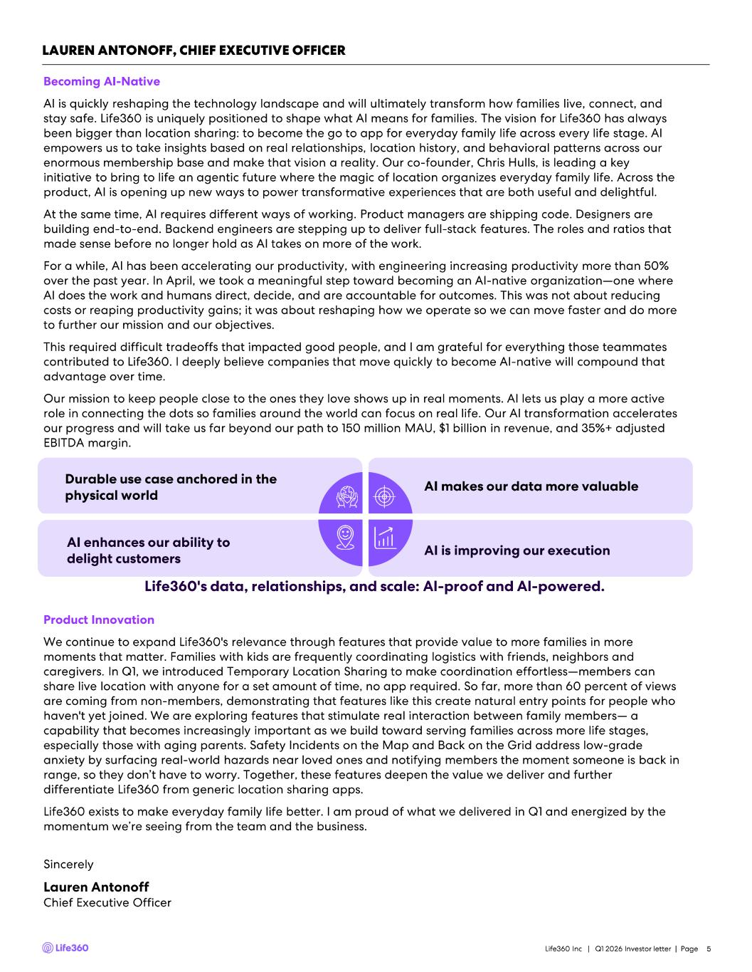
Life360 Inc | Q1 2026 Investor letter | Page 5 Becoming AI - Native AI is quickly reshaping the technology landscape and will ultimately transform how families live, connect, and stay safe. Life360 is uniquely positioned to shape what AI means for families. The vision for Life360 has always been bigger than location sharing: to become the go to app for everyday family life across every life stage. AI empowers us to take insights based on real relationships, location history, and behavioral patterns across our enormous membership base and make that vision a reality. Our co - founder, Chris Hulls, is leading a key initiative to bring to life an agentic future where the magic of location organizes everyday family life. Across the product, AI is opening up new ways to power transformative experiences that are both useful and delightful. At the same time, AI requires different ways of working. Product managers are shipping code. Designers are building end - to- end. Backend engineers are stepping up to deliver full - stack features. The roles and ratios that made sense before no longer hold as AI takes on more of the work. For a while, AI has been accelerating our productivity, with engineering increasing productivity more than 50% over the past year. In April, we took a meaningful step toward becoming an AI - native organization —one where AI does the work and humans direct, decide, and are accountable for outcomes. This was not about reducing costs or reaping productivity gains; it was about reshaping how we operate so we can move faster and do more to further our mission and our objectives. This required difficult tradeoffs that impacted good people, and I am grateful for everything those teammates contributed to Life360. I deeply believe companies that move quickly to become AI - native will compound that advantage over time. Our mission to keep people close to the ones they love shows up in real moments. AI lets us play a more active role in connecting the dots so families around the world can focus on real life. Our AI transformation accelerates our progress and will take us far beyond our path to 150 million MAU, $1 billion in revenue, and 35%+ adjusted EBITDA margin. Product Innovation We continue to expand Life360's relevance through features that provide value to more families in more moments that matter. Families with kids are frequently coordinating logistics with friends, neighbors and caregivers. In Q1, we introduced Temporary Location Sharing to make coordination effortless —members can share live location with anyone for a set amount of time, no app required. So far, more than 60 percent of views are coming from non - members, demonstrating that features like this create natural entry points for people who haven't yet joined. We are exploring features that stimulate real interaction between family members — a capability that becomes increasingly important as we build toward serving families across more life stages, especially those with aging parents. Safety Incidents on the Map and Back on the Grid address low - grade anxiety by surfacing real - world hazards near loved ones and notifying members the moment someone is back in range, so they don’t have to worry. Together, these features deepen the value we deliver and further differentiate Life360 from generic location sharing apps. Life360 exists to make everyday family life better. I am proud of what we delivered in Q1 and energized by the momentum we’re seeing from the team and the business. Sincerely Lauren Antonoff Chief Executive Officer LAUREN ANTONOFF, CHIEF EXECUTIVE OFFICER Life360's data, relationships, and scale: AI - proof and AI - powered. Durable use case anchored in the physical world AI makes our data more valuable AI enhances our ability to delight customers AI is improving our execution

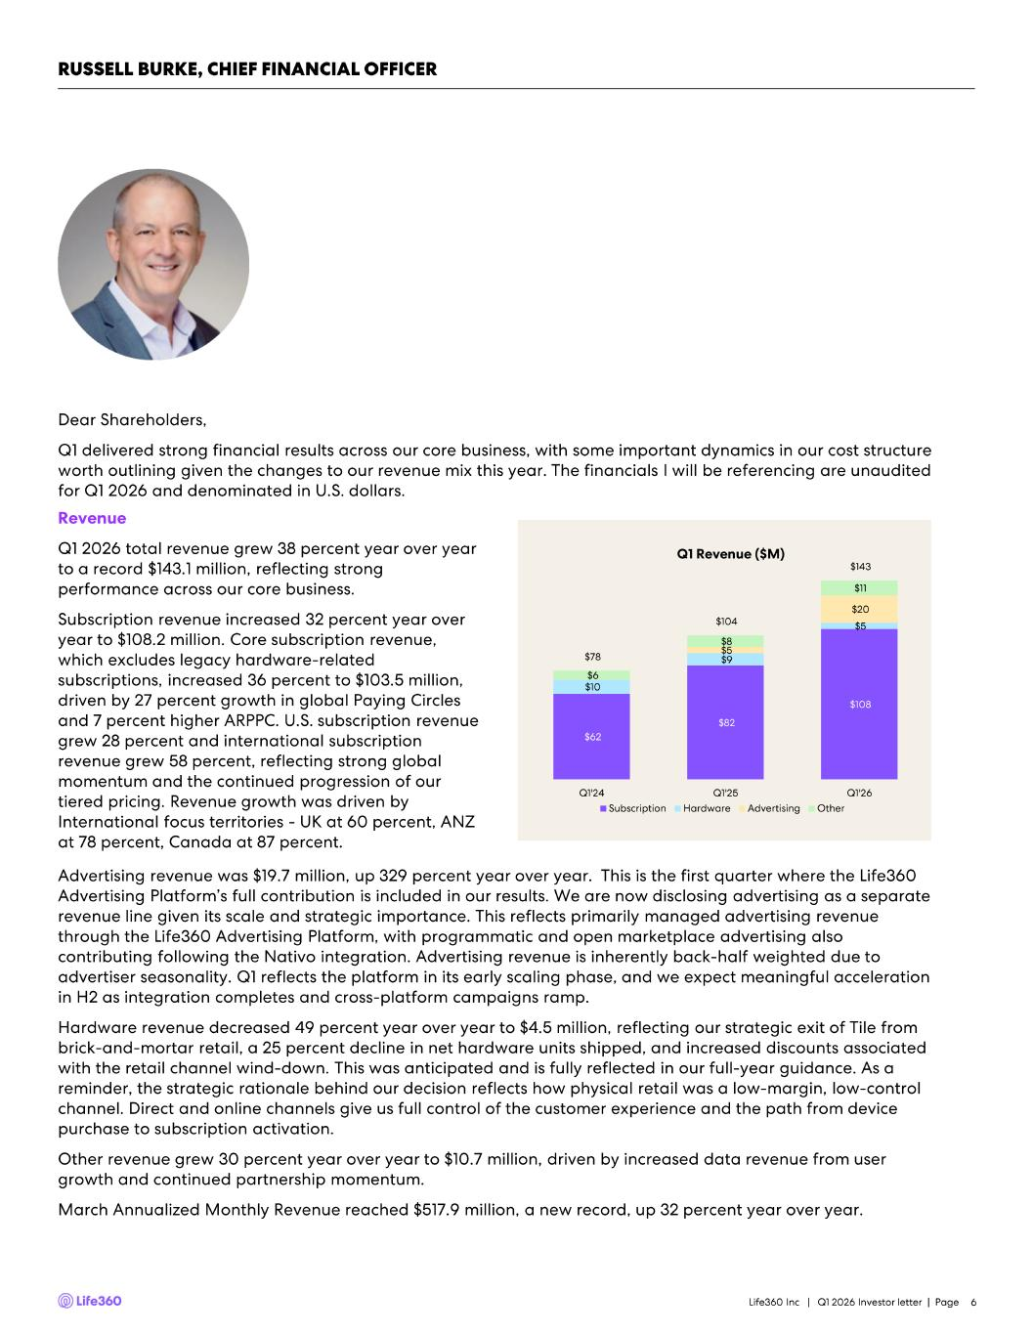
Life360 Inc | Q1 2026 Investor letter | Page 6 Dear Shareholders, Q1 delivered strong financial results across our core business, with some important dynamics in our cost structure worth outlining given the changes to our revenue mix this year. The financials I will be referencing are unaudited for Q1 2026 and denominated in U.S. dollars. Revenue Q1 2026 total revenue grew 38 percent year over year to a record $143.1 million, reflecting strong performance across our core business. Subscription revenue increased 32 percent year over year to $108.2 million. Core subscription revenue, which excludes legacy hardware - related subscriptions, increased 36 percent to $103.5 million, driven by 27 percent growth in global Paying Circles and 7 percent higher ARPPC. U.S. subscription revenue grew 28 percent and international subscription revenue grew 58 percent, reflecting strong global momentum and the continued progression of our tiered pricing. Revenue growth was driven by International focus territories - UK at 60 percent, ANZ at 78 percent, Canada at 87 percent. Advertising revenue was $19.7 million, up 329 percent year over year. This is the first quarter where the Life360 Advertising Platform’s full contribution is included in our results. We are now disclosing advertising as a separate revenue line given its scale and strategic importance. This reflects primarily managed advertising revenue through the Life360 Advertising Platform, with programmatic and open marketplace advertising also contributing following the Nativo integration. Advertising revenue is inherently back - half weighted due to advertiser seasonality. Q1 reflects the platform in its early scaling phase, and we expect meaningful acceleration in H2 as integration completes and cross - platform campaigns ramp. Hardware revenue decreased 49 percent year over year to $4.5 million, reflecting our strategic exit of Tile from brick - and - mortar retail, a 25 percent decline in net hardware units shipped, and increased discounts associated with the retail channel wind - down. This was anticipated and is fully reflected in our full - year guidance. As a reminder, the strategic rationale behind our decision reflects how physical retail was a low - margin, low - control channel. Direct and online channels give us full control of the customer experience and the path from device purchase to subscription activation. Other revenue grew 30 percent year over year to $10.7 million, driven by increased data revenue from user growth and continued partnership momentum. March Annualized Monthly Revenue reached $517.9 million, a new record, up 32 percent year over year. $62 $82 $108 $10 $9 $5 $5 $20 $6 $8 $11 $78 $104 $143 Q1'24 Q1'25 Q1'26 Subscription Hardware Advertising Other Q1 Revenue ($M) RUSSELL BURKE, CHIEF FINANCIAL OFFICER

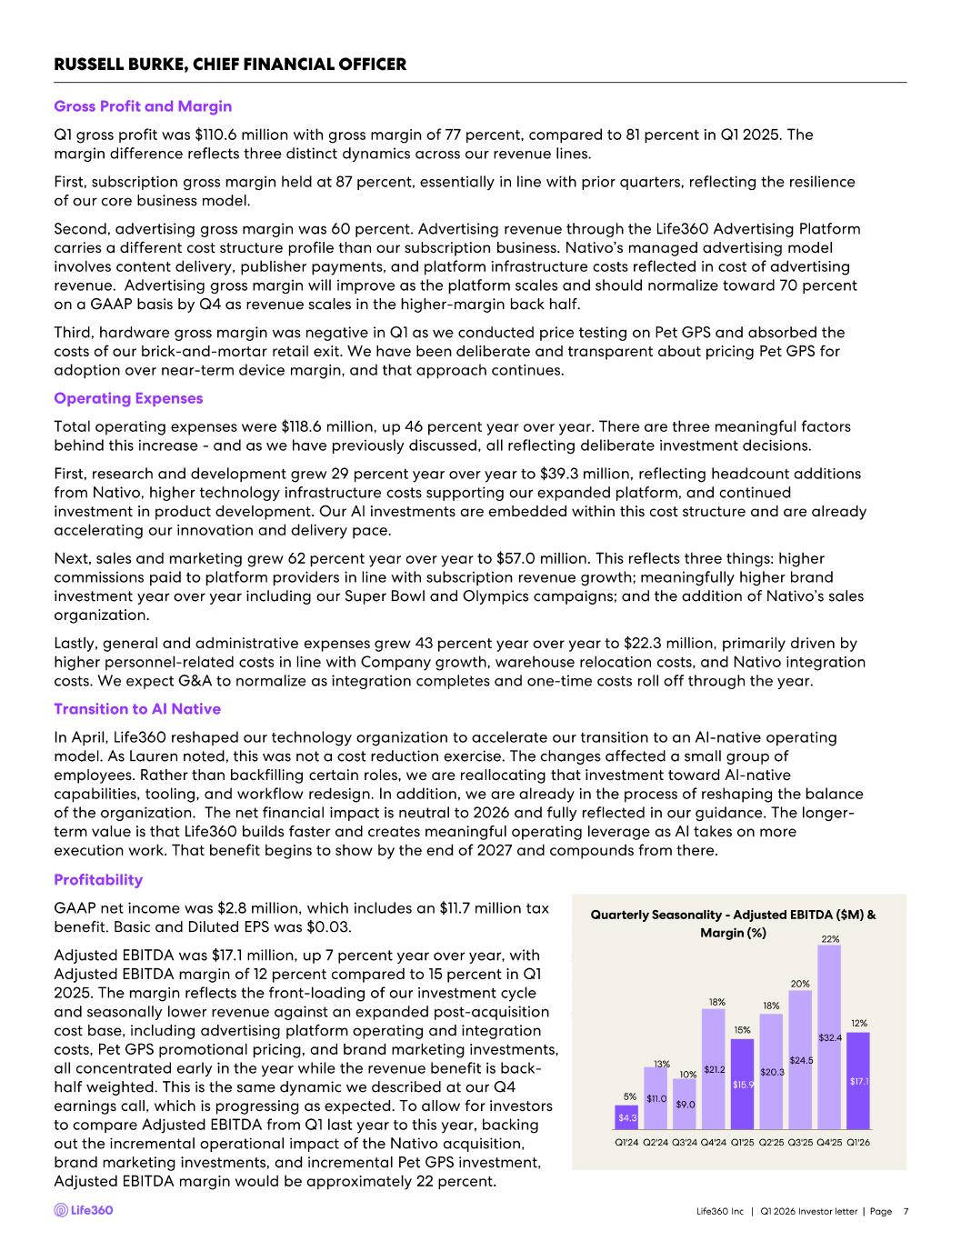
Quarterly Seasonality - Adjusted EBITDA ($M) & Margin (%) Life360 Inc | Q1 2026 Investor letter | Page 7 Gross Profit and Margin Q1 gross profit was $110.6 million with gross margin of 77 percent, compared to 81 percent in Q1 2025. The margin difference reflects three distinct dynamics across our revenue lines. First, subscription gross margin held at 87 percent, essentially in line with prior quarters, reflecting the resilience of our core business model. Second, advertising gross margin was 60 percent. Advertising revenue through the Life360 Advertising Platform carries a different cost structure profile than our subscription business. Nativo’s managed advertising model involves content delivery, publisher payments, and platform infrastructure costs reflected in cost of advertising revenue. Advertising gross margin will improve as the platform scales and should normalize toward 70 percent on a GAAP basis by Q4 as revenue scales in the higher - margin back half. Third, hardware gross margin was negative in Q1 as we conducted price testing on Pet GPS and absorbed the costs of our brick - and - mortar retail exit. We have been deliberate and transparent about pricing Pet GPS for adoption over near - term device margin, and that approach continues. Operating Expenses Total operating expenses were $118.6 million, up 46 percent year over year. There are three meaningful factors behind this increase - and as we have previously discussed, all reflecting deliberate investment decisions. First, research and development grew 29 percent year over year to $39.3 million, reflecting headcount additions from Nativo, higher technology infrastructure costs supporting our expanded platform, and continued investment in product development. Our AI investments are embedded within this cost structure and are already accelerating our innovation and delivery pace. Next, sales and marketing grew 62 percent year over year to $57.0 million. This reflects three things: higher commissions paid to platform providers in line with subscription revenue growth; meaningfully higher brand investment year over year including our Super Bowl and Olympics campaigns; and the addition of Nativo’s sales organization. Lastly, general and administrative expenses grew 43 percent year over year to $22.3 million, primarily driven by higher personnel - related costs in line with Company growth, warehouse relocation costs, and Nativo integration costs. We expect G&A to normalize as integration completes and one - time costs roll off through the year. Transition to AI Native In April, Life360 reshaped our technology organization to accelerate our transition to an AI - native operating model. As Lauren noted, this was not a cost reduction exercise. The changes affected a small group of employees. Rather than backfilling certain roles, we are reallocating that investment toward AI - native capabilities, tooling, and workflow redesign. In addition, we are already in the process of reshaping the balance of the organization. The net financial impact is neutral to 2026 and fully reflected in our guidance. The longer - term value is that Life360 builds faster and creates meaningful operating leverage as AI takes on more execution work. That benefit begins to show by the end of 2027 and compounds from there. Profitability GAAP net income was $2.8 million, which includes an $11.7 million tax benefit. Basic and Diluted EPS was $0.03. Adjusted EBITDA was $17.1 million, up 7 percent year over year, with Adjusted EBITDA margin of 12 percent compared to 15 percent in Q1 2025. The margin reflects the front - loading of our investment cycle and seasonally lower revenue against an expanded post - acquisition cost base, including advertising platform operating and integration costs, Pet GPS promotional pricing, and brand marketing investments, all concentrated early in the year while the revenue benefit is back - half weighted. This is the same dynamic we described at our Q4 earnings call, which is progressing as expected. To allow for investors to compare Adjusted EBITDA from Q1 last year to this year, backing out the incremental operational impact of the Nativo acquisition, brand marketing investments, and incremental Pet GPS investment, Adjusted EBITDA margin would be approximately 22 percent. RUSSELL BURKE, CHIEF FINANCIAL OFFICER $4.3 $11.0 $9.0 $21.2 $15.9 $20.3 $24.5 $32.4 $17.1 5% 13% 10% 18% 15% 18% 20% 22% 12% 5% 7% 9% 11% 13% 15% 17% 19% 21% 23% $- $5.0 $10.0 $15.0 $20.0 $25.0 $30.0 $35.0 Q1'24 Q2'24 Q3'24 Q4'24 Q1'25 Q2'25 Q3'25 Q4'25 Q1'26

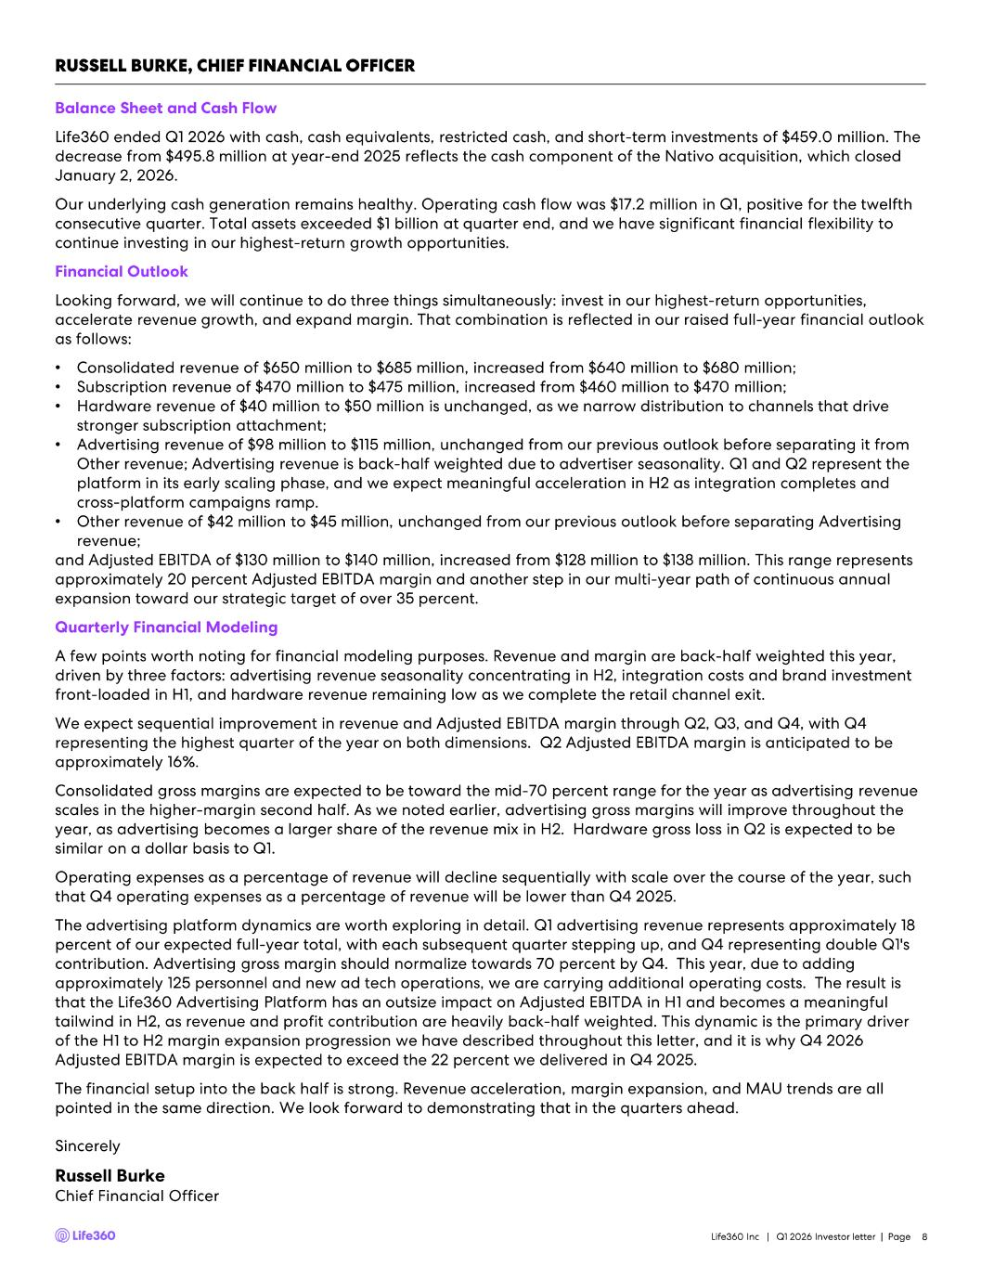
RUSSELL BURKE, CHIEF FINANCIAL OFFICER Life360 Inc | Q1 2026 Investor letter | Page 8 Sincerely Russell Burke Chief Financial Officer Balance Sheet and Cash Flow Life360 ended Q1 2026 with cash, cash equivalents, restricted cash, and short - term investments of $459.0 million. The decrease from $495.8 million at year - end 2025 reflects the cash component of the Nativo acquisition, which closed January 2, 2026. Our underlying cash generation remains healthy. Operating cash flow was $17.2 million in Q1, positive for the twelfth consecutive quarter. Total assets exceeded $1 billion at quarter end, and we have significant financial flexibility to continue investing in our highest - return growth opportunities. Financial Outlook Looking forward, we will continue to do three things simultaneously: invest in our highest - return opportunities, accelerate revenue growth, and expand margin. That combination is reflected in our raised full - year financial outlook as follows: • Consolidated revenue of $650 million to $685 million, increased from $640 million to $680 million; • Subscription revenue of $470 million to $475 million, increased from $460 million to $470 million; • Hardware revenue of $40 million to $50 million is unchanged, as we narrow distribution to channels that drive stronger subscription attachment; • Advertising revenue of $98 million to $115 million, unchanged from our previous outlook before separating it from Other revenue; Advertising revenue is back - half weighted due to advertiser seasonality. Q1 and Q2 represent the platform in its early scaling phase, and we expect meaningful acceleration in H2 as integration completes and cross - platform campaigns ramp. • Other revenue of $42 million to $45 million, unchanged from our previous outlook before separating Advertising revenue; and Adjusted EBITDA of $130 million to $140 million, increased from $128 million to $138 million. This range represents approximately 20 percent Adjusted EBITDA margin and another step in our multi - year path of continuous annual expansion toward our strategic target of over 35 percent. Quarterly Financial Modeling A few points worth noting for financial modeling purposes. Revenue and margin are back - half weighted this year, driven by three factors: advertising revenue seasonality concentrating in H2, integration costs and brand investment front - loaded in H1, and hardware revenue remaining low as we complete the retail channel exit. We expect sequential improvement in revenue and Adjusted EBITDA margin through Q2, Q3, and Q4, with Q4 representing the highest quarter of the year on both dimensions. Q2 Adjusted EBITDA margin is anticipated to be approximately 16%. Consolidated gross margins are expected to be toward the mid - 70 percent range for the year as advertising revenue scales in the higher - margin second half. As we noted earlier, advertising gross margins will improve throughout the year, as advertising becomes a larger share of the revenue mix in H2. Hardware gross loss in Q2 is expected to be similar on a dollar basis to Q1. Operating expenses as a percentage of revenue will decline sequentially with scale over the course of the year, such that Q4 operating expenses as a percentage of revenue will be lower than Q4 2025. The advertising platform dynamics are worth exploring in detail. Q1 advertising revenue represents approximately 18 percent of our expected full - year total, with each subsequent quarter stepping up, and Q4 representing double Q1's contribution. Advertising gross margin should normalize towards 70 percent by Q4. This year, due to adding approximately 125 personnel and new ad tech operations, we are carrying additional operating costs. The result is that the Life360 Advertising Platform has an outsize impact on Adjusted EBITDA in H1 and becomes a meaningful tailwind in H2, as revenue and profit contribution are heavily back - half weighted. This dynamic is the primary driver of the H1 to H2 margin expansion progression we have described throughout this letter, and it is why Q4 2026 Adjusted EBITDA margin is expected to exceed the 22 percent we delivered in Q4 2025. The financial setup into the back half is strong. Revenue acceleration, margin expansion, and MAU trends are all pointed in the same direction. We look forward to demonstrating that in the quarters ahead.


Appendix Life360 Inc | Q1 2026 Investor letter | Page 9

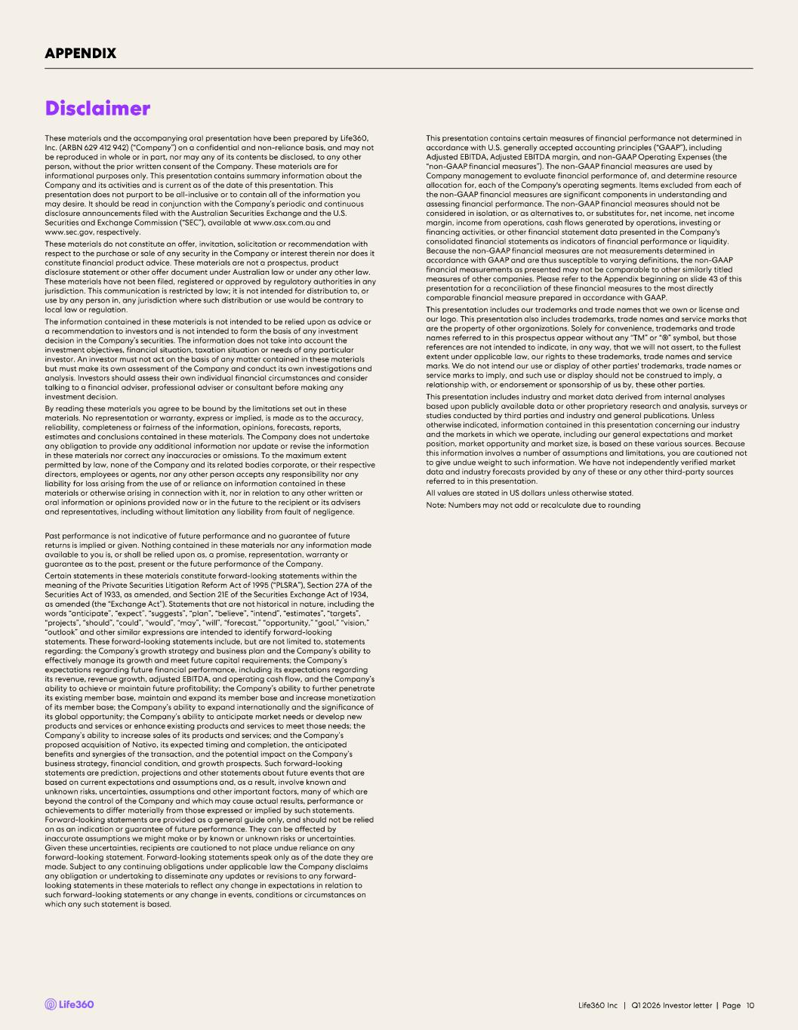
These materials and the accompanying oral presentation have been prepared by Life360, Inc. (ARBN 629 412 942) (“Company”) on a confidential and non - reliance basis, and may not be reproduced in whole or in part, nor may any of its contents be disclosed, to any other person, without the prior written consent of the Company. These materials are for informational purposes only. This presentation contains summary information about the Company and its activities and is current as of the date of this presentation. This presentation does not purport to be all - inclusive or to contain all of the information you may desire. It should be read in conjunction with the Company’s periodic and continuous disclosure announcements filed with the Australian Securities Exchange and the U.S. Securities and Exchange Commission (“SEC”), available at www.asx.com.au and www.sec.gov , respectively. These materials do not constitute an offer, invitation, solicitation or recommendation with respect to the purchase or sale of any security in the Company or interest therein nor does it constitute financial product advice. These materials are not a prospectus, product disclosure statement or other offer document under Australian law or under any other law. These materials have not been filed, registered or approved by regulatory authorities in any jurisdiction. This communication is restricted by law; it is not intended for distribution to, or use by any person in, any jurisdiction where such distribution or use would be contrary to local law or regulation. The information contained in these materials is not intended to be relied upon as advice or a recommendation to investors and is not intended to form the basis of any investment decision in the Company’s securities. The information does not take into account the investment objectives, financial situation, taxation situation or needs of any particular investor. An investor must not act on the basis of any matter contained in these materials but must make its own assessment of the Company and conduct its own investigations and analysis. Investors should assess their own individual financial circumstances and consider talking to a financial adviser, professional adviser or consultant before making any investment decision. By reading these materials you agree to be bound by the limitations set out in these materials. No representation or warranty, express or implied, is made as to the accuracy, reliability, completeness or fairness of the information, opinions, forecasts, reports, estimates and conclusions contained in these materials. The Company does not undertake any obligation to provide any additional information nor update or revise the information in these materials nor correct any inaccuracies or omissions. To the maximum extent permitted by law, none of the Company and its related bodies corporate, or their respective directors, employees or agents, nor any other person accepts any responsibility nor any liability for loss arising from the use of or reliance on information contained in these materials or otherwise arising in connection with it, nor in relation to any other written or oral information or opinions provided now or in the future to the recipient or its advisers and representatives, including without limitation any liability from fault of negligence. Past performance is not indicative of future performance and no guarantee of future returns is implied or given. Nothing contained in these materials nor any information made available to you is, or shall be relied upon as, a promise, representation, warranty or guarantee as to the past, present or the future performance of the Company. Certain statements in these materials constitute forward - looking statements within the meaning of the Private Securities Litigation Reform Act of 1995 (“PLSRA”), Section 27A of the Securities Act of 1933, as amended, and Section 21E of the Securities Exchange Act of 1934, as amended (the “Exchange Act”). Statements that are not historical in nature, including the words “anticipate”, “expect”, “suggests”, “plan”, “believe”, “intend”, “estimates”, “targets”, “projects”, “should”, “could”, “would”, “may”, “will”, “forecast,” “opportunity,” “goal,” “vision,” “outlook” and other similar expressions are intended to identify forward - looking statements. These forward - looking statements include, but are not limited to, statements regarding: the Company’s growth strategy and business plan and the Company’s ability to effectively manage its growth and meet future capital requirements; the Company’s expectations regarding future financial performance, including its expectations regarding its revenue, revenue growth, adjusted EBITDA, and operating cash flow, and the Company’s ability to achieve or maintain future profitability; the Company’s ability to further penetrate its existing member base, maintain and expand its member base and increase monetization of its member base; the Company’s ability to expand internationally and the significance of its global opportunity; the Company’s ability to anticipate market needs or develop new products and services or enhance existing products and services to meet those needs; the Company’s ability to increase sales of its products and services; and the Company’s proposed acquisition of Nativo, its expected timing and completion, the anticipated benefits and synergies of the transaction, and the potential impact on the Company’s business strategy, financial condition, and growth prospects. Such forward - looking statements are prediction, projections and other statements about future events that are based on current expectations and assumptions and, as a result, involve known and unknown risks, uncertainties, assumptions and other important factors, many of which are beyond the control of the Company and which may cause actual results, performance or achievements to differ materially from those expressed or implied by such statements. Forward - looking statements are provided as a general guide only, and should not be relied on as an indication or guarantee of future performance. They can be affected by inaccurate assumptions we might make or by known or unknown risks or uncertainties. Given these uncertainties, recipients are cautioned to not place undue reliance on any forward - looking statement. Forward - looking statements speak only as of the date they are made. Subject to any continuing obligations under applicable law the Company disclaims any obligation or undertaking to disseminate any updates or revisions to any forward - looking statements in these materials to reflect any change in expectations in relation to such forward - looking statements or any change in events, conditions or circumstances on which any such statement is based. This presentation contains certain measures of financial performance not determined in accordance with U.S. generally accepted accounting principles (“GAAP”), including Adjusted EBITDA, Adjusted EBITDA margin, and non - GAAP Operating Expenses (the “non - GAAP financial measures”). The non - GAAP financial measures are used by Company management to evaluate financial performance of, and determine resource allocation for, each of the Company's operating segments. Items excluded from each of the non - GAAP financial measures are significant components in understanding and assessing financial performance. The non - GAAP financial measures should not be considered in isolation, or as alternatives to, or substitutes for, net income, net income margin, income from operations, cash flows generated by operations, investing or financing activities, or other financial statement data presented in the Company's consolidated financial statements as indicators of financial performance or liquidity. Because the non - GAAP financial measures are not measurements determined in accordance with GAAP and are thus susceptible to varying definitions, the non - GAAP financial measurements as presented may not be comparable to other similarly titled measures of other companies. Please refer to the Appendix beginning on slide 43 of this presentation for a reconciliation of these financial measures to the most directly comparable financial measure prepared in accordance with GAAP. This presentation includes our trademarks and trade names that we own or license and our logo. This presentation also includes trademarks, trade names and service marks that are the property of other organizations. Solely for convenience, trademarks and trade names referred to in this prospectus appear without any “TM” or “®” symbol, but those references are not intended to indicate, in any way, that we will not assert, to the fullest extent under applicable law, our rights to these trademarks, trade names and service marks. We do not intend our use or display of other parties' trademarks, trade names or service marks to imply, and such use or display should not be construed to imply, a relationship with, or endorsement or sponsorship of us by, these other parties. This presentation includes industry and market data derived from internal analyses based upon publicly available data or other proprietary research and analysis, surveys or studies conducted by third parties and industry and general publications. Unless otherwise indicated, information contained in this presentation concerning our industry and the markets in which we operate, including our general expectations and market position, market opportunity and market size, is based on these various sources. Because this information involves a number of assumptions and limitations, you are cautioned not to give undue weight to such information. We have not independently verified market data and industry forecasts provided by any of these or any other third - party sources referred to in this presentation. All values are stated in US dollars unless otherwise stated. Note: Numbers may not add or recalculate due to rounding Disclaimer APPENDIX Life360 Inc | Q1 2026 Investor letter | Page 10

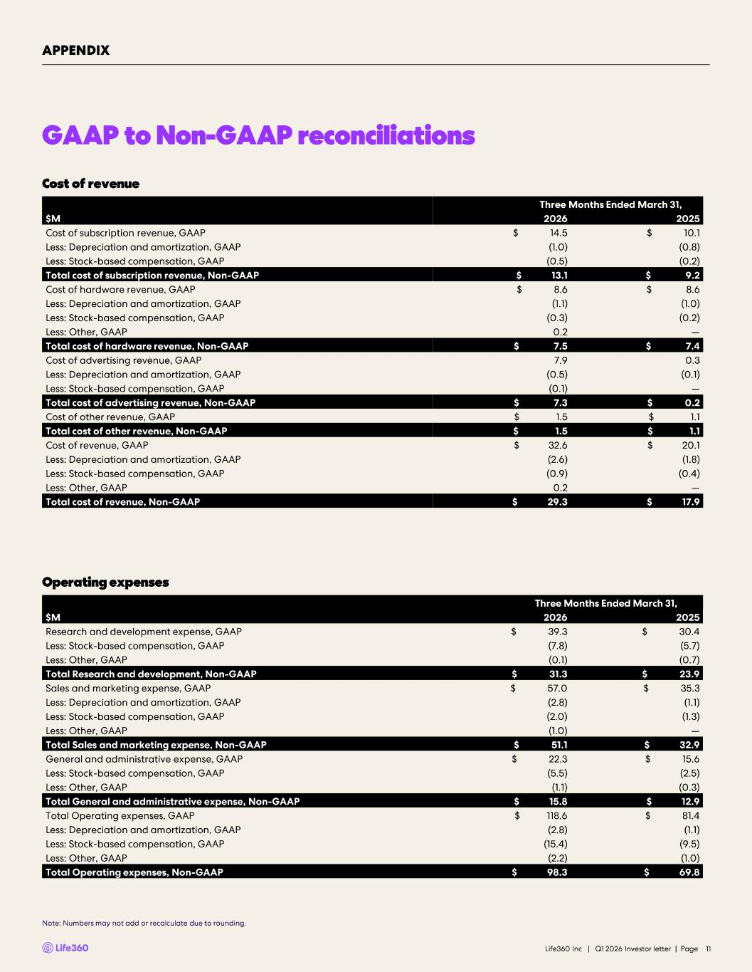
GAAP to Non -GAAP reconciliations Cost of revenue Operating expenses Life360 Inc | Q1 2026 Investor letter | Page 11 Three Months Ended March 31, $M 2026 2025 Cost of subscription revenue, GAAP $ 14.5 $ 10.1 Less: Depreciation and amortization, GAAP (1.0) (0.8) Less: Stock -based compensation, GAAP (0.5) (0.2) Total cost of subscription revenue, Non -GAAP $ 13.1 $ 9.2 Cost of hardware revenue, GAAP $ 8.6 $ 8.6 Less: Depreciation and amortization, GAAP (1.1) (1.0) Less: Stock -based compensation, GAAP (0.3) (0.2) Less: Other, GAAP 0.2 — Total cost of hardware revenue, Non -GAAP $ 7.5 $ 7.4 Cost of advertising revenue, GAAP 7.9 0.3 Less: Depreciation and amortization, GAAP (0.5) (0.1) Less: Stock -based compensation, GAAP (0.1) — Total cost of advertising revenue, Non -GAAP $ 7.3 $ 0.2 Cost of other revenue, GAAP $ 1.5 $ 1.1 Total cost of other revenue, Non -GAAP $ 1.5 $ 1.1 Cost of revenue, GAAP $ 32.6 $ 20.1 Less: Depreciation and amortization, GAAP (2.6) (1.8) Less: Stock -based compensation, GAAP (0.9) (0.4) Less: Other, GAAP 0.2 — Total cost of revenue, Non -GAAP $ 29.3 $ 17.9 Three Months Ended March 31, $M 2026 2025 Research and development expense, GAAP $ 39.3 $ 30.4 Less: Stock -based compensation, GAAP (7.8) (5.7) Less: Other, GAAP (0.1) (0.7) Total Research and development, Non -GAAP $ 31.3 $ 23.9 Sales and marketing expense, GAAP $ 57.0 $ 35.3 Less: Depreciation and amortization, GAAP (2.8) (1.1) Less: Stock -based compensation, GAAP (2.0) (1.3) Less: Other, GAAP (1.0) — Total Sales and marketing expense, Non -GAAP $ 51.1 $ 32.9 General and administrative expense, GAAP $ 22.3 $ 15.6 Less: Stock -based compensation, GAAP (5.5) (2.5) Less: Other, GAAP (1.1) (0.3) Total General and administrative expense, Non -GAAP $ 15.8 $ 12.9 Total Operating expenses, GAAP $ 118.6 $ 81.4 Less: Depreciation and amortization, GAAP (2.8) (1.1) Less: Stock -based compensation, GAAP (15.4) (9.5) Less: Other, GAAP (2.2) (1.0) Total Operating expenses, Non -GAAP $ 98.3 $ 69.8 APPENDIX Note: Numbers may not add or recalculate due to rounding.

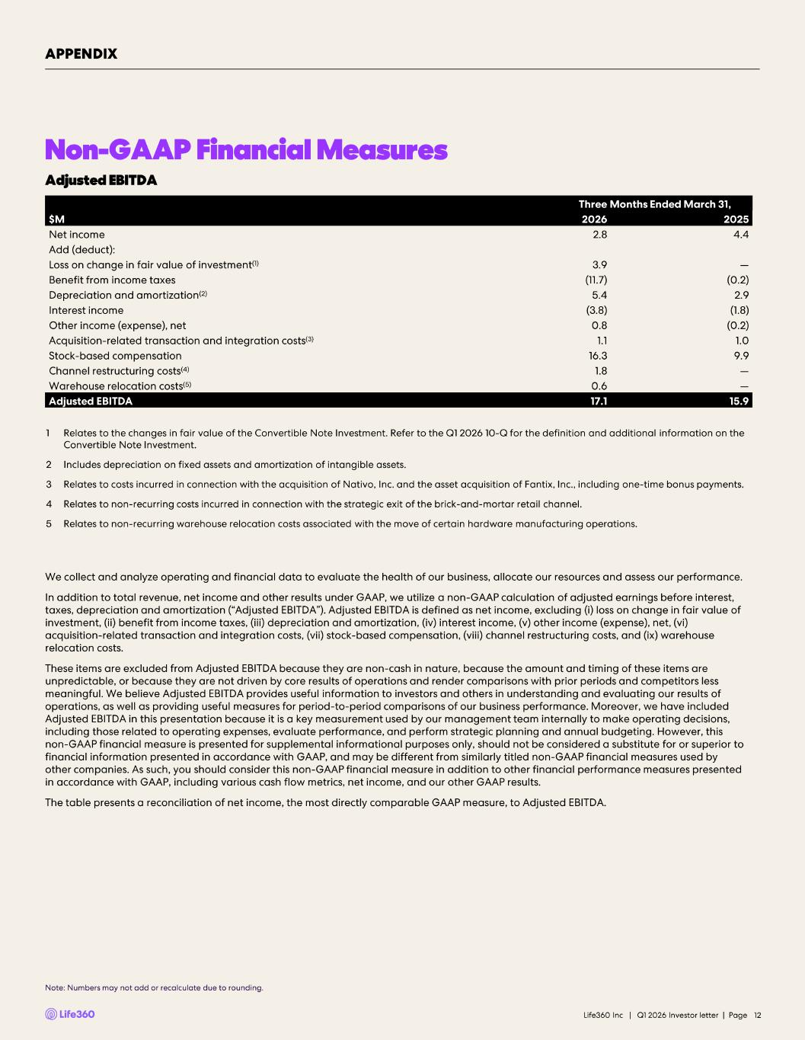
Non-GAAP Financial Measures Note: Numbers may not add or recalculate due to rounding. Life360 Inc | Q1 2026 Investor letter | Page 12 We collect and analyze operating and financial data to evaluate the health of our business, allocate our resources and assess ou r performance. In addition to total revenue, net income and other results under GAAP, we utilize a non -GAAP calculation of adjusted earnings be fore interest, taxes, depreciation and amortization (“Adjusted EBITDA”). Adjusted EBITDA is defined as net income, excluding ( i) loss on change in fair value of investment, (ii) benefit from income taxes, (iii) depreciation and amortization, (iv) interest income, (v) other income (expe nse ), net, (vi) acquisition - related transaction and integration costs, (vii) stock -based compensation, (viii) channel restructuring costs, and ( ix) warehouse relocation costs. These items are excluded from Adjusted EBITDA because they are non -cash in nature, because the amount and timing of these items are unpredictable, or because they are not driven by core results of operations and render comparisons with prior periods and com pet itors less meaningful. We believe Adjusted EBITDA provides useful information to investors and others in understanding and evaluating ou r results of operations, as well as providing useful measures for period - to-period comparisons of our business performance. Moreover, we have included Adjusted EBITDA in this presentation because it is a key measurement used by our management team internally to make operating de cisions, including those related to operating expenses, evaluate performance, and perform strategic planning and annual budgeting. How eve r, this non -GAAP financial measure is presented for supplemental informational purposes only, should not be considered a substitute for or superior to financial information presented in accordance with GAAP, and may be different from similarly titled non -GAAP financial measures used by other companies. As such, you should consider this non -GAAP financial measure in addition to other financial performance measure s presented in accordance with GAAP, including various cash flow metrics, net income, and our other GAAP results. The table presents a reconciliation of net income, the most directly comparable GAAP measure, to Adjusted EBITDA. Three Months Ended March 31, $M 2026 2025 Net income 2.8 4.4 Add (deduct): Loss on change in fair value of investment (1) 3.9 — Benefit from income taxes (11.7) (0.2) Depreciation and amortization (2) 5.4 2.9 Interest income (3.8) (1.8) Other income (expense), net 0.8 (0.2) Acquisition - related transaction and integration costs (3) 1.1 1.0 Stock -based compensation 16.3 9.9 Channel restructuring costs (4) 1.8 — Warehouse relocation costs (5) 0.6 — Adjusted EBITDA 17.1 15.9 1 Relates to the changes in fair value of the Convertible Note Investment. Refer to the Q1 2026 10 - Q for the definition and add itional information on the Convertible Note Investment. 2 Includes depreciation on fixed assets and amortization of intangible assets. 3 Relates to costs incurred in connection with the acquisition of Nativo, Inc. and the asset acquisition of Fantix, Inc., inclu ding one - time bonus payments. 4 Relates to non - recurring costs incurred in connection with the strategic exit of the brick - and - mortar retail channel. 5 Relates to non - recurring warehouse relocation costs associated with the move of certain hardware manufacturing operations. APPENDIX Adjusted EBITDA


Investor Presentation | May 2026 Q1’26 Investor Presentation 11 May 2026 U.S. PT | 12 May 2026 AEST


Investor Presentation | May 2026 DISCLAIMER These materials and the accompanying oral presentation have been prepared by Life360, Inc. (ARBN 629 412 942) (“Company”) on a confidential and non-reliance basis, and may not be reproduced in whole or in part, nor may any of its contents be disclosed, to any other person, without the prior written consent of the Company. These materials are for informational purposes only. This presentation contains summary information about the Company and its activities and is current as of the date of this presentation. This presentation does not purport to be all-inclusive or to contain all of the information you may desire. It should be read in conjunction with the Company’s periodic and continuous disclosure announcements filed with the Australian Securities Exchange and the U.S. Securities and Exchange Commission (“SEC”), available at www.asx.com.au and www.sec.gov, respectively. These materials do not constitute an offer, invitation, solicitation or recommendation with respect to the purchase or sale of any security in the Company or interest therein nor does it constitute financial product advice. These materials are not a prospectus, product disclosure statement or other offer document under Australian law or under any other law. These materials have not been filed, registered or approved by regulatory authorities in any jurisdiction. This communication is restricted by law; it is not intended for distribution to, or use by any person in, any jurisdiction where such distribution or use would be contrary to local law or regulation. The information contained in these materials is not intended to be relied upon as advice or a recommendation to investors and is not intended to form the basis of any investment decision in the Company’s securities. The information does not take into account the investment objectives, financial situation, taxation situation or needs of any particular investor. An investor must not act on the basis of any matter contained in these materials but must make its own assessment of the Company and conduct its own investigations and analysis. Investors should assess their own individual financial circumstances and consider talking to a financial adviser, professional adviser or consultant before making any investment decision. By reading these materials you agree to be bound by the limitations set out in these materials. No representation or warranty, express or implied, is made as to the accuracy, reliability, completeness or fairness of the information, opinions, forecasts, reports, estimates and conclusions contained in these materials. The Company does not undertake any obligation to provide any additional information nor update or revise the information in these materials nor correct any inaccuracies or omissions. To the maximum extent permitted by law, none of the Company and its related bodies corporate, or their respective directors, employees or agents, nor any other person accepts any responsibility nor any liability for loss arising from the use of or reliance on information contained in these materials or otherwise arising in connection with it, nor in relation to any other written or oral information or opinions provided now or in the future to the recipient or its advisers and representatives, including without limitation any liability from fault of negligence. Past performance is not indicative of future performance and no guarantee of future returns is implied or given. Nothing contained in these materials nor any information made available to you is, or shall be relied upon as, a promise, representation, warranty or guarantee as to the past, present or the future performance of the Company. Certain statements in these materials constitute forward-looking statements within the meaning of the Private Securities Litigation Reform Act of 1995 (“PLSRA”), Section 27A of the Securities Act of 1933, as amended, and Section 21E of the Securities Exchange Act of 1934, as amended (the “Exchange Act”). Statements that are not historical in nature, including the words “anticipate”, “expect”, “suggests”, “plan”, “believe”, “intend”, “estimates”, “targets”, “projects”, “should”, “could”, “would”, “may”, “will”, “forecast,” “opportunity,” “goal,” “vision,” “outlook” and other similar expressions are intended to identify forward-looking statements. These forward- looking statements include, but are not limited to, statements regarding: the Company’s growth strategy and business plan and the Company’s ability to effectively manage its growth and meet future capital requirements; the Company’s expectations regarding future financial performance, including its expectations regarding its revenue, revenue growth, adjusted EBITDA, and operating cash flow, and the Company’s ability to achieve or maintain future profitability; the Company’s ability to further penetrate its existing member base, maintain and expand its member base and increase monetization of its member base; the Company’s ability to expand internationally and the significance of its global opportunity; the Company’s ability to anticipate market needs or develop new products and services or enhance existing products and services to meet those needs; the Company’s ability to increase sales of its products and services; and the Company’s proposed acquisition of Nativo, its expected timing and completion, the anticipated benefits and synergies of the transaction, and the potential impact on the Company’s business strategy, financial condition, and growth prospects. Such forward-looking statements are prediction, projections and other statements about future events that are based on current expectations and assumptions and, as a result, involve known and unknown risks, uncertainties, assumptions and other important factors, many of which are beyond the control of the Company and which may cause actual results, performance or achievements to differ materially from those expressed or implied by such statements. Forward-looking statements are provided as a general guide only, and should not be relied on as an indication or guarantee of future performance. They can be affected by inaccurate assumptions we might make or by known or unknown risks or uncertainties. Given these uncertainties, recipients are cautioned to not place undue reliance on any forward- looking statement. Forward-looking statements speak only as of the date they are made. Subject to any continuing obligations under applicable law the Company disclaims any obligation or undertaking to disseminate any updates or revisions to any forward-looking statements in these materials to reflect any change in expectations in relation to such forward-looking statements or any change in events, conditions or circumstances on which any such statement is based. This presentation contains certain measures of financial performance not determined in accordance with U.S. generally accepted accounting principles (“GAAP”), including Adjusted EBITDA, Adjusted EBITDA margin, and non-GAAP Operating Expenses (the “non-GAAP financial measures”). The non-GAAP financial measures are used by Company management to evaluate financial performance of, and determine resource allocation for, each of the Company's operating segments. Items excluded from each of the non-GAAP financial measures are significant components in understanding and assessing financial performance. The non-GAAP financial measures should not be considered in isolation, or as alternatives to, or substitutes for, net income, net income margin, income from operations, cash flows generated by operations, investing or financing activities, or other financial statement data presented in the Company's consolidated financial statements as indicators of financial performance or liquidity. Because the non-GAAP financial measures are not measurements determined in accordance with GAAP and are thus susceptible to varying definitions, the non-GAAP financial measurements as presented may not be comparable to other similarly titled measures of other companies. Please refer to the Appendix beginning on slide 43 of this presentation for a reconciliation of these financial measures to the most directly comparable financial measure prepared in accordance with GAAP. This presentation includes our trademarks and trade names that we own or license and our logo. This presentation also includes trademarks, trade names and service marks that are the property of other organizations. Solely for convenience, trademarks and trade names referred to in this prospectus appear without any “TM” or “®” symbol, but those references are not intended to indicate, in any way, that we will not assert, to the fullest extent under applicable law, our rights to these trademarks, trade names and service marks. We do not intend our use or display of other parties' trademarks, trade names or service marks to imply, and such use or display should not be construed to imply, a relationship with, or endorsement or sponsorship of us by, these other parties. This presentation includes industry and market data derived from internal analyses based upon publicly available data or other proprietary research and analysis, surveys or studies conducted by third parties and industry and general publications. Unless otherwise indicated, information contained in this presentation concerning our industry and the markets in which we operate, including our general expectations and market position, market opportunity and market size, is based on these various sources. Because this information involves a number of assumptions and limitations, you are cautioned not to give undue weight to such information. We have not independently verified market data and industry forecasts provided by any of these or any other third-party sources referred to in this presentation. All values are stated in US dollars unless otherwise stated. 2

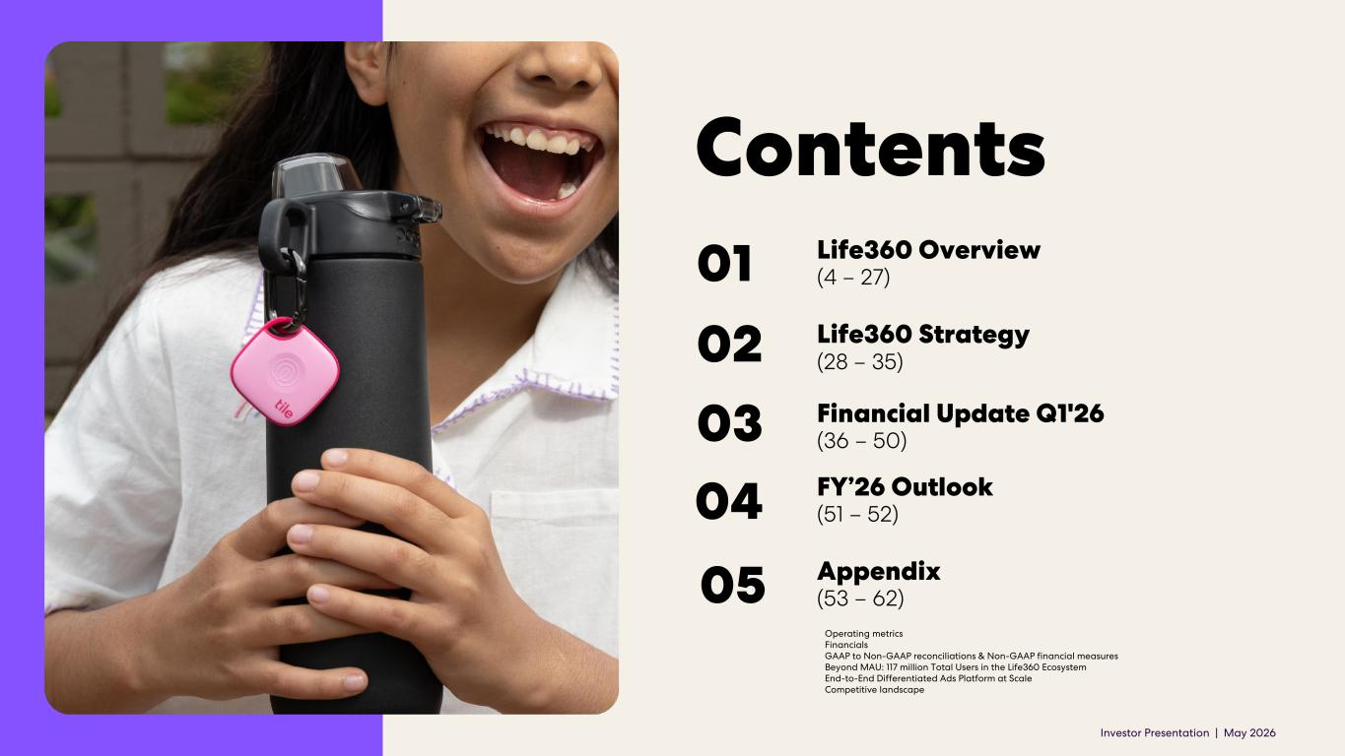
Investor Presentation | May 2026 Contents Appendix (53 – 62)05 04 Financial Update Q1'26 (36 – 50)03 Life360 Strategy (28 – 35)02 Life360 Overview (4 – 27)01 Operating metrics Financials GAAP to Non-GAAP reconciliations & Non-GAAP financial measures Beyond MAU: 117 million Total Users in the Life360 Ecosystem End-to-End Differentiated Ads Platform at Scale Competitive landscape FY’26 Outlook (51 – 52)


Investor Presentation | May 2026 01 Life360 Overview

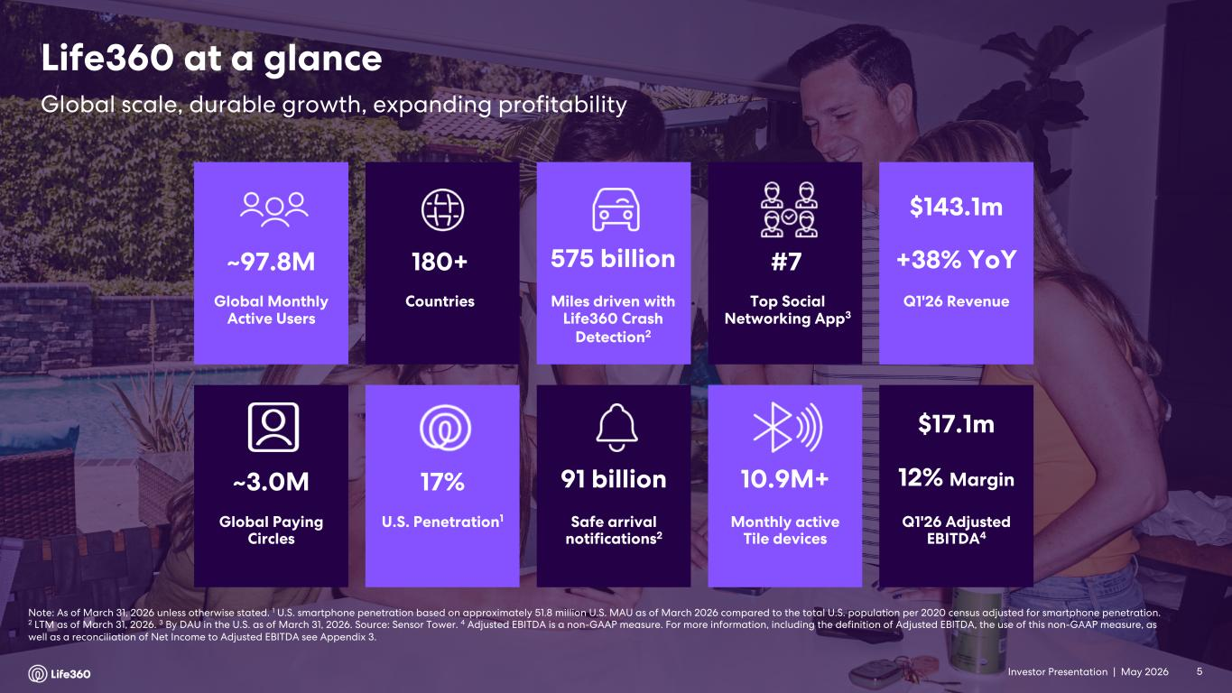
Investor Presentation | May 2026 Note: As of March 31, 2026 unless otherwise stated. 1 U.S. smartphone penetration based on approximately 51.8 million U.S. MAU as of March 2026 compared to the total U.S. population per 2020 census adjusted for smartphone penetration. 2 LTM as of March 31, 2026. 3 By DAU in the U.S. as of March 31, 2026. Source: Sensor Tower. 4 Adjusted EBITDA is a non-GAAP measure. For more information, including the definition of Adjusted EBITDA, the use of this non-GAAP measure, as well as a reconciliation of Net Income to Adjusted EBITDA see Appendix 3. Global Paying Circles ~3.0M Safe arrival notifications2 91 billion U.S. Penetration1 17% 10.9M+ Monthly active Tile devices Global Monthly Active Users ~97.8M Miles driven with Life360 Crash Detection2 575 billion Countries 180+ Top Social Networking App3 #7 Q1'26 Revenue $143.1m +38% YoY Q1'26 Adjusted EBITDA4 $17.1m 12% Margin Global scale, durable growth, expanding profitability Life360 at a glance 5

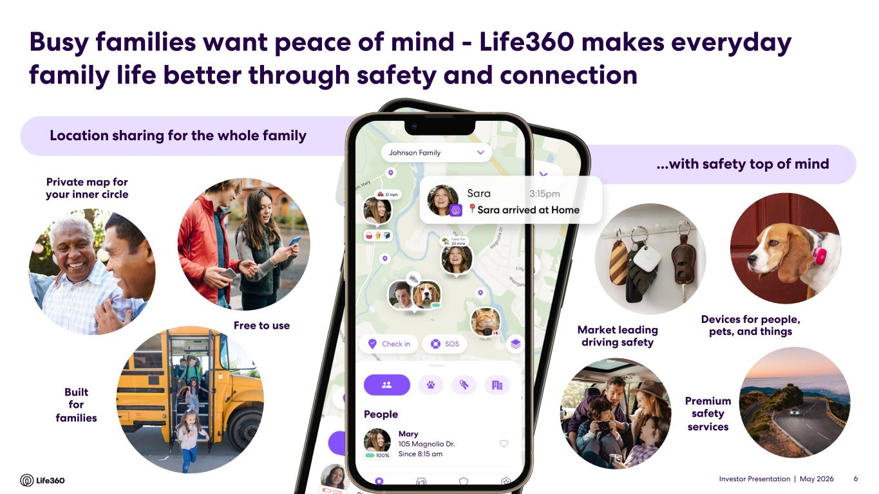
Investor Presentation | May 2026 Location sharing for the whole family ...with safety top of mind Private map for your inner circle Free to use Built for families Devices for people, pets, and things Premium safety services Market leading driving safety Busy families want peace of mind - Life360 makes everyday family life better through safety and connection 6

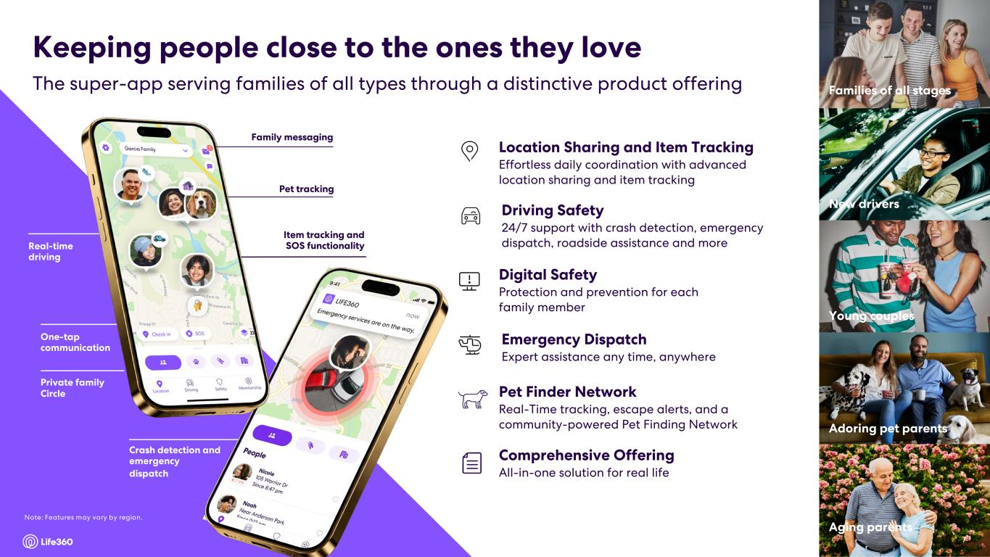
Investor Presentation | May 2026 7 Family messaging Real-time driving One-tap communication Private family Circle Item tracking and SOS functionality Crash detection and emergency dispatch Driving Safety 24/7 support with crash detection, emergency dispatch, roadside assistance and more Digital Safety Protection and prevention for each family member Location Sharing and Item Tracking Effortless daily coordination with advanced location sharing and item tracking Emergency Dispatch Expert assistance any time, anywhere Comprehensive Offering All-in-one solution for real life Young couples New drivers Families of all stages Aging parents Adoring pet parents The super-app serving families of all types through a distinctive product offering Keeping people close to the ones they love 7 Pet Finder Network Real-Time tracking, escape alerts, and a community-powered Pet Finding Network Pet tracking Note: Features may vary by region.

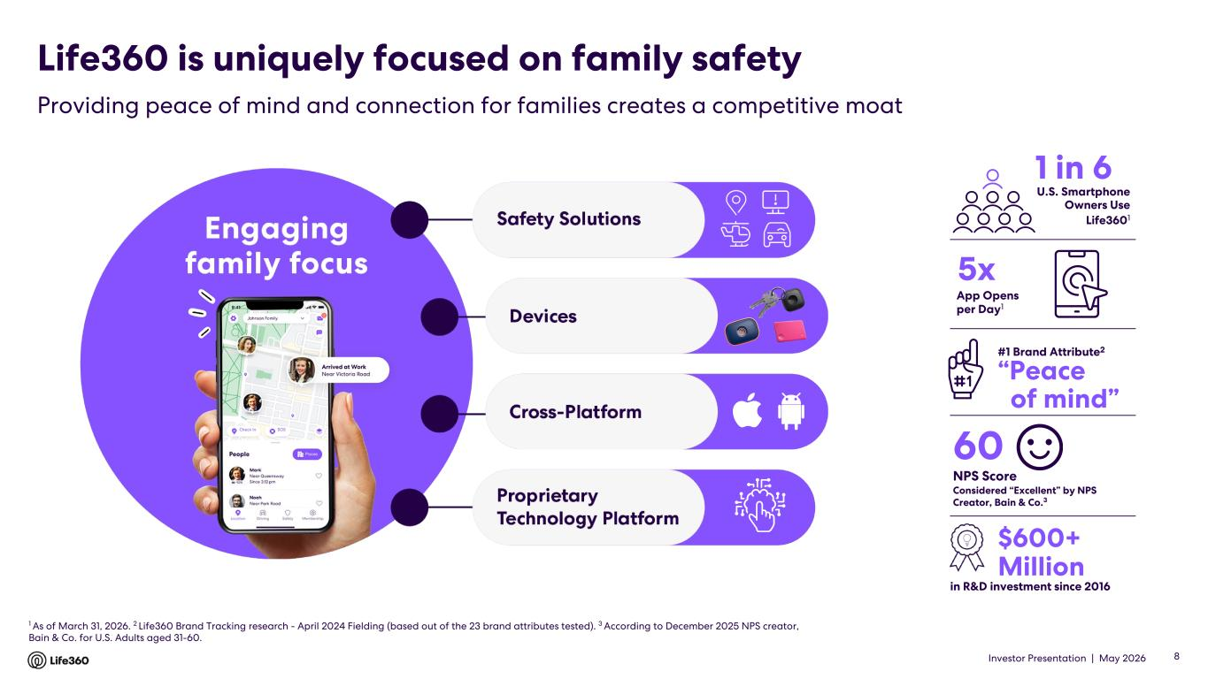
Investor Presentation | May 2026 1 As of March 31, 2026. 2 Life360 Brand Tracking research - April 2024 Fielding (based out of the 23 brand attributes tested). 3 According to December 2025 NPS creator, Bain & Co. for U.S. Adults aged 31-60. in R&D investment since 2016 #1 Brand Attribute2 1 in 6 60 NPS Score Considered “Excellent” by NPS Creator, Bain & Co.3 “Peace of mind” 5x U.S. Smartphone Owners Use Life3601 $600+ Million App Opens per Day1 Life360 is uniquely focused on family safety Providing peace of mind and connection for families creates a competitive moat 8

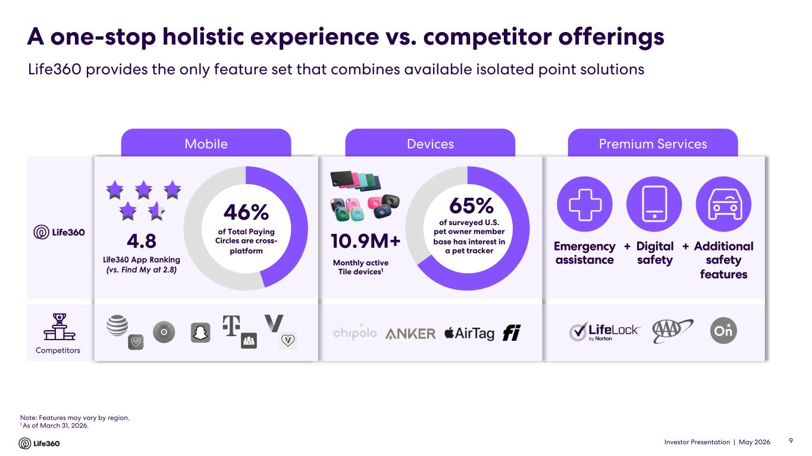
Investor Presentation | May 2026 Premium ServicesDevicesMobile A one-stop holistic experience vs. competitor offerings Life360 provides the only feature set that combines available isolated point solutions Note: Features may vary by region. 1 As of March 31, 2026. 10.9M+ 65% of surveyed U.S. pet owner member base has interest in a pet tracker Monthly active Tile devices1 Emergency assistance Digital safety Additional safety features + +4.8 Life360 App Ranking (vs. Find My at 2.8) Competitors 46% of Total Paying Circles are cross- platform 9

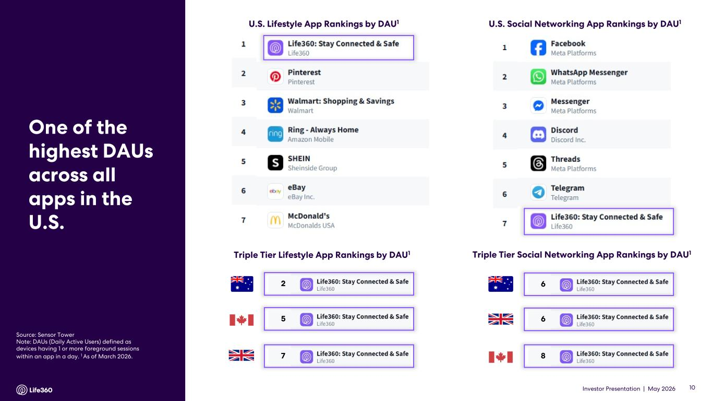
Investor Presentation | May 2026 U.S. Social Networking App Rankings by DAU1U.S. Lifestyle App Rankings by DAU1 Source: Sensor Tower Note: DAUs (Daily Active Users) defined as devices having 1 or more foreground sessions within an app in a day. 1 As of March 2026. One of the highest DAUs across all apps in the U.S. Triple Tier Social Networking App Rankings by DAU1 6 6 8 Triple Tier Lifestyle App Rankings by DAU1 2 7 5 10

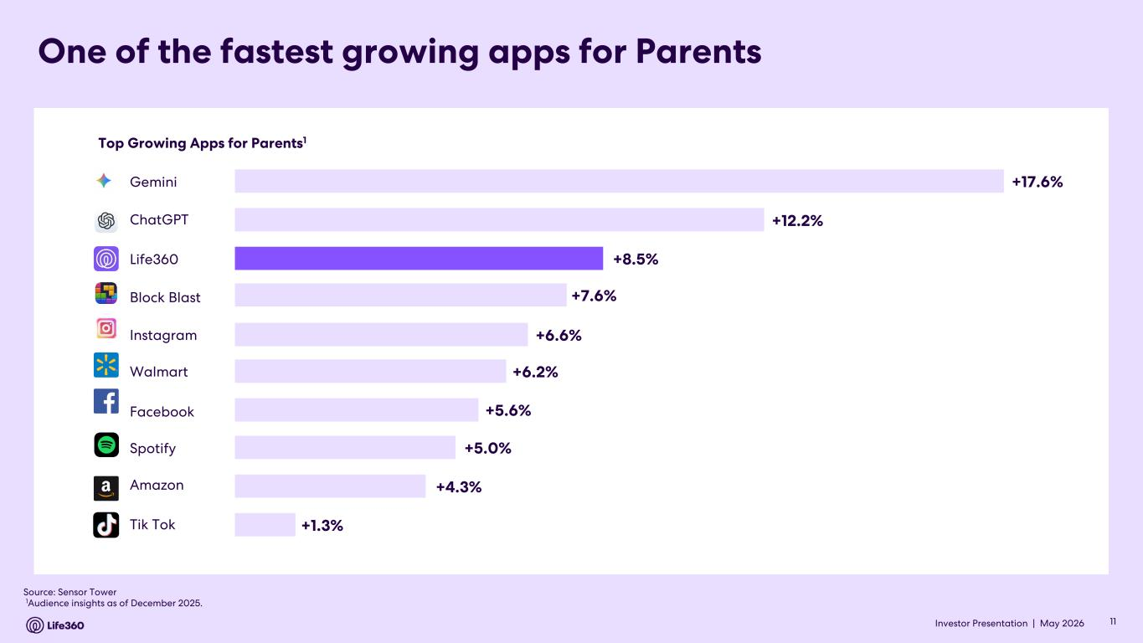
Investor Presentation | May 2026 Top Growing Apps for Parents1 Source: Sensor Tower 1Audience insights as of December 2025. +17.6% +12.2% +8.5% +7.6% +6.6% +6.2% +5.6% +5.0% +4.3% +1.3% Gemini ChatGPT Life360 Block Blast Instagram Walmart Spotify Amazon Tik Tok Facebook One of the fastest growing apps for Parents 11

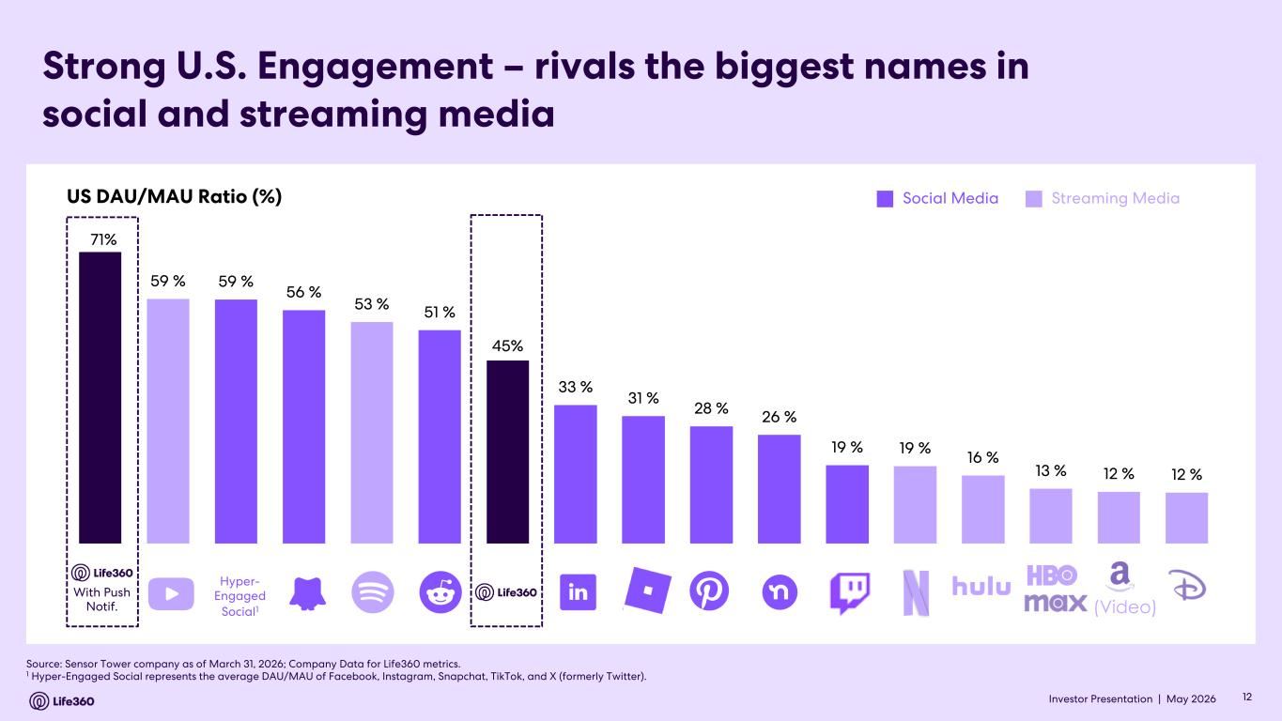
Investor Presentation | May 2026 Strong U.S. Engagement – rivals the biggest names in social and streaming media Source: Sensor Tower company as of March 31, 2026; Company Data for Life360 metrics. 1 Hyper-Engaged Social represents the average DAU/MAU of Facebook, Instagram, Snapchat, TikTok, and X (formerly Twitter). US DAU/MAU Ratio (%) Social Media Streaming Media (Video) Hyper- Engaged Social1 With Push Notif. 71% 59 % 59 % 56 % 53 % 51 % 45% 33 % 31 % 28 % 26 % 19 % 19 % 16 % 13 % 12 % 12 % 12

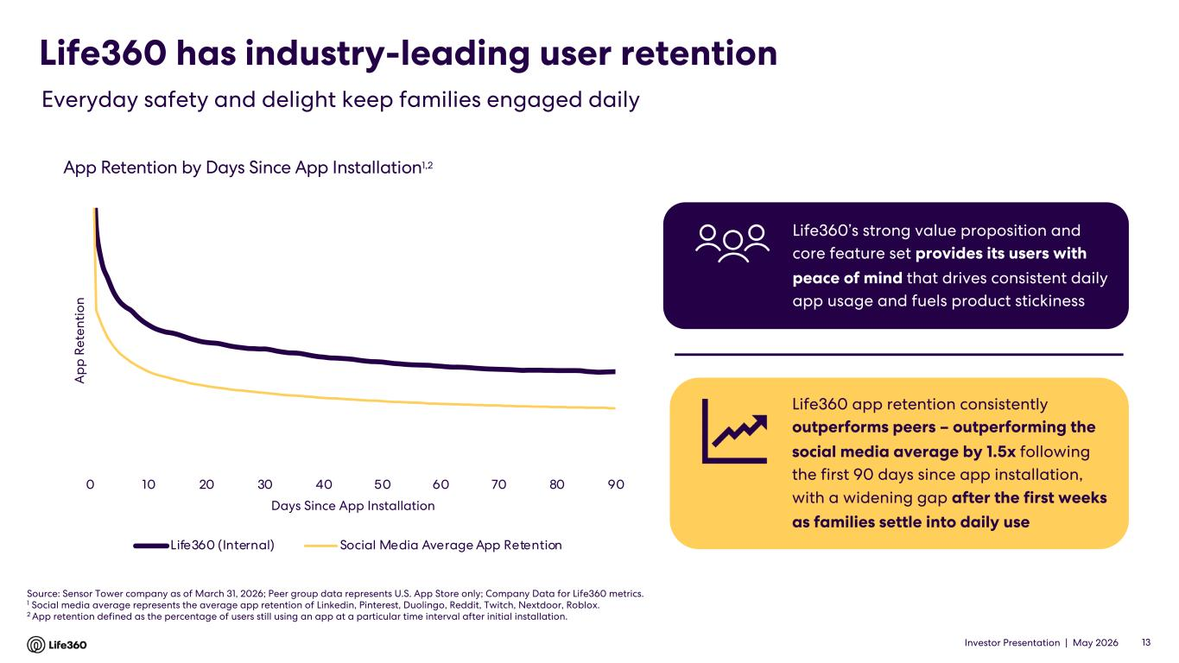
Investor Presentation | May 2026 Life360 has industry-leading user retention 13 Everyday safety and delight keep families engaged daily App Retention by Days Since App Installation1,2 Source: Sensor Tower company as of March 31, 2026; Peer group data represents U.S. App Store only; Company Data for Life360 metrics. 1 Social media average represents the average app retention of Linkedin, Pinterest, Duolingo, Reddit, Twitch, Nextdoor, Roblox. 2 App retention defined as the percentage of users still using an app at a particular time interval after initial installation. Life360 app retention consistently outperforms peers – outperforming the social media average by 1.5x following the first 90 days since app installation, with a widening gap after the first weeks as families settle into daily use Life360’s strong value proposition and core feature set provides its users with peace of mind that drives consistent daily app usage and fuels product stickiness 0 10 20 30 40 50 60 70 80 90 A p p R et en ti o n Days Since App Installation Life360 (Internal) Social Media Average App Retention

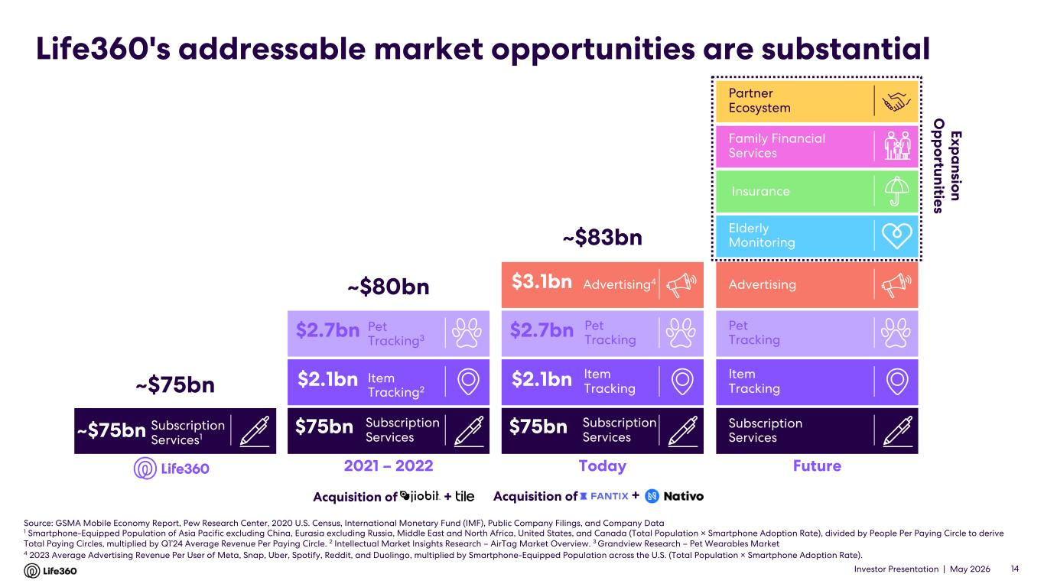
Investor Presentation | May 2026 Life360's addressable market opportunities are substantial Source: GSMA Mobile Economy Report, Pew Research Center, 2020 U.S. Census, International Monetary Fund (IMF), Public Company Filings, and Company Data 1 Smartphone-Equipped Population of Asia Pacific excluding China, Eurasia excluding Russia, Middle East and North Africa, United States, and Canada (Total Population × Smartphone Adoption Rate), divided by People Per Paying Circle to derive Total Paying Circles, multiplied by Q1’24 Average Revenue Per Paying Circle. 2 Intellectual Market Insights Research – AirTag Market Overview. 3 Grandview Research – Pet Wearables Market 4 2023 Average Advertising Revenue Per User of Meta, Snap, Uber, Spotify, Reddit, and Duolingo, multiplied by Smartphone-Equipped Population across the U.S. (Total Population × Smartphone Adoption Rate). 14 2021 – 2022 ~$80bn Subscription Services $2.7bn $2.1bn $75bn Today ~$83bn Advertising4 Item Tracking Pet Tracking Subscription Services $2.7bn $2.1bn $75bn $3.1bn Subscription Services1 ~$75bn ~$75bn Acquisition of + Future Exp a nsion O p p ortunities Family Financial Services Elderly Monitoring Insurance Advertising Item Tracking Pet Tracking Subscription Services Acquisition of + Partner Ecosystem Item Tracking2 Pet Tracking3

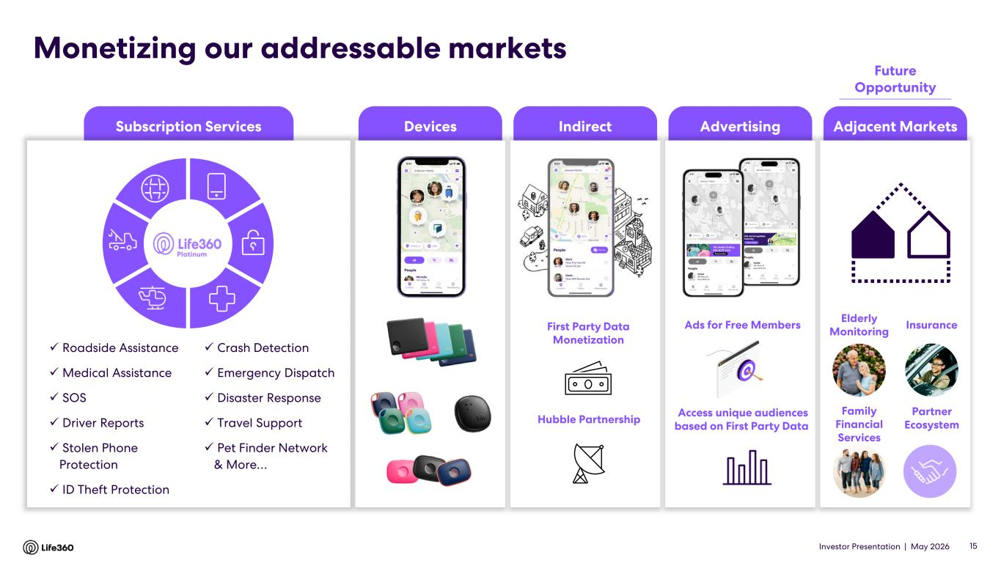
Investor Presentation | May 2026 Subscription Services IndirectDevices Advertising Adjacent Markets Monetizing our addressable markets ✓ Roadside Assistance ✓ Medical Assistance ✓ SOS ✓ Driver Reports ✓ Stolen Phone Protection ✓ ID Theft Protection ✓ Crash Detection ✓ Emergency Dispatch ✓ Disaster Response ✓ Travel Support ✓ Pet Finder Network & More… Platinum Ads for Free Members Access unique audiences based on First Party Data Elderly Monitoring Family Financial Services InsuranceFirst Party Data Monetization Hubble Partnership 15 Future Opportunity Partner Ecosystem

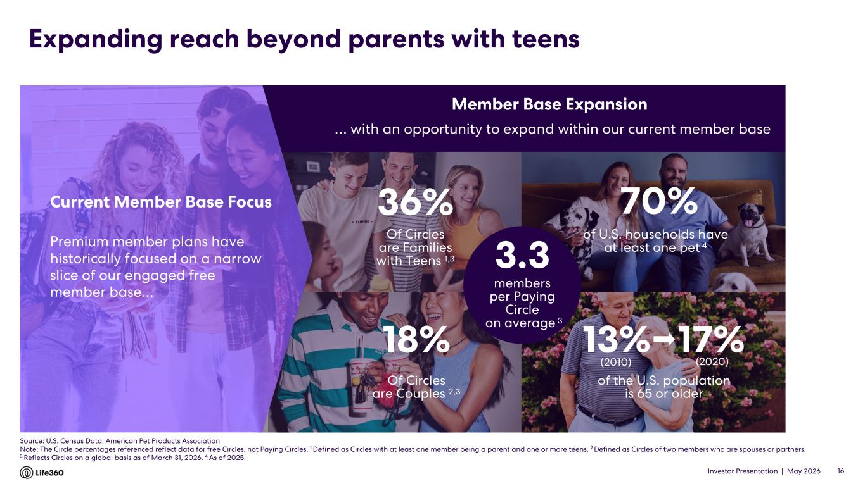
Investor Presentation | May 2026 Expanding reach beyond parents with teens 16 Of Circles are Families with Teens 1,3 36% of U.S. households have at least one pet 4 of the U.S. population is 65 or older 13% 17% (2020)(2010) Of Circles are Couples 2,3 18% 70% … with an opportunity to expand within our current member base Premium member plans have historically focused on a narrow slice of our engaged free member base… Current Member Base Focus Member Base Expansion 3.3 members per Paying Circle on average 3 Source: U.S. Census Data, American Pet Products Association Note: The Circle percentages referenced reflect data for free Circles, not Paying Circles. 1 Defined as Circles with at least one member being a parent and one or more teens. 2 Defined as Circles of two members who are spouses or partners. 3 Reflects Circles on a global basis as of March 31, 2026. 4 As of 2025.

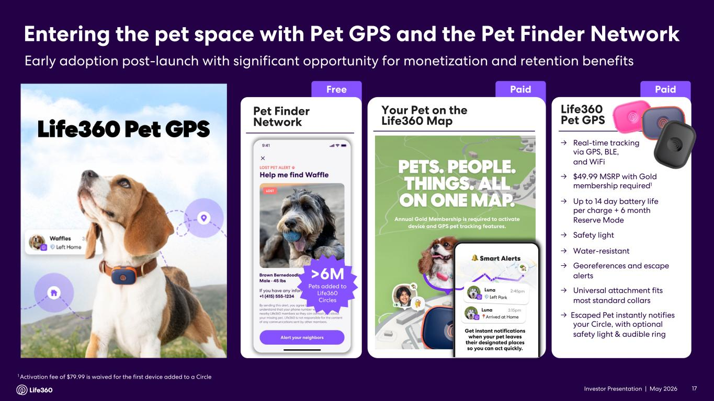
Investor Presentation | May 2026 Entering the pet space with Pet GPS and the Pet Finder Network Early adoption post-launch with significant opportunity for monetization and retention benefits 1 Activation fee of $79.99 is waived for the first device added to a Circle 17 Pet Finder Network Free >6M Pets added to Life360 Circles Paid Your Pet on the Life360 Map Paid Life360 Pet GPS → Real-time tracking via GPS, BLE, and WiFi → $49.99 MSRP with Gold membership required1 → Up to 14 day battery life per charge + 6 month Reserve Mode → Safety light → Water-resistant → Georeferences and escape alerts → Universal attachment fits most standard collars → Escaped Pet instantly notifies your Circle, with optional safety light & audible ring

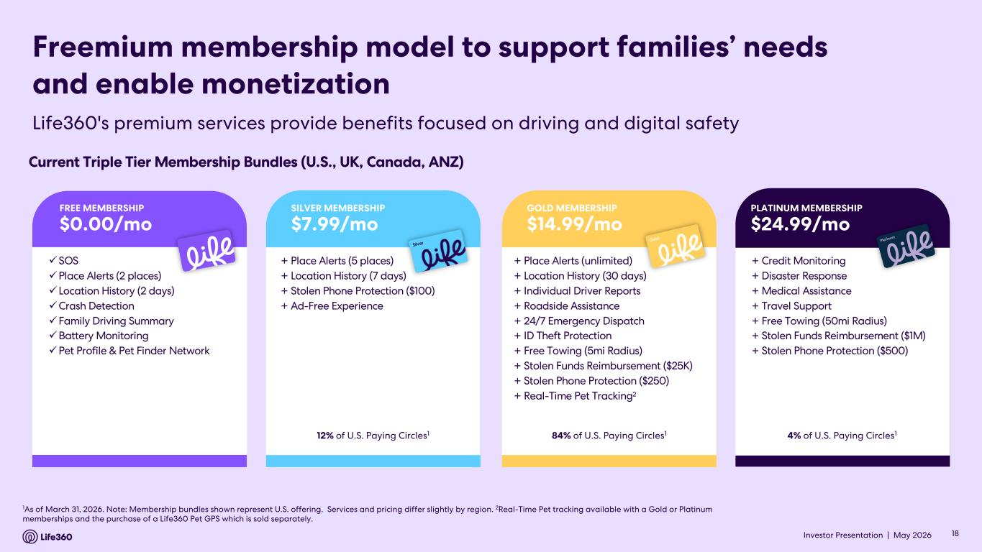
Investor Presentation | May 2026 1As of March 31, 2026. Note: Membership bundles shown represent U.S. offering. Services and pricing differ slightly by region. 2Real-Time Pet tracking available with a Gold or Platinum memberships and the purchase of a Life360 Pet GPS which is sold separately. Freemium membership model to support families’ needs and enable monetization Current Triple Tier Membership Bundles (U.S., UK, Canada, ANZ) + Place Alerts (5 places) + Location History (7 days) + Stolen Phone Protection ($100) + Ad-Free Experience 12% of U.S. Paying Circles1 SILVER MEMBERSHIP $7.99/mo + Place Alerts (unlimited) + Location History (30 days) + Individual Driver Reports + Roadside Assistance + 24/7 Emergency Dispatch + ID Theft Protection + Free Towing (5mi Radius) + Stolen Funds Reimbursement ($25K) + Stolen Phone Protection ($250) + Real-Time Pet Tracking2 84% of U.S. Paying Circles1 GOLD MEMBERSHIP $14.99/mo + Credit Monitoring + Disaster Response + Medical Assistance + Travel Support + Free Towing (50mi Radius) + Stolen Funds Reimbursement ($1M) + Stolen Phone Protection ($500) 4% of U.S. Paying Circles1 PLATINUM MEMBERSHIP $24.99/mo üSOS üPlace Alerts (2 places) üLocation History (2 days) üCrash Detection üFamily Driving Summary üBattery Monitoring üPet Profile & Pet Finder Network FREE MEMBERSHIP $0.00/mo Life360's premium services provide benefits focused on driving and digital safety 18

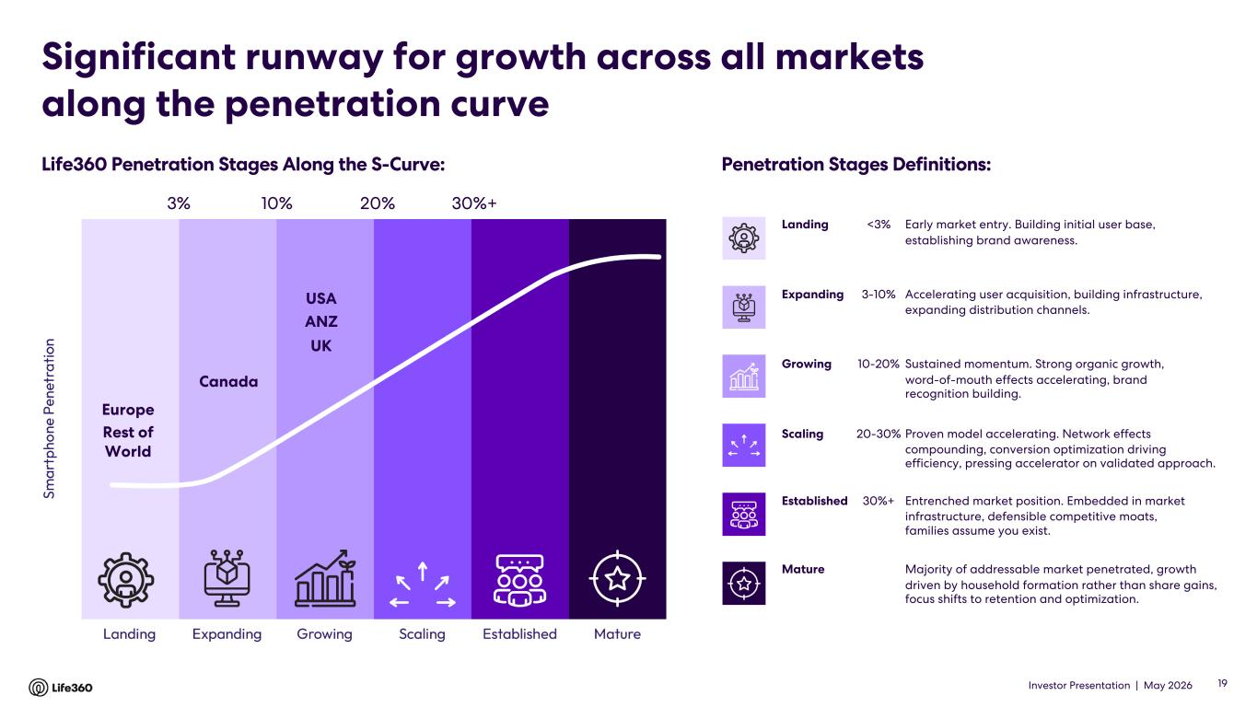
Investor Presentation | May 2026 Significant runway for growth across all markets along the penetration curve Landing <3% Early market entry. Building initial user base, establishing brand awareness. Expanding 3-10% Accelerating user acquisition, building infrastructure, expanding distribution channels. Growing 10-20% Sustained momentum. Strong organic growth, word-of-mouth effects accelerating, brand recognition building. Scaling 20-30% Proven model accelerating. Network effects compounding, conversion optimization driving efficiency, pressing accelerator on validated approach. Established 30%+ Entrenched market position. Embedded in market infrastructure, defensible competitive moats, families assume you exist. Mature Majority of addressable market penetrated, growth driven by household formation rather than share gains, focus shifts to retention and optimization. Life360 Penetration Stages Along the S-Curve: Penetration Stages Definitions: Canada USA ANZ UK Europe Rest of World 10% 20% 30%+3% 19

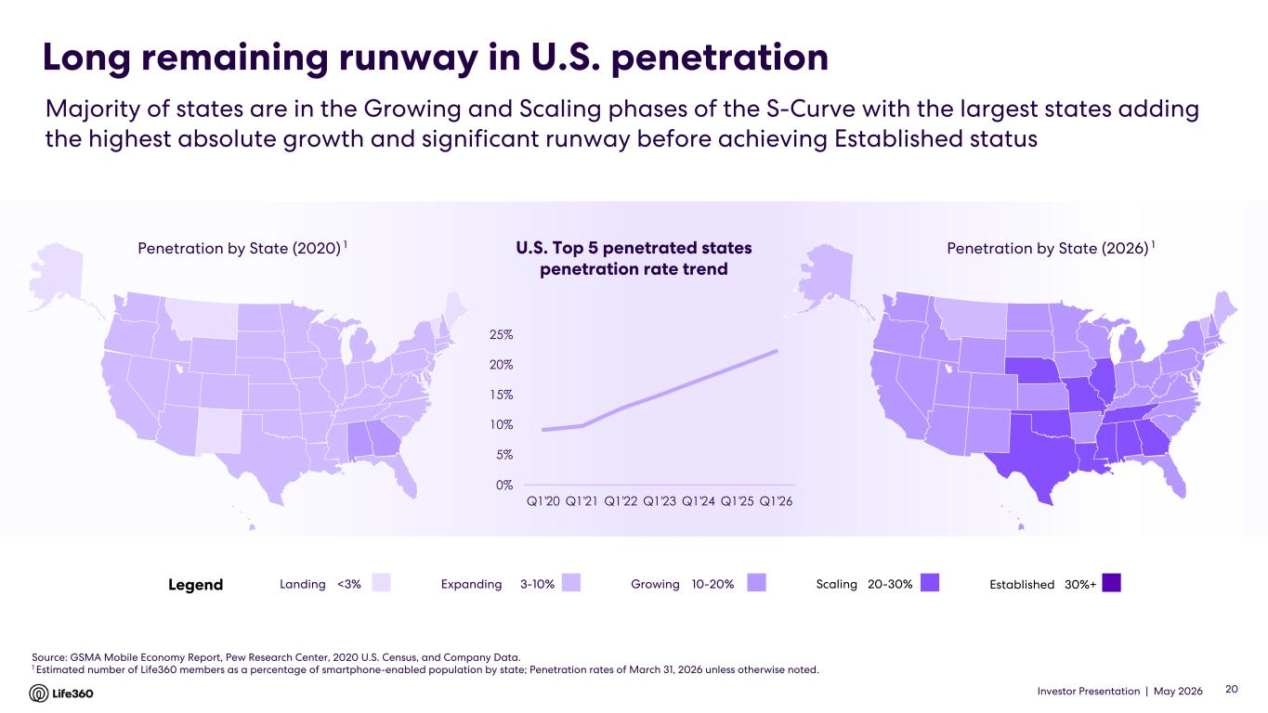
Investor Presentation | May 2026 Long remaining runway in U.S. penetration Source: GSMA Mobile Economy Report, Pew Research Center, 2020 U.S. Census, and Company Data. 1 Estimated number of Life360 members as a percentage of smartphone-enabled population by state; Penetration rates of March 31, 2026 unless otherwise noted. Penetration by State (2020) 1 Penetration by State (2026) 1 Landing <3% Majority of states are in the Growing and Scaling phases of the S-Curve with the largest states adding the highest absolute growth and significant runway before achieving Established status 20 U.S. Top 5 penetrated states penetration rate trend Legend Expanding 3-10% Growing 10-20% Scaling 20-30% Established 30%+ 0% 5% 10% 15% 20% 25% Q1'20 Q1'21 Q1'22 Q1'23 Q1'24 Q1'25 Q1'26

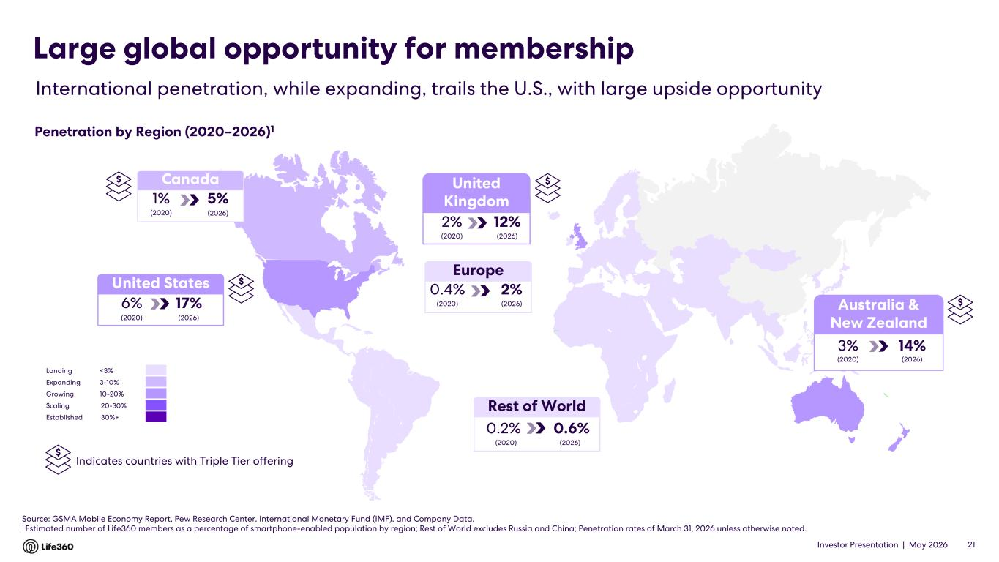
Investor Presentation | May 2026 Europe 2%0.4% (2020) (2026) Source: GSMA Mobile Economy Report, Pew Research Center, International Monetary Fund (IMF), and Company Data. 1 Estimated number of Life360 members as a percentage of smartphone-enabled population by region; Rest of World excludes Russia and China; Penetration rates of March 31, 2026 unless otherwise noted. Rest of World 0.6%0.2% (2020) (2026) International penetration, while expanding, trails the U.S., with large upside opportunity Large global opportunity for membership Penetration by Region (2020–2026)1 21 United Kingdom 12%2% (2020) (2026) $ Indicates countries with Triple Tier offering United States 17%6% (2020) (2026) Landing <3% Expanding 3-10% Growing 10-20% Scaling 20-30% Established 30%+ Australia & New Zealand 14%3% (2020) (2026) Canada 5%1% (2020) (2026) $ $ $ $

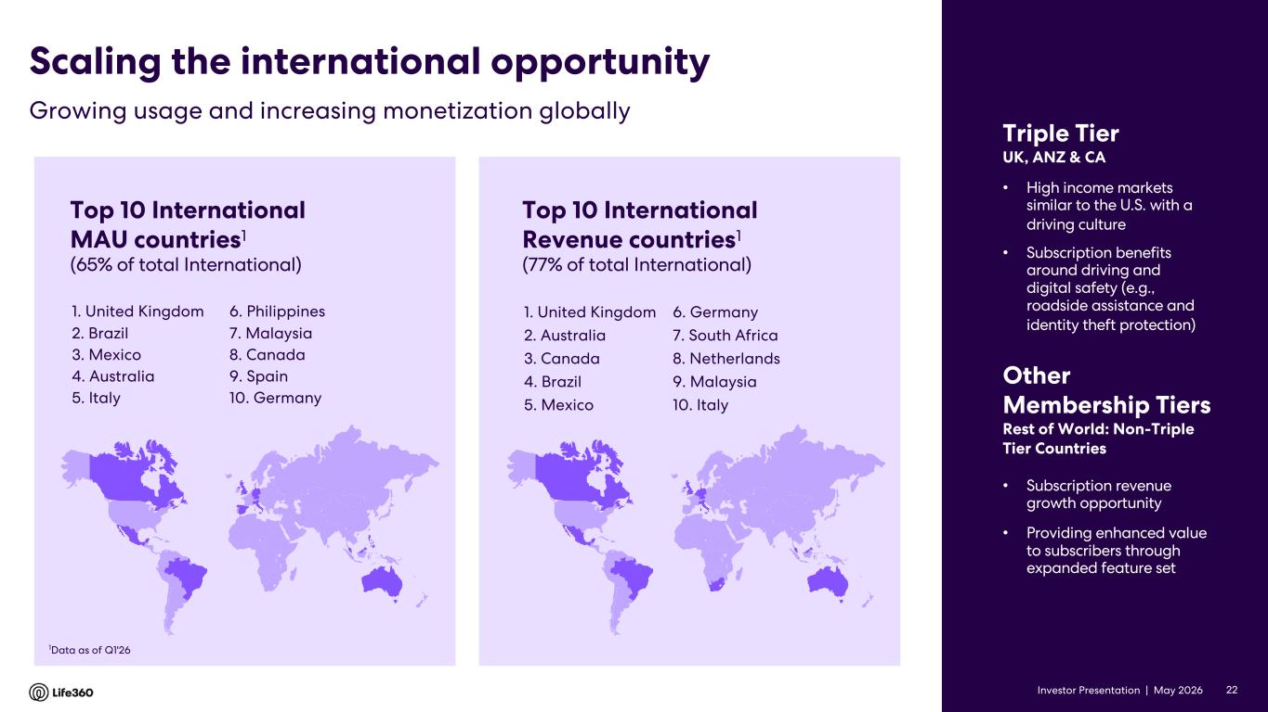
Investor Presentation | May 2026 Top 10 International MAU countries1 (65% of total International) 1. United Kingdom 2. Brazil 3. Mexico 4. Australia 5. Italy 1Data as of Q1'26 • Subscription revenue growth opportunity • Providing enhanced value to subscribers through expanded feature set Other Membership Tiers Rest of World: Non-Triple Tier Countries Growing usage and increasing monetization globally Scaling the international opportunity Triple Tier UK, ANZ & CA • High income markets similar to the U.S. with a driving culture • Subscription benefits around driving and digital safety (e.g., roadside assistance and identity theft protection) 6. Philippines 7. Malaysia 8. Canada 9. Spain 10. Germany 22 1. United Kingdom 2. Australia 3. Canada 4. Brazil 5. Mexico 6. Germany 7. South Africa 8. Netherlands 9. Malaysia 10. Italy Top 10 International Revenue countries1 (77% of total International)

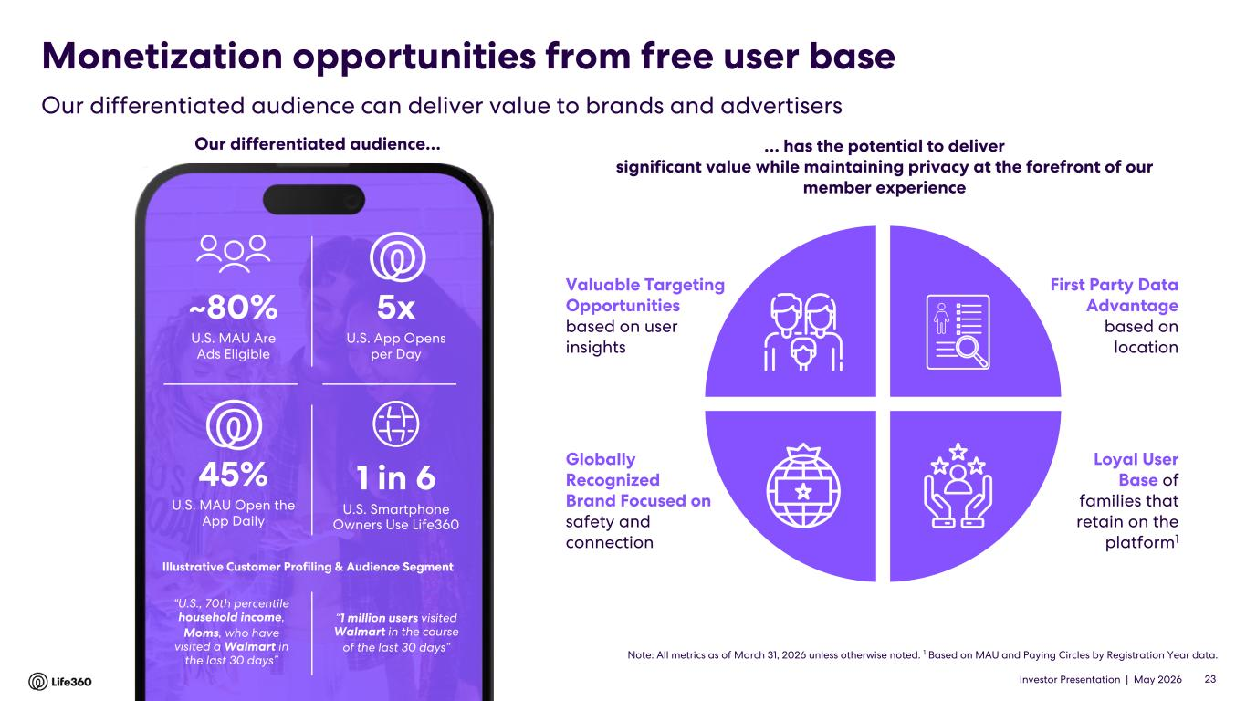
Investor Presentation | May 2026 Monetization opportunities from free user base Loyal User Base of families that retain on the platform1 Globally Recognized Brand Focused on safety and connection First Party Data Advantage based on location Valuable Targeting Opportunities based on user insights … has the potential to deliver significant value while maintaining privacy at the forefront of our member experience Note: All metrics as of March 31, 2026 unless otherwise noted. 1 Based on MAU and Paying Circles by Registration Year data. ~80% U.S. MAU Are Ads Eligible 1 in 6 U.S. Smartphone Owners Use Life360 5x U.S. App Opens per Day 45% U.S. MAU Open the App Daily “U.S., 70th percentile household income, Moms, who have visited a Walmart in the last 30 days” Illustrative Customer Profiling & Audience Segment “1 million users visited Walmart in the course of the last 30 days” Our differentiated audience… 23 Our differentiated audience can deliver value to brands and advertisers

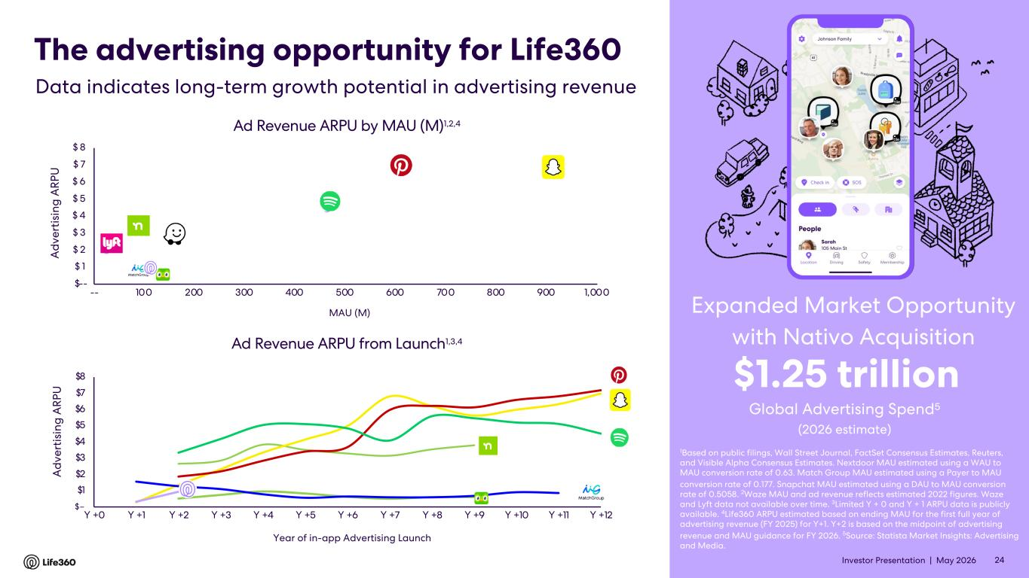
Investor Presentation | May 2026 $-- $ 1 $ 2 $ 3 $ 4 $ 5 $ 6 $ 7 $ 8 -- 100 200 300 400 500 600 700 800 900 1,000 Ad Revenue ARPU by MAU (M)1,2,4 MAU (M) The advertising opportunity for Life360 1Based on public filings, Wall Street Journal, FactSet Consensus Estimates, Reuters, and Visible Alpha Consensus Estimates. Nextdoor MAU estimated using a WAU to MAU conversion rate of 0.63. Match Group MAU estimated using a Payer to MAU conversion rate of 0.177. Snapchat MAU estimated using a DAU to MAU conversion rate of 0.5058. 2Waze MAU and ad revenue reflects estimated 2022 figures. Waze and Lyft data not available over time. 3Limited Y + 0 and Y + 1 ARPU data is publicly available. 4Life360 ARPU estimated based on ending MAU for the first full year of advertising revenue (FY 2025) for Y+1. Y+2 is based on the midpoint of advertising revenue and MAU guidance for FY 2026. 5Source: Statista Market Insights: Advertising and Media. Global Advertising Spend5 $1.25 trillion (2026 estimate) Data indicates long-term growth potential in advertising revenue A d ve rt is in g A R PU 24 Expanded Market Opportunity with Nativo Acquisition $– $1 $2 $3 $4 $5 $6 $7 $8 Y +0 Y +1 Y +2 Y +3 Y +4 Y +5 Y +6 Y +7 Y +8 Y +9 Y +10 Y +11 Y +12 Ad Revenue ARPU from Launch1,3,4 Year of in-app Advertising Launch A d ve rt is in g A R PU

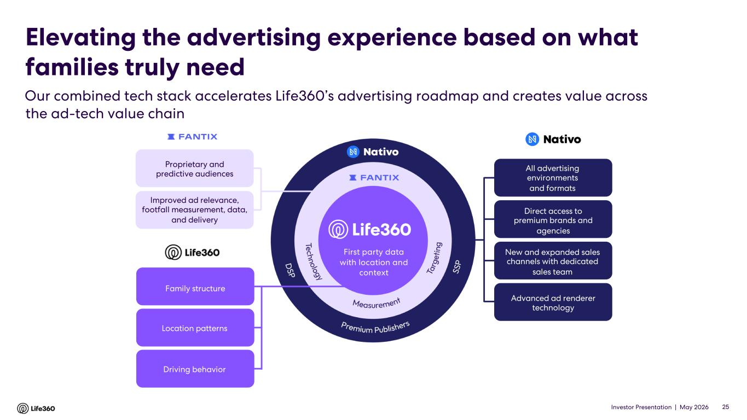
Investor Presentation | May 2026 25 First party data with location and context First party data with location and context Proprietary and predictive audiences Improved ad relevance, footfall measurement, data, and delivery All advertising environments and formats Advanced ad renderer technology Direct access to premium brands and agencies New and expanded sales channels with dedicated sales team Family structure Location patterns Driving behavior Our combined tech stack accelerates Life360’s advertising roadmap and creates value across the ad-tech value chain Elevating the advertising experience based on what families truly need

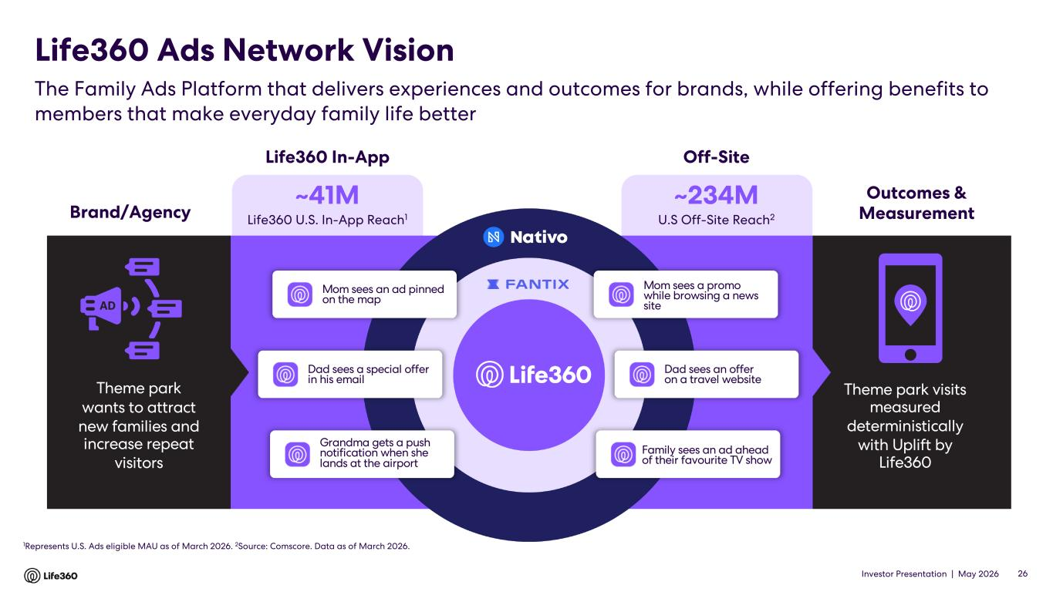
Investor Presentation | May 2026 ~41M Life360 U.S. In-App Reach1 ~234M U.S Off-Site Reach2Brand/Agency Theme park wants to attract new families and increase repeat visitors Theme park visits measured deterministically with Uplift by Life360 Off-SiteLife360 In-App Outcomes & Measurement The Family Ads Platform that delivers experiences and outcomes for brands, while offering benefits to members that make everyday family life better Life360 Ads Network Vision 26 1Represents U.S. Ads eligible MAU as of March 2026. 2Source: Comscore. Data as of March 2026. Mom sees an ad pinned on the map Dad sees a special offer in his email Grandma gets a push notification when she lands at the airport Mom sees a promo while browsing a news site Dad sees an offer on a travel website Family sees an ad ahead of their favourite TV show

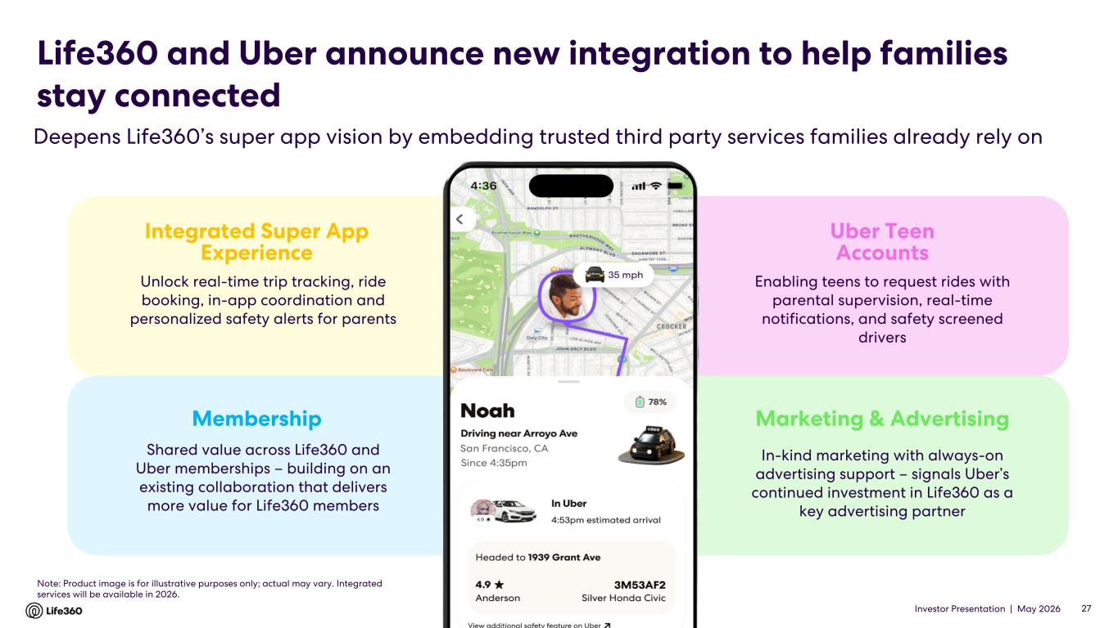
Investor Presentation | May 2026 Life360 and Uber announce new integration to help families stay connected Deepens Life360’s super app vision by embedding trusted third party services families already rely on 27 Integrated Super App Experience Membership Uber Teen Accounts Marketing & Advertising Shared value across Life360 and Uber memberships – building on an existing collaboration that delivers more value for Life360 members Unlock real-time trip tracking, ride booking, in-app coordination and personalized safety alerts for parents In-kind marketing with always-on advertising support – signals Uber’s continued investment in Life360 as a key advertising partner Enabling teens to request rides with parental supervision, real-time notifications, and safety screened drivers Note: Product image is for illustrative purposes only; actual may vary. Integrated services will be available in 2026.


Investor Presentation | May 2026 02 Life360 Strategy

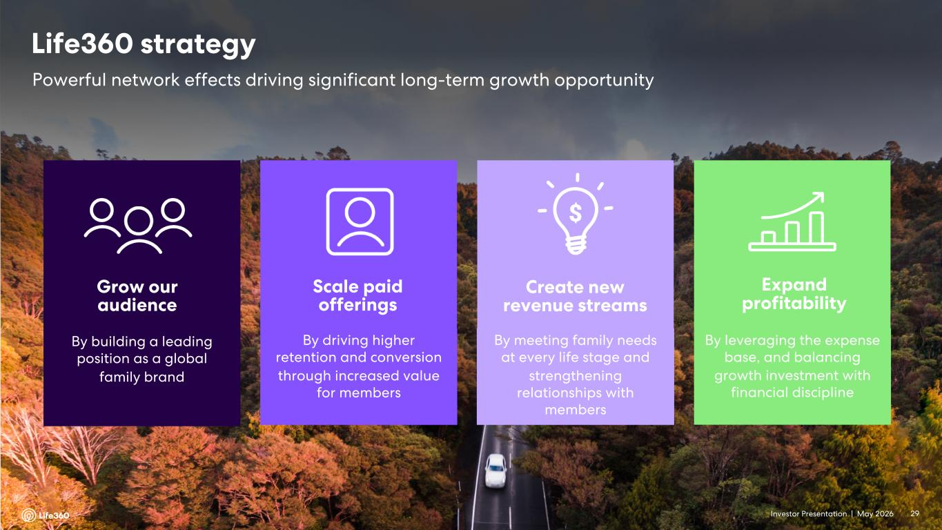
Investor Presentation | May 2026 Grow our audience By building a leading position as a global family brand Scale paid offerings By driving higher retention and conversion through increased value for members Create new revenue streams By meeting family needs at every life stage and strengthening relationships with members Expand profitability By leveraging the expense base, and balancing growth investment with financial discipline Powerful network effects driving significant long-term growth opportunity Life360 strategy 29

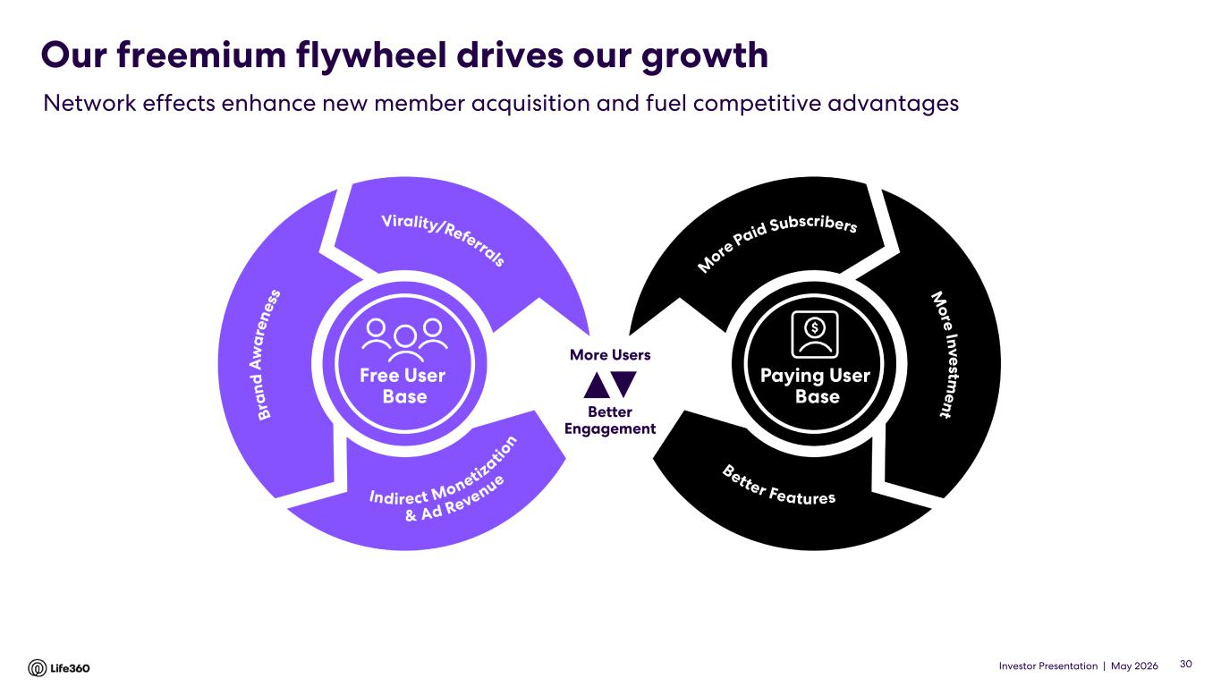
Investor Presentation | May 2026 Our freemium flywheel drives our growth Network effects enhance new member acquisition and fuel competitive advantages Better Engagement More Users 30

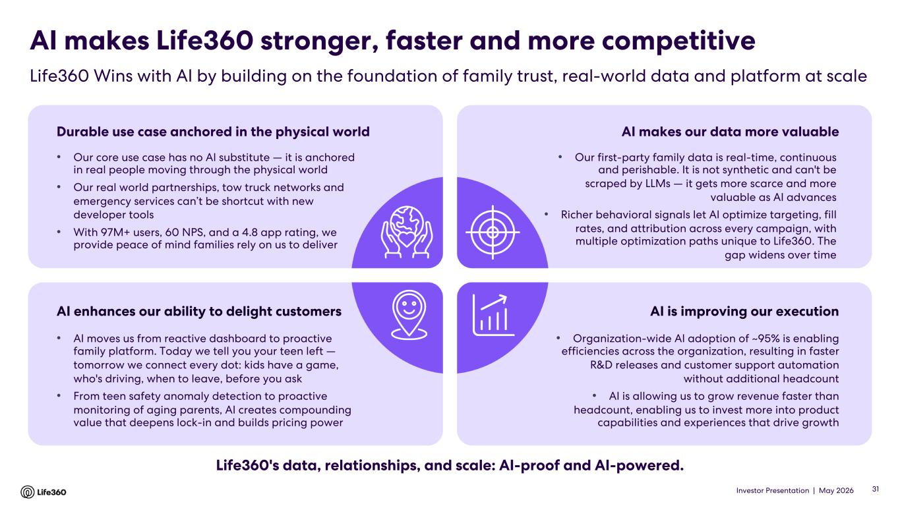
Investor Presentation | May 2026 AI makes Life360 stronger, faster and more competitive Life360 Wins with AI by building on the foundation of family trust, real-world data and platform at scale Durable use case anchored in the physical world • Our core use case has no AI substitute — it is anchored in real people moving through the physical world • Our real world partnerships, tow truck networks and emergency services can’t be shortcut with new developer tools • With 97M+ users, 60 NPS, and a 4.8 app rating, we provide peace of mind families rely on us to deliver AI makes our data more valuable • Our first-party family data is real-time, continuous and perishable. It is not synthetic and can't be scraped by LLMs — it gets more scarce and more valuable as AI advances • Richer behavioral signals let AI optimize targeting, fill rates, and attribution across every campaign, with multiple optimization paths unique to Life360. The gap widens over time AI enhances our ability to delight customers • AI moves us from reactive dashboard to proactive family platform. Today we tell you your teen left — tomorrow we connect every dot: kids have a game, who's driving, when to leave, before you ask • From teen safety anomaly detection to proactive monitoring of aging parents, AI creates compounding value that deepens lock-in and builds pricing power AI is improving our execution • Organization-wide AI adoption of ~95% is enabling efficiencies across the organization, resulting in faster R&D releases and customer support automation without additional headcount • AI is allowing us to grow revenue faster than headcount, enabling us to invest more into product capabilities and experiences that drive growth Life360's data, relationships, and scale: AI-proof and AI-powered. 31

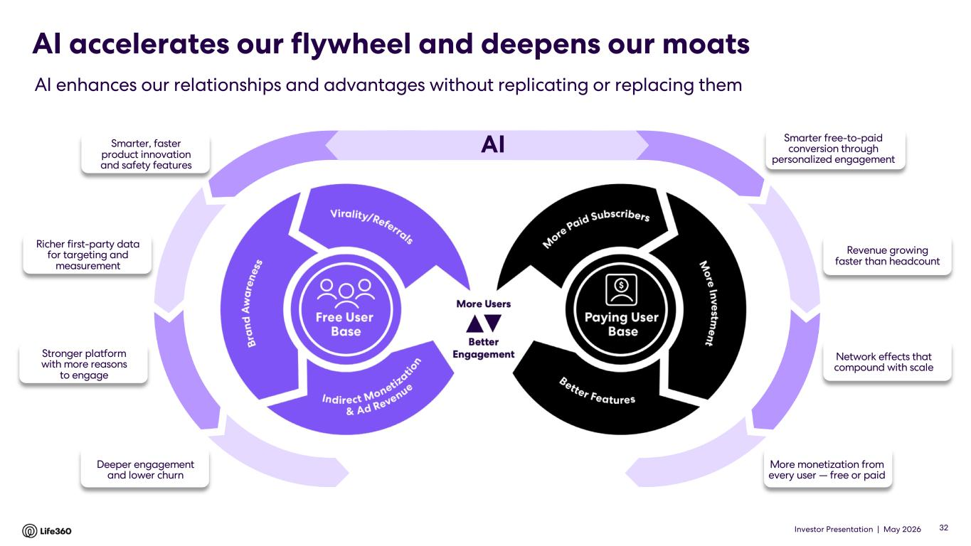
Investor Presentation | May 2026 AISmarter, faster product innovation and safety features AI accelerates our flywheel and deepens our moats AI enhances our relationships and advantages without replicating or replacing them 32 Richer first-party data for targeting and measurement Stronger platform with more reasons to engage Deeper engagement and lower churn Revenue growing faster than headcount Network effects that compound with scale More monetization from every user — free or paid Smarter free-to-paid conversion through personalized engagement

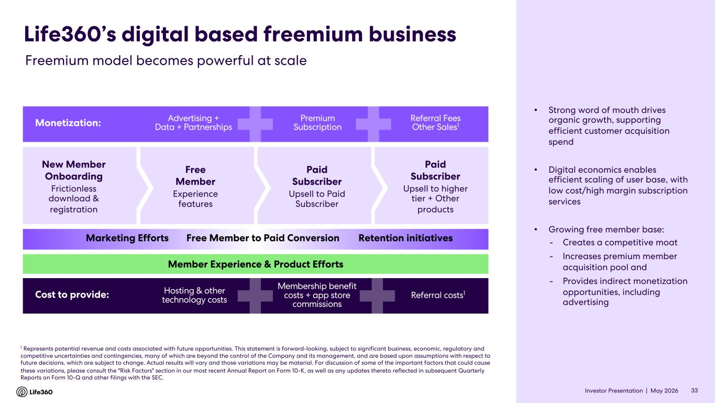
Investor Presentation | May 2026 New Member Onboarding Frictionless download & registration Free Member Experience features Paid Subscriber Upsell to Paid Subscriber Paid Subscriber Upsell to higher tier + Other products Life360’s digital based freemium business Monetization: Advertising + Data + Partnerships Premium Subscription Referral Fees Other Sales1 Cost to provide: Hosting & other technology costs Membership benefit costs + app store commissions Referral costs1 Marketing Efforts Free Member to Paid Conversion Retention initiatives Member Experience & Product Efforts 1 Represents potential revenue and costs associated with future opportunities. This statement is forward-looking, subject to significant business, economic, regulatory and competitive uncertainties and contingencies, many of which are beyond the control of the Company and its management, and are based upon assumptions with respect to future decisions, which are subject to change. Actual results will vary and those variations may be material. For discussion of some of the important factors that could cause these variations, please consult the "Risk Factors" section in our most recent Annual Report on Form 10-K, as well as any updates thereto reflected in subsequent Quarterly Reports on Form 10-Q and other filings with the SEC. Freemium model becomes powerful at scale • Strong word of mouth drives organic growth, supporting efficient customer acquisition spend • Digital economics enables efficient scaling of user base, with low cost/high margin subscription services • Growing free member base: - Creates a competitive moat - Increases premium member acquisition pool and - Provides indirect monetization opportunities, including advertising 33

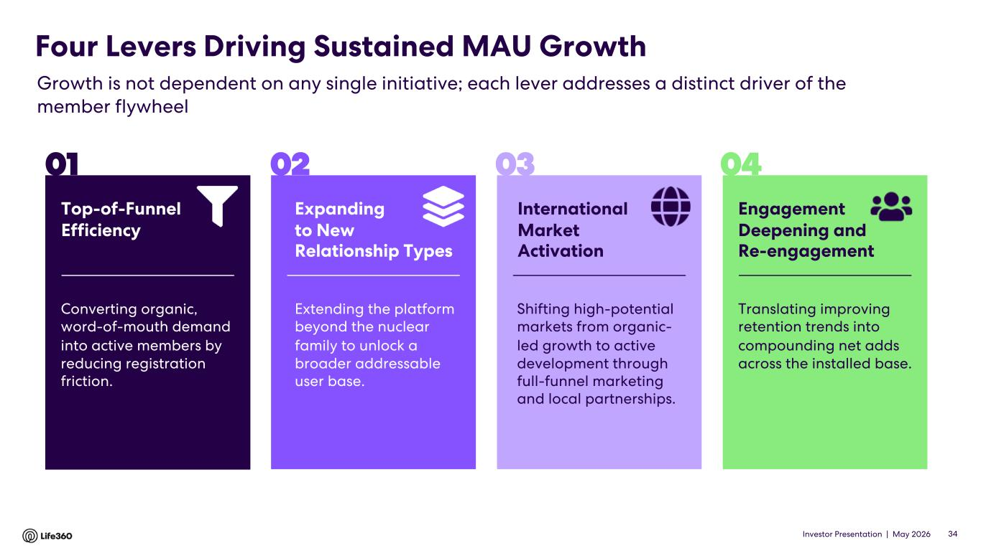
Investor Presentation | May 2026 Converting organic, word-of-mouth demand into active members by reducing registration friction. Expanding to New Relationship Types Extending the platform beyond the nuclear family to unlock a broader addressable user base. International Market Activation Shifting high-potential markets from organic- led growth to active development through full-funnel marketing and local partnerships. Engagement Deepening and Re-engagement Translating improving retention trends into compounding net adds across the installed base. Four Levers Driving Sustained MAU Growth Growth is not dependent on any single initiative; each lever addresses a distinct driver of the member flywheel Top-of-Funnel Efficiency 01 02 03 04 34

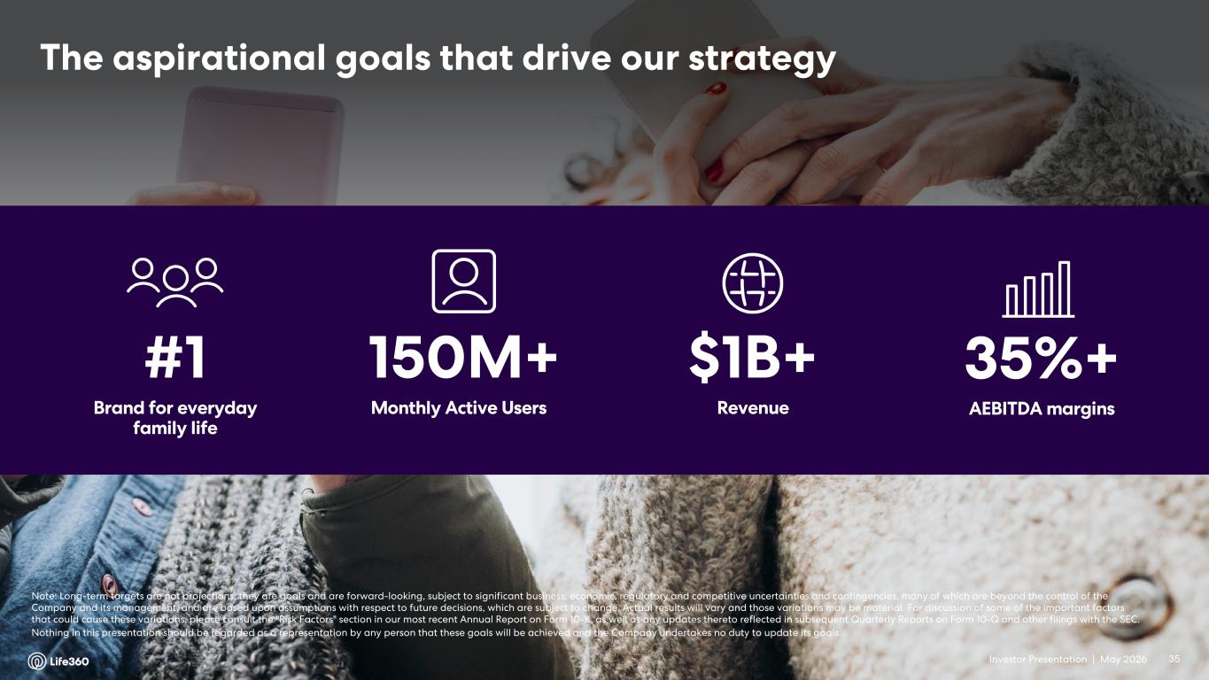
Investor Presentation | May 2026 The aspirational goals that drive our strategy #1 Brand for everyday family life 150M+ Monthly Active Users $1B+ Revenue 35%+ AEBITDA margins Note: Long-term targets are not projections; they are goals and are forward-looking, subject to significant business, economic, regulatory and competitive uncertainties and contingencies, many of which are beyond the control of the Company and its management, and are based upon assumptions with respect to future decisions, which are subject to change. Actual results will vary and those variations may be material. For discussion of some of the important factors that could cause these variations, please consult the "Risk Factors" section in our most recent Annual Report on Form 10-K, as well as any updates thereto reflected in subsequent Quarterly Reports on Form 10-Q and other filings with the SEC. Nothing in this presentation should be regarded as a representation by any person that these goals will be achieved and the Company undertakes no duty to update its goals. 35


Investor Presentation | May 2026 03 Financial Update Q1’26

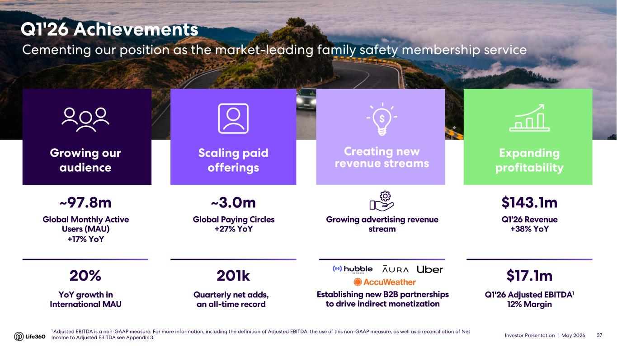
Investor Presentation | May 2026 Q1'26 Achievements Cementing our position as the market-leading family safety membership service $143.1m Q1'26 Revenue +38% YoY $17.1m Q1'26 Adjusted EBITDA1 12% Margin Expanding profitability ~3.0m Global Paying Circles +27% YoY 201k Quarterly net adds, an all-time record Scaling paid offerings ~97.8m Global Monthly Active Users (MAU) +17% YoY 20% YoY growth in International MAU Growing our audience Establishing new B2B partnerships to drive indirect monetization Growing advertising revenue stream Creating new revenue streams 37 1 Adjusted EBITDA is a non-GAAP measure. For more information, including the definition of Adjusted EBITDA, the use of this non-GAAP measure, as well as a reconciliation of Net Income to Adjusted EBITDA see Appendix 3.

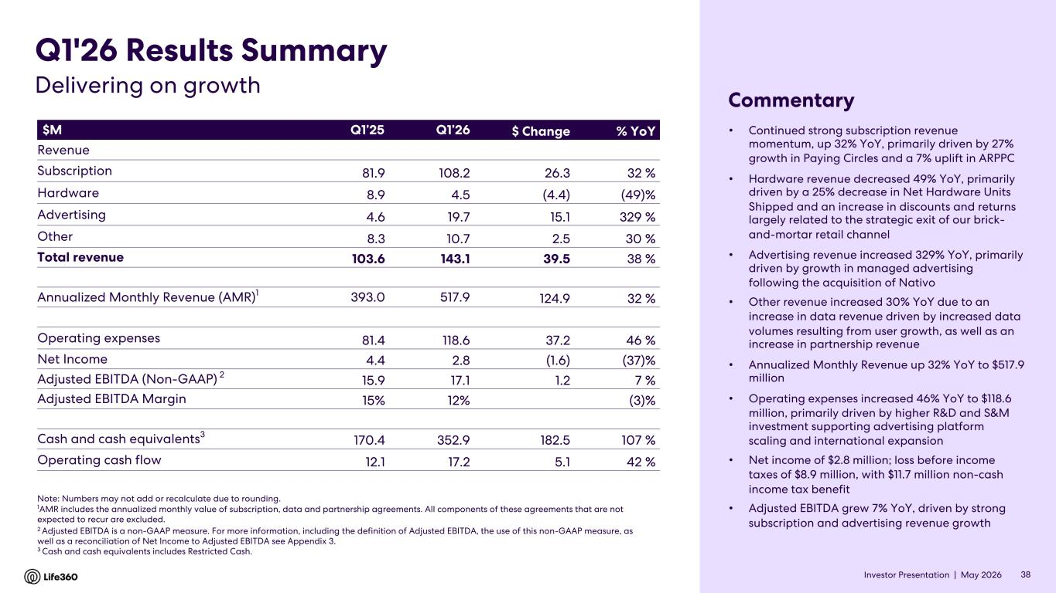
Investor Presentation | May 2026 • Continued strong subscription revenue momentum, up 32% YoY, primarily driven by 27% growth in Paying Circles and a 7% uplift in ARPPC • Hardware revenue decreased 49% YoY, primarily driven by a 25% decrease in Net Hardware Units Shipped and an increase in discounts and returns largely related to the strategic exit of our brick- and-mortar retail channel • Advertising revenue increased 329% YoY, primarily driven by growth in managed advertising following the acquisition of Nativo • Other revenue increased 30% YoY due to an increase in data revenue driven by increased data volumes resulting from user growth, as well as an increase in partnership revenue • Annualized Monthly Revenue up 32% YoY to $517.9 million • Operating expenses increased 46% YoY to $118.6 million, primarily driven by higher R&D and S&M investment supporting advertising platform scaling and international expansion • Net income of $2.8 million; loss before income taxes of $8.9 million, with $11.7 million non-cash income tax benefit • Adjusted EBITDA grew 7% YoY, driven by strong subscription and advertising revenue growth $M Q1’25 Q1’26 $ Change % YoY Revenue Subscription 81.9 108.2 26.3 32 % Hardware 8.9 4.5 (4.4) (49)% Advertising 4.6 19.7 15.1 329 % Other 8.3 10.7 2.5 30 % Total revenue 103.6 143.1 39.5 38 % Annualized Monthly Revenue (AMR)1 393.0 517.9 124.9 32 % Operating expenses 81.4 118.6 37.2 46 % Net Income 4.4 2.8 (1.6) (37)% Adjusted EBITDA (Non-GAAP) 2 15.9 17.1 1.2 7 % Adjusted EBITDA Margin 15% 12% (3)% Cash and cash equivalents3 170.4 352.9 182.5 107 % Operating cash flow 12.1 17.2 5.1 42 % Note: Numbers may not add or recalculate due to rounding. 1AMR includes the annualized monthly value of subscription, data and partnership agreements. All components of these agreements that are not expected to recur are excluded. 2 Adjusted EBITDA is a non-GAAP measure. For more information, including the definition of Adjusted EBITDA, the use of this non-GAAP measure, as well as a reconciliation of Net Income to Adjusted EBITDA see Appendix 3. 3 Cash and cash equivalents includes Restricted Cash. Q1'26 Results Summary Commentary Delivering on growth 38

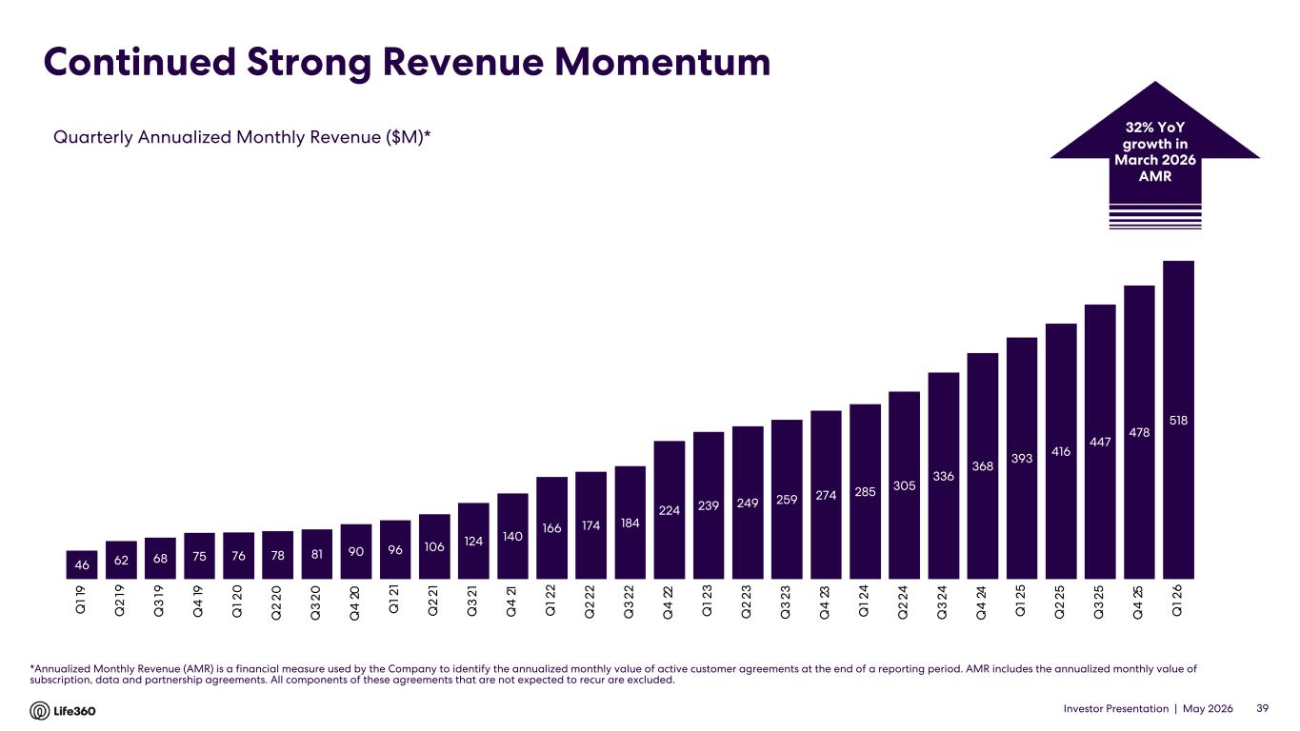
Investor Presentation | May 2026 Continued Strong Revenue Momentum *Annualized Monthly Revenue (AMR) is a financial measure used by the Company to identify the annualized monthly value of active customer agreements at the end of a reporting period. AMR includes the annualized monthly value of subscription, data and partnership agreements. All components of these agreements that are not expected to recur are excluded. Quarterly Annualized Monthly Revenue ($M)* 39 32% YoY growth in March 2026 AMR 46 62 68 75 76 78 81 90 96 106 124 140 166 174 184 224 239 249 259 274 285 305 336 368 393 416 447 478 518 Q 1 1 9 Q 2 19 Q 3 19 Q 4 19 Q 1 2 0 Q 2 20 Q 3 20 Q 4 20 Q 1 2 1 Q 2 21 Q 3 21 Q 4 21 Q 1 2 2 Q 2 22 Q 3 22 Q 4 22 Q 1 2 3 Q 2 23 Q 3 23 Q 4 23 Q 1 2 4 Q 2 24 Q 3 24 Q 4 24 Q 1 2 5 Q 2 25 Q 3 25 Q 4 25 Q 1 2 6

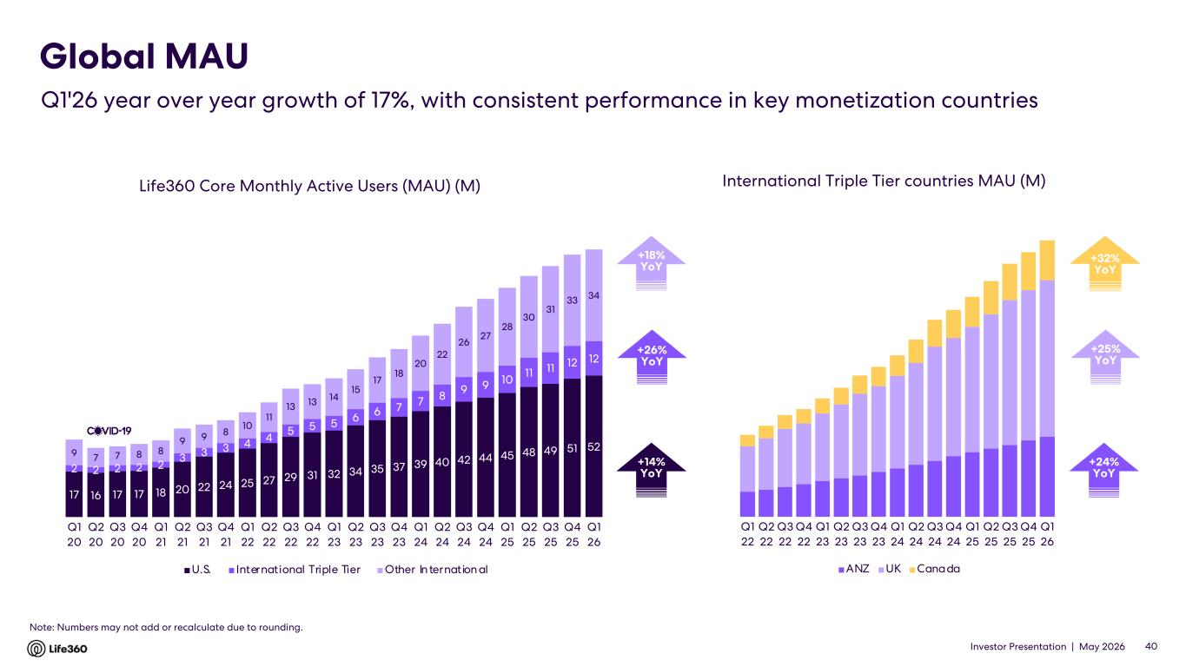
Investor Presentation | May 2026 Life360 Core Monthly Active Users (MAU) (M) Note: Numbers may not add or recalculate due to rounding. Global MAU Q1'26 year over year growth of 17%, with consistent performance in key monetization countries International Triple Tier countries MAU (M) +25% YoY +26% YoY +14% YoY +24% YoY 40 +32% YoY Q1 22 Q2 22 Q3 22 Q4 22 Q1 23 Q2 23 Q3 23 Q4 23 Q1 24 Q2 24 Q3 24 Q4 24 Q1 25 Q2 25 Q3 25 Q4 25 Q1 26 ANZ UK Canada 17 16 17 17 18 20 22 24 25 27 29 31 32 34 35 37 39 40 42 44 45 48 49 51 52 2 2 2 2 2 3 3 3 4 4 5 5 5 6 6 7 7 8 9 9 10 11 11 12 12 9 7 7 8 8 9 9 8 10 11 13 13 14 15 17 18 20 22 26 27 28 30 31 33 34 Q1 20 Q2 20 Q3 20 Q4 20 Q1 21 Q2 21 Q3 21 Q4 21 Q1 22 Q2 22 Q3 22 Q4 22 Q1 23 Q2 23 Q3 23 Q4 23 Q1 24 Q2 24 Q3 24 Q4 24 Q1 25 Q2 25 Q3 25 Q4 25 Q1 26 U.S. International Triple Tier Other In ternation al +18% YoY

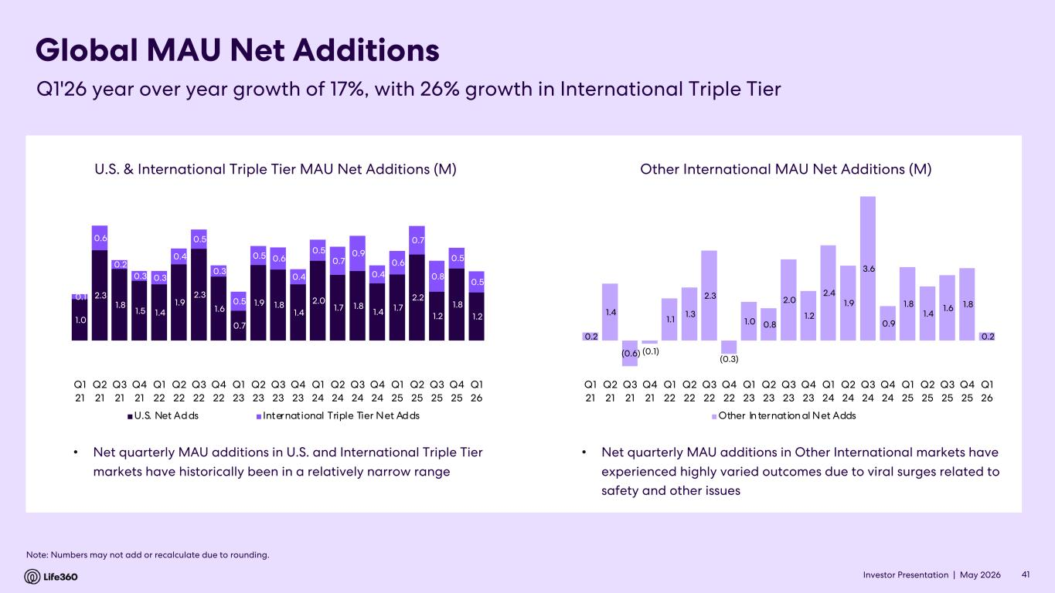
Investor Presentation | May 2026 Global MAU Net Additions • Net quarterly MAU additions in U.S. and International Triple Tier markets have historically been in a relatively narrow range 41 Note: Numbers may not add or recalculate due to rounding. Q1'26 year over year growth of 17%, with 26% growth in International Triple Tier • Net quarterly MAU additions in Other International markets have experienced highly varied outcomes due to viral surges related to safety and other issues Other International MAU Net Additions (M) 1.0 2.3 1.8 1.5 1.4 1.9 2.3 1.6 0.7 1.9 1.8 1.4 2.0 1.7 1.8 1.4 1.7 2.2 1.2 1.8 1.2 0.1 0.6 0.2 0.3 0.3 0.4 0.5 0.3 0.5 0.5 0.6 0.4 0.5 0.7 0.9 0.4 0.6 0.7 0.8 0.5 0.5 Q1 21 Q2 21 Q3 21 Q4 21 Q1 22 Q2 22 Q3 22 Q4 22 Q1 23 Q2 23 Q3 23 Q4 23 Q1 24 Q2 24 Q3 24 Q4 24 Q1 25 Q2 25 Q3 25 Q4 25 Q1 26 U.S. Net Adds International Triple Tier Net Adds 0.2 1.4 (0.6) (0.1) 1.1 1.3 2.3 (0.3) 1.0 0.8 2.0 1.2 2.4 1.9 3.6 0.9 1.8 1.4 1.6 1.8 0.2 Q1 21 Q2 21 Q3 21 Q4 21 Q1 22 Q2 22 Q3 22 Q4 22 Q1 23 Q2 23 Q3 23 Q4 23 Q1 24 Q2 24 Q3 24 Q4 24 Q1 25 Q2 25 Q3 25 Q4 25 Q1 26 Other In ternation al Net Adds U.S. & International Triple Tier MAU Net Additions (M)

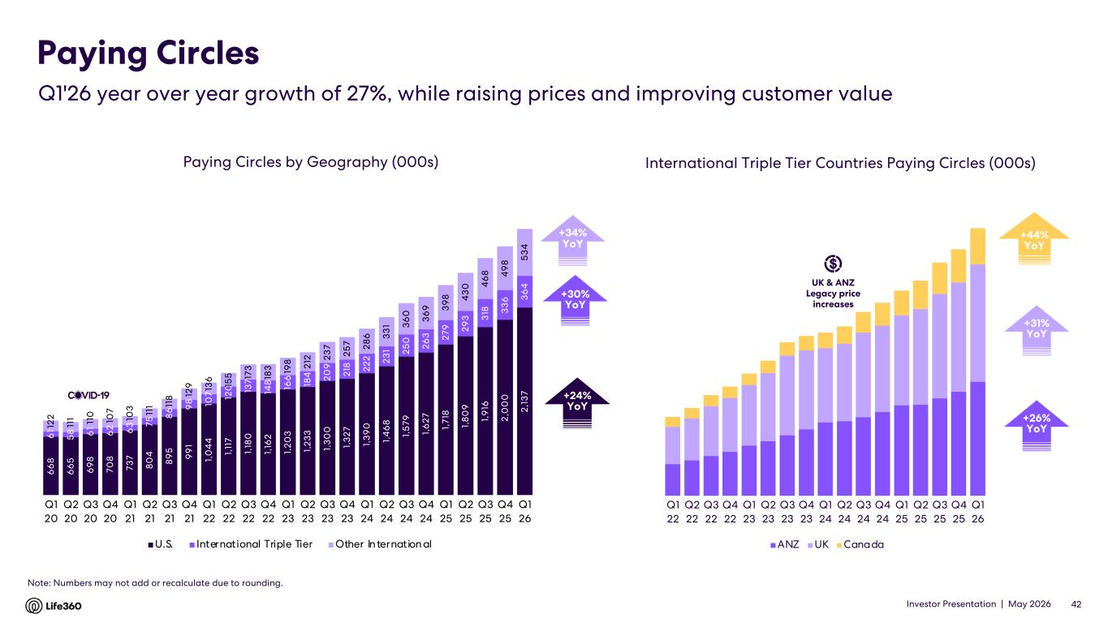
Investor Presentation | May 2026 Paying Circles by Geography (000s) Paying Circles $140 $1398 +42% YoY$38 +42% YoYInternational Triple Tier Countries Paying Circles (000s) +31% YoY +26% YoY +23% YoY 42 Note: Numbers may not add or recalculate due to rounding. Q1'26 year over year growth of 27%, while raising prices and improving customer value UK & ANZ Legacy price increases +44% YoY Q1 22 Q2 22 Q3 22 Q4 22 Q1 23 Q2 23 Q3 23 Q4 23 Q1 24 Q2 24 Q3 24 Q4 24 Q1 25 Q2 25 Q3 25 Q4 25 Q1 26 ANZ UK Canada +30% YoY +24% YoY +34% YoY 6 6 8 6 6 5 6 9 8 70 8 73 7 8 0 4 8 9 5 9 9 1 1, 0 4 4 1, 11 7 1, 18 0 1, 16 2 1, 2 0 3 1, 2 3 3 1, 3 0 0 1, 3 2 7 1, 3 9 0 1, 4 6 8 1, 5 79 1, 6 2 7 1, 71 8 1, 8 0 9 1, 9 16 2 ,0 0 0 2 ,1 3 7 6 1 5 8 6 1 6 2 6 3 75 8 6 9 8 10 7 12 0 13 7 14 8 16 6 18 4 2 0 9 2 18 2 2 2 2 3 1 2 5 0 2 6 3 2 79 2 9 3 3 18 3 3 6 3 6 4 12 2 11 1 11 0 10 7 10 3 11 1 11 8 12 9 13 6 15 5 17 3 18 3 19 8 2 12 2 3 7 2 5 7 2 8 6 3 3 1 3 6 0 3 6 9 3 9 8 4 3 0 4 6 8 4 9 8 5 3 4 Q1 20 Q2 20 Q3 20 Q4 20 Q1 21 Q2 21 Q3 21 Q4 21 Q1 22 Q2 22 Q3 22 Q4 22 Q1 23 Q2 23 Q3 23 Q4 23 Q1 24 Q2 24 Q3 24 Q4 24 Q1 25 Q2 25 Q3 25 Q4 25 Q1 26 U.S. International Triple Tier Other In ternation al

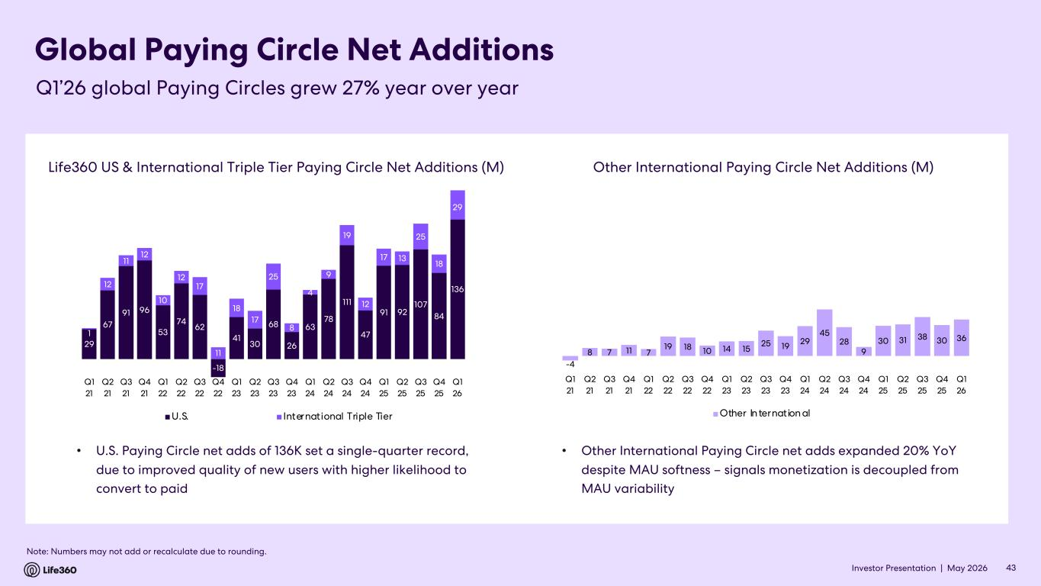
Investor Presentation | May 2026 Global Paying Circle Net Additions 43 Note: Numbers may not add or recalculate due to rounding. Q1’26 global Paying Circles grew 27% year over year Life360 US & International Triple Tier Paying Circle Net Additions (M) Other International Paying Circle Net Additions (M) 29 67 91 96 53 74 62 -18 41 30 68 26 63 78 111 47 91 92 107 84 136 1 12 11 12 10 12 17 11 18 17 25 8 4 9 19 12 17 13 25 18 29 (80) (60) (40) (20) - 20 40 60 80 100 -20 0 20 40 60 80 100 120 14 0 160 Q1 21 Q2 21 Q3 21 Q4 21 Q1 22 Q2 22 Q3 22 Q4 22 Q1 23 Q2 23 Q3 23 Q4 23 Q1 24 Q2 24 Q3 24 Q4 24 Q1 25 Q2 25 Q3 25 Q4 25 Q1 26 U.S. International Triple Tier -4 8 7 11 7 19 18 10 14 15 25 19 29 45 28 9 30 31 38 30 36 Q1 21 Q2 21 Q3 21 Q4 21 Q1 22 Q2 22 Q3 22 Q4 22 Q1 23 Q2 23 Q3 23 Q4 23 Q1 24 Q2 24 Q3 24 Q4 24 Q1 25 Q2 25 Q3 25 Q4 25 Q1 26 Other In ternation al • U.S. Paying Circle net adds of 136K set a single-quarter record, due to improved quality of new users with higher likelihood to convert to paid • Other International Paying Circle net adds expanded 20% YoY despite MAU softness – signals monetization is decoupled from MAU variability

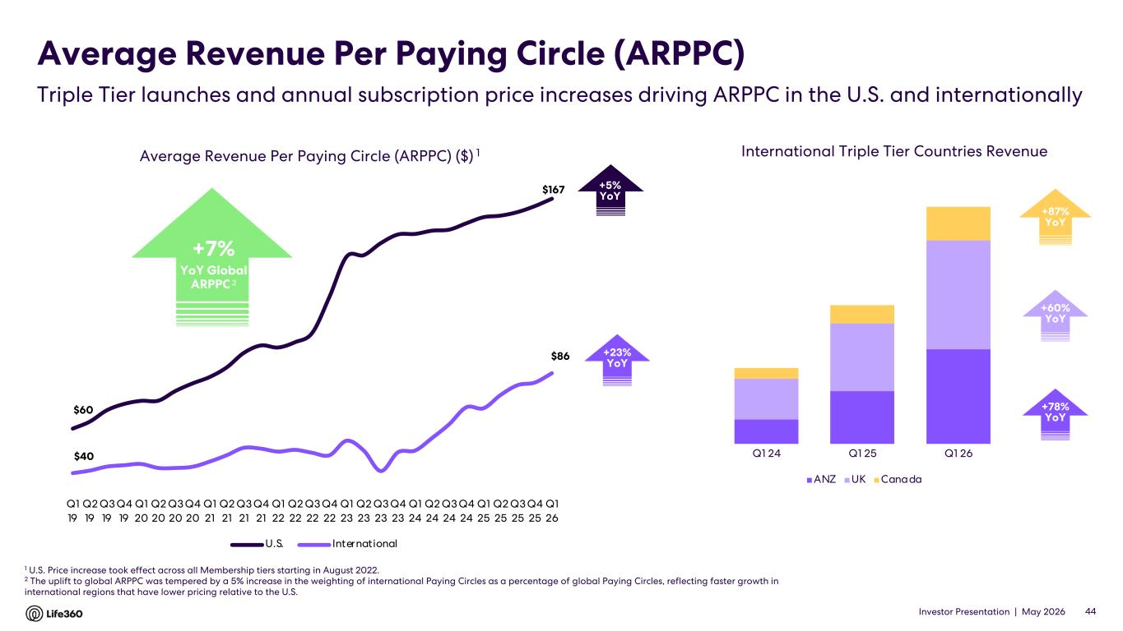
Investor Presentation | May 2026 Average Revenue Per Paying Circle (ARPPC) 1 U.S. Price increase took effect across all Membership tiers starting in August 2022. 2 The uplift to global ARPPC was tempered by a 5% increase in the weighting of international Paying Circles as a percentage of global Paying Circles, reflecting faster growth in international regions that have lower pricing relative to the U.S. Average Revenue Per Paying Circle (ARPPC) ($) 1 +5% YoY 44 +23% YoY +60% YoY +78% YoY Triple Tier launches and annual subscription price increases driving ARPPC in the U.S. and internationally International Triple Tier Countries Revenue +87% YoY +7% YoY Global ARPPC 2 $60 $167 $40 $86 Q1 19 Q2 19 Q3 19 Q4 19 Q1 20 Q2 20 Q3 20 Q4 20 Q1 21 Q2 21 Q3 21 Q4 21 Q1 22 Q2 22 Q3 22 Q4 22 Q1 23 Q2 23 Q3 23 Q4 23 Q1 24 Q2 24 Q3 24 Q4 24 Q1 25 Q2 25 Q3 25 Q4 25 Q1 26 U.S. International Q1 24 Q1 25 Q1 26 ANZ UK Canada

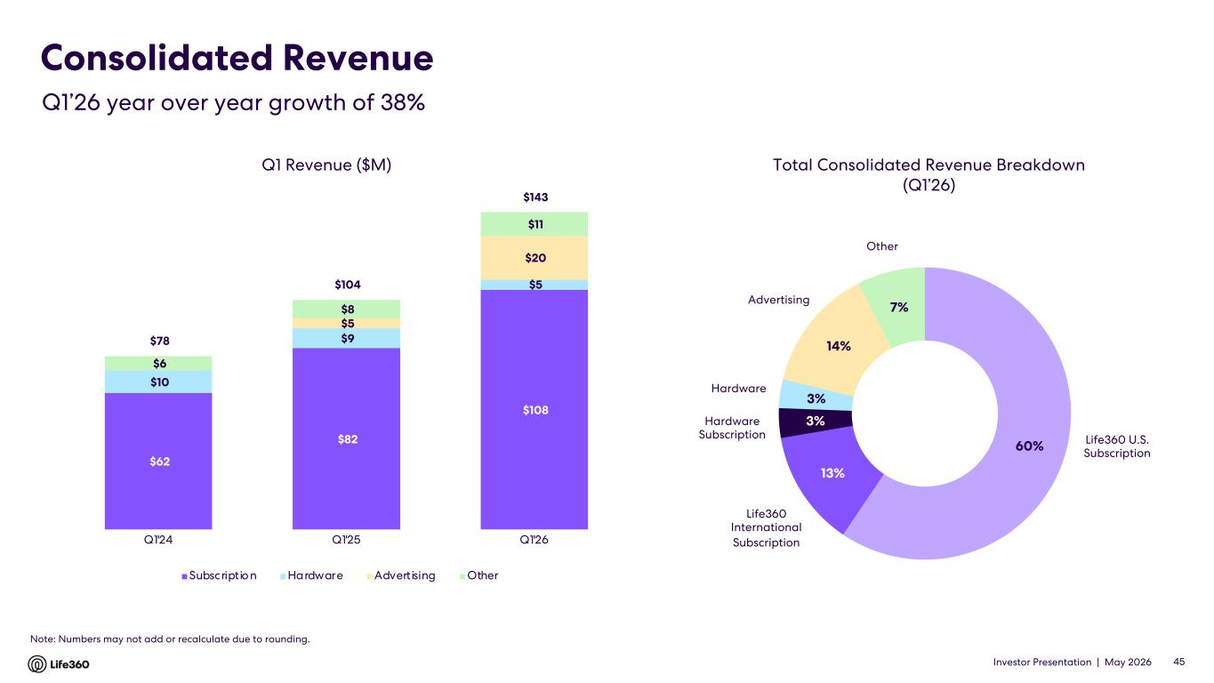
Investor Presentation | May 2026 60% 13% 3% 3% 14% 7% Consolidated Revenue 45 Q1 Revenue ($M) Total Consolidated Revenue Breakdown (Q1’26) Hardware Life360 U.S. Subscription Life360 International Subscription Hardware Subscription Advertising Q1’26 year over year growth of 38% Note: Numbers may not add or recalculate due to rounding. Other $62 $82 $108 $10 $9 $5 $5 $20 $6 $8 $11 $78 $104 $143 Q1'24 Q1'25 Q1'26 Subscription Hardware Advertising Other

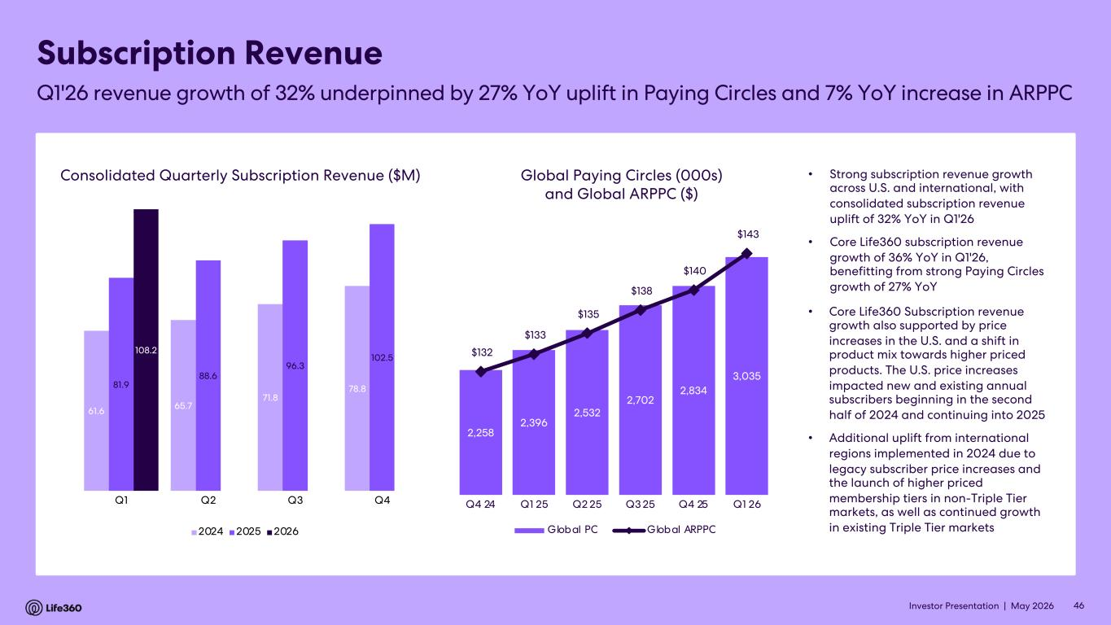
Investor Presentation | May 2026 46 Consolidated Quarterly Subscription Revenue ($M) Global Paying Circles (000s) and Global ARPPC ($) • Strong subscription revenue growth across U.S. and international, with consolidated subscription revenue uplift of 32% YoY in Q1'26 • Core Life360 subscription revenue growth of 36% YoY in Q1'26, benefitting from strong Paying Circles growth of 27% YoY • Core Life360 Subscription revenue growth also supported by price increases in the U.S. and a shift in product mix towards higher priced products. The U.S. price increases impacted new and existing annual subscribers beginning in the second half of 2024 and continuing into 2025 • Additional uplift from international regions implemented in 2024 due to legacy subscriber price increases and the launch of higher priced membership tiers in non-Triple Tier markets, as well as continued growth in existing Triple Tier markets 61.6 65.7 71.8 78.881.9 88.6 96.3 102.5 108.2 Q1 Q2 Q3 Q4 2024 2025 2026 2,258 2,396 2,532 2,702 2,834 3,035 $132 $133 $135 $138 $140 $143 $120 $125 $130 $135 $140 $145 1,400 1,600 1,800 2,000 2,200 2,400 2,600 2,800 3,000 3,200 Q4 24 Q1 25 Q2 25 Q3 25 Q4 25 Q1 26 Global PC Global ARPPC Subscription Revenue Q1'26 revenue growth of 32% underpinned by 27% YoY uplift in Paying Circles and 7% YoY increase in ARPPC

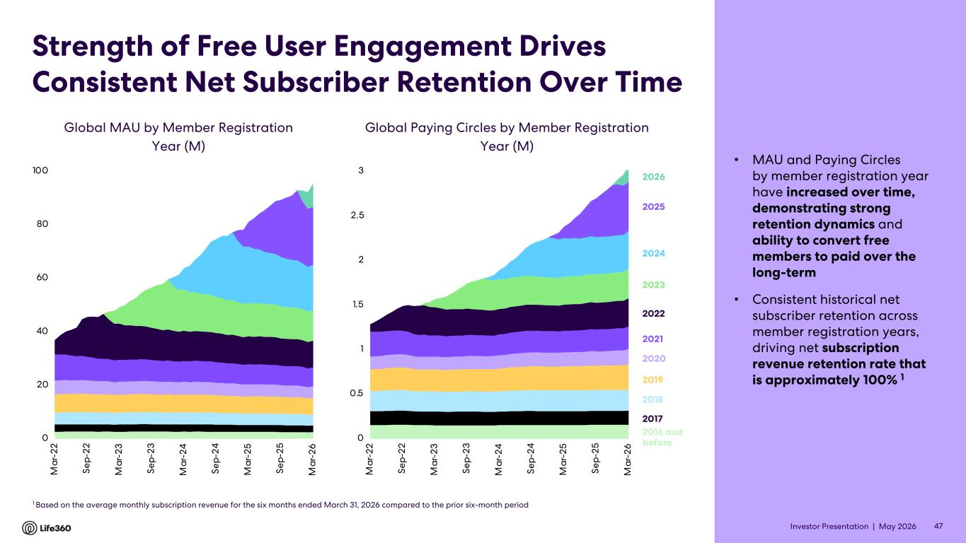
Investor Presentation | May 2026 Strength of Free User Engagement Drives Consistent Net Subscriber Retention Over Time • MAU and Paying Circles by member registration year have increased over time, demonstrating strong retention dynamics and ability to convert free members to paid over the long-term • Consistent historical net subscriber retention across member registration years, driving net subscription revenue retention rate that is approximately 100% 1 Global Paying Circles by Member Registration Year (M) Global MAU by Member Registration Year (M) 1 Based on the average monthly subscription revenue for the six months ended March 31, 2026 compared to the prior six-month period 47 0 20 40 60 80 100 M ar -2 2 Se p- 22 M ar -2 3 Se p- 23 M ar -2 4 Se p- 24 M ar -2 5 Se p- 25 M ar -2 6 2023 2022 2021 2020 2019 2018 2017 2016 and before 2024 2025 2026 0 0.5 1 1.5 2 2.5 3 M ar -2 2 Se p- 22 M ar -2 3 Se p- 23 M ar -2 4 Se p- 24 M ar -2 5 Se p- 25 M ar -2 6

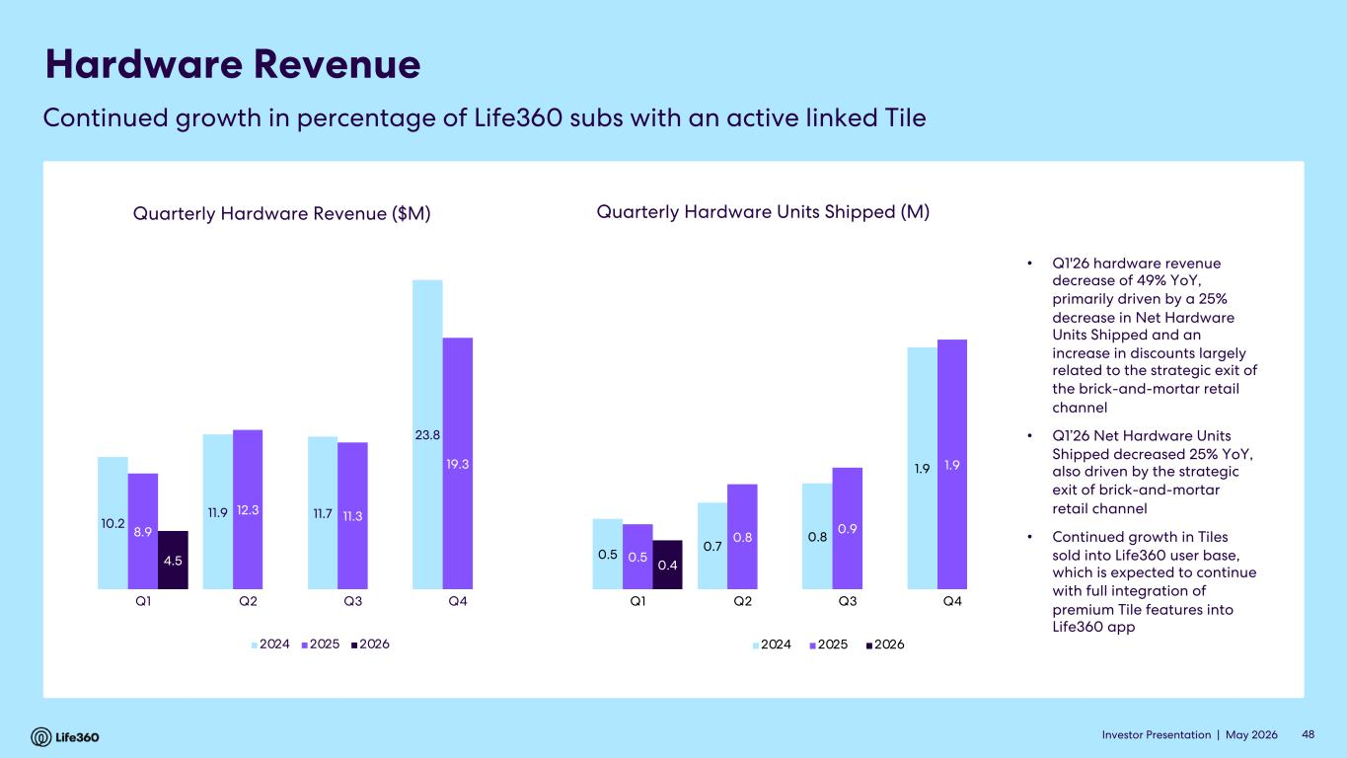
Investor Presentation | May 2026 Hardware Revenue Quarterly Hardware Revenue ($M) • Q1'26 hardware revenue decrease of 49% YoY, primarily driven by a 25% decrease in Net Hardware Units Shipped and an increase in discounts largely related to the strategic exit of the brick-and-mortar retail channel • Q1’26 Net Hardware Units Shipped decreased 25% YoY, also driven by the strategic exit of brick-and-mortar retail channel • Continued growth in Tiles sold into Life360 user base, which is expected to continue with full integration of premium Tile features into Life360 app Quarterly Hardware Units Shipped (M) Continued growth in percentage of Life360 subs with an active linked Tile 10.2 11.9 11.7 23.8 8.9 12.3 11.3 19.3 4.5 Q1 Q2 Q3 Q4 2024 2025 2026 0.5 0.7 0.8 1.9 0.5 0.8 0.9 1.9 0.4 Q1 Q2 Q3 Q4 2024 2025 2026 48

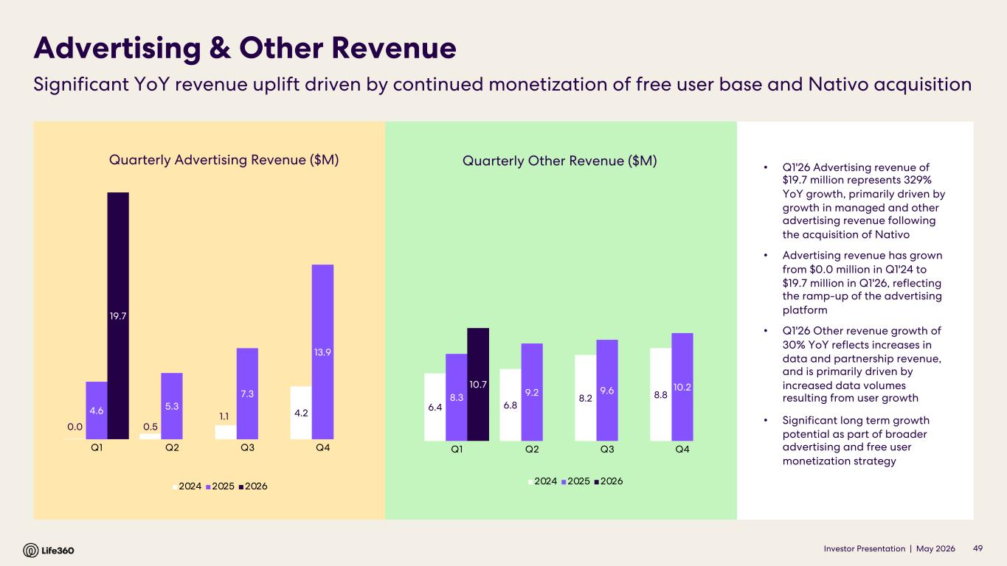
Investor Presentation | May 2026 0.0 0.5 1.1 4.24.6 5.3 7.3 13.9 19.7 Q1 Q2 Q3 Q4 2024 2025 2026 Quarterly Advertising Revenue ($M) Advertising & Other Revenue Significant YoY revenue uplift driven by continued monetization of free user base and Nativo acquisition • Q1'26 Advertising revenue of $19.7 million represents 329% YoY growth, primarily driven by growth in managed and other advertising revenue following the acquisition of Nativo • Advertising revenue has grown from $0.0 million in Q1'24 to $19.7 million in Q1'26, reflecting the ramp-up of the advertising platform • Q1'26 Other revenue growth of 30% YoY reflects increases in data and partnership revenue, and is primarily driven by increased data volumes resulting from user growth • Significant long term growth potential as part of broader advertising and free user monetization strategy 49 Quarterly Other Revenue ($M) 6.4 6.8 8.2 8.88.3 9.2 9.6 10.210.7 Q1 Q2 Q3 Q4 2024 2025 2026

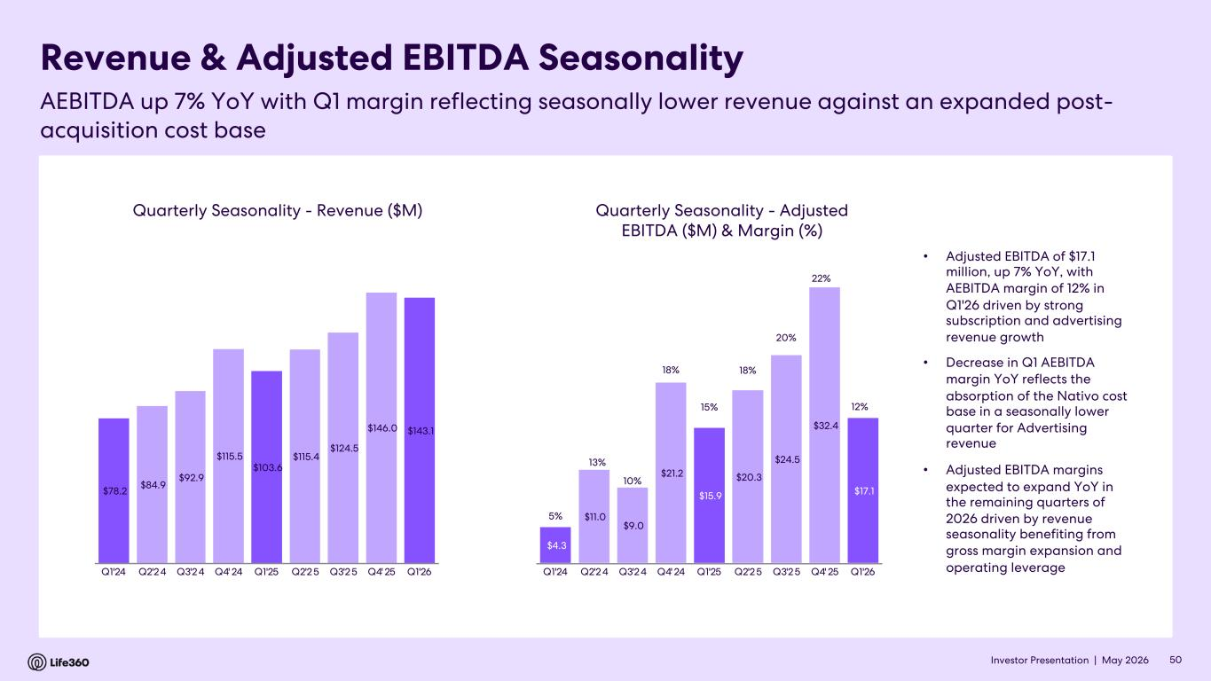
Investor Presentation | May 2026 Quarterly Seasonality - Revenue ($M) Revenue & Adjusted EBITDA Seasonality AEBITDA up 7% YoY with Q1 margin reflecting seasonally lower revenue against an expanded post- acquisition cost base 50 Quarterly Seasonality - Adjusted EBITDA ($M) & Margin (%) • Adjusted EBITDA of $17.1 million, up 7% YoY, with AEBITDA margin of 12% in Q1'26 driven by strong subscription and advertising revenue growth • Decrease in Q1 AEBITDA margin YoY reflects the absorption of the Nativo cost base in a seasonally lower quarter for Advertising revenue • Adjusted EBITDA margins expected to expand YoY in the remaining quarters of 2026 driven by revenue seasonality benefiting from gross margin expansion and operating leverage $78.2 $84.9 $92.9 $115.5 $103.6 $115.4 $124.5 $146.0 $143.1 Q1'24 Q2'24 Q3'24 Q4' 24 Q1'25 Q2'25 Q3'25 Q4' 25 Q1'26 $4.3 $11.0 $9.0 $21.2 $15.9 $20.3 $24.5 $32.4 $17.1 5% 13% 10% 18% 15% 18% 20% 22% 12% 5% 7% 9% 11% 13% 15% 17% 19% 21% 23% $- $5.0 $10.0 $15.0 $20.0 $25.0 $30.0 $35.0 Q1'24 Q2'24 Q3'24 Q4' 24 Q1'25 Q2'25 Q3'25 Q4' 25 Q1'26


Investor Presentation | May 2026 04 FY2026 Outlook

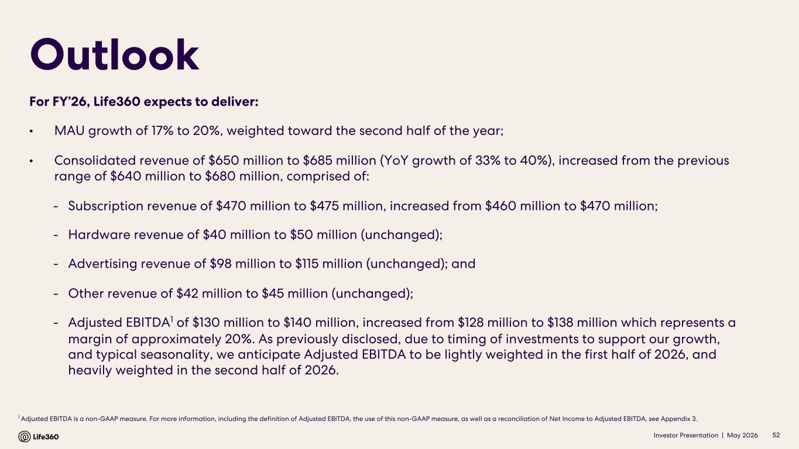
Investor Presentation | May 2026 1 Adjusted EBITDA is a non-GAAP measure. For more information, including the definition of Adjusted EBITDA, the use of this non-GAAP measure, as well as a reconciliation of Net Income to Adjusted EBITDA, see Appendix 3. Outlook 52 For FY’26, Life360 expects to deliver: • MAU growth of 17% to 20%, weighted toward the second half of the year; • Consolidated revenue of $650 million to $685 million (YoY growth of 33% to 40%), increased from the previous range of $640 million to $680 million, comprised of: - Subscription revenue of $470 million to $475 million, increased from $460 million to $470 million; - Hardware revenue of $40 million to $50 million (unchanged); - Advertising revenue of $98 million to $115 million (unchanged); and - Other revenue of $42 million to $45 million (unchanged); - Adjusted EBITDA1 of $130 million to $140 million, increased from $128 million to $138 million which represents a margin of approximately 20%. As previously disclosed, due to timing of investments to support our growth, and typical seasonality, we anticipate Adjusted EBITDA to be lightly weighted in the first half of 2026, and heavily weighted in the second half of 2026.


Investor Presentation | May 2026 05 Appendix

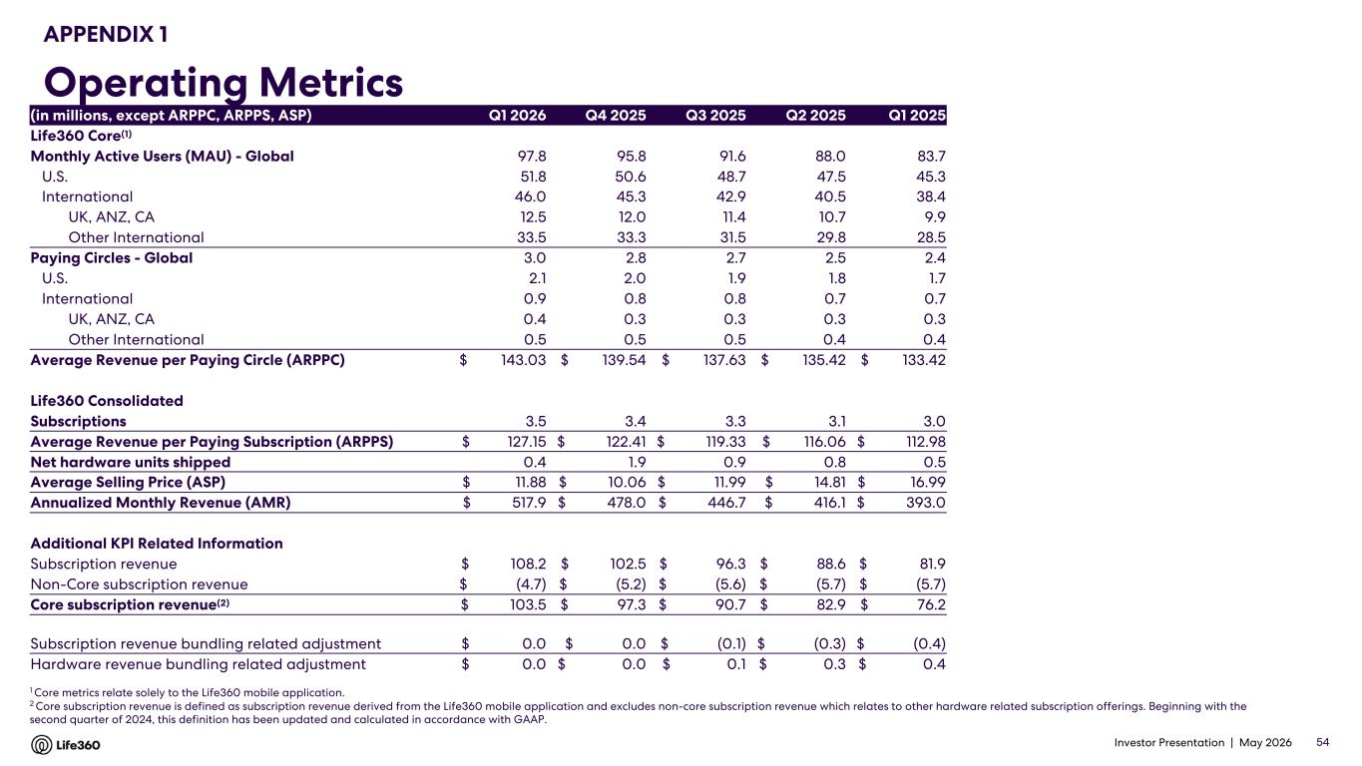
Investor Presentation | May 2026 APPENDIX 1 Operating Metrics 1 Core metrics relate solely to the Life360 mobile application. 2 Core subscription revenue is defined as subscription revenue derived from the Life360 mobile application and excludes non-core subscription revenue which relates to other hardware related subscription offerings. Beginning with the second quarter of 2024, this definition has been updated and calculated in accordance with GAAP. 54 (in millions, except ARPPC, ARPPS, ASP) Q1 2026 Q4 2025 Q3 2025 Q2 2025 Q1 2025 Life360 Core(1) Monthly Active Users (MAU) - Global 97.8 95.8 91.6 88.0 83.7 U.S. 51.8 50.6 48.7 47.5 45.3 International 46.0 45.3 42.9 40.5 38.4 UK, ANZ, CA 12.5 12.0 11.4 10.7 9.9 Other International 33.5 33.3 31.5 29.8 28.5 Paying Circles - Global 3.0 2.8 2.7 2.5 2.4 U.S. 2.1 2.0 1.9 1.8 1.7 International 0.9 0.8 0.8 0.7 0.7 UK, ANZ, CA 0.4 0.3 0.3 0.3 0.3 Other International 0.5 0.5 0.5 0.4 0.4 Average Revenue per Paying Circle (ARPPC) $ 143.03 $ 139.54 $ 137.63 $ 135.42 $ 133.42 Life360 Consolidated Subscriptions 3.5 3.4 3.3 3.1 3.0 Average Revenue per Paying Subscription (ARPPS) $ 127.15 $ 122.41 $ 119.33 $ 116.06 $ 112.98 Net hardware units shipped 0.4 1.9 0.9 0.8 0.5 Average Selling Price (ASP) $ 11.88 $ 10.06 $ 11.99 $ 14.81 $ 16.99 Annualized Monthly Revenue (AMR) $ 517.9 $ 478.0 $ 446.7 $ 416.1 $ 393.0 Additional KPI Related Information Subscription revenue $ 108.2 $ 102.5 $ 96.3 $ 88.6 $ 81.9 Non-Core subscription revenue $ (4.7) $ (5.2) $ (5.6) $ (5.7) $ (5.7) Core subscription revenue(2) $ 103.5 $ 97.3 $ 90.7 $ 82.9 $ 76.2 Subscription revenue bundling related adjustment $ 0.0 $ 0.0 $ (0.1) $ (0.3) $ (0.4) Hardware revenue bundling related adjustment $ 0.0 $ 0.0 $ 0.1 $ 0.3 $ 0.4

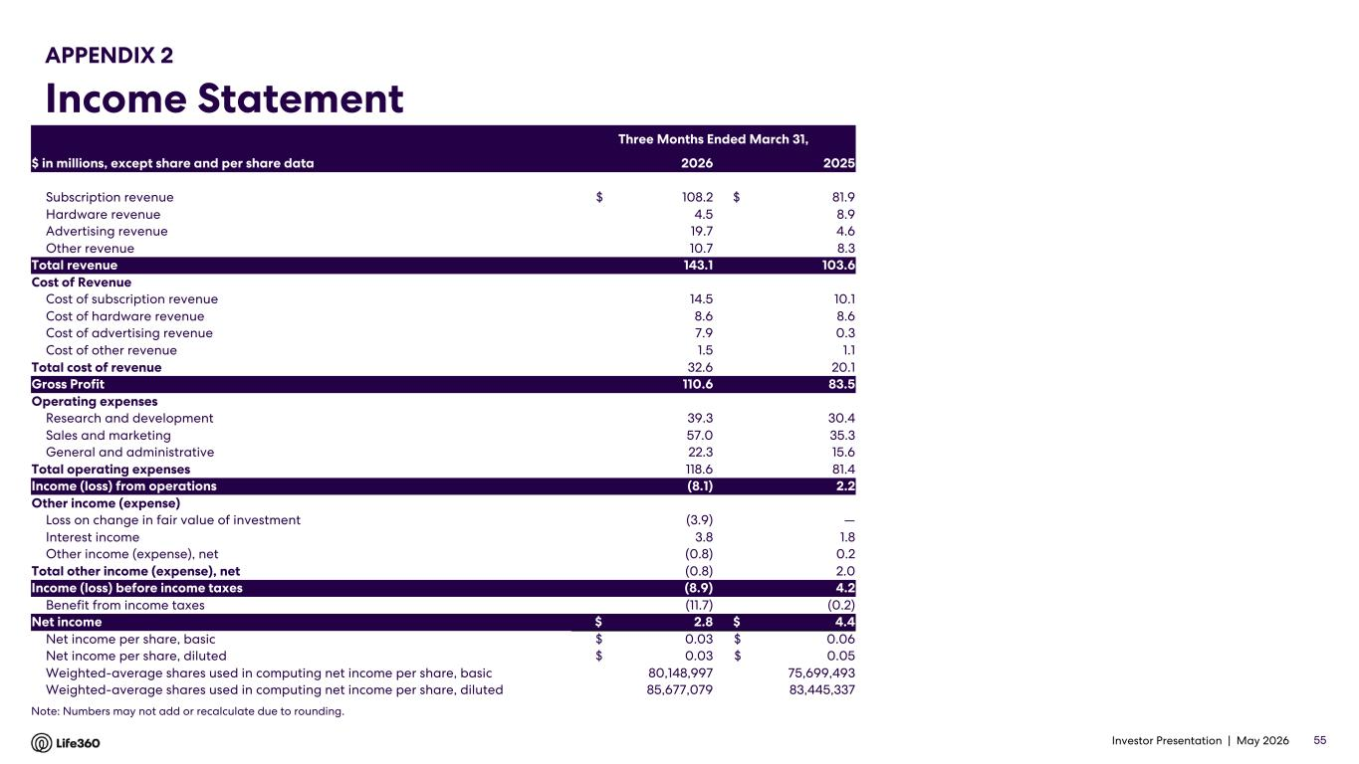
Investor Presentation | May 2026 APPENDIX 2 Income Statement 55 Note: Numbers may not add or recalculate due to rounding. Three Months Ended March 31, $ in millions, except share and per share data 2026 2025 Subscription revenue $ 108.2 $ 81.9 Hardware revenue 4.5 8.9 Advertising revenue 19.7 4.6 Other revenue 10.7 8.3 Total revenue 143.1 103.6 Cost of Revenue Cost of subscription revenue 14.5 10.1 Cost of hardware revenue 8.6 8.6 Cost of advertising revenue 7.9 0.3 Cost of other revenue 1.5 1.1 Total cost of revenue 32.6 20.1 Gross Profit 110.6 83.5 Operating expenses Research and development 39.3 30.4 Sales and marketing 57.0 35.3 General and administrative 22.3 15.6 Total operating expenses 118.6 81.4 Income (loss) from operations (8.1) 2.2 Other income (expense) Loss on change in fair value of investment (3.9) — Interest income 3.8 1.8 Other income (expense), net (0.8) 0.2 Total other income (expense), net (0.8) 2.0 Income (loss) before income taxes (8.9) 4.2 Benefit from income taxes (11.7) (0.2) Net income $ 2.8 $ 4.4 Net income per share, basic $ 0.03 $ 0.06 Net income per share, diluted $ 0.03 $ 0.05 Weighted-average shares used in computing net income per share, basic 80,148,997 75,699,493 Weighted-average shares used in computing net income per share, diluted 85,677,079 83,445,337

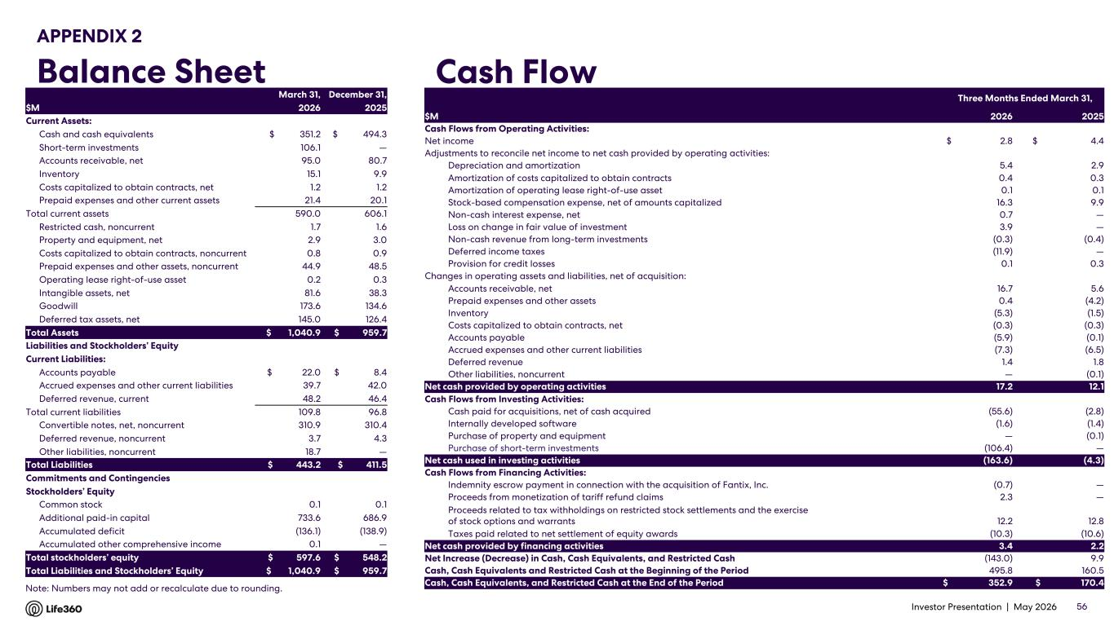
Investor Presentation | May 2026 APPENDIX 2 Balance Sheet Cash Flow 56 Note: Numbers may not add or recalculate due to rounding. March 31, December 31, $M 2026 2025 Current Assets: Cash and cash equivalents $ 351.2 $ 494.3 Short-term investments 106.1 — Accounts receivable, net 95.0 80.7 Inventory 15.1 9.9 Costs capitalized to obtain contracts, net 1.2 1.2 Prepaid expenses and other current assets 21.4 20.1 Total current assets 590.0 606.1 Restricted cash, noncurrent 1.7 1.6 Property and equipment, net 2.9 3.0 Costs capitalized to obtain contracts, noncurrent 0.8 0.9 Prepaid expenses and other assets, noncurrent 44.9 48.5 Operating lease right-of-use asset 0.2 0.3 Intangible assets, net 81.6 38.3 Goodwill 173.6 134.6 Deferred tax assets, net 145.0 126.4 Total Assets $ 1,040.9 $ 959.7 Liabilities and Stockholders’ Equity Current Liabilities: Accounts payable $ 22.0 $ 8.4 Accrued expenses and other current liabilities 39.7 42.0 Deferred revenue, current 48.2 46.4 Total current liabilities 109.8 96.8 Convertible notes, net, noncurrent 310.9 310.4 Deferred revenue, noncurrent 3.7 4.3 Other liabilities, noncurrent 18.7 — Total Liabilities $ 443.2 $ 411.5 Commitments and Contingencies Stockholders’ Equity Common stock 0.1 0.1 Additional paid-in capital 733.6 686.9 Accumulated deficit (136.1) (138.9) Accumulated other comprehensive income 0.1 — Total stockholders’ equity $ 597.6 $ 548.2 Total Liabilities and Stockholders’ Equity $ 1,040.9 $ 959.7 Three Months Ended March 31, $M 2026 2025 Cash Flows from Operating Activities: Net income $ 2.8 $ 4.4 Adjustments to reconcile net income to net cash provided by operating activities: Depreciation and amortization 5.4 2.9 Amortization of costs capitalized to obtain contracts 0.4 0.3 Amortization of operating lease right-of-use asset 0.1 0.1 Stock-based compensation expense, net of amounts capitalized 16.3 9.9 Non-cash interest expense, net 0.7 — Loss on change in fair value of investment 3.9 — Non-cash revenue from long-term investments (0.3) (0.4) Deferred income taxes (11.9) — Provision for credit losses 0.1 0.3 Changes in operating assets and liabilities, net of acquisition: Accounts receivable, net 16.7 5.6 Prepaid expenses and other assets 0.4 (4.2) Inventory (5.3) (1.5) Costs capitalized to obtain contracts, net (0.3) (0.3) Accounts payable (5.9) (0.1) Accrued expenses and other current liabilities (7.3) (6.5) Deferred revenue 1.4 1.8 Other liabilities, noncurrent — (0.1) Net cash provided by operating activities 17.2 12.1 Cash Flows from Investing Activities: Cash paid for acquisitions, net of cash acquired (55.6) (2.8) Internally developed software (1.6) (1.4) Purchase of property and equipment — (0.1) Purchase of short-term investments (106.4) — Net cash used in investing activities (163.6) (4.3) Cash Flows from Financing Activities: Indemnity escrow payment in connection with the acquisition of Fantix, Inc. (0.7) — Proceeds from monetization of tariff refund claims 2.3 — Proceeds related to tax withholdings on restricted stock settlements and the exercise of stock options and warrants 12.2 12.8 Taxes paid related to net settlement of equity awards (10.3) (10.6) Net cash provided by financing activities 3.4 2.2 Net Increase (Decrease) in Cash, Cash Equivalents, and Restricted Cash (143.0) 9.9 Cash, Cash Equivalents and Restricted Cash at the Beginning of the Period 495.8 160.5 Cash, Cash Equivalents, and Restricted Cash at the End of the Period $ 352.9 $ 170.4

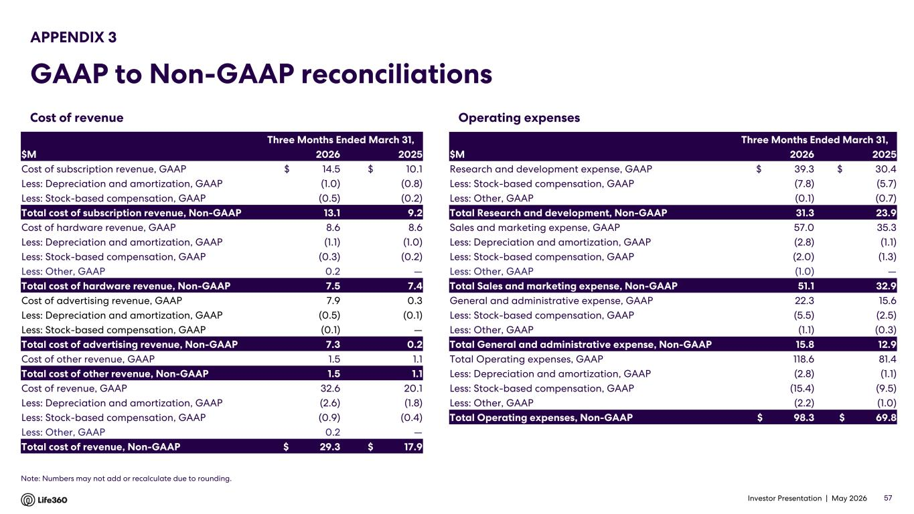
Investor Presentation | May 2026 Operating expenses APPENDIX 3 GAAP to Non-GAAP reconciliations 57 Note: Numbers may not add or recalculate due to rounding. Cost of revenue Three Months Ended March 31, $M 2026 2025 Cost of subscription revenue, GAAP $ 14.5 $ 10.1 Less: Depreciation and amortization, GAAP (1.0) (0.8) Less: Stock-based compensation, GAAP (0.5) (0.2) Total cost of subscription revenue, Non-GAAP 13.1 9.2 Cost of hardware revenue, GAAP 8.6 8.6 Less: Depreciation and amortization, GAAP (1.1) (1.0) Less: Stock-based compensation, GAAP (0.3) (0.2) Less: Other, GAAP 0.2 — Total cost of hardware revenue, Non-GAAP 7.5 7.4 Cost of advertising revenue, GAAP 7.9 0.3 Less: Depreciation and amortization, GAAP (0.5) (0.1) Less: Stock-based compensation, GAAP (0.1) — Total cost of advertising revenue, Non-GAAP 7.3 0.2 Cost of other revenue, GAAP 1.5 1.1 Total cost of other revenue, Non-GAAP 1.5 1.1 Cost of revenue, GAAP 32.6 20.1 Less: Depreciation and amortization, GAAP (2.6) (1.8) Less: Stock-based compensation, GAAP (0.9) (0.4) Less: Other, GAAP 0.2 — Total cost of revenue, Non-GAAP $ 29.3 $ 17.9 Three Months Ended March 31, $M 2026 2025 Research and development expense, GAAP $ 39.3 $ 30.4 Less: Stock-based compensation, GAAP (7.8) (5.7) Less: Other, GAAP (0.1) (0.7) Total Research and development, Non-GAAP 31.3 23.9 Sales and marketing expense, GAAP 57.0 35.3 Less: Depreciation and amortization, GAAP (2.8) (1.1) Less: Stock-based compensation, GAAP (2.0) (1.3) Less: Other, GAAP (1.0) — Total Sales and marketing expense, Non-GAAP 51.1 32.9 General and administrative expense, GAAP 22.3 15.6 Less: Stock-based compensation, GAAP (5.5) (2.5) Less: Other, GAAP (1.1) (0.3) Total General and administrative expense, Non-GAAP 15.8 12.9 Total Operating expenses, GAAP 118.6 81.4 Less: Depreciation and amortization, GAAP (2.8) (1.1) Less: Stock-based compensation, GAAP (15.4) (9.5) Less: Other, GAAP (2.2) (1.0) Total Operating expenses, Non-GAAP $ 98.3 $ 69.8

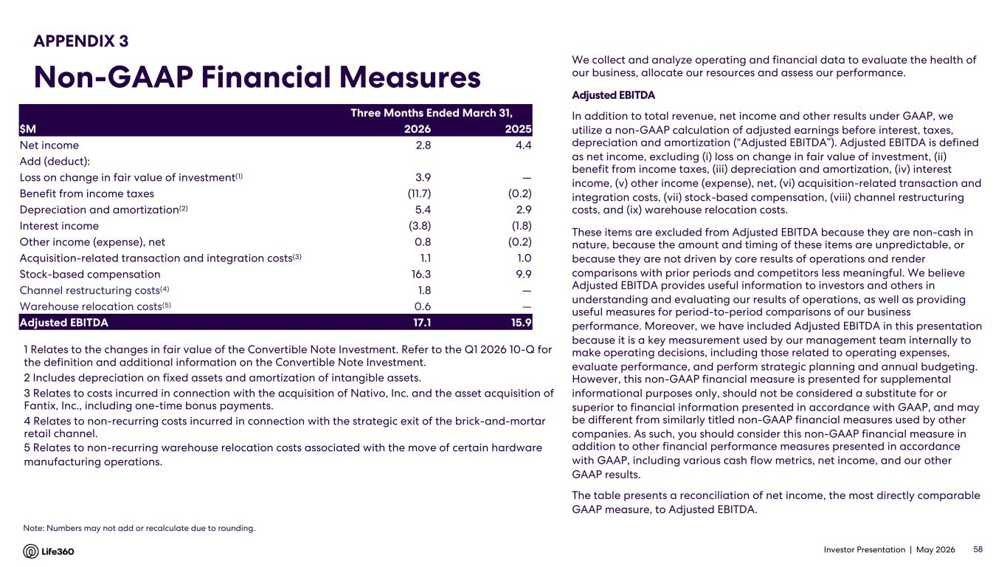
Investor Presentation | May 2026 We collect and analyze operating and financial data to evaluate the health of our business, allocate our resources and assess our performance. Adjusted EBITDA In addition to total revenue, net income and other results under GAAP, we utilize a non-GAAP calculation of adjusted earnings before interest, taxes, depreciation and amortization (“Adjusted EBITDA”). Adjusted EBITDA is defined as net income, excluding (i) loss on change in fair value of investment, (ii) benefit from income taxes, (iii) depreciation and amortization, (iv) interest income, (v) other income (expense), net, (vi) acquisition-related transaction and integration costs, (vii) stock-based compensation, (viii) channel restructuring costs, and (ix) warehouse relocation costs. These items are excluded from Adjusted EBITDA because they are non-cash in nature, because the amount and timing of these items are unpredictable, or because they are not driven by core results of operations and render comparisons with prior periods and competitors less meaningful. We believe Adjusted EBITDA provides useful information to investors and others in understanding and evaluating our results of operations, as well as providing useful measures for period-to-period comparisons of our business performance. Moreover, we have included Adjusted EBITDA in this presentation because it is a key measurement used by our management team internally to make operating decisions, including those related to operating expenses, evaluate performance, and perform strategic planning and annual budgeting. However, this non-GAAP financial measure is presented for supplemental informational purposes only, should not be considered a substitute for or superior to financial information presented in accordance with GAAP, and may be different from similarly titled non-GAAP financial measures used by other companies. As such, you should consider this non-GAAP financial measure in addition to other financial performance measures presented in accordance with GAAP, including various cash flow metrics, net income, and our other GAAP results. The table presents a reconciliation of net income, the most directly comparable GAAP measure, to Adjusted EBITDA. 1 Relates to the changes in fair value of the Convertible Note Investment. Refer to the Q1 2026 10-Q for the definition and additional information on the Convertible Note Investment. 2 Includes depreciation on fixed assets and amortization of intangible assets. 3 Relates to costs incurred in connection with the acquisition of Nativo, Inc. and the asset acquisition of Fantix, Inc., including one-time bonus payments. 4 Relates to non-recurring costs incurred in connection with the strategic exit of the brick-and-mortar retail channel. 5 Relates to non-recurring warehouse relocation costs associated with the move of certain hardware manufacturing operations. 58 APPENDIX 3 Non-GAAP Financial Measures Note: Numbers may not add or recalculate due to rounding. Three Months Ended March 31, $M 2026 2025 Net income 2.8 4.4 Add (deduct): Loss on change in fair value of investment(1) 3.9 — Benefit from income taxes (11.7) (0.2) Depreciation and amortization(2) 5.4 2.9 Interest income (3.8) (1.8) Other income (expense), net 0.8 (0.2) Acquisition-related transaction and integration costs(3) 1.1 1.0 Stock-based compensation 16.3 9.9 Channel restructuring costs(4) 1.8 — Warehouse relocation costs(5) 0.6 — Adjusted EBITDA 17.1 15.9

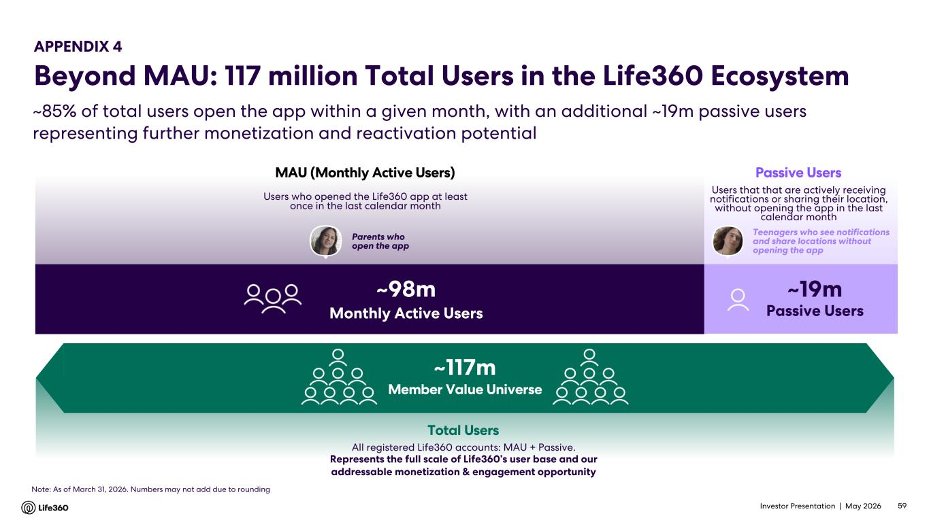
Investor Presentation | May 2026 ~85% of total users open the app within a given month, with an additional ~19m passive users representing further monetization and reactivation potential All registered Life360 accounts: MAU + Passive. Represents the full scale of Life360’s user base and our addressable monetization & engagement opportunity Total Users APPENDIX 4 Beyond MAU: 117 million Total Users in the Life360 Ecosystem ~117m Member Value Universe Users that that are actively receiving notifications or sharing their location, without opening the app in the last calendar month Passive Users Teenagers who see notifications and share locations without opening the app ~19m Passive Users Users who opened the Life360 app at least once in the last calendar month MAU (Monthly Active Users) ~98m Monthly Active Users Parents who open the app 59 Note: As of March 31, 2026. Numbers may not add due to rounding

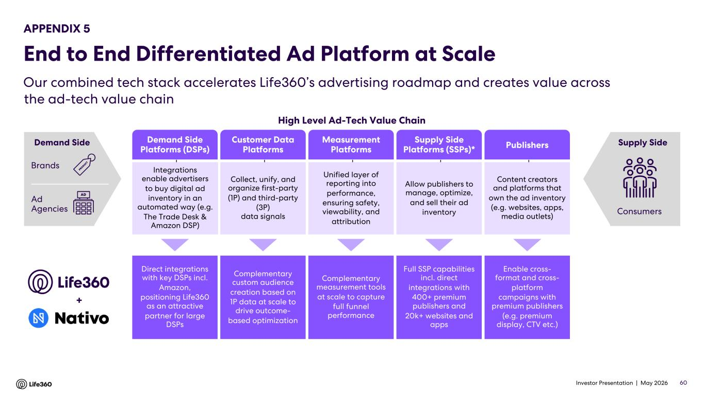
Investor Presentation | May 2026 Our combined tech stack accelerates Life360’s advertising roadmap and creates value across the ad-tech value chain 60 Demand Side Platforms (DSPs) Customer Data Platforms Measurement Platforms Supply Side Platforms (SSPs)* Publishers High Level Ad-Tech Value Chain Allow publishers to manage, optimize, and sell their ad inventory Collect, unify, and organize first-party (1P) and third-party (3P) data signals Unified layer of reporting into performance, ensuring safety, viewability, and attribution Content creators and platforms that own the ad inventory (e.g. websites, apps, media outlets) Integrations enable advertisers to buy digital ad inventory in an automated way (e.g. The Trade Desk & Amazon DSP) Consumers Supply Side Enable cross- format and cross- platform campaigns with premium publishers (e.g. premium display, CTV etc.) Complementary custom audience creation based on 1P data at scale to drive outcome- based optimization Direct integrations with key DSPs incl. Amazon, positioning Life360 as an attractive partner for large DSPs Full SSP capabilities incl. direct integrations with 400+ premium publishers and 20k+ websites and apps Complementary measurement tools at scale to capture full funnel performance + Brands Ad Agencies Demand Side APPENDIX 5 End to End Differentiated Ad Platform at Scale

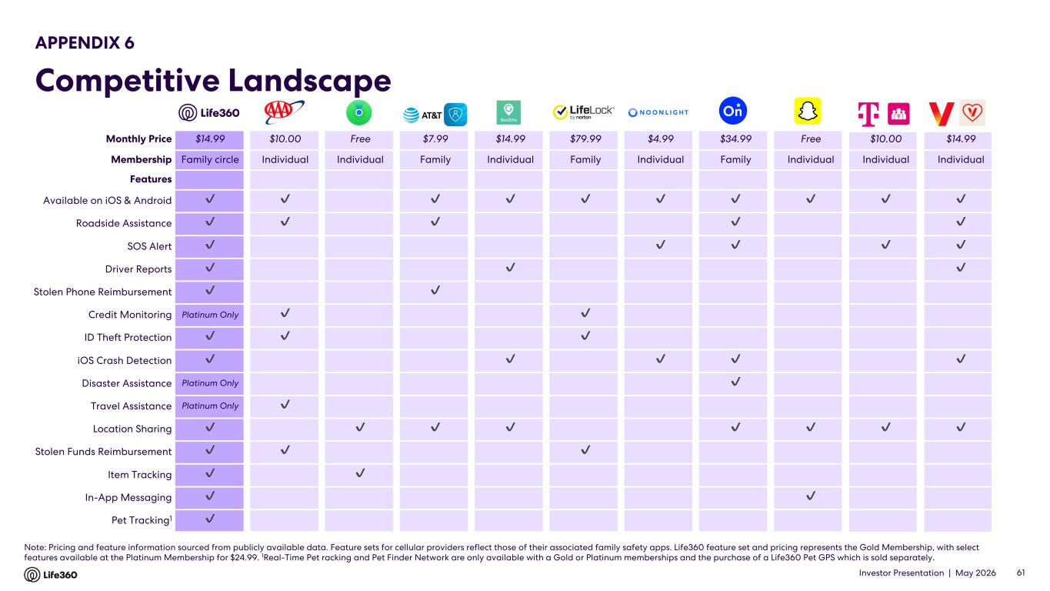
Investor Presentation | May 2026 Note: Pricing and feature information sourced from publicly available data. Feature sets for cellular providers reflect those of their associated family safety apps. Life360 feature set and pricing represents the Gold Membership, with select features available at the Platinum Membership for $24.99. 1Real-Time Pet racking and Pet Finder Network are only available with a Gold or Platinum memberships and the purchase of a Life360 Pet GPS which is sold separately. APPENDIX 6 Competitive Landscape Monthly Price $14.99 $10.00 Free $7.99 $14.99 $79.99 $4.99 $34.99 Free $10.00 $14.99 Membership Family circle Individual Individual Family Individual Family Individual Family Individual Individual Individual Features Available on iOS & Android ✔ ✔ ✔ ✔ ✔ ✔ ✔ ✔ ✔ ✔ Roadside Assistance ✔ ✔ ✔ ✔ ✔ SOS Alert ✔ ✔ ✔ ✔ ✔ Driver Reports ✔ ✔ ✔ Stolen Phone Reimbursement ✔ ✔ Credit Monitoring Platinum Only ✔ ✔ ID Theft Protection ✔ ✔ ✔ iOS Crash Detection ✔ ✔ ✔ ✔ ✔ Disaster Assistance Platinum Only ✔ Travel Assistance Platinum Only ✔ Location Sharing ✔ ✔ ✔ ✔ ✔ ✔ ✔ ✔ Stolen Funds Reimbursement ✔ ✔ ✔ Item Tracking ✔ ✔ In-App Messaging ✔ ✔ Pet Tracking1 ✔ 61


Investor Presentation | May 2026 Thank you.

