SCHEDULE 14A
Proxy Statement Pursuant to Section 14(a) of the
Securities Exchange Act of 1934

Filed by the Registrant ☒
Filed by a party other than the Registrant ☐
Check the appropriate box:

☐ | Preliminary Proxy Statement

☐ | Confidential, for Use of the Commission Only (as permitted by Rule 14a-6(e)(2))

☐ | Definitive Proxy Statement

☒ | Definitive Additional Materials

☐ | Soliciting Material under § 240.14a-12
Life360, Inc.
(Name of Registrant as Specified In Its Charter)
(Name of Person(s) Filing Proxy Statement, if other than the Registrant)
Payment of Filing Fee (Check all boxes that apply):

☒ | No fee required

☐ | Fee paid previously with preliminary materials

☐ | Fee computed on table in exhibit required by Item 25(b) per Exchange Act Rules 14a-6(i)(1) and 0-11

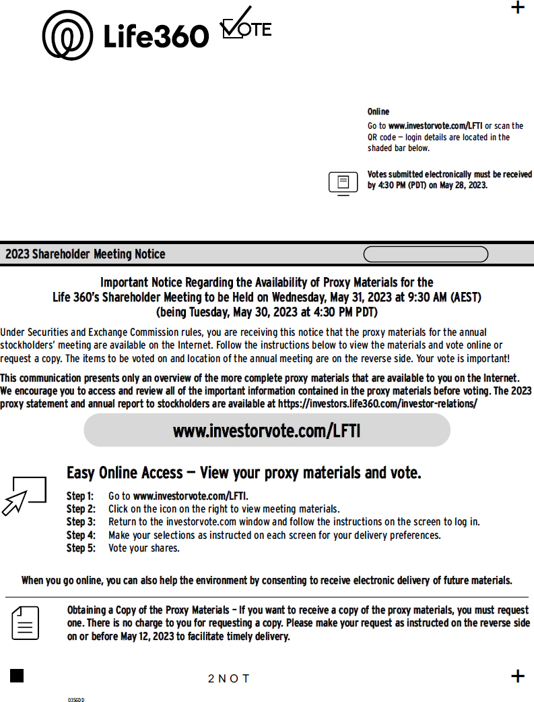
Online Go to www.investorvote.com/LFTI or scan the QR code  login details are located in the shaded bar below. Votes submitted electronically must be received by 4:30 PM (PDT) on May 28, 2023. 2023 Shareholder Meeting Notice Important Notice Regarding the Availability of Proxy Materials for the Life 360s Shareholder Meeting to be Held on Wednesday, May 31, 2023 at 9:30 AM (AEST) (being Tuesday, May 30, 2023 at 4:30 PM PDT) Under Securities and Exchange Commission rules, you are receiving this notice that the proxy materials for the annual stockholders meeting are available on the Internet. Follow the instructions below to view the materials and vote online or request a copy. The items to be voted on and location of the annual meeting are on the reverse side. Your vote is important! This communication presents only an overview of the more complete proxy materials that are available to you on the Internet. We encourage you to access and review all of the important information contained in the proxy materials before voting. The 2023 proxy statement and annual report to stockholders are available at https://investors.life360.com/investor-relations/ www.investorvote.com/LFTI Easy Online Access  View your proxy materials and vote. Step 1: Go to www.investorvote.com/LFTI. Step 2: Click on the icon on the right to view meeting materials. Step 3: Return to the investorvote.com window and follow the instructions on the screen to log in. Step 4: Make your selections as instructed on each screen for your delivery preferences. Step 5: Vote your shares. When you go online, you can also help the environment by consenting to receive electronic delivery of future materials. Obtaining a Copy of the Proxy Materials  If you want to receive a copy of the proxy materials, you must request one. There is no charge to you for requesting a copy. Please make your request as instructed on the reverse side on or before May 12, 2023 to facilitate timely delivery. 2NOT

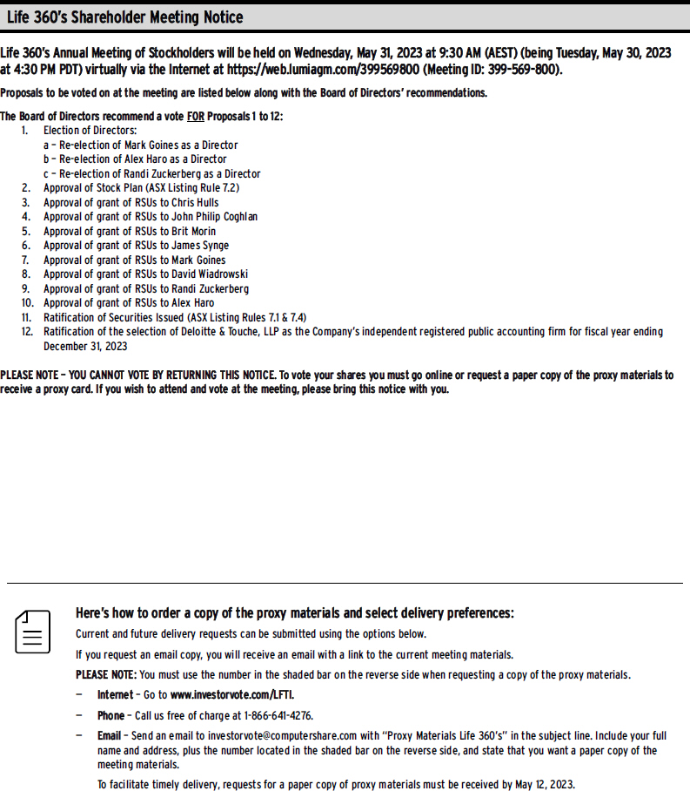
Life 360s Shareholder Meeting Notice Life 360s Annual Meeting of Stockholders will be held on Wednesday, May 31, 2023 at 9:30 AM (AEST) (being Tuesday, May 30, 2023 at 4:30 PM PDT) virtually via the Internet at https://web.lumiagm.com/399569800 (Meeting ID: 399-569-800). Proposals to be voted on at the meeting are listed below along with the Board of Directors recommendations. The Board of Directors recommend a vote FOR Proposals 1 to 12: 1. Election of Directors: a  Re-election of Mark Goines as a Director b  Re-election of Alex Haro as a Director c  Re-election of Randi Zuckerberg as a Director 2. Approval of Stock Plan (ASX Listing Rule 7.2) 3. Approval of grant of RSUs to Chris Hulls 4. Approval of grant of RSUs to John Philip Coghlan 5. Approval of grant of RSUs to Brit Morin 6. Approval of grant of RSUs to James Synge 7. Approval of grant of RSUs to Mark Goines 8. Approval of grant of RSUs to David Wiadrowski 9. Approval of grant of RSUs to Randi Zuckerberg 10. Approval of grant of RSUs to Alex Haro 11. Ratification of Securities Issued (ASX Listing Rules 7.1 & 7.4) 12. Ratification of the selection of Deloitte & Touche, LLP as the Companys independent registered public accounting firm for fiscal year ending December 31, 2023 PLEASE NOTE  YOU CANNOT VOTE BY RETURNING THIS NOTICE. To vote your shares you must go online or request a paper copy of the proxy materials to receive a proxy card. If you wish to attend and vote at the meeting, please bring this notice with you. Heres how to order a copy of the proxy materials and select delivery preferences: Current and future delivery requests can be submitted using the options below. If you request an email copy, you will receive an email with a link to the current meeting materials. PLEASE NOTE: You must use the number in the shaded bar on the reverse side when requesting a copy of the proxy materials.  Internet  Go to www.investorvote.com/LFTI.  Phone  Call us free of charge at 1-866-641-4276.  Email  Send an email to investorvote@computershare.com with Proxy Materials Life 360s in the subject line. Include your full name and address, plus the number located in the shaded bar on the reverse side, and state that you want a paper copy of the meeting materials. To facilitate timely delivery, requests for a paper copy of proxy materials must be received by May 12, 2023.

