SEC Form 4
FORM 4 |  | UNITED STATES SECURITIES AND EXCHANGE COMMISSION  Washington, D.C. 20549  STATEMENT OF CHANGES IN BENEFICIAL OWNERSHIP  Filed pursuant to Section 16(a) of the Securities Exchange Act of 1934  or Section 30(h) of the Investment Company Act of 1940
  OMB APPROVAL
  OMB Number: | 3235-0287
  Estimated average burden
  hours per response: | 0.5
 | Check this box if no longer subject to Section 16. Form 4 or Form 5 obligations may continue. See Instruction 1(b).
 | Check this box to indicate that a transaction was made pursuant to a contract, instruction or written plan for the purchase or sale of equity securities of the issuer that is intended to satisfy the affirmative defense conditions of Rule 10b5-1(c). See Instruction 10.
1. Name and Address of Reporting Person*  (Street) | 2. Issuer Name and Ticker or Trading Symbol  Life360, Inc. [ LIF ] | 5. Relationship of Reporting Person(s) to Issuer  (Check all applicable)
  Antonoff Lauren
  (Last) | (First) | (Middle)
  C/O LIFE360, INC.
  1900 SOUTH NORFOLK STREET, SUITE 310
  SAN MATEO | CA | 94403
  (City) | (State) | (Zip)
   | Director |  | 10% Owner
   | Officer (give title below) |  | Other (specify below)
  Chief Operating Officer
3. Date of Earliest Transaction (Month/Day/Year)
02/25/2025
 | 4. If Amendment, Date of Original Filed (Month/Day/Year) | 6. Individual or Joint/Group Filing (Check Applicable Line)
  Form filed by One Reporting Person
  Form filed by More than One Reporting Person
Table I - Non-Derivative Securities Acquired, Disposed of, or Beneficially Owned
1. Title of Security (Instr. 3) | 2. Transaction Date (Month/Day/Year) | 2A. Deemed Execution Date, if any (Month/Day/Year) | 3. Transaction Code (Instr. 8) |  | 4. Securities Acquired (A) or Disposed Of (D) (Instr. 3, 4 and 5) |  |  | 5. Amount of Securities Beneficially Owned Following Reported Transaction(s) (Instr. 3 and 4) | 6. Ownership Form: Direct (D) or Indirect (I) (Instr. 4) | 7. Nature of Indirect Beneficial Ownership (Instr. 4)
1. Title of Security (Instr. 3) | 2. Transaction Date (Month/Day/Year) | 2A. Deemed Execution Date, if any (Month/Day/Year) | Code | V | Amount | (A) or (D) | Price |  | 6. Ownership Form: Direct (D) or Indirect (I) (Instr. 4) | 7. Nature of Indirect Beneficial Ownership (Instr. 4)
Common Stock | 02/25/2025 |  | S(1) |  | 12,624 | D | $42.09(2) | 295,236(3) | D
Common Stock | 02/25/2025 |  | S(1) |  | 1,467 | D | $42.88(4) | 293,769(3) | D
Table II - Derivative Securities Acquired, Disposed of, or Beneficially Owned
(e.g., puts, calls, warrants, options, convertible securities)
1. Title of Derivative Security (Instr. 3) | 2. Conversion or Exercise Price of Derivative Security | 3. Transaction Date (Month/Day/Year) | 3A. Deemed Execution Date, if any (Month/Day/Year) | 4. Transaction Code (Instr. 8) |  | 5. Number of Derivative Securities Acquired (A) or Disposed of (D) (Instr. 3, 4 and 5) |  | 6. Date Exercisable and Expiration Date (Month/Day/Year) |  | 7. Title and Amount of Securities Underlying Derivative Security (Instr. 3 and 4) |  | 8. Price of Derivative Security (Instr. 5) | 9. Number of derivative Securities Beneficially Owned Following Reported Transaction(s) (Instr. 4) | 10. Ownership Form: Direct (D) or Indirect (I) (Instr. 4) | 11. Nature of Indirect Beneficial Ownership (Instr. 4)
 |  |  |  | Code | V | (A) | (D) | Date Exercisable | Expiration Date | Title | Amount or Number of Shares
Explanation of Responses:
1. The transaction reported on this Form 4 was effected pursuant to a Rule 10b5-1 trading plan adopted by the Reporting Person on November 27, 2024.
2. The price reported in Column 4 is the weighted average price. These shares were sold in multiple transactions at prices ranging from $41.675 to $42.46, inclusive, per share. The Reporting Person undertakes to provide to the Issuer, any securityholder of the Issuer or the Staff of the Securities and Exchange Commission, upon request, full details regarding the number of shares sold at each separate price within the range.
3. Includes 211,672 restricted stock units previously granted, each of which represents a contingent right to receive one share of the Issuer's common stock upon vesting.
4. The price reported in Column 4 is the weighted average price. These shares were sold in multiple transactions at prices ranging from $42.69 to $43.36, inclusive, per share. The Reporting Person undertakes to provide to the Issuer, any securityholder of the Issuer or the Staff of the Securities and Exchange Commission, upon request, full details regarding the number of shares sold at each separate price within the range.
Remarks:
 | /s/ Allison Chang | 02/27/2025
 | ** Signature of Reporting Person | Date
Reminder: Report on a separate line for each class of securities beneficially owned directly or indirectly.
* If the form is filed by more than one reporting person, see Instruction 4 (b)(v).
** Intentional misstatements or omissions of facts constitute Federal Criminal Violations See 18 U.S.C. 1001 and 15 U.S.C. 78ff(a).
Note: File three copies of this Form, one of which must be manually signed. If space is insufficient, see Instruction 6 for procedure.
Persons who respond to the collection of information contained in this form are not required to respond unless the form displays a currently valid OMB Number.
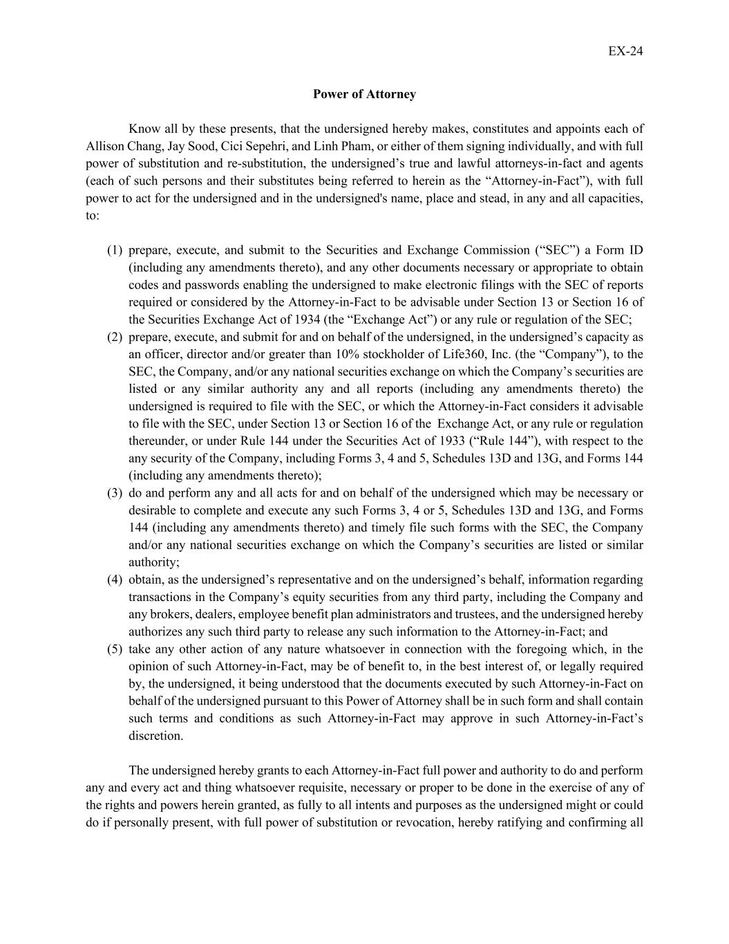
EX-24 Power of Attorney Know all by these presents, that the undersigned hereby makes, constitutes and appoints each of Allison Chang, Jay Sood, Cici Sepehri, and Linh Pham, or either of them signing individually, and with full power of substitution and re-substitution, the undersigned’s true and lawful attorneys-in-fact and agents (each of such persons and their substitutes being referred to herein as the “Attorney-in-Fact”), with full power to act for the undersigned and in the undersigned's name, place and stead, in any and all capacities, to: (1) prepare, execute, and submit to the Securities and Exchange Commission (“SEC”) a Form ID (including any amendments thereto), and any other documents necessary or appropriate to obtain codes and passwords enabling the undersigned to make electronic filings with the SEC of reports required or considered by the Attorney-in-Fact to be advisable under Section 13 or Section 16 of the Securities Exchange Act of 1934 (the “Exchange Act”) or any rule or regulation of the SEC; (2) prepare, execute, and submit for and on behalf of the undersigned, in the undersigned’s capacity as an officer, director and/or greater than 10% stockholder of Life360, Inc. (the “Company”), to the SEC, the Company, and/or any national securities exchange on which the Company’s securities are listed or any similar authority any and all reports (including any amendments thereto) the undersigned is required to file with the SEC, or which the Attorney-in-Fact considers it advisable to file with the SEC, under Section 13 or Section 16 of the Exchange Act, or any rule or regulation thereunder, or under Rule 144 under the Securities Act of 1933 (“Rule 144”), with respect to the any security of the Company, including Forms 3, 4 and 5, Schedules 13D and 13G, and Forms 144 (including any amendments thereto); (3) do and perform any and all acts for and on behalf of the undersigned which may be necessary or desirable to complete and execute any such Forms 3, 4 or 5, Schedules 13D and 13G, and Forms 144 (including any amendments thereto) and timely file such forms with the SEC, the Company and/or any national securities exchange on which the Company’s securities are listed or similar authority; (4) obtain, as the undersigned’s representative and on the undersigned’s behalf, information regarding transactions in the Company’s equity securities from any third party, including the Company and any brokers, dealers, employee benefit plan administrators and trustees, and the undersigned hereby authorizes any such third party to release any such information to the Attorney-in-Fact; and (5) take any other action of any nature whatsoever in connection with the foregoing which, in the opinion of such Attorney-in-Fact, may be of benefit to, in the best interest of, or legally required by, the undersigned, it being understood that the documents executed by such Attorney-in-Fact on behalf of the undersigned pursuant to this Power of Attorney shall be in such form and shall contain such terms and conditions as such Attorney-in-Fact may approve in such Attorney-in-Fact’s discretion. The undersigned hereby grants to each Attorney-in-Fact full power and authority to do and perform any and every act and thing whatsoever requisite, necessary or proper to be done in the exercise of any of the rights and powers herein granted, as fully to all intents and purposes as the undersigned might or could do if personally present, with full power of substitution or revocation, hereby ratifying and confirming all

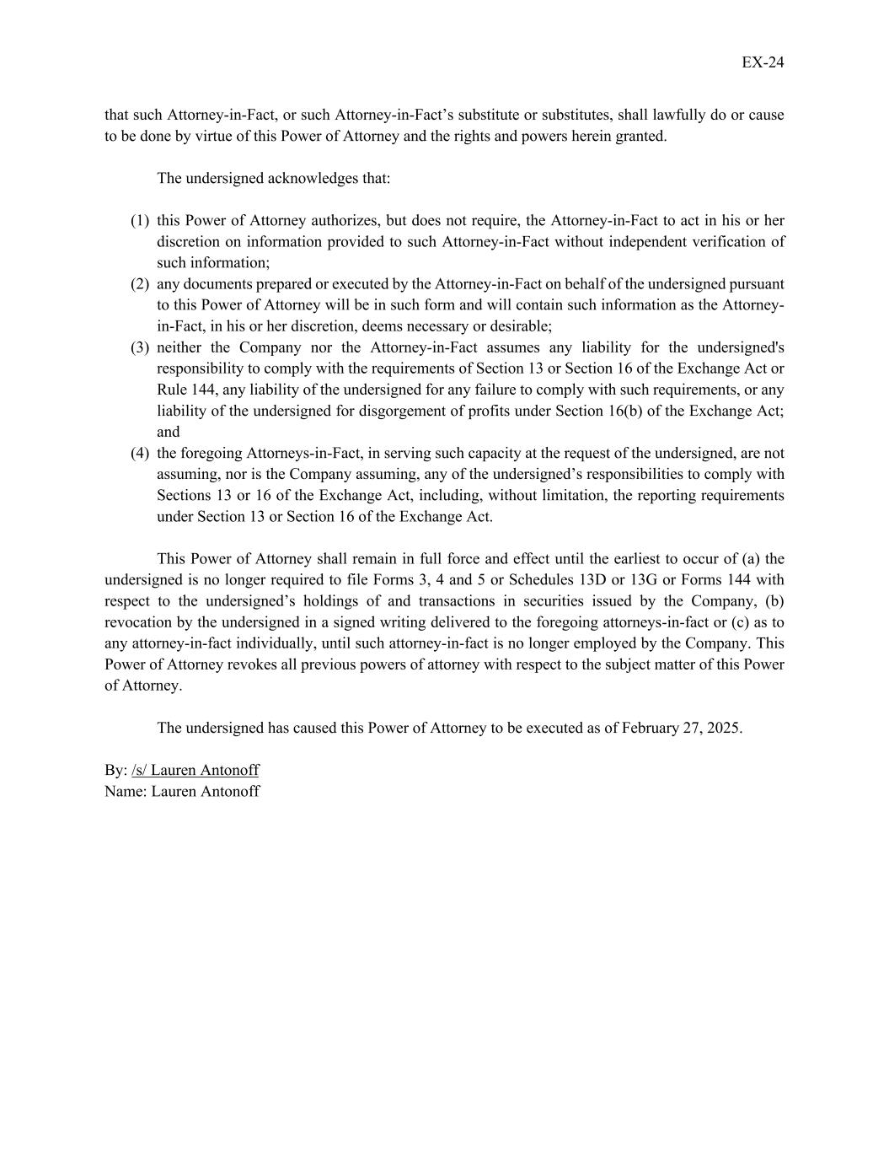
EX-24 that such Attorney-in-Fact, or such Attorney-in-Fact’s substitute or substitutes, shall lawfully do or cause to be done by virtue of this Power of Attorney and the rights and powers herein granted. The undersigned acknowledges that: (1) this Power of Attorney authorizes, but does not require, the Attorney-in-Fact to act in his or her discretion on information provided to such Attorney-in-Fact without independent verification of such information; (2) any documents prepared or executed by the Attorney-in-Fact on behalf of the undersigned pursuant to this Power of Attorney will be in such form and will contain such information as the Attorney- in-Fact, in his or her discretion, deems necessary or desirable; (3) neither the Company nor the Attorney-in-Fact assumes any liability for the undersigned's responsibility to comply with the requirements of Section 13 or Section 16 of the Exchange Act or Rule 144, any liability of the undersigned for any failure to comply with such requirements, or any liability of the undersigned for disgorgement of profits under Section 16(b) of the Exchange Act; and (4) the foregoing Attorneys-in-Fact, in serving such capacity at the request of the undersigned, are not assuming, nor is the Company assuming, any of the undersigned’s responsibilities to comply with Sections 13 or 16 of the Exchange Act, including, without limitation, the reporting requirements under Section 13 or Section 16 of the Exchange Act. This Power of Attorney shall remain in full force and effect until the earliest to occur of (a) the undersigned is no longer required to file Forms 3, 4 and 5 or Schedules 13D or 13G or Forms 144 with respect to the undersigned’s holdings of and transactions in securities issued by the Company, (b) revocation by the undersigned in a signed writing delivered to the foregoing attorneys-in-fact or (c) as to any attorney-in-fact individually, until such attorney-in-fact is no longer employed by the Company. This Power of Attorney revokes all previous powers of attorney with respect to the subject matter of this Power of Attorney. The undersigned has caused this Power of Attorney to be executed as of February 27, 2025. By: /s/ Lauren Antonoff Name: Lauren Antonoff

