UNITED STATES
SECURITIES AND EXCHANGE COMMISSION
Washington, D.C. 20549
______________

FORM 8-K

CURRENT REPORT
Pursuant to Section 13 or 15(d) of the
Securities Exchange Act of 1934

Date of Report (Date of earliest event reported): May 12, 2023

Life360, Inc.
(Exact name of registrant as specified in its charter)
Delaware |  |  | 000-56424 |  |  | 26-0197666
(State or other jurisdiction of  incorporation or organization) |  |  | (Commission File Number) |  |  | (I.R.S. Employer  Identification No.)

1900 South Norfolk Street, Suite 310
San Mateo, CA 94403
(Address of principal executive offices, including zip code)
(415) 484-5244
(Registrant’s telephone number, including area code)
Not applicable.
(Former name or former address, if changed since last report)
______________

Check the appropriate box below if the Form 8-K filing is intended to simultaneously satisfy the filing obligation of the registrant under any of the following provisions:
☐ |  |  | Written communications pursuant to Rule 425 under the Securities Act (17 CFR 230.425)
☐ |  |  | Soliciting material pursuant to Rule 14a-12 under the Exchange Act (17 CFR 240.14a-12)
☐ |  |  | Pre-commencement communications pursuant to Rule 14d-2(b) under the Exchange Act (17 CFR 240.14d-2(b))
☐ |  |  | Pre-commencement communications pursuant to Rule 13e-4(c) under the Exchange Act (17 CFR 240.13e-4(c))

Title of each class |  |  | Trading Symbol(s) |  |  | Name of each exchange on which registered
None. |  |  | None. |  |  | None.

Indicate by check mark whether the registrant is an emerging growth company as defined in Rule 405 of the Securities Act of 1933 (§230.405 of this chapter) or Rule 12b-2 of the Securities Exchange Act of 1934 (§240.12b-2 of this chapter).

Emerging growth company ☒
If an emerging growth company, indicate by check mark if the registrant has elected not to use the extended transition period for complying with any new or revised financial accounting standards provided pursuant to Section 13(a) of the Exchange Act. ☐

Item 2.02 Results of Operations and Financial Condition.
We are furnishing this Current Report on Form 8-K in connection with the disclosure of information, in the form of textual information from a media release issued on May 15, 2023. A copy of the media release is furnished as Exhibit 99.1 to this Current Report on Form 8-K.
The information in this Item 2.02 of this Current Report on Form 8-K (including Exhibit 99.1) is furnished pursuant to Item 2.02 and shall not be deemed to be “filed” for purpose of Section 18 of the Securities Exchange Act of 1934, as amended (the “Exchange Act”), or otherwise subject to the liabilities of that section, nor shall it be deemed incorporated by reference into any filing under the Securities Act of 1933, as amended (the “Securities Act”), or the Exchange Act, except as shall be expressly set forth by specific reference in such a filing. The media release included within Item 2.02 of this Current Report on Form 8-K is available on our website located at www.life360.com, although we reserve the right to discontinue that availability at any time.

Item 5.02 Departure of Directors or Certain Officers; Election of Directors; Appointment of Certain Officers; Compensatory Arrangements of Certain Officers.
Appointment of Lauren Antonoff
On May 15, 2023, Life 360, Inc. (the “Company”) announced the appointment of Lauren Antonoff as its Chief Operating Officer, effective May 2, 2023.
Since January 2022, Ms. Antonoff has been a Limited Partner at Operator Collective. Prior to joining Operator Collective, Ms. Antonoff, 52, served as President, Independents at GoDaddy Inc. (“GoDaddy”) an internet domain registrar and web hosting company, from November 2019 to January 2022. Previously, she served as Senior Vice President & General Manager, Presence and Commerce at GoDaddy from March 2015 to November 2019. Prior to GoDaddy, Ms. Antonoff spent over 18 years at Microsoft Corporation, a computer software company, serving in various program manager roles culminating as Director, Program Management for SharePoint. Ms. Antonoff has also served on the Board of Directors of Momentive Global Inc. since August 2022. Ms. Antonoff received a Bachelor of Arts in Rhetoric and Political Science from the University of California, Berkeley.
On May 2, 2023, Ms. Antonoff entered into an Employment Agreement with the Company (the “Employment Agreement”). In connection with Ms. Antonoff’s appointment as Chief Operating Officer, she will receive an annual base salary of $450,000 with an annual performance bonus target of 50% of her annual base salary. Additionally, she will receive a one-time signing bonus of $80,000.
Subject to the approval of the Compensation Committee (the “Committee”) of the Board of Directors of the Company, Ms. Antonoff will also be granted restricted stock unit (“RSU”) awards in the aggregate amount of $4 million. The RSUs will vest over three years, with one third of the RSUs vesting on the one-year anniversary of the vesting commencement date, and the remaining RSUs vesting in equal monthly installments thereafter. Upon the approval of the Committee, Ms. Antonoff is also entitled to an initial refresh RSU award in the aggregate of $2 million, at the earliest of (i) the grant date of equity refresh awards to other senior executives, or (ii) May 2, 2024, as well as a second refresh RSU grant award in the aggregate of $2 million, at the earliest of (i) the grant date of equity refresh awards to other senior executives for the fiscal year starting January 1, 2025, or (ii) May 2, 2025. The vesting of Ms. Antonoff’s RSUs is contingent upon her continuous employment at the Company through each such vesting date.
Ms. Antonoff will enter into an indemnification agreement with the Company consistent with the form of the existing indemnification agreement entered into between the Company and its executive officers.
There are no arrangements or understandings between Ms. Antonoff and any other persons pursuant to which Ms. Antonoff was appointed as Chief Operating Officer of the Company. There are also no family relationships between Ms. Antonoff and any director or executive officer of the Company, and she has no direct or indirect interest in any transaction or proposed transaction required to be disclosed pursuant to Item 404(a) of Regulation S-K.
Effective Date of Departure of CJ Prober
As previously disclosed, Charles (CJ) Prober will step down from his current positions as President of the Company and as Chief Executive Officer of the Company’s subsidiary, Tile, Inc. following Ms. Antonoff’s appointment as Chief Operating Officer. On May 12, 2023, the Company and Mr. Prober agreed to amend Mr. Prober’s separation agreement to change his date of departure to July 7, 2023. A summary of Mr. Prober’s separation agreement was previously disclosed in the Company’s Current Form on Form 8-K, filed with the Securities and Exchange Commission (“SEC”) on January 19, 2023. Such description does not purport to be complete and is qualified in its entirety by reference to the separation agreement, which will be filed with the SEC as an exhibit to the Company’s Quarterly Report on Form 10-Q for the quarter ended March 31, 2023.

Item 9.01 Financial Statements and Exhibits.
(d) Exhibits

Exhibit No. |  |  | Description
99.1 |  |  | Media release of the Registrant dated May 15, 2023
104 |  |  | Cover Page Interactive Data File - the cover page XBRL tags are embedded within the Inline XBRL document

SIGNATURES
Pursuant to the requirements of the Securities Exchange Act of 1934, the registrant has duly caused this report to be signed on its behalf by the undersigned hereunto duly authorized.
 |  |  |  |  |  | LIFE360, INC.
Dated: |  |  | May 15, 2023 |  |  | By: |  |  | /s/ Russell Burke
 |  |  |  |  |  |  |  |  | Russell Burke
 |  |  |  |  |  |  |  |  | Chief Financial Officer

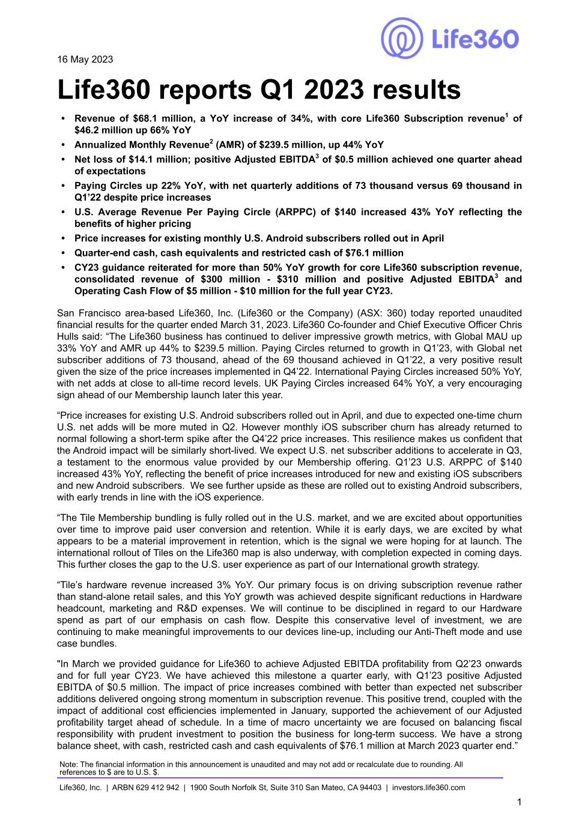

16 May 2023 Life360 reports Q1 2023 results • Revenue of $68.1 million, a YoY increase of 34%, with core Life360 Subscription revenue1 of $46.2 million up 66% YoY • Annualized Monthly Revenue2 (AMR) of $239.5 million, up 44% YoY • Net loss of $14.1 million; positive Adjusted EBITDA3 of $0.5 million achieved one quarter ahead of expectations • Paying Circles up 22% YoY, with net quarterly additions of 73 thousand versus 69 thousand in Q1’22 despite price increases • U.S. Average Revenue Per Paying Circle (ARPPC) of $140 increased 43% YoY reflecting the benefits of higher pricing • Price increases for existing monthly U.S. Android subscribers rolled out in April • Quarter-end cash, cash equivalents and restricted cash of $76.1 million • CY23 guidance reiterated for more than 50% YoY growth for core Life360 subscription revenue, consolidated revenue of $300 million - $310 million and positive Adjusted EBITDA3 and Operating Cash Flow of $5 million - $10 million for the full year CY23. San Francisco area-based Life360, Inc. (Life360 or the Company) (ASX: 360) today reported unaudited financial results for the quarter ended March 31, 2023. Life360 Co-founder and Chief Executive Officer Chris Hulls said: “The Life360 business has continued to deliver impressive growth metrics, with Global MAU up 33% YoY and AMR up 44% to $239.5 million. Paying Circles returned to growth in Q1’23, with Global net subscriber additions of 73 thousand, ahead of the 69 thousand achieved in Q1’22, a very positive result given the size of the price increases implemented in Q4’22. International Paying Circles increased 50% YoY, with net adds at close to all-time record levels. UK Paying Circles increased 64% YoY, a very encouraging sign ahead of our Membership launch later this year. “Price increases for existing U.S. Android subscribers rolled out in April, and due to expected one-time churn U.S. net adds will be more muted in Q2. However monthly iOS subscriber churn has already returned to normal following a short-term spike after the Q4’22 price increases. This resilience makes us confident that the Android impact will be similarly short-lived. We expect U.S. net subscriber additions to accelerate in Q3, a testament to the enormous value provided by our Membership offering. Q1’23 U.S. ARPPC of $140 increased 43% YoY, reflecting the benefit of price increases introduced for new and existing iOS subscribers and new Android subscribers. We see further upside as these are rolled out to existing Android subscribers, with early trends in line with the iOS experience. “The Tile Membership bundling is fully rolled out in the U.S. market, and we are excited about opportunities over time to improve paid user conversion and retention. While it is early days, we are excited by what appears to be a material improvement in retention, which is the signal we were hoping for at launch. The international rollout of Tiles on the Life360 map is also underway, with completion expected in coming days. This further closes the gap to the U.S. user experience as part of our International growth strategy. “Tile’s hardware revenue increased 3% YoY. Our primary focus is on driving subscription revenue rather than stand-alone retail sales, and this YoY growth was achieved despite significant reductions in Hardware headcount, marketing and R&D expenses. We will continue to be disciplined in regard to our Hardware spend as part of our emphasis on cash flow. Despite this conservative level of investment, we are continuing to make meaningful improvements to our devices line-up, including our Anti-Theft mode and use case bundles. "In March we provided guidance for Life360 to achieve Adjusted EBITDA profitability from Q2’23 onwards and for full year CY23. We have achieved this milestone a quarter early, with Q1’23 positive Adjusted EBITDA of $0.5 million. The impact of price increases combined with better than expected net subscriber additions delivered ongoing strong momentum in subscription revenue. This positive trend, coupled with the impact of additional cost efficiencies implemented in January, supported the achievement of our Adjusted profitability target ahead of schedule. In a time of macro uncertainty we are focused on balancing fiscal responsibility with prudent investment to position the business for long-term success. We have a strong balance sheet, with cash, restricted cash and cash equivalents of $76.1 million at March 2023 quarter end.” Note: The financial information in this announcement is unaudited and may not add or recalculate due to rounding. All references to $ are to U.S. $. Life360, Inc. | ARBN 629 412 942 | 1900 South Norfolk St, Suite 310 San Mateo, CA 94403 | investors.life360.com 1

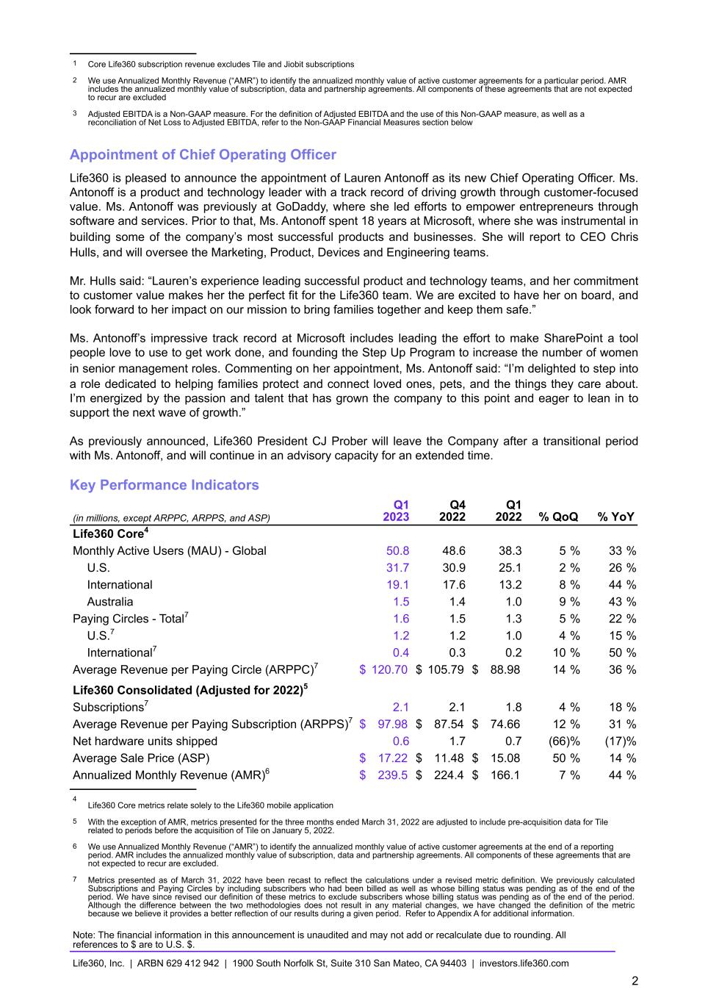
1 Core Life360 subscription revenue excludes Tile and Jiobit subscriptions 2 We use Annualized Monthly Revenue (“AMR”) to identify the annualized monthly value of active customer agreements for a particular period. AMR includes the annualized monthly value of subscription, data and partnership agreements. All components of these agreements that are not expected to recur are excluded 3 Adjusted EBITDA is a Non-GAAP measure. For the definition of Adjusted EBITDA and the use of this Non-GAAP measure, as well as a reconciliation of Net Loss to Adjusted EBITDA, refer to the Non-GAAP Financial Measures section below Appointment of Chief Operating Officer Life360 is pleased to announce the appointment of Lauren Antonoff as its new Chief Operating Officer. Ms. Antonoff is a product and technology leader with a track record of driving growth through customer-focused value. Ms. Antonoff was previously at GoDaddy, where she led efforts to empower entrepreneurs through software and services. Prior to that, Ms. Antonoff spent 18 years at Microsoft, where she was instrumental in building some of the company’s most successful products and businesses. She will report to CEO Chris Hulls, and will oversee the Marketing, Product, Devices and Engineering teams. Mr. Hulls said: “Lauren’s experience leading successful product and technology teams, and her commitment to customer value makes her the perfect fit for the Life360 team. We are excited to have her on board, and look forward to her impact on our mission to bring families together and keep them safe.” Ms. Antonoff’s impressive track record at Microsoft includes leading the effort to make SharePoint a tool people love to use to get work done, and founding the Step Up Program to increase the number of women in senior management roles. Commenting on her appointment, Ms. Antonoff said: “I’m delighted to step into a role dedicated to helping families protect and connect loved ones, pets, and the things they care about. I’m energized by the passion and talent that has grown the company to this point and eager to lean in to support the next wave of growth.” As previously announced, Life360 President CJ Prober will leave the Company after a transitional period with Ms. Antonoff, and will continue in an advisory capacity for an extended time. Key Performance Indicators (in millions, except ARPPC, ARPPS, and ASP) Q1 2023 Q4 2022 Q1 2022 % QoQ % YoY Life360 Core4 Monthly Active Users (MAU) - Global 50.8 48.6 38.3 5 % 33 % U.S. 31.7 30.9 25.1 2 % 26 % International 19.1 17.6 13.2 8 % 44 % Australia 1.5 1.4 1.0 9 % 43 % Paying Circles - Total7 1.6 1.5 1.3 5 % 22 % U.S.7 1.2 1.2 1.0 4 % 15 % International7 0.4 0.3 0.2 10 % 50 % Average Revenue per Paying Circle (ARPPC)7 $ 120.70 $ 105.79 $ 88.98 14 % 36 % Life360 Consolidated (Adjusted for 2022)5 Subscriptions7 2.1 2.1 1.8 4 % 18 % Average Revenue per Paying Subscription (ARPPS)7 $ 97.98 $ 87.54 $ 74.66 12 % 31 % Net hardware units shipped 0.6 1.7 0.7 (66) % (17) % Average Sale Price (ASP) $ 17.22 $ 11.48 $ 15.08 50 % 14 % Annualized Monthly Revenue (AMR)6 $ 239.5 $ 224.4 $ 166.1 7 % 44 % 4 Life360 Core metrics relate solely to the Life360 mobile application 5 With the exception of AMR, metrics presented for the three months ended March 31, 2022 are adjusted to include pre-acquisition data for Tile related to periods before the acquisition of Tile on January 5, 2022. 6 We use Annualized Monthly Revenue (“AMR”) to identify the annualized monthly value of active customer agreements at the end of a reporting period. AMR includes the annualized monthly value of subscription, data and partnership agreements. All components of these agreements that are not expected to recur are excluded. 7 Metrics presented as of March 31, 2022 have been recast to reflect the calculations under a revised metric definition. We previously calculated Subscriptions and Paying Circles by including subscribers who had been billed as well as whose billing status was pending as of the end of the period. We have since revised our definition of these metrics to exclude subscribers whose billing status was pending as of the end of the period. Although the difference between the two methodologies does not result in any material changes, we have changed the definition of the metric because we believe it provides a better reflection of our results during a given period. Refer to Appendix A for additional information. Note: The financial information in this announcement is unaudited and may not add or recalculate due to rounding. All references to $ are to U.S. $. Life360, Inc. | ARBN 629 412 942 | 1900 South Norfolk St, Suite 310 San Mateo, CA 94403 | investors.life360.com 2

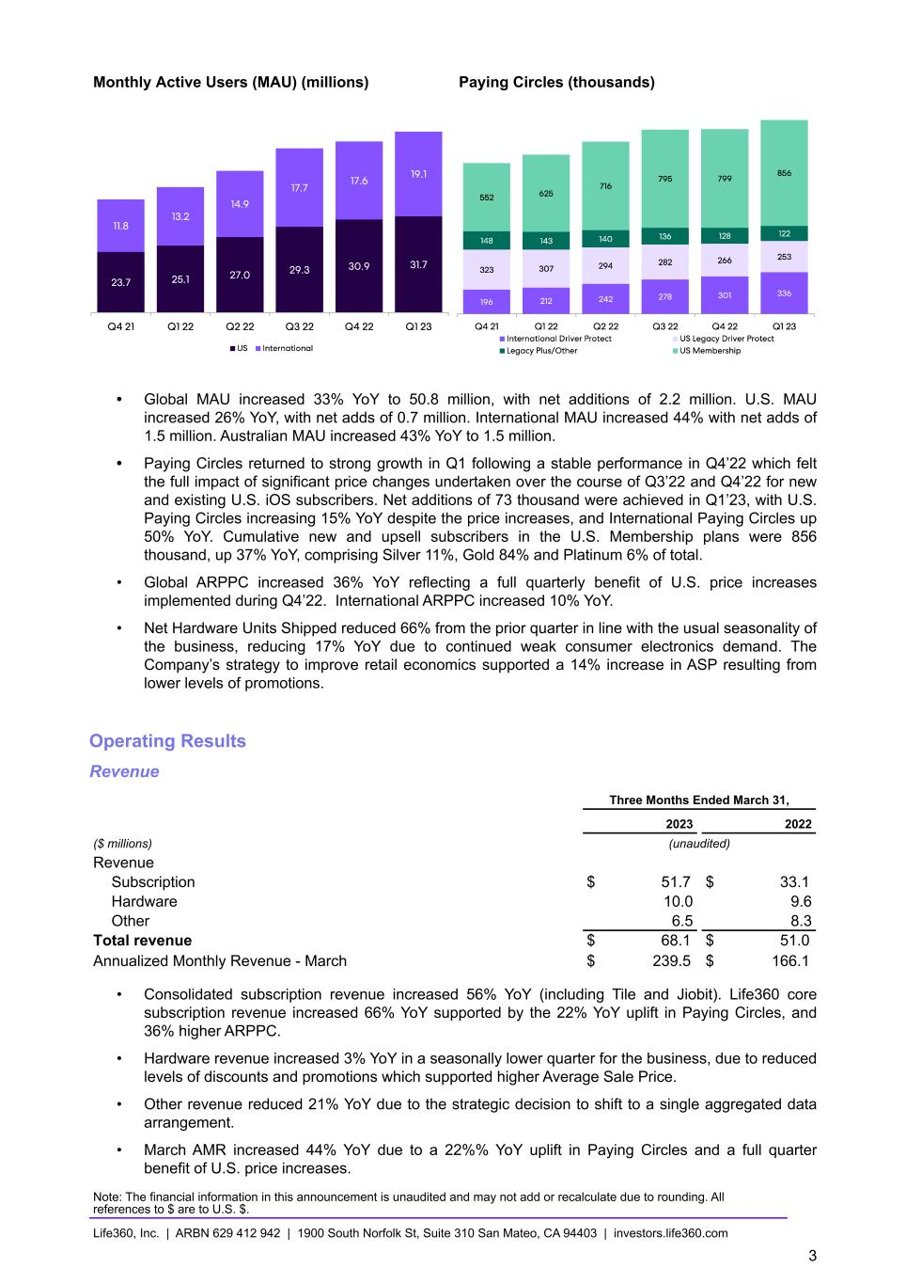
Monthly Active Users (MAU) (millions) Paying Circles (thousands) • Global MAU increased 33% YoY to 50.8 million, with net additions of 2.2 million. U.S. MAU increased 26% YoY, with net adds of 0.7 million. International MAU increased 44% with net adds of 1.5 million. Australian MAU increased 43% YoY to 1.5 million. • Paying Circles returned to strong growth in Q1 following a stable performance in Q4’22 which felt the full impact of significant price changes undertaken over the course of Q3’22 and Q4’22 for new and existing U.S. iOS subscribers. Net additions of 73 thousand were achieved in Q1’23, with U.S. Paying Circles increasing 15% YoY despite the price increases, and International Paying Circles up 50% YoY. Cumulative new and upsell subscribers in the U.S. Membership plans were 856 thousand, up 37% YoY, comprising Silver 11%, Gold 84% and Platinum 6% of total. • Global ARPPC increased 36% YoY reflecting a full quarterly benefit of U.S. price increases implemented during Q4’22. International ARPPC increased 10% YoY. • Net Hardware Units Shipped reduced 66% from the prior quarter in line with the usual seasonality of the business, reducing 17% YoY due to continued weak consumer electronics demand. The Company’s strategy to improve retail economics supported a 14% increase in ASP resulting from lower levels of promotions. Operating Results Revenue Three Months Ended March 31, 2023 2022 ($ millions) (unaudited) Revenue Subscription $ 51.7 $ 33.1 Hardware 10.0 9.6 Other 6.5 8.3 Total revenue $ 68.1 $ 51.0 Annualized Monthly Revenue - March $ 239.5 $ 166.1 • Consolidated subscription revenue increased 56% YoY (including Tile and Jiobit). Life360 core subscription revenue increased 66% YoY supported by the 22% YoY uplift in Paying Circles, and 36% higher ARPPC. • Hardware revenue increased 3% YoY in a seasonally lower quarter for the business, due to reduced levels of discounts and promotions which supported higher Average Sale Price. • Other revenue reduced 21% YoY due to the strategic decision to shift to a single aggregated data arrangement. • March AMR increased 44% YoY due to a 22%% YoY uplift in Paying Circles and a full quarter benefit of U.S. price increases. Note: The financial information in this announcement is unaudited and may not add or recalculate due to rounding. All references to $ are to U.S. $. Life360, Inc. | ARBN 629 412 942 | 1900 South Norfolk St, Suite 310 San Mateo, CA 94403 | investors.life360.com 3

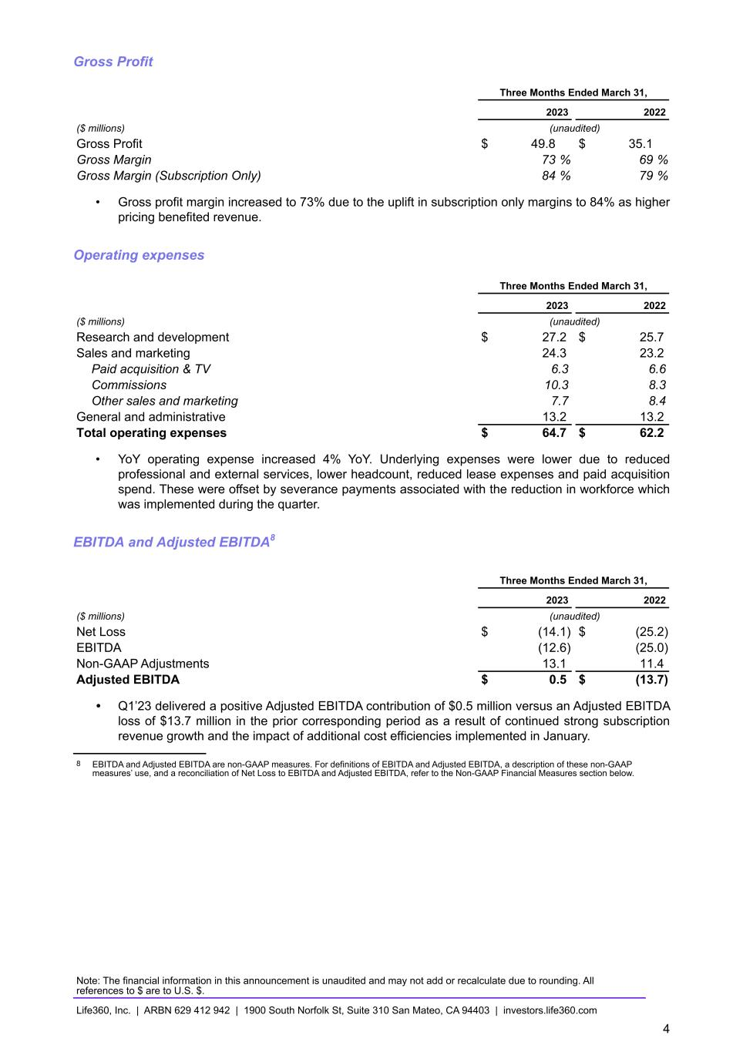
Gross Profit Three Months Ended March 31, 2023 2022 ($ millions) (unaudited) Gross Profit $ 49.8 $ 35.1 Gross Margin 73 % 69 % Gross Margin (Subscription Only) 84 % 79 % • Gross profit margin increased to 73% due to the uplift in subscription only margins to 84% as higher pricing benefited revenue. Operating expenses Three Months Ended March 31, 2023 2022 ($ millions) (unaudited) Research and development $ 27.2 $ 25.7 Sales and marketing 24.3 23.2 Paid acquisition & TV 6.3 6.6 Commissions 10.3 8.3 Other sales and marketing 7.7 8.4 General and administrative 13.2 13.2 Total operating expenses $ 64.7 $ 62.2 • YoY operating expense increased 4% YoY. Underlying expenses were lower due to reduced professional and external services, lower headcount, reduced lease expenses and paid acquisition spend. These were offset by severance payments associated with the reduction in workforce which was implemented during the quarter. EBITDA and Adjusted EBITDA8 Three Months Ended March 31, 2023 2022 ($ millions) (unaudited) Net Loss $ (14.1) $ (25.2) EBITDA (12.6) (25.0) Non-GAAP Adjustments 13.1 11.4 Adjusted EBITDA $ 0.5 $ (13.7) • Q1’23 delivered a positive Adjusted EBITDA contribution of $0.5 million versus an Adjusted EBITDA loss of $13.7 million in the prior corresponding period as a result of continued strong subscription revenue growth and the impact of additional cost efficiencies implemented in January. 8 EBITDA and Adjusted EBITDA are non-GAAP measures. For definitions of EBITDA and Adjusted EBITDA, a description of these non-GAAP measures’ use, and a reconciliation of Net Loss to EBITDA and Adjusted EBITDA, refer to the Non-GAAP Financial Measures section below. Note: The financial information in this announcement is unaudited and may not add or recalculate due to rounding. All references to $ are to U.S. $. Life360, Inc. | ARBN 629 412 942 | 1900 South Norfolk St, Suite 310 San Mateo, CA 94403 | investors.life360.com 4

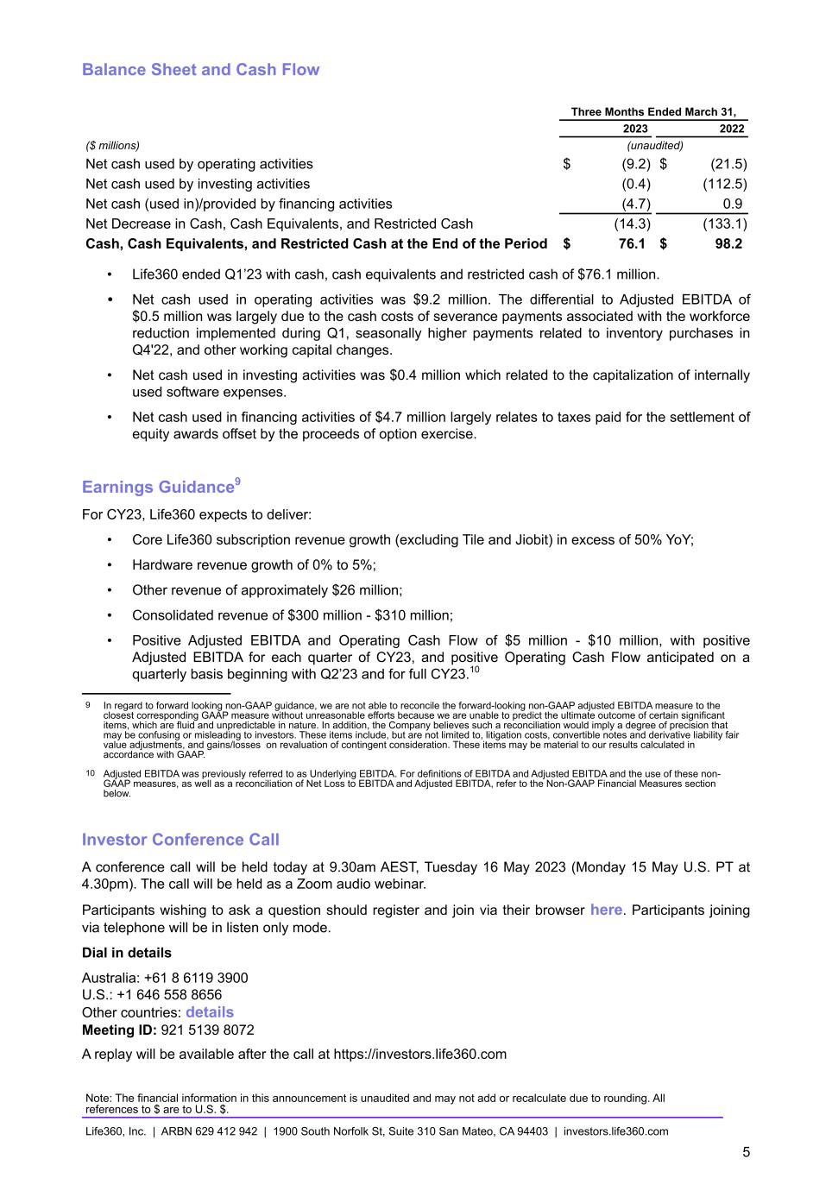
Balance Sheet and Cash Flow Three Months Ended March 31, 2023 2022 ($ millions) (unaudited) Net cash used by operating activities $ (9.2) $ (21.5) Net cash used by investing activities (0.4) (112.5) Net cash (used in)/provided by financing activities (4.7) 0.9 Net Decrease in Cash, Cash Equivalents, and Restricted Cash (14.3) (133.1) Cash, Cash Equivalents, and Restricted Cash at the End of the Period $ 76.1 $ 98.2 • Life360 ended Q1’23 with cash, cash equivalents and restricted cash of $76.1 million. • Net cash used in operating activities was $9.2 million. The differential to Adjusted EBITDA of $0.5 million was largely due to the cash costs of severance payments associated with the workforce reduction implemented during Q1, seasonally higher payments related to inventory purchases in Q4'22, and other working capital changes. • Net cash used in investing activities was $0.4 million which related to the capitalization of internally used software expenses. • Net cash used in financing activities of $4.7 million largely relates to taxes paid for the settlement of equity awards offset by the proceeds of option exercise. Earnings Guidance9 For CY23, Life360 expects to deliver: • Core Life360 subscription revenue growth (excluding Tile and Jiobit) in excess of 50% YoY; • Hardware revenue growth of 0% to 5%; • Other revenue of approximately $26 million; • Consolidated revenue of $300 million - $310 million; • Positive Adjusted EBITDA and Operating Cash Flow of $5 million - $10 million, with positive Adjusted EBITDA for each quarter of CY23, and positive Operating Cash Flow anticipated on a quarterly basis beginning with Q2’23 and for full CY23.10 9 In regard to forward looking non-GAAP guidance, we are not able to reconcile the forward-looking non-GAAP adjusted EBITDA measure to the closest corresponding GAAP measure without unreasonable efforts because we are unable to predict the ultimate outcome of certain significant items, which are fluid and unpredictable in nature. In addition, the Company believes such a reconciliation would imply a degree of precision that may be confusing or misleading to investors. These items include, but are not limited to, litigation costs, convertible notes and derivative liability fair value adjustments, and gains/losses on revaluation of contingent consideration. These items may be material to our results calculated in accordance with GAAP. 10 Adjusted EBITDA was previously referred to as Underlying EBITDA. For definitions of EBITDA and Adjusted EBITDA and the use of these non- GAAP measures, as well as a reconciliation of Net Loss to EBITDA and Adjusted EBITDA, refer to the Non-GAAP Financial Measures section below. Investor Conference Call A conference call will be held today at 9.30am AEST, Tuesday 16 May 2023 (Monday 15 May U.S. PT at 4.30pm). The call will be held as a Zoom audio webinar. Participants wishing to ask a question should register and join via their browser here. Participants joining via telephone will be in listen only mode. Dial in details Australia: +61 8 6119 3900 U.S.: +1 646 558 8656 Other countries: details Meeting ID: 921 5139 8072 A replay will be available after the call at https://investors.life360.com Note: The financial information in this announcement is unaudited and may not add or recalculate due to rounding. All references to $ are to U.S. $. Life360, Inc. | ARBN 629 412 942 | 1900 South Norfolk St, Suite 310 San Mateo, CA 94403 | investors.life360.com 5

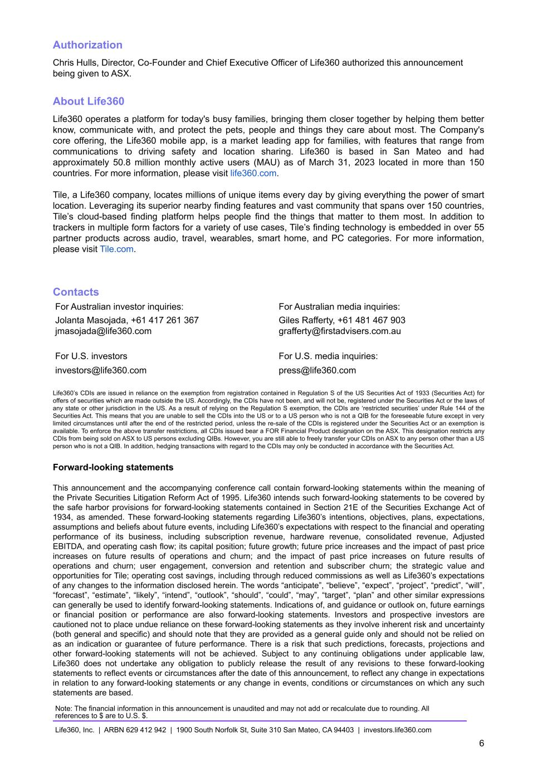
Authorization Chris Hulls, Director, Co-Founder and Chief Executive Officer of Life360 authorized this announcement being given to ASX. About Life360 Life360 operates a platform for today's busy families, bringing them closer together by helping them better know, communicate with, and protect the pets, people and things they care about most. The Company's core offering, the Life360 mobile app, is a market leading app for families, with features that range from communications to driving safety and location sharing. Life360 is based in San Mateo and had approximately 50.8 million monthly active users (MAU) as of March 31, 2023 located in more than 150 countries. For more information, please visit life360.com. Tile, a Life360 company, locates millions of unique items every day by giving everything the power of smart location. Leveraging its superior nearby finding features and vast community that spans over 150 countries, Tile’s cloud-based finding platform helps people find the things that matter to them most. In addition to trackers in multiple form factors for a variety of use cases, Tile’s finding technology is embedded in over 55 partner products across audio, travel, wearables, smart home, and PC categories. For more information, please visit Tile.com. Contacts For Australian investor inquiries: For Australian media inquiries: Jolanta Masojada, +61 417 261 367 Giles Rafferty, +61 481 467 903 jmasojada@life360.com grafferty@firstadvisers.com.au For U.S. investors For U.S. media inquiries: investors@life360.com press@life360.com Life360’s CDIs are issued in reliance on the exemption from registration contained in Regulation S of the US Securities Act of 1933 (Securities Act) for offers of securities which are made outside the US. Accordingly, the CDIs have not been, and will not be, registered under the Securities Act or the laws of any state or other jurisdiction in the US. As a result of relying on the Regulation S exemption, the CDIs are ‘restricted securities’ under Rule 144 of the Securities Act. This means that you are unable to sell the CDIs into the US or to a US person who is not a QIB for the foreseeable future except in very limited circumstances until after the end of the restricted period, unless the re-sale of the CDIs is registered under the Securities Act or an exemption is available. To enforce the above transfer restrictions, all CDIs issued bear a FOR Financial Product designation on the ASX. This designation restricts any CDIs from being sold on ASX to US persons excluding QIBs. However, you are still able to freely transfer your CDIs on ASX to any person other than a US person who is not a QIB. In addition, hedging transactions with regard to the CDIs may only be conducted in accordance with the Securities Act. Forward-looking statements This announcement and the accompanying conference call contain forward-looking statements within the meaning of the Private Securities Litigation Reform Act of 1995. Life360 intends such forward-looking statements to be covered by the safe harbor provisions for forward-looking statements contained in Section 21E of the Securities Exchange Act of 1934, as amended. These forward-looking statements regarding Life360’s intentions, objectives, plans, expectations, assumptions and beliefs about future events, including Life360’s expectations with respect to the financial and operating performance of its business, including subscription revenue, hardware revenue, consolidated revenue, Adjusted EBITDA, and operating cash flow; its capital position; future growth; future price increases and the impact of past price increases on future results of operations and churn; and the impact of past price increases on future results of operations and churn; user engagement, conversion and retention and subscriber churn; the strategic value and opportunities for Tile; operating cost savings, including through reduced commissions as well as Life360’s expectations of any changes to the information disclosed herein. The words “anticipate”, “believe”, “expect”, “project”, “predict”, “will”, “forecast”, “estimate”, “likely”, “intend”, “outlook”, “should”, “could”, “may”, “target”, “plan” and other similar expressions can generally be used to identify forward-looking statements. Indications of, and guidance or outlook on, future earnings or financial position or performance are also forward-looking statements. Investors and prospective investors are cautioned not to place undue reliance on these forward-looking statements as they involve inherent risk and uncertainty (both general and specific) and should note that they are provided as a general guide only and should not be relied on as an indication or guarantee of future performance. There is a risk that such predictions, forecasts, projections and other forward-looking statements will not be achieved. Subject to any continuing obligations under applicable law, Life360 does not undertake any obligation to publicly release the result of any revisions to these forward-looking statements to reflect events or circumstances after the date of this announcement, to reflect any change in expectations in relation to any forward-looking statements or any change in events, conditions or circumstances on which any such statements are based. Note: The financial information in this announcement is unaudited and may not add or recalculate due to rounding. All references to $ are to U.S. $. Life360, Inc. | ARBN 629 412 942 | 1900 South Norfolk St, Suite 310 San Mateo, CA 94403 | investors.life360.com 6

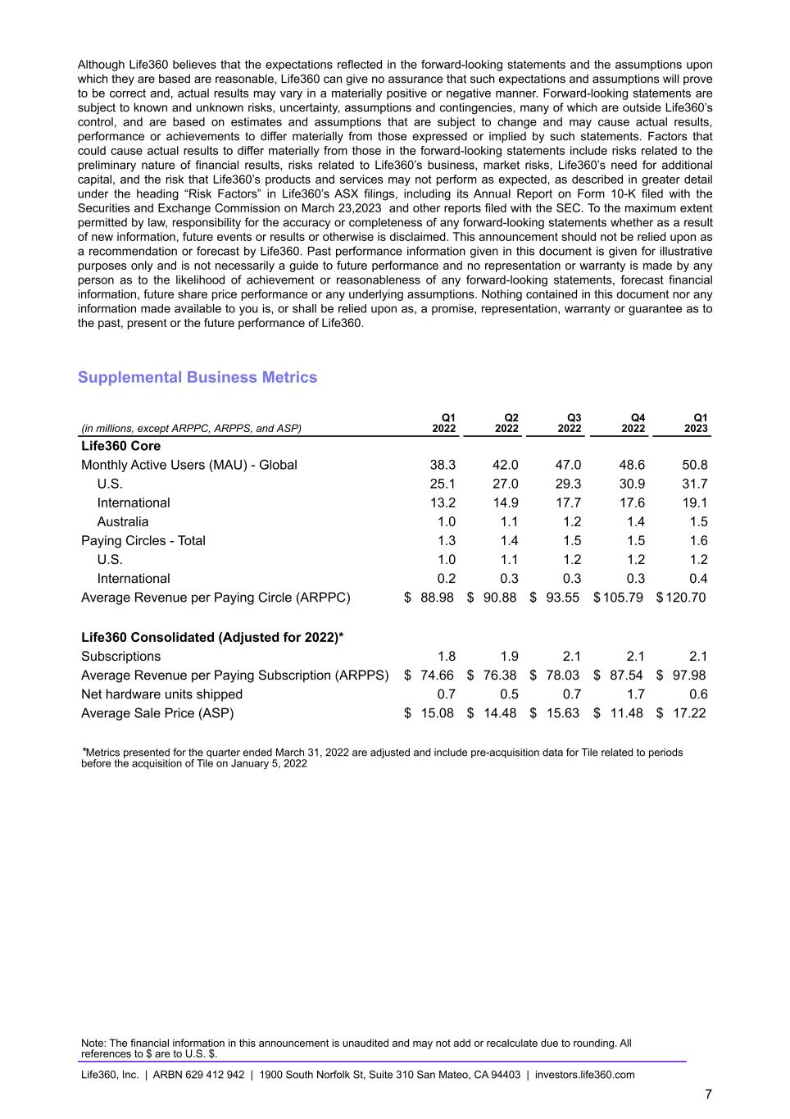
Although Life360 believes that the expectations reflected in the forward-looking statements and the assumptions upon which they are based are reasonable, Life360 can give no assurance that such expectations and assumptions will prove to be correct and, actual results may vary in a materially positive or negative manner. Forward-looking statements are subject to known and unknown risks, uncertainty, assumptions and contingencies, many of which are outside Life360’s control, and are based on estimates and assumptions that are subject to change and may cause actual results, performance or achievements to differ materially from those expressed or implied by such statements. Factors that could cause actual results to differ materially from those in the forward-looking statements include risks related to the preliminary nature of financial results, risks related to Life360’s business, market risks, Life360’s need for additional capital, and the risk that Life360’s products and services may not perform as expected, as described in greater detail under the heading “Risk Factors” in Life360’s ASX filings, including its Annual Report on Form 10-K filed with the Securities and Exchange Commission on March 23,2023 and other reports filed with the SEC. To the maximum extent permitted by law, responsibility for the accuracy or completeness of any forward-looking statements whether as a result of new information, future events or results or otherwise is disclaimed. This announcement should not be relied upon as a recommendation or forecast by Life360. Past performance information given in this document is given for illustrative purposes only and is not necessarily a guide to future performance and no representation or warranty is made by any person as to the likelihood of achievement or reasonableness of any forward-looking statements, forecast financial information, future share price performance or any underlying assumptions. Nothing contained in this document nor any information made available to you is, or shall be relied upon as, a promise, representation, warranty or guarantee as to the past, present or the future performance of Life360. Supplemental Business Metrics (in millions, except ARPPC, ARPPS, and ASP) Q1 2022 Q2 2022 Q3 2022 Q4 2022 Q1 2023 Life360 Core Monthly Active Users (MAU) - Global 38.3 42.0 47.0 48.6 50.8 U.S. 25.1 27.0 29.3 30.9 31.7 International 13.2 14.9 17.7 17.6 19.1 Australia 1.0 1.1 1.2 1.4 1.5 Paying Circles - Total 1.3 1.4 1.5 1.5 1.6 U.S. 1.0 1.1 1.2 1.2 1.2 International 0.2 0.3 0.3 0.3 0.4 Average Revenue per Paying Circle (ARPPC) $ 88.98 $ 90.88 $ 93.55 $ 105.79 $ 120.70 Life360 Consolidated (Adjusted for 2022)* Subscriptions 1.8 1.9 2.1 2.1 2.1 Average Revenue per Paying Subscription (ARPPS) $ 74.66 $ 76.38 $ 78.03 $ 87.54 $ 97.98 Net hardware units shipped 0.7 0.5 0.7 1.7 0.6 Average Sale Price (ASP) $ 15.08 $ 14.48 $ 15.63 $ 11.48 $ 17.22 *Metrics presented for the quarter ended March 31, 2022 are adjusted and include pre-acquisition data for Tile related to periods before the acquisition of Tile on January 5, 2022 Note: The financial information in this announcement is unaudited and may not add or recalculate due to rounding. All references to $ are to U.S. $. Life360, Inc. | ARBN 629 412 942 | 1900 South Norfolk St, Suite 310 San Mateo, CA 94403 | investors.life360.com 7

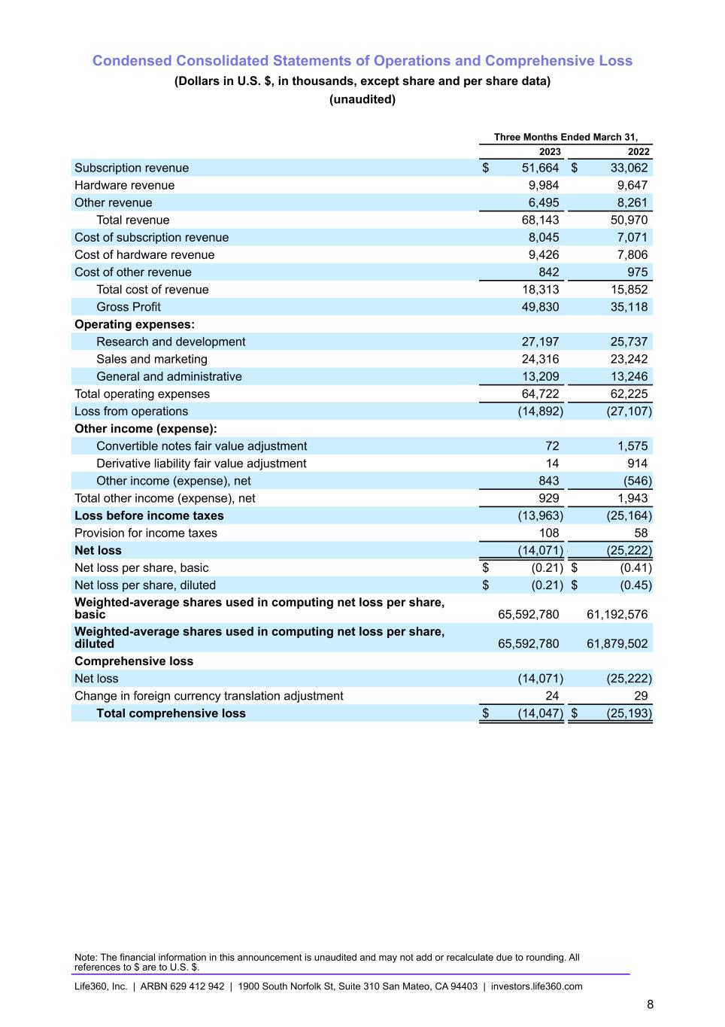
Condensed Consolidated Statements of Operations and Comprehensive Loss (Dollars in U.S. $, in thousands, except share and per share data) (unaudited) Three Months Ended March 31, 2023 2022 Subscription revenue $ 51,664 $ 33,062 Hardware revenue 9,984 9,647 Other revenue 6,495 8,261 Total revenue 68,143 50,970 Cost of subscription revenue 8,045 7,071 Cost of hardware revenue 9,426 7,806 Cost of other revenue 842 975 Total cost of revenue 18,313 15,852 Gross Profit 49,830 35,118 Operating expenses: Research and development 27,197 25,737 Sales and marketing 24,316 23,242 General and administrative 13,209 13,246 Total operating expenses 64,722 62,225 Loss from operations (14,892) (27,107) Other income (expense): Convertible notes fair value adjustment 72 1,575 Derivative liability fair value adjustment 14 914 Other income (expense), net 843 (546) Total other income (expense), net 929 1,943 Loss before income taxes (13,963) (25,164) Provision for income taxes 108 58 Net loss (14,071) — (25,222) Net loss per share, basic $ (0.21) $ (0.41) Net loss per share, diluted $ (0.21) $ (0.45) Weighted-average shares used in computing net loss per share, basic 65,592,780 61,192,576 Weighted-average shares used in computing net loss per share, diluted 65,592,780 61,879,502 Comprehensive loss Net loss (14,071) (25,222) Change in foreign currency translation adjustment 24 29 Total comprehensive loss $ (14,047) $ (25,193) Note: The financial information in this announcement is unaudited and may not add or recalculate due to rounding. All references to $ are to U.S. $. Life360, Inc. | ARBN 629 412 942 | 1900 South Norfolk St, Suite 310 San Mateo, CA 94403 | investors.life360.com 8

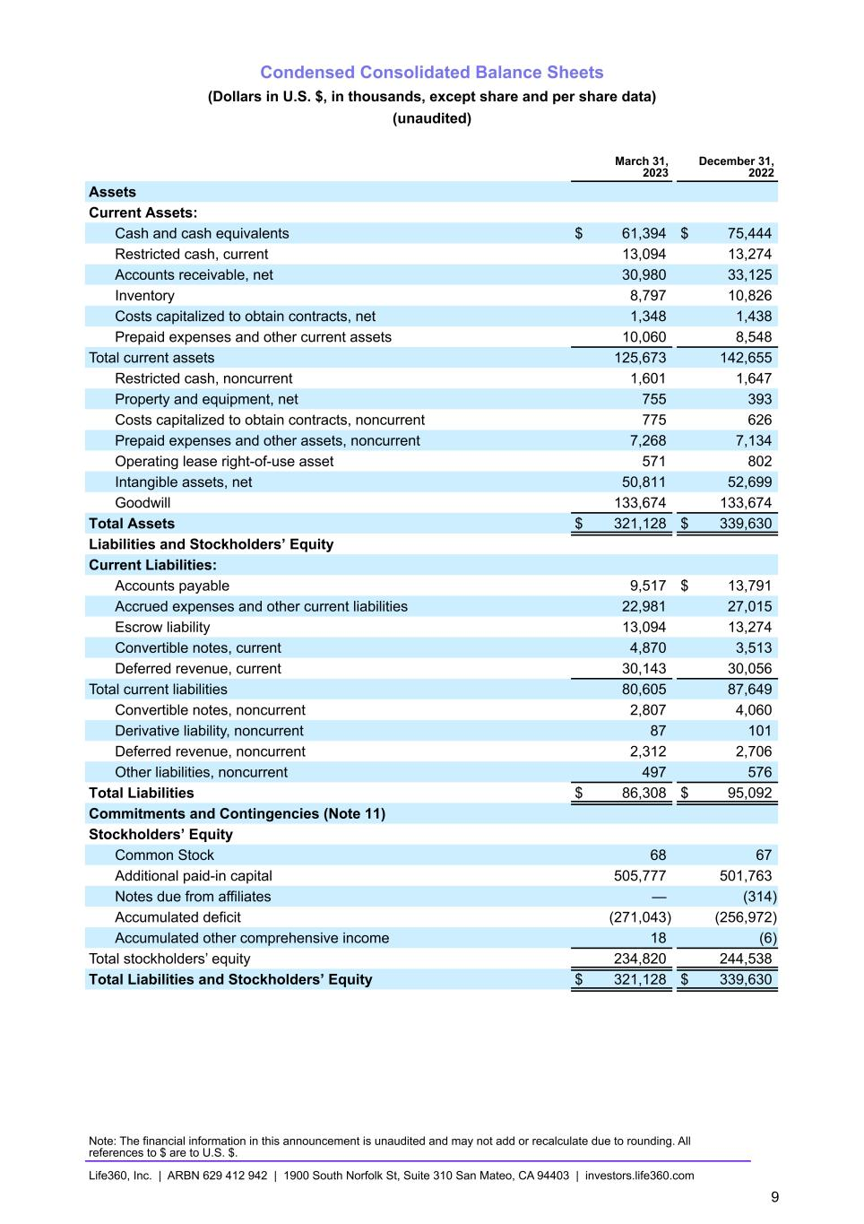
Condensed Consolidated Balance Sheets (Dollars in U.S. $, in thousands, except share and per share data) (unaudited) March 31, 2023 December 31, 2022 Assets Current Assets: Cash and cash equivalents $ 61,394 $ 75,444 Restricted cash, current 13,094 13,274 Accounts receivable, net 30,980 33,125 Inventory 8,797 10,826 Costs capitalized to obtain contracts, net 1,348 1,438 Prepaid expenses and other current assets 10,060 8,548 Total current assets 125,673 142,655 Restricted cash, noncurrent 1,601 1,647 Property and equipment, net 755 393 Costs capitalized to obtain contracts, noncurrent 775 626 Prepaid expenses and other assets, noncurrent 7,268 7,134 Operating lease right-of-use asset 571 802 Intangible assets, net 50,811 52,699 Goodwill 133,674 133,674 Total Assets $ 321,128 $ 339,630 Liabilities and Stockholders’ Equity Current Liabilities: Accounts payable 9,517 $ 13,791 Accrued expenses and other current liabilities 22,981 27,015 Escrow liability 13,094 13,274 Convertible notes, current 4,870 3,513 Deferred revenue, current 30,143 30,056 Total current liabilities 80,605 87,649 Convertible notes, noncurrent 2,807 4,060 Derivative liability, noncurrent 87 101 Deferred revenue, noncurrent 2,312 2,706 Other liabilities, noncurrent 497 576 Total Liabilities $ 86,308 $ 95,092 Commitments and Contingencies (Note 11) Stockholders’ Equity Common Stock 68 67 Additional paid-in capital 505,777 501,763 Notes due from affiliates — (314) Accumulated deficit (271,043) (256,972) Accumulated other comprehensive income 18 (6) Total stockholders’ equity 234,820 244,538 Total Liabilities and Stockholders’ Equity $ 321,128 $ 339,630 Note: The financial information in this announcement is unaudited and may not add or recalculate due to rounding. All references to $ are to U.S. $. Life360, Inc. | ARBN 629 412 942 | 1900 South Norfolk St, Suite 310 San Mateo, CA 94403 | investors.life360.com 9

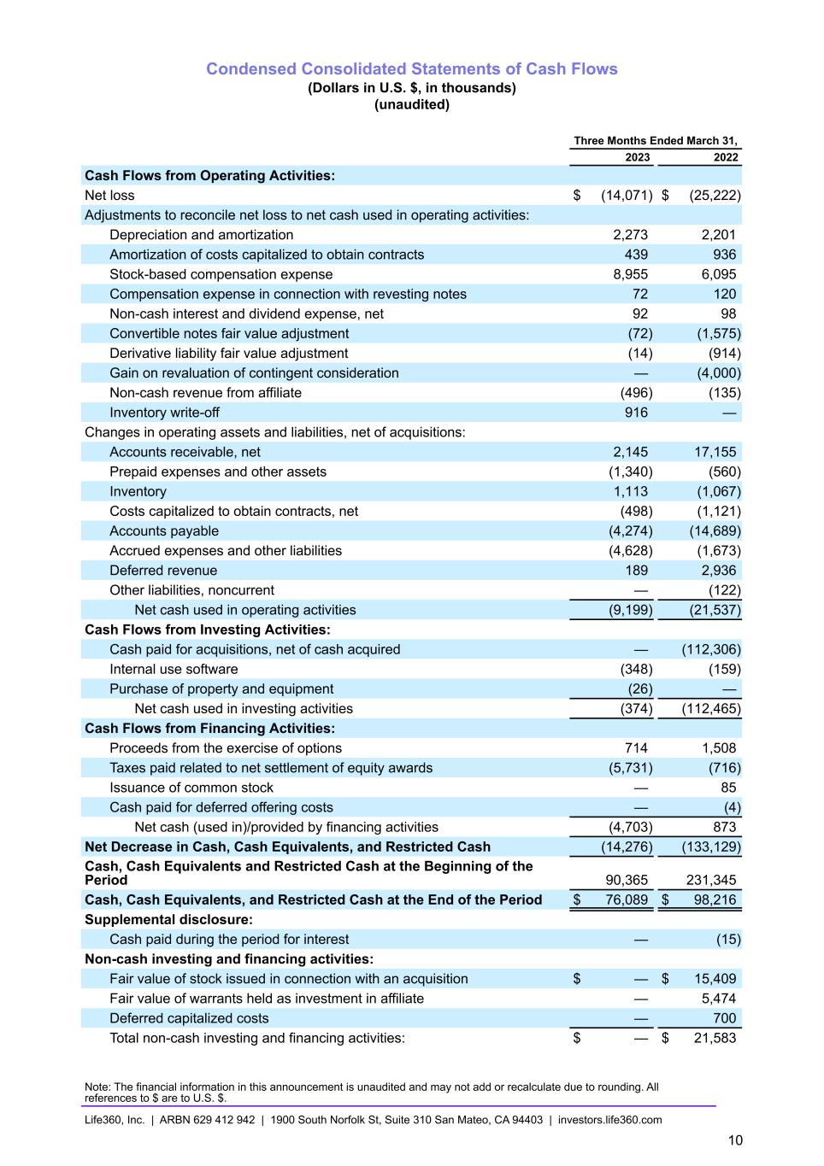
Condensed Consolidated Statements of Cash Flows (Dollars in U.S. $, in thousands) (unaudited) Three Months Ended March 31, 2023 2022 Cash Flows from Operating Activities: Net loss $ (14,071) $ (25,222) Adjustments to reconcile net loss to net cash used in operating activities: Depreciation and amortization 2,273 2,201 Amortization of costs capitalized to obtain contracts 439 936 Stock-based compensation expense 8,955 6,095 Compensation expense in connection with revesting notes 72 120 Non-cash interest and dividend expense, net 92 98 Convertible notes fair value adjustment (72) (1,575) Derivative liability fair value adjustment (14) (914) Gain on revaluation of contingent consideration — (4,000) Non-cash revenue from affiliate (496) (135) Inventory write-off 916 — Changes in operating assets and liabilities, net of acquisitions: Accounts receivable, net 2,145 17,155 Prepaid expenses and other assets (1,340) (560) Inventory 1,113 (1,067) Costs capitalized to obtain contracts, net (498) (1,121) Accounts payable (4,274) (14,689) Accrued expenses and other liabilities (4,628) (1,673) Deferred revenue 189 2,936 Other liabilities, noncurrent — (122) Net cash used in operating activities (9,199) (21,537) Cash Flows from Investing Activities: Cash paid for acquisitions, net of cash acquired — (112,306) Internal use software (348) (159) Purchase of property and equipment (26) — Net cash used in investing activities (374) (112,465) Cash Flows from Financing Activities: Proceeds from the exercise of options 714 1,508 Taxes paid related to net settlement of equity awards (5,731) (716) Issuance of common stock — 85 Cash paid for deferred offering costs — (4) Net cash (used in)/provided by financing activities (4,703) 873 Net Decrease in Cash, Cash Equivalents, and Restricted Cash (14,276) (133,129) Cash, Cash Equivalents and Restricted Cash at the Beginning of the Period 90,365 231,345 Cash, Cash Equivalents, and Restricted Cash at the End of the Period $ 76,089 $ 98,216 Supplemental disclosure: Cash paid during the period for interest — (15) Non-cash investing and financing activities: Fair value of stock issued in connection with an acquisition $ — $ 15,409 Fair value of warrants held as investment in affiliate — 5,474 Deferred capitalized costs — 700 Total non-cash investing and financing activities: $ — $ 21,583 Note: The financial information in this announcement is unaudited and may not add or recalculate due to rounding. All references to $ are to U.S. $. Life360, Inc. | ARBN 629 412 942 | 1900 South Norfolk St, Suite 310 San Mateo, CA 94403 | investors.life360.com 10

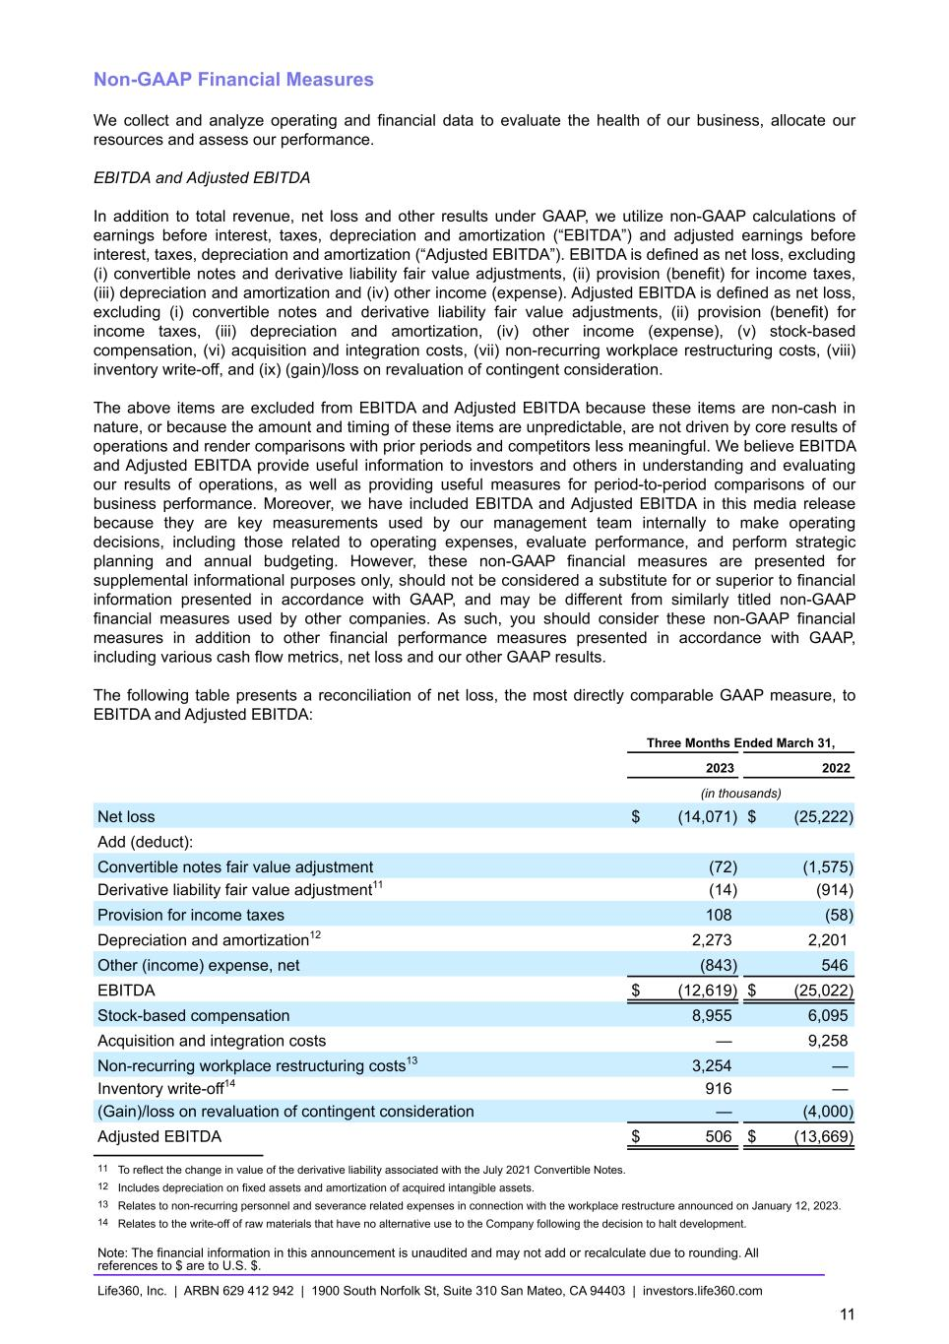
Non-GAAP Financial Measures We collect and analyze operating and financial data to evaluate the health of our business, allocate our resources and assess our performance. EBITDA and Adjusted EBITDA In addition to total revenue, net loss and other results under GAAP, we utilize non-GAAP calculations of earnings before interest, taxes, depreciation and amortization (“EBITDA”) and adjusted earnings before interest, taxes, depreciation and amortization (“Adjusted EBITDA”). EBITDA is defined as net loss, excluding (i) convertible notes and derivative liability fair value adjustments, (ii) provision (benefit) for income taxes, (iii) depreciation and amortization and (iv) other income (expense). Adjusted EBITDA is defined as net loss, excluding (i) convertible notes and derivative liability fair value adjustments, (ii) provision (benefit) for income taxes, (iii) depreciation and amortization, (iv) other income (expense), (v) stock-based compensation, (vi) acquisition and integration costs, (vii) non-recurring workplace restructuring costs, (viii) inventory write-off, and (ix) (gain)/loss on revaluation of contingent consideration. The above items are excluded from EBITDA and Adjusted EBITDA because these items are non-cash in nature, or because the amount and timing of these items are unpredictable, are not driven by core results of operations and render comparisons with prior periods and competitors less meaningful. We believe EBITDA and Adjusted EBITDA provide useful information to investors and others in understanding and evaluating our results of operations, as well as providing useful measures for period-to-period comparisons of our business performance. Moreover, we have included EBITDA and Adjusted EBITDA in this media release because they are key measurements used by our management team internally to make operating decisions, including those related to operating expenses, evaluate performance, and perform strategic planning and annual budgeting. However, these non-GAAP financial measures are presented for supplemental informational purposes only, should not be considered a substitute for or superior to financial information presented in accordance with GAAP, and may be different from similarly titled non-GAAP financial measures used by other companies. As such, you should consider these non-GAAP financial measures in addition to other financial performance measures presented in accordance with GAAP, including various cash flow metrics, net loss and our other GAAP results. The following table presents a reconciliation of net loss, the most directly comparable GAAP measure, to EBITDA and Adjusted EBITDA: Three Months Ended March 31, 2023 2022 (in thousands) Net loss $ (14,071) $ (25,222) Add (deduct): Convertible notes fair value adjustment (72) (1,575) Derivative liability fair value adjustment11 (14) (914) Provision for income taxes 108 (58) Depreciation and amortization12 2,273 2,201 Other (income) expense, net (843) 546 EBITDA $ (12,619) $ (25,022) Stock-based compensation 8,955 6,095 Acquisition and integration costs — 9,258 Non-recurring workplace restructuring costs13 3,254 — Inventory write-off14 916 — (Gain)/loss on revaluation of contingent consideration — (4,000) Adjusted EBITDA $ 506 $ (13,669) 11 To reflect the change in value of the derivative liability associated with the July 2021 Convertible Notes. 12 Includes depreciation on fixed assets and amortization of acquired intangible assets. 13 Relates to non-recurring personnel and severance related expenses in connection with the workplace restructure announced on January 12, 2023. 14 Relates to the write-off of raw materials that have no alternative use to the Company following the decision to halt development. Note: The financial information in this announcement is unaudited and may not add or recalculate due to rounding. All references to $ are to U.S. $. Life360, Inc. | ARBN 629 412 942 | 1900 South Norfolk St, Suite 310 San Mateo, CA 94403 | investors.life360.com 11

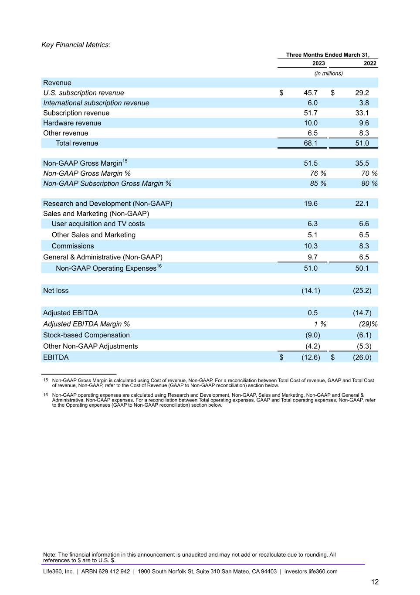
Key Financial Metrics: Three Months Ended March 31, 2023 2022 (in millions) Revenue U.S. subscription revenue $ 45.7 $ 29.2 International subscription revenue 6.0 3.8 Subscription revenue 51.7 33.1 Hardware revenue 10.0 9.6 Other revenue 6.5 8.3 Total revenue 68.1 51.0 Non-GAAP Gross Margin15 51.5 35.5 Non-GAAP Gross Margin % 76 % 70 % Non-GAAP Subscription Gross Margin % 85 % 80 % Research and Development (Non-GAAP) 19.6 22.1 Sales and Marketing (Non-GAAP) User acquisition and TV costs 6.3 6.6 Other Sales and Marketing 5.1 6.5 Commissions 10.3 8.3 General & Administrative (Non-GAAP) 9.7 6.5 Non-GAAP Operating Expenses16 51.0 50.1 Net loss (14.1) (25.2) Adjusted EBITDA 0.5 (14.7) Adjusted EBITDA Margin % 1 % (29) % Stock-based Compensation (9.0) (6.1) Other Non-GAAP Adjustments (4.2) (5.3) EBITDA $ (12.6) $ (26.0) 15 Non-GAAP Gross Margin is calculated using Cost of revenue, Non-GAAP. For a reconciliation between Total Cost of revenue, GAAP and Total Cost of revenue, Non-GAAP, refer to the Cost of Revenue (GAAP to Non-GAAP reconciliation) section below. 16 Non-GAAP operating expenses are calculated using Research and Development, Non-GAAP, Sales and Marketing, Non-GAAP and General & Administrative, Non-GAAP expenses. For a reconciliation between Total operating expenses, GAAP and Total operating expenses, Non-GAAP, refer to the Operating expenses (GAAP to Non-GAAP reconciliation) section below. Note: The financial information in this announcement is unaudited and may not add or recalculate due to rounding. All references to $ are to U.S. $. Life360, Inc. | ARBN 629 412 942 | 1900 South Norfolk St, Suite 310 San Mateo, CA 94403 | investors.life360.com 12

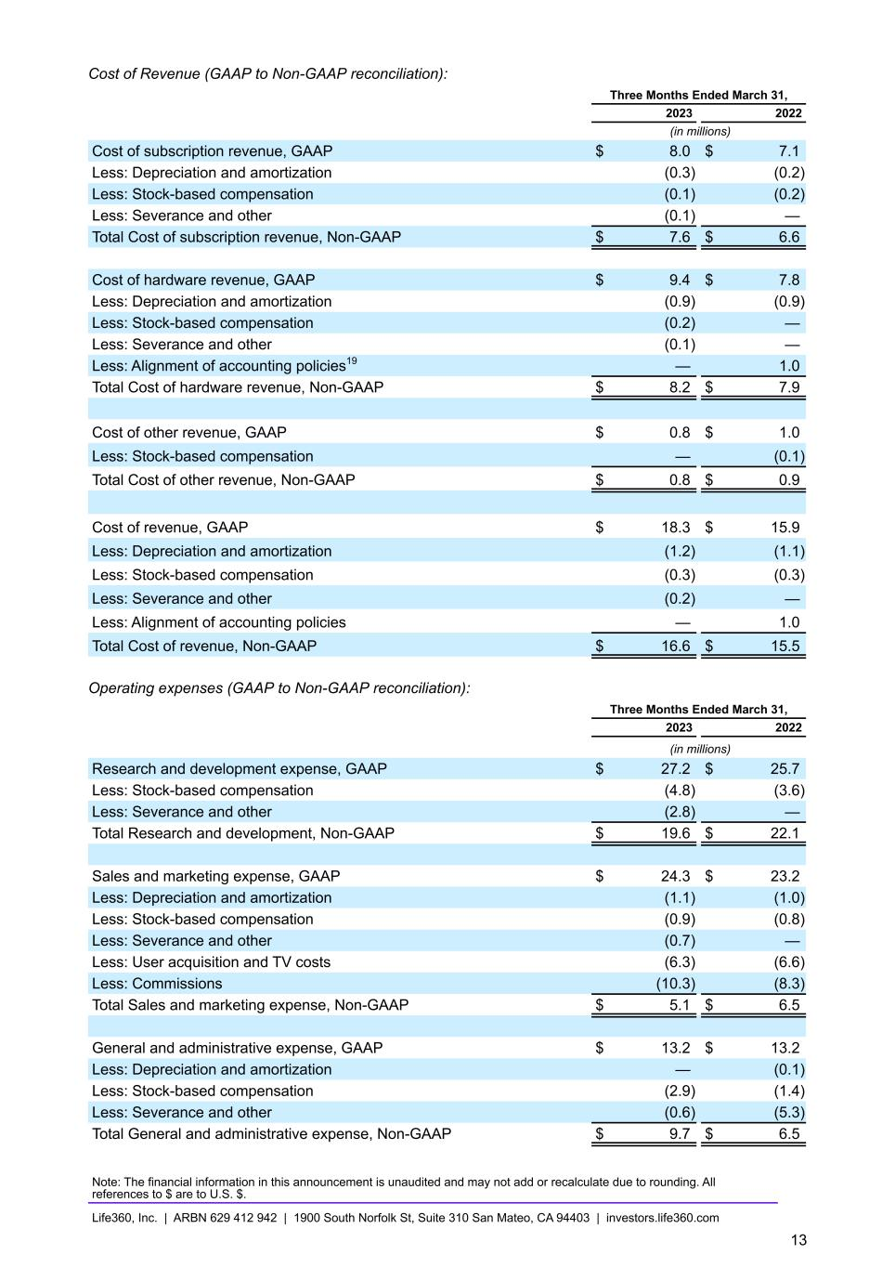
Cost of Revenue (GAAP to Non-GAAP reconciliation): Three Months Ended March 31, 2023 2022 (in millions) Cost of subscription revenue, GAAP $ 8.0 $ 7.1 Less: Depreciation and amortization (0.3) (0.2) Less: Stock-based compensation (0.1) (0.2) Less: Severance and other (0.1) — Total Cost of subscription revenue, Non-GAAP $ 7.6 $ 6.6 Cost of hardware revenue, GAAP $ 9.4 $ 7.8 Less: Depreciation and amortization (0.9) (0.9) Less: Stock-based compensation (0.2) — Less: Severance and other (0.1) — Less: Alignment of accounting policies19 — 1.0 Total Cost of hardware revenue, Non-GAAP $ 8.2 $ 7.9 Cost of other revenue, GAAP $ 0.8 $ 1.0 Less: Stock-based compensation — (0.1) Total Cost of other revenue, Non-GAAP $ 0.8 $ 0.9 Cost of revenue, GAAP $ 18.3 $ 15.9 Less: Depreciation and amortization (1.2) (1.1) Less: Stock-based compensation (0.3) (0.3) Less: Severance and other (0.2) — Less: Alignment of accounting policies — 1.0 Total Cost of revenue, Non-GAAP $ 16.6 $ 15.5 Operating expenses (GAAP to Non-GAAP reconciliation): Three Months Ended March 31, 2023 2022 (in millions) Research and development expense, GAAP $ 27.2 $ 25.7 Less: Stock-based compensation (4.8) (3.6) Less: Severance and other (2.8) — Total Research and development, Non-GAAP $ 19.6 $ 22.1 Sales and marketing expense, GAAP $ 24.3 $ 23.2 Less: Depreciation and amortization (1.1) (1.0) Less: Stock-based compensation (0.9) (0.8) Less: Severance and other (0.7) — Less: User acquisition and TV costs (6.3) (6.6) Less: Commissions (10.3) (8.3) Total Sales and marketing expense, Non-GAAP $ 5.1 $ 6.5 General and administrative expense, GAAP $ 13.2 $ 13.2 Less: Depreciation and amortization — (0.1) Less: Stock-based compensation (2.9) (1.4) Less: Severance and other (0.6) (5.3) Total General and administrative expense, Non-GAAP $ 9.7 $ 6.5 Note: The financial information in this announcement is unaudited and may not add or recalculate due to rounding. All references to $ are to U.S. $. Life360, Inc. | ARBN 629 412 942 | 1900 South Norfolk St, Suite 310 San Mateo, CA 94403 | investors.life360.com 13

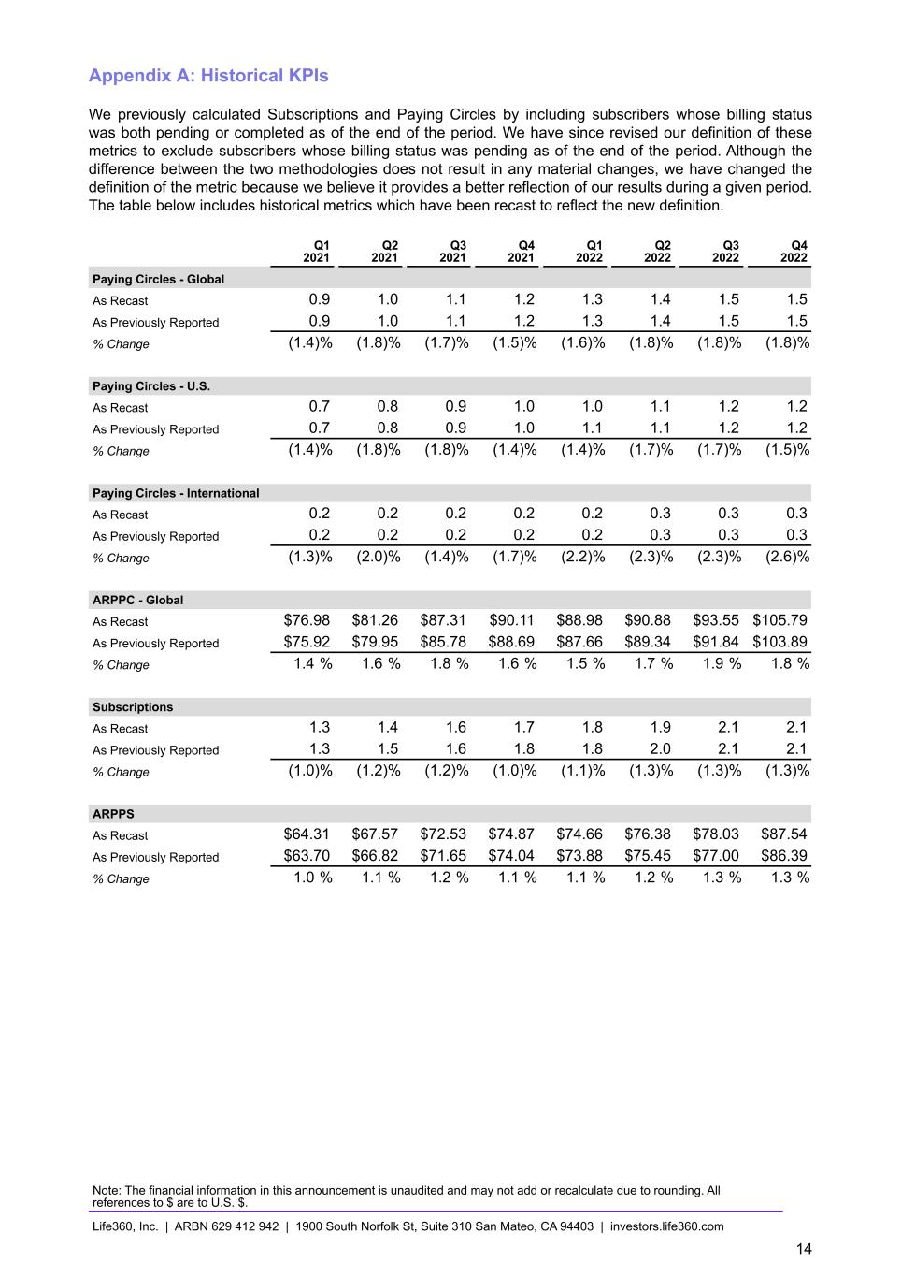
Appendix A: Historical KPIs We previously calculated Subscriptions and Paying Circles by including subscribers whose billing status was both pending or completed as of the end of the period. We have since revised our definition of these metrics to exclude subscribers whose billing status was pending as of the end of the period. Although the difference between the two methodologies does not result in any material changes, we have changed the definition of the metric because we believe it provides a better reflection of our results during a given period. The table below includes historical metrics which have been recast to reflect the new definition. Q1 2021 Q2 2021 Q3 2021 Q4 2021 Q1 2022 Q2 2022 Q3 2022 Q4 2022 Paying Circles - Global As Recast 0.9 1.0 1.1 1.2 1.3 1.4 1.5 1.5 As Previously Reported 0.9 1.0 1.1 1.2 1.3 1.4 1.5 1.5 % Change (1.4) % (1.8) % (1.7) % (1.5) % (1.6) % (1.8) % (1.8) % (1.8) % Paying Circles - U.S. As Recast 0.7 0.8 0.9 1.0 1.0 1.1 1.2 1.2 As Previously Reported 0.7 0.8 0.9 1.0 1.1 1.1 1.2 1.2 % Change (1.4) % (1.8) % (1.8) % (1.4) % (1.4) % (1.7) % (1.7) % (1.5) % Paying Circles - International As Recast 0.2 0.2 0.2 0.2 0.2 0.3 0.3 0.3 As Previously Reported 0.2 0.2 0.2 0.2 0.2 0.3 0.3 0.3 % Change (1.3) % (2.0) % (1.4) % (1.7) % (2.2) % (2.3) % (2.3) % (2.6) % ARPPC - Global As Recast $76.98 $81.26 $87.31 $90.11 $88.98 $90.88 $93.55 $105.79 As Previously Reported $75.92 $79.95 $85.78 $88.69 $87.66 $89.34 $91.84 $103.89 % Change 1.4 % 1.6 % 1.8 % 1.6 % 1.5 % 1.7 % 1.9 % 1.8 % Subscriptions As Recast 1.3 1.4 1.6 1.7 1.8 1.9 2.1 2.1 As Previously Reported 1.3 1.5 1.6 1.8 1.8 2.0 2.1 2.1 % Change (1.0) % (1.2) % (1.2) % (1.0) % (1.1) % (1.3) % (1.3) % (1.3) % ARPPS As Recast $64.31 $67.57 $72.53 $74.87 $74.66 $76.38 $78.03 $87.54 As Previously Reported $63.70 $66.82 $71.65 $74.04 $73.88 $75.45 $77.00 $86.39 % Change 1.0 % 1.1 % 1.2 % 1.1 % 1.1 % 1.2 % 1.3 % 1.3 % Note: The financial information in this announcement is unaudited and may not add or recalculate due to rounding. All references to $ are to U.S. $. Life360, Inc. | ARBN 629 412 942 | 1900 South Norfolk St, Suite 310 San Mateo, CA 94403 | investors.life360.com 14

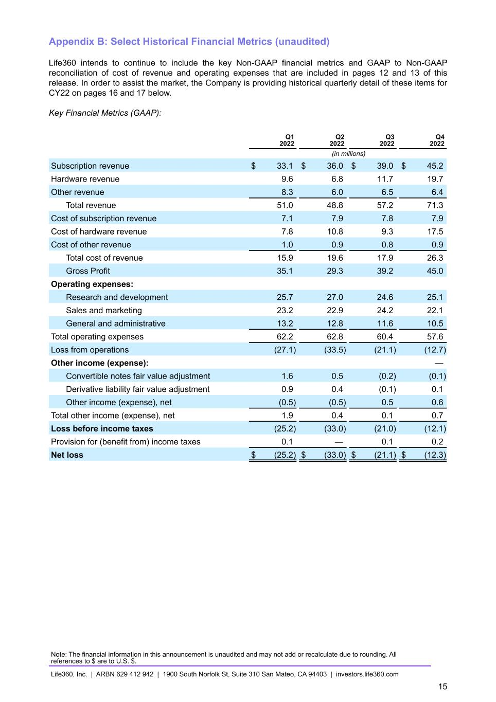
Appendix B: Select Historical Financial Metrics (unaudited) Life360 intends to continue to include the key Non-GAAP financial metrics and GAAP to Non-GAAP reconciliation of cost of revenue and operating expenses that are included in pages 12 and 13 of this release. In order to assist the market, the Company is providing historical quarterly detail of these items for CY22 on pages 16 and 17 below. Key Financial Metrics (GAAP): Q1 2022 Q2 2022 Q3 2022 Q4 2022 (in millions) Subscription revenue $ 33.1 $ 36.0 $ 39.0 $ 45.2 Hardware revenue 9.6 6.8 11.7 19.7 Other revenue 8.3 6.0 6.5 6.4 Total revenue 51.0 48.8 57.2 71.3 Cost of subscription revenue 7.1 7.9 7.8 7.9 Cost of hardware revenue 7.8 10.8 9.3 17.5 Cost of other revenue 1.0 0.9 0.8 0.9 Total cost of revenue 15.9 19.6 17.9 26.3 Gross Profit 35.1 29.3 39.2 45.0 Operating expenses: Research and development 25.7 27.0 24.6 25.1 Sales and marketing 23.2 22.9 24.2 22.1 General and administrative 13.2 12.8 11.6 10.5 Total operating expenses 62.2 62.8 60.4 57.6 Loss from operations (27.1) (33.5) (21.1) (12.7) Other income (expense): — Convertible notes fair value adjustment 1.6 0.5 (0.2) (0.1) Derivative liability fair value adjustment 0.9 0.4 (0.1) 0.1 Other income (expense), net (0.5) (0.5) 0.5 0.6 Total other income (expense), net 1.9 0.4 0.1 0.7 Loss before income taxes (25.2) (33.0) (21.0) (12.1) Provision for (benefit from) income taxes 0.1 — 0.1 0.2 Net loss $ (25.2) $ (33.0) $ (21.1) $ (12.3) Note: The financial information in this announcement is unaudited and may not add or recalculate due to rounding. All references to $ are to U.S. $. Life360, Inc. | ARBN 629 412 942 | 1900 South Norfolk St, Suite 310 San Mateo, CA 94403 | investors.life360.com 15

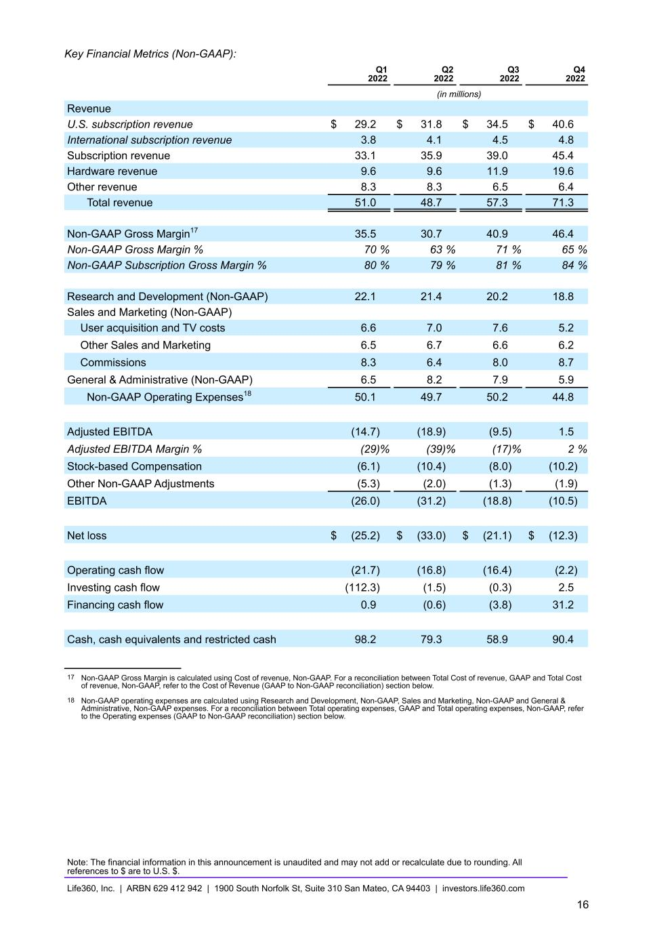
Key Financial Metrics (Non-GAAP): Q1 2022 Q2 2022 Q3 2022 Q4 2022 (in millions) Revenue U.S. subscription revenue $ 29.2 $ 31.8 $ 34.5 $ 40.6 International subscription revenue 3.8 4.1 4.5 4.8 Subscription revenue 33.1 35.9 39.0 45.4 Hardware revenue 9.6 9.6 11.9 19.6 Other revenue 8.3 8.3 6.5 6.4 Total revenue 51.0 48.7 57.3 71.3 Non-GAAP Gross Margin17 35.5 30.7 40.9 46.4 Non-GAAP Gross Margin % 70 % 63 % 71 % 65 % Non-GAAP Subscription Gross Margin % 80 % 79 % 81 % 84 % Research and Development (Non-GAAP) 22.1 21.4 20.2 18.8 Sales and Marketing (Non-GAAP) User acquisition and TV costs 6.6 7.0 7.6 5.2 Other Sales and Marketing 6.5 6.7 6.6 6.2 Commissions 8.3 6.4 8.0 8.7 General & Administrative (Non-GAAP) 6.5 8.2 7.9 5.9 Non-GAAP Operating Expenses18 50.1 49.7 50.2 44.8 Adjusted EBITDA (14.7) (18.9) (9.5) 1.5 Adjusted EBITDA Margin % (29) % (39) % (17) % 2 % Stock-based Compensation (6.1) (10.4) (8.0) (10.2) Other Non-GAAP Adjustments (5.3) (2.0) (1.3) (1.9) EBITDA (26.0) (31.2) (18.8) (10.5) Net loss $ (25.2) $ (33.0) $ (21.1) $ (12.3) Operating cash flow (21.7) (16.8) (16.4) (2.2) Investing cash flow (112.3) (1.5) (0.3) 2.5 Financing cash flow 0.9 (0.6) (3.8) 31.2 Cash, cash equivalents and restricted cash 98.2 79.3 58.9 90.4 17 Non-GAAP Gross Margin is calculated using Cost of revenue, Non-GAAP. For a reconciliation between Total Cost of revenue, GAAP and Total Cost of revenue, Non-GAAP, refer to the Cost of Revenue (GAAP to Non-GAAP reconciliation) section below. 18 Non-GAAP operating expenses are calculated using Research and Development, Non-GAAP, Sales and Marketing, Non-GAAP and General & Administrative, Non-GAAP expenses. For a reconciliation between Total operating expenses, GAAP and Total operating expenses, Non-GAAP, refer to the Operating expenses (GAAP to Non-GAAP reconciliation) section below. Note: The financial information in this announcement is unaudited and may not add or recalculate due to rounding. All references to $ are to U.S. $. Life360, Inc. | ARBN 629 412 942 | 1900 South Norfolk St, Suite 310 San Mateo, CA 94403 | investors.life360.com 16

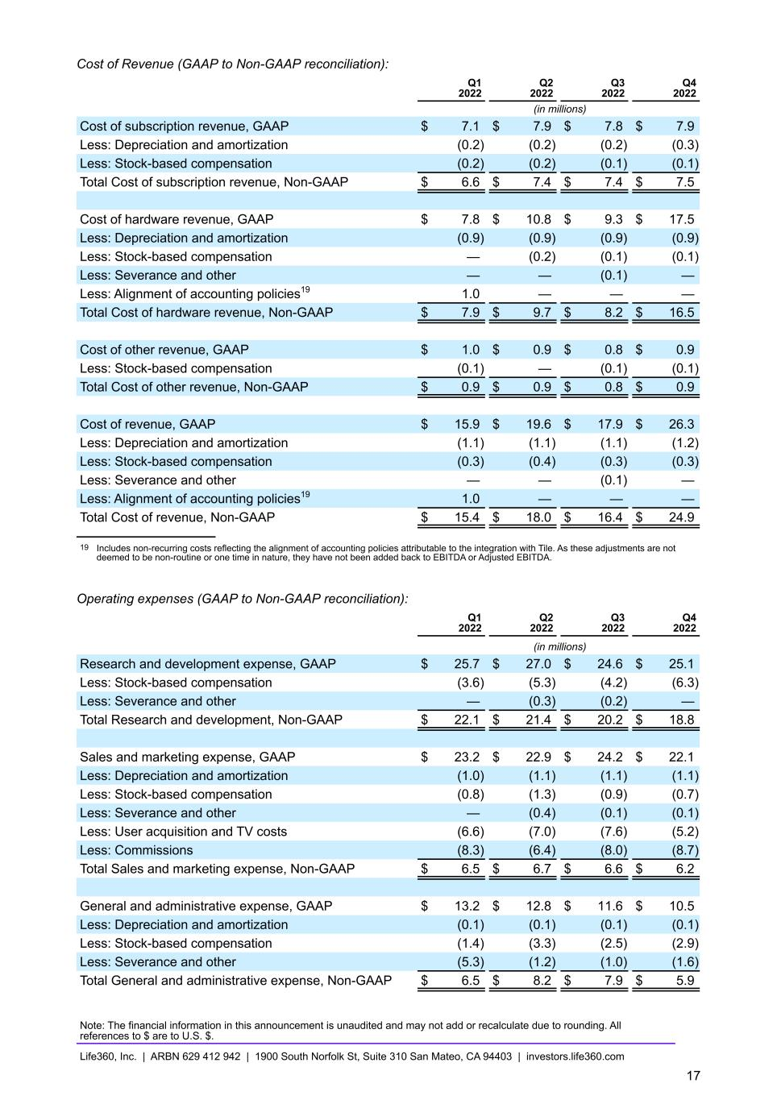
Cost of Revenue (GAAP to Non-GAAP reconciliation): Q1 2022 Q2 2022 Q3 2022 Q4 2022 (in millions) Cost of subscription revenue, GAAP $ 7.1 $ 7.9 $ 7.8 $ 7.9 Less: Depreciation and amortization (0.2) (0.2) (0.2) (0.3) Less: Stock-based compensation (0.2) (0.2) (0.1) (0.1) Total Cost of subscription revenue, Non-GAAP $ 6.6 $ 7.4 $ 7.4 $ 7.5 Cost of hardware revenue, GAAP $ 7.8 $ 10.8 $ 9.3 $ 17.5 Less: Depreciation and amortization (0.9) (0.9) (0.9) (0.9) Less: Stock-based compensation — (0.2) (0.1) (0.1) Less: Severance and other — — (0.1) — Less: Alignment of accounting policies19 1.0 — — — Total Cost of hardware revenue, Non-GAAP $ 7.9 $ 9.7 $ 8.2 $ 16.5 Cost of other revenue, GAAP $ 1.0 $ 0.9 $ 0.8 $ 0.9 Less: Stock-based compensation (0.1) — (0.1) (0.1) Total Cost of other revenue, Non-GAAP $ 0.9 $ 0.9 $ 0.8 $ 0.9 Cost of revenue, GAAP $ 15.9 $ 19.6 $ 17.9 $ 26.3 Less: Depreciation and amortization (1.1) (1.1) (1.1) (1.2) Less: Stock-based compensation (0.3) (0.4) (0.3) (0.3) Less: Severance and other — — (0.1) — Less: Alignment of accounting policies19 1.0 — — — Total Cost of revenue, Non-GAAP $ 15.4 $ 18.0 $ 16.4 $ 24.9 19 Includes non-recurring costs reflecting the alignment of accounting policies attributable to the integration with Tile. As these adjustments are not deemed to be non-routine or one time in nature, they have not been added back to EBITDA or Adjusted EBITDA. Operating expenses (GAAP to Non-GAAP reconciliation): Q1 2022 Q2 2022 Q3 2022 Q4 2022 (in millions) Research and development expense, GAAP $ 25.7 $ 27.0 $ 24.6 $ 25.1 Less: Stock-based compensation (3.6) (5.3) (4.2) (6.3) Less: Severance and other — (0.3) (0.2) — Total Research and development, Non-GAAP $ 22.1 $ 21.4 $ 20.2 $ 18.8 Sales and marketing expense, GAAP $ 23.2 $ 22.9 $ 24.2 $ 22.1 Less: Depreciation and amortization (1.0) (1.1) (1.1) (1.1) Less: Stock-based compensation (0.8) (1.3) (0.9) (0.7) Less: Severance and other — (0.4) (0.1) (0.1) Less: User acquisition and TV costs (6.6) (7.0) (7.6) (5.2) Less: Commissions (8.3) (6.4) (8.0) (8.7) Total Sales and marketing expense, Non-GAAP $ 6.5 $ 6.7 $ 6.6 $ 6.2 General and administrative expense, GAAP $ 13.2 $ 12.8 $ 11.6 $ 10.5 Less: Depreciation and amortization (0.1) (0.1) (0.1) (0.1) Less: Stock-based compensation (1.4) (3.3) (2.5) (2.9) Less: Severance and other (5.3) (1.2) (1.0) (1.6) Total General and administrative expense, Non-GAAP $ 6.5 $ 8.2 $ 7.9 $ 5.9 Note: The financial information in this announcement is unaudited and may not add or recalculate due to rounding. All references to $ are to U.S. $. Life360, Inc. | ARBN 629 412 942 | 1900 South Norfolk St, Suite 310 San Mateo, CA 94403 | investors.life360.com 17

