UNITED STATES
SECURITIES AND EXCHANGE COMMISSION
Washington, D.C. 20549
______________

FORM 8-K

CURRENT REPORT
Pursuant to Section 13 or 15(d) of the
Securities Exchange Act of 1934

Date of Report (Date of earliest event reported): November 28, 2023

Life360, Inc.
(Exact name of registrant as specified in its charter)
Delaware |  |  | 000-56424 |  |  | 26-0197666
(State or other jurisdiction of  incorporation or organization) |  |  | (Commission File Number) |  |  | (I.R.S. Employer  Identification No.)

1900 South Norfolk Street, Suite 310
San Mateo, CA 94403
(Address of principal executive offices, including zip code)
(415) 484-5244
(Registrant’s telephone number, including area code)
Not applicable.
(Former name or former address, if changed since last report)
______________

Check the appropriate box below if the Form 8-K filing is intended to simultaneously satisfy the filing obligation of the registrant under any of the following provisions:
☐ |  |  | Written communications pursuant to Rule 425 under the Securities Act (17 CFR 230.425)
☐ |  |  | Soliciting material pursuant to Rule 14a-12 under the Exchange Act (17 CFR 240.14a-12)
☐ |  |  | Pre-commencement communications pursuant to Rule 14d-2(b) under the Exchange Act (17 CFR 240.14d-2(b))
☐ |  |  | Pre-commencement communications pursuant to Rule 13e-4(c) under the Exchange Act (17 CFR 240.13e-4(c))

Title of each class |  |  | Trading Symbol(s) |  |  | Name of each exchange on which registered
None. |  |  | None. |  |  | None.

Indicate by check mark whether the registrant is an emerging growth company as defined in Rule 405 of the Securities Act of 1933 (§230.405 of this chapter) or Rule 12b-2 of the Securities Exchange Act of 1934 (§240.12b-2 of this chapter).

Emerging growth company ☒
If an emerging growth company, indicate by check mark if the registrant has elected not to use the extended transition period for complying with any new or revised financial accounting standards provided pursuant to Section 13(a) of the Exchange Act. ☐

Item 7.01 Regulation FD Disclosure
We are furnishing this Item 7.01 of this Current Report on Form 8-K in connection with the disclosure of information, in the form of the textual information from a PowerPoint presentation given during the UBS Global Technology Conference on November 30, 2023 at 6:35 a.m. Australian Eastern Standard Time (November 29, 2023 12:35 p.m. PT). A copy of the PowerPoint presentation used for the conference is furnished as Exhibit 99.1 to this Current Report on Form 8-K.
The information in this Item 7.01 of this Current Report on Form 8-K (including Exhibit 99.1) is furnished pursuant to Item 7.01 and shall not be deemed to be “filed” for the purpose of Section 18 of the Exchange Act or otherwise subject to the liabilities of that section, nor shall it be deemed incorporated by reference into any filing under the Securities Act or the Exchange Act, except as shall be expressly set forth by specific reference in such a filing. This Item 7.01 of this Current Report on Form 8-K will not be deemed an admission as the materiality of any information in this Item 7.01 that is required to be disclosed solely by Regulation FD.
The text included with this Item 7.01 of this Current Report on Form 8-K will be available on our website located at www.life360.com, although we reserve the right to discontinue that availability at any time.

Item 9.01 Financial Statements and Exhibits.
(d) Exhibits

Exhibit No. |  |  | Description
99.1 |  |  | Life360, Inc. Conference Presentation
104 |  |  | Cover Page Interactive Data File - the cover page XBRL tags are embedded within the Inline XBRL document

SIGNATURES
Pursuant to the requirements of the Securities Exchange Act of 1934, the registrant has duly caused this report to be signed on its behalf by the undersigned hereunto duly authorized.
 |  |  |  |  |  | LIFE360, INC.
Dated: |  |  | November 28, 2023 |  |  | By: |  |  | /s/ Russell Burke
 |  |  |  |  |  |  |  |  | Russell Burke
 |  |  |  |  |  |  |  |  | Chief Financial Officer

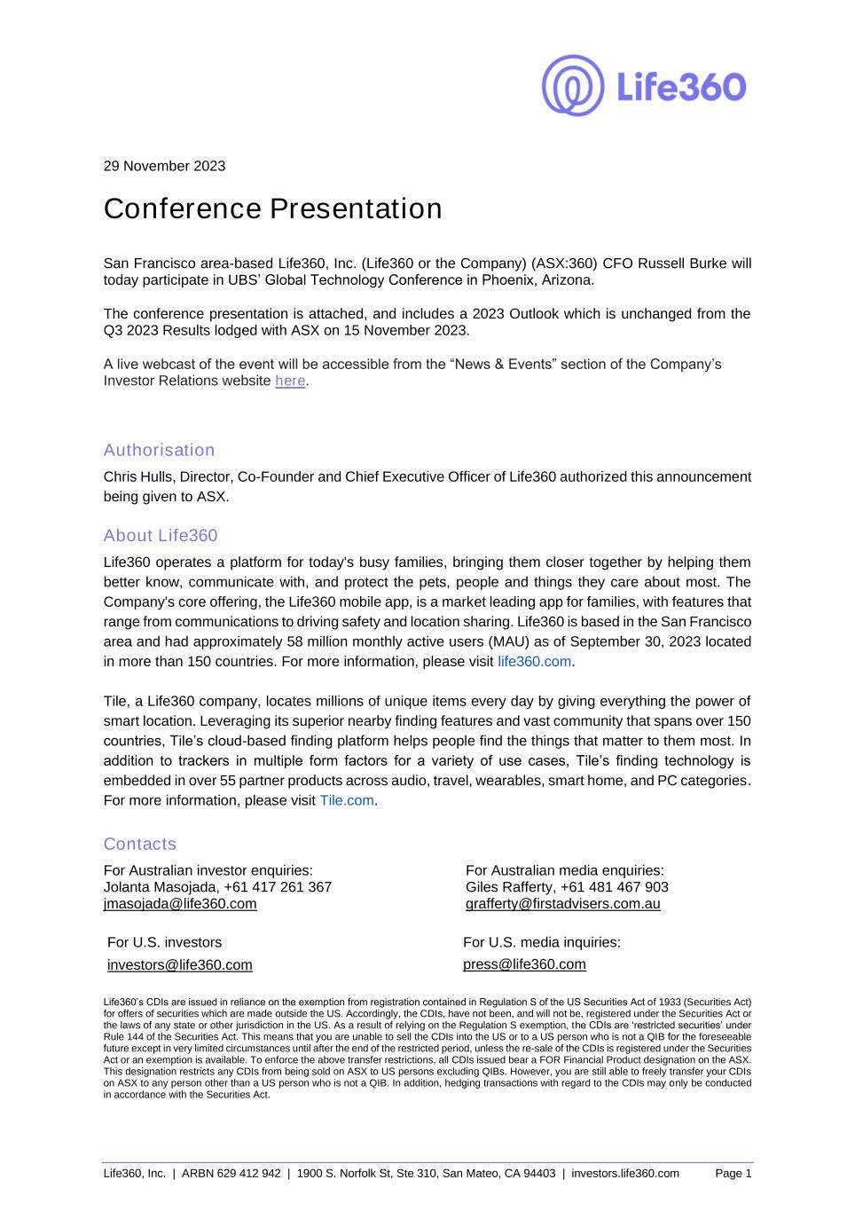

Life360, Inc. | ARBN 629 412 942 | 1900 S. Norfolk St, Ste 310, San Mateo, CA 94403 | investors.life360.com Page 1 29 November 2023 Conference Presentation San Francisco area-based Life360, Inc. (Life360 or the Company) (ASX:360) CFO Russell Burke will today participate in UBS’ Global Technology Conference in Phoenix, Arizona. The conference presentation is attached, and includes a 2023 Outlook which is unchanged from the Q3 2023 Results lodged with ASX on 15 November 2023. A live webcast of the event will be accessible from the “News & Events” section of the Company’s Investor Relations website here. Authorisation Chris Hulls, Director, Co-Founder and Chief Executive Officer of Life360 authorized this announcement being given to ASX. About Life360 Life360 operates a platform for today's busy families, bringing them closer together by helping them better know, communicate with, and protect the pets, people and things they care about most. The Company's core offering, the Life360 mobile app, is a market leading app for families, with features that range from communications to driving safety and location sharing. Life360 is based in the San Francisco area and had approximately 58 million monthly active users (MAU) as of September 30, 2023 located in more than 150 countries. For more information, please visit life360.com. Tile, a Life360 company, locates millions of unique items every day by giving everything the power of smart location. Leveraging its superior nearby finding features and vast community that spans over 150 countries, Tile’s cloud-based finding platform helps people find the things that matter to them most. In addition to trackers in multiple form factors for a variety of use cases, Tile’s finding technology is embedded in over 55 partner products across audio, travel, wearables, smart home, and PC categories. For more information, please visit Tile.com. Contacts For Australian investor enquiries: For Australian media enquiries: Jolanta Masojada, +61 417 261 367 Giles Rafferty, +61 481 467 903 jmasojada@life360.com grafferty@firstadvisers.com.au For U.S. investors For U.S. media inquiries: investors@life360.com press@life360.com Life360’s CDIs are issued in reliance on the exemption from registration contained in Regulation S of the US Securities Act of 1933 (Securities Act) for offers of securities which are made outside the US. Accordingly, the CDIs, have not been, and will not be, registered under the Securities Act or the laws of any state or other jurisdiction in the US. As a result of relying on the Regulation S exemption, the CDIs are ‘restricted securities’ under Rule 144 of the Securities Act. This means that you are unable to sell the CDIs into the US or to a US person who is not a QIB for the foreseeable future except in very limited circumstances until after the end of the restricted period, unless the re-sale of the CDIs is registered under the Securities Act or an exemption is available. To enforce the above transfer restrictions, all CDIs issued bear a FOR Financial Product designation on the ASX. This designation restricts any CDIs from being sold on ASX to US persons excluding QIBs. However, you are still able to freely transfer your CDIs on ASX to any person other than a US person who is not a QIB. In addition, hedging transactions with regard to the CDIs may only be conducted in accordance with the Securities Act.



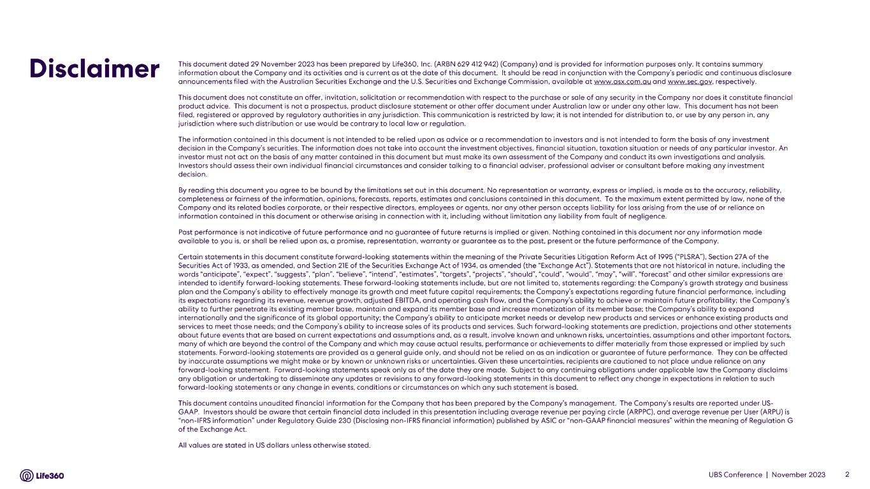

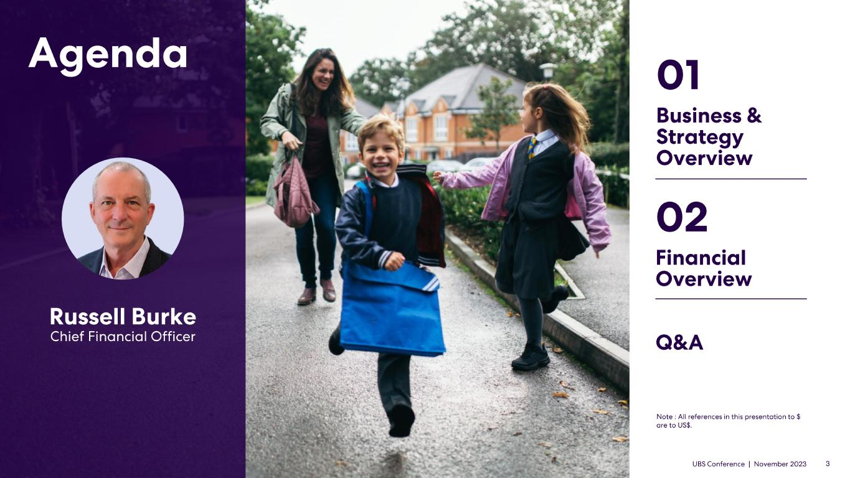



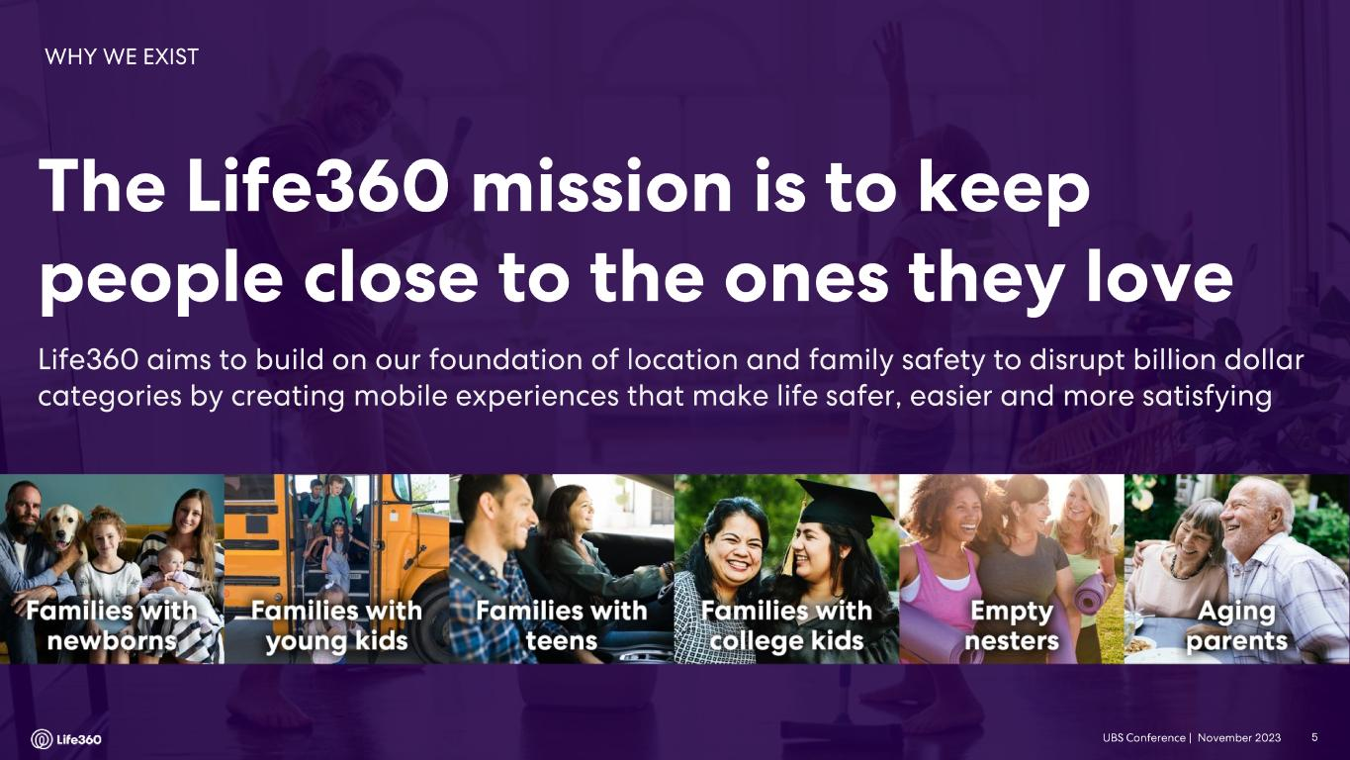

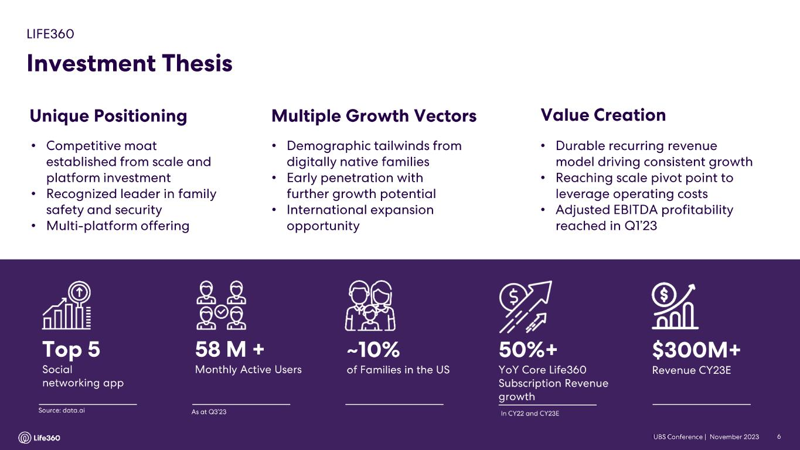
• • • • • • • • •

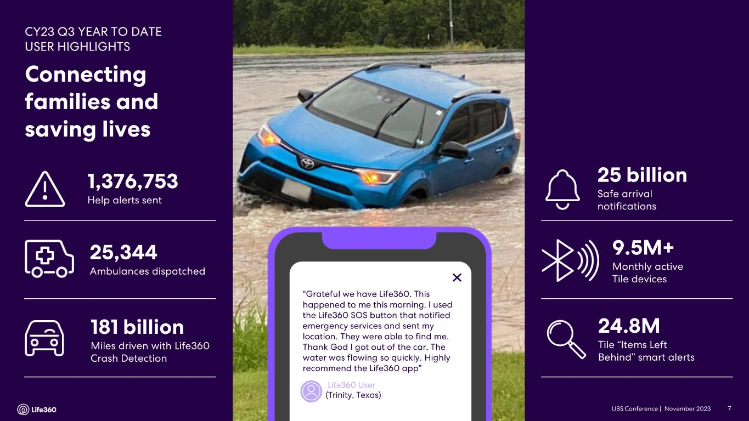

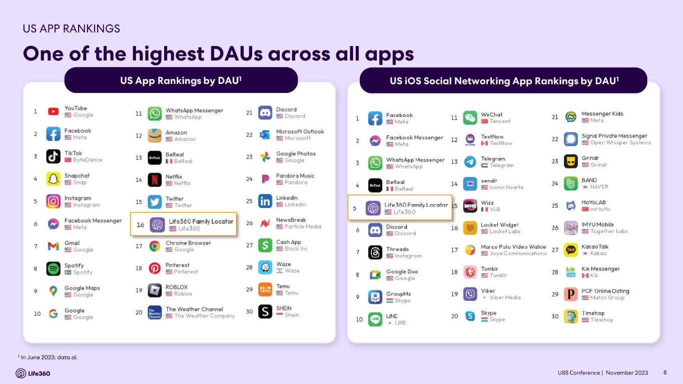

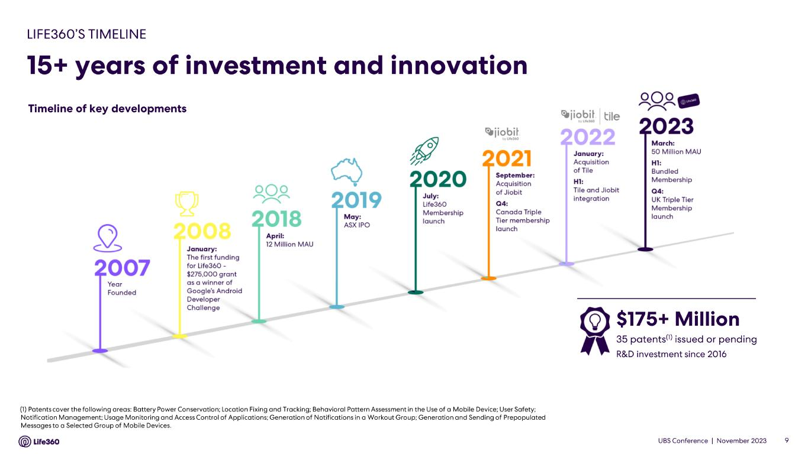

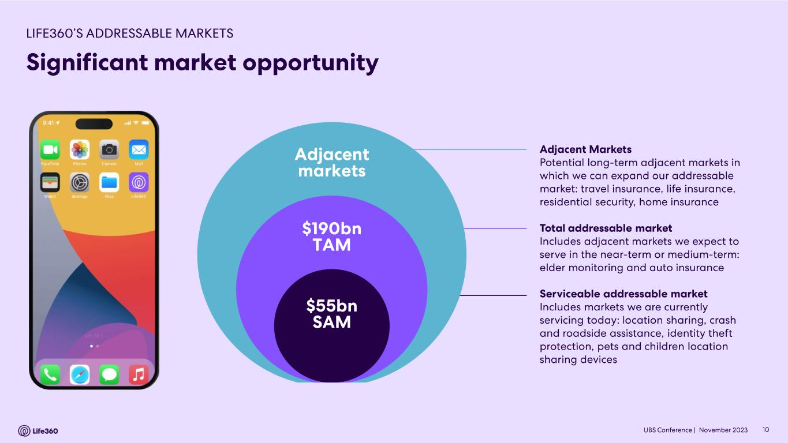

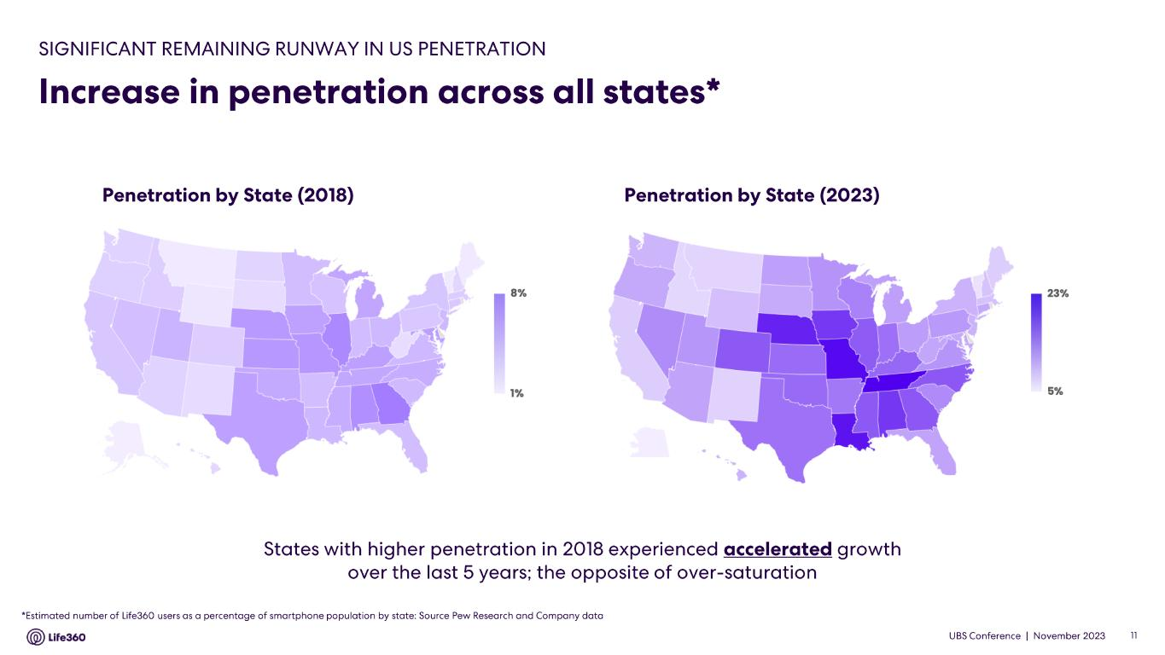
z z z

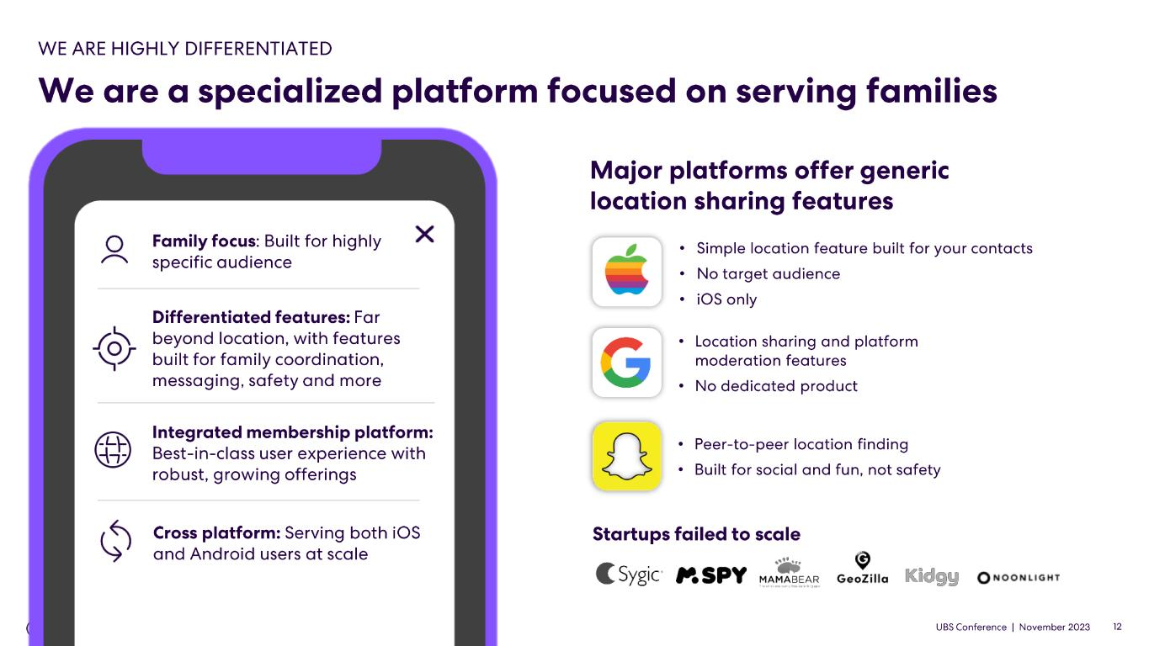
z z • • • • • • • • • • •

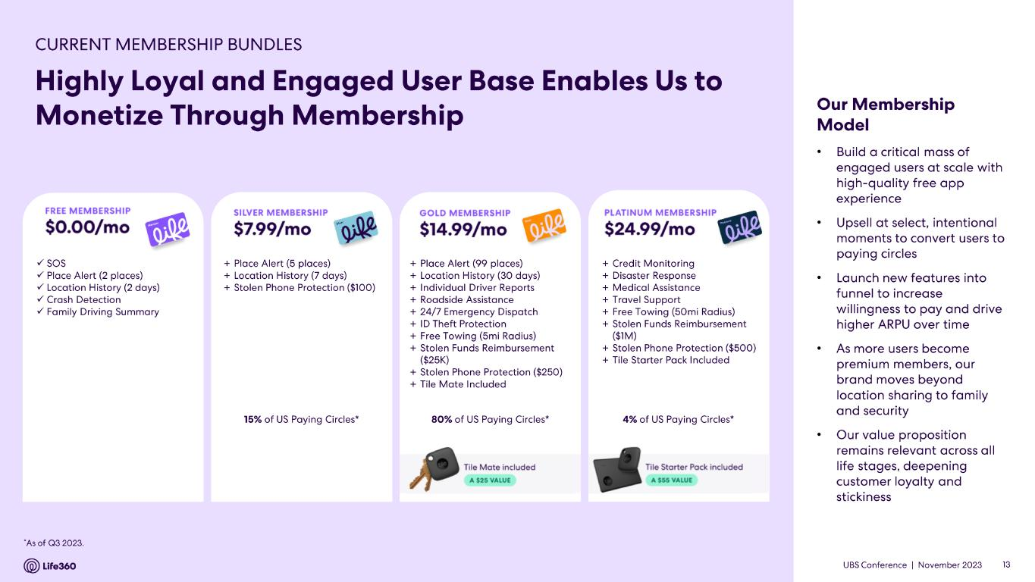
✓ ✓ ✓ ✓ ✓ + + + + + + + + + + + + + + + + + + + + + • • • • •

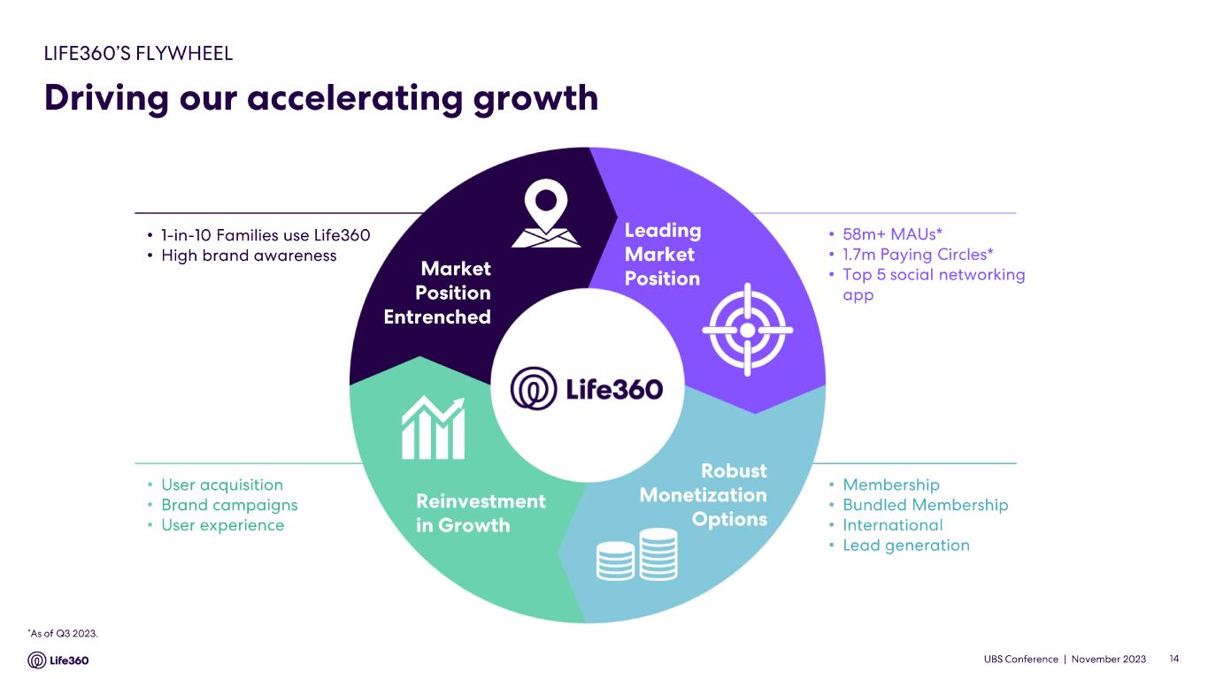
• • • • • • • • • • • •

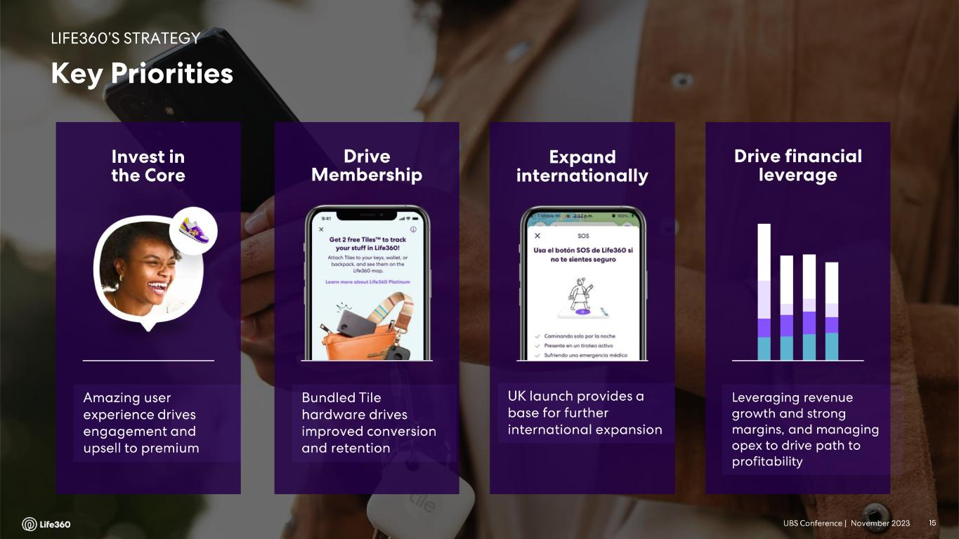



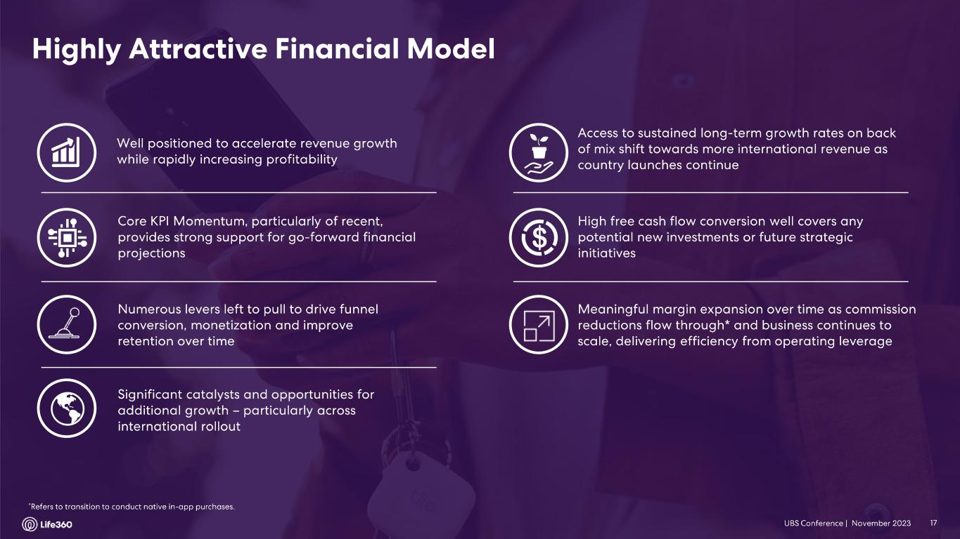

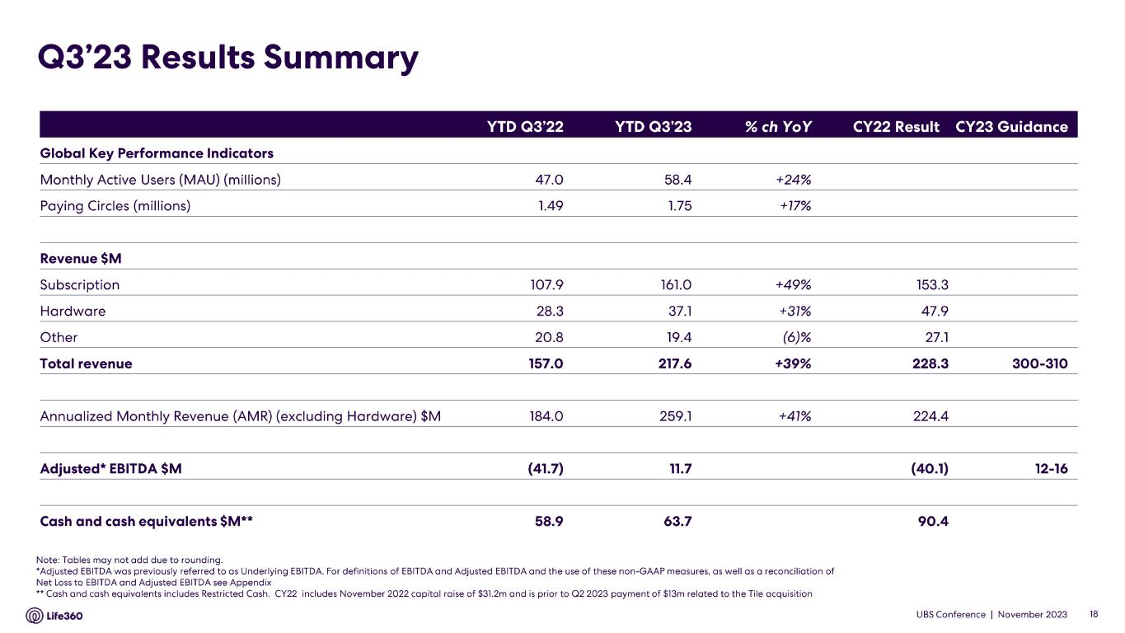

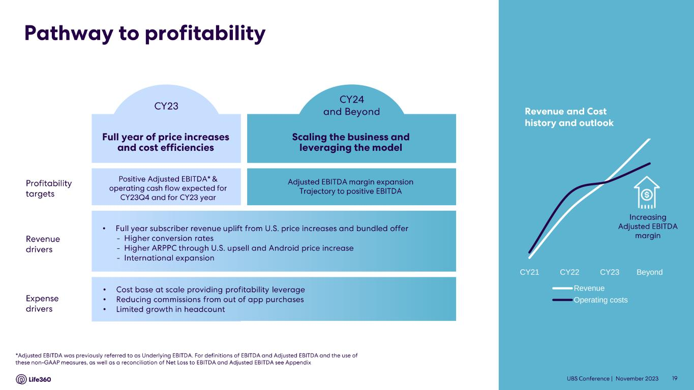
• • • • CY21 CY22 CY23 Beyond Revenue Operating costs

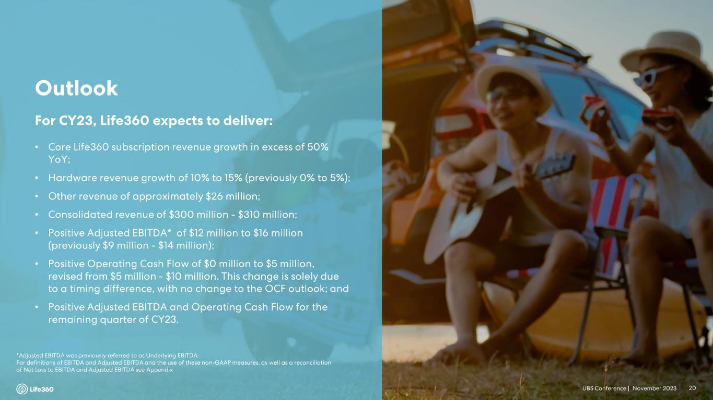
• • • • • • •







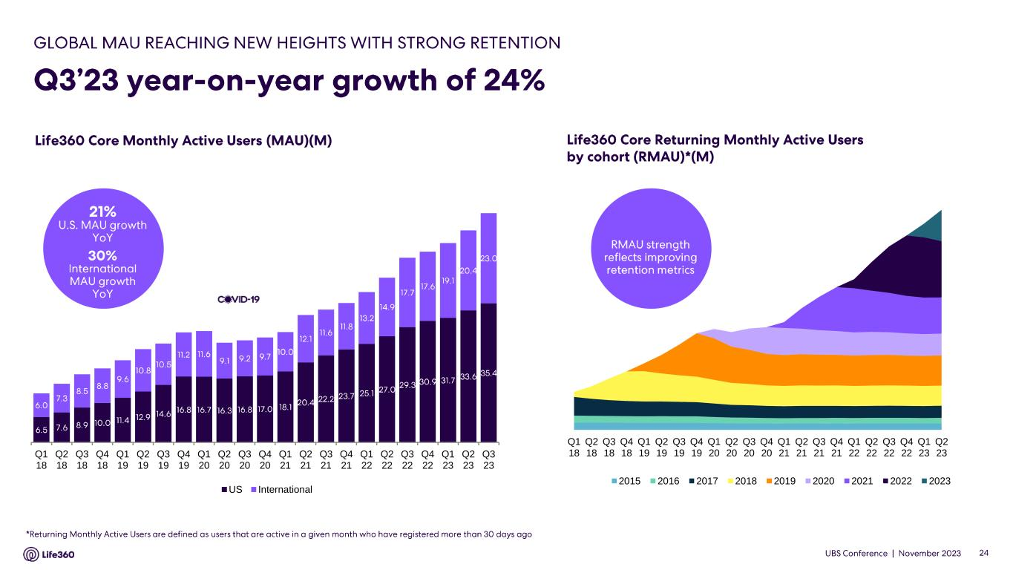
Q1 18 Q2 18 Q3 18 Q4 18 Q1 19 Q2 19 Q3 19 Q4 19 Q1 20 Q2 20 Q3 20 Q4 20 Q1 21 Q2 21 Q3 21 Q4 21 Q1 22 Q2 22 Q3 22 Q4 22 Q1 23 Q2 23 2015 2016 2017 2018 2019 2020 2021 2022 2023 Q1 18 Q2 18 Q3 18 Q4 18 Q1 19 Q2 19 Q3 19 Q4 19 Q1 20 Q2 20 Q3 20 Q4 20 Q1 21 Q2 21 Q3 21 Q4 21 Q1 22 Q2 22 Q3 22 Q4 22 Q1 23 Q2 23 Q3 23 US International

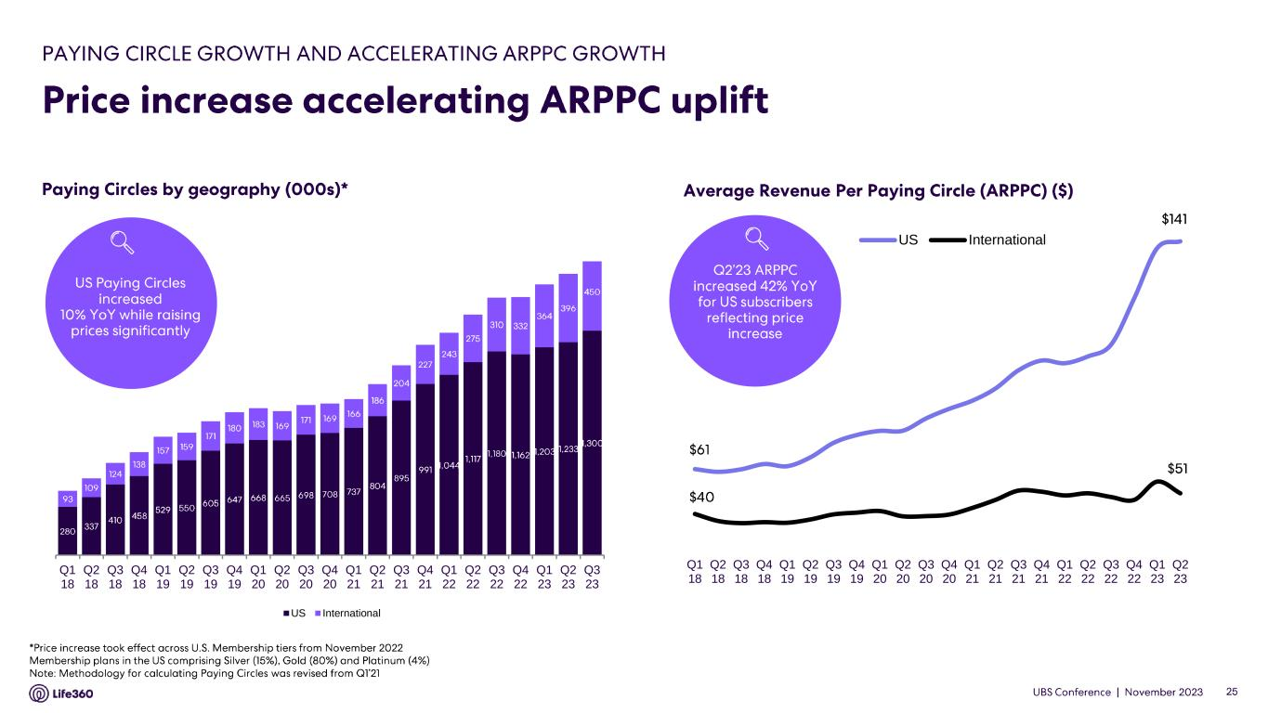
Q1 18 Q2 18 Q3 18 Q4 18 Q1 19 Q2 19 Q3 19 Q4 19 Q1 20 Q2 20 Q3 20 Q4 20 Q1 21 Q2 21 Q3 21 Q4 21 Q1 22 Q2 22 Q3 22 Q4 22 Q1 23 Q2 23 Q3 23 US International Q1 18 Q2 18 Q3 18 Q4 18 Q1 19 Q2 19 Q3 19 Q4 19 Q1 20 Q2 20 Q3 20 Q4 20 Q1 21 Q2 21 Q3 21 Q4 21 Q1 22 Q2 22 Q3 22 Q4 22 Q1 23 Q2 23 US International

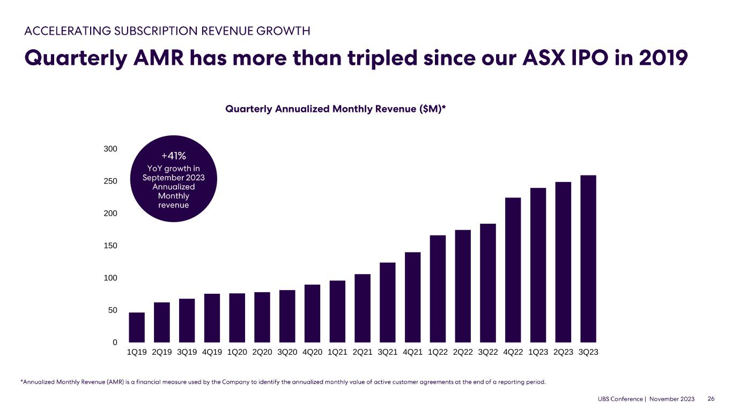
0 50 100 150 200 250 300 1Q19 2Q19 3Q19 4Q19 1Q20 2Q20 3Q20 4Q20 1Q21 2Q21 3Q21 4Q21 1Q22 2Q22 3Q22 4Q22 1Q23 2Q23 3Q23


 

