SEC Form 4

FORM 4

Check this box if no longer subject to Section
- Form 4 or Form 5 obligations may continue. See Instruction 1(b).

UNITED STATES SECURITIES AND EXCHANGE COMMISSION
Washington, D.C. 20549
Washington, D.C. 20549 |  | OMB APPROVAL
STATEMENT OF CHANGES IN BENEFICIAL OWNERSHIP
STATEMENT OF CHANGES IN BENEFICIAL OWNERSHIP |  | OMB Number: | 3235-0287
 |  | Estimated average burden
Filed pursuant to Section 16(a) of the Securities Exchange Act of 1934 |  | hours per response: | 0.5
or Section 30(h) of the Investment Company Act of 1940
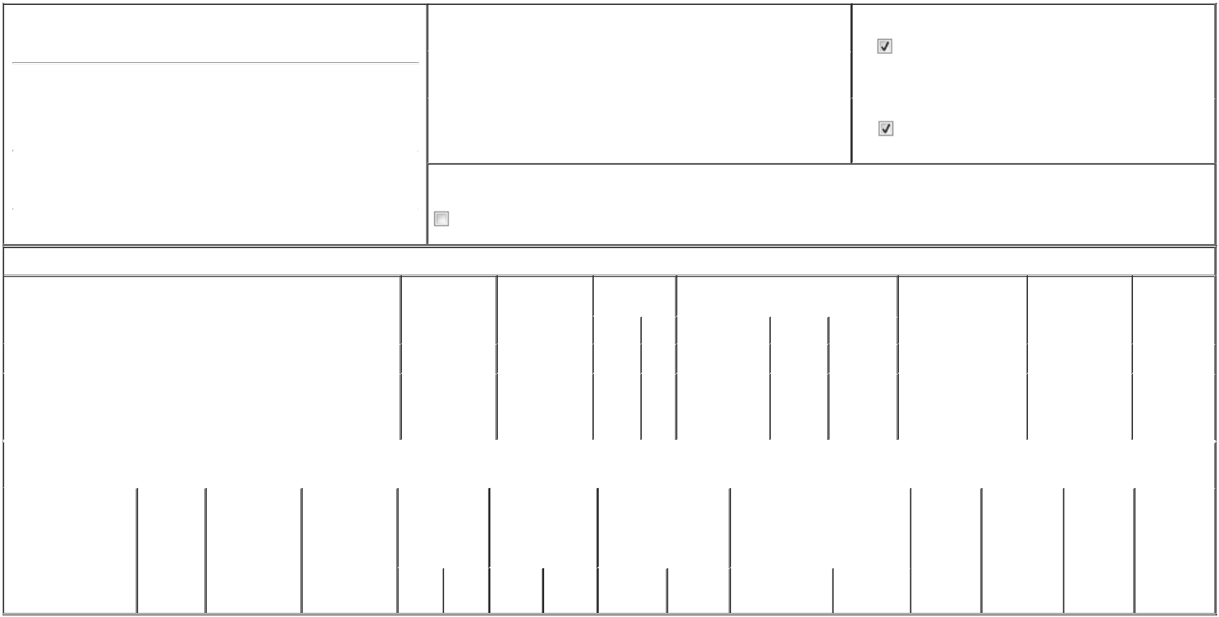

1. Name and Address of Reporting Person*
Haro Alex

 | (Last) | (First) | (Middle)
 | C/O LIFE360, INC.
 | 1900 SOUTH NORFOLK STREET, SUITE 310
(Street)
 | SAN MATEO | CA | 94403
 | (City) | (State) | (Zip)

2. |  | Issuer Name and Ticker or Trading Symbol |  | 5. Relationship of Reporting Person(s) to Issuer
 | Life360, Inc. [ LIF ] |  |  | (Check all applicable)
 |  |  |  | Director | 10% Owner
3. |  | Date of Earliest Transaction (Month/Day/Year) |  | Officer (give title | Other (specify below)
06/17/2024 |  |  |  | below) | Other (specify below)
4. |  | If Amendment, Date of Original Filed (Month/Day/Year) |  | 6. Individual or Joint/Group Filing (Check Applicable Line)
 |  |  |  | Form filed by One Reporting Person
 |  |  |  | Form filed by More than One Reporting Person

Rule 10b5-1(c) Transaction Indication

Check this box to indicate that a transaction was made pursuant to a contract, instruction or written plan that is intended to satisfy the affirmative defense conditions of Rule 10b5-1(c). See Instruction 10.

Table I - Non-Derivative Securities Acquired, Disposed of, or Beneficially Owned

 | 1. Title of Security (Instr. 3) |  |  |  | 2. Transaction | 2A. Deemed |  | 3. Transaction |  | 4. Securities Acquired (A) or Disposed Of |  |  |  | 5. Amount of Securities |  |  | 6. Ownership |  | 7. Nature of
 |  |  |  |  | Date | Execution Date, |  | Code (Instr. 8) |  | (D) (Instr. 3, 4 and 5) |  |  |  | Beneficially Owned |  |  | Form: Direct (D) or |  | Indirect
 |  |  |  |  | (Month/Day/Year) | if any |  |  |  |  |  |  |  | Following Reported |  |  | Indirect (I) (Instr. 4) |  | Beneficial
 |  |  |  |  |  | (Month/Day/Year) |  | Code | V | Amount |  | (A) or (D) | Price | Transaction(s) (Instr. 3 |  |  |  |  | Ownership
 |  |  |  |  |  |  |  | Code | V | Amount |  | (A) or (D) | Price | and 4) |  |  |  |  | (Instr. 4)
 | Common stock |  |  |  | 06/17/2024 |  |  | _{S}(1) |  | 362,580 |  | D | $27 | 958,601⁽²⁾⁽³⁾ |  |  |  | D
 |  |  |  |  |  |  |  |  |  |  |  |  |  |  |  |  |  |  | Held by
 | Common stock |  |  |  | 06/17/2024 |  |  | _{S}(1) |  | 8,544 |  | D | $27 | 1,887⁽³⁾ |  |  |  | I | ICCA Labs,
 |  |  |  |  |  |  |  |  |  |  |  |  |  |  |  |  |  |  | LLC⁽⁴⁾
 |  |  |  | Table II - Derivative Securities Acquired, Disposed of, or Beneficially Owned
 |  |  |  |  | (e.g., puts, calls, warrants, options, convertible securities)
 | 1. Title of Derivative | 2. | 3. Transaction | 3A. Deemed | 4. Transaction | 5. Number of |  | 6. Date Exercisable and |  |  | 7. Title and Amount of Securities |  |  |  | 8. Price of | 9. Number of |  | 10. | 11. Nature of
 | Security (Instr. 3) | Conversion | Date | Execution Date, | Code (Instr. 8) | Derivative |  | Expiration Date |  |  | Underlying Derivative Security |  |  |  | Derivative | derivative |  | Ownership | Indirect
 |  | or Exercise | (Month/Day/Year) | if any |  | Securities Acquired |  | (Month/Day/Year) |  |  | (Instr. 3 and 4) |  |  |  | Security | Securities |  | Form: | Beneficial
 |  | Price of |  | (Month/Day/Year) |  | (A) or Disposed of |  |  |  |  |  |  |  |  | (Instr. 5) | Beneficially |  | Direct (D) or | Ownership
 |  | Derivative |  |  |  | (D) (Instr. 3, 4 and |  |  |  |  |  |  |  |  |  | Owned |  | Indirect (I) | (Instr. 4)
 |  | Security |  |  |  | 5) |  |  |  |  |  |  |  |  |  | Following |  | (Instr. 4)
 |  |  |  |  |  |  |  |  |  |  |  |  |  |  |  | Reported
 |  |  |  |  |  |  |  |  |  |  |  |  | Amount or |  |  | Transaction(s)
 |  |  |  |  |  |  |  | Date |  | Expiration |  |  | Number of |  |  | (Instr. 4)
 |  |  |  |  | Code V | (A) | (D) | Exercisable |  | Date | Title |  | Shares

Explanation of Responses:

- The sales reported in this Form 4 were effected pursuant to the full exercise by the underwriters of a greenshoe option of the previously reported underwritten secondary offering that closed on June 7, 2024.

- Includes 8,065 restricted stock units, each of which represents a contingent right to receive one share of the Issuer's common stock upon vesting.

- Includes common stock and the number of common stock underlying Chess Depositary Interests ("CDIs") as converted on a 1:3 common stock to CDI ratio. The CDIs are traded on the Australian Securities Exchange (the "ASX") and are held by CHESS Depositary Nominees Pty, Limited, a subsidiary of ASX Limited, the company that operates the ASX.

- The Reporting Person is a member of ICCA Labs, LLC, an entity that holds an aggregate of 8,219 shares of the Issuer's common stock. The number of shares sold and held as reported herein by the Reporting Person represents his proportionate ownership interest in ICCA Labs, LLC.

Remarks:

Exhibit 24 - Power of Attorney

 | /s/ Russell J. Burke, Attorney-in-Fact |  | 06/20/2024
 | ** Signature of Reporting Person |  |  | Date
Reminder: Report on a separate line for each class of securities beneficially owned directly or indirectly.
* If the form is filed by more than one reporting person, see Instruction 4 (b)(v).
** Intentional misstatements or omissions of facts constitute Federal Criminal Violations See 18 U.S.C. 1001 and 15 U.S.C. 78ff(a).
Note: File three copies of this Form, one of which must be manually signed. If space is insufficient, see Instruction 6 for procedure.
Persons who respond to the collection of information contained in this form are not required to respond unless the form displays a currently valid OMB Number.



