UNITED STATES
SECURITIES AND EXCHANGE COMMISSION
Washington, D.C. 20549
______________

FORM 8-K

CURRENT REPORT
Pursuant to Section 13 or 15(d) of the
Securities Exchange Act of 1934

Date of Report (Date of earliest event reported): August 6, 2025

Life360, Inc.
(Exact name of registrant as specified in its charter)
Delaware |  |  | 001-42120 |  |  | 26-0197666
(State or other jurisdiction of  incorporation or organization) |  |  | (Commission File Number) |  |  | (I.R.S. Employer  Identification No.)

1900 South Norfolk Street, Suite 310
San Mateo, CA 94403
(Address of principal executive offices, including zip code)
(415) 484-5244
(Registrant’s telephone number, including area code)
Not applicable.
(Former name or former address, if changed since last report)
______________

Check the appropriate box below if the Form 8-K filing is intended to simultaneously satisfy the filing obligation of the registrant under any of the following provisions:
☐ |  |  | Written communications pursuant to Rule 425 under the Securities Act (17 CFR 230.425)
☐ |  |  | Soliciting material pursuant to Rule 14a-12 under the Exchange Act (17 CFR 240.14a-12)
☐ |  |  | Pre-commencement communications pursuant to Rule 14d-2(b) under the Exchange Act (17 CFR 240.14d-2(b))
☐ |  |  | Pre-commencement communications pursuant to Rule 13e-4(c) under the Exchange Act (17 CFR 240.13e-4(c))

Title of each class |  |  | Trading Symbol(s) |  |  | Name of each exchange on which registered
Common Stock, $0.001 par value per share |  |  | LIF |  |  | The Nasdaq Stock Market LLC

Indicate by check mark whether the registrant is an emerging growth company as defined in Rule 405 of the Securities Act of 1933 (§230.405 of this chapter) or Rule 12b-2 of the Securities Exchange Act of 1934 (§240.12b-2 of this chapter).

Emerging growth company ☐
If an emerging growth company, indicate by check mark if the registrant has elected not to use the extended transition period for complying with any new or revised financial accounting standards provided pursuant to Section 13(a) of the Exchange Act. ☐

Item 2.02 Results of Operations and Financial Condition.
Life360, Inc., a Delaware corporation (“the Company”) is furnishing this Current Report on Form 8-K in connection with the disclosure of information, in the form of textual information from a media release issued on August 11, 2025. A copy of the media release is furnished as Exhibit 99.1 to this Current Report on Form 8-K.

Item 5.02 Departure of Directors or Certain Officers; Election of Directors; Appointment of Certain Officers; Compensatory Arrangements of Certain Officers.
On August 6, 2025, the Board of Directors (the “Board”) of the Company appointed Lauren Antonoff, the Company’s Chief Operating Officer, as the Company’s Chief Executive Officer, and appointed Chris Hulls, the Company’s Co-Founder, and Chief Executive Officer, as the Executive Chairman of the Board, both effective August 11, 2025. On the same date, Mr. Hulls determined to step down as the Company’s Chief Executive Officer, effective August 11, 2025. On August 6, 2025, the Board also approved an increase in the size of the Board from nine to ten directors and elected Ms. Antonoff as a Class I director to fill the vacancy created by the enlargement of the Board, each effective August 11, 2025. Ms. Antonoff’s initial term as a director will expire at the Company’s annual meeting of stockholders to be held in 2026. She will not initially serve on any committees of the Board.
Ms. Antonoff, age 55, has served as the Company’s Chief Operating Officer since May 2023. Prior to joining the Company, Ms. Antonoff served several roles at GoDaddy Inc., an internet domain registrar and web hosting company, including President of the U.S. small business division from November 2019 to January 2022 and Senior Vice President & General Manager, Presence and Commerce from March 2015 to November 2019. Prior to GoDaddy, Ms. Antonoff spent over 18 years at Microsoft Corporation, a computer software company, serving in product leadership roles building and scaling the company’s products and business including SharePoint, Microsoft Office and Microsoft365. Ms. Antonoff served on the board of directors of Momentive Global Inc. from August 2022 to May 2023. Ms. Antonoff received a Bachelor of Arts in Rhetoric and Political Science from the University of California, Berkeley. Ms. Antonoff brings to the Board significant operational leadership skills and expertise, particularly related to companies in the technology and software industry. She also brings a deep and valuable understanding of the Company’s business, operations and culture, having previously served in key senior executive roles at the Company.
There are no arrangements or understandings between Ms. Antonoff and any other persons pursuant to which Ms. Antonoff was appointed as Chief Executive Officer of the Company or as a director of the Company. There are also no family relationships between Ms. Antonoff and any director or executive officer of the Company, and she has no direct or indirect interest in any transaction or proposed transaction required to be disclosed pursuant to Item 404(a) of Regulation S-K.
Ms. Antonoff previously entered into the Company’s standard form of indemnification agreement, a copy of which has previously been filed on July 5, 2022, as Exhibit 10.1 to the Company’s Amendment No. 2 to Form 10.
In connection with her appointment as the Company’s Chief Executive Officer, Ms. Antonoff and the Company entered into an amended and restated employment agreement (the “Amended Antonoff Agreement”). The Amended Antonoff Agreement is generally consistent with Ms. Antonoff’s existing employment agreement, except that the Amended Antonoff Agreement provides for an increase to Ms. Antonoff’s annual base salary to $515,000 and an increase to Ms. Antonoff’s target annual bonus opportunity equal to 100% of her annual base salary, with the actual payment amount to be determined upon the satisfaction of goals and objectives established by the Compensation Committee of the Board, and subject to such other terms and conditions of the annual cash bonus program maintained for senior executive officers of the Company. In addition, the Amended Antonoff Agreement provides that Ms. Antonoff will be granted a one-time promotion equity grant in the form of restricted stock units (“RSUs”) and performance-based restricted stock units (“PSUs”). The RSUs will have a grant date fair value of $4,800,000 and will vest in 48 equal monthly installments, subject to Ms. Antonoff’s continued employment (the “Promotion RSU Award”). The PSUs will have a target grant date fair value of $3,600,000, will be granted at the same time that the 2026 annual equity grants are made to the Company’s other executive officers and will vest based on the Company’s achievement with respect to revenue and adjusted earnings before interest, taxes, depreciation and amortization goals for 2026, in each case, as determined by the Compensation Committee of the Board (the “Promotion PSU Award”). To the extent the underlying performance goals are achieved, 44% of the earned PSUs will vest as of January 1, 2027 and the remaining 56% of the earned PSUs will vest in equal quarterly installments for the subsequent seven quarters, subject to Ms. Antonoff’s continuous employment through each vesting date.

Ms. Antonoff will also be granted a PSU award with a target grant date fair value of $3,600,000 that will vest based on the Company’s total shareholder return relative to the S&P Software and Services Index over three separate performance periods, each commencing on January 1, 2026 and ending on December 31, 2026, December 31, 2027 and December 1, 2028 (the “R-TSR PSU Award”). Subject to her execution of a participation agreement, Ms. Antonoff will also participate in the Company’s 2023 Severance and Change in Control Plan (the “Severance Plan”) as a Tier 1 participant; provided, that the base salary cash payment and COBRA benefits payable to her in connection with an “Enhanced Termination” (as defined in the Severance Plan) will each be equal to one and one-half times the base salary cash payment and COBRA benefits, respectively, payable to her in connection with a “Covered Termination” (as defined in the Severance Plan) that is not an “Enhanced Termination.”
In connection with Mr. Hulls’ appointment as Executive Chairman of the Board, he entered into a promotion letter with the Company, pursuant to which he will be granted a one-time promotion equity grant in the form of RSUs and PSUs. The RSUs will have a grant date fair value of $2,400,000 and the PSUs will have a target grant date fair value of $1,800,000, and the RSUs and PSUs will be subject to the same terms and conditions as the Promotion RSU Award and Promotion PSU Award, respectively. Mr. Hulls will also be granted an additional PSU award with a target grant date fair value of $1,800,000, which will be subject to the same terms and conditions as the R-TSR PSU Award.
Appointment of Lead Independent Director
On August 6, 2025, and in connection with the appointment of Mr. Hulls as Executive Chairman of the Board, the Board appointed Mr. Goines to serve as its Lead Independent Director, effective August 11, 2025. Mr. Goines has served as a member of the Board since 2019 and currently serves on the Compensation Committee of the Board and the Corporate Governance and Nominating Committee of the Board.

Item 7.01 Regulation FD Disclosure.
Results of Operations and Financial Condition
The Company is furnishing this Item 7.01 of this Current Report on Form 8-K in connection with the disclosure of information, in the form of the textual information from a PowerPoint presentation to be given during a conference call and webcast on August 11, 2025 at 6:00 p.m. Eastern Time. A copy of the PowerPoint presentation to be used for the conference call and webcast is furnished as Exhibit 99.2 to this Current Report on Form 8-K.
The replay of the conference call and webcast will be available on the Company’s website located at www.life360.com, although the Company reserves the right to discontinue that availability at any time.
Departure of Directors or Certain Officers; Election of Directors; Appointment of Certain Officers; Compensatory Arrangements of Certain Officers
On August 11, 2025, the Company issued a press release and blog post announcing the Company’s Chief Executive Officer transition and changes to the Board. Copies of the press release and blog post are attached as Exhibits 99.3 and 99.4, respectively, to this Current Report on Form 8-K and incorporated by reference into this Item 7.01.
The information in Item 2.02 (including Exhibit 99.1) and Item 7.01 (including Exhibit 99.2, 99.3 and 99.4) of this Current Report on Form 8-K is furnished and shall not be deemed to be “filed” for the purpose of Section 18 of the Securities Exchange Act of 1934, as amended (the “Exchange Act”) or otherwise subject to the liabilities of that section, nor shall it be deemed incorporated by reference into any filing under the Securities Act of 1933, as amended, or the Exchange Act, except as shall be expressly set forth by specific reference in such a filing.

Item 9.01 Financial Statements and Exhibits.
(d) Exhibits

Exhibit No. |  |  | Description
99.1 |  |  | Media release of the Registrant dated August 11, 2025
99.2 |  |  | Life360, Inc. Investor Presentation
99.3 |  |  | Press Release dated August 11, 2025 titled “Life360 Names COO Lauren Antonoff as Chief Executive Officer”
99.4 |  |  | Blog Post dated August 11, 2025 titled “Transitioning to Life360’s Executive Chairman”
104 |  |  | Cover Page Interactive Data File - the cover page XBRL tags are embedded within the Inline XBRL document

SIGNATURES
Pursuant to the requirements of the Securities Exchange Act of 1934, the registrant has duly caused this report to be signed on its behalf by the undersigned hereunto duly authorized.
 |  |  |  |  |  | LIFE360, INC.
Dated: |  |  | August 11, 2025 |  |  | By: |  |  | /s/ Russell Burke
 |  |  |  |  |  |  |  |  | Russell Burke
 |  |  |  |  |  |  |  |  | Chief Financial Officer

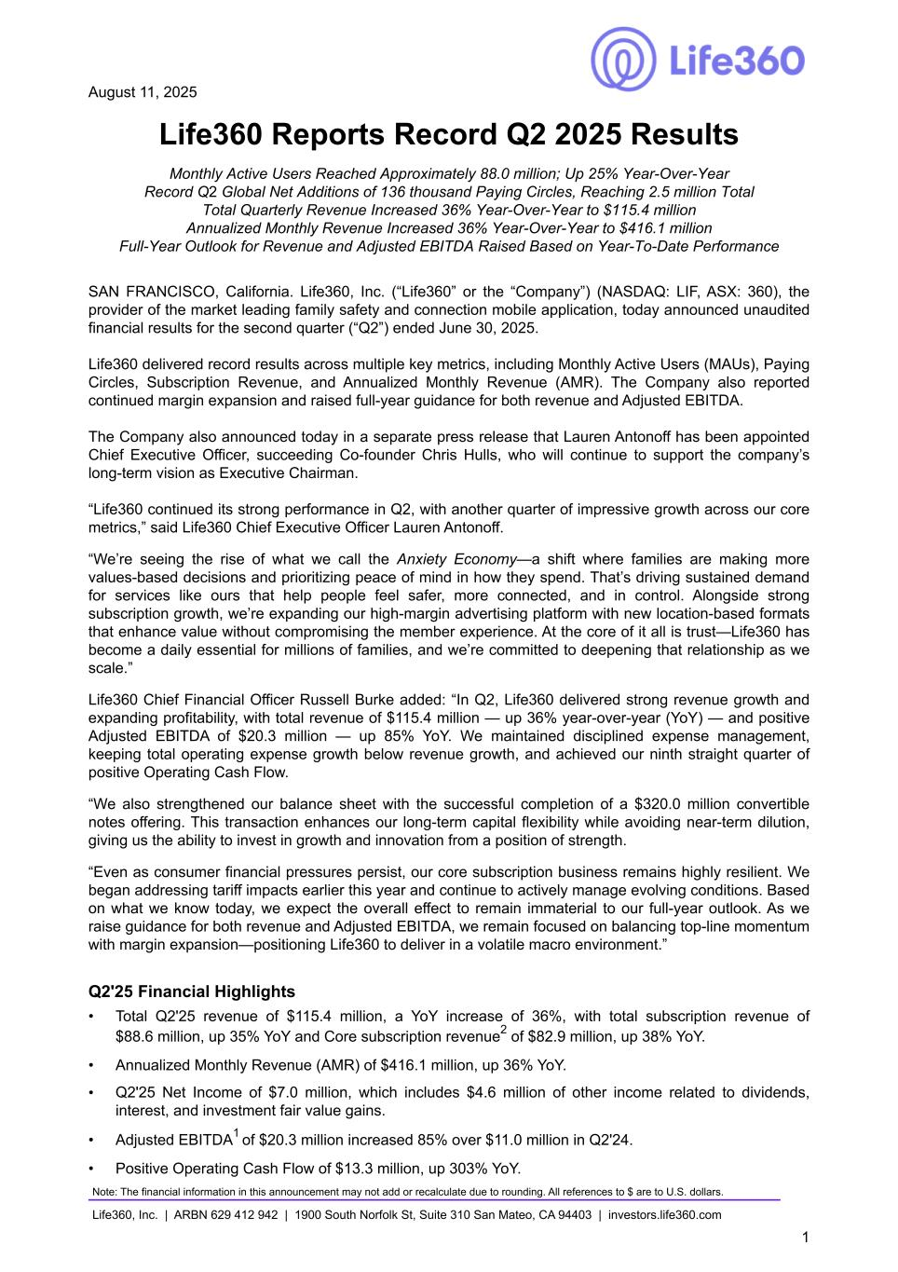

August 11, 2025 Life360 Reports Record Q2 2025 Results Monthly Active Users Reached Approximately 88.0 million; Up 25% Year-Over-Year Record Q2 Global Net Additions of 136 thousand Paying Circles, Reaching 2.5 million Total Total Quarterly Revenue Increased 36% Year-Over-Year to $115.4 million Annualized Monthly Revenue Increased 36% Year-Over-Year to $416.1 million Full-Year Outlook for Revenue and Adjusted EBITDA Raised Based on Year-To-Date Performance SAN FRANCISCO, California. Life360, Inc. (“Life360” or the “Company”) (NASDAQ: LIF, ASX: 360), the provider of the market leading family safety and connection mobile application, today announced unaudited financial results for the second quarter (“Q2”) ended June 30, 2025. Life360 delivered record results across multiple key metrics, including Monthly Active Users (MAUs), Paying Circles, Subscription Revenue, and Annualized Monthly Revenue (AMR). The Company also reported continued margin expansion and raised full-year guidance for both revenue and Adjusted EBITDA. The Company also announced today in a separate press release that Lauren Antonoff has been appointed Chief Executive Officer, succeeding Co-founder Chris Hulls, who will continue to support the company’s long-term vision as Executive Chairman. “Life360 continued its strong performance in Q2, with another quarter of impressive growth across our core metrics,” said Life360 Chief Executive Officer Lauren Antonoff. “We’re seeing the rise of what we call the Anxiety Economy—a shift where families are making more values-based decisions and prioritizing peace of mind in how they spend. That’s driving sustained demand for services like ours that help people feel safer, more connected, and in control. Alongside strong subscription growth, we’re expanding our high-margin advertising platform with new location-based formats that enhance value without compromising the member experience. At the core of it all is trust—Life360 has become a daily essential for millions of families, and we’re committed to deepening that relationship as we scale.” Life360 Chief Financial Officer Russell Burke added: “In Q2, Life360 delivered strong revenue growth and expanding profitability, with total revenue of $115.4 million — up 36% year-over-year (YoY) — and positive Adjusted EBITDA of $20.3 million — up 85% YoY. We maintained disciplined expense management, keeping total operating expense growth below revenue growth, and achieved our ninth straight quarter of positive Operating Cash Flow. “We also strengthened our balance sheet with the successful completion of a $320.0 million convertible notes offering. This transaction enhances our long-term capital flexibility while avoiding near-term dilution, giving us the ability to invest in growth and innovation from a position of strength. “Even as consumer financial pressures persist, our core subscription business remains highly resilient. We began addressing tariff impacts earlier this year and continue to actively manage evolving conditions. Based on what we know today, we expect the overall effect to remain immaterial to our full-year outlook. As we raise guidance for both revenue and Adjusted EBITDA, we remain focused on balancing top-line momentum with margin expansion—positioning Life360 to deliver in a volatile macro environment.” Q2'25 Financial Highlights • Total Q2'25 revenue of $115.4 million, a YoY increase of 36%, with total subscription revenue of $88.6 million, up 35% YoY and Core subscription revenue2 of $82.9 million, up 38% YoY. • Annualized Monthly Revenue (AMR) of $416.1 million, up 36% YoY. • Q2'25 Net Income of $7.0 million, which includes $4.6 million of other income related to dividends, interest, and investment fair value gains. • Adjusted EBITDA1 of $20.3 million increased 85% over $11.0 million in Q2'24. • Positive Operating Cash Flow of $13.3 million, up 303% YoY. Note: The financial information in this announcement may not add or recalculate due to rounding. All references to $ are to U.S. dollars. Life360, Inc. | ARBN 629 412 942 | 1900 South Norfolk St, Suite 310 San Mateo, CA 94403 | investors.life360.com 1

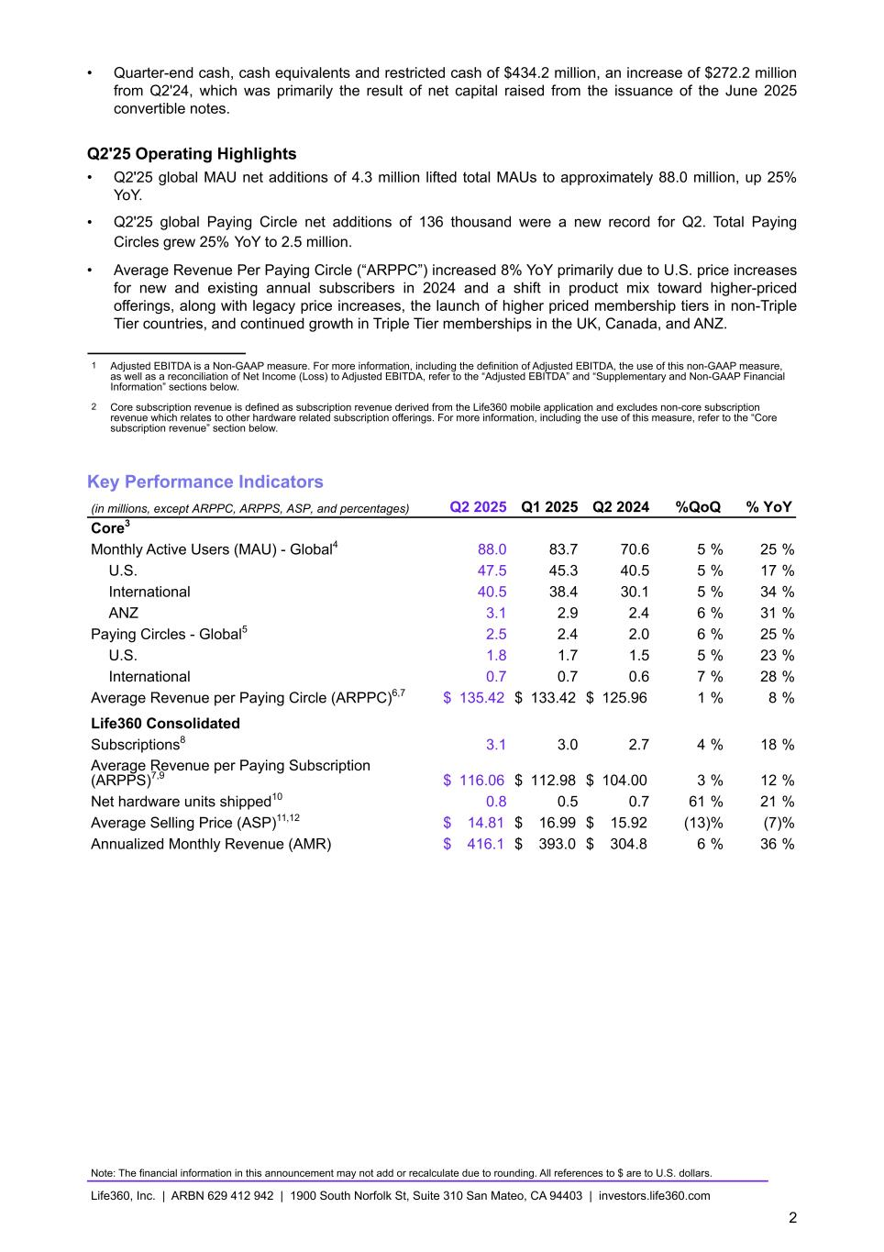
• Quarter-end cash, cash equivalents and restricted cash of $434.2 million, an increase of $272.2 million from Q2'24, which was primarily the result of net capital raised from the issuance of the June 2025 convertible notes. Q2'25 Operating Highlights • Q2'25 global MAU net additions of 4.3 million lifted total MAUs to approximately 88.0 million, up 25% YoY. • Q2'25 global Paying Circle net additions of 136 thousand were a new record for Q2. Total Paying Circles grew 25% YoY to 2.5 million. • Average Revenue Per Paying Circle (“ARPPC”) increased 8% YoY primarily due to U.S. price increases for new and existing annual subscribers in 2024 and a shift in product mix toward higher-priced offerings, along with legacy price increases, the launch of higher priced membership tiers in non-Triple Tier countries, and continued growth in Triple Tier memberships in the UK, Canada, and ANZ. 1 Adjusted EBITDA is a Non-GAAP measure. For more information, including the definition of Adjusted EBITDA, the use of this non-GAAP measure, as well as a reconciliation of Net Income (Loss) to Adjusted EBITDA, refer to the “Adjusted EBITDA” and “Supplementary and Non-GAAP Financial Information” sections below. 2 Core subscription revenue is defined as subscription revenue derived from the Life360 mobile application and excludes non-core subscription revenue which relates to other hardware related subscription offerings. For more information, including the use of this measure, refer to the “Core subscription revenue” section below. Key Performance Indicators (in millions, except ARPPC, ARPPS, ASP, and percentages) Q2 2025 Q1 2025 Q2 2024 %QoQ % YoY Core3 Monthly Active Users (MAU) - Global4 88.0 83.7 70.6 5 % 25 % U.S. 47.5 45.3 40.5 5 % 17 % International 40.5 38.4 30.1 5 % 34 % ANZ 3.1 2.9 2.4 6 % 31 % Paying Circles - Global5 2.5 2.4 2.0 6 % 25 % U.S. 1.8 1.7 1.5 5 % 23 % International 0.7 0.7 0.6 7 % 28 % Average Revenue per Paying Circle (ARPPC)6,7 $ 135.42 $ 133.42 $ 125.96 1 % 8 % Life360 Consolidated Subscriptions8 3.1 3.0 2.7 4 % 18 % Average Revenue per Paying Subscription (ARPPS)7,9 $ 116.06 $ 112.98 $ 104.00 3 % 12 % Net hardware units shipped10 0.8 0.5 0.7 61 % 21 % Average Selling Price (ASP)11,12 $ 14.81 $ 16.99 $ 15.92 (13) % (7) % Annualized Monthly Revenue (AMR) $ 416.1 $ 393.0 $ 304.8 6 % 36 % Note: The financial information in this announcement may not add or recalculate due to rounding. All references to $ are to U.S. dollars. Life360, Inc. | ARBN 629 412 942 | 1900 South Norfolk St, Suite 310 San Mateo, CA 94403 | investors.life360.com 2

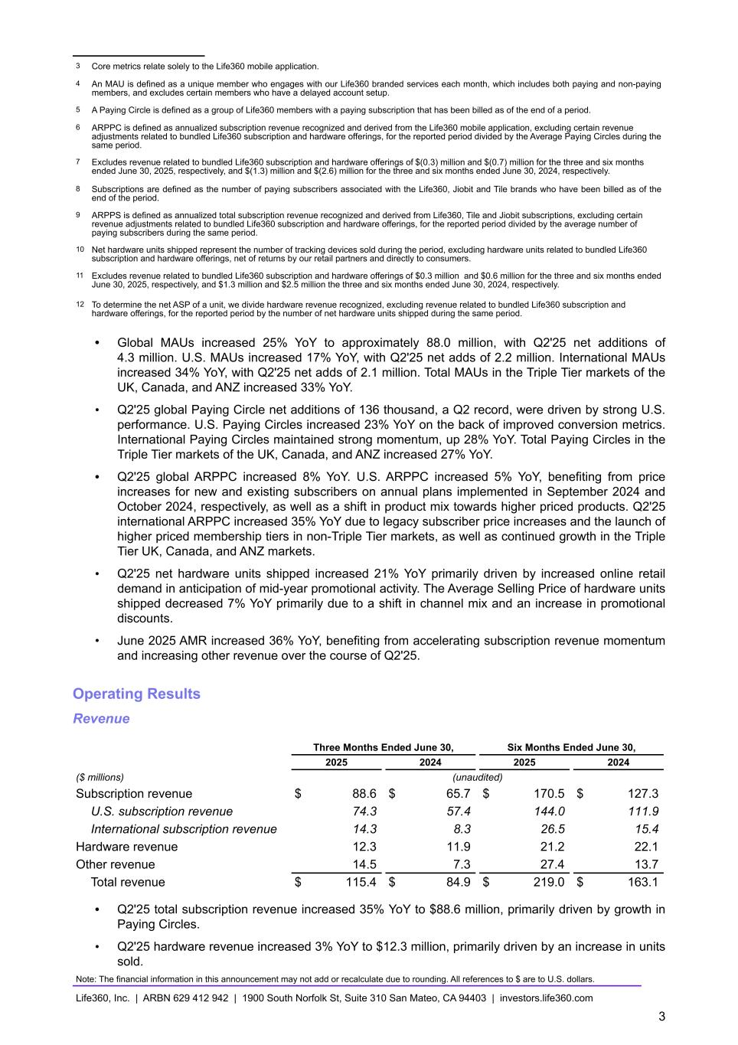
3 Core metrics relate solely to the Life360 mobile application. 4 An MAU is defined as a unique member who engages with our Life360 branded services each month, which includes both paying and non-paying members, and excludes certain members who have a delayed account setup. 5 A Paying Circle is defined as a group of Life360 members with a paying subscription that has been billed as of the end of a period. 6 ARPPC is defined as annualized subscription revenue recognized and derived from the Life360 mobile application, excluding certain revenue adjustments related to bundled Life360 subscription and hardware offerings, for the reported period divided by the Average Paying Circles during the same period. 7 Excludes revenue related to bundled Life360 subscription and hardware offerings of $(0.3) million and $(0.7) million for the three and six months ended June 30, 2025, respectively, and $(1.3) million and $(2.6) million for the three and six months ended June 30, 2024, respectively. 8 Subscriptions are defined as the number of paying subscribers associated with the Life360, Jiobit and Tile brands who have been billed as of the end of the period. 9 ARPPS is defined as annualized total subscription revenue recognized and derived from Life360, Tile and Jiobit subscriptions, excluding certain revenue adjustments related to bundled Life360 subscription and hardware offerings, for the reported period divided by the average number of paying subscribers during the same period. 10 Net hardware units shipped represent the number of tracking devices sold during the period, excluding hardware units related to bundled Life360 subscription and hardware offerings, net of returns by our retail partners and directly to consumers. 11 Excludes revenue related to bundled Life360 subscription and hardware offerings of $0.3 million and $0.6 million for the three and six months ended June 30, 2025, respectively, and $1.3 million and $2.5 million the three and six months ended June 30, 2024, respectively. 12 To determine the net ASP of a unit, we divide hardware revenue recognized, excluding revenue related to bundled Life360 subscription and hardware offerings, for the reported period by the number of net hardware units shipped during the same period. • Global MAUs increased 25% YoY to approximately 88.0 million, with Q2'25 net additions of 4.3 million. U.S. MAUs increased 17% YoY, with Q2'25 net adds of 2.2 million. International MAUs increased 34% YoY, with Q2'25 net adds of 2.1 million. Total MAUs in the Triple Tier markets of the UK, Canada, and ANZ increased 33% YoY. • Q2'25 global Paying Circle net additions of 136 thousand, a Q2 record, were driven by strong U.S. performance. U.S. Paying Circles increased 23% YoY on the back of improved conversion metrics. International Paying Circles maintained strong momentum, up 28% YoY. Total Paying Circles in the Triple Tier markets of the UK, Canada, and ANZ increased 27% YoY. • Q2'25 global ARPPC increased 8% YoY. U.S. ARPPC increased 5% YoY, benefiting from price increases for new and existing subscribers on annual plans implemented in September 2024 and October 2024, respectively, as well as a shift in product mix towards higher priced products. Q2'25 international ARPPC increased 35% YoY due to legacy subscriber price increases and the launch of higher priced membership tiers in non-Triple Tier markets, as well as continued growth in the Triple Tier UK, Canada, and ANZ markets. • Q2'25 net hardware units shipped increased 21% YoY primarily driven by increased online retail demand in anticipation of mid-year promotional activity. The Average Selling Price of hardware units shipped decreased 7% YoY primarily due to a shift in channel mix and an increase in promotional discounts. • June 2025 AMR increased 36% YoY, benefiting from accelerating subscription revenue momentum and increasing other revenue over the course of Q2'25. Operating Results Revenue Three Months Ended June 30, Six Months Ended June 30, 2025 2024 2025 2024 ($ millions) (unaudited) Subscription revenue $ 88.6 $ 65.7 $ 170.5 $ 127.3 U.S. subscription revenue 74.3 57.4 144.0 111.9 International subscription revenue 14.3 8.3 26.5 15.4 Hardware revenue 12.3 11.9 21.2 22.1 Other revenue 14.5 7.3 27.4 13.7 Total revenue $ 115.4 $ 84.9 $ 219.0 $ 163.1 • Q2'25 total subscription revenue increased 35% YoY to $88.6 million, primarily driven by growth in Paying Circles. • Q2'25 hardware revenue increased 3% YoY to $12.3 million, primarily driven by an increase in units sold. Note: The financial information in this announcement may not add or recalculate due to rounding. All references to $ are to U.S. dollars. Life360, Inc. | ARBN 629 412 942 | 1900 South Norfolk St, Suite 310 San Mateo, CA 94403 | investors.life360.com 3

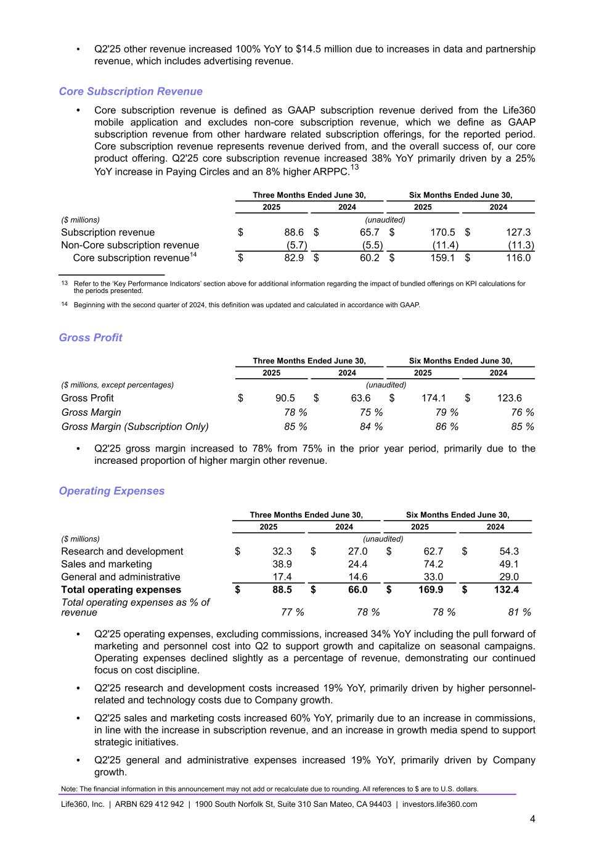
• Q2'25 other revenue increased 100% YoY to $14.5 million due to increases in data and partnership revenue, which includes advertising revenue. Core Subscription Revenue • Core subscription revenue is defined as GAAP subscription revenue derived from the Life360 mobile application and excludes non-core subscription revenue, which we define as GAAP subscription revenue from other hardware related subscription offerings, for the reported period. Core subscription revenue represents revenue derived from, and the overall success of, our core product offering. Q2'25 core subscription revenue increased 38% YoY primarily driven by a 25% YoY increase in Paying Circles and an 8% higher ARPPC.13 Three Months Ended June 30, Six Months Ended June 30, 2025 2024 2025 2024 ($ millions) (unaudited) Subscription revenue $ 88.6 $ 65.7 $ 170.5 $ 127.3 Non-Core subscription revenue (5.7) (5.5) (11.4) (11.3) Core subscription revenue14 $ 82.9 $ 60.2 $ 159.1 $ 116.0 13 Refer to the ‘Key Performance Indicators’ section above for additional information regarding the impact of bundled offerings on KPI calculations for the periods presented. 14 Beginning with the second quarter of 2024, this definition was updated and calculated in accordance with GAAP. Gross Profit Three Months Ended June 30, Six Months Ended June 30, 2025 2024 2025 2024 ($ millions, except percentages) (unaudited) Gross Profit $ 90.5 $ 63.6 $ 174.1 $ 123.6 Gross Margin 78 % 75 % 79 % 76 % Gross Margin (Subscription Only) 85 % 84 % 86 % 85 % • Q2'25 gross margin increased to 78% from 75% in the prior year period, primarily due to the increased proportion of higher margin other revenue. Operating Expenses Three Months Ended June 30, Six Months Ended June 30, 2025 2024 2025 2024 ($ millions) (unaudited) Research and development $ 32.3 $ 27.0 $ 62.7 $ 54.3 Sales and marketing 38.9 24.4 74.2 49.1 General and administrative 17.4 14.6 33.0 29.0 Total operating expenses $ 88.5 $ 66.0 $ 169.9 $ 132.4 Total operating expenses as % of revenue 77 % 78 % 78 % 81 % • Q2'25 operating expenses, excluding commissions, increased 34% YoY including the pull forward of marketing and personnel cost into Q2 to support growth and capitalize on seasonal campaigns. Operating expenses declined slightly as a percentage of revenue, demonstrating our continued focus on cost discipline. • Q2'25 research and development costs increased 19% YoY, primarily driven by higher personnel- related and technology costs due to Company growth. • Q2'25 sales and marketing costs increased 60% YoY, primarily due to an increase in commissions, in line with the increase in subscription revenue, and an increase in growth media spend to support strategic initiatives. • Q2'25 general and administrative expenses increased 19% YoY, primarily driven by Company growth. Note: The financial information in this announcement may not add or recalculate due to rounding. All references to $ are to U.S. dollars. Life360, Inc. | ARBN 629 412 942 | 1900 South Norfolk St, Suite 310 San Mateo, CA 94403 | investors.life360.com 4

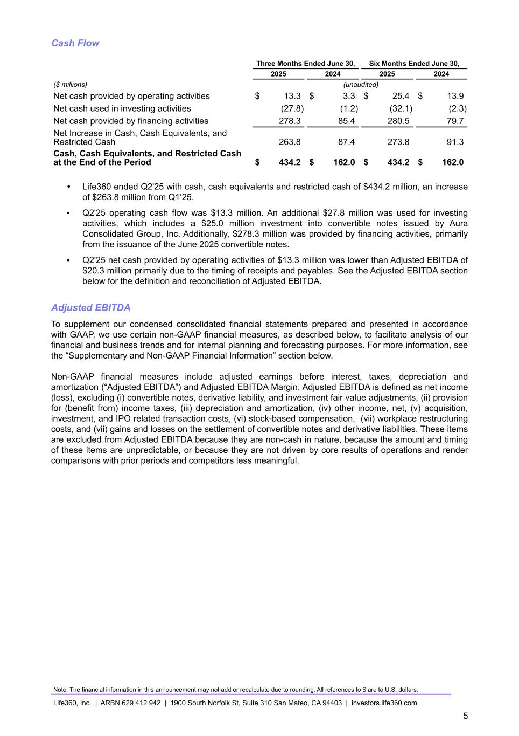
Cash Flow Three Months Ended June 30, Six Months Ended June 30, 2025 2024 2025 2024 ($ millions) (unaudited) Net cash provided by operating activities $ 13.3 $ 3.3 $ 25.4 $ 13.9 Net cash used in investing activities (27.8) (1.2) (32.1) (2.3) Net cash provided by financing activities 278.3 85.4 280.5 79.7 Net Increase in Cash, Cash Equivalents, and Restricted Cash 263.8 87.4 273.8 91.3 Cash, Cash Equivalents, and Restricted Cash at the End of the Period $ 434.2 $ 162.0 $ 434.2 $ 162.0 • Life360 ended Q2'25 with cash, cash equivalents and restricted cash of $434.2 million, an increase of $263.8 million from Q1’25. • Q2'25 operating cash flow was $13.3 million. An additional $27.8 million was used for investing activities, which includes a $25.0 million investment into convertible notes issued by Aura Consolidated Group, Inc. Additionally, $278.3 million was provided by financing activities, primarily from the issuance of the June 2025 convertible notes. • Q2'25 net cash provided by operating activities of $13.3 million was lower than Adjusted EBITDA of $20.3 million primarily due to the timing of receipts and payables. See the Adjusted EBITDA section below for the definition and reconciliation of Adjusted EBITDA. Adjusted EBITDA To supplement our condensed consolidated financial statements prepared and presented in accordance with GAAP, we use certain non-GAAP financial measures, as described below, to facilitate analysis of our financial and business trends and for internal planning and forecasting purposes. For more information, see the “Supplementary and Non-GAAP Financial Information” section below. Non-GAAP financial measures include adjusted earnings before interest, taxes, depreciation and amortization (“Adjusted EBITDA”) and Adjusted EBITDA Margin. Adjusted EBITDA is defined as net income (loss), excluding (i) convertible notes, derivative liability, and investment fair value adjustments, (ii) provision for (benefit from) income taxes, (iii) depreciation and amortization, (iv) other income, net, (v) acquisition, investment, and IPO related transaction costs, (vi) stock-based compensation, (vii) workplace restructuring costs, and (vii) gains and losses on the settlement of convertible notes and derivative liabilities. These items are excluded from Adjusted EBITDA because they are non-cash in nature, because the amount and timing of these items are unpredictable, or because they are not driven by core results of operations and render comparisons with prior periods and competitors less meaningful. Note: The financial information in this announcement may not add or recalculate due to rounding. All references to $ are to U.S. dollars. Life360, Inc. | ARBN 629 412 942 | 1900 South Norfolk St, Suite 310 San Mateo, CA 94403 | investors.life360.com 5

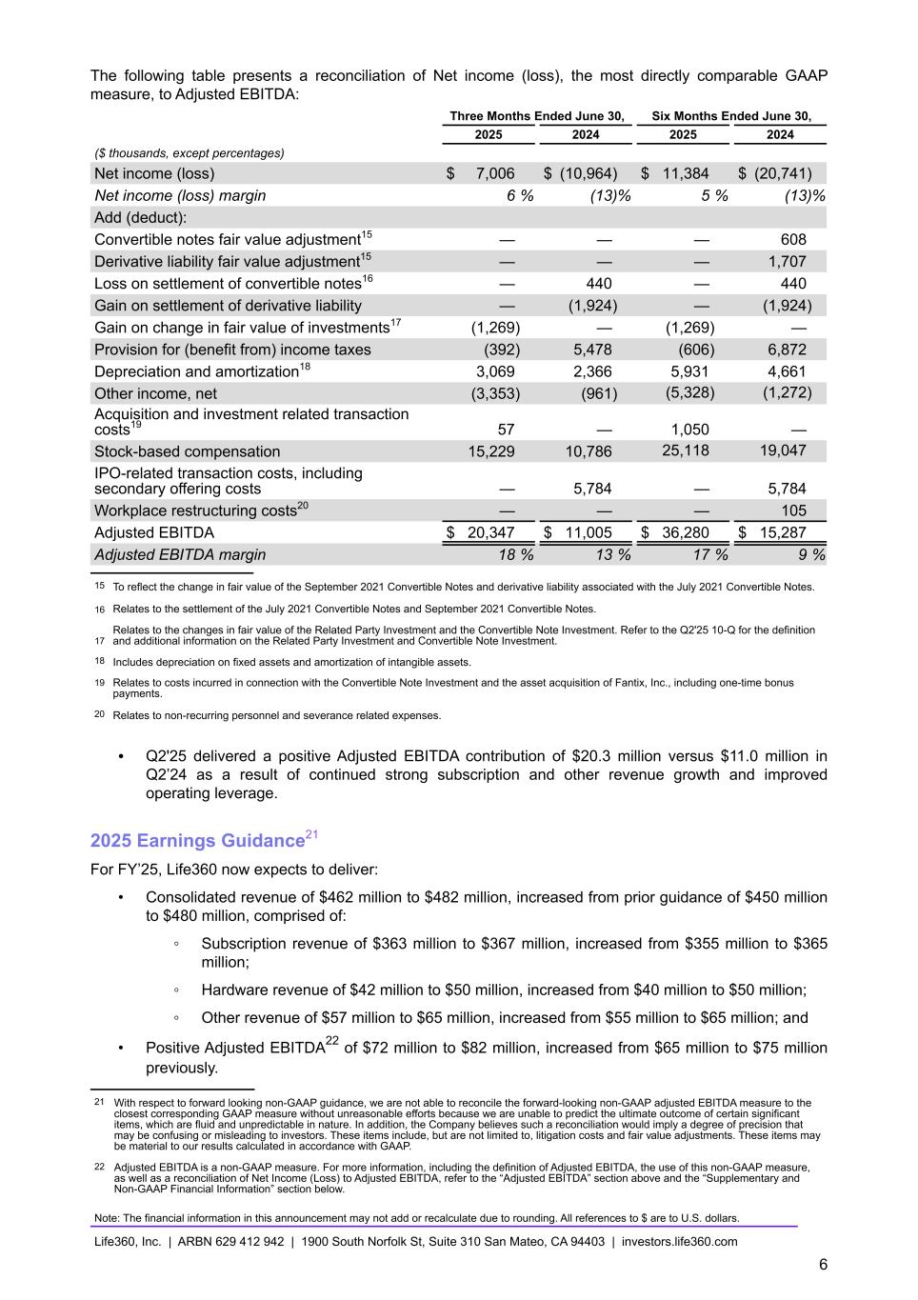
The following table presents a reconciliation of Net income (loss), the most directly comparable GAAP measure, to Adjusted EBITDA: Three Months Ended June 30, Six Months Ended June 30, 2025 2024 2025 2024 ($ thousands, except percentages) Net income (loss) $ 7,006 $ (10,964) $ 11,384 $ (20,741) Net income (loss) margin 6 % (13) % 5 % (13) % Add (deduct): Convertible notes fair value adjustment15 — — — 608 Derivative liability fair value adjustment15 — — — 1,707 Loss on settlement of convertible notes16 — 440 — 440 Gain on settlement of derivative liability — (1,924) — (1,924) Gain on change in fair value of investments17 (1,269) — (1,269) — Provision for (benefit from) income taxes (392) 5,478 (606) 6,872 Depreciation and amortization18 3,069 2,366 5,931 4,661 Other income, net (3,353) (961) (5,328) (1,272) Acquisition and investment related transaction costs19 57 — 1,050 — Stock-based compensation 15,229 10,786 25,118 19,047 IPO-related transaction costs, including secondary offering costs — 5,784 — 5,784 Workplace restructuring costs20 — — — 105 Adjusted EBITDA $ 20,347 $ 11,005 $ 36,280 $ 15,287 Adjusted EBITDA margin 18 % 13 % 17 % 9 % 15 To reflect the change in fair value of the September 2021 Convertible Notes and derivative liability associated with the July 2021 Convertible Notes. 16 Relates to the settlement of the July 2021 Convertible Notes and September 2021 Convertible Notes. 17 Relates to the changes in fair value of the Related Party Investment and the Convertible Note Investment. Refer to the Q2'25 10-Q for the definition and additional information on the Related Party Investment and Convertible Note Investment. 18 Includes depreciation on fixed assets and amortization of intangible assets. 19 Relates to costs incurred in connection with the Convertible Note Investment and the asset acquisition of Fantix, Inc., including one-time bonus payments. 20 Relates to non-recurring personnel and severance related expenses. • Q2'25 delivered a positive Adjusted EBITDA contribution of $20.3 million versus $11.0 million in Q2’24 as a result of continued strong subscription and other revenue growth and improved operating leverage. 2025 Earnings Guidance21 For FY’25, Life360 now expects to deliver: • Consolidated revenue of $462 million to $482 million, increased from prior guidance of $450 million to $480 million, comprised of: ◦ Subscription revenue of $363 million to $367 million, increased from $355 million to $365 million; ◦ Hardware revenue of $42 million to $50 million, increased from $40 million to $50 million; ◦ Other revenue of $57 million to $65 million, increased from $55 million to $65 million; and • Positive Adjusted EBITDA22 of $72 million to $82 million, increased from $65 million to $75 million previously. 21 With respect to forward looking non-GAAP guidance, we are not able to reconcile the forward-looking non-GAAP adjusted EBITDA measure to the closest corresponding GAAP measure without unreasonable efforts because we are unable to predict the ultimate outcome of certain significant items, which are fluid and unpredictable in nature. In addition, the Company believes such a reconciliation would imply a degree of precision that may be confusing or misleading to investors. These items include, but are not limited to, litigation costs and fair value adjustments. These items may be material to our results calculated in accordance with GAAP. 22 Adjusted EBITDA is a non-GAAP measure. For more information, including the definition of Adjusted EBITDA, the use of this non-GAAP measure, as well as a reconciliation of Net Income (Loss) to Adjusted EBITDA, refer to the “Adjusted EBITDA” section above and the “Supplementary and Non-GAAP Financial Information” section below. Note: The financial information in this announcement may not add or recalculate due to rounding. All references to $ are to U.S. dollars. Life360, Inc. | ARBN 629 412 942 | 1900 South Norfolk St, Suite 310 San Mateo, CA 94403 | investors.life360.com 6

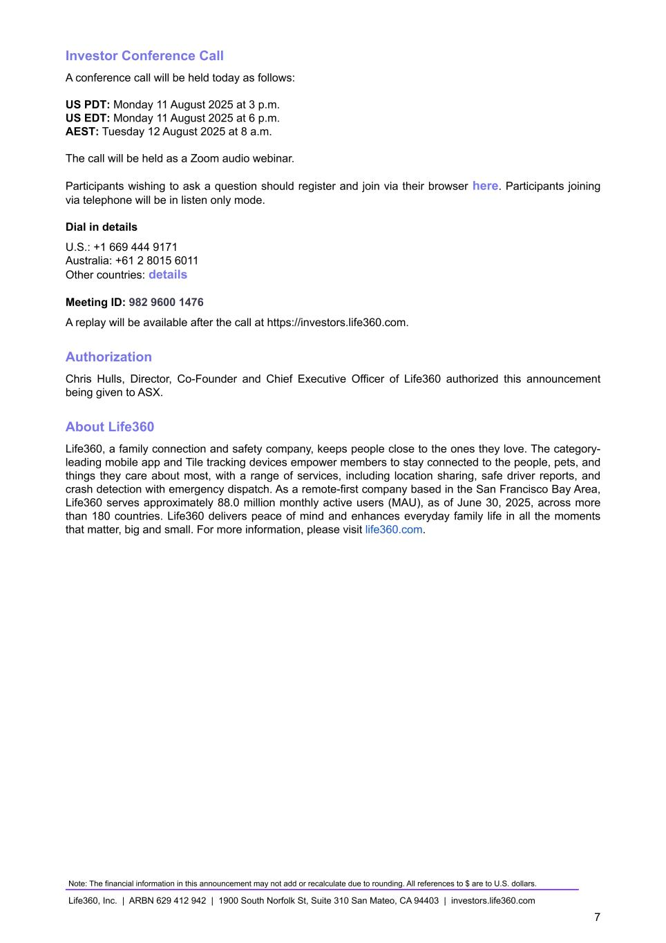
Investor Conference Call A conference call will be held today as follows: US PDT: Monday 11 August 2025 at 3 p.m. US EDT: Monday 11 August 2025 at 6 p.m. AEST: Tuesday 12 August 2025 at 8 a.m. The call will be held as a Zoom audio webinar. Participants wishing to ask a question should register and join via their browser here. Participants joining via telephone will be in listen only mode. Dial in details U.S.: +1 669 444 9171 Australia: +61 2 8015 6011 Other countries: details Meeting ID: 982 9600 1476 A replay will be available after the call at https://investors.life360.com. Authorization Chris Hulls, Director, Co-Founder and Chief Executive Officer of Life360 authorized this announcement being given to ASX. About Life360 Life360, a family connection and safety company, keeps people close to the ones they love. The category- leading mobile app and Tile tracking devices empower members to stay connected to the people, pets, and things they care about most, with a range of services, including location sharing, safe driver reports, and crash detection with emergency dispatch. As a remote-first company based in the San Francisco Bay Area, Life360 serves approximately 88.0 million monthly active users (MAU), as of June 30, 2025, across more than 180 countries. Life360 delivers peace of mind and enhances everyday family life in all the moments that matter, big and small. For more information, please visit life360.com. Note: The financial information in this announcement may not add or recalculate due to rounding. All references to $ are to U.S. dollars. Life360, Inc. | ARBN 629 412 942 | 1900 South Norfolk St, Suite 310 San Mateo, CA 94403 | investors.life360.com 7

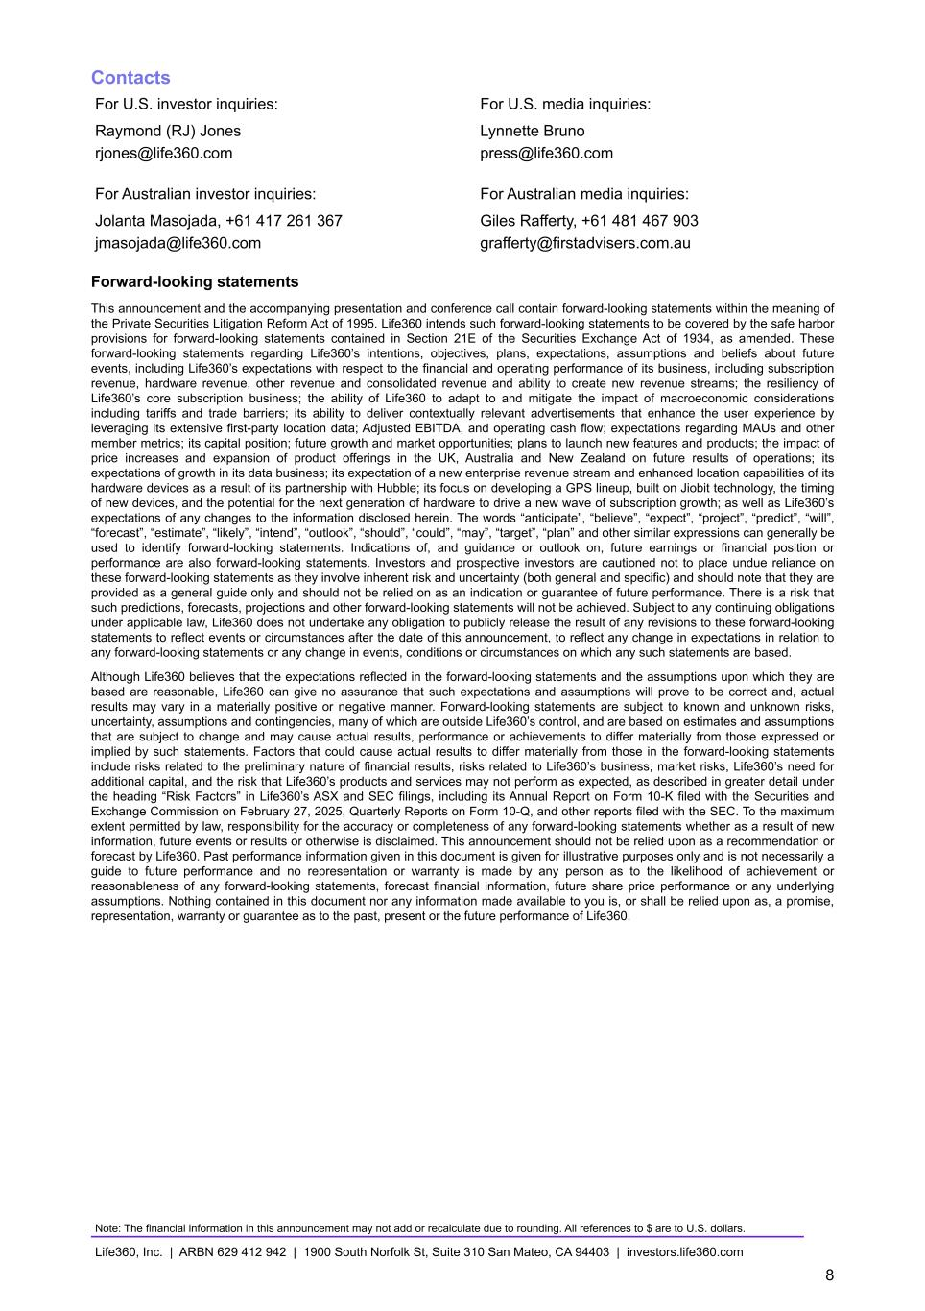
Contacts For U.S. investor inquiries: For U.S. media inquiries: Raymond (RJ) Jones Lynnette Bruno rjones@life360.com press@life360.com For Australian investor inquiries: For Australian media inquiries: Jolanta Masojada, +61 417 261 367 Giles Rafferty, +61 481 467 903 jmasojada@life360.com grafferty@firstadvisers.com.au Forward-looking statements This announcement and the accompanying presentation and conference call contain forward-looking statements within the meaning of the Private Securities Litigation Reform Act of 1995. Life360 intends such forward-looking statements to be covered by the safe harbor provisions for forward-looking statements contained in Section 21E of the Securities Exchange Act of 1934, as amended. These forward-looking statements regarding Life360’s intentions, objectives, plans, expectations, assumptions and beliefs about future events, including Life360’s expectations with respect to the financial and operating performance of its business, including subscription revenue, hardware revenue, other revenue and consolidated revenue and ability to create new revenue streams; the resiliency of Life360’s core subscription business; the ability of Life360 to adapt to and mitigate the impact of macroeconomic considerations including tariffs and trade barriers; its ability to deliver contextually relevant advertisements that enhance the user experience by leveraging its extensive first-party location data; Adjusted EBITDA, and operating cash flow; expectations regarding MAUs and other member metrics; its capital position; future growth and market opportunities; plans to launch new features and products; the impact of price increases and expansion of product offerings in the UK, Australia and New Zealand on future results of operations; its expectations of growth in its data business; its expectation of a new enterprise revenue stream and enhanced location capabilities of its hardware devices as a result of its partnership with Hubble; its focus on developing a GPS lineup, built on Jiobit technology, the timing of new devices, and the potential for the next generation of hardware to drive a new wave of subscription growth; as well as Life360’s expectations of any changes to the information disclosed herein. The words “anticipate”, “believe”, “expect”, “project”, “predict”, “will”, “forecast”, “estimate”, “likely”, “intend”, “outlook”, “should”, “could”, “may”, “target”, “plan” and other similar expressions can generally be used to identify forward-looking statements. Indications of, and guidance or outlook on, future earnings or financial position or performance are also forward-looking statements. Investors and prospective investors are cautioned not to place undue reliance on these forward-looking statements as they involve inherent risk and uncertainty (both general and specific) and should note that they are provided as a general guide only and should not be relied on as an indication or guarantee of future performance. There is a risk that such predictions, forecasts, projections and other forward-looking statements will not be achieved. Subject to any continuing obligations under applicable law, Life360 does not undertake any obligation to publicly release the result of any revisions to these forward-looking statements to reflect events or circumstances after the date of this announcement, to reflect any change in expectations in relation to any forward-looking statements or any change in events, conditions or circumstances on which any such statements are based. Although Life360 believes that the expectations reflected in the forward-looking statements and the assumptions upon which they are based are reasonable, Life360 can give no assurance that such expectations and assumptions will prove to be correct and, actual results may vary in a materially positive or negative manner. Forward-looking statements are subject to known and unknown risks, uncertainty, assumptions and contingencies, many of which are outside Life360’s control, and are based on estimates and assumptions that are subject to change and may cause actual results, performance or achievements to differ materially from those expressed or implied by such statements. Factors that could cause actual results to differ materially from those in the forward-looking statements include risks related to the preliminary nature of financial results, risks related to Life360’s business, market risks, Life360’s need for additional capital, and the risk that Life360’s products and services may not perform as expected, as described in greater detail under the heading “Risk Factors” in Life360’s ASX and SEC filings, including its Annual Report on Form 10-K filed with the Securities and Exchange Commission on February 27, 2025, Quarterly Reports on Form 10-Q, and other reports filed with the SEC. To the maximum extent permitted by law, responsibility for the accuracy or completeness of any forward-looking statements whether as a result of new information, future events or results or otherwise is disclaimed. This announcement should not be relied upon as a recommendation or forecast by Life360. Past performance information given in this document is given for illustrative purposes only and is not necessarily a guide to future performance and no representation or warranty is made by any person as to the likelihood of achievement or reasonableness of any forward-looking statements, forecast financial information, future share price performance or any underlying assumptions. Nothing contained in this document nor any information made available to you is, or shall be relied upon as, a promise, representation, warranty or guarantee as to the past, present or the future performance of Life360. Note: The financial information in this announcement may not add or recalculate due to rounding. All references to $ are to U.S. dollars. Life360, Inc. | ARBN 629 412 942 | 1900 South Norfolk St, Suite 310 San Mateo, CA 94403 | investors.life360.com 8

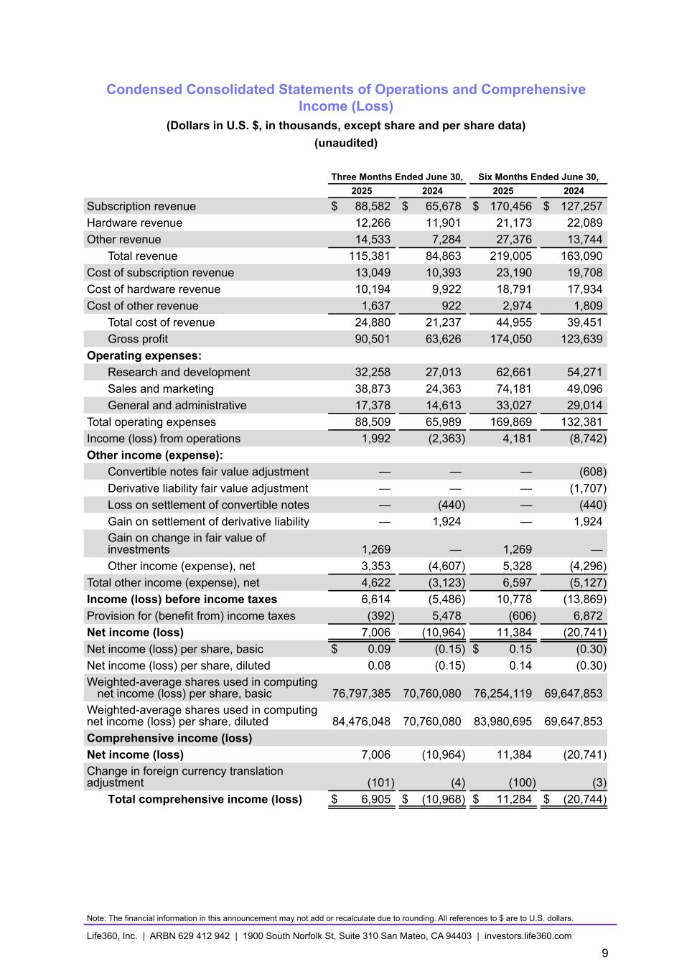
Condensed Consolidated Statements of Operations and Comprehensive Income (Loss) (Dollars in U.S. $, in thousands, except share and per share data) (unaudited) Three Months Ended June 30, Six Months Ended June 30, 2025 2024 2025 2024 Subscription revenue $ 88,582 $ 65,678 $ 170,456 $ 127,257 Hardware revenue 12,266 11,901 21,173 22,089 Other revenue 14,533 7,284 27,376 13,744 Total revenue 115,381 84,863 219,005 163,090 Cost of subscription revenue 13,049 10,393 23,190 19,708 Cost of hardware revenue 10,194 9,922 18,791 17,934 Cost of other revenue 1,637 922 2,974 1,809 Total cost of revenue 24,880 21,237 44,955 39,451 Gross profit 90,501 63,626 174,050 123,639 Operating expenses: Research and development 32,258 27,013 62,661 54,271 Sales and marketing 38,873 24,363 74,181 49,096 General and administrative 17,378 14,613 33,027 29,014 Total operating expenses 88,509 65,989 169,869 132,381 Income (loss) from operations 1,992 (2,363) 4,181 (8,742) Other income (expense): Convertible notes fair value adjustment — — — (608) Derivative liability fair value adjustment — — — (1,707) Loss on settlement of convertible notes — (440) — (440) Gain on settlement of derivative liability — 1,924 — 1,924 Gain on change in fair value of investments 1,269 — 1,269 — Other income (expense), net 3,353 (4,607) 5,328 (4,296) Total other income (expense), net 4,622 (3,123) 6,597 (5,127) Income (loss) before income taxes 6,614 (5,486) 10,778 (13,869) Provision for (benefit from) income taxes (392) 5,478 (606) 6,872 Net income (loss) 7,006 — (10,964) 11,384 (20,741) Net income (loss) per share, basic $ 0.09 (0.15) $ 0.15 (0.30) Net income (loss) per share, diluted 0.08 (0.15) 0.14 (0.30) Weighted-average shares used in computing net income (loss) per share, basic 76,797,385 70,760,080 76,254,119 69,647,853 Weighted-average shares used in computing net income (loss) per share, diluted 84,476,048 70,760,080 83,980,695 69,647,853 Comprehensive income (loss) Net income (loss) 7,006 (10,964) 11,384 (20,741) Change in foreign currency translation adjustment (101) (4) (100) (3) Total comprehensive income (loss) $ 6,905 $ (10,968) $ 11,284 $ (20,744) Note: The financial information in this announcement may not add or recalculate due to rounding. All references to $ are to U.S. dollars. Life360, Inc. | ARBN 629 412 942 | 1900 South Norfolk St, Suite 310 San Mateo, CA 94403 | investors.life360.com 9

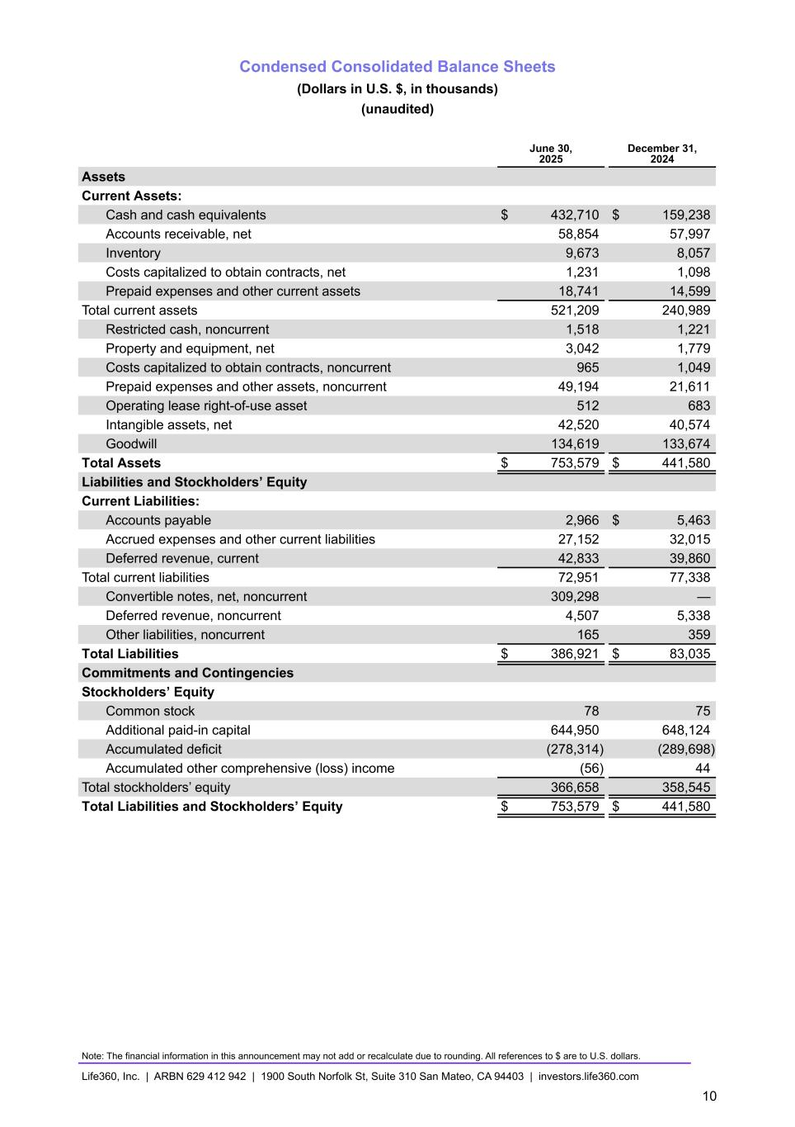
Condensed Consolidated Balance Sheets (Dollars in U.S. $, in thousands) (unaudited) June 30, 2025 December 31, 2024 Assets Current Assets: Cash and cash equivalents $ 432,710 $ 159,238 Accounts receivable, net 58,854 57,997 Inventory 9,673 8,057 Costs capitalized to obtain contracts, net 1,231 1,098 Prepaid expenses and other current assets 18,741 14,599 Total current assets 521,209 240,989 Restricted cash, noncurrent 1,518 1,221 Property and equipment, net 3,042 1,779 Costs capitalized to obtain contracts, noncurrent 965 1,049 Prepaid expenses and other assets, noncurrent 49,194 21,611 Operating lease right-of-use asset 512 683 Intangible assets, net 42,520 40,574 Goodwill 134,619 133,674 Total Assets $ 753,579 $ 441,580 Liabilities and Stockholders’ Equity Current Liabilities: Accounts payable 2,966 $ 5,463 Accrued expenses and other current liabilities 27,152 32,015 Deferred revenue, current 42,833 39,860 Total current liabilities 72,951 77,338 Convertible notes, net, noncurrent 309,298 — Deferred revenue, noncurrent 4,507 5,338 Other liabilities, noncurrent 165 359 Total Liabilities $ 386,921 $ 83,035 Commitments and Contingencies Stockholders’ Equity Common stock 78 75 Additional paid-in capital 644,950 648,124 Accumulated deficit (278,314) (289,698) Accumulated other comprehensive (loss) income (56) 44 Total stockholders’ equity 366,658 358,545 Total Liabilities and Stockholders’ Equity $ 753,579 $ 441,580 Note: The financial information in this announcement may not add or recalculate due to rounding. All references to $ are to U.S. dollars. Life360, Inc. | ARBN 629 412 942 | 1900 South Norfolk St, Suite 310 San Mateo, CA 94403 | investors.life360.com 10

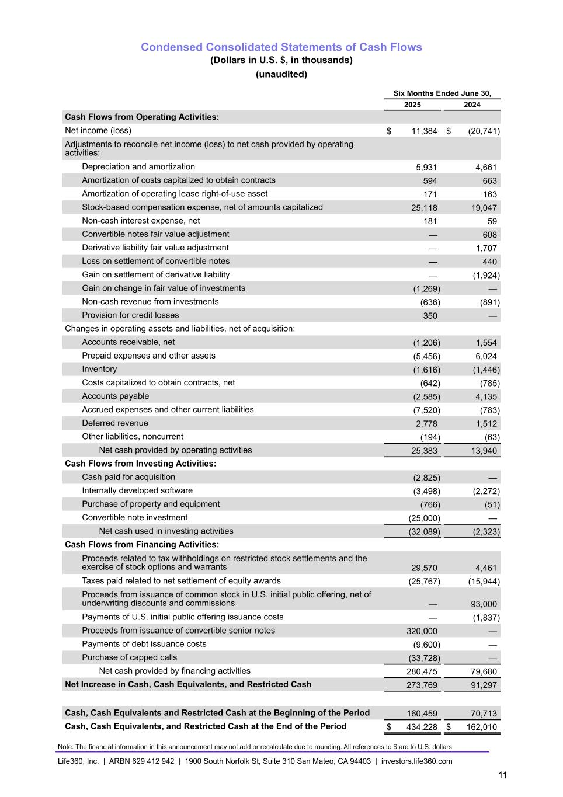
Condensed Consolidated Statements of Cash Flows (Dollars in U.S. $, in thousands) (unaudited) Six Months Ended June 30, 2025 2024 Cash Flows from Operating Activities: Net income (loss) $ 11,384 $ (20,741) Adjustments to reconcile net income (loss) to net cash provided by operating activities: Depreciation and amortization 5,931 4,661 Amortization of costs capitalized to obtain contracts 594 663 Amortization of operating lease right-of-use asset 171 163 Stock-based compensation expense, net of amounts capitalized 25,118 19,047 Non-cash interest expense, net 181 59 Convertible notes fair value adjustment — 608 Derivative liability fair value adjustment — 1,707 Loss on settlement of convertible notes — 440 Gain on settlement of derivative liability — (1,924) Gain on change in fair value of investments (1,269) — Non-cash revenue from investments (636) (891) Provision for credit losses 350 — Changes in operating assets and liabilities, net of acquisition: Accounts receivable, net (1,206) 1,554 Prepaid expenses and other assets (5,456) 6,024 Inventory (1,616) (1,446) Costs capitalized to obtain contracts, net (642) (785) Accounts payable (2,585) 4,135 Accrued expenses and other current liabilities (7,520) (783) Deferred revenue 2,778 1,512 Other liabilities, noncurrent (194) (63) Net cash provided by operating activities 25,383 13,940 Cash Flows from Investing Activities: Cash paid for acquisition (2,825) — Internally developed software (3,498) (2,272) Purchase of property and equipment (766) (51) Convertible note investment (25,000) — Net cash used in investing activities (32,089) (2,323) Cash Flows from Financing Activities: Proceeds related to tax withholdings on restricted stock settlements and the exercise of stock options and warrants 29,570 4,461 Taxes paid related to net settlement of equity awards (25,767) (15,944) Proceeds from issuance of common stock in U.S. initial public offering, net of underwriting discounts and commissions — 93,000 Payments of U.S. initial public offering issuance costs — (1,837) Proceeds from issuance of convertible senior notes 320,000 — Payments of debt issuance costs (9,600) — Purchase of capped calls (33,728) — Net cash provided by financing activities 280,475 79,680 Net Increase in Cash, Cash Equivalents, and Restricted Cash 273,769 91,297 Cash, Cash Equivalents and Restricted Cash at the Beginning of the Period 160,459 70,713 Cash, Cash Equivalents, and Restricted Cash at the End of the Period $ 434,228 $ 162,010 Note: The financial information in this announcement may not add or recalculate due to rounding. All references to $ are to U.S. dollars. Life360, Inc. | ARBN 629 412 942 | 1900 South Norfolk St, Suite 310 San Mateo, CA 94403 | investors.life360.com 11

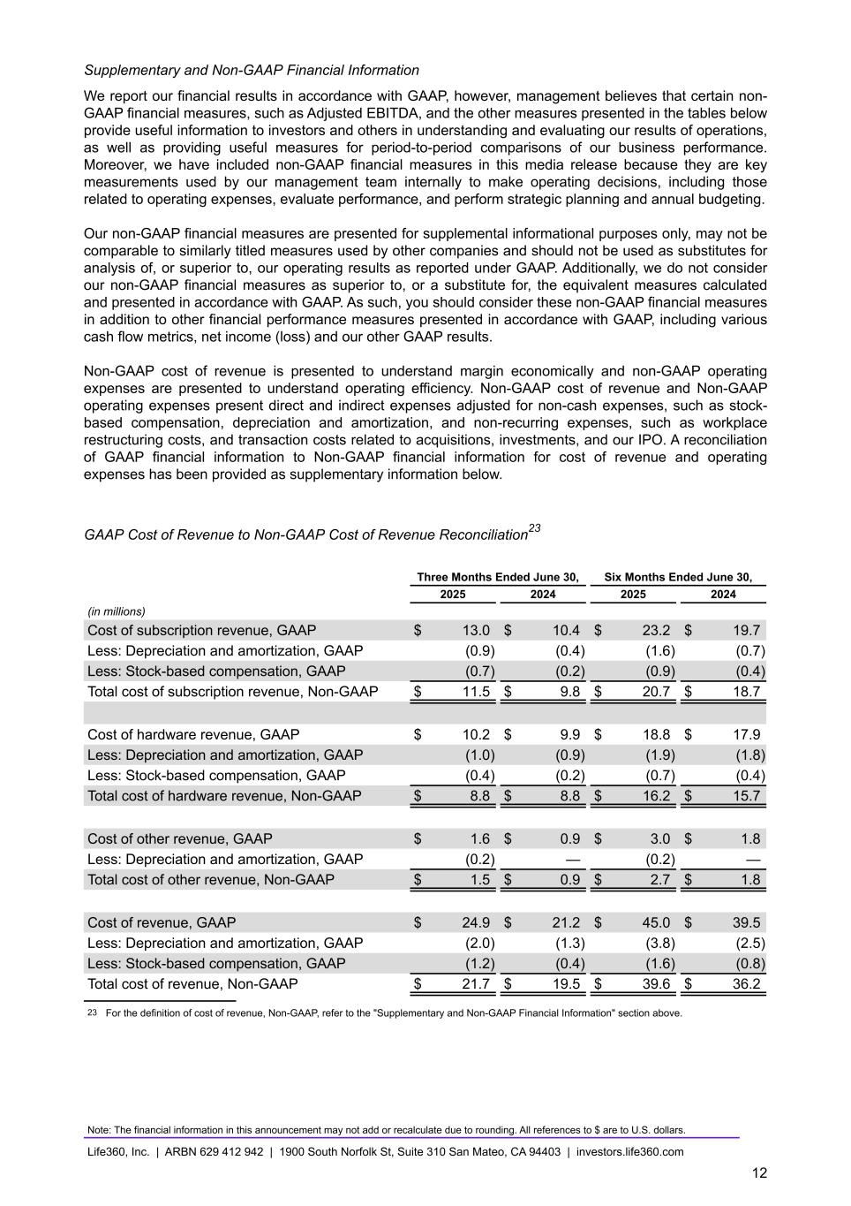
Supplementary and Non-GAAP Financial Information We report our financial results in accordance with GAAP, however, management believes that certain non- GAAP financial measures, such as Adjusted EBITDA, and the other measures presented in the tables below provide useful information to investors and others in understanding and evaluating our results of operations, as well as providing useful measures for period-to-period comparisons of our business performance. Moreover, we have included non-GAAP financial measures in this media release because they are key measurements used by our management team internally to make operating decisions, including those related to operating expenses, evaluate performance, and perform strategic planning and annual budgeting. Our non-GAAP financial measures are presented for supplemental informational purposes only, may not be comparable to similarly titled measures used by other companies and should not be used as substitutes for analysis of, or superior to, our operating results as reported under GAAP. Additionally, we do not consider our non-GAAP financial measures as superior to, or a substitute for, the equivalent measures calculated and presented in accordance with GAAP. As such, you should consider these non-GAAP financial measures in addition to other financial performance measures presented in accordance with GAAP, including various cash flow metrics, net income (loss) and our other GAAP results. Non-GAAP cost of revenue is presented to understand margin economically and non-GAAP operating expenses are presented to understand operating efficiency. Non-GAAP cost of revenue and Non-GAAP operating expenses present direct and indirect expenses adjusted for non-cash expenses, such as stock- based compensation, depreciation and amortization, and non-recurring expenses, such as workplace restructuring costs, and transaction costs related to acquisitions, investments, and our IPO. A reconciliation of GAAP financial information to Non-GAAP financial information for cost of revenue and operating expenses has been provided as supplementary information below. GAAP Cost of Revenue to Non-GAAP Cost of Revenue Reconciliation23 Three Months Ended June 30, Six Months Ended June 30, 2025 2024 2025 2024 (in millions) Cost of subscription revenue, GAAP $ 13.0 $ 10.4 $ 23.2 $ 19.7 Less: Depreciation and amortization, GAAP (0.9) (0.4) (1.6) (0.7) Less: Stock-based compensation, GAAP (0.7) (0.2) (0.9) (0.4) Total cost of subscription revenue, Non-GAAP $ 11.5 $ 9.8 $ 20.7 $ 18.7 Cost of hardware revenue, GAAP $ 10.2 $ 9.9 $ 18.8 $ 17.9 Less: Depreciation and amortization, GAAP (1.0) (0.9) (1.9) (1.8) Less: Stock-based compensation, GAAP (0.4) (0.2) (0.7) (0.4) Total cost of hardware revenue, Non-GAAP $ 8.8 $ 8.8 $ 16.2 $ 15.7 Cost of other revenue, GAAP $ 1.6 $ 0.9 $ 3.0 $ 1.8 Less: Depreciation and amortization, GAAP (0.2) — (0.2) — Total cost of other revenue, Non-GAAP $ 1.5 $ 0.9 $ 2.7 $ 1.8 Cost of revenue, GAAP $ 24.9 $ 21.2 $ 45.0 $ 39.5 Less: Depreciation and amortization, GAAP (2.0) (1.3) (3.8) (2.5) Less: Stock-based compensation, GAAP (1.2) (0.4) (1.6) (0.8) Total cost of revenue, Non-GAAP $ 21.7 $ 19.5 $ 39.6 $ 36.2 23 For the definition of cost of revenue, Non-GAAP, refer to the "Supplementary and Non-GAAP Financial Information" section above. Note: The financial information in this announcement may not add or recalculate due to rounding. All references to $ are to U.S. dollars. Life360, Inc. | ARBN 629 412 942 | 1900 South Norfolk St, Suite 310 San Mateo, CA 94403 | investors.life360.com 12

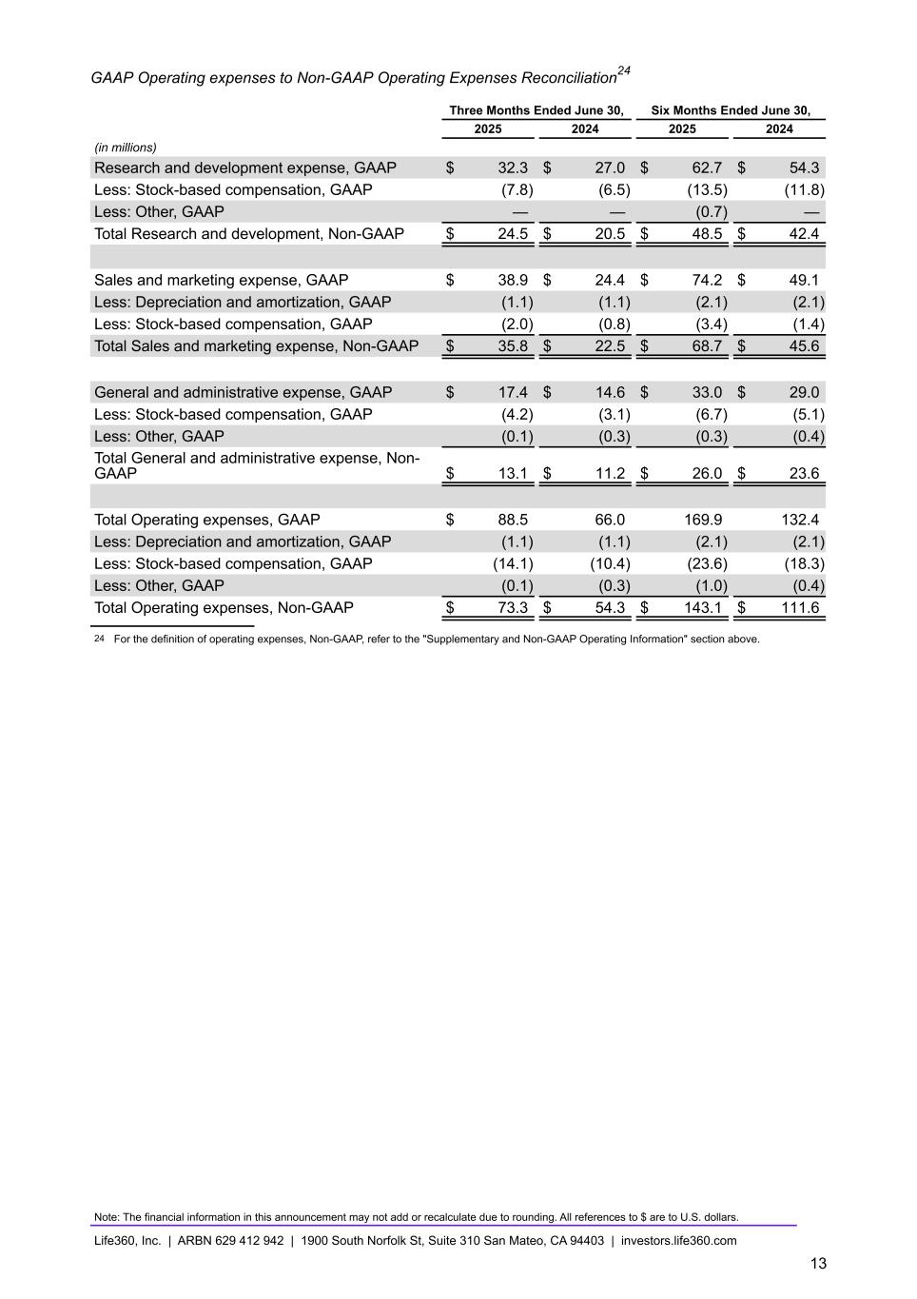
GAAP Operating expenses to Non-GAAP Operating Expenses Reconciliation24 Three Months Ended June 30, Six Months Ended June 30, 2025 2024 2025 2024 (in millions) Research and development expense, GAAP $ 32.3 $ 27.0 $ 62.7 $ 54.3 Less: Stock-based compensation, GAAP (7.8) (6.5) (13.5) (11.8) Less: Other, GAAP — — (0.7) — Total Research and development, Non-GAAP $ 24.5 $ 20.5 $ 48.5 $ 42.4 Sales and marketing expense, GAAP $ 38.9 $ 24.4 $ 74.2 $ 49.1 Less: Depreciation and amortization, GAAP (1.1) (1.1) (2.1) (2.1) Less: Stock-based compensation, GAAP (2.0) (0.8) (3.4) (1.4) Total Sales and marketing expense, Non-GAAP $ 35.8 $ 22.5 $ 68.7 $ 45.6 General and administrative expense, GAAP $ 17.4 $ 14.6 $ 33.0 $ 29.0 Less: Stock-based compensation, GAAP (4.2) (3.1) (6.7) (5.1) Less: Other, GAAP (0.1) (0.3) (0.3) (0.4) Total General and administrative expense, Non- GAAP $ 13.1 $ 11.2 $ 26.0 $ 23.6 Total Operating expenses, GAAP $ 88.5 66.0 169.9 132.4 Less: Depreciation and amortization, GAAP (1.1) (1.1) (2.1) (2.1) Less: Stock-based compensation, GAAP (14.1) (10.4) (23.6) (18.3) Less: Other, GAAP (0.1) (0.3) (1.0) (0.4) Total Operating expenses, Non-GAAP $ 73.3 $ 54.3 $ — $ 143.1 $ 111.6 24 For the definition of operating expenses, Non-GAAP, refer to the "Supplementary and Non-GAAP Operating Information" section above. Note: The financial information in this announcement may not add or recalculate due to rounding. All references to $ are to U.S. dollars. Life360, Inc. | ARBN 629 412 942 | 1900 South Norfolk St, Suite 310 San Mateo, CA 94403 | investors.life360.com 13


Investor Presentation | August 2025 11 Aug 2025 US PT 12 Aug 2025 AEST Investor Presentation Q2’25


Investor Presentation | August 2025 DISCLAIMER These materials and the accompanying oral presentation have been prepared by Life360, Inc. (ARBN 629 412 942) (“Company”) on a confidential and non-reliance basis, and may not be reproduced in whole or in part, nor may any of its contents be disclosed, to any other person, without the prior written consent of the Company. These materials are for informational purposes only. This presentation contains summary information about the Company and its activities and is current as of the date of this presentation. This presentation does not purport to be all-inclusive or to contain all of the information you may desire. It should be read in conjunction with the Company’s periodic and continuous disclosure announcements filed with the Australian Securities Exchange and the U.S. Securities and Exchange Commission (“SEC”), available at www.asx.com.au and www.sec.gov, respectively. These materials do not constitute an offer, invitation, solicitation or recommendation with respect to the purchase or sale of any security in the Company or interest therein nor does it constitute financial product advice. These materials are not a prospectus, product disclosure statement or other offer document under Australian law or under any other law. These materials have not been filed, registered or approved by regulatory authorities in any jurisdiction. This communication is restricted by law; it is not intended for distribution to, or use by any person in, any jurisdiction where such distribution or use would be contrary to local law or regulation. The information contained in these materials is not intended to be relied upon as advice or a recommendation to investors and is not intended to form the basis of any investment decision in the Company’s securities. The information does not take into account the investment objectives, financial situation, taxation situation or needs of any particular investor. An investor must not act on the basis of any matter contained in these materials but must make its own assessment of the Company and conduct its own investigations and analysis. Investors should assess their own individual financial circumstances and consider talking to a financial adviser, professional adviser or consultant before making any investment decision. By reading these materials you agree to be bound by the limitations set out in these materials. No representation or warranty, express or implied, is made as to the accuracy, reliability, completeness or fairness of the information, opinions, forecasts, reports, estimates and conclusions contained in these materials. The Company does not undertake any obligation to provide any additional information nor update or revise the information in these materials nor correct any inaccuracies or omissions. To the maximum extent permitted by law, none of the Company and its related bodies corporate, or their respective directors, employees or agents, nor any other person accepts any responsibility nor any liability for loss arising from the use of or reliance on information contained in these materials or otherwise arising in connection with it, nor in relation to any other written or oral information or opinions provided now or in the future to the recipient or its advisers and representatives, including without limitation any liability from fault of negligence. Past performance is not indicative of future performance and no guarantee of future returns is implied or given. Nothing contained in these materials nor any information made available to you is, or shall be relied upon as, a promise, representation, warranty or guarantee as to the past, present or the future performance of the Company. Certain statements in these materials constitute forward-looking statements within the meaning of the Private Securities Litigation Reform Act of 1995 (“PLSRA”), Section 27A of the Securities Act of 1933, as amended, and Section 21E of the Securities Exchange Act of 1934, as amended (the “Exchange Act”). Statements that are not historical in nature, including the words “anticipate”, “expect”, “suggests”, “plan”, “believe”, “intend”, “estimates”, “targets”, “projects”, “should”, “could”, “would”, “may”, “will”, “forecast,” “opportunity,” “goal,” “vision,” “outlook” and other similar expressions are intended to identify forward-looking statements. These forward- looking statements include, but are not limited to, statements regarding: the Company’s growth strategy and business plan and the Company’s ability to effectively manage its growth and meet future capital requirements; the Company’s expectations regarding future financial performance, including its expectations regarding its revenue, revenue growth, adjusted EBITDA, and operating cash flow, and the Company’s ability to achieve or maintain future profitability; the Company’s ability to further penetrate its existing member base, maintain and expand its member base and increase monetization of its member base; the Company’s ability to expand internationally and the significance of its global opportunity; the Company’s ability to anticipate market needs or develop new products and services or enhance existing products and services to meet those needs; and the Company’s ability to increase sales of its products and services. Such forward-looking statements are prediction, projections and other statements about future events that are based on current expectations and assumptions and, as a result, involve known and unknown risks, uncertainties, assumptions and other important factors, many of which are beyond the control of the Company and which may cause actual results, performance or achievements to differ materially from those expressed or implied by such statements. Forward-looking statements are provided as a general guide only, and should not be relied on as an indication or guarantee of future performance. They can be affected by inaccurate assumptions we might make or by known or unknown risks or uncertainties. Given these uncertainties, recipients are cautioned to not place undue reliance on any forward- looking statement. Forward-looking statements speak only as of the date they are made. Subject to any continuing obligations under applicable law the Company disclaims any obligation or undertaking to disseminate any updates or revisions to any forward-looking statements in these materials to reflect any change in expectations in relation to such forward-looking statements or any change in events, conditions or circumstances on which any such statement is based. This presentation contains certain measures of financial performance not determined in accordance with U.S. generally accepted accounting principles (“GAAP”), including Adjusted EBITDA, Adjusted EBITDA margin, and non-GAAP Operating Expenses (the “non-GAAP financial measures”). The non-GAAP financial measures are used by Company management to evaluate financial performance of, and determine resource allocation for, each of the Company's operating segments. Items excluded from each of the non-GAAP financial measures are significant components in understanding and assessing financial performance. The non-GAAP financial measures should not be considered in isolation, or as alternatives to, or substitutes for, net income, net income margin, income from operations, cash flows generated by operations, investing or financing activities, or other financial statement data presented in the Company's consolidated financial statements as indicators of financial performance or liquidity. Because the non-GAAP financial measures are not measurements determined in accordance with GAAP and are thus susceptible to varying definitions, the non-GAAP financial measurements as presented may not be comparable to other similarly titled measures of other companies. Please refer to the Appendix beginning on slide 43 of this presentation for a reconciliation of these financial measures to the most directly comparable financial measure prepared in accordance with GAAP. This presentation includes our trademarks and trade names that we own or license and our logo. This presentation also includes trademarks, trade names and service marks that are the property of other organizations. Solely for convenience, trademarks and trade names referred to in this prospectus appear without any “TM” or “®” symbol, but those references are not intended to indicate, in any way, that we will not assert, to the fullest extent under applicable law, our rights to these trademarks, trade names and service marks. We do not intend our use or display of other parties' trademarks, trade names or service marks to imply, and such use or display should not be construed to imply, a relationship with, or endorsement or sponsorship of us by, these other parties. This presentation includes industry and market data derived from internal analyses based upon publicly available data or other proprietary research and analysis, surveys or studies conducted by third parties and industry and general publications. Unless otherwise indicated, information contained in this presentation concerning our industry and the markets in which we operate, including our general expectations and market position, market opportunity and market size, is based on these various sources. Because this information involves a number of assumptions and limitations, you are cautioned not to give undue weight to such information. We have not independently verified market data and industry forecasts provided by any of these or any other third-party sources referred to in this presentation. All values are stated in US dollars unless otherwise stated.


Investor Presentation | August 2025 3 Life360 Overview (4 – 23) Financial Update Q2’25 (29 – 41) Contents FY’25 Outlook (42 – 43) 1. 2. 3. 4. Appendix (44 – 51) Operating metrics Financials GAAP to Non-GAAP reconciliations & Non-GAAP financial measures Competitive landscape Life360 Strategy (24 – 28)


Investor Presentation | August 2025 Life360 Overview

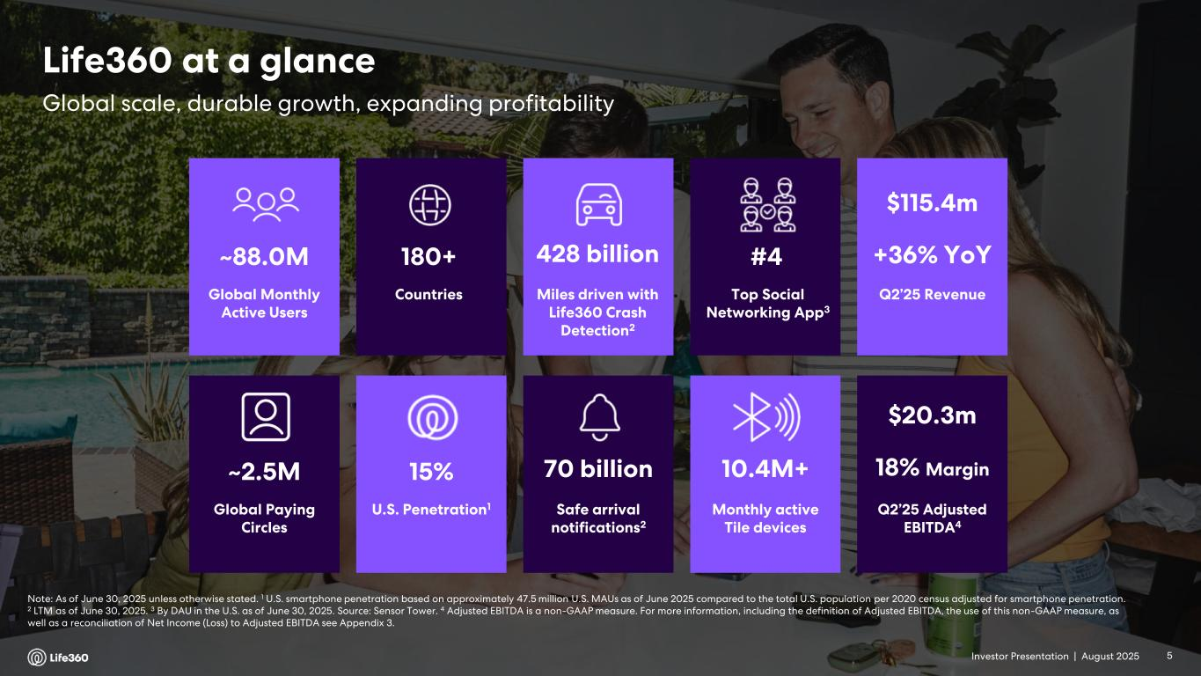
Investor Presentation | August 2025 Note: As of June 30, 2025 unless otherwise stated. 1 U.S. smartphone penetration based on approximately 47.5 million U.S. MAUs as of June 2025 compared to the total U.S. population per 2020 census adjusted for smartphone penetration. 2 LTM as of June 30, 2025. 3 By DAU in the U.S. as of June 30, 2025. Source: Sensor Tower. 4 Adjusted EBITDA is a non-GAAP measure. For more information, including the definition of Adjusted EBITDA, the use of this non-GAAP measure, as well as a reconciliation of Net Income (Loss) to Adjusted EBITDA see Appendix 3. Global Paying Circles ~2.5M Safe arrival notifications2 70 billion U.S. Penetration1 15% 10.4M+ Monthly active Tile devices Global Monthly Active Users ~88.0M Miles driven with Life360 Crash Detection2 428 billion Countries 180+ Top Social Networking App3 #4 Q2’25 Revenue $115.4m +36% YoY Q2’25 Adjusted EBITDA4 $20.3m 18% Margin Global scale, durable growth, expanding profitability Life360 at a glance 5Investor Presentation |

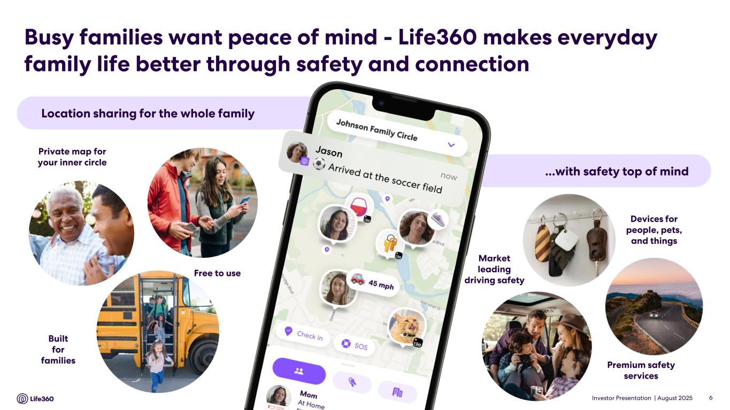
Investor Presentation | August 2025 Location sharing for the whole family ...with safety top of mind Private map for your inner circle Free to use Built for families Devices for people, pets, and things Premium safety services Market leading driving safety Busy families want peace of mind - Life360 makes everyday family life better through safety and connection 6

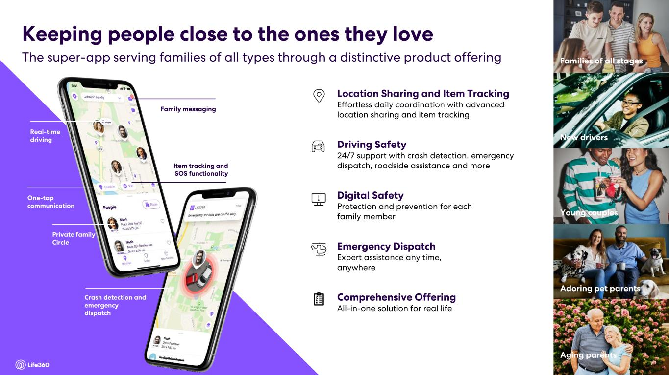
Investor Presentation | August 2025 7 Family messaging Real-time driving One-tap communication Private family Circle Item tracking and SOS functionality Crash detection and emergency dispatch Driving Safety 24/7 support with crash detection, emergency dispatch, roadside assistance and more Digital Safety Protection and prevention for each family member Location Sharing and Item Tracking Effortless daily coordination with advanced location sharing and item tracking Emergency Dispatch Expert assistance any time, anywhere Comprehensive Offering All-in-one solution for real life Young couples New drivers Families of all stages Aging parents Adoring pet parents The super-app serving families of all types through a distinctive product offering Keeping people close to the ones they love 7

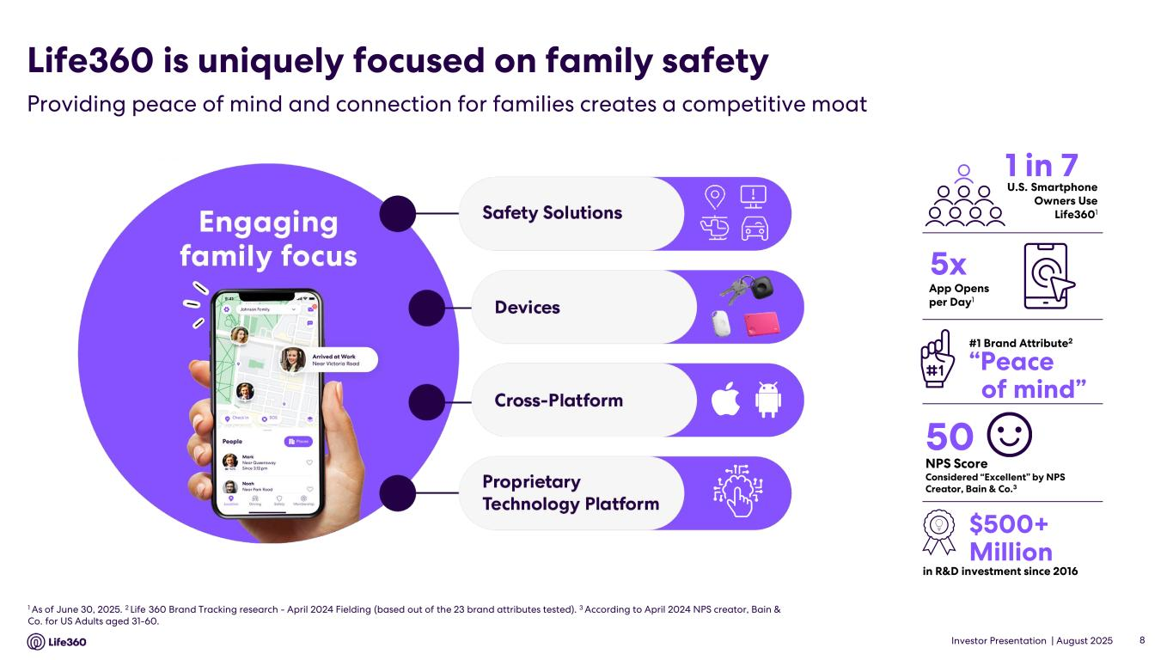
Investor Presentation | August 2025 8 1 As of June 30, 2025. 2 Life 360 Brand Tracking research - April 2024 Fielding (based out of the 23 brand attributes tested). 3 According to April 2024 NPS creator, Bain & Co. for US Adults aged 31-60. in R&D investment since 2016 #1 Brand Attribute2 1 in 7 50 NPS Score Considered “Excellent” by NPS Creator, Bain & Co.3 “Peace of mind” 5x U.S. Smartphone Owners Use Life3601 $500+ Million App Opens per Day1 Life360 is uniquely focused on family safety Providing peace of mind and connection for families creates a competitive moat

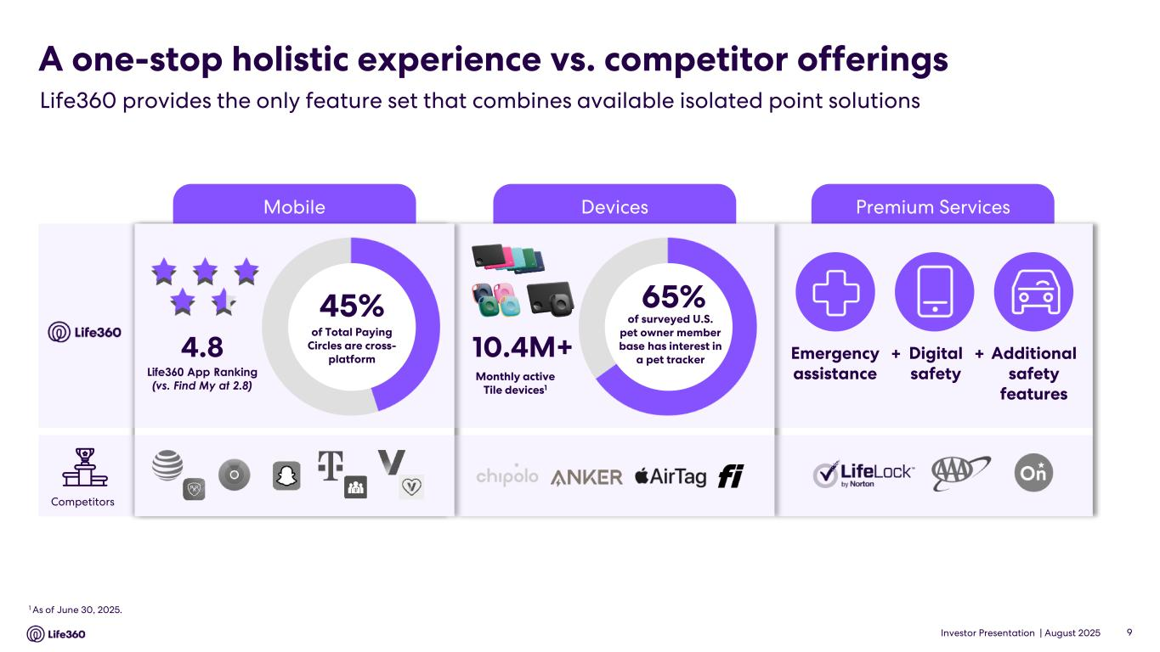
Investor Presentation | August 2025 Premium ServicesDevicesMobile A one-stop holistic experience vs. competitor offerings Life360 provides the only feature set that combines available isolated point solutions 1 As of June 30, 2025. 10.4M+ 65% of surveyed U.S. pet owner member base has interest in a pet tracker Monthly active Tile devices1 Emergency assistance Digital safety Additional safety features + +4.8 Life360 App Ranking (vs. Find My at 2.8) Competitors 9 45% of Total Paying Circles are cross- platform

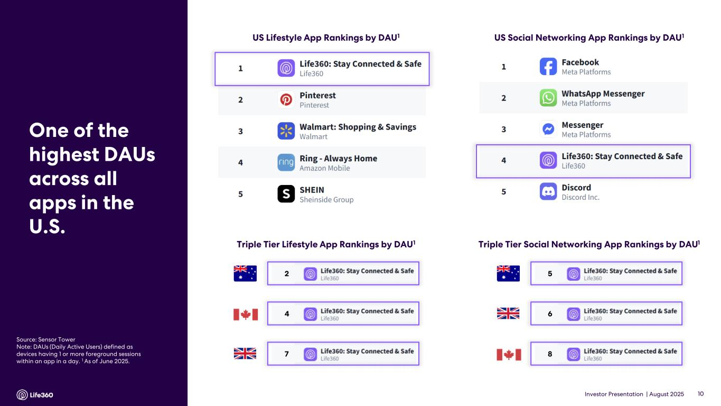
Investor Presentation | August 2025 10 US Social Networking App Rankings by DAU1US Lifestyle App Rankings by DAU1 Source: Sensor Tower Note: DAUs (Daily Active Users) defined as devices having 1 or more foreground sessions within an app in a day. 1 As of June 2025. One of the highest DAUs across all apps in the U.S. Triple Tier Social Networking App Rankings by DAU1 5 6 8 Triple Tier Lifestyle App Rankings by DAU1 2 7 4

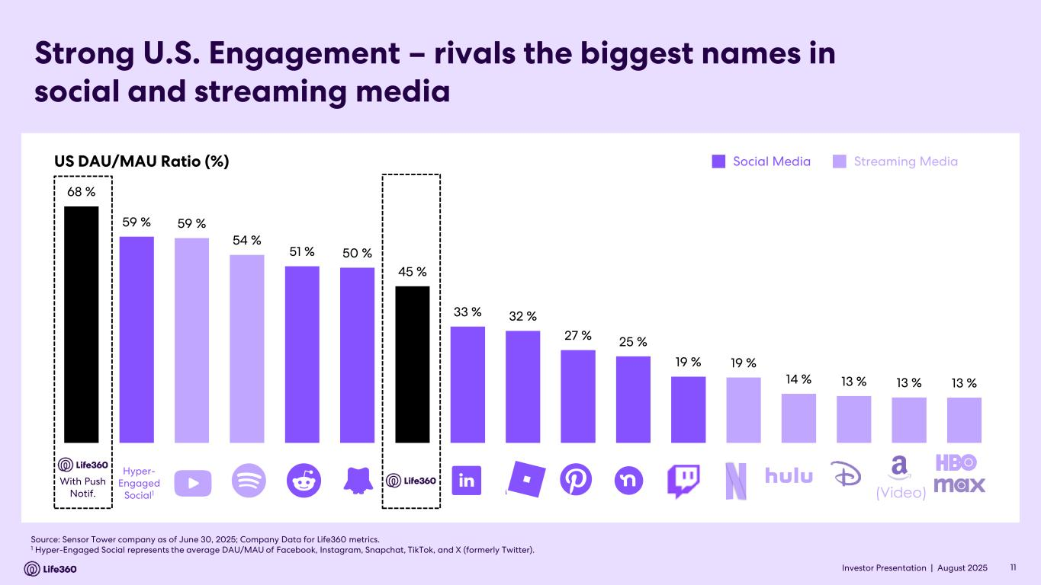
Investor Presentation | August 2025 Strong U.S. Engagement – rivals the biggest names in social and streaming media Source: Sensor Tower company as of June 30, 2025; Company Data for Life360 metrics. 1 Hyper-Engaged Social represents the average DAU/MAU of Facebook, Instagram, Snapchat, TikTok, and X (formerly Twitter). 11Investor Presentation | US DAU/MAU Ratio (%) Social Media Streaming Media (Video) Hyper- Engaged Social1 With Push Notif. 68 % 59 % 59 % 54 % 51 % 50 % 45 % 33 % 32 % 27 % 25 % 19 % 19 % 14 % 13 % 13 % 13 %

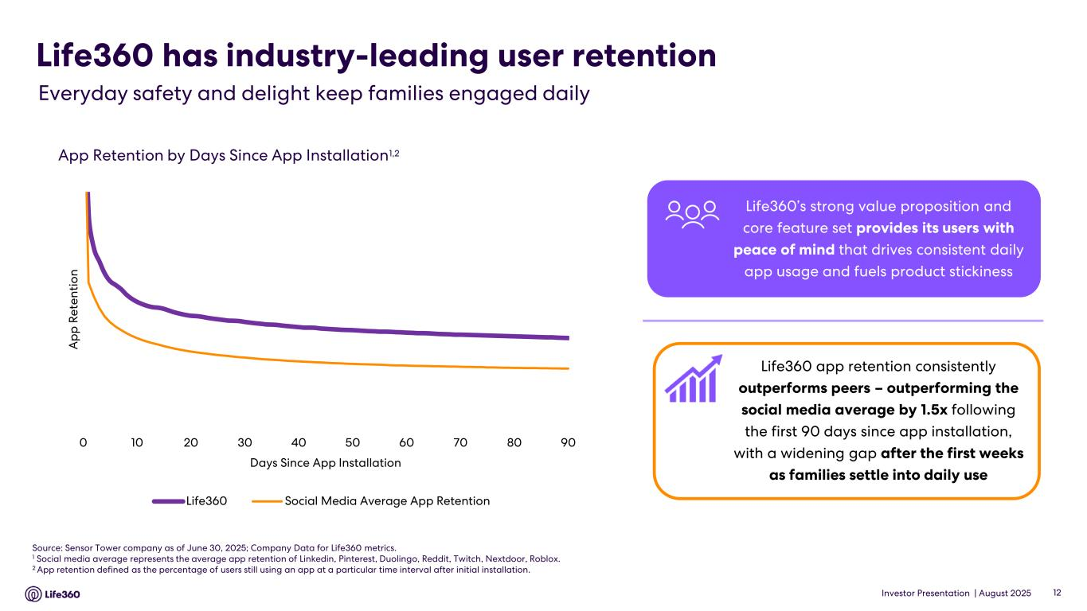
Investor Presentation | August 2025 Life360 has industry-leading user retention 12 Everyday safety and delight keep families engaged daily 0 10 20 30 40 50 60 70 80 90 A p p R e te n ti o n Days Since App Installation Life360 Social Media Average App Retention App Retention by Days Since App Installation1,2 Source: Sensor Tower company as of June 30, 2025; Company Data for Life360 metrics. 1 Social media average represents the average app retention of Linkedin, Pinterest, Duolingo, Reddit, Twitch, Nextdoor, Roblox. 2 App retention defined as the percentage of users still using an app at a particular time interval after initial installation. Life360 app retention consistently outperforms peers – outperforming the social media average by 1.5x following the first 90 days since app installation, with a widening gap after the first weeks as families settle into daily use Life360’s strong value proposition and core feature set provides its users with peace of mind that drives consistent daily app usage and fuels product stickiness

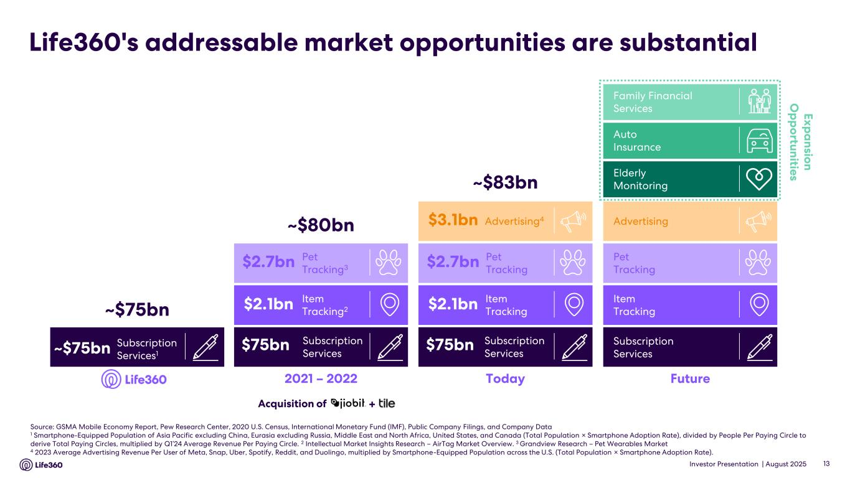
Investor Presentation | August 2025 Life360's addressable market opportunities are substantial Source: GSMA Mobile Economy Report, Pew Research Center, 2020 U.S. Census, International Monetary Fund (IMF), Public Company Filings, and Company Data 1 Smartphone-Equipped Population of Asia Pacific excluding China, Eurasia excluding Russia, Middle East and North Africa, United States, and Canada (Total Population × Smartphone Adoption Rate), divided by People Per Paying Circle to derive Total Paying Circles, multiplied by Q1’24 Average Revenue Per Paying Circle. 2 Intellectual Market Insights Research – AirTag Market Overview. 3 Grandview Research – Pet Wearables Market 4 2023 Average Advertising Revenue Per User of Meta, Snap, Uber, Spotify, Reddit, and Duolingo, multiplied by Smartphone-Equipped Population across the U.S. (Total Population × Smartphone Adoption Rate). 13 2021 – 2022 ~$80bn Item Tracking2 Pet Tracking3 Subscription Services $2.7bn $2.1bn $75bn Today ~$83bn Advertising4 Item Tracking Pet Tracking Subscription Services $2.7bn $2.1bn $75bn $3.1bn Subscription Services1 ~$75bn ~$75bn Acquisition of + Future E x p a n sio n O p p o rtu n itie s Family Financial Services Elderly Monitoring Auto Insurance Advertising Item Tracking Pet Tracking Subscription Services

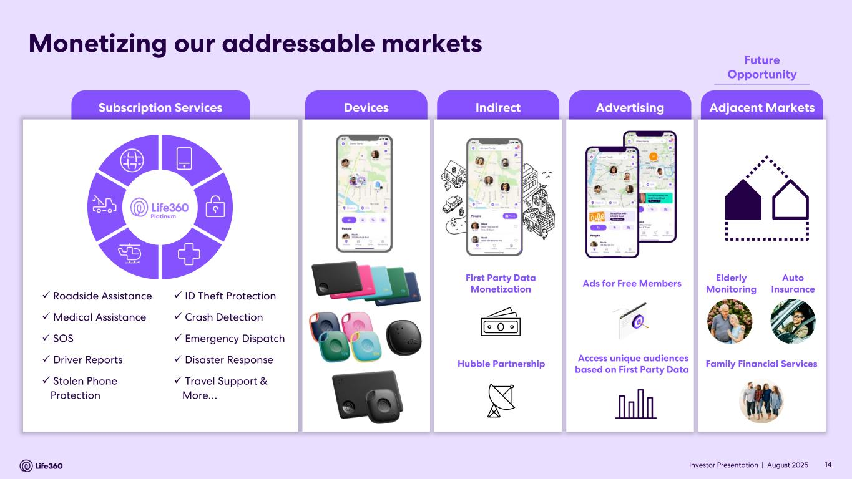
Investor Presentation | August 2025 Subscription Services IndirectDevices Advertising Adjacent Markets Monetizing our addressable markets ✓ Roadside Assistance ✓ Medical Assistance ✓ SOS ✓ Driver Reports ✓ Stolen Phone Protection ✓ ID Theft Protection ✓ Crash Detection ✓ Emergency Dispatch ✓ Disaster Response ✓ Travel Support & More… Platinum Ads for Free Members Access unique audiences based on First Party Data Elderly Monitoring Family Financial Services Auto Insurance First Party Data Monetization Hubble Partnership 14 Future Opportunity Investor Presentation |

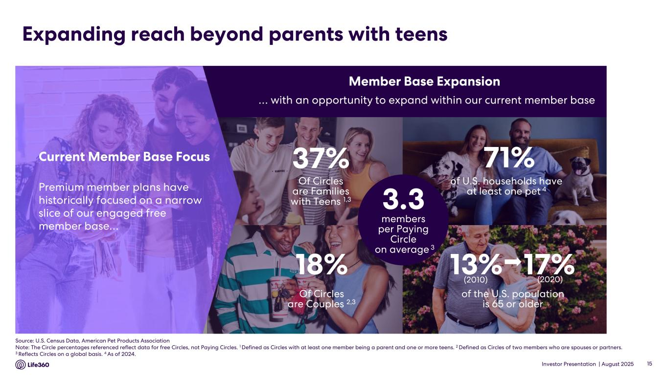
Investor Presentation | August 2025 Expanding reach beyond parents with teens 15 Of Circles are Families with Teens 1,3 37% of U.S. households have at least one pet 4 of the U.S. population is 65 or older 13% 17% (2020)(2010) Of Circles are Couples 2,3 18% 71% … with an opportunity to expand within our current member base Premium member plans have historically focused on a narrow slice of our engaged free member base… Current Member Base Focus Member Base Expansion 3.3 members per Paying Circle on average 3 Source: U.S. Census Data, American Pet Products Association Note: The Circle percentages referenced reflect data for free Circles, not Paying Circles. 1 Defined as Circles with at least one member being a parent and one or more teens. 2 Defined as Circles of two members who are spouses or partners. 3 Reflects Circles on a global basis. 4 As of 2024.

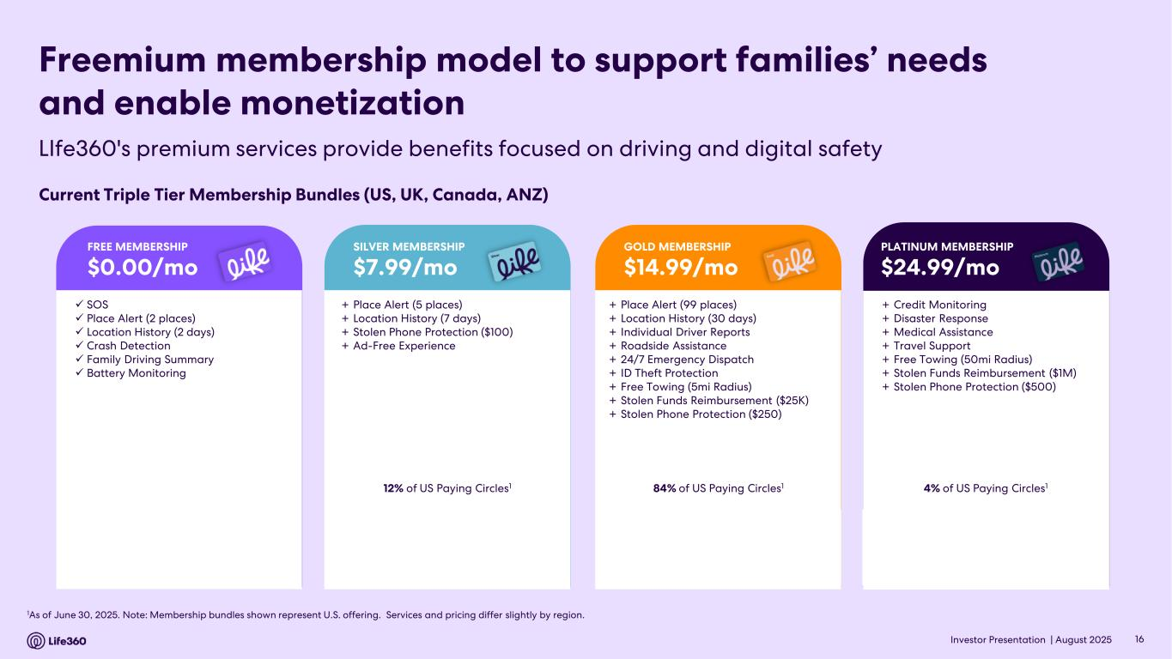
Investor Presentation | August 2025 1As of June 30, 2025. Note: Membership bundles shown represent U.S. offering. Services and pricing differ slightly by region. Freemium membership model to support families’ needs and enable monetization Current Triple Tier Membership Bundles (US, UK, Canada, ANZ) + Place Alert (5 places) + Location History (7 days) + Stolen Phone Protection ($100) + Ad-Free Experience 12% of US Paying Circles1 SILVER MEMBERSHIP $7.99/mo + Place Alert (99 places) + Location History (30 days) + Individual Driver Reports + Roadside Assistance + 24/7 Emergency Dispatch + ID Theft Protection + Free Towing (5mi Radius) + Stolen Funds Reimbursement ($25K) + Stolen Phone Protection ($250) 84% of US Paying Circles1 GOLD MEMBERSHIP $14.99/mo + Credit Monitoring + Disaster Response + Medical Assistance + Travel Support + Free Towing (50mi Radius) + Stolen Funds Reimbursement ($1M) + Stolen Phone Protection ($500) 4% of US Paying Circles1 PLATINUM MEMBERSHIP $24.99/mo ✓ SOS ✓ Place Alert (2 places) ✓ Location History (2 days) ✓ Crash Detection ✓ Family Driving Summary ✓ Battery Monitoring FREE MEMBERSHIP $0.00/mo 16 LIfe360's premium services provide benefits focused on driving and digital safety

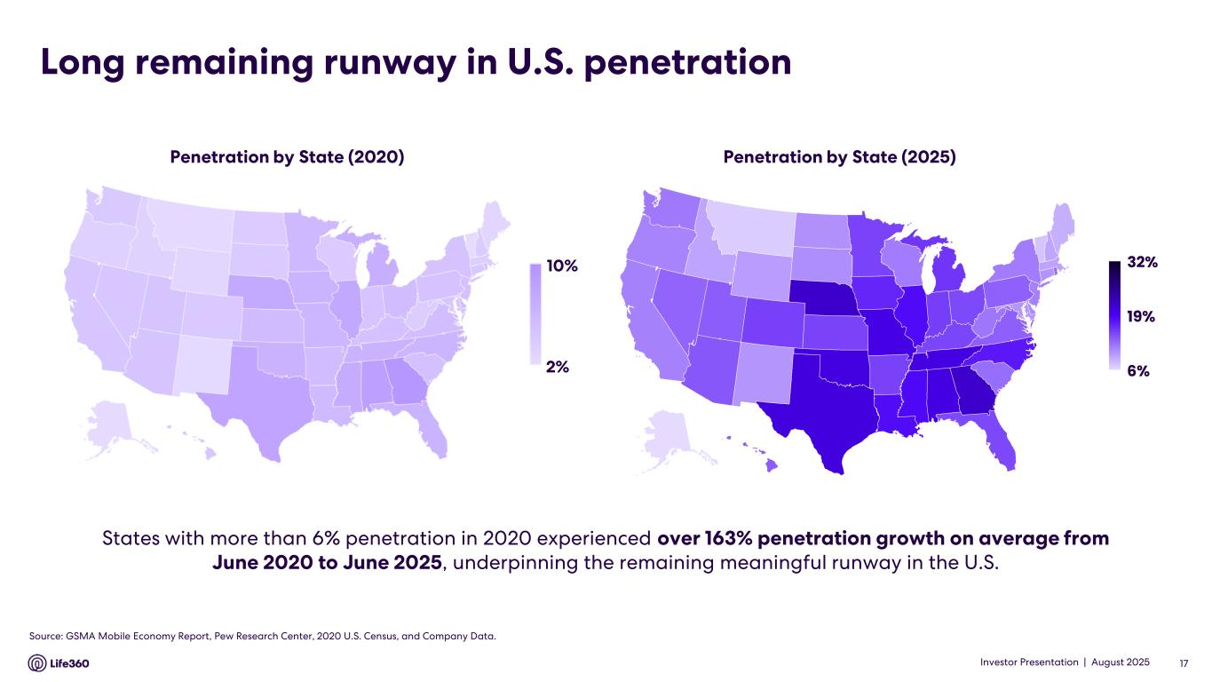
Investor Presentation | August 2025 States with more than 6% penetration in 2020 experienced over 163% penetration growth on average from June 2020 to June 2025, underpinning the remaining meaningful runway in the U.S. Long remaining runway in U.S. penetration Penetration by State (2025)Penetration by State (2020) 10% 2% Source: GSMA Mobile Economy Report, Pew Research Center, 2020 U.S. Census, and Company Data. 17 © GeoNames, Microsoft, TomTom Powered by Bing 6% 19% 32% Series1 Investor Presentation | © GeoNames, Microsoft, TomTom Powered by Bing 6% 19% 32% Series1

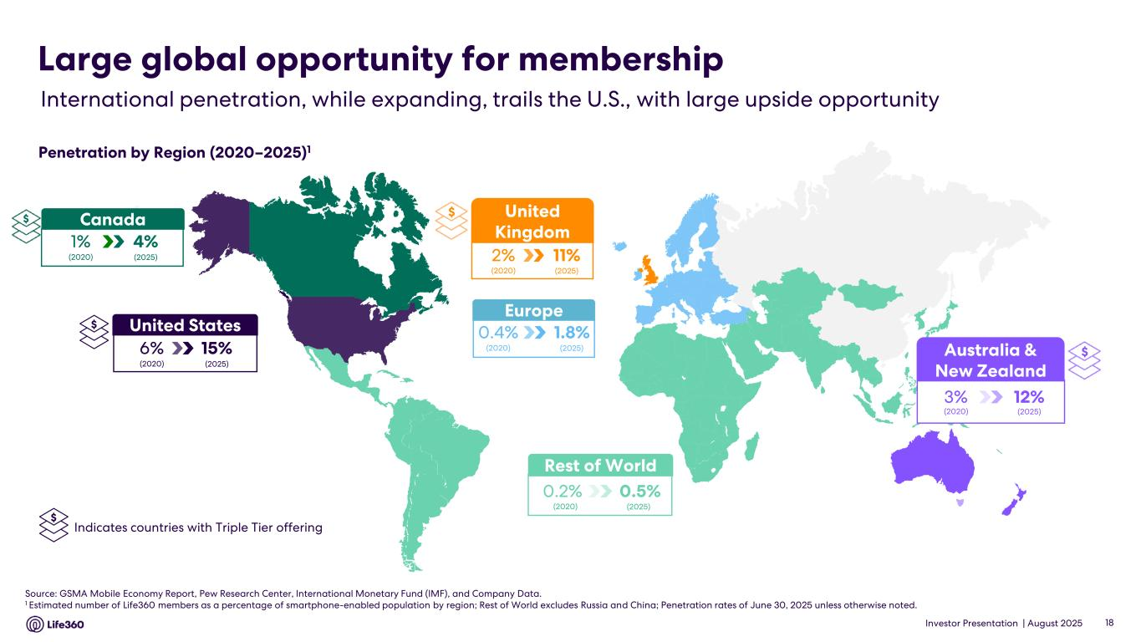
Investor Presentation | August 2025 Source: GSMA Mobile Economy Report, Pew Research Center, International Monetary Fund (IMF), and Company Data. 1 Estimated number of Life360 members as a percentage of smartphone-enabled population by region; Rest of World excludes Russia and China; Penetration rates of June 30, 2025 unless otherwise noted. Rest of World 0.5%0.2% (2020) (2025) Europe 1.8%0.4% (2020) (2025) International penetration, while expanding, trails the U.S., with large upside opportunity Large global opportunity for membership Penetration by Region (2020–2025)1 18 $Australia & New Zealand 12%3% (2020) (2025) $ United Kingdom 11%2% (2020) (2025) $ Indicates countries with Triple Tier offering United States 15%6% (2020) (2025) $ Canada 4%1% (2020) (2025) $

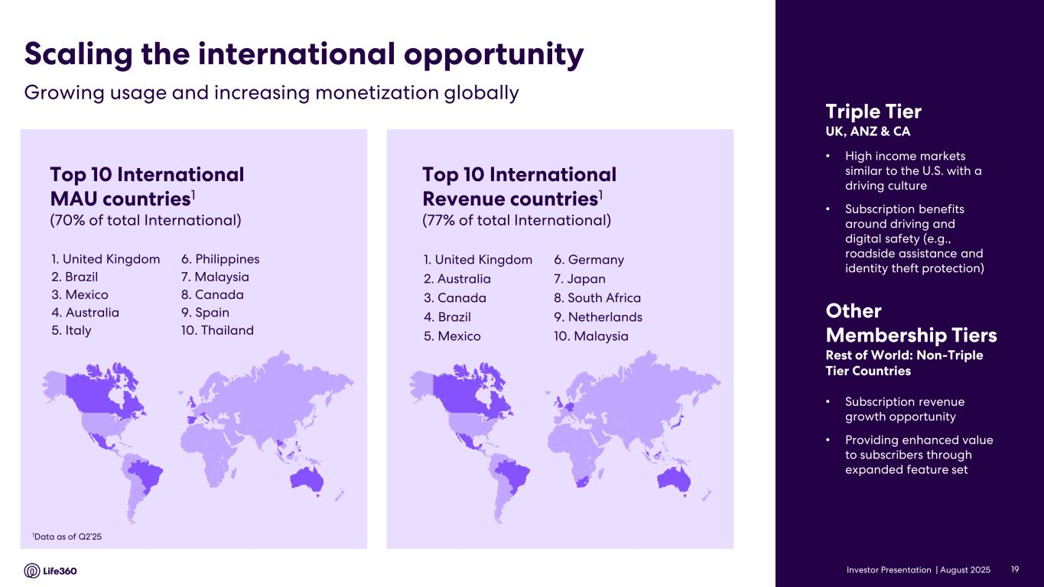
Investor Presentation | August 2025 Top 10 International MAU countries1 (70% of total International) 1. United Kingdom 2. Brazil 3. Mexico 4. Australia 5. Italy 1Data as of Q2’25 Top 10 International Revenue countries1 (77% of total International) 1. United Kingdom 2. Australia 3. Canada 4. Brazil 5. Mexico • Subscription revenue growth opportunity • Providing enhanced value to subscribers through expanded feature set Other Membership Tiers Rest of World: Non-Triple Tier Countries Growing usage and increasing monetization globally Scaling the international opportunity Triple Tier UK, ANZ & CA • High income markets similar to the U.S. with a driving culture • Subscription benefits around driving and digital safety (e.g., roadside assistance and identity theft protection) 6. Germany 7. Japan 8. South Africa 9. Netherlands 10. Malaysia 6. Philippines 7. Malaysia 8. Canada 9. Spain 10. Thailand 19

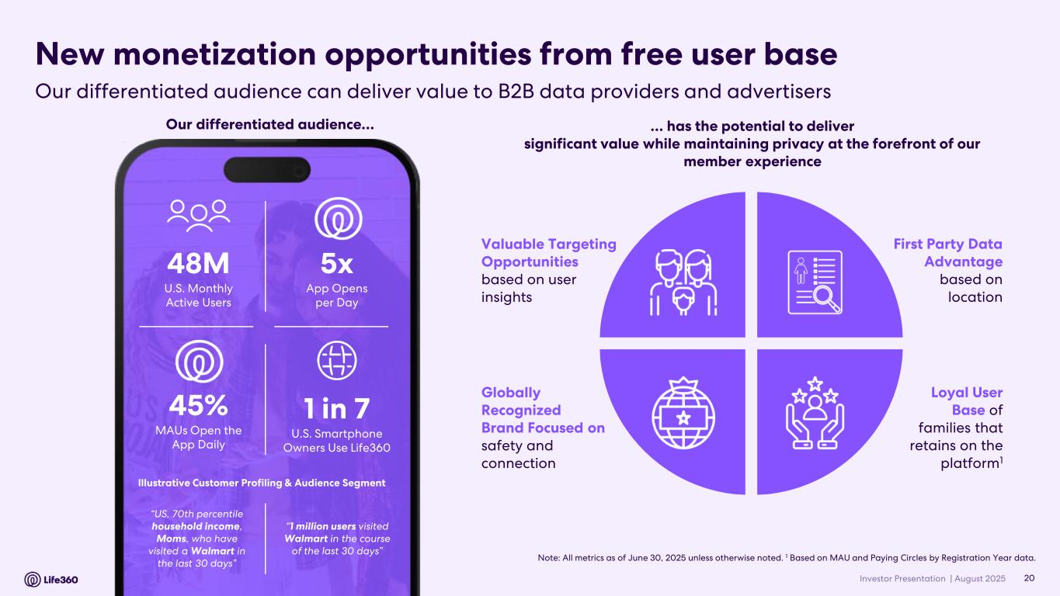
Investor Presentation | August 2025 New monetization opportunities from free user base Loyal User Base of families that retains on the platform1 Globally Recognized Brand Focused on safety and connection First Party Data Advantage based on location Valuable Targeting Opportunities based on user insights … has the potential to deliver significant value while maintaining privacy at the forefront of our member experience Note: All metrics as of June 30, 2025 unless otherwise noted. 1 Based on MAU and Paying Circles by Registration Year data. 48M U.S. Monthly Active Users 1 in 7 U.S. Smartphone Owners Use Life360 5x App Opens per Day 45% MAUs Open the App Daily “US, 70th percentile household income, Moms, who have visited a Walmart in the last 30 days” Illustrative Customer Profiling & Audience Segment “1 million users visited Walmart in the course of the last 30 days” Our differentiated audience… 20 Our differentiated audience can deliver value to B2B data providers and advertisers

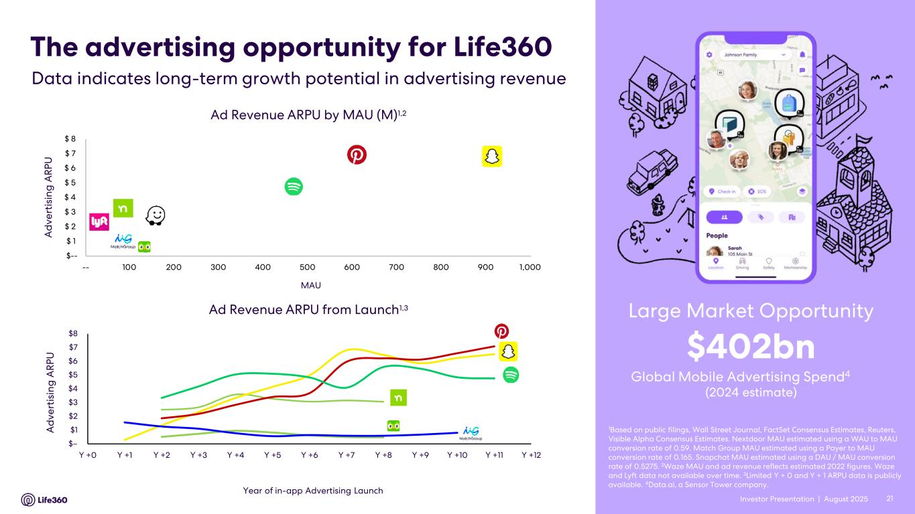
Investor Presentation | August 2025 $-- $ 1 $ 2 $ 3 $ 4 $ 5 $ 6 $ 7 $ 8 -- 100 200 300 400 500 600 700 800 900 1,000 Ad Revenue ARPU by MAU (M)1,2 MAU Ad Revenue ARPU from Launch1,3 21 The advertising opportunity for Life360 1Based on public filings, Wall Street Journal, FactSet Consensus Estimates, Reuters, Visible Alpha Consensus Estimates. Nextdoor MAU estimated using a WAU to MAU conversion rate of 0.59. Match Group MAU estimated using a Payer to MAU conversion rate of 0.165. Snapchat MAU estimated using a DAU / MAU conversion rate of 0.5275. 2Waze MAU and ad revenue reflects estimated 2022 figures. Waze and Lyft data not available over time. 3Limited Y + 0 and Y + 1 ARPU data is publicly available. 4Data.ai, a Sensor Tower company. Global Mobile Advertising Spend4 $402bn (2024 estimate) Large Market Opportunity Year of in-app Advertising Launch Data indicates long-term growth potential in advertising revenue A d v e rt is in g A R P U Investor Presentation | A d v e rt is in g A R P U $– $1 $2 $3 $4 $5 $6 $7 $8 Y +0 Y +1 Y +2 Y +3 Y +4 Y +5 Y +6 Y +7 Y +8 Y +9 Y +10 Y +11 Y +12

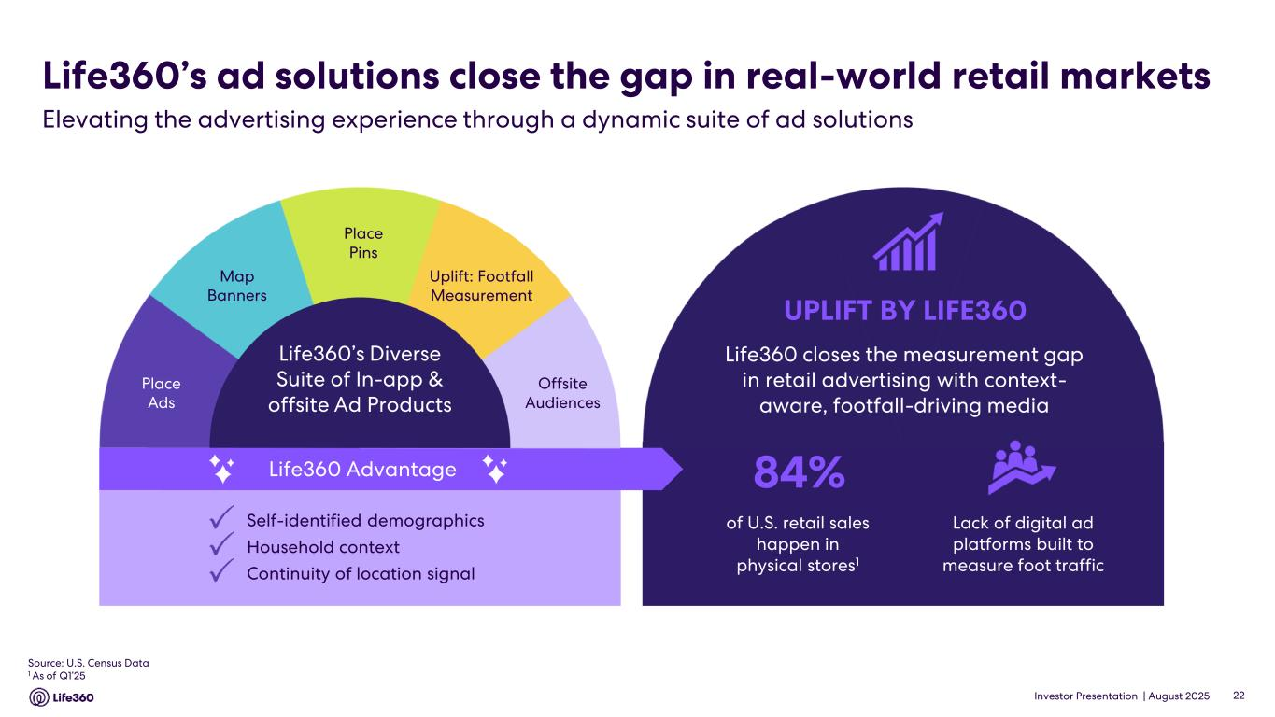
Investor Presentation | August 2025 UPLIFT BY LIFE360 Offsite Audiences Uplift: Footfall Measurement Map Banners Place Ads Place Pins Self-identified demographics Household context Continuity of location signal Life360 closes the measurement gap in retail advertising with context- aware, footfall-driving media Life360’s ad solutions close the gap in real-world retail markets Life360 Advantage 84% Lack of digital ad platforms built to measure foot traffic of U.S. retail sales happen in physical stores1 Source: U.S. Census Data 1 As of Q1’25 22 Elevating the advertising experience through a dynamic suite of ad solutions

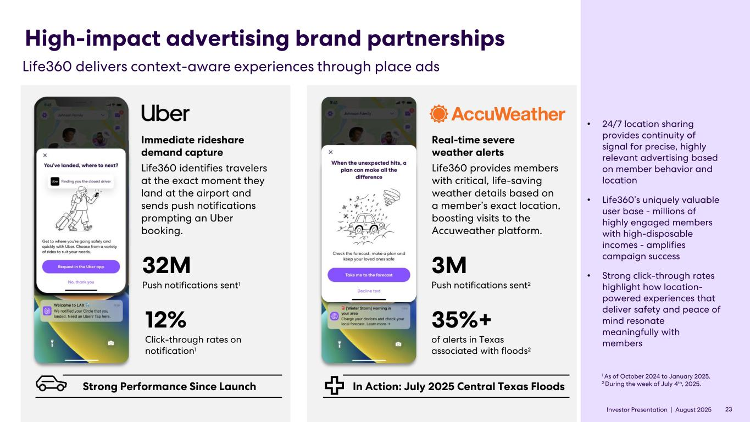
Investor Presentation | August 2025 High-impact advertising brand partnerships 23 Life360 delivers context-aware experiences through place ads 32M Push notifications sent1 12% Click-through rates on notification1 Immediate rideshare demand capture Life360 identifies travelers at the exact moment they land at the airport and sends push notifications prompting an Uber booking. • 24/7 location sharing provides continuity of signal for precise, highly relevant advertising based on member behavior and location • Life360’s uniquely valuable user base - millions of highly engaged members with high-disposable incomes - amplifies campaign success • Strong click-through rates highlight how location- powered experiences that deliver safety and peace of mind resonate meaningfully with members Real-time severe weather alerts Life360 provides members with critical, life-saving weather details based on a member’s exact location, boosting visits to the Accuweather platform. In Action: July 2025 Central Texas Floods 3M Push notifications sent2 Strong Performance Since Launch 35%+ of alerts in Texas associated with floods2 1 As of October 2024 to January 2025. 2 During the week of July 4th, 2025. Investor Presentation |


Investor Presentation | August 2025 Life360 Strategy

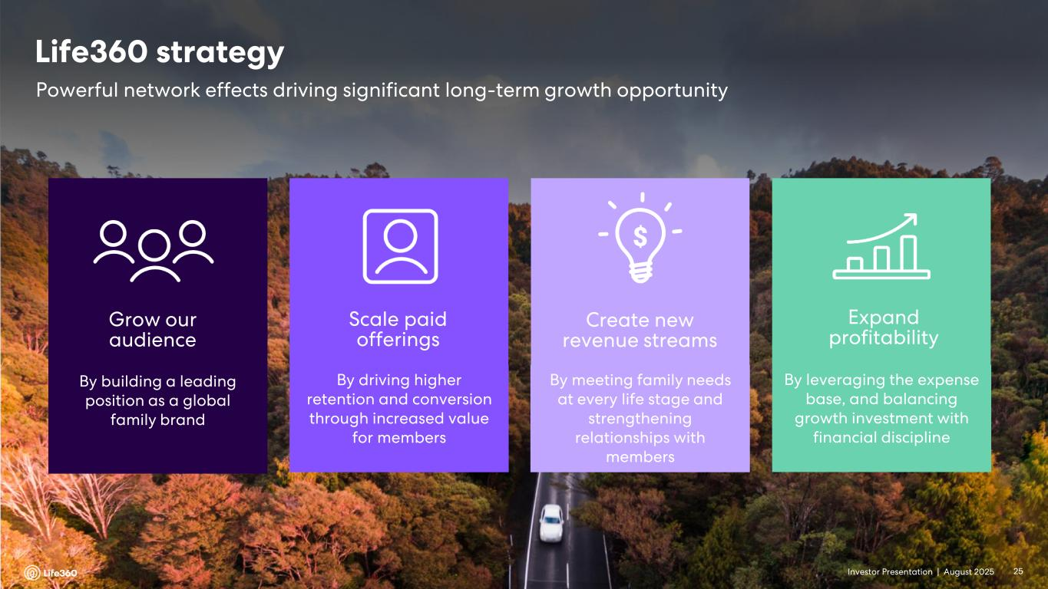
Investor Presentation | August 2025 Grow our audience By building a leading position as a global family brand Scale paid offerings By driving higher retention and conversion through increased value for members Create new revenue streams By meeting family needs at every life stage and strengthening relationships with members Expand profitability By leveraging the expense base, and balancing growth investment with financial discipline Powerful network effects driving significant long-term growth opportunity Life360 strategy 25Investor Presentation |

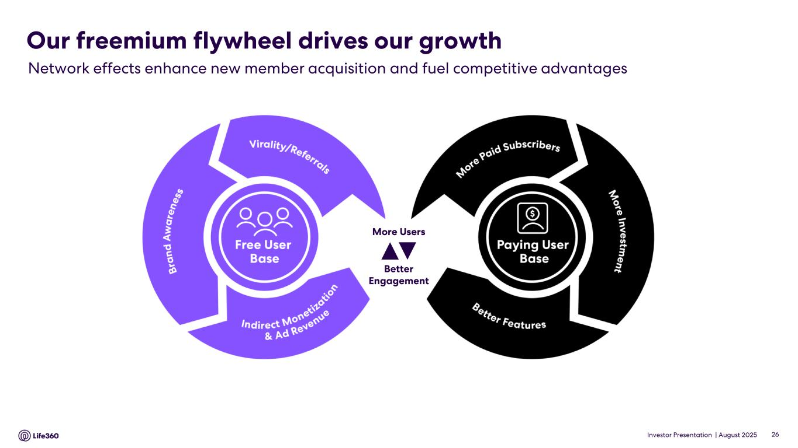
Investor Presentation | August 2025 Our freemium flywheel drives our growth 26 Network effects enhance new member acquisition and fuel competitive advantages Better Engagement More Users

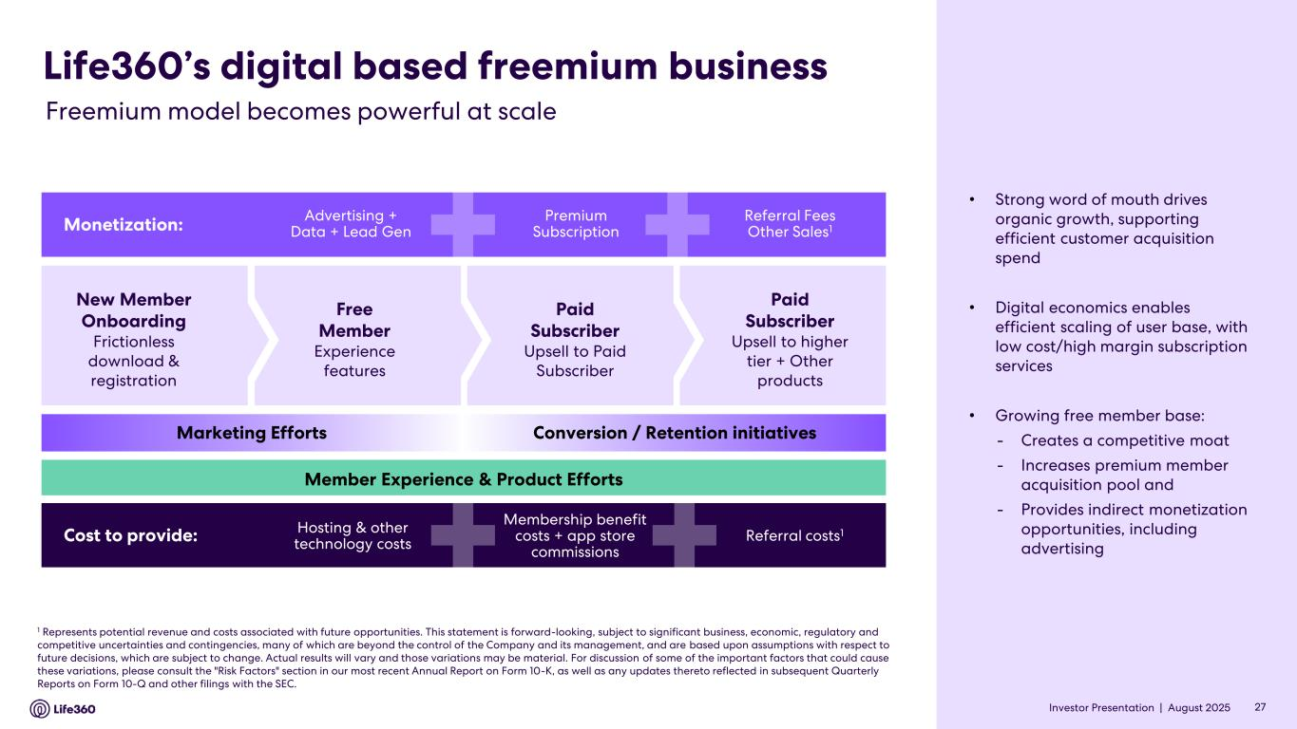
Investor Presentation | August 2025 New Member Onboarding Frictionless download & registration Free Member Experience features Paid Subscriber Upsell to Paid Subscriber Paid Subscriber Upsell to higher tier + Other products Life360’s digital based freemium business Monetization: Advertising + Data + Lead Gen Premium Subscription Referral Fees Other Sales1 Cost to provide: Hosting & other technology costs Membership benefit costs + app store commissions Referral costs1 Marketing Efforts Conversion / Retention initiatives Member Experience & Product Efforts 1 Represents potential revenue and costs associated with future opportunities. This statement is forward-looking, subject to significant business, economic, regulatory and competitive uncertainties and contingencies, many of which are beyond the control of the Company and its management, and are based upon assumptions with respect to future decisions, which are subject to change. Actual results will vary and those variations may be material. For discussion of some of the important factors that could cause these variations, please consult the "Risk Factors" section in our most recent Annual Report on Form 10-K, as well as any updates thereto reflected in subsequent Quarterly Reports on Form 10-Q and other filings with the SEC. 27 Freemium model becomes powerful at scale • Strong word of mouth drives organic growth, supporting efficient customer acquisition spend • Digital economics enables efficient scaling of user base, with low cost/high margin subscription services • Growing free member base: - Creates a competitive moat - Increases premium member acquisition pool and - Provides indirect monetization opportunities, including advertising Investor Presentation |

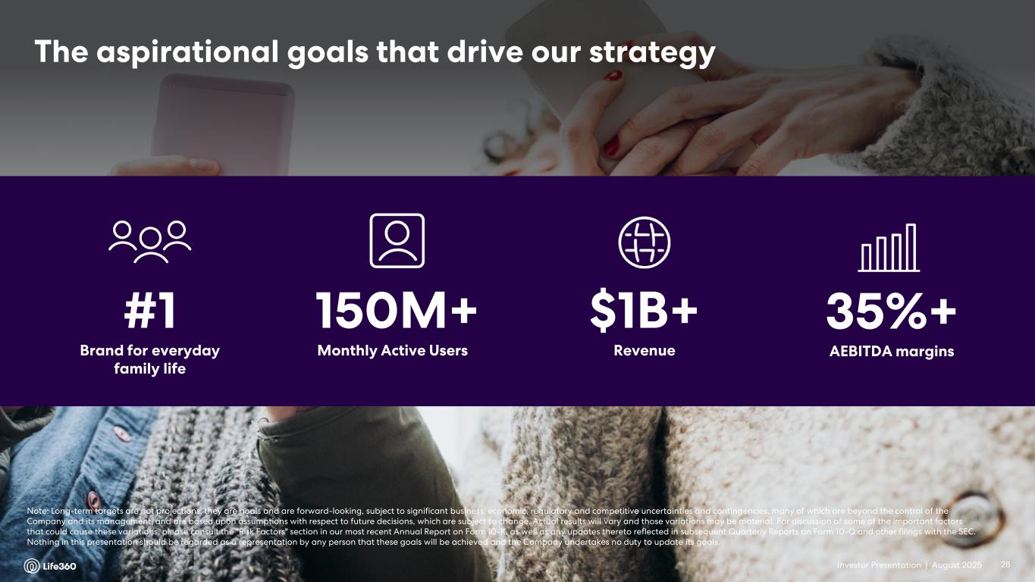
Investor Presentation | August 2025 The aspirational goals that drive our strategy #1 Brand for everyday family life 150M+ Monthly Active Users $1B+ Revenue 35%+ AEBITDA margins Note: Long-term targets are not projections; they are goals and are forward-looking, subject to significant business, economic, regulatory and competitive uncertainties and contingencies, many of which are beyond the control of the Company and its management, and are based upon assumptions with respect to future decisions, which are subject to change. Actual results will vary and those variations may be material. For discussion of some of the important factors that could cause these variations, please consult the "Risk Factors" section in our most recent Annual Report on Form 10-K, as well as any updates thereto reflected in subsequent Quarterly Reports on Form 10-Q and other filings with the SEC. Nothing in this presentation should be regarded as a representation by any person that these goals will be achieved and the Company undertakes no duty to update its goals. 28Investor Presentation |


Investor Presentation | August 2025 Financial Update Q2’25

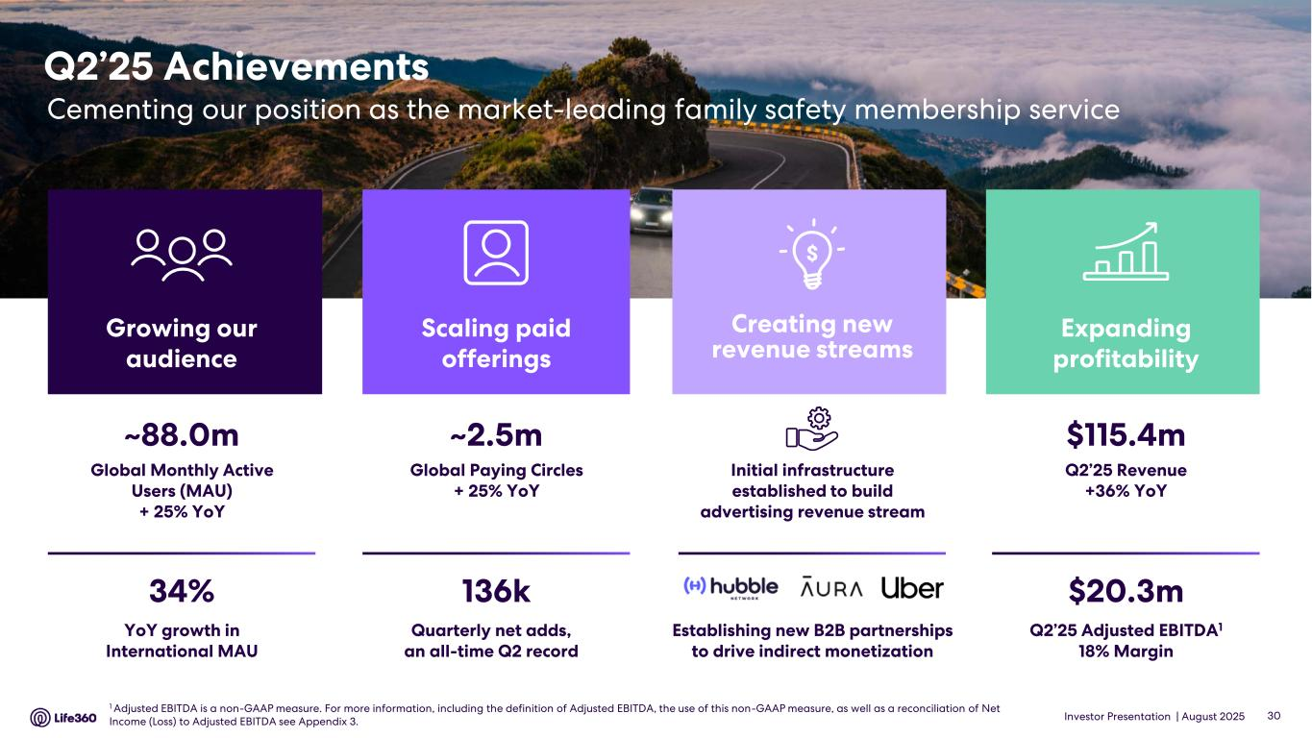
Investor Presentation | August 2025 Q2’25 Achievements Cementing our position as the market-leading family safety membership service $115.4m Q2’25 Revenue +36% YoY $20.3m Q2’25 Adjusted EBITDA1 18% Margin Expanding profitability ~2.5m Global Paying Circles + 25% YoY 136k Quarterly net adds, an all-time Q2 record Scaling paid offerings ~88.0m Global Monthly Active Users (MAU) + 25% YoY 34% YoY growth in International MAU Growing our audience Establishing new B2B partnerships to drive indirect monetization Initial infrastructure established to build advertising revenue stream Creating new revenue streams 30 1 Adjusted EBITDA is a non-GAAP measure. For more information, including the definition of Adjusted EBITDA, the use of this non-GAAP measure, as well as a reconciliation of Net Income (Loss) to Adjusted EBITDA see Appendix 3.

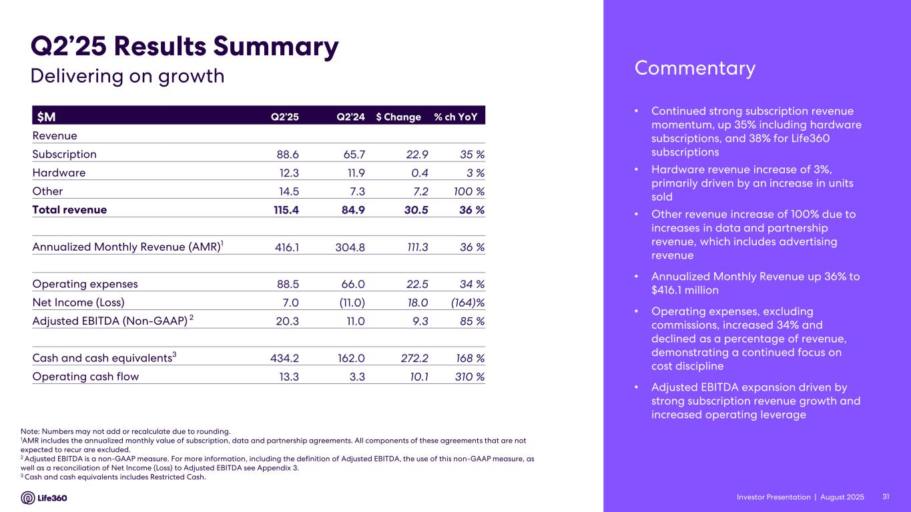
Investor Presentation | August 2025 • Continued strong subscription revenue momentum, up 35% including hardware subscriptions, and 38% for Life360 subscriptions • Hardware revenue increase of 3%, primarily driven by an increase in units sold • Other revenue increase of 100% due to increases in data and partnership revenue, which includes advertising revenue • Annualized Monthly Revenue up 36% to $416.1 million • Operating expenses, excluding commissions, increased 34% and declined as a percentage of revenue, demonstrating a continued focus on cost discipline • Adjusted EBITDA expansion driven by strong subscription revenue growth and increased operating leverage $M Q2’25 Q2’24 $ Change % ch YoY Revenue Subscription 88.6 65.7 22.9 35 % Hardware 12.3 11.9 0.4 3 % Other 14.5 7.3 7.2 100 % Total revenue 115.4 84.9 30.5 36 % Annualized Monthly Revenue (AMR)1 416.1 304.8 111.3 36 % Operating expenses 88.5 66.0 22.5 34 % Net Income (Loss) 7.0 (11.0) 18.0 (164)% Adjusted EBITDA (Non-GAAP) 2 20.3 11.0 9.3 85 % Cash and cash equivalents3 434.2 162.0 272.2 168 % Operating cash flow 13.3 3.3 10.1 310 % Note: Numbers may not add or recalculate due to rounding. 1AMR includes the annualized monthly value of subscription, data and partnership agreements. All components of these agreements that are not expected to recur are excluded. 2 Adjusted EBITDA is a non-GAAP measure. For more information, including the definition of Adjusted EBITDA, the use of this non-GAAP measure, as well as a reconciliation of Net Income (Loss) to Adjusted EBITDA see Appendix 3. 3 Cash and cash equivalents includes Restricted Cash. Q2’25 Results Summary CommentaryDelivering on growth 31Investor Presentation |

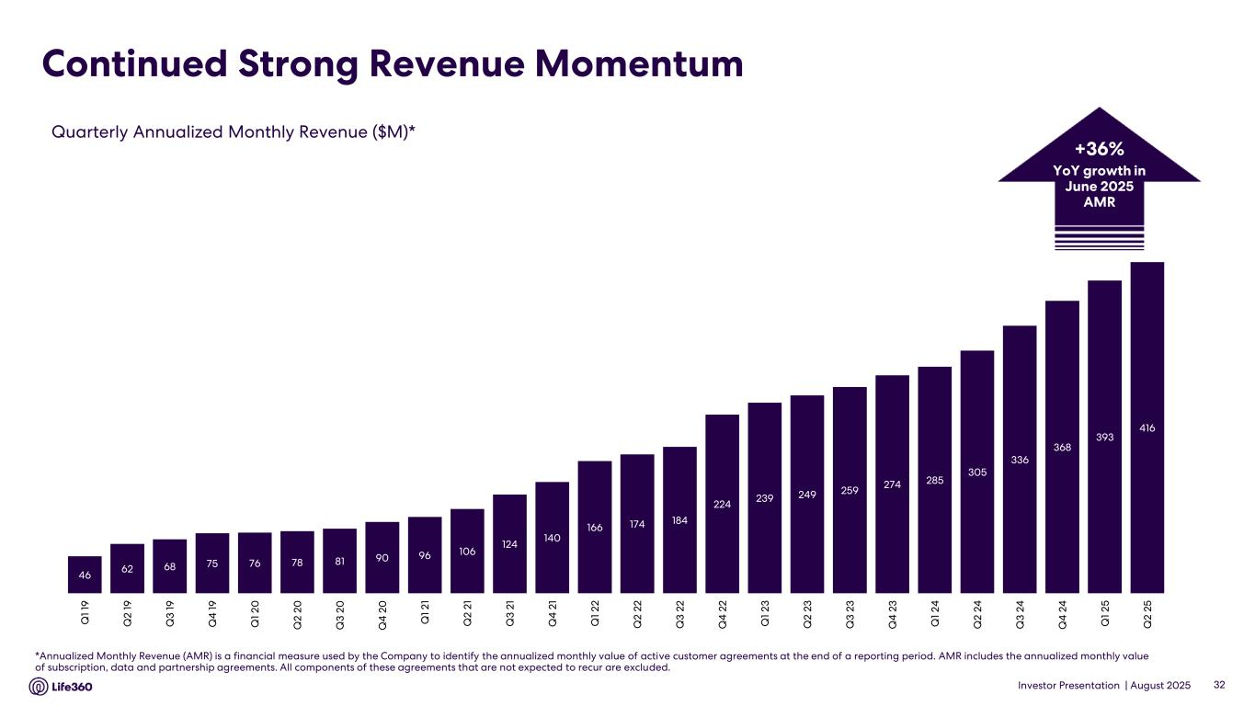
Investor Presentation | August 2025 Continued Strong Revenue Momentum *Annualized Monthly Revenue (AMR) is a financial measure used by the Company to identify the annualized monthly value of active customer agreements at the end of a reporting period. AMR includes the annualized monthly value of subscription, data and partnership agreements. All components of these agreements that are not expected to recur are excluded. Quarterly Annualized Monthly Revenue ($M)* 32 +36% YoY growth in June 2025 AMR 46 62 68 75 76 78 81 90 96 106 124 140 166 174 184 224 239 249 259 274 285 305 336 368 393 416 Q 1 19 Q 2 1 9 Q 3 1 9 Q 4 1 9 Q 1 2 0 Q 2 2 0 Q 3 2 0 Q 4 2 0 Q 1 2 1 Q 2 2 1 Q 3 2 1 Q 4 2 1 Q 1 2 2 Q 2 2 2 Q 3 2 2 Q 4 2 2 Q 1 2 3 Q 2 2 3 Q 3 2 3 Q 4 2 3 Q 1 2 4 Q 2 2 4 Q 3 2 4 Q 4 2 4 Q 1 2 5 Q 2 2 5

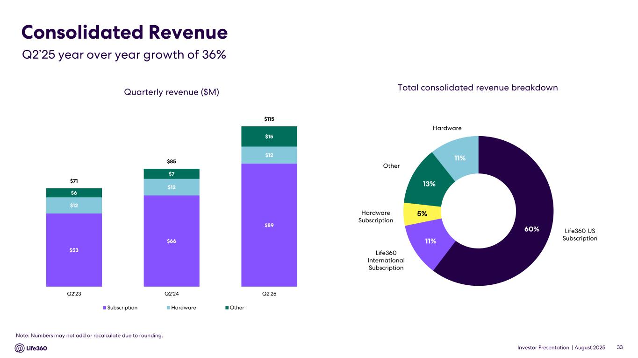
Investor Presentation | August 2025 Consolidated Revenue 33 Quarterly revenue ($M) Total consolidated revenue breakdown Hardware Life360 US Subscription Life360 International Subscription Hardware Subscription Other Q2’25 year over year growth of 36% $53 $66 $89 $12 $12 $12 $6 $7 $15 $71 $85 $115 Q2'23 Q2'24 Q2'25 Subscription Hardware Other 60% 11% 5% 13% 11% Note: Numbers may not add or recalculate due to rounding.

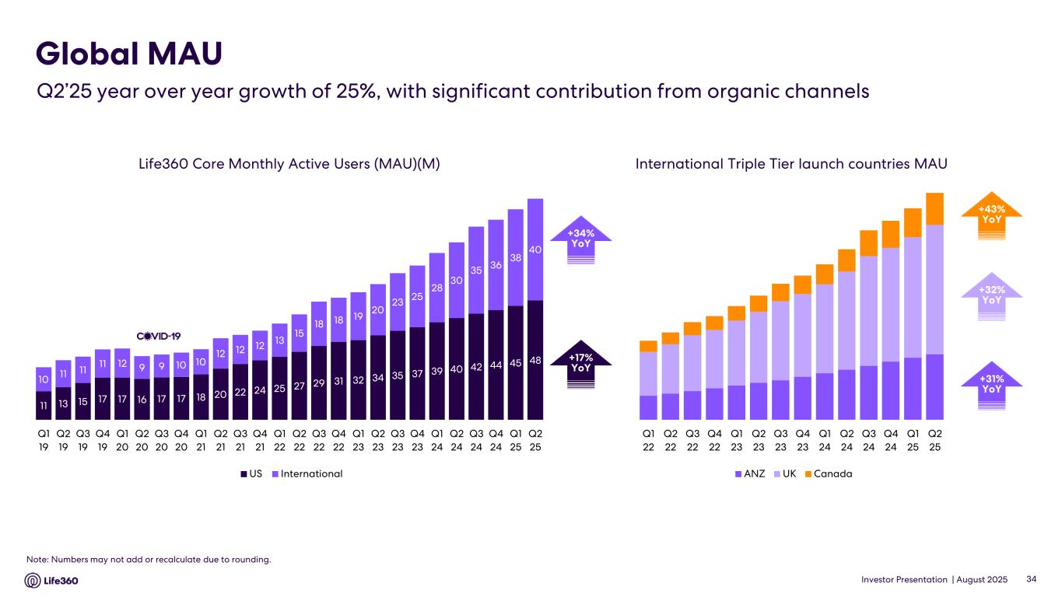
Investor Presentation | August 2025 Life360 Core Monthly Active Users (MAU)(M) Note: Numbers may not add or recalculate due to rounding. Global MAU Q2’25 year over year growth of 25%, with significant contribution from organic channels International Triple Tier launch countries MAU +32% YoY +43% YoY +31% YoY +34% YoY +17% YoY 34 11 13 15 17 17 16 17 17 18 20 22 24 25 27 29 31 32 34 35 37 39 40 42 44 45 48 10 11 11 11 12 9 9 10 10 12 12 12 13 15 18 18 19 20 23 25 28 30 35 36 38 40 Q1 19 Q2 19 Q3 19 Q4 19 Q1 20 Q2 20 Q3 20 Q4 20 Q1 21 Q2 21 Q3 21 Q4 21 Q1 22 Q2 22 Q3 22 Q4 22 Q1 23 Q2 23 Q3 23 Q4 23 Q1 24 Q2 24 Q3 24 Q4 24 Q1 25 Q2 25 US International Q1 22 Q2 22 Q3 22 Q4 22 Q1 23 Q2 23 Q3 23 Q4 23 Q1 24 Q2 24 Q3 24 Q4 24 Q1 25 Q2 25 ANZ UK Canada

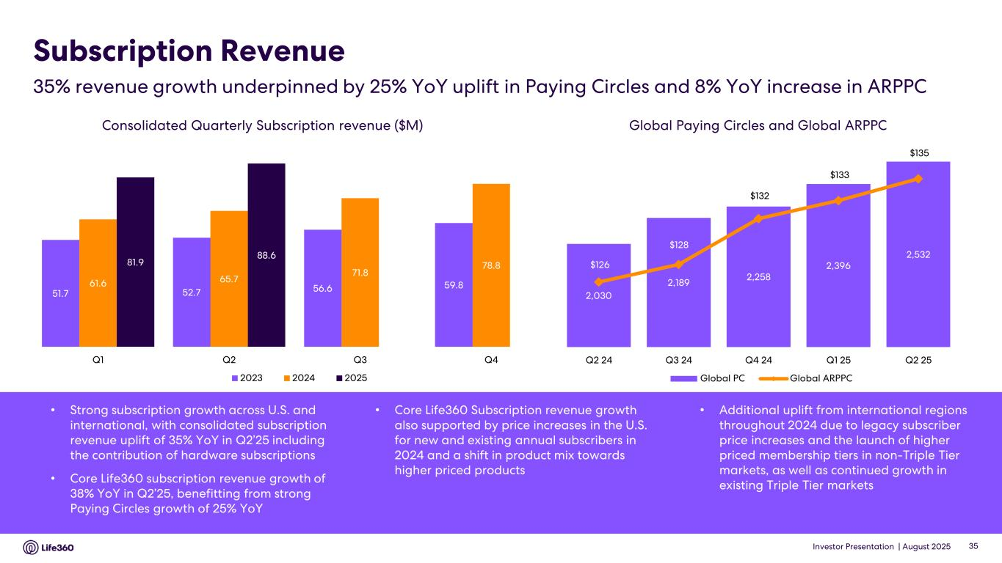
Investor Presentation | August 2025 2,030 2,189 2,258 2,396 2,532 $126 $128 $132 $133 $135 $120 $122 $124 $126 $128 $130 $132 $134 $136 $138 1,400 1,600 1,800 2,000 2,200 2,400 2,600 Q2 24 Q3 24 Q4 24 Q1 25 Q2 25 Global PC Global ARPPC Subscription Revenue Consolidated Quarterly Subscription revenue ($M) Global Paying Circles and Global ARPPC • Strong subscription growth across U.S. and international, with consolidated subscription revenue uplift of 35% YoY in Q2’25 including the contribution of hardware subscriptions • Core Life360 subscription revenue growth of 38% YoY in Q2’25, benefitting from strong Paying Circles growth of 25% YoY • Core Life360 Subscription revenue growth also supported by price increases in the U.S. for new and existing annual subscribers in 2024 and a shift in product mix towards higher priced products • Additional uplift from international regions throughout 2024 due to legacy subscriber price increases and the launch of higher priced membership tiers in non-Triple Tier markets, as well as continued growth in existing Triple Tier markets 35% revenue growth underpinned by 25% YoY uplift in Paying Circles and 8% YoY increase in ARPPC 35 51.7 52.7 56.6 59.861.6 65.7 71.8 78.881.9 88.6 Q1 Q2 Q3 Q4 2023 2024 2025

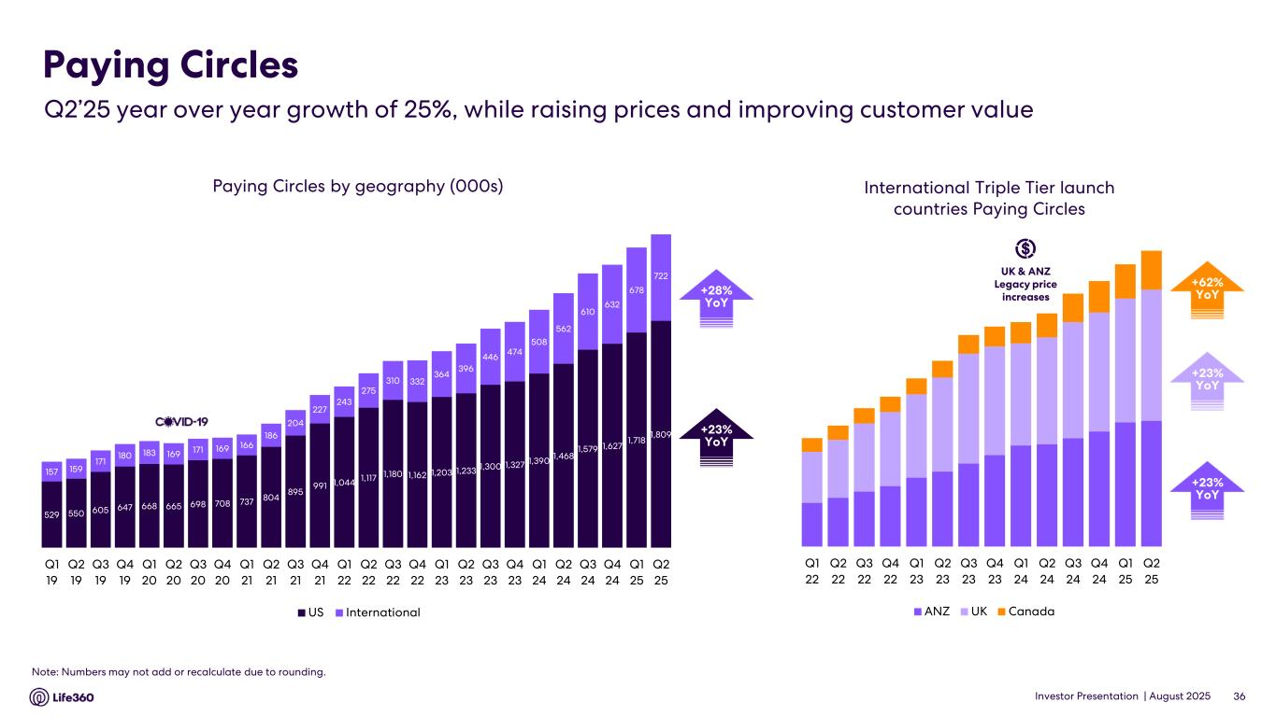
Investor Presentation | August 2025 529 550 605 647 668 665 698 708 737 804 895 991 1,044 1,117 1,180 1,162 1,203 1,233 1,300 1,327 1,390 1,468 1,579 1,627 1,718 1,809 157 159 171 180 183 169 171 169 166 186 204 227 243 275 310 332 364 396 446 474 508 562 610 632 678 722 Q1 19 Q2 19 Q3 19 Q4 19 Q1 20 Q2 20 Q3 20 Q4 20 Q1 21 Q2 21 Q3 21 Q4 21 Q1 22 Q2 22 Q3 22 Q4 22 Q1 23 Q2 23 Q3 23 Q4 23 Q1 24 Q2 24 Q3 24 Q4 24 Q1 25 Q2 25 US International Paying Circles by geography (000s) Paying Circles $140 $1398 +42% YoY$38 +42% YoYInternational Triple Tier launch countries Paying Circles +23% YoY +62% YoY +23% YoY +28% YoY +23% YoY 36 Note: Numbers may not add or recalculate due to rounding. Q2’25 year over year growth of 25%, while raising prices and improving customer value UK & ANZ Legacy price increases Q1 22 Q2 22 Q3 22 Q4 22 Q1 23 Q2 23 Q3 23 Q4 23 Q1 24 Q2 24 Q3 24 Q4 24 Q1 25 Q2 25 ANZ UK Canada

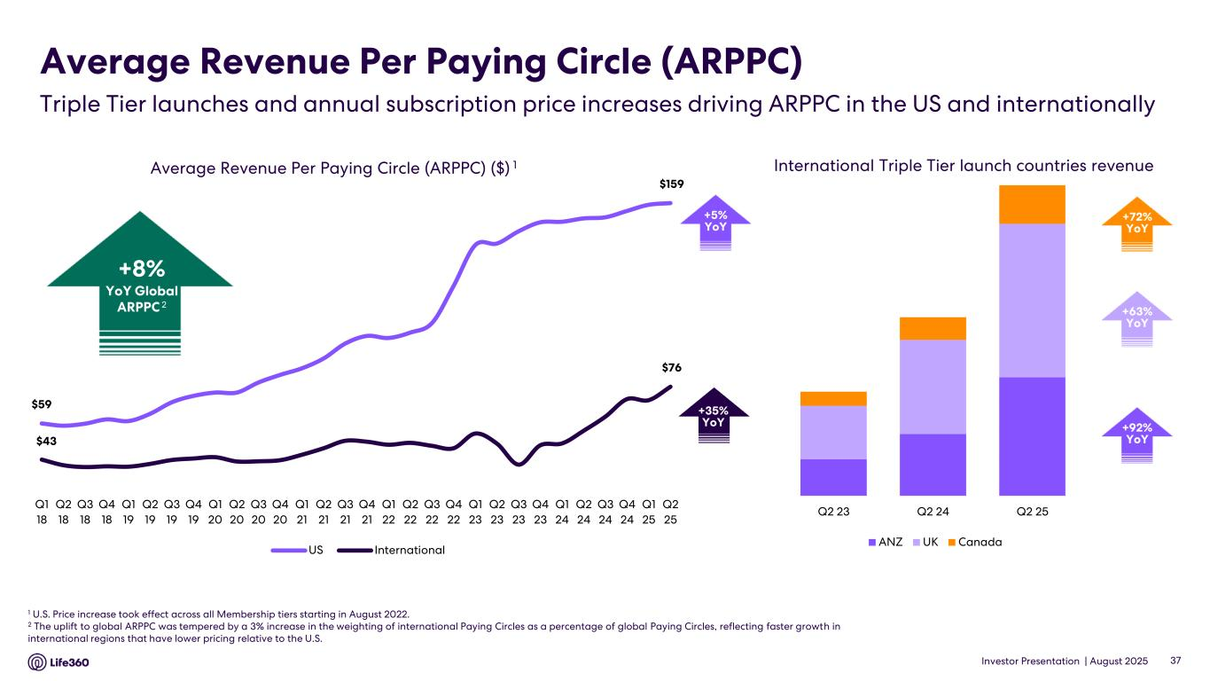
Investor Presentation | August 2025 $59 $159 $43 $76 Q1 18 Q2 18 Q3 18 Q4 18 Q1 19 Q2 19 Q3 19 Q4 19 Q1 20 Q2 20 Q3 20 Q4 20 Q1 21 Q2 21 Q3 21 Q4 21 Q1 22 Q2 22 Q3 22 Q4 22 Q1 23 Q2 23 Q3 23 Q4 23 Q1 24 Q2 24 Q3 24 Q4 24 Q1 25 Q2 25 US International Average Revenue Per Paying Circle (ARPPC) 1 U.S. Price increase took effect across all Membership tiers starting in August 2022. 2 The uplift to global ARPPC was tempered by a 3% increase in the weighting of international Paying Circles as a percentage of global Paying Circles, reflecting faster growth in international regions that have lower pricing relative to the U.S. Average Revenue Per Paying Circle (ARPPC) ($) 1 +35% YoY 37 +5% YoY +8% YoY Global ARPPC 2 +63% YoY +72% YoY +92% YoY Triple Tier launches and annual subscription price increases driving ARPPC in the US and internationally Q2 23 Q2 24 Q2 25 ANZ UK Canada International Triple Tier launch countries revenue

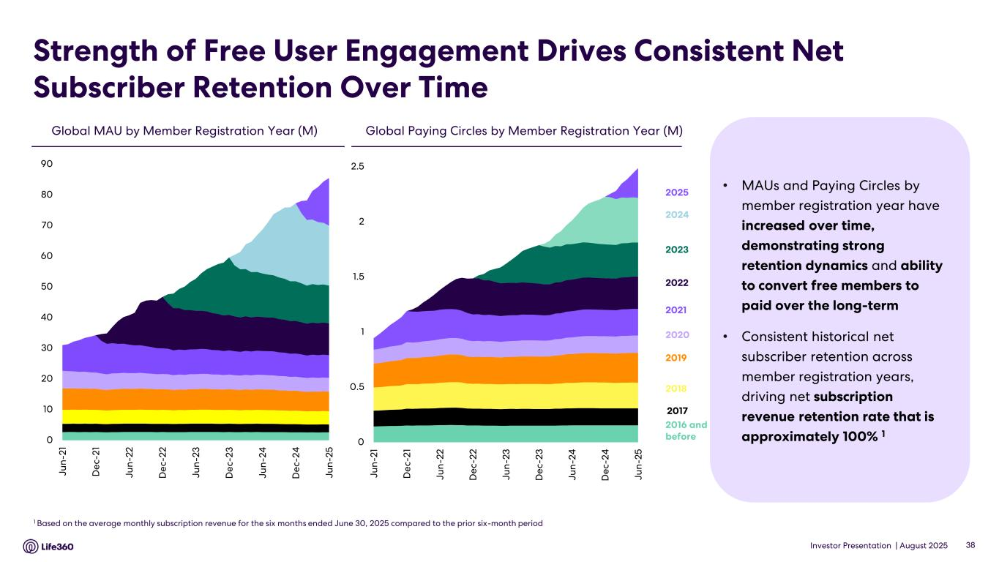
Investor Presentation | August 2025 Strength of Free User Engagement Drives Consistent Net Subscriber Retention Over Time • MAUs and Paying Circles by member registration year have increased over time, demonstrating strong retention dynamics and ability to convert free members to paid over the long-term • Consistent historical net subscriber retention across member registration years, driving net subscription revenue retention rate that is approximately 100% 1 Global Paying Circles by Member Registration Year (M)Global MAU by Member Registration Year (M) 1 Based on the average monthly subscription revenue for the six months ended June 30, 2025 compared to the prior six-month period 2023 2022 2021 2020 2019 2018 2017 2016 and before 2024 38 2025 0 0.5 1 1.5 2 2.5 Ju n -2 1 D e c- 2 1 Ju n -2 2 D e c- 2 2 Ju n -2 3 D e c- 2 3 Ju n -2 4 D e c- 2 4 Ju n -2 5 0 10 20 30 40 50 60 70 80 90 J u n -2 1 D e c- 2 1 Ju n -2 2 D e c- 2 2 Ju n -2 3 D e c- 2 3 Ju n -2 4 D e c- 2 4 Ju n -2 5

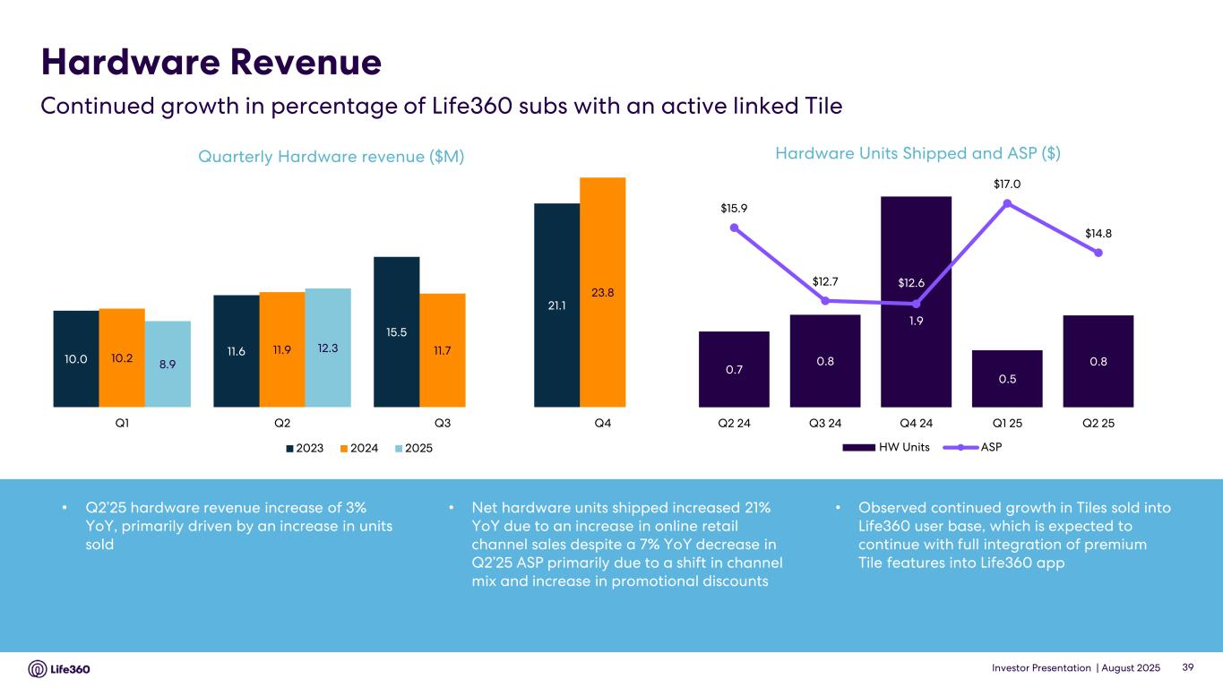
Investor Presentation | August 2025 Hardware Revenue Quarterly Hardware revenue ($M) 39 • Q2’25 hardware revenue increase of 3% YoY, primarily driven by an increase in units sold • Net hardware units shipped increased 21% YoY due to an increase in online retail channel sales despite a 7% YoY decrease in Q2’25 ASP primarily due to a shift in channel mix and increase in promotional discounts • Observed continued growth in Tiles sold into Life360 user base, which is expected to continue with full integration of premium Tile features into Life360 app Hardware Units Shipped and ASP ($) Continued growth in percentage of Life360 subs with an active linked Tile 10.0 11.6 15.5 21.1 10.2 11.9 11.7 23.8 8.9 12.3 Q1 Q2 Q3 Q4 2023 2024 2025 0.7 0.8 1.9 0.5 0.8 $15.9 $12.7 $12.6 $17.0 $14.8 8.00 9.00 10.00 11.00 12.00 13.00 14.00 15.00 16.00 17.00 18.00 0.00 0.20 0.40 0.60 0.80 1.00 1.20 1.40 1.60 1.80 2.00 Q2 24 Q3 24 Q4 24 Q1 25 Q2 25 HW Units ASP

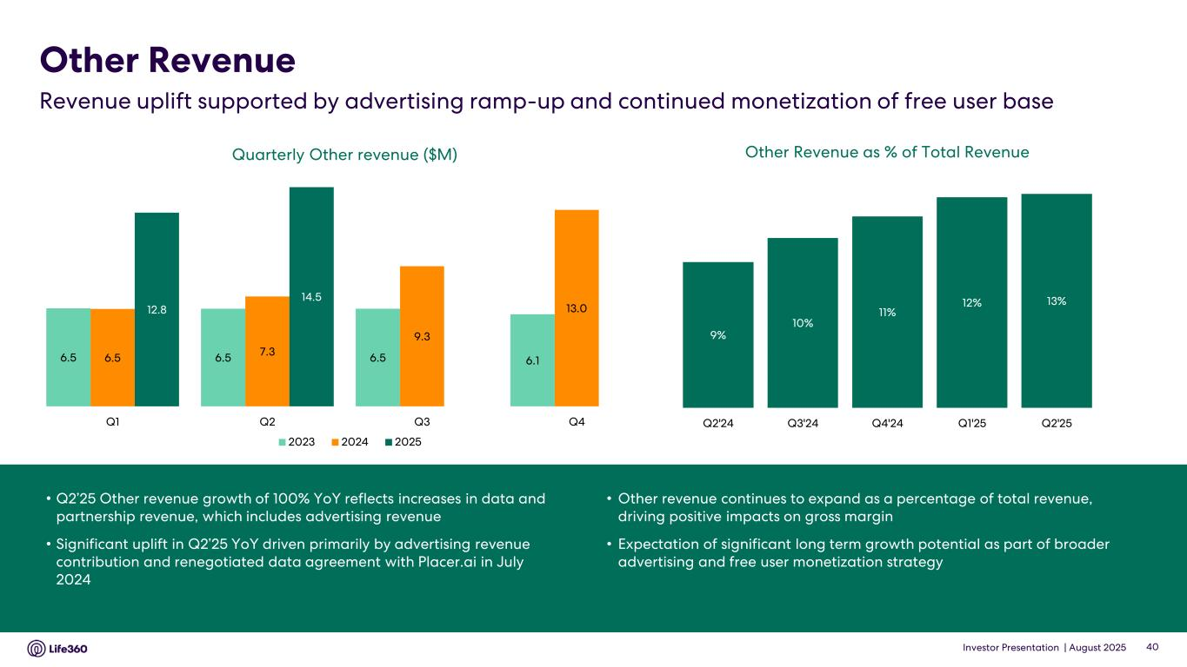
Investor Presentation | August 2025 9% 10% 11% 12% 13% Q2'24 Q3'24 Q4'24 Q1'25 Q2'25 • Q2’25 Other revenue growth of 100% YoY reflects increases in data and partnership revenue, which includes advertising revenue • Significant uplift in Q2’25 YoY driven primarily by advertising revenue contribution and renegotiated data agreement with Placer.ai in July 2024 • Other revenue continues to expand as a percentage of total revenue, driving positive impacts on gross margin • Expectation of significant long term growth potential as part of broader advertising and free user monetization strategy Quarterly Other revenue ($M) Other Revenue Revenue uplift supported by advertising ramp-up and continued monetization of free user base 40 Other Revenue as % of Total Revenue 6.5 6.5 6.5 6.16.5 7.3 9.3 13.012.8 14.5 Q1 Q2 Q3 Q4 2023 2024 2025

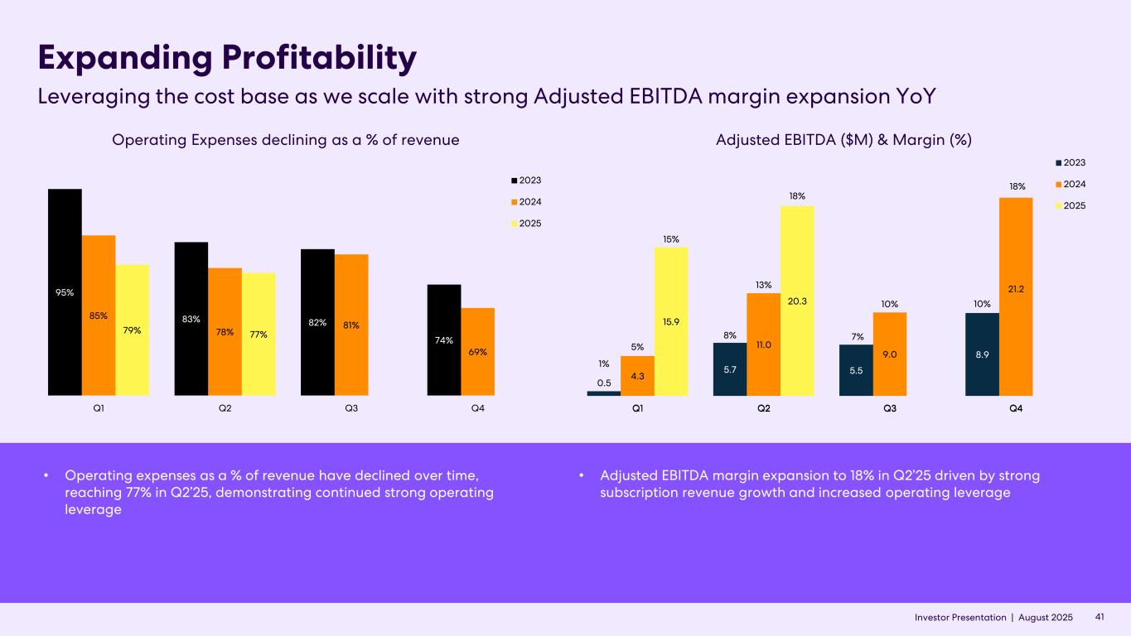
Investor Presentation | August 2025 Expanding Profitability Leveraging the cost base as we scale with strong Adjusted EBITDA margin expansion YoY 41Investor Presentation | Adjusted EBITDA ($M) & Margin (%)Operating Expenses declining as a % of revenue 7% • Operating expenses as a % of revenue have declined over time, reaching 77% in Q2’25, demonstrating continued strong operating leverage • Adjusted EBITDA margin expansion to 18% in Q2’25 driven by strong subscription revenue growth and increased operating leverage 0.5 5.7 5.5 8.9 4.3 11.0 9.0 21.2 15.9 20.3 Q1 Q2 Q3 Q4 2023 2024 2025 1% 8% 7% 10% 5% 13% 10% 18% 15% 18% 95% 83% 82% 74% 85% 78% 81% 69% 79% 77% Q1 Q2 Q3 Q4 2023 2024 2025


Investor Presentation | August 2025 FY’25 Outlook

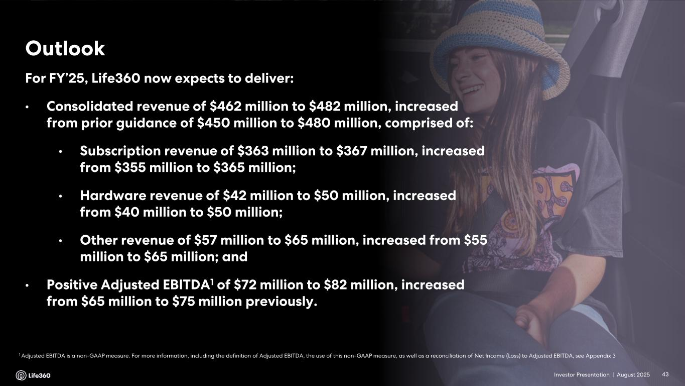
Investor Presentation | August 2025 1 Adjusted EBITDA is a non-GAAP measure. For more information, including the definition of Adjusted EBITDA, the use of this non-GAAP measure, as well as a reconciliation of Net Income (Loss) to Adjusted EBITDA, see Appendix 3 Outlook 43 For FY’25, Life360 now expects to deliver: • Consolidated revenue of $462 million to $482 million, increased from prior guidance of $450 million to $480 million, comprised of: • Subscription revenue of $363 million to $367 million, increased from $355 million to $365 million; • Hardware revenue of $42 million to $50 million, increased from $40 million to $50 million; • Other revenue of $57 million to $65 million, increased from $55 million to $65 million; and • Positive Adjusted EBITDA1 of $72 million to $82 million, increased from $65 million to $75 million previously. Investor Presentation |


Investor Presentation | August 2025 Appendix

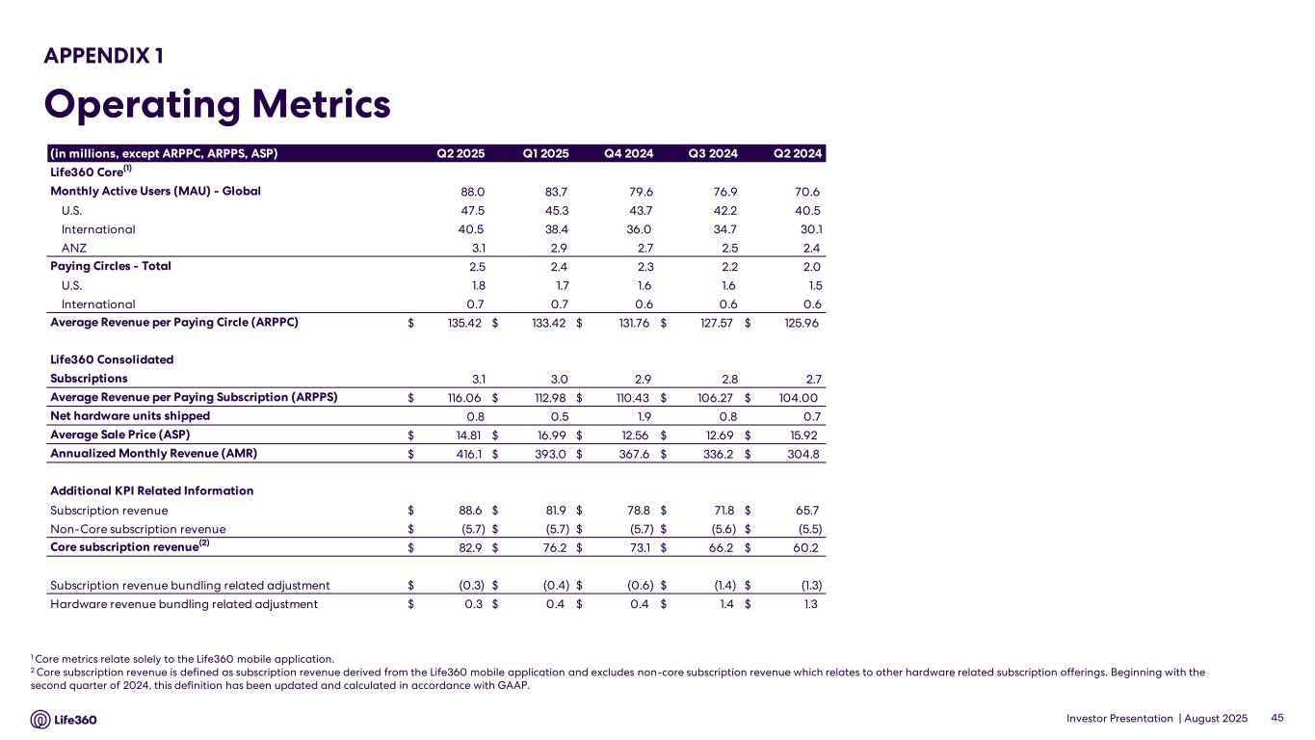
Investor Presentation | August 2025 APPENDIX 1 Operating Metrics 1 Core metrics relate solely to the Life360 mobile application. 2 Core subscription revenue is defined as subscription revenue derived from the Life360 mobile application and excludes non-core subscription revenue which relates to other hardware related subscription offerings. Beginning with the second quarter of 2024, this definition has been updated and calculated in accordance with GAAP. 45 (in millions, except ARPPC, ARPPS, ASP) Q2 2025 Q1 2025 Q4 2024 Q3 2024 Q2 2024 Life360 Core(1) Monthly Active Users (MAU) - Global 88.0 83.7 79.6 76.9 70.6 U.S. 47.5 45.3 43.7 42.2 40.5 International 40.5 38.4 36.0 34.7 30.1 ANZ 3.1 2.9 2.7 2.5 2.4 Paying Circles - Total 2.5 2.4 2.3 2.2 2.0 U.S. 1.8 1.7 1.6 1.6 1.5 International 0.7 0.7 0.6 0.6 0.6 Average Revenue per Paying Circle (ARPPC) $ 135.42 $ 133.42 $ 131.76 $ 127.57 $ 125.96 Life360 Consolidated Subscriptions 3.1 3.0 2.9 2.8 2.7 Average Revenue per Paying Subscription (ARPPS) $ 116.06 $ 112.98 $ 110.43 $ 106.27 $ 104.00 Net hardware units shipped 0.8 0.5 1.9 0.8 0.7 Average Sale Price (ASP) $ 14.81 $ 16.99 $ 12.56 $ 12.69 $ 15.92 Annualized Monthly Revenue (AMR) $ 416.1 $ 393.0 $ 367.6 $ 336.2 $ 304.8 Additional KPI Related Information Subscription revenue $ 88.6 $ 81.9 $ 78.8 $ 71.8 $ 65.7 Non-Core subscription revenue $ (5.7) $ (5.7) $ (5.7) $ (5.6) $ (5.5) Core subscription revenue(2) $ 82.9 $ 76.2 $ 73.1 $ 66.2 $ 60.2 Subscription revenue bundling related adjustment $ (0.3) $ (0.4) $ (0.6) $ (1.4) $ (1.3) Hardware revenue bundling related adjustment $ 0.3 $ 0.4 $ 0.4 $ 1.4 $ 1.3

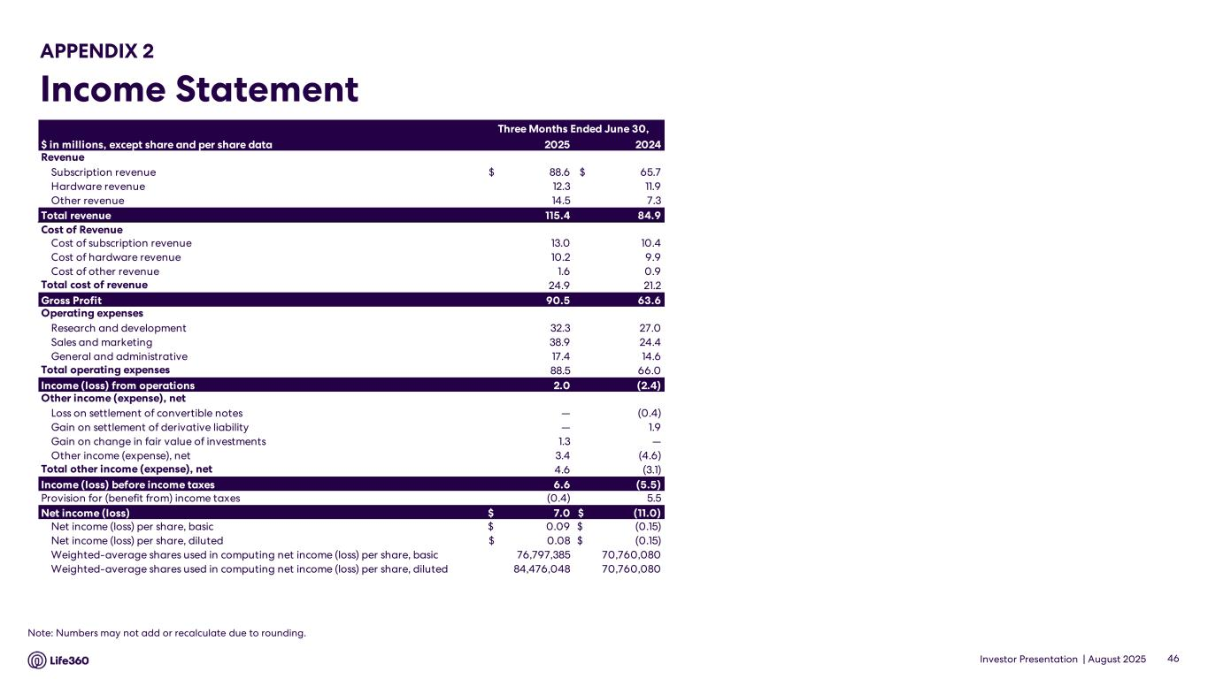
Investor Presentation | August 2025 APPENDIX 2 Income Statement 46 Note: Numbers may not add or recalculate due to rounding. Three Months Ended June 30, Six Months Ended June 30, $ in millions, except share and per share data 2025 2024 Revenue Subscription revenue $ 88.6 $ 65.7 Hardware revenue 12.3 11.9 Other revenue 14.5 7.3 Total revenue 115.4 84.9 Cost of Revenue Cost of subscription revenue 13.0 10.4 Cost of hardware revenue 10.2 9.9 Cost of other revenue 1.6 0.9 Total cost of revenue 24.9 21.2 Gross Profit 90.5 63.6 Operating expenses Research and development 32.3 27.0 Sales and marketing 38.9 24.4 General and administrative 17.4 14.6 Total operating expenses 88.5 66.0 Income (loss) from operations 2.0 (2.4) Other income (expense), net Loss on settlement of convertible notes — (0.4) Gain on settlement of derivative liability — 1.9 Gain on change in fair value of investments 1.3 — Other income (expense), net 3.4 (4.6) Total other income (expense), net 4.6 (3.1) Income (loss) before income taxes 6.6 (5.5) Provision for (benefit from) income taxes (0.4) 5.5 Net income (loss) $ 7.0 $ (11.0) Net income (loss) per share, basic $ 0.09 $ (0.15) Net income (loss) per share, diluted $ 0.08 $ (0.15) Weighted-average shares used in computing net income (loss) per share, basic 76,797,385 70,760,080 Weighted-average shares used in computing net income (loss) per share, diluted 84,476,048 70,760,080

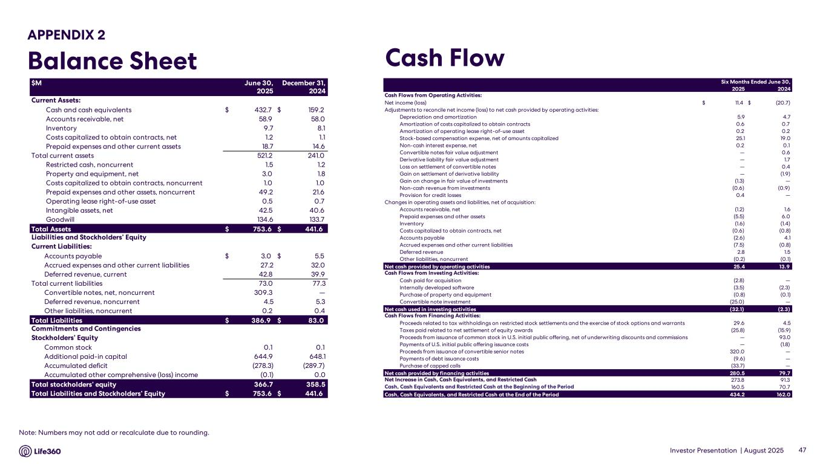
Investor Presentation | August 2025 APPENDIX 2 Balance Sheet Cash Flow 47 Note: Numbers may not add or recalculate due to rounding. $M June 30, December 31, 2025 2024 Current Assets: Cash and cash equivalents $ 432.7 $ 159.2 Accounts receivable, net 58.9 58.0 Inventory 9.7 8.1 Costs capitalized to obtain contracts, net 1.2 1.1 Prepaid expenses and other current assets 18.7 14.6 Total current assets 521.2 241.0 Restricted cash, noncurrent 1.5 1.2 Property and equipment, net 3.0 1.8 Costs capitalized to obtain contracts, noncurrent 1.0 1.0 Prepaid expenses and other assets, noncurrent 49.2 21.6 Operating lease right-of-use asset 0.5 0.7 Intangible assets, net 42.5 40.6 Goodwill 134.6 133.7 Total Assets $ 753.6 $ 441.6 Liabilities and Stockholders’ Equity Current Liabilities: Accounts payable $ 3.0 $ 5.5 Accrued expenses and other current liabilities 27.2 32.0 Deferred revenue, current 42.8 39.9 Total current liabilities 73.0 77.3 Convertible notes, net, noncurrent 309.3 — Deferred revenue, noncurrent 4.5 5.3 Other liabilities, noncurrent 0.2 0.4 Total Liabilities $ 386.9 $ 83.0 Commitments and Contingencies Stockholders’ Equity Common stock 0.1 0.1 Additional paid-in capital 644.9 648.1 Accumulated deficit (278.3) (289.7) Accumulated other comprehensive (loss) income (0.1) 0.0 Total stockholders’ equity 366.7 358.5 Total Liabilities and Stockholders’ Equity $ 753.6 $ 441.6 2025 2024 Cash Flows from Operating Activities: Net income (loss) $ 11.4 $ (20.7) Adjustments to reconcile net income (loss) to net cash provided by operating activities: Depreciation and amortization 5.9 4.7 Amortization of costs capitalized to obtain contracts 0.6 0.7 Amortization of operating lease right-of-use asset 0.2 0.2 Stock-based compensation expense, net of amounts capitalized 25.1 19.0 Non-cash interest expense, net 0.2 0.1 Convertible notes fair value adjustment — 0.6 Derivative liability fair value adjustment — 1.7 Loss on settlement of convertible notes — 0.4 Gain on settlement of derivative liability — (1.9) Gain on change in fair value of investments (1.3) — Non-cash revenue from investments (0.6) (0.9) Provision for credit losses 0.4 — Changes in operating assets and liabilities, net of acquisition: Accounts receivable, net (1.2) 1.6 Prepaid expenses and other assets (5.5) 6.0 Inventory (1.6) (1.4) Costs capitalized to obtain contracts, net (0.6) (0.8) Accounts payable (2.6) 4.1 Accrued expenses and other current liabilities (7.5) (0.8) Deferred revenue 2.8 1.5 Other liabilities, noncurrent (0.2) (0.1) Net cash provided by operating activities 25.4 13.9 Cash Flows from Investing Activities: Cash paid for acquisition (2.8) — Internally developed software (3.5) (2.3) Purchase of property and equipment (0.8) (0.1) Convertible note investment (25.0) — Net cash used in investing activities (32.1) (2.3) Cash Flows from Financing Activities: Proceeds related to tax withholdings on restricted stock settlements and the exercise of stock options and warrants 29.6 4.5 Taxes paid related to net settlement of equity awards (25.8) (15.9) Proceeds from issuance of common stock in U.S. initial public offering, net of underwriting discounts and commissions — 93.0 Payments of U.S. initial public offering issuance costs — (1.8) Proceeds from issuance of convertible senior notes 320.0 — Payments of debt issuance costs (9.6) — Purchase of capped calls (33.7) — Net cash provided by financing activities 280.5 79.7 Net Increase in Cash, Cash Equivalents, and Restricted Cash 273.8 91.3 Cash, Cash Equivalents and Restricted Cash at the Beginning of the Period 160.5 70.7 Cash, Cash Equivalents, and Restricted Cash at the End of the Period 434.2 162.0 Six Months Ended June 30,

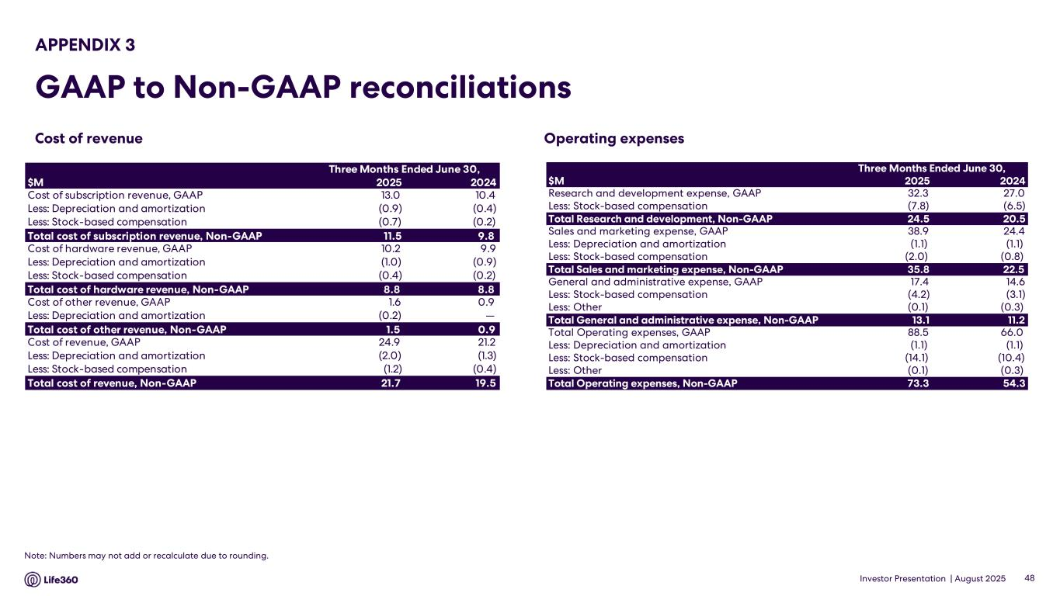
Investor Presentation | August 2025 Operating expenses APPENDIX 3 GAAP to Non-GAAP reconciliations 48 Note: Numbers may not add or recalculate due to rounding. Cost of revenue Three Months Ended June 30, Six Months Ended June 30, $M 2025 2024 Cost of subscription revenue, GAAP 13.0 10.4 Less: Depreciation and amortization (0.9) (0.4) Less: Stock-based compensation (0.7) (0.2) Total cost of subscription revenue, Non-GAAP 11.5 9.8 Cost of hardware revenue, GAAP 10.2 9.9 Less: Depreciation and amortization (1.0) (0.9) Less: Stock-based compensation (0.4) (0.2) Total cost of hardware revenue, Non-GAAP 8.8 8.8 Cost of other revenue, GAAP 1.6 0.9 Less: Depreciation and amortization (0.2) — Total cost of other revenue, Non-GAAP 1.5 0.9 Cost of revenue, GAAP 24.9 21.2 Less: Depreciation and amortization (2.0) (1.3) Less: Stock-based compensation (1.2) (0.4) Total cost of revenue, Non-GAAP 21.7 19.5 Three Months Ended June 30, Six Months Ended June 30, $M 2025 2024 Research and development expense, GAAP 32.3 27.0 Less: Stock-based compensation (7.8) (6.5) Total Research and development, Non-GAAP 24.5 20.5 Sales and marketing expense, GAAP 38.9 24.4 Less: Depreciation and amortization (1.1) (1.1) Less: Stock-based compensation (2.0) (0.8) Total Sales and marketing expense, Non-GAAP 35.8 22.5 General and administrative expense, GAAP 17.4 14.6 Less: Stock-based compensation (4.2) (3.1) Less: Other (0.1) (0.3) Total General and administrative expense, Non-GAAP 13.1 11.2 Total Operating expenses, GAAP 88.5 66.0 Less: Depreciation and amortization (1.1) (1.1) Less: Stock-based compensation (14.1) (10.4) Less: Other (0.1) (0.3) Total Operating expenses, Non-GAAP 73.3 54.3

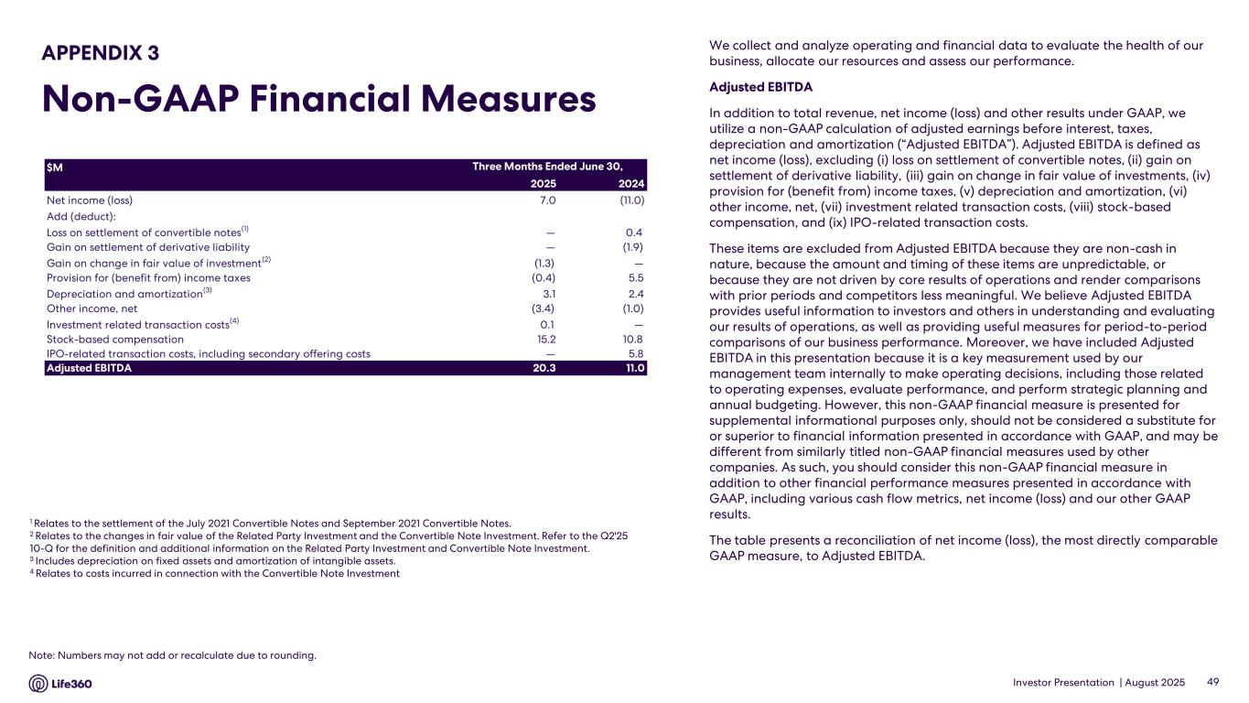
Investor Presentation | August 2025 We collect and analyze operating and financial data to evaluate the health of our business, allocate our resources and assess our performance. Adjusted EBITDA In addition to total revenue, net income (loss) and other results under GAAP, we utilize a non-GAAP calculation of adjusted earnings before interest, taxes, depreciation and amortization (“Adjusted EBITDA”). Adjusted EBITDA is defined as net income (loss), excluding (i) loss on settlement of convertible notes, (ii) gain on settlement of derivative liability, (iii) gain on change in fair value of investments, (iv) provision for (benefit from) income taxes, (v) depreciation and amortization, (vi) other income, net, (vii) investment related transaction costs, (viii) stock-based compensation, and (ix) IPO-related transaction costs. These items are excluded from Adjusted EBITDA because they are non-cash in nature, because the amount and timing of these items are unpredictable, or because they are not driven by core results of operations and render comparisons with prior periods and competitors less meaningful. We believe Adjusted EBITDA provides useful information to investors and others in understanding and evaluating our results of operations, as well as providing useful measures for period-to-period comparisons of our business performance. Moreover, we have included Adjusted EBITDA in this presentation because it is a key measurement used by our management team internally to make operating decisions, including those related to operating expenses, evaluate performance, and perform strategic planning and annual budgeting. However, this non-GAAP financial measure is presented for supplemental informational purposes only, should not be considered a substitute for or superior to financial information presented in accordance with GAAP, and may be different from similarly titled non-GAAP financial measures used by other companies. As such, you should consider this non-GAAP financial measure in addition to other financial performance measures presented in accordance with GAAP, including various cash flow metrics, net income (loss) and our other GAAP results. The table presents a reconciliation of net income (loss), the most directly comparable GAAP measure, to Adjusted EBITDA. 1 Relates to the settlement of the July 2021 Convertible Notes and September 2021 Convertible Notes. 2 Relates to the changes in fair value of the Related Party Investment and the Convertible Note Investment. Refer to the Q2'25 10-Q for the definition and additional information on the Related Party Investment and Convertible Note Investment. 3 Includes depreciation on fixed assets and amortization of intangible assets. 4 Relates to costs incurred in connection with the Convertible Note Investment 49 APPENDIX 3 Non-GAAP Financial Measures Note: Numbers may not add or recalculate due to rounding. $M 2025 2024 Net income (loss) 7.0 (11.0) Add (deduct): Loss on settlement of convertible notes(1) — 0.4 Gain on settlement of derivative liability — (1.9) Gain on change in fair value of investment(2) (1.3) — Provision for (benefit from) income taxes (0.4) 5.5 Depreciation and amortization(3) 3.1 2.4 Other income, net (3.4) (1.0) Investment related transaction costs(4) 0.1 — Stock-based compensation 15.2 10.8 IPO-related transaction costs, including secondary offering costs — 5.8 Adjusted EBITDA 20.3 11.0 Three Months Ended June 30,

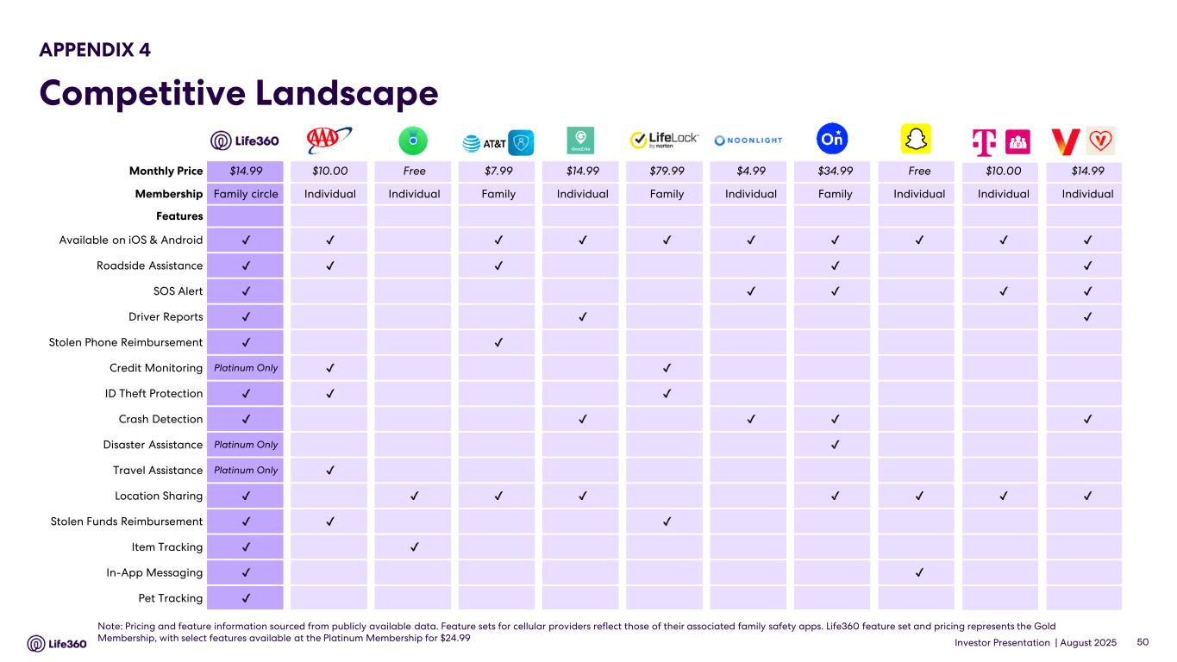
Investor Presentation | August 2025 50 Note: Pricing and feature information sourced from publicly available data. Feature sets for cellular providers reflect those of their associated family safety apps. Life360 feature set and pricing represents the Gold Membership, with select features available at the Platinum Membership for $24.99 APPENDIX 4 Competitive Landscape Monthly Price $14.99 $10.00 Free $7.99 $14.99 $79.99 $4.99 $34.99 Free $10.00 $14.99 Membership Family circle Individual Individual Family Individual Family Individual Family Individual Individual Individual Features Available on iOS & Android Roadside Assistance SOS Alert Driver Reports Stolen Phone Reimbursement Credit Monitoring Platinum Only ID Theft Protection Crash Detection Disaster Assistance Platinum Only Travel Assistance Platinum Only Location Sharing Stolen Funds Reimbursement Item Tracking In-App Messaging Pet Tracking


Investor Presentation | August 2025 Thank You

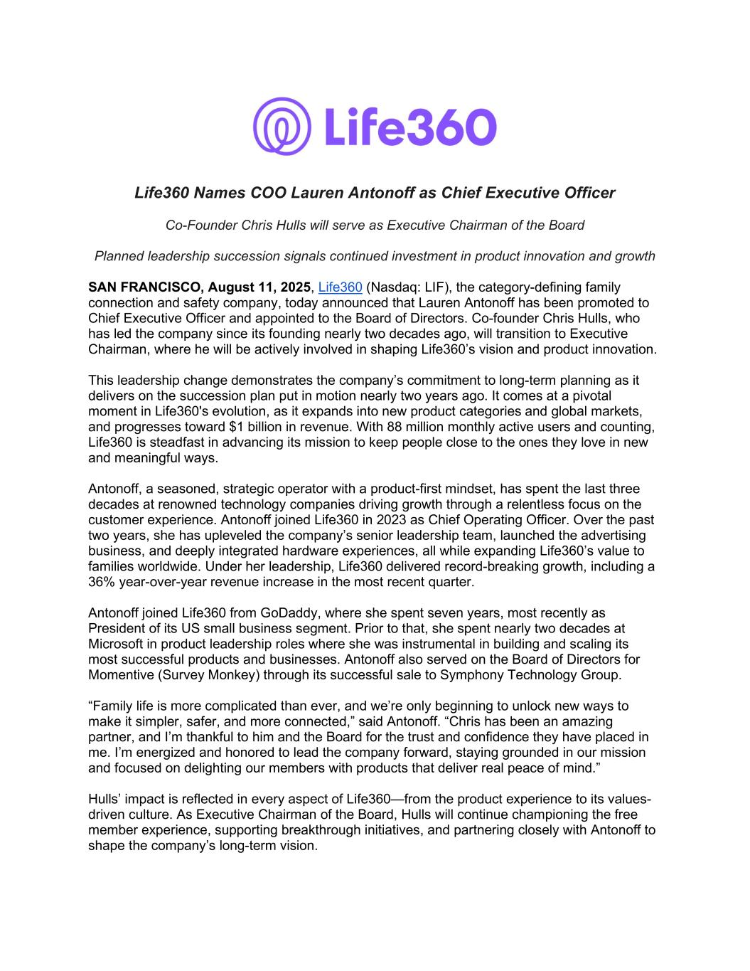
Life360 Names COO Lauren Antonoff as Chief Executive Officer Co-Founder Chris Hulls will serve as Executive Chairman of the Board Planned leadership succession signals continued investment in product innovation and growth SAN FRANCISCO, August 11, 2025, Life360 (Nasdaq: LIF), the category-defining family connection and safety company, today announced that Lauren Antonoff has been promoted to Chief Executive Officer and appointed to the Board of Directors. Co-founder Chris Hulls, who has led the company since its founding nearly two decades ago, will transition to Executive Chairman, where he will be actively involved in shaping Life360’s vision and product innovation. This leadership change demonstrates the company’s commitment to long-term planning as it delivers on the succession plan put in motion nearly two years ago. It comes at a pivotal moment in Life360's evolution, as it expands into new product categories and global markets, and progresses toward $1 billion in revenue. With 88 million monthly active users and counting, Life360 is steadfast in advancing its mission to keep people close to the ones they love in new and meaningful ways. Antonoff, a seasoned, strategic operator with a product-first mindset, has spent the last three decades at renowned technology companies driving growth through a relentless focus on the customer experience. Antonoff joined Life360 in 2023 as Chief Operating Officer. Over the past two years, she has upleveled the company’s senior leadership team, launched the advertising business, and deeply integrated hardware experiences, all while expanding Life360’s value to families worldwide. Under her leadership, Life360 delivered record-breaking growth, including a 36% year-over-year revenue increase in the most recent quarter. Antonoff joined Life360 from GoDaddy, where she spent seven years, most recently as President of its US small business segment. Prior to that, she spent nearly two decades at Microsoft in product leadership roles where she was instrumental in building and scaling its most successful products and businesses. Antonoff also served on the Board of Directors for Momentive (Survey Monkey) through its successful sale to Symphony Technology Group. “Family life is more complicated than ever, and we’re only beginning to unlock new ways to make it simpler, safer, and more connected,” said Antonoff. “Chris has been an amazing partner, and I’m thankful to him and the Board for the trust and confidence they have placed in me. I’m energized and honored to lead the company forward, staying grounded in our mission and focused on delighting our members with products that deliver real peace of mind.” Hulls’ impact is reflected in every aspect of Life360—from the product experience to its values- driven culture. As Executive Chairman of the Board, Hulls will continue championing the free member experience, supporting breakthrough initiatives, and partnering closely with Antonoff to shape the company’s long-term vision.

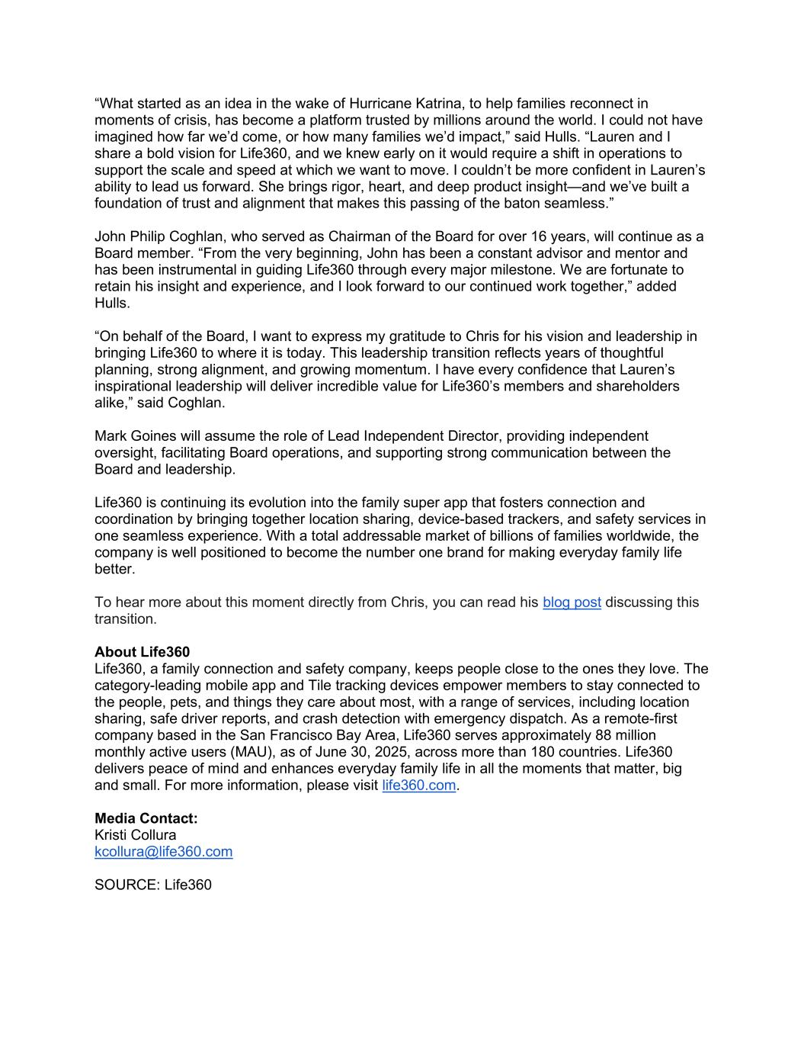
“What started as an idea in the wake of Hurricane Katrina, to help families reconnect in moments of crisis, has become a platform trusted by millions around the world. I could not have imagined how far we’d come, or how many families we’d impact,” said Hulls. “Lauren and I share a bold vision for Life360, and we knew early on it would require a shift in operations to support the scale and speed at which we want to move. I couldn’t be more confident in Lauren’s ability to lead us forward. She brings rigor, heart, and deep product insight—and we’ve built a foundation of trust and alignment that makes this passing of the baton seamless.” John Philip Coghlan, who served as Chairman of the Board for over 16 years, will continue as a Board member. “From the very beginning, John has been a constant advisor and mentor and has been instrumental in guiding Life360 through every major milestone. We are fortunate to retain his insight and experience, and I look forward to our continued work together,” added Hulls. “On behalf of the Board, I want to express my gratitude to Chris for his vision and leadership in bringing Life360 to where it is today. This leadership transition reflects years of thoughtful planning, strong alignment, and growing momentum. I have every confidence that Lauren’s inspirational leadership will deliver incredible value for Life360’s members and shareholders alike,” said Coghlan. Mark Goines will assume the role of Lead Independent Director, providing independent oversight, facilitating Board operations, and supporting strong communication between the Board and leadership. Life360 is continuing its evolution into the family super app that fosters connection and coordination by bringing together location sharing, device-based trackers, and safety services in one seamless experience. With a total addressable market of billions of families worldwide, the company is well positioned to become the number one brand for making everyday family life better. To hear more about this moment directly from Chris, you can read his blog post discussing this transition. About Life360 Life360, a family connection and safety company, keeps people close to the ones they love. The category-leading mobile app and Tile tracking devices empower members to stay connected to the people, pets, and things they care about most, with a range of services, including location sharing, safe driver reports, and crash detection with emergency dispatch. As a remote-first company based in the San Francisco Bay Area, Life360 serves approximately 88 million monthly active users (MAU), as of June 30, 2025, across more than 180 countries. Life360 delivers peace of mind and enhances everyday family life in all the moments that matter, big and small. For more information, please visit life360.com. Media Contact: Kristi Collura kcollura@life360.com SOURCE: Life360


Transitioning to Life360’s Executive Chairman To Life360’s team, our investors, and whoever else has been following our journey, With the full support of the board, I’m excited to announce that after nearly 20 years of leading Life360, I’m promoting Lauren Antonoff to CEO and taking on the role of full-time Executive Chairman. Lauren and me, this Sunday at my house, with our dogs, testing out the new pet trackers. This was a challenging note to write. Moments like this come with a lot of pressure to sanitize the message and speak only in superlatives, but my brain isn’t wired that way. I disdain corporate speak and owe more than the standard “I want to spend more time with my family and


Lauren is a great visionary product-centric strategic operator.” (I do, however, want to spend more time with my family, and Lauren is, in fact, a great visionary product-centric strategic operator.) I’ve never overhyped or played into the Silicon Valley kool-aid-drinking tech bro stereotypes. That’s probably why I never made a “30 Under 30” list… and also why I avoided the often corresponding securities fraud. Comms wrote me a draft. Legal wanted to chime in too. A lot of people had advice on what to say. But I ignored it and decided to share my own thoughts without talking points or filters, in this single message to anyone who wants to read it. When I turned 40 two years ago, I told the board I planned to transition as CEO before I turned 45. I also publicly shared that I expected to have another chapter at some point. So this shift isn’t sudden; it’s something I’ve been very intentional about. And I made it clear this would only happen when the company, the team, and I were all ready. This day has come, sooner than expected, because I’m confident Lauren is ready to take my place. The results she’s driven over the last year make that clear. Under her leadership, we’ve brought in exceptional new talent and leveled up the team we already had. Our organization is stronger than it’s ever been at every layer. We’re moving faster while maintaining quality. Marketing is on fire. International is taking off. Our brand has never been stronger. And we’re becoming highly profitable. On the topic of team, it’s a truism that nothing is more important than your people. Rather than call out a few and miss many, I’ll highlight the areas where our team has made parts of me obsolete. I no longer have to stay up at night worrying about location bugs, you’re ahead of me. I don’t need to be the one pushing us to lean into danger—look at how bold our new marketing campaigns have been. I don’t have to challenge systems and processes constantly—we now have people who bring real balance to the table. I don’t have to call BS on low-quality work— craftsmanship is getting elevated every day. I don’t have to stress about standards or hard decisions—we’re aligned on building a world-class team, and we’re doing it. So if things are going so well, why don’t I just stay CEO? I’ve always had a tendency to share the complete picture, not just the highlights. That probably cost me at times, especially in fundraising, but over the long run, it’s built credibility. People know I mean what I say. The honest truth is that my brute force style got results and still can, but being the backstop of last resort, 24/7, year after year, comes with a constant weight. After nearly two decades of being the last line of defense, I feel it more than I used to. There are parts of the CEO role I love that fuel me, and parts that drain me. When I’m running on empty, everything suffers. This move lets me focus on the work that plays to my strengths and delivers the highest impact for the company. But the CEO role needs someone who is all in on every aspect of it, every single day, and that’s Lauren.


She leads in a way that brings out the best in people. She knows how to hire exceptionally well, set a high bar, and use process without overdoing it. When it comes to our users and long-term vision, we’re completely aligned — but in other ways, we’re polar opposites. The challenges that wear me down at this scale are exactly the ones that fire her up. She’s fresh, relentless, and loves the work. I can call her at midnight to talk Life360, and she’s not just available, she’s energized. We also click in a way that makes product work a joy. I’ve always had that with my co-founder Alex, and now I have it with Lauren too. In many ways, she’s a spiritual late-stage co-founder. We spar, challenge each other, and sharpen ideas, and we have a lot of fun doing it. Some of our biggest wins over the past year have come out of these sessions, often from initiatives she’s brought to the table. She’s not just a COO who executes my vision; she’s a creative force in her own right. I hope one day we can be like Jeff Weiner and Reid Hoffman at LinkedIn, one of those leadership duos people point to as a model for how to scale and evolve a company. Much of what’s launched this year, and what’s still to come, has her fingerprints all over it. By moving to Executive Chairman, I’m focusing on the parts of the job that give me the most energy and impact: strategy, high-stakes projects, product deep-dives, and key relationships. Over the past year, we’ve essentially tested this setup — Lauren took on more CEO responsibilities while I stepped back from daily operations and leaned into an outward-facing role — and the results speak for themselves. And, because this transition has in many ways already happened, most people on the team won’t notice much of a change, if at all. After nearly two decades here, I’ve seen almost every idea before, along with the mistakes we made trying them. My job now is to make sure we learn from that history and keep everything tied to the bigger arc of where we’re going, all while staying true to our Member Bill of Rights. Thinking multiple steps ahead is what I do best, and Lauren and I are fully aligned on where we’re headed. If she ever needs a pit-fighter, I’ll be here to tussle — whether that’s taking on patent trolls, bottom-feeding class action lawyers, causing trouble on TikTok, or injecting a little crazy in a way only a founder can. Just for fun, here’s a seed pitch I made in 2008. I’d give myself 9.5/10 for vision and 2/10 for execution. Half the initiatives we’re planning for next year were already in that old document. They just took 10x the time and 100x the money compared to what I expected as a then-naive entrepreneur. Better late than never! Life360 has been my life’s work, and that’s not changing. This move simply formalizes what’s already true: I’m shifting into a role that reflects where I am now and lets me keep contributing in a meaningful, sustainable way. With that, I’m excited to officially welcome our new CEO, Lauren Antonoff, as the leader for this next chapter. She’s already made a huge impact, and I have full confidence in where she’ll take us next. I’ll be right alongside her, continuing to push the vision forward.


Together, we’ll focus on making Life360 the family super app that puts us alongside Facebook, LinkedIn, and other network giants. There is a real shot we can make this happen. Chris

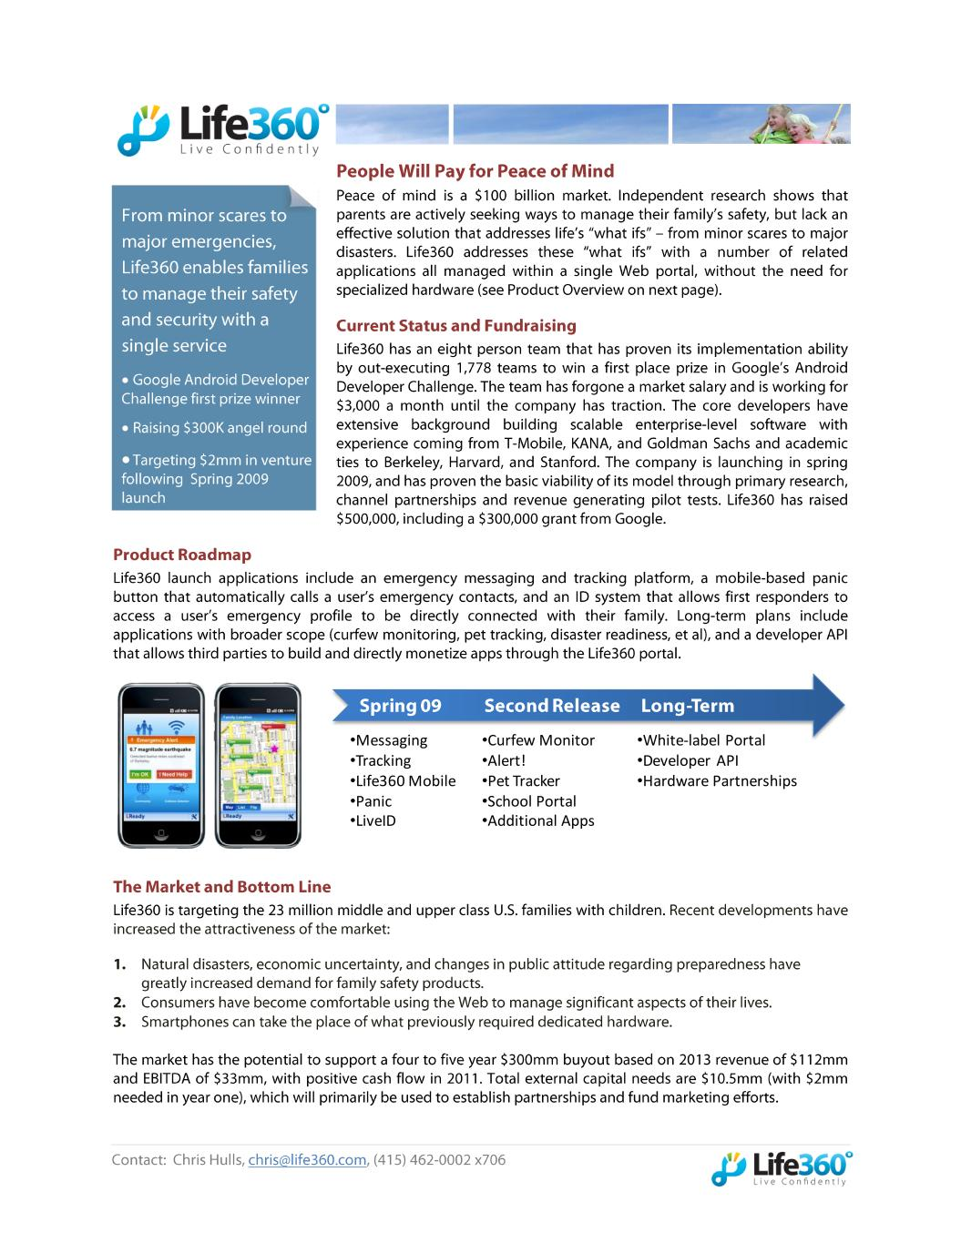
• • • • • • • • •Messaging •Tracking •Life360 Mobile •Panic •LiveID •Curfew Monitor •Alert! •Pet Tracker •School Portal •Additional Apps •White-label Portal •Developer API •Hardware Partnerships


L Marice Phid 7609 3344 Life360 Live Confidently

