UNITED STATES
SECURITIES AND EXCHANGE COMMISSION
Washington, D.C. 20549
______________

FORM 10-K

x |  |  | ANNUAL REPORT PURSUANT TO SECTION 13 OR 15(d) OF THE SECURITIES EXCHANGE ACT OF 1934
 |  |  | For the fiscal year ended December 31, 2025
OR
☐ |  |  | TRANSITION REPORT PURSUANT TO SECTION 13 OR 15(d) OF THE SECURITIES EXCHANGE ACT OF 1934
 |  |  | For the transition period from __________ to __________
Commission File Number 001-42120
Life360, Inc.
(Exact name of registrant as specified in its charter)
Delaware |  |  | 26-0197666
(State or other jurisdiction of  incorporation or organization) |  |  | (I.R.S. Employer  Identification No.)
1900 South Norfolk Street, Suite 310  San Mateo, CA |  |  | 94403
(Address of principal executive offices)(1) |  |  | (Zip Code)
Tel: (415) 484-5244
(Registrant's telephone number, including area code)
Securities registered pursuant to Section 12(b) Act:
Title of each class |  |  | Trading Symbol(s) |  |  | Name of each exchange on which registered
Common Stock, $0.001 par value per share |  |  | LIF |  |  | The Nasdaq Stock Market LLC
Securities registered pursuant to Section 12(g) of the Act: Common Stock, par value $0.001 per share
Indicate by check mark if the registrant is a well-known seasoned issuer, as defined in Rule 405 of the Securities Act. Yes x No o
Indicate by check mark if the registrant is not required to file reports pursuant to Section 13 or Section 15(d) of the Act. Yes o No x
Indicate by check mark whether the registrant: (1) has filed all reports required to be filed by Section 13 or 15(d) of the Exchange Act during the preceding 12 months (or for such shorter period that the registrant was required to file such reports); and (2) has been subject to such filing requirements for the past 90 days. Yes x No o
Indicate by check mark whether the registrant has submitted electronically every Interactive Data File required to be submitted pursuant to Rule 405 of Regulation S-T (§232.405 of this chapter) during the preceding 12 months (or for such shorter period that the registrant was required to submit and post such files). Yes x No o
Indicate by check mark whether the registrant is a large accelerated filer, an accelerated filer, a non-accelerated filer, a smaller reporting company or an “emerging growth” company. See the definitions of “large accelerated filer,” “accelerated filer,” “smaller reporting company” and “emerging growth company” in Rule 12b-2 of the Act.
Large accelerated filer |  |  | x |  |  |  |  |  | Accelerated filer |  |  | o
Non-accelerated filer |  |  | o |  |  |  |  |  | Smaller reporting company |  |  | o
Emerging growth company |  |  | o
If an emerging growth company, indicate by check mark if the registrant has elected not to use the extended transition period for complying with any new or revised financial accounting standards provided pursuant to Section 13(a) of the Exchange Act. o
Indicate by check mark whether the registrant has filed a report on and attestation to its management’s assessment of the effectiveness of its internal control over financial reporting under Section 404(b) of the Sarbanes-Oxley Act (15 U.S.C. 7262(b)) by the registered public accounting firm that prepared or issued its audit report. x
If securities are registered pursuant to Section 12(b) of the Act, indicate by check mark whether the financial statements of the registrant included in the filing reflect the correction of an error to previously issued financial statements. o

Indicate by check mark whether any of those error corrections are restatements that required a recovery analysis of incentive-based compensation received by any of the registrant’s executive officers during the relevant recovery period pursuant to §240.10D-1(b). o

Indicate by check mark whether the registrant is a shell company (as defined in Rule 12b-2 of the Act). Yes o No x
The aggregate market value of the voting and non-voting common equity held by non-affiliates of the Registrant as of June 30, 2025 was approximately $4.84 billion, based on the closing price of $65.25 per share for the Registrant’s common stock as reported by Nasdaq Stock Market LLC.
As of February 24, 2026, the registrant had 80,198,613 shares of common stock, par value $0.001 per share, including shares underlying all issued and outstanding CHESS Depositary Interests (“CDIs”), outstanding.

DOCUMENTS INCORPORATED BY REFERENCE
Portions of the definitive proxy statement for the 2026 Annual Meeting of Stockholders of the Registrant (the “2026 Proxy Statement”), are incorporated by reference into Part III of this Annual Report on Form 10-K. The Proxy Statement will be filed with the Securities and Exchange Commission within 120 days of the Registrant’s fiscal year ended December 31, 2025.
____________________
(1)We are a Delaware corporation with a globally distributed workforce and no corporate headquarters. Under the Securities and Exchange Commission's rules, we are required to designate a “principal executive office.” For purposes of this report, we have designated our office in San Mateo, California as our principal executive office.

Life360, Inc.
Annual Report on Form 10-K for the Year Ended December 31, 2025
Table of Contents
 |  |  |  |  |  | Page
Forward-Looking Statements |  |  |  |  |  | 1
Part I
Item 1. |  |  | Business |  |  | 2
Item 1A. |  |  | Risk Factors |  |  | 9
Item 1B. |  |  | Unresolved Staff Comments |  |  | 45
Item 1C. |  |  | Cybersecurity |  |  | 45
Item 2. |  |  | Properties |  |  | 46
Item 3. |  |  | Legal Proceedings |  |  | 47
Item 4. |  |  | Mine Safety Disclosures |  |  | 47
Part II
Item 5. |  |  | Market for Registrant’s Common Equity, Related Stockholder Matters and Issuer Purchases of Equity Securities |  |  | 47
Item 6. |  |  | Reserved |  |  | 48
Item 7. |  |  | Management’s Discussion and Analysis of Financial Condition and Results of Operations |  |  | 48
Item 7A. |  |  | Quantitative and Qualitative Disclosures about Market Risk |  |  | 65
Item 8. |  |  | Financial Statements and Supplementary Data |  |  | 65
Item 9. |  |  | Changes in and Disagreements with Accountants on Accounting and Financial Disclosure |  |  | 107
Item 9A. |  |  | Controls and Procedures. |  |  | 107
Item 9B. |  |  | Other Information |  |  | 110
Item 9C. |  |  | Disclosure Regarding Foreign Jurisdictions that Prevent Inspections |  |  | 110
Part III
Item 10. |  |  | Directors, Executive Officers and Corporate Governance |  |  | 110
Item 11. |  |  | Executive Compensation |  |  | 111
Item 12. |  |  | Security Ownership of Certain Beneficial Owners and Management and Related Stockholder Matters |  |  | 111
Item 13. |  |  | Certain Relationships and Related Transactions, and Director Independence |  |  | 111
Item 14. |  |  | Principal Accounting Fees and Services |  |  | 111
Part IV
Item 15. |  |  | Exhibits and Financial Statement Schedules |  |  | 112
Item 16. |  |  | Form 10-K Summary |  |  | 116
 |  |  | Signatures |  |  | 117
In this report, unless otherwise stated or the context otherwise indicates, the terms “Life360,” “the Company,” “we,” “us,” “our” and similar references refer to Life360, Inc. and its consolidated subsidiaries. The Life360 logo, and other trademarks, trade names or service marks of Life360, Inc. appearing in this Annual Report on Form 10-K are the property of Life360, Inc. All other trademarks, trade names, and service marks appearing in this Annual Report on Form 10-K are the property of their respective owners. Solely for convenience, the trademarks and trade names in this report may be referred to without the ® and ™ symbols, but such references should not be construed as any indicator that their respective owners will not assert their rights thereto.

Table of Contents
FORWARD-LOOKING STATEMENTS
This Annual Report on Form 10-K (this “Annual Report”) contains forward-looking statements within the meaning of the Private Securities Litigation Reform Act of 1995 that are based on our management’s beliefs and assumptions and on information currently available to our management. We intend such forward-looking statements to be covered by the safe harbor provisions for forward-looking statements contained in Section 21E of the Securities Exchange Act of 1934, as amended (the “Exchange Act”). Some of the statements under “Item 1. Business,” “Item 1A. Risk Factors,” “Item 7. Management’s Discussion and Analysis of Financial Condition and Results of Operations” and elsewhere in this Annual Report contain forward-looking statements. They are generally identifiable by use of the words: “may,” “might,” “will,” “could,” “would,” “should,” “expect,” “plan,” “anticipate,” “intend,” “seek,” “believe,” “estimate,” “predict,” “potential,” “continue,” “contemplate,” “possible” or the negative of these terms or other comparable terminology, although not all forward-looking statements contain these words. We caution you the foregoing list may not contain all of the forward-looking statements made in this Annual Report.
These forward-looking statements are subject to risk and uncertainties, many of which are outside of our control, that may cause our actual results, levels of activity, performance or achievements to be materially different from the information expressed or implied by these forward-looking statements. Although we believe that we have a reasonable basis for each forward-looking statement contained in this Annual Report, we caution you that these statements are based on a combination of facts and factors currently known by us as of the date of this Annual Report and our projections of the future, about which we cannot be certain. Forward-looking statements in this Annual Report include, but are not limited to, statements about:
•our ability to further penetrate our existing member base, maintain and expand our member base, increase monetization of our member base, and expand in new use cases;
•our ability to maintain the value and reputation of our brands;
•the effects of increased competition in our markets and our ability to compete effectively in our industry;
•our ability to anticipate market needs or develop new products and services or enhance existing products and services to meet those needs;
•anticipated trends, developments, and challenges in our industry, business and in the markets in which we operate;
•our growth strategy and business plan and our ability to effectively manage our growth and meet future capital requirements;
•our ability to expand internationally and the significance of our global opportunity;
•market acceptance of our location sharing services, tracking products, and digital subscription services;
•our ability to increase sales of our products and services;
•our expectations concerning relationships with third parties; including suppliers, manufacturers, platforms, and fulfillment partners;
•our ability to continue to manufacture our hardware products on reasonable terms, including our ability to continue our relationship with Jabil, Inc. (“Jabil”), or at all;
•our ability to develop, and the success of, new monetization features, such as the introduction of advertisements in our app, and improve on existing features;
•the effects of uncertainties with respect to the legal system in the People’s Republic of China (the “PRC”) and in Malaysia, where our primary manufacturer’s facilities are located, and of disruption in the supply chain from Malaysia and the PRC;
•the effects of seasonal trends on our results of operations;
•our ability to identify, recruit, and retain skilled personnel, including key members of senior management;
•our ability to successfully acquire and integrate companies and assets and to expand and diversify our operations through strategic acquisitions and partnerships;
•our expectation regarding future financial performance, including our expectations regarding our revenue, cost of revenue, and operating expenses, and our ability to achieve or maintain future profitability;
•the effects of an economic downturn or economic uncertainty on consumer discretionary spending and demand for our products and services;
•economic and industry trends, projected growth, or trend analysis;
1
Table of Contents
•our compliance with laws and regulations that currently apply or may become applicable to our business both in the U.S. and internationally, including with respect to data privacy and security, consumer protection, location sharing, precise geolocation data (including of children), item tracking, targeting, and children’s privacy protections;
•our ability to maintain, protect, and enhance our intellectual property; and
•our ability to succeed in our core mission of simplifying safety for families through responsible business practices and corporate governance initiatives.
You should refer to the “Item 1A. Risk Factors” section of this Annual Report for a discussion of other important factors that may cause our actual results to differ materially from those expressed or implied by our forward-looking statements. As a result of these factors, we cannot assure you that the forward-looking statements in this Annual Report will prove to be accurate. Moreover, we operate in a very competitive and rapidly changing environment. New risks and uncertainties emerge from time to time and existing risks and uncertainties may become more material, and it is not possible for us to predict all risks and uncertainties that could have an impact on the forward-looking statements contained in this Annual Report.
In addition, statements that “we believe” and similar statements reflect our beliefs and opinions on the relevant subject. These statements are based upon information available to us as of the date of this Annual Report, and although we believe such information forms a reasonable basis for such statements, such information may be limited or incomplete, and our statements should not be read to indicate that we have conducted a thorough inquiry into, or review of, all potentially available relevant information. These statements are inherently uncertain, and investors are cautioned not to unduly rely upon these statements. Furthermore, if our forward-looking statements prove to be inaccurate, the inaccuracy may be material. In light of the significant uncertainties in these forward-looking statements, you should not regard these statements as a representation or warranty by us or any other person that we will achieve our objectives and plans in any specified time frame, or at all. We undertake no obligation to publicly update any forward-looking statements, whether as a result of new information, future events, or otherwise.

PART I

Item 1. Business

Overview
Life360 is a leading technology platform connecting millions of people throughout the world to the people, pets and things they care about most. We have created a new category at the intersection of family, technology, and safety to help keep families connected and safe. Our core offering, the Life360 mobile application, includes features like communications, driving safety, digital safety and location sharing. Beyond the everyday, Life360 also provides much-needed protection and saves lives, which is crucial for families in emergency situations such as natural disasters, vehicle collisions, physical property theft, and digital identity theft. The Life360 mobile application operates under a “freemium” model where its core offering is available to members at no charge, with additional membership subscription options that are available but not required.
In addition to the Life360 mobile application, we also offer hardware tracking devices through the sale of Tile by Life360, Inc. devices (“Tile”) and Life360 Pet GPS devices to keep members close to the people, pets and things they care about most.
Our suite of product and service offerings, including the Life360 and Tile mobile applications, and related third-party services, is system and platform-agnostic, allowing our products and services to work seamlessly for our members, regardless of the different devices they use. As of December 31, 2025, we had approximately 95.8 million Monthly Active Users (“MAU”), and 2.8 million global Paying Circles on the Life360 Platform, as described below, representing a year-over-year increase of 20% and 26%, respectively. We define a Paying Circle as a group of Life360 members with a paying subscription who have been billed as of the end of period.
Our revenue is generated from the sale of subscriptions, hardware tracking devices used to access our services, and from partnerships, including through the placement of ads within our platform, and the sale of aggregated, non-personally identifiable data for data insight purposes.
2
Table of Contents
For the years ended December 31, 2025, 2024, and 2023, we generated:
•Total revenue of $489.5 million, $371.5 million, and $304.5 million, respectively;
◦Subscription revenue of $369.3 million, $277.8 million, and $220.8 million, respectively;
◦Hardware revenue of $51.8 million, $57.6 million, and $58.2 million, respectively;
◦Other revenue of $68.4 million, $36.0 million, and $25.5 million, respectively; and
•Net income of $150.8 million in 2025, and net loss of $4.6 million, and $28.2 million in 2024 and 2023, respectively.

Our Products
Life360 Platform
We currently offer four key product features that make up the Life360 Platform: (i) location coordination and safety, (ii) driving safety, (iii) digital safety, and (iv) emergency assistance. Each of these features keeps members connected to the important people in their lives by organizing them into groups called “Circles”. A member selects who to invite to their Circle and what information a Circle, or any individual member within that Circle, receives.
Location coordination and safety features include real-time location, location history, and smart notifications such as location-specific alerts, driving alerts, and crime reports. Driving safety features include crash detection, roadside assistance, family driving summaries, and individual driver reports. Digital safety features include data breach alerts, identity theft protection, stolen funds reimbursement, and credit monitoring. Emergency assistance features include SOS with emergency dispatch, disaster response, medical assistance, and travel support.
The Life360 mobile application operates under a “freemium” model where its core offering is available to members at no charge, with paid membership subscription options that are available but not required. Paid subscription options offer members a comprehensive suite of premium safety services. We expect that, from time to time, the prices of our membership plans in each country may change and that we may implement other plan and price variations.
Hardware Products
Our hardware products, which include Tile branded bluetooth and Life360 Pet GPS devices, seamlessly integrate with the Life360 Platform. The Tile Bluetooth® network leverages the installed base of Life360 members to scan for locations of devices, while our Life360 Pet GPS devices leverage GPS and cellular networks, generating even higher confidence that we can locate lost devices and pets of our customers. Our hardware products are sold through online and brick and mortar retail channels as well as directly on our website and are available, in various shapes, sizes, and price points for different use cases. The Tile mobile application offers a free service as well as two paid subscription options: Premium and Premium Protect, which offer additional services such as warranties and item reimbursement. The Life360 Pet GPS requires a Gold or Platinum Life360 subscription and offers additional location tracking services.

Our Technology Platform
To help families stay connected and safe, we have developed a scalable mobile-first technology platform that protects our members’ data and ensures operational integrity, security, and performance. Highlights of our technology platform include a robust location engine design, scalable and modern technology infrastructure, and seamless third-party integration.
We have designed an end-to-end technology location solution that allows us to deliver real-time location-based experiences and includes functionality such as storage, processing, and communication of events, locations, drives, maps, places, networking, and visualization of device characteristics for people, pets, and things. The Tile finding network has been integrated into the Life360 Platform. This integration allows members and Paying Circles to keep track of their things and connect with each other through the Life360 Platform. Through our strategic partnership with Hubble Network Inc., (“Hubble”), and subject to successful development and integration, we may expand our location tracking capabilities.

We utilize third-party services for our backend platform and infrastructure to connect to our apps and the hardware devices running them. Using these services grants us access to a highly distributed, scalable, reliable, and secure architecture for global delivery of our mission critical services with potential to extend features and functionality—from dispatching tow trucks for roadside assistance to connecting calls for 24/7 SOS help.

3
Table of Contents
Competition
Our competitors include both large competitors with various product and service offerings and smaller competitors, including (i) direct competitors with location sharing products focused on family safety, (ii) competitors providing location sharing platforms that are not focused on family safety, (iii) competitors in the item tracking technology market, (iv) competitors in the pet tracking technology market, and (v) competitors that have, or may in the future have, overlapping offerings (for example, companies in industries related to roadside assistance and crash detection, identity theft protection, phone insurance and travel, and disaster and medical assistance).
While our industry is becoming increasingly competitive, we believe that we will continue to compete successfully due to our leading market position, superior value proposition, brand recognition, ability to leverage our member base, our comprehensive suite of offerings, and economies of scale. In addition, our data-driven insights on families’ habits, needs, and preferences enable us to continuously enhance our product offerings and improve the member experience, reinforcing our competitive differentiation.

Employees and Culture
Life360’s core values are designed to create a culture that supports our vision of an ambitious, professionally driven organization that can simplify safety so families can live fully:
•Be a Good Person. Everyone at Life360 respects each other and maintains a high level of integrity.
•Be Direct with Respect. We communicate directly, even when it’s hard. This is always done in support of the other person’s development, and we are intentionally inclusive and always respectful.
•Members Before Metrics. We value metrics and use them to influence strategy and measure results, but at our core we always focus on building an exceptional experience for families.
•High Intensity, High Impact. We do whatever it takes to get the job done. We are in a fast moving and competitive environment and we have a team that is in it to win it.
As of December 31, 2025, we had approximately 547 full-time employees and approximately 95 contractors, all of whom work remotely but have the option to work out of our San Mateo, California office, or at other flexible workspaces. Life360 aims to provide a work environment in which all of our people can excel regardless of race, religion, age, disability, gender identity, sexual orientation, or marital status. We believe that diversity contributes to our business success, and benefits all of our stakeholders. We are committed to creating an inclusive and equitable work environment for all employees.
We view the quality of our products and services as our key long-term strategic differentiator, and as such, we also provide training opportunities for our employees to further promote personal and professional growth. We do this through both cohort learning as well as personalized learning via the LinkedIn Learning® platform throughout the year.

Responsible Business Practices and Corporate Governance
Life360's approach to responsible business practices and good corporate governance reflects our founding mission and continues to shape how we operate as a public company. Our co-founder and Executive Chairman Chris Hulls created Life360 in response to Hurricane Katrina, envisioning technology that could keep families connected and safe during emergencies. That origin in an environmental crisis informs our commitment to impact, resilience, and responsibility across our business today.
Our responsible business practices strategy is structured around the three pillars of environmental, social, and governance, and is informed by our materiality assessment conducted with employees, leadership, and investors to identify priorities most relevant to our long-term value creation and that may be material to our business, financial condition, and results of operations.
4
Table of Contents
Environmental
We are committed to measuring, disclosing, and reducing our environmental footprint. We quantify our carbon impact across Scope 1 emissions (direct emissions from controlled sources), Scope 2 emissions (indirect emissions from purchased energy), and Scope 3 emissions (value chain impacts including our supply chain and product lifecycle), where data is available and based on reasonable estimates. While we partner with third parties for hardware manufacturing, we prioritize durable product design and responsible vendor practices.
We participate in leading disclosure frameworks including the S&P Global Corporate Sustainability Assessment (“CSA”) and CDP, formerly known as the Carbon Disclosure Project, to ensure transparency and alignment with investor expectations on environmental performance.
Social
Our social mission centers on safety, privacy, and empowerment across our member base, workforce, and communities. Through real-time location technology, emergency response features, and data protection practices, we serve millions of families seeking connection and peace of mind. We maintain a corporate culture of respect and belonging, with legal recruiting practices, compensation practices, and career advancement pathways for all employees. We provide safe, flexible, and supportive workplaces that are free from all forms of modern slavery. We support employee philanthropic engagement through matching contributions to nonprofit organizations focused on family well-being and community support, and collaborate with partners to amplify safety and privacy in the communities we serve.
Governance
We maintain governance frameworks designed to foster trust, transparency, and ethical decision-making across all stakeholder relationships. Our approach includes disciplined risk identification, assessment, and monitoring processes; business code of conduct training; and transparent disclosure practices.
An internal cross-functional team oversees responsible business practices and corporate governance benchmarking, education, and advancement of responsible business practices aligned with global standards and stakeholder expectations. We have begun incorporating elements of the Sustainability Accounting Standards Board (“SASB”) framework to guide reporting of financially material topics and review our materiality assessment annually to ensure continued relevance as our business and the broader responsible business practices landscape evolve.
Additional Information
The responsible business practices and corporate governance initiatives and goals described above reflect our current priorities and expectations and do not constitute guarantees, contractual commitments, or assurances of future performance.
Additional information about our responsible business practices and corporate governance approach, including our published SASB report and detailed disclosures, is available at investors.life360.com/impact/overview. Information contained on, or accessible through, our website is not incorporated by reference into this Form 10-K and should not be considered part of this filing.

Research and Development
We invest substantial resources in research and development to enhance our customer offerings and competitiveness. Our global research and development team supports the design and development of our location sharing services, mobile app development, web development, firmware development, platform software development, site reliability engineering, hardware engineering, test engineering, and data science and analytics. Our research and development expenses were $128.4 million, $113.1 million and $101.0 million for the years ended December 31, 2025, 2024, and 2023, respectively. We intend to continue to significantly invest in research and development to bring new customer experiences and devices to market and expand our platform capabilities.

5
Table of Contents
Manufacturing, Logistics and Fulfillment
We outsource the manufacturing of our hardware products to our contract manufacturer, Jabil, located in Asia. Jabil has been designated the sole contract manufacturer of our hardware products. To continue to provide our members with quality technology, our supply chain teams in the U.S. and Asia coordinate the relationships between our contract manufacturers and suppliers. In order to mitigate risks associated with a single supply source, and to ensure we can scale our manufacturing base as we continue to expand, we routinely evaluate new partners, manufacturers, and suppliers.
In October 2024, we entered into a new manufacturing agreement with Jabil for an initial term of three years that will automatically renew for additional one-year periods, unless terminated or advance written notice not to renew is given. Under our agreement with Jabil, Jabil manufactures our products using design specifications, quality assurance programs, and standards that we establish. We additionally grant Jabil a non-exclusive, royalty-free, non-transferable right and license to use certain Life360 and Tile intellectual property as it relates to Jabil’s obligations under the agreement. We pay for and own the majority of tooling and other equipment specifically required to manufacture our products. We have purchase commitments based on our purchase orders and forecasts for certain amounts of finished goods, works-in-progress, and components purchased in order to support such purchase orders and forecasts. Under the terms of the agreement, the agreement may be terminated (i) by mutual written consent, (ii) by advanced written notice from either party, (iii) for cause by either party after written notice of a material breach and failure by the other party to cure such breach within thirty days, or (iv) immediately upon written notice by either party upon the bankruptcy or insolvency of the other party.
We also work with third-party fulfillment partners that package and deliver our products to multiple locations worldwide, which allows us to reduce order fulfillment time and shipping costs, as well as improve inventory flexibility. Our partner relationships help us maintain access to the resources needed to scale seasonally.

Intellectual Property
Intellectual property is an integral aspect of our business, and we seek protection for our intellectual property and technological innovations as appropriate. We rely upon a combination of federal, state, and common-law rights in the U.S. and the rights under the laws of other countries, patents, trademarks, copyrights, domain name, trade secrets, including know-how, license agreements, confidentiality procedures, nondisclosure agreements with third parties, employee confidentiality, and proprietary rights agreements, and other contractual rights, to establish and protect our proprietary rights.
We have developed and acquired patent assets to protect our proprietary technology. Individual patents have terms for varying periods depending on the date of filing of the patent application or the date of patent issuance and the legal term of patents in the countries in which they are obtained. Generally, utility patents issued for applications filed in the U.S., and in many foreign countries, are granted a term of 20 years from the earliest effective filing date of a non-provisional patent application (14 or 15 years from the date of grant for U.S. design patents) provided their registrations are properly maintained. We continually review our development efforts to assess the existence and patentability of new intellectual property. We also pursue the registration of certain of our domain names and trademarks and service marks in the U.S. and in certain locations outside the U.S. Notwithstanding these efforts, there can be no assurance that we will adequately protect our intellectual property or that it will provide any competitive advantage. Further, in some foreign countries, the mechanisms to establish and enforce intellectual property rights may be inadequate to protect our technology. To protect our brand, we hold and maintain a global trademark portfolio. In the U.S., we own trademark registrations for our “Life360”, “Jiobit”, and “Tile” brands. We also own applications and registrations for “Life360,” “Tile,” “Tile-formative,” and other trademarks in certain foreign jurisdictions. Trademark registrations can generally be renewed as long as the marks are in use. We also enter into, and rely on, confidentiality and proprietary rights agreements with our employees, consultants, contractors, and business partners to protect our trade secrets, proprietary technology, and other confidential information. We further protect the use of our proprietary technology and intellectual property through provisions in both our customer terms of service on our website and in our vendor terms and conditions. For information regarding risks related to our intellectual property, please see “Item 1A. Risk Factors — Risks Related to Our Technology and Intellectual Property.”

6
Table of Contents
Seasonality
Life360 subscriptions in the U.S. have historically experienced member and subscription growth seasonality in the third quarter of each calendar year, which includes the return to school for many of our members. Hardware sales have historically experienced comparatively higher seasonal growth in the fourth quarter of each calendar year, which includes the important selling periods in November and December largely driven by holiday demand.

Government Regulation
Our Company is subject to many U.S. federal and state and foreign laws and regulations that involve matters central to our business. These include laws and regulations that relate to data privacy, security, intellectual property (including copyright and patent laws), content regulation, rights of publicity, advertising, marketing, competition, protection of children and minors, consumer protection, payment processing, subscription services, taxation, health and safety, employment and labor, and telecommunications. These laws and regulations are constantly evolving and being tested in courts and by regulators and may be interpreted, applied, created, or amended, in a manner that could harm our business. The application and interpretation of these laws and regulations are often uncertain, especially in new or rapidly evolving industries, and could be interpreted and applied in a manner that is inconsistent from country to country or state to state and inconsistent with our current policies and practices and in ways that could harm our business.
Additionally, our service providers are also subject to domestic and international laws and regulations. Our business depends on certain products and services, including those delivered via internet, from these third parties. The uncertainty in the regulations and interpretation and application of such regulations in the third-party industries may result in an increase in our own expenses or adversely affect our business.
The costs of complying with U.S. and foreign laws and regulations, which in some cases can be enforced by private parties in addition to government entities, are high and likely to increase in the future, particularly as the degree of regulation increases, our business grows, and our geographic scope and data processing activities expand. Furthermore, the impact of these laws and regulations may disproportionately affect our business in comparison to our peers in the technology sector that have greater resources. It is imperative that we secure the assets, functionality, materials, and member data that are critical to our business. Any failure on our part to comply with these laws and regulations may subject us to significant liabilities or penalties, or otherwise adversely affect our business, financial condition or operating results. Further, it is possible that certain governments may seek to block or limit our products or services or otherwise impose other restrictions that may affect the accessibility or usability of any or all our products or services for an extended period of time or indefinitely.
For additional information, see the section entitled “Item 1A. Risk Factors—Risks Related to Our Technology and Intellectual Property.”

Government Regulation of Data Privacy and Security
In the ordinary course of our business, we may process personal or other sensitive data. This data may relate to our members, employees, partners, vendors, and others. This data may include contact details, payment card information, geolocation data, as well as information collected from and about children and minors. Accordingly, we are or may become subject to numerous data privacy and security obligations, including federal, state, local, and foreign laws, regulations, guidance, and industry standards related to data privacy and security. Such obligations may include, without limitation, the Federal Trade Commission Act, the Telephone Consumer Protection Act of 1991 (“TCPA”), the Children’s Online Privacy Protection Act of 1998 (“COPPA”), the Controlling the Assault of Non-Solicited Pornography And Marketing Act of 2003 (“CAN-SPAM”), the California Consumer Privacy Act of 2018 (“CCPA”) and other state privacy laws, the European Union’s General Data Protection Regulation 2016/679 (“EU GDPR”), the EU GDPR as it forms part of the law of England and Wales by virtue of section 3 of the European Union (Withdrawal) Act 2018 and the Data Protection Act 2018 (collectively the “UK GDPR”, with the EU GDPR and UK GDPR together referred to as the “GDPR”), the EU Digital Services Act (“DSA”), the UK Online Safety Act, the Age Appropriate Design Code enacted by the UK Information Commissioner’s Office, the Privacy and Electronic Communications Directive 2002/58/EC on Privacy and Electronic Communications (the “ePrivacy Directive”), the EU Data Act (Regulation (EU) 2023/2854) (“EU Data Act”), and the Payment Card Industry Data Security Standard (“PCI DSS”). Several states within the U.S. have enacted or proposed data privacy laws, including laws that govern the use of precise geolocation data. Additionally, we are or may become subject to various U.S. federal and state consumer protection laws which require us to publish statements that accurately and fairly describe how we handle personal data and choices individuals may have about the way we handle their personal data.
7
Table of Contents
The CCPA and the GDPR are examples of the increasingly stringent and evolving regulatory frameworks related to personal data processing that may increase our compliance obligations and exposure for any noncompliance. Similar laws have been enacted or proposed in the past few years in several other U.S. states and other foreign jurisdictions. These laws impose certain data privacy and security obligations on covered businesses. Generally, these and similar laws obligate covered businesses to provide specific disclosures in privacy notices and afford relevant individuals with certain rights concerning their personal data. As applicable, such rights may include the right to access, correct, or delete certain personal data or device data, and to opt-out of certain personal data processing activities, such as targeted advertising, profiling, or automated decision-making. The exercise of these rights may impact our business and ability to provide our products and services. These laws may also allow for regulators to impose statutory fines or allow private claimants to recover damages for noncompliance.
The European Union and the UK are also focused on the regulation of digital services and online platforms. The EU DSA came into force in 2022, with the majority of the substantive provisions taking effect in 2024. The UK Online Safety Act came into force in 2024, with the majority of the substantive provisions taking effect in 2025. The DSA and the UK Online Safety Act may increase our compliance costs, require changes to our user interfaces, processes, operations, and business practices which may adversely affect our ability to attract, retain and provide our services to members, increase our liability for content hosted, and may otherwise adversely affect our business, operations, and financial condition. If the rules, doctrines or currently available defenses change, if international jurisdictions refuse to apply similar protections that are currently available in the U.S. or the European Union or a court were to disagree with our application of those rules to our service, we could be required to expend significant resources to try to comply with the new rules or incur liability, and our business, financial condition, and results of operations could be harmed.
Certain foreign jurisdictions have enacted or proposed laws restricting minors’ access to social media platforms. For example, Australia has enacted legislation restricting access to social media platforms by minors. We do not believe our platform constitutes a “social media platform” as defined under such legislation and therefore do not believe these restrictions apply to our products and services. However, regulator interpretations are evolving, and if we were determined to be subject to such laws, we could be required to limit access to our services for certain users, implement additional compliance measures, or modify product features, which could adversely affect user growth and engagement globally, and harm our business, financial condition, and results of operations.
For additional information about the laws and regulations to which we are or may become subject and about the risks to our business associated with such laws and regulations, see the section entitled “Item 1A. Risk Factors — Risks Related to Privacy and Cybersecurity.”
Available Information
Our website address is www.life360.com. We make available on our website, free of charge, our Annual Reports on Form 10-K, our Quarterly Reports on Form 10-Q, our Current Reports on Form 8-K, and any amendments to those reports filed or furnished pursuant to Section 13(a) or 15(d) of the Securities Exchange Act of 1934, as amended (the “Exchange Act”), as soon as reasonably practicable after we electronically file such material with, or furnish it to, the Securities and Exchange Commission (“SEC”). The SEC maintains a website that contains reports, proxy and information statements, and other information regarding our filings at www.sec.gov. The ASX maintains a website that contains documents required under Australian securities laws and other information regarding our filings at www.asx.com.au. Additionally, we routinely post additional important information, including press releases, on our website and recognize our website as a channel of distribution to reach public investors and as a means of disclosing material non-public information for complying with disclosure obligations under Regulation FD. Accordingly, investors should monitor our website in addition to our SEC filings, ASX filings, and public webcasts. These items are available at investors.life360.com under “Financials and Filings.”
The information found on our website is not incorporated by reference into this Annual Report on Form 10-K or any other report we file with or furnish to the SEC.
8
Table of Contents
Jurisdiction of Incorporation
We are incorporated in the State of Delaware, United States of America, and are a registered foreign entity in Australia. As a foreign Company registered in Australia, we are subject to different reporting and regulatory regimes than Australian companies. As a foreign Company registered in Australia, we are not subject to Chapters 6, 6A, 6B and 6C of the Corporations Act 2001 (Cth) of Australia (“Corporations Act”) dealing with the acquisition of shares (including substantial shareholdings and takeovers).
Delaware Law, Certificate of Incorporation and Bylaws
Under the provisions of Delaware General Corporation Law (“DGCL”), shares are freely transferable and subject to restrictions imposed by the U.S. federal or state securities laws, by our certificate of incorporation, as amended (“Certificate of Incorporation”) or bylaws (“Bylaws”), or by an agreement signed with the holders of the shares at issuance. Our Certificate of Incorporation and Bylaws do not impose any specific restrictions on transfer. However, provisions of the DGCL, our Certificate of Incorporation and our Bylaws could make it more difficult to acquire the us by means of a tender offer (takeover), a proxy contest or otherwise, or to remove incumbent officers and directors of the Company. These provisions could discourage certain types of coercive takeover practices and takeover bids that the Board may consider inadequate and encourage persons seeking to acquire control of the Company to first negotiate with the Board.
The Company believes that the benefits of increased protection of its ability to negotiate with the proponent of an unfriendly or unsolicited proposal to acquire or restructure the Company outweigh the disadvantages of discouraging takeover or acquisition proposals because, among other things, negotiation of these proposals could result in an improvement of their terms.
CHESS Depository Interests (“CDIs”)
Life360’s CDIs are issued in reliance on the exemption from registration contained in Regulation S of the U.S. Securities Act of 1933 (the “Securities Act”) for offers of securities which are made outside the U.S. Accordingly, the CDIs, have not been, and will not be, registered under the Securities Act or the laws of any state or other jurisdiction in the U.S. As a result of relying on the exemption pursuant to Regulation S, the CDIs are ‘restricted securities’ under Rule 144 of the Securities Act. This means that the CDIs cannot be sold into the U.S. or to a U.S. person who is not a Qualified Institutional Buyer (as defined under Rule 144A under the Securities Act, a ‘QIB’) for the foreseeable future except in very limited circumstances until after the end of the restricted period, unless the re-sale of the CDIs is registered under the Securities Act or an exemption is available. To enforce the transfer restrictions, all CDIs issued bear a FOR Financial Product designation on the ASX. This designation restricts any CDIs from being sold on the ASX to U.S. persons excluding QIBs. CDIs may be transferred on the ASX to any person other than a U.S. person who is not a QIB. Hedging transactions with regard to the CDIs may only be conducted in accordance with the Securities Act.

Item 1A. Risk Factors
Our business is subject to a high degree of risk. You should carefully consider the risks described below, as well as the other information in this Annual Report on Form 10-K, including our financial statements and the related notes and “Management’s Discussion and Analysis of Financial Condition and Results of Operations.” The occurrence of any of the events or developments described below could harm our business, financial condition, results of operations, and prospects. In such an event, the market price of our common stock could decline.

Risk Factors Summary
Our business is subject to numerous risks and uncertainties. These risks and uncertainties may cause our operations to vary materially from those contemplated by our forward-looking statements. These risk factors include:
•If we fail to retain existing members or add new members, or if our members decrease their level of engagement with our products and services or do not convert to paying subscribers, our revenue, business, financial condition, and results of operations may be significantly harmed.
9
Table of Contents
•If we are not able to maintain the value and reputation of our brands, or if we are not able to compete successfully with current or future competitors, our ability to expand our member base and maintain our relationships with partners and other key service providers may be impaired and our business, financial condition, and results of operations may be harmed.
•Changes to our existing brands, products, and services, or the introduction of new brands, products, or services, could fail to attract or retain members or generate revenue and profits.
•Our growth and profitability rely, in part, on our ability to attract members through cost-effective marketing efforts. Any failure in these efforts could materially adversely affect our business, financial condition, and results of operations.
•Distribution and marketing of, and access to, our products and services depends, in significant part, on third-party publishers, retailers, and platforms. If these third parties change their policies in such a way that restricts our business, increases our expenses or limits, prohibits or otherwise interferes with or changes the terms of the distribution, use or marketing of our products and services in any material way, or affects our ability to collect revenue, our business, financial condition, and results of operations may be adversely affected. Such changes could also negatively affect the functionality, performance, or quality of our products and services.
•If we do not successfully coordinate the worldwide manufacturing, fulfillment, and distribution of our products, we could lose sales, which could materially adversely affect our business, financial condition, and results of operations.
•Our manufacturer’s facilities are located in Malaysia and the PRC. Uncertainties with respect to the legal system of the PRC, including uncertainties regarding the enforcement of laws, and sudden or unexpected changes in policies, laws and regulations in the PRC could materially adversely affect us. Disruption in the supply chains from the PRC and Malaysia could also adversely affect our business.
•We rely on key data partners, and any termination of our agreements with such data partners could have a material adverse effect on our revenues, business, financial condition, and results of operations.
•Investment in new business strategies, partnerships, and acquisitions could fail to produce the expected results, disrupt our ongoing business, present risks not originally contemplated, and materially adversely affect our business, reputation, results of operations, and financial condition.
•We have grown rapidly in recent years and have limited operating experience at our current scale of operations. If we are unable to manage our growth effectively, our brands, company culture, and financial performance may suffer and place significant demands on our operational, risk management, sales and marketing, technology, compliance, and finance and accounting resources.
•We are subject to stringent and evolving laws (U.S. and foreign), regulations, rules, contracts, policies and other obligations related to data privacy and security, data protection, consumer protection, advertising, location tracking, digital tracking technologies, and the protection of minors. Our actual or perceived failure to comply with such obligations could lead to regulatory investigations or actions; litigation (including class action or similar lawsuits); fines and penalties; changes to or disruptions of our business operations; reputational harm; loss of revenue or profits; declines in member growth or engagement; and other material adverse business consequences. In certain foreign jurisdictions, we have limited operating experience, compliance risk may be heightened.
•Our success depends, in part, on the integrity of our information technology systems and infrastructures, as well as those of third parties on which we rely, and on our ability to enhance, expand, and adapt these systems and infrastructures in a timely and cost-effective manner. Any compromise, disruption, or failure of these systems could result in material adverse consequences, including operational disruptions, loss of data, regulatory investigations, reputational harm, and financial loss.
•We may fail to adequately obtain, protect, and maintain our intellectual property rights or prevent third parties from making unauthorized use of such rights.
•The market price of our CDIs and common stock has been, and may in the future be, volatile, or may decline regardless of our operating performance and you could lose all or part of your investment.
•Our indebtedness and liabilities could adversely affect our financial condition and results of operations and limit the cash flow available for our operations, which may impair our ability to satisfy our obligations under our 0.00% Convertible Senior Notes due 2030 (the “June 2025 Convertible Notes”).
10
Table of Contents
•We may be unable to raise the funds necessary to repurchase the June 2025 Convertible Notes for cash following a fundamental change (as defined in the indenture governing the June 2025 Convertible Notes) or to pay any cash amounts due upon maturity or conversion of the June 2025 Convertible Notes, and our other indebtedness may limit our ability to repurchase the June 2025 Convertible Notes or to pay any cash amounts due upon their maturity or conversion.
•Provisions in the indenture governing the June 2025 Convertible Notes could delay or prevent an otherwise beneficial takeover of us.

Risks Related to Our Business
If we fail to retain existing members or add new members, or if our members decrease their level of engagement with our products and services or do not convert to paying subscribers, our revenue, business, financial condition, and results of operations may be significantly harmed.
Our business model is predicated on building a large critical mass of members and monetizing them directly through subscription-based products and services we build ourselves, and indirectly by allowing third parties to derive value from our members. Our financial performance has been and will continue to be significantly determined by our ability to attract, retain, and engage members and convert them into paying subscribers. We have in the past, and may in the future, experienced that the size of our member base has or may fluctuate or decline in one or more markets or periods from time to time. The sources and drivers of our member growth may change over time, and growth in one geography, channel, or member segment may not offset slower growth or declines in another.
If people do not perceive our products and services to be useful, effective, reliable, and/or trustworthy, we may not be able to attract or retain members or otherwise maintain or increase the frequency and duration of their engagement or the percentage of members that are converted into paying subscribers. Any number of factors can negatively affect member retention, growth, engagement, and conversion, some of which are not in our control:
•members increasingly engage with other competitive products or services;
•member behavior on any of our apps or with respect to any of our products or services changes, including decreases in the frequency of their use;
•members lose confidence in the quality or usefulness of our products or services or have concerns related to safety, security, privacy (for example, children’s data and precise geolocation data), well-being, or other factors;
•members do not perceive additional value in a paid subscription at all or at our pricing levels;
•members or subscribers may not be willing to pay for subscriptions or hardware purchases;
•members feel that their experience is diminished as a result of the decisions we make with respect to the frequency, prominence, format, size, and quality of ads that we display;
•member experience is affected due to difficulty installing, updating, or otherwise accessing our products and services on mobile devices or hardware as a result of actions or unplanned network or site outages by us or third parties that we rely on to distribute our products and deliver our services;
•we fail to keep pace with evolving online, mobile device, market and industry trends (including the introduction of new and enhanced digital services), as well as prevailing social, cultural, or political preferences in the markets in which our apps are available for download;
•third-party initiatives that may enable greater use of our products and services, including low-cost or discounted data plans, are discontinued;
•we fail to detect or combat inappropriate, fraudulent, criminal, or abusive activity on our platform;
•advertisers and partners display ads that are untrue, offensive, or otherwise fail to follow our guidelines; and
•we fail to provide adequate customer service to members, marketers, or other partners.
If we fail to monetize members through subscription plans, our business, financial condition, and results of operations may be harmed.
If members using the free version of the Life360 app do not perceive additional value in a paid subscription or there is an actual or perceived reduction in the functionality, quality, reliability, and cost-effectiveness of our subscription plans, our ability to retain and grow paid subscriptions would be adversely impacted. Our failure to provide successful enhancements and new features that grow paid subscriptions may have a material adverse impact on our business, financial condition, and results of operations.
11
Table of Contents
If we are not able to maintain the value and reputation of our brands, or if we are not able to compete successfully with current or future competitors, our ability to expand our member base and maintain our relationships with partners and other key service providers may be impaired and our business, financial condition, and results of operations may be harmed.
We believe that our brands have significantly contributed to our word-of-mouth virality, which has in turn contributed to the success of our business. We also believe that maintaining, protecting, and enhancing our brands is critical to expanding our member base and maintaining our relationships with partners and other key service providers that will assist in successfully implementing our business strategy which we anticipate will increase our expenses. If we fail to do so, our business, financial condition, and results of operations could be materially adversely affected. We believe that the importance of brand recognition will continue to increase, as the location-based services and item tracking markets grow. Many of our new members are referred by existing members. Maintaining our brands will depend largely on our ability to continue to provide useful, reliable, trustworthy, and innovative products and services, which will require us to make substantial investments and, if we fail to do so, our business, financial condition, and results of operations could be materially adversely affected.
The digital consumer subscription products market is competitive, with low switching costs and a consistent stream of new products, services, and entrants. We may not be able to compete successfully with current or future competitors, which may impact our business, financial condition, and results of operations.
The digital consumer subscription products market in general, and the markets for family safety, location sharing, location tracking and related offerings, are fast-paced and constantly changing, with frequent changes in technology, consumer expectations and requirements, industry standards and regulations and a consistent stream of new products, services, and entrants both in the U.S. and abroad. New technology developments, including the development and use of artificial intelligence (“AI”) and other emerging technologies, are rapidly evolving. If our competitors gain an advantage by using such technologies, our ability to compete effectively and our results of operations could be adversely impacted. We face significant competition in every aspect of our business, and competitors include both large competitors with various product and service offerings and many smaller competitors.
Many of our current and potential competitors, both domestically and internationally, have or may have competitive advantages over us, including longer operating histories, significantly more resources (including larger marketing and operating budgets), greater brand recognition, access to more data and potential insights related to members, potential acquisition and other opportunities, higher amounts of available capital or access to such capital and in some cases, lower costs. Some of our competitors may enjoy better competitive positions in certain geographical regions, member demographics, or other key areas that we currently serve or may serve in the future. These advantages could enable these competitors to offer products that are more appealing to our existing and prospective members, to respond more quickly and/or cost-effectively than us to new or changing opportunities and regulations, new or emerging technologies or changes in customer requirements and preferences, or to offer lower prices or free products and services.
Potential competitors may also include operators of mobile operating systems and app stores. These mobile platform competitors could use strong or dominant positions in one or more markets, and access to existing large pools of potential members and personal information regarding those members, to gain competitive advantages over us. These competitors also control the app stores that are the principal means by which our members access our platform.
If we are not able to compete effectively against our current or future competitors and products or services that may emerge, the size and level of engagement of our member base may decrease, which could adversely affect our business, financial condition, and results of operations.
12
Table of Contents
We have in the past, and may in the future, need to change our pricing models to compete successfully.
Since October 2022, we have incrementally increased prices across our premium subscription offerings globally, while continuing to offer a freemium model that allows members to access core functionality at no cost. If we continue to increase prices for our products and services, demand for our solutions could decline as members adopt less expensive competing products and services, and our market share could suffer. We increased prices for our U.S. Life360 iOS and Android premium subscription offerings in December 2022 and April 2023, respectively, and for our United Kingdom and Australia and New Zealand Life360 iOS and Android subscriptions in the first half of 2024. The intense competition we face in the family safety, location-based services, and item tracking technology markets, in addition to general economic and business conditions, including inflation and rising interest rates, can impact the prices of our products and services. If our competitors offer significant discounts on competing products or services or develop products or services that our customers believe are more valuable or cost-effective, we may be required to decrease our prices or offer other incentives in order to compete successfully. If we do not adapt our pricing models to reflect changes in customer use of our products and services or changes in customer demand, our revenues could decrease.
Any broad-based change to our pricing strategy could cause our revenues to decline or could delay future sales as our sales force implements, and our subscribers adjust to, the new pricing terms. We or our competitors may bundle products and services for promotional purposes or as a long-term go-to-market or pricing strategy or provide price guarantees to certain subscribers as part of our overall sales strategy. These practices could, over time, significantly limit our flexibility to change prices for existing products and services and to establish prices for new or enhanced products and services. Any such changes could reduce our margins and adversely affect our business, financial position, and results of operations.
The market for our offerings is evolving, and our future success depends on the growth of this market and our ability to anticipate and satisfy consumer preferences in a timely manner.
The family safety and location-based services and item tracking technology markets for our offerings are in a relatively early stage of development, and it is uncertain whether these markets will grow, and even if they do grow, how rapidly they will grow, how much they will grow, or whether our platform will be widely adopted. As such, any predictions or forecasts about our future growth, revenue, and expenses may not be as accurate as they would be if we had a longer operating history or operated in a more predictable market. Any expansion in our markets depends on a number of factors, including the cost, performance, and perceived value associated with our platform and the offerings of our competitors.
Our success will depend, in part, on market acceptance and the widespread adoption of our family safety and location sharing products and services as an alternative to other family coordination options such as texts and phone calls, and member selection of our products and services over competing products and services that may have similar functionality. Family safety, location sharing, and location tracking technology is still evolving and we cannot predict marketplace acceptance of our products and services or the development of products and services based on entirely new technologies.
There is a risk that we will not be able to grow our member base outside of the U.S. in a way that provides the scale required to offer the full functionality of our services to a particular geography, or to a scale that will enable us to generate indirect revenue.
Changes to our existing brands, products, and services, or the introduction of new brands, products, or services, could fail to attract or retain members or generate revenue and profits.
Our ability to retain, increase, and engage our member base and to increase our revenue depends heavily on our ability to continue to evolve our existing brands, products, and services, as well as to acquire or create successful new ones, both independently and in conjunction with developers or other third parties. We may introduce significant changes to our existing brands, products, and services, or acquire new and unproven brands, products, services, and product and services extensions, including technologies with which we have little or no prior development or operating experience. We have also invested, and expect to continue to invest, significant resources in growing our subscription-based services to support increasing usage as well as new lines of business, products, services, product extensions, and other initiatives to generate revenue. Developing new products and services is expensive and can require substantial management and Company resources and attention and investing in the development and launch of new products and services can involve an extended period of time before a return on investment is achieved, if at all. An important element of our business strategy is to continue to make investments in innovation and related product and services opportunities to maintain our competitive position. Unanticipated problems in developing products and services could also divert substantial research and development resources, which may impair our ability to develop new products and services or enhance existing products and services, and substantially increase our costs. We may not receive revenues from these investments for several years and may not realize returns from such investments at all.
13
Table of Contents
The development of our products and services is complex and costly, and we typically have several products and services in development at the same time. Given the complexity, we occasionally have experienced, and could experience in the future, delays in the development and introduction of new and enhanced products and services. Problems in the design or quality of our products or services may also have an adverse effect on our brand, business, financial condition, or results of operations. Unanticipated problems in developing products and services could also divert substantial resources, including, but not limited to research and development, which may impair our ability to develop new products and services and enhancements of existing products and services, and could substantially increase our costs. For example, as we continue to expand our hardware offerings, including connected devices such as our recently launched Life360 Pet GPS tracker, we may be exposed to additional risks relating to product performance, quality, safety, or reliability. These devices may contain defects, experience performance issues, or fail to operate as intended. These may result from the design or manufacture of the product, or from the software or other components used in the product. Such issues could result in property damage, personal or pet injury, product returns, warranty claims, or product recalls. Any such issues, or the perception that our products are unsafe or unreliable, could damage our brand, lead to product liability claims or regulatory investigations, and require us to incur significant costs or expenses. Our insurance coverage may not fully protect us against all potential liabilities, and any resulting claims or adverse publicity could materially adversely affect our business, financial condition, and results of operations. If new or enhanced product and service introductions are delayed or not successful, we may not be able to achieve an acceptable return, if any, on our research and development efforts, and our business, financial condition, and results of operations may be adversely affected.
Unfavorable media coverage and publicity could damage our brands and reputation and materially adversely affect our business, financial condition, and results of operations.
Major media outlets have increased scrutiny of the location data market, including companies such as Life360. Unfavorable publicity or media reports, regardless of the veracity, concerning our data privacy and security practices, including those related to children and minors, security incidents, product or service changes, quality or features, litigation or regulatory activity, including any intellectual property proceeding, any investigation and/or enforcement activity from data protection or other regulatory authorities or proceeding relating to the privacy or security of our data, or regarding the actions of our partners, our members, our employees or other companies in our industry, could materially adversely affect our brands and reputation, regardless of the veracity of such publicity or media reports. Major media outlets have increased scrutiny of the location data market and Life360 has been the subject of media articles, which could impact member retention, growth, engagement, and conversion as well as increase regulatory scrutiny of our actions or decisions regarding member privacy, security, encryption, content, contributors, advertising, and other issues, which may materially adversely affect our reputation and brands.
If we fail to protect our brands or reputation, we may experience material adverse effects to the size, demographics, engagement, and loyalty of our member base, resulting in decreased revenue, fewer app installs (or increased app uninstalls) and subscription purchases, or slower member growth rates. Any of the foregoing could materially adversely affect our business, financial condition, and results of operations.
Inappropriate actions by third parties or our members could be attributed to us and cause damage to our brands.
Our members may be physically, financially, emotionally, or otherwise harmed by other individuals through the use of one of our products or through features of our products. If one or more of our members suffers or alleges to have suffered any such harm as a result of our services, we could in the future experience negative publicity or legal action that could damage our brands. Similar events affecting users of our competitors’ products and services could also result in negative publicity for our products and services, as well as the industries in which we operate, including the location sharing and tracking industries, which could in turn negatively affect our business.
14
Table of Contents
The reputation of our brands may also be materially adversely affected by the actions of our members or advertisers that are deemed to be hostile, offensive, inappropriate, or unlawful. Furthermore, members have in the past used competitor products and may use our products for illegal or harmful purposes such as stalking or theft, rather than for their intended purposes. While we have systems and processes in place that aim to monitor and review the appropriateness of the content accessible through our products and services and have adopted policies regarding illegal, offensive, or inappropriate use of our products and services, our members have in the past, and could in the future, nonetheless engage in activities that violate our policies. In addition, our advertisers may use our system or our members’ data in a manner inconsistent with our terms, contracts, or policies. Additionally, while our policies attempt to address illegal, offensive, or inappropriate use of our products, we cannot control how our members engage on our products. We may also be unsuccessful in our efforts to enforce our policies or otherwise prevent or remediate any such incidents. As a result, our existing safeguards may not be sufficient to avoid harm to our reputation and brands, especially if such hostile, offensive, or inappropriate use is well-publicized.
Our business could be harmed if we are unable to accurately forecast demand for our products and services and to adequately manage our product inventory.
We invest broadly in our business, and such investments are driven by our expectations of the future success of a product or service. For example, our hardware devices often require investments with long lead times. We must forecast inventory needs and expenses and place orders sufficiently in advance with our third-party suppliers and contract manufacturers based on our estimates of future demand for particular products. Our ability to accurately forecast demand for our products and services may be affected by many factors, including fluctuations in demand for our products and services or competing offerings, and unanticipated changes in general market or economic or political conditions. An inability to correctly forecast the success of a particular product or service could cause us to experience a shortage or to produce excess inventory levels resulting in write-offs, either of which could harm our business.
Our growth and profitability rely, in part, on our ability to attract members through cost-effective marketing efforts. Any failure in these efforts could materially adversely affect our business, financial condition, and results of operations.
Attracting members involves considerable expenditure for online and offline marketing. Historically, we have had to increase our marketing expenditures over time in order to build our brand awareness, attract members and drive our long-term growth. To continue to reach potential members and grow our business, we must identify and devote our overall marketing expenditures to newer advertising channels, such as mobile and online video platforms as well as targeted campaigns in which we communicate directly with potential, former and current members via new virtual means. Generally, the opportunities in and sophistication of newer advertising channels are relatively undeveloped and unproven, and we may not be able to continue to appropriately manage and fine-tune our marketing efforts in response to these and other trends in the marketing and advertising industries. Any failure to do so could materially adversely affect our business, financial condition and results of operations.
Distribution and marketing of, and access to, our products and services depend, in significant part, on third-party publishers, retailers, and platforms. If these third parties change their policies in such a way that restricts our business, increases our expenses or limits, prohibits or otherwise interferes with or changes the terms of the distribution, use or marketing of our products and services in any material way, or affects our ability to collect revenue, our business, financial condition, and results of operations may be adversely affected. Such changes could also negatively affect the functionality, performance, or quality of our products and services.
We market and distribute our products and services (including the Life360 app, Tile app and Jiobit app) through our third-party platforms (each a “Channel Partner”). Our mobile applications are almost exclusively accessed through the Apple App Store and the Google Play Store, and we depend on Apple and Google approving our mobile applications on their respective platforms. Our ability to market our brands on any given property or channel is subject to the policies of the relevant third party. There is no guarantee that popular mobile platforms will continue to feature our products, or that mobile device users will continue to use our products and services rather than competing ones. Because Life360 is only used on mobile devices, it must remain interoperable with popular mobile operating systems, networks, technologies, products, and standards that we do not control, such as the Android and iOS operating systems and related hardware, including but not limited to GPS, accelerometers, and gyrometers. Any changes, bugs, or technical issues in such systems, or changes in our relationships with mobile operating system partners, some of which are competitors or potential competitors of ours, handset manufacturers, or mobile carriers, or in their terms of service or policies that degrade our products’ functionality, reduce or eliminate our ability to update or distribute our products, give preferential treatment to competitive products, limit our ability to deliver, target, or measure the effectiveness of ads, or charge fees related to the distribution of our products or our delivery of ads could materially adversely affect the usage of our products and services on mobile devices.
15
Table of Contents
We are subject to the standard policies and terms of service of these third-party platforms, which generally govern the promotion, distribution, content, and operation of applications on such platforms. Each Channel Partner has broad discretion to change its policies and interpret its terms of service and other policies with respect to us and other companies, including changes that may be unfavorable to us and may limit, eliminate or otherwise interfere with our ability to distribute or market through their stores, impose restrictions on access to our products by potential customers, affect our ability to update our applications, including to make bug fixes or other feature updates or upgrades and affect our ability to access native functionality or other aspects of mobile devices and our ability to access information about our members that they collect. A platform provider may also change how the personal information of its users is made available to developers on its platform, limit the use of personal information for advertising purposes, restrict how members can share information on its platform or across platforms, or significantly increase the level of compliance or requirements necessary to use its platform.
In addition, the platforms we use may dictate rules, conduct or technical features relating to the collection, storage, use, transmission, sharing and protection of personal information and other consumer data, which may result in substantial costs and may necessitate changes to our business practices, which in turn may compromise our growth strategy, adversely affect our ability to attract, monetize or retain members, and otherwise adversely affect our reputation, legal and regulatory exposures, business, financial condition and results of operations. Any failure or perceived failure by us to comply with these platform-dictated rules, conduct or technical features may result in investigations or enforcement actions, litigation, or public statements against us, which in turn could result in significant liability or temporary or permanent suspension of our business activities with these platforms, cause our members to lose trust in us, and otherwise compromise our growth strategy, adversely affect our ability to attract, monetize or retain members, and otherwise adversely affect our reputation, legal exposures, business, financial condition and results of operations.
If we violate, or a distribution platform provider believes we have violated, a distribution platform’s terms of service, or if there is any change or deterioration in our relationship with such distribution provider, that platform provider could limit or discontinue our access to its platform. If one of our Channel Partners were to limit or discontinue our access to their platform, it could significantly reduce our ability to distribute our products to members, decrease the size of the member base we could potentially convert into subscribers, or decrease the revenues we derive from subscribers or advertisers, each of which could adversely affect our business, financial condition and results of operations.
We also rely on the continued popularity, member adoption, and functionality of third-party platforms. In the past, some of these platform providers have been unavailable for short periods of time or experienced issues with their in-app purchasing functionality. If either of these events recurs on a prolonged, or even short-term, basis or if similar issues arise that impact members’ ability to access our products and services, our business, financial condition, results of operations and reputation may be harmed. Third-party platforms may also impose certain file size limitations, which could limit the ability of our members to download some of our larger app updates over-the-air.
Furthermore, the owners of mobile operating systems provide consumers with the ability to download products that compete with Life360. We have no control over our Channel Partners’ operating systems or hardware or hardware manufactured by other original equipment manufacturers, and any changes to these systems or hardware could degrade the functionality of our mobile apps, impact the accessibility, speed or other performance aspects of our mobile apps or give preferential treatment to competitive products. If issues arise with third-party platforms that impact the visibility or availability of our products and services, our members’ ability to access our products and services or our ability to monetize our products and services, or otherwise impact the design or effectiveness of our software, our business, financial condition and results of operations could be adversely affected.
In addition, many of our subscription fees are collected by our Channel Partners and remitted to us. Historically, the number of new and retained members recorded by Life360’s internal database has differed from the number recorded by our Channel Partners in their respective databases and direct revenue is recognized based on the invoices received from our Channel Partners. Any delay to a remittance from our Channel Partners or difference in the numbers in our respective databases may lead to distortions between our expected direct revenue and our actual direct revenue and may have an adverse effect on our business, financial condition, and results of operations.
16
Table of Contents
We depend on retailers and distributors to sell and market our hardware products, and our failure to maintain and further develop our sales channels could harm our business.
We primarily sell our hardware products through retailers and distributors and depend on these third parties to adequately display, sell and market our products to consumers. However, we have recently decided to reduce our reliance on brick-and-mortar retail and focus more heavily on a direct-to-consumer (“DTC”) sales model including sales through our own online channels. As we transition away from physical retail, we may experience reduced brand visibility and consumer awareness previously supported by in-store placement and retailer promotion. In addition, our success in expanding and entering into new markets internationally will depend on our ability to establish relationships with new retailers and distributors, as well as our ability to scale our DTC sales capabilities in those markets. We also sell through, and will need to continue to expand our sales through, online retailers. If we do not maintain our relationship with existing retailers and distributors, or if our DTC strategy is not successful, our ability to sell our products and services could be adversely affected and our business may be harmed.
For the fiscal years ended December 31, 2025, 2024, and 2023, Amazon accounted for less than 10% of total revenue.
Select retailers and distributors make up the majority of our distribution channels. Accordingly, the loss of a small number of our large retailers, distributors, and distribution channels, or disruption caused by changes in our distribution strategy, could have a significant adverse impact on our operating results.
We rely on a limited number of suppliers, manufacturers, and fulfillment partners for our smart trackers. A loss of or change with any of these partners could negatively affect our business, including the potential inability to produce or obtain quality products and services on a timely basis or in sufficient quantity.
We outsource the manufacturing of our hardware devices to a single contract manufacturer located in Asia, Jabil, Inc., using our design specifications. To monitor the quality of our products, we conduct routine product audits.
We also work with third-party fulfillment partners that package and deliver our products to multiple locations worldwide, which allows us to reduce order fulfillment time, reduce shipping costs, and improve inventory flexibility. Our reliance on a single manufacturer for our hardware devices and a limited number of fulfillment partners for each of our smart trackers increases our risk since we do not currently have alternative or replacement suppliers beyond these key parties. In the event of an interruption from our manufacturer or any of our fulfillment partners, we may not be able to increase capacity from other sources or develop alternate or secondary sources without incurring material additional costs and substantial production delays. Furthermore, our manufacturer’s facilities are located in Malaysia and the PRC. Our business could be adversely affected if our manufacturer or one or more of our fulfillment partners is impacted by a natural disaster, political, social or economic instability, military conflict, bank failures, changing foreign regulations, labor unrest, pandemics, trade wars, or any other interruption at a particular location.
If we experience a significant increase in demand for our smart trackers, or if we need to replace an existing supplier or partner, we may be unable to supplement or replace them on terms that are acceptable to us, if at all, which could limit our ability to deliver our products to our members in a timely manner. Identifying suitable suppliers, manufacturers, and fulfillment partners is an extensive process that requires us to become satisfied with their quality control, technical capabilities, responsiveness and service, financial stability, regulatory compliance, and labor and other ethical practices. Accordingly, the loss of our manufacturer or any of our significant fulfillment partners could have an adverse effect on our business, financial condition and results of operations.
We have limited control over our suppliers, manufacturers, fulfillment partners and inflation in costs, which may subject us to significant risks, including the potential inability to produce or obtain quality products and services on a timely basis or in sufficient quantity.
We have limited control over our suppliers, manufacturers, fulfillment partners and inflation in costs, which subjects us to risks, including, among others:
•inability to satisfy demand for our smart trackers;
•reduced control over delivery timing and product reliability;
•reduced ability to monitor the manufacturing process and components used in our smart trackers;
•limited ability to develop comprehensive manufacturing specifications that take into account any materials shortages or substitutions;
•variance in the manufacturing capability of our third-party manufacturers for our hardware products;
17
Table of Contents
•design and manufacturing defects;
•price increases;
•failure of a significant supplier, manufacturer, or fulfillment partner to perform its obligations to us for technical, market, or other reasons;
•difficulties in establishing additional supplier, manufacturer, or fulfillment partner relationships if we experience difficulties with our existing suppliers, manufacturers, or fulfillment partners;
•shortages of materials or components;
•misappropriation of our intellectual property;
•exposure to natural catastrophes, political unrest, terrorism, labor disputes, and economic instability resulting in the disruption of trade from foreign countries in which our smart trackers are manufactured or the components thereof are sourced;
•changes in local economic conditions in the jurisdictions where our suppliers, manufacturers, and fulfillment partners are located including as a result of global supply chain issues;
•the imposition of new laws and regulations, including those relating to labor conditions, quality and safety standards, imports, duties, tariffs, taxes, and other charges on imports, as well as trade restrictions and restrictions on currency exchange or the transfer of funds; and
•insufficient warranties and indemnities on components supplied to our manufacturers or performance by our partners.
If we do not successfully coordinate the worldwide manufacturing, fulfillment, and distribution of our products, we could lose sales, which could materially adversely affect our business, financial condition, and results of operations.
Our business requires us to coordinate the manufacture, fulfill, and distribution of our hardware products across the U.S. and over the world. We rely on third parties to manufacture our products, manage centralized distribution centers and transport our products. If we do not successfully coordinate the timely manufacturing and distribution of our products, if our manufacturers, distribution logistics providers or transport providers are not able to successfully and timely process our business or if we do not receive timely and accurate information from such providers, and especially if we expand into new product categories or our business grows in volume, we may have an insufficient supply of products to meet customer demand, lose sales, experience a build-up in inventory, incur additional costs, and our financial condition and results of operations may be adversely affected.
Transportation costs, fuel costs, labor unrest, political unrest, natural disasters, regional or global pandemics, military conflicts, and other adverse effects on our ability, timing and cost of delivering products can increase our inventory, decrease our margins, adversely affect our relationships with distributors and other customers and otherwise adversely affect our financial condition and results of operations.
Our manufacturer’s facilities are located in Malaysia and the PRC. Uncertainties with respect to the legal system of the PRC, including uncertainties regarding the enforcement of laws, and sudden or unexpected changes in policies, laws and regulations in the PRC could materially adversely affect us. Disruption in the supply chains from the PRC and Malaysia could also adversely affect our business.
Our manufacturer’s operations in the PRC are governed by Chinese laws and regulations. The Chinese government has exercised and continues to exercise substantial control over virtually every sector of the Chinese economy through regulation and state ownership. The central Chinese government or local governments having jurisdiction within the PRC may impose new, stricter regulations, or interpretations of existing regulations. Our manufacturer in the PRC may be subject to regulation and interference by various political, governmental and regulatory entities in the provinces in which it operates, including local and municipal agencies and other governmental divisions. As such, any such future laws or regulations may impair the ability of our manufacturer to operate and may increase its costs, which could adversely impact our results of operations, as well as our ability to deliver our products to our members in a timely manner and to meet demand for our smart trackers.
18
Table of Contents
The PRC’s legal system is a civil law system based on written statutes. Due to the fact that these laws and regulations have not been fully developed, and because of the limited volume of published cases and the non-binding nature of prior court decisions, interpretation of Chinese laws and regulations involves a degree of uncertainty. Some of these laws may be changed without immediate publication or may be amended with retroactive effect. Furthermore, since the PRC’s legal system continues to rapidly evolve, the interpretations of many laws and regulations are not always uniform and enforcement of these laws and regulations involves uncertainties. As a result, our manufacturer may not be aware of their violation of any of these policies and rules until sometime after the violation. Such unpredictability towards contractual, property and procedural rights and any failure to quickly respond to changes in the regulatory environment in the PRC could adversely affect our manufacturer’s business, which in turn may impede our ability to deliver our products to our members in a timely manner and to meet demand for our smart trackers or may result in increased expenses for us. Such actions could have a material adverse effect on our business, financial condition, and results of operations. Although we may from time to time seek to secure a back-up manufacturer outside of the PRC, we may not be able to do so in a timely manner, on acceptable terms, or at all.
Additionally, disruption in our supply chain from our manufacturer’s facilities in Malaysia could also significantly impact our ability to fill customer orders for our products. Our supply chain could be adversely impacted by the uncertainties such as health concerns and related governmental restrictions, natural disasters, inclement weather conditions, civil unrest including wars and armed conflicts, contractual disagreements, labor unrest, strikes, acts of terrorism, breaches of data security, and other adverse events.
Our apps are currently available for download internationally and in the future we expect to penetrate additional international regions, including certain markets and regions in which we have limited experience, which subjects us to a number of additional risks.
We have expanded to new international markets and are growing our operations in existing international markets, which requires additional financial, legal, and management resources. As of the year ended December 31, 2025, international members represented approximately 47% of our total monthly active users (“MAU”) and accounted for approximately 15% of our total revenue. Offering our apps for download internationally and rolling out full-service memberships outside of the U.S., particularly in countries in which we have limited experience, exposes us to a number of additional risks including, among others:
•operational and compliance challenges caused by legal and regulatory, distance, language, and cultural differences;
•difficulties in staffing and managing international operations and differing labor regulations for contractors and certain employees working internationally;
•differing levels of social and technological acceptance and adoption of our products and services or lack of acceptance of them generally and the risk that our products and services may not resonate as deeply in certain international markets;
•foreign currency fluctuations and related hedging activity;
•restrictions on the transfer of funds among countries and back to the U.S., as well as costs associated with repatriating funds to the U.S.;
•differing and potentially adverse tax laws and consequences;
•competitive environments that favor local businesses or local knowledge of such environments;
•use of international data hosting platforms and other third-party platforms;
•low usage and/or penetration of internet connected consumer electronic devices; and
•lower prices paid by international subscribers.
In addition, expanding internationally increases the complexity of our operations and may subject us to additional risks, including compliance with local laws relating to privacy, security, consumer protection, advertising and location tracking technologies; restrictions on cross-border data transfers; challenges in localizing our products and marketing strategies; and difficulties achieving sufficient scale in new geographies.
The occurrence of any or all of the risks described above could adversely affect our international operations, which could in turn adversely affect our business, financial condition and results of operations.
19
Table of Contents
We rely on key data partners, and any termination of our agreements with such data partners could have a material adverse effect on our revenues, business, financial condition, and results of operations.
We generate indirect revenue from key partners through the sale of data insights derived from the personal data we collect from our members. This revenue represented approximately 7% of our total revenue in each of the years ended December 31, 2025, 2024 and 2023. Termination of agreements with key partners may adversely impact our future financial performance.
Our future success depends on the continuing efforts of our executive officers and other key employees and our ability to attract and retain highly skilled personnel and senior management.
We currently depend on the continued services and performance of our executive officers and other key employees. The risk that competitors or other companies may poach our talent increases as we continue to build our brands and become more well-known. The loss of key executive personnel as well as key engineering, product development, marketing, and sales personnel, could disrupt our operations and have a material adverse effect on our business. Changes in senior management, including planned leadership transitions, may create execution, continuity, or retention challenges that could adversely affect our business.
Our future success will depend upon our continued ability to identify, hire, develop, motivate and retain highly skilled individuals across the globe, with the continued contributions of our senior management being especially critical to our success. If we fail to effectively manage our hiring needs and successfully integrate our new hires, or if we fail to effectively manage remote work arrangements, our efficiency and ability to meet our forecasts and our ability to maintain our culture, employee morale, productivity and retention could suffer, and our business, financial condition, and results of operations could be materially adversely affected.
Investment in new business strategies, partnerships, and acquisitions could fail to produce the expected results, disrupt our ongoing business, present risks not originally contemplated, and materially adversely affect our business, reputation, results of operations, and financial condition.
We have invested, and in the future may invest, in new business strategies, partnerships or acquisitions. Such endeavors may involve significant risks and uncertainties, including distraction of management from current operations, the potential for greater-than-expected liabilities and expenses, economic, political, legal, and regulatory challenges associated with implementing new business strategies, operating in new regions or countries, inadequate return on capital, potential impairment of tangible and intangible assets, and significant write-offs. Investment, partnership and acquisition transactions are exposed to additional risks, including failing to obtain required regulatory approvals on a timely basis or at all, or the imposition of onerous conditions or other factors that could delay or prevent us from completing a transaction or otherwise limit our ability to fully realize the anticipated benefits of a transaction. New ventures are inherently risky and may not be successful. For example, in November 2024, we entered into a technology exclusivity and revenue sharing agreement with Hubble (the “Hubble Agreement”), under which we became the exclusive consumer application of their satellite Bluetooth technology. We intend to connect the Company’s Tile Bluetooth trackers with Hubble’s satellites to create a global location-tracking network. However, our inability to realize the anticipated benefits of our transactions with Hubble could have a material adverse effect on our growth prospects and expectations. In addition, in November 2025, we agreed to acquire Nativo, Inc. (“Nativo”) and subsequently closed on January 2, 2026. The acquisition intends to accelerate the Company’s advertising roadmap and intends to position the company to scale a full-funnel ads platform. The failure of any significant investment or business strategy, opportunity, partnership or acquisition could materially adversely affect our business, growth prospects, expectations, reputation, results of operations and financial condition. Further, our ability to realize the expected benefits of acquisitions depends on the successful integration of acquired businesses, which may be complex, costly, and disruptive to our operations. Integration challenges may divert management attention, result in the loss of key personnel or customers, and lead to unanticipated expenses or operational inefficiencies. Failure to integrate acquisitions effectively or achieve anticipated synergies could materially and adversely affect our business, financial condition, and results of operations.
20
Table of Contents
Our member metrics and other estimates are subject to inherent challenges in measurement, and real or perceived inaccuracies in those metrics may negatively affect our reputation and our business.
We regularly review metrics, including MAU, Paying Circles, subscription fees paid by Paying Circles for Life360 memberships, average revenue per Paying Circle (“ARPPC”), and Tile subscriptions to evaluate growth trends, measure our performance, and make strategic decisions. There are inherent challenges in measuring how our products and services are used across large populations globally. Our member metrics require significant judgment, have not been validated by an independent third-party and may differ from estimates or similar metrics published by third parties due to differences in sources, methodologies, or the assumptions on which we rely. Our member metrics are affected by technology on certain mobile devices that automatically runs in the background of our application when another phone function is used, and this activity can cause our system to miscount the member metrics associated with such an account. Given the complexity of the systems involved and the rapidly changing nature of mobile devices and systems, we expect to continue to encounter challenges, particularly if we continue to expand in parts of the world where mobile data systems and connections are less stable. Further, similar to other internet-based platforms, certain of our metrics (and their accuracy), have in the past been and may in the future be, affected by members whose behaviors violate our applicable terms of service, including by creating duplicative or violative accounts or other illegitimate activities such as bot-generated activity, which we may not be able to detect and could result in inaccuracies in or changes to the metrics we report publicly.
Errors or inaccuracies in our metrics or data could also result in incorrect business decisions and inefficiencies. Further, if our operational metrics are not accurate representations of our business, or if investors do not perceive these metrics to be accurate, or if we discover material inaccuracies with respect to these figures, our reputation may be significantly harmed, we may be subject to legal or regulatory actions, and our business, financial condition, results of operations and prospects could be materially adversely affected.
The limited operating history of our new brands, products, and services makes it difficult to evaluate our current business and future prospects.
We seek to tailor each of our brands, products, and services to meet the preferences of specific communities of members. Building a given brand, product or service is generally an iterative process that occurs over a meaningful period of time and involves considerable resources and expenditures. Although certain of our newer brands, products and services may experience significant growth over relatively short periods of time, the historical growth rates of these brands and products and services may not be an indication of their future growth rates generally.
We have grown rapidly in recent years and have limited operating experience at our current scale of operations. If we are unable to manage our growth effectively, our brands, company culture, and financial performance may suffer and place significant demands on our operational, risk management, sales and marketing, technology, compliance, and finance and accounting resources.
Although we have experienced rapid growth and demand for our products and services since inception, we have had operating losses in the past and we may not be able to maintain profitability in the future. We have expanded our operations rapidly, including as a result of organic growth and our acquisition of Tile and Nativo, and have limited operating experience at our current size. As we have grown, we have increased our employee headcount and we expect headcount growth to continue for the foreseeable future. Further, as we grow, our business becomes increasingly complex and subject to increased demands on our operational, administrative and financial resources. To effectively manage and capitalize on our growth, we must continue to scale our technology infrastructure and systems to support new products and market expansion, expand our sales and marketing, focus on innovative product and services development and upgrade our management information systems and other processes. Our future growth will depend, among other things, on our ability to maintain an operating platform and management system sufficient to address our growth. Our continued growth could strain our existing resources, and we could experience ongoing operating difficulties in managing our business across numerous jurisdictions.
Unstable market and economic conditions may adversely affect consumer discretionary spending and demand for our products and services.
Our general business strategy may be adversely affected by any economic downturn, volatile business environment or continued unpredictable, and unstable market conditions.
21
Table of Contents
As global economic conditions continue to be volatile or economic uncertainty remains, trends in consumer discretionary spending also remain unpredictable and subject to reductions. Our products and services may be considered discretionary items for consumers. Unfavorable economic conditions may lead consumers to delay or reduce purchases of our products and services and consumer demand for our products and services may not grow as we expect. Our sensitivity to economic cycles and any related fluctuation in consumer demand for our products and services may have an adverse effect on our business, financial condition and results of operations. We cannot predict the timing, strength, or duration of any economic slowdown or any subsequent recovery generally, of any industry in particular. If the conditions in the general economy and the markets in which we operate worsen from present levels, our business, financial condition, and results of operations could be materially adversely affected.
We are affected by seasonality, which may cause fluctuations in our operating results and affect investor expectations.
Life360 has historically experienced member and subscription growth seasonality in the third quarter of each calendar year, which includes the return to school for many of our members. Hardware sales have historically experienced comparatively higher seasonal growth in the fourth quarter of each calendar year, which includes the important selling periods in November and December largely driven by holiday demand. As a result, our revenue, member growth, and operating results may fluctuate from quarter to quarter and results for any interim period are not necessarily indicative of results for the full fiscal year. An unexpected decrease in sales over those traditionally high-volume selling periods may impact our revenue, result in surplus inventory, and have a disproportionate effect on our results of operations for the entire fiscal year. Seasonality in our business can also be affected by introductions of new or enhanced products and services, including the costs associated with such introductions. Variability in quarterly results due to seasonal patterns could also contribute to volatility in the market price of our common stock and CDIs.
We derive a portion of our revenues from lead generation offerings. If we are unable to continue to compete for these lead generation offerings, or if any events occur that negatively impact our relationships with potential advertising partners, our partnership revenue, which includes advertising revenue, and results of operations will be negatively impacted.
We generate a portion of our revenue by delivering product offerings from partners to members in contextually relevant ways that do not feel like advertisements. We intend to optimize programmatic advertising and establish direct partnerships with advertising partners with the aim of delivering targeted advertising on and off site.
There is a risk that members may not engage with the lead generation offering or other advertisements at the scale necessary for potential advertising partners to spend a meaningful amount, or any of their advertising budget on the offering. There is a risk that advertisers will not utilize the lead generation offering or choose to advertise on our platform. A failure to grow the lead generation offering and to broadly expand our infrastructure for targeted advertisements may inhibit the development of a new advertising revenue stream and have a material adverse impact on our business, financial condition and results of operations.
Our advertising offerings, including those developed through the acquisition of Nativo, are new and subject to various risks and uncertainties, which may adversely affect our business.
Our advertising offerings, including those developed or enhanced as a result of our acquisition of Nativo, are at an early stage, and we have limited experience and operating history in operating and scaling an advertising business. As a result, our advertising revenue may not grow as we expect or at all. Our ability to successfully integrate Nativo’s technology, personnel, and operations, and to develop, scale, and monetize advertising offerings on our platform, depends on a number of factors, including:
•our ability to attract and retain advertisers;
•fluctuations in membership, including those on ad-supported offerings, and overall member engagement with our platform;
•the volume, relevance, quality, and placement of advertisements shown to members, and members’ tolerance for advertising within our products;
•our ability to compete effectively for advertising spend against larger or more established advertising platforms;
•seasonal, cyclical, macroeconomic, and industry-specific fluctuations in advertising budgets and demand;
•the availability, accuracy, and effectiveness of measurement, analytics, attribution, and reporting solutions, whether developed internally or provided by third parties, and our ability to improve or maintain the effectiveness of such tools;
22
Table of Contents
•changes in how advertising inventory is measured, priced, or transacted across mobile devices and other platforms;
•changes in third-party policies, platforms, or technologies that affect our ability to deliver, target, or measure advertising;
•regulatory, legislative, and industry developments relating to privacy, data protection, and the collection and use of data, including restrictions on ad targeting, measurement, or personalization;
•legal, regulatory, or enforcement actions relating to advertising practices, content, or measurement methodologies; and
•potential liability, reputational harm, or member dissatisfaction arising from advertisements displayed on our platform.
If we are unable to effectively manage these risks, successfully scale our advertising offerings, or align advertising with member expectations and regulatory requirements, our advertising revenue may be limited, our member experience could be negatively affected, and our business, financial condition, and results of operations could be adversely affected.
We may require additional capital to support business growth and objectives, and this capital might not be available to us on reasonable terms, if at all, and may result in stockholder dilution.
Our future capital requirements will depend on many factors, including our subscription growth rate, subscription renewal activity, the timing and the amount of cash received from subscribers, the timing and extent of spending to support development efforts, the expansion of sales and marketing activities, the introductions of new and enhanced product offerings, such as advertisements, the sale of aggregated, non-personally identifiable data for data insight purposes, and the continuing market adoption of our platform. We intend to continue to make investments to support our business growth and may require additional capital to fund our business and to respond to competitive challenges, including the need to promote our products and services, develop new products and services, enhance our existing products, services, and operating infrastructure, and potentially to acquire complementary businesses and technologies. Accordingly, we may need to engage in equity or debt financings to secure additional funds. Any such additional funding may not be available on terms attractive to us, or at all. Our inability to obtain funding when needed on acceptable terms, or at all, could have an adverse effect on our business, financial condition, and results of operations. If additional funds are raised through the issuance of equity or convertible debt securities, holders of our common stock could suffer significant dilution, and any new shares we issue could have rights, preferences, and privileges superior to those of our common stock. Any debt financing secured by us in the future could involve restrictive covenants relating to our capital raising activities and other financial and operational matters, which may make it more difficult for us to obtain additional capital and to pursue business opportunities, including potential acquisitions.

If our estimates or judgments relating to our critical accounting policies prove to be incorrect, our results of operations could be adversely affected.
The preparation of financial statements in conformity with U.S. Generally Accepted Accounting Principles (“GAAP”) requires management to make estimates and assumptions that affect the amounts reported in our financial statements and accompanying notes appearing elsewhere in this Annual Report on Form 10-K. We base our estimates on short duration historical experience and on various other assumptions that we believe to be reasonable under the circumstances, as provided in the section titled “Item 7. Management’s Discussion and Analysis of Financial Condition and Results of Operations — Critical Accounting Policies and Significant Management Estimates.” The results of these estimates form the basis for making judgments about the carrying values of assets, liabilities, and equity, and the amount of revenue and expenses. Our results of operations may be adversely affected if our assumptions change or if actual circumstances differ from those in our assumptions, which could cause our results of operations to fall below the expectations of securities analysts and investors, resulting in a decline in the market price of our common stock.

23
Table of Contents
Risks Related to Privacy and Cybersecurity
We are subject to stringent and evolving laws (U.S. and foreign), regulations, rules, contracts, policies and other obligations related to data privacy and security, data protection, consumer protection, advertising, location tracking, digital tracking technologies, and the protection of minors. Our actual or perceived failure to comply with such obligations could lead to regulatory investigations or actions; litigation (including class action or similar lawsuits); fines and penalties; changes to or disruptions of our business operations; reputational harm; loss of revenue or profits; declines in member growth or engagement; and other material adverse business consequences. In certain foreign jurisdictions, we have limited operating experience, compliance risk may be heightened.
We (and the third parties or service providers upon whom we rely) collect, receive, store, process, generate, use, transfer, disclose, make accessible, protect, secure, dispose of, transmit, and share (collectively, “process” and its conjugates) personal data and other sensitive information, including proprietary and confidential business data, trade secrets, intellectual property, sensitive third-party data, business plans, transactions, and financial information (collectively, sensitive data). Our data processing activities may subject us to numerous data privacy and security obligations, such as various laws, regulations, guidance, industry standards, external and internal privacy and security policies, contractual requirements, and other obligations relating to data privacy and security.
In the U.S., federal, state, and local governments have enacted numerous data privacy and security laws, including data breach notification laws, personal data privacy laws, consumer protection laws (e.g., Section 5 of the Federal Trade Commission Act), and other similar laws (e.g., wiretapping laws). In the past few years, numerous U.S. states, including California, have enacted comprehensive privacy laws that impose certain data privacy and security obligations on covered businesses. Generally, these and similar laws obligate covered businesses to provide specific disclosures in privacy notices and afford relevant individuals with certain rights concerning their personal data. As applicable, such rights may include the right to access, correct, or delete certain personal data, and to opt-out of certain personal data processing activities, such as targeted advertising, profiling, automated decision-making or the sale of such information. If individuals were to exercise these rights at a significant volume or pace, such actions may impact our business and ability to provide our products and services. These laws may also allow for regulators to impose statutory fines or allow private claimants to recover damages for noncompliance. For example, the CCPA applies to personal information of consumers, business representatives, and employees who are California residents, and requires businesses to provide specific disclosures in privacy notices and honor requests of California residents to exercise certain privacy rights, such as those noted below. These developments may further complicate compliance efforts and may increase legal risk and compliance costs for us and the third parties upon whom we rely.
Federal, state and local privacy and consumer protection laws also govern specific technologies that we employ or how we market to, and otherwise communicate with, our members. For example, CAN-SPAM and TCPA impose specific requirements on communications with consumers. The TCPA, for instance, imposes various consumer consent requirements and other restrictions on certain telemarketing activity and other communications with consumers by phone, fax or text message. We may also use parental consent and identity verification technologies (including those offered by or through service providers) that may capture biometric information or identifiers that may subject us to applicable biometric privacy legal requirements. For example, the Illinois Biometric Information Privacy Act (“BIPA”), regulates the collection, use, safeguarding, and storage of Illinois residents’ biometric information or identifiers. The TCPA and BIPA provide for substantial penalties and statutory damages and have generated significant class action activity. The costs of litigating and/or settling a TCPA, BIPA or similar legal claim could be significant.
24
Table of Contents
Additionally, regulators are increasingly scrutinizing companies that process children’s data. We are subject to COPPA, which applies to operators of certain websites and online services directed to children under the age of 13 or with actual knowledge that they collect or maintain personal information from children under the age of 13. COPPA may be enforced by state Attorneys General or the FTC, which is empowered to impose civil penalties as well as injunctive and equitable relief for violations. COPPA requirements may be modified, interpreted, or applied in new manners that we may be unable to anticipate or prepare for appropriately. Specifically, the updated COPPA rule includes new requirements, including obtaining separate parental consent for data sharing with third parties for targeted ads and other non-integral purposes, prohibiting indefinite retention of children’s data, requiring additional policies, expanding parental notice requirements, and expanding the definition of covered information. Additional laws and regulations that apply to children’s data under certain circumstances have been adopted or proposed in recent years, including the GDPR, the UK Age-Appropriate Design Code, the CCPA and other comprehensive state privacy laws. These laws generally impose various obligations on companies that process children’s data, such as requiring certain consents to process such data, age verification requirements and extending certain rights to children and their parents with respect to that data. Some of these obligations have wide ranging applications, including for services that do not intentionally target child users (defined in some circumstances a user under the age of 18 years old). These laws are or may be subject to legal challenges and changing interpretations, which may further complicate our efforts to comply with these laws and could lead to increased compliance costs.
In the U.S., several states enacted laws regulating social media companies and platforms. These laws may be subject to legal challenges and the attendant heightened scrutiny associated with processing certain children’s data on social media platforms may lead to increased compliance costs and obligations on us, to the extent we could be considered subject to these laws.
In addition, certain U.S. state privacy laws impose heightened requirements and restrictions specifically on the collection, use, retention, and disclosure of precise geolocation data, which is a core component of our products and services. These laws may require express user consent, impose limitations on permitted processing purposes, restrict data sharing, and provide individuals with expanded rights relating to precise geolocation information. As new state privacy laws continue to be enacted and existing laws are amended, interpreted, or enforced, we may be required to modify our data practices, product features, user interfaces, internal processes, or technical controls, or to limit or discontinue certain uses of precise geolocation data. Compliance with these requirements may increase operational complexity and costs, and differing or inconsistent state requirements may further complicate our compliance efforts. If our ability to collect, use, or process precise geolocation data is materially restricted, or if we fail to comply with applicable requirements, our products and services may become less effective or attractive to members, and we could be subject to regulatory inquiries, enforcement actions, fines, litigation, or reputational harm, any of which could materially adversely affect our business, financial condition, and results of operations.
25
Table of Contents
Outside the U.S., an increasing number of laws, regulations, and industry standards may govern personal data privacy and security, which could increase our compliance costs and subject us to potential fines from numerous regulatory agencies. In addition, we may be unable to transfer personal data from Europe, the UK, and other jurisdictions to the U.S. or other countries due to data localization requirements or limitations on cross-border data flows. Europe, the UK, and other jurisdictions have enacted laws limiting the transfer of personal data to other countries. In particular, the EEA and the UK restrict the transfer of personal data to the U.S. and other countries whose privacy laws they consider inadequate, unless a data transfer mechanism has been put in place or a derogation under the GDPR can be relied on. In certain cases, a transfer impact assessment (“TIA”) must also be carried out to, among other things, assess laws governing access to personal data in the recipient country and consider whether supplementary measures that provide privacy protections additional to those provided under the appropriate data transfer mechanism will need to be implemented to ensure an “essentially equivalent” level of data protection to that afforded in the EEA/UK. Other jurisdictions may adopt similarly stringent interpretations of their data localization and cross-border data transfer laws. Although there are currently various mechanisms that may be used to transfer personal data from the EEA and UK to the U.S. in compliance with law, these mechanisms are subject to legal challenges (which may result in their invalidation). There is no assurance that we can satisfy or rely on these measures in all circumstances to transfer personal data to the U.S. as they alone may not necessarily be sufficient as transfers must be assessed on a case-by-case basis and the requirements may change if they are challenged. If there is no lawful manner for us to transfer personal data from the EEA, the UK, or other jurisdictions to the U.S., or if the requirements for a legally-compliant transfer are too onerous, we could face significant adverse consequences, including the interruption or degradation of our operations, the need to relocate part of or all of our business or data processing activities to other jurisdictions at significant expense, increased exposure to regulatory actions, substantial fines and penalties, the inability to transfer data and work with partners, vendors and other third parties, and injunctions against our processing or transferring of personal data necessary to operate our business. Regulators in the U.S. are also increasingly scrutinizing certain personal data transfers and may impose personal data localization requirements.
Our personnel currently use generative AI technologies to perform their work for example in the context of development productivity tools and limited internal communication. The disclosure and use of personal data in generative AI technologies may be subject to various privacy laws and other obligations. Governments have passed and are likely to pass additional laws regulating generative AI, such as the EU’s Artificial Intelligence Act (the “AI Act”). The AI Act imposes regulatory requirements onto AI system providers, importers, distributors, and deployers, in accordance with the level of risk involved with the AI system (“unacceptable”, “high”, “limited”. risk). Moreover, states such as Colorado, Utah and California, have passed or are considering legislation or regulation governing the development or use of AI technologies, supplementing the existing consumer protection and other regulatory guidance that may apply to the use of AI technologies in our business, and which may impact our use of technology.
Our use of this technology could result in additional compliance costs, regulatory investigations and actions, and consumer lawsuits.
We publish privacy policies, marketing materials, and other statements, such as compliance with certain certifications or self-regulatory principles, regarding data privacy and security. If these policies, materials or statements are found to be deficient, lacking in transparency, deceptive, unfair, or not representative of our practices, we may be subject to investigation, enforcement actions by regulators, or other adverse consequences.
In addition, major technology platforms on which we rely, privacy advocates, and industry groups have regularly proposed, and may propose in the future, platform requirements or self-regulatory standards by which we are legally or contractually bound. If we fail to comply with these contractual obligations or standards, we may lose access to technology platforms on which we rely and face substantial regulatory enforcement, liability, and fines. For example, in 2021 one of our Channel Partners, Apple, began to require mobile applications using its operating system, iOS, to affirmatively (on an opt-in basis) obtain an end user’s permission to “track them across apps or websites owned by other companies” or access their device’s advertising identifier for advertising and advertising measurement purposes. Such restrictions could limit the efficacy or our marketing activities. In addition, consumer resistance to the collection and sharing of the data used to deliver targeted advertising, increased visibility of consent or “do not track” mechanisms (such as browser signals from the Global Privacy Control) as a result of industry regulatory or legal developments, the adoption by consumers of browser settings or “ad-blocking” software, and the development and deployment of new technologies could materially impact our ability to collect data or reduce our ability to deliver relevant promotions or media or market our products and reach new members, which could materially impair the results of our operations.
26
Table of Contents
We are also subject to evolving EU and UK privacy laws on the deployment of cookies, tracking technologies and e-marketing. In the EU and the UK, regulators are increasingly focusing on compliance with requirements related to the behavioral, interest-based, or tailored advertising ecosystem. Enforcement actions could lead to substantial costs, require significant systems and/or operational changes, limit the effectiveness of our marketing activities, divert the attention of our technology personnel, adversely affect our margins, and subject us to additional liabilities. In light of the complex and evolving nature of EU, EU Member State and UK laws on the deployment of cookies and tracking technologies, there can be no assurances that we will be successful in our efforts to comply with such laws; violations of such laws could result in regulatory investigations, fines, orders to cease or change our use of such technologies, as well as civil claims including class actions, and reputational damage. Outside of Europe, other laws further regulate behavioral, interest-based, or tailored advertising, making certain online advertising activities more difficult and subject to additional scrutiny. For example, the CCPA grants California residents the right to opt-out of a company’s sharing of personal data for advertising purposes in exchange for money or other valuable consideration.
Further, because we accept debit and credit cards for payment of certain products and services, we are subject to the Payment Card Industry Data Security, or the PCI Standard, issued by the Payment Card Industry Security Standards Council, with respect to payment card information. The PCI DSS requires merchants to adopt certain measures to protect the security of cardholder information, such as using and maintaining firewalls, adopting proper password protections for certain devices and software, and restricting data access. Compliance with the PCI Standard and implementing related procedures, technology and information security measures requires ongoing attention and devotion of resources. Costs and potential problems and interruptions associated with the implementation and maintenance of systems and technology, such as those necessary to achieve compliance with the PCI Standard could also disrupt or reduce the efficiency of our operations. Noncompliance with PCI DSS, to the extent applicable to us, can result in penalties, litigation, damage to our reputation, and revenue losses. Generally, we rely on vendors to process payment card data and those vendors may be subject to PCI DSS. Our business may be negatively affected if our vendors are fined or suffer other consequences as a result of PCI DSS noncompliance.
Obligations related to data privacy and security are quickly changing, becoming increasingly stringent, and creating regulatory uncertainty. Additionally, these obligations may be subject to differing applications and interpretations, which may be inconsistent or conflict among jurisdictions. Our business model materially depends on our ability to process personal data, so we are particularly exposed to the risks associated with the rapidly changing legal landscape. Preparing for and complying with these obligations requires us to devote significant resources and may necessitate changes to our services, information technologies, systems, and practices and to those of any third parties that process personal data on our behalf. In addition, a shift in consumers' data privacy expectations or other social, economic or political developments could impact the regulatory enforcement of these obligations, which could increase the cost of and complicate our compliance with applicable obligations.
We have in the past received inquiries and been subject to investigations, proceedings, orders, and other various inquiries and claims brought by regulators and private claimants regarding our data privacy (including in relation to children’s data) and security practices and processing of personal data. We may in the future be subject to similar inquiries, claims and other proceedings.
Providers of online websites, applications and services are subject to various laws, regulations, and other requirements relating to children’s privacy and protection, which if violated, could subject us to an increased risk of litigation and regulatory actions.
Children’s privacy has been a regular focus of regulatory enforcement activity and subjects our business to potential liability that could adversely affect our business, financial condition, or operating results. The FTC and state attorneys general in the U.S. have in recent years increased enforcement of COPPA. In addition, where a controller relies on consent to process personal data belonging to a child (which can vary from the age of thirteen to sixteen depending on jurisdiction), the GDPR requires that such consent is provided by a parent or guardian. The CCPA requires companies to obtain the consent of children in California under the age of sixteen (or parental consent for children under the age of thirteen) before selling their personal information. In addition, several jurisdictions have issued enforceable codes for designing online services that will be used by children. Our services include the collection of data, including personal data and precise geolocation data, directly from devices associated with children, which fall within the scope of these child privacy laws, regulations and requirements. Although we take reasonable efforts to comply with these laws and regulations, we may in the future face claims under COPPA, the GDPR, the CCPA, or other laws relating to children’s privacy.
27
Table of Contents
There are also a number of legislative or regulatory proposals pending before the U.S. Congress, various state legislative bodies and foreign governments concerning child or teen safety, content regulation and data protection that could affect us if enacted in the future.
If our information technology systems or data, or those of third parties upon which we rely, are or were compromised, we could experience adverse consequences resulting from such compromise, including but not limited to regulatory investigations or actions; litigation (including class action or similar lawsuits); fines and penalties; disruptions of our business operations; reputational harm; loss of revenue or profits; and other adverse consequences.
We and the third parties upon which we rely process proprietary, confidential, and sensitive data (such as precise geolocation data and information relating to children), and, as a result, we and the third parties upon which we rely face a variety of evolving threats, including but not limited to ransomware attacks, which could cause security incidents. Cyber-attacks, malicious internet-based activity, online and offline fraud, and other similar activities threaten the confidentiality, integrity, and availability of our sensitive data and information technology systems, and those of the third parties upon which we rely. Such threats are prevalent and continue to rise, are increasingly difficult to detect, and come from a variety of sources, including traditional computer “hackers,” threat actors, “hacktivists,” organized criminal threat actors, personnel (such as through theft or misuse), sophisticated nation states, and nation-state-supported actors.
Some actors now engage and are expected to continue to engage in cyber-attacks, including without limitation nation-state actors for geopolitical reasons and in conjunction with military conflicts and defense activities. During times of war and other major conflicts, we and the third parties upon which we rely may be vulnerable to a heightened risk of these attacks, including retaliatory cyber-attacks, that could materially disrupt our systems and operations, supply chain, and ability to produce, sell and distribute our services.
We and the third parties upon which we rely may be subject to and have previously responded to a variety of evolving threats, including but not limited to social-engineering attacks (including through phishing attacks and deep fakes, which may be increasingly more difficult to identify as fake), malicious code (such as viruses and worms), malware (including as a result of advanced persistent threat intrusions), bot-generated activity, denial-of-service attacks, credential stuffing attacks, credential harvesting, personnel misconduct or error, ransomware attacks, supply-chain attacks, software bugs, server malfunctions, software or hardware failures, loss of data or other information technology assets, adware, telecommunications failures, earthquakes, fires, floods, and other similar threats. Threat actors may continue to develop and use more sophisticated tools and techniques (including AI) that are specifically designed to circumvent security controls, evade detection, and obfuscate forensic evidence, which may make it more difficult for us to identify, investigate, respond to and recover from incidents.
In particular, severe ransomware attacks are becoming increasingly prevalent and can lead to significant interruptions in our operations, loss of sensitive data and income, reputational harm, and diversion of funds. Extortion payments may alleviate the negative impact of a ransomware attack, but we may be unwilling or unable to make such payments due to, for example, applicable laws or regulations prohibiting such payments. Additionally, to offer services to our customers and operate our business, we use a number of products and services, such as IT networks and systems, including those we own and operate as well as others provided by third-party providers. Our ability to provide our platform and services could be interrupted if these systems were impacted by a ransomware or other cyber-attack.
Our efforts to investigate, mitigate, contain, and remediate a security incident may not be successful. Actions taken by us or the third parties with whom we work to detect, investigate, mitigate, contain, and remediate a security incident could result in outages, data losses, and disruptions of our business. Threat actors may also gain access to other networks and systems after a compromise of our networks and systems.
Remote work has become more common and has increased risks to our information technology systems and data, as more of our personnel utilize network connections, computers, and devices outside our premises or network, including working at home, while in transit and in public locations. Additionally, future or past business transactions (such as acquisitions or integrations) could expose us to additional cybersecurity risks and vulnerabilities, as our systems could be negatively affected by vulnerabilities present in acquired or integrated entities’ systems and technologies.
28
Table of Contents
In addition, our reliance on third-party service providers could introduce new cybersecurity risks and vulnerabilities, including supply-chain attacks, and other threats to our business operations. We may rely on third-party service providers and technologies to operate critical business systems to process sensitive data in a variety of contexts, including, without limitation, cloud-based infrastructure, data center facilities, encryption and authentication technology, employee email, content delivery to customers, and other functions. Our ability to monitor these third parties’ information security practices is limited, and these third parties may not have adequate information security measures in place. If our third-party service providers experience a security incident, coding issue, malfunction or other interruption, we could experience adverse consequences. In addition, supply-chain attacks have increased in frequency and severity, and we cannot guarantee that third parties’ infrastructure in our supply chain or our third-party partners’ supply chains have not been compromised.
With respect to data or information system vulnerabilities, we may be unable now or in the future to detect all vulnerabilities or other compromises in our data or information systems because such threats and techniques change frequently, are often sophisticated in nature, and may not be detected until after a security incident has occurred. While we take steps designed to mitigate the risks associated with such known vulnerabilities, there can be no assurance that these controls and measures will always be effective and thus there remains risks associated with both known and unknown vulnerabilities. Further, we may experience delays in developing and deploying remedial measures designed to address any such identified vulnerabilities.
Any of the previously identified or similar threats could cause a security incident or other interruption that could result in unauthorized, unlawful, or accidental acquisition, modification, destruction, loss, alteration, encryption, disclosure of, or access to our sensitive data (or sensitive data that our members, advertisers, and partners have shared with us) or our information technology systems, or those of the third parties upon whom we rely, or impact the calculation or measurement of our member metrics or other estimates, as disclosed above. A security incident or other interruption could disrupt our ability (and that of third parties upon whom we rely) to provide our services.
We may expend significant resources or modify our business activities to try to protect against security incidents. Additionally, certain data privacy and security obligations may require us to implement and maintain specific security measures or industry-standard or reasonable security measures to protect our information technology systems and sensitive data.
We and our third-party providers have been and may in the future be compromised by the aforementioned or similar threats, and result in unauthorized, unlawful, or accidental processing of our information, or vulnerabilities in the products or systems upon which we rely. For example, we have previously experienced credential stuffing attacks and other security incidents, including coding issues and instances of unauthorized access to certain member data. We determined that none of these incidents were material to us. We have encountered and may in the future encounter attempts to create false or other illegitimate member accounts or to take other unauthorized actions on or through our platform and services.
Applicable data privacy and security obligations may require us, or we may choose, to notify relevant stakeholders, such as governmental authorities, partners, and affected individuals, of security incidents. Such disclosures may involve inconsistent requirements and are costly, and the disclosure or the failure to comply with applicable requirements could lead to adverse consequences. If we (or a third party upon whom we rely) experience a security incident or are perceived to have experienced a security incident, we may experience, and at times in the past have experienced, adverse consequences. These consequences may include: government enforcement actions (for example, investigations, fines, penalties, audits, and inspections); additional reporting requirements and/or oversight; restrictions on processing sensitive data (including personal data); litigation (including class claims and mass arbitration demands); indemnification obligations; negative publicity; reputational harm; monetary fund diversions; interruptions in our operations (including availability of data); direct and indirect financial loss (including due to potential loss of members, partners, or advertising revenue); and other similar harms. Security incidents and attendant consequences may cause customers to stop using our services, deter new customers from using our services, disrupt our ability to provide our products and services, and negatively impact our ability to grow and operate our business.
In addition to experiencing a security incident, third parties may gather, collect, or infer sensitive information about us from public sources, data brokers, or other means that reveals competitively sensitive details about our organization and could be used to undermine our competitive advantage or market position.

29
Table of Contents
Risks Related to Our Technology and Intellectual Property
Our success depends, in part, on the integrity of third-party systems and infrastructures, and on the continued and unimpeded access to our products and services on the internet.
We rely on third parties to maintain and support our information technology infrastructure, obtain mapping services and collect, process and analyze certain data. If an agreement with a key supplier is terminated or disrupted, Life360’s operations and financial performance could be adversely impacted. In particular, we rely on contracts with Amazon Web Services (“AWS”) for the provision of our computing, network, database, software development platforms and software infrastructure. We procure mapping services from our Channel Partners. We have designed our software and computer systems to utilize data processing, storage capabilities, and other services provided by AWS, and currently rely on such providers for the vast majority of our primary data storage and computing. If the AWS contract or contracts with other key suppliers in the future are terminated or suffer a disruption for any reason, our business, financial condition and results of operations could be materially adversely impacted.
We have entered into an agreement (the “Arity Agreement”) to license from Arity 875, LLC (“Arity”) its application program interfaces, including the Arity Driving Engine API, which we integrate into our products and services. Pursuant to the Arity Agreement, we are required to exclusively obtain such services from Arity during the term of the Arity Agreement.
We have also entered into an emergency roadside assistance servicing agreement under which Signature Motor Club, Inc. provides Roadside Assistance on our behalf. If Signature Motor Club were to terminate the agreement, we would be required to engage another third party to provide roadside assistance services and an alternative service by another third party may not be available on reasonable terms, or at all, and such change to an alternative third party may be costly and disruptive, and may have an adverse impact on our business, financial condition and results of operations.
We have also partnered with AvantGuard Monitoring Centers LLC (“AvantGuard”) to provide access to AvantGuard’s emergency alert response services to our Life360 Gold and Life360 Platinum subscribers. In the event Life360 detects a crash, Life360 will trigger an alert to AvantGuard, who will call the subscriber and/or dispatch emergency services to the subscriber’s location. If AvantGuard were to terminate the agreement, we would be required to engage another third party to provide emergency alert response services and an alternative service by another third party may not be available on reasonable terms, or at all, and such change to an alternative third party may be costly and disruptive, and may have an adverse impact on our business, financial condition and results of operations.
Similarly, under our warranty program agreement with Cover Genius Warranty Services, LLC (“Cover Genius”), Cover Genius administers warranties and service contracts on behalf of Tile. If the Cover Genius contract were to be terminated or not renewed, Tile would be required to enter into a new warranty program agreement and such agreement may not be available on reasonable terms, or at all, and could be disruptive and costly, and may have an adverse impact on Tile’s business, financial condition and results of operations.
We also rely on data center service providers (such as colocation providers), as well as third-party payment processors, computer systems, internet transit providers and other communications systems and service providers, in connection with the provision of our products generally, as well as to facilitate and process certain transactions with our subscribers. We have experienced infrastructure outages by our service providers, and expect to experience more outages in the future. We do not control these third-party providers, and we cannot guarantee that such third-party providers will not experience system interruptions, outages or delays, or deterioration in the performance. While we typically control and have access to the servers we operate in co-location facilities and the components of our custom-built infrastructure that are located in those co-location facilities, we control neither the operation of these facilities nor our third-party service providers. Furthermore, we have no physical access or control over the services provided by AWS. Data center leases and agreements with the providers of data center services expire at various times. The owners of these data centers and providers of these data center services may have no obligation to renew their agreements with us on commercially reasonable terms, or at all.
30
Table of Contents
Problems or insolvency experienced by third-party service providers upon whom we rely, the telecommunications network providers with whom we or they contract or with the systems through which telecommunications providers allocate capacity among their customers could also materially adversely affect us. Any changes in service levels at our data centers, any third-party “cloud” computing services, or payment processors or any interruptions, outages or delays in our systems or those of our third-party providers, or deterioration in the performance of these systems, could impair our ability to provide our products or process transactions with our subscribers, which could materially adversely impact our business, financial condition, results of operations and prospects. Further, if the data centers and third-party service providers that we use are unable to keep up with our growing needs for capacity, or if we are unable to renew our agreements with data centers, and service providers on commercially reasonable terms, we may be required to transfer servers or content to new data centers or engage new service providers, and we may incur significant costs, and possible service interruption in connection with doing so. Additionally, if we need to migrate our business to different third-party data center service providers or payment aggregators as a result of any such problems or insolvency, it could delay our ability to process transactions with our subscribers. Any changes in third-party service levels at data centers or any real or perceived errors, defects, disruptions, or other performance problems with our platform could harm our reputation and may result in damage to, or loss or compromise of, our members’ content. See “Item 1A. Risk Factors — If our information technology systems or data, or those of third parties upon which we rely, are or were compromised, we could experience adverse consequences resulting from such compromise, including but not limited to regulatory investigations or actions; litigation (including class action or similar lawsuits); fines and penalties; disruptions of our business operations; reputational harm; loss of revenue or profits; and other adverse consequences.”
In addition, we depend on the ability of our members to access the internet with high-bandwidth data capabilities. Currently, this access is provided by companies that have significant market power in the broadband and internet access marketplace, including incumbent telephone companies, cable companies, mobile communications companies, government-owned service providers, device manufacturers and operating system providers, any of whom could take actions that degrade, disrupt or increase the cost of member access to our products or services, which would, in turn, negatively impact our business. The adoption or repeal of any laws or regulations that adversely affect the growth, popularity or use of the internet, including laws or practices limiting internet neutrality, could decrease the demand for, or the usage of, our products and services, increase our cost of doing business and adversely affect our financial condition and results of operations.
Our success depends, in part, on the integrity of our information technology systems and infrastructures, as well as those of third parties on which we rely, and on our ability to enhance, expand, and adapt these systems and infrastructures in a timely and cost-effective manner. Any compromise, disruption, or failure of these systems could result in material adverse consequences, including operational disruptions, loss of data, regulatory investigations, reputational harm, and financial loss.
In order for us to succeed, our information technology systems and infrastructures must perform well on a consistent basis. Our products and systems rely on software and hardware that are highly technical and complex and depend on the ability of such software and hardware to store, retrieve, process and manage immense amounts of data. We may in the future experience system interruptions that make some or all of our systems or data temporarily unavailable and prevent our products from functioning properly for our members; any such interruption could arise for any number of reasons, including software bugs and human errors. Further, our systems and infrastructures are vulnerable to damage from fire, power loss, hardware and operating software errors, cyber-attacks, technical limitations, telecommunications failures, acts of God, the financial insolvency of third parties that we work with, global pandemics and other public health crises, and other unanticipated problems or events. While we have backup systems in place for certain aspects of our operations, not all of our systems and infrastructures are fully redundant. Disaster recovery planning can never account for all possible eventualities and even if we anticipate an incident, our incident response, business continuity and disaster recovery plans may not be sufficient to timely and effectively address the issue, and our property and business interruption insurance coverage may not be adequate to compensate us fully for any losses that we may suffer. Any interruptions or outages, regardless of the cause, could negatively impact our members’ experiences with our products, tarnish our brand reputations and decrease demand for our products, any or all of which could materially adversely affect our business, financial condition and results of operations. Moreover, even if detected, the resolution of such interruptions may take a long time, during which customers may not be able to access, or may have limited access to, the service.
31
Table of Contents
We also continually work to expand and enhance the efficiency and scalability of our technology and network systems to improve the experience of our members, accommodate substantial increases in the volume of traffic to our various products, provide acceptable load times for our products and keep up with changes in technology and member preferences. Any failure to do so in a timely and cost-effective manner could materially adversely affect our members’ experience with our various products and thereby negatively impact the demand for our products, and could increase our costs, either of which could materially adversely affect our business, financial condition and results of operations.
We may fail to adequately obtain, protect, and maintain our intellectual property rights or prevent third parties from making unauthorized use of such rights.
Our intellectual property is a material asset of our business and our success depends in part on our ability to protect our proprietary rights and intellectual property. For example, we rely on a combination of intellectual property rights, including patents, trademarks, designs, copyrights, related domain names, social media handles and logos to market our brands and to build and maintain brand loyalty and recognition. We also rely upon proprietary technologies and trade secrets, as well as a combination of laws and contractual restrictions, including confidentiality agreements with employees, customers, suppliers, affiliates and others, to establish, protect and enforce our various intellectual property rights.
We have in the past sought to register and we expect to continue to apply to register and renew, or secure by contract where appropriate, material trademarks and service marks as they are introduced and used, and reserve, register and renew domain names and social media handles as we deem appropriate. We rely on our trademarks and trade names to identify our platform and to differentiate our platform and services from those of our competitors, and if our trademarks and trade names are not adequately protected, then third parties may use trade names or trademarks similar to ours in a manner that may cause confusion in the market and we may not be able to build and maintain sufficient brand recognition in our markets of interest, which could decrease the value of our brand and adversely affect our business, financial condition and results of operations. Effective trademark protection may not be available or may not be sought in every country in which our products and services are made available, or in every class of goods and services in which we operate, and contractual disputes may affect the use of marks governed by private contract. Our trademarks, trade names or other intellectual property rights may be challenged, infringed, circumvented or declared generic or determined to be infringing on other marks. The occurrence of any of these events could result in the erosion of our brands and limit our ability to market our brands using our various domain names and social media handles, as well as impede our ability to effectively compete against competitors with similar technologies or products, any of which could materially adversely affect our business, financial condition and results of operations.
We have received patents and have filed patent applications with respect to certain aspects of our technology; however, there can be no assurances that the steps taken by us would be adequate to exclude or prevent our competitors from implementing technology, methods, and processes similar to our own. We cannot be certain that our pending patent applications will result in issued patents or that any of our issued patents will afford protection against a competitor or provide a competitive advantage. The issuance of a patent involves complex legal and factual questions, and the breadth of claims allowed is uncertain. As a result, we cannot be certain that the patent applications that we file will result in patents being issued, or that our patents and any patents that may be issued to us in the future will afford protection against competitors with similar technology. In addition, patent applications filed in foreign countries are subject to laws, rules and procedures that differ from those of the U.S., and thus we cannot be certain that foreign patent applications, whether or not related to issued U.S. patents, will be issued in other regions. Furthermore, even if these patent applications are accepted and the associated patents issued, some foreign countries provide significantly less effective patent enforcement than in the U.S. Further, we may not timely or successfully apply for a patent to secure rights in our intellectual property.
In addition, the increasing use of AI and machine learning technologies presents additional challenges to the protection and enforcement of intellectual property rights. The legal framework governing ownership, protectability, and enforceability of intellectual property created or assisted by AI is evolving and remains uncertain. The use or adoption of such technologies may increase our exposure to claims that our products, services, or technologies infringe the intellectual property rights of third parties, or that our own intellectual property rights are limited or unenforceable. If we are unable to adequately protect or enforce intellectual property rights related to AI-enabled technologies, or if we are subject to increased intellectual property claims arising from the use of such technologies, our competitive position, business, financial condition, and results of operations could be adversely affected.
32
Table of Contents
Various courts, including the United States Supreme Court, have rendered decisions that affect the scope of patentability of certain inventions or discoveries relating to software. These decisions state, among other things, that a patent claim that recites an abstract idea, natural phenomenon or law of nature are not themselves patentable. Precisely what constitutes a law of nature or abstract idea is uncertain, and it is possible that certain aspects of our technology could be considered abstract ideas. Accordingly, the evolving case law in the U.S. may adversely affect our ability to obtain patents and may facilitate third-party challenges to any owned or licensed patents.
In addition, patents issued to us may be infringed upon or designed around by others and others may obtain patents that we need to license or design around, either of which would increase costs and may adversely affect our business, financial condition and results of operations. The issuance of a patent is not conclusive as to its inventorship, scope, validity or enforceability. Litigation or proceedings before the U.S. Patent and Trademark Office (“USPTO”) or other governmental authorities and administrative bodies in the U.S. and abroad may be necessary in the future to enforce our intellectual property rights and to determine the validity and scope of our rights and the proprietary rights of others. Some of our patents or patent applications (including licensed patents) may be challenged at a future point in time in opposition, derivation, reexamination, inter partes review, post-grant review or interference. Any successful third-party challenge to our patents in this or any other proceeding could result in the unenforceability or invalidity of such patents, which may lead to increased competition to our business, which could harm our business, financial condition and results of operations. In addition, in patent litigation in the U.S., defendant counterclaims alleging invalidity or unenforceability are commonplace. The outcome following legal assertions of invalidity and unenforceability during patent litigation is unpredictable. If a defendant were to prevail on a legal assertion of invalidity or unenforceability, we would lose at least part, and perhaps all, of the patent protection on certain aspects of our platform technologies. In addition, if the breadth or strength of protection provided by our patents and patent applications is threatened, regardless of the outcome, it could dissuade companies from collaborating with us to license, develop or commercialize current or future products. We expect to continue to expand internationally and, in some foreign countries, the mechanisms to establish and enforce intellectual property rights may be inadequate to protect our technology, which could harm our business, financial condition and results of operations.
We also rely upon trade secret laws to protect intellectual property that may not be patentable, or for which we believe patent protection is too expensive or otherwise undesirable. While it is our policy to enter into confidentiality agreements with employees and third parties to protect our proprietary expertise and other trade secrets, we cannot guarantee that we have entered into such agreements with each party that has developed intellectual property on or behalf, or that has or may have had access to our proprietary information or trade secrets. Even if entered into, these agreements may otherwise fail to effectively prevent disclosure of proprietary information, may be limited as to their term and may not provide an adequate remedy in the event of unauthorized disclosure or use of proprietary information. Monitoring unauthorized uses and disclosures is difficult, and we do not know whether the steps we have taken to protect our proprietary technologies will be effective. Enforcing a claim that a party illegally disclosed or misappropriated a trade secret can be difficult, expensive and time-consuming, and the outcome is unpredictable. Some courts inside and outside the U.S. may be less willing or unwilling to protect trade secrets. In addition, technology that we protect as a trade secret may still be independently developed by others, and trade secret laws do not protect against the use and disclosure of such independently developed technologies. If any of our confidential or proprietary information, such as our trade secrets, was to be disclosed or misappropriated, or if any such information was independently developed by a competitor, our competitive position would be materially adversely harmed.
Further, while it is our policy to require our employees and contractors who may be involved in the conception or development of intellectual property to execute agreements assigning such intellectual property to us, we may be unsuccessful in executing such an agreement with each party who, in fact, conceives or develops intellectual property that we regard as our own. Additionally, no assurance can be given that these agreements will be effective in controlling access to or potential misuse of our proprietary information and trade secrets, any such assignment of intellectual property rights may not be self-executing, or the assignment agreements may be breached, and we may be forced to bring claims against third parties, or defend claims that they may bring against us, to determine the ownership of what we regard as our intellectual property.
33
Table of Contents
Policing unauthorized use of our intellectual property and misappropriation of our technology and trade secrets is difficult and we may not always be aware of such unauthorized use or misappropriation. We may be forced to bring claims against third parties to determine the ownership of what we regard as our intellectual property or to enforce our intellectual property rights against infringement, misappropriation or other violations by third parties. However, the measures we take to protect our intellectual property from unauthorized use by others may not be effective and there can be no assurance that our intellectual property rights will be sufficient to protect against others offering products or services that are substantially similar or superior to ours or that compete with our business. We may not prevail in any intellectual property-related proceedings that we initiate against third parties. Further, in such proceedings or in proceedings before patent, trademark and copyright agencies, our asserted intellectual property could be narrowed or found to be invalid or unenforceable, in which case we could lose valuable intellectual property rights. In addition, even if we are successful in enforcing our intellectual property against third parties, the damages or other remedies awarded, if any, may not be commercially meaningful. Regardless of whether any such proceedings are resolved in our favor, such proceedings could cause us to incur significant expenses and could distract our personnel from their normal responsibilities. Accordingly, our efforts to enforce our intellectual property rights around the world may be inadequate to obtain a significant commercial advantage. Our inability to protect our intellectual property and proprietary technology against unauthorized copying and use could delay further sales or the implementation of our solutions, impair the functionality of our platform, prevent or delay introductions of new or enhanced solutions, or injure our reputation. Furthermore, many of our current and potential competitors may have the ability to dedicate substantially greater resources to developing and protecting their technology or intellectual property rights than we do. As a result, we may be aware of infringement by our competitors but may choose not to bring litigation to protect our intellectual property rights due to the cost, time, and distraction of bringing such litigation.
Despite the measures we take to protect our intellectual property rights, our intellectual property rights may still not be adequate and protected in a meaningful manner, challenges to contractual rights could arise, third parties could copy or otherwise obtain and use our intellectual property without authorization, or laws and interpretations of laws regarding the enforceability of existing intellectual property rights may change over time in a manner that provides less protection. The occurrence of any of these events could impede our ability to effectively compete against competitors with similar technologies, any of which could materially adversely affect our business, financial condition and results of operations.
From time to time, we have been and may be party to intellectual property-related litigation and proceedings that are expensive and time-consuming to defend, and, if resolved adversely, could materially adversely impact our business, financial condition and results of operations.
Our commercial success depends in part on avoiding infringement, misappropriation or other violations of the intellectual property rights of third parties. From time to time, however, we have received and may in the future receive claims from third parties which allege that we have infringed upon their intellectual property rights, and we may not prevail in these disputes. If patents later issue on these applications, we may be found liable for subsequent infringement. Companies in the internet and technology industries are subject to frequent litigation based on allegations of infringement, misappropriation or other violations of intellectual property rights. Many companies in these industries, including many of our competitors, have substantially larger intellectual property portfolios than we do, which could make us a target for litigation as we may not be able to assert counterclaims against parties that sue us for infringement, misappropriation or other violations of patent or other intellectual property rights. Furthermore, various “non-practicing entities” that own patents and other intellectual property rights often attempt to assert claims in order to extract value from technology companies and, given that these non-practicing entities typically have no relevant product revenue, our own issued or pending patents and other intellectual property rights may provide little or no deterrence to their bringing infringement claims against us. Further, from time to time we may introduce new products, product features and services, including in areas where we currently do not have an offering, which could increase our exposure to patent and other intellectual property claims from competitors and non-practicing entities. In addition, some of our agreements with third-party partners require us to indemnify them for certain intellectual property claims against them, which could require us to incur considerable costs in defending such claims and may require us to pay significant damages in the event of an adverse ruling. Such third-party partners may also discontinue their relationships with us as a result of injunctions or otherwise, which could result in loss of revenue and adversely impact our business, financial condition, and results of operations.
Although we try to ensure that our employees and consultants do not use the proprietary information or know-how of others in their work for us, we may be subject to claims that we or our employees or consultants have inadvertently or otherwise used or disclosed intellectual property, including trade secrets, software code or other proprietary information, of a former employer or other third parties. Litigation may be necessary to defend against these claims and if we fail in defending any such claims, in addition to paying monetary damages, we may lose valuable intellectual property rights or personnel.
34
Table of Contents
As we gain greater public recognition, face increasing competition and develop new products, we expect the number of patent and other intellectual property claims against us may grow. Companies in the technology industry, and other patent, copyright, and trademark holders seeking to profit from royalties in connection with grants of licenses, own large numbers of patents, copyrights, trademarks, domain names, and trade secrets and frequently commence litigation based on allegations of infringement, misappropriation, or other violations of intellectual property or other rights.
Any claim or litigation alleging that we have infringed or otherwise violated intellectual property or other rights of third parties, with or without merit, and whether or not settled out of court or determined in our favor, could be time-consuming and costly to address and resolve, and could divert the time and attention of our management and technical personnel. The outcome of any litigation is inherently uncertain, and there can be no assurances that favorable final outcomes will be obtained in all cases. In addition, third parties may seek, and we may become subject to, preliminary or provisional rulings in the course of any such litigation, including potential preliminary injunctions requiring us to cease some or all of our operations. During the course of such litigation matters, there may be announcements of the results of hearings and motions, and other interim developments related to the litigation matters. If securities analysts or investors regard these announcements as material and negative, the market price of our common stock may decline. We may decide to settle such lawsuits and disputes on terms that are unfavorable to us. Similarly, if any litigation to which we are a party is resolved adversely, we may be subject to an unfavorable judgment. The terms of such a settlement or judgment may require us to cease some or all of our operations, pay substantial amounts to the other party including treble damages and attorneys’ fees, if we are found to have willfully infringed a party’s intellectual property rights. Moreover, as part of any settlement or other compromise to avoid complex, protracted litigation, we may agree not to pursue future claims against a third party, including for claims related to alleged infringement of our intellectual property rights. Part of any settlement or other compromise with another party may resolve a potentially costly dispute but may also have future repercussions on our ability to defend and protect our intellectual property rights, which in turn could adversely affect our business, financial conditions, and results of operations. In addition, we may have to seek a license to continue practices found to be in violation of a third party’s rights. However, such arrangements may not be available on reasonable or exclusive terms, or at all, and may significantly increase our operating costs and expenses. As a result, we may be forced to develop or procure alternative non-infringing technology, which could require significant effort, time and expense or discontinue use of the technology. There also can be no assurance that we would be able to develop or license suitable alternative technology to permit us to continue offering the affected products or services as currently offered. If we cannot develop or license alternative technology for any allegedly infringing aspect of our business, we would be forced to limit our products and services and may be unable to compete effectively. Furthermore, because of the substantial amount of discovery required in connection with intellectual property litigation, there is a risk that some of our confidential information could be compromised by disclosure during this type of litigation. Any of the foregoing, and any unfavorable resolution of such disputes and litigation, would materially and adversely impact our business, financial condition and results of operations.
Our use of “open source” software could subject our proprietary software to general release, adversely affect our ability to sell our products and services and subject us to possible litigation.
Our products incorporate open-source software in connection with a portion of our proprietary software and we expect to continue to use open-source software in the future. Under certain circumstances, some open-source licenses require users of the licensed code to provide the user’s own proprietary source code to third parties upon request, to license at no cost the user’s own proprietary source code or other materials for the purpose of making derivative works, require the relicensing of the open-source software and derivatives thereof under the terms of the applicable license, or prohibit users from charging a fee to third parties in connection with the use of the user’s proprietary code. While we try to insulate our proprietary code from the effects of such open-source license provisions and employ practices designed to monitor our compliance with the licenses of third-party open-source software, we cannot guarantee that we will be successful. Accordingly, we may face claims from others challenging our use of open-source software, claiming ownership of, or seeking to enforce the license terms applicable to such open-source software, including by demanding release of the open-source software, derivative works or our proprietary source code that was developed or distributed in connection with such software. Such claims could also require us to purchase a commercial license or require us to devote additional research and development resources to change our software, any of which would have a negative effect on our business, financial condition and results of operations. In addition, if the license terms for the open-source code change, we may be forced to re-engineer our software or incur additional costs. Additionally, the terms of many open-source licenses to which we are subject have not been interpreted by U.S. or foreign courts, resulting in a dearth of guidance regarding the proper legal interpretation of such licenses. There is a risk that open-source software licenses could be construed in a manner that imposes unanticipated conditions or restrictions on our ability to market or provide our products and services.
35
Table of Contents
In addition, the use of open-source software may entail greater risks than the use of third-party commercial software, as open-source licensors generally do not provide warranties, support, indemnities for infringement or controls on the functionality or origin of the software. Further, the use of open-source software may also present additional security risks because the public availability of the source code of such software may make it easier for hackers and other third parties to exploit vulnerabilities in the software. To the extent that our platform depends upon the successful operation of the open-source software we use, any undetected errors or defects in this open-source software could prevent the deployment or impair the functionality of our platform, delay the introduction of new solutions, result in a failure of our platform, and injure our reputation. For example, undetected errors or defects in open-source software could render it vulnerable to breaches or security attacks and make our systems more vulnerable to data breaches.
Our exposure to these risks may be increased as a result of evolving our core source code base, introducing new content and offerings, integrating acquired-company technologies, or making other business changes, including in areas where we do not currently compete. Any of the foregoing could adversely impact the value or enforceability of our intellectual property, and materially adversely affect our business, financial condition and results of operations.

Risks Related to Legal Matters and Our Regulatory Environment
Changes in laws regulating subscription and auto-payment renewals may be unfavorable, which could have a material adverse effect on our business, reputation, financial condition, and results of operations.
We are subject to certain federal and state laws that govern the ability of members to cancel subscriptions and auto-payment renewals. These laws require companies to adhere to various consent, notice, disclosure and cancellation requirements when entering into automatically renewing contracts with subscription customers. As this area of the law evolves, we are committed to reviewing and amending our practices accordingly. Regulators and plaintiffs have brought enforcement and litigation actions challenging automatic renewal and subscription programs. Any failure, or perceived failure, by the Company to comply with any of these laws or regulations could result in damage to our reputation, lost business, and proceedings or actions against us by governmental entities or others, which could impact our operating results.
Our business is subject to complex and evolving U.S. and international laws and regulations. Many of these laws and regulations are subject to change and uncertain interpretation, and failure to comply with such laws and regulations could result in claims, changes to our business practices, monetary penalties, increased cost of operations, reputational damage, or declines in member growth or engagement, or otherwise harm our business, financial condition, and results of operations.
We are subject to a variety of laws and regulations in the U.S. and abroad that involve matters that are important to or may otherwise impact our business, including, among others, broadband internet access, online commerce, advertising, data privacy, data security, intermediary liability, protection of minors, consumer protection, accessibility, taxation and securities law compliance. The introduction of new products, expansion of our activities in certain jurisdictions, or other actions that we may take may subject us to additional laws, regulations or other government scrutiny. In addition, foreign laws and regulations can impose different obligations or be more restrictive than those in the U.S.
These U.S. federal, state, and municipal and foreign laws and regulations, which in some cases can be enforced by private parties in addition to government entities, are constantly evolving and can be subject to significant change. In addition, the introduction of new brands and products, or changes to our existing brands and products, may result in new or enhanced governmental or regulatory scrutiny. As a result, the application, interpretation, and enforcement of these laws and regulations are often uncertain, particularly in the new and rapidly evolving industry in which we operate, and may be interpreted and applied inconsistently from state to state and country to country and inconsistently with our current policies and practices. These laws and regulations, as well as any associated inquiries or investigations or any other government actions, may be costly to comply with and may delay or impede the development of new products, require that we change or cease certain business practices, result in negative publicity, increase our operating costs, require significant management time and attention, and subject us to remedies that may harm our business, including fines, demands or orders that require us to modify or cease existing business practices. We have in the past and may in the future be subject to claims, inquiries or regulatory investigations, relating to such laws and regulations. It is possible that a regulatory inquiry might result in changes to our policies or practices. In addition, it is possible that future orders issued by, or enforcement actions initiated by, regulatory authorities could cause us to incur substantial costs or require us to change our business practices in a manner that could materially adversely affect our business, financial condition and results of operations.
36
Table of Contents
The promulgation of new laws or regulations, or the new interpretation of existing laws and regulations, in each case, that restrict or otherwise unfavorably impact our business, or our ability to provide or the manner in which we provide our services, could require us to change certain aspects of our business and operations to comply, which could decrease demand for services, reduce revenues, increase costs and subject us to additional liabilities. For example, U.S. courts have increasingly interpreted Title III of the Americans with Disabilities Act (the “ADA”) to require websites and web-based applications to be made fully accessible to individuals with disabilities. As a result, we may become subject to claims that our apps are not compliant with the ADA, which may require us to make modifications to our products to provide enhanced or accessible services to, or make reasonable accommodations for, individuals, and failure to comply could result in litigation, including class action lawsuits.
The adoption of any laws or regulations that adversely affect the popularity or growth in use of the internet or our services, including laws or regulations that undermine open and neutrally administered internet access, could decrease member demand for our service offerings and increase our cost of doing business. To the extent internet service providers engage in any blocking, throttling or “paid prioritization” of content or similar actions as a result of an FCC order and the adoption of similar laws or regulations, our business, financial condition and results of operations could be materially adversely affected.
We rely on a variety of statutory and common-law frameworks and defenses relevant to the content available on the Life360 Platform, including the Digital Millennium Copyright Act, the Communications Decency Act (“CDA”) and the fair-use doctrine in the U.S., and the Electronic Commerce Directive in the European Union. However, each of these statutes is subject to uncertain or evolving judicial interpretation and regulatory and legislative amendments. There have been various federal and state legislative efforts to restrict the scope of the protections available to online platforms under the CDA, in particular with regards to Section 230 of the CDA, and current protections from liability for third-party content in the U.S. could decrease or change. We could incur significant costs investigating and defending such claims and, if we are found liable, significant damages.
The European Union is also focused on the regulation of digital services and online platforms. The DSA came into force in 2022, with the majority of the substantive provisions taking effect in 2024. The DSA could create potential liability for us for illegal services and products or content on our platform and imposes obligations around traceability of business users and enhanced transparency measures (including in relation to any recommender systems (including the main parameters used by such systems and any available options for recipients to modify or influence them)). In addition to the general DSA obligations, we may be subject to obligations if we are considered a hosting service, such as implementing a notice and takedown procedure for allegedly illegal content, and reporting to national law enforcement or judicial authorities of relevant EU Member States of information that gives rise to suspicions of criminal offenses involving a threat to the life or safety of persons. Further, the DSA contains more stringent requirements for hosting providers that qualify as “online platform” such as the requirement that user interfaces may not deceive or manipulate users. The DSA may increase our compliance costs, require changes to our user interfaces, processes, operations, and business practices which may adversely affect our ability to attract, retain and provide our services to members, and may otherwise adversely affect our business, operations and financial condition, and increase our overall regulatory and civil liability. In addition, the UK enacted the Online Safety Act in 2025, which imposes new obligations and potential liabilities for online platforms with respect to certain types of harmful content. Other European jurisdictions have also proposed or intend to pass similar laws. While the scope and timing of these proposals are currently uncertain, if the rules, doctrines or currently available defenses change, if international jurisdictions refuse to apply similar protections that are currently available in the U.S., UK, or the European Union or if a court were to disagree with our application of those rules to our service, we could be required to expend significant resources to try to comply with the new rules or incur liability, and our business, financial condition and results of operations could be harmed.
We may fail to comply with laws regulating subscriptions and auto-payment renewals, which could have a material adverse effect on our business, reputation, financial condition, and results of operations.
We are subject to certain federal and state laws that govern the ability of members to cancel subscriptions and auto-payment renewals. Our subscriptions automatically renew unless the subscriber cancels the subscription before the end of the current period. The Federal Restore Online Shoppers’ Confidence Act (“ROSCA”), and state law analogues require companies to adhere to enhanced disclosure and cancellation requirements when entering into automatically renewing contracts with subscription customers. Regulators and private plaintiffs have brought enforcement and litigation actions against companies, challenging automatic renewal and subscription programs. If we fail to comply with ROSCA or its state law analogues, we could incur substantial legal fees and costs and reputational harm. In addition, compliance and remediation efforts can be costly.
37
Table of Contents
Adverse litigation judgments or settlements resulting from legal proceedings in which we may be involved could have a material adverse effect on our business, financial condition, and results of operations.
We have been in the past, are, and may in the future become, subject to litigation and various legal proceedings (including, without limitation, government and private party inquiries and claims), including litigation and proceedings related to intellectual property matters, data privacy, data security, and consumer protection laws, as well as stockholder derivative suits, class action lawsuits, actions from former employees and other matters, that involve claims for substantial amounts of money or for other relief or that might necessitate changes to our business or operations. We have received, and may in the future continue to receive, inquiries from regulators regarding our compliance with law and regulations, including those related to data protection and consumer rights, and due to the nature of our business and the rapidly evolving landscape of laws relating to data privacy, cybersecurity, consumer protection and data use, we expect to continue to be the subject of regulatory investigations and inquiries in the future. The defense of these legal proceedings could be time-consuming and expensive and could distract our personnel from their normal responsibilities. If any of these legal proceedings were to be determined adversely to us, or we were to enter into a settlement arrangement, we could be forced to change the way in which we operate our business or be exposed to monetary damages that, to the extent not covered by our insurance, could have a material adverse effect on our business, financial condition and results of operations. See “Item 3. Legal Proceedings.”
Our ability to use our net operating losses and certain other tax attributes to offset future taxable income may be subject to certain limitations.
In general, under Section 382 and 383 of the U.S. Internal Revenue Code of 1986, as amended, or (the “Code”), a corporation that undergoes an ‘‘ownership change’’ is subject to limitations on its ability to utilize its pre-change net operating losses, or (“NOLs”), and other pre-change tax attributes, such as research tax credits, to offset future taxable income. A Section 382 ‘‘ownership change’’ generally occurs if one or more stockholders or groups of stockholders who own at least 5% of our stock increase their ownership by more than 50 percentage points over their lowest ownership percentage within a rolling three-year period. Similar rules may apply under state tax laws. As of December 31, 2025, we have approximately $339.9 million and $135.4 million of federal and state net operating loss carryforwards, respectively, available to offset future taxable income which, if not utilized, will begin to expire in varying amounts in 2027. The Company performed a Section 382 analysis through December 31, 2025 and does not expect any previous ownership changes to result in a limitation that will materially reduce the total amount of net operating loss carryforwards and credits that can be utilized. However, future changes in our stock ownership, some of which are outside of our control, could result in an ownership change under Section 382 of the Code, limiting our ability to utilize NOLs and other tax attributes arising prior to such ownership change in the future.
For U.S. federal income tax purposes, NOLs arising in tax years beginning before January 1, 2018 can be carried forward to the earlier of the next subsequent twenty tax years or until such losses are fully utilized. NOLs arising in tax years beginning after December 31, 2017 are not subject to the twenty-year limitation, but our use of such net operating losses in a tax year may not exceed 80% of such year’s taxable income. Certain U.S. states have imposed additional limitations on the use of state net operating loss carryforwards. There is also a risk that due to regulatory changes, such as suspensions on the use of NOLs, or other unforeseen reasons, our existing NOLs could expire or otherwise be unavailable to offset future income tax liabilities.
We are subject to taxation related risks in multiple jurisdictions.
We are a U.S.-based multinational company subject to tax in multiple U.S. and foreign tax jurisdictions. Significant judgment is required in determining our global provision for income taxes, deferred tax assets or liabilities and in evaluating our tax positions on a worldwide basis. While we believe our tax positions are consistent with the tax laws in the jurisdictions in which we conduct our business, it is possible that these positions may be challenged by jurisdictional tax authorities, which may have a significant impact on our global provision for income taxes.
38
Table of Contents
Tax authorities are increasingly scrutinizing the tax positions of companies. Many countries in the European Union, as well as a number of other countries and organizations, such as the Organization for Economic Cooperation and Development (“OECD”) and the European Commission, are actively considering changes to existing tax laws that, if enacted, could increase our tax obligations in countries where we do business. These proposals include changes to the existing framework to calculate income tax, as well as proposals to change or impose new types of non-income taxes, including taxes based on a percentage of revenue. For example, several countries in the European Union have proposed or enacted taxes applicable to digital services, which includes business activities on social media platforms and online marketplaces, and would likely apply to our business. The interpretation and implementation of the various digital services taxes (especially if there is inconsistency in the application of these taxes across tax jurisdictions) could have a materially adverse impact on our business, financial condition, results of operations and cash flows. Further, more than 140 countries agreed to enact the Pillar II global minimum tax. While the OECD issued a framework model, each country will enact its own laws to incorporate Pillar II. While Pillar II is a global model, the country by country enactment of different laws to incorporate the framework is complex and there is uncertainty as to how the enactment of these laws will impact us. These changes could increase our total tax burden in the future. Moreover, the U.S. government has in the past, and may in the future enact changes to the taxation of business entities such as the United States Inflation Reduction Act which, among other changes, introduced a 15% corporate minimum tax on certain U.S. corporations and a 1% excise tax on certain stock redemptions by certain publicly traded corporations.
More recently, in July 2025, the U.S. enacted the One Big Beautiful Bill Act (“OBBBA”), which made significant changes to the Code. Among other provisions, the OBBBA restored the immediate deductibility of domestic research and experimental (“R&E”) expenditures for tax years beginning after December 31, 2024, while retaining the requirement to capitalize and amortize foreign R&E expenditures. The OBBBA also introduced other complex tax provisions, including changes to provisions relating to income from non-U.S. subsidiaries. Although the full impact of the OBBBA will depend on future regulatory guidance and implementation, these changes may materially affect our effective tax rate, deferred tax balances, and cash taxes.
We continue to evaluate the impacts of these and other recent tax law changes on our business. Changes in or interpretations under the OBBBA or other existing or future tax legislation may increase our tax liabilities or compliance costs. Furthermore, future guidance from the IRS and other tax authorities, or judicial decisions interpreting these laws, could materially impact our provision for income taxes. Additionally, if the U.S. or other foreign tax authorities change applicable tax laws or practices, our overall tax liability could increase, and our business, financial condition and results of operations may be adversely impacted.
Actions by governments to restrict access to Life360 in their countries, or that otherwise impair our ability to sell advertising in their countries, could substantially harm our business, financial condition, and results of operations.
Governments may seek to censor content available on our app, restrict access to the platform from their country entirely, or impose other restrictions that may affect the accessibility of the platform in their country for an extended period of time or indefinitely. In addition, government authorities in other countries may seek to restrict member access to the platform if they consider us to be in violation of their laws or a threat to public safety or for other reasons. It is possible that the government authorities could take action that impairs our ability to sell advertising, including in countries where access to our consumer-facing platform may be blocked or restricted. In the event that content shown on our app or our other products is subject to censorship, access to our products is restricted, in whole or in part, in one or more countries, we are required to or elect to make changes to our operations, or other restrictions are imposed on our products, or our competitors are able to successfully penetrate new geographic markets or capture a greater share of existing geographic markets that we cannot access or where we face other restrictions, our ability to retain or increase our member base, member engagement, or the level of advertising by marketers may be adversely affected, we may not be able to maintain or grow our revenue as anticipated, and our financial results could be materially adversely affected.
39
Table of Contents
If additional tariffs on Chinese-origin goods are imposed, related countermeasures are taken by the PRC, additional tariffs are imposed on goods manufactured in Malaysia or other jurisdictions in which we operate, or we experience supply chain transformation setbacks, it could have an adverse impact on our business, financial condition, and results of operations.
Life360 and Tile’s products are currently manufactured in Malaysia and the PRC, making the pricing and availability of our products susceptible to international trade risks. International trade regulations remain volatile and as a result, our products manufactured in Malaysia, the PRC or any other country could be subject to increased tariffs, which may increase our costs. Although recent court rulings have invalidated certain previously imposed tariffs, the ultimate scope, timing, and implementation of any changes, including the process for potential refunds of prior payments, remain uncertain and could result in continued volatility or additional governmental action. An increase in tariffs on our products manufactured in Malaysia, the PRC or any other country could have a negative impact on our revenue, gross margins, financial condition and results of operations.
We are subject to governmental export and import controls and economic sanction laws that could subject us to liability and impair our ability to compete in international markets.
The U.S. and various foreign governments have imposed controls, export license requirements, prohibitions and restrictions on the import, export, reexport and other transfers of certain goods, software, services, and technologies. Compliance with applicable regulatory requirements regarding the export or other transfer of our products and services and other items may create delays in the introduction of our products and services in international markets, prevent our international members from accessing our products and services, and, in some cases, prevent the supply of our products and services to some countries altogether.
Furthermore, U.S. export control laws and economic sanctions prohibit the provision of products and services to countries, regions, governments, organizations and persons targeted by U.S. sanctions. Even though we take precautions to prevent our products from being provided to targets of U.S. sanctions, our products and services, including our firmware updates, could be provided to those targets. Any such unauthorized provision could have negative consequences, including government investigations, penalties, or reputational harm. Our failure to obtain required import, export or other transfer approval for our products could harm our international and domestic sales and adversely affect our revenue.
We could be subject to future enforcement action with respect to compliance with governmental export and import controls and economic sanctions laws that result in penalties, costs, and restrictions on export and reexport eligibility that could have an adverse effect on our business, financial condition and results of operations.

Risks Related to Our Common Stock and CDIs
The market price of our CDIs and common stock has been, and may in the future be, volatile, or may decline regardless of our operating performance and you could lose all or part of your investment.
The trading price of our CDIs on the ASX and of our common stock on the Nasdaq Global Select Market (“Nasdaq”) has been and may continue to be volatile, and could be subject to wide fluctuations. In addition, the trading volume in our CDIs and common stock has in the past and may in the future fluctuate and cause significant price variations to occur. Securities markets worldwide experience significant price and volume fluctuations as a result of a variety of factors, many of which are beyond our control but may nonetheless decrease the market price of our CDIs and common stock, regardless of our actual operating performance, including:
•public reaction to our press releases, announcements and filings with the SEC and ASX;
•our operating and financial performance;
•fluctuations in market prices and trading volumes of technology;
•changes in market valuations of similar companies;
•departures of key personnel;
•commencement of or involvement in litigation;
•changes in economic and political conditions, financial markets, and/or the technology industry;
•interest rate fluctuations;
•changes in accounting standards, policies, guidance, interpretations, or principles;
•actions by our securityholders;
40
Table of Contents
•the failure of securities analysts to cover our common stock and/or changes in their recommendations and estimates of our financial performance;
•future sales of our common stock;
•trading prices and trading volumes of our CDIs on the ASX and our common stock on the Nasdaq; and
•the other factors described in these “Risk Factors”.
The stock market has in the past experienced extreme price and volume fluctuations, and, following periods of such volatility in the overall market and the market price of a company’s securities, securities class action litigation has often been instituted against these companies. Such litigation, if instituted against us, could result in substantial costs and a diversion of our management’s attention and resources, which would harm our business, operating results or financial condition.
Our common stock is currently listed on Nasdaq and our CDIs are currently listed on the ASX. Trading in our common stock and CDIs therefore takes place in different currencies (U.S. dollars on the Nasdaq and Australian dollars on the ASX), and at different times (resulting from different time zones, different trading days and different public holidays in the U.S. and Australia). The trading prices of our common stock and our CDIs on two markets may differ as a result of these, or other, factors. Any decrease in the price of our common stock or CDIs on either market could cause a decrease in the trading prices of our CDIs or our common stock on the other market. In addition, investors may seek to profit by exploiting the difference, if any, between the price of our common stock on Nasdaq and the price of our CDIs on the ASX. Such arbitrage activities could cause our stock price in the market with the higher value to decrease to the price set by the market with the lower value and could also lead to significant volatility in the price of our common stock or CDIs.
If securities and industry analysts do not publish research or publish inaccurate or unfavorable research about our business, our stock price and trading volume could decline.
The trading market for our common stock on Nasdaq or our CDIs on the ASX is influenced by the research and reports that industry or securities analysts publish about us or our business. If one or more of the analysts currently covering our securities ceases coverage, the liquidity and trading price for our common stock on Nasdaq and our CDIs on the ASX would be negatively impacted. If any of the analysts who cover us downgrade our stock or issue an adverse or misleading opinion regarding us, our business model, our intellectual property or our common stock or CDI performance, or if our results of operations fail to meet the expectations of analysts, the trading price of our common stock or CDIs would likely decline.

Future sales of our common stock in the public market could cause the market price of our common stock to decline.
Future sales of a substantial number of shares of our common stock in the public market, or the perception that a sale might occur, could depress the market price of our common stock, and could impair our ability to raise capital through the sale of additional equity securities. For example, many of our existing equity holders have substantial unrecognized gains on the value of the equity they hold based upon the price of our common stock subsequent to our initial public offering in the U.S. (our “U.S. IPO”), and therefore, may take steps to sell their shares or otherwise secure the unrecognized gains on those shares. We are unable to predict the timing of or the effect that such sales may have on the prevailing market price of our common stock.
As of December 31, 2025, up to 8,402,396 shares of our common stock may be issued upon exercise of outstanding stock options or vesting and settlement of outstanding RSUs, and up to 15,118,992 shares of our common stock are available for future issuance under our 2011 Equity Incentive Plan, and will become eligible for sale in the public market to the extent permitted by the provisions of various vesting schedules, exercise limitations, the lock-up agreements and market stand-off provisions. We have registered all of the shares of our common stock issuable upon exercise of outstanding options or other equity incentive awards we may grant in the future for public resale under the Securities Act. If these additional shares of our common stock are sold, or if it is perceived that they will be sold, in the public market, the trading price of our common stock could decline.
41
Table of Contents
Provisions of our charter documents and Delaware law may inhibit a takeover, which could limit the price investors might be willing to pay in the future for our common stock.
Some provisions of our charter documents could make it more difficult for a third party to acquire control of us, even if the change of control would be beneficial to our stockholders, including: (i) limitations on the ability of our stockholders to act by written consent or call a special meeting; (ii) establishing advance notice provisions for stockholder proposals, including nominations for elections to the Board; and (iii) establishing that our Board is divided into three classes, with each class serving three-year, staggered terms. These provisions could discourage an acquisition of us or other change in control transactions, thereby negatively affecting the price that investors might be willing to pay in the future for our common stock.
We have identified a material weakness in our internal control over financial reporting in the past. If we identify additional material weaknesses in our future or otherwise fail to maintain effective internal control over financial reporting, we may not be able to accurately or timely report our financial condition or results of operations, which may adversely affect our business and the price of our common stock and CDIs.
We are required, pursuant to Section 404 Sarbanes-Oxley Act of 2002 (“Section 404”), to furnish a report by management on, among other things, the effectiveness of our internal control over financial reporting. This assessment includes disclosure of any material weaknesses identified by our management in our internal control over financial reporting. In addition, because we ceased to be an “emerging growth company” as defined in the Jumpstart our Business Startups Act of 2012 as of December 31, 2023, our independent registered public accounting firm is required to formally attest to the effectiveness of our internal control over financial reporting. Our independent registered public accounting firm may issue a report that is adverse in the event it is not satisfied with the level at which our internal control over financial reporting is documented, designed, or operating. Our compliance with Section 404 requires that we incur substantial accounting expense and expend significant management efforts. We may need to hire additional accounting and financial staff with appropriate public company experience and technical accounting knowledge and update the systems and process documentation necessary to perform the evaluation needed to comply with Section 404. Any failure to maintain effective disclosure controls and internal control over financial reporting could harm our business, results of operations, and financial condition and could cause a decline in the trading price of our common stock and CDIs.
In connection with the preparation and audit of our financial statements as of and for the fiscal year ended December 31, 2022, our management identified a material weakness in our internal control over financial reporting related to management’s risk assessment process over information technology general controls (“ITGCs”), including certain controls over logical access, segregation of duties and change management, and certain process level controls including information used in the execution of those controls that impacted our financial reporting processes. During 2023, we identified and implemented remedial measures to address the control deficiencies that led to the material weakness and determined our internal controls over financial reporting were effective as of December 31, 2023.
Our Certificate of Incorporation provides, subject to certain exceptions, that the Court of Chancery of the State of Delaware is the exclusive forum for certain stockholder litigation matters and the U.S. federal district courts are the exclusive forum for actions arising under the Securities Act, which could limit our stockholders’ ability to bring a claim in a judicial forum that they find more favorable for disputes with us or our directors, officers, employees, or stockholders.
Pursuant to our Certificate of Incorporation unless we consent in writing to the selection of an alternative forum, the Court of Chancery of the State of Delaware will be the exclusive forum for (1) any derivative action or proceeding brought on our behalf, (2) any action or proceeding asserting a claim of breach of a fiduciary duty by any of our stockholders, directors, officers, employees or agents to us or our stockholders, (3) any action or proceeding asserting a claim against us arising pursuant to any provision of the Delaware General Corporation Law or our Certificate of Incorporation or Bylaws or (4) any action or proceeding asserting a claim governed by the internal affairs doctrine. This exclusive forum provision does not apply to any actions brought to enforce a duty or liability created by the Securities Act, as amended, the Exchange Act or any other claim for which the U.S. federal courts have exclusive jurisdiction. In addition, our Certificate of Incorporation provides that, unless we consent in writing to the selection of an alternative forum, the sole and exclusive forum for the resolution of any complainant asserting a cause of action arising under the Securities Act shall be the U.S. federal district courts. The forum selection clauses in our Certificate of Incorporation may have the effect of discouraging lawsuits against us or our directors and officers and may limit our stockholders’ ability to bring a claim in a judicial forum that they find more favorable for disputes with us or any of our directors, officers, other employees, or stockholders.
42
Table of Contents
Alternatively, if a court were to find the choice of forum provision contained in our Certificate of Incorporation to be inapplicable or unenforceable in an action, we may incur additional costs associated with resolving such action in other jurisdictions, which could adversely affect our business, financial condition and results of operations.

Risks Related to Our Indebtedness
Our indebtedness and liabilities could adversely affect our financial condition and results of operations and limit the cash flow available for our operations, which may impair our ability to satisfy our obligations under our 0.00% Convertible Senior Notes due 2030 (the “June 2025 Convertible Notes”).
As of December 31, 2025, we had outstanding indebtedness with a principal amount of $320.0 million, and we may incur additional indebtedness. Our indebtedness may reduce our financial flexibility, limit our ability to obtain additional financing, increase our vulnerability to adverse economic and industry conditions, and require us to use cash resources to satisfy repayment or conversion obligations. In addition, conversion of the June 2025 Convertible Notes may result in dilution to existing stockholders.
Before March 1, 2030, holders of our June 2025 Convertible Notes will have the right to convert their June 2025 Convertible Notes only upon the occurrence of certain events. From and after March 1, 2030, noteholders may convert their June 2025 Convertible Notes at any time at their election until the close of business on the second scheduled trading day immediately before the maturity date. However, many of the conditions that permit the conversion of the June 2025 Convertible Notes before March 1, 2030 are beyond our control. Upon conversion, we may be required to settle all or a portion of the conversion value in cash, which could require us to use significant liquidity.
If we do not have sufficient cash at maturity or upon conversion, we may need to refinance the notes or raise additional capital, which may not be available on acceptable terms or at all. In addition, a failure to satisfy our obligations under the notes or any future indebtedness could result in default and acceleration of repayment.
We may be unable to raise the funds necessary to repurchase the June 2025 Convertible Notes for cash following a fundamental change (as defined in the indenture governing the June 2025 Convertible Notes) or to pay any cash amounts due upon maturity or conversion of the June 2025 Convertible Notes, and our other indebtedness may limit our ability to repurchase the June 2025 Convertible Notes or to pay any cash amounts due upon their maturity or conversion.
Holders of the June 2025 Convertible Notes may, subject to limited exceptions, require us to repurchase their June 2025 Convertible Notes following a fundamental change (as defined in the indenture governing the June 2025 Convertible Notes) at a cash repurchase price generally equal to the principal amount of the June 2025 Convertible Notes to be repurchased, plus accrued and unpaid special interest or additional interest, if any. Upon maturity of the June 2025 Convertible Notes, we must pay their principal amount and accrued and unpaid interest in cash, unless they have been previously repurchased, redeemed or converted. In addition, all conversions of the June 2025 Convertible Notes will be settled partially or entirely in cash. We may not have enough available cash or be able to obtain financing at the time we are required to repurchase the June 2025 Convertible Notes or pay any cash amounts due upon their maturity or conversion. In addition, applicable law, regulatory authorities and the agreements governing our other indebtedness may restrict our ability to repurchase the June 2025 Convertible Notes or to pay any cash amounts due upon their maturity or conversion, if any. Our failure to repurchase the June 2025 Convertible Notes or to pay any cash amounts due upon their maturity or conversion when required will constitute a default under the indenture governing the June 2025 Convertible Notes. A default under the indenture or the fundamental change itself could also lead to a default under agreements governing our other indebtedness, which may result in that other indebtedness becoming immediately payable in full. We may not have sufficient funds to satisfy all amounts due under the other indebtedness and the June 2025 Convertible Notes, if any.
The capped call transactions entered into in connection with the pricing of the June 2025 Convertible Notes may affect the value of our common stock.
In connection with the pricing of the June 2025 Convertible Notes, we entered into privately negotiated capped call transactions with certain option counterparties. The capped call transactions are expected to generally reduce the potential dilution to our common stock upon any conversion of the June 2025 Convertible Notes and/or offset any potential cash payments we are required to make in excess of the principal amount of converted June 2025 Convertible Notes, as the case may be, with such reduction and/or offset subject to a cap.
43
Table of Contents
In connection with establishing their initial hedges of the capped call transactions, the option counterparties or their respective affiliates purchased shares of our common stock and/or entered into various derivative transactions with respect to our common stock concurrently with or shortly after the pricing of the June 2025 Convertible Notes.
In addition, the option counterparties and/or their respective affiliates may modify their hedge positions by entering into or unwinding various derivatives with respect to our common stock and/or purchasing or selling our common stock or other securities of ours in secondary market transactions following the pricing of the June 2025 Convertible Notes and prior to the maturity of the June 2025 Convertible Notes (and (x) are likely to do so during any observation period related to a conversion of the June 2025 Convertible Notes or following any repurchase of the June 2025 Convertible Notes by us in connection with any redemption or fundamental change (as defined in the indenture governing the June 2025 Convertible Notes) and (y) are likely to do so following any repurchase of the June 2025 Convertible Notes by us other than in connection with any redemption or fundamental change if we elect to unwind a corresponding portion of the capped call transactions in connection with such repurchase). This activity could also cause or avoid an increase or a decrease in the market price of our common stock.
We are subject to counterparty risk with respect to the capped call transactions, and the capped call may not operate as planned.
The option counterparties are, or are affiliates of, financial institutions, and we will be subject to the risk that any or all of them might default under the capped call transactions. Our exposure to the credit risk of the option counterparties will not be secured by any collateral. Global economic conditions have from time to time resulted in the actual or perceived failure or financial difficulties of many financial institutions. If an option counterparty becomes subject to insolvency proceedings, we will become an unsecured creditor in those proceedings with a claim equal to our exposure at that time under our transactions with that option counterparty. Our exposure will depend on many factors, but, generally, the increase in our exposure will be correlated with increases in the market price or the volatility of our common stock. In addition, upon a default by an option counterparty, we may suffer adverse tax consequences and more dilution than we currently anticipate with respect to our common stock. We can provide no assurances as to the financial stability or viability of any option counterparty.
In addition, the capped call transactions are complex, and they may not operate as planned. For example, the terms of the capped call transactions may be subject to adjustment, modification or, in some cases, renegotiation if certain corporate or other transactions occur. Accordingly, these transactions may not operate as we intend if we are required to adjust their terms as a result of transactions in the future or upon unanticipated developments that may adversely affect the functioning of the capped call transactions.
Provisions in the indenture governing the June 2025 Convertible Notes could delay or prevent an otherwise beneficial takeover of us.
Certain provisions in the June 2025 Convertible Notes and the indenture governing the June 2025 Convertible Notes could make a third-party attempt to acquire us more difficult or expensive. For example, if a takeover constitutes a fundamental change (as defined in the indenture governing the June 2025 Convertible Notes), then noteholders will have the right to require us to repurchase their June 2025 Convertible Notes for cash. In addition, if a takeover constitutes a make-whole fundamental change (as defined in the indenture governing the June 2025 Convertible Notes), then we may be required to temporarily increase the conversion rate. In either case, and in other cases, our obligations under the June 2025 Convertible Notes and the indenture governing the June 2025 Convertible Notes could increase the cost of acquiring us or otherwise discourage a third party from acquiring us or removing incumbent management, including in a transaction that noteholders or holders of our common stock may view as favorable.

44
Table of Contents
General Risk Factors
Severe weather, natural disasters, global pandemics, acts of war or terrorism, theft, civil unrest, government expropriation or other external events could have significant effects on our business.
Severe weather and natural disasters, including hurricanes, tornados, earthquakes, fires, droughts and floods, acts of war or terrorism, epidemics and global pandemics, theft, civil unrest, government expropriation, condemnation or other external events in the markets where our apps are available for download or where our customers live could have a significant effect on our ability to conduct business. Such events could affect the stability of our deposit base, cause significant property damage, impair employee productivity, result in loss of revenue and/or cause us to incur additional expenses. For example, the conflict in Ukraine delayed certain projects due to temporarily reduced engineering capacity while we redeployed local teams. The occurrence of any such event could have a material adverse effect on our business, which, in turn, could have a material adverse effect on our financial condition and results of operations.

Item 1B. Unresolved Staff Comments
None.

Item 1C. Cybersecurity
Risk Management and Strategy
We take a layered approach to cybersecurity and leverage multiple levels of controls designed to mitigate and minimize cybersecurity risks and protect the confidentiality, integrity, and availability of our critical systems and information. We have established and implemented policies and processes designed to assess, identify, and manage risks from cybersecurity threats, including those related to our products and SaaS security, and have integrated these activities into our operating model and enterprise risk management processes. We monitor for, and assess, material risks from cybersecurity threats such as unauthorized occurrences or events on or conducted through our information systems that may result in adverse effects to the confidentiality, integrity, or availability of our information systems or information, including personal information, proprietary information, and intellectual property.
Identification and Assessment
To identify and assess risk, we maintain a cybersecurity risk register that is reviewed regularly and updated as appropriate. These risk assessments include identification of reasonably foreseeable internal and external risks, consideration of our use of third-party service providers and vendors, the likelihood and potential damages that could result from such risks (to the extent known), and the potential sufficiency of existing mitigating policies, procedures, systems, and safeguards. Risk is scored based on the potential impact to the business (inherent risk) and re-scored based on mitigations in place (residual risk). Following this assessment, we determine opportunities to further mitigate identified risks, including potential changes to controls and processes.
Risk Mitigation
We implement and maintain various technical, physical, and organizational measures, processes, standards, and policies designed to manage and mitigate material risks from cybersecurity threats, including those related to our products and SaaS security. These measures include monitoring our information systems, networks, and devices for potential threats, managing vulnerabilities, and updating systems and tools to address identified risks or emerging threat vectors. Changes to material systems are governed by our change management processes, and we evaluate certain systems for potential vulnerabilities on a periodic basis. We also maintain processes designed to control access to material systems, which are reviewed and updated as appropriate. We also use third-party service providers, some of which incorporate machine-learning or AI capabilities, to assist in detecting anomalous activity and identifying potential cybersecurity threats.
As part of our product development and operational practices, we incorporate security reviews intended to identify and mitigate potential risks in our products and services. These reviews may include penetration testing, secure development practices, and the use of automated tools to help identify potential vulnerabilities.
Vendor Management
In providing our products and services, we use third-party vendors and applications extensively. We onboard material vendors through a vendor review process, which includes a security assessment, and evaluate certifications and testing as relevant. Vendors are reviewed periodically to assess compliance and related cybersecurity risk.
45
Table of Contents
Additional Information
For additional information regarding whether any risks from cybersecurity threats, including as a result of any previous cybersecurity incidents, have materially affected or are reasonably likely to materially affect our company, including our business strategy, results of operations, or financial condition, please refer to “Item 1A. Risk Factors” in this annual report on Form 10-K. To date, we have not identified cybersecurity incidents that have materially affected our business strategy, results of operations, or financial condition. However, cybersecurity threats continue to evolve and future incidents could be material. Threat actors are also increasingly leveraging AI to enhance phishing, social engineering, and attack automation.
Governance
Responsibilities of the Board of Directors
Our Board provides oversight of our risk management process, including risks from cybersecurity threats. Our Board is responsible for monitoring and assessing strategic risk exposure and the mitigation and remediation of cybersecurity incidents, and our executive officers (including our Chief Executive Officer and Chief Financial Officer) are responsible for the day-to-day management of the material risks we face, including cybersecurity risks. Our Board administers its cybersecurity risk oversight function as a whole, as well as through the Audit Committee (“AC”). Our corporate information security team informs the Board and AC of certain cybersecurity risks and threats during quarterly meetings and provides materials shared in connection with such meetings, as well as ad hoc updates when there are material developments or changes that may impact cybersecurity risk to the company. Refer to “Item 10. Directors, Executive Officers and Corporate Governance” section of this Annual Report for additional information regarding the AC and other committees of the Board as well as the AC charter.
Responsibilities of Management
Our corporate information security team, reporting to our Chief Technology Officer, is primarily responsible for assessing and managing material risks from cybersecurity threats, defining and overseeing our corporate security program, reviewing technical designs and vendors for security risks, and managing our security tools and infrastructure. The team supervises efforts to prevent, detect, mitigate, and remediate cybersecurity risks and incidents through various means, which may include threat intelligence and other information obtained from governmental, public, or private sources, including external consultants engaged by us; and alerts and reports produced by security tools deployed in the information technology systems environment, including those described in “Item 1C. Cybersecurity — Risk Management and Strategy.”
Our corporate information security team provides frequent briefings to management regarding the Company’s cyber security risks and risk-mitigation efforts, which may include recent incidents and related responses, newly identified risks, changes to the security program, and activities of third parties and vendors, as appropriate. Management provides cybersecurity updates to executive management and the Board through meetings and materials shared in connection with those meetings, as well as ad hoc updates when there are material developments or changes.
Incident Response Procedures
We maintain cybersecurity incident response procedures designed to identify, assess, escalate, and remediate cybersecurity incidents. These procedures include processes for evaluating the nature and potential impact of an incident, determining whether disclosure or regulatory reporting is required, and coordinating response efforts across relevant internal teams and external specialists, as appropriate. Significant cybersecurity incidents are reported to senior management and, when appropriate, to the Board of Directors or the AC.

Item 2. Properties.
We are a Delaware corporation with a globally distributed workforce. Since 2020, we have operated as a remote-first company and intend to continue doing so indefinitely. While our employees primarily work remotely, all have the option to work from our San Mateo, California office, or at other flexible workspaces. All of our facilities are leased. We believe our facilities are adequate for our needs and that suitable additional or alternative space will be available to support our operations, if needed.

46
Table of Contents
Item 3. Legal Proceedings.
From time to time, we may be and have been involved in legal proceedings, claims, and government investigations in the ordinary course of business. We have received, and may in the future continue to receive, inquiries from regulators regarding our compliance with law and regulations, including those related to data protection and consumer rights, and due to the nature of our business and the rapidly evolving landscape of laws relating to data privacy, cybersecurity, consumer protection, and data use, we expect to continue to be the subject of regulatory investigations and inquiries in the future. We have received, and may in the future continue to receive, claims from third parties relating to information or content that is published or made available on our platform, among other types of claims including those relating to, among other things, regulatory matters, commercial matters, intellectual property, competition, tax, employment, pricing, discrimination, and consumer rights. Future litigation may be necessary to defend ourselves, our partners, and our customers by determining the scope, enforceability, and validity of these claims. The results of any current or future regulatory inquiry or litigation cannot be predicted with certainty, and regardless of the outcome, such investigations and litigation can have an adverse impact on us because of defense and settlement costs, diversion of management resources, the potential for enforcement orders or settlements to impose operational restrictions or obligations on our business practices, and other factors.
The information set forth under Note 10, "Commitments and Contingencies" in the notes to the consolidated financial statements under the caption “Litigation and Arbitration” is incorporated herein by reference.

Item 4. Mine Safety Disclosures.
None.

Part II

Item 5. Market for Registrant’s Common Equity, Related Stockholder Matters and Issuer Purchases of Equity Securities.
Market Information
Our CDIs began trading on the Australian Securities Exchange under the symbol “360” on May 10, 2019. On June 6, 2024, our common stock began trading on The Nasdaq Stock Market under the symbol “LIF.”
Holders of Record
As of February 24, 2026, there were approximately 225 stockholders of record. The actual number of stockholders is greater than this number of record holders, and includes stockholders who are beneficial owners, but whose shares are held in street name by brokers and other nominees. This number of holders of record also does not include stockholders whose shares may be held in trust by other entities.
Dividend Policy
We have never paid or declared any cash dividends on our common stock or CDIs in the past, and we do not anticipate paying any cash dividends on our common stock in the foreseeable future. We currently intend to retain all available funds and any future earnings to fund the development and expansion of our business. Subject to such restrictions, any future determination to pay dividends or other distributions from our reserves will be at the discretion of our Board of Directors and will depend upon a number of factors, including our results of operations, financial condition, future prospects, contractual restrictions, restrictions imposed by applicable law and other factors our Board of Directors deems relevant.
47
Table of Contents
Performance Graph
The following performance graph shows a comparison of the change in the cumulative total return for our common stock, the S&P 500 Index, and the ASX 200 Index. The graph assumes $100 was invested (with reinvestment of all dividends, as applicable) at the close of market on December 31, 2020. The value of our common stock prior to our June 2024 U.S. IPO is based on the closing price per share of our common stock on the ASX and the daily exchange rate as reported by Tullett Prebon for conversion of Australian dollars into U.S. dollars. The value of our common stock subsequent to our June 2024 U.S. IPO is based on the closing price per share of our common stock as reported by Nasdaq Stock Market LLC. All values and are presented in USD. The comparisons are based on historical data and are not indicative of, nor intended to forecast, the future performance of our common stock.
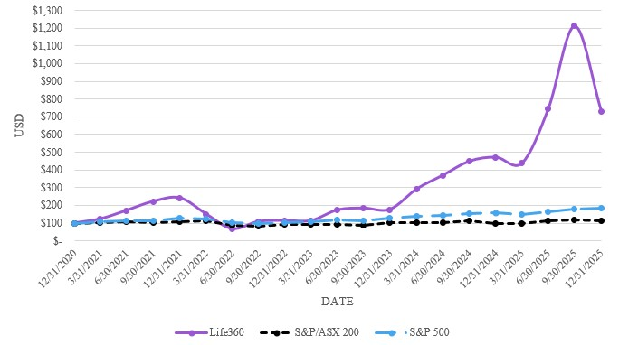
Recent Sales of Unregistered Equity Securities
None.
Purchases of Equity Securities by the Issuer and Affiliated Purchasers
None.

Item 6. [Reserved]

Item 7. Management’s Discussion and Analysis of Financial Condition and Results of Operations
The following discussion and analysis of our financial condition and results of operations should be read in conjunction with our consolidated financial statements and related notes appearing elsewhere in this Annual Report on Form 10-K. In addition to historical financial information, the following discussion contains forward-looking statements based upon current plans, expectations, and beliefs that involve risks and uncertainties. Our actual results could differ materially from those discussed in the forward-looking statements as a result of a variety of factors, including but not limited to those discussed in “Item 1A. Risk Factors” and “Forward-Looking Statements” in this Annual Report on Form 10-K.
A discussion of our financial condition and results of operations for the year ended December 31, 2025 compared to the year ended December 31, 2024 is presented below. A discussion of our financial condition and results of operations for the year ended December 31, 2024 compared to the year ended December 31, 2023 is included under “Management’s Discussion and Analysis of Financial Condition and Results of Operations” within our Form 10-K filed with the SEC on February 27, 2025.

48
Table of Contents
Overview
Life360 is a leading technology platform used to locate the people, pets, and things that matter most to families. Life360 is creating a new category at the intersection of family, technology, and safety to help keep families connected and safe. Our core offering, the Life360 mobile application, includes features that range from communications to driving safety and location sharing. The Life360 mobile application operates under a “freemium” model where its core offering is available to members at no charge, with three membership subscription options that are available but not required. We also generate revenue through hardware subscription services and the sale of hardware tracking devices. By offering devices and integrated software to members, we have expanded our addressable market to provide members of all ages with a vertically integrated, cross-platform solution of scale. We also generate other revenue from partnerships, including through the placement of ads within our platform, and the sale of aggregated, non-personally identifiable data for data insight purposes.
For the years ended December 31, 2025 and 2024, we generated:
•Total revenues of $489.5 million and $371.5 million, respectively, representing year-over-year growth of 32%;
•Subscription revenues of $369.3 million and $277.8 million, respectively, representing year-over-year growth of 33%;
•Hardware revenues of $51.8 million and $57.6 million, respectively, representing year-over-year decline of 10%;
•Other revenues of $68.4 million and $36.0 million, respectively, representing year-over-year growth of 90%;
•Gross profit of $380.8 million and $279.2 million, respectively, representing year-over-year growth of 36%;
•Net income of $150.8 million and net loss of $4.6 million, respectively; and
•Operating cash flows of $88.6 million and $32.6 million, respectively.

Key Factors Affecting Our Performance
As we focus on growing our customers and revenue, and achieving profitability while investing for the future and managing risk, expenses and capital, the following factors and others identified in the section of this Annual Report on Form 10-K titled “Item 1A. Risk Factors” have been important to our business and we expect them to impact our operations in future periods:
Ability to Retain Trusted Brand. We strongly believe in our vision to become the indispensable safety membership for families, with a suite of safety services that span every life stage of the family. Our business model and future success are dependent on the value and reputation of the Life360 and Tile by Life360, Inc. (“Tile”) brands. Our brand is trusted by approximately 96 million members as of December 31, 2025, and because we know the value of trust is immeasurable, we will continue to work tirelessly to provide useful, reliable, trustworthy, and innovative products and services.
Attract, Retain, and Convert Members. Our business model is based on attracting new members to our platform, converting free members to subscribers, and retaining and expanding subscriptions over time. Our continued success depends in part on our ability to offer compelling new products and features to our members, and to continue providing a quality user experience to convert and retain paying subscribers. We will also seek to increase brand awareness and customer adoption of our platform through various programs and digital and broad-scale advertising.
Maintaining Efficient Member Acquisition. Our investment in developing effective services and devices creates an efficient member acquisition model which drives strong unit economics. Our member acquisition model is complemented by our word-of-mouth and freemium models. We accelerate our organic member acquisition with strategic and targeted paid marketing spend. We expect to continue to invest in product and marketing, while balancing growth with strong unit economics. As we continue to expand internationally, we may increase our targeted marketing investments.
Ability to Attract New and Repeat Purchasers of Our Hardware Tracking Devices. Attracting new and repeat purchasers depends on our ability to design and release compelling smart trackers and market them effectively. Additionally we face increasing competition from better funded global companies. We pioneered the finding category and we continue to invest in the development of hardware products, assessing new and existing technologies with a priority on providing a great member finding experience.
49
Table of Contents
Growth in Average Revenue Per Paying Circle. Our business model is dependent upon our ability to grow and maintain a large member base, including growing the number of Paying Circles. We have a sophisticated understanding of our members, and as a result, the services we provide are core to families and hard to switch. We continue to develop new monetization features leveraging our core technologies to offer additional services, expand into more stages of families and enter new verticals to increase adoption. Many factors will affect the Average Revenue per Paying Circle (“ARPPC”) including the number of Paying Circles, mix of monetization offerings on our platform, as well as demographic shifts and geographic differences across these variables.
Expanding the Offerings on Our Platform. We are continually evaluating new product offerings that are aligned with our core competencies and the needs of families across the life stage continuum. For example, our acquisition of Tile gave our members the ability to seamlessly leverage Bluetooth wireless technology enabled smart trackers, which can equip nearly any item—such as wallets, keys or remotes—with location-based finding technology. In addition, the launch of our Life360 Pet GPS trackers in October 2025 enables families to seamlessly monitor the location of pets directly within the Life360 mobile application. We will continue to invest in and launch products where we see opportunities to grow our platform.
Attracting and Retaining Talent. We compete for talent in the technology industry. Our business relies on the ability to attract and retain talent, including engineers, data scientists, designers and software developers. As of December 31, 2025, we had approximately 547 full-time employees and approximately 95 contractors. Our core values are aimed at simplifying safety for families and we believe there are people who want to work at a values-driven company like Life360. We believe that our ability to recruit talent is aided by our reputation.
Seasonality. We experience seasonality in our member growth, engagement, Paying Circles growth, and monetization on our platform. Life360 has historically experienced member and subscription growth in the U.S. in the third quarter of each calendar year, driven by the back to school period for many of our members. Hardware sales have historically experienced comparatively higher seasonal growth in the fourth quarter of each calendar year, which includes the important selling periods in November and December largely driven by holiday demand. As the majority of revenue is generated within the U.S., our seasonality primarily relates to U.S. events. Accordingly, an unexpected decrease in sales over those traditionally high-volume selling periods may impact our revenue, result in surplus inventory, and could have a disproportionate effect on our operating results for the entire fiscal year. Seasonality in our business can also be affected by introductions of new or enhanced products and services, including the costs associated with such introductions.
International Expansion. We believe our global opportunity is significant, and to address this opportunity, we intend to continue to invest in sales and marketing efforts, infrastructure, and personnel to support our international expansion. Our growth will depend in part on the adoption and sales of our products and services in international markets.
Growth and Monetization of Advertising Offerings. Advertising represents an additional revenue opportunity for our business, and our ability to grow and effectively monetize our advertising offerings will impact our operating results. Our success in this area will depend on our ability to successfully integrate acquired technology, operations, and personnel, scale advertiser demand, maintain advertiser relationships, and balance monetization opportunities with a positive member experience. Advertising revenue may also be affected by macroeconomic conditions, changes in advertiser spending, competition, and evolving privacy and data protection regulations.

50
Table of Contents
Key Components of Our Results of Operations
The following discussion describes certain line items in our consolidated statements of operations and comprehensive income (loss).
Revenue
The Company generates revenue from direct and indirect streams. Direct revenue includes subscription and hardware revenue, while indirect revenue consists of all other revenue sources, such as data and partnership, which includes advertising.
Subscription Revenue
We generate revenue primarily from sales of subscriptions on our platform, including Life360 and Tile. Revenue is recognized ratably over the related contractual term generally beginning on the date that our platform is made available to a customer. Our subscription agreements typically have monthly or annual contractual terms. Our agreements are generally non-cancellable during the contract term. We typically bill in advance for monthly and annual contracts. Amounts that have been billed are initially recorded as deferred revenue until the revenue is recognized.
Hardware Revenue
We generate our hardware revenue from the sale of hardware tracking devices and related accessories. For hardware and accessories, revenue is recognized at the time products are delivered. We sell hardware tracking devices and accessories through a number of channels including our website, brick and mortar retail, and online retail.
Other Revenue
Other revenue consists of data and partnership revenue, which includes advertising revenue. We generate data revenue primarily through an arrangement with a key data partner that provides location-based analytics to customers in the retail and real estate sectors, municipalities, and other private and public organizations. The agreement permits commercialization of certain aggregated and de-identified data and provides for fixed and variable monthly revenue amounts. We generate partnership revenue through agreements with third parties which grant them access to anonymized data insights or advertising on the Company’s mobile platform, and through the recognition of revenue related to a warrant to purchase common stock of a related party (“Related Party Warrant”).
Cost of Revenue and Gross Margin
Cost of Subscription Revenue
Cost of subscription revenue primarily consists of expenses related to hosting our services and providing support to our free and paying subscribers. These expenses include personnel-related costs associated with our cloud-based infrastructure and our customer support organization, third-party hosting fees, software and maintenance costs, outside services associated with the delivery of our subscription services, amortization of acquired intangibles and allocated overhead, such as facilities, including rent, utilities, depreciation on equipment shared by all departments, credit card and transaction processing fees, and shared information technology costs. Personnel-related expenses include salaries, bonuses, benefits, and stock-based compensation for operations personnel.
We plan to continue increasing the capacity and enhancing the capability and reliability of our infrastructure to support member growth and increased use of our platform. We expect that cost of revenue will increase in absolute dollars in future periods.
Cost of Hardware Revenue
Cost of hardware revenue consists of product costs, including hardware production, contract manufacturers for production, shipping and handling, packaging, fulfillment, personnel-related expenses, manufacturing and equipment depreciation, warehousing, tariff costs, customer support costs, credit card and transaction processing fees, warranty replacement, write-downs of excess and obsolete inventory, allocated overhead, such as facilities, including rent and utilities, and shared information technology costs. Personnel-related expenses include salaries, bonuses, benefits, and stock-based compensation for operations personnel.
51
Table of Contents
Cost of Other Revenue
Cost of other revenue includes cloud-based hosting costs, software and technology costs, amortization of acquired intangibles, costs of product operations functions, and personnel-related costs associated with our data and advertising platforms. Personnel-related expenses include salaries, bonuses, benefits, and stock-based compensation for operations personnel.
Gross Profit and Gross Profit Margin
Our gross profit has been, and may in the future be, influenced by several factors, including timing of capital expenditures and related depreciation expense, increases in infrastructure costs, component costs, tariffs, contract manufacturing and supplier pricing, and foreign currency exchange rates. Gross profit and gross profit margin may fluctuate over time based on the factors described above.
Operating Expenses
Our operating expenses consist of research and development, selling and marketing, and general and administrative expenses.
Research and Development
Our research and development expenses consist primarily of personnel-related costs for our engineering, product, and design teams, material costs of building and developing prototypes for new products, mobile app development, and allocated overhead. We believe that continued investment in our platform is important for our growth. We intend to continue to invest in research and development to bring new customer experiences and devices to market and expand our platform capabilities.
Sales and Marketing
Our sales and marketing expenses consist primarily of commissions to the Company’s Channel Partners, personnel-related costs, brand marketing costs, lead generation costs, sales incentives, sponsorships, amortization of acquired intangibles, bad debt expense, and allocated overhead. Commission payments to Channel Partners in connection with annual subscription sales of the Company’s mobile application on third-party store platforms are considered to be incremental and recoverable costs of obtaining a contract with a customer and are expensed as incurred or deferred and amortized over an estimated period of benefit of three years depending on the subscription type.
We plan to continue to invest in sales and marketing to grow our member base and increase our brand awareness, including marketing efforts to continue to drive our business model. We expect that sales and marketing expenses will increase in absolute dollars in future periods and will fluctuate as a percentage of revenue. The trend and timing of sales and marketing expenses will depend in part on the timing of marketing campaigns.
General and Administrative
Our general and administrative expenses consist primarily of employee-related costs for our legal, finance, human resources, and other administrative teams, as well as certain executive officers. In addition, general and administrative expenses include allocated overhead, outside legal, accounting and other professional fees, and non-income-based taxes. We expect general and administrative expenses will increase in absolute dollars as our business grows.
Other Income (Expense)
Convertible Notes Fair Value Adjustment
The Company issued convertible notes to investors in July 2021 (the “July 2021 Convertible Notes”), and as part of the purchase consideration related to the acquisition of Jiobit in September 2021 (the “September 2021 Convertible Notes” and together with the July 2021 Convertible Notes, the “Convertible Notes”). The September 2021 Convertible Notes were recorded at fair value and revalued at each reporting period prior to their conversion to common stock in April 2024.
52
Table of Contents
Derivative Liability Fair Value Adjustment
Derivative liability fair value adjustment relates to the change in the fair value of the embedded conversion and redemption features associated with the July 2021 Convertible Notes prior to their conversion to common stock in June 2024.
Loss on Settlement of Convertible Notes
Loss on settlement of convertible notes relates to the conversion of the July 2021 Convertible Notes into common stock, which resulted in a loss recognized upon settlement.
Gain on Settlement of Derivative Liability
Gain on settlement of derivative liability relates to the conversion by the holders of the July 2021 Convertible Notes, which settled the embedded share-settled redemption features bifurcated from the Company’s July 2021 Convertible Notes.
Gain on Change in Fair Value of Investments
The Company measures certain non-marketable equity securities and warrant investments at fair value on a nonrecurring basis in accordance with ASC 321, Investment - Equity Securities. In April 2025, the SAFE investment in a related party (the “Related Party SAFE”) converted into shares of preferred stock (the “Related Party Investment”), as a result of an observable price change. Additionally, the Company measures and reports certain assets at fair value each reporting period. In May 2025, the Company entered into a series of transactions with Aura Consolidated Group, Inc. (“Aura”), which included a convertible note investment by the Company into Aura (“Convertible Note Investment”). The Company elected to apply the fair value option in accordance with ASC 825, Financial Instruments.
Gain on change in fair value of investments relates to the change in fair value associated with the Convertible Note Investment and the observable price change upon the conversion of the Related Party SAFE into the Related Party Investment.
Interest Income
Interest income consists of interest earned on our cash and cash equivalents balances received from bank deposits and our investments in money market funds.
Other Income (expense), net
Other income (expense), net consists of foreign currency exchange gains/(losses) related to the remeasurement of certain assets and liabilities of our foreign subsidiaries that are denominated in currencies other than the functional currency of the subsidiary, foreign exchange transactions gains/(losses), and interest expense primarily related to convertible notes.
Provision for (Benefit from) Income Taxes
Provision for (benefit from) income taxes consists of U.S. federal and state income taxes and foreign income taxes in jurisdictions in which we conduct business. Deferred income taxes reflect the net tax effect of temporary differences between the carrying amount of assets and liabilities for financial reporting purposes and the amounts used for income tax purposes.

53
Table of Contents
Results of Operations
The following tables set forth our consolidated statement of operations and comprehensive income (loss) for the years ended December 31, 2025, 2024, and 2023 (in thousands, except percentages). We have derived this data from our consolidated financial statements included elsewhere in this Annual Report on Form 10-K. This information should be read in conjunction with our consolidated financial statements and related notes included elsewhere in this Annual Report on Form 10-K. The results of historical periods are not necessarily indicative of the results of operations for any future period.
 |  |  | Year Ended December 31,
 |  |  | 2025 |  |  |  |  |  | 2024 |  |  |  |  |  | 2023
Subscription revenue |  |  | $ | 369,253 |  |  |  |  | $ | 277,845 |  |  |  |  | $ | 220,794
Hardware revenue |  |  | 51,816 |  |  |  |  |  | 57,589 |  |  |  |  |  | 58,178
Other revenue |  |  | 68,412 |  |  |  |  |  | 36,050 |  |  |  |  |  | 25,546
Total revenue |  |  | 489,481 |  |  |  |  |  | 371,484 |  |  |  |  |  | 304,518
Cost of subscription revenue |  |  | 50,968 |  |  |  |  |  | 41,014 |  |  |  |  |  | 30,975
Cost of hardware revenue |  |  | 51,175 |  |  |  |  |  | 47,225 |  |  |  |  |  | 47,384
Cost of other revenue |  |  | 6,496 |  |  |  |  |  | 4,088 |  |  |  |  |  | 3,522
Total cost of revenue(1) |  |  | 108,639 |  |  |  |  |  | 92,327 |  |  |  |  |  | 81,881
Gross profit |  |  | 380,842 |  |  |  |  |  | 279,157 |  |  |  |  |  | 222,637
Operating expenses(1):
Research and development |  |  | 128,409 |  |  |  |  |  | 113,071 |  |  |  |  |  | 100,965
Sales and marketing |  |  | 154,963 |  |  |  |  |  | 113,350 |  |  |  |  |  | 99,072
General and administrative |  |  | 78,644 |  |  |  |  |  | 60,712 |  |  |  |  |  | 52,583
Total operating expenses |  |  | 362,016 |  |  |  |  |  | 287,133 |  |  |  |  |  | 252,620
Income (loss) from operations |  |  | 18,826 |  |  |  |  |  | (7,976) |  |  |  |  |  | (29,983)
Other income (expense):
Convertible notes fair value adjustment |  |  | — |  |  |  |  |  | (608) |  |  |  |  |  | (684)
Derivative liability fair value adjustment |  |  | — |  |  |  |  |  | (1,707) |  |  |  |  |  | (116)
Loss on settlement of convertible notes |  |  | — |  |  |  |  |  | (440) |  |  |  |  |  | —
Gain on settlement of derivative liability |  |  | — |  |  |  |  |  | 1,924 |  |  |  |  |  | —
Gain on change in fair value of investments |  |  | 609 |  |  |  |  |  | 5,389 |  |  |  |  |  | —
Interest income |  |  | 13,705 |  |  |  |  |  | 6,009 |  |  |  |  |  | 3,083
Other income (expense), net |  |  | (481) |  |  |  |  |  | (7,217) |  |  |  |  |  | 145
Total other income (expense), net |  |  | 13,833 |  |  |  |  |  | 3,350 |  |  |  |  |  | 2,428
Income (loss) before income taxes |  |  | 32,659 |  |  |  |  |  | (4,626) |  |  |  |  |  | (27,555)
Provision for (benefit from) income taxes |  |  | (118,173) |  |  |  |  |  | (71) |  |  |  |  |  | 616
Net income (loss) |  |  | 150,832 |  |  |  |  |  | (4,555) |  |  |  |  |  | (28,171)
Change in foreign currency translation adjustment |  |  | 4 |  |  |  |  |  | 35 |  |  |  |  |  | 15
Total comprehensive income (loss) |  |  | $ | 150,836 |  |  |  |  | $ | (4,520) |  |  |  |  | $ | (28,156)
____________________
(1)Includes stock-based compensation expense as follows:
54
Table of Contents
 |  |  | Year Ended December 31,
 |  |  | 2025 |  |  |  |  |  | 2024 |  |  |  |  |  | % Change
Cost of subscription revenue |  |  | $ | 1,869 |  |  |  |  | $ | 730 |  |  |  |  | 156 |  | %
Cost of hardware revenue |  |  | 1,476 |  |  |  |  |  | 798 |  |  |  |  |  | 85 |  | %
Cost of other revenue |  |  | 8 |  |  |  |  |  | 4 |  |  |  |  |  | 100 |  | %
Total cost of revenue |  |  | 3,353 |  |  |  |  |  | 1,532
Research and development |  |  | 28,037 |  |  |  |  |  | 25,457 |  |  |  |  |  | 10 |  | %
Sales and marketing |  |  | 7,029 |  |  |  |  |  | 3,344 |  |  |  |  |  | 110 |  | %
General and administrative |  |  | 17,041 |  |  |  |  |  | 11,936 |  |  |  |  |  | 43 |  | %
Total stock-based compensation expense, net of amounts capitalized |  |  | $ | 55,460 |  |  |  |  | $ | 42,269 |  |  |  |  | 31 |  | %
The following table sets forth our results of operations as a percentage of revenue:
 |  |  | Year Ended December 31,
 |  |  | 2025 |  |  |  |  |  | 2024 |  |  |  |  |  | 2023
Subscription revenue |  |  | 75 |  | % |  |  |  | 75 |  | % |  |  |  | 73 |  | %
Hardware revenue |  |  | 11 |  | % |  |  |  | 16 |  | % |  |  |  | 19 |  | %
Other revenue |  |  | 14 |  | % |  |  |  | 10 |  | % |  |  |  | 8 |  | %
Total revenue |  |  | 100 |  | % |  |  |  | 100 |  | % |  |  |  | 100 |  | %
Cost of subscription revenue |  |  | 10 |  | % |  |  |  | 11 |  | % |  |  |  | 10 |  | %
Cost of hardware revenue |  |  | 10 |  | % |  |  |  | 13 |  | % |  |  |  | 16 |  | %
Cost of other revenue |  |  | 1 |  | % |  |  |  | 1 |  | % |  |  |  | 1 |  | %
Total cost of revenue |  |  | 22 |  | % |  |  |  | 25 |  | % |  |  |  | 27 |  | %
Gross profit |  |  | 78 |  | % |  |  |  | 75 |  | % |  |  |  | 73 |  | %
Operating expenses:
Research and development |  |  | 26 |  | % |  |  |  | 30 |  | % |  |  |  | 33 |  | %
Sales and marketing |  |  | 32 |  | % |  |  |  | 31 |  | % |  |  |  | 33 |  | %
General and administrative |  |  | 16 |  | % |  |  |  | 16 |  | % |  |  |  | 17 |  | %
Total operating expenses |  |  | 74 |  | % |  |  |  | 77 |  | % |  |  |  | 83 |  | %
Income (loss) from operations |  |  | 4 |  | % |  |  |  | (2) |  | % |  |  |  | (10) |  | %
Other income (expense):
Convertible notes fair value adjustment |  |  | — |  | % |  |  |  | — |  | % |  |  |  | — |  | %
Derivative liability fair value adjustment |  |  | — |  | % |  |  |  | — |  | % |  |  |  | — |  | %
Loss on settlement of convertible notes |  |  | — |  | % |  |  |  | — |  | % |  |  |  | — |  | %
Gain on settlement of derivative liability |  |  | — |  | % |  |  |  | 1 |  | % |  |  |  | — |  | %
Gain on change in fair value of investments |  |  | — |  | % |  |  |  | 1 |  | % |  |  |  | — |  | %
Interest income |  |  | 3 |  | % |  |  |  | 2 |  | % |  |  |  | 1 |  | %
Other income (expense), net |  |  | — |  | % |  |  |  | (2) |  | % |  |  |  | — |  | %
Total other income (expense), net |  |  | 3 |  | % |  |  |  | 1 |  | % |  |  |  | 1 |  | %
Income (loss) before income taxes |  |  | 7 |  | % |  |  |  | (1) |  | % |  |  |  | (9) |  | %
Provision for (benefit from) income taxes |  |  | (24) |  | % |  |  |  | — |  | % |  |  |  | — |  | %
Net income (loss) |  |  | 31 |  | % |  |  |  | (1) |  | % |  |  |  | (9) |  | %
Change in foreign currency translation adjustment |  |  | — |  | % |  |  |  | — |  | % |  |  |  | — |  | %
Total comprehensive income (loss) |  |  | 31 |  | % |  |  |  | (1) |  | % |  |  |  | (9) |  | %
55
Table of Contents
Comparison of the years ended December 31, 2025 and 2024:
Revenue
 |  |  | Year Ended December 31, |  |  |  |  |  |  |  |  |  |  |  | Change
(in thousands, except percentages) |  |  | 2025 |  |  |  |  |  | 2024 |  |  |  |  |  | $ |  |  |  |  |  | %
Subscription revenue |  |  | $ | 369,253 |  |  |  |  | $ | 277,845 |  |  |  |  | $ | 91,408 |  |  |  |  | 33 |  | %
Hardware revenue |  |  | 51,816 |  |  |  |  |  | 57,589 |  |  |  |  |  | (5,773) |  |  |  |  |  | (10) |  | %
Other revenue |  |  | 68,412 |  |  |  |  |  | 36,050 |  |  |  |  |  | 32,362 |  |  |  |  |  | 90 |  | %
Total revenue |  |  | $ | 489,481 |  |  |  |  | $ | 371,484 |  |  |  |  | $ | 117,997 |  |  |  |  | 32 |  | %
Subscription revenue increased $91.4 million, or 33%, during the year ended December 31, 2025 as compared to the year ended December 31, 2024, primarily due to 26% growth in Paying Circles and 17% growth in total subscriptions. Additionally, subscription revenue in the current period benefited from a 7% uplift in ARPPC. Please refer to the “Key Performance Indicators” section for definitions of key performance indicators (“KPIs”).
Hardware revenue decreased $5.8 million, or 10%, during the year ended December 31, 2025 as compared to the year ended December 31, 2024. Although net hardware units shipped increased 7%, contributing to $6.3 million of revenue, this increase was more than offset by an $8.5 million increase in discounts and a $3.6 million reduction in revenue related to bundled offerings.
Other revenue increased $32.4 million, or 90%, during the year ended December 31, 2025 as compared to the year ended December 31, 2024. This was primarily due to a $26.3 million increase in partnership revenue, which includes advertising revenue, and reflects growth in advertising activity from both existing arrangements and an increased number of partners. In addition, data revenue increased $6.1 million, primarily attributable to the Amended and Restated Data Services and License Agreement with Placer.ai entered into in July 2024, and increased data volumes resulting from user growth.
Cost of Revenue, Gross Profit, and Gross Margin
 |  |  | Year Ended December 31, |  |  |  |  |  |  |  |  |  |  |  | Change
(in thousands, except percentages) |  |  | 2025 |  |  |  |  |  | 2024 |  |  |  |  |  | $ |  |  |  |  |  | %
Cost of subscription revenue |  |  | $ | 50,968 |  |  |  |  | $ | 41,014 |  |  |  |  | $ | 9,954 |  |  |  |  | 24 |  | %
Cost of hardware revenue |  |  | 51,175 |  |  |  |  |  | 47,225 |  |  |  |  |  | 3,950 |  |  |  |  |  | 8 |  | %
Cost of other revenue |  |  | 6,496 |  |  |  |  |  | 4,088 |  |  |  |  |  | 2,408 |  |  |  |  |  | 59 |  | %
Total cost of revenue |  |  | 108,639 |  |  |  |  |  | 92,327 |  |  |  |  |  | 16,312
Gross profit |  |  | $ | 380,842 |  |  |  |  | $ | 279,157 |  |  |  |  | $ | 101,685
Gross margin:
Subscription |  |  | 86 |  | % |  |  |  | 85 |  | %
Hardware |  |  | 1 |  | % |  |  |  | 18 |  | %
Other |  |  | 91 |  | % |  |  |  | 89 |  | %
Cost of subscription revenue increased $10.0 million, or 24%, during the year ended December 31, 2025 as compared to the year ended December 31, 2024, primarily due to increases of $4.1 million in personnel-related and stock-based compensation costs, $3.1 million in technology expenses, $2.6 million in amortization of internally developed software related to the release of new features and significant updates on our platform, all attributable to Company growth, and $0.2 million in costs associated with premium membership offerings.
Subscription gross margin increased to 86% during the year ended December 31, 2025 from 85% during the year ended December 31, 2024, primarily due to price increases for new and existing Life360 subscriptions implemented during the second half of 2024 and continuing into 2025, consistent with the increase in ARPPC. Subscription gross margin also benefited from ongoing technology efficiency initiatives implemented by the Company. Please refer to “Key Performance Indicators” for definitions of KPIs.
56
Table of Contents
Cost of hardware revenue increased by $4.0 million, or 8%, during the year ended December 31, 2025 as compared to the year ended December 31, 2024. This was driven by increases of $3.9 million in tariff costs due to increases in tariff rates and changes in product mix, and $0.5 million in product and other costs due to a 7% increase in net hardware units shipped. Additional increases include $2.5 million in personnel-related and stock-based compensation costs, attributable to Company growth. The increases were partially offset by decreases of $1.7 million in freight costs and $1.2 million in fulfillment costs, both related to a shift in channel mix.
Hardware gross margin decreased to 1% during the year ended December 31, 2025 from 18% during the year ended December 31, 2024, primarily due to an increase in discounts and tariff costs.
Cost of other revenue increased by $2.4 million, or 59%, during the year ended December 31, 2025 as compared to the year ended December 31, 2024, due to an increase of $2.4 million in technology and other related expenses.
Other gross margin increased to 91% during the year ended December 31, 2025 from 89% during the year ended December 31, 2024, primarily due to revenue outpacing the increase in costs.
Research and Development
 |  |  | Year Ended December 31, |  |  |  |  |  |  |  |  |  |  |  | Change
(in thousands, except percentages) |  |  | 2025 |  |  |  |  |  | 2024 |  |  |  |  |  | $ |  |  |  |  |  | %
Research and development |  |  | $ | 128,409 |  |  |  |  | $ | 113,071 |  |  |  |  | $ | 15,338 |  |  |  |  | 14 |  | %
Research and development expenses increased $15.3 million, or 14%, during the year ended December 31, 2025 as compared to the year ended December 31, 2024. This was primarily due to increases of $13.2 million in personnel-related and stock-based compensation costs, $4.1 million in technology and other expenses, and $0.9 million in professional and outside services, all attributable to Company growth. The increases were partially offset by higher capitalized costs of $2.2 million for internally developed software related to the development of new features and significant updates to our platform, and higher capitalized construction in progress costs of $0.7 million, in line with our product development roadmap.
Sales and Marketing
 |  |  | Year Ended December 31, |  |  |  |  |  |  |  |  |  |  |  | Change
(in thousands, except percentages) |  |  | 2025 |  |  |  |  |  | 2024 |  |  |  |  |  | $ |  |  |  |  |  | %
Sales and marketing |  |  | $ | 154,963 |  |  |  |  | $ | 113,350 |  |  |  |  | $ | 41,613 |  |  |  |  | 37 |  | %
Sales and marketing expenses increased $41.6 million, or 37%, during the year ended December 31, 2025 as compared to the year ended December 31, 2024. This was primarily due to increases of $16.8 million in commissions to the Company’s Channel Partners, in line with the increase in subscription revenue, and $14.4 million in growth media spend to support strategic initiatives. Additional increases include $7.9 million in personnel-related and stock-based compensation costs, $1.3 million in marketing and other spend related to production and public relations, and $1.2 million in technology expenses, all attributable to Company growth.
General and Administrative
 |  |  | Year Ended December 31, |  |  |  |  |  |  |  |  |  |  |  | Change
(in thousands, except percentages) |  |  | 2025 |  |  |  |  |  | 2024 |  |  |  |  |  | $ |  |  |  |  |  | %
General and administrative |  |  | $ | 78,644 |  |  |  |  | $ | 60,712 |  |  |  |  | $ | 17,932 |  |  |  |  | 30 |  | %
57
Table of Contents
General and administrative expenses increased $17.9 million, or 30%, during the year ended December 31, 2025 as compared to the year ended December 31, 2024. This was primarily due to increases of $12.2 million in personnel-related and stock-based compensation costs, $1.0 million in technology expenses, and $0.7 million in insurance and other costs, all attributable to Company growth. Additional increases include $2.0 million in professional and outside services spend, primarily driven by transaction costs incurred related to acquisitions, $1.3 million for travel and entertainment costs primarily related to the Company’s annual event, and $0.7 million in warehouse relocation costs related to the move of certain hardware manufacturing operations.
Convertible Notes Fair Value Adjustment
In April and June 2024, the September 2021 Convertible Notes and the July 2021 Convertible Notes, respectively, were converted to common stock. As a result, the Company recorded no gain or loss associated with the Convertible Notes fair value adjustment for the year ended December 31, 2025. The Company recorded a $0.6 million loss associated with the Convertible Notes fair value adjustment for the year ended December 31, 2024.
Derivative Liability Fair Value Adjustment
In June 2024, the holders of the July 2021 Convertible Notes converted their notes and accrued interest to common stock and the embedded derivative liability was settled as a result of the conversion. As a result, the Company recorded no gain or loss and a $1.7 million loss associated with the derivative liability fair value adjustment for the years ended December 31, 2025 and 2024, respectively.
Loss on Settlement of Convertible Notes
In April and June 2024, the September 2021 Convertible Notes and the July 2021 Convertible Notes, respectively, were converted to common stock. As a result, the Company recorded no gain or loss related to the settlement of the September 2021 Convertible Notes and July 2021 Convertible Notes for the year ended December 31, 2025. The Company recorded a $0.4 million loss associated with the settlement of the July 2021 Convertible Notes and the September 2021 Convertible Notes for the year ended December 31, 2024.
Gain on Settlement of Derivative Liability
In June 2024, the holders of the July 2021 Convertible Notes converted their notes and accrued interest to common stock and the derivative liability was settled as a result of the conversion. As a result, the Company recorded no gain or loss related to the settlement of the derivative liability for the year ended December 31, 2025. The Company recorded a $1.9 million gain related to the settlement of the derivative liability upon conversion of the July 2021 Convertible Notes for the year ended December 31, 2024.
Gain on Change in Fair Value of Investments
In April 2025, an observable price change related to the conversion of the Related Party SAFE into the Related Party Investment took place. As a result, a $0.9 million gain related to the observable price change was recognized during the year ended December 31, 2025.
In addition, in May 2025, the Company entered into a series of transactions with Aura, which included a $25.0 million convertible note investment by the Company into Aura. The Company elected to apply the fair value option in accordance with ASC 825, Financial Instruments. As a result, a $0.3 million loss related to the revaluation of the Convertible Note Investment was recognized during the year ended December 31, 2025.
In July 2024, an observable price change related to our investment in a warrant held to purchase shares of preferred stock of a data revenue partner took place. The observable price change resulted in a fair value adjustment and gain of $5.4 million recorded for the year ended December 31, 2024.
Interest Income
Interest income increased $7.7 million, or 128%, during the year ended December 31, 2025 as compared to the year ended December 31, 2024, resulting from higher average gross yields attributable to an increased cash and cash equivalents balance.
58
Table of Contents

Other Income (Expense), Net
Other income (expense), net includes U.S. IPO transaction costs, foreign exchange gains and losses, and interest expense associated with the July 2021 Convertible Notes and the convertible notes issued to investors in June 2025 (the “June 2025 Convertible Notes”).
Other income (expense), net increased $6.7 million, or 93%, during the year ended December 31, 2025 as compared to the year ended December 31, 2024. This was primarily driven by a $5.6 million decrease in transaction costs incurred in the prior period in connection with our U.S. IPO, a $1.9 million increase in foreign exchange gains, and a $0.3 million decrease in other costs. This was partially offset by a $1.1 million increase in interest expense related to the June 2025 Convertible Notes.
Provision for (Benefit from) Income Taxes
We recognized an income tax benefit of $118.2 million during the year ended December 31, 2025, compared to an income tax benefit of $0.1 million during the year ended December 31, 2024.
Our income tax benefit consisted primarily of a $118.4 million benefit related to the release of a valuation allowance on our U.S. deferred tax assets during the year ended December 31, 2025. We regularly assess the need for a valuation allowance on our deferred tax assets. In making this assessment, we consider both positive and negative evidence related to the likelihood of realization of the deferred tax assets to determine, based on the weight of available evidence, whether it is more likely than not that some or all the deferred tax assets will not be realized. As of December 31, 2025, based on all available positive and negative evidence, having demonstrated sustained U.S. profitability, which is objective and verifiable, and taking into account anticipated future earnings, we have concluded it is more likely than not that we will realize our U.S. federal and states deferred tax assets, with the exception of California state and Canadian tax credits. We continue to maintain a valuation allowance against these deferred tax assets as they have not met the “more likely than not” realization criterion.

Key Performance Indicators
We review several operating metrics, including the following KPIs, to evaluate our business, measure our performance, identify trends affecting our business, develop financial forecasts, and make strategic decisions. We believe these KPIs are useful to investors because they allow for greater transparency with respect to key metrics used by management in its financial and operational decision-making, and they may be used by investors to help analyze the health of our business. Key operating metrics are presented in millions, except ARPPC, Average Revenue per Paying Subscription (“ARPPS”) and Average Sales Price (“ASP”), however percentage changes are calculated based on actual results. As a result, percentage changes may not recalculate based on figures presented due to rounding. Please refer to “Results of Operations” for additional metrics management reviews in conjunction with the consolidated financial statements.
59
Table of Contents
Key Operating Metrics
 |  |  | As of and for the year ended December 31,
 |  |  | 2025 |  |  |  |  |  | 2024 |  |  |  |  |  | % Change
 |  |  | (in millions, except ARPPC, ARPPS and ASP)
AMR |  |  | $ | 478.0 |  |  |  |  | $ | 367.6 |  |  |  |  | 30 |  | %
MAU |  |  | 95.8 |  |  |  |  |  | 79.6 |  |  |  |  |  | 20 |  | %
Paying Circles |  |  | 2.8 |  |  |  |  |  | 2.3 |  |  |  |  |  | 26 |  | %
ARPPC1 |  |  | $ | 136.63 |  |  |  |  | $ | 128.00 |  |  |  |  | 7 |  | %
Subscriptions |  |  | 3.4 |  |  |  |  |  | 2.9 |  |  |  |  |  | 17 |  | %
ARPPS1 |  |  | $ | 118.17 |  |  |  |  | $ | 106.16 |  |  |  |  | 11 |  | %
Net hardware units shipped |  |  | 4.2 |  |  |  |  |  | 3.9 |  |  |  |  |  | 7 |  | %
ASP2 |  |  | $ | 12.25 |  |  |  |  | $ | 13.72 |  |  |  |  | (11) |  | %
(1) Excludes revenue related to bundled Life360 subscription and hardware offerings of $(0.8) million for the year ended December 31, 2025, and $(4.6) million for the year ended December 31, 2024.
(2) Excludes revenue related to bundled Life360 subscription and hardware offerings of $0.7 million for the year ended December 31, 2025, and $4.3 million for the year ended December 31, 2024.
Annualized Monthly Revenue
We use Annualized Monthly Revenue (“AMR”) to identify the annualized monthly value of active customer agreements at the end of a reporting period. AMR includes the annualized monthly value of subscription, data and partnership agreements. All components of these agreements that are not expected to recur are excluded. This does not represent revenue under GAAP on an annualized basis, as the operating metric can be impacted by start and end dates and renewal rates. AMR as of December 31, 2025, and 2024 was $478.0 million and $367.6 million, respectively, representing an increase of 30% year-over-year, which is largely attributable to continued subscriber growth as well as an increase in other recurring revenue.
Monthly Active Users
We have a large and growing global member base as of December 31, 2025. A Life360 monthly active user (“MAU”) is defined as a unique member who engages with our Life360 branded services each month, which includes both paying and non-paying members, and excludes certain members who have a delayed account setup. As of December 31, 2025 and 2024, we had approximately 95.8 million and 79.6 million MAU on the Life360 platform, respectively, representing an increase of 20% year-over-year. We believe this has been driven by continued strong new member growth and retention.
Paying Circles
We define a Paying Circle as a group of Life360 members with a paying subscription who have been billed as of the end of period. Each subscription covers all members in the payor’s Circle so everyone in the Circle can utilize the benefits of a Life360 membership, including access to premium location, driving, digital and emergency safety insights and services.
As of December 31, 2025 and 2024, we had approximately 2.8 million and 2.3 million paid subscribers to services under our Life360 brand, respectively, representing an increase of 26% year-over-year. We grow the number of Paying Circles by increasing our free member base, converting free members to subscribers, and retaining them over time with the provision of high-quality family connectivity and safety services.
Average Revenue per Paying Circle
We define ARPPC as annualized subscription revenue recognized and derived from the Life360 mobile application, excluding revenue related to bundled Life360 subscription and hardware offerings, for the reported period, divided by the Average Paying Circles during the same period. Average Paying Circles are calculated by adding the number of Paying Circles as of the beginning of the period to the number of Paying Circles as of the end of the period, and then dividing by two.
60
Table of Contents
For the years ended December 31, 2025 and 2024, our ARPPC was $136.63 and $128.00, respectively, representing a 7% increase year-over-year.
ARPPC is a key indicator utilized by the Company to determine our effectiveness at monetizing Paying Circles through tiered product offerings. The year-over-year growth in ARPPC primarily reflects U.S. price increases for new and existing annual subscribers implemented in the second half of 2024 and continuing into 2025, a shift in product mix toward higher-priced offerings, and the introduction of higher-priced membership tiers across select international markets throughout 2024 and 2025.
Subscriptions
We define subscriptions as the number of paying subscribers associated with the Life360 and Tile brands who have been billed as of the end of the period.
As of December 31, 2025 and 2024, we had approximately 3.4 million and 2.9 million paid subscribers to services under Life360 and Tile brands, respectively, representing an increase of 17% year-over-year.
We grow the number of subscriptions by selling hardware units and increasing our free member base, converting free members to subscribers, and retaining them over time with the provision of location tracking and high-quality family and safety services.
Average Revenue per Paying Subscription
We define ARPPS as annualized total subscription revenue recognized and derived from Life360 and Tile subscriptions, excluding revenue related to bundled Life360 subscription and hardware offerings, for the reported period divided by the average number of paying subscribers during the same period. The average number of paying subscribers is calculated by adding the number of paying subscribers as of the beginning of the period to the number of paying subscribers as of the end of the period, and then dividing by two. Paying subscribers represent subscribers who have been billed as of the end of the period.
ARPPS for the years ended December 31, 2025 and 2024 was $118.17 and $106.16, respectively, representing an increase of 11% year-over-year.
ARPPS has increased year-over-year as a result of U.S. price increases for new and existing annual subscribers implemented in the second half of 2024 and continuing into 2025, a shift in product mix towards higher-priced offerings, and the introduction of higher-priced membership tiers across select international markets throughout 2024 and 2025.
Net Hardware Units Shipped
Net hardware units shipped represents the number of tracking devices sold during a period, excluding certain hardware units related to bundled Life360 subscription and hardware offerings, net of returns by our retail partners and directly to consumers. Selling units contributes to hardware revenue and ultimately increases the number of members eligible for a subscription.
For the years ended December 31, 2025 and 2024, Life360 sold approximately 4.2 million and 3.9 million, respectively, representing a 7% increase year-over-year. The increase in net hardware units shipped was primarily due to an increase in online retail sales.
Net Average Sales Price
To determine the net ASP of a unit, we divide hardware revenue recognized, excluding revenue related to bundled Life360 subscription and hardware offerings, for the reported period by the number of net hardware units shipped during the same period. ASP is largely driven by the price we charge customers, including the price we charge our retail partners, net of customer allowances, and directly to consumers.
For the years ended December 31, 2025 and 2024, the net ASP of a unit was $12.25 and $13.72, respectively, representing an 11% decrease year-over-year. The decrease in net ASP was primarily due to a shift in channel mix and an increase in discounts.

61
Table of Contents
Liquidity and Capital Resources
As of December 31, 2025, we had cash and cash equivalents of $494.3 million and restricted cash of $1.6 million. As of December 31, 2024, we had cash and cash equivalents of $159.2 million and restricted cash of $1.2 million. The increase in cash and cash equivalents was primarily related to the issuance of the June 2025 Convertible Notes and positive net cash provided by operating activities for the year ended December 31, 2025.
We believe our existing cash and cash equivalents, together with cash generated from subscriptions, hardware tracking devices, partnerships, including through the placement of ads within our platform, and the sale of aggregated, non-personally identifiable data for data insight purposes will be sufficient to support working capital and capital expenditure requirements for at least the next 12 months. We may from time to time seek to raise additional capital based on a variety of factors, including our capital requirements and the relative favorability of conditions in the capital markets. If we are unable to raise additional capital on terms acceptable to us or generate cash flows necessary to expand our operations and invest in continued innovation, we may not be able to compete successfully, which would harm our business, financial condition and results of operations.
Our cash flow activities were as follows for the periods presented (in thousands):
 |  |  | Year Ended December 31,
 |  |  | 2025 |  |  |  |  |  | 2024 |  |  |  |  |  | 2023
Net cash provided by operating activities |  |  | $ | 88,630 |  |  |  |  | $ | 32,612 |  |  |  |  | $ | 7,524
Net cash used in investing activities |  |  | (35,333) |  |  |  |  |  | (10,132) |  |  |  |  |  | (2,221)
Net cash provided by (used in) financing activities |  |  | 282,072 |  |  |  |  |  | 67,266 |  |  |  |  |  | (24,955)
Net Increase (Decrease) in Cash, Cash Equivalents, and Restricted Cash |  |  | $ | 335,369 |  |  |  |  | $ | 89,746 |  |  |  |  | $ | (19,652)
Operating Activities
Our primary sources of operating cash are cash collections from our paying members for subscriptions to our platform, hardware tracking device sales, partnership revenue, which includes advertising, and revenue generated from the sale of aggregated, non-personally identifiable data for data insight purposes. Our primary uses of cash from operating activities are for employee-related expenditures, costs to acquire inventory, infrastructure-related costs, commissions paid to Channel Partners, and other marketing expenses.
A number of our members pay in advance for annual subscriptions, while a majority pay in advance for monthly subscriptions. Deferred revenue consists of the unearned portion of customer billings, which is recognized as revenue in accordance with our revenue recognition policy. As of December 31, 2025 and 2024, we had deferred revenue of $50.7 million and $45.2 million, respectively, of which $46.4 million and $39.9 million is expected to be recorded as revenue in the next 12 months, respectively, provided all other revenue recognition criteria have been met.
For the year ended December 31, 2025, net cash provided by operating activities was $88.6 million. The primary factors affecting our operating cash flows during this period were our net income of $150.8 million, impacted by $47.6 million of non-cash adjustments, and $14.6 million of cash used by changes in our operating assets and liabilities. The non-cash adjustments primarily consisted of stock-based compensation expense, and depreciation and amortization. The cash used by changes in our operating assets and liabilities was primarily due to increases in accounts receivable and prepaid expenses and other current assets. These cash outflows were offset by increases in accounts payable, inventory, and accrued expenses and other current liabilities.
For the year ended December 31, 2024, net cash provided by operating activities was $32.6 million. The primary factors affecting our operating cash flows were our net loss of $4.6 million, impacted by $48.4 million of non-cash adjustments, and $11.2 million of cash used by changes in our operating assets and liabilities. The non-cash adjustments primarily consisted of stock-based compensation expense, depreciation and amortization, and gain on the change in fair value of investment. The cash used by changes in our operating assets and liabilities was primarily due to an increase in accounts receivable, net, an increase in costs capitalized to obtain contracts with customers, and an increase in inventory. These amounts were partially offset by an increase in deferred revenue, and an increase in accrued expenses and other liabilities.
62
Table of Contents
Investing Activities
For the year ended December 31, 2025, net cash used in investing activities was $35.3 million, which primarily related to the $25.0 million Convertible Note Investment. Net cash used in investing activities also included capitalization of internally developed software costs in accordance with ASC 350-40, Intangibles - Goodwill and Other, Internal-Use Software, and cash paid for an acquisition. Refer to Note 6, "Business Combinations" for additional information on the acquisition.
For the year ended December 31, 2024, net cash used in investing activities was $10.1 million, which primarily related to the Related Party SAFE of $5.0 million, the capitalization of internally developed software costs of $3.9 million in accordance with ASC 350-40, Intangibles - Goodwill and Other, Internal-Use Software, and purchases of property and equipment of $1.2 million.
Financing Activities
For the year ended December 31, 2025, net cash provided by financing activities was $282.1 million, which primarily related to net proceeds of $320.0 million from the issuance of the June 2025 Convertible Notes offset by payments of $10.9 million for debt issuance costs. In connection with the issuance of the June 2025 Convertible Notes, the Company paid $33.7 million in capped call transactions. Refer to Note 8, "Convertible Notes" for more information on the June 2025 Convertible Notes and the June 2025 Capped Calls. Financing activities also included $62.8 million of employee taxes paid for the net settlement of equity awards, offset by $69.5 million of proceeds related to employee tax withholdings on restricted stock settlements and the exercise of stock options and warrants.
For the year ended December 31, 2024, net cash provided by financing activities was $67.3 million. This was primarily related to net proceeds of $93.0 million after deducting underwriting discounts and commissions from our U.S. IPO, which closed on June 6, 2024 and involved the sale of 3,703,704 shares of common stock. Additionally, financing activities also included $14.6 million of proceeds from the exercise of options and warrants and restricted stock settlements, offset by $34.0 million of taxes paid for the net settlement of equity awards, and $6.3 million in payments related to the U.S. IPO.

Obligations and Other Commitments
Our principal commitments consist of obligations under our operating leases for office space, and other purchase commitments. Information regarding our non-cancellable lease and other purchase commitments as of December 31, 2025, can be found in Note 7, "Balance Sheet Components" and Note 10, "Commitments and Contingencies" to our consolidated financial statements.

Critical Accounting Policies and Significant Management Estimates
We prepare our consolidated financial statements in accordance with GAAP. The preparation of consolidated financial statements also requires us to make estimates and assumptions that affect the reported amounts of assets, liabilities, revenues, costs and expenses, and related disclosures. We base our estimates on historical experience and on various other assumptions that we believe to be reasonable under the circumstances. Actual results could differ significantly from the estimates made by our management. To the extent that there are differences between our estimates and actual results, our future financial statement presentation, financial condition, results of operations, and cash flows will be affected. We believe that of our significant accounting policies, which are described in Note 2, "Summary of Significant Accounting Policies" to our consolidated financial statements, the following accounting policies, and specific estimates involve a greater degree of judgment and complexity.
Revenue Recognition
We derive revenue from subscription fees, the sale of hardware tracking devices and accessories, and other revenue. We sell subscriptions to our platform through arrangements that are generally monthly to annual in length. Our arrangements are generally non-cancellable and non-refundable. Our subscription arrangements do not provide customers with the right to take possession of the software supporting the platform and, as a result, are accounted for as service arrangements.
63
Table of Contents
While most of our sales arrangements contain standard terms and conditions, certain arrangements contain non-standard terms and conditions and include promises to transfer multiple goods or services. As a result, significant interpretation and judgment are sometimes required to determine the appropriate accounting for these transactions, including: (1) whether related performance obligations are considered distinct and should be accounted for separately versus together, (2) how the price should be allocated among separate performance obligations, and when to recognize revenue for each performance obligation; (3) developing an estimate of the stand-alone selling price (“SSP”), of each distinct performance obligation; and (4) estimating and accounting for variable consideration, which may include sales incentives and investment.
Some of our contracts with customers contain multiple performance obligations, primarily hardware and subscription services for hardware tracking devices. For arrangements with multiple performance obligations where the contracted price differs from the SSP for any distinct good or service, we may be required to allocate the transaction price to each performance obligation using our best estimates for the SSP. Our process for determining the SSP considers multiple factors including consumer behaviors, our internal pricing model, and cost-plus margin, and may vary depending upon the facts and circumstances related to each performance obligation. For business-to-business hardware sales, we will estimate the expected consideration amount after credits and discounts.
We provide our customers with incentives through various programs including promotional agreements and marketing development agreements. Sales incentives are considered variable consideration, which we estimate and record as a reduction to revenue. Incentives are influenced by historical experience, projected sales data, and contractual terms.
Any change in judgments with respect to these assumptions and estimates could impact the timing or amount of revenue recognition.
Income Taxes
Management is required to exercise judgment in determining our provision for income taxes. The provision for income taxes is determined by taking into account guidance related to uncertain tax positions. Judgment is required in assessing the timing and amounts of deductible and taxable items.
Deferred tax assets are amounts available to reduce income taxes payable on taxable income in future years and are initially recognized at enacted tax rates. We regularly assess the need for a valuation allowance against our deferred tax assets. In making that assessment, we consider both positive and negative evidence related to the likelihood of realization of the deferred tax assets as well as the nature of the deferred tax attribute to determine, based on the weight of available evidence, whether it is more likely than not that some or all of the deferred tax assets will not be realized. For the year ended December 31, 2025, the valuation allowance was released on U.S. and state deferred tax assets, with the exception of California state and Canadian tax credits, due to positive evidence that the assets are more likely than not to be realized in future years. The Company will continue to assess all available evidence during future periods to evaluate any changes to the realization of its deferred tax assets. All of the factors that the Company considers in evaluating whether and when to establish or release all or a portion of the deferred tax asset valuation allowance involve significant judgment.
Although we believe that we have adequately reserved for our uncertain tax positions, we can provide no assurance that the final tax outcome of these matters will not be materially different. We make adjustments to these reserves when facts and circumstances change, such as the closing of a tax audit or the refinement of an estimate. To the extent that the final tax outcome of these matters is different than the amounts recorded, such differences may affect the provision for income taxes in the period in which such determination is made and could have a material impact on our financial condition and results of operations.

Recent Accounting Pronouncements
See Note 2, "Summary of Significant Accounting Policies" to our consolidated financial statements included in Item 8 of Part II hereof for a discussion of recent accounting pronouncements.

64
Table of Contents
Item 7A. Quantitative and Qualitative Disclosures About Market Risk
We are exposed to market risk in the ordinary course of our business. Market risk represents the risk of loss that may impact our financial position due to adverse changes in financial market prices and rates. Our market risk exposure is primarily the result of fluctuations in interest rates and foreign currency exchange rates.
Interest Rate Risk
As of December 31, 2025 and December 31, 2024, we had $494.3 million and $159.2 million, respectively, of cash and cash equivalents invested in money market funds. Our cash and cash equivalents are held for working capital purposes. As of December 31, 2025 and December 31, 2024, a hypothetical 10% relative change in interest rates would not have a material impact on our consolidated financial statements.
Foreign Currency Exchange Risk
Our reporting currency and functional currency is the U.S. dollar. The majority of our sales are denominated in U.S. dollars, and therefore our revenue is not currently subject to significant foreign currency risk. Our operating expenses are denominated in the currencies of the countries in which our operations are located, which is primarily in the U.S. Our consolidated results of operations and cash flows are, therefore, subject to fluctuations due to changes in foreign currency exchange rates and may be adversely affected in the future due to changes in foreign exchange rates. To date, we have not entered into any active hedging arrangements with respect to foreign currency risk or other derivative financial instruments, although we may choose to do so in the future. We do not believe that a hypothetical 1,000 basis-point increase or decrease in the relative value of the U.S. dollar to other currencies would have a material effect on our operating results.
Inflation Risk
We do not believe that inflation has had a material effect on our business, results of operations, or financial condition. Nonetheless, if our costs were to become subject to significant inflationary pressures, we may not be able to fully offset such higher costs. Our inability or failure to do so could harm our business, results of operations, or financial condition.

Item 8. Financial Statements and Supplementary Data.

Index to Consolidated Financial Statements
 |  |  | Page
Report of Independent Registered Public Accounting Firms (Deloitte and Touche LLP; San Francisco, CA; PCAOB ID #34) |  |  | 66
Financial Statements
Consolidated Balance Sheets |  |  | 68
Consolidated Statements of Operations and Comprehensive Income (Loss) |  |  | 69
Consolidated Statements of Stockholders’ Equity |  |  | 70
Consolidated Statements of Cash Flows |  |  | 71
Notes to Consolidated Financial Statements |  |  | 73

65

Report of Independent Registered Public Accounting Firm
To the stockholders and the Board of Directors of Life360, Inc.
Opinion on the Financial Statements
We have audited the accompanying consolidated balance sheets of Life360, Inc. and subsidiaries (the "Company") as of December 31, 2025 and 2024, the related consolidated statements of operations and comprehensive income (loss), stockholders' equity, and cash flows, for each of the three years in the period ended December 31, 2025, and the related notes (collectively referred to as the "financial statements"). In our opinion, the financial statements present fairly, in all material respects, the financial position of the Company as of December 31, 2025 and 2024, and the results of its operations and its cash flows for each of the three years in the period ended December 31, 2025, in conformity with accounting principles generally accepted in the United States of America.
We have also audited, in accordance with the standards of the Public Company Accounting Oversight Board (United States) (PCAOB), the Company's internal control over financial reporting as of December 31, 2025, based on criteria established in Internal Control — Integrated Framework (2013) issued by the Committee of Sponsoring Organizations of the Treadway Commission and our report dated March 2, 2026, expressed an unqualified opinion on the Company’s internal control over financial reporting.
Basis for Opinion
These financial statements are the responsibility of the Company's management. Our responsibility is to express an opinion on the Company's financial statements based on our audits. We are a public accounting firm registered with the PCAOB and are required to be independent with respect to the Company in accordance with the U.S. federal securities laws and the applicable rules and regulations of the Securities and Exchange Commission and the PCAOB.
We conducted our audits in accordance with the standards of the PCAOB. Those standards require that we plan and perform the audit to obtain reasonable assurance about whether the financial statements are free of material misstatement, whether due to error or fraud. Our audits included performing procedures to assess the risks of material misstatement of the financial statements, whether due to error or fraud, and performing procedures that respond to those risks. Such procedures included examining, on a test basis, evidence regarding the amounts and disclosures in the financial statements. Our audits also included evaluating the accounting principles used and significant estimates made by management, as well as evaluating the overall presentation of the financial statements. We believe that our audits provide a reasonable basis for our opinion.
Critical Audit Matters
The critical audit matter communicated below is a matter arising from the current-period audit of the financial statements that was communicated or required to be communicated to the audit committee and that (1) relates to accounts or disclosures that are material to the financial statements and (2) involved our especially challenging, subjective, or complex judgments. The communication of critical audit matters does not alter in any way our opinion on the financial statements, taken as a whole, and we are not, by communicating the critical audit matter below, providing a separate opinion on the critical audit matter or on the accounts or disclosures to which it relates.
Subscription revenue — Refer to Note 2 to the financial statements
Critical Audit Matter Description
The Company derives a significant amount of its revenue from subscription sales. Subscriptions are considered single combined performance obligations and the subscription fees are fixed and recognized on a straight-line basis over the non-cancellable contractual term of the agreement. During the year ended December 31, 2025, the Company recognized subscription revenue of $369.3 million.
We identified subscription revenue as a critical audit matter given the significant volume of transactions. This required an increased extent of audit effort in performing procedures and evaluating audit evidence relating to the accuracy and occurrence of subscription revenue.
66

How the Critical Audit Matter Was Addressed in the Audit
Our audit procedures related to the Company's subscription revenue included the following, among others:
•We tested the effectiveness of controls relating to the subscription revenue recognition process, including controls over the accuracy and occurrence of subscription revenue recognized.
•We tested the internal listing of subscriptions sold used by the Company to calculate subscription revenue by comparing the subscriptions sold to third-party information and cash receipts.
•We recalculated the amount of subscription revenue recorded using the internal listing of subscriptions sold.

/s/ Deloitte & Touche LLP

San Francisco, California
March 2, 2026

We have served as the Company's auditor since 2023.

67
Table of Contents
Life360, Inc.
Consolidated Balance Sheets
(Dollars in U.S. $, in thousands, except share and per share data)
 |  |  | December 31,  2025 |  |  |  |  |  | December 31,  2024
Assets
Current Assets:
Cash and cash equivalents |  |  | $ | 494,261 |  |  |  |  | $ | 159,238
Accounts receivable, net(1) |  |  | 80,715 |  |  |  |  |  | 57,997
Inventory |  |  | 9,867 |  |  |  |  |  | 8,057
Costs capitalized to obtain contracts, net |  |  | 1,211 |  |  |  |  |  | 1,098
Prepaid expenses and other current assets |  |  | 20,050 |  |  |  |  |  | 14,599
Total current assets |  |  | 606,104 |  |  |  |  |  | 240,989
Restricted cash, noncurrent |  |  | 1,567 |  |  |  |  |  | 1,221
Property and equipment, net |  |  | 3,019 |  |  |  |  |  | 1,779
Costs capitalized to obtain contracts, noncurrent |  |  | 869 |  |  |  |  |  | 1,049
Prepaid expenses and other assets, noncurrent(2)(3) |  |  | 48,480 |  |  |  |  |  | 21,611
Operating lease right-of-use asset |  |  | 335 |  |  |  |  |  | 683
Intangible assets, net |  |  | 38,277 |  |  |  |  |  | 40,574
Goodwill |  |  | 134,619 |  |  |  |  |  | 133,674
Deferred tax assets, net |  |  | 126,418 |  |  |  |  |  | —
Total Assets |  |  | $ | 959,688 |  |  |  |  | $ | 441,580
Liabilities and Stockholders’ Equity
Current Liabilities:
Accounts payable |  |  | $ | 8,411 |  |  |  |  | $ | 5,463
Accrued expenses and other current liabilities |  |  | 42,002 |  |  |  |  |  | 32,015
Deferred revenue, current(4) |  |  | 46,377 |  |  |  |  |  | 39,860
Total current liabilities |  |  | 96,790 |  |  |  |  |  | 77,338
Convertible notes, net, noncurrent |  |  | 310,386 |  |  |  |  |  | —
Deferred revenue, noncurrent(5) |  |  | 4,330 |  |  |  |  |  | 5,338
Other liabilities, noncurrent |  |  | — |  |  |  |  |  | 359
Total Liabilities |  |  | $ | 411,506 |  |  |  |  | $ | 83,035
Commitments and Contingencies (Note 10)
Stockholders’ Equity
Common Stock, $0.001 par value; 500,000,000 shares authorized as of December 31, 2025 and December 31, 2024, respectively; 79,359,589 and 75,404,996 issued and outstanding as of December 31, 2025 and December 31, 2024, respectively |  |  | 79 |  |  |  |  |  | 75
Additional paid-in capital |  |  | 686,921 |  |  |  |  |  | 648,124
Accumulated deficit |  |  | (138,866) |  |  |  |  |  | (289,698)
Accumulated other comprehensive income |  |  | 48 |  |  |  |  |  | 44
Total stockholders’ equity |  |  | 548,182 |  |  |  |  |  | 358,545
Total Liabilities and Stockholders’ Equity |  |  | $ | 959,688 |  |  |  |  | $ | 441,580
(1) Includes related party receivables of $3 and $55 as of December 31, 2025 and December 31, 2024, respectively.
(2) Includes $24,726 and zero measured using the fair value option as of December 31, 2025 and December 31, 2024, respectively, related to the Convertible Note Investment. Refer to Note 5, "Fair Value Measurements" for additional information.
(3) The balance as of December 31, 2025 includes the $5,882 Related Party Investment and the $3,898 Related Party Warrant. The balance as of December 31, 2024 includes the $5,000 Related Party SAFE and the $3,898 Related Party Warrant. Refer to Note 5, "Fair Value Measurements" and Note 15, "Related-Party Transactions" for additional information.
(4) Includes related party deferred revenue, current of $780 and $877 as of December 31, 2025 and December 31, 2024, respectively.
(5) Includes related party deferred revenue, noncurrent of $2,242 and $3,021 as of December 31, 2025 and December 31, 2024, respectively.
See accompanying notes to the consolidated financial statements.

68
Table of Contents
Life360, Inc.
Consolidated Statements of Operations and Comprehensive Income (Loss)
(Dollars in U.S. $, in thousands, except share and per share data)
 |  |  | Year Ended December 31,
 |  |  | 2025 |  |  |  |  |  | 2024 |  |  |  |  |  | 2023
Subscription revenue |  |  | $ | 369,253 |  |  |  |  | $ | 277,845 |  |  |  |  | $ | 220,794
Hardware revenue(1) |  |  | 51,816 |  |  |  |  |  | 57,589 |  |  |  |  |  | 58,178
Other revenue(2) |  |  | 68,412 |  |  |  |  |  | 36,050 |  |  |  |  |  | 25,546
Total revenue |  |  | 489,481 |  |  |  |  |  | 371,484 |  |  |  |  |  | 304,518
Cost of subscription revenue |  |  | 50,968 |  |  |  |  |  | 41,014 |  |  |  |  |  | 30,975
Cost of hardware revenue(3) |  |  | 51,175 |  |  |  |  |  | 47,225 |  |  |  |  |  | 47,384
Cost of other revenue |  |  | 6,496 |  |  |  |  |  | 4,088 |  |  |  |  |  | 3,522
Total cost of revenue |  |  | 108,639 |  |  |  |  |  | 92,327 |  |  |  |  |  | 81,881
Gross profit |  |  | 380,842 |  |  |  |  |  | 279,157 |  |  |  |  |  | 222,637
Operating expenses:
Research and development |  |  | 128,409 |  |  |  |  |  | 113,071 |  |  |  |  |  | 100,965
Sales and marketing |  |  | 154,963 |  |  |  |  |  | 113,350 |  |  |  |  |  | 99,072
General and administrative |  |  | 78,644 |  |  |  |  |  | 60,712 |  |  |  |  |  | 52,583
Total operating expenses |  |  | 362,016 |  |  |  |  |  | 287,133 |  |  |  |  |  | 252,620
Income (loss) from operations |  |  | 18,826 |  |  |  |  |  | (7,976) |  |  |  |  |  | (29,983)
Other income (expense):
Convertible notes fair value adjustment |  |  | — |  |  |  |  |  | (608) |  |  |  |  |  | (684)
Derivative liability fair value adjustment |  |  | — |  |  |  |  |  | (1,707) |  |  |  |  |  | (116)
Loss on settlement of convertible notes |  |  | — |  |  |  |  |  | (440) |  |  |  |  |  | —
Gain on settlement of derivative liability |  |  | — |  |  |  |  |  | 1,924 |  |  |  |  |  | —
Gain on change in fair value of investments(4) |  |  | 609 |  |  |  |  |  | 5,389 |  |  |  |  |  | —
Interest income |  |  | 13,705 |  |  |  |  |  | 6,009 |  |  |  |  |  | 3,083
Other income (expense), net(5) |  |  | (481) |  |  |  |  |  | (7,217) |  |  |  |  |  | 145
Total other income (expense), net |  |  | 13,833 |  |  |  |  |  | 3,350 |  |  |  |  |  | 2,428
Income (loss) before income taxes |  |  | 32,659 |  |  |  |  |  | (4,626) |  |  |  |  |  | (27,555)
Provision for (benefit from) income taxes |  |  | (118,173) |  |  |  |  |  | (71) |  |  |  |  |  | 616
Net income (loss) |  |  | 150,832 |  |  |  |  |  | (4,555) |  |  |  |  |  | (28,171)
Net income (loss) per share, basic (Note 17) |  |  | $ | 1.95 |  |  |  |  | $ | (0.06) |  |  |  |  | $ | (0.42)
Net income (loss) per share, diluted (Note 17) |  |  | $ | 1.77 |  |  |  |  | $ | (0.06) |  |  |  |  | $ | (0.42)
Weighted-average shares used in computing net income (loss) per share, basic (Note 17) |  |  | 77,251,239 |  |  |  |  |  | 72,125,571 |  |  |  |  |  | 66,748,542
Weighted-average shares used in computing net income (loss) per share, diluted (Note 17) |  |  | 85,172,415 |  |  |  |  |  | 72,125,571 |  |  |  |  |  | 66,748,542
Comprehensive income (loss)
Net income (loss) |  |  | $ | 150,832 |  |  |  |  | $ | (4,555) |  |  |  |  | $ | (28,171)
Change in foreign currency translation adjustment |  |  | 4 |  |  |  |  |  | 35 |  |  |  |  |  | 15
Total comprehensive income (loss) |  |  | $ | 150,836 |  |  |  |  | $ | (4,520) |  |  |  |  | $ | (28,156)
(1) Includes related party revenue of $195, $55, and zero for the years ended December 31, 2025, 2024, and 2023, respectively.
(2) Includes related party revenue of $890, zero, and zero for the years ended December 31, 2025, 2024, and 2023, respectively.
(3) Includes related party cost of revenue of $137, zero, and zero for the years ended December 31, 2025, 2024, and 2023, respectively.
(4) Includes a related party gain of $882, zero, and zero for the years ended December 31, 2025, 2024, and 2023, respectively.
(5) Includes related party other expense of zero, $5,498, and zero for the years ended December 31, 2025, 2024, and 2023, respectively.
See accompanying notes to the consolidated financial statements.

69
Table of Contents
Life360, Inc.
Consolidated Statements of Stockholders’ Equity
(Dollars in U.S. $, in thousands, except share and per share data)
 |  |  | Common Stock |  |  |  |  |  |  |  |  |  |  |  | Additional  Paid-In Capital |  |  |  |  |  | Notes Due  from  Affiliates |  |  |  |  |  | Accumulated  Deficit |  |  |  |  |  | Accumulated  Other  Comprehensive  Income (Loss) |  |  |  |  |  | Total  Stockholders’  Equity
 |  |  | Shares |  |  |  |  |  | Amount
Balance at December 31, 2022 |  |  | 65,239,843 |  |  |  |  |  | $ | 67 |  |  |  |  | $ | 501,763 |  |  |  |  | $ | (314) |  |  |  |  | $ | (256,972) |  |  |  |  | $ | (6) |  |  |  |  | $ | 244,538
Exercise of stock options |  |  | 935,007 |  |  |  |  |  | 1 |  |  |  |  |  | 5,810 |  |  |  |  |  | — |  |  |  |  |  | — |  |  |  |  |  | — |  |  |  |  |  | 5,811
Vesting of restricted stock units |  |  | 1,980,980 |  |  |  |  |  | 2 |  |  |  |  |  | (2) |  |  |  |  |  | — |  |  |  |  |  | — |  |  |  |  |  | — |  |  |  |  |  | —
Taxes paid related to net settlement of equity awards |  |  | — |  |  |  |  |  | — |  |  |  |  |  | (14,033) |  |  |  |  |  | — |  |  |  |  |  | — |  |  |  |  |  | — |  |  |  |  |  | (14,033)
Repayment of notes due from affiliate |  |  | — |  |  |  |  |  | — |  |  |  |  |  | 78 |  |  |  |  |  | 274 |  |  |  |  |  | — |  |  |  |  |  | — |  |  |  |  |  | 352
Stock-based compensation expense |  |  | — |  |  |  |  |  | — |  |  |  |  |  | 38,512 |  |  |  |  |  | — |  |  |  |  |  | — |  |  |  |  |  | — |  |  |  |  |  | 38,512
Interest accrued relating to notes due from affiliates |  |  | — |  |  |  |  |  | — |  |  |  |  |  | — |  |  |  |  |  | 40 |  |  |  |  |  | — |  |  |  |  |  | — |  |  |  |  |  | 40
Change in foreign currency translation adjustment |  |  | — |  |  |  |  |  | — |  |  |  |  |  | — |  |  |  |  |  | — |  |  |  |  |  | — |  |  |  |  |  | 15 |  |  |  |  |  | 15
Net loss |  |  | — |  |  |  |  |  | — |  |  |  |  |  | — |  |  |  |  |  | — |  |  |  |  |  | (28,171) |  |  |  |  |  | — |  |  |  |  |  | (28,171)
Balance at December 31, 2023 |  |  | 68,155,830 |  |  |  |  |  | $ | 70 |  |  |  |  | $ | 532,128 |  |  |  |  | $ | — |  |  |  |  | $ | (285,143) |  |  |  |  | $ | 9 |  |  |  |  | $ | 247,064
Exercise of stock options |  |  | 758,101 |  |  |  |  |  | — |  |  |  |  |  | 5,780 |  |  |  |  |  | — |  |  |  |  |  | — |  |  |  |  |  | — |  |  |  |  |  | 5,780
Exercise of warrants |  |  | 129,897 |  |  |  |  |  | — |  |  |  |  |  | 1,149 |  |  |  |  |  | — |  |  |  |  |  | — |  |  |  |  |  | — |  |  |  |  |  | 1,149
Vesting of restricted stock units |  |  | 2,315,587 |  |  |  |  |  | 2 |  |  |  |  |  | (1) |  |  |  |  |  | — |  |  |  |  |  | — |  |  |  |  |  | — |  |  |  |  |  | 1
Taxes paid related to the settlement of equity awards, net of settlement proceeds received |  |  | — |  |  |  |  |  | — |  |  |  |  |  | (26,370) |  |  |  |  |  | — |  |  |  |  |  | — |  |  |  |  |  | — |  |  |  |  |  | (26,370)
Stock-based compensation expense |  |  | — |  |  |  |  |  | — |  |  |  |  |  | 42,983 |  |  |  |  |  | — |  |  |  |  |  | — |  |  |  |  |  | — |  |  |  |  |  | 42,983
Settlement of convertible notes |  |  | 341,877 |  |  |  |  |  | — |  |  |  |  |  | 5,751 |  |  |  |  |  | — |  |  |  |  |  | — |  |  |  |  |  | — |  |  |  |  |  | 5,751
Issuance of common stock net of issuance costs of $13,293 |  |  | 3,703,704 |  |  |  |  |  | 3 |  |  |  |  |  | 86,704 |  |  |  |  |  | — |  |  |  |  |  | — |  |  |  |  |  | — |  |  |  |  |  | 86,707
Change in foreign currency translation adjustment |  |  | — |  |  |  |  |  | — |  |  |  |  |  | — |  |  |  |  |  | — |  |  |  |  |  | — |  |  |  |  |  | 35 |  |  |  |  |  | 35
Net loss |  |  | — |  |  |  |  |  | — |  |  |  |  |  | — |  |  |  |  |  | — |  |  |  |  |  | (4,555) |  |  |  |  |  | — |  |  |  |  |  | (4,555)
Balance at December 31, 2024 |  |  | 75,404,996 |  |  |  |  |  | $ | 75 |  |  |  |  | $ | 648,124 |  |  |  |  | $ | — |  |  |  |  | $ | (289,698) |  |  |  |  | $ | 44 |  |  |  |  | $ | 358,545
Exercise of stock options |  |  | 1,545,786 |  |  |  |  |  | 2 |  |  |  |  |  | 11,484 |  |  |  |  |  | — |  |  |  |  |  | — |  |  |  |  |  | — |  |  |  |  |  | 11,486
Exercise of warrants |  |  | 7,205 |  |  |  |  |  | — |  |  |  |  |  | — |  |  |  |  |  | — |  |  |  |  |  | — |  |  |  |  |  | — |  |  |  |  |  | —
Vesting of restricted stock units |  |  | 2,379,350 |  |  |  |  |  | 2 |  |  |  |  |  | (2) |  |  |  |  |  | — |  |  |  |  |  | — |  |  |  |  |  | — |  |  |  |  |  | —
Taxes paid related to the settlement of equity awards, net of settlement proceeds received |  |  | — |  |  |  |  |  | — |  |  |  |  |  | (4,802) |  |  |  |  |  | — |  |  |  |  |  | — |  |  |  |  |  | — |  |  |  |  |  | (4,802)
Stock-based compensation expense |  |  | — |  |  |  |  |  | — |  |  |  |  |  | 56,781 |  |  |  |  |  | — |  |  |  |  |  | — |  |  |  |  |  | — |  |  |  |  |  | 56,781
Shares issued in connection with an acquisition |  |  | 22,252 |  |  |  |  |  | — |  |  |  |  |  | 1,000 |  |  |  |  |  | — |  |  |  |  |  | — |  |  |  |  |  | — |  |  |  |  |  | 1,000
Purchase of capped calls related to the June 2025 Convertible Notes, net of tax |  |  | — |  |  |  |  |  | — |  |  |  |  |  | (25,664) |  |  |  |  |  | — |  |  |  |  |  | — |  |  |  |  |  | — |  |  |  |  |  | (25,664)
Change in foreign currency translation adjustment |  |  | — |  |  |  |  |  | — |  |  |  |  |  | — |  |  |  |  |  | — |  |  |  |  |  | — |  |  |  |  |  | 4 |  |  |  |  |  | 4
Net income |  |  | — |  |  |  |  |  | — |  |  |  |  |  | — |  |  |  |  |  | — |  |  |  |  |  | 150,832 |  |  |  |  |  | — |  |  |  |  |  | 150,832
Balance at December 31, 2025 |  |  | 79,359,589 |  |  |  |  |  | $ | 79 |  |  |  |  | $ | 686,921 |  |  |  |  | $ | — |  |  |  |  | $ | (138,866) |  |  |  |  | $ | 48 |  |  |  |  | $ | 548,182

70
Table of Contents
Life360, Inc.
Consolidated Statements of Cash Flows
(Dollars in U.S. $, in thousands)
 |  |  | Year Ended December 31,
 |  |  | 2025 |  |  |  |  |  | 2024 |  |  |  |  |  | 2023
Cash Flows from Operating Activities:
Net income (loss) |  |  | $ | 150,832 |  |  |  |  | $ | (4,555) |  |  |  |  | $ | (28,171)
Adjustments to reconcile net income (loss) to net cash provided by operating activities:
Depreciation and amortization |  |  | 13,329 |  |  |  |  |  | 9,778 |  |  |  |  |  | 9,141
Amortization of costs capitalized to obtain contracts |  |  | 1,297 |  |  |  |  |  | 1,268 |  |  |  |  |  | 2,125
Amortization of operating lease right-of-use asset |  |  | 348 |  |  |  |  |  | 331 |  |  |  |  |  | 842
Stock-based compensation expense, net of amounts capitalized |  |  | 55,460 |  |  |  |  |  | 42,269 |  |  |  |  |  | 38,512
Compensation expense in connection with revesting notes |  |  | — |  |  |  |  |  | — |  |  |  |  |  | 73
Non-cash interest expense, net |  |  | 1,271 |  |  |  |  |  | 59 |  |  |  |  |  | 462
Convertible notes fair value adjustment |  |  | — |  |  |  |  |  | 608 |  |  |  |  |  | 684
Derivative liability fair value adjustment |  |  | — |  |  |  |  |  | 1,707 |  |  |  |  |  | 116
Loss on settlement of convertible notes |  |  | — |  |  |  |  |  | 440 |  |  |  |  |  | —
Gain on settlement of derivative liability |  |  | — |  |  |  |  |  | (1,924) |  |  |  |  |  | —
Gain on change in fair value of investments(1) |  |  | (609) |  |  |  |  |  | (5,389) |  |  |  |  |  | —
Provision for credit losses |  |  | 799 |  |  |  |  |  | 300 |  |  |  |  |  | —
Non-cash revenue from investments |  |  | (1,174) |  |  |  |  |  | (1,040) |  |  |  |  |  | (1,608)
Inventory write-off |  |  | — |  |  |  |  |  | — |  |  |  |  |  | 916
Adjustment in connection with membership benefit |  |  | — |  |  |  |  |  | — |  |  |  |  |  | (2,172)
Deferred income taxes |  |  | (118,354) |  |  |  |  |  | — |  |  |  |  |  | —
Changes in operating assets and liabilities, net of acquisition:
Accounts receivable, net |  |  | (23,518) |  |  |  |  |  | (16,117) |  |  |  |  |  | (9,055)
Prepaid expenses and other assets |  |  | (6,706) |  |  |  |  |  | 135 |  |  |  |  |  | (6,667)
Inventory |  |  | (1,810) |  |  |  |  |  | (3,958) |  |  |  |  |  | 5,811
Costs capitalized to obtain contracts, net |  |  | (1,231) |  |  |  |  |  | (1,571) |  |  |  |  |  | (1,905)
Accounts payable |  |  | 3,060 |  |  |  |  |  | (433) |  |  |  |  |  | (7,895)
Accrued expenses and other current liabilities |  |  | 9,312 |  |  |  |  |  | 4,504 |  |  |  |  |  | 2,193
Deferred revenue |  |  | 6,683 |  |  |  |  |  | 6,564 |  |  |  |  |  | 4,620
Other liabilities, noncurrent |  |  | (359) |  |  |  |  |  | (364) |  |  |  |  |  | (498)
Net cash provided by operating activities |  |  | 88,630 |  |  |  |  |  | 32,612 |  |  |  |  |  | 7,524
Cash Flows from Investing Activities:
Cash paid for acquisition |  |  | (2,825) |  |  |  |  |  | — |  |  |  |  |  | —
Internally developed software |  |  | (5,716) |  |  |  |  |  | (3,945) |  |  |  |  |  | (1,715)
Purchase of property and equipment |  |  | (1,792) |  |  |  |  |  | (1,187) |  |  |  |  |  | (506)
Related Party SAFE |  |  | — |  |  |  |  |  | (5,000) |  |  |  |  |  | —
Convertible note investment |  |  | (25,000) |  |  |  |  |  | — |  |  |  |  |  | —
Net cash used in investing activities |  |  | (35,333) |  |  |  |  |  | (10,132) |  |  |  |  |  | (2,221)
Cash Flows from Financing Activities:
Indemnity escrow payment in connection with an acquisition |  |  | — |  |  |  |  |  | — |  |  |  |  |  | (13,128)
Proceeds related to tax withholdings on restricted stock settlements and the exercise of stock options and warrants |  |  | 69,520 |  |  |  |  |  | 14,553 |  |  |  |  |  | 5,811
Taxes paid related to net settlement of equity awards |  |  | (62,836) |  |  |  |  |  | (33,995) |  |  |  |  |  | (14,033)
Proceeds from issuance of common stock in U.S. initial public offering, net of underwriting discounts and commissions |  |  | — |  |  |  |  |  | 93,000 |  |  |  |  |  | —
Payments of U.S. initial public offering issuance costs |  |  | — |  |  |  |  |  | (6,292) |  |  |  |  |  | —
Proceeds from repayment of notes due from affiliates |  |  | — |  |  |  |  |  | — |  |  |  |  |  | 314
71
Table of Contents
Life360, Inc.
Repayment of convertible notes |  |  | — |  |  |  |  |  | — |  |  |  |  |  | (3,919)
Proceeds from issuance of convertible senior notes |  |  | 320,000 |  |  |  |  |  | — |  |  |  |  |  | —
Payments of debt issuance costs |  |  | (10,884) |  |  |  |  |  | — |  |  |  |  |  | —
Purchase of capped calls |  |  | (33,728) |  |  |  |  |  | — |  |  |  |  |  | —
Net cash provided by (used in) financing activities |  |  | 282,072 |  |  |  |  |  | 67,266 |  |  |  |  |  | (24,955)
Net Increase in Cash, Cash Equivalents, and Restricted Cash |  |  | 335,369 |  |  |  |  |  | 89,746 |  |  |  |  |  | (19,652)
Cash, Cash Equivalents and Restricted Cash at the Beginning of the Period |  |  | 160,459 |  |  |  |  |  | 70,713 |  |  |  |  |  | 90,365
Cash, Cash Equivalents, and Restricted Cash at the End of the Period |  |  | $ | 495,828 |  |  |  |  | $ | 160,459 |  |  |  |  | $ | 70,713
Supplemental disclosure:
Cash paid (refunds received) during the period for income taxes, net |  |  | (893) |  |  |  |  |  | 2,381 |  |  |  |  |  | 697
Cash paid during the period for interest |  |  | — |  |  |  |  |  | 46 |  |  |  |  |  | 640
Cash payments included in the measurement of operating lease liabilities |  |  | 390 |  |  |  |  |  | 379 |  |  |  |  |  | 861
Non-cash investing and financing activities:
Right of use asset recognized in connection with lease modification |  |  | $ | — |  |  |  |  | $ | — |  |  |  |  | $ | 1,054
Fair value of stock issued in connection with the acquisition of Fantix, Inc. |  |  | 1,000 |  |  |  |  |  | — |  |  |  |  |  | —
Liability incurred in connection with the acquisition of Fantix, Inc. |  |  | 675 |  |  |  |  |  | — |  |  |  |  |  | —
Operating lease liability recognized in connection with lease modification |  |  | — |  |  |  |  |  | — |  |  |  |  |  | 1,054
Conversion of September 2021 Convertible Notes to common stock |  |  | — |  |  |  |  |  | 3,548 |  |  |  |  |  | —
Conversion of July 2021 Convertible Notes and accrued interest to common stock |  |  | — |  |  |  |  |  | 2,203 |  |  |  |  |  | —
Property and equipment included within accrued expenses and other current liabilities |  |  | — |  |  |  |  |  | 112 |  |  |  |  |  | —
Stock-based compensation included in internally developed software |  |  | 1,321 |  |  |  |  |  | 714 |  |  |  |  |  | —
Related Party Warrant |  |  | — |  |  |  |  |  | 3,898 |  |  |  |  |  | —
Conversion of Related Party SAFE to Related Party Investment |  |  | 5,000 |  |  |  |  |  | — |  |  |  |  |  | —
(1) Includes a related party gain of $882, zero, and zero for the years ended December 31, 2025, 2024, and 2023, respectively.
The following table presents the cash, cash equivalents, and restricted cash reported within the consolidated statements of cash flows shown above:
 |  |  | December 31,  2025 |  |  |  |  |  | December 31,  2024 |  |  |  |  |  | December 31,  2023
Cash and cash equivalents |  |  | $ | 494,261 |  |  |  |  | $ | 159,238 |  |  |  |  | $ | 68,964
Restricted cash, noncurrent |  |  | 1,567 |  |  |  |  |  | 1,221 |  |  |  |  |  | 1,749
Total cash and cash equivalents, and restricted cash |  |  | $ | 495,828 |  |  |  |  | $ | 160,459 |  |  |  |  | $ | 70,713
See accompanying notes to the consolidated financial statements.

72
Table of Contents
Life360, Inc.
Notes to Consolidated Financial Statements

1. Nature of Business
Life360, Inc. (the “Company”) is a leading technology platform connecting millions of people throughout the world to the people, pets, and things they care about most. The Company has created a new category at the intersection of family, technology, and safety to help keep families connected and safe. The Company’s core offering, the Life360 mobile application, includes features like communications, driving safety, digital safety, and location sharing. Beyond the everyday, Life360 also provides much-needed protection and saves lives, which is crucial for families in emergency situations such as natural disasters, vehicle collisions, physical property theft, and digital identity theft. The Life360 mobile application operates under a “freemium” model where its core offering is available to members at no charge, with additional membership subscription options that are available but not required.
In addition to the Life360 mobile application, the Company also offers hardware tracking devices through the sale of Tile by Life360, Inc. (“Tile”) and Life360 Pet GPS products to keep members close to the people, pets, and things they care about most. The Company’s suite of product and service offerings, including the Life360 and Tile mobile applications, and related third-party services, is system and platform-agnostic, allowing its products and services to work seamlessly for its members, regardless of the devices they use.
The Company also generates revenue through partnerships, including through the placement of ads within our platform, and the sale of aggregated, non-personally identifiable data for data insight purposes.
Management and Board of Directors Transitions
On August 11, 2025, the Company announced that its Board of Directors appointed Lauren Antonoff, then Chief Operating Officer, as the Company’s Chief Executive Officer and a member of the Company’s Board of Directors, and Chris Hulls, the Company’s Co-Founder and then Chief Executive Officer, as Executive Chairman of the Board.
Effective the same date, the Company’s Board of Directors appointed Mark Goines as Lead Independent Director.
U.S. Initial Public Offering (“U.S. IPO”)
On June 6, 2024, the Company completed its U.S. IPO and began trading on the Nasdaq Global Select Market under the trading symbol “LIF”. The Company issued and sold 3,703,704 shares of common stock and certain selling securityholders sold 2,908,796 shares of common stock (including 862,500 shares sold pursuant to the underwriters’ full exercise of their option to purchase additional shares) in each case at an offering price of $27.00 per share. The Company received net proceeds of $93.0 million after deducting underwriting discounts and commissions of $7.0 million. An additional $5.5 million of expenses were paid on behalf of selling securityholders. Refer to Note 15, "Related-Party Transactions" for further details. The Company did not receive any proceeds from the sale of shares of common stock by the selling securityholders.
In connection with the U.S. IPO, the Company restated its certificate of incorporation to increase the authorized number of shares of its common stock from 100,000,000 shares to 500,000,000 shares.

2. Summary of Significant Accounting Policies
Basis of Presentation and Consolidation
The consolidated financial statements and accompanying notes have been prepared in accordance with generally accepted accounting principles in the U.S., or (“GAAP”), are presented in U.S. dollars unless otherwise stated, and include the accounts of the Company and its wholly owned subsidiaries. All inter-company transactions and balances have been eliminated.
During the current period, the Company revised its presentation of Interest income in the consolidated statements of operations and comprehensive income (loss) to provide more meaningful information to financial statement users. Previously, Interest income was included within Other income (expense), net. Comparative prior period amounts have been reclassified to conform to the current period presentation. The reclassification had no impact on net income (loss).
73
Table of Contents
Life360, Inc.
Notes to Consolidated Financial Statements
Use of Estimates
The preparation of the Company’s consolidated financial statements in conformity with GAAP requires management to make certain estimates, judgments, and assumptions that affect the reported amounts of assets, liabilities, net revenue, and expenses. Significant items subject to such estimates, judgments, and assumptions include:
•revenue recognition, including the determination of selling prices for distinct performance obligations sold in multiple performance obligation arrangements, the period over which revenue is recognized for certain arrangements, and estimated delivery dates for orders with title transfer upon delivery;
•allowance for credit losses and product returns;
•promotional and marketing allowances;
•inventory valuation;
•average useful customer life;
•valuation of stock-based awards, including market-based restricted stock units (“MRSUs”);
•achievement of performance-based restricted stock units (“PRSUs”);
•legal contingencies;
•impairment of long-lived assets and goodwill;
•valuation of non-cash consideration, contingent consideration, investments, convertible notes, and embedded derivatives;
•useful lives of long-lived assets; and
•income taxes including valuation allowances on deferred tax assets.
The Company bases its estimates and judgments on historical experience and on various assumptions that it believes are reasonable under the circumstances. Actual results could differ significantly from those estimates.
Recently adopted accounting pronouncements
In December 2023, the Financial Accounting Standards Board (“FASB”) issued Accounting Standards Update (“ASU”) 2023-09, Income Taxes (Topic 740): Improvements to Income Tax Disclosures. The ASU requires disaggregated information about a reporting entity’s effective tax rate reconciliation as well as information on income taxes paid. The updates in this ASU are effective for annual periods beginning after December 15, 2024, and can be applied either retrospectively or prospectively. The Company adopted the ASU and has opted for retrospective application to our income tax disclosures as presented in Note 14, "Income Taxes". The adoption of this ASU did not have a material impact on the Company’s financial position or results of operations. Prior-year income tax disclosures for 2024 and 2023 have been updated to conform to the current period presentation.
Accounting pronouncements not yet adopted
In December 2025, the FASB issued ASU 2025-11, Interim Reporting (Topic 270) Narrow-Scope Improvements. The ASU clarifies and reorganizes interim reporting guidance, including disclosure requirements related to events occurring since the end of the most recent annual reporting period, and improves the presentation and usability of interim financial statement disclosures. The ASU is effective for interim reporting periods within fiscal years beginning after December 15, 2027, with early adoption permitted. The Company is currently evaluating the impact of this ASU on its interim financial reporting and does not expect the adoption of this ASU to have a material impact on its consolidated financial statements.
In September 2025, the FASB issued ASU 2025-07, Derivatives and Hedging (Topic 815) and Revenue from Contracts with Customers (Topic 606): Derivatives Scope Refinements and Scope Clarification for Share-Based Noncash Consideration from a Customer in a Revenue Contract. The ASU narrows the scope of derivative accounting by excluding certain non-exchange-traded contracts whose terms are based on the normal operations or activities of one of the parties, and clarifies that share-based noncash consideration received from a customer in a revenue contract should be accounted for under ASC 606 until the right to the consideration becomes unconditional. The ASU is effective for annual periods beginning after December 15, 2026, and interim periods within those annual periods, with early adoption permitted. The Company does not expect the adoption of this ASU to have a material impact on its financial position or results of operations.

74
Table of Contents
Life360, Inc.
Notes to Consolidated Financial Statements
In September 2025, the FASB issued ASU 2025-06, Intangibles - Goodwill and Other - Internal-Use Software (Subtopic 350-40): Targeted Improvements to the Accounting for Internal-Use Software. The ASU eliminates project stages and requires software cost capitalization to begin after management has authorized and committed to funding the software project and it is probable the project will be completed and used to perform the function intended. The ASU also requires additional property, plant and equipment disclosures for all capitalized software costs. The ASU is effective for annual periods beginning after December 15, 2027, and interim periods within those years, with early adoption permitted. The Company is currently evaluating the impact of this ASU on its consolidated financial statements and related disclosures.
In July 2025, the FASB issued ASU 2025-05, Financial Instruments - Credit Losses (Topic 326): Measurement of Credit Losses for Accounts Receivable and Contract Assets. The ASU introduces a practical expedient for estimating expected credit losses on current accounts receivable and current contract assets arising from revenue transactions from contracts with customers. The ASU is effective for annual periods beginning after December 15, 2025, and interim periods within those annual periods, with early adoption permitted. The Company is currently evaluating the impact of this ASU on its consolidated financial statements and related disclosures.
In November 2024, the FASB issued ASU 2024-03, Income Statement - Reporting Comprehensive Income - Expense Disaggregation (Subtopic 220-40): Disaggregation of Income Statement Expenses. The ASU requires the disclosure of additional information related to certain costs and expenses, including amounts of inventory purchases, employee compensation, and depreciation and amortization included in each income statement line item. The ASU is effective for the Company beginning in fiscal year 2027 and interim periods beginning in fiscal year 2028, with early adoption permitted. The Company is currently evaluating the impact of adopting this ASU on its consolidated financial statements and disclosures.
Revenue Recognition
The Company generates revenue from direct and indirect streams. Direct revenue includes subscription and hardware revenue, while indirect revenue consists of all other revenue sources, such as data and partnership, which includes advertising.
The Company recognizes revenue upon transfer of control of promised goods or services to customers at transaction price, an amount that reflects the consideration the Company expects to receive in exchange for those goods or services. Transaction price is calculated as the net selling price of variable consideration, which may include estimates for future returns and sales incentives related to current period revenue. The Company determines revenue recognition through the following steps: (i) identify the contract(s) with a customer; (ii) identify the performance obligations in the contract; (iii) determine the transaction price; (iv) allocate the transaction price to the performance obligations in the contract; and (v) recognize revenue when (or as) the Company satisfies a performance obligation. The Company only applies the five-step model to contracts when it is probable that the Company will collect the consideration it is entitled to in exchange for the goods or services it transfers to the customer.
Subscription Revenue
The Company’s subscription revenue is comprised of Life360 mobile application subscriptions and premium subscription service plans for hardware tracking devices. The Company’s subscription contracts with customers are established at the point of mobile application download and purchase as indicated through acceptance of the Company’s Terms of Use. The Company’s subscription agreements generally have monthly or annual contractual terms and are billed and paid in advance.
The cloud-based subscriptions are considered single combined performance obligations, consisting of multiple features that can be purchased separately, but which are bundled together and delivered to the customer as a combined output. The Company provides its customers with technical support along with unspecified updates and upgrades to the platform on an if and when available basis.
75
Table of Contents
Life360, Inc.
Notes to Consolidated Financial Statements
The premium subscription plan for hardware tracking devices is a distinct and separate performance obligation from the hardware. Subscription fees are fixed and recognized on a straight-line basis over the non-cancellable contractual term of the agreement, generally beginning on the date that the Company’s service is made available to the customer. The Company recognizes revenues on a straight-line basis because the customer receives and consumes the benefits of the service ratably throughout the contractual period. The Company’s contracts are generally non-cancelable and do not provide for refunds to customers in the event of cancellations.
Hardware Revenue
The Company’s hardware revenue consists of hardware and accessories, embedded software, customer support and unspecified upgrades and updates on a when and if-available basis, and includes amounts generated from a partnership with a related party, as described in Note 15, "Related-Party Transactions". The Company’s hardware and embedded operating system are considered one performance obligation as the embedded operation system is integral to the functionality of the hardware and only combined produce the essential functionality of the hardware. Revenue for the hardware and embedded software performance obligation is recognized when control is transferred to the customer. The allocated value of the unspecified updates and upgrades and customer support are recognized as hardware revenue ratably over the estimated economic life of the hardware. The Company offers certain rights of return and estimates return reserves based on historical experience, and the reserves are recorded as a reduction of revenue and an accrued liability. Amounts billed to customers for shipping and handling are classified as revenue, and the Company’s related shipping and handling costs incurred are classified as cost of revenue. Sales taxes collected from customers and remitted to respective governmental authorities are recorded as liabilities and are not included in revenue. The customers are billed upon shipment of hardware tracking devices.
The premium subscription service plans available for hardware tracking devices are separate and distinct from hardware performance obligations and are included in subscription revenue.
Other Revenue
The Company’s other revenue consists of data and partnership revenue, which includes advertising revenue.
Data revenue is generated primarily through an arrangement with a key data partner that provides location-based analytics to customers in the retail and real estate sectors, municipalities, and other private and public organizations (“Data Partner”). In January 2022, the Company announced a partnership agreement with a Data Partner, a prominent provider of aggregated analytics for the retail ecosystem, in which executives of the Company have an immaterial ownership interest through a passive investment vehicle. This agreement was amended and restated in August 2024, and the term was extended for a period of five years. As part of this partnership, the Data Partner will provide data processing and analytics services to the Company and will have the right to commercialize aggregated data related to place visits during the agreement term. The partnership agreement includes fixed and variable monthly revenue amounts, as well as quarterly minimum guarantees, for access to aggregated data for the duration of the five-year agreement. The Company has an obligation to provide aggregated user data over the term of the partnership agreement and recognizes revenue ratably over the performance period as data is delivered. In connection with the original agreement, the Data Partner issued the Company a warrant to purchase up to 5,100,167 shares of Series C Preferred Stock of the Data Partner (the “Data Revenue Partner Warrant”) at an exercise price of $4.90 per share. The Company estimates and includes variable consideration related to the Data Revenue Partner Warrant, in the transaction price at contract inception to the extent it is probable that a significant reversal in the amount of cumulative revenue recognized will not occur when the uncertainty associated with the variable consideration is subsequently resolved. The partnership agreement has standard payment terms that require payment within 30 days.
The grant of the Data Revenue Partner Warrant is considered non-cash consideration, which the Company measured at fair value on the date of issuance. The warrant was valued using a Black-Scholes option pricing model, and the fair value at issuance of approximately $5.4 million has been included as variable consideration in the transaction price of the data partnership agreement, and is included in prepaid expenses and other assets, noncurrent and deferred revenue on the Company’s consolidated balance sheets. The fair value of the warrant included within deferred revenue is amortized to other revenue over the life of the agreement. Refer to the "Investments" section below for additional information regarding the Company's Data Revenue Partner Warrant.

76
Table of Contents
Life360, Inc.
Notes to Consolidated Financial Statements
Data revenue was $32.7 million, $26.6 million, and $21.6 million for the years ended December 31, 2025, 2024, and 2023, respectively.
Partnership revenue includes lead generation offerings and agreements with third parties that allow access to anonymized data insights or advertising on the Company’s mobile platform. Under these agreements, the Company may earn a percentage of the revenue generated from data insights or advertising spend. Revenue is recorded on a gross basis if the Company acts as the principal in the transaction, or a net basis if the Company acts as the agent. Variable amounts earned from partnership revenue arrangements are allocated to the month in which the partner’s related revenue is generated or advertising is delivered.
Partnership revenue also includes revenue related to the Company’s partnership with a related party. In 2024, the Company entered into a strategic partnership and series of transactions with a related party, including a partnership and revenue share agreement (the “Related Party Agreement”). Refer to Note 15, "Related-Party Transactions" for additional information. The Related Party Agreement includes revenue-share payments in which the related party will pay the Company a percentage of revenues earned from leveraging the new global location-tracking network service offering. In connection with the Related Party Agreement, the related party issued the Company a warrant to purchase up to 6,147,574 shares of its common stock at an exercise price of $0.46 per share (the “Related Party Warrant”). The Company estimates and includes variable consideration related to the Related Party Warrant, in the transaction price at contract inception to the extent it is probable that a significant reversal in the amount of cumulative revenue recognized will not occur when the uncertainty associated with the variable consideration is subsequently resolved. The Related Party Agreement has standard payment terms that require payment within 30 days.
The grant of the Related Party Warrant was considered non-cash consideration, which the Company measured at fair value on the date of issuance. The Related Party Warrant includes various performance-based vesting conditions based on revenue and operational milestones to be measured and assessed throughout the term of the agreement. As of December 31, 2025, 2,049,191 shares of the Related Party Warrant have vested. The warrant was valued using a Black Scholes option-pricing model, and the fair value of approximately $3.9 million has been included as consideration in the transaction price of the Related Party Agreement, and is also included in prepaid expenses and other assets, noncurrent and deferred revenue on the Company’s consolidated balance sheets. The fair value of the warrant included within deferred revenue is amortized to other revenue over the life of the agreement. The Company recognized $0.9 million, zero, and zero in other revenue on the consolidated statements of operations and comprehensive income (loss) in connection with the Related Party Warrant during the years ended December 31, 2025, 2024, and 2023, respectively.
Partnership revenue was $35.7 million, $9.4 million, and $3.9 million for the years ended December 31, 2025, 2024, and 2023, respectively.
Performance Obligations
Some of the Company’s contracts with customers contain multiple performance obligations, primarily hardware and subscription services for hardware tracking devices and hardware bundles (bundled Life360 subscription and hardware offerings). For these contracts, the Company accounts for individual performance obligations separately if they are distinct and distinct within the context of the contract. The transaction price is allocated to the separate performance obligations on a relative stand-alone selling price (“SSP”) basis with the amounts allocated to ongoing services deferred and recognized over a period of time and amounts allocated to hardware tracking devices recognized at a point-in time with a portion of the consideration being allocated to application usage (maintenance) and support. The Company determines SSP based on observable, if available, prices for those related goods and services when sold separately. When such observable prices are not available, the Company determines SSP based on multiple factors including consumer behaviors, the Company’s internal pricing model, and relative costs incurred plus a normal margin. The factors may vary depending on the facts and circumstances related to each performance obligation.
77
Table of Contents
Life360, Inc.
Notes to Consolidated Financial Statements
Our hardware sales arrangements typically contain multiple performance obligations, consisting of the hardware sale, application usage, hardware support, and in some cases, premium subscriptions. The Company provides warranties of up to twelve months for products with manufacturing defects or hardware failures. As part of Tile Premium subscriptions, the Company offers warranties to end-users covering the contractual service period (up to 3 years) for products with manufacturing defects or hardware failures. The warranties are not sold separately and do not represent separate performance obligations. Payment terms and conditions vary by contract type and are billed either in advance or have a standard payment term generally requiring payment within 30 to 60 days. Therefore, such warranties are accounted for under ASC 460, Guarantees, and the estimated costs of warranty claims are generally accrued as cost of revenue in the period the related revenue is recorded.
Variable Consideration
The Company recognizes hardware revenue at the net sales price, which includes certain estimates for variable consideration with its customers. The Company’s variable consideration is primarily in the form of promotional agreements and marketing development fund agreements related to the hardware tracking devices.
These agreements are designed to enhance the sale of the Company’s products and consist of incentives to the Company’s customers. The Company estimates variable consideration using the expected value method. All forms of variable consideration are recorded as contra-revenue and a corresponding liability in its consolidated balance sheets. These estimates are based on the Company’s incentive program experience, historical and projected sales data and current contractual terms. The remaining portion of this liability is based on contractual amounts and does not require estimation.
Remaining Performance Obligations
Remaining performance obligations represent the amount of contracted future revenue not yet recognized as the amounts relate to undelivered performance obligations, including both deferred revenue and non-cancelable contracted amounts that will be invoiced and recognized as revenue in future periods. Revenue expected to be recognized in connection with remaining performance obligations was $207.1 million as of December 31, 2025, of which the Company expects 43% to be recognized over the next twelve months.
Cost of Revenue
Cost of subscription revenue primarily consists of expenses related to hosting the Company’s services and providing support to the Company’s free members and paying subscribers. These expenses include personnel-related costs associated with the Company’s cloud-based infrastructure and the Company’s customer support organization, third-party hosting fees, software and maintenance costs, outside services associated with the delivery of subscription services, amortization of acquired intangibles and allocated overhead, such as facilities, including rent, utilities, depreciation on equipment shared by all departments, credit card and transaction processing fees, and shared information technology costs. Personnel-related expenses include salaries, bonuses, benefits, and stock-based compensation for operations personnel.
Cost of hardware revenue consists of product costs, including hardware production, contract manufacturers for production, shipping and handling, packaging, fulfillment, personnel-related expenses, manufacturing and equipment depreciation, warehousing, tariff costs, customer support costs, credit card and transaction processing fees, warranty replacement, and write-downs of excess and obsolete inventory. Personnel-related expenses include salaries, bonuses, benefits, and stock-based compensation for operations personnel.
Cost of other revenue includes cloud-based hosting costs, as well as costs of product operations functions and personnel-related costs associated with the Company’s data and advertising platforms. Personnel-related expenses include salaries, bonuses, benefits, and stock-based compensation for operations personnel.
78
Table of Contents
Life360, Inc.
Notes to Consolidated Financial Statements
Costs Capitalized to Obtain Contracts
Costs capitalized to obtain contracts are comprised of commission payments in connection with annual subscription sales of the Company’s mobile application through a third-party store platform. These costs that are incremental and directly related to new customer sales contracts are accrued and capitalized upon execution of a non-cancelable customer contract, and subsequently expensed over the estimated period of benefit, which is currently estimated to be three years. The Company has elected the practical expedient under ASC 340-40 to expense incremental costs of obtaining a contract if the amortization periods is one year or less.
Accounts Receivable and Allowances
Accounts receivable are recorded at the invoiced amount, net of allowance for credit losses. The allowance for credit losses is based on the Company’s assessment of the collectibility of accounts by considering the age of each outstanding invoice, the collection history of each customer, and an evaluation of the current expected risk of credit loss based on current economic conditions and reasonable and supportable forecasts of future economic conditions over the life of the receivable. The Company assesses collectibility by reviewing accounts receivable on an aggregated basis where similar characteristics exist and on an individual basis when specific customers with collectibility issues are identified. As of December 31, 2025 and 2024, the allowance for credit losses was $0.1 million and $0.4 million, respectively. For the years ended December 31, 2025, 2024, and 2023, respectively, the provision for credit losses expense was $0.8 million, $0.3 million, and zero.
Included in accounts receivable, net are unbilled receivables, which are amounts that have not yet been invoiced to customers as of the balance sheet date, but are contractually owed to the Company.. As of December 31, 2025 and 2024, unbilled receivables were $10.3 million and $5.5 million, respectively.
Inventory and Contract Manufacturing
Inventory is comprised of raw materials and finished goods related to hardware tracking devices and accessories. Inventory is stated at the lower of cost or net realizable value on a weighted average basis. The Company assesses the valuation of inventory and writes down the value for estimated excess and obsolete inventory based upon estimates of future demand and market conditions.
The Company outsources a significant portion of its manufacturing to an independent contract manufacturer in Asia. A significant portion of its cost of revenue consists of inventory purchased from this manufacturer. The Company’s inventory is held at third party warehouses and the contract manufacturer premises. The Company’s manufacturer procures components and manufactures the Company’s products based on the demand forecasts provided. These forecasts are based on estimates of future demand for the Company’s products, which are in turn based on historical trends and an analysis from the Company’s sales and marketing organizations, adjusted for overall market conditions. Shipments of inventory from the contract manufacturer are recorded as finished goods inventory upon shipment when title and the significant risks and reward of ownership have passed to the Company.
Concentrations of Risk and Significant Customers
The Company’s business, operations, and financial results are subject to various risks and uncertainties, including adverse global economic conditions and competition in the Company’s industry that could adversely affect the Company’s business, financial conditions, results of operations and cash flows. These important factors, among others, could cause actual results to differ materially from any future results.
Major Customers
The Company’s customers primarily consist of individual consumers, who subscribe to the Company’s product offerings through its third-party platforms (each a “Channel Partner”), data and partnership revenue customers, and retail partners, who purchase hardware tracking devices from the Company and resell them directly to individual consumers. Any changes in customer preferences and trends or changes in terms of use of Channel Partners’ platforms could have an adverse impact on the Company’s results of operations and financial condition.
79
Table of Contents
Life360, Inc.
Notes to Consolidated Financial Statements
The Company derives its accounts receivable from revenue earned from customers located in the U.S. and internationally. Channel and retail partners account for the majority of the Company’s revenue and accounts receivable for all periods presented.
The following tables set forth the information about Channel Partners that processed revenue transactions and retail partners who accounted for more than 10% of revenue or accounts receivable, respectively:
 |  |  | Percentage of Revenue
 |  |  | Year Ended December 31,
 |  |  | 2025 |  |  |  |  |  | 2024 |  |  |  |  |  | 2023
Channel Partner (Apple) |  |  | 52 |  | % |  |  |  | 53 |  | % |  |  |  | 53 |  | %
Channel Partner (Google) |  |  | 19 |  | % |  |  |  | 18 |  | % |  |  |  | 16 |  | %
* Represents less than 10%
 |  |  | Percentage of Gross Accounts Receivable
 |  |  | As of December 31,
 |  |  | 2025 |  |  |  |  |  | 2024
Channel Partner (Apple) |  |  | 48 |  | % |  |  |  | *
Channel Partner (Google) |  |  | 10 |  | % |  |  |  | 49 |  | %
Data Partner A |  |  | * |  |  |  |  |  | 11 |  | %
Retail Partner A |  |  | 17 |  | % |  |  |  | 17 |  | %
* Represents less than 10%
Supplier Concentration
The Company currently outsources the manufacturing of its hardware devices to a sole contract manufacturer. Although there are a limited number of manufacturers, management believes that other suppliers could provide similar manufacturing services on comparable terms.
Research and Development Costs
The Company charges costs related to research and development which consist primarily of personnel-related costs for its engineering, product, and design teams, material costs of building and developing prototypes for new products, mobile app development, and allocated overhead.
Sales and Marketing Costs
The Company’s sales and marketing expenses consist primarily of commissions to Channel Partners, personnel-related costs, brand marketing costs, lead generation costs, sales incentives, sponsorships, amortization of acquired intangibles, bad debt expense, and allocated overhead. Commission payments to Channel Partners in connection with annual subscription sales of the Company’s mobile application on third-party store platforms are considered to be incremental and recoverable costs of obtaining a contract with a customer and are either expensed as incurred or deferred and amortized over an estimated period of benefit of three years depending on the subscription type.
Advertising Expense
Advertising expenses are recorded in the period in which cost is incurred, and are presented within sales and marketing expense on the consolidated statements of operations. Advertising expense was $36.1 million, $23.8 million, and $28.6 million for the years ended December 31, 2025, 2024 and 2023, respectively.
80
Table of Contents
Life360, Inc.
Notes to Consolidated Financial Statements
Cash and Cash Equivalents
The Company considers all highly liquid investment securities with remaining maturities at the date of purchase of three months or less to be cash equivalents. Cash and cash equivalents include deposit and money market funds. Money market mutual funds are valued using quoted market prices and therefore are classified within Level 1 of the fair value hierarchy.
Restricted Cash
The restricted cash, noncurrent balance of $1.6 million and $1.2 million as of December 31, 2025 and December 31, 2024, respectively, relates to cash deposits restricted under letters of credit issued on behalf of the Company in support of indebtedness to trade creditors incurred in the ordinary course of business.
Fair Value of Financial Instruments
The Company measures and reports certain assets and liabilities at fair value each reporting period using a fair value hierarchy that prioritizes the use of observable inputs and minimizes the use of unobservable inputs when measuring fair value. A financial instrument’s classification within the fair value hierarchy is based upon the lowest level of input that is significant to the fair value measurement.
The Company measures certain non-marketable equity securities and warrant investments at fair value on a nonrecurring basis in accordance with ASC 321, Investment - Equity Securities. Instruments are remeasured to fair value when observable price changes in orderly transactions for an identical or a similar investment of the same issuer occur.
The three levels of inputs that may be used to measure fair value are as follows:
Level 1 – Observable inputs, such as quoted prices in active markets for identical assets or liabilities.
Level 2 – Observable inputs other than Level 1 prices, such as quoted prices for similar assets or liabilities, or other inputs that are observable or can be corroborated by observable market data for substantially the full term of the assets or liabilities.
Level 3 – Valuations based on unobservable inputs to the valuation methodology and including data about assumptions market participants would use in pricing the asset or liability based on the best information available under the circumstances.
The recorded carrying amounts of certain financial instruments, including cash and cash equivalents, prepaid expenses, accounts payable, and accounts receivable as of December 31, 2025 and December 31, 2024, approximate fair value due to their short-term maturities. Refer to Note 5, "Fair Value Measurements" and Note 7, "Balance Sheet Components" for additional information on the assets and liabilities measured at fair value.
Property and Equipment, net
Property and equipment are stated at cost less accumulated depreciation and amortization. Depreciation is computed using the straight-line method over the estimated useful lives of the respective assets. Equipment, computer software, furniture, and product manufacturing equipment, which includes construction-in-process that is capitalized and depreciated when placed into service, have estimated useful lives ranging from three to five years. Leasehold improvements are amortized on a straight-line basis over the lesser of the estimated useful life or the term of the lease with expected renewals.
Costs of maintenance and repairs that do not improve or extend the lives of the respective assets are expensed as incurred. When assets are retired or otherwise disposed of, the cost and related accumulated depreciation are removed from the balance sheets and the resulting gain or loss is reported in other income (expense), net in the period realized.
81
Table of Contents
Life360, Inc.
Notes to Consolidated Financial Statements
Internally Developed Software
For development costs related to internally developed software projects, including costs incurred in connection with the development of new features added to the Life360 app, the Company capitalizes costs incurred during the application development stage, which begins after the completion of the preliminary project phase and when it is probable that the project will be completed and used as intended. Capitalized costs include personnel and related expenses for employees and fees paid to third-party contractors and vendors directly involved in the development effort. The capitalization of costs stops once the software is substantially complete and ready for its intended use. Costs related to preliminary project activities and post implementation activities are expensed as incurred. Internally developed software is amortized to cost of subscription revenue on a straight-line basis over its estimated useful life, which is generally three years. The Company capitalized $7.0 million, $4.7 million, and $1.7 million during the years ended December 31, 2025, 2024 and 2023, respectively. Capitalized costs are included within intangible assets, net on the consolidated balance sheets.
Lease Obligation
Operating lease right-of-use (“ROU”) assets and lease liabilities are recognized at the present value of the future lease payments at commencement date. The interest rate implicit in the Company’s operating leases is not readily determinable, and therefore an incremental borrowing rate is estimated to determine the present value of future payments. The estimated incremental borrowing rate factors in a hypothetical interest rate on a collateralized basis with similar terms, payments, and economic environments. Operating lease ROU assets also include any prepaid lease payments and lease incentives. ROU assets are assessed for impairment in accordance with ASC 360 whenever events or changes in circumstances indicate the carrying value may not be recoverable. As of December 31, 2025, 2024, 2023, respectively, no impairment expense related to ROU assets has been recognized.
The operating lease agreement contains rent concession, rent escalation, and option to renew provisions. Rent concession and rent escalation provisions are considered in determining the straight-line single lease cost to be recorded over the lease term. Single lease cost is recognized on a straight-line basis over the lease term commencing on the date the Company has the right to use the leased property. The lease term includes the option to extend or terminate the lease. The Company generally uses the base, non-cancellable, lease term when recognizing the lease assets and liabilities, unless it is reasonably certain that the renewal option will be exercised.
In addition, the Company’s operating lease agreement contains tenant improvement allowances from its landlord. These allowances are accounted for as lease incentives and decrease the Company’s ROU asset and reduce single lease cost over the lease term. Refer to Note 7, "Balance Sheet Components" for additional lease disclosures.
Restructuring and Other Charges
Restructuring generally includes significant actions involving employee-related severance charges, facilities consolidation, and contract termination costs. Employee-related severance charges are largely based upon substantive severance plans, while some are mandated requirements in certain foreign jurisdictions. Severance costs generally include severance payments, outplacement services, health insurance coverage, and legal costs. These charges are reflected in the period when both the actions are probable, at the balance sheet date, and the amounts are reasonably estimable.
On January 12, 2023, the Company announced a workforce restructure which resulted in a reduction of the Company’s workforce of approximately 14%. The Company incurred $0.2 million, and $4.0 million in non-recurring personnel and severance related expenses in connection with the restructuring during the years ended December 31, 2024 and 2023 respectively. As of December 31, 2024, all expenses incurred had been paid.
The restructuring costs are recognized in the consolidated statements of operations for the years ended December 31, 2024 and 2023 are as follows (in thousands). The Company did not incur non-recurring personnel and severance related expenses during the year ended December 31, 2025.
82
Table of Contents
Life360, Inc.
Notes to Consolidated Financial Statements
 |  |  | Personnel and Severance Related Expenses
 |  |  | Year Ended December 31,
 |  |  |  |  |  | 2024 |  |  |  |  |  | 2023
Cost of subscription revenue |  |  |  |  |  | $ | — |  |  |  |  | $ | 64
Cost of hardware revenue |  |  |  |  |  | — |  |  |  |  |  | 94
Research and development |  |  |  |  |  | — |  |  |  |  |  | 1,824
Sales and marketing |  |  |  |  |  | — |  |  |  |  |  | 872
General and administrative |  |  |  |  |  | 153 |  |  |  |  |  | 1,170
Total |  |  |  |  |  | $ | 153 |  |  |  |  | $ | 4,024
Business Combinations
The Company uses best estimates and assumptions to assign a fair value to the tangible and intangible assets acquired and liabilities assumed in business combinations as of the acquisition date. These estimates are inherently uncertain and subject to refinement. During the measurement period, which may be up to one year from the acquisition date, adjustments to the fair value of these tangible and intangible assets acquired and liabilities assumed may be recorded, with the corresponding offset to goodwill. Upon the conclusion of the measurement period or final determination of the fair value of assets acquired or liabilities assumed, whichever comes first, any subsequent adjustments are recorded to the Company’s consolidated statements of operations.
Goodwill
Goodwill represents the excess of the purchase price in a business combination over the fair value of net tangible and intangible assets acquired and reflects benefits from assets not individually identifiable, including anticipated synergies and growth opportunities. Goodwill amounts are not amortized but are tested for impairment annually as of October 31 of each year, or more frequently if indicators of impairment exist. There was no impairment of goodwill during the years ended December 31, 2025, 2024 and 2023.
Intangible Assets, net
Intangible assets, including acquired, trade names, customer relationships, acquired developed technology, and internally developed software are carried at cost and amortized on a straight-line basis over their estimated useful lives. The Company determines the appropriate useful life of the Company’s intangible assets by measuring the expected cash flows of acquired assets. There was no impairment of intangible assets recorded during the years ended December 31, 2025, 2024 and 2023.
Impairment of Long-Lived Assets
The Company assesses the impairment of long-lived assets, such as property and equipment subject to depreciation and acquired intangibles subject to amortization, when events or changes in circumstances indicate that their carrying amount may not be recoverable. Recoverability of assets to be held and used is measured by a comparison of the carrying amount of an asset to the estimated undiscounted future cash flows expected to be generated by the asset. If the carrying amount of an asset exceeds its estimated future cash flows, an impairment charge is recognized in the amount by which the carrying amount of the asset exceeds the fair value of the asset.
The Company reviews long-lived assets for impairment at least annually, or more frequently if events or changes in circumstances would more likely than not reduce the fair value of its single reporting unit below its carrying value. There was no impairment of long-lived assets recognized during the years ended December 31, 2025, 2024 and 2023.
83
Table of Contents
Life360, Inc.
Notes to Consolidated Financial Statements
Deferred Revenue
Deferred revenue consists primarily of payments received and accounts receivable recorded in advance of revenue recognition under the Company’s subscription service arrangements and is recognized as the revenue recognition criteria is met. The Company primarily invoices its customers for its subscription services arrangements in advance. Deferred revenue also includes balances related to future performance obligations for hardware and other revenue. Amounts anticipated to be recognized within one year of the balance sheet date are recorded as deferred revenue, current; the remaining portion is recorded as deferred revenue, noncurrent in the consolidated balance sheets.
Investments
Investments relate to non-marketable equity securities held in privately held companies without readily determinable market values. Investments in non-public businesses that do not have readily determinable pricing, and for which the Company does not have control or does not exert significant influence, are carried at cost less impairments, if any, plus or minus changes in observable prices for those investments. Gains or losses resulting from changes in the carrying value of these investments are included as non-operating expenses on the Company’s consolidated statements of operations and comprehensive income (loss).
Data Revenue Partner Warrant
The Data Revenue Partner Warrant is a non-marketable equity security consisting of a warrant held to purchase shares of preferred stock of a Data Revenue Partner. Refer to the “Revenue Recognition” section above for additional information. In September 2024, an observable price change of the Data Revenue Partner Warrant took place. This resulted in a $5.4 million increase in the investment asset value and a corresponding gain on fair value adjustment recorded in other income (expense), net in the consolidated statements of operations and comprehensive income (loss). There was no gain or loss associated with the Data Revenue Partner Warrant in 2025. The carrying value of the Company’s investment in the Data Revenue Partner Warrant is included in prepaid expenses and other assets, noncurrent in the consolidated balance sheets. As of December 31, 2025 and 2024, the balance was $10.9 million and $10.9 million, respectively.
Related Party Simple Agreement for Future Equity (“SAFE”) Conversion to Related Party Investment
In December 2024, the Company entered into a SAFE with a related party and invested $5.0 million (the “Related Party SAFE”). Under the terms of the SAFE, the Company holds the right to receive equity upon the occurrence of specified future events. For additional information, refer to Note 15, "Related-Party Transactions". In April 2025, the Related Party SAFE was converted into shares of preferred stock in the related party (the “Related Party Investment”). As of December 31, 2024, the Related Party SAFE had a carrying balance of $5.0 million, and as of December 31, 2025, the Related Party Investment had a carrying balance of $5.9 million. Both investments are included in prepaid expenses and other assets, noncurrent on the consolidated balance sheets. Refer to Note 5, "Fair Value Measurements" for additional information on the conversion of the Related Party SAFE to the Related Party Investment.
Related Party Warrant
The Related Party Warrant is a non-marketable equity security consisting of a warrant held to purchase shares of common stock of a related party. Refer to the “Revenue Recognition” section above and Note 15, "Related-Party Transactions" for further details. As of December 31, 2025 and 2024, the carrying value of the Company’s investment in the Related Party Warrant is $3.9 million and is included in prepaid expenses and other assets, noncurrent on the consolidated balance sheets.
84
Table of Contents
Life360, Inc.
Notes to Consolidated Financial Statements
Convertible Note Investment
In May 2025, the Company entered into a series of transactions with Aura Consolidated Group, Inc (“Aura”) including (i) a 3-year advertising partnership and revenue sharing agreement intended to expand the Company's other revenue channels and subscription membership offerings, and (ii) a $25.0 million convertible note investment by the Company into Aura (“Convertible Note Investment”). The note bears zero interest and matures on May 12, 2030. The principal is due at maturity and includes both optional and mandatory conversion features, which may result in conversion into the issuer’s equity upon the occurrence of specific events, including financing events, change in control, or at maturity. The Company elected to apply the fair value option in accordance with ASC 825, Financial Instruments, to account for the hybrid instrument as a single financial instrument. As a result, the entire instrument is measured at fair value, with changes in fair value recognized in the consolidated statements of operations and comprehensive income (loss) within other income (expense). The Convertible Note Investment is included within prepaid expenses and other assets, noncurrent on the consolidated balance sheets.
The Company classifies the Convertible Note Investment as Level 3 due to the absence of relevant observable inputs. The fair value of the Convertible Note Investment was estimated using a scenario-based, probability-weighted option pricing model. Significant assumptions include the discount rate as well as the timing and probability weighting of each settlement scenario.
Common Stock Warrants
The Company has issued freestanding warrants to purchase shares of common stock in connection with certain debt financing transactions. The warrants are recorded as equity instruments at the grant date fair value using the Black-Scholes option pricing model and are not subject to revaluation at each balance sheet date.
Stock-Based Compensation
The Company maintains an equity incentive plan under which various types of equity-based awards are granted. The Plan allows the Company to grant restricted stock units (“RSUs”), which include time-based, performance-based, and market-based restricted stock units, restricted stock, as well as stock options to employees and consultants of the Company and any of the Company’s parent, subsidiaries, or affiliates, and to the members of the Board of Directors.
The Company accounts for stock-based compensation in accordance with ASC 718, Compensation—Stock Compensation, and recognizes stock-based compensation expense based on the grant-date fair value of the awards. The fair value of RSUs and restricted stock awards is based on the fair value of the Company’s common stock on the grant date. For RSUs with market-based vesting conditions, the Company estimates fair value using a Monte Carlo simulation model. The fair value of stock options is determined using the Black-Scholes option pricing model.
Stock-based compensation expense is recognized over the requisite service period of the awards, which is generally three to four years. Awards with time-based vesting conditions, including RSUs, restricted stock, and stock options, are recognized on a straight-line basis. Awards with performance-based vesting conditions are recognized using an accelerated attribution method when achievement of the performance condition is considered probable and are reassessed each reporting period. Awards with market-based vesting conditions are recognized over the requisite service period and are not adjusted for actual performance outcomes. The Company accounts for forfeitures as they occur.
Refer to Note 13, "Equity Incentive Plan" for further details.
Foreign Currency
The functional currency of the Company’s foreign subsidiary is the respective local currency. Translation adjustments arising from the use of a differing exchange rate from period to period are included in accumulated other comprehensive income (loss) within the consolidated statements of stockholders’ equity. Foreign currency transaction gains and losses are included in other income (expense), net in the consolidated statements of operations and were not material during the years ended December 31, 2025, 2024 or 2023. All assets and liabilities denominated in a foreign currency are translated into U.S. dollars at the exchange rate on the balance sheet date. Revenue and expenses are translated at the average exchange rate during the period.
85
Table of Contents
Life360, Inc.
Notes to Consolidated Financial Statements
Income Taxes
The Company accounts for income taxes under the asset and liability method. The Company estimates actual current tax exposure together with assessing temporary differences resulting from differences in accounting for reporting purposes and tax purposes for certain items, such as accruals and allowances not currently deductible for tax purposes. These temporary differences result in deferred tax assets and liabilities, which are included in the Company’s balance sheets. In general, deferred tax assets represent future tax benefits to be received when certain expenses previously recognized in the Company’s statements of operations and comprehensive income (loss) become deductible expenses under applicable income tax laws or when net operating loss or credit carryforwards are utilized. Accordingly, realization of the Company’s deferred tax assets is dependent on future taxable income against which these deductions, losses and credits can be utilized.
The Company must assess the likelihood that the Company’s deferred tax assets will be recovered from future taxable income, and to the extent the Company believes that recovery is not likely, the Company establishes a valuation allowance. To the extent recovery is not considered likely, any previously established valuation allowance is released in the period such determination is made. The assessment of whether a valuation allowance is required often requires significant judgment including current and historical operating results, the forecast of future taxable income and on-going prudent and feasible tax planning initiatives.
The Company recognizes interest and penalties related to uncertain tax positions in income tax expense. The Company did not accrue any interest or penalties related to income tax positions during the years ended December 31, 2025, 2024, and 2023.
Net Income (Loss) Per Share
The Company computes basic and diluted net income (loss) per share in conformity with ASC 260, Earnings per Share. Basic net income (loss) per share is calculated by dividing the net income (loss) by the weighted-average number of shares of common stock outstanding during the period.
Diluted net income (loss) per share reflects the potential dilution that could occur from securities that may result in the issuance of common stock and is calculated by dividing net income (loss) by the diluted weighted-average number of shares outstanding. Diluted weighted-average shares outstanding include the effect of potential dilutive securities outstanding during the period, including stock options, restricted stock units, warrants, and other similar equity-based securities, which are calculated using the treasury stock method, as well as convertible debt instruments, which are calculated using the if-converted method. Potential common shares are excluded from diluted net income (loss) per share when their effect would be antidilutive.
Refer to Note 17, "Net Income (Loss) Per Share" for further details.

86
Table of Contents
Life360, Inc.
Notes to Consolidated Financial Statements
3. Segment and Geographic Revenue
The Company operates as one operating segment. Operating segments are defined as components of an entity for which separate financial information is regularly evaluated by the chief operating decision maker (“CODM”), which is the Company’s Chief Executive Officer, in deciding how to allocate resources and assess performance. The Company’s CODM evaluates financial information and resources and assesses the performance of these resources on a consolidated basis. There is no expense or asset information that is supplemental to information disclosed within the consolidated financial statements, that is regularly provided to the CODM. The allocation of resources and assessment of performance of the operating segment is based on consolidated net income (loss) and functional expenses as reported on our consolidated statements of operations and comprehensive income (loss). Because the Company operates as one operating segment, financial segment information, including expense and asset information, can be found in the consolidated financial statements. All material long-lived assets are based in the U.S.
Revenue by geography is generally based on the address of the customer as defined in the contract with the customer. The following table sets forth revenue by geographic region for the periods presented (in thousands):
 |  |  | Year Ended December 31,
 |  |  | 2025 |  |  |  |  |  | 2024 |  |  |  |  |  | 2023
North America |  |  | $ | 425,760 |  |  |  |  | $ | 325,787 |  |  |  |  | $ | 272,727
Europe, Middle East and Africa |  |  | 36,098 |  |  |  |  |  | 27,322 |  |  |  |  |  | 19,159
Other international regions |  |  | 27,623 |  |  |  |  |  | 18,375 |  |  |  |  |  | 12,632
Total revenue |  |  | $ | 489,481 |  |  |  |  | $ | 371,484 |  |  |  |  | $ | 304,518
The Company’s revenues in the U.S. were $415.4 million, or 85%, of total revenue for the year ended December 31, 2025, $318.6 million, or 86%, of total revenue for the year ended December 31, 2024, and $258.5 million, or 85% of total revenue for the year ended December 31, 2023.

4. Deferred Revenue
The following table represents a roll forward of the Company’s deferred revenue (in thousands):
 |  |  | Year Ended December 31,
 |  |  | 2025 |  |  |  |  |  | 2024
Deferred revenue, beginning of period |  |  | $ | 45,198 |  |  |  |  | $ | 35,774
Additions to deferred revenue |  |  | 386,753 |  |  |  |  |  | 304,903
Recognized revenue in the period |  |  | (381,244) |  |  |  |  |  | (295,479)
Deferred revenue, end of period |  |  | $ | 50,707 |  |  |  |  | $ | 45,198
During the year ended December 31, 2025, the Company recognized $39.9 million of revenue that was included in the deferred revenue balance as of December 31, 2024. During the year ended December 31, 2024, the Company recognized $33.9 million of revenue that was included in the deferred revenue balance as of December 31, 2023.

87
Table of Contents
Life360, Inc.
Notes to Consolidated Financial Statements
5. Fair Value Measurements
Recurring Fair Value Measurements
The Company measures and reports certain assets and liabilities at fair value on a recurring basis. The fair value of these assets and liabilities as of December 31, 2025 and December 31, 2024 are classified as follows (in thousands):

 |  |  | As of December 31, 2025
 |  |  | Level 1 |  |  |  |  |  | Level 2 |  |  |  |  |  | Level 3 |  |  |  |  |  | Total
Assets:
Money market funds |  |  | $ | 332,808 |  |  |  |  | $ | — |  |  |  |  | $ | — |  |  |  |  | $ | 332,808
Convertible Note Investment |  |  | — |  |  |  |  |  | — |  |  |  |  |  | 24,726 |  |  |  |  |  | 24,726
Total assets |  |  | $ | 332,808 |  |  |  |  | $ | — |  |  |  |  | $ | 24,726 |  |  |  |  | $ | 357,534
 |  |  | As of December 31, 2024
 |  |  | Level 1 |  |  |  |  |  | Level 2 |  |  |  |  |  | Level 3 |  |  |  |  |  | Total
Assets:
Money market funds |  |  | $ | 133,959 |  |  |  |  | $ | — |  |  |  |  | $ | — |  |  |  |  | $ | 133,959
Total assets |  |  | $ | 133,959 |  |  |  |  | $ | — |  |  |  |  | $ | — |  |  |  |  | $ | 133,959
The change in fair value of the Level 3 instruments were as follows (in thousands):
 |  |  | As of December 31, 2025
 |  |  | Convertible Note Investment
Fair value, beginning of the year |  |  | $ | —
Initial investment |  |  | 25,000
Changes in fair value |  |  | (274)
Fair value, end of period |  |  | $ | 24,726
 |  |  | As of December 31, 2024
 |  |  | Derivative  Liability |  |  |  |  |  | September 2021 Convertible Notes
Fair value, beginning of the year |  |  | 217 |  |  |  |  |  | 3,449
Changes in fair value |  |  | 1,707 |  |  |  |  |  | 608
Settlement of September 2021 Convertible Notes upon conversion (Note 8) |  |  | — |  |  |  |  |  | (3,548)
Gain on settlement of September 2021 Convertible Notes (Note 8) |  |  | — |  |  |  |  |  | (509)
Gain on settlement of derivative liability (Note 9) |  |  | (1,924) |  |  |  |  |  | —
Fair value, end of period |  |  | $ | — |  |  |  |  | $ | —
For the year ended December 31, 2025, the Company recorded a loss associated with the change in fair value of the Convertible Note Investment of $0.3 million. The amounts have been recorded in other income (expense), net in the consolidated statement of operations and comprehensive income (loss).
For the year ended December 31, 2024, the Company recorded a loss associated with the change in fair value of the derivative liability of $1.7 million and a gain related to the settlement of the derivative liability upon conversion of the July 2021 Convertible Notes of $1.9 million. For the year ended December 31, 2024, the Company recorded a loss associated with the change in fair value of the September 2021 Convertible Notes of $0.6 million and a gain related to the settlement of the September 2021 Convertible Notes upon conversion of $0.5 million. The amounts have been recorded in other income (expense), net in the consolidated statement of operations and comprehensive income (loss).
88
Table of Contents
Life360, Inc.
Notes to Consolidated Financial Statements
Non-Recurring Fair Value Measurements
In April 2025, a related party completed a qualified equity financing and the Related Party SAFE was converted into the Related Party Investment. The conversion resulted in an observable price change based on the financing round for identical preferred shares. As a result, a $0.9 million gain on the change in the fair value of the investment was recorded within other income (expense), net on the consolidated statements of operations and comprehensive income (loss) for the year ended December 31, 2025. The Related Party Investment is classified within Level 2 of the fair value hierarchy as the valuation is based on an observable price for identical shares that are not readily determinable. The Related Party Investment balance as of December 31, 2025 was $5.9 million and is included within prepaid expenses and other assets, noncurrent on the consolidated balance sheet.

6. Business Combinations
Fantix, Inc.
On February 27, 2025, the Company entered into an Asset Purchase Agreement with Fantix, Inc., to purchase certain assets of Fantix, Inc. for total consideration of $4.5 million, consisting of $3.5 million in cash and $1.0 million in common stock. Of the $3.5 million in cash consideration, $2.8 million was paid at closing and $0.7 million, which is payable one year from the closing date, has been recorded in accrued expenses and other current liabilities on the Company’s consolidated balance sheet. The transaction has been accounted for as a business combination.
The Company also recorded $3.6 million to intangible assets, net and $0.9 million to goodwill. Goodwill represents the excess of the purchase price over the fair value of net assets acquired and reflects benefits from assets not individually identifiable, including anticipated synergies and growth opportunities. The goodwill is not deductible for tax purposes.
The Company has not presented the pro forma results of operations for the Fantix, Inc. acquisition as the impact is not material to the Company’s consolidated results of operations.

7. Balance Sheet Components
Accounts receivable, net
Accounts receivable, net consists of the following (in thousands):
 |  |  | As of December 31,
 |  |  | 2025 |  |  |  |  |  | 2024
Accounts receivable |  |  | $ | 80,809 |  |  |  |  | $ | 58,391
Allowance for credit losses |  |  | (94) |  |  |  |  |  | (394)
Total accounts receivable, net |  |  | $ | 80,715 |  |  |  |  | $ | 57,997
Accounts receivable, net is presented net of the allowance for credit losses, which represents management’s estimate of expected credit losses based on historical trends, current economic conditions, and other relevant factors as of December 31, 2025 and 2024, respectively.
Inventory
Inventory consists of the following (in thousands):
 |  |  | As of December 31,
 |  |  | 2025 |  |  |  |  |  | 2024
Raw materials |  |  | $ | 40 |  |  |  |  | $ | 24
Finished goods |  |  | 9,827 |  |  |  |  |  | 8,033
Total inventory |  |  | $ | 9,867 |  |  |  |  | $ | 8,057
89
Table of Contents
Life360, Inc.
Notes to Consolidated Financial Statements
There were no inventory write-offs recorded for the years ended December 31, 2025 and 2024. The Company recorded a raw materials inventory write-off of $0.9 million for the year ended December 31, 2023. The write-off resulted from a discontinuation of a product line in the Company’s product roadmap where the raw materials had no alternative use.
Prepaid Expenses and Other Current Assets
Prepaid expenses and other current assets consist of the following (in thousands):
 |  |  | As of December 31,
 |  |  | 2025 |  |  |  |  |  | 2024
Prepaid expenses |  |  | $ | 17,838 |  |  |  |  | $ | 11,074
Other receivables |  |  | 2,212 |  |  |  |  |  | 3,525
Total prepaid expenses and other current assets |  |  | $ | 20,050 |  |  |  |  | $ | 14,599
Prepaid expenses primarily consist of advance payments for certain cloud platform costs, advertising, information technology solutions, insurance, and inventory. Other receivables primarily consist of refunds owed to the Company and other amounts which the Company is expected to receive in less than twelve months.
Property and Equipment, net
Property and equipment, net consists of the following (in thousands):
 |  |  | As of December 31,
 |  |  | 2025 |  |  |  |  |  | 2024
Computer equipment |  |  | $ | 297 |  |  |  |  | $ | 297
Leasehold improvements |  |  | 86 |  |  |  |  |  | 101
Production manufacturing equipment |  |  | 4,067 |  |  |  |  |  | 2,026
Construction in progress |  |  | — |  |  |  |  |  | 362
Furniture and fixtures |  |  | 29 |  |  |  |  |  | 29
Total property and equipment, gross |  |  | 4,479 |  |  |  |  |  | 2,815
Less: accumulated depreciation |  |  | (1,460) |  |  |  |  |  | (1,036)
Total property and equipment, net |  |  | $ | 3,019 |  |  |  |  | $ | 1,779
Construction in progress relates to certain costs incurred with production manufacturing equipment.
Depreciation expense was $0.4 million, $0.3 million, and $0.1 million for the years ended December 31, 2025, 2024, and 2023, respectively.
Prepaid Expenses and Other Assets, noncurrent
Prepaid expenses and other assets, noncurrent consist of the following (in thousands):
 |  |  | As of December 31,
 |  |  | 2025 |  |  |  |  |  | 2024
Prepaid expenses, noncurrent |  |  | $ | 3,110 |  |  |  |  | $ | 1,849
Convertible Note Investment |  |  | 24,726 |  |  |  |  |  | —
Data Revenue Partner Warrant |  |  | 10,864 |  |  |  |  |  | 10,864
Related Party Investment |  |  | 5,882 |  |  |  |  |  | —
Related Party Warrant |  |  | 3,898 |  |  |  |  |  | 3,898
Related Party SAFE |  |  | — |  |  |  |  |  | 5,000
Total prepaid expenses and other assets, noncurrent |  |  | $ | 48,480 |  |  |  |  | $ | 21,611
90
Table of Contents
Life360, Inc.
Notes to Consolidated Financial Statements
Prepaid expenses, noncurrent primarily consist of cloud platform costs. As of December 31, 2025, other assets consists of investments, including the Convertible Note Investment, Data Revenue Partner Warrant, Related Party Investment, and Related Party Warrant. As of December 31, 2024, investments relate to the Data Revenue Partner Warrant, the Related Party Warrant, and the Related Party SAFE. Refer to Note 2, "Summary of Significant Accounting Policies" for additional information.
Leases
The Company leases office space under a non-cancelable operating lease with a remaining lease term of up to 0.9 years, which includes the option to extend the lease.
The Company did not have any finance leases as of December 31, 2025 or December 31, 2024.
Operating lease costs were as follows (in thousands):
 |  |  | Year Ended December 31,
 |  |  | 2025 |  |  |  |  |  | 2024 |  |  |  |  |  | 2023
Operating lease cost (1) |  |  | $ | 502 |  |  |  |  | $ | 452 |  |  |  |  | $ | 924
(1) Amounts include short-term leases, which are immaterial.
For the years ended December 31, 2025, 2024, and 2023, payments for operating leases included in cash from operating activities were $0.4 million, $0.4 million and $0.9 million, respectively.
Supplemental balance sheet information related to leases is as follows (in thousands, except lease term):

 |  |  | As of December 31,
 |  |  | 2025 |  |  |  |  |  | 2024
Operating lease right-of-use asset |  |  | $ | 335 |  |  |  |  | $ | 683
Operating lease liability, current (included in accrued expenses and other current liabilities) |  |  | 359 |  |  |  |  |  | 364
Operating lease liability, noncurrent (included in other liabilities, noncurrent) |  |  | — |  |  |  |  |  | 359
Weighted-average remaining term for operating lease (in years) |  |  | 0.9 |  |  |  |  |  | 1.9
The weighted-average discount rate used to measure the present value of the operating lease liabilities was 5.0% for each period presented.
Maturities of the Company’s operating lease liabilities as of December 31, 2025, were as follows (in thousands):
 |  |  | Operating leases
2026 |  |  | $ | 367
Total future minimum lease payments |  |  | 367
Less imputed interest |  |  | (8)
Total operating lease liability |  |  | $ | 359
91
Table of Contents
Life360, Inc.
Notes to Consolidated Financial Statements
Goodwill and Intangible Assets, net
Intangible assets, net consists of the following (in thousands):

 |  |  | As of December 31, 2025
 |  |  | Gross |  |  |  |  |  | Accumulated Amortization |  |  |  |  |  | Net
Trade name |  |  | $ | 23,380 |  |  |  |  | $ | (9,575) |  |  |  |  | $ | 13,805
Technology |  |  | 25,985 |  |  |  |  |  | (18,756) |  |  |  |  |  | 7,229
Customer relationships |  |  | 15,290 |  |  |  |  |  | (7,595) |  |  |  |  |  | 7,695
Internally developed software |  |  | 14,113 |  |  |  |  |  | (4,565) |  |  |  |  |  | 9,548
Total |  |  | $ | 78,768 |  |  |  |  | $ | (40,491) |  |  |  |  | $ | 38,277

 |  |  | As of December 31, 2024
 |  |  | Gross |  |  |  |  |  | Accumulated Amortization |  |  |  |  |  | Net
Trade name |  |  | $ | 23,380 |  |  |  |  | $ | (7,100) |  |  |  |  | $ | 16,280
Technology |  |  | 22,430 |  |  |  |  |  | (13,677) |  |  |  |  |  | 8,753
Customer relationships |  |  | 15,290 |  |  |  |  |  | (5,668) |  |  |  |  |  | 9,622
Internally developed software |  |  | 7,076 |  |  |  |  |  | (1,157) |  |  |  |  |  | 5,919
Total |  |  | $ | 68,176 |  |  |  |  | $ | (27,602) |  |  |  |  | $ | 40,574
For the years ended December 31, 2025 and 2024, the Company capitalized $7.0 million and $4.7 million, respectively, in internally developed software.
For the years ended December 31, 2025, 2024, and 2023, amortization expense was $12.9 million, $9.5 million, and $9.0 million, respectively.
As of December 31, 2025, the estimated remaining amortization expense for intangible assets by fiscal year is as follows (in thousands):
 |  |  | Amount
2026 |  |  | $ | 13,013
2027 |  |  | 8,320
2028 |  |  | 5,454
2029 |  |  | 4,498
2030 |  |  | 2,143
Thereafter |  |  | 2,027
Total future amortization expense |  |  | 35,455
Internally developed software not yet in service |  |  | 2,822
Total future amortization expense |  |  | $ | 38,277
The weighted-average remaining useful lives of the Company’s acquired intangible assets are as follows:

 |  |  | Weighted-Average Remaining Useful Life
 |  |  | As of December 31,
 |  |  | 2025 |  |  |  |  |  | 2024
Trade name |  |  | 5.5 years |  |  |  |  |  | 7.0 years
Technology |  |  | 2.3 years |  |  |  |  |  | 1.9 years
Customer relationships |  |  | 3.9 years |  |  |  |  |  | 5.1 years
Internally developed software |  |  | 2.3 years |  |  |  |  |  | 2.6 years
92
Table of Contents
Life360, Inc.
Notes to Consolidated Financial Statements
As of December 31, 2025 and December 31, 2024, the Company had $2.8 million and $0.9 million of capitalized internally developed software projects that were not yet in service, respectively. These projects have been excluded from the weighted-average remaining useful life calculation for internally developed software in the table above.
As of December 31, 2025 and December 31, 2024, goodwill was $134.6 million and $133.7 million, respectively. Goodwill increased $0.9 million in connection with the Fantix, Inc. acquisition. Refer to Note 6, "Business Combinations" for additional information.
Accrued Expenses and Other Current Liabilities
Accrued expenses and other current liabilities consist of the following (in thousands):
 |  |  | As of December 31,
 |  |  | 2025 |  |  |  |  |  | 2024
Accrued vendor expenses |  |  | $ | 14,891 |  |  |  |  | $ | 13,856
Customer related promotions and discounts |  |  | 14,013 |  |  |  |  |  | 9,761
Accrued compensation |  |  | 7,121 |  |  |  |  |  | 3,834
Sales return reserves |  |  | 2,072 |  |  |  |  |  | 2,817
Other current liabilities |  |  | 3,905 |  |  |  |  |  | 1,747
Total accrued expenses and other current liabilities |  |  | $ | 42,002 |  |  |  |  | $ | 32,015
As of December 31, 2025, other current liabilities primarily relate to the Company’s deferred purchase price liability related to the Fantix, Inc. acquisition, inventory received but not yet billed, and sales taxes payable. As of December 31, 2024, other current liabilities primarily relate to the operating lease liability and sales tax payable.

8. Convertible Notes
June 2025 Convertible Notes
In June 2025, the Company issued $320.0 million aggregate principal amount of 0.00% convertible senior notes due June 1, 2030. The June 2025 Convertible Notes are senior unsecured obligations and do not bear regular interest. Each $1,000 principal amount of the notes is initially convertible into 12.3501 shares of the Company’s common stock, which represents a conversion price of approximately $80.97 per share, subject to adjustment upon the occurrence of specified events. In certain circumstances, including conversions in connection with a make-whole fundamental change, the conversion rate may be increased, resulting in a conversion price as low as $61.11. However, the maximum number of shares issuable per $1,000 principal amount is capped at 16.3639, which is subject to the same adjustment provisions as the initial conversion rate.
The June 2025 Convertible Notes are convertible at the option of the holders prior to the close of business on the business day immediately preceding March 1, 2030, only under the following circumstances: (1) during any fiscal quarter (and only during such quarter) beginning after September 30, 2025, if the closing price of the Company’s common stock for at least 20 trading days in any 30 consecutive trading day period ending on the last trading day of the prior fiscal quarter is greater than or equal to 130% of the then-applicable conversion price; (2) during the five business days immediately following any 10 consecutive trading day period in which the trading price per $1,000 principal amount of notes was less than 98% of the product of the closing price of the Company’s common stock and the conversion rate on each applicable trading day, following a request for such determination by a holder; (3) if the Company calls the notes for redemption, at any time prior to the close of business on the second scheduled trading day immediately preceding the redemption date; or (4) upon the occurrence of specified corporate events, such as certain mergers, reorganizations, or other changes of control.
The June 2025 Convertible Notes are convertible at the option of the holders on or after March 1, 2030, at any time prior to the close of business on the second scheduled trading day prior to the maturity date. Upon conversion, the Company will settle the principal portion of any June 2025 Convertible Notes in cash. Any amounts due on conversion over the principal portion may be settled, at the Company’s election, in cash, shares of common stock, or a combination thereof.
93
Table of Contents
Life360, Inc.
Notes to Consolidated Financial Statements
The Company may not redeem the June 2025 Convertible Notes prior to June 5, 2028. On or after that date, the Company may redeem all or a portion of the notes for cash if the closing price of the Company’s common stock has been at least 130% of the conversion price then in effect for at least 20 trading days (whether or not consecutive) during a 30 consecutive trading day period ending on the trading day immediately preceding the date on which the Company provides notice of redemption. The redemption price will equal the principal amount of the notes to be redeemed, plus any accrued and unpaid interest up to, but excluding, the redemption date.
Upon the occurrence of a fundamental change, which includes certain change-of-control transactions, a delisting of the Company’s common stock, or a liquidation event, holders may require the Company to repurchase up to 100% of their notes, plus accrued and unpaid special interest, if any, to, but excluding, the fundamental change repurchase date for cash.
The Company accounts for the June 2025 Convertible Notes entirely as a liability in accordance with ASC 470-20, Debt with Conversion and Other Options, as amended by ASU 2020-06. The embedded conversion feature is not separately accounted for as it does not require bifurcation under ASC 815, Derivatives and Hedging, as it is considered clearly and closely related to the host debt contract and does not meet the criteria for derivative accounting. The notes were issued at par and are recorded net of debt issuance costs.
As of December 31, 2025, the June 2025 Convertible Notes are classified as noncurrent as the conditions allowing holders of the notes to convert have not been met and the notes are not redeemable until June 5, 2028. The balance has been recorded within convertible notes, net, noncurrent on the Company’s consolidated balance sheet.
The net carrying amount of the June 2025 Convertible Notes consists of the following (in thousands):
 |  |  | As of December 31,
 |  |  | 2025
Principal |  |  | $ | 320,000
Unamortized debt issuance costs |  |  | (9,614)
Net carrying amount |  |  | $ | 310,386
The debt issuance costs are amortized to interest expense over the term of the June 2025 Convertible Notes using the effective interest rate method. The effective interest rate used to amortize the debt issuance costs is 0.68%. Interest expense recognized related to the June 2025 Convertible Notes was $1.3 million for the year ended December 31, 2025. Interest expense is included within other income (expense), net on the consolidated statements of operations and comprehensive income (loss).
The estimated fair value of the June 2025 Convertible Notes, which we classify as Level 2 financial instruments, was determined using observable market prices. As of December 31, 2025, the estimated fair value of the June 2025 Convertible Notes was $343.2 million.
June 2025 Capped Calls
In connection with the pricing of the June 2025 Convertible Notes, the Company entered into privately-negotiated capped call transactions with certain dealer counterparties (the “June 2025 Capped Calls”). The June 2025 Capped Calls have an initial strike price of approximately $80.97 per share, which corresponds to the initial conversion price of the June 2025 Convertible Notes and is subject to certain adjustments. The June 2025 Capped Calls have a cap price of $122.22 per share, which is also subject to certain adjustments. The $33.7 million cost incurred in connection with the June 2025 Capped Calls was recorded as a reduction to Additional paid-in capital on the Company’s consolidated balance sheet. This was partially offset by an $8.0 million increase to Additional paid-in capital related to the release of the associated valuation allowance as of December 31, 2025. Conditions triggering adjustments to the initial strike price and the initial cap price of these capped calls are similar to those causing adjustments for the June 2025 Convertible Notes.
94
Table of Contents
Life360, Inc.
Notes to Consolidated Financial Statements
The June 2025 Capped Calls are intended to reduce or offset potential dilution to our common stock upon any conversion of the June 2025 Convertible Notes, with this reduction or offset subject to the specified cap price. The June 2025 Capped Calls are separate transactions, and are not part of the terms of the June 2025 Convertible Notes. These transactions are classified as equity in accordance with ASC 815, Derivatives and Hedging, as they are (i) indexed to the Company’s own stock, (ii) settled in shares or permitted net-share settlement, and (iii) do not require net cash settlement. As such, the June 2025 Capped Calls have been recorded within stockholders’ equity and are not accounted for as derivatives.
July 2021 Convertible Notes
In July 2021, the Company issued the July 2021 Convertible Notes to investors with an underlying principal amount of $2.1 million. In June 2024, the July 2021 Convertible Notes were converted to common stock based on a fixed conversion price of $11.96 per share. At the time of conversion, the July 2021 Convertible Notes had an outstanding principal and accrued interest balance of $2.2 million. As a result of the conversion, 184,192 shares of common stock were issued to the holders in redemption of the outstanding July 2021 Convertible Notes. In June 2024, the fair value of the issued common stock was recorded within additional paid-in capital on the Company’s consolidated balance sheet and a $0.9 million loss on the settlement of the July 2021 Convertible Notes was recorded in other income (expense), net on the consolidated statements of operations and comprehensive income (loss). As of December 31, 2025 and 2024, the balance of the July 2021 Convertible Notes is zero on the Company’s consolidated balance sheets.
The Company recognized a total of zero, $0.1 million, and $0.4 million in non-cash interest expense related to the July 2021 Convertible Notes for the years ended December 31, 2025, 2024, and 2023, respectively.
September 2021 Convertible Notes
In September 2021, the Company issued $11.6 million representing the fair value of convertible notes (the “September 2021 Convertible Notes”) and $1.6 million of revesting convertible notes that vested over time. In April 2024, the holders of the September 2021 Convertible Notes elected to convert their notes and accrued interest to common stock based on a fixed conversion price of $22.50 per share. At the time of conversion, the September 2021 Convertible Notes had an outstanding principal and accrued interest balance of $3.5 million. As a result of the conversion, 157,685 shares of common stock with a fair value of $3.5 million were issued to the holders in redemption of the outstanding September 2021 Convertible Notes. In April 2024, the fair value of the issued common stock was recorded within additional paid-in capital on the Company’s consolidated balance sheet and a $0.5 million gain on settlement of the September 2021 Convertible Notes was recorded in other income (expense), net on the consolidated statements of operations and comprehensive income (loss). As of December 31, 2025 and 2024, the balance of the September 2021 Convertible Notes is zero on the Company’s consolidated balance sheets.

9. Derivative Liability
The Company’s derivative liability, which represented embedded share-settled redemption features bifurcated from its July 2021 Convertible Notes, was settled in June 2024 upon the conversion of the July 2021 Convertible Notes to common stock based on a fixed conversion price of $11.96 per share. A $1.9 million gain was recorded at the time of conversion within other income (expense), net on the consolidated statements of operations and comprehensive income (loss) for the year ended December 31, 2024. As of December 31, 2025 and 2024, the fair value of the derivative liability was zero on the Company’s consolidated balance sheets.

10. Commitments and Contingencies
Purchase Commitments
The Company has contractual commitments with our cloud platform provider and contract manufacturer that are non-cancellable. As of December 31, 2025, future non-cancellable commitments under these arrangements were as follows (in thousands):

95
Table of Contents
Life360, Inc.
Notes to Consolidated Financial Statements
 |  |  | Amount
2026 |  |  | $ | 39,062
2027 |  |  | 26,000
Total purchase commitments |  |  | $ | 65,062
Contingencies
From time to time, the Company may have certain contingent liabilities that arise in the ordinary course of business activities. The Company accrues a liability for such matters when it is probable that future expenditures will be made, and such expenditures can be reasonably estimated. The Company is not subject to any current pending legal matters or claims that the Company believes could have a material adverse effect on its financial position, results of operations or cash flows.
Indemnification
The Company enters into standard indemnification agreements in the ordinary course of business. Pursuant to these arrangements, the Company indemnifies, holds harmless, and agrees to reimburse the indemnified parties for losses suffered or incurred by the indemnified party, in connection with any trade secret, copyright, patent or other intellectual property infringement claim by any third party with respect to its technology. The term of these indemnification agreements is generally perpetual after the execution of the agreement. The maximum potential amount of future payments the Company could be required to make under these agreements is not determinable because it involves claims that may be made against the Company in the future but have not yet been made.
The Company has entered into indemnification agreements with its directors and officers that may require the Company to indemnify its directors and officers against liabilities that may arise by reason of their status or service as directors or officers, other than liabilities arising from willful misconduct of the individual.
To date, the Company has not incurred significant costs and has not accrued any material liabilities in the accompanying consolidated financial statements as a result of its indemnification obligations.
Litigation and Arbitration
Occasionally, the Company is involved in various legal proceedings, formal and informal dispute resolution processes, which may include arbitration or litigation, claims, and government investigations in the ordinary course of business. The outcome of litigation and other legal matters is inherently uncertain, though the Company intends to vigorously defend against any such matters. In making a determination regarding accruals, using available information, the Company evaluates the likelihood of an unfavorable outcome in legal or regulatory proceedings to which the Company is a party and records a loss contingency when it is probable a liability has been incurred and the amount of the loss can be reasonably estimated. When the Company determines an unfavorable outcome is not probable or reasonably estimable the Company does not accrue for any potential litigation loss. Actual outcomes of these legal and regulatory proceedings may materially differ from the Company’s estimates.
As previously disclosed, in March 2019, Cellwitch, Inc. filed a patent infringement action against Tile in the U.S. District Court for the Northern District of California. Following inter partes review proceedings in which the Patent Trial and Appeal Board invalidated a majority of the asserted claims, and subsequent affirmance by the U.S. Court of Appeals for the Federal Circuit, the district court proceedings continued. As previously reported in our Quarterly Report on Form 10-Q for the quarter ended March 31, 2025, in April 2024, the district court invalidated all but two asserted claims. On May 16, 2025, the district court granted Tile’s motion for summary judgment of non-infringement, and on June 12, 2025, Cellwitch statutorily disclaimed the asserted patent. In light of these developments, no loss was considered probable and no litigation reserve was recorded. On August 5, 2025, the parties settled the remaining claims at no cost.
96
Table of Contents
Life360, Inc.
Notes to Consolidated Financial Statements
On August 14, 2023, plaintiffs Stephanie Ireland-Gordy and Shannon Ireland-Gordy filed a putative class action lawsuit against Tile, Life360, and Amazon.com, Inc. in the U.S. District Court for the Northern District of California (the “Court”), seeking damages as well as injunctive and declaratory relief. An amended complaint was filed on April 26, 2024, adding named plaintiffs Melissa Broad and Jane Doe. Plaintiffs allege that Tile trackers were used by third parties to monitor their movements without their consent, and assert product liability and other claims. On February 14, 2025, the Company filed a Motion to Dismiss. As of August 6, 2025, the Court granted the Company’s Motion to Dismiss the claims of the Ireland-Gordy plaintiffs with prejudice and the remaining plaintiffs' claims are stayed pending an appeal of the Court's ruling on the Company's Motion to Compel Arbitration, which was granted-in-part and denied-in-part. The hearing on the appeal occurred on January 5, 2026. At this time, a loss is not probable nor estimable, and as a result, no legal accrual has been recorded on the Company’s consolidated balance sheet as of December 31, 2025.
The Company receives claims and other threats of litigation from customers in the ordinary course of business. These claims are arbitrable and the Company accrues various costs for these claims including arbitration fees, legal fees and costs. At this time, a loss is not probable nor estimable from any such claims, and as a result, no legal accruals have been recorded on the Company’s consolidated balance sheet as of December 31, 2025.
No litigation reserve was recorded on the Company’s consolidated balance sheets as of December 31, 2025 or December 31, 2024.

11. Common Stock
The Company has the following potentially outstanding common stock reserved for issuance:
 |  |  | As of December 31,
 |  |  | 2025 |  |  |  |  |  | 2024
Issuances under stock incentive plan, stock options |  |  | 4,108,029 |  |  |  |  |  | 5,673,947
Issuances upon exercise of common stock warrants |  |  | — |  |  |  |  |  | 7,761
Issuances upon vesting of restricted stock units |  |  | 4,294,367 |  |  |  |  |  | 5,091,601
Shares reserved for shares available to be granted but not granted yet |  |  | 15,118,992 |  |  |  |  |  | 12,815,029
 |  |  | 23,521,388 |  |  |  |  |  | 23,588,338

12. Warrants
As of December 31, 2024, the Company had 7,761 outstanding warrants, entitling the holder thereof to purchase shares of the Company’s common stock with an exercise price of $6.44. In September 2025, all 7,761 outstanding warrants were exercised on a cashless basis at an exercise price of $6.44 per share, resulting in the issuance of 7,205 shares of common stock. As of December 31, 2025, no warrants remained outstanding.

13. Equity Incentive Plan
2011 Equity Incentive Plan
The Company’s 2011 Stock Plan was originally adopted by the Company’s Board of Directors on July 27, 2011 and the Company’s stockholders on October 11, 2011, and most recently amended and restated, and adopted by the Board of Directors on March 10, 2020 and the Company’s stockholders on July 21, 2020 (as restated, the “Plan”). The Plan allows the Company to grant restricted stock units (“RSUs”), which include time-based, performance-based, and market-based restricted stock units, restricted stock, as well as stock options to employees and consultants of the Company and any of the Company’s parent, subsidiaries, or affiliates, and to the members of the Board of Directors. Options granted under the Plan may be either incentive stock options or nonqualified stock options. Incentive stock options (“ISOs”) may be granted only to employees of the Company or any of the Company’s parent or subsidiaries (including officers and directors who are also employees). Nonqualified stock options (“NSOs”) may be granted to any person eligible for grants under the Plan.
As of December 31, 2025, the Company had 23,521,388 shares reserved for issuance and 15,118,992 shares available for issuance under the Plan.
97
Table of Contents
Life360, Inc.
Notes to Consolidated Financial Statements
Time-Based Restricted Stock Units
Time-based restricted stock units (“TRSUs”) generally vest based on continued service over a specified period, which is typically four years. Each TRSU represents the right to receive one share of common stock upon vesting. The fair value of TRSUs is determined based on the closing price of the Company’s common stock on the date of grant. Stock-based compensation expense for these awards is recognized on a straight-line basis over the requisite service period and is offset by actual forfeitures as they occur.
Performance-Based Restricted Stock Units
PRSUs are granted primarily to executive officers and, in limited cases, to certain other senior-level employees. Vesting is based on continued service and the attainment of certain financial performance metrics, including revenue and Adjusted Earnings Before Interest, Taxes, Depreciation and Amortization targets, over a one-year performance period, as established and approved by the Board of Directors. The number of shares issued upon vesting may be greater or lesser than the target award amount depending on actual performance, and shares attained over target will be recognized as awards granted in the period earned.
During the years ended December 31, 2025 and 2024, 225,386 and 115,403 PRSUs (“the Target Grant”) were granted with a weighted average grant-date fair value per share of $36.61 and $27.40, respectively. No PRSUs were granted during the year ended December 31, 2023. The fair value of PRSUs is determined based on the closing price of the Company’s common stock on the date of grant. Stock-based compensation expense is recognized on a graded-vesting basis for multi-tranche awards and on a straight-line basis for single-tranche awards, based on the estimated probability of achieving the performance conditions, which is reassessed each period. If achievement of the performance conditions is not considered probable, all previously recognized stock-based compensation expense related to the unvested awards is reversed.
As of December 31, 2025, the performance goals for the PRSU awards granted in 2025 have been achieved. Accordingly, stock-based compensation cost related to these awards is no longer subject to reversal, and vesting is contingent solely upon the continued service conditions. In accordance with the vesting schedule of the awards, no shares related to these awards have vested as of December 31, 2025.
Market-Based Restricted Stock Units
Certain executive officers were granted MRSUs during the year ended December 31, 2025. No MRSUs were granted during the year ended December 31, 2024 or 2023. Vesting is based on continued service and the Company’s total shareholder return during one-year, two-year, and three-year performance periods as measured relative to the group of companies comprising the S&P Software and Services Index. The number of shares issued upon vesting may vary from the target award amount depending on actual performance, and shares attained over the target will be recognized as awards granted in the period earned.
During the year ended December 31, 2025, 59,622 MRSUs were granted with a total weighted average grant-date fair value per share of $114.73. Stock-based compensation expense is recognized on a graded-vesting basis over the requisite service period and is not adjusted for actual performance outcomes.
The Company estimated the fair value of the MRSUs granted using a Monte Carlo simulation model with the following assumptions:
 |  |  | Tranche 1 |  |  |  |  |  | Tranche 2 |  |  |  |  |  | Tranche 3
Expected volatility |  |  | 55.6 |  | % |  |  |  | 55.6 |  | % |  |  |  | 55.6 |  | %
Risk-free interest rate based on U.S. Treasury yields |  |  | 3.8 |  | % |  |  |  | 3.6 |  | % |  |  |  | 3.6 |  | %
Expected term (years) |  |  | 1 |  |  |  |  |  | 2 |  |  |  |  |  | 3
Weighted average grant-date fair value per share |  |  | $ | 99.14 |  |  |  |  | $ | 121.80 |  |  |  |  | $ | 122.99
98
Table of Contents
Life360, Inc.
Notes to Consolidated Financial Statements
RSUs, including TRSUs, PRSUs, and MRSUs
RSU activity for the periods presented is as follows:
 |  |  | Number of Shares |  |  |  |  |  | Weighted  average grant  date fair value
Balance as of December 31, 2024 |  |  | 5,091,601 |  |  |  |  |  | $ | 19.22
RSUs granted |  |  | 2,167,685 |  |  |  |  |  | 49.79
RSUs vested and settled |  |  | (2,452,615) |  |  |  |  |  | 19.78
RSUs cancelled/forfeited |  |  | (512,304) |  |  |  |  |  | 19.79
Balance as of December 31, 2025 |  |  | 4,294,367 |  |  |  |  |  | $ | 34.05
As of December 31, 2025, there was total unrecognized stock-based compensation expense for outstanding RSUs of $127.7 million to be recognized over a period of approximately 2.8 years. This amount is comprised of unrecognized compensation expense of $116.2 million related to outstanding TRSUs, $5.7 million related to outstanding PRSUs, and $5.8 million related to outstanding MRSUs.
The number of RSUs vested and settled includes shares of common stock that the Company withheld on behalf of employees to satisfy the tax withholding requirements.
RSUs granted during the years ended December 31, 2025, 2024, and 2023 had a weighted average grant date fair value of $49.79, $27.36, and $13.15 per share, respectively. The total fair value of shares vested during the years ended December 31, 2025, 2024, and 2023 was $160.8 million, $101.0 million, and $39.2 million, respectively.
Stock Options
The Company granted no stock options during the years ended December 31, 2025, 2024, and 2023. Outstanding options at December 31, 2025 relate to historical grants under the Plan.
The following summary of stock option activity for the periods presented is as follows (in thousands, except share and per share data):
 |  |  | Number of Shares  Underlying  Outstanding Options |  |  |  |  |  | Weighted  Average  Exercise Price  per Share |  |  |  |  |  | Weighted  Average  Remaining  Contractual Life  (in Years) |  |  |  |  |  | Aggregate  Intrinsic Value
Balance as of December 31, 2024 |  |  | 5,673,947 |  |  |  |  |  | $ | 6.16 |  |  |  |  | 3.9 |  |  |  |  |  | $ | 199,239
Options granted |  |  | — |  |  |  |  |  | —
Options exercised |  |  | (1,545,786) |  |  |  |  |  | 7.43
Options cancelled/forfeited |  |  | (20,132) |  |  |  |  |  | 10.30
Balance as of December 31, 2025 |  |  | 4,108,029 |  |  |  |  |  | 5.66 |  |  |  |  |  | 2.8 |  |  |  |  |  | 240,230
Exercisable as of December 31, 2025 |  |  | 4,064,254 |  |  |  |  |  | $ | 5.60 |  |  |  |  | 2.8 |  |  |  |  |  | $ | 237,923
As of December 31, 2025, there was total unrecognized compensation cost for outstanding stock options of $0.1 million to be recognized over a period of approximately 0.3 years.
The intrinsic values of outstanding, vested, and exercisable options were determined by multiplying the number of shares by the difference in exercise price of the options and the fair value of the common stock as of December 31, 2025, 2024, and 2023 of $64.14, $41.27, and $15.46 per share, respectively. The intrinsic value of the options exercised represents the difference between the exercise price and the fair market value on the date of exercise. The total intrinsic value of the options exercised during the years ended December 31, 2025, 2024, and 2023 was $88.8 million, $18.2 million, and $7.7 million, respectively.
99
Table of Contents
Life360, Inc.
Notes to Consolidated Financial Statements
Stock-Based Compensation
Stock-based compensation expense was allocated as follows (in thousands):
 |  |  | Year Ended December 31,
 |  |  | 2025 |  |  |  |  |  | 2024 |  |  |  |  |  | 2023
Cost of subscription revenue |  |  | $ | 1,869 |  |  |  |  | $ | 730 |  |  |  |  | $ | 651
Cost of hardware revenue |  |  | 1,476 |  |  |  |  |  | 798 |  |  |  |  |  | 1,096
Cost of other revenue |  |  | 8 |  |  |  |  |  | 4 |  |  |  |  |  | 43
Total cost of revenue |  |  | 3,353 |  |  |  |  |  | 1,532 |  |  |  |  |  | 1,790
Research and development |  |  | 28,037 |  |  |  |  |  | 25,457 |  |  |  |  |  | 22,015
Sales and marketing |  |  | 7,029 |  |  |  |  |  | 3,344 |  |  |  |  |  | 3,059
General and administrative |  |  | 17,041 |  |  |  |  |  | 11,936 |  |  |  |  |  | 11,648
Total stock-based compensation expense, net of amounts capitalized |  |  | $ | 55,460 |  |  |  |  | $ | 42,269 |  |  |  |  | $ | 38,512
There was $1.3 million and $0.7 million of capitalized stock-based compensation costs during the years ended December 31, 2025 and 2024, respectively. There was an immaterial amount of capitalized stock-based compensation costs during the year ended December 31, 2023.

14. Income Taxes
During the year ended December 31, 2025, the Company incurred $30.6 million of pre-tax net operating income in the U.S. and $2.0 million of pre-tax net operating income internationally.
The Provision for (benefit from) income taxes is composed of the following (in thousands):
 |  |  | Year Ended December 31,
 |  |  | 2025 |  |  |  |  |  | 2024 |  |  |  |  |  | 2023
Current
State and local |  |  | $ | 181 |  |  |  |  | $ | (71) |  |  |  |  | $ | 616
Total current |  |  | 181 |  |  |  |  |  | (71) |  |  |  |  |  | 616
Deferred
Federal |  |  | (104,351) |  |  |  |  |  | — |  |  |  |  |  | —
State and local |  |  | (14,003) |  |  |  |  |  | — |  |  |  |  |  | —
Total deferred |  |  | (118,354) |  |  |  |  |  | — |  |  |  |  |  | —
Provision for (benefit from) income taxes |  |  | $ | (118,173) |  |  |  |  | $ | (71) |  |  |  |  | $ | 616
100
Table of Contents
Life360, Inc.
Notes to Consolidated Financial Statements
The reconciliation of the Company’s effective tax to the U.S. statutory federal income tax is as follows:
 |  |  | Year Ended December 31,
 |  |  | 2025 |  |  |  |  |  |  |  |  | 2024 |  |  |  |  |  |  |  |  | 2023
 |  |  | (in thousands) |  |  | Percent |  |  |  |  |  | (in thousands) |  |  | Percent |  |  |  |  |  | (in thousands) |  |  | Percent
Statutory federal income tax |  |  | $ | 6,858 |  | 21 |  | % |  |  |  | $ | (972) |  | 21 |  | % |  |  |  | $ | (5,640) |  | 21 |  | %
State and local income taxes, net of federal income tax effect (1) |  |  | (10,264) |  |  | (31) |  | % |  |  |  | 114 |  |  | (2) |  | % |  |  |  | 338 |  |  | (1) |  | %
Tax credits
Research & development tax credits |  |  | (2,915) |  |  | (9) |  | % |  |  |  | (4,805) |  |  | 104 |  | % |  |  |  | (2,296) |  |  | 9 |  | %
Change in valuation allowance |  |  | (87,509) |  |  | (269) |  | % |  |  |  | 11,936 |  |  | (259) |  | % |  |  |  | 4,475 |  |  | (18) |  | %
Nondeductible items
Stock issuance cost |  |  |  |  |  | — |  | % |  |  |  | 1,178 |  |  | (25) |  | % |  |  |  |  |  |  | — |  | %
Stock-based compensation |  |  | (30,207) |  |  | (92) |  | % |  |  |  | (12,641) |  |  | 273 |  | % |  |  |  | (267) |  |  | 1 |  | %
Other permanent differences |  |  | 1,069 |  |  | 3 |  | % |  |  |  | 157 |  |  | (3) |  | % |  |  |  | 239 |  |  | (1) |  | %
Officer compensation - 162(m) |  |  | 7,794 |  |  | 24 |  | % |  |  |  | 4,701 |  |  | (102) |  | % |  |  |  | 2,666 |  |  | (10) |  | %
Fair value adjustment |  |  |  |  |  | — |  | % |  |  |  | 154 |  |  | (3) |  | % |  |  |  | 181 |  |  | (1) |  | %
Meals & entertainment |  |  | 80 |  |  | — |  | % |  |  |  | 53 |  |  | (1) |  | % |  |  |  | 72 |  |  | — |  | %
Worldwide changes in unrecognized tax benefits |  |  | (3,079) |  |  | (9) |  | % |  |  |  | 54 |  |  | (1) |  | % |  |  |  | 909 |  |  | (3) |  | %
Foreign tax effects
Canadian rate differential |  |  | 128 |  |  | — |  | % |  |  |  | 71 |  |  | (2) |  | % |  |  |  | 18 |  |  | — |  | %
Canadian SRED credit(2) |  |  | (406) |  |  | (1) |  | % |  |  |  | 1,065 |  |  | (23) |  | % |  |  |  | (704) |  |  | 3 |  | %
Canadian valuation allowance |  |  | 278 |  |  | 1 |  | % |  |  |  | (1,136) |  |  | 25 |  | % |  |  |  | 625 |  |  | (2) |  | %
Effective income tax |  |  | $ | (118,173) |  | (362) |  | % |  |  |  | $ | (71) |  | 2 |  | % |  |  |  | $ | 616 |  | (2) |  | %
(1) The states and local jurisdictions that contribute to the majority (greater than 50%) of the tax effect in this category include Illinois, California, New York, Georgia, Pennsylvania, and Tennessee.
(2) Canadian SRED credit refers to the Canadian Scientific Research and Experimental Development tax incentive program.
101
Table of Contents
Life360, Inc.
Notes to Consolidated Financial Statements
The significant components of net deferred income tax assets were as follows (in thousands):
 |  |  | Year Ended December 31,
 |  |  | 2025 |  |  |  |  |  | 2024
Deferred tax assets
Reserves and allowances |  |  | $ | 3,400 |  |  |  |  | $ | 2,977
Lease liability |  |  | 85 |  |  |  |  |  | 175
Net operating loss carryforward |  |  | 80,404 |  |  |  |  |  | 52,776
Stock-based compensation |  |  | 3,907 |  |  |  |  |  | 3,307
Capitalized research and development |  |  | 28,441 |  |  |  |  |  | 42,610
Credits carryforward |  |  | 22,033 |  |  |  |  |  | 16,937
June 2025 Convertible Notes |  |  | 7,157 |  |  |  |  |  | —
Total deferred tax assets |  |  | 145,427 |  |  |  |  |  | 118,782
Deferred tax liabilities
Operating lease ROU asset |  |  | (80) |  |  |  |  |  | (165)
Depreciable assets |  |  | (274) |  |  |  |  |  | (125)
Acquired intangibles |  |  | (7,764) |  |  |  |  |  | (9,178)
Data Revenue Partner Warrant |  |  | (2,347) |  |  |  |  |  | (2,302)
Total deferred tax liabilities |  |  | (10,465) |  |  |  |  |  | (11,770)
Less: Valuation allowance and other reserves |  |  | (8,544) |  |  |  |  |  | (107,012)
Deferred tax assets, net |  |  | $ | 126,418 |  |  |  |  | $ | —
The valuation allowance decreased by $98.5 million during 2025 due to the release of the valuation allowance on the Company’s U.S. and state deferred tax assets. As a result of the release, the Company recognized $126.4 million of previously unrecognized net deferred tax assets on the consolidated balance sheet. Additionally, the Company recorded $118.4 million in Provision for (benefit from) income taxes on the consolidated statement of operations and comprehensive income (loss), and $8.0 million as an increase to Additional paid-in capital related to the purchase of the June 2025 Capped Calls on the consolidated statement of stockholders’ equity.
The remaining valuation allowance of $8.5 million primarily relates to California state tax credits and Canadian SRED credits as of December 31, 2025. Since the Company mainly conducts research and development activities in California, but earns a substantial portion of its U.S. income in other states, the Company could not assert, at the required more likely than not level of certainty, that it would generate future taxable California income sufficient to realize the benefit of those deferred tax assets. Similarly, the Company has historically generated more Canadian tax credits than it utilizes each year. Accordingly, the Company maintained a valuation allowance specific to California state tax credits and Canadian SRED credits.
At December 31, 2025 the Company had approximately $339.9 million and $135.4 million of federal and state net operating loss carryforwards, respectively, available to offset future taxable income. Such carryforwards expire in varying amounts beginning in 2027. The federal net operating loss carryforwards of $254.7 million arising after December 31, 2017 do not expire.
The Company also had federal and state research and development credit carryforwards of $18.5 million and $10.4 million, respectively. The federal tax credits expire in varying amounts beginning in 2034. The state tax credits do not expire. Additionally, the Company has approximately $0.5 million of tax credits in Canada, which are expected to expire in varying amounts beginning 2033.
The Tax Reform Act of 1986 limits the use of net operating loss carryforwards in certain situations where changes occur in the stock ownership of a Company. The annual limitation may result in the expiration of net operating losses and credits before utilization. The Company performed a Section 382 analysis through December 31, 2025. The Company does not expect any previous ownership changes (as defined under Sections 382 and 383 of the Internal Revenue Code of 1986, as amended) to result in a limitation that will materially reduce the total amount of net operating loss carryforwards and credits that can be utilized. Subsequent ownership changes may affect the limitation in future years.
102
Table of Contents
Life360, Inc.
Notes to Consolidated Financial Statements
The Company files income tax returns in the U.S. federal jurisdiction, various state jurisdictions and Canada. In the normal course of business, the Company is subject to examination by taxing authorities throughout the nation. The Company is not currently under audit by the Internal Revenue Service or other similar state and local authorities. All tax years remain open to examination by major taxing jurisdictions to which the Company is subject.
As of December 31, 2025 and 2024, the Company had $7.4 million and $12.0 million, respectively, of gross unrecognized tax benefits related to federal and state research credits. As of December 31, 2025, $5.0 million of these unrecognized tax benefits, if recognized, would affect the Company’s effective tax rate.
The aggregate changes in the balance of gross unrecognized tax benefits were as follows (in thousands):
Balance as of December 31, 2023 |  |  | $ | 12,059
Additions based on tax positions related to 2024 |  |  | 2,050
Reductions for tax positions of prior years |  |  | (2,077)
Balance as of December 31, 2024 |  |  | 12,032
Additions based on tax positions related to 2025 |  |  | 1,816
Reductions for tax positions of prior years |  |  | (6,477)
Balance as of December 31, 2025 |  |  | $ | 7,371
The amounts of cash paid (refunds received) during the period for income taxes, net were as follows (in thousands):
 |  |  | Year Ended December 31,
 |  |  | 2025 |  |  |  |  |  | 2024 |  |  |  |  |  | 2023
Federal |  |  | $ | — |  |  |  |  | $ | 481 |  |  |  |  | $ | —
State and local |  |  | (893) |  |  |  |  |  | 1,900 |  |  |  |  |  | 697
Cash paid (refunds received) during the period for income taxes, net |  |  | $ | (893) |  |  |  |  | $ | 2,381 |  |  |  |  | $ | 697

15. Related-Party Transactions
Hubble Transactions
In 2024, the Company entered into a strategic partnership and series of transactions with Hubble Network, Inc. (“Hubble”) including (i) a technology exclusivity and revenue share agreement (the “Hubble Agreement”), (ii) a Hubble SAFE investment (the “Related Party SAFE”); and (iii) Hubble’s issuance of a warrant to purchase common stock (“Related Party Warrant”). The Hubble Agreement has an initial term of 5 years beginning on November 12, 2024.
Alex Haro, the founder, and Chief Executive Officer of Hubble is a co-founder, former executive, and existing member of the Company’s Board of Directors. In addition, as part of the agreement, the Company obtained an observer right to Hubble’s board of directors. As a result, all transactions with Hubble entered into in connection with the strategic partnership are considered related party transactions.
As part of this partnership, the Company will leverage Hubble’s global satellite infrastructure to introduce a new global location-tracking network service offering. The partnership agreement includes revenue-share payments in which Hubble will pay the Company a percentage of revenue earned from leveraging the new global location-tracking network service offering. Refer to Note 2, "Summary of Significant Accounting Policies" for additional information. As of December 31, 2025, and 2024, the Company earned immaterial net revenue from the revenue share arrangement. The partnership also allows Hubble to purchase Tile hardware devices at a price equal to the Company’s burdened cost of goods sold plus 12.5%. During the years ended December 31, 2025 and 2024, the Company recognized $0.2 million and $0.1 million in hardware revenue from sales to Hubble, respectively. The related cost of hardware revenue totaled $0.1 million and zero during the years ended December 31, 2025 and 2024, respectively. These amounts are reflected within hardware revenue and cost of hardware revenue, respectively, on the Company’s consolidated statements of operations and comprehensive income (loss). As of December 31, 2025 and 2024, the Company recorded immaterial amounts and $0.1 million of accounts receivable, net from Hubble, respectively, on the Company’s consolidated balance sheets.
103
Table of Contents
Life360, Inc.
Notes to Consolidated Financial Statements
As of December 31, 2025, 2,049,191 shares of the Related Party Warrant have vested. The carrying value of the warrants as of December 31, 2025 and 2024, was $3.9 million and is also included in prepaid expenses and other assets, noncurrent. The related deferred revenue, current and deferred revenue, noncurrent balance as of December 31, 2025 was $0.8 million and $2.2 million, respectively. The deferred revenue, current and deferred revenue, noncurrent balance as of December 31, 2024 was $0.9 million and $3.0 million, respectively. The fair value of the warrant included within deferred revenue is amortized to other revenue over the life of the agreement. The Company recognized $0.9 million and zero in other revenue on the consolidated statements of operations and comprehensive income (loss) in connection with the Related Party Warrant during the year ended December 31, 2025 and 2024, respectively. Refer to the “Other Revenue” section of “Note 2, "Summary of Significant Accounting Policies" for additional information on the Related Party Warrant.
As of December 31, 2024, the carrying value of the Related Party SAFE was $5.0 million and included within prepaid expenses and other noncurrent assets on the consolidated balance sheet. In April 2025, the Related Party SAFE converted to the Related Party Investment and resulted in a gain of $0.9 million, which was recorded within gain on change in fair value of investments on the consolidated statement of operations and comprehensive income (loss). As of December 31, 2025, the carrying value of the Related Party Investment was $5.9 million and is included within prepaid expenses and other noncurrent assets on the consolidated balance sheet. Refer to Note 5, "Fair Value Measurements" for additional information.
Payments made on behalf of Related Parties in connection with the U.S. IPO
On June 6, 2024, in connection with its U.S. IPO, the Company issued and sold 3,703,704 shares of common stock and certain selling securityholders including members of the Company’s Board of Directors, executive officers, non-executive employees, and other stockholders of the Company, sold 2,908,796 shares of common stock (including 862,500 shares sold pursuant to the underwriters’ full exercise of their option to purchase additional shares) in each case at an offering price of $27.00 per share. The Company received net proceeds of $93.0 million after deducting underwriting discounts and commissions of $7.0 million. The Company did not receive any proceeds from the sale of shares of common stock by the selling securityholders. The Company paid the underwriting discounts and commissions in connection with the sale of shares of common stock by the selling securityholders. A summary of the expenses paid on behalf of the selling securityholders is detailed below (in millions):

 |  |  | Year Ended December 31, 2024
Executive Officers(1) |  |  | $ | 0.9
Board of Directors |  |  | 3.9
Non-Executive Employees |  |  | 0.1
Other |  |  | 0.6
Total |  |  | $ | 5.5
(1) Includes $0.7 million in expenses paid on behalf of a securityholder who is both an executive officer and member of the board of directors.
The $5.5 million in total fees paid have been recorded within Other income (expense), net on the consolidated statement of operations and comprehensive income (loss) for the year ended December 31, 2024.
For additional details regarding this transaction, refer to the prospectus supplement filed with the SEC on June 6, 2024 as well as the registration statement on Form S-3 (File No. 333-279271) filed with the SEC on May 9, 2024, of which the prospectus supplement forms a part.

16. Defined Contribution Plan
The Company sponsors a defined contribution plan under Section 401(k) of the Internal Revenue Code covering substantially all employees over the age of 21 years. Contributions made by the Company are voluntary and are determined annually by the Board of Directors on an individual basis subject to the maximum allowable amount under federal tax regulations. Employer contributions to the plan were $1.4 million, $1.2 million, and $1.1 million for the years ended December 31, 2025, 2024, and 2023, respectively.

104
Table of Contents
Life360, Inc.
Notes to Consolidated Financial Statements
17. Net Income (Loss) Per Share
The Company computes basic and diluted net income (loss) per share in conformity with ASC 260, Earnings per Share. Basic net income (loss) per share is calculated by dividing the net income (loss) by the weighted-average number of shares of common stock outstanding during the period.
Diluted net income (loss) per share reflects the potential dilution that could occur from securities that may result in the issuance of common stock and is calculated using the treasury stock method. Diluted weighted-average shares outstanding include the effect of potential dilutive securities outstanding during the period, including stock options, restricted stock units, warrants, and other similar equity-based securities, which are calculated using the treasury stock method, as well as convertible debt instruments, which are calculated using the if-converted method. Potential common shares are excluded from diluted net income (loss) per share when their effect would be antidilutive.
The following table presents the calculation of basic and diluted net income (loss) per share (in thousands, except share and per share data):

 |  |  | Year Ended December 31,
 |  |  | 2025 |  |  |  |  |  | 2024 |  |  |  |  |  | 2023
Numerator:
Net income (loss) |  |  | $ | 150,832 |  |  |  |  | $ | (4,555) |  |  |  |  | $ | (28,171)
Denominator:
Weighted-average shares used in computing net income (loss) per share, basic |  |  | 77,251,239 |  |  |  |  |  | 72,125,571 |  |  |  |  |  | 66,748,542
Net income (loss) per share, basic |  |  | $ | 1.95 |  |  |  |  | $ | (0.06) |  |  |  |  | $ | (0.42)
 |  |  | Year Ended December 31,
 |  |  | 2025 |  |  |  |  |  | 2024 |  |  |  |  |  | 2023
Numerator:
Net income (loss) |  |  | $ | 150,832 |  |  |  |  | $ | (4,555) |  |  |  |  | $ | (28,171)
Denominator:
Weighted-average shares used in computing net income (loss) per share, basic |  |  | 77,251,239 |  |  |  |  |  | 72,125,571 |  |  |  |  |  | 66,748,542
Effect of dilutive securities:
June 2025 Convertible Notes |  |  | 43,432 |  |  |  |  |  | — |  |  |  |  |  | —
Outstanding options, RSUs, and warrants |  |  | 7,877,744 |  |  |  |  |  | — |  |  |  |  |  | —
Adjusted weighted-average shares used in computing net income (loss) per share, diluted |  |  | 85,172,415 |  |  |  |  |  | 72,125,571 |  |  |  |  |  | 66,748,542
Net income (loss) per share, diluted |  |  | $ | 1.77 |  |  |  |  | $ | (0.06) |  |  |  |  | $ | (0.42)
The potential shares of common stock that were excluded from the computation of diluted net income (loss) per share for the periods presented because including them would have been antidilutive are as follows:
 |  |  | Year Ended December 31,
 |  |  | 2025 |  |  |  |  |  | 2024 |  |  |  |  |  | 2023
Issuances under stock incentive plan, stock options |  |  | — |  |  |  |  |  | 5,673,947 |  |  |  |  |  | 6,625,812
Issuances upon exercise of common stock warrants |  |  | — |  |  |  |  |  | 7,761 |  |  |  |  |  | 137,658
Issuances upon vesting of restricted stock units |  |  | 106,496 |  |  |  |  |  | 5,091,601 |  |  |  |  |  | 6,182,543
Issuances upon conversion of convertible notes |  |  | — |  |  |  |  |  | — |  |  |  |  |  | 325,981
Total |  |  | 106,496 |  |  |  |  |  | 10,773,309 |  |  |  |  |  | 13,271,994

105
Table of Contents
Life360, Inc.
Notes to Consolidated Financial Statements
18. Subsequent Events
On January 2, 2026, the Company completed the acquisition of Nativo, Inc., acquiring all outstanding equity interests. The total consideration was approximately $106.0 million, and consisted of $78.0 million in cash and $28.0 million in shares of the Company’s common stock, measured based on the closing market price on the acquisition date in accordance with ASC 805.

106
Table of Contents
Item 9. Changes in and Disagreements with Accountants on Accounting and Financial Disclosure.
None.

Item 9A. Controls and Procedures.
Evaluation of Disclosure Controls and Procedures
Our management, with the participation of our Chief Executive Officer and Chief Financial Officer, evaluated the effectiveness of our disclosure controls and procedures as of December 31, 2025 pursuant to Rule 13a-15 under the Securities Exchange Act of 1934, as amended (the “Exchange Act”). The term “disclosure controls and procedures” means controls and other procedures of a company that are designed to ensure that information required to be disclosed by a company in the reports that it files or submits under the Exchange Act is recorded, processed, summarized, and reported within the time periods specified in the SEC’s rules and forms. Disclosure controls and procedures include, without limitation, controls, and procedures designed to ensure that information required to be disclosed by a company in the reports that it files or submits under the Exchange Act is accumulated and communicated to the Company’s management, including its principal executive and principal financial officers, as appropriate to allow timely decisions regarding required disclosure. Based on such evaluation, our management concluded that our disclosure controls and procedures were effective as of December 31, 2025.
Changes in Internal Control over Financial Reporting
There were no changes in our internal control over financial reporting identified in connection with the evaluation required by Rule 13a-15(d) and 15d-15(d) of the Exchange Act that occurred during the year ended December 31, 2025 that have materially affected, or are reasonably likely to materially affect, our internal control over financial reporting.
Management’s Annual Report on Internal Control Over Financial Reporting
Our management is responsible for establishing and maintaining adequate internal control over financial reporting, as such term is defined in Exchange Act Rules 13a-15(f) and 15d-15(f). Under the supervision and with the participation of our management, including our Chief Executive Officer and Chief Financial Officer, we conducted an evaluation of the effectiveness of our internal control over financial reporting as of December 31, 2025 based on the guidelines established in the Internal Control—Integrated Framework (2013) issued by the Committee of Sponsoring Organizations of the Treadway Commission. Our internal control over financial reporting includes policies and procedures that provide reasonable assurance regarding the reliability of financial reporting and the preparation of financial statements for external reporting purposes in accordance with GAAP.
Based on the results of our evaluation, our management concluded that our internal control over financial reporting was effective as of December 31, 2025.
Our independent registered public accounting firm, Deloitte & Touche LLP, has audited the consolidated financial statements included in this Annual Report and, as part of the audit, has issued an attestation report on the effectiveness of our internal control over financial reporting as of December 31, 2025, which is included below.
107
Table of Contents
Limitations on the Effectiveness of Controls and Procedures
Our management, including our Chief Executive Officer and Chief Financial Officer, does not expect that our disclosure controls and procedures or our internal controls over financial reporting will prevent all errors and all fraud. A control system, no matter how well designed and implemented, can provide only reasonable, not absolute, assurance that the objectives of the control system will be met. Further, the design of a control system must reflect the fact that there are resource constraints and the benefits of controls must be considered relative to their costs. Because of the inherent limitations in all control systems, no evaluation of controls can provide absolute assurance that all control issues within a company are detected. The inherent limitations include the realities that judgments in decision-making can be faulty and that breakdowns can occur because of simple errors or mistakes. Controls can also be circumvented by the individual acts of some persons, by collusion of two or more people, or by management override of the controls. Also, projections of any evaluation of effectiveness to future periods are subject to the risk that controls may become inadequate because of changes in conditions or that the degree of compliance with the policies or procedures may deteriorate. Because of the inherent limitations in a cost-effective control system, misstatements due to error or fraud may occur and may not be detected.
108
Table of Contents
Report of Independent Registered Public Accounting Firm

To the stockholders and the Board of Directors of Life360, Inc.

Opinion on Internal Control over Financial Reporting
We have audited the internal control over financial reporting of Life360, Inc. and subsidiaries (the "Company") as of December 31, 2025, based on criteria established in Internal Control — Integrated Framework (2013) issued by the Committee of Sponsoring Organizations of the Treadway Commission (COSO). In our opinion, the Company maintained, in all material respects, effective internal control over financial reporting as of December 31, 2025, based on criteria established in Internal Control — Integrated Framework (2013) issued by COSO.
We have also audited, in accordance with the standards of the Public Company Accounting Oversight Board (United States) (PCAOB), the consolidated financial statements as of and for the year ended December 31, 2025, of the Company and our report dated March 2, 2026, expressed an unqualified opinion on those financial statements.

Basis for Opinion
The Company's management is responsible for maintaining effective internal control over financial reporting and for its assessment of the effectiveness of internal control over financial reporting, included in the accompanying Management’s Report on Internal Control Over Financial Reporting. Our responsibility is to express an opinion on the Company's internal control over financial reporting based on our audit. We are a public accounting firm registered with the PCAOB and are required to be independent with respect to the Company in accordance with the U.S. federal securities laws and the applicable rules and regulations of the Securities and Exchange Commission and the PCAOB.
We conducted our audit in accordance with the standards of the PCAOB. Those standards require that we plan and perform the audit to obtain reasonable assurance about whether effective internal control over financial reporting was maintained in all material respects. Our audit included obtaining an understanding of internal control over financial reporting, assessing the risk that a material weakness exists, testing and evaluating the design and operating effectiveness of internal control based on the assessed risk, and performing such other procedures as we considered necessary in the circumstances. We believe that our audit provides a reasonable basis for our opinion.

Definition and Limitations of Internal Control over Financial Reporting
A company's internal control over financial reporting is a process designed to provide reasonable assurance regarding the reliability of financial reporting and the preparation of financial statements for external purposes in accordance with generally accepted accounting principles. A company's internal control over financial reporting includes those policies and procedures that (1) pertain to the maintenance of records that, in reasonable detail, accurately and fairly reflect the transactions and dispositions of the assets of the company; (2) provide reasonable assurance that transactions are recorded as necessary to permit preparation of financial statements in accordance with generally accepted accounting principles, and that receipts and expenditures of the company are being made only in accordance with authorizations of management and directors of the company; and (3) provide reasonable assurance regarding prevention or timely detection of unauthorized acquisition, use, or disposition of the company's assets that could have a material effect on the financial statements.
Because of its inherent limitations, internal control over financial reporting may not prevent or detect misstatements. Also, projections of any evaluation of effectiveness to future periods are subject to the risk that controls may become inadequate because of changes in conditions, or that the degree of compliance with the policies or procedures may deteriorate.

/s/ Deloitte & Touche LLP

San Francisco, California
March 2, 2026
109
Table of Contents

Item 9B. Other Information.
Rule 10b5-1 Trading Plans
Our directors and officers, subject to Rule 16a-1(f) of the Exchange Act, may from time to time enter into plans for the purchase or sale of our common stock that are intended to satisfy the affirmative defense in Rule 10b5-1(c) of the Exchange Act. During the three months ended December 31, 2025, the following directors and officers adopted or terminated a “Rule 10b5-1 trading arrangement” as defined in Item 408 of Regulation S-K of the Exchange Act:
Name |  |  |  |  |  | Title |  |  |  |  |  | Action |  |  |  |  |  | Adoption Date |  |  |  |  |  | Expiration Date |  |  |  |  |  | Total number of securities to be sold
Brit Morin |  |  |  |  |  | Director |  |  |  |  |  | Adoption |  |  |  |  |  | 12/01/2025 |  |  |  |  |  | 12/31/2026 |  |  |  |  |  | Up to 84,591 shares
Lauren Antonoff |  |  |  |  |  | Chief Executive Officer and Director |  |  |  |  |  | Adoption |  |  |  |  |  | 12/02/2025 |  |  |  |  |  | 12/31/2026 |  |  |  |  |  | Up to 21,000 shares
John Philip Coghlan |  |  |  |  |  | Director |  |  |  |  |  | Adoption |  |  |  |  |  | 12/08/2025 |  |  |  |  |  | 12/01/2026 |  |  |  |  |  | Up to 40,000 shares
Chris Hulls |  |  |  |  |  | Executive Chairman of the Board and Director |  |  |  |  |  | Adoption |  |  |  |  |  | 12/16/2025 |  |  |  |  |  | 04/26/2027 |  |  |  |  |  | Up to 1,156,000 shares
Alex Haro |  |  |  |  |  | Director |  |  |  |  |  | Adoption |  |  |  |  |  | 12/16/2025 |  |  |  |  |  | 09/17/2026 |  |  |  |  |  | Up to 200,000 shares

Item 9C. Disclosure Regarding Foreign Jurisdictions that Prevent Inspections.
Not applicable.

PART III

Item 10. Directors, Executive Officers and Corporate Governance.
The information required by this item will be contained in the Company’s Proxy Statement for its 2026 Annual Stockholder Meeting, to be filed with the SEC within 120 days after December 31, 2025 (the “2026 Proxy Statement”), under the headings “Proposal 1 — Election of Directors” and “Executive Officers” and is incorporated herein by reference.
The information regarding compliance with Section 16(a) of the Exchange Act is incorporated by reference to the information set forth under the caption “Delinquent Section 16(a) Reports” in the 2026 Proxy Statement. Such information, if any, is incorporated herein by reference.
We have adopted a code of conduct that applies to our directors, officers, and employees, including our principal executive officer, principal financial officer, principal accounting officer or controller, or persons performing similar functions. If we make any substantive amendments to the code of conduct or grant any waiver from a provision of the code of conduct to any executive officer or director, we will promptly disclose the nature of the amendment or waiver on our website. The full text of our code of conduct is on the investor relations portion of our website at investors.life360.com. The inclusion of our website address in this Annual Report on Form 10-K does not include or incorporate by reference into this Annual Report on Form 10-K the information on or accessible through our website.
We have insider trading policies and procedures that govern the purchase, sale and other disposition of our securities by directors, officers, employees and contractors, as well as by the Company itself. We believe these policies and procedures are reasonably designed to promote compliance with insider trading laws, rules and regulations and listing standards applicable to the Company. A copy of our Insider Trading Policy is filed with this Annual Report on Form 10-K as Exhibit 19.1*.

110
Table of Contents
Item 11. Executive Compensation.
The information required by this item will be contained in the Company’s 2026 Proxy Statement, under the heading “Executive Compensation,” and is incorporated herein by reference.

Item 12. Security Ownership of Certain Beneficial Owners and Management and Related Stockholder Matters.
The information required by this item will be contained in the Company’s 2026 Proxy Statement, under the heading “Security Ownership of Certain Beneficial Owners and Management,” and is incorporated herein by reference.

Item 13. Certain Relationships and Related Transactions, and Director Independence.
The information required by this item will be contained in the Company’s 2026 Proxy Statement, under the heading “Transactions with Related Persons and Indemnification,” and is incorporated herein by reference.

Item 14. Principal Accountant Fees and Services.
The information required by this item will be contained in the Company’s 2026 Proxy, under the heading “Principal Accountant Fees and Services,” and is incorporated herein by reference.

111
Table of Contents
PART IV

Item 15. Exhibits and Financial Statement Schedules.
The following documents are filed as part of this Annual Report on Form 10-K:
1.Financial Statements. Our consolidated financial statements are listed in the “Index to Consolidated Financial Statements” under Part II, Item 8 of this Annual Report on Form 10-K.
2.Financial Statement Schedules. The financial statement schedules have been omitted as they are either not applicable or the required information is otherwise included.
3.Exhibits. The exhibits required to be filed as part of this report are listed in the Exhibit List attached hereto and are incorporated herein by reference.
 |  |  |  |  |  |  |  |  |  |  |  |  |  |  |  |  |  | Incorporated by Reference
Exhibit  No. |  |  |  |  |  | Description |  |  |  |  |  | Filed Herewith |  |  |  |  |  | Form |  |  |  |  |  | File No. |  |  |  |  |  | Filing Date |  |  |  |  |  | Exhibit Number
3.1* |  |  |  |  |  | Restated Certificate of Incorporation of the Company |  |  |  |  |  |  |  |  |  |  |  | 8-K |  |  |  |  |  | 000-56424 |  |  |  |  |  | June 3, 2024 |  |  |  |  |  | 3.1
3.2* |  |  |  |  |  | Amended and Restated Bylaws of the Company |  |  |  |  |  |  |  |  |  |  |  | 8-K |  |  |  |  |  | 000-56424 |  |  |  |  |  | June 3, 2024 |  |  |  |  |  | 3.2
4.1†* |  |  |  |  |  | Fourth Amended and Restated Investors’ Rights Agreement dated September 18, 2018, by and among Life360, Inc., the Founders, the Existing Preferred Holders and the New Investors |  |  |  |  |  |  |  |  |  |  |  | 10-12G/A |  |  |  |  |  | 000-56424 |  |  |  |  |  | July 5, 2022 |  |  |  |  |  | 4.1
4.2* |  |  |  |  |  | Description of Capital Stock |  |  |  |  |  |  |  |  |  |  |  | 10-K |  |  |  |  |  | 000-56424 |  |  |  |  |  | February 29, 2024 |  |  |  |  |  | 4.2
4.3* |  |  |  |  |  | Indenture, dated as of June 5, 2025, between Life360, Inc. and U.S. Bank Trust Company, National Association, as trustee. |  |  |  |  |  |  |  |  |  |  |  | 8-K |  |  |  |  |  | 001-42120 |  |  |  |  |  | June 5, 2025 |  |  |  |  |  | 4.1
4.4* |  |  |  |  |  | Form of certificate representing the 0.00% Convertible Senior Notes due 2030(included as Exhibit A to Exhibit 4.1). |  |  |  |  |  |  |  |  |  |  |  | 8-K |  |  |  |  |  | 001-42120 |  |  |  |  |  | June 5, 2025 |  |  |  |  |  | 4.2
10.1+* |  |  |  |  |  | Form of Indemnification Agreement between Life360 and its directors and officers |  |  |  |  |  |  |  |  |  |  |  | 10-12G/A |  |  |  |  |  | 000-56424 |  |  |  |  |  | July 5, 2022 |  |  |  |  |  | 10.1
10.2+* |  |  |  |  |  | Amended and Restated 2011 Stock Plan |  |  |  |  |  |  |  |  |  |  |  | 10-12G/A |  |  |  |  |  | 000-56424 |  |  |  |  |  | July 5, 2022 |  |  |  |  |  | 10.2
10.3+* |  |  |  |  |  | Form of Amended and Restated 2011 Stock Plan Restricted Stock Unit Agreement |  |  |  |  |  |  |  |  |  |  |  | 10-K |  |  |  |  |  | 000-56424 |  |  |  |  |  | February 29, 2024 |  |  |  |  |  | 10.3
10.4+* |  |  |  |  |  | Form of Amended and Restated 2011 Stock Plan Stock Option Agreement |  |  |  |  |  |  |  |  |  |  |  | 10-K |  |  |  |  |  | 000-56424 |  |  |  |  |  | February 29, 2024 |  |  |  |  |  | 10.4
10.5+* |  |  |  |  |  | Life360 Compensation Plan for Board Directors and Company Leadership |  |  |  |  |  |  |  |  |  |  |  | 10-12G/A |  |  |  |  |  | 000-56424 |  |  |  |  |  | July 5, 2022 |  |  |  |  |  | 10.5
10.6+* |  |  |  |  |  | Employment Agreement, dated May 14, 2019, between Life360, Inc. and Chris Hulls |  |  |  |  |  |  |  |  |  |  |  | 10-12G/A |  |  |  |  |  | 000-56424 |  |  |  |  |  | July 5, 2022 |  |  |  |  |  | 10.6
112
Table of Contents
10.7§* |  |  |  |  |  | Data Services and License Agreement, effective as of January 26, 2022, by and between Life360, Inc. and Placer Labs Inc. |  |  |  |  |  |  |  |  |  |  |  | 10-12G/A |  |  |  |  |  | 000-56424 |  |  |  |  |  | July 5, 2022 |  |  |  |  |  | 10.13
10.8§ |  |  |  |  |  | Amendment No. 1 to Data Services and License Agreement, effective as of June 8, 2022, by and between Life360, Inc. and Placer Labs Inc. |  |  |  |  |  |  |  |  |  |  |  | 10-K |  |  |  |  |  | 000-56424 |  |  |  |  |  | February 29, 2024 |  |  |  |  |  | 10.12
10.9†§* |  |  |  |  |  | Warranty Program Agreement, dated June 26, 2020, by and between Cover Genius Warranty Services, LLC and Tile, Inc. |  |  |  |  |  |  |  |  |  |  |  | 10-12G/A |  |  |  |  |  | 000-56424 |  |  |  |  |  | July 5, 2022 |  |  |  |  |  | 10.15
10.10§* |  |  |  |  |  | First Amendment to the Warranty Program Agreement, dated September 17, 2020, by and between Cover Genius Warranty Services, LLC and Tile, Inc. |  |  |  |  |  |  |  |  |  |  |  | 10-12G/A |  |  |  |  |  | 000-56424 |  |  |  |  |  | July 5, 2022 |  |  |  |  |  | 10.16
10.11§* |  |  |  |  |  | Second Amendment to the Warranty Program Agreement, dated October 8, 2021, by and between Cover Genius Warranty Services, LLC and Tile, Inc. |  |  |  |  |  |  |  |  |  |  |  | 10-12G/A |  |  |  |  |  | 000-56424 |  |  |  |  |  | July 5, 2022 |  |  |  |  |  | 10.17
10.12* |  |  |  |  |  | Vendor Terms and Conditions between Tile, Inc. and Amazon.com, effective June 4, 2018 |  |  |  |  |  |  |  |  |  |  |  | 10-12G/A |  |  |  |  |  | 000-56424 |  |  |  |  |  | July 5, 2022 |  |  |  |  |  | 10.35
10.13* |  |  |  |  |  | Apple Developer Program License Agreement between Life360, Inc. and Apple Inc. |  |  |  |  |  |  |  |  |  |  |  | 10-12G/A |  |  |  |  |  | 000-56424 |  |  |  |  |  | July 5, 2022 |  |  |  |  |  | 10.36
10.14* |  |  |  |  |  | Schedules 2 and 3 to Apple Developer Program License Agreement between Life360, Inc. and Apple Inc. |  |  |  |  |  |  |  |  |  |  |  | 10-12G/A |  |  |  |  |  | 000-56424 |  |  |  |  |  | July 5, 2022 |  |  |  |  |  | 10.37
10.15+ |  |  |  |  |  | Form of Non-Executive Director Appointment Letter |  |  |  |  |  |  |  |  |  |  |  | 10-K |  |  |  |  |  | 000-56424 |  |  |  |  |  | February 29, 2024 |  |  |  |  |  | 10.26
10.16* |  |  |  |  |  | Form of 2023 Severance and Change in Control Plan |  |  |  |  |  |  |  |  |  |  |  | 10-Q |  |  |  |  |  | 000-56424 |  |  |  |  |  | May 10, 2024 |  |  |  |  |  | 10.1
10.17+* |  |  |  |  |  | Employment Agreement, dated May 11, 2020, by and between Life360, Inc. and Russell Burke |  |  |  |  |  |  |  |  |  |  |  | 10-Q |  |  |  |  |  | 000-56424 |  |  |  |  |  | May 10, 2024 |  |  |  |  |  | 10.2
10.18+* |  |  |  |  |  | Employment Agreement, dated May 2, 2023, by and between Life360, Inc. and Lauren Antonoff |  |  |  |  |  |  |  |  |  |  |  | 10-Q |  |  |  |  |  | 000-56424 |  |  |  |  |  | May 10, 2024 |  |  |  |  |  | 10.3
10.19* |  |  |  |  |  | Jabil Manufacturing Services Agreement, dated October 25, 2024, by and between Life360, Inc. and Jabil Inc., for itself and Jabil Circuit (Singapore) Pte. Ltd. |  |  |  |  |  |  |  |  |  |  |  | 10-Q |  |  |  |  |  | 0001-42120 |  |  |  |  |  | November 12, 2024 |  |  |  |  |  | 10.1
10.20* |  |  |  |  |  | Exclusivity and Revenue Share Agreement with Hubble Network Inc. |  |  |  |  |  |  |  |  |  |  |  | 10-K |  |  |  |  |  | 001-42120 |  |  |  |  |  | February 27, 2025 |  |  |  |  |  | 10.31
10.21* |  |  |  |  |  | Form of Capped Call Confirmations. |  |  |  |  |  |  |  |  |  |  |  | 8-K |  |  |  |  |  | 001-42120 |  |  |  |  |  | June 5, 2025 |  |  |  |  |  | 10.1
10.22* |  |  |  |  |  | Separation Agreement between Life360, Inc. and Susan Stick. |  |  |  |  |  |  |  |  |  |  |  | 10-Q |  |  |  |  |  | 001-42120 |  |  |  |  |  | August 11, 2025 |  |  |  |  |  | 10.2
10.23* |  |  |  |  |  | Consulting Agreement between Life360, Inc. and Susan Stick. |  |  |  |  |  |  |  |  |  |  |  | 10-Q |  |  |  |  |  | 001-42120 |  |  |  |  |  | August 11, 2025 |  |  |  |  |  | 10.3
10.24+* |  |  |  |  |  | Promotion Letter, dated August 8, 2025, between Life360, Inc. and Chris Hulls |  |  |  |  |  |  |  |  |  |  |  | 10-Q |  |  |  |  |  | 001-42120 |  |  |  |  |  | November 10, 2025 |  |  |  |  |  | 10.1
113
Table of Contents
10.25+* |  |  |  |  |  | Promotion Letter, dated August 8, 2025, between Life360, Inc. and Lauren Antonoff |  |  |  |  |  |  |  |  |  |  |  | 10-Q |  |  |  |  |  | 001-42120 |  |  |  |  |  | November 10, 2025 |  |  |  |  |  | 10.2
10.26 |  |  |  |  |  | Addendum to Form of Amended and Restated 2011 Stock Plan Restricted Stock Unit Agreement |  |  |  |  |  | X
10.27 |  |  |  |  |  | Form of Amended and Restated 2011 Stock Plan Performance Restricted Stock Unit Agreement |  |  |  |  |  | X
10.28 |  |  |  |  |  | Form of Amended and Restated 2011 Stock Plan Performance R-TSR Restricted Stock Unit Agreement |  |  |  |  |  | X
19.1* |  |  |  |  |  | Insider Trading Policy |  |  |  |  |  |  |  |  |  |  |  | 10-K |  |  |  |  |  | 001-42120 |  |  |  |  |  | February 27, 2025 |  |  |  |  |  | 19.1
21.1* |  |  |  |  |  | List of Subsidiaries of the Company |  |  |  |  |  |  |  |  |  |  |  | 10-12G/A |  |  |  |  |  | 000-56424 |  |  |  |  |  | July 5, 2022 |  |  |  |  |  | 21.1
23.1 |  |  |  |  |  | Consent of Deloitte and Touche LLP, an Independent Registered Public Accounting Firm. |  |  |  |  |  | X
24.1 |  |  |  |  |  | Power of Attorney (included on the signature page to this report) |  |  |  |  |  | X
31.1 |  |  |  |  |  | Chief Executive Officer Certification Pursuant to Rule 13a-14(a) of the Exchange Act. |  |  |  |  |  | X
31.2 |  |  |  |  |  | Chief Financial Officer Certification Pursuant to Rule 13a-14(a) of the Exchange Act |  |  |  |  |  | X
32.1 |  |  |  |  |  | Certification pursuant to 18 U.S.C. Section 1350 as adopted pursuant to Section 906 of the Sarbanes-Oxley Act of 2002 |  |  |  |  |  | X
32.2 |  |  |  |  |  | Certification pursuant to 18 U.S.C. Section 1350 as adopted pursuant to Section 906 of the Sarbanes-Oxley Act of 2002 |  |  |  |  |  | X
97.1* |  |  |  |  |  | Incentive Compensation Recoupment Policy |  |  |  |  |  |  |  |  |  |  |  | 10-K |  |  |  |  |  | 001-42120 |  |  |  |  |  | February 27, 2025 |  |  |  |  |  | 97.1
101.INS |  |  |  |  |  | Inline XBRL Instance Document |  |  |  |  |  | X
101.SCH |  |  |  |  |  | Inline XBRL Schema Document |  |  |  |  |  | X
101.CAL |  |  |  |  |  | Inline XBRL Calculation Linkbase Document |  |  |  |  |  | X
101.DEF |  |  |  |  |  | Inline XBRL Definition Linkbase Document |  |  |  |  |  | X
101.LAB |  |  |  |  |  | Inline XBRL Label Linkbase Document |  |  |  |  |  | X
101.PRE |  |  |  |  |  | Inline XBRL Presentation Linkbase Document |  |  |  |  |  | X
104 |  |  |  |  |  | Cover Page Interactive Data (formatted as Inline XBRL and contained in Exhibit 101) |  |  |  |  |  | X
_____________________
* Filed previously.
+ Indicates a management contract or compensatory plan, contract or arrangement.
114
Table of Contents
† Certain exhibits and schedules to this exhibit have been omitted in accordance with Item 601(a)(5) of Regulation S-K. The registrant hereby agrees to furnish supplementally a copy of any omitted exhibit or schedule to the SEC upon its request.
§ Portions of this exhibit have been redacted in accordance with Regulation S-K Item 601(b)(10)(iv).

115
Table of Contents
Item 16. Form 10-K Summary
None.

116
Table of Contents
SIGNATURES
Pursuant to the requirements of Section 13 or 15(d) of the Securities Exchange Act of 1934, the registrant has duly caused this report to be signed on its behalf by the undersigned, thereunto duly authorized.
 |  |  |  |  |  | LIFE360, INC.
Dated: |  |  | March 2, 2026 |  |  | By: |  |  | /s/ Lauren Antonoff
 |  |  |  |  |  |  |  |  | Lauren Antonoff
 |  |  |  |  |  |  |  |  | Chief Executive Officer and Director
 |  |  |  |  |  |  |  |  | (Principal Executive Officer)
Dated: |  |  | March 2, 2026 |  |  | By: |  |  | /s/ Russell Burke
 |  |  |  |  |  |  |  |  | Russell Burke
 |  |  |  |  |  |  |  |  | Chief Financial Officer
 |  |  |  |  |  |  |  |  | (Principal Financial and Accounting Officer)

POWER OF ATTORNEY
Each person whose individual signature appears below hereby authorizes and appoints Lauren Antonoff and Russell Burke, and each of them, with full power of substitution and resubstitution and full power to act without the other, as his or her true and lawful attorney-in-fact and agent to act in his or her name, place and stead and to execute in the name and on behalf of each person, individually and in each capacity stated below, and to file any and all amendments to this report on Form 10-K, and to file the same, with all exhibits thereto, and other documents in connection therewith, with the Securities and Exchange Commission, granting unto said attorneys-in-fact and agents, and each of them, full power and authority to do and perform each and every act and thing, ratifying and confirming all that said attorneys-in-fact and agents or any of them or their or his substitute or substitutes may lawfully do or cause to be done by virtue thereof.
Pursuant to the requirements of the Securities Exchange Act of 1934, as amended, this report has been signed below by the following persons on behalf of the Registrant in the capacities and on the dates indicated.
117
Table of Contents
Name |  |  |  |  |  | Title |  |  |  |  |  | Date
/s/ Lauren Antonoff |  |  |  |  |  | Chief Executive Officer and Director  (Principal Executive Officer) |  |  |  |  |  | March 2, 2026
Lauren Antonoff
/s/ Russell Burke |  |  |  |  |  | Chief Financial Officer  (Principal Financial and Accounting Officer) |  |  |  |  |  | March 2, 2026
Russell Burke
/s/ Chris Hulls |  |  |  |  |  | Executive Chairman of the Board and Director |  |  |  |  |  | March 2, 2026
Chris Hulls
/s/ Charles (CJ) Prober |  |  |  |  |  | Director |  |  |  |  |  | March 2, 2026
Charles (CJ) Prober
/s/ John Philip Coghlan |  |  |  |  |  | Director |  |  |  |  |  | March 2, 2026
John Philip Coghlan
/s/ Mark Goines |  |  |  |  |  | Lead Independent Director |  |  |  |  |  | March 2, 2026
Mark Goines
/s/ Alex Haro |  |  |  |  |  | Director |  |  |  |  |  | March 2, 2026
Alex Haro
/s/ Brit Morin |  |  |  |  |  | Director |  |  |  |  |  | March 2, 2026
Brit Morin
/s/ James Synge |  |  |  |  |  | Director |  |  |  |  |  | March 2, 2026
James Synge
/s/ David Wiadrowski |  |  |  |  |  | Director |  |  |  |  |  | March 2, 2026
David Wiadrowski
/s/ Randi Zuckerberg |  |  |  |  |  | Director |  |  |  |  |  | March 2, 2026
Randi Zuckerberg

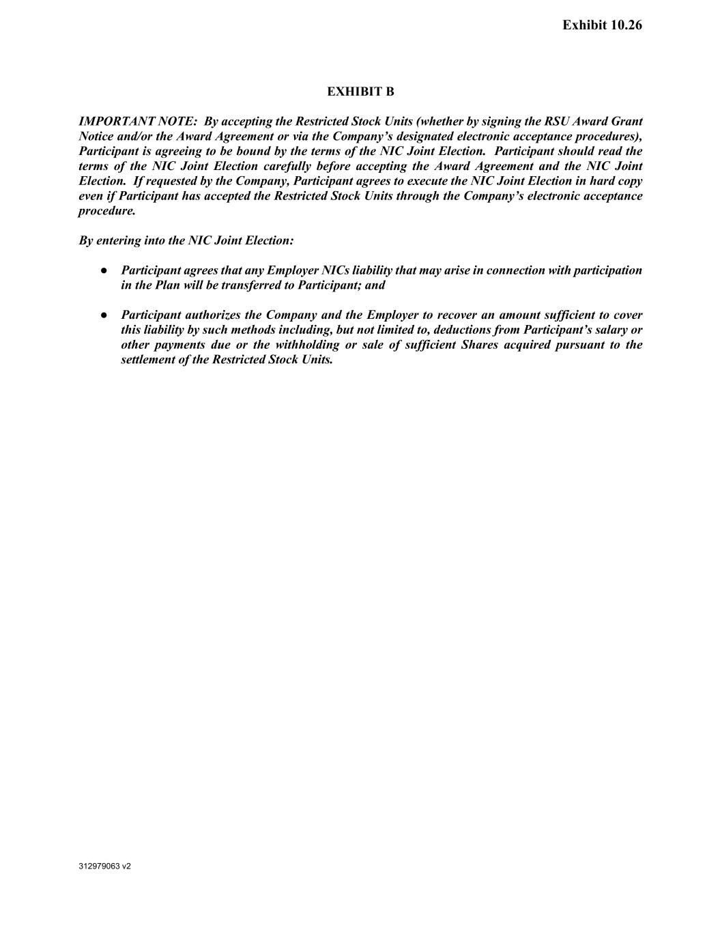
118
312979063 v2 Exhibit 10.26 EXHIBIT B IMPORTANT NOTE: By accepting the Restricted Stock Units (whether by signing the RSU Award Grant Notice and/or the Award Agreement or via the Company’s designated electronic acceptance procedures), Participant is agreeing to be bound by the terms of the NIC Joint Election. Participant should read the terms of the NIC Joint Election carefully before accepting the Award Agreement and the NIC Joint Election. If requested by the Company, Participant agrees to execute the NIC Joint Election in hard copy even if Participant has accepted the Restricted Stock Units through the Company’s electronic acceptance procedure. By entering into the NIC Joint Election: ● Participant agrees that any Employer NICs liability that may arise in connection with participation in the Plan will be transferred to Participant; and ● Participant authorizes the Company and the Employer to recover an amount sufficient to cover this liability by such methods including, but not limited to, deductions from Participant’s salary or other payments due or the withholding or sale of sufficient Shares acquired pursuant to the settlement of the Restricted Stock Units.

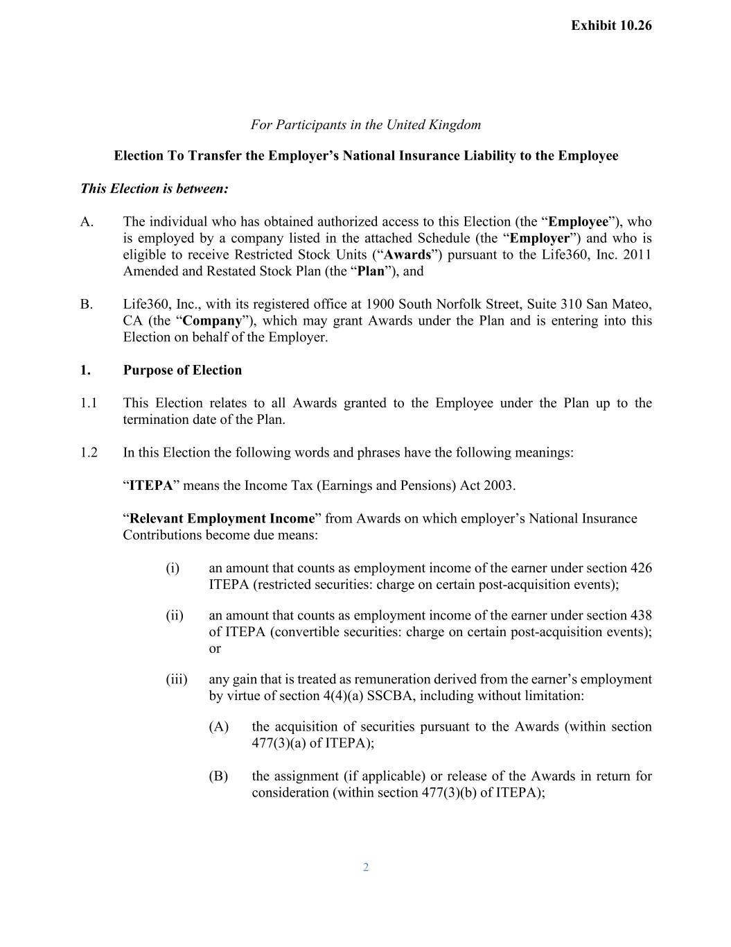
2 For Participants in the United Kingdom Election To Transfer the Employer’s National Insurance Liability to the Employee This Election is between: A. The individual who has obtained authorized access to this Election (the “Employee”), who is employed by a company listed in the attached Schedule (the “Employer”) and who is eligible to receive Restricted Stock Units (“Awards”) pursuant to the Life360, Inc. 2011 Amended and Restated Stock Plan (the “Plan”), and B. Life360, Inc., with its registered office at 1900 South Norfolk Street, Suite 310 San Mateo, CA (the “Company”), which may grant Awards under the Plan and is entering into this Election on behalf of the Employer. 1. Purpose of Election 1.1 This Election relates to all Awards granted to the Employee under the Plan up to the termination date of the Plan. 1.2 In this Election the following words and phrases have the following meanings: “ITEPA” means the Income Tax (Earnings and Pensions) Act 2003. “Relevant Employment Income” from Awards on which employer’s National Insurance Contributions become due means: (i) an amount that counts as employment income of the earner under section 426 ITEPA (restricted securities: charge on certain post-acquisition events); (ii) an amount that counts as employment income of the earner under section 438 of ITEPA (convertible securities: charge on certain post-acquisition events); or (iii) any gain that is treated as remuneration derived from the earner’s employment by virtue of section 4(4)(a) SSCBA, including without limitation: (A) the acquisition of securities pursuant to the Awards (within section 477(3)(a) of ITEPA); (B) the assignment (if applicable) or release of the Awards in return for consideration (within section 477(3)(b) of ITEPA); Exhibit 10.26

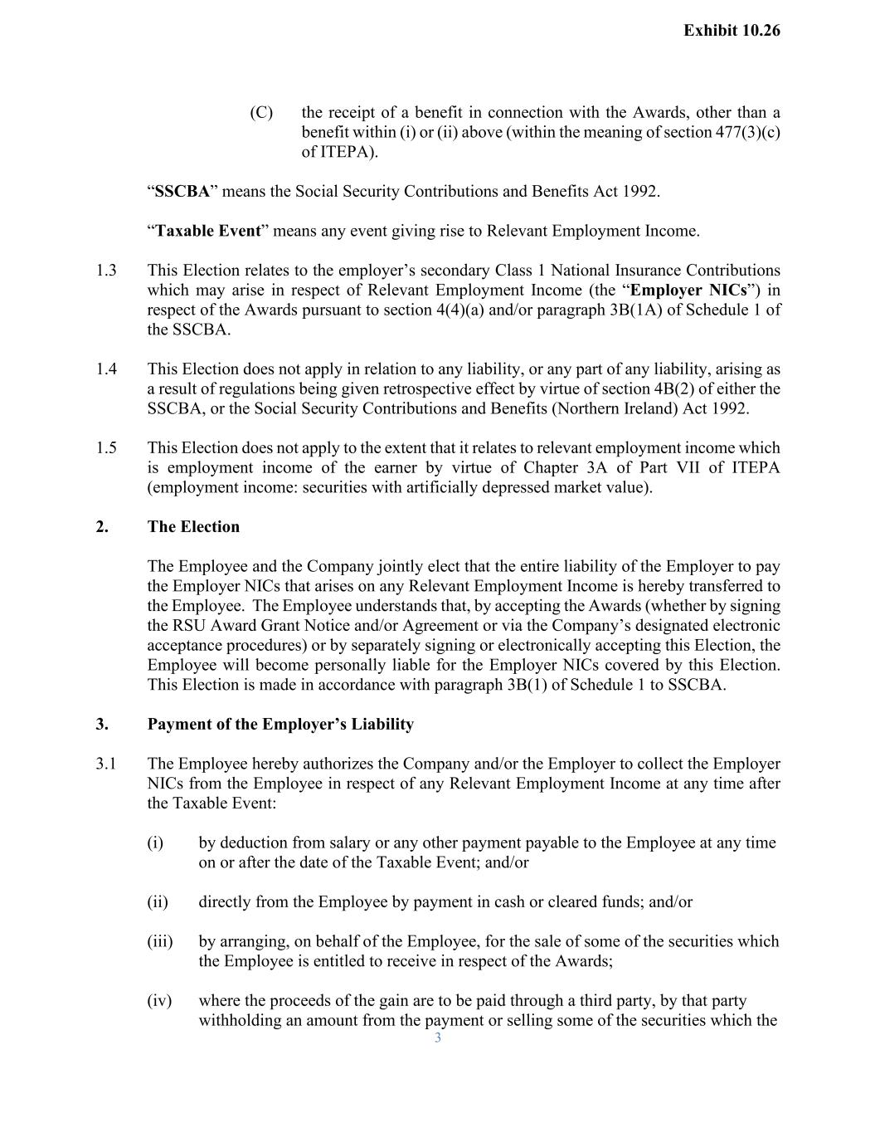
3 (C) the receipt of a benefit in connection with the Awards, other than a benefit within (i) or (ii) above (within the meaning of section 477(3)(c) of ITEPA). “SSCBA” means the Social Security Contributions and Benefits Act 1992. “Taxable Event” means any event giving rise to Relevant Employment Income. 1.3 This Election relates to the employer’s secondary Class 1 National Insurance Contributions which may arise in respect of Relevant Employment Income (the “Employer NICs”) in respect of the Awards pursuant to section 4(4)(a) and/or paragraph 3B(1A) of Schedule 1 of the SSCBA. 1.4 This Election does not apply in relation to any liability, or any part of any liability, arising as a result of regulations being given retrospective effect by virtue of section 4B(2) of either the SSCBA, or the Social Security Contributions and Benefits (Northern Ireland) Act 1992. 1.5 This Election does not apply to the extent that it relates to relevant employment income which is employment income of the earner by virtue of Chapter 3A of Part VII of ITEPA (employment income: securities with artificially depressed market value). 2. The Election The Employee and the Company jointly elect that the entire liability of the Employer to pay the Employer NICs that arises on any Relevant Employment Income is hereby transferred to the Employee. The Employee understands that, by accepting the Awards (whether by signing the RSU Award Grant Notice and/or Agreement or via the Company’s designated electronic acceptance procedures) or by separately signing or electronically accepting this Election, the Employee will become personally liable for the Employer NICs covered by this Election. This Election is made in accordance with paragraph 3B(1) of Schedule 1 to SSCBA. 3. Payment of the Employer’s Liability 3.1 The Employee hereby authorizes the Company and/or the Employer to collect the Employer NICs from the Employee in respect of any Relevant Employment Income at any time after the Taxable Event: (i) by deduction from salary or any other payment payable to the Employee at any time on or after the date of the Taxable Event; and/or (ii) directly from the Employee by payment in cash or cleared funds; and/or (iii) by arranging, on behalf of the Employee, for the sale of some of the securities which the Employee is entitled to receive in respect of the Awards; (iv) where the proceeds of the gain are to be paid through a third party, by that party withholding an amount from the payment or selling some of the securities which the Exhibit 10.26

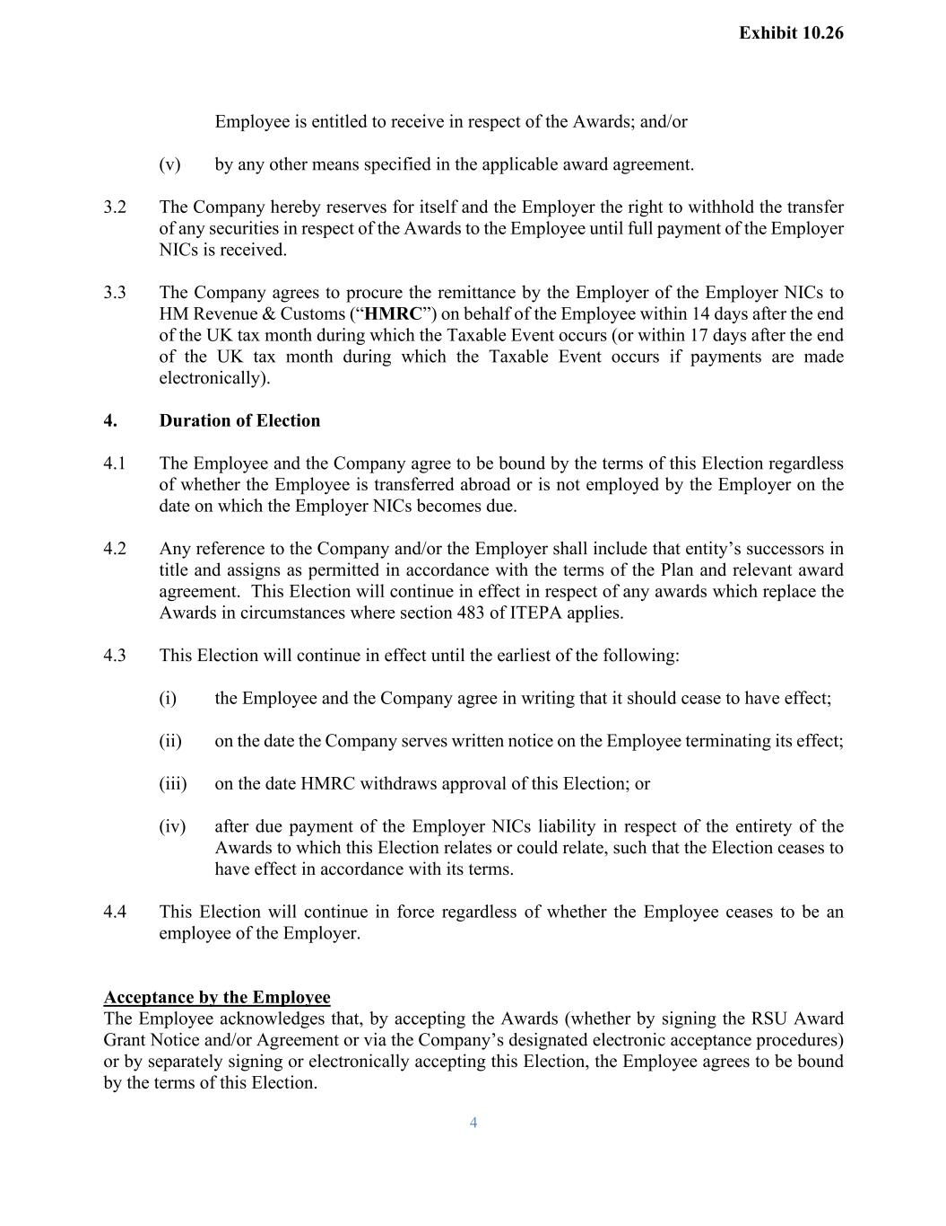
4 Employee is entitled to receive in respect of the Awards; and/or (v) by any other means specified in the applicable award agreement. 3.2 The Company hereby reserves for itself and the Employer the right to withhold the transfer of any securities in respect of the Awards to the Employee until full payment of the Employer NICs is received. 3.3 The Company agrees to procure the remittance by the Employer of the Employer NICs to HM Revenue & Customs (“HMRC”) on behalf of the Employee within 14 days after the end of the UK tax month during which the Taxable Event occurs (or within 17 days after the end of the UK tax month during which the Taxable Event occurs if payments are made electronically). 4. Duration of Election 4.1 The Employee and the Company agree to be bound by the terms of this Election regardless of whether the Employee is transferred abroad or is not employed by the Employer on the date on which the Employer NICs becomes due. 4.2 Any reference to the Company and/or the Employer shall include that entity’s successors in title and assigns as permitted in accordance with the terms of the Plan and relevant award agreement. This Election will continue in effect in respect of any awards which replace the Awards in circumstances where section 483 of ITEPA applies. 4.3 This Election will continue in effect until the earliest of the following: (i) the Employee and the Company agree in writing that it should cease to have effect; (ii) on the date the Company serves written notice on the Employee terminating its effect; (iii) on the date HMRC withdraws approval of this Election; or (iv) after due payment of the Employer NICs liability in respect of the entirety of the Awards to which this Election relates or could relate, such that the Election ceases to have effect in accordance with its terms. 4.4 This Election will continue in force regardless of whether the Employee ceases to be an employee of the Employer. Acceptance by the Employee The Employee acknowledges that, by accepting the Awards (whether by signing the RSU Award Grant Notice and/or Agreement or via the Company’s designated electronic acceptance procedures) or by separately signing or electronically accepting this Election, the Employee agrees to be bound by the terms of this Election. Exhibit 10.26

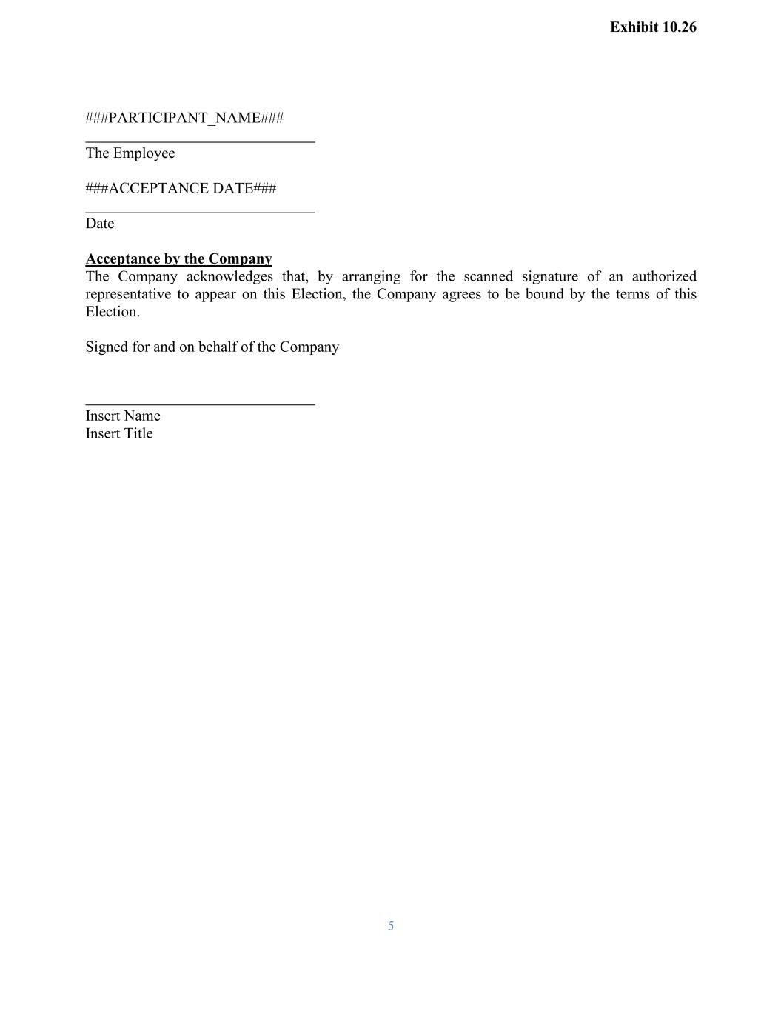
5 ###PARTICIPANT_NAME### The Employee ###ACCEPTANCE DATE### Date Acceptance by the Company The Company acknowledges that, by arranging for the scanned signature of an authorized representative to appear on this Election, the Company agrees to be bound by the terms of this Election. Signed for and on behalf of the Company Insert Name Insert Title Exhibit 10.26

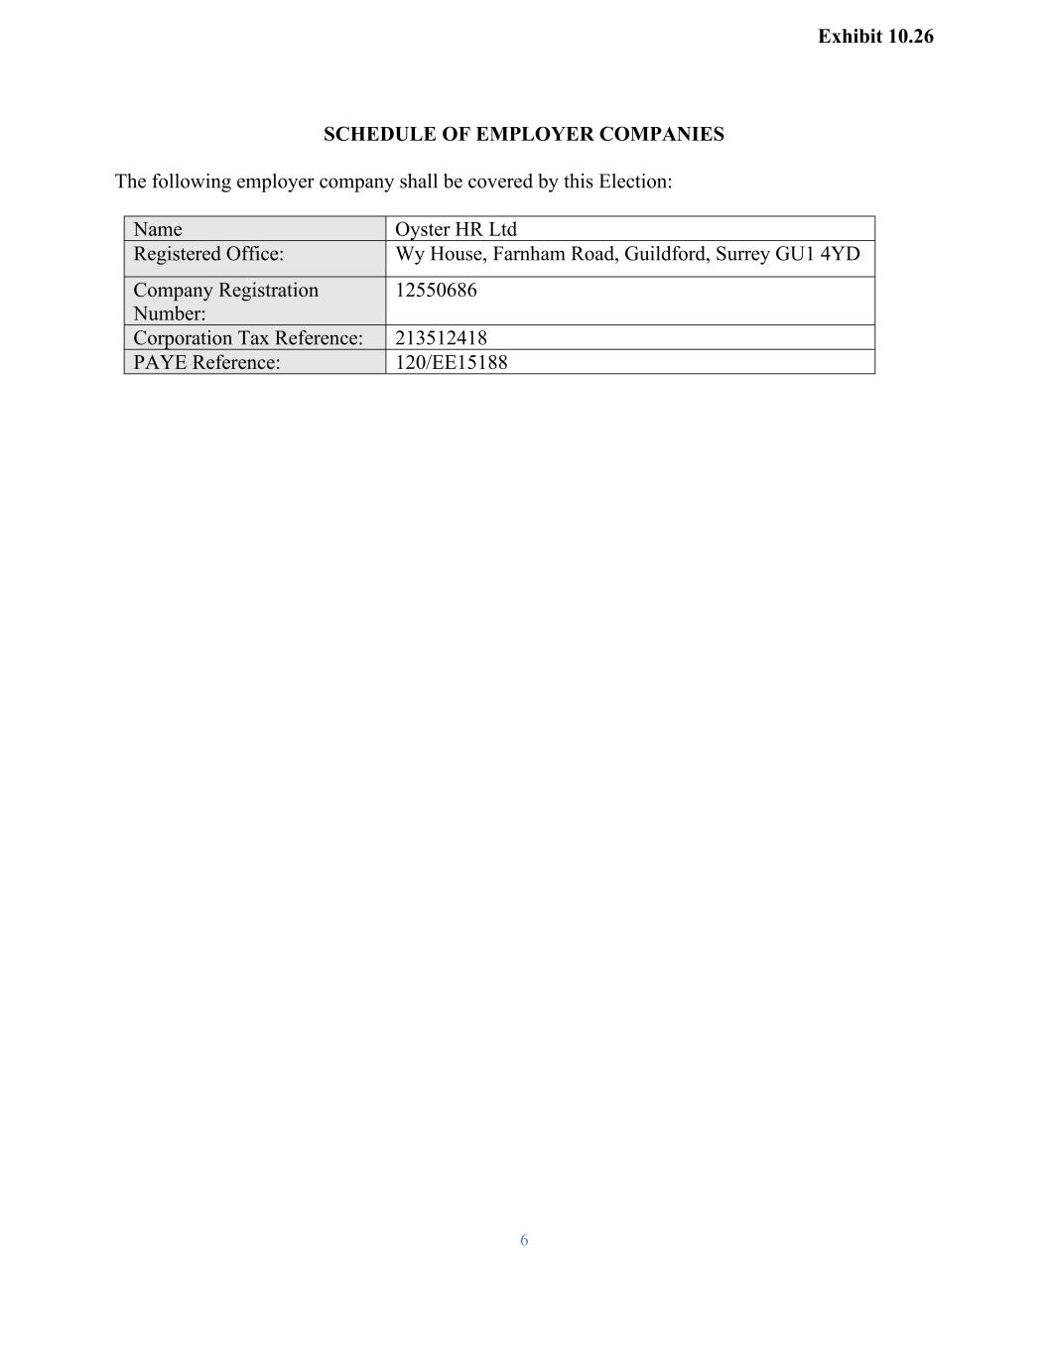
6 SCHEDULE OF EMPLOYER COMPANIES The following employer company shall be covered by this Election: Name Oyster HR Ltd Registered Office: Wy House, Farnham Road, Guildford, Surrey GU1 4YD Company Registration Number: 12550686 Corporation Tax Reference: 213512418 PAYE Reference: 120/EE15188 Exhibit 10.26

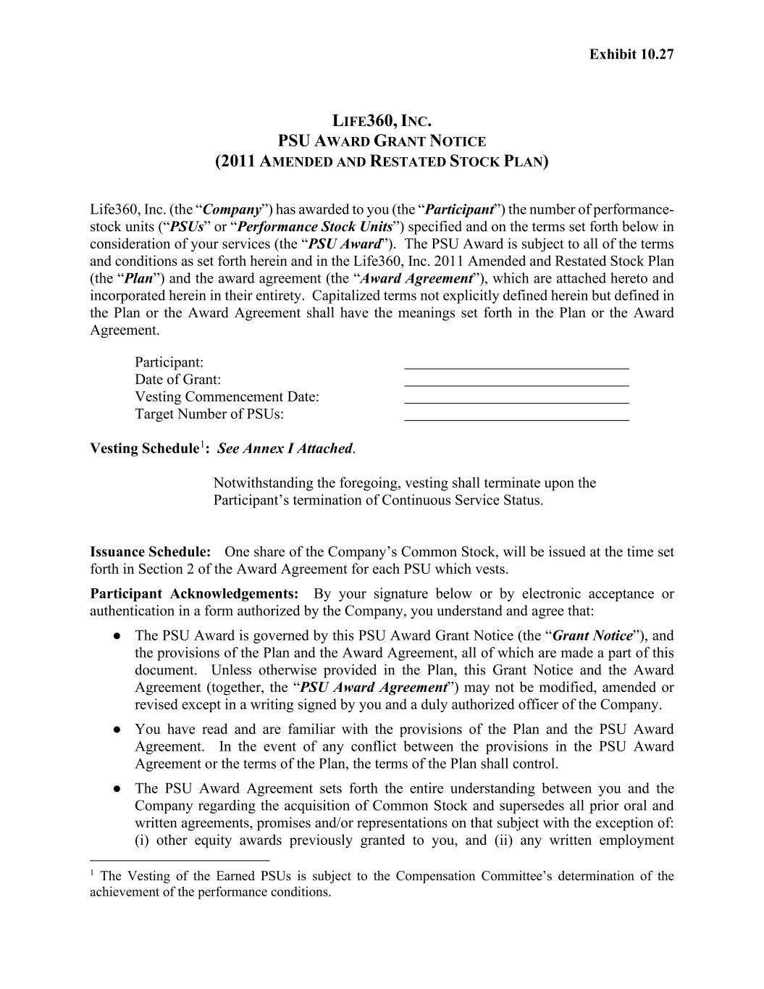
Exhibit 10.27 LIFE360, INC. PSU AWARD GRANT NOTICE (2011 AMENDED AND RESTATED STOCK PLAN) Life360, Inc. (the “Company”) has awarded to you (the “Participant”) the number of performance- stock units (“PSUs” or “Performance Stock Units”) specified and on the terms set forth below in consideration of your services (the “PSU Award”). The PSU Award is subject to all of the terms and conditions as set forth herein and in the Life360, Inc. 2011 Amended and Restated Stock Plan (the “Plan”) and the award agreement (the “Award Agreement”), which are attached hereto and incorporated herein in their entirety. Capitalized terms not explicitly defined herein but defined in the Plan or the Award Agreement shall have the meanings set forth in the Plan or the Award Agreement. Participant: Date of Grant: Vesting Commencement Date: Target Number of PSUs: Vesting Schedule1: See Annex I Attached. Notwithstanding the foregoing, vesting shall terminate upon the Participant’s termination of Continuous Service Status. Issuance Schedule: One share of the Company’s Common Stock, will be issued at the time set forth in Section 2 of the Award Agreement for each PSU which vests. Participant Acknowledgements: By your signature below or by electronic acceptance or authentication in a form authorized by the Company, you understand and agree that: ● The PSU Award is governed by this PSU Award Grant Notice (the “Grant Notice”), and the provisions of the Plan and the Award Agreement, all of which are made a part of this document. Unless otherwise provided in the Plan, this Grant Notice and the Award Agreement (together, the “PSU Award Agreement”) may not be modified, amended or revised except in a writing signed by you and a duly authorized officer of the Company. ● You have read and are familiar with the provisions of the Plan and the PSU Award Agreement. In the event of any conflict between the provisions in the PSU Award Agreement or the terms of the Plan, the terms of the Plan shall control. ● The PSU Award Agreement sets forth the entire understanding between you and the Company regarding the acquisition of Common Stock and supersedes all prior oral and written agreements, promises and/or representations on that subject with the exception of: (i) other equity awards previously granted to you, and (ii) any written employment 1 The Vesting of the Earned PSUs is subject to the Compensation Committee’s determination of the achievement of the performance conditions.

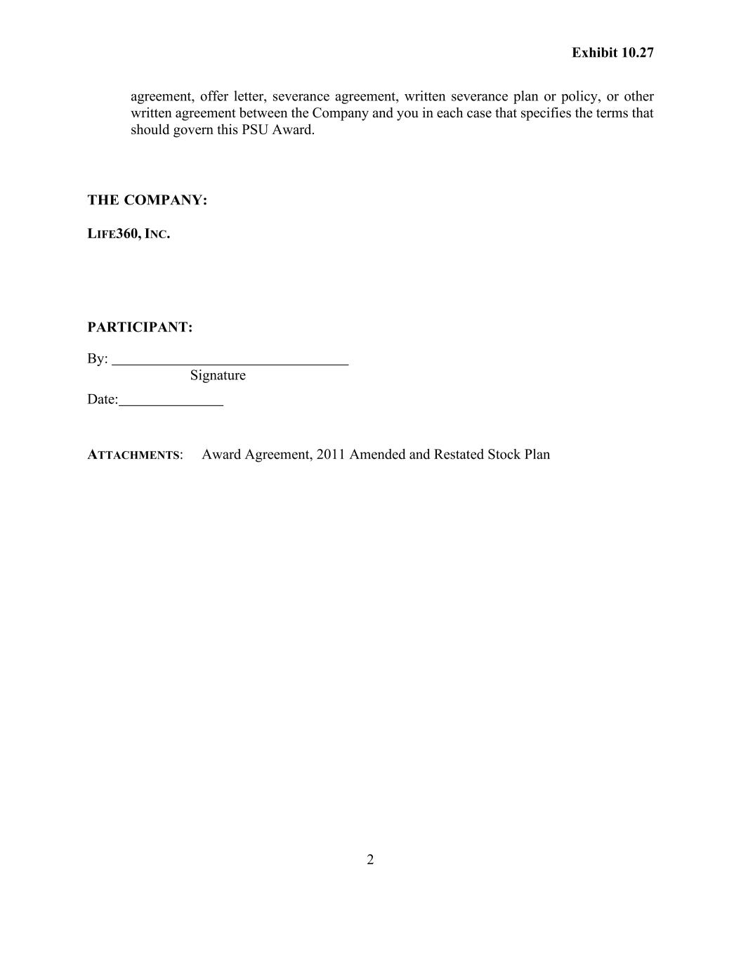
2 Exhibit 10.27 agreement, offer letter, severance agreement, written severance plan or policy, or other written agreement between the Company and you in each case that specifies the terms that should govern this PSU Award. THE COMPANY: LIFE360, INC. PARTICIPANT: By: Signature Date: ATTACHMENTS: Award Agreement, 2011 Amended and Restated Stock Plan

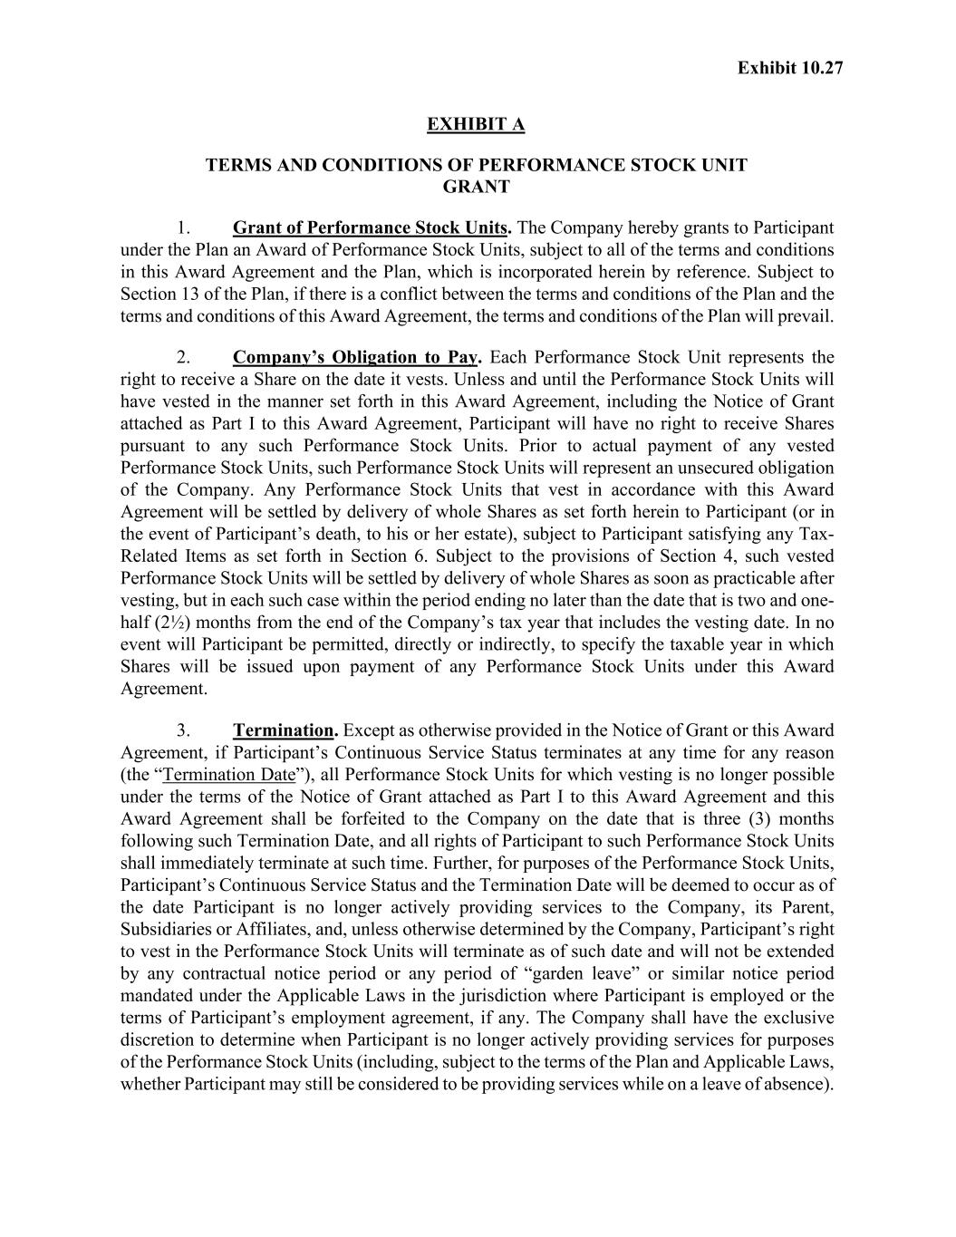
Exhibit 10.27 EXHIBIT A TERMS AND CONDITIONS OF PERFORMANCE STOCK UNIT GRANT 1. Grant of Performance Stock Units. The Company hereby grants to Participant under the Plan an Award of Performance Stock Units, subject to all of the terms and conditions in this Award Agreement and the Plan, which is incorporated herein by reference. Subject to Section 13 of the Plan, if there is a conflict between the terms and conditions of the Plan and the terms and conditions of this Award Agreement, the terms and conditions of the Plan will prevail. 2. Company’s Obligation to Pay. Each Performance Stock Unit represents the right to receive a Share on the date it vests. Unless and until the Performance Stock Units will have vested in the manner set forth in this Award Agreement, including the Notice of Grant attached as Part I to this Award Agreement, Participant will have no right to receive Shares pursuant to any such Performance Stock Units. Prior to actual payment of any vested Performance Stock Units, such Performance Stock Units will represent an unsecured obligation of the Company. Any Performance Stock Units that vest in accordance with this Award Agreement will be settled by delivery of whole Shares as set forth herein to Participant (or in the event of Participant’s death, to his or her estate), subject to Participant satisfying any Tax- Related Items as set forth in Section 6. Subject to the provisions of Section 4, such vested Performance Stock Units will be settled by delivery of whole Shares as soon as practicable after vesting, but in each such case within the period ending no later than the date that is two and one- half (2½) months from the end of the Company’s tax year that includes the vesting date. In no event will Participant be permitted, directly or indirectly, to specify the taxable year in which Shares will be issued upon payment of any Performance Stock Units under this Award Agreement. 3. Termination. Except as otherwise provided in the Notice of Grant or this Award Agreement, if Participant’s Continuous Service Status terminates at any time for any reason (the “Termination Date”), all Performance Stock Units for which vesting is no longer possible under the terms of the Notice of Grant attached as Part I to this Award Agreement and this Award Agreement shall be forfeited to the Company on the date that is three (3) months following such Termination Date, and all rights of Participant to such Performance Stock Units shall immediately terminate at such time. Further, for purposes of the Performance Stock Units, Participant’s Continuous Service Status and the Termination Date will be deemed to occur as of the date Participant is no longer actively providing services to the Company, its Parent, Subsidiaries or Affiliates, and, unless otherwise determined by the Company, Participant’s right to vest in the Performance Stock Units will terminate as of such date and will not be extended by any contractual notice period or any period of “garden leave” or similar notice period mandated under the Applicable Laws in the jurisdiction where Participant is employed or the terms of Participant’s employment agreement, if any. The Company shall have the exclusive discretion to determine when Participant is no longer actively providing services for purposes of the Performance Stock Units (including, subject to the terms of the Plan and Applicable Laws, whether Participant may still be considered to be providing services while on a leave of absence).

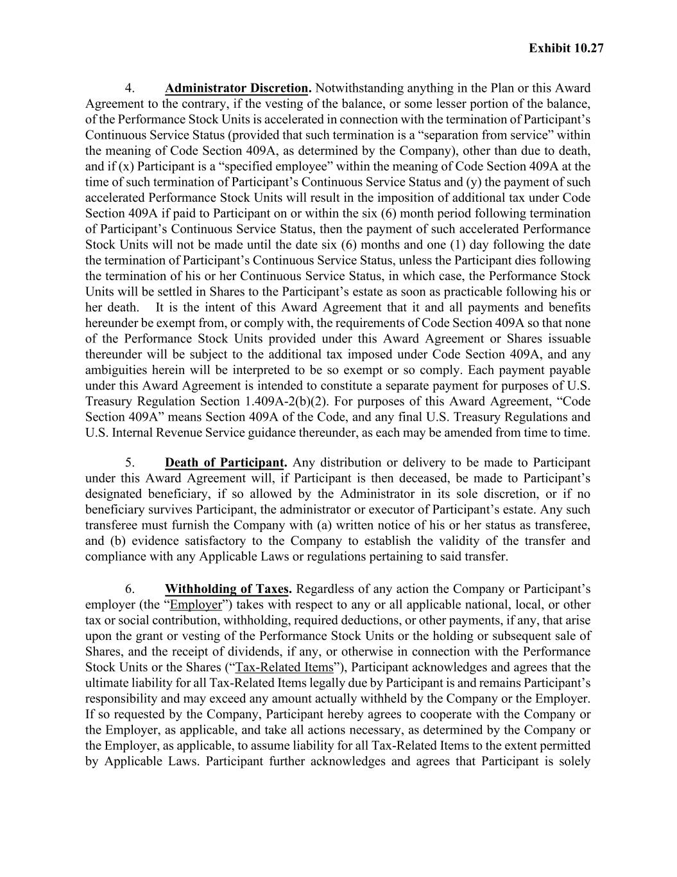
Exhibit 10.27 4. Administrator Discretion. Notwithstanding anything in the Plan or this Award Agreement to the contrary, if the vesting of the balance, or some lesser portion of the balance, of the Performance Stock Units is accelerated in connection with the termination of Participant’s Continuous Service Status (provided that such termination is a “separation from service” within the meaning of Code Section 409A, as determined by the Company), other than due to death, and if (x) Participant is a “specified employee” within the meaning of Code Section 409A at the time of such termination of Participant’s Continuous Service Status and (y) the payment of such accelerated Performance Stock Units will result in the imposition of additional tax under Code Section 409A if paid to Participant on or within the six (6) month period following termination of Participant’s Continuous Service Status, then the payment of such accelerated Performance Stock Units will not be made until the date six (6) months and one (1) day following the date the termination of Participant’s Continuous Service Status, unless the Participant dies following the termination of his or her Continuous Service Status, in which case, the Performance Stock Units will be settled in Shares to the Participant’s estate as soon as practicable following his or her death. It is the intent of this Award Agreement that it and all payments and benefits hereunder be exempt from, or comply with, the requirements of Code Section 409A so that none of the Performance Stock Units provided under this Award Agreement or Shares issuable thereunder will be subject to the additional tax imposed under Code Section 409A, and any ambiguities herein will be interpreted to be so exempt or so comply. Each payment payable under this Award Agreement is intended to constitute a separate payment for purposes of U.S. Treasury Regulation Section 1.409A-2(b)(2). For purposes of this Award Agreement, “Code Section 409A” means Section 409A of the Code, and any final U.S. Treasury Regulations and U.S. Internal Revenue Service guidance thereunder, as each may be amended from time to time. 5. Death of Participant. Any distribution or delivery to be made to Participant under this Award Agreement will, if Participant is then deceased, be made to Participant’s designated beneficiary, if so allowed by the Administrator in its sole discretion, or if no beneficiary survives Participant, the administrator or executor of Participant’s estate. Any such transferee must furnish the Company with (a) written notice of his or her status as transferee, and (b) evidence satisfactory to the Company to establish the validity of the transfer and compliance with any Applicable Laws or regulations pertaining to said transfer. 6. Withholding of Taxes. Regardless of any action the Company or Participant’s employer (the “Employer”) takes with respect to any or all applicable national, local, or other tax or social contribution, withholding, required deductions, or other payments, if any, that arise upon the grant or vesting of the Performance Stock Units or the holding or subsequent sale of Shares, and the receipt of dividends, if any, or otherwise in connection with the Performance Stock Units or the Shares (“Tax-Related Items”), Participant acknowledges and agrees that the ultimate liability for all Tax-Related Items legally due by Participant is and remains Participant’s responsibility and may exceed any amount actually withheld by the Company or the Employer. If so requested by the Company, Participant hereby agrees to cooperate with the Company or the Employer, as applicable, and take all actions necessary, as determined by the Company or the Employer, as applicable, to assume liability for all Tax-Related Items to the extent permitted by Applicable Laws. Participant further acknowledges and agrees that Participant is solely

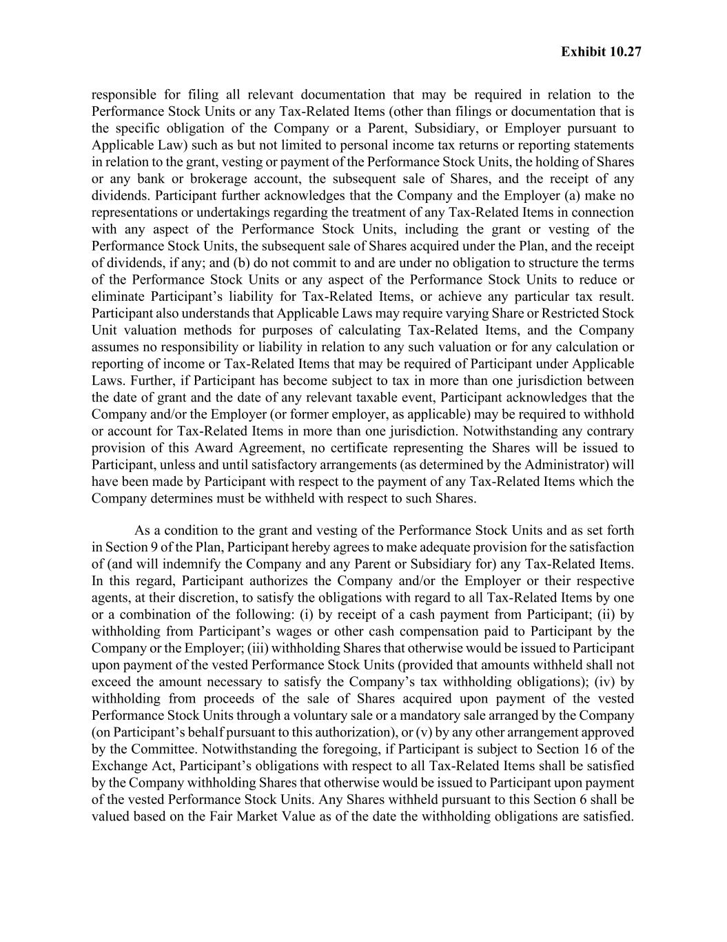
Exhibit 10.27 responsible for filing all relevant documentation that may be required in relation to the Performance Stock Units or any Tax-Related Items (other than filings or documentation that is the specific obligation of the Company or a Parent, Subsidiary, or Employer pursuant to Applicable Law) such as but not limited to personal income tax returns or reporting statements in relation to the grant, vesting or payment of the Performance Stock Units, the holding of Shares or any bank or brokerage account, the subsequent sale of Shares, and the receipt of any dividends. Participant further acknowledges that the Company and the Employer (a) make no representations or undertakings regarding the treatment of any Tax-Related Items in connection with any aspect of the Performance Stock Units, including the grant or vesting of the Performance Stock Units, the subsequent sale of Shares acquired under the Plan, and the receipt of dividends, if any; and (b) do not commit to and are under no obligation to structure the terms of the Performance Stock Units or any aspect of the Performance Stock Units to reduce or eliminate Participant’s liability for Tax-Related Items, or achieve any particular tax result. Participant also understands that Applicable Laws may require varying Share or Restricted Stock Unit valuation methods for purposes of calculating Tax-Related Items, and the Company assumes no responsibility or liability in relation to any such valuation or for any calculation or reporting of income or Tax-Related Items that may be required of Participant under Applicable Laws. Further, if Participant has become subject to tax in more than one jurisdiction between the date of grant and the date of any relevant taxable event, Participant acknowledges that the Company and/or the Employer (or former employer, as applicable) may be required to withhold or account for Tax-Related Items in more than one jurisdiction. Notwithstanding any contrary provision of this Award Agreement, no certificate representing the Shares will be issued to Participant, unless and until satisfactory arrangements (as determined by the Administrator) will have been made by Participant with respect to the payment of any Tax-Related Items which the Company determines must be withheld with respect to such Shares. As a condition to the grant and vesting of the Performance Stock Units and as set forth in Section 9 of the Plan, Participant hereby agrees to make adequate provision for the satisfaction of (and will indemnify the Company and any Parent or Subsidiary for) any Tax-Related Items. In this regard, Participant authorizes the Company and/or the Employer or their respective agents, at their discretion, to satisfy the obligations with regard to all Tax-Related Items by one or a combination of the following: (i) by receipt of a cash payment from Participant; (ii) by withholding from Participant’s wages or other cash compensation paid to Participant by the Company or the Employer; (iii) withholding Shares that otherwise would be issued to Participant upon payment of the vested Performance Stock Units (provided that amounts withheld shall not exceed the amount necessary to satisfy the Company’s tax withholding obligations); (iv) by withholding from proceeds of the sale of Shares acquired upon payment of the vested Performance Stock Units through a voluntary sale or a mandatory sale arranged by the Company (on Participant’s behalf pursuant to this authorization), or (v) by any other arrangement approved by the Committee. Notwithstanding the foregoing, if Participant is subject to Section 16 of the Exchange Act, Participant’s obligations with respect to all Tax-Related Items shall be satisfied by the Company withholding Shares that otherwise would be issued to Participant upon payment of the vested Performance Stock Units. Any Shares withheld pursuant to this Section 6 shall be valued based on the Fair Market Value as of the date the withholding obligations are satisfied.

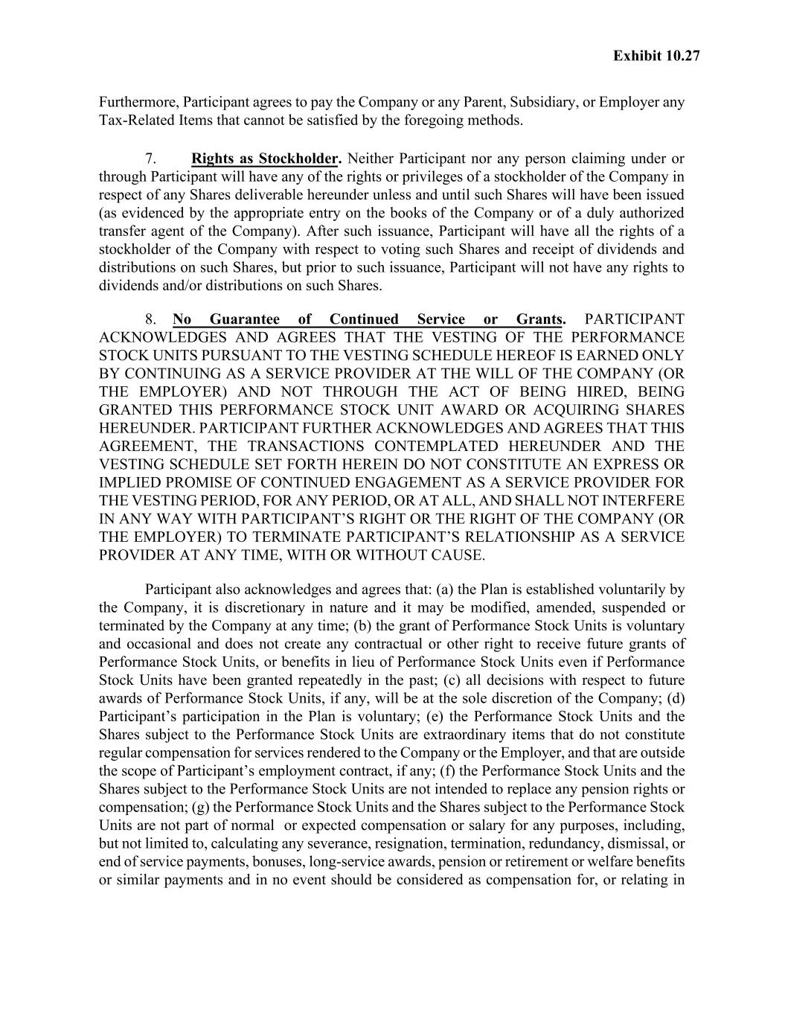
Exhibit 10.27 Furthermore, Participant agrees to pay the Company or any Parent, Subsidiary, or Employer any Tax-Related Items that cannot be satisfied by the foregoing methods. 7. Rights as Stockholder. Neither Participant nor any person claiming under or through Participant will have any of the rights or privileges of a stockholder of the Company in respect of any Shares deliverable hereunder unless and until such Shares will have been issued (as evidenced by the appropriate entry on the books of the Company or of a duly authorized transfer agent of the Company). After such issuance, Participant will have all the rights of a stockholder of the Company with respect to voting such Shares and receipt of dividends and distributions on such Shares, but prior to such issuance, Participant will not have any rights to dividends and/or distributions on such Shares. 8. No Guarantee of Continued Service or Grants. PARTICIPANT ACKNOWLEDGES AND AGREES THAT THE VESTING OF THE PERFORMANCE STOCK UNITS PURSUANT TO THE VESTING SCHEDULE HEREOF IS EARNED ONLY BY CONTINUING AS A SERVICE PROVIDER AT THE WILL OF THE COMPANY (OR THE EMPLOYER) AND NOT THROUGH THE ACT OF BEING HIRED, BEING GRANTED THIS PERFORMANCE STOCK UNIT AWARD OR ACQUIRING SHARES HEREUNDER. PARTICIPANT FURTHER ACKNOWLEDGES AND AGREES THAT THIS AGREEMENT, THE TRANSACTIONS CONTEMPLATED HEREUNDER AND THE VESTING SCHEDULE SET FORTH HEREIN DO NOT CONSTITUTE AN EXPRESS OR IMPLIED PROMISE OF CONTINUED ENGAGEMENT AS A SERVICE PROVIDER FOR THE VESTING PERIOD, FOR ANY PERIOD, OR AT ALL, AND SHALL NOT INTERFERE IN ANY WAY WITH PARTICIPANT’S RIGHT OR THE RIGHT OF THE COMPANY (OR THE EMPLOYER) TO TERMINATE PARTICIPANT’S RELATIONSHIP AS A SERVICE PROVIDER AT ANY TIME, WITH OR WITHOUT CAUSE. Participant also acknowledges and agrees that: (a) the Plan is established voluntarily by the Company, it is discretionary in nature and it may be modified, amended, suspended or terminated by the Company at any time; (b) the grant of Performance Stock Units is voluntary and occasional and does not create any contractual or other right to receive future grants of Performance Stock Units, or benefits in lieu of Performance Stock Units even if Performance Stock Units have been granted repeatedly in the past; (c) all decisions with respect to future awards of Performance Stock Units, if any, will be at the sole discretion of the Company; (d) Participant’s participation in the Plan is voluntary; (e) the Performance Stock Units and the Shares subject to the Performance Stock Units are extraordinary items that do not constitute regular compensation for services rendered to the Company or the Employer, and that are outside the scope of Participant’s employment contract, if any; (f) the Performance Stock Units and the Shares subject to the Performance Stock Units are not intended to replace any pension rights or compensation; (g) the Performance Stock Units and the Shares subject to the Performance Stock Units are not part of normal or expected compensation or salary for any purposes, including, but not limited to, calculating any severance, resignation, termination, redundancy, dismissal, or end of service payments, bonuses, long-service awards, pension or retirement or welfare benefits or similar payments and in no event should be considered as compensation for, or relating in

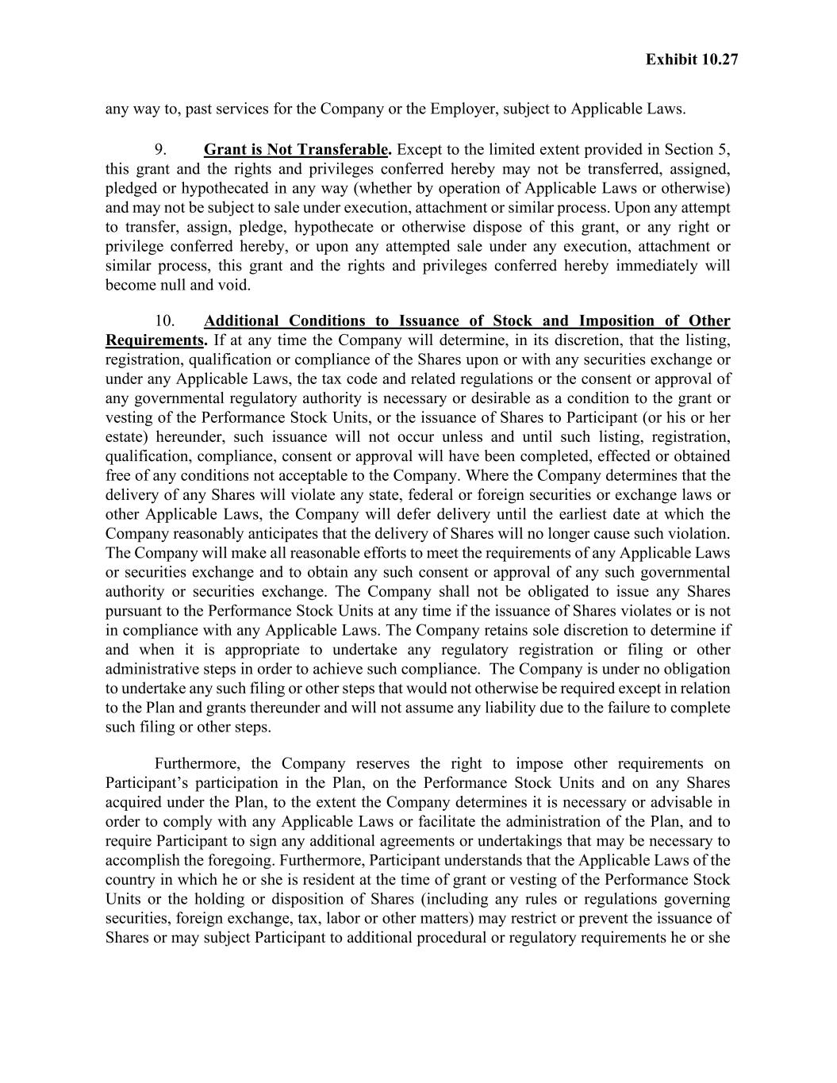
Exhibit 10.27 any way to, past services for the Company or the Employer, subject to Applicable Laws. 9. Grant is Not Transferable. Except to the limited extent provided in Section 5, this grant and the rights and privileges conferred hereby may not be transferred, assigned, pledged or hypothecated in any way (whether by operation of Applicable Laws or otherwise) and may not be subject to sale under execution, attachment or similar process. Upon any attempt to transfer, assign, pledge, hypothecate or otherwise dispose of this grant, or any right or privilege conferred hereby, or upon any attempted sale under any execution, attachment or similar process, this grant and the rights and privileges conferred hereby immediately will become null and void. 10. Additional Conditions to Issuance of Stock and Imposition of Other Requirements. If at any time the Company will determine, in its discretion, that the listing, registration, qualification or compliance of the Shares upon or with any securities exchange or under any Applicable Laws, the tax code and related regulations or the consent or approval of any governmental regulatory authority is necessary or desirable as a condition to the grant or vesting of the Performance Stock Units, or the issuance of Shares to Participant (or his or her estate) hereunder, such issuance will not occur unless and until such listing, registration, qualification, compliance, consent or approval will have been completed, effected or obtained free of any conditions not acceptable to the Company. Where the Company determines that the delivery of any Shares will violate any state, federal or foreign securities or exchange laws or other Applicable Laws, the Company will defer delivery until the earliest date at which the Company reasonably anticipates that the delivery of Shares will no longer cause such violation. The Company will make all reasonable efforts to meet the requirements of any Applicable Laws or securities exchange and to obtain any such consent or approval of any such governmental authority or securities exchange. The Company shall not be obligated to issue any Shares pursuant to the Performance Stock Units at any time if the issuance of Shares violates or is not in compliance with any Applicable Laws. The Company retains sole discretion to determine if and when it is appropriate to undertake any regulatory registration or filing or other administrative steps in order to achieve such compliance. The Company is under no obligation to undertake any such filing or other steps that would not otherwise be required except in relation to the Plan and grants thereunder and will not assume any liability due to the failure to complete such filing or other steps. Furthermore, the Company reserves the right to impose other requirements on Participant’s participation in the Plan, on the Performance Stock Units and on any Shares acquired under the Plan, to the extent the Company determines it is necessary or advisable in order to comply with any Applicable Laws or facilitate the administration of the Plan, and to require Participant to sign any additional agreements or undertakings that may be necessary to accomplish the foregoing. Furthermore, Participant understands that the Applicable Laws of the country in which he or she is resident at the time of grant or vesting of the Performance Stock Units or the holding or disposition of Shares (including any rules or regulations governing securities, foreign exchange, tax, labor or other matters) may restrict or prevent the issuance of Shares or may subject Participant to additional procedural or regulatory requirements he or she

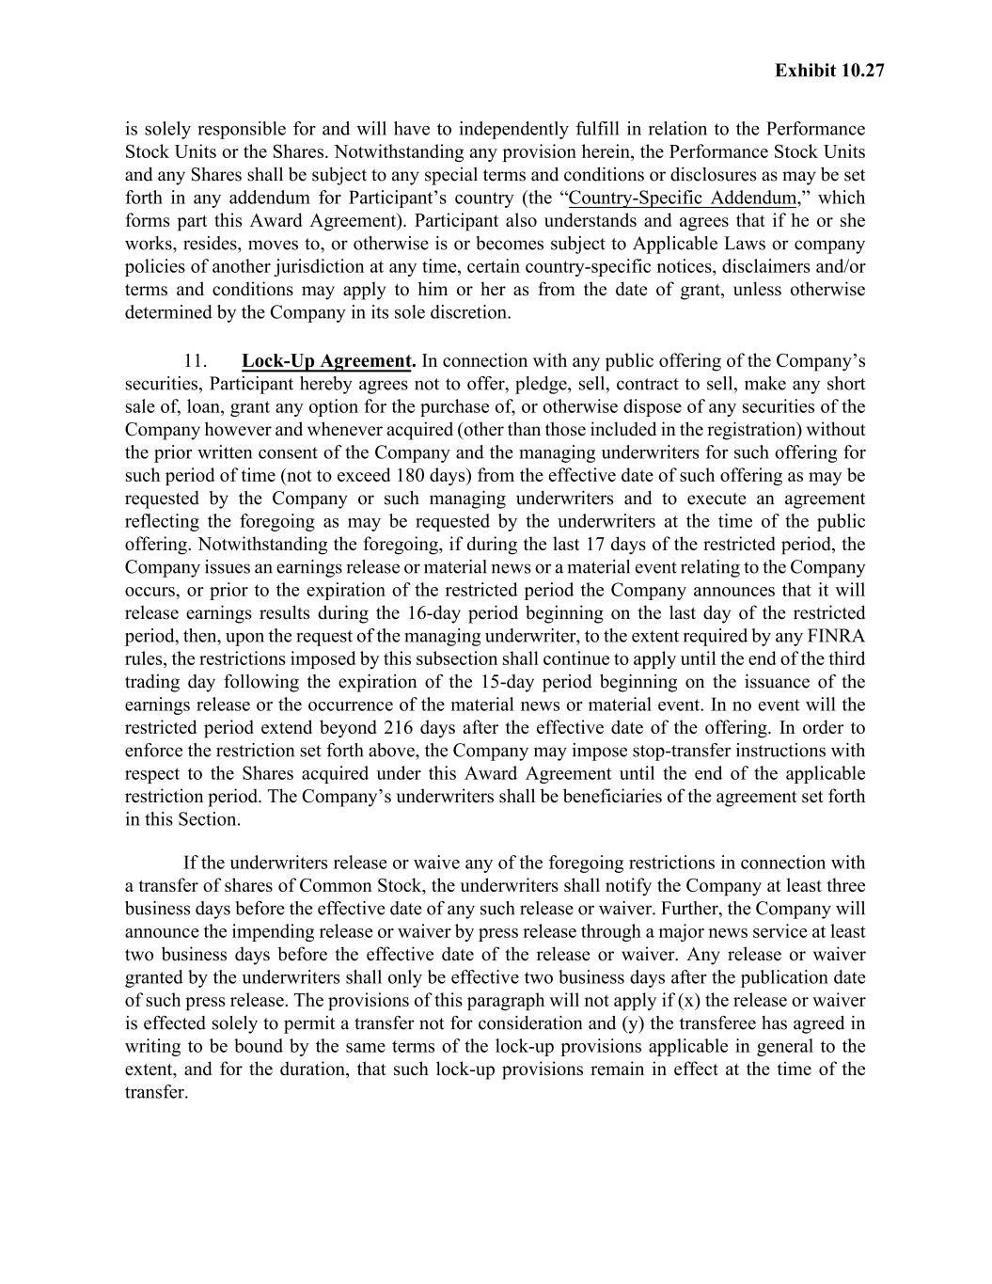
Exhibit 10.27 is solely responsible for and will have to independently fulfill in relation to the Performance Stock Units or the Shares. Notwithstanding any provision herein, the Performance Stock Units and any Shares shall be subject to any special terms and conditions or disclosures as may be set forth in any addendum for Participant’s country (the “Country-Specific Addendum,” which forms part this Award Agreement). Participant also understands and agrees that if he or she works, resides, moves to, or otherwise is or becomes subject to Applicable Laws or company policies of another jurisdiction at any time, certain country-specific notices, disclaimers and/or terms and conditions may apply to him or her as from the date of grant, unless otherwise determined by the Company in its sole discretion. 11. Lock-Up Agreement. In connection with any public offering of the Company’s securities, Participant hereby agrees not to offer, pledge, sell, contract to sell, make any short sale of, loan, grant any option for the purchase of, or otherwise dispose of any securities of the Company however and whenever acquired (other than those included in the registration) without the prior written consent of the Company and the managing underwriters for such offering for such period of time (not to exceed 180 days) from the effective date of such offering as may be requested by the Company or such managing underwriters and to execute an agreement reflecting the foregoing as may be requested by the underwriters at the time of the public offering. Notwithstanding the foregoing, if during the last 17 days of the restricted period, the Company issues an earnings release or material news or a material event relating to the Company occurs, or prior to the expiration of the restricted period the Company announces that it will release earnings results during the 16-day period beginning on the last day of the restricted period, then, upon the request of the managing underwriter, to the extent required by any FINRA rules, the restrictions imposed by this subsection shall continue to apply until the end of the third trading day following the expiration of the 15-day period beginning on the issuance of the earnings release or the occurrence of the material news or material event. In no event will the restricted period extend beyond 216 days after the effective date of the offering. In order to enforce the restriction set forth above, the Company may impose stop-transfer instructions with respect to the Shares acquired under this Award Agreement until the end of the applicable restriction period. The Company’s underwriters shall be beneficiaries of the agreement set forth in this Section. If the underwriters release or waive any of the foregoing restrictions in connection with a transfer of shares of Common Stock, the underwriters shall notify the Company at least three business days before the effective date of any such release or waiver. Further, the Company will announce the impending release or waiver by press release through a major news service at least two business days before the effective date of the release or waiver. Any release or waiver granted by the underwriters shall only be effective two business days after the publication date of such press release. The provisions of this paragraph will not apply if (x) the release or waiver is effected solely to permit a transfer not for consideration and (y) the transferee has agreed in writing to be bound by the same terms of the lock-up provisions applicable in general to the extent, and for the duration, that such lock-up provisions remain in effect at the time of the transfer.

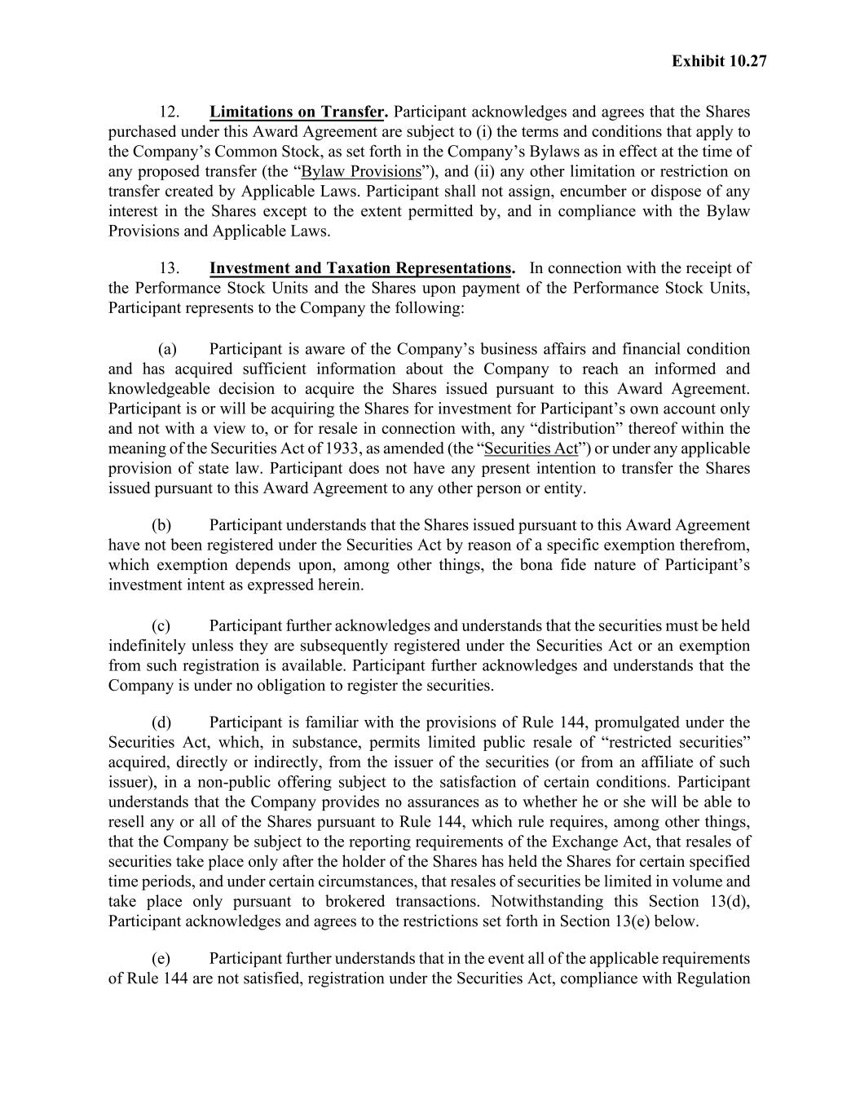
Exhibit 10.27 12. Limitations on Transfer. Participant acknowledges and agrees that the Shares purchased under this Award Agreement are subject to (i) the terms and conditions that apply to the Company’s Common Stock, as set forth in the Company’s Bylaws as in effect at the time of any proposed transfer (the “Bylaw Provisions”), and (ii) any other limitation or restriction on transfer created by Applicable Laws. Participant shall not assign, encumber or dispose of any interest in the Shares except to the extent permitted by, and in compliance with the Bylaw Provisions and Applicable Laws. 13. Investment and Taxation Representations. In connection with the receipt of the Performance Stock Units and the Shares upon payment of the Performance Stock Units, Participant represents to the Company the following: (a) Participant is aware of the Company’s business affairs and financial condition and has acquired sufficient information about the Company to reach an informed and knowledgeable decision to acquire the Shares issued pursuant to this Award Agreement. Participant is or will be acquiring the Shares for investment for Participant’s own account only and not with a view to, or for resale in connection with, any “distribution” thereof within the meaning of the Securities Act of 1933, as amended (the “Securities Act”) or under any applicable provision of state law. Participant does not have any present intention to transfer the Shares issued pursuant to this Award Agreement to any other person or entity. (b) Participant understands that the Shares issued pursuant to this Award Agreement have not been registered under the Securities Act by reason of a specific exemption therefrom, which exemption depends upon, among other things, the bona fide nature of Participant’s investment intent as expressed herein. (c) Participant further acknowledges and understands that the securities must be held indefinitely unless they are subsequently registered under the Securities Act or an exemption from such registration is available. Participant further acknowledges and understands that the Company is under no obligation to register the securities. (d) Participant is familiar with the provisions of Rule 144, promulgated under the Securities Act, which, in substance, permits limited public resale of “restricted securities” acquired, directly or indirectly, from the issuer of the securities (or from an affiliate of such issuer), in a non-public offering subject to the satisfaction of certain conditions. Participant understands that the Company provides no assurances as to whether he or she will be able to resell any or all of the Shares pursuant to Rule 144, which rule requires, among other things, that the Company be subject to the reporting requirements of the Exchange Act, that resales of securities take place only after the holder of the Shares has held the Shares for certain specified time periods, and under certain circumstances, that resales of securities be limited in volume and take place only pursuant to brokered transactions. Notwithstanding this Section 13(d), Participant acknowledges and agrees to the restrictions set forth in Section 13(e) below. (e) Participant further understands that in the event all of the applicable requirements of Rule 144 are not satisfied, registration under the Securities Act, compliance with Regulation

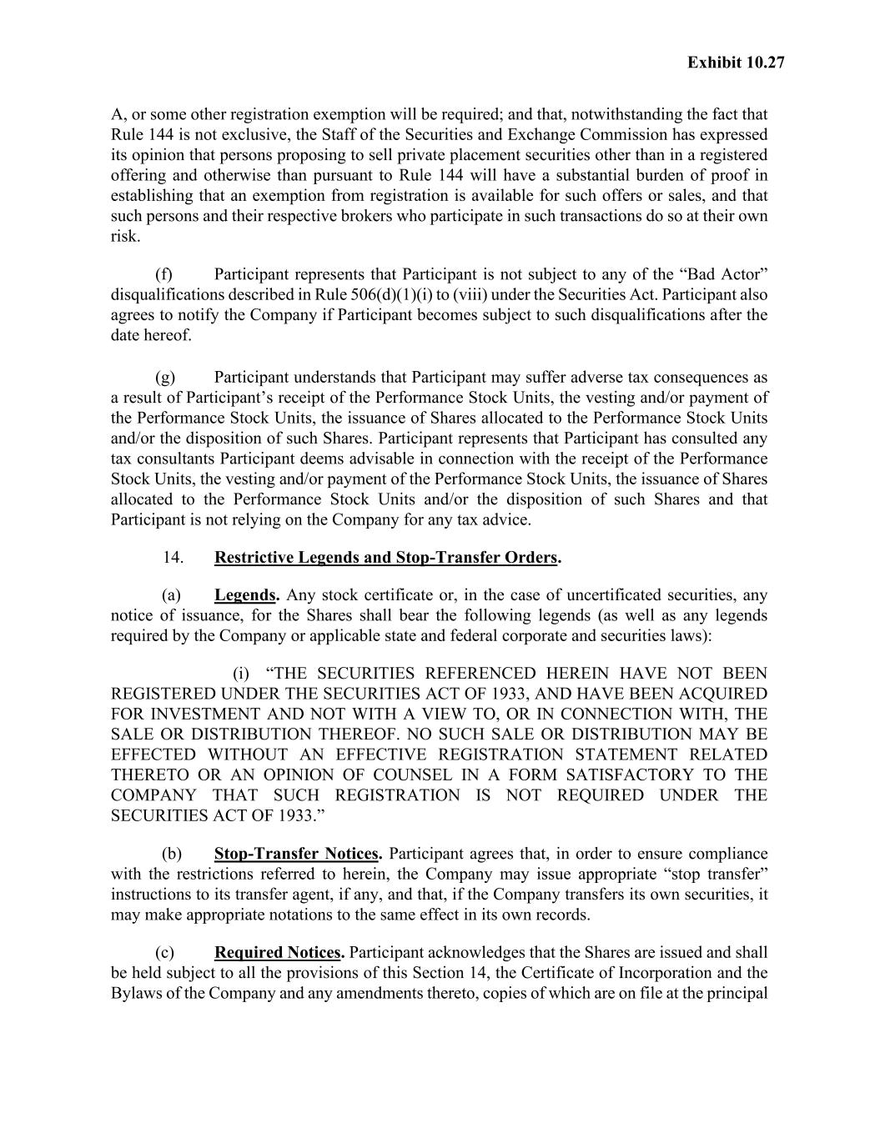
Exhibit 10.27 A, or some other registration exemption will be required; and that, notwithstanding the fact that Rule 144 is not exclusive, the Staff of the Securities and Exchange Commission has expressed its opinion that persons proposing to sell private placement securities other than in a registered offering and otherwise than pursuant to Rule 144 will have a substantial burden of proof in establishing that an exemption from registration is available for such offers or sales, and that such persons and their respective brokers who participate in such transactions do so at their own risk. (f) Participant represents that Participant is not subject to any of the “Bad Actor” disqualifications described in Rule 506(d)(1)(i) to (viii) under the Securities Act. Participant also agrees to notify the Company if Participant becomes subject to such disqualifications after the date hereof. (g) Participant understands that Participant may suffer adverse tax consequences as a result of Participant’s receipt of the Performance Stock Units, the vesting and/or payment of the Performance Stock Units, the issuance of Shares allocated to the Performance Stock Units and/or the disposition of such Shares. Participant represents that Participant has consulted any tax consultants Participant deems advisable in connection with the receipt of the Performance Stock Units, the vesting and/or payment of the Performance Stock Units, the issuance of Shares allocated to the Performance Stock Units and/or the disposition of such Shares and that Participant is not relying on the Company for any tax advice. 14. Restrictive Legends and Stop-Transfer Orders. (a) Legends. Any stock certificate or, in the case of uncertificated securities, any notice of issuance, for the Shares shall bear the following legends (as well as any legends required by the Company or applicable state and federal corporate and securities laws): (i) “THE SECURITIES REFERENCED HEREIN HAVE NOT BEEN REGISTERED UNDER THE SECURITIES ACT OF 1933, AND HAVE BEEN ACQUIRED FOR INVESTMENT AND NOT WITH A VIEW TO, OR IN CONNECTION WITH, THE SALE OR DISTRIBUTION THEREOF. NO SUCH SALE OR DISTRIBUTION MAY BE EFFECTED WITHOUT AN EFFECTIVE REGISTRATION STATEMENT RELATED THERETO OR AN OPINION OF COUNSEL IN A FORM SATISFACTORY TO THE COMPANY THAT SUCH REGISTRATION IS NOT REQUIRED UNDER THE SECURITIES ACT OF 1933.” (b) Stop-Transfer Notices. Participant agrees that, in order to ensure compliance with the restrictions referred to herein, the Company may issue appropriate “stop transfer” instructions to its transfer agent, if any, and that, if the Company transfers its own securities, it may make appropriate notations to the same effect in its own records. (c) Required Notices. Participant acknowledges that the Shares are issued and shall be held subject to all the provisions of this Section 14, the Certificate of Incorporation and the Bylaws of the Company and any amendments thereto, copies of which are on file at the principal

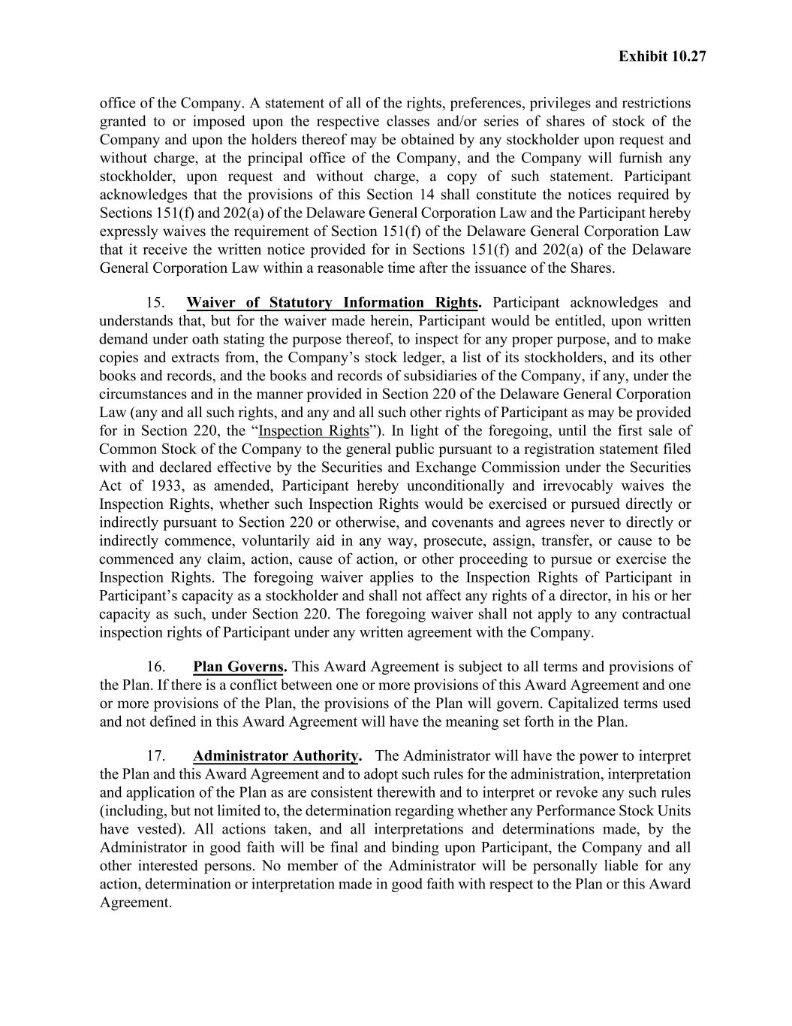
Exhibit 10.27 office of the Company. A statement of all of the rights, preferences, privileges and restrictions granted to or imposed upon the respective classes and/or series of shares of stock of the Company and upon the holders thereof may be obtained by any stockholder upon request and without charge, at the principal office of the Company, and the Company will furnish any stockholder, upon request and without charge, a copy of such statement. Participant acknowledges that the provisions of this Section 14 shall constitute the notices required by Sections 151(f) and 202(a) of the Delaware General Corporation Law and the Participant hereby expressly waives the requirement of Section 151(f) of the Delaware General Corporation Law that it receive the written notice provided for in Sections 151(f) and 202(a) of the Delaware General Corporation Law within a reasonable time after the issuance of the Shares. 15. Waiver of Statutory Information Rights. Participant acknowledges and understands that, but for the waiver made herein, Participant would be entitled, upon written demand under oath stating the purpose thereof, to inspect for any proper purpose, and to make copies and extracts from, the Company’s stock ledger, a list of its stockholders, and its other books and records, and the books and records of subsidiaries of the Company, if any, under the circumstances and in the manner provided in Section 220 of the Delaware General Corporation Law (any and all such rights, and any and all such other rights of Participant as may be provided for in Section 220, the “Inspection Rights”). In light of the foregoing, until the first sale of Common Stock of the Company to the general public pursuant to a registration statement filed with and declared effective by the Securities and Exchange Commission under the Securities Act of 1933, as amended, Participant hereby unconditionally and irrevocably waives the Inspection Rights, whether such Inspection Rights would be exercised or pursued directly or indirectly pursuant to Section 220 or otherwise, and covenants and agrees never to directly or indirectly commence, voluntarily aid in any way, prosecute, assign, transfer, or cause to be commenced any claim, action, cause of action, or other proceeding to pursue or exercise the Inspection Rights. The foregoing waiver applies to the Inspection Rights of Participant in Participant’s capacity as a stockholder and shall not affect any rights of a director, in his or her capacity as such, under Section 220. The foregoing waiver shall not apply to any contractual inspection rights of Participant under any written agreement with the Company. 16. Plan Governs. This Award Agreement is subject to all terms and provisions of the Plan. If there is a conflict between one or more provisions of this Award Agreement and one or more provisions of the Plan, the provisions of the Plan will govern. Capitalized terms used and not defined in this Award Agreement will have the meaning set forth in the Plan. 17. Administrator Authority. The Administrator will have the power to interpret the Plan and this Award Agreement and to adopt such rules for the administration, interpretation and application of the Plan as are consistent therewith and to interpret or revoke any such rules (including, but not limited to, the determination regarding whether any Performance Stock Units have vested). All actions taken, and all interpretations and determinations made, by the Administrator in good faith will be final and binding upon Participant, the Company and all other interested persons. No member of the Administrator will be personally liable for any action, determination or interpretation made in good faith with respect to the Plan or this Award Agreement.

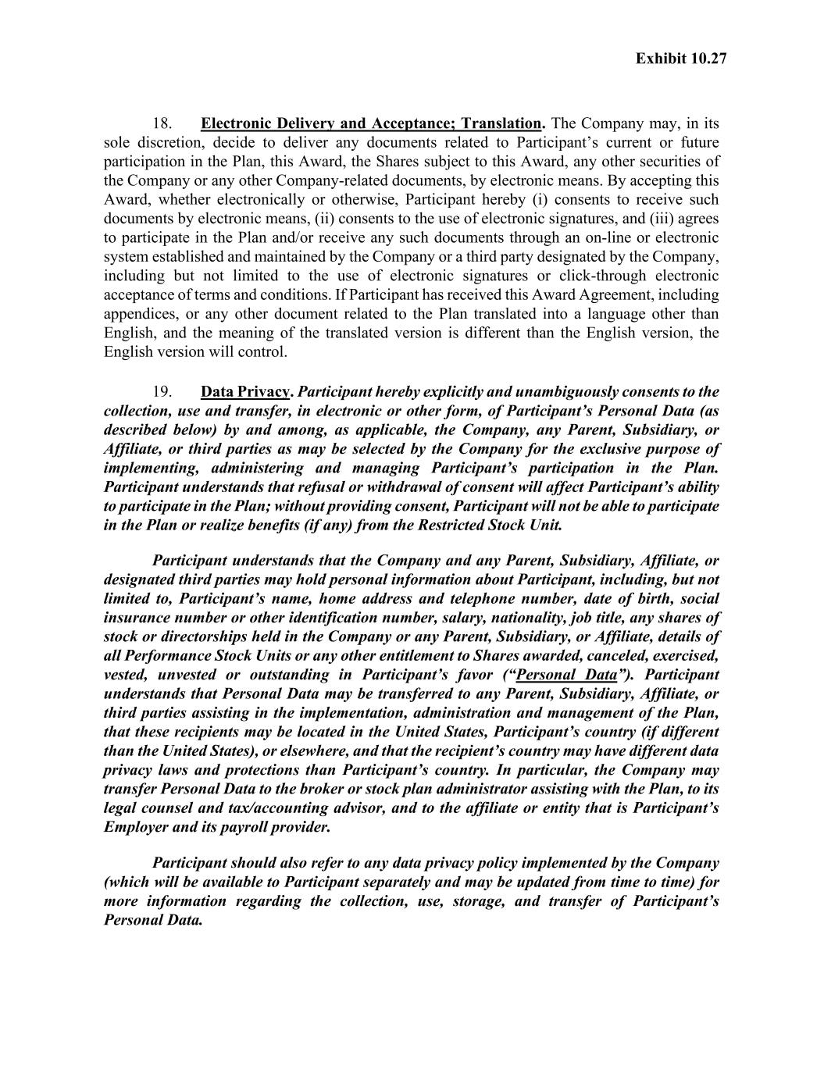
Exhibit 10.27 18. Electronic Delivery and Acceptance; Translation. The Company may, in its sole discretion, decide to deliver any documents related to Participant’s current or future participation in the Plan, this Award, the Shares subject to this Award, any other securities of the Company or any other Company-related documents, by electronic means. By accepting this Award, whether electronically or otherwise, Participant hereby (i) consents to receive such documents by electronic means, (ii) consents to the use of electronic signatures, and (iii) agrees to participate in the Plan and/or receive any such documents through an on-line or electronic system established and maintained by the Company or a third party designated by the Company, including but not limited to the use of electronic signatures or click-through electronic acceptance of terms and conditions. If Participant has received this Award Agreement, including appendices, or any other document related to the Plan translated into a language other than English, and the meaning of the translated version is different than the English version, the English version will control. 19. Data Privacy. Participant hereby explicitly and unambiguously consents to the collection, use and transfer, in electronic or other form, of Participant’s Personal Data (as described below) by and among, as applicable, the Company, any Parent, Subsidiary, or Affiliate, or third parties as may be selected by the Company for the exclusive purpose of implementing, administering and managing Participant’s participation in the Plan. Participant understands that refusal or withdrawal of consent will affect Participant’s ability to participate in the Plan; without providing consent, Participant will not be able to participate in the Plan or realize benefits (if any) from the Restricted Stock Unit. Participant understands that the Company and any Parent, Subsidiary, Affiliate, or designated third parties may hold personal information about Participant, including, but not limited to, Participant’s name, home address and telephone number, date of birth, social insurance number or other identification number, salary, nationality, job title, any shares of stock or directorships held in the Company or any Parent, Subsidiary, or Affiliate, details of all Performance Stock Units or any other entitlement to Shares awarded, canceled, exercised, vested, unvested or outstanding in Participant’s favor (“Personal Data”). Participant understands that Personal Data may be transferred to any Parent, Subsidiary, Affiliate, or third parties assisting in the implementation, administration and management of the Plan, that these recipients may be located in the United States, Participant’s country (if different than the United States), or elsewhere, and that the recipient’s country may have different data privacy laws and protections than Participant’s country. In particular, the Company may transfer Personal Data to the broker or stock plan administrator assisting with the Plan, to its legal counsel and tax/accounting advisor, and to the affiliate or entity that is Participant’s Employer and its payroll provider. Participant should also refer to any data privacy policy implemented by the Company (which will be available to Participant separately and may be updated from time to time) for more information regarding the collection, use, storage, and transfer of Participant’s Personal Data.

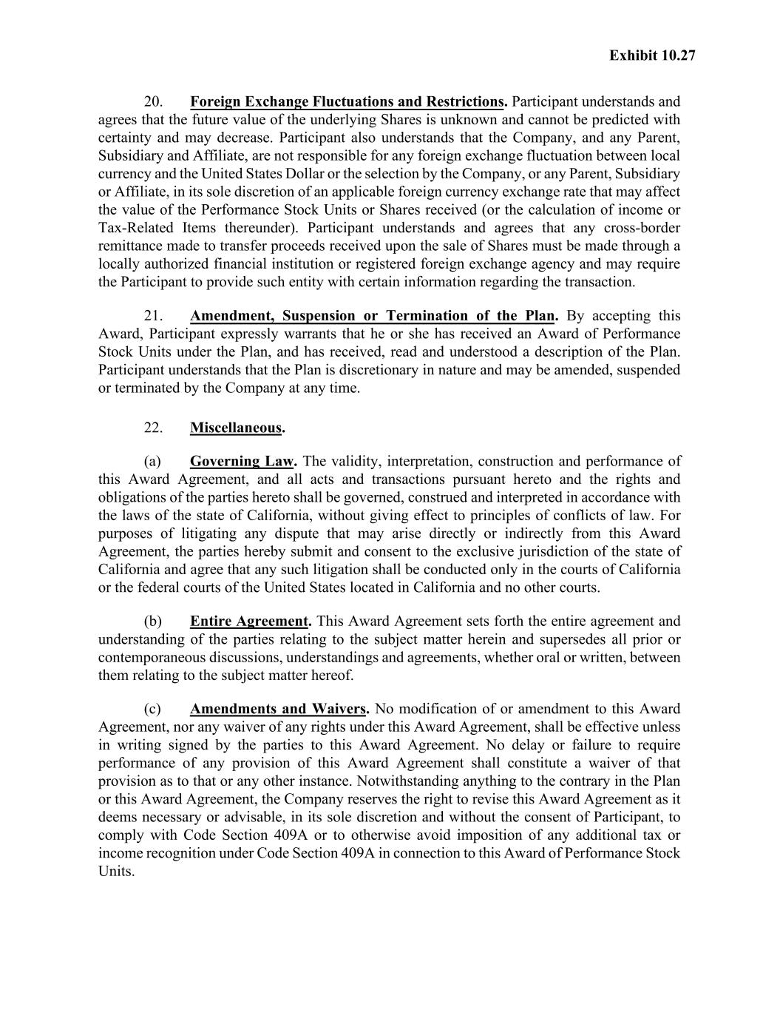
Exhibit 10.27 20. Foreign Exchange Fluctuations and Restrictions. Participant understands and agrees that the future value of the underlying Shares is unknown and cannot be predicted with certainty and may decrease. Participant also understands that the Company, and any Parent, Subsidiary and Affiliate, are not responsible for any foreign exchange fluctuation between local currency and the United States Dollar or the selection by the Company, or any Parent, Subsidiary or Affiliate, in its sole discretion of an applicable foreign currency exchange rate that may affect the value of the Performance Stock Units or Shares received (or the calculation of income or Tax-Related Items thereunder). Participant understands and agrees that any cross-border remittance made to transfer proceeds received upon the sale of Shares must be made through a locally authorized financial institution or registered foreign exchange agency and may require the Participant to provide such entity with certain information regarding the transaction. 21. Amendment, Suspension or Termination of the Plan. By accepting this Award, Participant expressly warrants that he or she has received an Award of Performance Stock Units under the Plan, and has received, read and understood a description of the Plan. Participant understands that the Plan is discretionary in nature and may be amended, suspended or terminated by the Company at any time. 22. Miscellaneous. (a) Governing Law. The validity, interpretation, construction and performance of this Award Agreement, and all acts and transactions pursuant hereto and the rights and obligations of the parties hereto shall be governed, construed and interpreted in accordance with the laws of the state of California, without giving effect to principles of conflicts of law. For purposes of litigating any dispute that may arise directly or indirectly from this Award Agreement, the parties hereby submit and consent to the exclusive jurisdiction of the state of California and agree that any such litigation shall be conducted only in the courts of California or the federal courts of the United States located in California and no other courts. (b) Entire Agreement. This Award Agreement sets forth the entire agreement and understanding of the parties relating to the subject matter herein and supersedes all prior or contemporaneous discussions, understandings and agreements, whether oral or written, between them relating to the subject matter hereof. (c) Amendments and Waivers. No modification of or amendment to this Award Agreement, nor any waiver of any rights under this Award Agreement, shall be effective unless in writing signed by the parties to this Award Agreement. No delay or failure to require performance of any provision of this Award Agreement shall constitute a waiver of that provision as to that or any other instance. Notwithstanding anything to the contrary in the Plan or this Award Agreement, the Company reserves the right to revise this Award Agreement as it deems necessary or advisable, in its sole discretion and without the consent of Participant, to comply with Code Section 409A or to otherwise avoid imposition of any additional tax or income recognition under Code Section 409A in connection to this Award of Performance Stock Units.

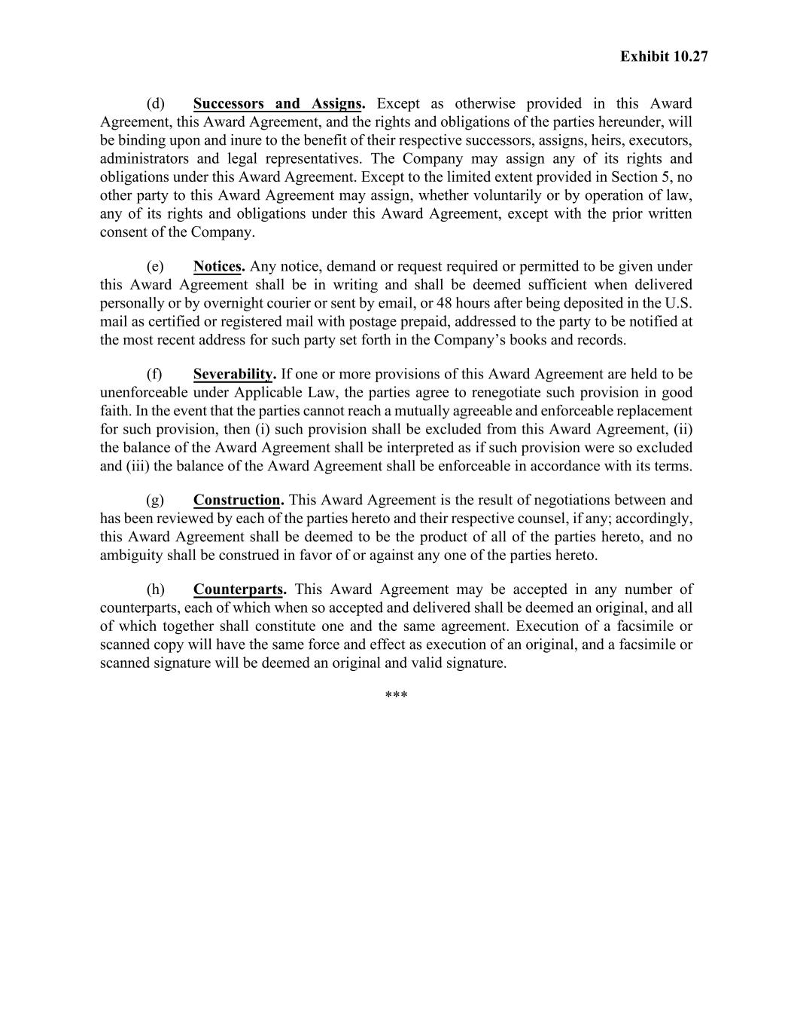
Exhibit 10.27 (d) Successors and Assigns. Except as otherwise provided in this Award Agreement, this Award Agreement, and the rights and obligations of the parties hereunder, will be binding upon and inure to the benefit of their respective successors, assigns, heirs, executors, administrators and legal representatives. The Company may assign any of its rights and obligations under this Award Agreement. Except to the limited extent provided in Section 5, no other party to this Award Agreement may assign, whether voluntarily or by operation of law, any of its rights and obligations under this Award Agreement, except with the prior written consent of the Company. (e) Notices. Any notice, demand or request required or permitted to be given under this Award Agreement shall be in writing and shall be deemed sufficient when delivered personally or by overnight courier or sent by email, or 48 hours after being deposited in the U.S. mail as certified or registered mail with postage prepaid, addressed to the party to be notified at the most recent address for such party set forth in the Company’s books and records. (f) Severability. If one or more provisions of this Award Agreement are held to be unenforceable under Applicable Law, the parties agree to renegotiate such provision in good faith. In the event that the parties cannot reach a mutually agreeable and enforceable replacement for such provision, then (i) such provision shall be excluded from this Award Agreement, (ii) the balance of the Award Agreement shall be interpreted as if such provision were so excluded and (iii) the balance of the Award Agreement shall be enforceable in accordance with its terms. (g) Construction. This Award Agreement is the result of negotiations between and has been reviewed by each of the parties hereto and their respective counsel, if any; accordingly, this Award Agreement shall be deemed to be the product of all of the parties hereto, and no ambiguity shall be construed in favor of or against any one of the parties hereto. (h) Counterparts. This Award Agreement may be accepted in any number of counterparts, each of which when so accepted and delivered shall be deemed an original, and all of which together shall constitute one and the same agreement. Execution of a facsimile or scanned copy will have the same force and effect as execution of an original, and a facsimile or scanned signature will be deemed an original and valid signature. ***

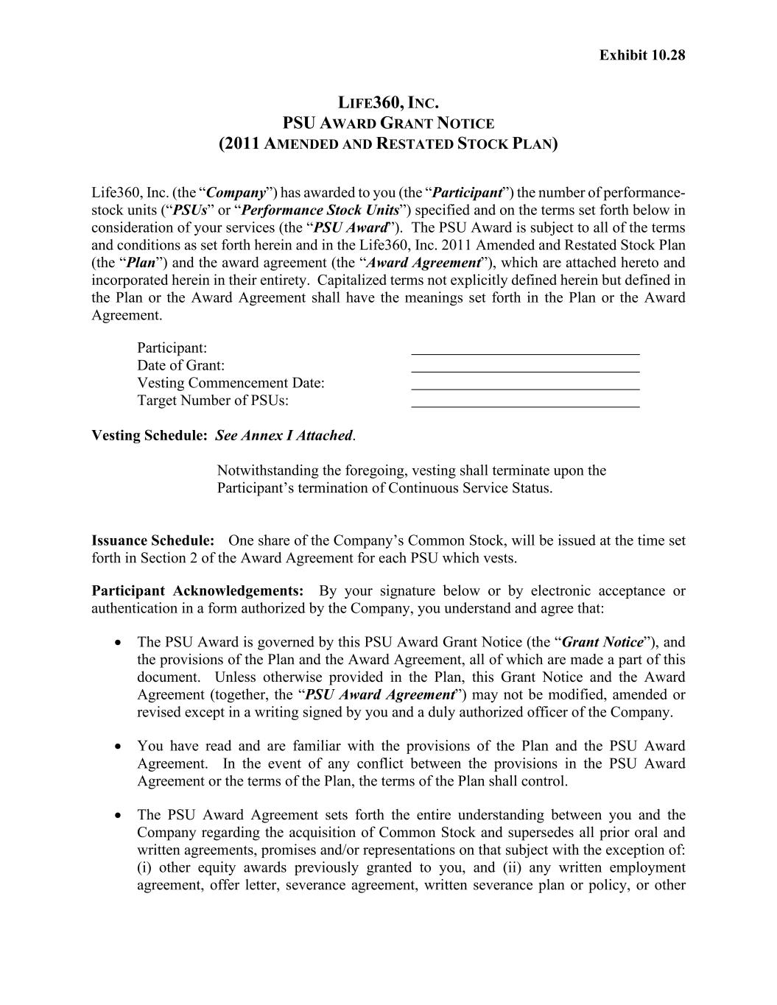
Exhibit 10.28 LIFE360, INC. PSU AWARD GRANT NOTICE (2011 AMENDED AND RESTATED STOCK PLAN) Life360, Inc. (the “Company”) has awarded to you (the “Participant”) the number of performance- stock units (“PSUs” or “Performance Stock Units”) specified and on the terms set forth below in consideration of your services (the “PSU Award”). The PSU Award is subject to all of the terms and conditions as set forth herein and in the Life360, Inc. 2011 Amended and Restated Stock Plan (the “Plan”) and the award agreement (the “Award Agreement”), which are attached hereto and incorporated herein in their entirety. Capitalized terms not explicitly defined herein but defined in the Plan or the Award Agreement shall have the meanings set forth in the Plan or the Award Agreement. Participant: Date of Grant: Vesting Commencement Date: Target Number of PSUs: Vesting Schedule: See Annex I Attached. Notwithstanding the foregoing, vesting shall terminate upon the Participant’s termination of Continuous Service Status. Issuance Schedule: One share of the Company’s Common Stock, will be issued at the time set forth in Section 2 of the Award Agreement for each PSU which vests. Participant Acknowledgements: By your signature below or by electronic acceptance or authentication in a form authorized by the Company, you understand and agree that: • The PSU Award is governed by this PSU Award Grant Notice (the “Grant Notice”), and the provisions of the Plan and the Award Agreement, all of which are made a part of this document. Unless otherwise provided in the Plan, this Grant Notice and the Award Agreement (together, the “PSU Award Agreement”) may not be modified, amended or revised except in a writing signed by you and a duly authorized officer of the Company. • You have read and are familiar with the provisions of the Plan and the PSU Award Agreement. In the event of any conflict between the provisions in the PSU Award Agreement or the terms of the Plan, the terms of the Plan shall control. • The PSU Award Agreement sets forth the entire understanding between you and the Company regarding the acquisition of Common Stock and supersedes all prior oral and written agreements, promises and/or representations on that subject with the exception of: (i) other equity awards previously granted to you, and (ii) any written employment agreement, offer letter, severance agreement, written severance plan or policy, or other

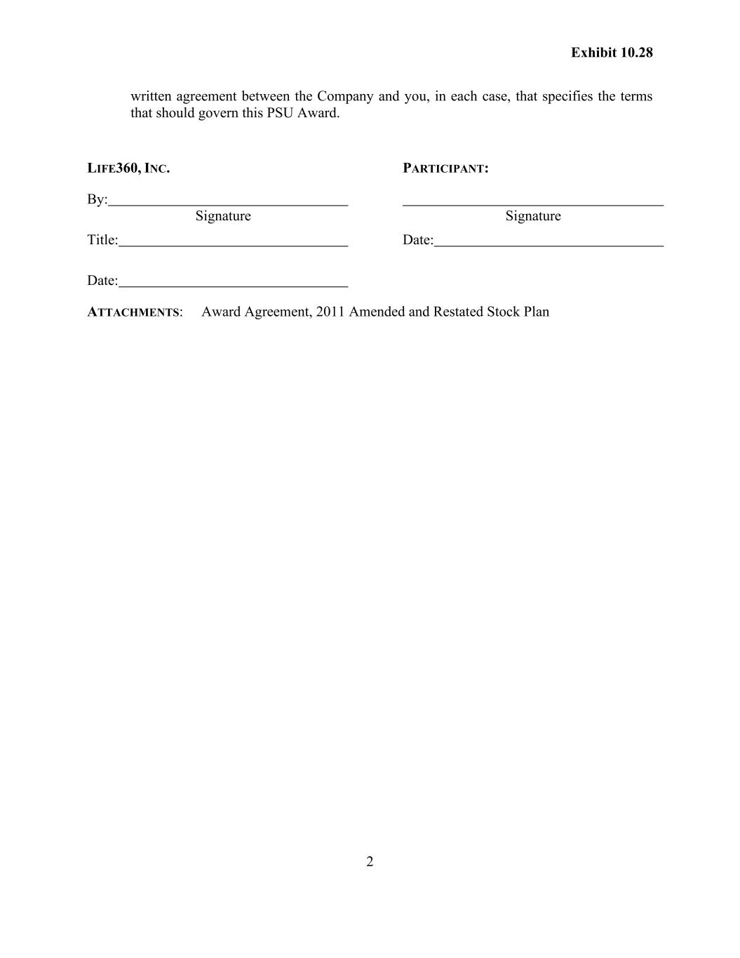
2 Exhibit 10.28 written agreement between the Company and you, in each case, that specifies the terms that should govern this PSU Award. LIFE360, INC. By: Signature Title: Date: PARTICIPANT: Signature Date: ATTACHMENTS: Award Agreement, 2011 Amended and Restated Stock Plan

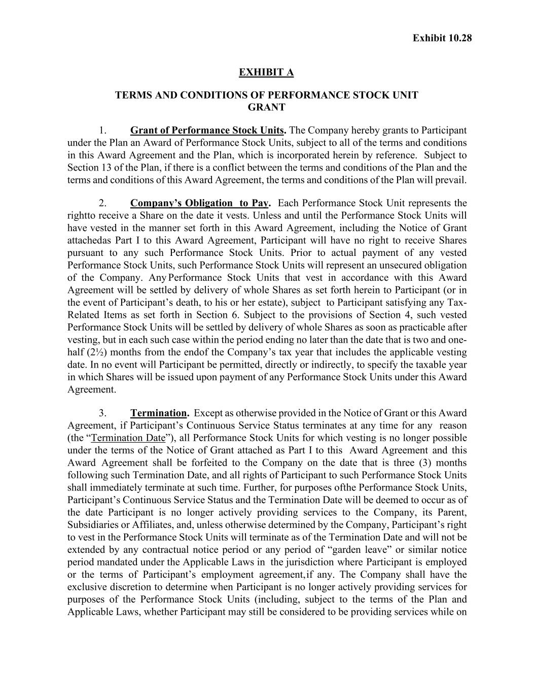
Exhibit 10.28 EXHIBIT A TERMS AND CONDITIONS OF PERFORMANCE STOCK UNIT GRANT 1. Grant of Performance Stock Units. The Company hereby grants to Participant under the Plan an Award of Performance Stock Units, subject to all of the terms and conditions in this Award Agreement and the Plan, which is incorporated herein by reference. Subject to Section 13 of the Plan, if there is a conflict between the terms and conditions of the Plan and the terms and conditions of this Award Agreement, the terms and conditions of the Plan will prevail. 2. Company’s Obligation to Pay. Each Performance Stock Unit represents the right to receive a Share on the date it vests. Unless and until the Performance Stock Units will have vested in the manner set forth in this Award Agreement, including the Notice of Grant attached as Part I to this Award Agreement, Participant will have no right to receive Shares pursuant to any such Performance Stock Units. Prior to actual payment of any vested Performance Stock Units, such Performance Stock Units will represent an unsecured obligation of the Company. Any Performance Stock Units that vest in accordance with this Award Agreement will be settled by delivery of whole Shares as set forth herein to Participant (or in the event of Participant’s death, to his or her estate), subject to Participant satisfying any Tax- Related Items as set forth in Section 6. Subject to the provisions of Section 4, such vested Performance Stock Units will be settled by delivery of whole Shares as soon as practicable after vesting, but in each such case within the period ending no later than the date that is two and one- half (2½) months from the end of the Company’s tax year that includes the applicable vesting date. In no event will Participant be permitted, directly or indirectly, to specify the taxable year in which Shares will be issued upon payment of any Performance Stock Units under this Award Agreement. 3. Termination. Except as otherwise provided in the Notice of Grant or this Award Agreement, if Participant’s Continuous Service Status terminates at any time for any reason (the “Termination Date”), all Performance Stock Units for which vesting is no longer possible under the terms of the Notice of Grant attached as Part I to this Award Agreement and this Award Agreement shall be forfeited to the Company on the date that is three (3) months following such Termination Date, and all rights of Participant to such Performance Stock Units shall immediately terminate at such time. Further, for purposes of the Performance Stock Units, Participant’s Continuous Service Status and the Termination Date will be deemed to occur as of the date Participant is no longer actively providing services to the Company, its Parent, Subsidiaries or Affiliates, and, unless otherwise determined by the Company, Participant’s right to vest in the Performance Stock Units will terminate as of the Termination Date and will not be extended by any contractual notice period or any period of “garden leave” or similar notice period mandated under the Applicable Laws in the jurisdiction where Participant is employed or the terms of Participant’s employment agreement, if any. The Company shall have the exclusive discretion to determine when Participant is no longer actively providing services for purposes of the Performance Stock Units (including, subject to the terms of the Plan and Applicable Laws, whether Participant may still be considered to be providing services while on

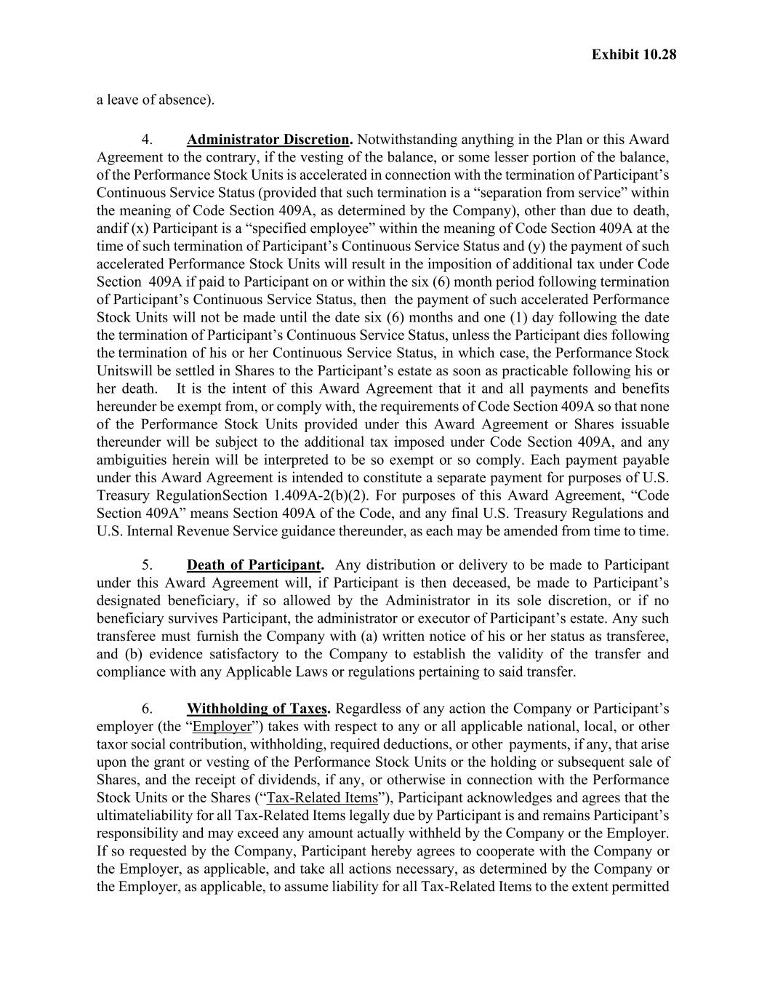
Exhibit 10.28 a leave of absence). 4. Administrator Discretion. Notwithstanding anything in the Plan or this Award Agreement to the contrary, if the vesting of the balance, or some lesser portion of the balance, of the Performance Stock Units is accelerated in connection with the termination of Participant’s Continuous Service Status (provided that such termination is a “separation from service” within the meaning of Code Section 409A, as determined by the Company), other than due to death, and if (x) Participant is a “specified employee” within the meaning of Code Section 409A at the time of such termination of Participant’s Continuous Service Status and (y) the payment of such accelerated Performance Stock Units will result in the imposition of additional tax under Code Section 409A if paid to Participant on or within the six (6) month period following termination of Participant’s Continuous Service Status, then the payment of such accelerated Performance Stock Units will not be made until the date six (6) months and one (1) day following the date the termination of Participant’s Continuous Service Status, unless the Participant dies following the termination of his or her Continuous Service Status, in which case, the Performance Stock Units will be settled in Shares to the Participant’s estate as soon as practicable following his or her death. It is the intent of this Award Agreement that it and all payments and benefits hereunder be exempt from, or comply with, the requirements of Code Section 409A so that none of the Performance Stock Units provided under this Award Agreement or Shares issuable thereunder will be subject to the additional tax imposed under Code Section 409A, and any ambiguities herein will be interpreted to be so exempt or so comply. Each payment payable under this Award Agreement is intended to constitute a separate payment for purposes of U.S. Treasury Regulation Section 1.409A-2(b)(2). For purposes of this Award Agreement, “Code Section 409A” means Section 409A of the Code, and any final U.S. Treasury Regulations and U.S. Internal Revenue Service guidance thereunder, as each may be amended from time to time. 5. Death of Participant. Any distribution or delivery to be made to Participant under this Award Agreement will, if Participant is then deceased, be made to Participant’s designated beneficiary, if so allowed by the Administrator in its sole discretion, or if no beneficiary survives Participant, the administrator or executor of Participant’s estate. Any such transferee must furnish the Company with (a) written notice of his or her status as transferee, and (b) evidence satisfactory to the Company to establish the validity of the transfer and compliance with any Applicable Laws or regulations pertaining to said transfer. 6. Withholding of Taxes. Regardless of any action the Company or Participant’s employer (the “Employer”) takes with respect to any or all applicable national, local, or other tax or social contribution, withholding, required deductions, or other payments, if any, that arise upon the grant or vesting of the Performance Stock Units or the holding or subsequent sale of Shares, and the receipt of dividends, if any, or otherwise in connection with the Performance Stock Units or the Shares (“Tax-Related Items”), Participant acknowledges and agrees that the ultimate liability for all Tax-Related Items legally due by Participant is and remains Participant’s responsibility and may exceed any amount actually withheld by the Company or the Employer. If so requested by the Company, Participant hereby agrees to cooperate with the Company or the Employer, as applicable, and take all actions necessary, as determined by the Company or the Employer, as applicable, to assume liability for all Tax-Related Items to the extent permitted

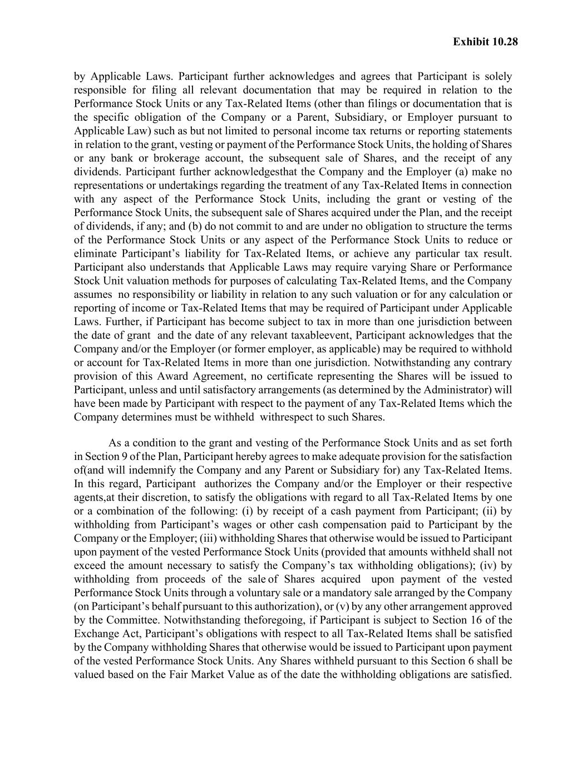
Exhibit 10.28 by Applicable Laws. Participant further acknowledges and agrees that Participant is solely responsible for filing all relevant documentation that may be required in relation to the Performance Stock Units or any Tax-Related Items (other than filings or documentation that is the specific obligation of the Company or a Parent, Subsidiary, or Employer pursuant to Applicable Law) such as but not limited to personal income tax returns or reporting statements in relation to the grant, vesting or payment of the Performance Stock Units, the holding of Shares or any bank or brokerage account, the subsequent sale of Shares, and the receipt of any dividends. Participant further acknowledges that the Company and the Employer (a) make no representations or undertakings regarding the treatment of any Tax-Related Items in connection with any aspect of the Performance Stock Units, including the grant or vesting of the Performance Stock Units, the subsequent sale of Shares acquired under the Plan, and the receipt of dividends, if any; and (b) do not commit to and are under no obligation to structure the terms of the Performance Stock Units or any aspect of the Performance Stock Units to reduce or eliminate Participant’s liability for Tax-Related Items, or achieve any particular tax result. Participant also understands that Applicable Laws may require varying Share or Performance Stock Unit valuation methods for purposes of calculating Tax-Related Items, and the Company assumes no responsibility or liability in relation to any such valuation or for any calculation or reporting of income or Tax-Related Items that may be required of Participant under Applicable Laws. Further, if Participant has become subject to tax in more than one jurisdiction between the date of grant and the date of any relevant taxable event, Participant acknowledges that the Company and/or the Employer (or former employer, as applicable) may be required to withhold or account for Tax-Related Items in more than one jurisdiction. Notwithstanding any contrary provision of this Award Agreement, no certificate representing the Shares will be issued to Participant, unless and until satisfactory arrangements (as determined by the Administrator) will have been made by Participant with respect to the payment of any Tax-Related Items which the Company determines must be withheld with respect to such Shares. As a condition to the grant and vesting of the Performance Stock Units and as set forth in Section 9 of the Plan, Participant hereby agrees to make adequate provision for the satisfaction of (and will indemnify the Company and any Parent or Subsidiary for) any Tax-Related Items. In this regard, Participant authorizes the Company and/or the Employer or their respective agents, at their discretion, to satisfy the obligations with regard to all Tax-Related Items by one or a combination of the following: (i) by receipt of a cash payment from Participant; (ii) by withholding from Participant’s wages or other cash compensation paid to Participant by the Company or the Employer; (iii) withholding Shares that otherwise would be issued to Participant upon payment of the vested Performance Stock Units (provided that amounts withheld shall not exceed the amount necessary to satisfy the Company’s tax withholding obligations); (iv) by withholding from proceeds of the sale of Shares acquired upon payment of the vested Performance Stock Units through a voluntary sale or a mandatory sale arranged by the Company (on Participant’s behalf pursuant to this authorization), or (v) by any other arrangement approved by the Committee. Notwithstanding the foregoing, if Participant is subject to Section 16 of the Exchange Act, Participant’s obligations with respect to all Tax-Related Items shall be satisfied by the Company withholding Shares that otherwise would be issued to Participant upon payment of the vested Performance Stock Units. Any Shares withheld pursuant to this Section 6 shall be valued based on the Fair Market Value as of the date the withholding obligations are satisfied.

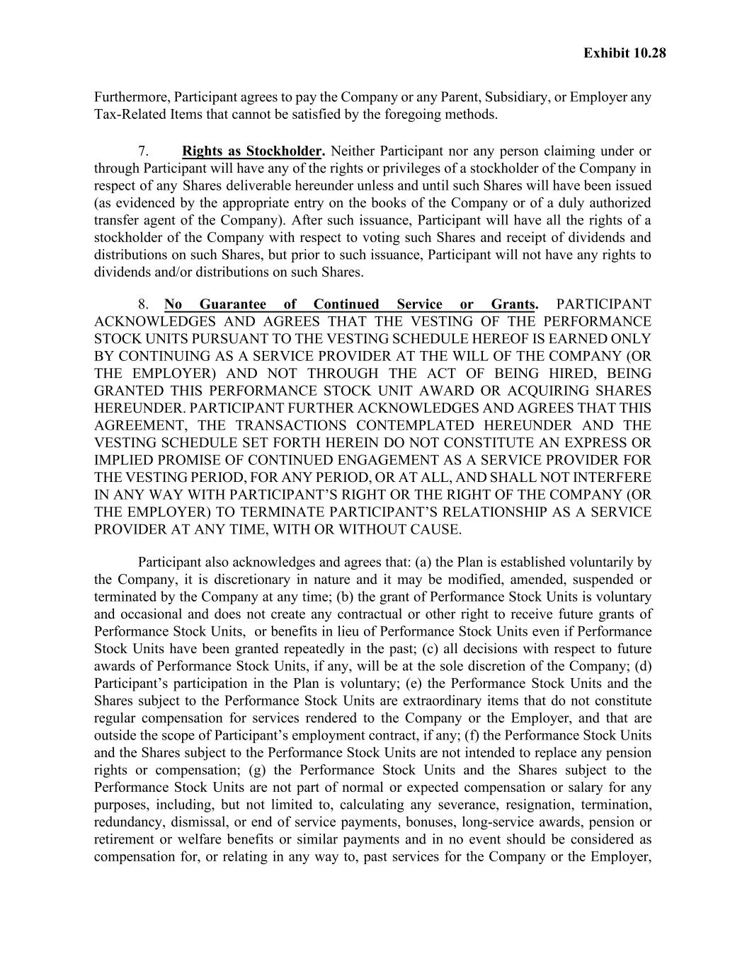
Exhibit 10.28 Furthermore, Participant agrees to pay the Company or any Parent, Subsidiary, or Employer any Tax-Related Items that cannot be satisfied by the foregoing methods. 7. Rights as Stockholder. Neither Participant nor any person claiming under or through Participant will have any of the rights or privileges of a stockholder of the Company in respect of any Shares deliverable hereunder unless and until such Shares will have been issued (as evidenced by the appropriate entry on the books of the Company or of a duly authorized transfer agent of the Company). After such issuance, Participant will have all the rights of a stockholder of the Company with respect to voting such Shares and receipt of dividends and distributions on such Shares, but prior to such issuance, Participant will not have any rights to dividends and/or distributions on such Shares. 8. No Guarantee of Continued Service or Grants. PARTICIPANT ACKNOWLEDGES AND AGREES THAT THE VESTING OF THE PERFORMANCE STOCK UNITS PURSUANT TO THE VESTING SCHEDULE HEREOF IS EARNED ONLY BY CONTINUING AS A SERVICE PROVIDER AT THE WILL OF THE COMPANY (OR THE EMPLOYER) AND NOT THROUGH THE ACT OF BEING HIRED, BEING GRANTED THIS PERFORMANCE STOCK UNIT AWARD OR ACQUIRING SHARES HEREUNDER. PARTICIPANT FURTHER ACKNOWLEDGES AND AGREES THAT THIS AGREEMENT, THE TRANSACTIONS CONTEMPLATED HEREUNDER AND THE VESTING SCHEDULE SET FORTH HEREIN DO NOT CONSTITUTE AN EXPRESS OR IMPLIED PROMISE OF CONTINUED ENGAGEMENT AS A SERVICE PROVIDER FOR THE VESTING PERIOD, FOR ANY PERIOD, OR AT ALL, AND SHALL NOT INTERFERE IN ANY WAY WITH PARTICIPANT’S RIGHT OR THE RIGHT OF THE COMPANY (OR THE EMPLOYER) TO TERMINATE PARTICIPANT’S RELATIONSHIP AS A SERVICE PROVIDER AT ANY TIME, WITH OR WITHOUT CAUSE. Participant also acknowledges and agrees that: (a) the Plan is established voluntarily by the Company, it is discretionary in nature and it may be modified, amended, suspended or terminated by the Company at any time; (b) the grant of Performance Stock Units is voluntary and occasional and does not create any contractual or other right to receive future grants of Performance Stock Units, or benefits in lieu of Performance Stock Units even if Performance Stock Units have been granted repeatedly in the past; (c) all decisions with respect to future awards of Performance Stock Units, if any, will be at the sole discretion of the Company; (d) Participant’s participation in the Plan is voluntary; (e) the Performance Stock Units and the Shares subject to the Performance Stock Units are extraordinary items that do not constitute regular compensation for services rendered to the Company or the Employer, and that are outside the scope of Participant’s employment contract, if any; (f) the Performance Stock Units and the Shares subject to the Performance Stock Units are not intended to replace any pension rights or compensation; (g) the Performance Stock Units and the Shares subject to the Performance Stock Units are not part of normal or expected compensation or salary for any purposes, including, but not limited to, calculating any severance, resignation, termination, redundancy, dismissal, or end of service payments, bonuses, long-service awards, pension or retirement or welfare benefits or similar payments and in no event should be considered as compensation for, or relating in any way to, past services for the Company or the Employer,

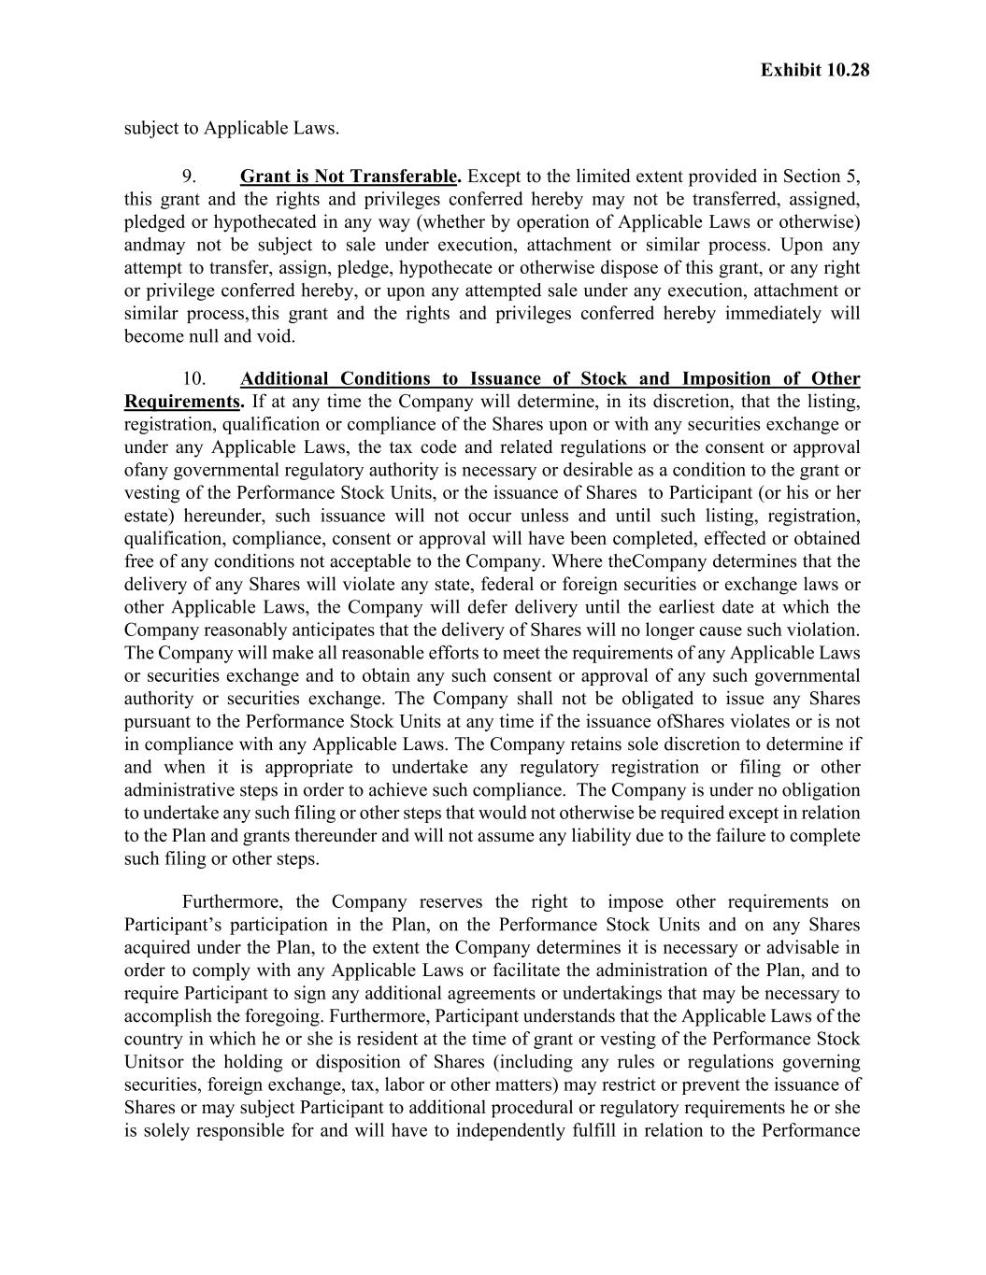
Exhibit 10.28 subject to Applicable Laws. 9. Grant is Not Transferable. Except to the limited extent provided in Section 5, this grant and the rights and privileges conferred hereby may not be transferred, assigned, pledged or hypothecated in any way (whether by operation of Applicable Laws or otherwise) and may not be subject to sale under execution, attachment or similar process. Upon any attempt to transfer, assign, pledge, hypothecate or otherwise dispose of this grant, or any right or privilege conferred hereby, or upon any attempted sale under any execution, attachment or similar process, this grant and the rights and privileges conferred hereby immediately will become null and void. 10. Additional Conditions to Issuance of Stock and Imposition of Other Requirements. If at any time the Company will determine, in its discretion, that the listing, registration, qualification or compliance of the Shares upon or with any securities exchange or under any Applicable Laws, the tax code and related regulations or the consent or approval of any governmental regulatory authority is necessary or desirable as a condition to the grant or vesting of the Performance Stock Units, or the issuance of Shares to Participant (or his or her estate) hereunder, such issuance will not occur unless and until such listing, registration, qualification, compliance, consent or approval will have been completed, effected or obtained free of any conditions not acceptable to the Company. Where the Company determines that the delivery of any Shares will violate any state, federal or foreign securities or exchange laws or other Applicable Laws, the Company will defer delivery until the earliest date at which the Company reasonably anticipates that the delivery of Shares will no longer cause such violation. The Company will make all reasonable efforts to meet the requirements of any Applicable Laws or securities exchange and to obtain any such consent or approval of any such governmental authority or securities exchange. The Company shall not be obligated to issue any Shares pursuant to the Performance Stock Units at any time if the issuance of Shares violates or is not in compliance with any Applicable Laws. The Company retains sole discretion to determine if and when it is appropriate to undertake any regulatory registration or filing or other administrative steps in order to achieve such compliance. The Company is under no obligation to undertake any such filing or other steps that would not otherwise be required except in relation to the Plan and grants thereunder and will not assume any liability due to the failure to complete such filing or other steps. Furthermore, the Company reserves the right to impose other requirements on Participant’s participation in the Plan, on the Performance Stock Units and on any Shares acquired under the Plan, to the extent the Company determines it is necessary or advisable in order to comply with any Applicable Laws or facilitate the administration of the Plan, and to require Participant to sign any additional agreements or undertakings that may be necessary to accomplish the foregoing. Furthermore, Participant understands that the Applicable Laws of the country in which he or she is resident at the time of grant or vesting of the Performance Stock Units or the holding or disposition of Shares (including any rules or regulations governing securities, foreign exchange, tax, labor or other matters) may restrict or prevent the issuance of Shares or may subject Participant to additional procedural or regulatory requirements he or she is solely responsible for and will have to independently fulfill in relation to the Performance

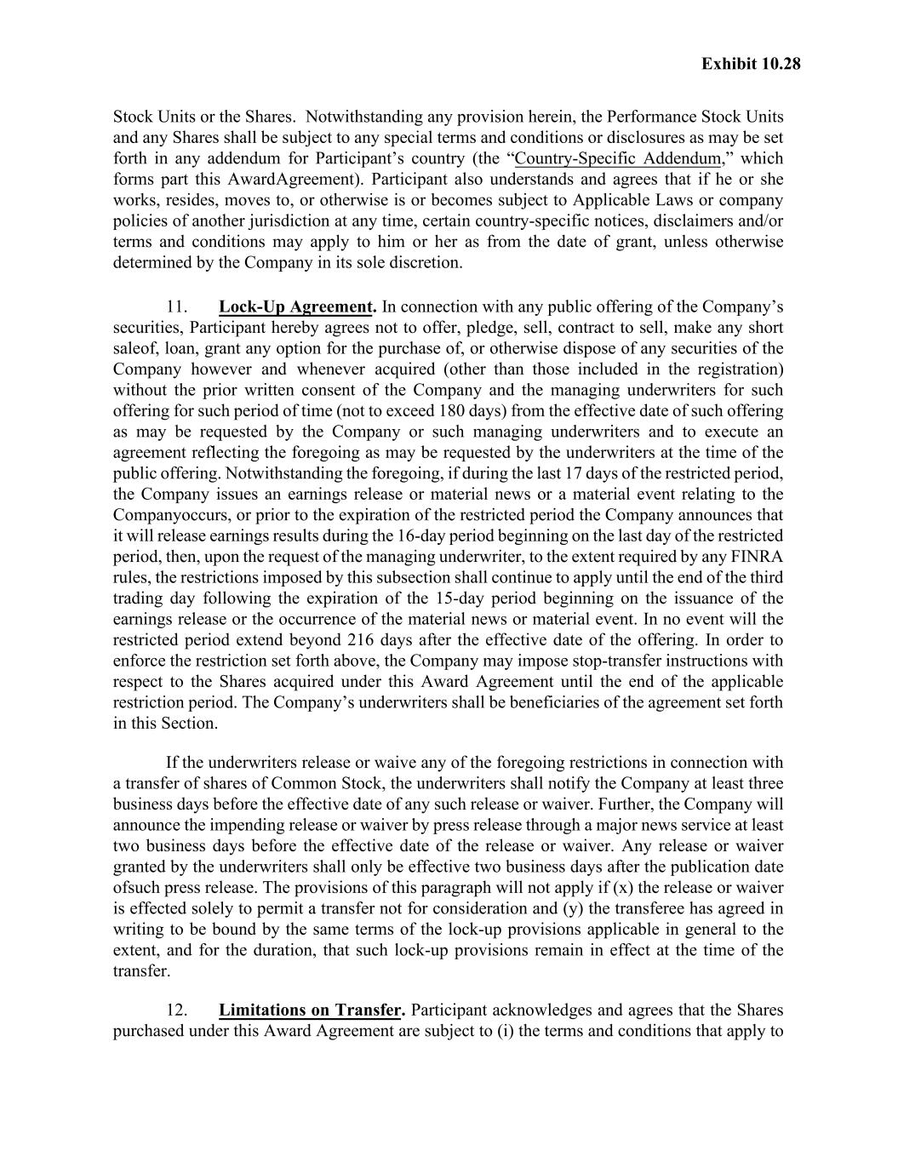
Exhibit 10.28 Stock Units or the Shares. Notwithstanding any provision herein, the Performance Stock Units and any Shares shall be subject to any special terms and conditions or disclosures as may be set forth in any addendum for Participant’s country (the “Country-Specific Addendum,” which forms part this Award Agreement). Participant also understands and agrees that if he or she works, resides, moves to, or otherwise is or becomes subject to Applicable Laws or company policies of another jurisdiction at any time, certain country-specific notices, disclaimers and/or terms and conditions may apply to him or her as from the date of grant, unless otherwise determined by the Company in its sole discretion. 11. Lock-Up Agreement. In connection with any public offering of the Company’s securities, Participant hereby agrees not to offer, pledge, sell, contract to sell, make any short sale of, loan, grant any option for the purchase of, or otherwise dispose of any securities of the Company however and whenever acquired (other than those included in the registration) without the prior written consent of the Company and the managing underwriters for such offering for such period of time (not to exceed 180 days) from the effective date of such offering as may be requested by the Company or such managing underwriters and to execute an agreement reflecting the foregoing as may be requested by the underwriters at the time of the public offering. Notwithstanding the foregoing, if during the last 17 days of the restricted period, the Company issues an earnings release or material news or a material event relating to the Company occurs, or prior to the expiration of the restricted period the Company announces that it will release earnings results during the 16-day period beginning on the last day of the restricted period, then, upon the request of the managing underwriter, to the extent required by any FINRA rules, the restrictions imposed by this subsection shall continue to apply until the end of the third trading day following the expiration of the 15-day period beginning on the issuance of the earnings release or the occurrence of the material news or material event. In no event will the restricted period extend beyond 216 days after the effective date of the offering. In order to enforce the restriction set forth above, the Company may impose stop-transfer instructions with respect to the Shares acquired under this Award Agreement until the end of the applicable restriction period. The Company’s underwriters shall be beneficiaries of the agreement set forth in this Section. If the underwriters release or waive any of the foregoing restrictions in connection with a transfer of shares of Common Stock, the underwriters shall notify the Company at least three business days before the effective date of any such release or waiver. Further, the Company will announce the impending release or waiver by press release through a major news service at least two business days before the effective date of the release or waiver. Any release or waiver granted by the underwriters shall only be effective two business days after the publication date of such press release. The provisions of this paragraph will not apply if (x) the release or waiver is effected solely to permit a transfer not for consideration and (y) the transferee has agreed in writing to be bound by the same terms of the lock-up provisions applicable in general to the extent, and for the duration, that such lock-up provisions remain in effect at the time of the transfer. 12. Limitations on Transfer. Participant acknowledges and agrees that the Shares purchased under this Award Agreement are subject to (i) the terms and conditions that apply to

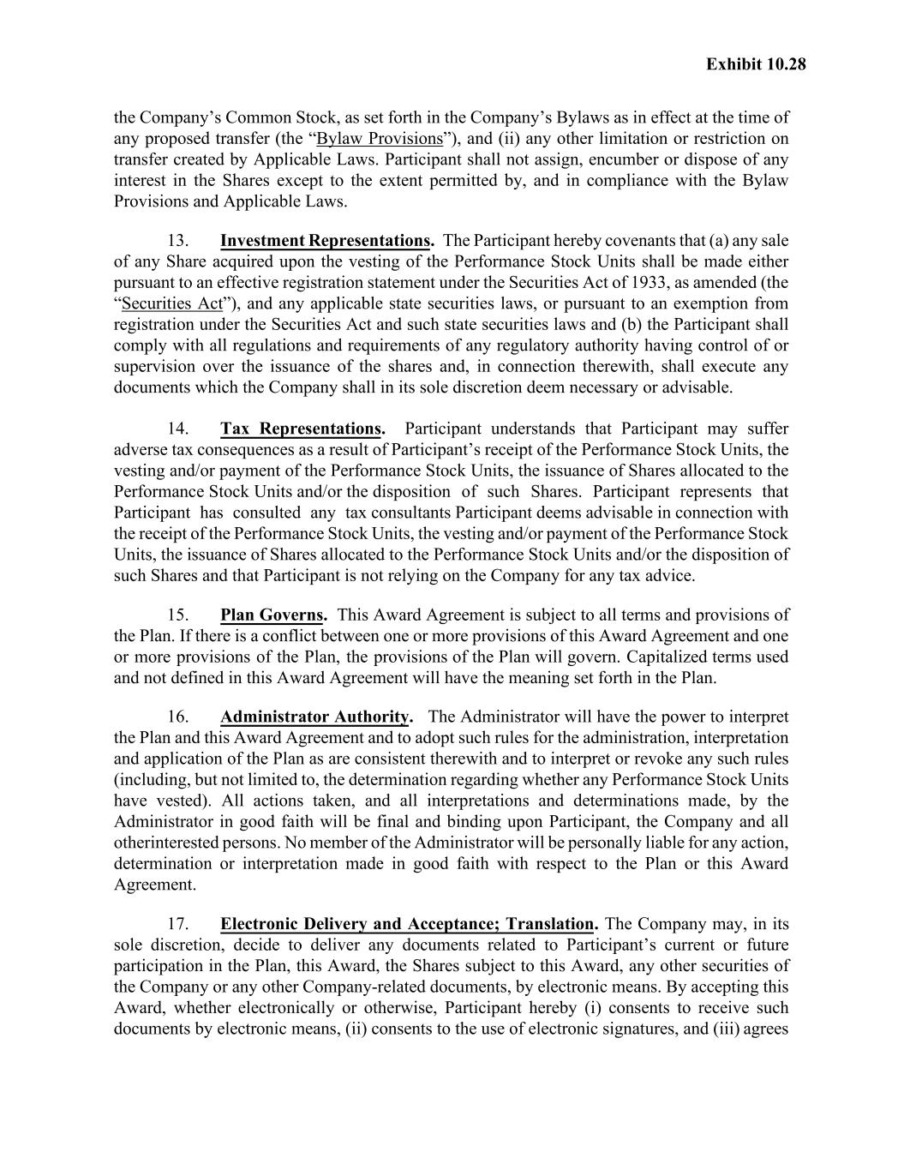
Exhibit 10.28 the Company’s Common Stock, as set forth in the Company’s Bylaws as in effect at the time of any proposed transfer (the “Bylaw Provisions”), and (ii) any other limitation or restriction on transfer created by Applicable Laws. Participant shall not assign, encumber or dispose of any interest in the Shares except to the extent permitted by, and in compliance with the Bylaw Provisions and Applicable Laws. 13. Investment Representations. The Participant hereby covenants that (a) any sale of any Share acquired upon the vesting of the Performance Stock Units shall be made either pursuant to an effective registration statement under the Securities Act of 1933, as amended (the “Securities Act”), and any applicable state securities laws, or pursuant to an exemption from registration under the Securities Act and such state securities laws and (b) the Participant shall comply with all regulations and requirements of any regulatory authority having control of or supervision over the issuance of the shares and, in connection therewith, shall execute any documents which the Company shall in its sole discretion deem necessary or advisable. 14. Tax Representations. Participant understands that Participant may suffer adverse tax consequences as a result of Participant’s receipt of the Performance Stock Units, the vesting and/or payment of the Performance Stock Units, the issuance of Shares allocated to the Performance Stock Units and/or the disposition of such Shares. Participant represents that Participant has consulted any tax consultants Participant deems advisable in connection with the receipt of the Performance Stock Units, the vesting and/or payment of the Performance Stock Units, the issuance of Shares allocated to the Performance Stock Units and/or the disposition of such Shares and that Participant is not relying on the Company for any tax advice. 15. Plan Governs. This Award Agreement is subject to all terms and provisions of the Plan. If there is a conflict between one or more provisions of this Award Agreement and one or more provisions of the Plan, the provisions of the Plan will govern. Capitalized terms used and not defined in this Award Agreement will have the meaning set forth in the Plan. 16. Administrator Authority. The Administrator will have the power to interpret the Plan and this Award Agreement and to adopt such rules for the administration, interpretation and application of the Plan as are consistent therewith and to interpret or revoke any such rules (including, but not limited to, the determination regarding whether any Performance Stock Units have vested). All actions taken, and all interpretations and determinations made, by the Administrator in good faith will be final and binding upon Participant, the Company and all other interested persons. No member of the Administrator will be personally liable for any action, determination or interpretation made in good faith with respect to the Plan or this Award Agreement. 17. Electronic Delivery and Acceptance; Translation. The Company may, in its sole discretion, decide to deliver any documents related to Participant’s current or future participation in the Plan, this Award, the Shares subject to this Award, any other securities of the Company or any other Company-related documents, by electronic means. By accepting this Award, whether electronically or otherwise, Participant hereby (i) consents to receive such documents by electronic means, (ii) consents to the use of electronic signatures, and (iii) agrees

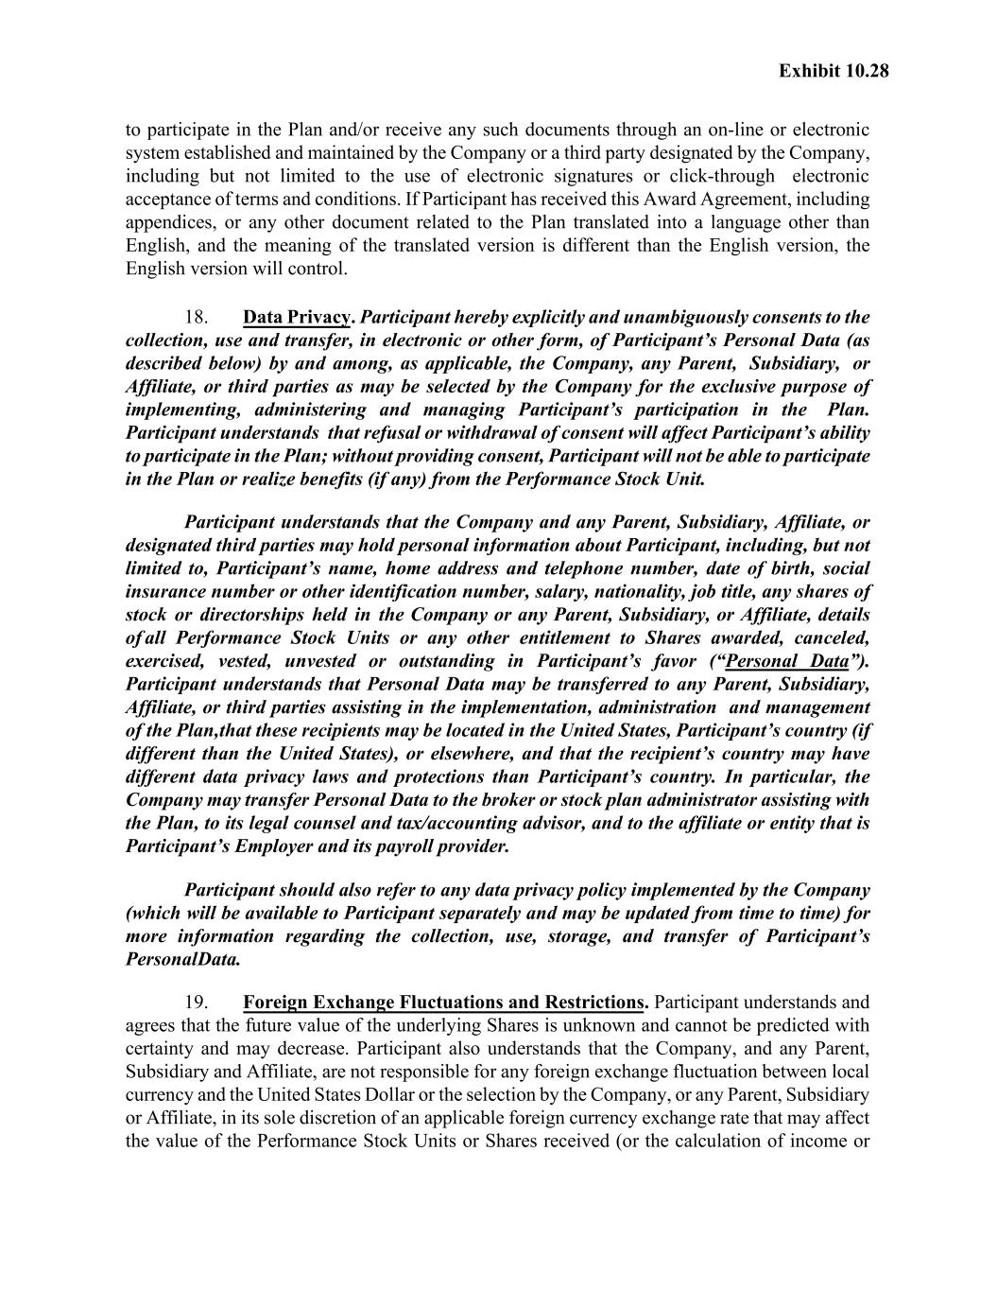
Exhibit 10.28 to participate in the Plan and/or receive any such documents through an on-line or electronic system established and maintained by the Company or a third party designated by the Company, including but not limited to the use of electronic signatures or click-through electronic acceptance of terms and conditions. If Participant has received this Award Agreement, including appendices, or any other document related to the Plan translated into a language other than English, and the meaning of the translated version is different than the English version, the English version will control. 18. Data Privacy. Participant hereby explicitly and unambiguously consents to the collection, use and transfer, in electronic or other form, of Participant’s Personal Data (as described below) by and among, as applicable, the Company, any Parent, Subsidiary, or Affiliate, or third parties as may be selected by the Company for the exclusive purpose of implementing, administering and managing Participant’s participation in the Plan. Participant understands that refusal or withdrawal of consent will affect Participant’s ability to participate in the Plan; without providing consent, Participant will not be able to participate in the Plan or realize benefits (if any) from the Performance Stock Unit. Participant understands that the Company and any Parent, Subsidiary, Affiliate, or designated third parties may hold personal information about Participant, including, but not limited to, Participant’s name, home address and telephone number, date of birth, social insurance number or other identification number, salary, nationality, job title, any shares of stock or directorships held in the Company or any Parent, Subsidiary, or Affiliate, details of all Performance Stock Units or any other entitlement to Shares awarded, canceled, exercised, vested, unvested or outstanding in Participant’s favor (“Personal Data”). Participant understands that Personal Data may be transferred to any Parent, Subsidiary, Affiliate, or third parties assisting in the implementation, administration and management of the Plan, that these recipients may be located in the United States, Participant’s country (if different than the United States), or elsewhere, and that the recipient’s country may have different data privacy laws and protections than Participant’s country. In particular, the Company may transfer Personal Data to the broker or stock plan administrator assisting with the Plan, to its legal counsel and tax/accounting advisor, and to the affiliate or entity that is Participant’s Employer and its payroll provider. Participant should also refer to any data privacy policy implemented by the Company (which will be available to Participant separately and may be updated from time to time) for more information regarding the collection, use, storage, and transfer of Participant’s Personal Data. 19. Foreign Exchange Fluctuations and Restrictions. Participant understands and agrees that the future value of the underlying Shares is unknown and cannot be predicted with certainty and may decrease. Participant also understands that the Company, and any Parent, Subsidiary and Affiliate, are not responsible for any foreign exchange fluctuation between local currency and the United States Dollar or the selection by the Company, or any Parent, Subsidiary or Affiliate, in its sole discretion of an applicable foreign currency exchange rate that may affect the value of the Performance Stock Units or Shares received (or the calculation of income or

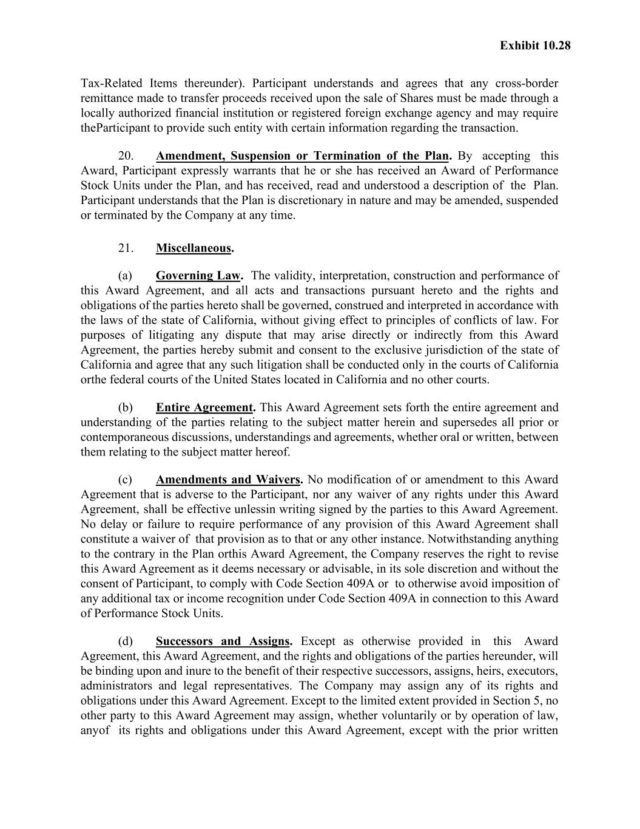
Exhibit 10.28 Tax-Related Items thereunder). Participant understands and agrees that any cross-border remittance made to transfer proceeds received upon the sale of Shares must be made through a locally authorized financial institution or registered foreign exchange agency and may require the Participant to provide such entity with certain information regarding the transaction. 20. Amendment, Suspension or Termination of the Plan. By accepting this Award, Participant expressly warrants that he or she has received an Award of Performance Stock Units under the Plan, and has received, read and understood a description of the Plan. Participant understands that the Plan is discretionary in nature and may be amended, suspended or terminated by the Company at any time. 21. Miscellaneous. (a) Governing Law. The validity, interpretation, construction and performance of this Award Agreement, and all acts and transactions pursuant hereto and the rights and obligations of the parties hereto shall be governed, construed and interpreted in accordance with the laws of the state of California, without giving effect to principles of conflicts of law. For purposes of litigating any dispute that may arise directly or indirectly from this Award Agreement, the parties hereby submit and consent to the exclusive jurisdiction of the state of California and agree that any such litigation shall be conducted only in the courts of California or the federal courts of the United States located in California and no other courts. (b) Entire Agreement. This Award Agreement sets forth the entire agreement and understanding of the parties relating to the subject matter herein and supersedes all prior or contemporaneous discussions, understandings and agreements, whether oral or written, between them relating to the subject matter hereof. (c) Amendments and Waivers. No modification of or amendment to this Award Agreement that is adverse to the Participant, nor any waiver of any rights under this Award Agreement, shall be effective unless in writing signed by the parties to this Award Agreement. No delay or failure to require performance of any provision of this Award Agreement shall constitute a waiver of that provision as to that or any other instance. Notwithstanding anything to the contrary in the Plan or this Award Agreement, the Company reserves the right to revise this Award Agreement as it deems necessary or advisable, in its sole discretion and without the consent of Participant, to comply with Code Section 409A or to otherwise avoid imposition of any additional tax or income recognition under Code Section 409A in connection to this Award of Performance Stock Units. (d) Successors and Assigns. Except as otherwise provided in this Award Agreement, this Award Agreement, and the rights and obligations of the parties hereunder, will be binding upon and inure to the benefit of their respective successors, assigns, heirs, executors, administrators and legal representatives. The Company may assign any of its rights and obligations under this Award Agreement. Except to the limited extent provided in Section 5, no other party to this Award Agreement may assign, whether voluntarily or by operation of law, any of its rights and obligations under this Award Agreement, except with the prior written

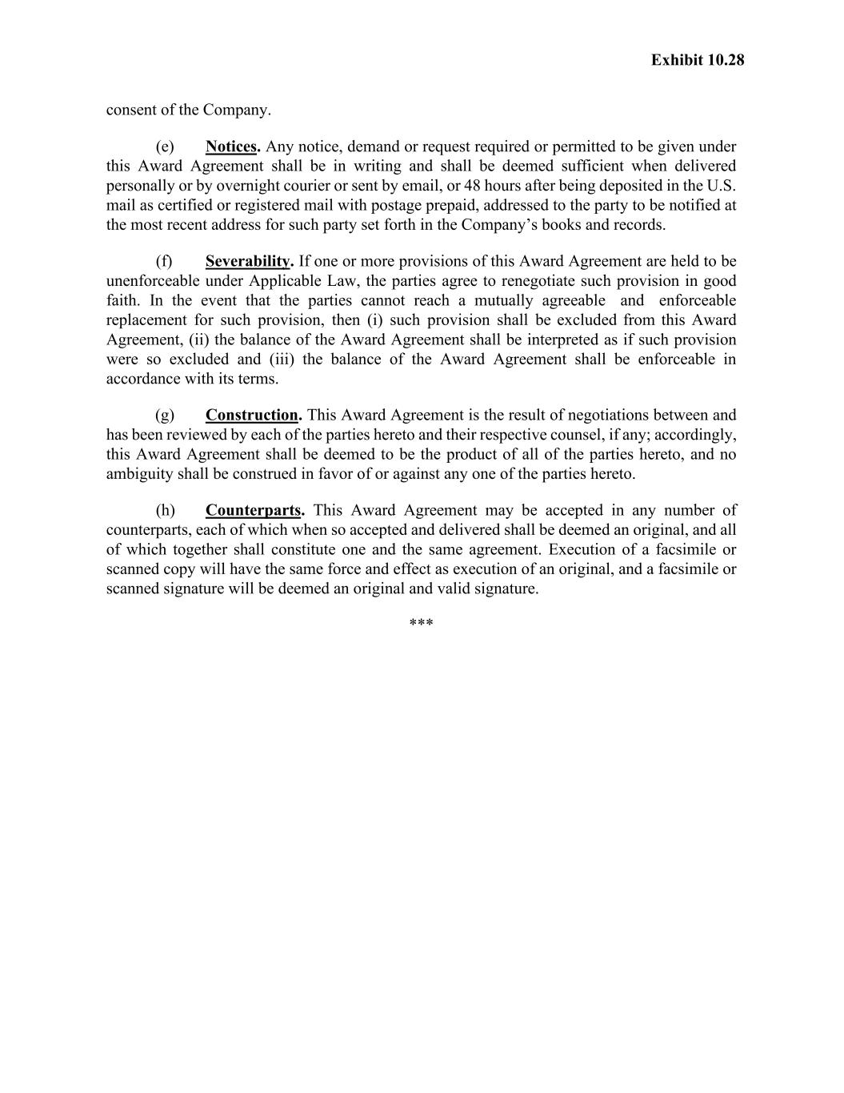
Exhibit 10.28 consent of the Company. (e) Notices. Any notice, demand or request required or permitted to be given under this Award Agreement shall be in writing and shall be deemed sufficient when delivered personally or by overnight courier or sent by email, or 48 hours after being deposited in the U.S. mail as certified or registered mail with postage prepaid, addressed to the party to be notified at the most recent address for such party set forth in the Company’s books and records. (f) Severability. If one or more provisions of this Award Agreement are held to be unenforceable under Applicable Law, the parties agree to renegotiate such provision in good faith. In the event that the parties cannot reach a mutually agreeable and enforceable replacement for such provision, then (i) such provision shall be excluded from this Award Agreement, (ii) the balance of the Award Agreement shall be interpreted as if such provision were so excluded and (iii) the balance of the Award Agreement shall be enforceable in accordance with its terms. (g) Construction. This Award Agreement is the result of negotiations between and has been reviewed by each of the parties hereto and their respective counsel, if any; accordingly, this Award Agreement shall be deemed to be the product of all of the parties hereto, and no ambiguity shall be construed in favor of or against any one of the parties hereto. (h) Counterparts. This Award Agreement may be accepted in any number of counterparts, each of which when so accepted and delivered shall be deemed an original, and all of which together shall constitute one and the same agreement. Execution of a facsimile or scanned copy will have the same force and effect as execution of an original, and a facsimile or scanned signature will be deemed an original and valid signature. ***

Exhibit 23.1

CONSENT OF INDEPENDENT REGISTERED PUBLIC ACCOUNTING FIRM

Life360, Inc.
San Mateo, California
We consent to the incorporation by reference in this Registration Statement Nos. 333-279271 on Form S-3 and 333-268529, 333-274727, 333-277598, and 333-285348 on Form S-8 of our reports dated March 02, 2026, relating to the financial statements of Life360, Inc. and the effectiveness of Life360, Inc.'s internal control over financial reporting appearing in this Annual Report on Form 10-K for the year ended December 31, 2025.

/s/ Deloitte & Touche LLP
San Francisco, California
March 2, 2026

Exhibit 31.1
CERTIFICATION OF CHIEF EXECUTIVE OFFICER
PURSUANT TO EXCHANGE ACT RULE 13a-14(a)/15d-14(a)
AS ADOPTED PURSUANT TO SECTION 302
OF THE SARBANES-OXLEY ACT OF 2002

I, Lauren Antonoff, certify that:
1. I have reviewed this Annual Report on Form 10-K of Life360, Inc. (the “registrant”);
2. Based on my knowledge, this report does not contain any untrue statement of a material fact or omit to state a material fact necessary to make the statements made, in light of the circumstances under which such statements were made, not misleading with respect to the period covered by this report;
3. Based on my knowledge, the financial statements, and other financial information included in this report, fairly present in all material respects the financial condition, results of operations and cash flows of the registrant as of, and for, the periods presented in this report;
4. The registrant's other certifying officer and I are responsible for establishing and maintaining disclosure controls and procedures (as defined in Exchange Act Rules 13a-15(e) and 15d-15(e)) and internal control over financial reporting (as defined in Exchange Act Rules 13a-15(f) and 15d-15(f)) for the registrant and have:
a) Designed such disclosure controls and procedures, or caused such disclosure controls and procedures to be designed under our supervision, to ensure that material information relating to the registrant, including its consolidated subsidiaries, is made known to us by others within those entities, particularly during the period in which this report is being prepared;
b) Designed such internal control over financial reporting, or caused such internal control over financial reporting to be designed under our supervision, to provide reasonable assurance regarding the reliability of financial reporting and the preparation of financial statements for external purposes in accordance with generally accepted accounting principles;
c) Evaluated the effectiveness of the registrant's disclosure controls and procedures and presented in this report our conclusions about the effectiveness of the disclosure controls and procedures, as of the end of the period covered by this report based on such evaluation; and
d) Disclosed in this report any change in the registrant’s internal control over financial reporting that occurred during the registrant’s most recent fiscal quarter (the registrant’s fourth fiscal quarter in the case of an annual report) that has materially affected, or is reasonably likely to materially affect, the registrant’s internal control over financial reporting.
5. The registrant's other certifying officer and I have disclosed, based on our most recent evaluation of internal control over financial reporting, to the registrant's auditors and the audit committee of the registrant's board of directors (or persons performing the equivalent functions):
a) All significant deficiencies and material weaknesses in the design or operation of internal control over financial reporting which are reasonably likely to adversely affect the registrant's ability to record, process, summarize and report financial information; and
b) Any fraud, whether or not material, that involves management or other employees who have a significant role in the registrant's internal control over financial reporting.
Dated: |  |  | March 2, 2026 |  |  | /s/ |  |  | Lauren Antonoff
 |  |  |  |  |  |  |  |  | Lauren Antonoff
 |  |  |  |  |  |  |  |  | Chief Executive Officer

Exhibit 31.2
CERTIFICATION OF CHIEF FINANCIAL OFFICER
PURSUANT TO EXCHANGE ACT RULE 13a-14(a)/15d-14(a)
AS ADOPTED PURSUANT TO SECTION 302
OF THE SARBANES-OXLEY ACT OF 2002

I, Russell Burke, certify that:
1. I have reviewed this Annual Report on Form 10-K of Life360, Inc. (the “registrant”);
2. Based on my knowledge, this report does not contain any untrue statement of a material fact or omit to state a material fact necessary to make the statements made, in light of the circumstances under which such statements were made, not misleading with respect to the period covered by this report;
3. Based on my knowledge, the financial statements, and other financial information included in this report, fairly present in all material respects the financial condition, results of operations and cash flows of the registrant as of, and for, the periods presented in this report;
4. The registrant's other certifying officer and I are responsible for establishing and maintaining disclosure controls and procedures (as defined in Exchange Act Rules 13a-15(e) and 15d-15(e)) and internal control over financial reporting (as defined in Exchange Act Rules 13a-15(f) and 15d-15(f)) for the registrant and have:
a) Designed such disclosure controls and procedures, or caused such disclosure controls and procedures to be designed under our supervision, to ensure that material information relating to the registrant, including its consolidated subsidiaries, is made known to us by others within those entities, particularly during the period in which this report is being prepared;
b) Designed such internal control over financial reporting, or caused such internal control over financial reporting to be designed under our supervision, to provide reasonable assurance regarding the reliability of financial reporting and the preparation of financial statements for external purposes in accordance with generally accepted accounting principles;
c) Evaluated the effectiveness of the registrant's disclosure controls and procedures and presented in this report our conclusions about the effectiveness of the disclosure controls and procedures, as of the end of the period covered by this report based on such evaluation; and
d) Disclosed in this report any change in the registrant’s internal control over financial reporting that occurred during the registrant’s most recent fiscal quarter (the registrant’s fourth fiscal quarter in the case of an annual report) that has materially affected, or is reasonably likely to materially affect, the registrant’s internal control over financial reporting.
5. The registrant's other certifying officer and I have disclosed, based on our most recent evaluation of internal control over financial reporting, to the registrant's auditors and the audit committee of the registrant's board of directors (or persons performing the equivalent functions):
a) All significant deficiencies and material weaknesses in the design or operation of internal control over financial reporting which are reasonably likely to adversely affect the registrant's ability to record, process, summarize and report financial information; and
b) Any fraud, whether or not material, that involves management or other employees who have a significant role in the registrant's internal control over financial reporting.
Dated: |  |  | March 2, 2026 |  |  | /s/ |  |  | Russell Burke
 |  |  |  |  |  |  |  |  | Russell Burke
 |  |  |  |  |  |  |  |  | Chief Financial Officer

Exhibit 32.1

CERTIFICATION
PURSUANT TO 18 U.S.C. SECTION 1350
AS ADOPTED PURSUANT TO
SECTION 906 OF THE SARBANES-OXLEY ACT OF 2002

In connection with the accompanying Annual Report of Life360, Inc. (the “Company”), on Form 10-K for the year ended December 31, 2025 (the “Report”), I, Lauren Antonoff, Chief Executive Officer of the Company, hereby certify pursuant to 18 U.S.C. § 1350, as adopted pursuant to § 906 of the Sarbanes-Oxley Act of 2002 that, to my knowledge:

(1)the Report fully complies with the requirements of section 13(a) or 15(d) of the Securities Exchange Act of 1934; and

(2)the information contained in the Report fairly presents, in all material respects, the financial condition and results of operations of the Company.

Dated: |  |  | March 2, 2026 |  |  | /s/ |  |  | Lauren Antonoff
 |  |  |  |  |  |  |  |  | Lauren Antonoff
 |  |  |  |  |  |  |  |  | Chief Executive Officer

This certification accompanies the Form 10-K to which it relates, is not deemed filed with the Securities and Exchange Commission and is not to be incorporated by reference into any filing of Life360, Inc. under the Securities Act of 1933, as amended, or the Securities Exchange Act of 1934, as amended (whether made before or after the date of the Form 10-K), irrespective of any general incorporation language contained in such filing.

Exhibit 32.2

CERTIFICATION
PURSUANT TO 18 U.S.C. SECTION 1350
AS ADOPTED PURSUANT TO
SECTION 906 OF THE SARBANES-OXLEY ACT OF 2002

In connection with the accompanying Annual Report of Life360, Inc. (the “Company”), on Form 10-K for the year ended December 31, 2025 (the “Report”), I, Russell Burke, Chief Financial Officer of the Company, hereby certify pursuant to 18 U.S.C. § 1350, as adopted pursuant to § 906 of the Sarbanes-Oxley Act of 2002 that, to my knowledge:

(1)the Report fully complies with the requirements of section 13(a) or 15(d) of the Securities Exchange Act of 1934; and

(2)the information contained in the Report fairly presents, in all material respects, the financial condition and results of operations of the Company.

Dated: |  |  | March 2, 2026 |  |  | /s/ |  |  | Russell Burke
 |  |  |  |  |  |  |  |  | Russell Burke
 |  |  |  |  |  |  |  |  | Chief Financial Officer

This certification accompanies the Form 10-K to which it relates, is not deemed filed with the Securities and Exchange Commission and is not to be incorporated by reference into any filing of Life360, Inc. under the Securities Act of 1933, as amended, or the Securities Exchange Act of 1934, as amended (whether made before or after the date of the Form 10-K), irrespective of any general incorporation language contained in such filing.

