UNITED STATES
SECURITIES AND EXCHANGE COMMISSION
Washington, D.C. 20549
______________

FORM 8-K

CURRENT REPORT
Pursuant to Section 13 or 15(d) of the
Securities Exchange Act of 1934

Date of Report (Date of earliest event reported): February 27, 2025

Life360, Inc.
(Exact name of registrant as specified in its charter)
Delaware |  |  | 001-42120 |  |  | 26-0197666
(State or other jurisdiction of  incorporation or organization) |  |  | (Commission File Number) |  |  | (I.R.S. Employer  Identification No.)

1900 South Norfolk Street, Suite 310
San Mateo, CA 94403
(Address of principal executive offices, including zip code)
(415) 484-5244
(Registrant’s telephone number, including area code)
Not applicable.
(Former name or former address, if changed since last report)
______________

Check the appropriate box below if the Form 8-K filing is intended to simultaneously satisfy the filing obligation of the registrant under any of the following provisions:
☐ |  |  | Written communications pursuant to Rule 425 under the Securities Act (17 CFR 230.425)
☐ |  |  | Soliciting material pursuant to Rule 14a-12 under the Exchange Act (17 CFR 240.14a-12)
☐ |  |  | Pre-commencement communications pursuant to Rule 14d-2(b) under the Exchange Act (17 CFR 240.14d-2(b))
☐ |  |  | Pre-commencement communications pursuant to Rule 13e-4(c) under the Exchange Act (17 CFR 240.13e-4(c))

Title of each class |  |  | Trading Symbol(s) |  |  | Name of each exchange on which registered
Common Stock, $0.001 par value per share |  |  | LIF |  |  | The Nasdaq Stock Market LLC

Indicate by check mark whether the registrant is an emerging growth company as defined in Rule 405 of the Securities Act of 1933 (§230.405 of this chapter) or Rule 12b-2 of the Securities Exchange Act of 1934 (§240.12b-2 of this chapter).

Emerging growth company ☐
If an emerging growth company, indicate by check mark if the registrant has elected not to use the extended transition period for complying with any new or revised financial accounting standards provided pursuant to Section 13(a) of the Exchange Act. ☐

Item 2.02 Results of Operations and Financial Condition.
We are furnishing this Current Report on Form 8-K in connection with the disclosure of information, in the form of textual information from a media release issued on February 27, 2025. A copy of the media release is furnished as Exhibit 99.1 to this Current Report on Form 8-K.

Item 7.01 Regulation FD Disclosure.
We are furnishing this Item 7.01 of this Current Report on Form 8-K in connection with the disclosure of information, in the form of the textual information from a PowerPoint presentation to be given during a conference call and webcast on February 27, 2025 at 5:30 p.m. Eastern Time. A copy of the PowerPoint presentation to be used for the conference call and webcast is furnished as Exhibit 99.2 to this Current Report on Form 8-K.
The information in Item 2.02 (including Exhibit 99.1) and Item 7.01 (including Exhibit 99.2) of this Current Report on Form 8-K is furnished and shall not be deemed to be “filed” for the purpose of Section 18 of the Securities Exchange Act of 1934, as amended (the “Exchange Act”) or otherwise subject to the liabilities of that section, nor shall it be deemed incorporated by reference into any filing under the Securities Act of 1933, as amended, or the Exchange Act, except as shall be expressly set forth by specific reference in such a filing.
The text included with this Item 2.02 and Item 7.01 of this Current Report on Form 8-K and the replay of the conference call and webcast will be available on our website located at www.life360.com, although we reserve the right to discontinue that availability at any time.

Item 9.01 Financial Statements and Exhibits.
(d) Exhibits

Exhibit No. |  |  | Description
99.1 |  |  | Media release of the Registrant dated February 27, 2024
99.2 |  |  | Life360, Inc. Investor Presentation
104 |  |  | Cover Page Interactive Data File - the cover page XBRL tags are embedded within the Inline XBRL document

SIGNATURES
Pursuant to the requirements of the Securities Exchange Act of 1934, the registrant has duly caused this report to be signed on its behalf by the undersigned hereunto duly authorized.
 |  |  |  |  |  | LIFE360, INC.
Dated: |  |  | February 27, 2025 |  |  | By: |  |  | /s/ Russell Burke
 |  |  |  |  |  |  |  |  | Russell Burke
 |  |  |  |  |  |  |  |  | Chief Financial Officer

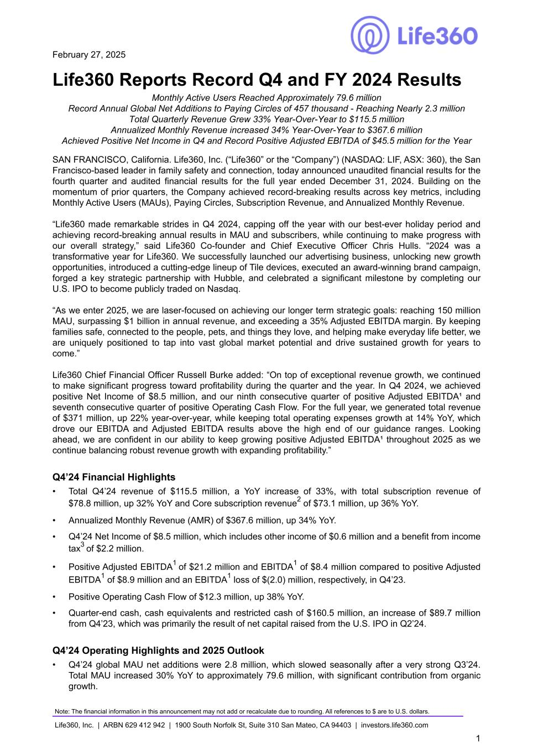

February 27, 2025 Life360 Reports Record Q4 and FY 2024 Results Monthly Active Users Reached Approximately 79.6 million Record Annual Global Net Additions to Paying Circles of 457 thousand - Reaching Nearly 2.3 million Total Quarterly Revenue Grew 33% Year-Over-Year to $115.5 million Annualized Monthly Revenue increased 34% Year-Over-Year to $367.6 million Achieved Positive Net Income in Q4 and Record Positive Adjusted EBITDA of $45.5 million for the Year SAN FRANCISCO, California. Life360, Inc. (“Life360” or the “Company”) (NASDAQ: LIF, ASX: 360), the San Francisco-based leader in family safety and connection, today announced unaudited financial results for the fourth quarter and audited financial results for the full year ended December 31, 2024. Building on the momentum of prior quarters, the Company achieved record-breaking results across key metrics, including Monthly Active Users (MAUs), Paying Circles, Subscription Revenue, and Annualized Monthly Revenue. “Life360 made remarkable strides in Q4 2024, capping off the year with our best-ever holiday period and achieving record-breaking annual results in MAU and subscribers, while continuing to make progress with our overall strategy,” said Life360 Co-founder and Chief Executive Officer Chris Hulls. “2024 was a transformative year for Life360. We successfully launched our advertising business, unlocking new growth opportunities, introduced a cutting-edge lineup of Tile devices, executed an award-winning brand campaign, forged a key strategic partnership with Hubble, and celebrated a significant milestone by completing our U.S. IPO to become publicly traded on Nasdaq. “As we enter 2025, we are laser-focused on achieving our longer term strategic goals: reaching 150 million MAU, surpassing $1 billion in annual revenue, and exceeding a 35% Adjusted EBITDA margin. By keeping families safe, connected to the people, pets, and things they love, and helping make everyday life better, we are uniquely positioned to tap into vast global market potential and drive sustained growth for years to come.” Life360 Chief Financial Officer Russell Burke added: “On top of exceptional revenue growth, we continued to make significant progress toward profitability during the quarter and the year. In Q4 2024, we achieved positive Net Income of $8.5 million, and our ninth consecutive quarter of positive Adjusted EBITDA¹ and seventh consecutive quarter of positive Operating Cash Flow. For the full year, we generated total revenue of $371 million, up 22% year-over-year, while keeping total operating expenses growth at 14% YoY, which drove our EBITDA and Adjusted EBITDA results above the high end of our guidance ranges. Looking ahead, we are confident in our ability to keep growing positive Adjusted EBITDA¹ throughout 2025 as we continue balancing robust revenue growth with expanding profitability.” Q4’24 Financial Highlights • Total Q4’24 revenue of $115.5 million, a YoY increase of 33%, with total subscription revenue of $78.8 million, up 32% YoY and Core subscription revenue2 of $73.1 million, up 36% YoY. • Annualized Monthly Revenue (AMR) of $367.6 million, up 34% YoY. • Q4’24 Net Income of $8.5 million, which includes other income of $0.6 million and a benefit from income tax3 of $2.2 million. • Positive Adjusted EBITDA1 of $21.2 million and EBITDA1 of $8.4 million compared to positive Adjusted EBITDA1 of $8.9 million and an EBITDA1 loss of $(2.0) million, respectively, in Q4’23. • Positive Operating Cash Flow of $12.3 million, up 38% YoY. • Quarter-end cash, cash equivalents and restricted cash of $160.5 million, an increase of $89.7 million from Q4’23, which was primarily the result of net capital raised from the U.S. IPO in Q2’24. Q4’24 Operating Highlights and 2025 Outlook • Q4’24 global MAU net additions were 2.8 million, which slowed seasonally after a very strong Q3’24. Total MAU increased 30% YoY to approximately 79.6 million, with significant contribution from organic growth. Note: The financial information in this announcement may not add or recalculate due to rounding. All references to $ are to U.S. dollars. Life360, Inc. | ARBN 629 412 942 | 1900 South Norfolk St, Suite 310 San Mateo, CA 94403 | investors.life360.com 1

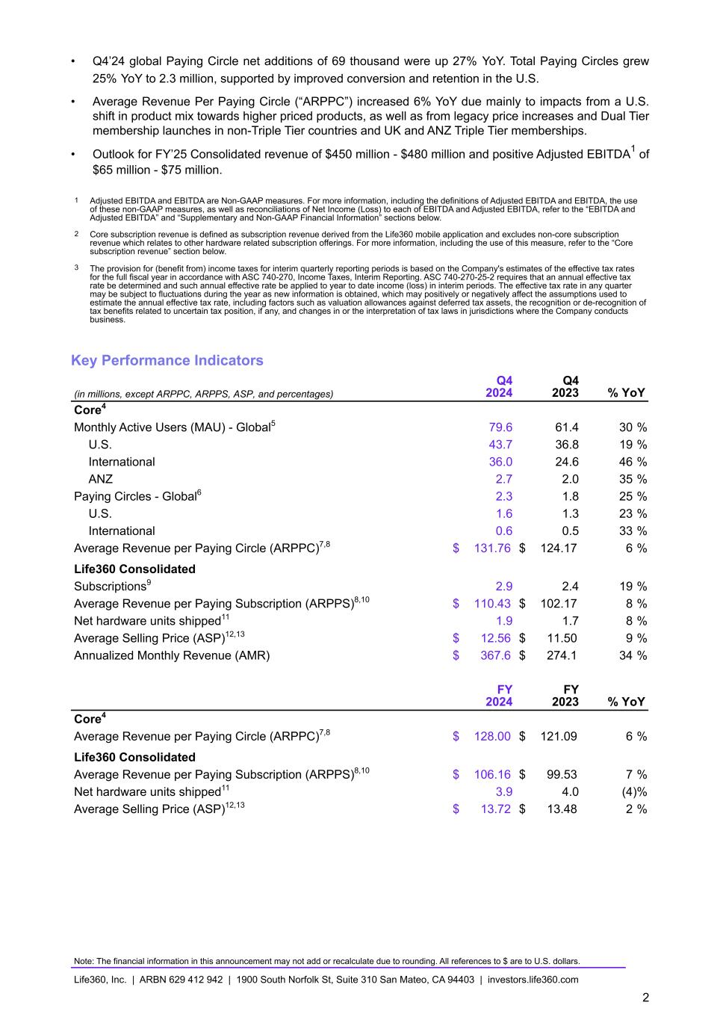
• Q4’24 global Paying Circle net additions of 69 thousand were up 27% YoY. Total Paying Circles grew 25% YoY to 2.3 million, supported by improved conversion and retention in the U.S. • Average Revenue Per Paying Circle (“ARPPC”) increased 6% YoY due mainly to impacts from a U.S. shift in product mix towards higher priced products, as well as from legacy price increases and Dual Tier membership launches in non-Triple Tier countries and UK and ANZ Triple Tier memberships. • Outlook for FY’25 Consolidated revenue of $450 million - $480 million and positive Adjusted EBITDA1 of $65 million - $75 million. 1 Adjusted EBITDA and EBITDA are Non-GAAP measures. For more information, including the definitions of Adjusted EBITDA and EBITDA, the use of these non-GAAP measures, as well as reconciliations of Net Income (Loss) to each of EBITDA and Adjusted EBITDA, refer to the “EBITDA and Adjusted EBITDA” and “Supplementary and Non-GAAP Financial Information” sections below. 2 Core subscription revenue is defined as subscription revenue derived from the Life360 mobile application and excludes non-core subscription revenue which relates to other hardware related subscription offerings. For more information, including the use of this measure, refer to the “Core subscription revenue” section below. 3 The provision for (benefit from) income taxes for interim quarterly reporting periods is based on the Company's estimates of the effective tax rates for the full fiscal year in accordance with ASC 740-270, Income Taxes, Interim Reporting. ASC 740-270-25-2 requires that an annual effective tax rate be determined and such annual effective rate be applied to year to date income (loss) in interim periods. The effective tax rate in any quarter may be subject to fluctuations during the year as new information is obtained, which may positively or negatively affect the assumptions used to estimate the annual effective tax rate, including factors such as valuation allowances against deferred tax assets, the recognition or de-recognition of tax benefits related to uncertain tax position, if any, and changes in or the interpretation of tax laws in jurisdictions where the Company conducts business. Key Performance Indicators (in millions, except ARPPC, ARPPS, ASP, and percentages) Q4 2024 Q4 2023 % YoY Core4 Monthly Active Users (MAU) - Global5 79.6 61.4 30 % U.S. 43.7 36.8 19 % International 36.0 24.6 46 % ANZ 2.7 2.0 35 % Paying Circles - Global6 2.3 1.8 25 % U.S. 1.6 1.3 23 % International 0.6 0.5 33 % Average Revenue per Paying Circle (ARPPC)7,8 $ 131.76 $ 124.17 6 % Life360 Consolidated Subscriptions9 2.9 2.4 19 % Average Revenue per Paying Subscription (ARPPS)8,10 $ 110.43 $ 102.17 8 % Net hardware units shipped11 1.9 1.7 8 % Average Selling Price (ASP)12,13 $ 12.56 $ 11.50 9 % Annualized Monthly Revenue (AMR) $ 367.6 $ 274.1 34 % FY 2024 FY 2023 % YoY Core4 Average Revenue per Paying Circle (ARPPC)7,8 $ 128.00 $ 121.09 6 % Life360 Consolidated Average Revenue per Paying Subscription (ARPPS)8,10 $ 106.16 $ 99.53 7 % Net hardware units shipped11 3.9 4.0 (4) % Average Selling Price (ASP)12,13 $ 13.72 $ 13.48 2 % Note: The financial information in this announcement may not add or recalculate due to rounding. All references to $ are to U.S. dollars. Life360, Inc. | ARBN 629 412 942 | 1900 South Norfolk St, Suite 310 San Mateo, CA 94403 | investors.life360.com 2

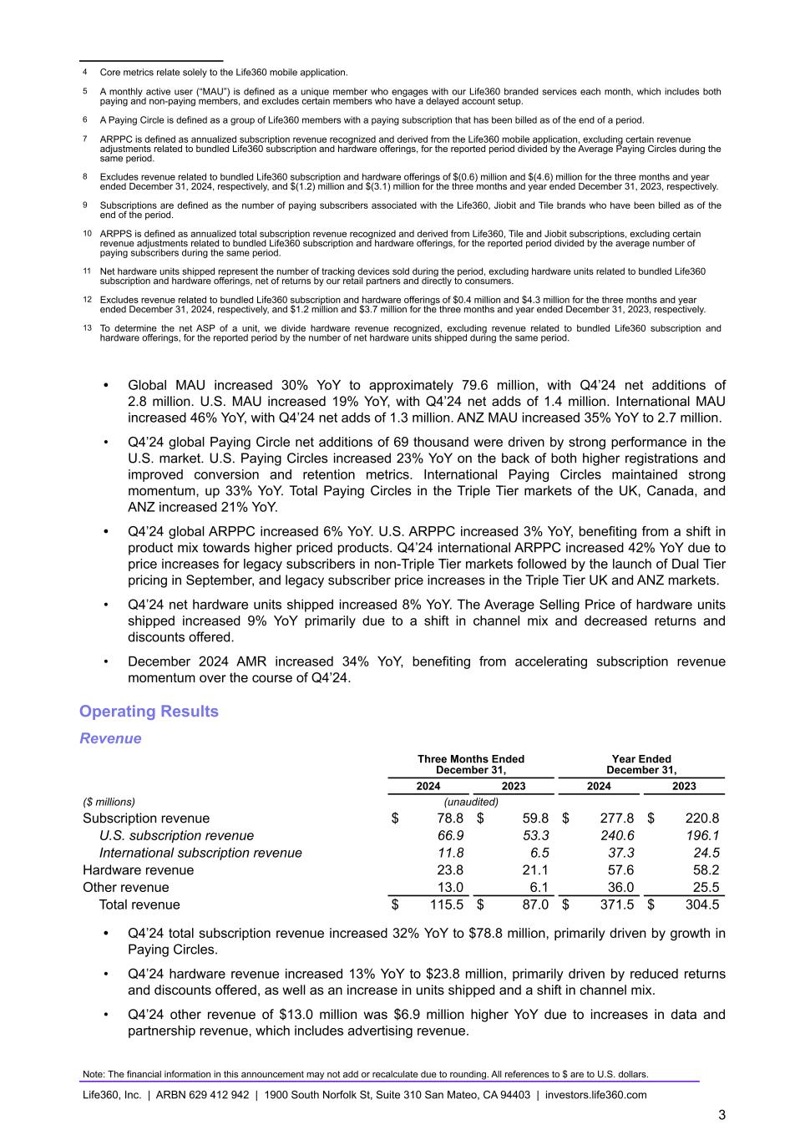
4 Core metrics relate solely to the Life360 mobile application. 5 A monthly active user (“MAU”) is defined as a unique member who engages with our Life360 branded services each month, which includes both paying and non-paying members, and excludes certain members who have a delayed account setup. 6 A Paying Circle is defined as a group of Life360 members with a paying subscription that has been billed as of the end of a period. 7 ARPPC is defined as annualized subscription revenue recognized and derived from the Life360 mobile application, excluding certain revenue adjustments related to bundled Life360 subscription and hardware offerings, for the reported period divided by the Average Paying Circles during the same period. 8 Excludes revenue related to bundled Life360 subscription and hardware offerings of $(0.6) million and $(4.6) million for the three months and year ended December 31, 2024, respectively, and $(1.2) million and $(3.1) million for the three months and year ended December 31, 2023, respectively. 9 Subscriptions are defined as the number of paying subscribers associated with the Life360, Jiobit and Tile brands who have been billed as of the end of the period. 10 ARPPS is defined as annualized total subscription revenue recognized and derived from Life360, Tile and Jiobit subscriptions, excluding certain revenue adjustments related to bundled Life360 subscription and hardware offerings, for the reported period divided by the average number of paying subscribers during the same period. 11 Net hardware units shipped represent the number of tracking devices sold during the period, excluding hardware units related to bundled Life360 subscription and hardware offerings, net of returns by our retail partners and directly to consumers. 12 Excludes revenue related to bundled Life360 subscription and hardware offerings of $0.4 million and $4.3 million for the three months and year ended December 31, 2024, respectively, and $1.2 million and $3.7 million for the three months and year ended December 31, 2023, respectively. 13 To determine the net ASP of a unit, we divide hardware revenue recognized, excluding revenue related to bundled Life360 subscription and hardware offerings, for the reported period by the number of net hardware units shipped during the same period. • Global MAU increased 30% YoY to approximately 79.6 million, with Q4’24 net additions of 2.8 million. U.S. MAU increased 19% YoY, with Q4’24 net adds of 1.4 million. International MAU increased 46% YoY, with Q4’24 net adds of 1.3 million. ANZ MAU increased 35% YoY to 2.7 million. • Q4’24 global Paying Circle net additions of 69 thousand were driven by strong performance in the U.S. market. U.S. Paying Circles increased 23% YoY on the back of both higher registrations and improved conversion and retention metrics. International Paying Circles maintained strong momentum, up 33% YoY. Total Paying Circles in the Triple Tier markets of the UK, Canada, and ANZ increased 21% YoY. • Q4’24 global ARPPC increased 6% YoY. U.S. ARPPC increased 3% YoY, benefiting from a shift in product mix towards higher priced products. Q4’24 international ARPPC increased 42% YoY due to price increases for legacy subscribers in non-Triple Tier markets followed by the launch of Dual Tier pricing in September, and legacy subscriber price increases in the Triple Tier UK and ANZ markets. • Q4’24 net hardware units shipped increased 8% YoY. The Average Selling Price of hardware units shipped increased 9% YoY primarily due to a shift in channel mix and decreased returns and discounts offered. • December 2024 AMR increased 34% YoY, benefiting from accelerating subscription revenue momentum over the course of Q4’24. Operating Results Revenue Three Months Ended December 31, Year Ended December 31, 2024 2023 2024 2023 ($ millions) (unaudited) Subscription revenue $ 78.8 $ 59.8 $ 277.8 $ 220.8 U.S. subscription revenue 66.9 53.3 240.6 196.1 International subscription revenue 11.8 6.5 37.3 24.5 Hardware revenue 23.8 21.1 57.6 58.2 Other revenue 13.0 6.1 36.0 25.5 Total revenue $ 115.5 $ 87.0 $ 371.5 $ 304.5 • Q4’24 total subscription revenue increased 32% YoY to $78.8 million, primarily driven by growth in Paying Circles. • Q4’24 hardware revenue increased 13% YoY to $23.8 million, primarily driven by reduced returns and discounts offered, as well as an increase in units shipped and a shift in channel mix. • Q4’24 other revenue of $13.0 million was $6.9 million higher YoY due to increases in data and partnership revenue, which includes advertising revenue. Note: The financial information in this announcement may not add or recalculate due to rounding. All references to $ are to U.S. dollars. Life360, Inc. | ARBN 629 412 942 | 1900 South Norfolk St, Suite 310 San Mateo, CA 94403 | investors.life360.com 3

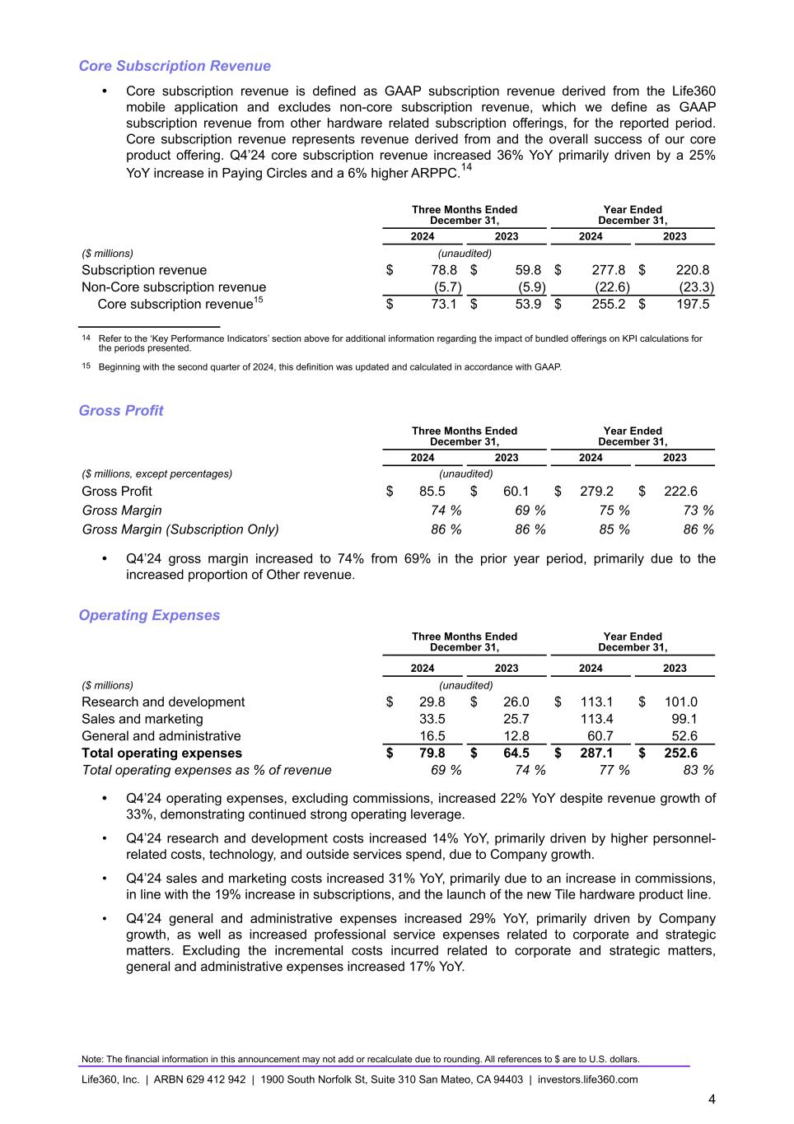
Core Subscription Revenue • Core subscription revenue is defined as GAAP subscription revenue derived from the Life360 mobile application and excludes non-core subscription revenue, which we define as GAAP subscription revenue from other hardware related subscription offerings, for the reported period. Core subscription revenue represents revenue derived from and the overall success of our core product offering. Q4’24 core subscription revenue increased 36% YoY primarily driven by a 25% YoY increase in Paying Circles and a 6% higher ARPPC.14 Three Months Ended December 31, Year Ended December 31, 2024 2023 2024 2023 ($ millions) (unaudited) Subscription revenue $ 78.8 $ 59.8 $ 277.8 $ 220.8 Non-Core subscription revenue (5.7) (5.9) (22.6) (23.3) Core subscription revenue15 $ 73.1 $ 53.9 $ 255.2 $ 197.5 14 Refer to the ‘Key Performance Indicators’ section above for additional information regarding the impact of bundled offerings on KPI calculations for the periods presented. 15 Beginning with the second quarter of 2024, this definition was updated and calculated in accordance with GAAP. Gross Profit Three Months Ended December 31, Year Ended December 31, 2024 2023 2024 2023 ($ millions, except percentages) (unaudited) Gross Profit $ 85.5 $ 60.1 $ 279.2 $ 222.6 Gross Margin 74 % 69 % 75 % 73 % Gross Margin (Subscription Only) 86 % 86 % 85 % 86 % • Q4’24 gross margin increased to 74% from 69% in the prior year period, primarily due to the increased proportion of Other revenue. Operating Expenses Three Months Ended December 31, Year Ended December 31, 2024 2023 2024 2023 ($ millions) (unaudited) Research and development $ 29.8 $ 26.0 $ 113.1 $ 101.0 Sales and marketing 33.5 25.7 113.4 99.1 General and administrative 16.5 12.8 60.7 52.6 Total operating expenses $ 79.8 $ 64.5 $ 287.1 $ 252.6 Total operating expenses as % of revenue 69 % 74 % 77 % 83 % • Q4’24 operating expenses, excluding commissions, increased 22% YoY despite revenue growth of 33%, demonstrating continued strong operating leverage. • Q4’24 research and development costs increased 14% YoY, primarily driven by higher personnel- related costs, technology, and outside services spend, due to Company growth. • Q4’24 sales and marketing costs increased 31% YoY, primarily due to an increase in commissions, in line with the 19% increase in subscriptions, and the launch of the new Tile hardware product line. • Q4’24 general and administrative expenses increased 29% YoY, primarily driven by Company growth, as well as increased professional service expenses related to corporate and strategic matters. Excluding the incremental costs incurred related to corporate and strategic matters, general and administrative expenses increased 17% YoY. Note: The financial information in this announcement may not add or recalculate due to rounding. All references to $ are to U.S. dollars. Life360, Inc. | ARBN 629 412 942 | 1900 South Norfolk St, Suite 310 San Mateo, CA 94403 | investors.life360.com 4

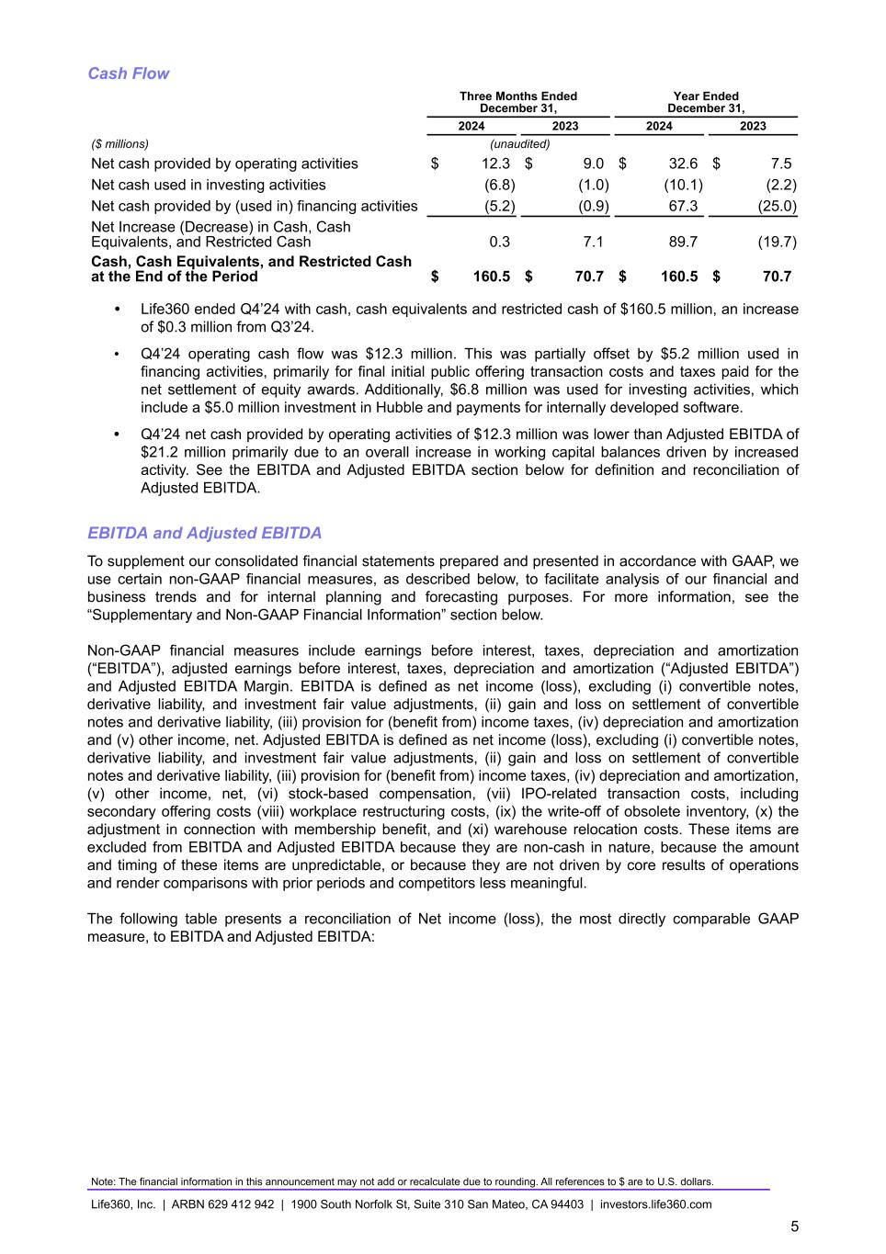
Cash Flow Three Months Ended December 31, Year Ended December 31, 2024 2023 2024 2023 ($ millions) (unaudited) Net cash provided by operating activities $ 12.3 $ 9.0 $ 32.6 $ 7.5 Net cash used in investing activities (6.8) (1.0) (10.1) (2.2) Net cash provided by (used in) financing activities (5.2) (0.9) 67.3 (25.0) Net Increase (Decrease) in Cash, Cash Equivalents, and Restricted Cash 0.3 7.1 89.7 (19.7) Cash, Cash Equivalents, and Restricted Cash at the End of the Period $ 160.5 $ 70.7 $ 160.5 $ 70.7 • Life360 ended Q4’24 with cash, cash equivalents and restricted cash of $160.5 million, an increase of $0.3 million from Q3’24. • Q4’24 operating cash flow was $12.3 million. This was partially offset by $5.2 million used in financing activities, primarily for final initial public offering transaction costs and taxes paid for the net settlement of equity awards. Additionally, $6.8 million was used for investing activities, which include a $5.0 million investment in Hubble and payments for internally developed software. • Q4’24 net cash provided by operating activities of $12.3 million was lower than Adjusted EBITDA of $21.2 million primarily due to an overall increase in working capital balances driven by increased activity. See the EBITDA and Adjusted EBITDA section below for definition and reconciliation of Adjusted EBITDA. EBITDA and Adjusted EBITDA To supplement our consolidated financial statements prepared and presented in accordance with GAAP, we use certain non-GAAP financial measures, as described below, to facilitate analysis of our financial and business trends and for internal planning and forecasting purposes. For more information, see the “Supplementary and Non-GAAP Financial Information” section below. Non-GAAP financial measures include earnings before interest, taxes, depreciation and amortization (“EBITDA”), adjusted earnings before interest, taxes, depreciation and amortization (“Adjusted EBITDA”) and Adjusted EBITDA Margin. EBITDA is defined as net income (loss), excluding (i) convertible notes, derivative liability, and investment fair value adjustments, (ii) gain and loss on settlement of convertible notes and derivative liability, (iii) provision for (benefit from) income taxes, (iv) depreciation and amortization and (v) other income, net. Adjusted EBITDA is defined as net income (loss), excluding (i) convertible notes, derivative liability, and investment fair value adjustments, (ii) gain and loss on settlement of convertible notes and derivative liability, (iii) provision for (benefit from) income taxes, (iv) depreciation and amortization, (v) other income, net, (vi) stock-based compensation, (vii) IPO-related transaction costs, including secondary offering costs (viii) workplace restructuring costs, (ix) the write-off of obsolete inventory, (x) the adjustment in connection with membership benefit, and (xi) warehouse relocation costs. These items are excluded from EBITDA and Adjusted EBITDA because they are non-cash in nature, because the amount and timing of these items are unpredictable, or because they are not driven by core results of operations and render comparisons with prior periods and competitors less meaningful. The following table presents a reconciliation of Net income (loss), the most directly comparable GAAP measure, to EBITDA and Adjusted EBITDA: Note: The financial information in this announcement may not add or recalculate due to rounding. All references to $ are to U.S. dollars. Life360, Inc. | ARBN 629 412 942 | 1900 South Norfolk St, Suite 310 San Mateo, CA 94403 | investors.life360.com 5

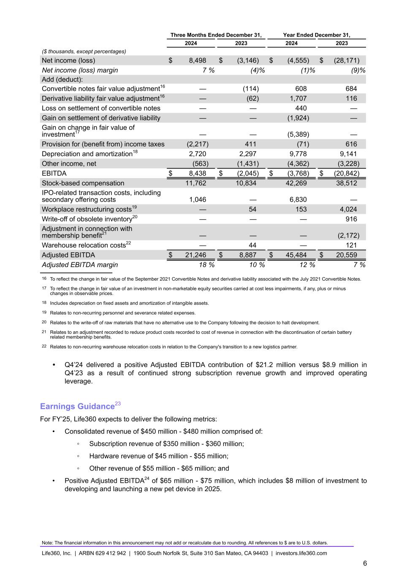
Three Months Ended December 31, Year Ended December 31, 2024 2023 2024 2023 ($ thousands, except percentages) Net income (loss) $ 8,498 $ (3,146) $ (4,555) $ (28,171) Net income (loss) margin 7 % (4) % (1) % (9) % Add (deduct): Convertible notes fair value adjustment16 — (114) 608 684 Derivative liability fair value adjustment16 — (62) 1,707 116 Loss on settlement of convertible notes — — 440 — Gain on settlement of derivative liability — — (1,924) — Gain on change in fair value of investment17 — — (5,389) — Provision for (benefit from) income taxes (2,217) 411 (71) 616 Depreciation and amortization18 2,720 2,297 9,778 9,141 Other income, net (563) (1,431) (4,362) (3,228) EBITDA $ 8,438 $ (2,045) $ (3,768) $ (20,842) Stock-based compensation 11,762 10,834 42,269 38,512 IPO-related transaction costs, including secondary offering costs 1,046 — 6,830 — Workplace restructuring costs19 — 54 153 4,024 Write-off of obsolete inventory20 — — — 916 Adjustment in connection with membership benefit21 — — — (2,172) Warehouse relocation costs22 — 44 — 121 Adjusted EBITDA $ 21,246 $ 8,887 $ 45,484 $ 20,559 Adjusted EBITDA margin 18 % 10 % 12 % 7 % 16 To reflect the change in fair value of the September 2021 Convertible Notes and derivative liability associated with the July 2021 Convertible Notes. 17 To reflect the change in fair value of an investment in non-marketable equity securities carried at cost less impairments, if any, plus or minus changes in observable prices. 18 Includes depreciation on fixed assets and amortization of intangible assets. 19 Relates to non-recurring personnel and severance related expenses. 20 Relates to the write-off of raw materials that have no alternative use to the Company following the decision to halt development. 21 Relates to an adjustment recorded to reduce product costs recorded to cost of revenue in connection with the discontinuation of certain battery related membership benefits. 22 Relates to non-recurring warehouse relocation costs in relation to the Company's transition to a new logistics partner. • Q4’24 delivered a positive Adjusted EBITDA contribution of $21.2 million versus $8.9 million in Q4’23 as a result of continued strong subscription revenue growth and improved operating leverage. Earnings Guidance23 For FY’25, Life360 expects to deliver the following metrics: • Consolidated revenue of $450 million - $480 million comprised of: ◦ Subscription revenue of $350 million - $360 million; ◦ Hardware revenue of $45 million - $55 million; ◦ Other revenue of $55 million - $65 million; and • Positive Adjusted EBITDA24 of $65 million - $75 million, which includes $8 million of investment to developing and launching a new pet device in 2025. Note: The financial information in this announcement may not add or recalculate due to rounding. All references to $ are to U.S. dollars. Life360, Inc. | ARBN 629 412 942 | 1900 South Norfolk St, Suite 310 San Mateo, CA 94403 | investors.life360.com 6

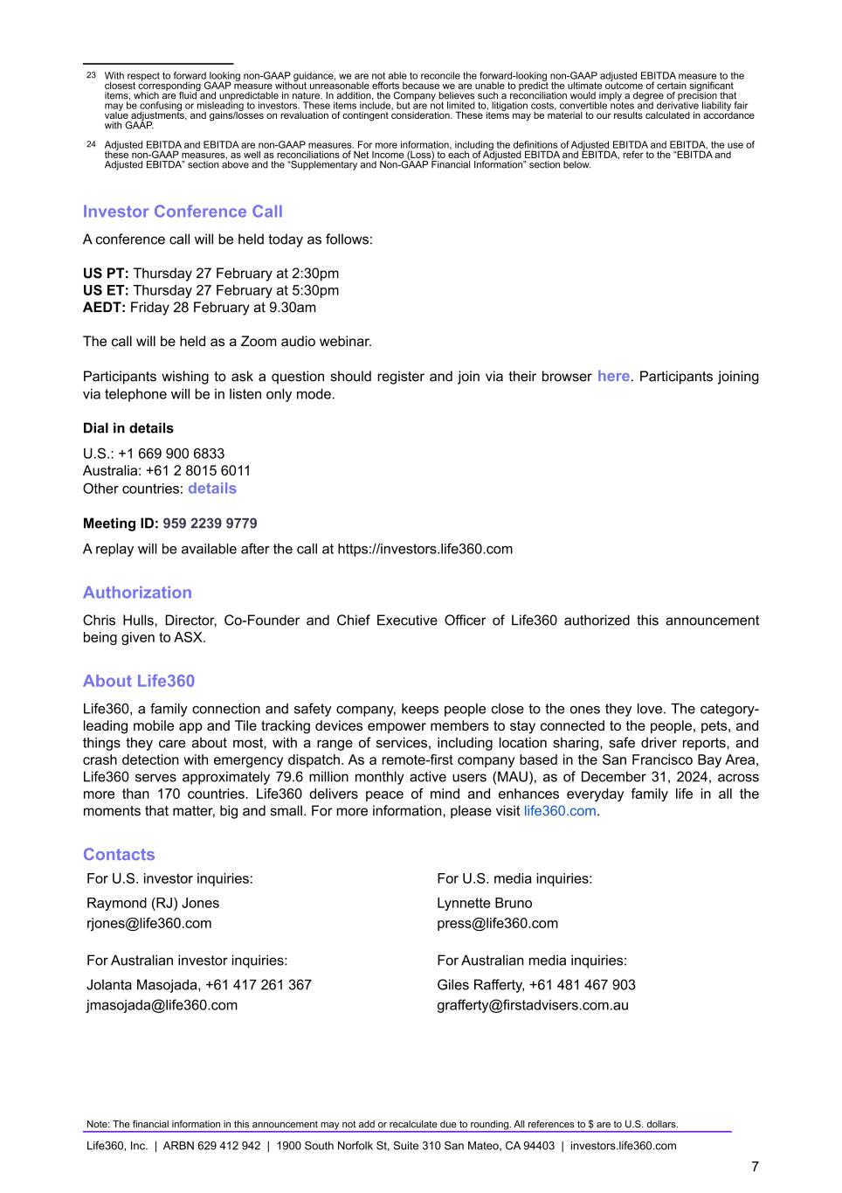
23 With respect to forward looking non-GAAP guidance, we are not able to reconcile the forward-looking non-GAAP adjusted EBITDA measure to the closest corresponding GAAP measure without unreasonable efforts because we are unable to predict the ultimate outcome of certain significant items, which are fluid and unpredictable in nature. In addition, the Company believes such a reconciliation would imply a degree of precision that may be confusing or misleading to investors. These items include, but are not limited to, litigation costs, convertible notes and derivative liability fair value adjustments, and gains/losses on revaluation of contingent consideration. These items may be material to our results calculated in accordance with GAAP. 24 Adjusted EBITDA and EBITDA are non-GAAP measures. For more information, including the definitions of Adjusted EBITDA and EBITDA, the use of these non-GAAP measures, as well as reconciliations of Net Income (Loss) to each of Adjusted EBITDA and EBITDA, refer to the “EBITDA and Adjusted EBITDA” section above and the “Supplementary and Non-GAAP Financial Information” section below. Investor Conference Call A conference call will be held today as follows: US PT: Thursday 27 February at 2:30pm US ET: Thursday 27 February at 5:30pm AEDT: Friday 28 February at 9.30am The call will be held as a Zoom audio webinar. Participants wishing to ask a question should register and join via their browser here. Participants joining via telephone will be in listen only mode. Dial in details U.S.: +1 669 900 6833 Australia: +61 2 8015 6011 Other countries: details Meeting ID: 959 2239 9779 A replay will be available after the call at https://investors.life360.com Authorization Chris Hulls, Director, Co-Founder and Chief Executive Officer of Life360 authorized this announcement being given to ASX. About Life360 Life360, a family connection and safety company, keeps people close to the ones they love. The category- leading mobile app and Tile tracking devices empower members to stay connected to the people, pets, and things they care about most, with a range of services, including location sharing, safe driver reports, and crash detection with emergency dispatch. As a remote-first company based in the San Francisco Bay Area, Life360 serves approximately 79.6 million monthly active users (MAU), as of December 31, 2024, across more than 170 countries. Life360 delivers peace of mind and enhances everyday family life in all the moments that matter, big and small. For more information, please visit life360.com. Contacts For U.S. investor inquiries: For U.S. media inquiries: Raymond (RJ) Jones Lynnette Bruno rjones@life360.com press@life360.com For Australian investor inquiries: For Australian media inquiries: Jolanta Masojada, +61 417 261 367 Giles Rafferty, +61 481 467 903 jmasojada@life360.com grafferty@firstadvisers.com.au Note: The financial information in this announcement may not add or recalculate due to rounding. All references to $ are to U.S. dollars. Life360, Inc. | ARBN 629 412 942 | 1900 South Norfolk St, Suite 310 San Mateo, CA 94403 | investors.life360.com 7

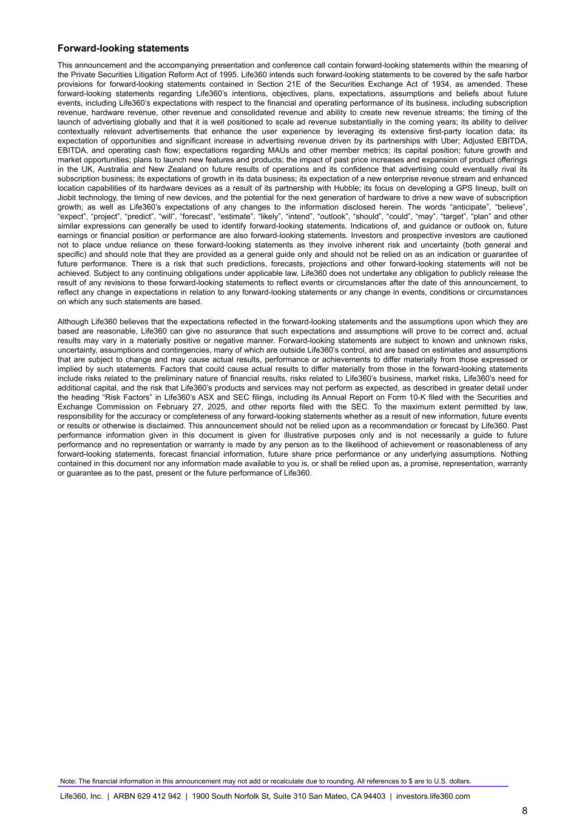
Forward-looking statements This announcement and the accompanying presentation and conference call contain forward-looking statements within the meaning of the Private Securities Litigation Reform Act of 1995. Life360 intends such forward-looking statements to be covered by the safe harbor provisions for forward-looking statements contained in Section 21E of the Securities Exchange Act of 1934, as amended. These forward-looking statements regarding Life360’s intentions, objectives, plans, expectations, assumptions and beliefs about future events, including Life360’s expectations with respect to the financial and operating performance of its business, including subscription revenue, hardware revenue, other revenue and consolidated revenue and ability to create new revenue streams; the timing of the launch of advertising globally and that it is well positioned to scale ad revenue substantially in the coming years; its ability to deliver contextually relevant advertisements that enhance the user experience by leveraging its extensive first-party location data; its expectation of opportunities and significant increase in advertising revenue driven by its partnerships with Uber; Adjusted EBITDA, EBITDA, and operating cash flow; expectations regarding MAUs and other member metrics; its capital position; future growth and market opportunities; plans to launch new features and products; the impact of past price increases and expansion of product offerings in the UK, Australia and New Zealand on future results of operations and its confidence that advertising could eventually rival its subscription business; its expectations of growth in its data business; its expectation of a new enterprise revenue stream and enhanced location capabilities of its hardware devices as a result of its partnership with Hubble; its focus on developing a GPS lineup, built on Jiobit technology, the timing of new devices, and the potential for the next generation of hardware to drive a new wave of subscription growth; as well as Life360’s expectations of any changes to the information disclosed herein. The words “anticipate”, “believe”, “expect”, “project”, “predict”, “will”, “forecast”, “estimate”, “likely”, “intend”, “outlook”, “should”, “could”, “may”, “target”, “plan” and other similar expressions can generally be used to identify forward-looking statements. Indications of, and guidance or outlook on, future earnings or financial position or performance are also forward-looking statements. Investors and prospective investors are cautioned not to place undue reliance on these forward-looking statements as they involve inherent risk and uncertainty (both general and specific) and should note that they are provided as a general guide only and should not be relied on as an indication or guarantee of future performance. There is a risk that such predictions, forecasts, projections and other forward-looking statements will not be achieved. Subject to any continuing obligations under applicable law, Life360 does not undertake any obligation to publicly release the result of any revisions to these forward-looking statements to reflect events or circumstances after the date of this announcement, to reflect any change in expectations in relation to any forward-looking statements or any change in events, conditions or circumstances on which any such statements are based. Although Life360 believes that the expectations reflected in the forward-looking statements and the assumptions upon which they are based are reasonable, Life360 can give no assurance that such expectations and assumptions will prove to be correct and, actual results may vary in a materially positive or negative manner. Forward-looking statements are subject to known and unknown risks, uncertainty, assumptions and contingencies, many of which are outside Life360’s control, and are based on estimates and assumptions that are subject to change and may cause actual results, performance or achievements to differ materially from those expressed or implied by such statements. Factors that could cause actual results to differ materially from those in the forward-looking statements include risks related to the preliminary nature of financial results, risks related to Life360’s business, market risks, Life360’s need for additional capital, and the risk that Life360’s products and services may not perform as expected, as described in greater detail under the heading “Risk Factors” in Life360’s ASX and SEC filings, including its Annual Report on Form 10-K filed with the Securities and Exchange Commission on February 27, 2025, and other reports filed with the SEC. To the maximum extent permitted by law, responsibility for the accuracy or completeness of any forward-looking statements whether as a result of new information, future events or results or otherwise is disclaimed. This announcement should not be relied upon as a recommendation or forecast by Life360. Past performance information given in this document is given for illustrative purposes only and is not necessarily a guide to future performance and no representation or warranty is made by any person as to the likelihood of achievement or reasonableness of any forward-looking statements, forecast financial information, future share price performance or any underlying assumptions. Nothing contained in this document nor any information made available to you is, or shall be relied upon as, a promise, representation, warranty or guarantee as to the past, present or the future performance of Life360. Note: The financial information in this announcement may not add or recalculate due to rounding. All references to $ are to U.S. dollars. Life360, Inc. | ARBN 629 412 942 | 1900 South Norfolk St, Suite 310 San Mateo, CA 94403 | investors.life360.com 8

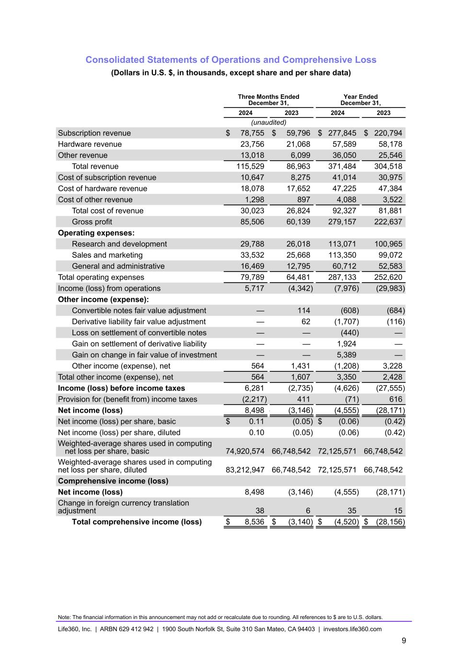
Consolidated Statements of Operations and Comprehensive Loss (Dollars in U.S. $, in thousands, except share and per share data) Three Months Ended December 31, Year Ended December 31, 2024 2023 2024 2023 (unaudited) Subscription revenue $ 78,755 $ 59,796 $ 277,845 $ 220,794 Hardware revenue 23,756 21,068 57,589 58,178 Other revenue 13,018 6,099 36,050 25,546 Total revenue 115,529 86,963 371,484 304,518 Cost of subscription revenue 10,647 8,275 41,014 30,975 Cost of hardware revenue 18,078 17,652 47,225 47,384 Cost of other revenue 1,298 897 4,088 3,522 Total cost of revenue 30,023 26,824 92,327 81,881 Gross profit 85,506 60,139 279,157 222,637 Operating expenses: Research and development 29,788 26,018 113,071 100,965 Sales and marketing 33,532 25,668 113,350 99,072 General and administrative 16,469 12,795 60,712 52,583 Total operating expenses 79,789 64,481 287,133 252,620 Income (loss) from operations 5,717 (4,342) (7,976) (29,983) Other income (expense): Convertible notes fair value adjustment — 114 (608) (684) Derivative liability fair value adjustment — 62 (1,707) (116) Loss on settlement of convertible notes — — (440) — Gain on settlement of derivative liability — — 1,924 — Gain on change in fair value of investment — — 5,389 — Other income (expense), net 564 1,431 (1,208) 3,228 Total other income (expense), net 564 1,607 3,350 2,428 Income (loss) before income taxes 6,281 (2,735) (4,626) (27,555) Provision for (benefit from) income taxes (2,217) 411 (71) 616 Net income (loss) 8,498 — (3,146) (4,555) (28,171) Net income (loss) per share, basic $ 0.11 (0.05) $ (0.06) (0.42) Net income (loss) per share, diluted 0.10 (0.05) (0.06) (0.42) Weighted-average shares used in computing net loss per share, basic 74,920,574 66,748,542 72,125,571 66,748,542 Weighted-average shares used in computing net loss per share, diluted 83,212,947 66,748,542 72,125,571 66,748,542 Comprehensive income (loss) Net income (loss) 8,498 (3,146) (4,555) (28,171) Change in foreign currency translation adjustment 38 6 35 15 Total comprehensive income (loss) $ 8,536 $ (3,140) $ (4,520) $ (28,156) Note: The financial information in this announcement may not add or recalculate due to rounding. All references to $ are to U.S. dollars. Life360, Inc. | ARBN 629 412 942 | 1900 South Norfolk St, Suite 310 San Mateo, CA 94403 | investors.life360.com 9

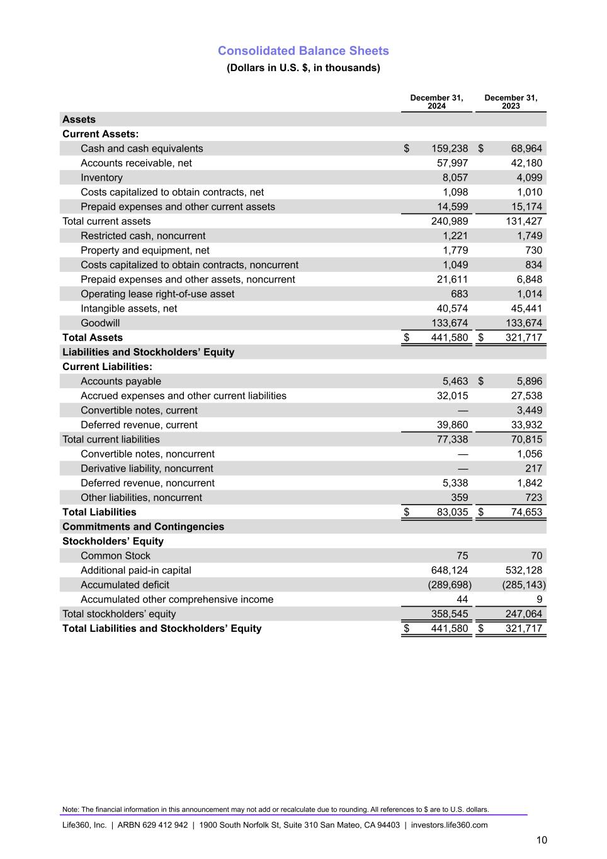
Consolidated Balance Sheets (Dollars in U.S. $, in thousands) December 31, 2024 December 31, 2023 Assets Current Assets: Cash and cash equivalents $ 159,238 $ 68,964 Accounts receivable, net 57,997 42,180 Inventory 8,057 4,099 Costs capitalized to obtain contracts, net 1,098 1,010 Prepaid expenses and other current assets 14,599 15,174 Total current assets 240,989 131,427 Restricted cash, noncurrent 1,221 1,749 Property and equipment, net 1,779 730 Costs capitalized to obtain contracts, noncurrent 1,049 834 Prepaid expenses and other assets, noncurrent 21,611 6,848 Operating lease right-of-use asset 683 1,014 Intangible assets, net 40,574 45,441 Goodwill 133,674 133,674 Total Assets $ 441,580 $ 321,717 Liabilities and Stockholders’ Equity Current Liabilities: Accounts payable 5,463 $ 5,896 Accrued expenses and other current liabilities 32,015 27,538 Convertible notes, current — 3,449 Deferred revenue, current 39,860 33,932 Total current liabilities 77,338 70,815 Convertible notes, noncurrent — 1,056 Derivative liability, noncurrent — 217 Deferred revenue, noncurrent 5,338 1,842 Other liabilities, noncurrent 359 723 Total Liabilities $ 83,035 $ 74,653 Commitments and Contingencies Stockholders’ Equity Common Stock 75 70 Additional paid-in capital 648,124 532,128 Accumulated deficit (289,698) (285,143) Accumulated other comprehensive income 44 9 Total stockholders’ equity 358,545 247,064 Total Liabilities and Stockholders’ Equity $ 441,580 $ 321,717 Note: The financial information in this announcement may not add or recalculate due to rounding. All references to $ are to U.S. dollars. Life360, Inc. | ARBN 629 412 942 | 1900 South Norfolk St, Suite 310 San Mateo, CA 94403 | investors.life360.com 10

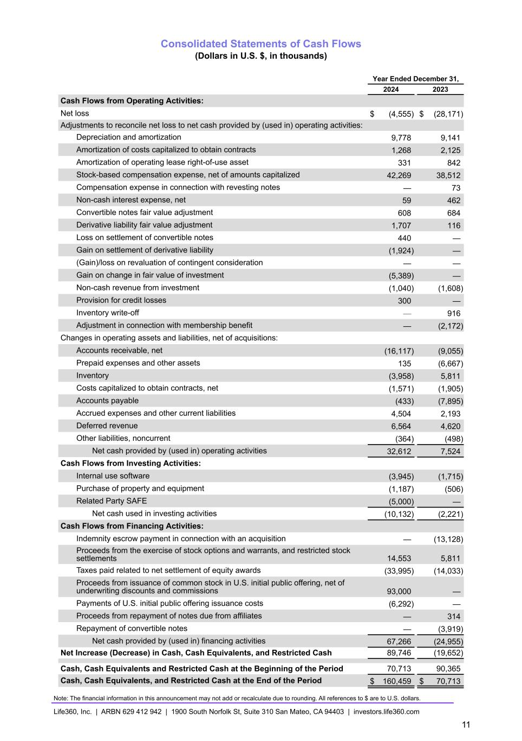
Consolidated Statements of Cash Flows (Dollars in U.S. $, in thousands) Year Ended December 31, 2024 2023 Cash Flows from Operating Activities: Net loss $ (4,555) $ (28,171) Adjustments to reconcile net loss to net cash provided by (used in) operating activities: Depreciation and amortization 9,778 9,141 Amortization of costs capitalized to obtain contracts 1,268 2,125 Amortization of operating lease right-of-use asset 331 842 Stock-based compensation expense, net of amounts capitalized 42,269 38,512 Compensation expense in connection with revesting notes — 73 Non-cash interest expense, net 59 462 Convertible notes fair value adjustment 608 684 Derivative liability fair value adjustment 1,707 116 Loss on settlement of convertible notes 440 — Gain on settlement of derivative liability (1,924) — (Gain)/loss on revaluation of contingent consideration — — Gain on change in fair value of investment (5,389) — Non-cash revenue from investment (1,040) (1,608) Provision for credit losses 300 — Inventory write-off — 916 Adjustment in connection with membership benefit — (2,172) Changes in operating assets and liabilities, net of acquisitions: Accounts receivable, net (16,117) (9,055) Prepaid expenses and other assets 135 (6,667) Inventory (3,958) 5,811 Costs capitalized to obtain contracts, net (1,571) (1,905) Accounts payable (433) (7,895) Accrued expenses and other current liabilities 4,504 2,193 Deferred revenue 6,564 4,620 Other liabilities, noncurrent (364) (498) Net cash provided by (used in) operating activities 32,612 7,524 Cash Flows from Investing Activities: Internal use software (3,945) (1,715) Purchase of property and equipment (1,187) (506) Related Party SAFE (5,000) — Net cash used in investing activities (10,132) (2,221) Cash Flows from Financing Activities: Indemnity escrow payment in connection with an acquisition — (13,128) Proceeds from the exercise of stock options and warrants, and restricted stock settlements 14,553 5,811 Taxes paid related to net settlement of equity awards (33,995) (14,033) Proceeds from issuance of common stock in U.S. initial public offering, net of underwriting discounts and commissions 93,000 — Payments of U.S. initial public offering issuance costs (6,292) — Proceeds from repayment of notes due from affiliates — 314 Repayment of convertible notes — (3,919) Net cash provided by (used in) financing activities 67,266 (24,955) Net Increase (Decrease) in Cash, Cash Equivalents, and Restricted Cash 89,746 (19,652) Cash, Cash Equivalents and Restricted Cash at the Beginning of the Period 70,713 90,365 Cash, Cash Equivalents, and Restricted Cash at the End of the Period $ 160,459 $ 70,713 Note: The financial information in this announcement may not add or recalculate due to rounding. All references to $ are to U.S. dollars. Life360, Inc. | ARBN 629 412 942 | 1900 South Norfolk St, Suite 310 San Mateo, CA 94403 | investors.life360.com 11

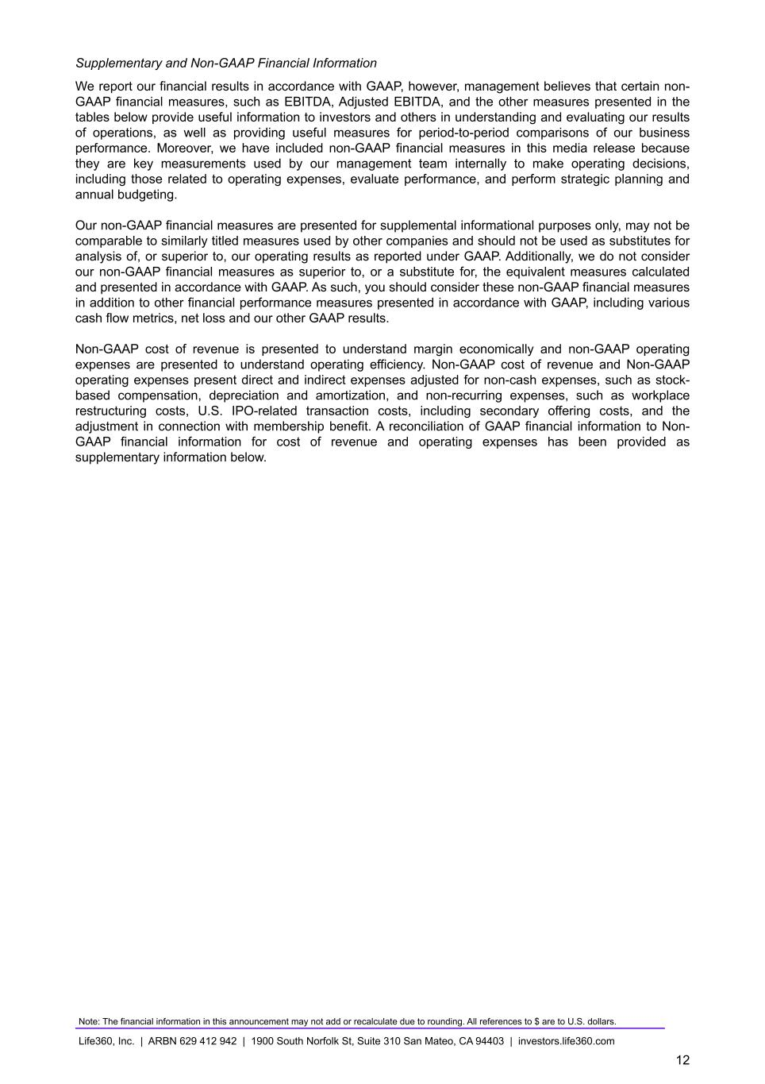
Supplementary and Non-GAAP Financial Information We report our financial results in accordance with GAAP, however, management believes that certain non- GAAP financial measures, such as EBITDA, Adjusted EBITDA, and the other measures presented in the tables below provide useful information to investors and others in understanding and evaluating our results of operations, as well as providing useful measures for period-to-period comparisons of our business performance. Moreover, we have included non-GAAP financial measures in this media release because they are key measurements used by our management team internally to make operating decisions, including those related to operating expenses, evaluate performance, and perform strategic planning and annual budgeting. Our non-GAAP financial measures are presented for supplemental informational purposes only, may not be comparable to similarly titled measures used by other companies and should not be used as substitutes for analysis of, or superior to, our operating results as reported under GAAP. Additionally, we do not consider our non-GAAP financial measures as superior to, or a substitute for, the equivalent measures calculated and presented in accordance with GAAP. As such, you should consider these non-GAAP financial measures in addition to other financial performance measures presented in accordance with GAAP, including various cash flow metrics, net loss and our other GAAP results. Non-GAAP cost of revenue is presented to understand margin economically and non-GAAP operating expenses are presented to understand operating efficiency. Non-GAAP cost of revenue and Non-GAAP operating expenses present direct and indirect expenses adjusted for non-cash expenses, such as stock- based compensation, depreciation and amortization, and non-recurring expenses, such as workplace restructuring costs, U.S. IPO-related transaction costs, including secondary offering costs, and the adjustment in connection with membership benefit. A reconciliation of GAAP financial information to Non- GAAP financial information for cost of revenue and operating expenses has been provided as supplementary information below. Note: The financial information in this announcement may not add or recalculate due to rounding. All references to $ are to U.S. dollars. Life360, Inc. | ARBN 629 412 942 | 1900 South Norfolk St, Suite 310 San Mateo, CA 94403 | investors.life360.com 12

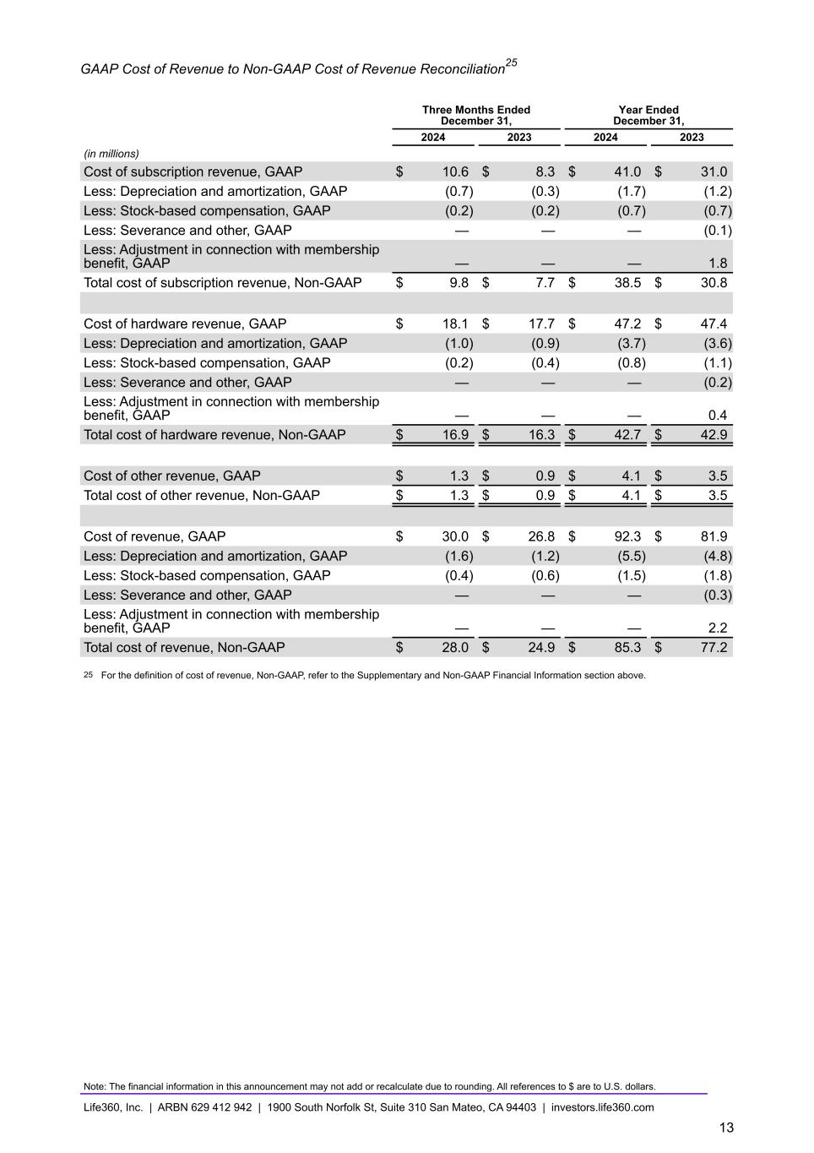
GAAP Cost of Revenue to Non-GAAP Cost of Revenue Reconciliation25 Three Months Ended December 31, Year Ended December 31, 2024 2023 2024 2023 (in millions) Cost of subscription revenue, GAAP $ 10.6 $ 8.3 $ 41.0 $ 31.0 Less: Depreciation and amortization, GAAP (0.7) (0.3) (1.7) (1.2) Less: Stock-based compensation, GAAP (0.2) (0.2) (0.7) (0.7) Less: Severance and other, GAAP — — — (0.1) Less: Adjustment in connection with membership benefit, GAAP — — — 1.8 Total cost of subscription revenue, Non-GAAP $ 9.8 $ 7.7 $ 38.5 $ 30.8 Cost of hardware revenue, GAAP $ 18.1 $ 17.7 $ 47.2 $ 47.4 Less: Depreciation and amortization, GAAP (1.0) (0.9) (3.7) (3.6) Less: Stock-based compensation, GAAP (0.2) (0.4) (0.8) (1.1) Less: Severance and other, GAAP — — — (0.2) Less: Adjustment in connection with membership benefit, GAAP — — — 0.4 Total cost of hardware revenue, Non-GAAP $ 16.9 $ 16.3 $ 42.7 $ 42.9 Cost of other revenue, GAAP $ 1.3 $ 0.9 $ 4.1 $ 3.5 Total cost of other revenue, Non-GAAP $ 1.3 $ 0.9 $ 4.1 $ 3.5 Cost of revenue, GAAP $ 30.0 $ 26.8 $ 92.3 $ 81.9 Less: Depreciation and amortization, GAAP (1.6) (1.2) (5.5) (4.8) Less: Stock-based compensation, GAAP (0.4) (0.6) (1.5) (1.8) Less: Severance and other, GAAP — — — (0.3) Less: Adjustment in connection with membership benefit, GAAP — — — 2.2 Total cost of revenue, Non-GAAP $ 28.0 $ 24.9 $ 85.3 $ 77.2 25 For the definition of cost of revenue, Non-GAAP, refer to the Supplementary and Non-GAAP Financial Information section above. Note: The financial information in this announcement may not add or recalculate due to rounding. All references to $ are to U.S. dollars. Life360, Inc. | ARBN 629 412 942 | 1900 South Norfolk St, Suite 310 San Mateo, CA 94403 | investors.life360.com 13

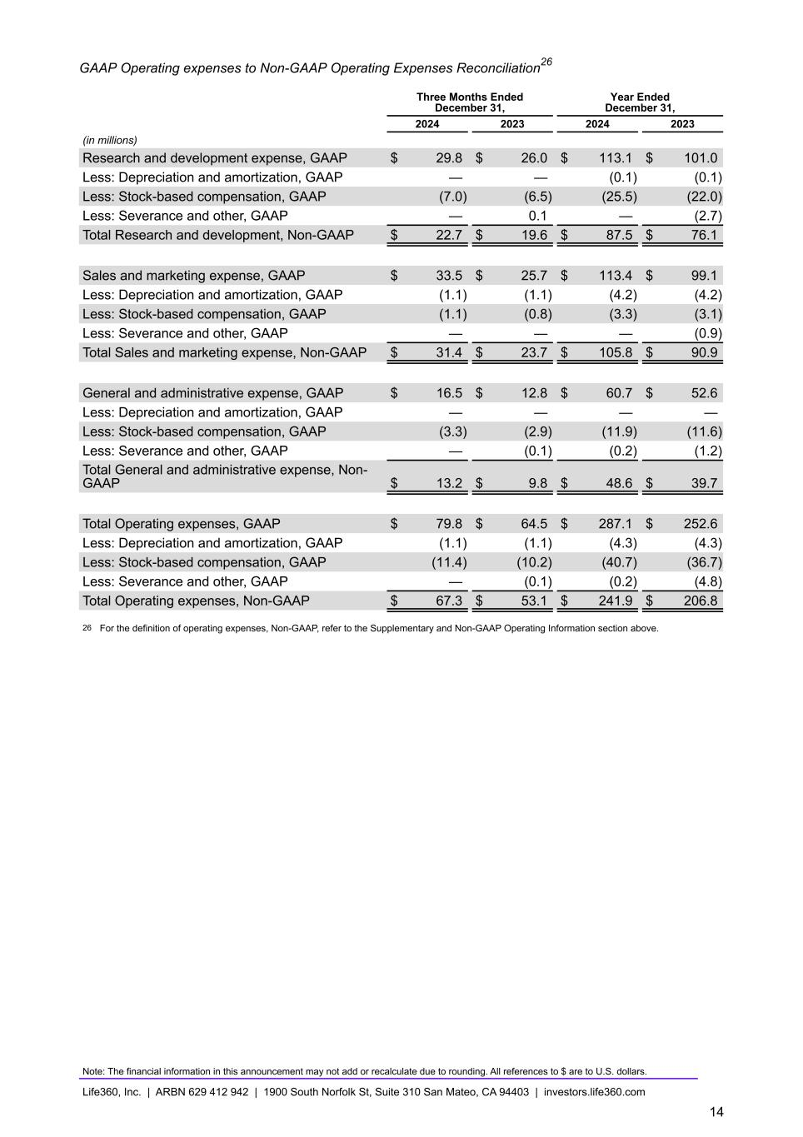
GAAP Operating expenses to Non-GAAP Operating Expenses Reconciliation26 Three Months Ended December 31, Year Ended December 31, 2024 2023 2024 2023 (in millions) Research and development expense, GAAP $ 29.8 $ 26.0 $ 113.1 $ 101.0 Less: Depreciation and amortization, GAAP — — (0.1) (0.1) Less: Stock-based compensation, GAAP (7.0) (6.5) (25.5) (22.0) Less: Severance and other, GAAP — 0.1 — (2.7) Total Research and development, Non-GAAP $ 22.7 $ 19.6 $ 87.5 $ 76.1 Sales and marketing expense, GAAP $ 33.5 $ 25.7 $ 113.4 $ 99.1 Less: Depreciation and amortization, GAAP (1.1) (1.1) (4.2) (4.2) Less: Stock-based compensation, GAAP (1.1) (0.8) (3.3) (3.1) Less: Severance and other, GAAP — — — (0.9) Total Sales and marketing expense, Non-GAAP $ 31.4 $ 23.7 $ 105.8 $ 90.9 General and administrative expense, GAAP $ 16.5 $ 12.8 $ 60.7 $ 52.6 Less: Depreciation and amortization, GAAP — — — — Less: Stock-based compensation, GAAP (3.3) (2.9) (11.9) (11.6) Less: Severance and other, GAAP — (0.1) (0.2) (1.2) Total General and administrative expense, Non- GAAP $ 13.2 $ 9.8 $ 48.6 $ 39.7 Total Operating expenses, GAAP $ 79.8 $ 64.5 $ 287.1 $ 252.6 Less: Depreciation and amortization, GAAP (1.1) (1.1) (4.3) (4.3) Less: Stock-based compensation, GAAP (11.4) (10.2) (40.7) (36.7) Less: Severance and other, GAAP — (0.1) (0.2) (4.8) Total Operating expenses, Non-GAAP $ 67.3 $ 53.1 $ — $ 241.9 $ 206.8 26 For the definition of operating expenses, Non-GAAP, refer to the Supplementary and Non-GAAP Operating Information section above. Note: The financial information in this announcement may not add or recalculate due to rounding. All references to $ are to U.S. dollars. Life360, Inc. | ARBN 629 412 942 | 1900 South Norfolk St, Suite 310 San Mateo, CA 94403 | investors.life360.com 14


Investor Presentation | February 2025 27 February 2025 US PT 28 February 2025 AEDT Investor Presentation FY’24


Investor Presentation | February 2025 DISCLAIMER These materials and the accompanying oral presentation have been prepared by Life360, Inc. (ARBN 629 412 942) (“Company”) on a confidential and non-reliance basis, and may not be reproduced in whole or in part, nor may any of its contents be disclosed, to any other person, without the prior written consent of the Company. These materials are for informational purposes only. This presentation contains summary information about the Company and its activities and is current as of the date of this presentation. This presentation does not purport to be all-inclusive or to contain all of the information you may desire. It should be read in conjunction with the Company’s periodic and continuous disclosure announcements filed with the Australian Securities Exchange and the U.S. Securities and Exchange Commission (“SEC”), available at www.asx.com.au and www.sec.gov, respectively. These materials do not constitute an offer, invitation, solicitation or recommendation with respect to the purchase or sale of any security in the Company or interest therein nor does it constitute financial product advice. These materials are not a prospectus, product disclosure statement or other offer document under Australian law or under any other law. These materials have not been filed, registered or approved by regulatory authorities in any jurisdiction. This communication is restricted by law; it is not intended for distribution to, or use by any person in, any jurisdiction where such distribution or use would be contrary to local law or regulation. The information contained in these materials is not intended to be relied upon as advice or a recommendation to investors and is not intended to form the basis of any investment decision in the Company’s securities. The information does not take into account the investment objectives, financial situation, taxation situation or needs of any particular investor. An investor must not act on the basis of any matter contained in these materials but must make its own assessment of the Company and conduct its own investigations and analysis. Investors should assess their own individual financial circumstances and consider talking to a financial adviser, professional adviser or consultant before making any investment decision. By reading these materials you agree to be bound by the limitations set out in these materials. No representation or warranty, express or implied, is made as to the accuracy, reliability, completeness or fairness of the information, opinions, forecasts, reports, estimates and conclusions contained in these materials. The Company does not undertake any obligation to provide any additional information nor update or revise the information in these materials nor correct any inaccuracies or omissions. To the maximum extent permitted by law, none of the Company and its related bodies corporate, or their respective directors, employees or agents, nor any other person accepts any responsibility nor any liability for loss arising from the use of or reliance on information contained in these materials or otherwise arising in connection with it, nor in relation to any other written or oral information or opinions provided now or in the future to the recipient or its advisers and representatives, including without limitation any liability from fault of negligence. Past performance is not indicative of future performance and no guarantee of future returns is implied or given. Nothing contained in these materials nor any information made available to you is, or shall be relied upon as, a promise, representation, warranty or guarantee as to the past, present or the future performance of the Company. Certain statements in these materials constitute forward-looking statements within the meaning of the Private Securities Litigation Reform Act of 1995 (“PLSRA”), Section 27A of the Securities Act of 1933, as amended, and Section 21E of the Securities Exchange Act of 1934, as amended (the “Exchange Act”). Statements that are not historical in nature, including the words “anticipate”, “expect”, “suggests”, “plan”, “believe”, “intend”, “estimates”, “targets”, “projects”, “should”, “could”, “would”, “may”, “will”, “forecast,” “opportunity,” “goal,” “vision,” “outlook” and other similar expressions are intended to identify forward-looking statements. These forward- looking statements include, but are not limited to, statements regarding: the Company’s growth strategy and business plan and the Company’s ability to effectively manage its growth and meet future capital requirements; the Company’s expectations regarding future financial performance, including its expectations regarding its revenue, revenue growth, adjusted EBITDA, and operating cash flow, and the Company’s ability to achieve or maintain future profitability; the Company’s ability to further penetrate its existing member base, maintain and expand its member base and increase monetization of its member base; the Company’s ability to expand internationally and the significance of its global opportunity; the Company’s ability to anticipate market needs or develop new products and services or enhance existing products and services to meet those needs; and the Company’s ability to increase sales of its products and services. Such forward-looking statements are prediction, projections and other statements about future events that are based on current expectations and assumptions and, as a result, involve known and unknown risks, uncertainties, assumptions and other important factors, many of which are beyond the control of the Company and which may cause actual results, performance or achievements to differ materially from those expressed or implied by such statements. Forward-looking statements are provided as a general guide only, and should not be relied on as an indication or guarantee of future performance. They can be affected by inaccurate assumptions we might make or by known or unknown risks or uncertainties. Given these uncertainties, recipients are cautioned to not place undue reliance on any forward- looking statement. Forward-looking statements speak only as of the date they are made. Subject to any continuing obligations under applicable law the Company disclaims any obligation or undertaking to disseminate any updates or revisions to any forward-looking statements in these materials to reflect any change in expectations in relation to such forward-looking statements or any change in events, conditions or circumstances on which any such statement is based. This presentation contains certain measures of financial performance not determined in accordance with U.S. generally accepted accounting principles (“GAAP”), including EBITDA, Adjusted EBITDA, Adjusted EBITDA margin, and non- GAAP Operating Expenses (the “non-GAAP financial measures”). The non-GAAP financial measures are used by Company management to evaluate financial performance of, and determine resource allocation for, each of the Company's operating segments. Items excluded from each of the non-GAAP financial measures are significant components in understanding and assessing financial performance. The non-GAAP financial measures should not be considered in isolation, or as alternatives to, or substitutes for, net income, net income margin, income from operations, cash flows generated by operations, investing or financing activities, or other financial statement data presented in the Company's consolidated financial statements as indicators of financial performance or liquidity. Because the non- GAAP financial measures are not measurements determined in accordance with GAAP and are thus susceptible to varying definitions, the non-GAAP financial measurements as presented may not be comparable to other similarly titled measures of other companies. Please refer to the Appendix beginning on slide 48 of this presentation for a reconciliation of these financial measures to the most directly comparable financial measure prepared in accordance with GAAP. This presentation includes our trademarks and trade names that we own or license and our logo. This presentation also includes trademarks, trade names and service marks that are the property of other organizations. Solely for convenience, trademarks and trade names referred to in this prospectus appear without any “TM” or “®” symbol, but those references are not intended to indicate, in any way, that we will not assert, to the fullest extent under applicable law, our rights to these trademarks, trade names and service marks. We do not intend our use or display of other parties' trademarks, trade names or service marks to imply, and such use or display should not be construed to imply, a relationship with, or endorsement or sponsorship of us by, these other parties. This presentation includes industry and market data derived from internal analyses based upon publicly available data or other proprietary research and analysis, surveys or studies conducted by third parties and industry and general publications. Unless otherwise indicated, information contained in this presentation concerning our industry and the markets in which we operate, including our general expectations and market position, market opportunity and market size, is based on these various sources. Because this information involves a number of assumptions and limitations, you are cautioned not to give undue weight to such information. We have not independently verified market data and industry forecasts provided by any of these or any other third-party sources referred to in this presentation. All values are stated in US dollars unless otherwise stated.


Investor Presentation | February 2025 01 | Life360 Overview (4 – 32) 02 | Financial Update FY’24 (33 – 45) Contents 03 | FY’25 Outlook (46 – 47) 1. 2. 3. 4. 5. 04 | Appendix (48 – 56) Operating metrics Financials GAAP to Non-GAAP reconciliations & Non-GAAP financial measures Competitive landscape Dual tier offering 3


Investor Presentation | February 2025 Life360 Overview 01

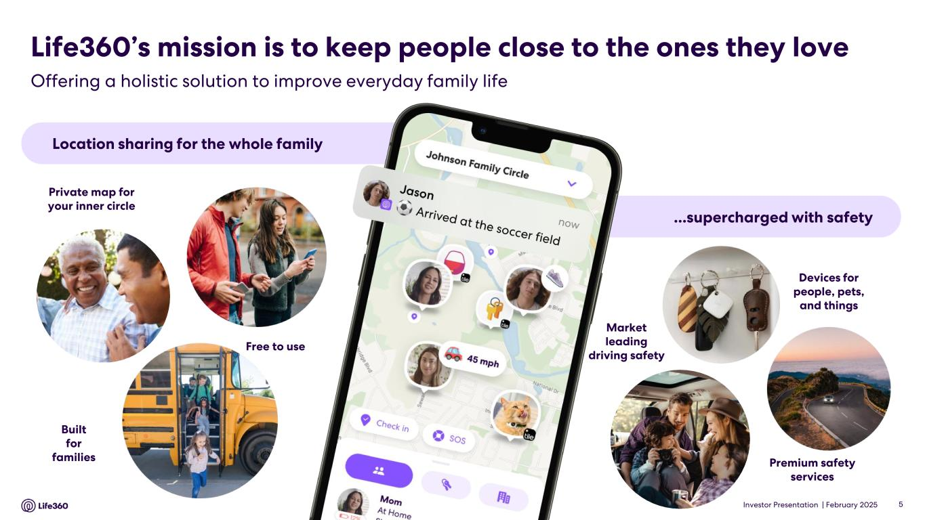
Investor Presentation | February 2025 Offering a holistic solution to improve everyday family life Location sharing for the whole family ...supercharged with safety Private map for your inner circle Free to use Built for families Devices for people, pets, and things Premium safety services Market leading driving safety Life360’s mission is to keep people close to the ones they love 5

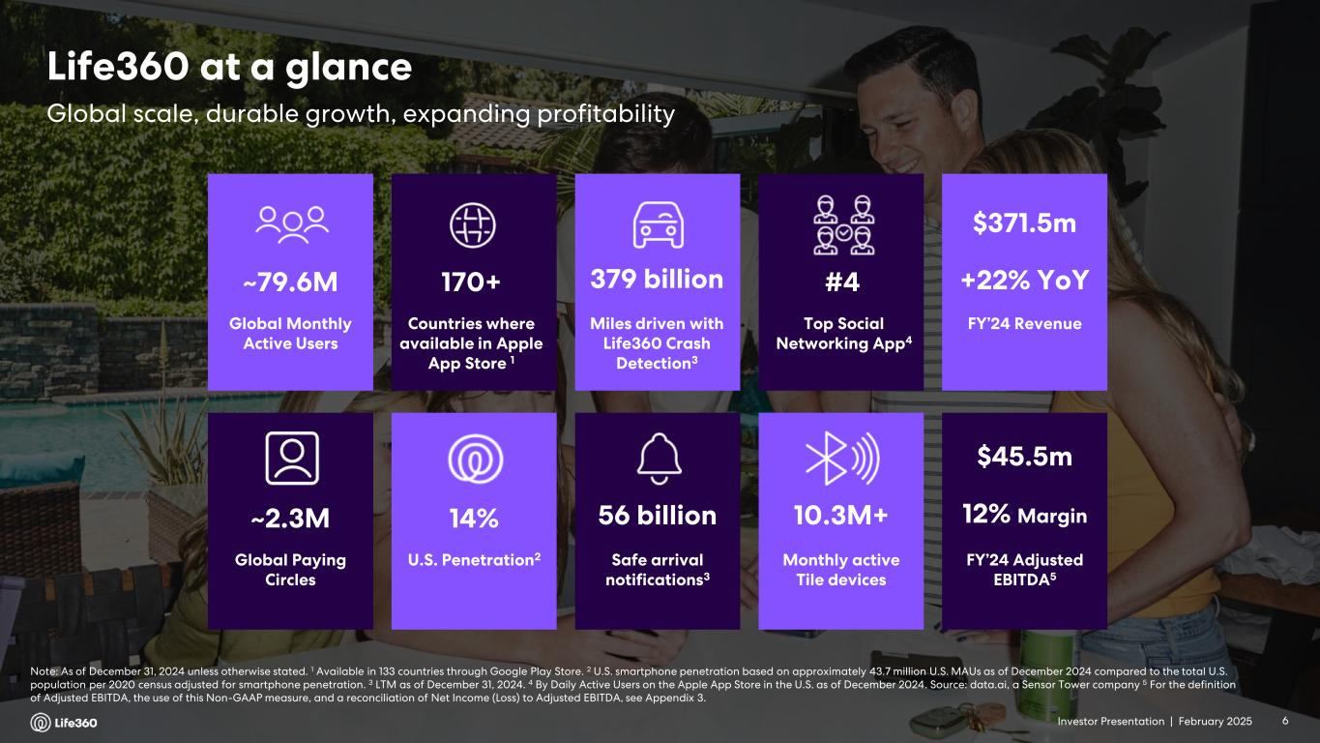
Investor Presentation | February 2025 Note: As of December 31, 2024 unless otherwise stated. 1 Available in 133 countries through Google Play Store. 2 U.S. smartphone penetration based on approximately 43.7 million U.S. MAUs as of December 2024 compared to the total U.S. population per 2020 census adjusted for smartphone penetration. 3 LTM as of December 31, 2024. 4 By Daily Active Users on the Apple App Store in the U.S. as of December 2024. Source: data.ai, a Sensor Tower company 5 For the definition of Adjusted EBITDA, the use of this Non-GAAP measure, and a reconciliation of Net Income (Loss) to Adjusted EBITDA, see Appendix 3. Global Paying Circles ~2.3M Safe arrival notifications3 56 billion U.S. Penetration2 14% 10.3M+ Monthly active Tile devices Global Monthly Active Users ~79.6M Miles driven with Life360 Crash Detection3 379 billion Countries where available in Apple App Store 1 170+ Top Social Networking App4 #4 FY’24 Revenue $371.5m +22% YoY FY’24 Adjusted EBITDA5 $45.5m 12% Margin Global scale, durable growth, expanding profitability Life360 at a glance 6Investor Presentation |

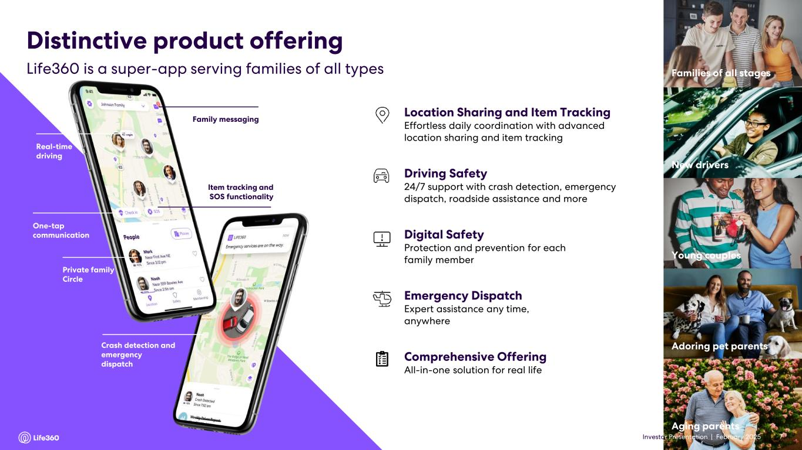
Investor Presentation | February 2025 7 Family messaging Real-time driving One-tap communication Private family Circle Item tracking and SOS functionality Crash detection and emergency dispatch Driving Safety 24/7 support with crash detection, emergency dispatch, roadside assistance and more Digital Safety Protection and prevention for each family member Location Sharing and Item Tracking Effortless daily coordination with advanced location sharing and item tracking Emergency Dispatch Expert assistance any time, anywhere Comprehensive Offering All-in-one solution for real life Young couples New drivers Families of all stages Aging parents Adoring pet parents Life360 is a super-app serving families of all types Distinctive product offering 7Investor Presentation |

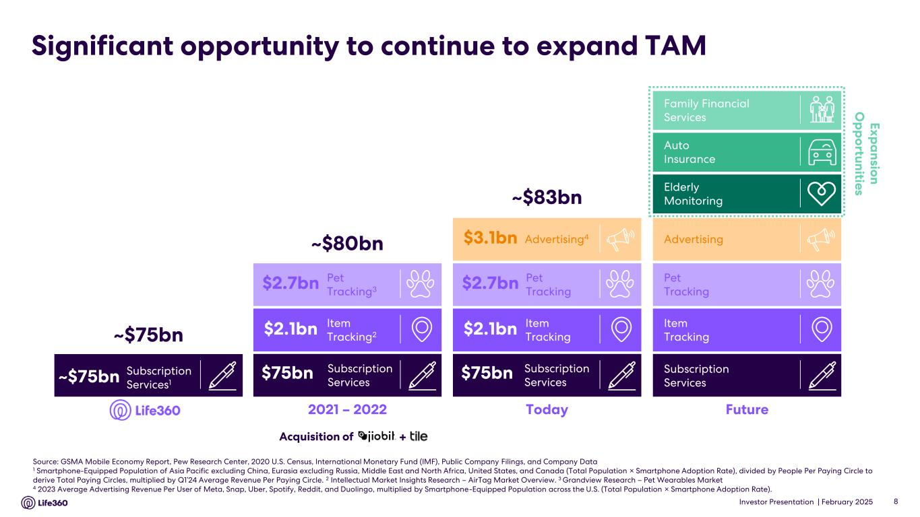
Investor Presentation | February 2025 Significant opportunity to continue to expand TAM Source: GSMA Mobile Economy Report, Pew Research Center, 2020 U.S. Census, International Monetary Fund (IMF), Public Company Filings, and Company Data 1 Smartphone-Equipped Population of Asia Pacific excluding China, Eurasia excluding Russia, Middle East and North Africa, United States, and Canada (Total Population × Smartphone Adoption Rate), divided by People Per Paying Circle to derive Total Paying Circles, multiplied by Q1’24 Average Revenue Per Paying Circle. 2 Intellectual Market Insights Research – AirTag Market Overview. 3 Grandview Research – Pet Wearables Market 4 2023 Average Advertising Revenue Per User of Meta, Snap, Uber, Spotify, Reddit, and Duolingo, multiplied by Smartphone-Equipped Population across the U.S. (Total Population × Smartphone Adoption Rate). 8 2021 – 2022 ~$80bn Item Tracking2 Pet Tracking3 Subscription Services $2.7bn $2.1bn $75bn Today ~$83bn Advertising4 Item Tracking Pet Tracking Subscription Services $2.7bn $2.1bn $75bn $3.1bn Subscription Services1 ~$75bn ~$75bn Acquisition of + Future E x p a n sio n O p p o rtu n itie s Family Financial Services Elderly Monitoring Auto Insurance Advertising Item Tracking Pet Tracking Subscription Services

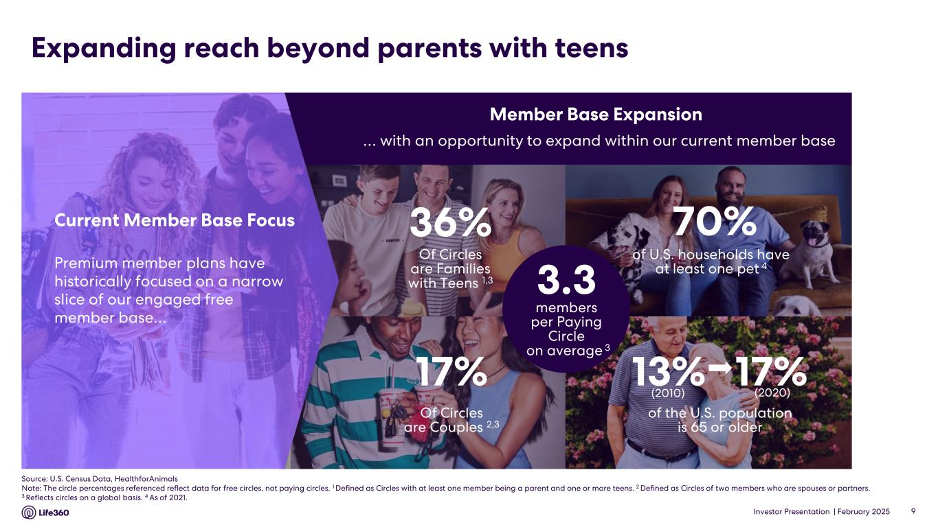
Investor Presentation | February 2025 Expanding reach beyond parents with teens 9 Of Circles are Families with Teens 1,3 36% of U.S. households have at least one pet 4 of the U.S. population is 65 or older 13% 17% (2020)(2010) Of Circles are Couples 2,3 17% 70% … with an opportunity to expand within our current member base Premium member plans have historically focused on a narrow slice of our engaged free member base… Current Member Base Focus Member Base Expansion 3.3 members per Paying Circle on average 3 Source: U.S. Census Data, HealthforAnimals Note: The circle percentages referenced reflect data for free circles, not paying circles. 1 Defined as Circles with at least one member being a parent and one or more teens. 2 Defined as Circles of two members who are spouses or partners. 3 Reflects circles on a global basis. 4 As of 2021.

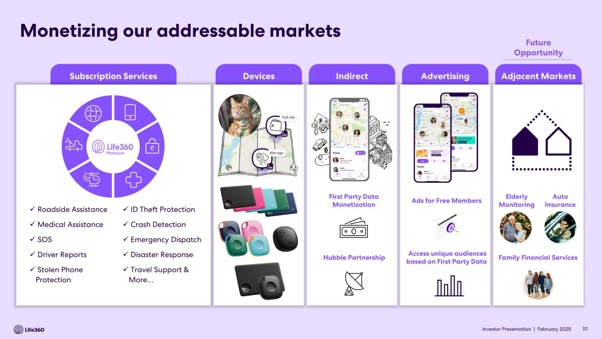
Investor Presentation | February 2025 Subscription Services IndirectDevices Advertising Adjacent Markets Monetizing our addressable markets ✓ Roadside Assistance ✓ Medical Assistance ✓ SOS ✓ Driver Reports ✓ Stolen Phone Protection ✓ ID Theft Protection ✓ Crash Detection ✓ Emergency Dispatch ✓ Disaster Response ✓ Travel Support & More… Platinum Ads for Free Members Access unique audiences based on First Party Data Elderly Monitoring Family Financial Services Auto Insurance First Party Data Monetization Hubble Partnership 10 Future Opportunity Investor Presentation |

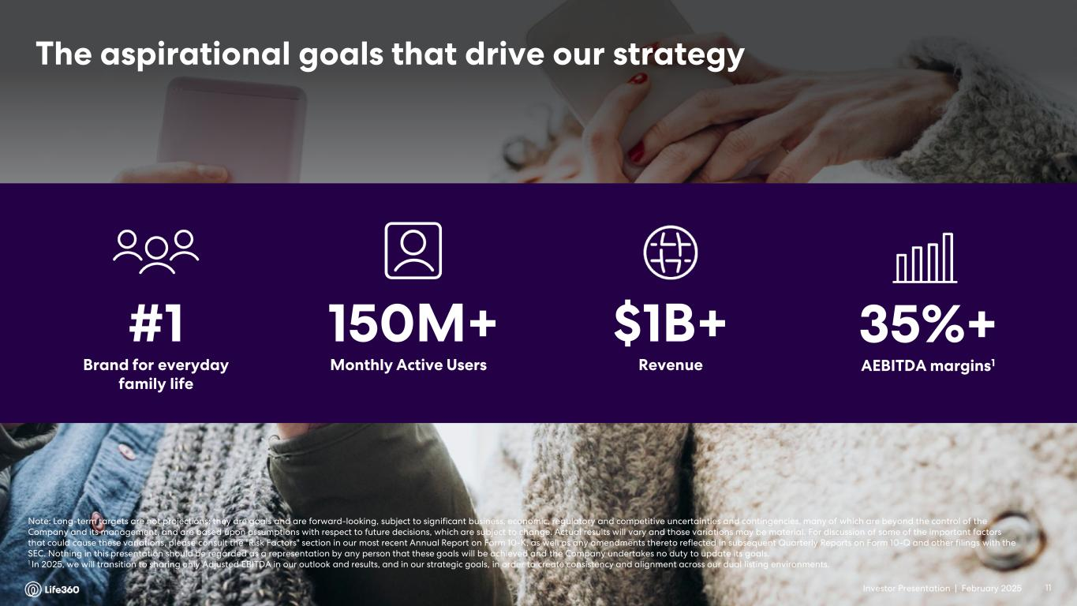
Investor Presentation | February 2025 The aspirational goals that drive our strategy #1 Brand for everyday family life 150M+ Monthly Active Users $1B+ Revenue 35%+ AEBITDA margins1 Note: Long-term targets are not projections; they are goals and are forward-looking, subject to significant business, economic, regulatory and competitive uncertainties and contingencies, many of which are beyond the control of the Company and its management, and are based upon assumptions with respect to future decisions, which are subject to change. Actual results will vary and those variations may be material. For discussion of some of the important factors that could cause these variations, please consult the "Risk Factors" section in our most recent Annual Report on Form 10-K, as well as any amendments thereto reflected in subsequent Quarterly Reports on Form 10-Q and other filings with the SEC. Nothing in this presentation should be regarded as a representation by any person that these goals will be achieved and the Company undertakes no duty to update its goals. 1 In 2025, we will transition to sharing only Adjusted EBITDA in our outlook and results, and in our strategic goals, in order to create consistency and alignment across our dual listing environments. 11Investor Presentation |

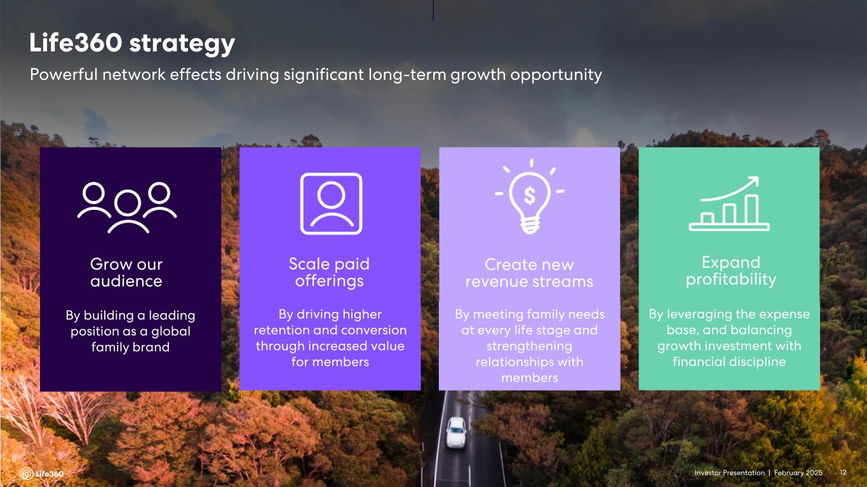
Investor Presentation | February 2025 Grow our audience By building a leading position as a global family brand Scale paid offerings By driving higher retention and conversion through increased value for members Create new revenue streams By meeting family needs at every life stage and strengthening relationships with members Expand profitability By leveraging the expense base, and balancing growth investment with financial discipline Powerful network effects driving significant long-term growth opportunity Life360 strategy 12Investor Presentation |

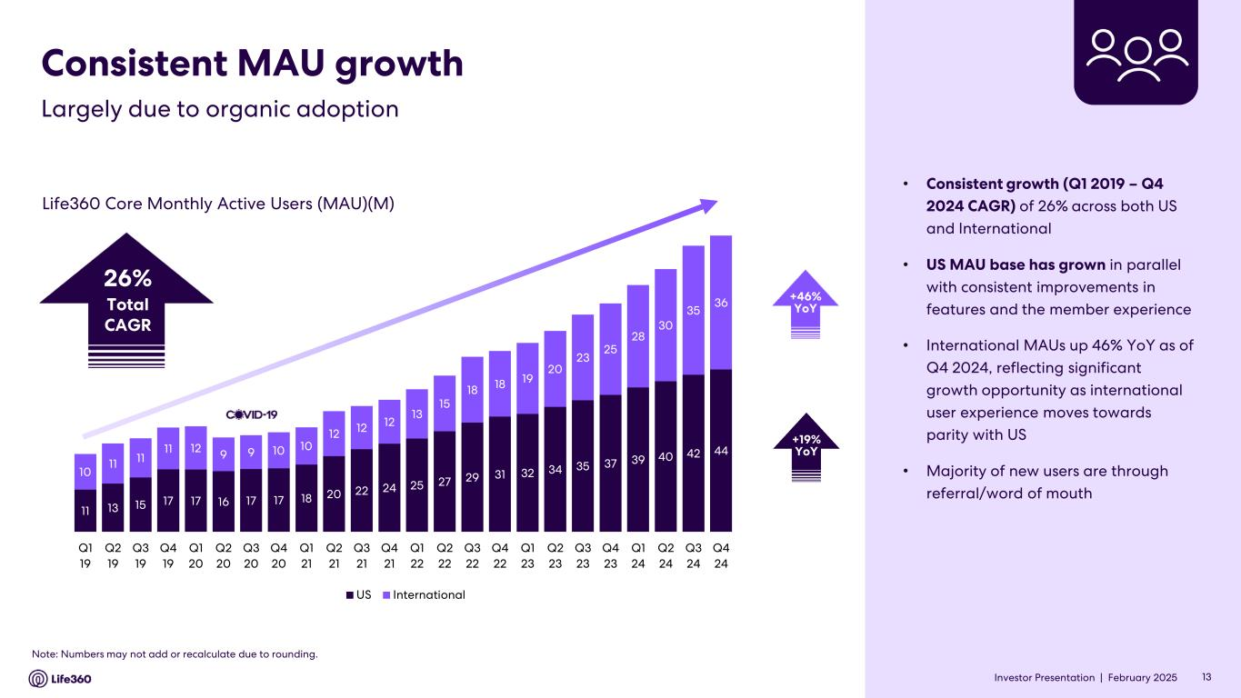
Investor Presentation | February 2025 Consistent MAU growth • Consistent growth (Q1 2019 – Q4 2024 CAGR) of 26% across both US and International • US MAU base has grown in parallel with consistent improvements in features and the member experience • International MAUs up 46% YoY as of Q4 2024, reflecting significant growth opportunity as international user experience moves towards parity with US • Majority of new users are through referral/word of mouth Life360 Core Monthly Active Users (MAU)(M) Note: Numbers may not add or recalculate due to rounding. 13 Largely due to organic adoption 26% Total CAGR +46% YoY +19% YoY Investor Presentation | 11 13 15 17 17 16 17 17 18 20 22 24 25 27 29 31 32 34 35 37 39 40 42 44 10 11 11 11 12 9 9 10 10 12 12 12 13 15 18 18 19 20 23 25 28 30 35 36 Q1 19 Q2 19 Q3 19 Q4 19 Q1 20 Q2 20 Q3 20 Q4 20 Q1 21 Q2 21 Q3 21 Q4 21 Q1 22 Q2 22 Q3 22 Q4 22 Q1 23 Q2 23 Q3 23 Q4 23 Q1 24 Q2 24 Q3 24 Q4 24 US International

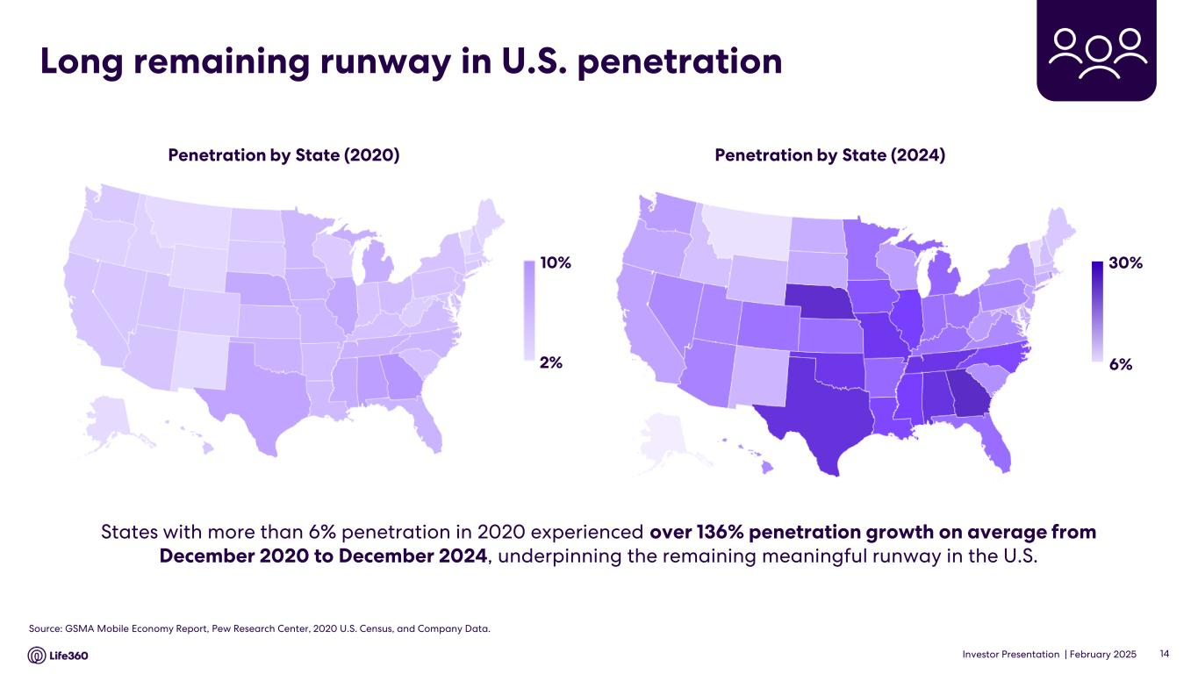
Investor Presentation | February 2025 Long remaining runway in U.S. penetration Penetration by State (2024)Penetration by State (2020) States with more than 6% penetration in 2020 experienced over 136% penetration growth on average from December 2020 to December 2024, underpinning the remaining meaningful runway in the U.S. 10% 2% 30% 6% Source: GSMA Mobile Economy Report, Pew Research Center, 2020 U.S. Census, and Company Data. 14

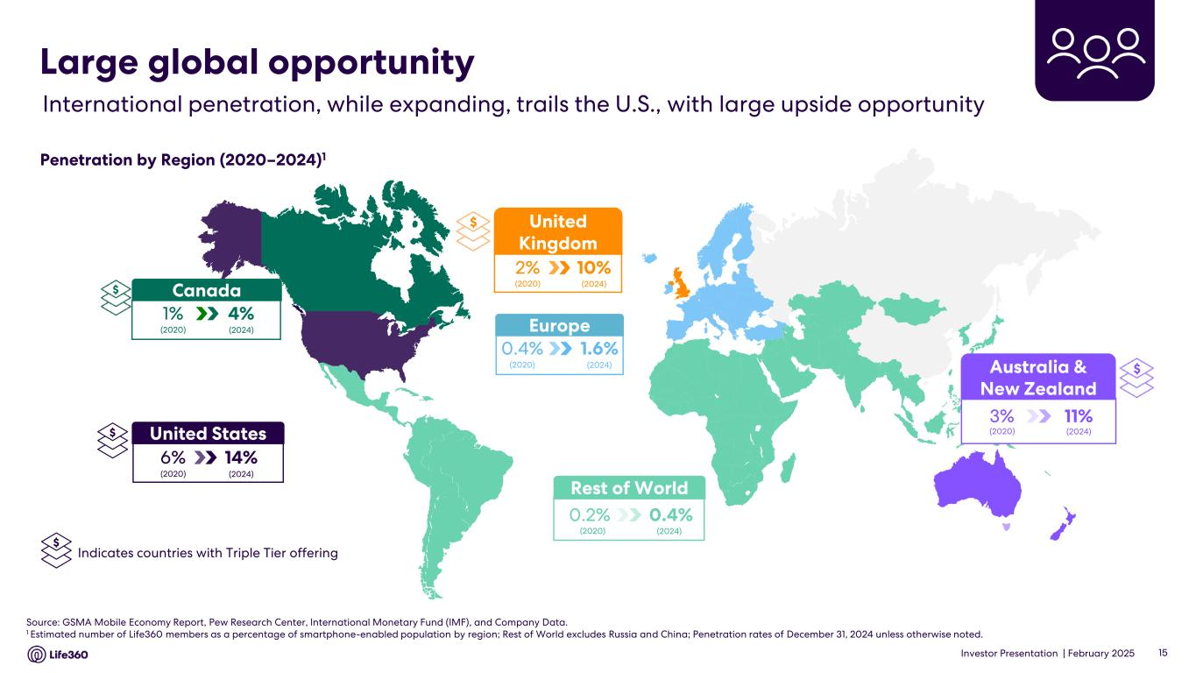
Investor Presentation | February 2025 Source: GSMA Mobile Economy Report, Pew Research Center, International Monetary Fund (IMF), and Company Data. 1 Estimated number of Life360 members as a percentage of smartphone-enabled population by region; Rest of World excludes Russia and China; Penetration rates of December 31, 2024 unless otherwise noted. Rest of World 0.4%0.2% (2020) (2024) Europe 1.6%0.4% (2020) (2024) International penetration, while expanding, trails the U.S., with large upside opportunity Large global opportunity Penetration by Region (2020–2024)1 15 $Australia & New Zealand 11%3% (2020) (2024)United States 14%6% (2020) (2024) Canada 4%1% (2020) (2024) $ United Kingdom 10%2% (2020) (2024) $ Indicates countries with Triple Tier offering $ $

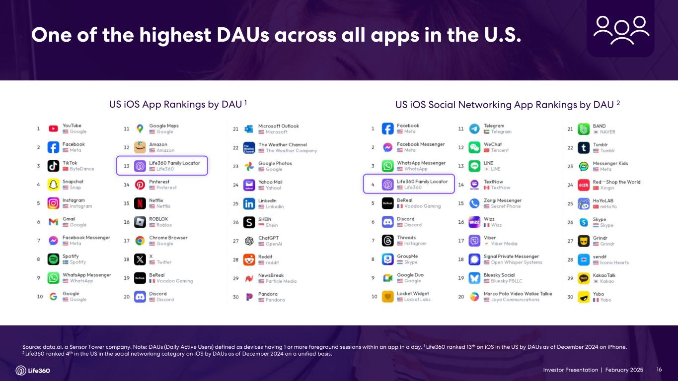
Investor Presentation | February 2025 US iOS App Rankings by DAU 1 US iOS Social Networking App Rankings by DAU 2 Source: data.ai, a Sensor Tower company. Note: DAUs (Daily Active Users) defined as devices having 1 or more foreground sessions within an app in a day. 1 Life360 ranked 13th on iOS in the US by DAUs as of December 2024 on iPhone. 2 Life360 ranked 4th in the US in the social networking category on iOS by DAUs as of December 2024 on a unified basis. 16 One of the highest DAUs across all apps in the U.S. Investor Presentation |

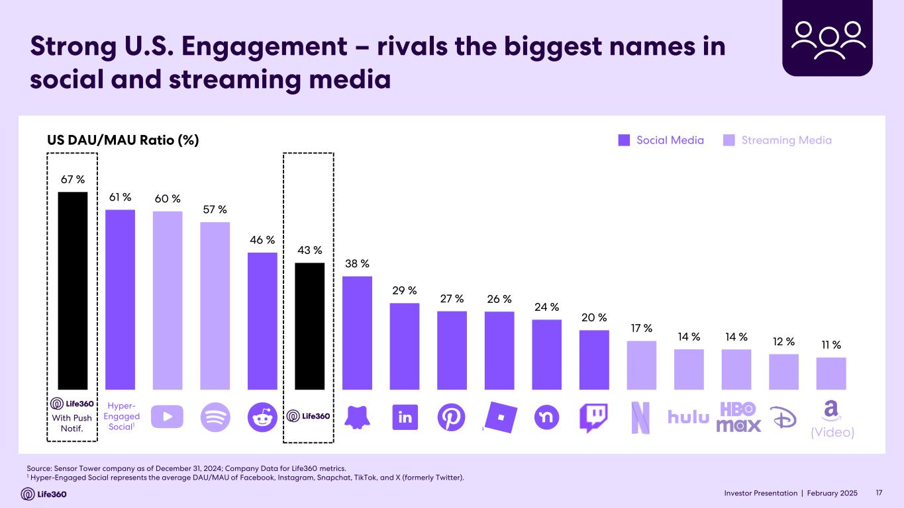
Investor Presentation | February 2025 Strong U.S. Engagement – rivals the biggest names in social and streaming media US DAU/MAU Ratio (%) Source: Sensor Tower company as of December 31, 2024; Company Data for Life360 metrics. 1 Hyper-Engaged Social represents the average DAU/MAU of Facebook, Instagram, Snapchat, TikTok, and X (formerly Twitter). (Video) Social Media Streaming Media Hyper- Engaged Social1 With Push Notif. 17Investor Presentation | 67 % 61 % 60 % 57 % 46 % 43 % 38 % 29 % 27 % 26 % 24 % 20 % 17 % 14 % 14 % 12 % 11 %

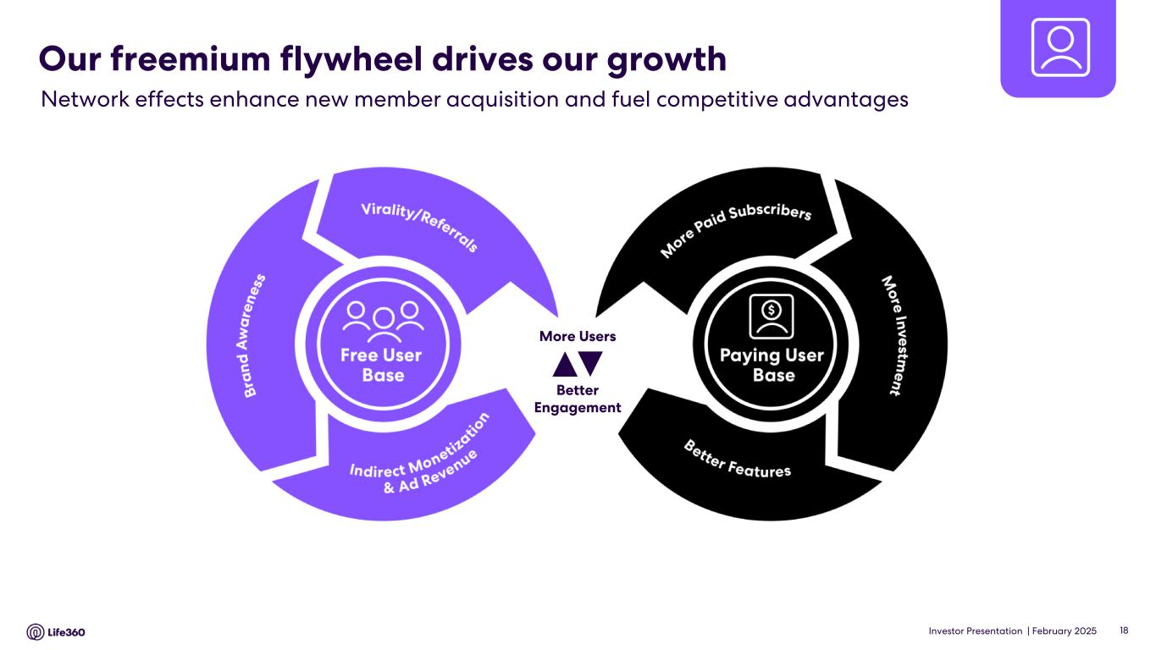
Investor Presentation | February 2025 Our freemium flywheel drives our growth 18 Network effects enhance new member acquisition and fuel competitive advantages Better Engagement More Users

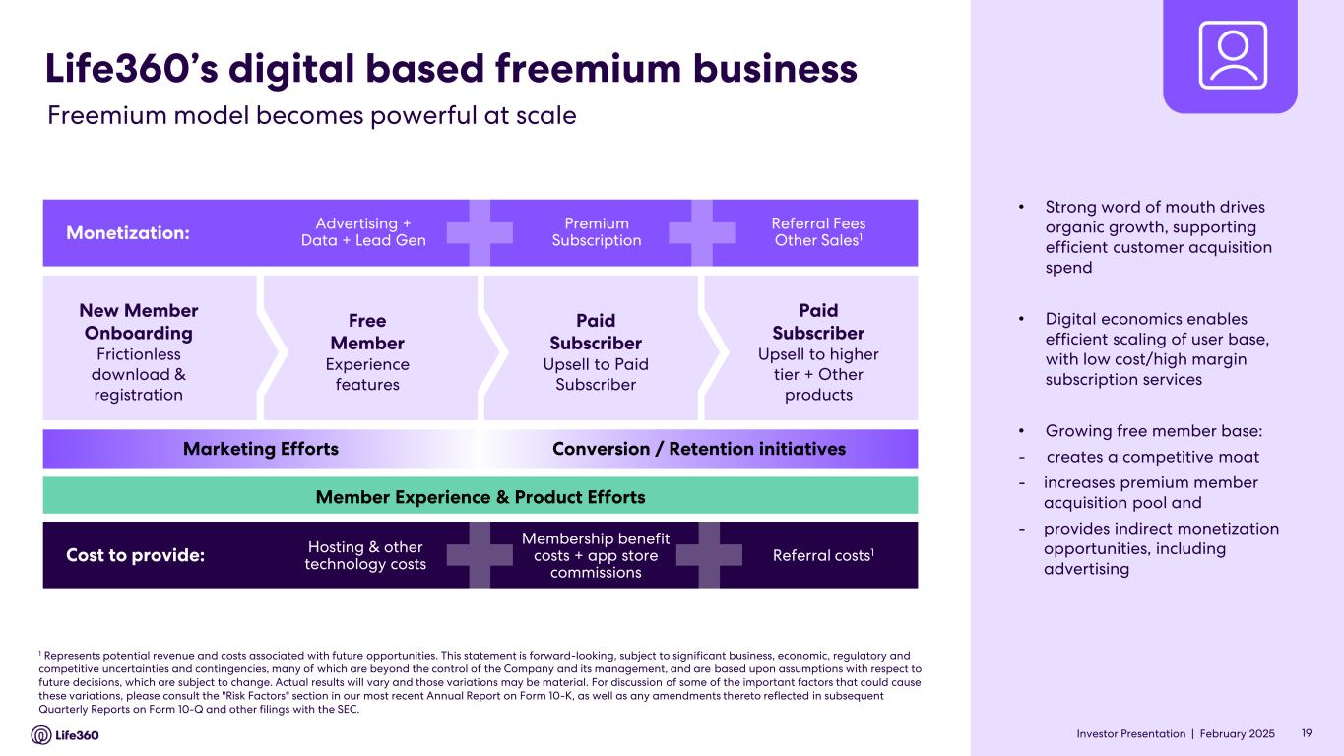
Investor Presentation | February 2025 New Member Onboarding Frictionless download & registration Free Member Experience features Paid Subscriber Upsell to Paid Subscriber Paid Subscriber Upsell to higher tier + Other products Life360’s digital based freemium business Monetization: Advertising + Data + Lead Gen Premium Subscription Referral Fees Other Sales1 Cost to provide: Hosting & other technology costs Membership benefit costs + app store commissions Referral costs1 Marketing Efforts Conversion / Retention initiatives Member Experience & Product Efforts 1 Represents potential revenue and costs associated with future opportunities. This statement is forward-looking, subject to significant business, economic, regulatory and competitive uncertainties and contingencies, many of which are beyond the control of the Company and its management, and are based upon assumptions with respect to future decisions, which are subject to change. Actual results will vary and those variations may be material. For discussion of some of the important factors that could cause these variations, please consult the "Risk Factors" section in our most recent Annual Report on Form 10-K, as well as any amendments thereto reflected in subsequent Quarterly Reports on Form 10-Q and other filings with the SEC. 19 Freemium model becomes powerful at scale • Strong word of mouth drives organic growth, supporting efficient customer acquisition spend • Digital economics enables efficient scaling of user base, with low cost/high margin subscription services • Growing free member base: - creates a competitive moat - increases premium member acquisition pool and - provides indirect monetization opportunities, including advertising Investor Presentation |

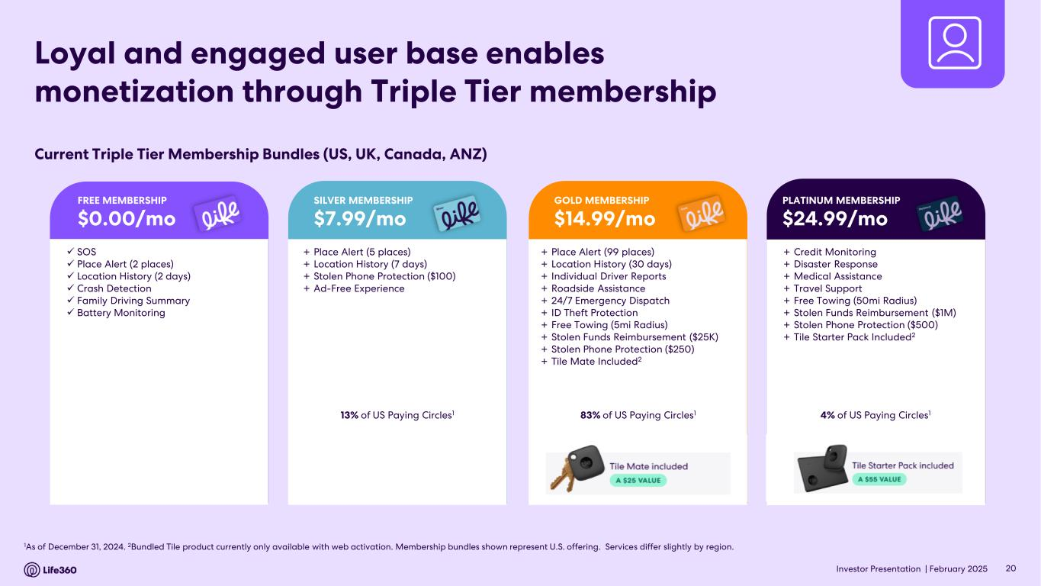
Investor Presentation | February 2025 1As of December 31, 2024. 2Bundled Tile product currently only available with web activation. Membership bundles shown represent U.S. offering. Services differ slightly by region. Loyal and engaged user base enables monetization through Triple Tier membership Current Triple Tier Membership Bundles (US, UK, Canada, ANZ) + Place Alert (5 places) + Location History (7 days) + Stolen Phone Protection ($100) + Ad-Free Experience 13% of US Paying Circles1 SILVER MEMBERSHIP $7.99/mo + Place Alert (99 places) + Location History (30 days) + Individual Driver Reports + Roadside Assistance + 24/7 Emergency Dispatch + ID Theft Protection + Free Towing (5mi Radius) + Stolen Funds Reimbursement ($25K) + Stolen Phone Protection ($250) + Tile Mate Included2 83% of US Paying Circles1 GOLD MEMBERSHIP $14.99/mo + Credit Monitoring + Disaster Response + Medical Assistance + Travel Support + Free Towing (50mi Radius) + Stolen Funds Reimbursement ($1M) + Stolen Phone Protection ($500) + Tile Starter Pack Included2 4% of US Paying Circles1 PLATINUM MEMBERSHIP $24.99/mo ✓ SOS ✓ Place Alert (2 places) ✓ Location History (2 days) ✓ Crash Detection ✓ Family Driving Summary ✓ Battery Monitoring FREE MEMBERSHIP $0.00/mo 20

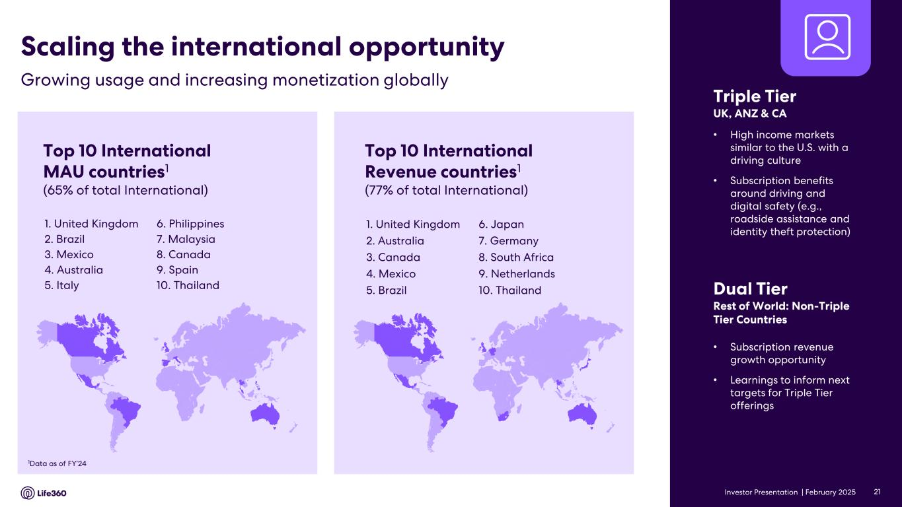
Investor Presentation | February 2025 Top 10 International MAU countries1 (65% of total International) 1. United Kingdom 2. Brazil 3. Mexico 4. Australia 5. Italy 1Data as of FY’24 Top 10 International Revenue countries1 (77% of total International) 1. United Kingdom 2. Australia 3. Canada 4. Mexico 5. Brazil • Subscription revenue growth opportunity • Learnings to inform next targets for Triple Tier offerings Dual Tier Rest of World: Non-Triple Tier Countries Growing usage and increasing monetization globally Scaling the international opportunity Triple Tier UK, ANZ & CA • High income markets similar to the U.S. with a driving culture • Subscription benefits around driving and digital safety (e.g., roadside assistance and identity theft protection) 6. Japan 7. Germany 8. South Africa 9. Netherlands 10. Thailand 6. Philippines 7. Malaysia 8. Canada 9. Spain 10. Thailand 21

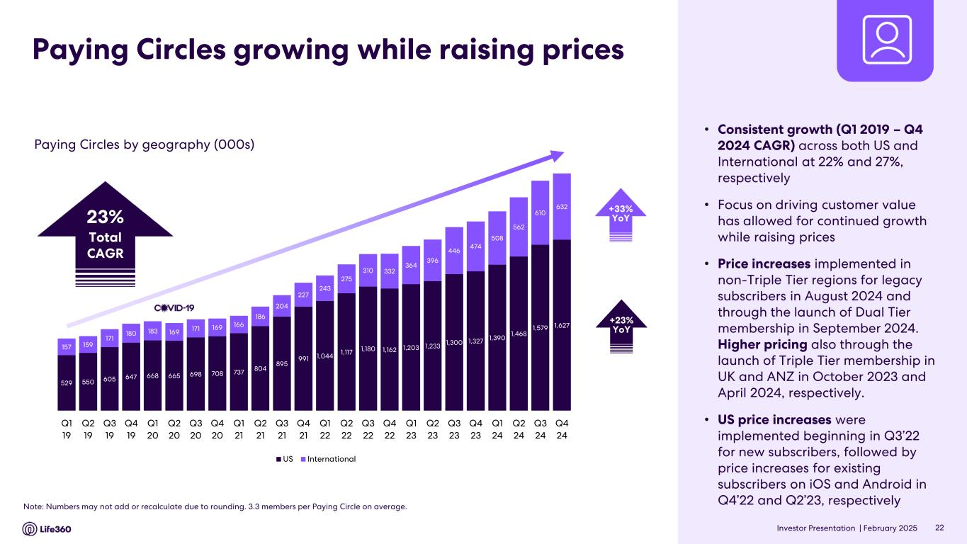
Investor Presentation | February 2025 Paying Circles growing while raising prices Paying Circles by geography (000s) • Consistent growth (Q1 2019 – Q4 2024 CAGR) across both US and International at 22% and 27%, respectively • Focus on driving customer value has allowed for continued growth while raising prices • Price increases implemented in non-Triple Tier regions for legacy subscribers in August 2024 and through the launch of Dual Tier membership in September 2024. Higher pricing also through the launch of Triple Tier membership in UK and ANZ in October 2023 and April 2024, respectively. • US price increases were implemented beginning in Q3’22 for new subscribers, followed by price increases for existing subscribers on iOS and Android in Q4’22 and Q2’23, respectively Note: Numbers may not add or recalculate due to rounding. 3.3 members per Paying Circle on average. 22 +33% YoY +23% YoY 23% Total CAGR 529 550 605 647 668 665 698 708 737 804 895 991 1,044 1,117 1,180 1,162 1,203 1,233 1,300 1,327 1,390 1,468 1,579 1,627 157 159 171 180 183 169 171 169 166 186 204 227 243 275 310 332 364 396 446 474 508 562 610 632 Q1 19 Q2 19 Q3 19 Q4 19 Q1 20 Q2 20 Q3 20 Q4 20 Q1 21 Q2 21 Q3 21 Q4 21 Q1 22 Q2 22 Q3 22 Q4 22 Q1 23 Q2 23 Q3 23 Q4 23 Q1 24 Q2 24 Q3 24 Q4 24 US International

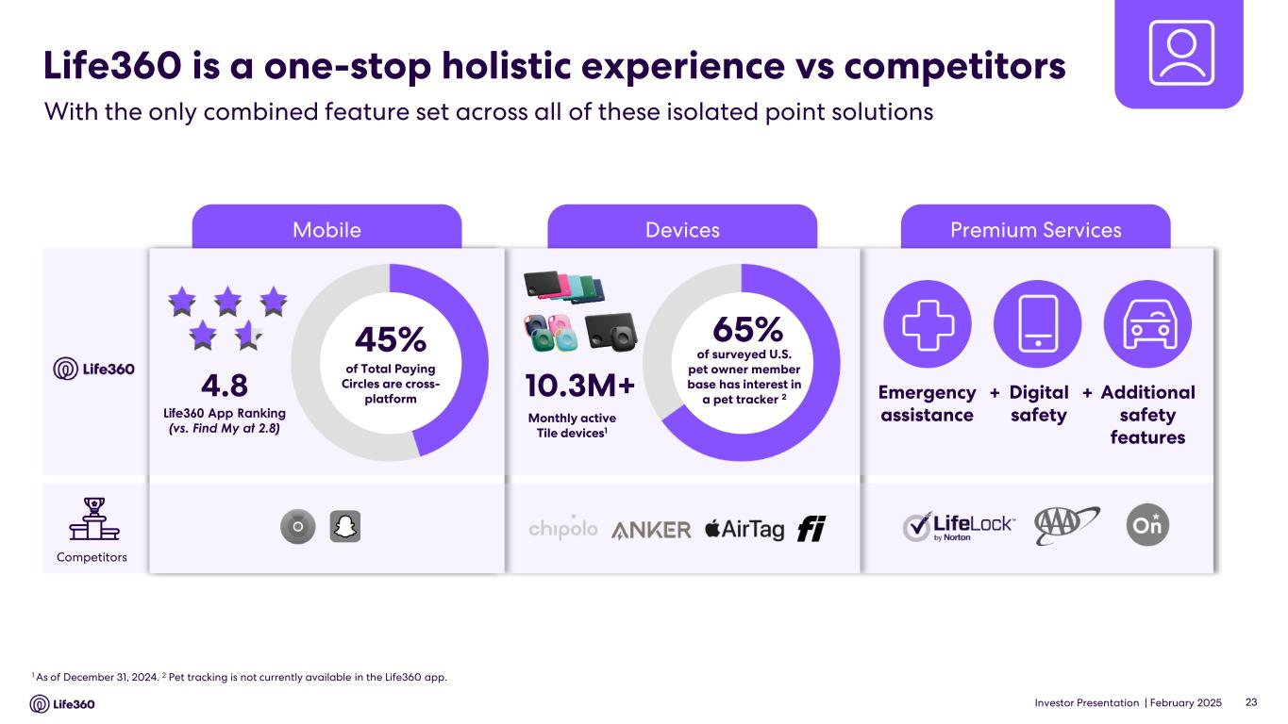
Investor Presentation | February 2025 Premium ServicesDevicesMobile Life360 is a one-stop holistic experience vs competitors With the only combined feature set across all of these isolated point solutions 1 As of December 31, 2024. 2 Pet tracking is not currently available in the Life360 app. 10.3M+ 65% of surveyed U.S. pet owner member base has interest in a pet tracker 2 Monthly active Tile devices1 Emergency assistance Digital safety Additional safety features + +4.8 Life360 App Ranking (vs. Find My at 2.8) Competitors 23 45% of Total Paying Circles are cross- platform

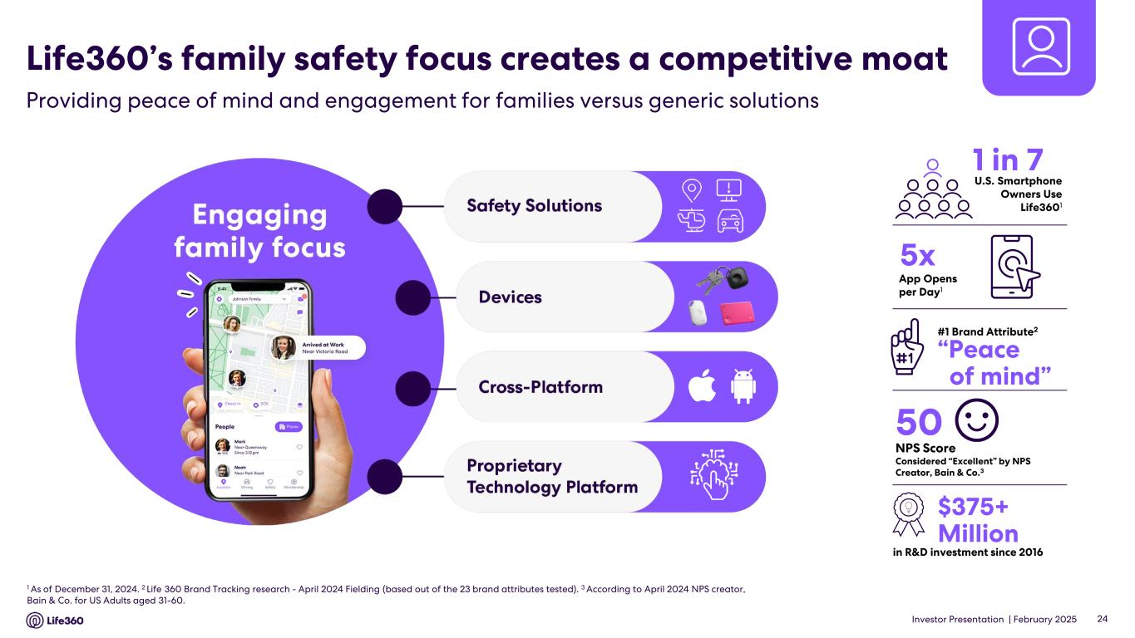
Investor Presentation | February 2025 24 4.6 4.7 1 As of December 31, 2024. 2 Life 360 Brand Tracking research - April 2024 Fielding (based out of the 23 brand attributes tested). 3 According to April 2024 NPS creator, Bain & Co. for US Adults aged 31-60. in R&D investment since 2016 #1 Brand Attribute2 1 in 7 50 NPS Score Considered “Excellent” by NPS Creator, Bain & Co.3 “Peace of mind” 5x U.S. Smartphone Owners Use Life3601 $375+ Million App Opens per Day1 Life360’s family safety focus creates a competitive moat Providing peace of mind and engagement for families versus generic solutions

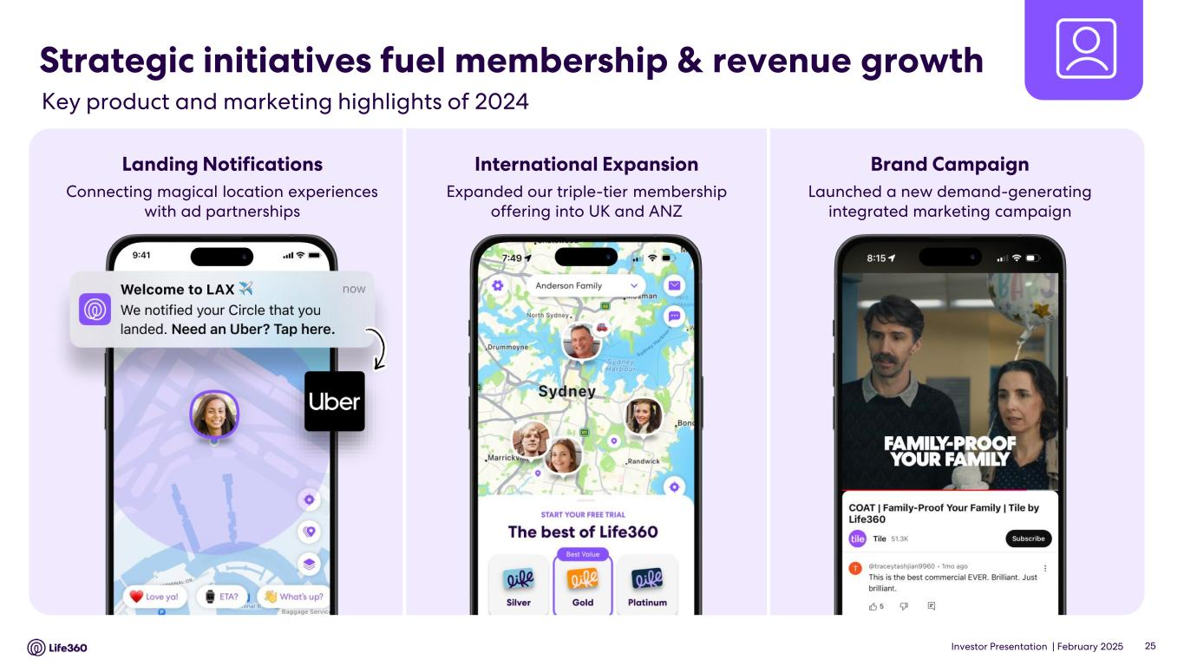
Investor Presentation | February 2025 Strategic initiatives fuel membership & revenue growth 25 Connecting magical location experiences with ad partnerships Landing Notifications Expanded our triple-tier membership offering into UK and ANZ International Expansion Launched a new demand-generating integrated marketing campaign Brand Campaign Key product and marketing highlights of 2024

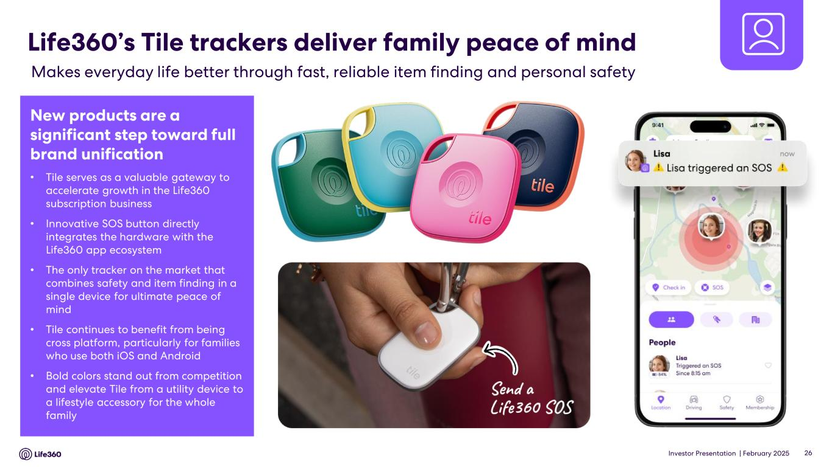
Investor Presentation | February 2025 26 Life360’s Tile trackers deliver family peace of mind Makes everyday life better through fast, reliable item finding and personal safety New products are a significant step toward full brand unification • Tile serves as a valuable gateway to accelerate growth in the Life360 subscription business • Innovative SOS button directly integrates the hardware with the Life360 app ecosystem • The only tracker on the market that combines safety and item finding in a single device for ultimate peace of mind • Tile continues to benefit from being cross platform, particularly for families who use both iOS and Android • Bold colors stand out from competition and elevate Tile from a utility device to a lifestyle accessory for the whole family

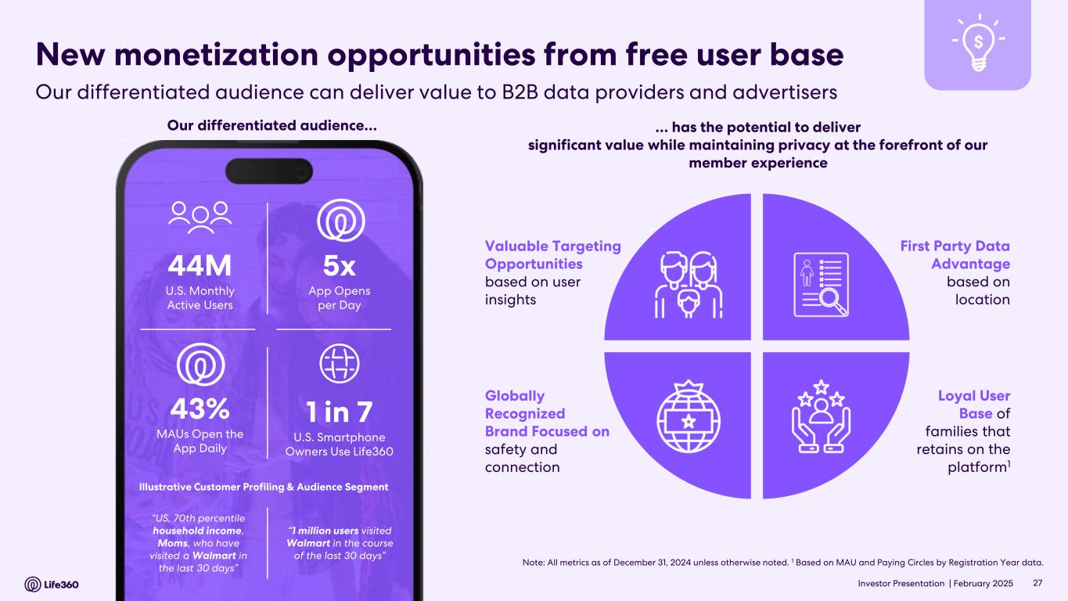
Investor Presentation | February 2025 New monetization opportunities from free user base Loyal User Base of families that retains on the platform1 Globally Recognized Brand Focused on safety and connection First Party Data Advantage based on location Valuable Targeting Opportunities based on user insights … has the potential to deliver significant value while maintaining privacy at the forefront of our member experience Note: All metrics as of December 31, 2024 unless otherwise noted. 1 Based on MAU and Paying Circles by Registration Year data. 44M U.S. Monthly Active Users 1 in 7 U.S. Smartphone Owners Use Life360 5x App Opens per Day 43% MAUs Open the App Daily “US, 70th percentile household income, Moms, who have visited a Walmart in the last 30 days” Illustrative Customer Profiling & Audience Segment “1 million users visited Walmart in the course of the last 30 days” Our differentiated audience… 27 Our differentiated audience can deliver value to B2B data providers and advertisers

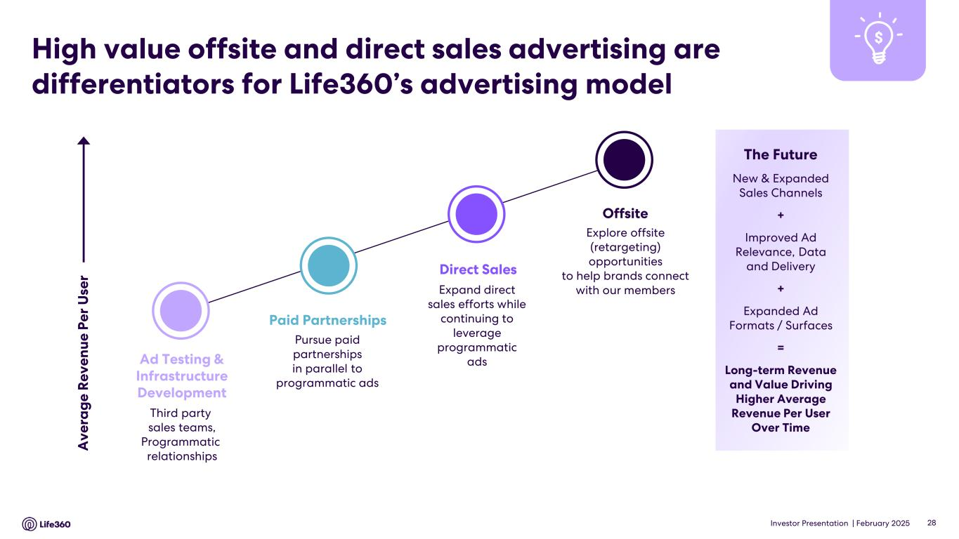
Investor Presentation | February 2025 High value offsite and direct sales advertising are differentiators for Life360’s advertising model 28 The Future New & Expanded Sales Channels + Improved Ad Relevance, Data and Delivery + Expanded Ad Formats / Surfaces = Long-term Revenue and Value Driving Higher Average Revenue Per User Over Time Third party sales teams, Programmatic relationships Ad Testing & Infrastructure Development Paid Partnerships Pursue paid partnerships in parallel to programmatic ads Direct Sales Expand direct sales efforts while continuing to leverage programmatic ads Offsite Explore offsite (retargeting) opportunities to help brands connect with our members A v e ra g e R e v e n u e P e r U se r

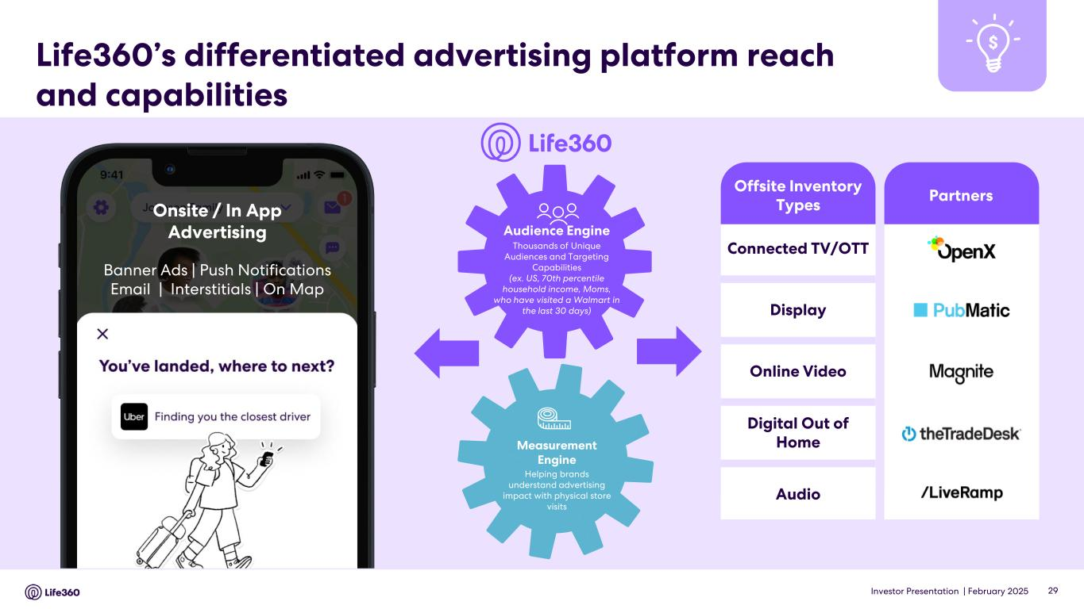
Investor Presentation | February 2025 Partners Life360’s differentiated advertising platform reach and capabilities 29 Audience Engine Thousands of Unique Audiences and Targeting Capabilities (ex. US, 70th percentile household income, Moms, who have visited a Walmart in the last 30 days) Measurement Engine Helping brands understand advertising impact with physical store visits Connected TV/OTT Display Online Video Digital Out of Home Audio Offsite Inventory TypesOnsite / In App Advertising Banner Ads | Push Notifications Email | Interstitials | On Map

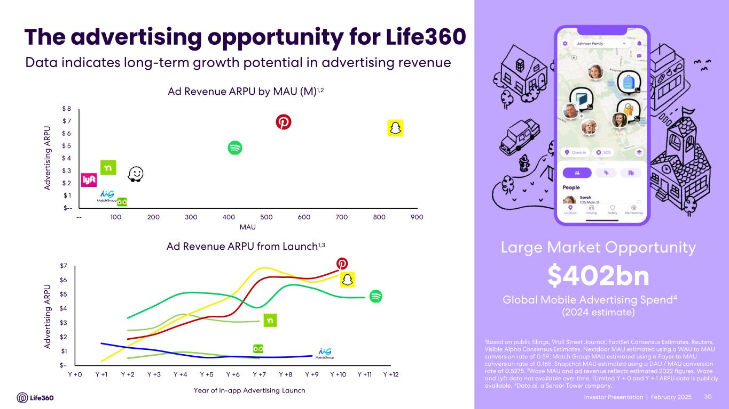
Investor Presentation | February 2025 Ad Revenue ARPU by MAU (M)1,2 MAU A d v e rt is in g A R P U Ad Revenue ARPU from Launch1,3 30 The advertising opportunity for Life360 1Based on public filings, Wall Street Journal, FactSet Consensus Estimates, Reuters, Visible Alpha Consensus Estimates. Nextdoor MAU estimated using a WAU to MAU conversion rate of 0.59. Match Group MAU estimated using a Payer to MAU conversion rate of 0.165. Snapchat MAU estimated using a DAU / MAU conversion rate of 0.5275. 2Waze MAU and ad revenue reflects estimated 2022 figures. Waze and Lyft data not available over time. 3Limited Y + 0 and Y + 1 ARPU data is publicly available. 4Data.ai, a Sensor Tower company. Global Mobile Advertising Spend4 $402bn (2024 estimate) Large Market Opportunity Year of in-app Advertising Launch Data indicates long-term growth potential in advertising revenue A d v e rt is in g A R P U Investor Presentation | $-- $ 1 $ 2 $ 3 $ 4 $ 5 $ 6 $ 7 $ 8 -- 100 200 300 400 500 600 700 800 900 $– $1 $2 $3 $4 $5 $6 $7 Y +0 Y +1 Y +2 Y +3 Y +4 Y +5 Y +6 Y +7 Y +8 Y +9 Y +10 Y +11 Y +12

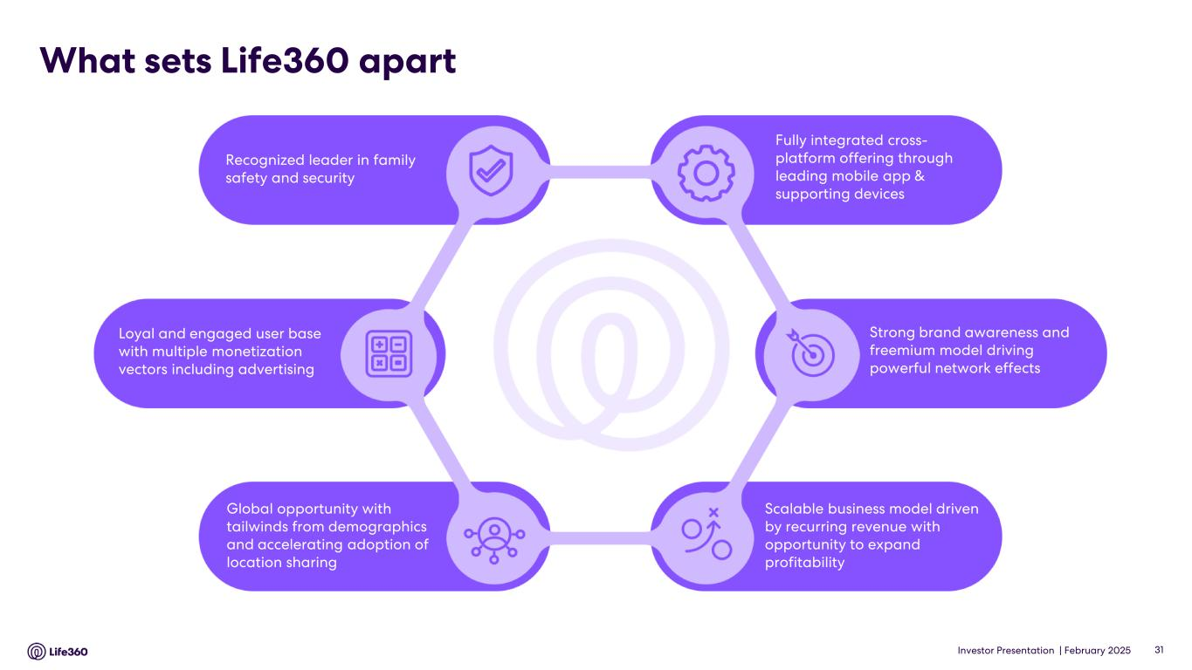
Investor Presentation | February 2025 Recognized leader in family safety and security Fully integrated cross- platform offering through leading mobile app & supporting devices Loyal and engaged user base with multiple monetization vectors including advertising Global opportunity with tailwinds from demographics and accelerating adoption of location sharing Scalable business model driven by recurring revenue with opportunity to expand profitability Strong brand awareness and freemium model driving powerful network effects What sets Life360 apart 31

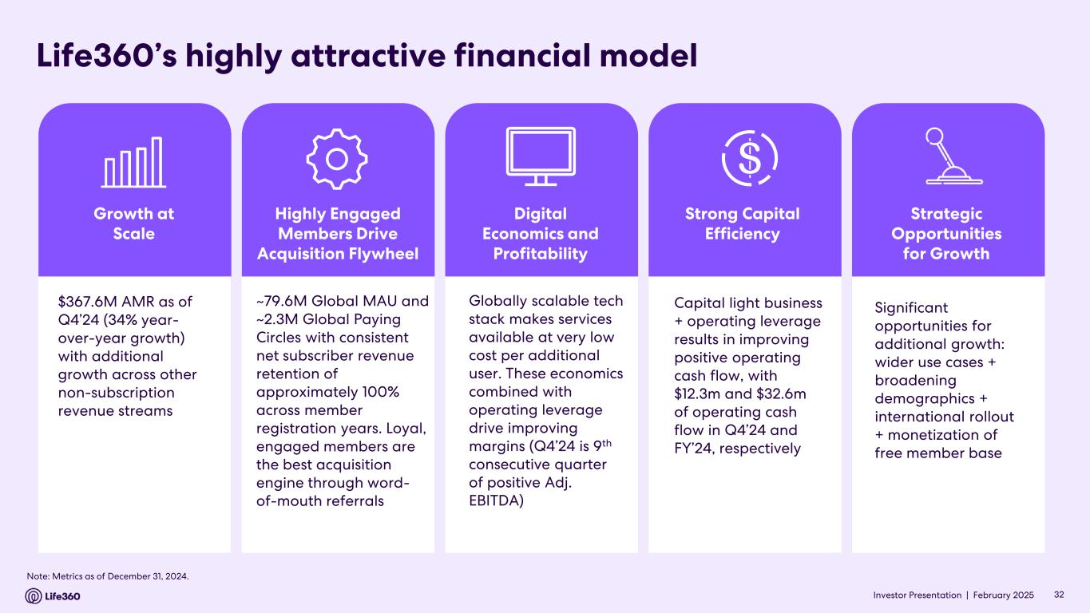
Investor Presentation | February 2025 Life360’s highly attractive financial model $367.6M AMR as of Q4’24 (34% year- over-year growth) with additional growth across other non-subscription revenue streams Growth at Scale Capital light business + operating leverage results in improving positive operating cash flow, with $12.3m and $32.6m of operating cash flow in Q4’24 and FY’24, respectively Strong Capital Efficiency Significant opportunities for additional growth: wider use cases + broadening demographics + international rollout + monetization of free member base Strategic Opportunities for Growth ~79.6M Global MAU and ~2.3M Global Paying Circles with consistent net subscriber revenue retention of approximately 100% across member registration years. Loyal, engaged members are the best acquisition engine through word- of-mouth referrals Highly Engaged Members Drive Acquisition Flywheel Globally scalable tech stack makes services available at very low cost per additional user. These economics combined with operating leverage drive improving margins (Q4’24 is 9th consecutive quarter of positive Adj. EBITDA) Digital Economics and Profitability Note: Metrics as of December 31, 2024. 32Investor Presentation |


Investor Presentation | February 2025 Financial Update FY’24 02

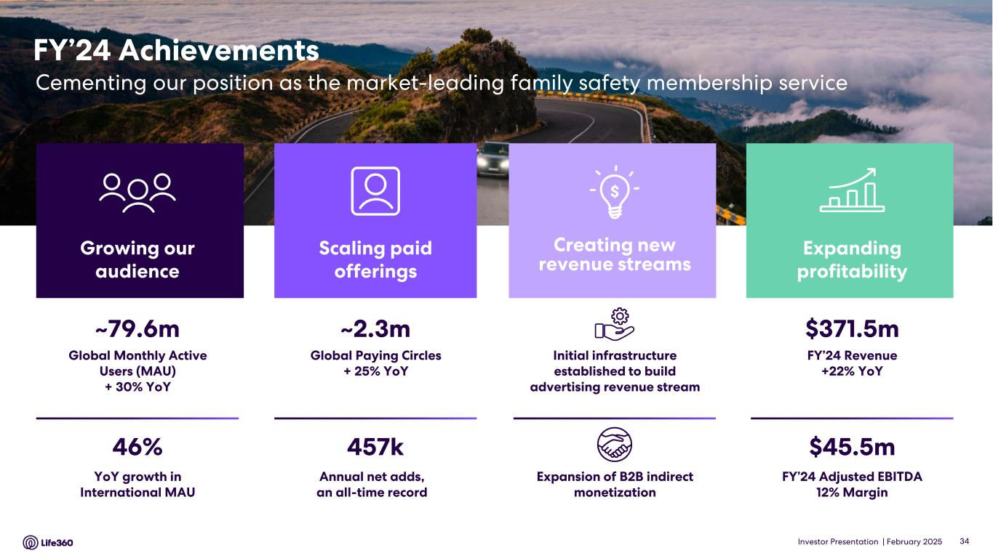
Investor Presentation | February 2025 FY’24 Achievements Cementing our position as the market-leading family safety membership service $371.5m FY’24 Revenue +22% YoY $45.5m FY’24 Adjusted EBITDA 12% Margin Expanding profitability ~2.3m Global Paying Circles + 25% YoY 457k Annual net adds, an all-time record Scaling paid offerings ~79.6m Global Monthly Active Users (MAU) + 30% YoY 46% YoY growth in International MAU Growing our audience Expansion of B2B indirect monetization Initial infrastructure established to build advertising revenue stream Creating new revenue streams 34

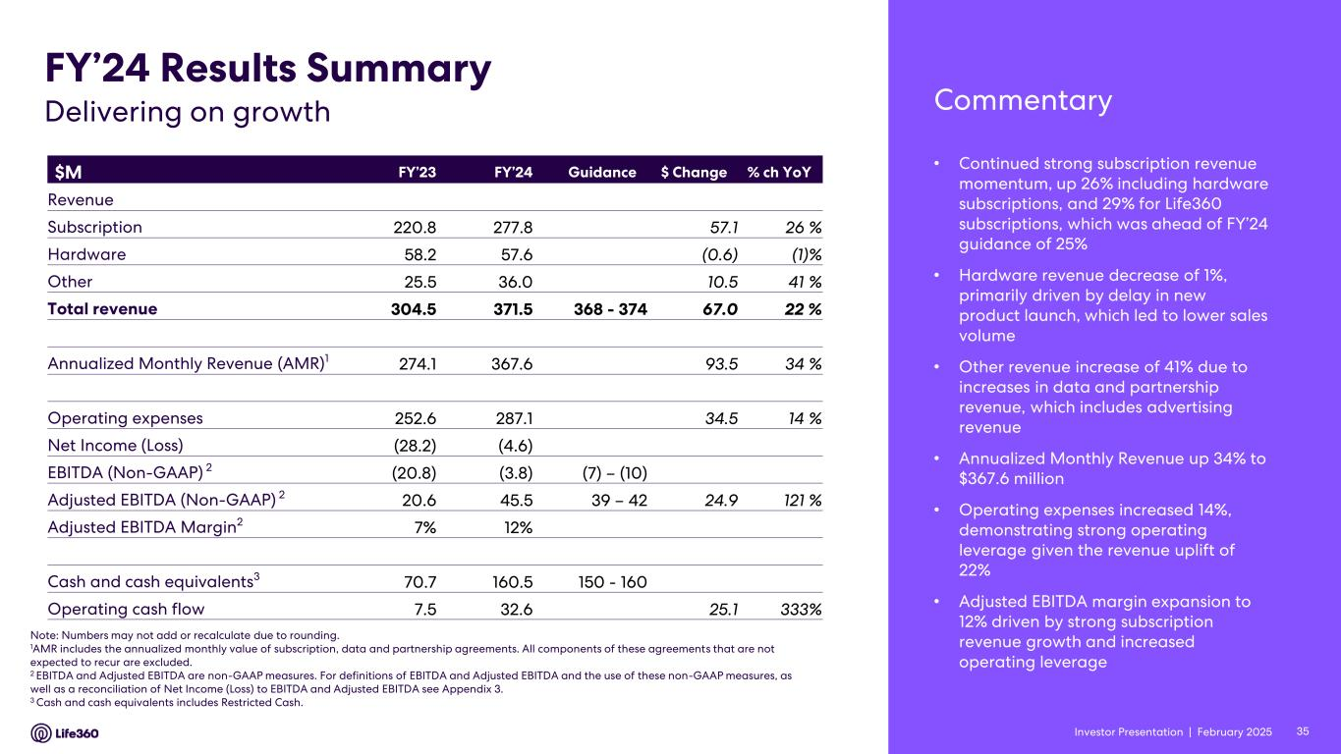
Investor Presentation | February 2025 • Continued strong subscription revenue momentum, up 26% including hardware subscriptions, and 29% for Life360 subscriptions, which was ahead of FY’24 guidance of 25% • Hardware revenue decrease of 1%, primarily driven by delay in new product launch, which led to lower sales volume • Other revenue increase of 41% due to increases in data and partnership revenue, which includes advertising revenue • Annualized Monthly Revenue up 34% to $367.6 million • Operating expenses increased 14%, demonstrating strong operating leverage given the revenue uplift of 22% • Adjusted EBITDA margin expansion to 12% driven by strong subscription revenue growth and increased operating leverage $M FY’23 FY’24 Guidance $ Change % ch YoY Revenue Subscription 220.8 277.8 57.1 26 % Hardware 58.2 57.6 (0.6) (1)% Other 25.5 36.0 10.5 41 % Total revenue 304.5 371.5 368 - 374 67.0 22 % Annualized Monthly Revenue (AMR)1 274.1 367.6 93.5 34 % Operating expenses 252.6 287.1 34.5 14 % Net Income (Loss) (28.2) (4.6) EBITDA (Non-GAAP) 2 (20.8) (3.8) (7) – (10) Adjusted EBITDA (Non-GAAP) 2 20.6 45.5 39 – 42 24.9 121 % Adjusted EBITDA Margin2 7% 12% Cash and cash equivalents3 70.7 160.5 150 - 160 Operating cash flow 7.5 32.6 25.1 333% Note: Numbers may not add or recalculate due to rounding. 1AMR includes the annualized monthly value of subscription, data and partnership agreements. All components of these agreements that are not expected to recur are excluded. 2 EBITDA and Adjusted EBITDA are non-GAAP measures. For definitions of EBITDA and Adjusted EBITDA and the use of these non-GAAP measures, as well as a reconciliation of Net Income (Loss) to EBITDA and Adjusted EBITDA see Appendix 3. 3 Cash and cash equivalents includes Restricted Cash. FY’24 Results Summary CommentaryDelivering on growth 35Investor Presentation |

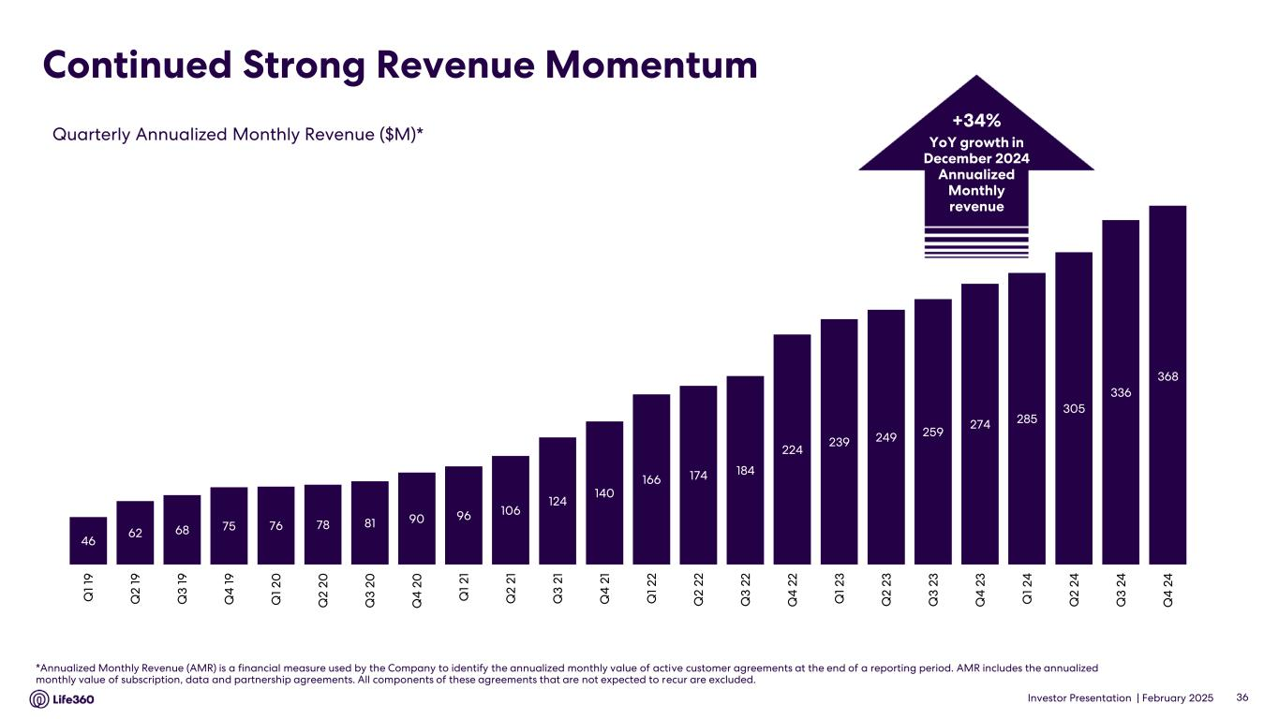
Investor Presentation | February 2025 Continued Strong Revenue Momentum *Annualized Monthly Revenue (AMR) is a financial measure used by the Company to identify the annualized monthly value of active customer agreements at the end of a reporting period. AMR includes the annualized monthly value of subscription, data and partnership agreements. All components of these agreements that are not expected to recur are excluded. Quarterly Annualized Monthly Revenue ($M)* 36 +34% YoY growth in December 2024 Annualized Monthly revenue 46 62 68 75 76 78 81 90 96 106 124 140 166 174 184 224 239 249 259 274 285 305 336 368 Q 1 19 Q 2 1 9 Q 3 1 9 Q 4 1 9 Q 1 2 0 Q 2 2 0 Q 3 2 0 Q 4 2 0 Q 1 2 1 Q 2 2 1 Q 3 2 1 Q 4 2 1 Q 1 2 2 Q 2 2 2 Q 3 2 2 Q 4 2 2 Q 1 2 3 Q 2 2 3 Q 3 2 3 Q 4 2 3 Q 1 2 4 Q 2 2 4 Q 3 2 4 Q 4 2 4

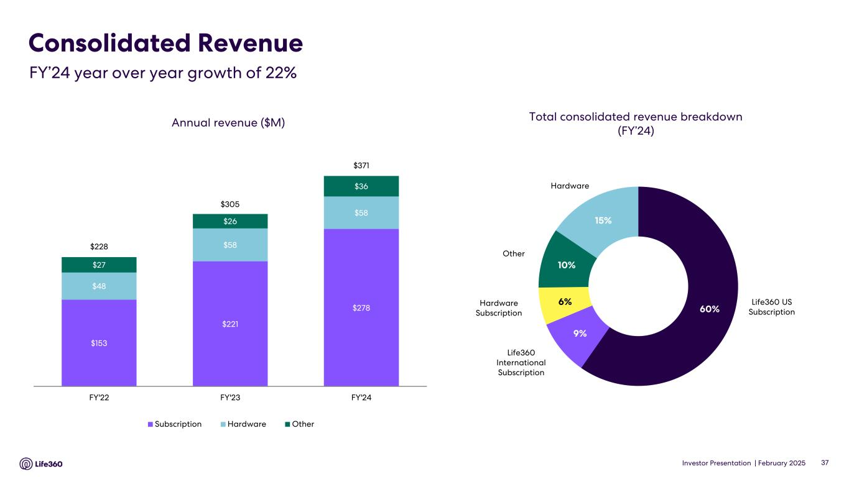
Investor Presentation | February 2025 Consolidated Revenue 37 Annual revenue ($M) $153 $221 $278 $48 $58 $58 $27 $26 $36 $228 $305 $371 FY'22 FY'23 FY'24 Subscription Hardware Other Total consolidated revenue breakdown (FY’24) Hardware Life360 US Subscription Life360 International Subscription Hardware Subscription Other 60% 9% 6% 10% 15% *Includes non-recurring adjustment of approximately $0.9 million in relation to deferral of subscription revenue FY’24 year over year growth of 22%

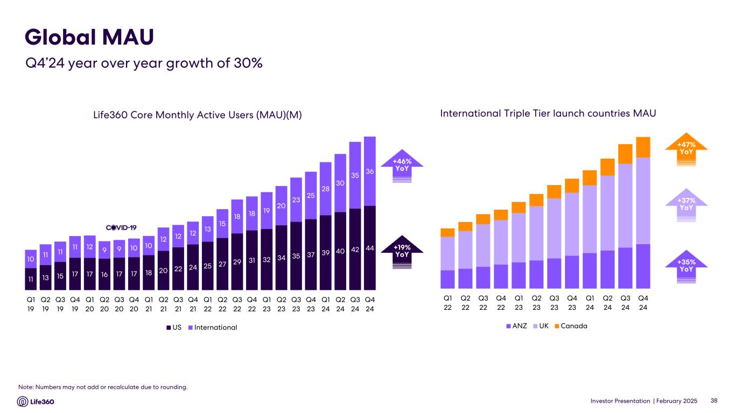
Investor Presentation | February 2025 Life360 Core Monthly Active Users (MAU)(M) Note: Numbers may not add or recalculate due to rounding. Global MAU Q4’24 year over year growth of 30% International Triple Tier launch countries MAU +37% YoY +47% YoY +35% YoY +46% YoY +19% YoY 38 Q1 22 Q2 22 Q3 22 Q4 22 Q1 23 Q2 23 Q3 23 Q4 23 Q1 24 Q2 24 Q3 24 Q4 24 ANZ UK Canada 11 13 15 17 17 16 17 17 18 20 22 24 25 27 29 31 32 34 35 37 39 40 42 44 10 11 11 11 12 9 9 10 10 12 12 12 13 15 18 18 19 20 23 25 28 30 35 36 Q1 19 Q2 19 Q3 19 Q4 19 Q1 20 Q2 20 Q3 20 Q4 20 Q1 21 Q2 21 Q3 21 Q4 21 Q1 22 Q2 22 Q3 22 Q4 22 Q1 23 Q2 23 Q3 23 Q4 23 Q1 24 Q2 24 Q3 24 Q4 24 US International

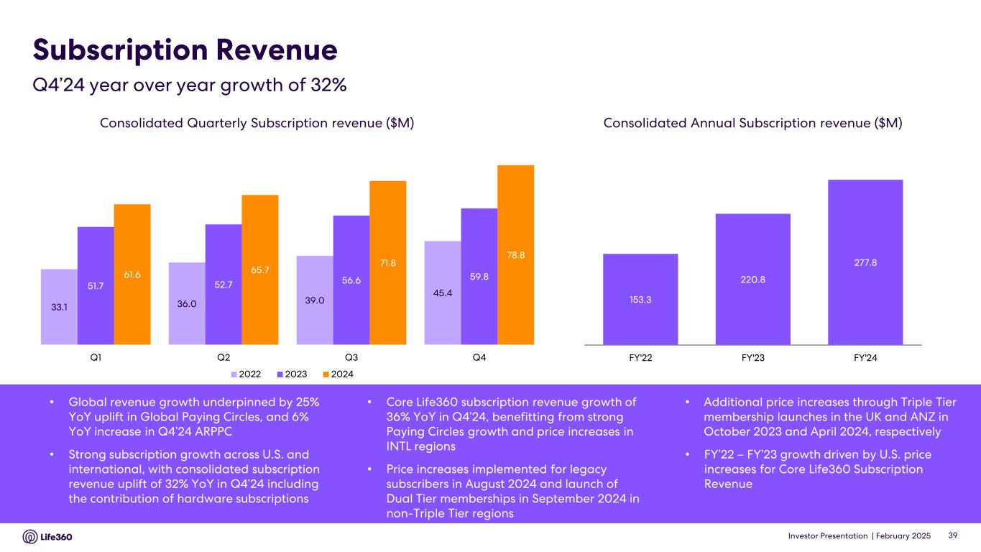
Investor Presentation | February 2025 Subscription Revenue Consolidated Quarterly Subscription revenue ($M) Consolidated Annual Subscription revenue ($M) • Global revenue growth underpinned by 25% YoY uplift in Global Paying Circles, and 6% YoY increase in Q4’24 ARPPC • Strong subscription growth across U.S. and international, with consolidated subscription revenue uplift of 32% YoY in Q4’24 including the contribution of hardware subscriptions • Core Life360 subscription revenue growth of 36% YoY in Q4’24, benefitting from strong Paying Circles growth and price increases in INTL regions • Price increases implemented for legacy subscribers in August 2024 and launch of Dual Tier memberships in September 2024 in non-Triple Tier regions • Additional price increases through Triple Tier membership launches in the UK and ANZ in October 2023 and April 2024, respectively • FY’22 – FY’23 growth driven by U.S. price increases for Core Life360 Subscription Revenue Q4’24 year over year growth of 32% 39 33.1 36.0 39.0 45.4 51.7 52.7 56.6 59.861.6 65.7 71.8 78.8 Q1 Q2 Q3 Q4 2022 2023 2024 153.3 220.8 277.8 FY'22 FY'23 FY'24

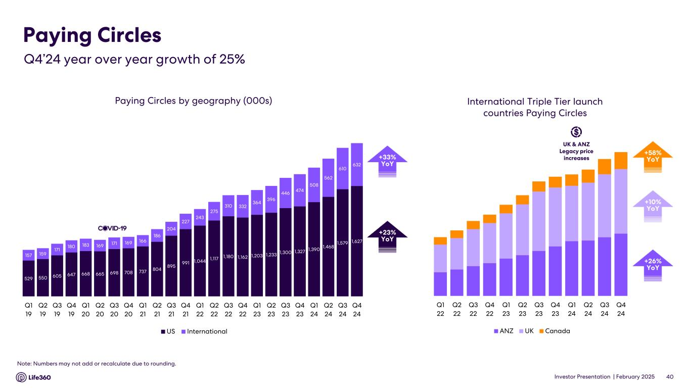
Investor Presentation | February 2025 Paying Circles by geography (000s) Paying Circles $140 $1398 +42% YoY$38 +42% YoYInternational Triple Tier launch countries Paying Circles +10% YoY +58% YoY +26% YoY +33% YoY +23% YoY 40 Note: Numbers may not add or recalculate due to rounding. Q1 22 Q2 22 Q3 22 Q4 22 Q1 23 Q2 23 Q3 23 Q4 23 Q1 24 Q2 24 Q3 24 Q4 24 ANZ UK Canada 529 550 605 647 668 665 698 708 737 804 895 991 1,044 1,117 1,180 1,162 1,203 1,233 1,300 1,327 1,390 1,468 1,579 1,627 157 159 171 180 183 169 171 169 166 186 204 227 243 275 310 332 364 396 446 474 508 562 610 632 Q1 19 Q2 19 Q3 19 Q4 19 Q1 20 Q2 20 Q3 20 Q4 20 Q1 21 Q2 21 Q3 21 Q4 21 Q1 22 Q2 22 Q3 22 Q4 22 Q1 23 Q2 23 Q3 23 Q4 23 Q1 24 Q2 24 Q3 24 Q4 24 US International Q4’24 year over year growth of 25% UK & ANZ Legacy price increases

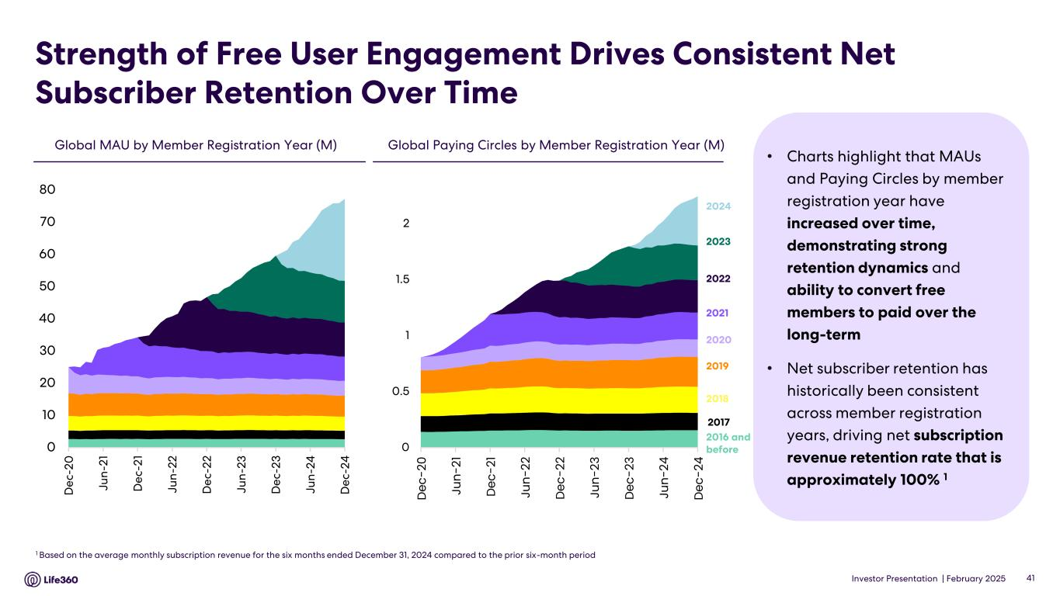
Investor Presentation | February 2025 Strength of Free User Engagement Drives Consistent Net Subscriber Retention Over Time • Charts highlight that MAUs and Paying Circles by member registration year have increased over time, demonstrating strong retention dynamics and ability to convert free members to paid over the long-term • Net subscriber retention has historically been consistent across member registration years, driving net subscription revenue retention rate that is approximately 100% 1 Global Paying Circles by Member Registration Year (M)Global MAU by Member Registration Year (M) 1 Based on the average monthly subscription revenue for the six months ended December 31, 2024 compared to the prior six-month period 2023 2022 2021 2020 2019 2018 2017 2016 and before 2024 41 0 10 20 30 40 50 60 70 80 D e c- 2 0 Ju n -2 1 D e c- 2 1 Ju n -2 2 D e c- 2 2 Ju n -2 3 D e c- 2 3 Ju n -2 4 D e c- 2 4 0 0.5 1 1.5 2 D ec -2 0 Ju n- 21 D ec -2 1 Ju n- 22 D ec -2 2 Ju n- 23 D ec -2 3 Ju n- 24 D ec -2 4

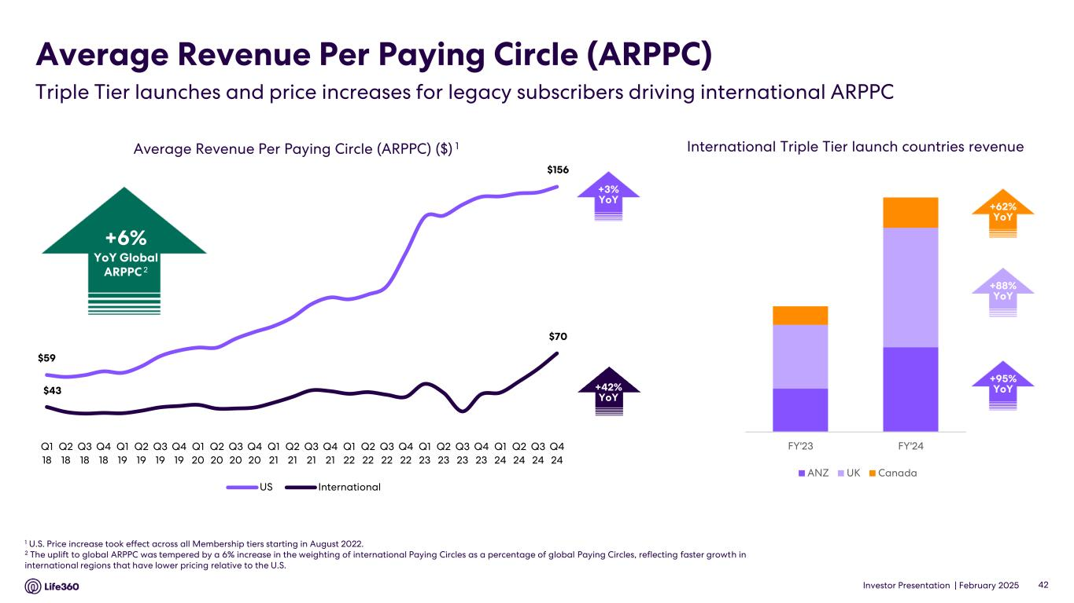
Investor Presentation | February 2025 $59 $156 $43 $70 Q1 18 Q2 18 Q3 18 Q4 18 Q1 19 Q2 19 Q3 19 Q4 19 Q1 20 Q2 20 Q3 20 Q4 20 Q1 21 Q2 21 Q3 21 Q4 21 Q1 22 Q2 22 Q3 22 Q4 22 Q1 23 Q2 23 Q3 23 Q4 23 Q1 24 Q2 24 Q3 24 Q4 24 US International Average Revenue Per Paying Circle (ARPPC) 1 U.S. Price increase took effect across all Membership tiers starting in August 2022. 2 The uplift to global ARPPC was tempered by a 6% increase in the weighting of international Paying Circles as a percentage of global Paying Circles, reflecting faster growth in international regions that have lower pricing relative to the U.S. Triple Tier launches and price increases for legacy subscribers driving international ARPPC Average Revenue Per Paying Circle (ARPPC) ($) 1 +42% YoY 42 +3% YoY +6% YoY Global ARPPC 2 FY'23 FY'24 ANZ UK Canada +88% YoY +62% YoY +95% YoY International Triple Tier launch countries revenue

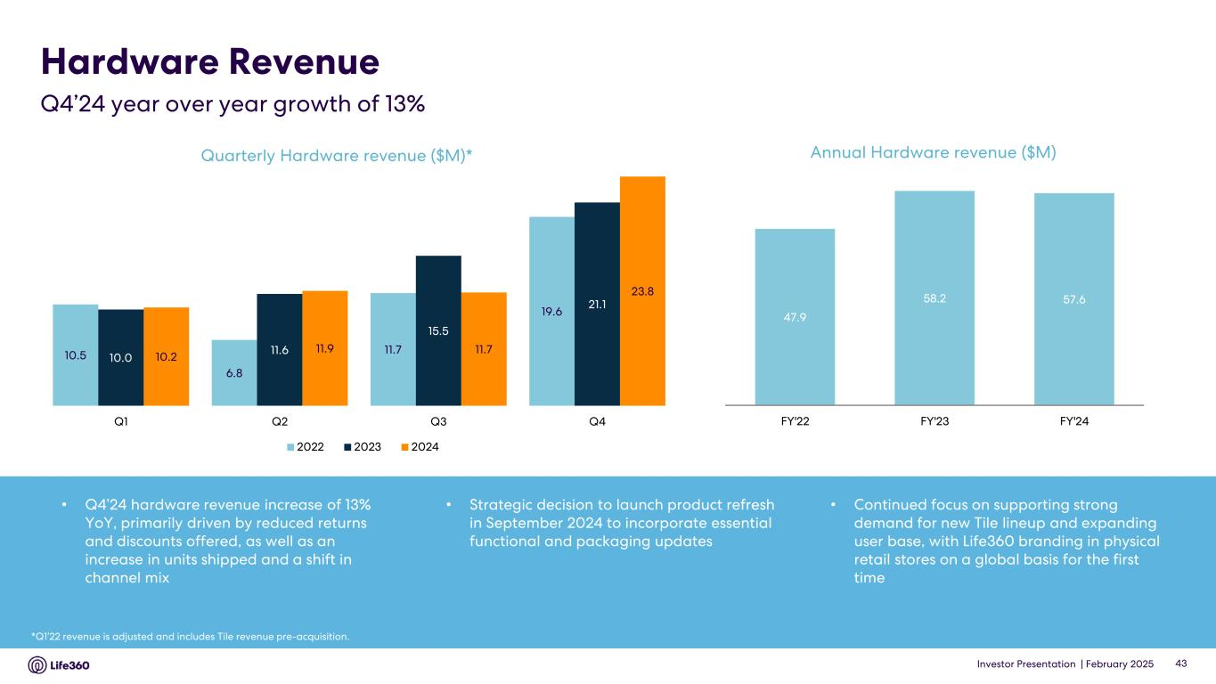
Investor Presentation | February 2025 Hardware Revenue Q4’24 year over year growth of 13% *Q1’22 revenue is adjusted and includes Tile revenue pre-acquisition. Quarterly Hardware revenue ($M)* 43 • Q4’24 hardware revenue increase of 13% YoY, primarily driven by reduced returns and discounts offered, as well as an increase in units shipped and a shift in channel mix • Strategic decision to launch product refresh in September 2024 to incorporate essential functional and packaging updates • Continued focus on supporting strong demand for new Tile lineup and expanding user base, with Life360 branding in physical retail stores on a global basis for the first time 10.5 6.8 11.7 19.6 10.0 11.6 15.5 21.1 10.2 11.9 11.7 23.8 Q1 Q2 Q3 Q4 2022 2023 2024 Annual Hardware revenue ($M) 47.9 58.2 57.6 FY'22 FY'23 FY'24

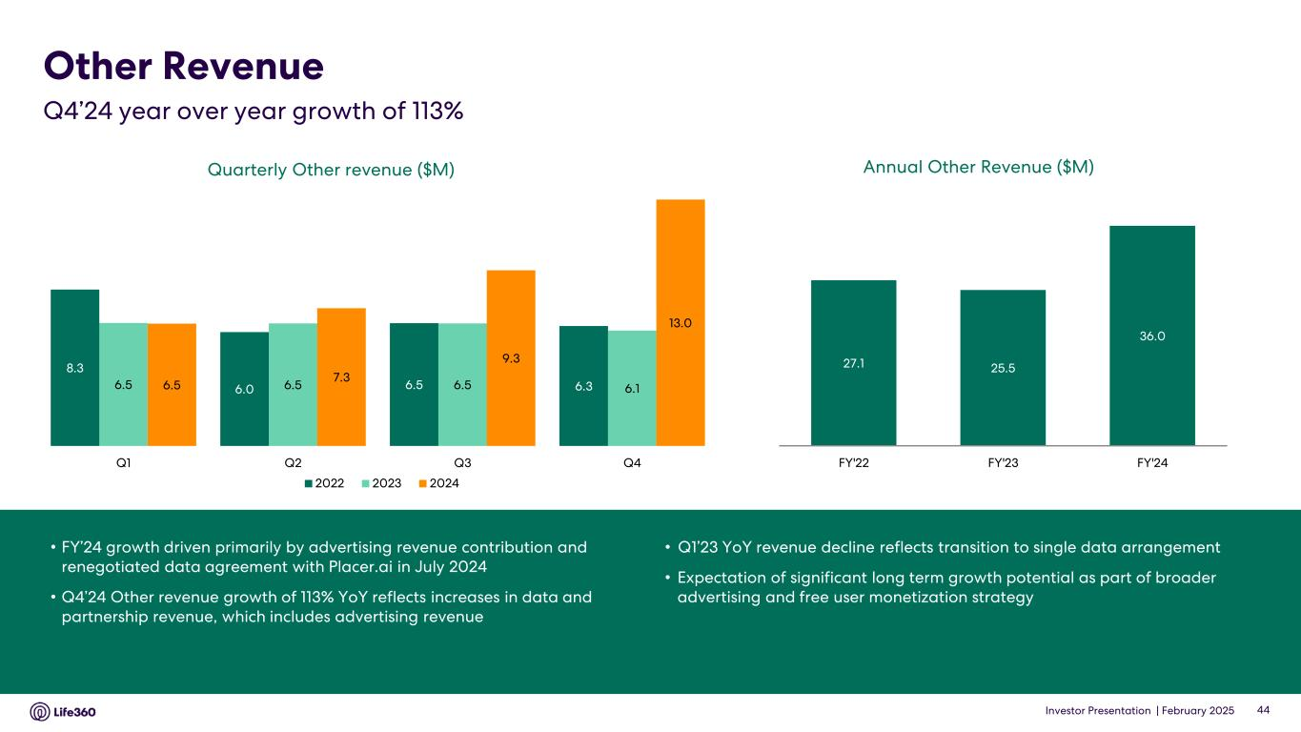
Investor Presentation | February 2025 • FY’24 growth driven primarily by advertising revenue contribution and renegotiated data agreement with Placer.ai in July 2024 • Q4’24 Other revenue growth of 113% YoY reflects increases in data and partnership revenue, which includes advertising revenue • Q1’23 YoY revenue decline reflects transition to single data arrangement • Expectation of significant long term growth potential as part of broader advertising and free user monetization strategy Quarterly Other revenue ($M) Other Revenue Q4’24 year over year growth of 113% 44 Annual Other Revenue ($M) 8.3 6.0 6.5 6.36.5 6.5 6.5 6.16.5 7.3 9.3 13.0 Q1 Q2 Q3 Q4 2022 2023 2024 27.1 25.5 36.0 FY'22 FY'23 FY'24

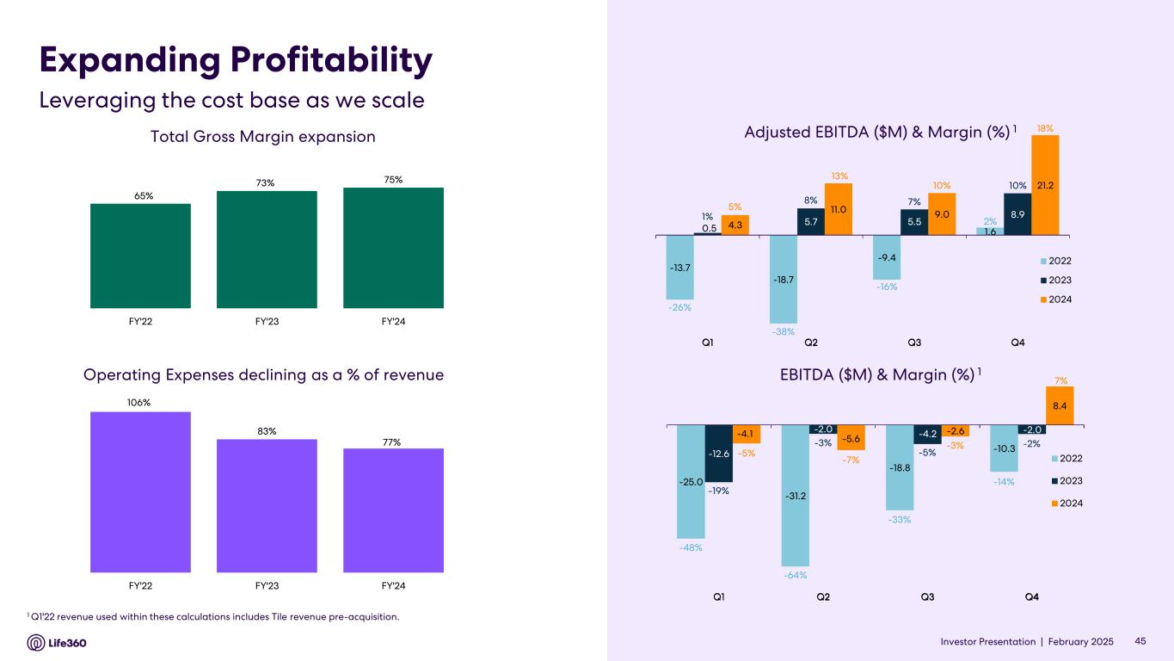
Investor Presentation | February 2025 Expanding Profitability Leveraging the cost base as we scale 45Investor Presentation | -13.7 -18.7 -9.4 1.60.5 5.7 5.5 8.9 4.3 11.0 9.0 21.2 Q1 Q2 Q3 Q4 2022 2023 2024 -25.0 -31.2 -18.8 -10.3 -12.6 -2.0 -4.2 -2.0-4.1 -5.6 -2.6 8.4 Q1 Q2 Q3 Q4 2022 2023 2024 Adjusted EBITDA ($M) & Margin (%) 1 Total Gross Margin expansion 1 Q1'22 revenue used within these calculations includes Tile revenue pre-acquisition. Operating Expenses declining as a % of revenue -48% -64% -33% -14% -19% -3% -5% -2% -5% -7% -3% 7% -26% -38% -16% 2%1% 8% 7% 10% 5% 13% 10% 18% 18% 13% 7% 106% 83% 77% FY'22 FY'23 FY'24 65% 73% 75% FY'22 FY'23 FY'24 EBITDA ($M) & Margin (%) 1


Investor Presentation | February 2025 FY’25 Outlook 03

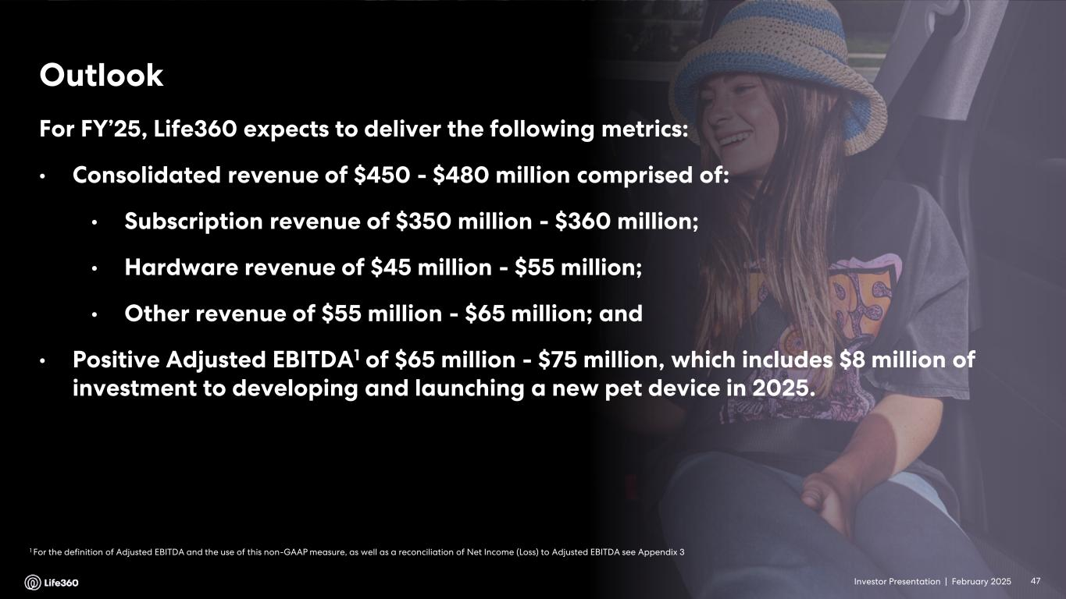
Investor Presentation | February 2025 1 For the definition of Adjusted EBITDA and the use of this non-GAAP measure, as well as a reconciliation of Net Income (Loss) to Adjusted EBITDA see Appendix 3 Outlook 47 For FY’25, Life360 expects to deliver the following metrics: • Consolidated revenue of $450 - $480 million comprised of: • Subscription revenue of $350 million - $360 million; • Hardware revenue of $45 million - $55 million; • Other revenue of $55 million - $65 million; and • Positive Adjusted EBITDA1 of $65 million - $75 million, which includes $8 million of investment to developing and launching a new pet device in 2025. Investor Presentation |


Investor Presentation | February 2025 Appendix 04

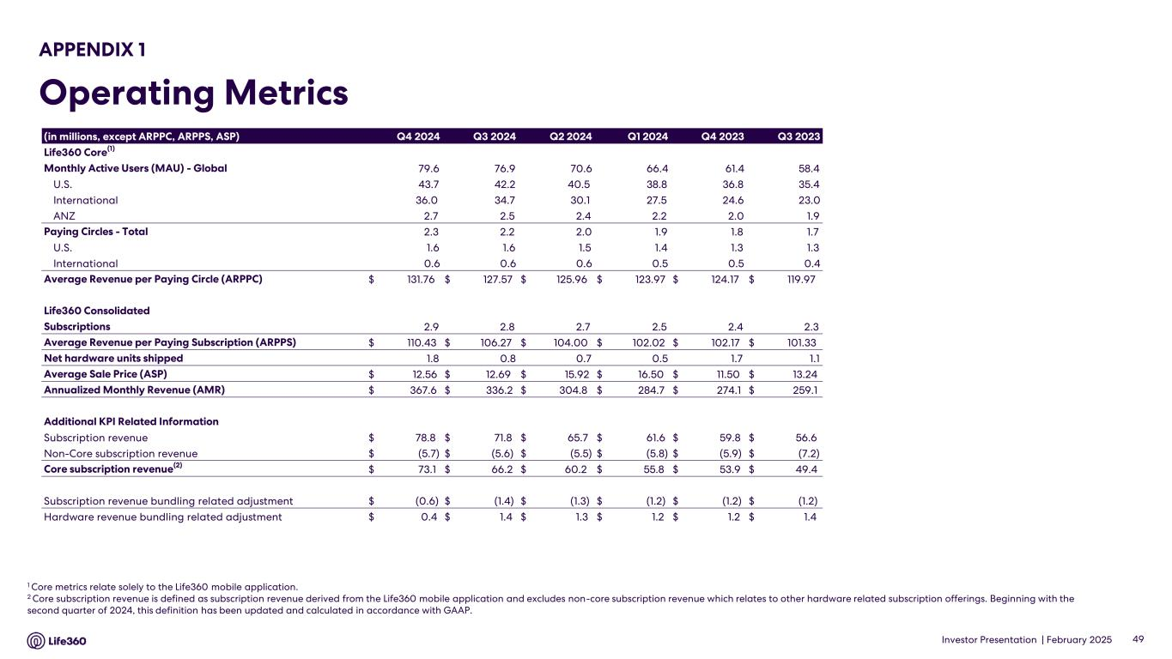
Investor Presentation | February 2025 APPENDIX 1 Operating Metrics 1 Core metrics relate solely to the Life360 mobile application. 2 Core subscription revenue is defined as subscription revenue derived from the Life360 mobile application and excludes non-core subscription revenue which relates to other hardware related subscription offerings. Beginning with the second quarter of 2024, this definition has been updated and calculated in accordance with GAAP. 49 (in millions, except ARPPC, ARPPS, ASP) Q4 2024 Q3 2024 Q2 2024 Q1 2024 Q4 2023 Q3 2023 Life360 Core(1) Monthly Active Users (MAU) - Global 79.6 76.9 70.6 66.4 61.4 58.4 U.S. 43.7 42.2 40.5 38.8 36.8 35.4 International 36.0 34.7 30.1 27.5 24.6 23.0 ANZ 2.7 2.5 2.4 2.2 2.0 1.9 Paying Circles - Total 2.3 2.2 2.0 1.9 1.8 1.7 U.S. 1.6 1.6 1.5 1.4 1.3 1.3 International 0.6 0.6 0.6 0.5 0.5 0.4 Average Revenue per Paying Circle (ARPPC) $ 131.76 $ 127.57 $ 125.96 $ 123.97 $ 124.17 $ 119.97 Life360 Consolidated Subscriptions 2.9 2.8 2.7 2.5 2.4 2.3 Average Revenue per Paying Subscription (ARPPS) $ 110.43 $ 106.27 $ 104.00 $ 102.02 $ 102.17 $ 101.33 Net hardware units shipped 1.8 0.8 0.7 0.5 1.7 1.1 Average Sale Price (ASP) $ 12.56 $ 12.69 $ 15.92 $ 16.50 $ 11.50 $ 13.24 Annualized Monthly Revenue (AMR) $ 367.6 $ 336.2 $ 304.8 $ 284.7 $ 274.1 $ 259.1 Additional KPI Related Information Subscription revenue $ 78.8 $ 71.8 $ 65.7 $ 61.6 $ 59.8 $ 56.6 Non-Core subscription revenue $ (5.7) $ (5.6) $ (5.5) $ (5.8) $ (5.9) $ (7.2) Core subscription revenue(2) $ 73.1 $ 66.2 $ 60.2 $ 55.8 $ 53.9 $ 49.4 Subscription revenue bundling related adjustment $ (0.6) $ (1.4) $ (1.3) $ (1.2) $ (1.2) $ (1.2) Hardware revenue bundling related adjustment $ 0.4 $ 1.4 $ 1.3 $ 1.2 $ 1.2 $ 1.4

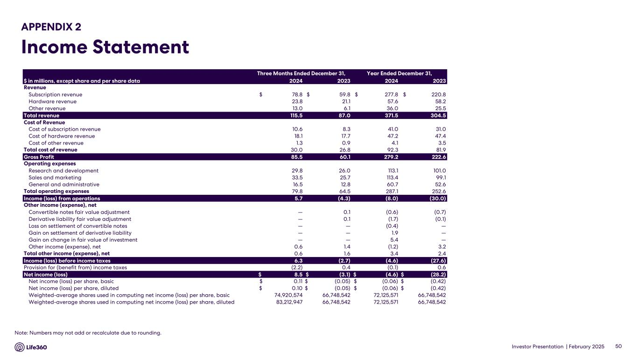
Investor Presentation | February 2025 APPENDIX 2 Income Statement 50 Note: Numbers may not add or recalculate due to rounding. Three Months Ended December 31, Year Ended December 31, $ in millions, except share and per share data 2024 2023 2024 2023 Revenue Subscription revenue $ 78.8 $ 59.8 $ 277.8 $ 220.8 Hardware revenue 23.8 21.1 57.6 58.2 Other revenue 13.0 6.1 36.0 25.5 Total revenue 115.5 87.0 371.5 304.5 Cost of Revenue Cost of subscription revenue 10.6 8.3 41.0 31.0 Cost of hardware revenue 18.1 17.7 47.2 47.4 Cost of other revenue 1.3 0.9 4.1 3.5 Total cost of revenue 30.0 26.8 92.3 81.9 Gross Profit 85.5 60.1 279.2 222.6 Operating expenses Research and development 29.8 26.0 113.1 101.0 Sales and marketing 33.5 25.7 113.4 99.1 General and administrative 16.5 12.8 60.7 52.6 Total operating expenses 79.8 64.5 287.1 252.6 Income (loss) from operations 5.7 (4.3) (8.0) (30.0) Other income (expense), net Convertible notes fair value adjustment — 0.1 (0.6) (0.7) Derivative liability fair value adjustment — 0.1 (1.7) (0.1) Loss on settlement of convertible notes — — (0.4) — Gain on settlement of derivative liability — — 1.9 — Gain on change in fair value of investment — — 5.4 — Other income (expense), net 0.6 1.4 (1.2) 3.2 Total other income (expense), net 0.6 1.6 3.4 2.4 Income (loss) before income taxes 6.3 (2.7) (4.6) (27.6) Provision for (benefit from) income taxes (2.2) 0.4 (0.1) 0.6 Net income (loss) $ 8.5 $ (3.1) $ (4.6) $ (28.2) Net income (loss) per share, basic $ 0.11 $ (0.05) $ (0.06) $ (0.42) Net income (loss) per share, diluted $ 0.10 $ (0.05) $ (0.06) $ (0.42) Weighted-average shares used in computing net income (loss) per share, basic 74,920,574 66,748,542 72,125,571 66,748,542 Weighted-average shares used in computing net income (loss) per share, diluted 83,212,947 66,748,542 72,125,571 66,748,542

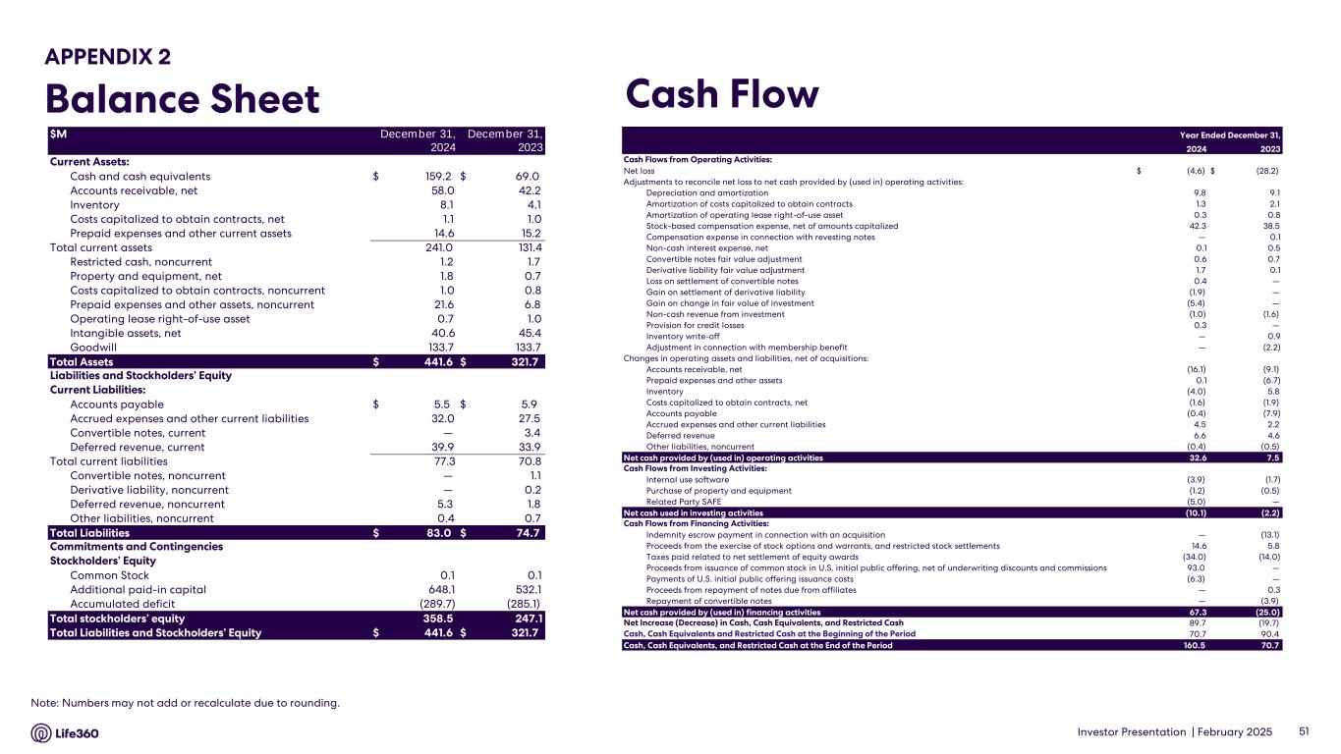
Investor Presentation | February 2025 APPENDIX 2 Balance Sheet Cash Flow 51 Note: Numbers may not add or recalculate due to rounding. $M December 31, December 31, 2024 2023 Current Assets: Cash and cash equivalents $ 159.2 $ 69.0 Accounts receivable, net 58.0 42.2 Inventory 8.1 4.1 Costs capitalized to obtain contracts, net 1.1 1.0 Prepaid expenses and other current assets 14.6 15.2 Total current assets 241.0 131.4 Restricted cash, noncurrent 1.2 1.7 Property and equipment, net 1.8 0.7 Costs capitalized to obtain contracts, noncurrent 1.0 0.8 Prepaid expenses and other assets, noncurrent 21.6 6.8 Operating lease right-of-use asset 0.7 1.0 Intangible assets, net 40.6 45.4 Goodwill 133.7 133.7 Total Assets $ 441.6 $ 321.7 Liabilities and Stockholders’ Equity Current Liabilities: Accounts payable $ 5.5 $ 5.9 Accrued expenses and other current liabilities 32.0 27.5 Convertible notes, current — 3.4 Deferred revenue, current 39.9 33.9 Total current liabilities 77.3 70.8 Convertible notes, noncurrent — 1.1 Derivative liability, noncurrent — 0.2 Deferred revenue, noncurrent 5.3 1.8 Other liabilities, noncurrent 0.4 0.7 Total Liabilities $ 83.0 $ 74.7 Commitments and Contingencies Stockholders’ Equity Common Stock 0.1 0.1 Additional paid-in capital 648.1 532.1 Accumulated deficit (289.7) (285.1) Total stockholders’ equity 358.5 247.1 Total Liabilities and Stockholders’ Equity $ 441.6 $ 321.7 2024 2023 Cash Flows from Operating Activities: Net loss $ (4.6) $ (28.2) Adjustments to reconcile net loss to net cash provided by (used in) operating activities: Depreciation and amortization 9.8 9.1 Amortization of costs capitalized to obtain contracts 1.3 2.1 Amortization of operating lease right-of-use asset 0.3 0.8 Stock-based compensation expense, net of amounts capitalized 42.3 38.5 Compensation expense in connection with revesting notes — 0.1 Non-cash interest expense, net 0.1 0.5 Convertible notes fair value adjustment 0.6 0.7 Derivative liability fair value adjustment 1.7 0.1 Loss on settlement of convertible notes 0.4 — Gain on settlement of derivative liability (1.9) — Gain on change in fair value of investment (5.4) — Non-cash revenue from investment (1.0) (1.6) Provision for credit losses 0.3 — Inventory write-off — 0.9 Adjustment in connection with membership benefit — (2.2) Changes in operating assets and liabilities, net of acquisitions: Accounts receivable, net (16.1) (9.1) Prepaid expenses and other assets 0.1 (6.7) Inventory (4.0) 5.8 Costs capitalized to obtain contracts, net (1.6) (1.9) Accounts payable (0.4) (7.9) Accrued expenses and other current liabilities 4.5 2.2 Deferred revenue 6.6 4.6 Other liabilities, noncurrent (0.4) (0.5) Net cash provided by (used in) operating activities 32.6 7.5 Cash Flows from Investing Activities: Internal use software (3.9) (1.7) Purchase of property and equipment (1.2) (0.5) Related Party SAFE (5.0) — Net cash used in investing activities (10.1) (2.2) Cash Flows from Financing Activities: Indemnity escrow payment in connection with an acquisition — (13.1) Proceeds from the exercise of stock options and warrants, and restricted stock settlements 14.6 5.8 Taxes paid related to net settlement of equity awards (34.0) (14.0) Proceeds from issuance of common stock in U.S. initial public offering, net of underwriting discounts and commissions 93.0 — Payments of U.S. initial public offering issuance costs (6.3) — Proceeds from repayment of notes due from affiliates — 0.3 Repayment of convertible notes — (3.9) Net cash provided by (used in) financing activities 67.3 (25.0) Net Increase (Decrease) in Cash, Cash Equivalents, and Restricted Cash 89.7 (19.7) Cash, Cash Equivalents and Restricted Cash at the Beginning of the Period 70.7 90.4 Cash, Cash Equivalents, and Restricted Cash at the End of the Period 160.5 70.7 Year Ended December 31,

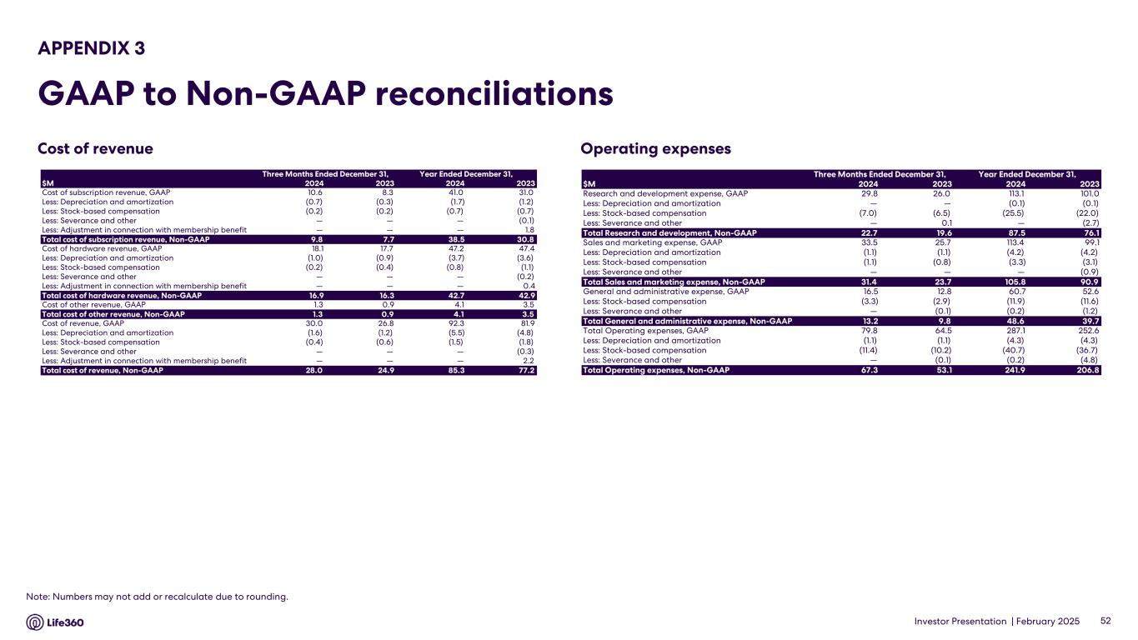
Investor Presentation | February 2025 Operating expenses APPENDIX 3 GAAP to Non-GAAP reconciliations 52 Note: Numbers may not add or recalculate due to rounding. Cost of revenue Three Months Ended December 31, Year Ended December 31, $M 2024 2023 2024 2023 Cost of subscription revenue, GAAP 10.6 8.3 41.0 31.0 Less: Depreciation and amortization (0.7) (0.3) (1.7) (1.2) Less: Stock-based compensation (0.2) (0.2) (0.7) (0.7) Less: Severance and other — — — (0.1) Less: Adjustment in connection with membership benefit — — — 1.8 Total cost of subscription revenue, Non-GAAP 9.8 7.7 38.5 30.8 Cost of hardware revenue, GAAP 18.1 17.7 47.2 47.4 Less: Depreciation and amortization (1.0) (0.9) (3.7) (3.6) Less: Stock-based compensation (0.2) (0.4) (0.8) (1.1) Less: Severance and other — — — (0.2) Less: Adjustment in connection with membership benefit — — — 0.4 Total cost of hardware revenue, Non-GAAP 16.9 16.3 42.7 42.9 Cost of other revenue, GAAP 1.3 0.9 4.1 3.5 Total cost of other revenue, Non-GAAP 1.3 0.9 4.1 3.5 Cost of revenue, GAAP 30.0 26.8 92.3 81.9 Less: Depreciation and amortization (1.6) (1.2) (5.5) (4.8) Less: Stock-based compensation (0.4) (0.6) (1.5) (1.8) Less: Severance and other — — — (0.3) Less: Adjustment in connection with membership benefit — — — 2.2 Total cost of revenue, Non-GAAP 28.0 24.9 85.3 77.2 Three Months Ended December 31, Year Ended December 31, $M 2024 2023 2024 2023 Research and development expense, GAAP 29.8 26.0 113.1 101.0 Less: Depreciation and amortization — — (0.1) (0.1) Less: Stock-based compensation (7.0) (6.5) (25.5) (22.0) Less: Severance and other — 0.1 — (2.7) Total Research and development, Non-GAAP 22.7 19.6 87.5 76.1 Sales and marketing expense, GAAP 33.5 25.7 113.4 99.1 Less: Depreciation and amortization (1.1) (1.1) (4.2) (4.2) Less: Stock-based compensation (1.1) (0.8) (3.3) (3.1) Less: Severance and other — — — (0.9) Total Sales and marketing expense, Non-GAAP 31.4 23.7 105.8 90.9 General and administrative expense, GAAP 16.5 12.8 60.7 52.6 Less: Stock-based compensation (3.3) (2.9) (11.9) (11.6) Less: Severance and other — (0.1) (0.2) (1.2) Total General and administrative expense, Non-GAAP 13.2 9.8 48.6 39.7 Total Operating expenses, GAAP 79.8 64.5 287.1 252.6 Less: Depreciation and amortization (1.1) (1.1) (4.3) (4.3) Less: Stock-based compensation (11.4) (10.2) (40.7) (36.7) Less: Severance and other — (0.1) (0.2) (4.8) Total Operating expenses, Non-GAAP 67.3 53.1 241.9 206.8

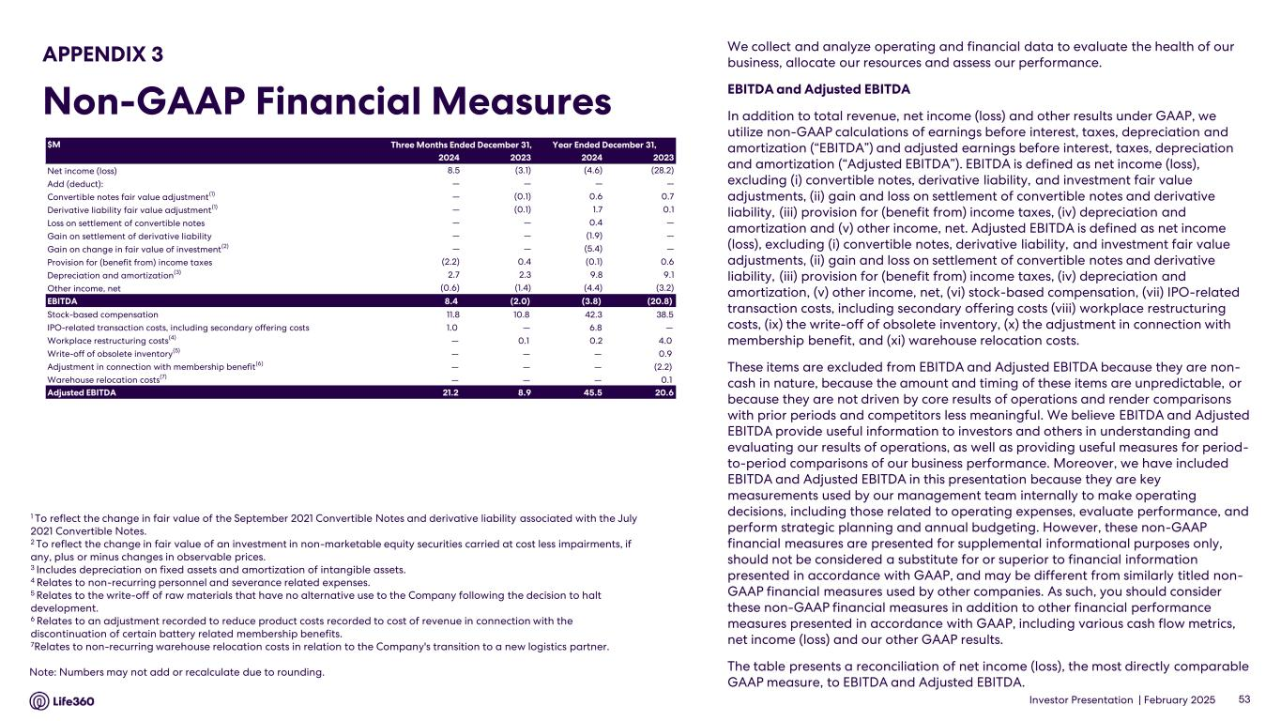
Investor Presentation | February 2025 We collect and analyze operating and financial data to evaluate the health of our business, allocate our resources and assess our performance. EBITDA and Adjusted EBITDA In addition to total revenue, net income (loss) and other results under GAAP, we utilize non-GAAP calculations of earnings before interest, taxes, depreciation and amortization (“EBITDA”) and adjusted earnings before interest, taxes, depreciation and amortization (“Adjusted EBITDA”). EBITDA is defined as net income (loss), excluding (i) convertible notes, derivative liability, and investment fair value adjustments, (ii) gain and loss on settlement of convertible notes and derivative liability, (iii) provision for (benefit from) income taxes, (iv) depreciation and amortization and (v) other income, net. Adjusted EBITDA is defined as net income (loss), excluding (i) convertible notes, derivative liability, and investment fair value adjustments, (ii) gain and loss on settlement of convertible notes and derivative liability, (iii) provision for (benefit from) income taxes, (iv) depreciation and amortization, (v) other income, net, (vi) stock-based compensation, (vii) IPO-related transaction costs, including secondary offering costs (viii) workplace restructuring costs, (ix) the write-off of obsolete inventory, (x) the adjustment in connection with membership benefit, and (xi) warehouse relocation costs. These items are excluded from EBITDA and Adjusted EBITDA because they are non- cash in nature, because the amount and timing of these items are unpredictable, or because they are not driven by core results of operations and render comparisons with prior periods and competitors less meaningful. We believe EBITDA and Adjusted EBITDA provide useful information to investors and others in understanding and evaluating our results of operations, as well as providing useful measures for period- to-period comparisons of our business performance. Moreover, we have included EBITDA and Adjusted EBITDA in this presentation because they are key measurements used by our management team internally to make operating decisions, including those related to operating expenses, evaluate performance, and perform strategic planning and annual budgeting. However, these non-GAAP financial measures are presented for supplemental informational purposes only, should not be considered a substitute for or superior to financial information presented in accordance with GAAP, and may be different from similarly titled non- GAAP financial measures used by other companies. As such, you should consider these non-GAAP financial measures in addition to other financial performance measures presented in accordance with GAAP, including various cash flow metrics, net income (loss) and our other GAAP results. The table presents a reconciliation of net income (loss), the most directly comparable GAAP measure, to EBITDA and Adjusted EBITDA. 1 To reflect the change in fair value of the September 2021 Convertible Notes and derivative liability associated with the July 2021 Convertible Notes. 2 To reflect the change in fair value of an investment in non-marketable equity securities carried at cost less impairments, if any, plus or minus changes in observable prices. 3 Includes depreciation on fixed assets and amortization of intangible assets. 4 Relates to non-recurring personnel and severance related expenses. 5 Relates to the write-off of raw materials that have no alternative use to the Company following the decision to halt development. 6 Relates to an adjustment recorded to reduce product costs recorded to cost of revenue in connection with the discontinuation of certain battery related membership benefits. 7Relates to non-recurring warehouse relocation costs in relation to the Company's transition to a new logistics partner. 53 APPENDIX 3 Non-GAAP Financial Measures Note: Numbers may not add or recalculate due to rounding. $M 2024 2023 2024 2023 Net income (loss) 8.5 (3.1) (4.6) (28.2) Add (deduct): — — — — Convertible notes fair value adjustment(1) — (0.1) 0.6 0.7 Derivative liability fair value adjustment(1) — (0.1) 1.7 0.1 Loss on settlement of convertible notes — — 0.4 — Gain on settlement of derivative liability — — (1.9) — Gain on change in fair value of investment(2) — — (5.4) — Provision for (benefit from) income taxes (2.2) 0.4 (0.1) 0.6 Depreciation and amortization(3) 2.7 2.3 9.8 9.1 Other income, net (0.6) (1.4) (4.4) (3.2) EBITDA 8.4 (2.0) (3.8) (20.8) Stock-based compensation 11.8 10.8 42.3 38.5 IPO-related transaction costs, including secondary offering costs 1.0 — 6.8 — Workplace restructuring costs(4) — 0.1 0.2 4.0 Write-off of obsolete inventory(5) — — — 0.9 Adjustment in connection with membership benefit(6) — — — (2.2) Warehouse relocation costs(7) — — — 0.1 Adjusted EBITDA 21.2 8.9 45.5 20.6 Three Months Ended December 31, Year Ended December 31,

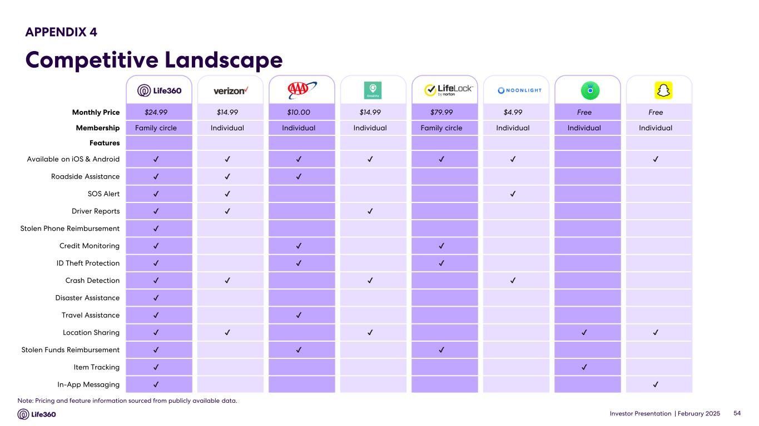
Investor Presentation | February 2025 54 Monthly Price $24.99 $14.99 $10.00 $14.99 $79.99 $4.99 Free Free Membership Family circle Individual Individual Individual Family circle Individual Individual Individual Features Available on iOS & Android Roadside Assistance SOS Alert Driver Reports Stolen Phone Reimbursement Credit Monitoring ID Theft Protection Crash Detection Disaster Assistance Travel Assistance Location Sharing Stolen Funds Reimbursement Item Tracking In-App Messaging Note: Pricing and feature information sourced from publicly available data. APPENDIX 4 Competitive Landscape

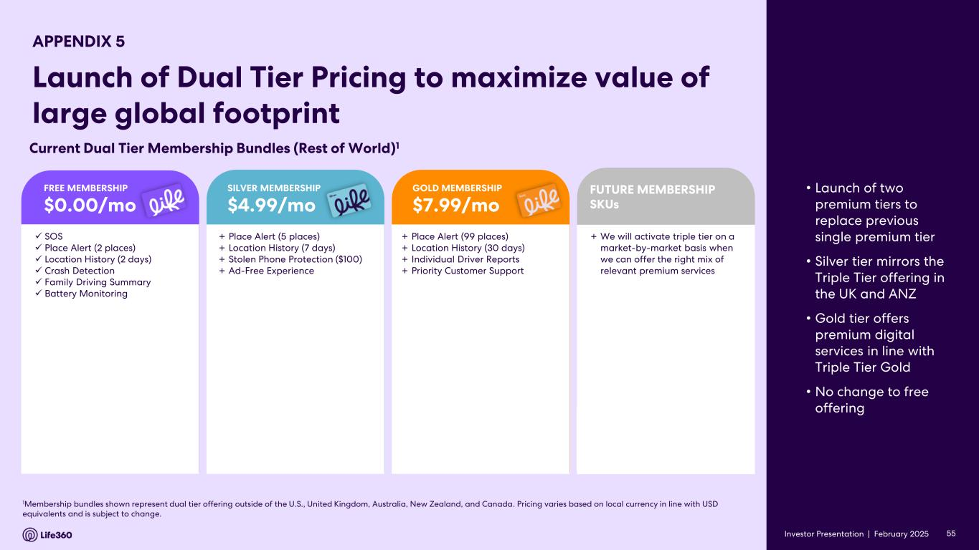
Investor Presentation | February 2025 1Membership bundles shown represent dual tier offering outside of the U.S., United Kingdom, Australia, New Zealand, and Canada. Pricing varies based on local currency in line with USD equivalents and is subject to change. ✓ SOS ✓ Place Alert (2 places) ✓ Location History (2 days) ✓ Crash Detection ✓ Family Driving Summary ✓ Battery Monitoring + Place Alert (5 places) + Location History (7 days) + Stolen Phone Protection ($100) + Ad-Free Experience + Place Alert (99 places) + Location History (30 days) + Individual Driver Reports + Priority Customer Support Current Dual Tier Membership Bundles (Rest of World)1 FREE MEMBERSHIP $0.00/mo SILVER MEMBERSHIP $4.99/mo GOLD MEMBERSHIP $7.99/mo + We will activate triple tier on a market-by-market basis when we can offer the right mix of relevant premium services FUTURE MEMBERSHIP SKUs 55 • Launch of two premium tiers to replace previous single premium tier • Silver tier mirrors the Triple Tier offering in the UK and ANZ • Gold tier offers premium digital services in line with Triple Tier Gold • No change to free offering Investor Presentation | APPENDIX 5 Launch of Dual Tier Pricing to maximize value of large global footprint


Investor Presentation | February 2025 Thank You

