UNITED STATES
SECURITIES AND EXCHANGE COMMISSION
Washington, D.C. 20549
______________

FORM 8-K

CURRENT REPORT
Pursuant to Section 13 or 15(d) of the
Securities Exchange Act of 1934

Date of Report (Date of earliest event reported): August 14, 2023

Life360, Inc.
(Exact name of registrant as specified in its charter)
Delaware |  |  | 000-56424 |  |  | 26-0197666
(State or other jurisdiction of  incorporation or organization) |  |  | (Commission File Number) |  |  | (I.R.S. Employer  Identification No.)

1900 South Norfolk Street, Suite 310
San Mateo, CA 94403
(Address of principal executive offices, including zip code)
(415) 484-5244
(Registrant’s telephone number, including area code)
Not applicable.
(Former name or former address, if changed since last report)
______________

Check the appropriate box below if the Form 8-K filing is intended to simultaneously satisfy the filing obligation of the registrant under any of the following provisions:
☐ |  |  | Written communications pursuant to Rule 425 under the Securities Act (17 CFR 230.425)
☐ |  |  | Soliciting material pursuant to Rule 14a-12 under the Exchange Act (17 CFR 240.14a-12)
☐ |  |  | Pre-commencement communications pursuant to Rule 14d-2(b) under the Exchange Act (17 CFR 240.14d-2(b))
☐ |  |  | Pre-commencement communications pursuant to Rule 13e-4(c) under the Exchange Act (17 CFR 240.13e-4(c))

Title of each class |  |  | Trading Symbol(s) |  |  | Name of each exchange on which registered
None. |  |  | None. |  |  | None.

Indicate by check mark whether the registrant is an emerging growth company as defined in Rule 405 of the Securities Act of 1933 (§230.405 of this chapter) or Rule 12b-2 of the Securities Exchange Act of 1934 (§240.12b-2 of this chapter).

Emerging growth company ☒
If an emerging growth company, indicate by check mark if the registrant has elected not to use the extended transition period for complying with any new or revised financial accounting standards provided pursuant to Section 13(a) of the Exchange Act. ☐

Item 2.02 Results of Operations and Financial Condition.
We are furnishing this Current Report on Form 8-K in connection with the disclosure of information, in the form of textual information from a media release issued on August 14, 2023. A copy of the media release is furnished as Exhibit 99.1 to this Current Report on Form 8-K.

Item 7.01 Regulation FD Disclosure.

We are furnishing this Item 7.01 of this Current Report on Form 8-K in connection with the disclosure of information, in the form of the textual information from a PowerPoint presentation to be given during a conference call and webcast on August 14, 2023 at 6:30 p.m. Eastern Time. A copy of the PowerPoint presentation to be used for the conference call and webcast is furnished as Exhibit 99.2 to this Current Report on Form 8-K.

The information in Item 2.02 (including Exhibit 99.1) and Item 7.01 (including Exhibit 99.2) of this Current Report on Form 8-K is furnished and shall not be deemed to be “filed” for the purpose of Section 18 of the Securities Exchange Act of 1934, as amended (the “Exchange Act”) or otherwise subject to the liabilities of that section, nor shall it be deemed incorporated by reference into any filing under the Securities Act of 1933, as amended, or the Exchange Act, except as shall be expressly set forth by specific reference in such a filing.

The text included with this Item 2.02 and Item 7.01 of this Current Report on Form 8-K and the replay of the conference call and webcast will be available on our website located at www.life360.com, although we reserve the right to discontinue that availability at any time.

Item 9.01 Financial Statements and Exhibits.
(d) Exhibits

Exhibit No. |  |  | Description
99.1 |  |  | Media release of the Registrant dated August 14, 2023
99.2 |  |  | Life360, Inc. Investor Presentation
104 |  |  | Cover Page Interactive Data File - the cover page XBRL tags are embedded within the Inline XBRL document

SIGNATURES
Pursuant to the requirements of the Securities Exchange Act of 1934, the registrant has duly caused this report to be signed on its behalf by the undersigned hereunto duly authorized.
 |  |  |  |  |  | LIFE360, INC.
Dated: |  |  | August 14, 2023 |  |  | By: |  |  | /s/ Russell Burke
 |  |  |  |  |  |  |  |  | Russell Burke
 |  |  |  |  |  |  |  |  | Chief Financial Officer

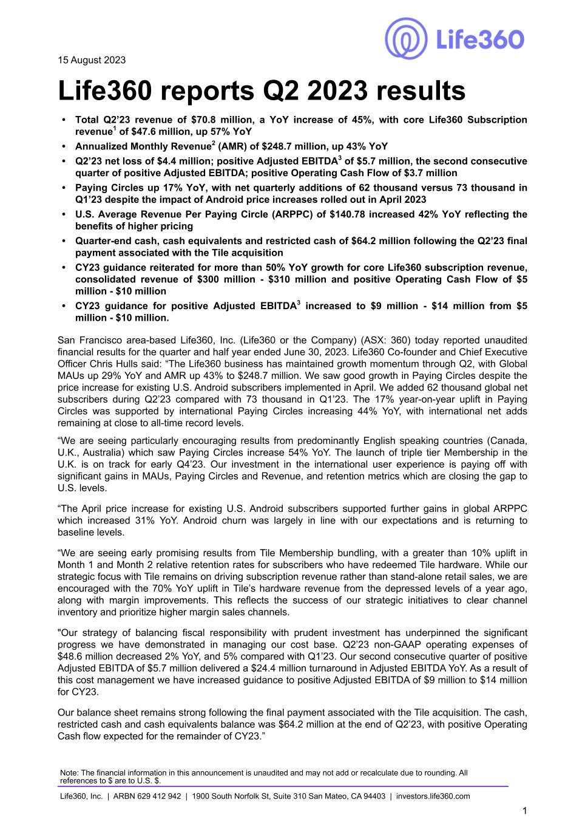

15 August 2023 Life360 reports Q2 2023 results • Total Q2’23 revenue of $70.8 million, a YoY increase of 45%, with core Life360 Subscription revenue1 of $47.6 million, up 57% YoY • Annualized Monthly Revenue2 (AMR) of $248.7 million, up 43% YoY • Q2’23 net loss of $4.4 million; positive Adjusted EBITDA3 of $5.7 million, the second consecutive quarter of positive Adjusted EBITDA; positive Operating Cash Flow of $3.7 million • Paying Circles up 17% YoY, with net quarterly additions of 62 thousand versus 73 thousand in Q1’23 despite the impact of Android price increases rolled out in April 2023 • U.S. Average Revenue Per Paying Circle (ARPPC) of $140.78 increased 42% YoY reflecting the benefits of higher pricing • Quarter-end cash, cash equivalents and restricted cash of $64.2 million following the Q2’23 final payment associated with the Tile acquisition • CY23 guidance reiterated for more than 50% YoY growth for core Life360 subscription revenue, consolidated revenue of $300 million - $310 million and positive Operating Cash Flow of $5 million - $10 million • CY23 guidance for positive Adjusted EBITDA3 increased to $9 million - $14 million from $5 million - $10 million. San Francisco area-based Life360, Inc. (Life360 or the Company) (ASX: 360) today reported unaudited financial results for the quarter and half year ended June 30, 2023. Life360 Co-founder and Chief Executive Officer Chris Hulls said: “The Life360 business has maintained growth momentum through Q2, with Global MAUs up 29% YoY and AMR up 43% to $248.7 million. We saw good growth in Paying Circles despite the price increase for existing U.S. Android subscribers implemented in April. We added 62 thousand global net subscribers during Q2’23 compared with 73 thousand in Q1’23. The 17% year-on-year uplift in Paying Circles was supported by international Paying Circles increasing 44% YoY, with international net adds remaining at close to all-time record levels. “We are seeing particularly encouraging results from predominantly English speaking countries (Canada, U.K., Australia) which saw Paying Circles increase 54% YoY. The launch of triple tier Membership in the U.K. is on track for early Q4’23. Our investment in the international user experience is paying off with significant gains in MAUs, Paying Circles and Revenue, and retention metrics which are closing the gap to U.S. levels. “The April price increase for existing U.S. Android subscribers supported further gains in global ARPPC which increased 31% YoY. Android churn was largely in line with our expectations and is returning to baseline levels. “We are seeing early promising results from Tile Membership bundling, with a greater than 10% uplift in Month 1 and Month 2 relative retention rates for subscribers who have redeemed Tile hardware. While our strategic focus with Tile remains on driving subscription revenue rather than stand-alone retail sales, we are encouraged with the 70% YoY uplift in Tile’s hardware revenue from the depressed levels of a year ago, along with margin improvements. This reflects the success of our strategic initiatives to clear channel inventory and prioritize higher margin sales channels. "Our strategy of balancing fiscal responsibility with prudent investment has underpinned the significant progress we have demonstrated in managing our cost base. Q2’23 non-GAAP operating expenses of $48.6 million decreased 2% YoY, and 5% compared with Q1’23. Our second consecutive quarter of positive Adjusted EBITDA of $5.7 million delivered a $24.4 million turnaround in Adjusted EBITDA YoY. As a result of this cost management we have increased guidance to positive Adjusted EBITDA of $9 million to $14 million for CY23. Our balance sheet remains strong following the final payment associated with the Tile acquisition. The cash, restricted cash and cash equivalents balance was $64.2 million at the end of Q2’23, with positive Operating Cash flow expected for the remainder of CY23.” Note: The financial information in this announcement is unaudited and may not add or recalculate due to rounding. All references to $ are to U.S. $. Life360, Inc. | ARBN 629 412 942 | 1900 South Norfolk St, Suite 310 San Mateo, CA 94403 | investors.life360.com 1

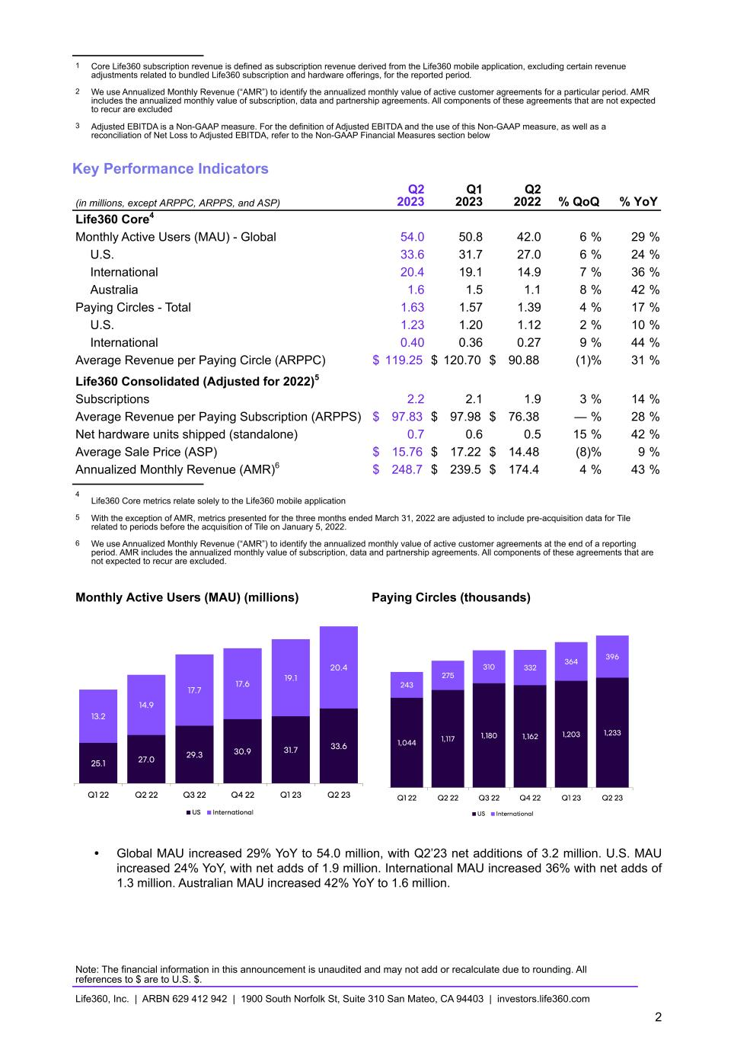
1 Core Life360 subscription revenue is defined as subscription revenue derived from the Life360 mobile application, excluding certain revenue adjustments related to bundled Life360 subscription and hardware offerings, for the reported period. 2 We use Annualized Monthly Revenue (“AMR”) to identify the annualized monthly value of active customer agreements for a particular period. AMR includes the annualized monthly value of subscription, data and partnership agreements. All components of these agreements that are not expected to recur are excluded 3 Adjusted EBITDA is a Non-GAAP measure. For the definition of Adjusted EBITDA and the use of this Non-GAAP measure, as well as a reconciliation of Net Loss to Adjusted EBITDA, refer to the Non-GAAP Financial Measures section below Key Performance Indicators (in millions, except ARPPC, ARPPS, and ASP) Q2 2023 Q1 2023 Q2 2022 % QoQ % YoY Life360 Core4 Monthly Active Users (MAU) - Global 54.0 50.8 42.0 6 % 29 % U.S. 33.6 31.7 27.0 6 % 24 % International 20.4 19.1 14.9 7 % 36 % Australia 1.6 1.5 1.1 8 % 42 % Paying Circles - Total 1.63 1.57 1.39 4 % 17 % U.S. 1.23 1.20 1.12 2 % 10 % International 0.40 0.36 0.27 9 % 44 % Average Revenue per Paying Circle (ARPPC) $ 119.25 $ 120.70 $ 90.88 (1) % 31 % Life360 Consolidated (Adjusted for 2022)5 Subscriptions 2.2 2.1 1.9 3 % 14 % Average Revenue per Paying Subscription (ARPPS) $ 97.83 $ 97.98 $ 76.38 — % 28 % Net hardware units shipped (standalone) 0.7 0.6 0.5 15 % 42 % Average Sale Price (ASP) $ 15.76 $ 17.22 $ 14.48 (8) % 9 % Annualized Monthly Revenue (AMR)6 $ 248.7 $ 239.5 $ 174.4 4 % 43 % 4 Life360 Core metrics relate solely to the Life360 mobile application 5 With the exception of AMR, metrics presented for the three months ended March 31, 2022 are adjusted to include pre-acquisition data for Tile related to periods before the acquisition of Tile on January 5, 2022. 6 We use Annualized Monthly Revenue (“AMR”) to identify the annualized monthly value of active customer agreements at the end of a reporting period. AMR includes the annualized monthly value of subscription, data and partnership agreements. All components of these agreements that are not expected to recur are excluded. Monthly Active Users (MAU) (millions) Paying Circles (thousands) • Global MAU increased 29% YoY to 54.0 million, with Q2’23 net additions of 3.2 million. U.S. MAU increased 24% YoY, with net adds of 1.9 million. International MAU increased 36% with net adds of 1.3 million. Australian MAU increased 42% YoY to 1.6 million. Note: The financial information in this announcement is unaudited and may not add or recalculate due to rounding. All references to $ are to U.S. $. Life360, Inc. | ARBN 629 412 942 | 1900 South Norfolk St, Suite 310 San Mateo, CA 94403 | investors.life360.com 2

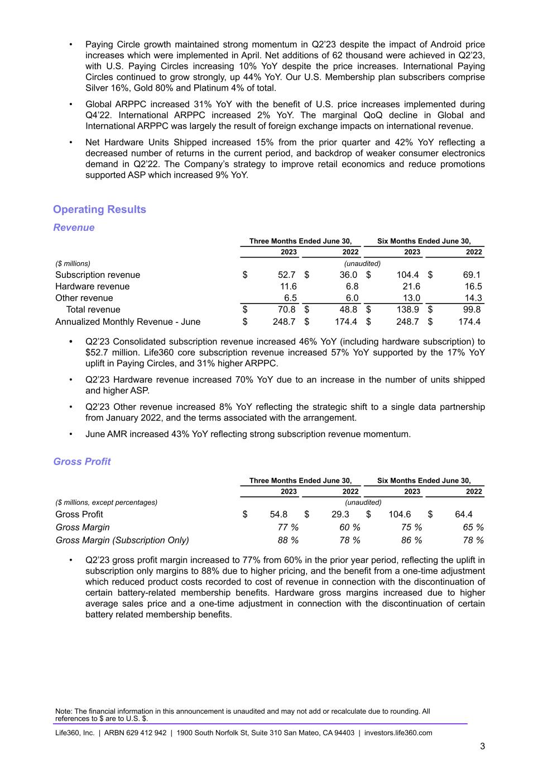
• Paying Circle growth maintained strong momentum in Q2’23 despite the impact of Android price increases which were implemented in April. Net additions of 62 thousand were achieved in Q2’23, with U.S. Paying Circles increasing 10% YoY despite the price increases. International Paying Circles continued to grow strongly, up 44% YoY. Our U.S. Membership plan subscribers comprise Silver 16%, Gold 80% and Platinum 4% of total. • Global ARPPC increased 31% YoY with the benefit of U.S. price increases implemented during Q4’22. International ARPPC increased 2% YoY. The marginal QoQ decline in Global and International ARPPC was largely the result of foreign exchange impacts on international revenue. • Net Hardware Units Shipped increased 15% from the prior quarter and 42% YoY reflecting a decreased number of returns in the current period, and backdrop of weaker consumer electronics demand in Q2’22. The Company’s strategy to improve retail economics and reduce promotions supported ASP which increased 9% YoY. Operating Results Revenue Three Months Ended June 30, Six Months Ended June 30, 2023 2022 2023 2022 ($ millions) (unaudited) Subscription revenue $ 52.7 $ 36.0 $ 104.4 $ 69.1 Hardware revenue 11.6 6.8 21.6 16.5 Other revenue 6.5 6.0 13.0 14.3 Total revenue $ 70.8 $ 48.8 $ 138.9 $ 99.8 Annualized Monthly Revenue - June $ 248.7 $ 174.4 $ 248.7 $ 174.4 • Q2’23 Consolidated subscription revenue increased 46% YoY (including hardware subscription) to $52.7 million. Life360 core subscription revenue increased 57% YoY supported by the 17% YoY uplift in Paying Circles, and 31% higher ARPPC. • Q2’23 Hardware revenue increased 70% YoY due to an increase in the number of units shipped and higher ASP. • Q2’23 Other revenue increased 8% YoY reflecting the strategic shift to a single data partnership from January 2022, and the terms associated with the arrangement. • June AMR increased 43% YoY reflecting strong subscription revenue momentum. Gross Profit Three Months Ended June 30, Six Months Ended June 30, 2023 2022 2023 2022 ($ millions, except percentages) (unaudited) Gross Profit $ 54.8 $ 29.3 $ 104.6 $ 64.4 Gross Margin 77 % 60 % 75 % 65 % Gross Margin (Subscription Only) 88 % 78 % 86 % 78 % • Q2’23 gross profit margin increased to 77% from 60% in the prior year period, reflecting the uplift in subscription only margins to 88% due to higher pricing, and the benefit from a one-time adjustment which reduced product costs recorded to cost of revenue in connection with the discontinuation of certain battery-related membership benefits. Hardware gross margins increased due to higher average sales price and a one-time adjustment in connection with the discontinuation of certain battery related membership benefits. Note: The financial information in this announcement is unaudited and may not add or recalculate due to rounding. All references to $ are to U.S. $. Life360, Inc. | ARBN 629 412 942 | 1900 South Norfolk St, Suite 310 San Mateo, CA 94403 | investors.life360.com 3

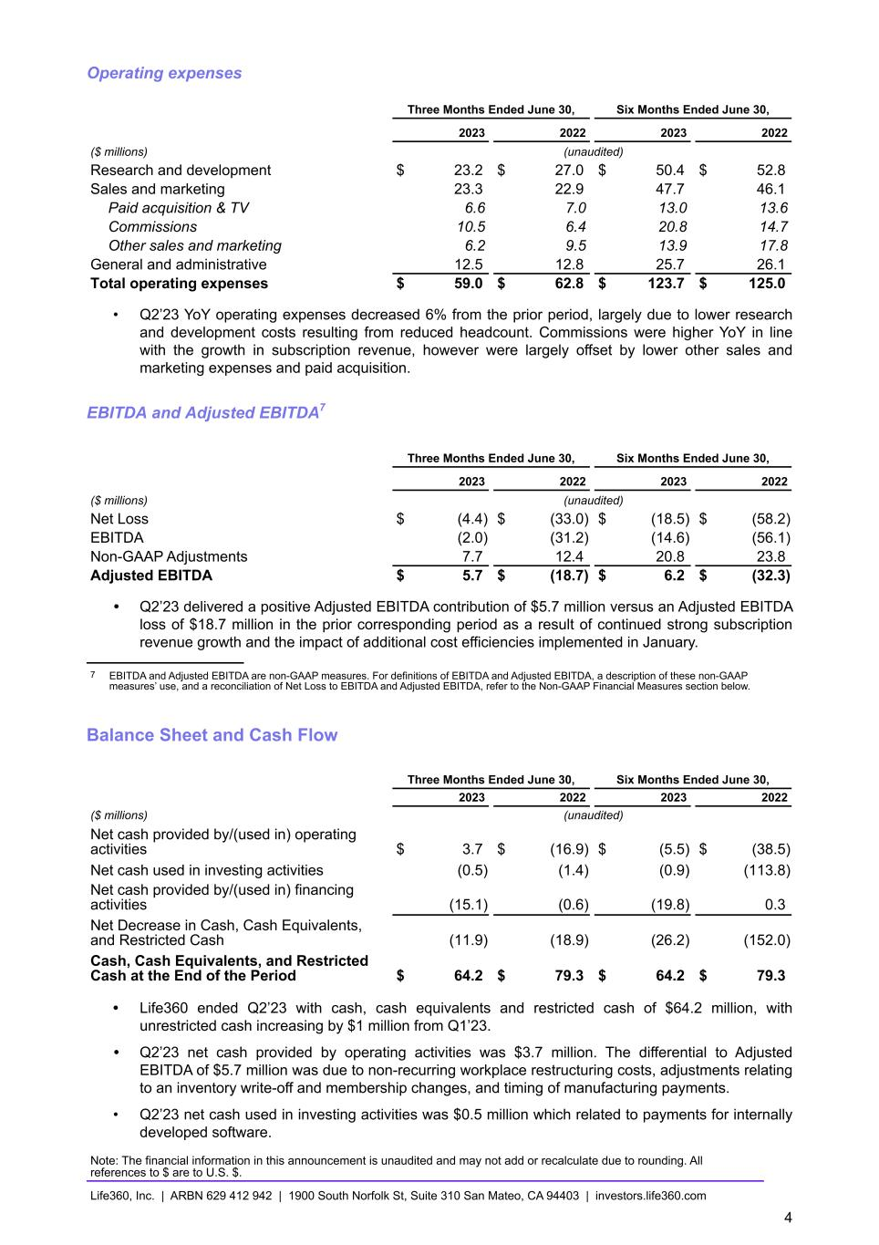
Operating expenses Three Months Ended June 30, Six Months Ended June 30, 2023 2022 2023 2022 ($ millions) (unaudited) Research and development $ 23.2 $ 27.0 $ 50.4 $ 52.8 Sales and marketing 23.3 22.9 47.7 46.1 Paid acquisition & TV 6.6 7.0 13.0 13.6 Commissions 10.5 6.4 20.8 14.7 Other sales and marketing 6.2 9.5 13.9 17.8 General and administrative 12.5 12.8 25.7 26.1 Total operating expenses $ 59.0 $ 62.8 $ 123.7 $ 125.0 • Q2’23 YoY operating expenses decreased 6% from the prior period, largely due to lower research and development costs resulting from reduced headcount. Commissions were higher YoY in line with the growth in subscription revenue, however were largely offset by lower other sales and marketing expenses and paid acquisition. EBITDA and Adjusted EBITDA7 Three Months Ended June 30, Six Months Ended June 30, 2023 2022 2023 2022 ($ millions) (unaudited) Net Loss $ (4.4) $ (33.0) $ (18.5) $ (58.2) EBITDA (2.0) (31.2) (14.6) (56.1) Non-GAAP Adjustments 7.7 12.4 20.8 23.8 Adjusted EBITDA $ 5.7 $ (18.7) $ 6.2 $ (32.3) • Q2’23 delivered a positive Adjusted EBITDA contribution of $5.7 million versus an Adjusted EBITDA loss of $18.7 million in the prior corresponding period as a result of continued strong subscription revenue growth and the impact of additional cost efficiencies implemented in January. 7 EBITDA and Adjusted EBITDA are non-GAAP measures. For definitions of EBITDA and Adjusted EBITDA, a description of these non-GAAP measures’ use, and a reconciliation of Net Loss to EBITDA and Adjusted EBITDA, refer to the Non-GAAP Financial Measures section below. Balance Sheet and Cash Flow Three Months Ended June 30, Six Months Ended June 30, 2023 2022 2023 2022 ($ millions) (unaudited) Net cash provided by/(used in) operating activities $ 3.7 $ (16.9) $ (5.5) $ (38.5) Net cash used in investing activities (0.5) (1.4) (0.9) (113.8) Net cash provided by/(used in) financing activities (15.1) (0.6) (19.8) 0.3 Net Decrease in Cash, Cash Equivalents, and Restricted Cash (11.9) (18.9) (26.2) (152.0) Cash, Cash Equivalents, and Restricted Cash at the End of the Period $ 64.2 $ 79.3 $ 64.2 $ 79.3 • Life360 ended Q2’23 with cash, cash equivalents and restricted cash of $64.2 million, with unrestricted cash increasing by $1 million from Q1’23. • Q2’23 net cash provided by operating activities was $3.7 million. The differential to Adjusted EBITDA of $5.7 million was due to non-recurring workplace restructuring costs, adjustments relating to an inventory write-off and membership changes, and timing of manufacturing payments. • Q2’23 net cash used in investing activities was $0.5 million which related to payments for internally developed software. Note: The financial information in this announcement is unaudited and may not add or recalculate due to rounding. All references to $ are to U.S. $. Life360, Inc. | ARBN 629 412 942 | 1900 South Norfolk St, Suite 310 San Mateo, CA 94403 | investors.life360.com 4

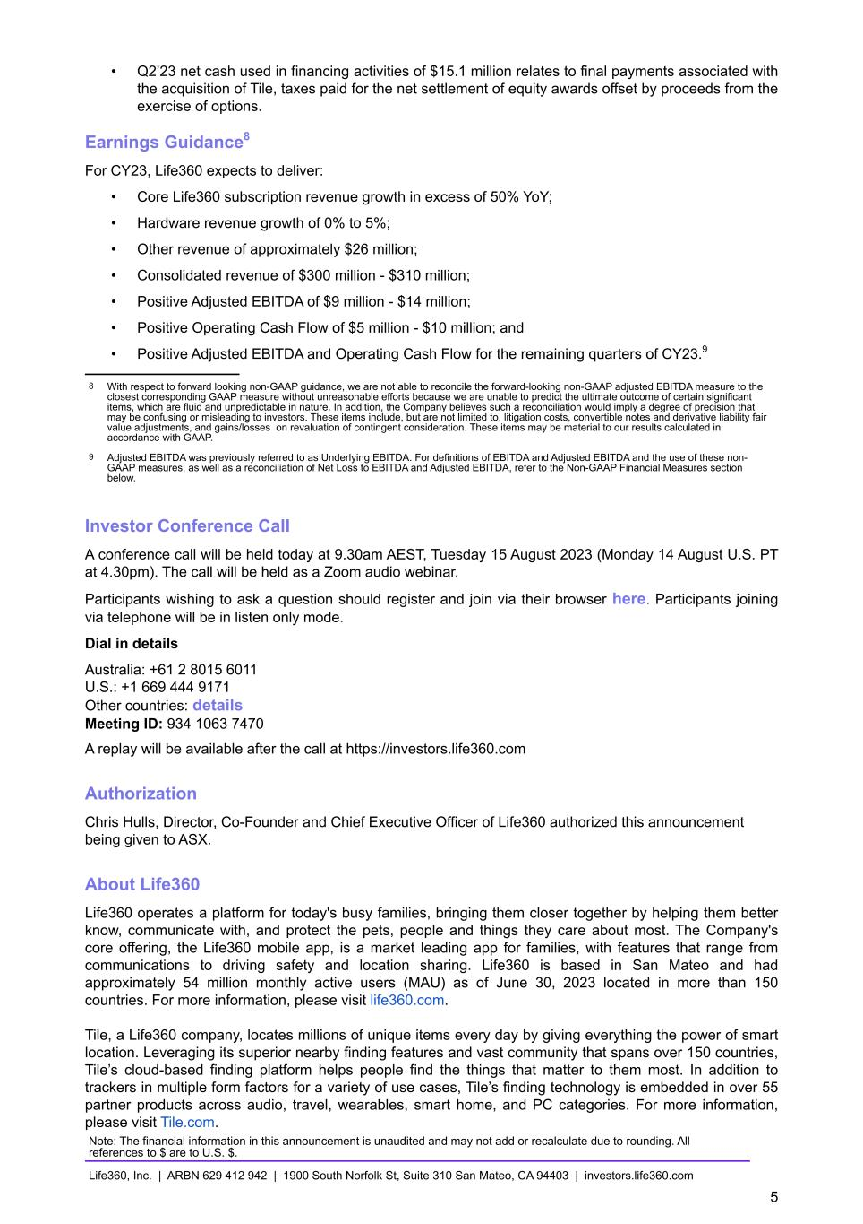
• Q2’23 net cash used in financing activities of $15.1 million relates to final payments associated with the acquisition of Tile, taxes paid for the net settlement of equity awards offset by proceeds from the exercise of options. Earnings Guidance8 For CY23, Life360 expects to deliver: • Core Life360 subscription revenue growth in excess of 50% YoY; • Hardware revenue growth of 0% to 5%; • Other revenue of approximately $26 million; • Consolidated revenue of $300 million - $310 million; • Positive Adjusted EBITDA of $9 million - $14 million; • Positive Operating Cash Flow of $5 million - $10 million; and • Positive Adjusted EBITDA and Operating Cash Flow for the remaining quarters of CY23.9 8 With respect to forward looking non-GAAP guidance, we are not able to reconcile the forward-looking non-GAAP adjusted EBITDA measure to the closest corresponding GAAP measure without unreasonable efforts because we are unable to predict the ultimate outcome of certain significant items, which are fluid and unpredictable in nature. In addition, the Company believes such a reconciliation would imply a degree of precision that may be confusing or misleading to investors. These items include, but are not limited to, litigation costs, convertible notes and derivative liability fair value adjustments, and gains/losses on revaluation of contingent consideration. These items may be material to our results calculated in accordance with GAAP. 9 Adjusted EBITDA was previously referred to as Underlying EBITDA. For definitions of EBITDA and Adjusted EBITDA and the use of these non- GAAP measures, as well as a reconciliation of Net Loss to EBITDA and Adjusted EBITDA, refer to the Non-GAAP Financial Measures section below. Investor Conference Call A conference call will be held today at 9.30am AEST, Tuesday 15 August 2023 (Monday 14 August U.S. PT at 4.30pm). The call will be held as a Zoom audio webinar. Participants wishing to ask a question should register and join via their browser here. Participants joining via telephone will be in listen only mode. Dial in details Australia: +61 2 8015 6011 U.S.: +1 669 444 9171 Other countries: details Meeting ID: 934 1063 7470 A replay will be available after the call at https://investors.life360.com Authorization Chris Hulls, Director, Co-Founder and Chief Executive Officer of Life360 authorized this announcement being given to ASX. About Life360 Life360 operates a platform for today's busy families, bringing them closer together by helping them better know, communicate with, and protect the pets, people and things they care about most. The Company's core offering, the Life360 mobile app, is a market leading app for families, with features that range from communications to driving safety and location sharing. Life360 is based in San Mateo and had approximately 54 million monthly active users (MAU) as of June 30, 2023 located in more than 150 countries. For more information, please visit life360.com. Tile, a Life360 company, locates millions of unique items every day by giving everything the power of smart location. Leveraging its superior nearby finding features and vast community that spans over 150 countries, Tile’s cloud-based finding platform helps people find the things that matter to them most. In addition to trackers in multiple form factors for a variety of use cases, Tile’s finding technology is embedded in over 55 partner products across audio, travel, wearables, smart home, and PC categories. For more information, please visit Tile.com. Note: The financial information in this announcement is unaudited and may not add or recalculate due to rounding. All references to $ are to U.S. $. Life360, Inc. | ARBN 629 412 942 | 1900 South Norfolk St, Suite 310 San Mateo, CA 94403 | investors.life360.com 5

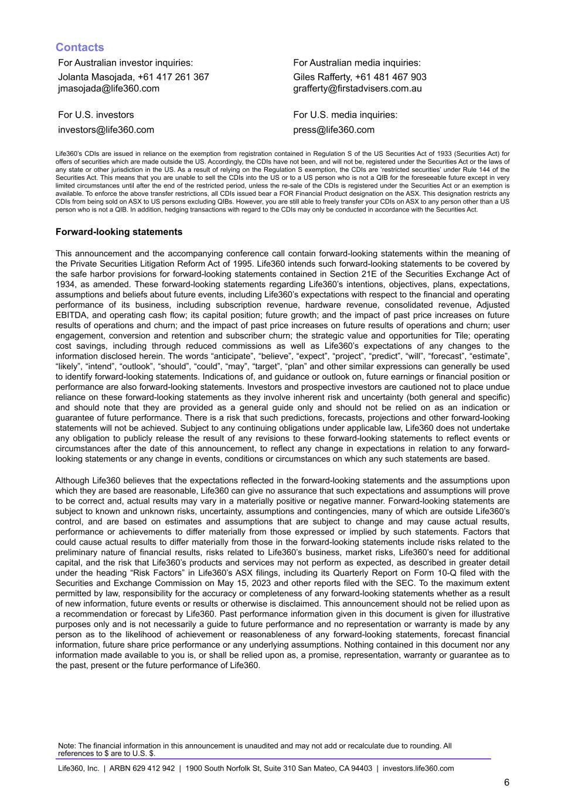
Contacts For Australian investor inquiries: For Australian media inquiries: Jolanta Masojada, +61 417 261 367 Giles Rafferty, +61 481 467 903 jmasojada@life360.com grafferty@firstadvisers.com.au For U.S. investors For U.S. media inquiries: investors@life360.com press@life360.com Life360’s CDIs are issued in reliance on the exemption from registration contained in Regulation S of the US Securities Act of 1933 (Securities Act) for offers of securities which are made outside the US. Accordingly, the CDIs have not been, and will not be, registered under the Securities Act or the laws of any state or other jurisdiction in the US. As a result of relying on the Regulation S exemption, the CDIs are ‘restricted securities’ under Rule 144 of the Securities Act. This means that you are unable to sell the CDIs into the US or to a US person who is not a QIB for the foreseeable future except in very limited circumstances until after the end of the restricted period, unless the re-sale of the CDIs is registered under the Securities Act or an exemption is available. To enforce the above transfer restrictions, all CDIs issued bear a FOR Financial Product designation on the ASX. This designation restricts any CDIs from being sold on ASX to US persons excluding QIBs. However, you are still able to freely transfer your CDIs on ASX to any person other than a US person who is not a QIB. In addition, hedging transactions with regard to the CDIs may only be conducted in accordance with the Securities Act. Forward-looking statements This announcement and the accompanying conference call contain forward-looking statements within the meaning of the Private Securities Litigation Reform Act of 1995. Life360 intends such forward-looking statements to be covered by the safe harbor provisions for forward-looking statements contained in Section 21E of the Securities Exchange Act of 1934, as amended. These forward-looking statements regarding Life360’s intentions, objectives, plans, expectations, assumptions and beliefs about future events, including Life360’s expectations with respect to the financial and operating performance of its business, including subscription revenue, hardware revenue, consolidated revenue, Adjusted EBITDA, and operating cash flow; its capital position; future growth; and the impact of past price increases on future results of operations and churn; and the impact of past price increases on future results of operations and churn; user engagement, conversion and retention and subscriber churn; the strategic value and opportunities for Tile; operating cost savings, including through reduced commissions as well as Life360’s expectations of any changes to the information disclosed herein. The words “anticipate”, “believe”, “expect”, “project”, “predict”, “will”, “forecast”, “estimate”, “likely”, “intend”, “outlook”, “should”, “could”, “may”, “target”, “plan” and other similar expressions can generally be used to identify forward-looking statements. Indications of, and guidance or outlook on, future earnings or financial position or performance are also forward-looking statements. Investors and prospective investors are cautioned not to place undue reliance on these forward-looking statements as they involve inherent risk and uncertainty (both general and specific) and should note that they are provided as a general guide only and should not be relied on as an indication or guarantee of future performance. There is a risk that such predictions, forecasts, projections and other forward-looking statements will not be achieved. Subject to any continuing obligations under applicable law, Life360 does not undertake any obligation to publicly release the result of any revisions to these forward-looking statements to reflect events or circumstances after the date of this announcement, to reflect any change in expectations in relation to any forward- looking statements or any change in events, conditions or circumstances on which any such statements are based. Although Life360 believes that the expectations reflected in the forward-looking statements and the assumptions upon which they are based are reasonable, Life360 can give no assurance that such expectations and assumptions will prove to be correct and, actual results may vary in a materially positive or negative manner. Forward-looking statements are subject to known and unknown risks, uncertainty, assumptions and contingencies, many of which are outside Life360’s control, and are based on estimates and assumptions that are subject to change and may cause actual results, performance or achievements to differ materially from those expressed or implied by such statements. Factors that could cause actual results to differ materially from those in the forward-looking statements include risks related to the preliminary nature of financial results, risks related to Life360’s business, market risks, Life360’s need for additional capital, and the risk that Life360’s products and services may not perform as expected, as described in greater detail under the heading “Risk Factors” in Life360’s ASX filings, including its Quarterly Report on Form 10-Q filed with the Securities and Exchange Commission on May 15, 2023 and other reports filed with the SEC. To the maximum extent permitted by law, responsibility for the accuracy or completeness of any forward-looking statements whether as a result of new information, future events or results or otherwise is disclaimed. This announcement should not be relied upon as a recommendation or forecast by Life360. Past performance information given in this document is given for illustrative purposes only and is not necessarily a guide to future performance and no representation or warranty is made by any person as to the likelihood of achievement or reasonableness of any forward-looking statements, forecast financial information, future share price performance or any underlying assumptions. Nothing contained in this document nor any information made available to you is, or shall be relied upon as, a promise, representation, warranty or guarantee as to the past, present or the future performance of Life360. Note: The financial information in this announcement is unaudited and may not add or recalculate due to rounding. All references to $ are to U.S. $. Life360, Inc. | ARBN 629 412 942 | 1900 South Norfolk St, Suite 310 San Mateo, CA 94403 | investors.life360.com 6

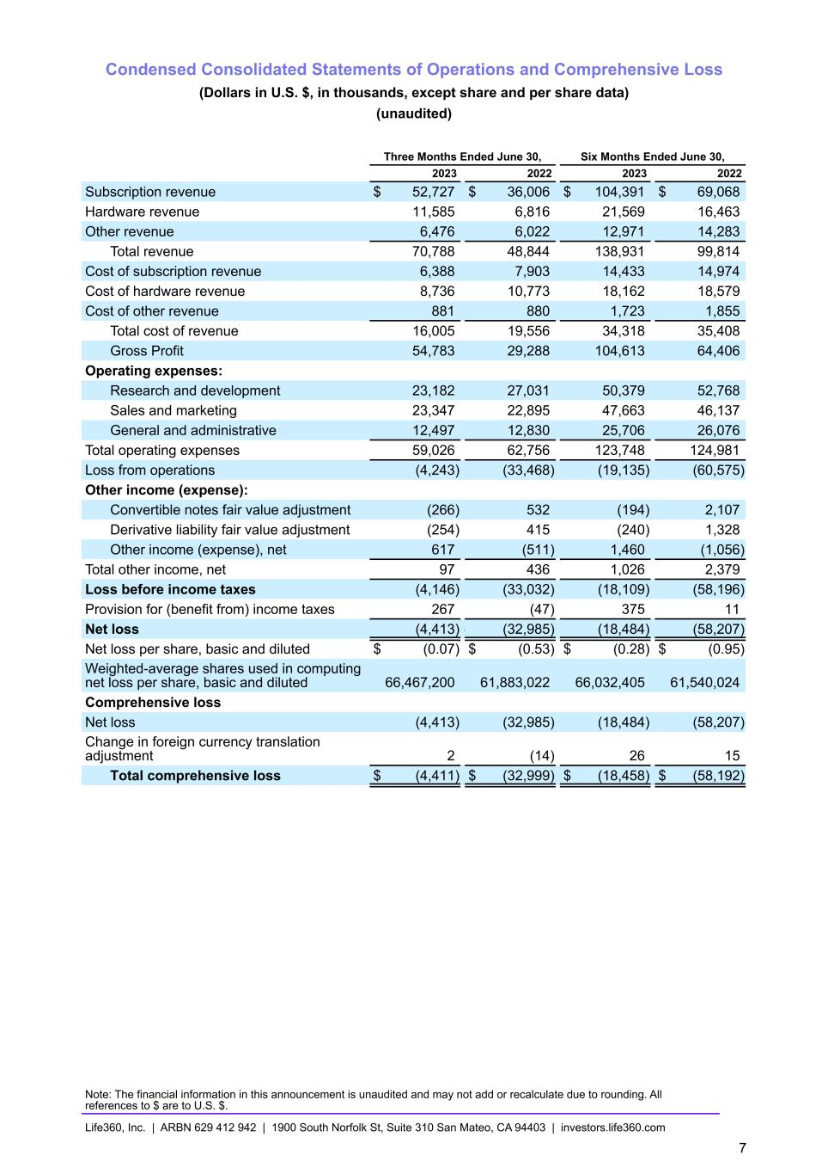
Condensed Consolidated Statements of Operations and Comprehensive Loss (Dollars in U.S. $, in thousands, except share and per share data) (unaudited) Three Months Ended June 30, Six Months Ended June 30, 2023 2022 2023 2022 Subscription revenue $ 52,727 $ 36,006 $ 104,391 $ 69,068 Hardware revenue 11,585 6,816 21,569 16,463 Other revenue 6,476 6,022 12,971 14,283 Total revenue 70,788 48,844 138,931 99,814 Cost of subscription revenue 6,388 7,903 14,433 14,974 Cost of hardware revenue 8,736 10,773 18,162 18,579 Cost of other revenue 881 880 1,723 1,855 Total cost of revenue 16,005 19,556 34,318 35,408 Gross Profit 54,783 29,288 104,613 64,406 Operating expenses: Research and development 23,182 27,031 50,379 52,768 Sales and marketing 23,347 22,895 47,663 46,137 General and administrative 12,497 12,830 25,706 26,076 Total operating expenses 59,026 62,756 123,748 124,981 Loss from operations (4,243) (33,468) (19,135) (60,575) Other income (expense): Convertible notes fair value adjustment (266) 532 (194) 2,107 Derivative liability fair value adjustment (254) 415 (240) 1,328 Other income (expense), net 617 (511) 1,460 (1,056) Total other income, net 97 436 1,026 2,379 Loss before income taxes (4,146) (33,032) (18,109) (58,196) Provision for (benefit from) income taxes 267 (47) 375 11 Net loss (4,413) — (32,985) (18,484) (58,207) Net loss per share, basic and diluted $ (0.07) $ (0.53) $ (0.28) $ (0.95) Weighted-average shares used in computing net loss per share, basic and diluted 66,467,200 61,883,022 66,032,405 61,540,024 Comprehensive loss Net loss (4,413) (32,985) (18,484) (58,207) Change in foreign currency translation adjustment 2 (14) 26 15 Total comprehensive loss $ (4,411) $ (32,999) $ (18,458) $ (58,192) Note: The financial information in this announcement is unaudited and may not add or recalculate due to rounding. All references to $ are to U.S. $. Life360, Inc. | ARBN 629 412 942 | 1900 South Norfolk St, Suite 310 San Mateo, CA 94403 | investors.life360.com 7

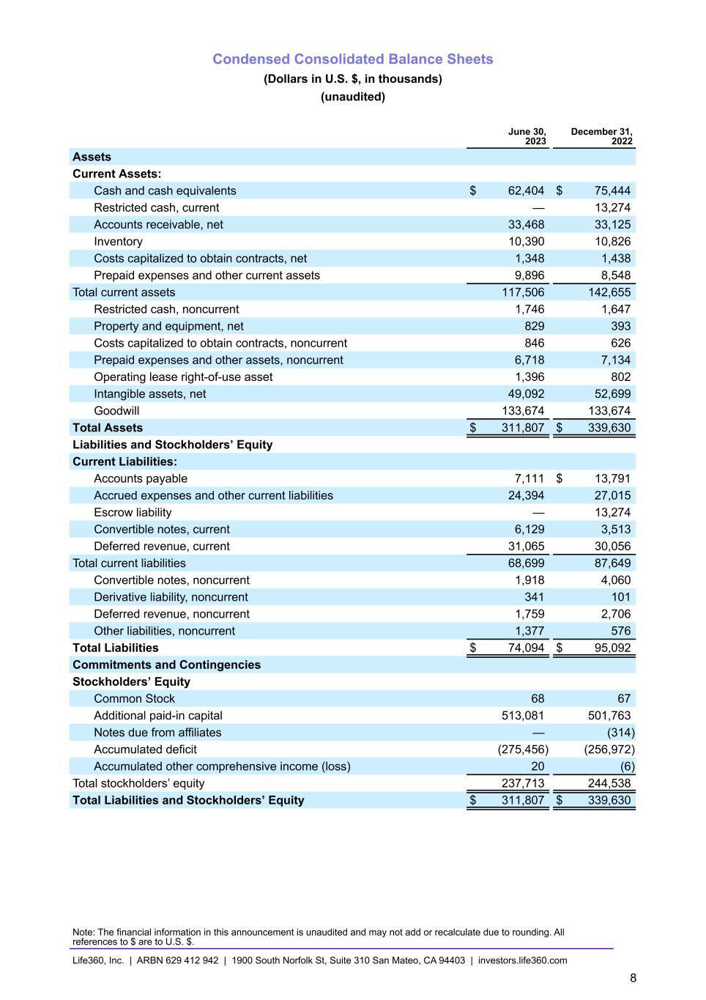
Condensed Consolidated Balance Sheets (Dollars in U.S. $, in thousands) (unaudited) June 30, 2023 December 31, 2022 Assets Current Assets: Cash and cash equivalents $ 62,404 $ 75,444 Restricted cash, current — 13,274 Accounts receivable, net 33,468 33,125 Inventory 10,390 10,826 Costs capitalized to obtain contracts, net 1,348 1,438 Prepaid expenses and other current assets 9,896 8,548 Total current assets 117,506 142,655 Restricted cash, noncurrent 1,746 1,647 Property and equipment, net 829 393 Costs capitalized to obtain contracts, noncurrent 846 626 Prepaid expenses and other assets, noncurrent 6,718 7,134 Operating lease right-of-use asset 1,396 802 Intangible assets, net 49,092 52,699 Goodwill 133,674 133,674 Total Assets $ 311,807 $ 339,630 Liabilities and Stockholders’ Equity Current Liabilities: Accounts payable 7,111 $ 13,791 Accrued expenses and other current liabilities 24,394 27,015 Escrow liability — 13,274 Convertible notes, current 6,129 3,513 Deferred revenue, current 31,065 30,056 Total current liabilities 68,699 87,649 Convertible notes, noncurrent 1,918 4,060 Derivative liability, noncurrent 341 101 Deferred revenue, noncurrent 1,759 2,706 Other liabilities, noncurrent 1,377 576 Total Liabilities $ 74,094 $ 95,092 Commitments and Contingencies Stockholders’ Equity Common Stock 68 67 Additional paid-in capital 513,081 501,763 Notes due from affiliates — (314) Accumulated deficit (275,456) (256,972) Accumulated other comprehensive income (loss) 20 (6) Total stockholders’ equity 237,713 244,538 Total Liabilities and Stockholders’ Equity $ 311,807 $ 339,630 Note: The financial information in this announcement is unaudited and may not add or recalculate due to rounding. All references to $ are to U.S. $. Life360, Inc. | ARBN 629 412 942 | 1900 South Norfolk St, Suite 310 San Mateo, CA 94403 | investors.life360.com 8

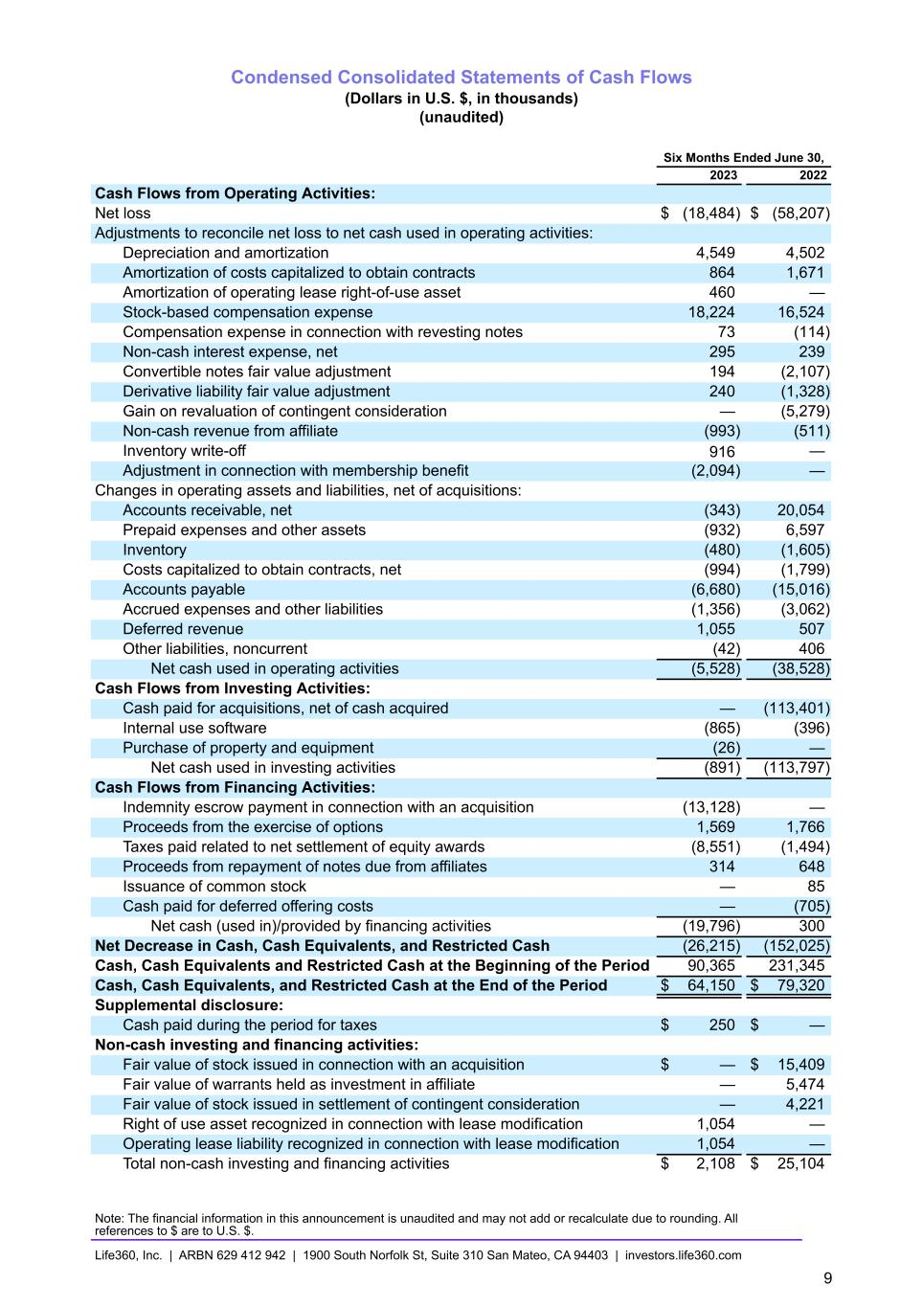
Condensed Consolidated Statements of Cash Flows (Dollars in U.S. $, in thousands) (unaudited) Six Months Ended June 30, 2023 2022 Cash Flows from Operating Activities: Net loss $ (18,484) $ (58,207) Adjustments to reconcile net loss to net cash used in operating activities: Depreciation and amortization 4,549 4,502 Amortization of costs capitalized to obtain contracts 864 1,671 Amortization of operating lease right-of-use asset 460 — Stock-based compensation expense 18,224 16,524 Compensation expense in connection with revesting notes 73 (114) Non-cash interest expense, net 295 239 Convertible notes fair value adjustment 194 (2,107) Derivative liability fair value adjustment 240 (1,328) Gain on revaluation of contingent consideration — (5,279) Non-cash revenue from affiliate (993) (511) Inventory write-off 916 — Adjustment in connection with membership benefit (2,094) — Changes in operating assets and liabilities, net of acquisitions: Accounts receivable, net (343) 20,054 Prepaid expenses and other assets (932) 6,597 Inventory (480) (1,605) Costs capitalized to obtain contracts, net (994) (1,799) Accounts payable (6,680) (15,016) Accrued expenses and other liabilities (1,356) (3,062) Deferred revenue 1,055 507 Other liabilities, noncurrent (42) 406 Net cash used in operating activities (5,528) (38,528) Cash Flows from Investing Activities: Cash paid for acquisitions, net of cash acquired — (113,401) Internal use software (865) (396) Purchase of property and equipment (26) — Net cash used in investing activities (891) (113,797) Cash Flows from Financing Activities: Indemnity escrow payment in connection with an acquisition (13,128) — Proceeds from the exercise of options 1,569 1,766 Taxes paid related to net settlement of equity awards (8,551) (1,494) Proceeds from repayment of notes due from affiliates 314 648 Issuance of common stock — 85 Cash paid for deferred offering costs — (705) Net cash (used in)/provided by financing activities (19,796) 300 Net Decrease in Cash, Cash Equivalents, and Restricted Cash (26,215) (152,025) Cash, Cash Equivalents and Restricted Cash at the Beginning of the Period 90,365 231,345 Cash, Cash Equivalents, and Restricted Cash at the End of the Period $ 64,150 $ 79,320 Supplemental disclosure: Cash paid during the period for taxes $ 250 $ — Non-cash investing and financing activities: Fair value of stock issued in connection with an acquisition $ — $ 15,409 Fair value of warrants held as investment in affiliate — 5,474 Fair value of stock issued in settlement of contingent consideration — 4,221 Right of use asset recognized in connection with lease modification 1,054 — Operating lease liability recognized in connection with lease modification 1,054 — Total non-cash investing and financing activities $ 2,108 $ 25,104 Note: The financial information in this announcement is unaudited and may not add or recalculate due to rounding. All references to $ are to U.S. $. Life360, Inc. | ARBN 629 412 942 | 1900 South Norfolk St, Suite 310 San Mateo, CA 94403 | investors.life360.com 9

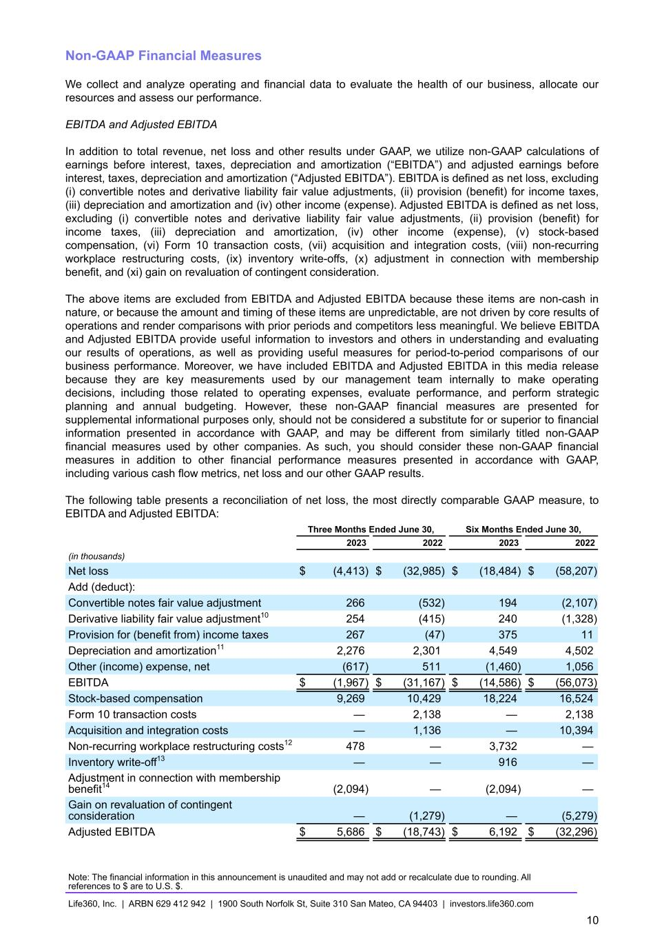
Non-GAAP Financial Measures We collect and analyze operating and financial data to evaluate the health of our business, allocate our resources and assess our performance. EBITDA and Adjusted EBITDA In addition to total revenue, net loss and other results under GAAP, we utilize non-GAAP calculations of earnings before interest, taxes, depreciation and amortization (“EBITDA”) and adjusted earnings before interest, taxes, depreciation and amortization (“Adjusted EBITDA”). EBITDA is defined as net loss, excluding (i) convertible notes and derivative liability fair value adjustments, (ii) provision (benefit) for income taxes, (iii) depreciation and amortization and (iv) other income (expense). Adjusted EBITDA is defined as net loss, excluding (i) convertible notes and derivative liability fair value adjustments, (ii) provision (benefit) for income taxes, (iii) depreciation and amortization, (iv) other income (expense), (v) stock-based compensation, (vi) Form 10 transaction costs, (vii) acquisition and integration costs, (viii) non-recurring workplace restructuring costs, (ix) inventory write-offs, (x) adjustment in connection with membership benefit, and (xi) gain on revaluation of contingent consideration. The above items are excluded from EBITDA and Adjusted EBITDA because these items are non-cash in nature, or because the amount and timing of these items are unpredictable, are not driven by core results of operations and render comparisons with prior periods and competitors less meaningful. We believe EBITDA and Adjusted EBITDA provide useful information to investors and others in understanding and evaluating our results of operations, as well as providing useful measures for period-to-period comparisons of our business performance. Moreover, we have included EBITDA and Adjusted EBITDA in this media release because they are key measurements used by our management team internally to make operating decisions, including those related to operating expenses, evaluate performance, and perform strategic planning and annual budgeting. However, these non-GAAP financial measures are presented for supplemental informational purposes only, should not be considered a substitute for or superior to financial information presented in accordance with GAAP, and may be different from similarly titled non-GAAP financial measures used by other companies. As such, you should consider these non-GAAP financial measures in addition to other financial performance measures presented in accordance with GAAP, including various cash flow metrics, net loss and our other GAAP results. The following table presents a reconciliation of net loss, the most directly comparable GAAP measure, to EBITDA and Adjusted EBITDA: Three Months Ended June 30, Six Months Ended June 30, 2023 2022 2023 2022 (in thousands) Net loss $ (4,413) $ (32,985) $ (18,484) $ (58,207) Add (deduct): Convertible notes fair value adjustment 266 (532) 194 (2,107) Derivative liability fair value adjustment10 254 (415) 240 (1,328) Provision for (benefit from) income taxes 267 (47) 375 11 Depreciation and amortization11 2,276 2,301 4,549 4,502 Other (income) expense, net (617) 511 (1,460) 1,056 EBITDA $ (1,967) $ (31,167) $ (14,586) $ (56,073) Stock-based compensation 9,269 10,429 18,224 16,524 Form 10 transaction costs — 2,138 — 2,138 Acquisition and integration costs — 1,136 — 10,394 Non-recurring workplace restructuring costs12 478 — 3,732 — Inventory write-off13 — — 916 — Adjustment in connection with membership benefit14 (2,094) — (2,094) — Gain on revaluation of contingent consideration — (1,279) — (5,279) Adjusted EBITDA $ 5,686 $ (18,743) $ 6,192 $ (32,296) Note: The financial information in this announcement is unaudited and may not add or recalculate due to rounding. All references to $ are to U.S. $. Life360, Inc. | ARBN 629 412 942 | 1900 South Norfolk St, Suite 310 San Mateo, CA 94403 | investors.life360.com 10

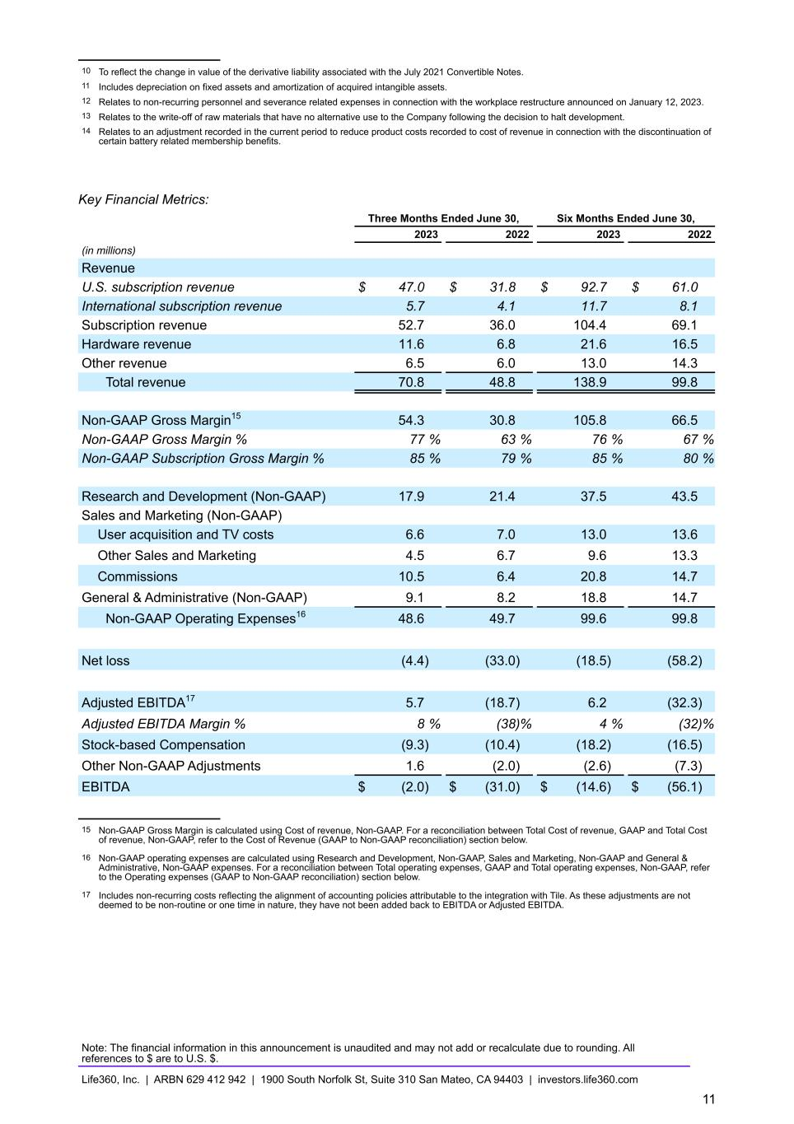
10 To reflect the change in value of the derivative liability associated with the July 2021 Convertible Notes. 11 Includes depreciation on fixed assets and amortization of acquired intangible assets. 12 Relates to non-recurring personnel and severance related expenses in connection with the workplace restructure announced on January 12, 2023. 13 Relates to the write-off of raw materials that have no alternative use to the Company following the decision to halt development. 14 Relates to an adjustment recorded in the current period to reduce product costs recorded to cost of revenue in connection with the discontinuation of certain battery related membership benefits. Key Financial Metrics: Three Months Ended June 30, Six Months Ended June 30, 2023 2022 2023 2022 (in millions) Revenue U.S. subscription revenue $ 47.0 $ 31.8 $ 92.7 $ 61.0 International subscription revenue 5.7 4.1 11.7 8.1 Subscription revenue 52.7 36.0 104.4 69.1 Hardware revenue 11.6 6.8 21.6 16.5 Other revenue 6.5 6.0 13.0 14.3 Total revenue 70.8 48.8 138.9 99.8 Non-GAAP Gross Margin15 54.3 30.8 105.8 66.5 Non-GAAP Gross Margin % 77 % 63 % 76 % 67 % Non-GAAP Subscription Gross Margin % 85 % 79 % 85 % 80 % Research and Development (Non-GAAP) 17.9 21.4 37.5 43.5 Sales and Marketing (Non-GAAP) User acquisition and TV costs 6.6 7.0 13.0 13.6 Other Sales and Marketing 4.5 6.7 9.6 13.3 Commissions 10.5 6.4 20.8 14.7 General & Administrative (Non-GAAP) 9.1 8.2 18.8 14.7 Non-GAAP Operating Expenses16 48.6 49.7 99.6 99.8 Net loss (4.4) (33.0) (18.5) (58.2) Adjusted EBITDA17 5.7 (18.7) 6.2 (32.3) Adjusted EBITDA Margin % 8 % (38) % 4 % (32) % Stock-based Compensation (9.3) (10.4) (18.2) (16.5) Other Non-GAAP Adjustments 1.6 (2.0) (2.6) (7.3) EBITDA $ (2.0) $ (31.0) $ (14.6) $ (56.1) 15 Non-GAAP Gross Margin is calculated using Cost of revenue, Non-GAAP. For a reconciliation between Total Cost of revenue, GAAP and Total Cost of revenue, Non-GAAP, refer to the Cost of Revenue (GAAP to Non-GAAP reconciliation) section below. 16 Non-GAAP operating expenses are calculated using Research and Development, Non-GAAP, Sales and Marketing, Non-GAAP and General & Administrative, Non-GAAP expenses. For a reconciliation between Total operating expenses, GAAP and Total operating expenses, Non-GAAP, refer to the Operating expenses (GAAP to Non-GAAP reconciliation) section below. 17 Includes non-recurring costs reflecting the alignment of accounting policies attributable to the integration with Tile. As these adjustments are not deemed to be non-routine or one time in nature, they have not been added back to EBITDA or Adjusted EBITDA. Note: The financial information in this announcement is unaudited and may not add or recalculate due to rounding. All references to $ are to U.S. $. Life360, Inc. | ARBN 629 412 942 | 1900 South Norfolk St, Suite 310 San Mateo, CA 94403 | investors.life360.com 11

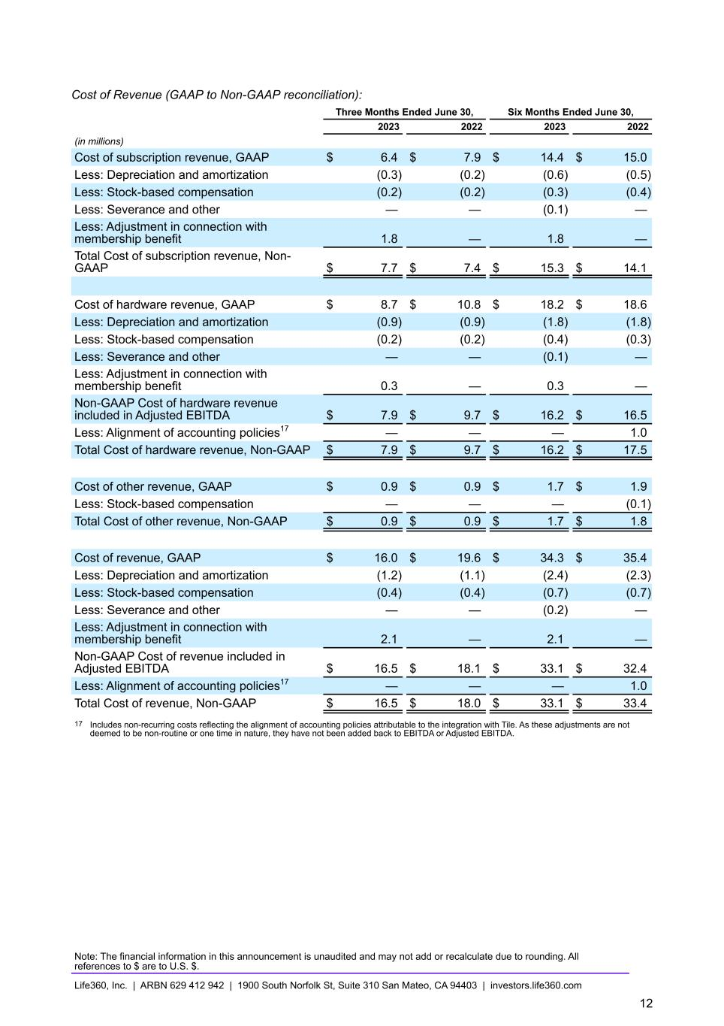
Cost of Revenue (GAAP to Non-GAAP reconciliation): Three Months Ended June 30, Six Months Ended June 30, 2023 2022 2023 2022 (in millions) Cost of subscription revenue, GAAP $ 6.4 $ 7.9 $ 14.4 $ 15.0 Less: Depreciation and amortization (0.3) (0.2) (0.6) (0.5) Less: Stock-based compensation (0.2) (0.2) (0.3) (0.4) Less: Severance and other — — (0.1) — Less: Adjustment in connection with membership benefit 1.8 — 1.8 — Total Cost of subscription revenue, Non- GAAP $ 7.7 $ 7.4 $ 15.3 $ 14.1 Cost of hardware revenue, GAAP $ 8.7 $ 10.8 $ 18.2 $ 18.6 Less: Depreciation and amortization (0.9) (0.9) (1.8) (1.8) Less: Stock-based compensation (0.2) (0.2) (0.4) (0.3) Less: Severance and other — — (0.1) — Less: Adjustment in connection with membership benefit 0.3 — 0.3 — Non-GAAP Cost of hardware revenue included in Adjusted EBITDA $ 7.9 $ 9.7 $ 16.2 $ 16.5 Less: Alignment of accounting policies17 — — — 1.0 Total Cost of hardware revenue, Non-GAAP $ 7.9 $ 9.7 $ 16.2 $ 17.5 Cost of other revenue, GAAP $ 0.9 $ 0.9 $ 1.7 $ 1.9 Less: Stock-based compensation — — — (0.1) Total Cost of other revenue, Non-GAAP $ 0.9 $ 0.9 $ 1.7 $ 1.8 Cost of revenue, GAAP $ 16.0 $ 19.6 $ 34.3 $ 35.4 Less: Depreciation and amortization (1.2) (1.1) (2.4) (2.3) Less: Stock-based compensation (0.4) (0.4) (0.7) (0.7) Less: Severance and other — — (0.2) — Less: Adjustment in connection with membership benefit 2.1 — 2.1 — Non-GAAP Cost of revenue included in Adjusted EBITDA $ 16.5 $ 18.1 $ 33.1 $ 32.4 Less: Alignment of accounting policies17 — — — 1.0 Total Cost of revenue, Non-GAAP $ 16.5 $ 18.0 $ 33.1 $ 33.4 17 Includes non-recurring costs reflecting the alignment of accounting policies attributable to the integration with Tile. As these adjustments are not deemed to be non-routine or one time in nature, they have not been added back to EBITDA or Adjusted EBITDA. Note: The financial information in this announcement is unaudited and may not add or recalculate due to rounding. All references to $ are to U.S. $. Life360, Inc. | ARBN 629 412 942 | 1900 South Norfolk St, Suite 310 San Mateo, CA 94403 | investors.life360.com 12

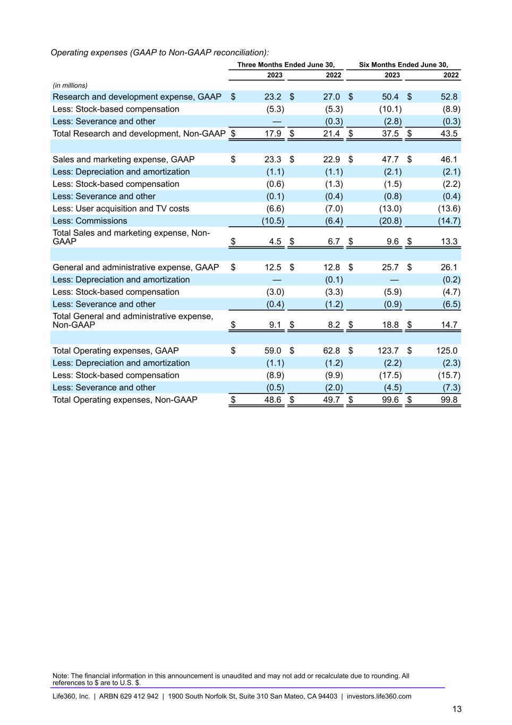
Operating expenses (GAAP to Non-GAAP reconciliation): Three Months Ended June 30, Six Months Ended June 30, 2023 2022 2023 2022 (in millions) Research and development expense, GAAP $ 23.2 $ 27.0 $ 50.4 $ 52.8 Less: Stock-based compensation (5.3) (5.3) (10.1) (8.9) Less: Severance and other — (0.3) (2.8) (0.3) Total Research and development, Non-GAAP $ 17.9 $ 21.4 $ 37.5 $ 43.5 Sales and marketing expense, GAAP $ 23.3 $ 22.9 $ 47.7 $ 46.1 Less: Depreciation and amortization (1.1) (1.1) (2.1) (2.1) Less: Stock-based compensation (0.6) (1.3) (1.5) (2.2) Less: Severance and other (0.1) (0.4) (0.8) (0.4) Less: User acquisition and TV costs (6.6) (7.0) (13.0) (13.6) Less: Commissions (10.5) (6.4) (20.8) (14.7) Total Sales and marketing expense, Non- GAAP $ 4.5 $ 6.7 $ 9.6 $ 13.3 General and administrative expense, GAAP $ 12.5 $ 12.8 $ 25.7 $ 26.1 Less: Depreciation and amortization — (0.1) — (0.2) Less: Stock-based compensation (3.0) (3.3) (5.9) (4.7) Less: Severance and other (0.4) (1.2) (0.9) (6.5) Total General and administrative expense, Non-GAAP $ 9.1 $ 8.2 $ 18.8 $ 14.7 Total Operating expenses, GAAP $ 59.0 $ 62.8 $ 123.7 $ 125.0 Less: Depreciation and amortization (1.1) (1.2) (2.2) (2.3) Less: Stock-based compensation (8.9) (9.9) (17.5) (15.7) Less: Severance and other (0.5) (2.0) (4.5) (7.3) Total Operating expenses, Non-GAAP $ 48.6 $ 49.7 $ 99.6 $ 99.8 Note: The financial information in this announcement is unaudited and may not add or recalculate due to rounding. All references to $ are to U.S. $. Life360, Inc. | ARBN 629 412 942 | 1900 South Norfolk St, Suite 310 San Mateo, CA 94403 | investors.life360.com 13



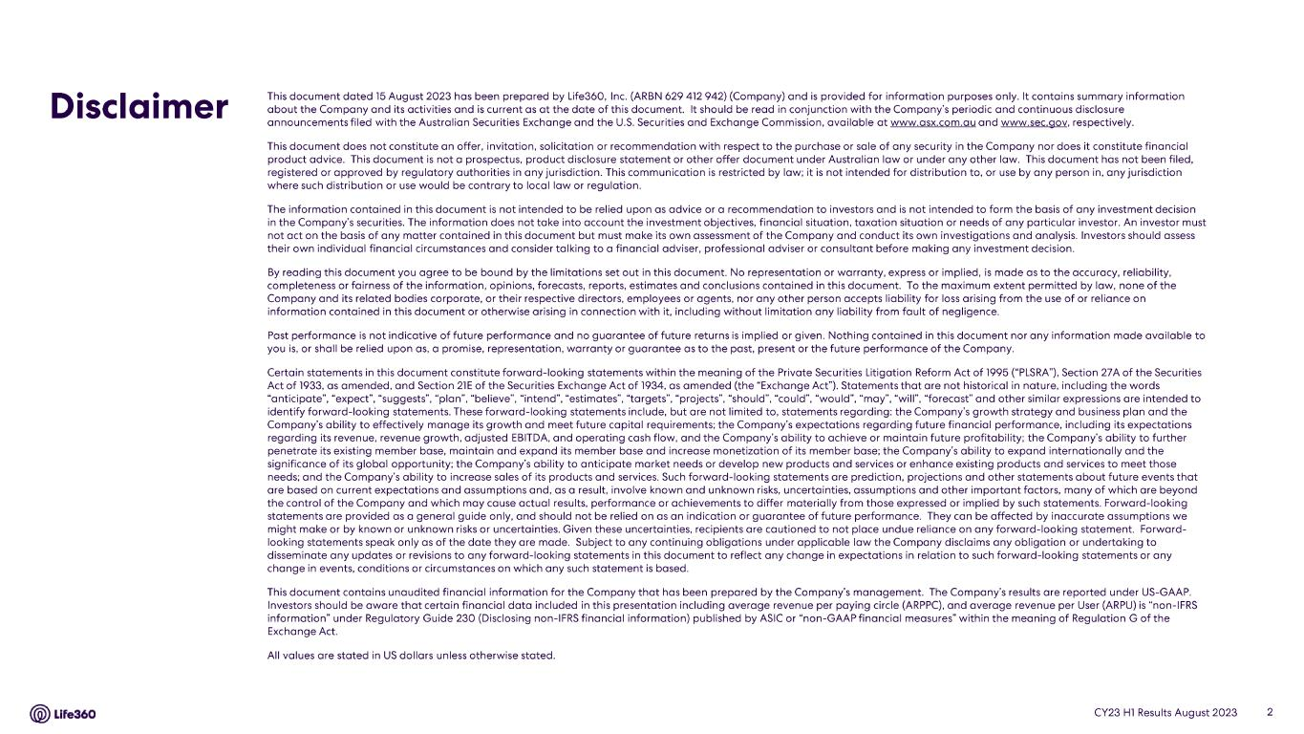







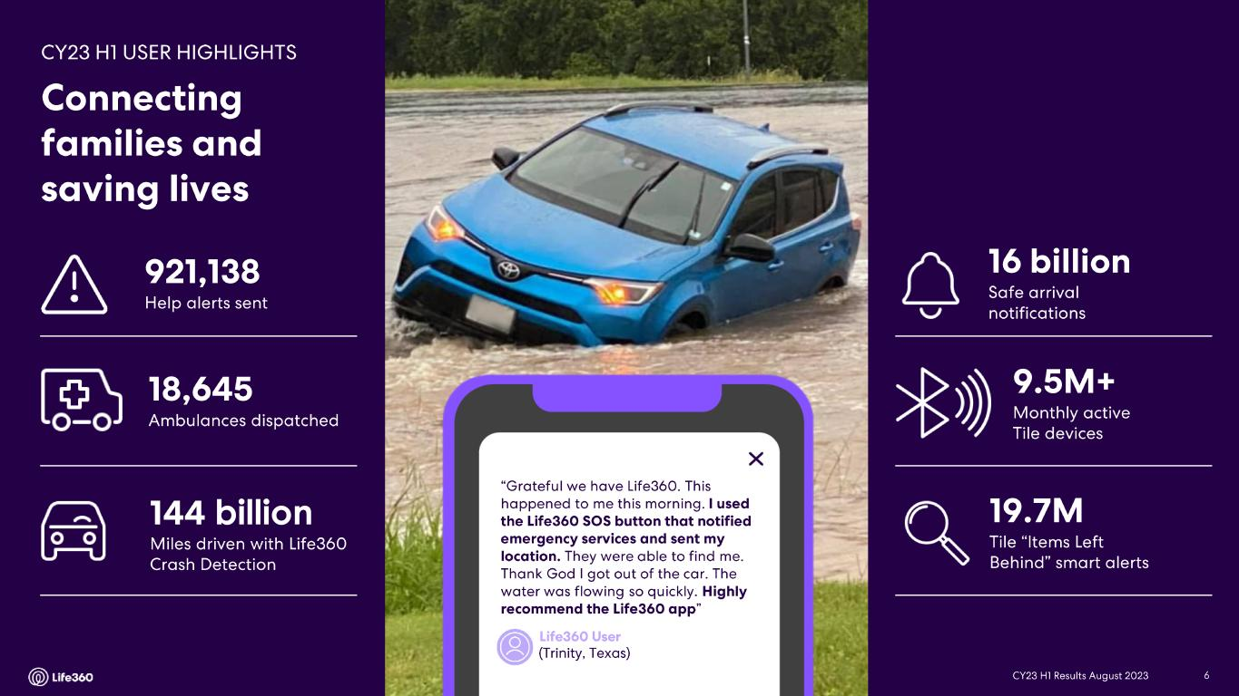
6Management Presentation | August 2023 6 billion


      









