UNITED STATES
SECURITIES AND EXCHANGE COMMISSION
Washington, D.C. 20549
______________

FORM 8-K

CURRENT REPORT
Pursuant to Section 13 or 15(d) of the
Securities Exchange Act of 1934

Date of Report (Date of earliest event reported): August 8, 2024

Life360, Inc.
(Exact name of registrant as specified in its charter)
Delaware |  |  | 000-56424 |  |  | 26-0197666
(State or other jurisdiction of  incorporation or organization) |  |  | (Commission File Number) |  |  | (I.R.S. Employer  Identification No.)

1900 South Norfolk Street, Suite 310
San Mateo, CA 94403
(Address of principal executive offices, including zip code)
(415) 484-5244
(Registrant’s telephone number, including area code)
Not applicable.
(Former name or former address, if changed since last report)
______________

Check the appropriate box below if the Form 8-K filing is intended to simultaneously satisfy the filing obligation of the registrant under any of the following provisions:
☐ |  |  | Written communications pursuant to Rule 425 under the Securities Act (17 CFR 230.425)
☐ |  |  | Soliciting material pursuant to Rule 14a-12 under the Exchange Act (17 CFR 240.14a-12)
☐ |  |  | Pre-commencement communications pursuant to Rule 14d-2(b) under the Exchange Act (17 CFR 240.14d-2(b))
☐ |  |  | Pre-commencement communications pursuant to Rule 13e-4(c) under the Exchange Act (17 CFR 240.13e-4(c))

Title of each class |  |  | Trading Symbol(s) |  |  | Name of each exchange on which registered
Common Stock, $0.001 par value per share |  |  | LIF |  |  | The Nasdaq Stock Market LLC

Indicate by check mark whether the registrant is an emerging growth company as defined in Rule 405 of the Securities Act of 1933 (§230.405 of this chapter) or Rule 12b-2 of the Securities Exchange Act of 1934 (§240.12b-2 of this chapter).

Emerging growth company ☐
If an emerging growth company, indicate by check mark if the registrant has elected not to use the extended transition period for complying with any new or revised financial accounting standards provided pursuant to Section 13(a) of the Exchange Act. ☐

Item 2.02 Results of Operations and Financial Condition.
We are furnishing this Current Report on Form 8-K in connection with the disclosure of information, in the form of textual information from a media release issued on August 8, 2024. A copy of the media release is furnished as Exhibit 99.1 to this Current Report on Form 8-K.

Item 7.01 Regulation FD Disclosure.
We are furnishing this Item 7.01 of this Current Report on Form 8-K in connection with the disclosure of information, in the form of the textual information from a PowerPoint presentation to be given during a conference call and webcast on August 8, 2024 at 6:00 p.m. Eastern Time. A copy of the PowerPoint presentation to be used for the conference call and webcast is furnished as Exhibit 99.2 to this Current Report on Form 8-K.

The information in Item 2.02 (including Exhibit 99.1) and Item 7.01 (including Exhibit 99.2) of this Current Report on Form 8-K is furnished and shall not be deemed to be “filed” for the purpose of Section 18 of the Securities Exchange Act of 1934, as amended (the “Exchange Act”) or otherwise subject to the liabilities of that section, nor shall it be deemed incorporated by reference into any filing under the Securities Act of 1933, as amended, or the Exchange Act, except as shall be expressly set forth by specific reference in such a filing.

The text included with this Item 2.02 and Item 7.01 of this Current Report on Form 8-K and the replay of the conference call and webcast will be available on our website located at www.life360.com, although we reserve the right to discontinue that availability at any time.

Item 9.01 Financial Statements and Exhibits.
(d) Exhibits

Exhibit No. |  |  | Description
99.1 |  |  | Media release of the Registrant dated August 8, 2024
99.2 |  |  | Life360, Inc. Investor Presentation
104 |  |  | Cover Page Interactive Data File - the cover page XBRL tags are embedded within the Inline XBRL document

SIGNATURES
Pursuant to the requirements of the Securities Exchange Act of 1934, the registrant has duly caused this report to be signed on its behalf by the undersigned hereunto duly authorized.
 |  |  |  |  |  | LIFE360, INC.
Dated: |  |  | August 8, 2024 |  |  | By: |  |  | /s/ Russell Burke
 |  |  |  |  |  |  |  |  | Russell Burke
 |  |  |  |  |  |  |  |  | Chief Financial Officer

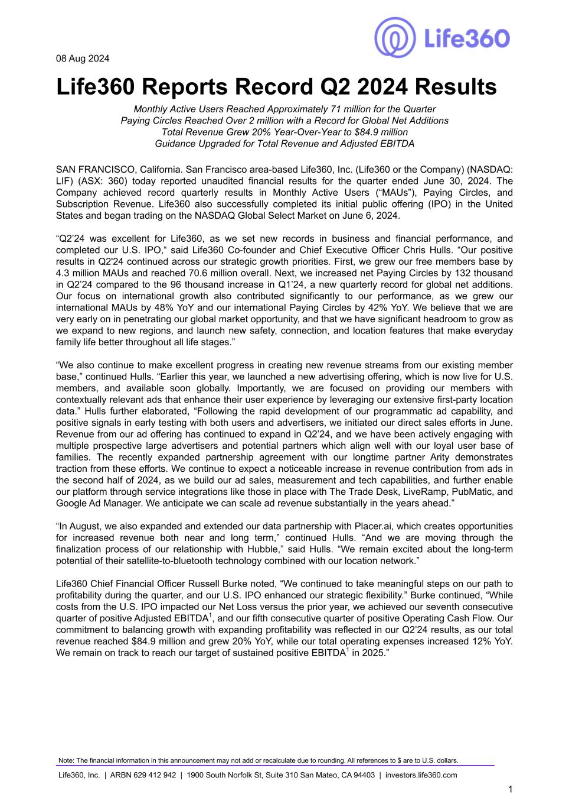

08 Aug 2024 Life360 Reports Record Q2 2024 Results Monthly Active Users Reached Approximately 71 million for the Quarter Paying Circles Reached Over 2 million with a Record for Global Net Additions Total Revenue Grew 20% Year-Over-Year to $84.9 million Guidance Upgraded for Total Revenue and Adjusted EBITDA SAN FRANCISCO, California. San Francisco area-based Life360, Inc. (Life360 or the Company) (NASDAQ: LIF) (ASX: 360) today reported unaudited financial results for the quarter ended June 30, 2024. The Company achieved record quarterly results in Monthly Active Users (“MAUs”), Paying Circles, and Subscription Revenue. Life360 also successfully completed its initial public offering (IPO) in the United States and began trading on the NASDAQ Global Select Market on June 6, 2024. “Q2’24 was excellent for Life360, as we set new records in business and financial performance, and completed our U.S. IPO,“ said Life360 Co-founder and Chief Executive Officer Chris Hulls. “Our positive results in Q2'24 continued across our strategic growth priorities. First, we grew our free members base by 4.3 million MAUs and reached 70.6 million overall. Next, we increased net Paying Circles by 132 thousand in Q2’24 compared to the 96 thousand increase in Q1’24, a new quarterly record for global net additions. Our focus on international growth also contributed significantly to our performance, as we grew our international MAUs by 48% YoY and our international Paying Circles by 42% YoY. We believe that we are very early on in penetrating our global market opportunity, and that we have significant headroom to grow as we expand to new regions, and launch new safety, connection, and location features that make everyday family life better throughout all life stages.” “We also continue to make excellent progress in creating new revenue streams from our existing member base,” continued Hulls. “Earlier this year, we launched a new advertising offering, which is now live for U.S. members, and available soon globally. Importantly, we are focused on providing our members with contextually relevant ads that enhance their user experience by leveraging our extensive first-party location data.” Hulls further elaborated, “Following the rapid development of our programmatic ad capability, and positive signals in early testing with both users and advertisers, we initiated our direct sales efforts in June. Revenue from our ad offering has continued to expand in Q2’24, and we have been actively engaging with multiple prospective large advertisers and potential partners which align well with our loyal user base of families. The recently expanded partnership agreement with our longtime partner Arity demonstrates traction from these efforts. We continue to expect a noticeable increase in revenue contribution from ads in the second half of 2024, as we build our ad sales, measurement and tech capabilities, and further enable our platform through service integrations like those in place with The Trade Desk, LiveRamp, PubMatic, and Google Ad Manager. We anticipate we can scale ad revenue substantially in the years ahead.” “In August, we also expanded and extended our data partnership with Placer.ai, which creates opportunities for increased revenue both near and long term,” continued Hulls. “And we are moving through the finalization process of our relationship with Hubble,” said Hulls. “We remain excited about the long-term potential of their satellite-to-bluetooth technology combined with our location network.” Life360 Chief Financial Officer Russell Burke noted, “We continued to take meaningful steps on our path to profitability during the quarter, and our U.S. IPO enhanced our strategic flexibility.” Burke continued, “While costs from the U.S. IPO impacted our Net Loss versus the prior year, we achieved our seventh consecutive quarter of positive Adjusted EBITDA1, and our fifth consecutive quarter of positive Operating Cash Flow. Our commitment to balancing growth with expanding profitability was reflected in our Q2’24 results, as our total revenue reached $84.9 million and grew 20% YoY, while our total operating expenses increased 12% YoY. We remain on track to reach our target of sustained positive EBITDA1 in 2025.” Note: The financial information in this announcement may not add or recalculate due to rounding. All references to $ are to U.S. dollars. Life360, Inc. | ARBN 629 412 942 | 1900 South Norfolk St, Suite 310 San Mateo, CA 94403 | investors.life360.com 1

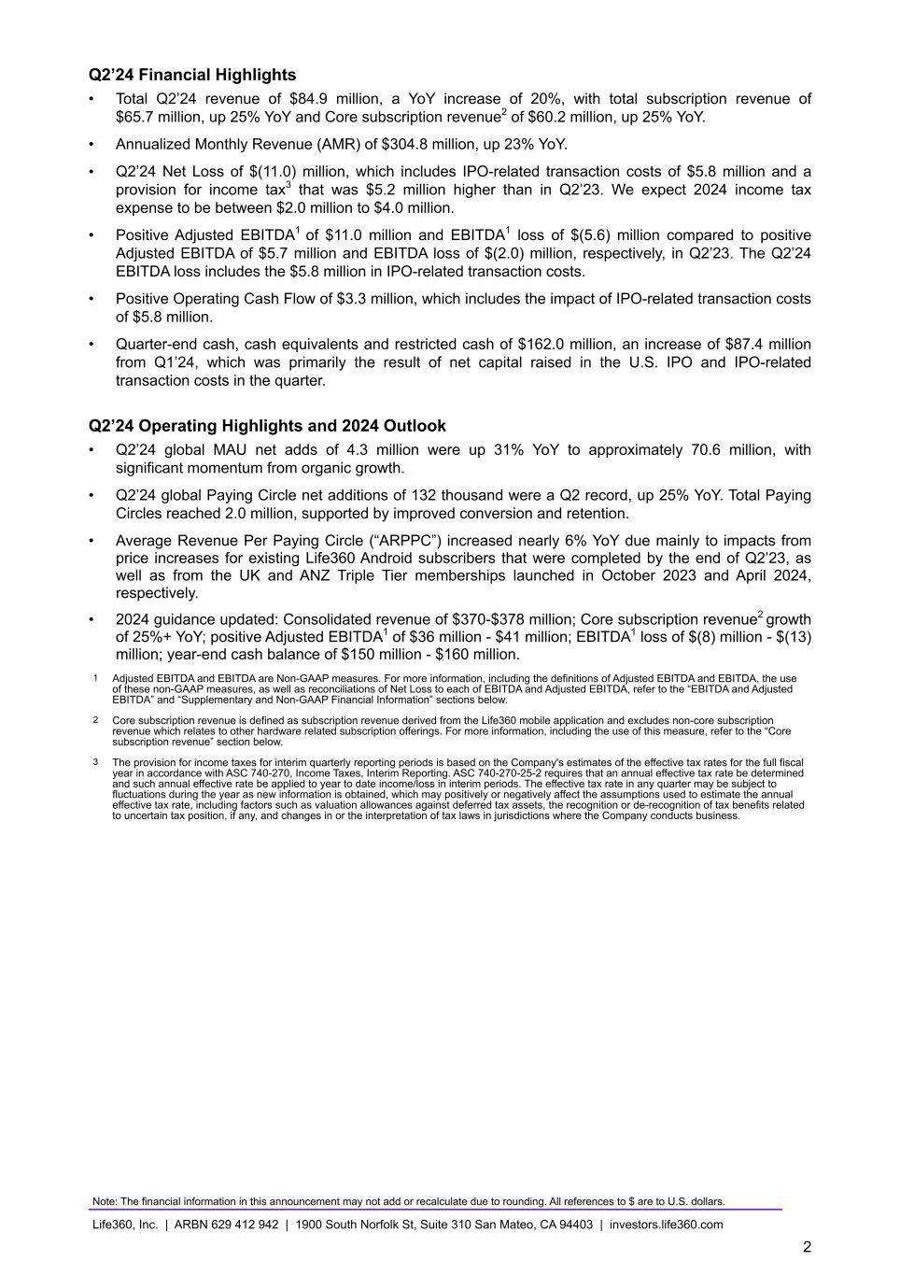
Q2’24 Financial Highlights • Total Q2’24 revenue of $84.9 million, a YoY increase of 20%, with total subscription revenue of $65.7 million, up 25% YoY and Core subscription revenue2 of $60.2 million, up 25% YoY. • Annualized Monthly Revenue (AMR) of $304.8 million, up 23% YoY. • Q2’24 Net Loss of $(11.0) million, which includes IPO-related transaction costs of $5.8 million and a provision for income tax3 that was $5.2 million higher than in Q2’23. We expect 2024 income tax expense to be between $2.0 million to $4.0 million. • Positive Adjusted EBITDA1 of $11.0 million and EBITDA1 loss of $(5.6) million compared to positive Adjusted EBITDA of $5.7 million and EBITDA loss of $(2.0) million, respectively, in Q2’23. The Q2’24 EBITDA loss includes the $5.8 million in IPO-related transaction costs. • Positive Operating Cash Flow of $3.3 million, which includes the impact of IPO-related transaction costs of $5.8 million. • Quarter-end cash, cash equivalents and restricted cash of $162.0 million, an increase of $87.4 million from Q1’24, which was primarily the result of net capital raised in the U.S. IPO and IPO-related transaction costs in the quarter. Q2’24 Operating Highlights and 2024 Outlook • Q2’24 global MAU net adds of 4.3 million were up 31% YoY to approximately 70.6 million, with significant momentum from organic growth. • Q2’24 global Paying Circle net additions of 132 thousand were a Q2 record, up 25% YoY. Total Paying Circles reached 2.0 million, supported by improved conversion and retention. • Average Revenue Per Paying Circle (“ARPPC”) increased nearly 6% YoY due mainly to impacts from price increases for existing Life360 Android subscribers that were completed by the end of Q2’23, as well as from the UK and ANZ Triple Tier memberships launched in October 2023 and April 2024, respectively. • 2024 guidance updated: Consolidated revenue of $370-$378 million; Core subscription revenue2 growth of 25%+ YoY; positive Adjusted EBITDA1 of $36 million - $41 million; EBITDA1 loss of $(8) million - $(13) million; year-end cash balance of $150 million - $160 million. 1 Adjusted EBITDA and EBITDA are Non-GAAP measures. For more information, including the definitions of Adjusted EBITDA and EBITDA, the use of these non-GAAP measures, as well as reconciliations of Net Loss to each of EBITDA and Adjusted EBITDA, refer to the “EBITDA and Adjusted EBITDA” and “Supplementary and Non-GAAP Financial Information” sections below. 2 Core subscription revenue is defined as subscription revenue derived from the Life360 mobile application and excludes non-core subscription revenue which relates to other hardware related subscription offerings. For more information, including the use of this measure, refer to the “Core subscription revenue” section below. 3 The provision for income taxes for interim quarterly reporting periods is based on the Company's estimates of the effective tax rates for the full fiscal year in accordance with ASC 740-270, Income Taxes, Interim Reporting. ASC 740-270-25-2 requires that an annual effective tax rate be determined and such annual effective rate be applied to year to date income/loss in interim periods. The effective tax rate in any quarter may be subject to fluctuations during the year as new information is obtained, which may positively or negatively affect the assumptions used to estimate the annual effective tax rate, including factors such as valuation allowances against deferred tax assets, the recognition or de-recognition of tax benefits related to uncertain tax position, if any, and changes in or the interpretation of tax laws in jurisdictions where the Company conducts business. Note: The financial information in this announcement may not add or recalculate due to rounding. All references to $ are to U.S. dollars. Life360, Inc. | ARBN 629 412 942 | 1900 South Norfolk St, Suite 310 San Mateo, CA 94403 | investors.life360.com 2

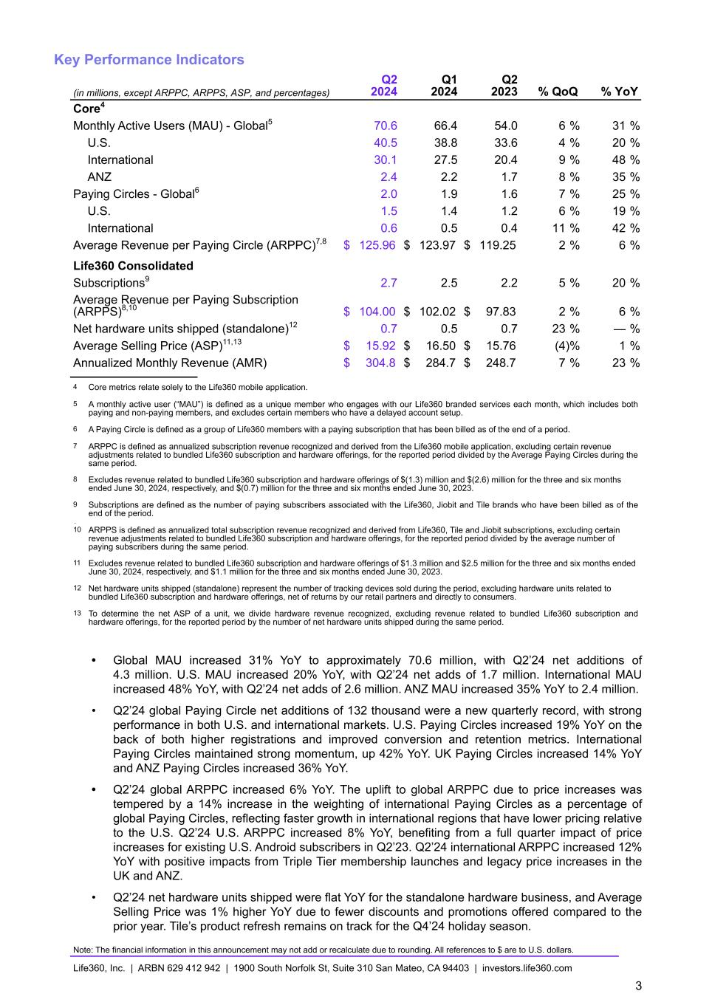
Key Performance Indicators (in millions, except ARPPC, ARPPS, ASP, and percentages) Q2 2024 Q1 2024 Q2 2023 % QoQ % YoY Core4 Monthly Active Users (MAU) - Global5 70.6 66.4 54.0 6 % 31 % U.S. 40.5 38.8 33.6 4 % 20 % International 30.1 27.5 20.4 9 % 48 % ANZ 2.4 2.2 1.7 8 % 35 % Paying Circles - Global6 2.0 1.9 1.6 7 % 25 % U.S. 1.5 1.4 1.2 6 % 19 % International 0.6 0.5 0.4 11 % 42 % Average Revenue per Paying Circle (ARPPC)7,8 $ 125.96 $ 123.97 $ 119.25 2 % 6 % Life360 Consolidated Subscriptions9 2.7 2.5 2.2 5 % 20 % Average Revenue per Paying Subscription (ARPPS)8,10 $ 104.00 $ 102.02 $ 97.83 2 % 6 % Net hardware units shipped (standalone)12 0.7 0.5 0.7 23 % — % Average Selling Price (ASP)11,13 $ 15.92 $ 16.50 $ 15.76 (4) % 1 % Annualized Monthly Revenue (AMR) $ 304.8 $ 284.7 $ 248.7 7 % 23 % 4 Core metrics relate solely to the Life360 mobile application. 5 A monthly active user (“MAU”) is defined as a unique member who engages with our Life360 branded services each month, which includes both paying and non-paying members, and excludes certain members who have a delayed account setup. 6 A Paying Circle is defined as a group of Life360 members with a paying subscription that has been billed as of the end of a period. 7 ARPPC is defined as annualized subscription revenue recognized and derived from the Life360 mobile application, excluding certain revenue adjustments related to bundled Life360 subscription and hardware offerings, for the reported period divided by the Average Paying Circles during the same period. 8 Excludes revenue related to bundled Life360 subscription and hardware offerings of $(1.3) million and $(2.6) million for the three and six months ended June 30, 2024, respectively, and $(0.7) million for the three and six months ended June 30, 2023. 9 Subscriptions are defined as the number of paying subscribers associated with the Life360, Jiobit and Tile brands who have been billed as of the end of the period. 910 ARPPS is defined as annualized total subscription revenue recognized and derived from Life360, Tile and Jiobit subscriptions, excluding certain revenue adjustments related to bundled Life360 subscription and hardware offerings, for the reported period divided by the average number of paying subscribers during the same period. 11 Excludes revenue related to bundled Life360 subscription and hardware offerings of $1.3 million and $2.5 million for the three and six months ended June 30, 2024, respectively, and $1.1 million for the three and six months ended June 30, 2023. 12 Net hardware units shipped (standalone) represent the number of tracking devices sold during the period, excluding hardware units related to bundled Life360 subscription and hardware offerings, net of returns by our retail partners and directly to consumers. 13 To determine the net ASP of a unit, we divide hardware revenue recognized, excluding revenue related to bundled Life360 subscription and hardware offerings, for the reported period by the number of net hardware units shipped during the same period. • Global MAU increased 31% YoY to approximately 70.6 million, with Q2’24 net additions of 4.3 million. U.S. MAU increased 20% YoY, with Q2’24 net adds of 1.7 million. International MAU increased 48% YoY, with Q2’24 net adds of 2.6 million. ANZ MAU increased 35% YoY to 2.4 million. • Q2’24 global Paying Circle net additions of 132 thousand were a new quarterly record, with strong performance in both U.S. and international markets. U.S. Paying Circles increased 19% YoY on the back of both higher registrations and improved conversion and retention metrics. International Paying Circles maintained strong momentum, up 42% YoY. UK Paying Circles increased 14% YoY and ANZ Paying Circles increased 36% YoY. • Q2’24 global ARPPC increased 6% YoY. The uplift to global ARPPC due to price increases was tempered by a 14% increase in the weighting of international Paying Circles as a percentage of global Paying Circles, reflecting faster growth in international regions that have lower pricing relative to the U.S. Q2’24 U.S. ARPPC increased 8% YoY, benefiting from a full quarter impact of price increases for existing U.S. Android subscribers in Q2’23. Q2’24 international ARPPC increased 12% YoY with positive impacts from Triple Tier membership launches and legacy price increases in the UK and ANZ. • Q2’24 net hardware units shipped were flat YoY for the standalone hardware business, and Average Selling Price was 1% higher YoY due to fewer discounts and promotions offered compared to the prior year. Tile’s product refresh remains on track for the Q4’24 holiday season. Note: The financial information in this announcement may not add or recalculate due to rounding. All references to $ are to U.S. dollars. Life360, Inc. | ARBN 629 412 942 | 1900 South Norfolk St, Suite 310 San Mateo, CA 94403 | investors.life360.com 3

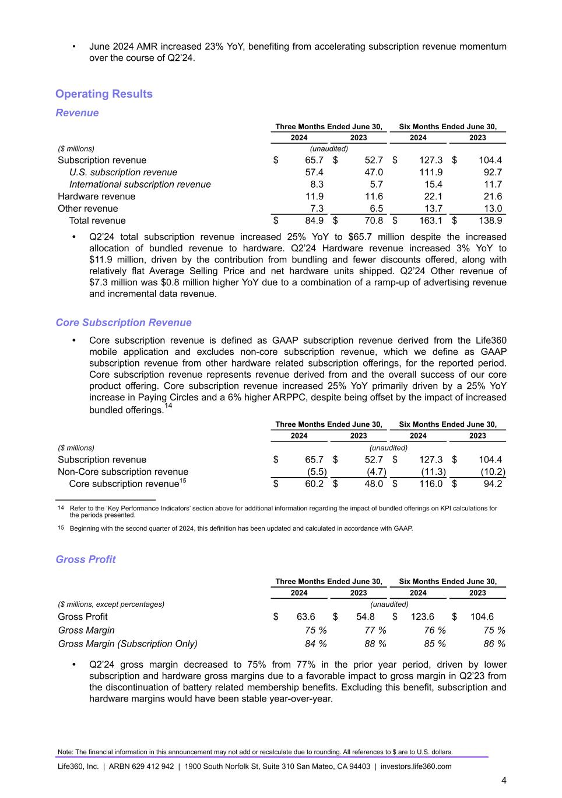
• June 2024 AMR increased 23% YoY, benefiting from accelerating subscription revenue momentum over the course of Q2’24. Operating Results Revenue Three Months Ended June 30, Six Months Ended June 30, 2024 2023 2024 2023 ($ millions) (unaudited) Subscription revenue $ 65.7 $ 52.7 $ 127.3 $ 104.4 U.S. subscription revenue 57.4 47.0 111.9 92.7 International subscription revenue 8.3 5.7 15.4 11.7 Hardware revenue 11.9 11.6 22.1 21.6 Other revenue 7.3 6.5 13.7 13.0 Total revenue $ 84.9 $ 70.8 $ 163.1 $ 138.9 • Q2’24 total subscription revenue increased 25% YoY to $65.7 million despite the increased allocation of bundled revenue to hardware. Q2’24 Hardware revenue increased 3% YoY to $11.9 million, driven by the contribution from bundling and fewer discounts offered, along with relatively flat Average Selling Price and net hardware units shipped. Q2’24 Other revenue of $7.3 million was $0.8 million higher YoY due to a combination of a ramp-up of advertising revenue and incremental data revenue. Core Subscription Revenue • Core subscription revenue is defined as GAAP subscription revenue derived from the Life360 mobile application and excludes non-core subscription revenue, which we define as GAAP subscription revenue from other hardware related subscription offerings, for the reported period. Core subscription revenue represents revenue derived from and the overall success of our core product offering. Core subscription revenue increased 25% YoY primarily driven by a 25% YoY increase in Paying Circles and a 6% higher ARPPC, despite being offset by the impact of increased bundled offerings.14 Three Months Ended June 30, Six Months Ended June 30, 2024 2023 2024 2023 ($ millions) (unaudited) Subscription revenue $ 65.7 $ 52.7 $ 127.3 $ 104.4 Non-Core subscription revenue (5.5) (4.7) (11.3) (10.2) Core subscription revenue15 $ 60.2 $ 48.0 $ 116.0 $ 94.2 14 Refer to the ‘Key Performance Indicators’ section above for additional information regarding the impact of bundled offerings on KPI calculations for the periods presented. 15 Beginning with the second quarter of 2024, this definition has been updated and calculated in accordance with GAAP. Gross Profit Three Months Ended June 30, Six Months Ended June 30, 2024 2023 2024 2023 ($ millions, except percentages) (unaudited) Gross Profit $ 63.6 $ 54.8 $ 123.6 $ 104.6 Gross Margin 75 % 77 % 76 % 75 % Gross Margin (Subscription Only) 84 % 88 % 85 % 86 % • Q2’24 gross margin decreased to 75% from 77% in the prior year period, driven by lower subscription and hardware gross margins due to a favorable impact to gross margin in Q2’23 from the discontinuation of battery related membership benefits. Excluding this benefit, subscription and hardware margins would have been stable year-over-year. Note: The financial information in this announcement may not add or recalculate due to rounding. All references to $ are to U.S. dollars. Life360, Inc. | ARBN 629 412 942 | 1900 South Norfolk St, Suite 310 San Mateo, CA 94403 | investors.life360.com 4

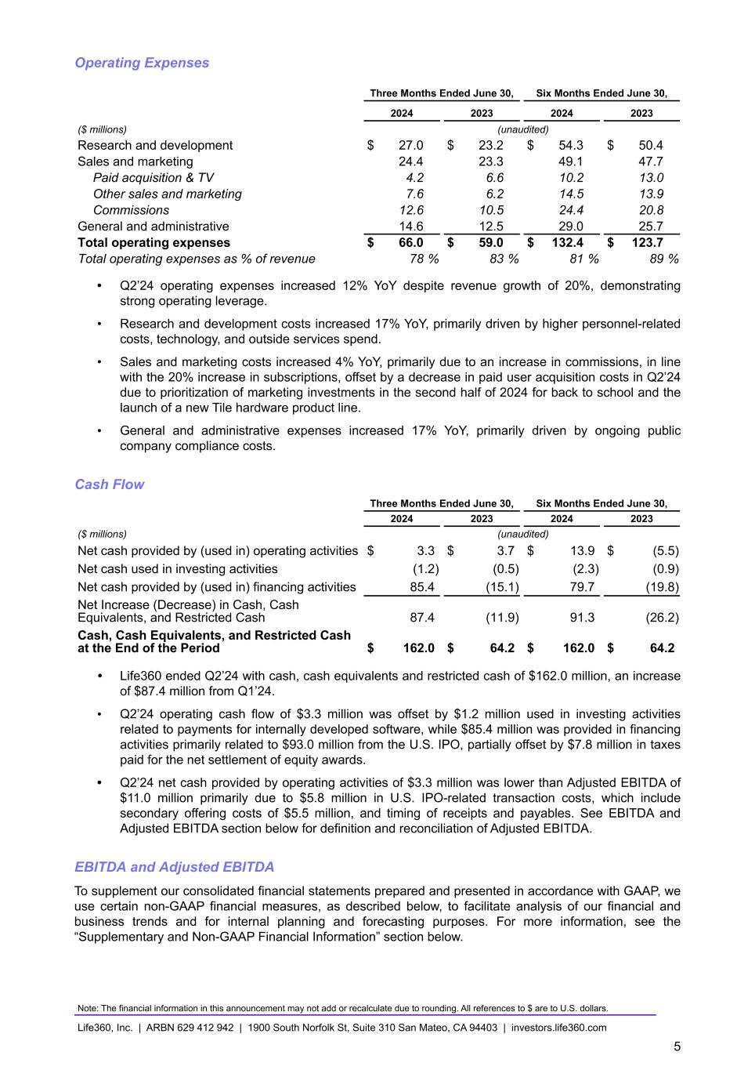
Operating Expenses Three Months Ended June 30, Six Months Ended June 30, 2024 2023 2024 2023 ($ millions) (unaudited) Research and development $ 27.0 $ 23.2 $ 54.3 $ 50.4 Sales and marketing 24.4 23.3 49.1 47.7 Paid acquisition & TV 4.2 6.6 10.2 13.0 Other sales and marketing 7.6 6.2 14.5 13.9 Commissions 12.6 10.5 24.4 20.8 General and administrative 14.6 12.5 29.0 25.7 Total operating expenses $ 66.0 $ 59.0 $ 132.4 $ 123.7 Total operating expenses as % of revenue 78 % 83 % 81 % 89 % • Q2’24 operating expenses increased 12% YoY despite revenue growth of 20%, demonstrating strong operating leverage. • Research and development costs increased 17% YoY, primarily driven by higher personnel-related costs, technology, and outside services spend. • Sales and marketing costs increased 4% YoY, primarily due to an increase in commissions, in line with the 20% increase in subscriptions, offset by a decrease in paid user acquisition costs in Q2’24 due to prioritization of marketing investments in the second half of 2024 for back to school and the launch of a new Tile hardware product line. • General and administrative expenses increased 17% YoY, primarily driven by ongoing public company compliance costs. Cash Flow Three Months Ended June 30, Six Months Ended June 30, 2024 2023 2024 2023 ($ millions) (unaudited) Net cash provided by (used in) operating activities $ 3.3 $ 3.7 $ 13.9 $ (5.5) Net cash used in investing activities (1.2) (0.5) (2.3) (0.9) Net cash provided by (used in) financing activities 85.4 (15.1) 79.7 (19.8) Net Increase (Decrease) in Cash, Cash Equivalents, and Restricted Cash 87.4 (11.9) 91.3 (26.2) Cash, Cash Equivalents, and Restricted Cash at the End of the Period $ 162.0 $ 64.2 $ 162.0 $ 64.2 • Life360 ended Q2’24 with cash, cash equivalents and restricted cash of $162.0 million, an increase of $87.4 million from Q1’24. • Q2’24 operating cash flow of $3.3 million was offset by $1.2 million used in investing activities related to payments for internally developed software, while $85.4 million was provided in financing activities primarily related to $93.0 million from the U.S. IPO, partially offset by $7.8 million in taxes paid for the net settlement of equity awards. • Q2’24 net cash provided by operating activities of $3.3 million was lower than Adjusted EBITDA of $11.0 million primarily due to $5.8 million in U.S. IPO-related transaction costs, which include secondary offering costs of $5.5 million, and timing of receipts and payables. See EBITDA and Adjusted EBITDA section below for definition and reconciliation of Adjusted EBITDA. EBITDA and Adjusted EBITDA To supplement our consolidated financial statements prepared and presented in accordance with GAAP, we use certain non-GAAP financial measures, as described below, to facilitate analysis of our financial and business trends and for internal planning and forecasting purposes. For more information, see the “Supplementary and Non-GAAP Financial Information” section below. Note: The financial information in this announcement may not add or recalculate due to rounding. All references to $ are to U.S. dollars. Life360, Inc. | ARBN 629 412 942 | 1900 South Norfolk St, Suite 310 San Mateo, CA 94403 | investors.life360.com 5

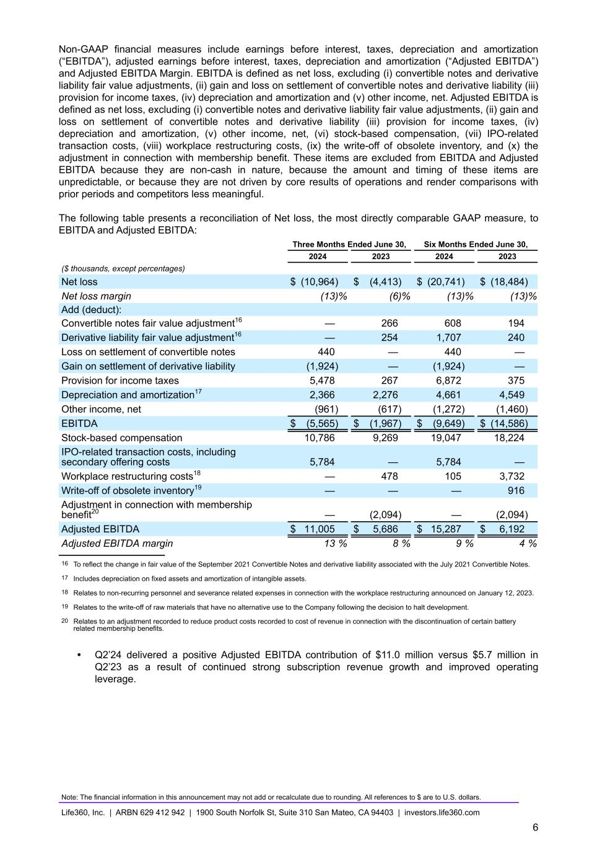
Non-GAAP financial measures include earnings before interest, taxes, depreciation and amortization (“EBITDA”), adjusted earnings before interest, taxes, depreciation and amortization (“Adjusted EBITDA”) and Adjusted EBITDA Margin. EBITDA is defined as net loss, excluding (i) convertible notes and derivative liability fair value adjustments, (ii) gain and loss on settlement of convertible notes and derivative liability (iii) provision for income taxes, (iv) depreciation and amortization and (v) other income, net. Adjusted EBITDA is defined as net loss, excluding (i) convertible notes and derivative liability fair value adjustments, (ii) gain and loss on settlement of convertible notes and derivative liability (iii) provision for income taxes, (iv) depreciation and amortization, (v) other income, net, (vi) stock-based compensation, (vii) IPO-related transaction costs, (viii) workplace restructuring costs, (ix) the write-off of obsolete inventory, and (x) the adjustment in connection with membership benefit. These items are excluded from EBITDA and Adjusted EBITDA because they are non-cash in nature, because the amount and timing of these items are unpredictable, or because they are not driven by core results of operations and render comparisons with prior periods and competitors less meaningful. The following table presents a reconciliation of Net loss, the most directly comparable GAAP measure, to EBITDA and Adjusted EBITDA: Three Months Ended June 30, Six Months Ended June 30, 2024 2023 2024 2023 ($ thousands, except percentages) Net loss $ (10,964) $ (4,413) $ (20,741) $ (18,484) Net loss margin (13) % (6) % (13) % (13) % Add (deduct): Convertible notes fair value adjustment16 — 266 608 194 Derivative liability fair value adjustment16 — 254 1,707 240 Loss on settlement of convertible notes 440 — 440 — Gain on settlement of derivative liability (1,924) — (1,924) — Provision for income taxes 5,478 267 6,872 375 Depreciation and amortization17 2,366 2,276 4,661 4,549 Other income, net (961) (617) (1,272) (1,460) EBITDA $ (5,565) $ (1,967) $ (9,649) $ (14,586) Stock-based compensation 10,786 9,269 19,047 18,224 IPO-related transaction costs, including secondary offering costs 5,784 — 5,784 — Workplace restructuring costs18 — 478 105 3,732 Write-off of obsolete inventory19 — — — 916 Adjustment in connection with membership benefit20 — (2,094) — (2,094) Adjusted EBITDA $ 11,005 $ 5,686 $ 15,287 $ 6,192 Adjusted EBITDA margin 13 % 8 % 9 % 4 % 16 To reflect the change in fair value of the September 2021 Convertible Notes and derivative liability associated with the July 2021 Convertible Notes. 17 Includes depreciation on fixed assets and amortization of intangible assets. 18 Relates to non-recurring personnel and severance related expenses in connection with the workplace restructuring announced on January 12, 2023. 19 Relates to the write-off of raw materials that have no alternative use to the Company following the decision to halt development. 20 Relates to an adjustment recorded to reduce product costs recorded to cost of revenue in connection with the discontinuation of certain battery related membership benefits. • Q2’24 delivered a positive Adjusted EBITDA contribution of $11.0 million versus $5.7 million in Q2’23 as a result of continued strong subscription revenue growth and improved operating leverage. Note: The financial information in this announcement may not add or recalculate due to rounding. All references to $ are to U.S. dollars. Life360, Inc. | ARBN 629 412 942 | 1900 South Norfolk St, Suite 310 San Mateo, CA 94403 | investors.life360.com 6

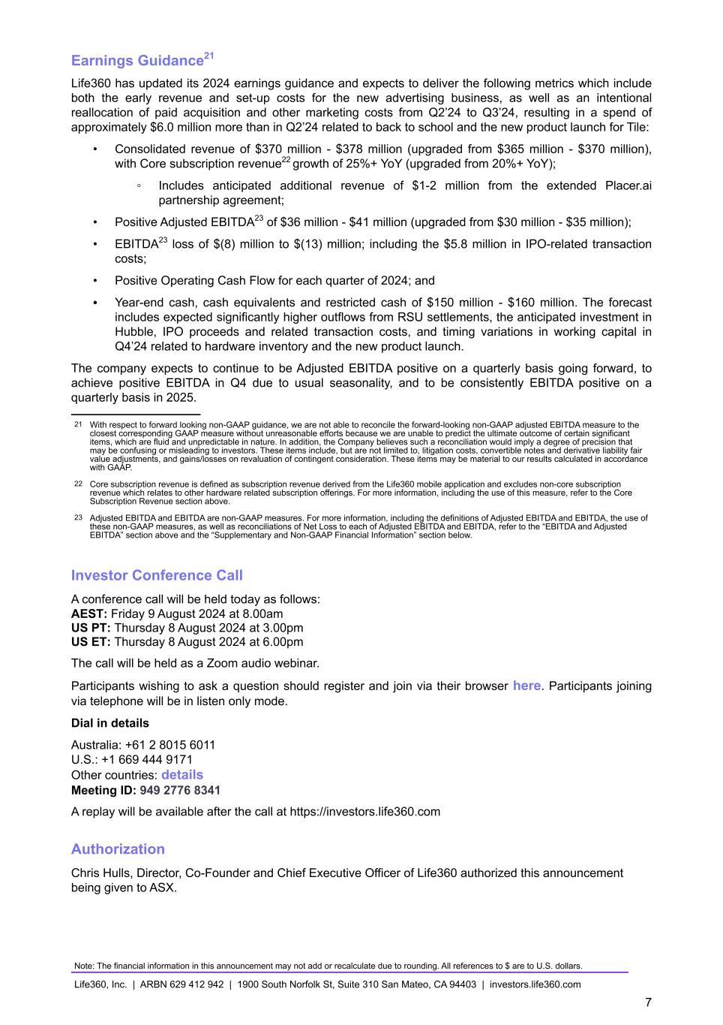
Earnings Guidance21 Life360 has updated its 2024 earnings guidance and expects to deliver the following metrics which include both the early revenue and set-up costs for the new advertising business, as well as an intentional reallocation of paid acquisition and other marketing costs from Q2’24 to Q3’24, resulting in a spend of approximately $6.0 million more than in Q2’24 related to back to school and the new product launch for Tile: • Consolidated revenue of $370 million - $378 million (upgraded from $365 million - $370 million), with Core subscription revenue22 growth of 25%+ YoY (upgraded from 20%+ YoY); ◦ Includes anticipated additional revenue of $1-2 million from the extended Placer.ai partnership agreement; • Positive Adjusted EBITDA23 of $36 million - $41 million (upgraded from $30 million - $35 million); • EBITDA23 loss of $(8) million to $(13) million; including the $5.8 million in IPO-related transaction costs; • Positive Operating Cash Flow for each quarter of 2024; and • Year-end cash, cash equivalents and restricted cash of $150 million - $160 million. The forecast includes expected significantly higher outflows from RSU settlements, the anticipated investment in Hubble, IPO proceeds and related transaction costs, and timing variations in working capital in Q4’24 related to hardware inventory and the new product launch. The company expects to continue to be Adjusted EBITDA positive on a quarterly basis going forward, to achieve positive EBITDA in Q4 due to usual seasonality, and to be consistently EBITDA positive on a quarterly basis in 2025. 21 With respect to forward looking non-GAAP guidance, we are not able to reconcile the forward-looking non-GAAP adjusted EBITDA measure to the closest corresponding GAAP measure without unreasonable efforts because we are unable to predict the ultimate outcome of certain significant items, which are fluid and unpredictable in nature. In addition, the Company believes such a reconciliation would imply a degree of precision that may be confusing or misleading to investors. These items include, but are not limited to, litigation costs, convertible notes and derivative liability fair value adjustments, and gains/losses on revaluation of contingent consideration. These items may be material to our results calculated in accordance with GAAP. 22 Core subscription revenue is defined as subscription revenue derived from the Life360 mobile application and excludes non-core subscription revenue which relates to other hardware related subscription offerings. For more information, including the use of this measure, refer to the Core Subscription Revenue section above. 23 Adjusted EBITDA and EBITDA are non-GAAP measures. For more information, including the definitions of Adjusted EBITDA and EBITDA, the use of these non-GAAP measures, as well as reconciliations of Net Loss to each of Adjusted EBITDA and EBITDA, refer to the “EBITDA and Adjusted EBITDA” section above and the “Supplementary and Non-GAAP Financial Information” section below. Investor Conference Call A conference call will be held today as follows: AEST: Friday 9 August 2024 at 8.00am US PT: Thursday 8 August 2024 at 3.00pm US ET: Thursday 8 August 2024 at 6.00pm The call will be held as a Zoom audio webinar. Participants wishing to ask a question should register and join via their browser here. Participants joining via telephone will be in listen only mode. Dial in details Australia: +61 2 8015 6011 U.S.: +1 669 444 9171 Other countries: details Meeting ID: 949 2776 8341 A replay will be available after the call at https://investors.life360.com Authorization Chris Hulls, Director, Co-Founder and Chief Executive Officer of Life360 authorized this announcement being given to ASX. Note: The financial information in this announcement may not add or recalculate due to rounding. All references to $ are to U.S. dollars. Life360, Inc. | ARBN 629 412 942 | 1900 South Norfolk St, Suite 310 San Mateo, CA 94403 | investors.life360.com 7

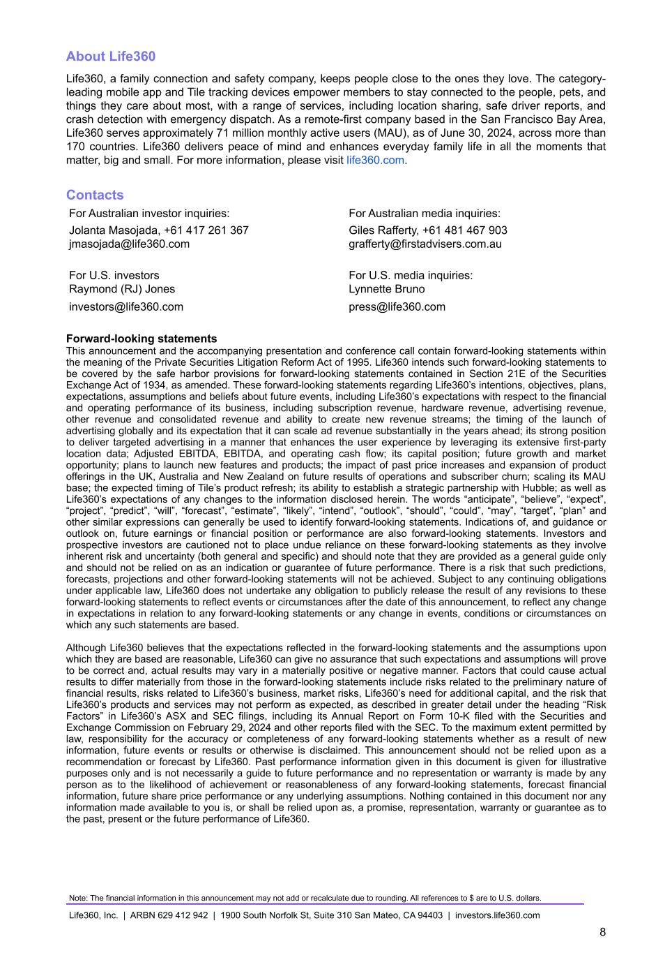
About Life360 Life360, a family connection and safety company, keeps people close to the ones they love. The category- leading mobile app and Tile tracking devices empower members to stay connected to the people, pets, and things they care about most, with a range of services, including location sharing, safe driver reports, and crash detection with emergency dispatch. As a remote-first company based in the San Francisco Bay Area, Life360 serves approximately 71 million monthly active users (MAU), as of June 30, 2024, across more than 170 countries. Life360 delivers peace of mind and enhances everyday family life in all the moments that matter, big and small. For more information, please visit life360.com. Contacts For Australian investor inquiries: For Australian media inquiries: Jolanta Masojada, +61 417 261 367 Giles Rafferty, +61 481 467 903 jmasojada@life360.com grafferty@firstadvisers.com.au For U.S. investors For U.S. media inquiries: Raymond (RJ) Jones Lynnette Bruno investors@life360.com press@life360.com Forward-looking statements This announcement and the accompanying presentation and conference call contain forward-looking statements within the meaning of the Private Securities Litigation Reform Act of 1995. Life360 intends such forward-looking statements to be covered by the safe harbor provisions for forward-looking statements contained in Section 21E of the Securities Exchange Act of 1934, as amended. These forward-looking statements regarding Life360’s intentions, objectives, plans, expectations, assumptions and beliefs about future events, including Life360’s expectations with respect to the financial and operating performance of its business, including subscription revenue, hardware revenue, advertising revenue, other revenue and consolidated revenue and ability to create new revenue streams; the timing of the launch of advertising globally and its expectation that it can scale ad revenue substantially in the years ahead; its strong position to deliver targeted advertising in a manner that enhances the user experience by leveraging its extensive first-party location data; Adjusted EBITDA, EBITDA, and operating cash flow; its capital position; future growth and market opportunity; plans to launch new features and products; the impact of past price increases and expansion of product offerings in the UK, Australia and New Zealand on future results of operations and subscriber churn; scaling its MAU base; the expected timing of Tile’s product refresh; its ability to establish a strategic partnership with Hubble; as well as Life360’s expectations of any changes to the information disclosed herein. The words “anticipate”, “believe”, “expect”, “project”, “predict”, “will”, “forecast”, “estimate”, “likely”, “intend”, “outlook”, “should”, “could”, “may”, “target”, “plan” and other similar expressions can generally be used to identify forward-looking statements. Indications of, and guidance or outlook on, future earnings or financial position or performance are also forward-looking statements. Investors and prospective investors are cautioned not to place undue reliance on these forward-looking statements as they involve inherent risk and uncertainty (both general and specific) and should note that they are provided as a general guide only and should not be relied on as an indication or guarantee of future performance. There is a risk that such predictions, forecasts, projections and other forward-looking statements will not be achieved. Subject to any continuing obligations under applicable law, Life360 does not undertake any obligation to publicly release the result of any revisions to these forward-looking statements to reflect events or circumstances after the date of this announcement, to reflect any change in expectations in relation to any forward-looking statements or any change in events, conditions or circumstances on which any such statements are based. Although Life360 believes that the expectations reflected in the forward-looking statements and the assumptions upon which they are based are reasonable, Life360 can give no assurance that such expectations and assumptions will prove to be correct and, actual results may vary in a materially positive or negative manner. Factors that could cause actual results to differ materially from those in the forward-looking statements include risks related to the preliminary nature of financial results, risks related to Life360’s business, market risks, Life360’s need for additional capital, and the risk that Life360’s products and services may not perform as expected, as described in greater detail under the heading “Risk Factors” in Life360’s ASX and SEC filings, including its Annual Report on Form 10-K filed with the Securities and Exchange Commission on February 29, 2024 and other reports filed with the SEC. To the maximum extent permitted by law, responsibility for the accuracy or completeness of any forward-looking statements whether as a result of new information, future events or results or otherwise is disclaimed. This announcement should not be relied upon as a recommendation or forecast by Life360. Past performance information given in this document is given for illustrative purposes only and is not necessarily a guide to future performance and no representation or warranty is made by any person as to the likelihood of achievement or reasonableness of any forward-looking statements, forecast financial information, future share price performance or any underlying assumptions. Nothing contained in this document nor any information made available to you is, or shall be relied upon as, a promise, representation, warranty or guarantee as to the past, present or the future performance of Life360. Note: The financial information in this announcement may not add or recalculate due to rounding. All references to $ are to U.S. dollars. Life360, Inc. | ARBN 629 412 942 | 1900 South Norfolk St, Suite 310 San Mateo, CA 94403 | investors.life360.com 8

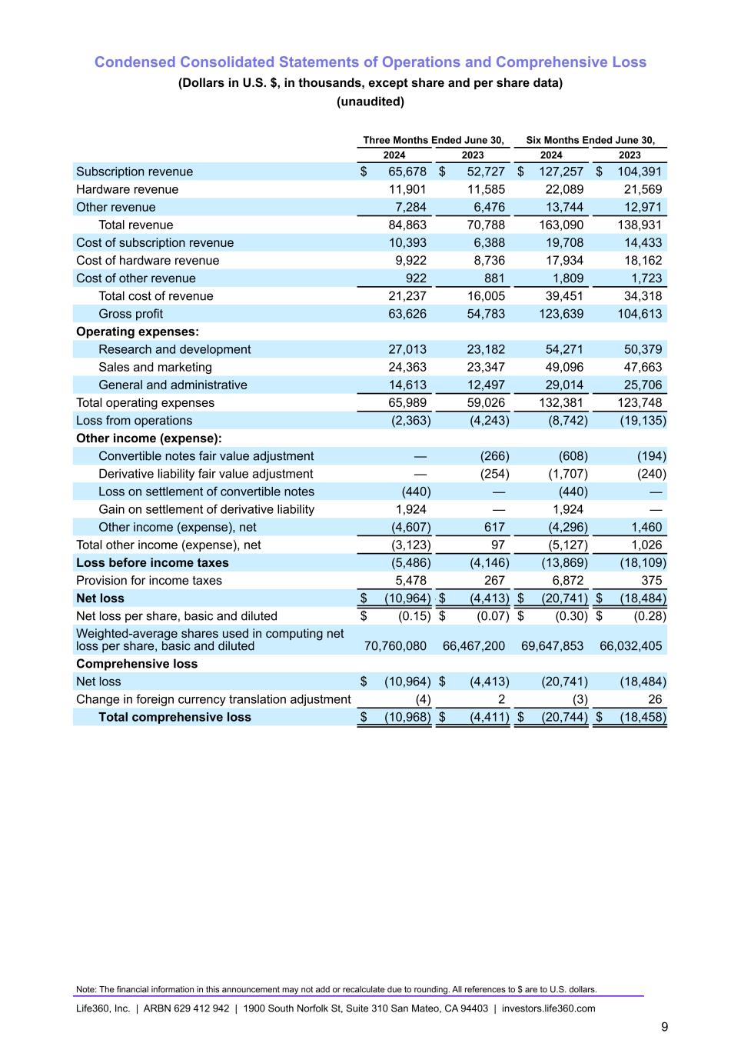
Condensed Consolidated Statements of Operations and Comprehensive Loss (Dollars in U.S. $, in thousands, except share and per share data) (unaudited) Three Months Ended June 30, Six Months Ended June 30, 2024 2023 2024 2023 Subscription revenue $ 65,678 $ 52,727 $ 127,257 $ 104,391 Hardware revenue 11,901 11,585 22,089 21,569 Other revenue 7,284 6,476 13,744 12,971 Total revenue 84,863 70,788 163,090 138,931 Cost of subscription revenue 10,393 6,388 19,708 14,433 Cost of hardware revenue 9,922 8,736 17,934 18,162 Cost of other revenue 922 881 1,809 1,723 Total cost of revenue 21,237 16,005 39,451 34,318 Gross profit 63,626 54,783 123,639 104,613 Operating expenses: Research and development 27,013 23,182 54,271 50,379 Sales and marketing 24,363 23,347 49,096 47,663 General and administrative 14,613 12,497 29,014 25,706 Total operating expenses 65,989 59,026 132,381 123,748 Loss from operations (2,363) (4,243) (8,742) (19,135) Other income (expense): Convertible notes fair value adjustment — (266) (608) (194) Derivative liability fair value adjustment — (254) (1,707) (240) Loss on settlement of convertible notes (440) — (440) — Gain on settlement of derivative liability 1,924 — 1,924 — Other income (expense), net (4,607) 617 (4,296) 1,460 Total other income (expense), net (3,123) 97 (5,127) 1,026 Loss before income taxes (5,486) (4,146) (13,869) (18,109) Provision for income taxes 5,478 267 6,872 375 Net loss $ (10,964) — $ (4,413) $ (20,741) $ (18,484) Net loss per share, basic and diluted $ (0.15) $ (0.07) $ (0.30) $ (0.28) Weighted-average shares used in computing net loss per share, basic and diluted 70,760,080 66,467,200 69,647,853 66,032,405 Comprehensive loss Net loss $ (10,964) $ (4,413) (20,741) (18,484) Change in foreign currency translation adjustment (4) 2 (3) 26 Total comprehensive loss $ (10,968) $ (4,411) $ (20,744) $ (18,458) Note: The financial information in this announcement may not add or recalculate due to rounding. All references to $ are to U.S. dollars. Life360, Inc. | ARBN 629 412 942 | 1900 South Norfolk St, Suite 310 San Mateo, CA 94403 | investors.life360.com 9

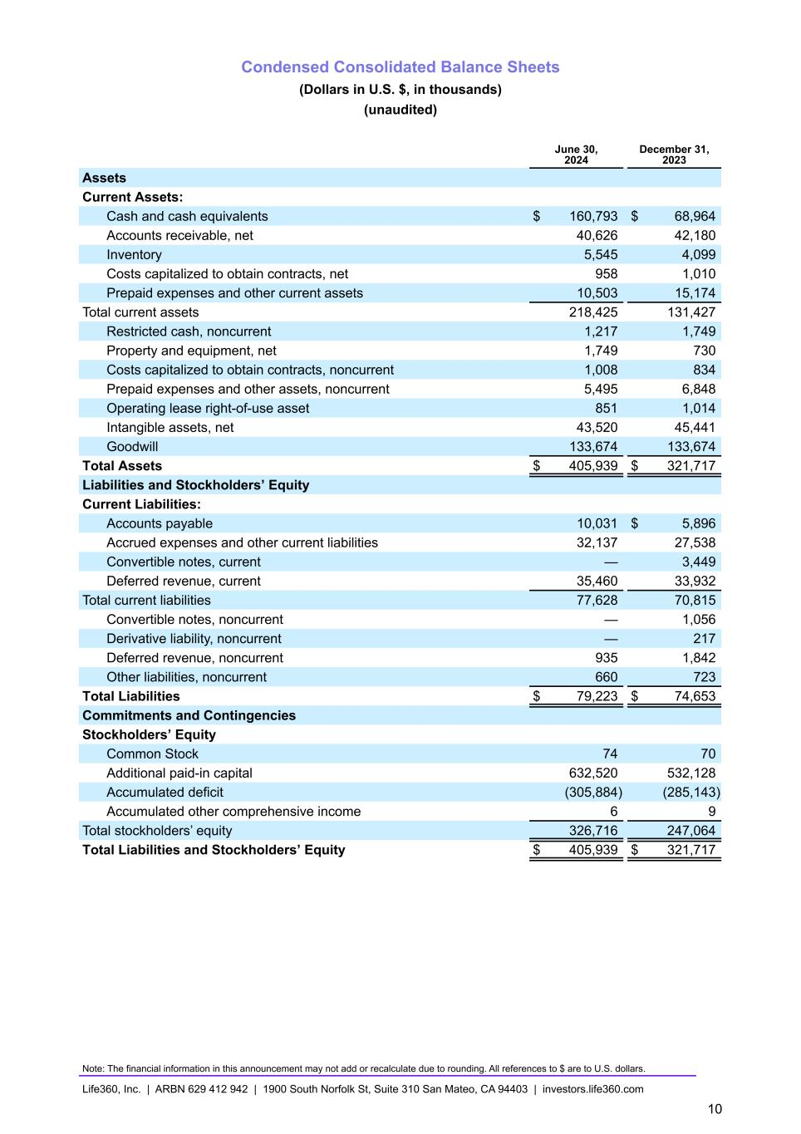
Condensed Consolidated Balance Sheets (Dollars in U.S. $, in thousands) (unaudited) June 30, 2024 December 31, 2023 Assets Current Assets: Cash and cash equivalents $ 160,793 $ 68,964 Accounts receivable, net 40,626 42,180 Inventory 5,545 4,099 Costs capitalized to obtain contracts, net 958 1,010 Prepaid expenses and other current assets 10,503 15,174 Total current assets 218,425 131,427 Restricted cash, noncurrent 1,217 1,749 Property and equipment, net 1,749 730 Costs capitalized to obtain contracts, noncurrent 1,008 834 Prepaid expenses and other assets, noncurrent 5,495 6,848 Operating lease right-of-use asset 851 1,014 Intangible assets, net 43,520 45,441 Goodwill 133,674 133,674 Total Assets $ 405,939 $ 321,717 Liabilities and Stockholders’ Equity Current Liabilities: Accounts payable 10,031 $ 5,896 Accrued expenses and other current liabilities 32,137 27,538 Convertible notes, current — 3,449 Deferred revenue, current 35,460 33,932 Total current liabilities 77,628 70,815 Convertible notes, noncurrent — 1,056 Derivative liability, noncurrent — 217 Deferred revenue, noncurrent 935 1,842 Other liabilities, noncurrent 660 723 Total Liabilities $ 79,223 $ 74,653 Commitments and Contingencies Stockholders’ Equity Common Stock 74 70 Additional paid-in capital 632,520 532,128 Accumulated deficit (305,884) (285,143) Accumulated other comprehensive income 6 9 Total stockholders’ equity 326,716 247,064 Total Liabilities and Stockholders’ Equity $ 405,939 $ 321,717 Note: The financial information in this announcement may not add or recalculate due to rounding. All references to $ are to U.S. dollars. Life360, Inc. | ARBN 629 412 942 | 1900 South Norfolk St, Suite 310 San Mateo, CA 94403 | investors.life360.com 10

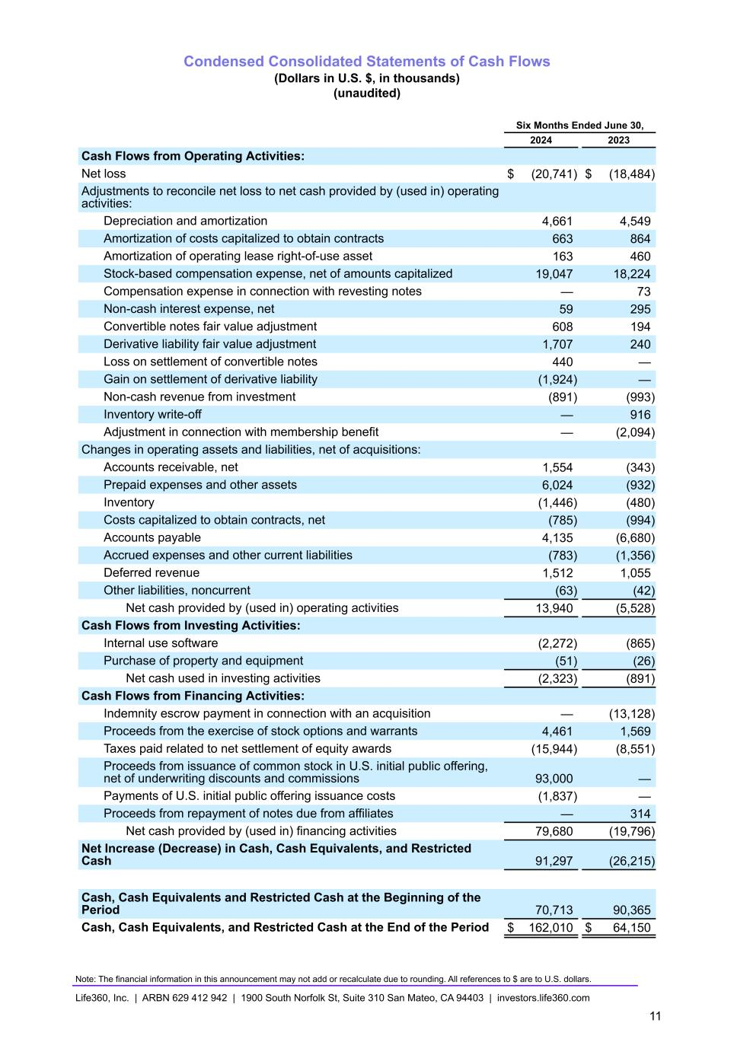
Condensed Consolidated Statements of Cash Flows (Dollars in U.S. $, in thousands) (unaudited) Six Months Ended June 30, 2024 2023 Cash Flows from Operating Activities: Net loss $ (20,741) $ (18,484) Adjustments to reconcile net loss to net cash provided by (used in) operating activities: Depreciation and amortization 4,661 4,549 Amortization of costs capitalized to obtain contracts 663 864 Amortization of operating lease right-of-use asset 163 460 Stock-based compensation expense, net of amounts capitalized 19,047 18,224 Compensation expense in connection with revesting notes — 73 Non-cash interest expense, net 59 295 Convertible notes fair value adjustment 608 194 Derivative liability fair value adjustment 1,707 240 Loss on settlement of convertible notes 440 — Gain on settlement of derivative liability (1,924) — Non-cash revenue from investment (891) (993) Inventory write-off — 916 Adjustment in connection with membership benefit — (2,094) Changes in operating assets and liabilities, net of acquisitions: Accounts receivable, net 1,554 (343) Prepaid expenses and other assets 6,024 (932) Inventory (1,446) (480) Costs capitalized to obtain contracts, net (785) (994) Accounts payable 4,135 (6,680) Accrued expenses and other current liabilities (783) (1,356) Deferred revenue 1,512 1,055 Other liabilities, noncurrent (63) (42) Net cash provided by (used in) operating activities 13,940 (5,528) Cash Flows from Investing Activities: Internal use software (2,272) (865) Purchase of property and equipment (51) (26) Net cash used in investing activities (2,323) (891) Cash Flows from Financing Activities: Indemnity escrow payment in connection with an acquisition — (13,128) Proceeds from the exercise of stock options and warrants 4,461 1,569 Taxes paid related to net settlement of equity awards (15,944) (8,551) Proceeds from issuance of common stock in U.S. initial public offering, net of underwriting discounts and commissions 93,000 — Payments of U.S. initial public offering issuance costs (1,837) — Proceeds from repayment of notes due from affiliates — 314 Net cash provided by (used in) financing activities 79,680 (19,796) Net Increase (Decrease) in Cash, Cash Equivalents, and Restricted Cash 91,297 (26,215) Cash, Cash Equivalents and Restricted Cash at the Beginning of the Period 70,713 90,365 Cash, Cash Equivalents, and Restricted Cash at the End of the Period $ 162,010 $ 64,150 Note: The financial information in this announcement may not add or recalculate due to rounding. All references to $ are to U.S. dollars. Life360, Inc. | ARBN 629 412 942 | 1900 South Norfolk St, Suite 310 San Mateo, CA 94403 | investors.life360.com 11

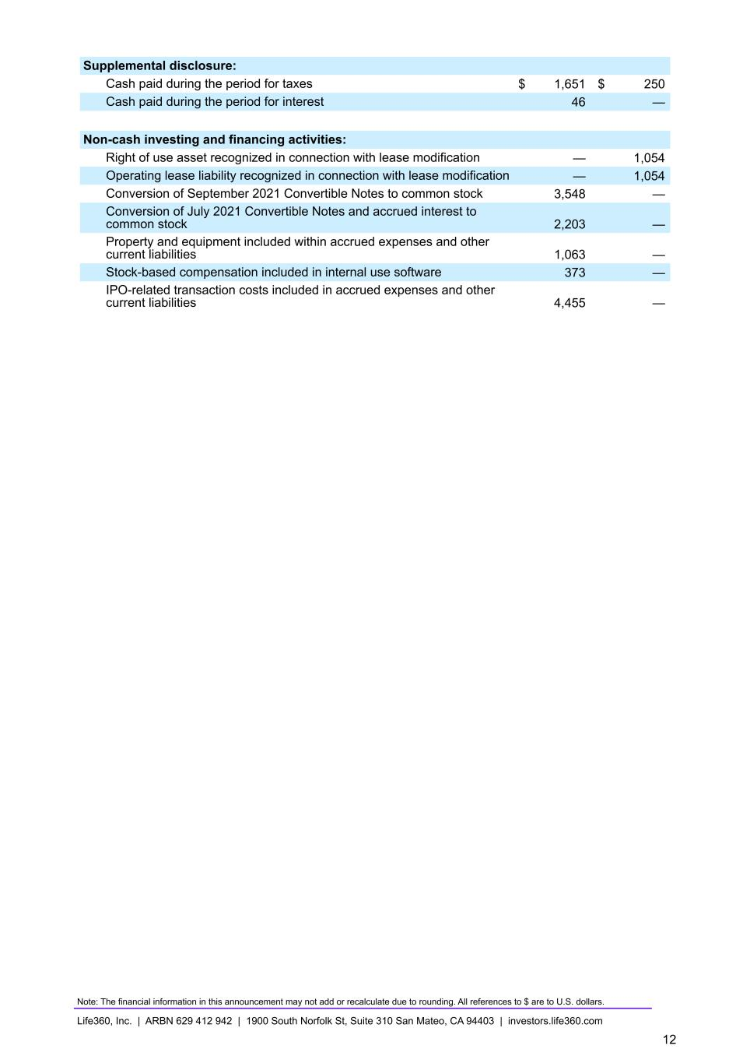
Supplemental disclosure: Cash paid during the period for taxes $ 1,651 $ 250 Cash paid during the period for interest 46 — Non-cash investing and financing activities: Right of use asset recognized in connection with lease modification — 1,054 Operating lease liability recognized in connection with lease modification — 1,054 Conversion of September 2021 Convertible Notes to common stock 3,548 — Conversion of July 2021 Convertible Notes and accrued interest to common stock 2,203 — Property and equipment included within accrued expenses and other current liabilities 1,063 — Stock-based compensation included in internal use software 373 — IPO-related transaction costs included in accrued expenses and other current liabilities 4,455 — Note: The financial information in this announcement may not add or recalculate due to rounding. All references to $ are to U.S. dollars. Life360, Inc. | ARBN 629 412 942 | 1900 South Norfolk St, Suite 310 San Mateo, CA 94403 | investors.life360.com 12

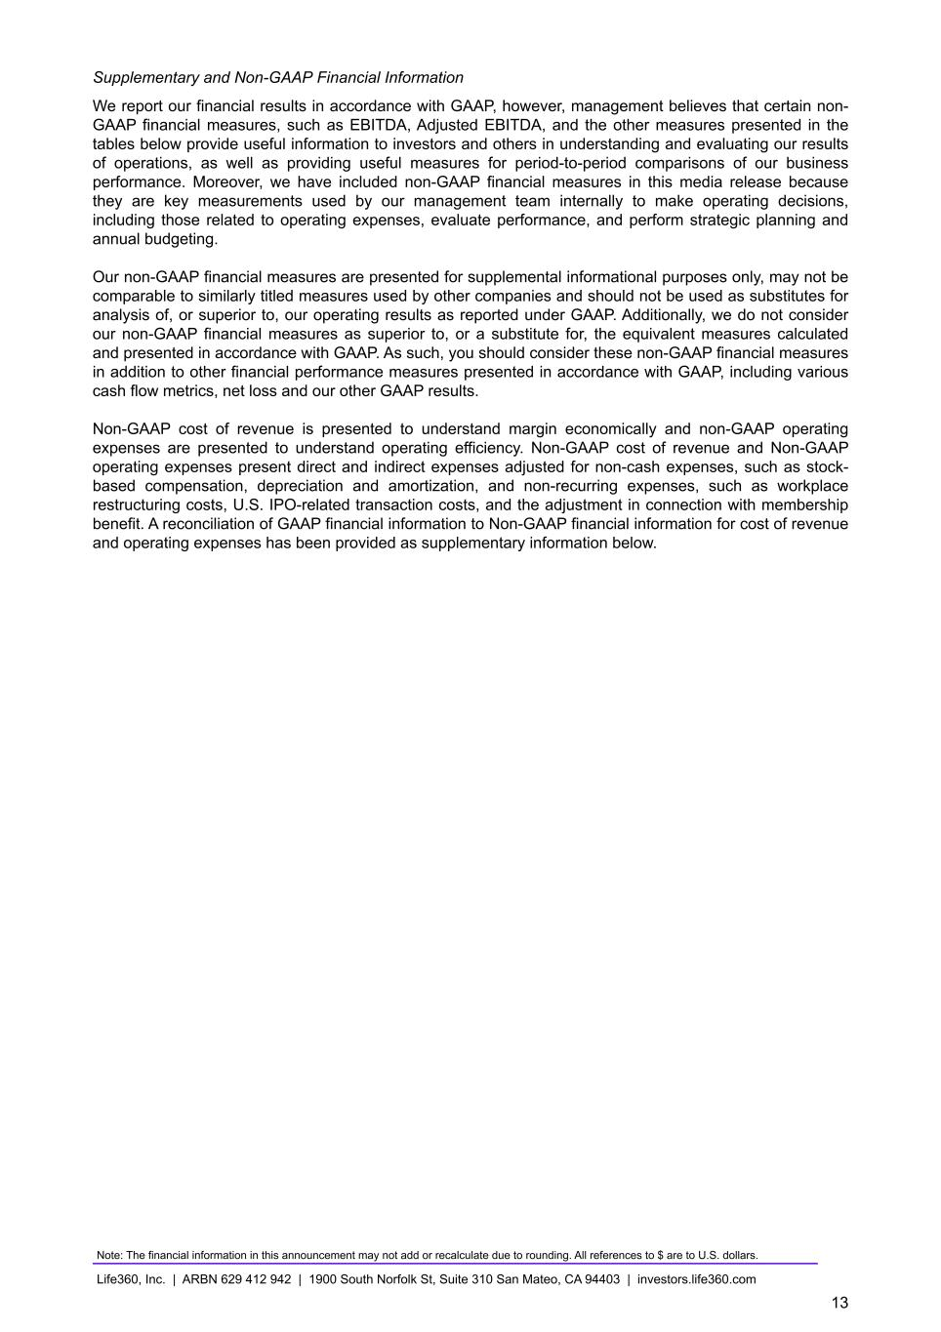
Supplementary and Non-GAAP Financial Information We report our financial results in accordance with GAAP, however, management believes that certain non- GAAP financial measures, such as EBITDA, Adjusted EBITDA, and the other measures presented in the tables below provide useful information to investors and others in understanding and evaluating our results of operations, as well as providing useful measures for period-to-period comparisons of our business performance. Moreover, we have included non-GAAP financial measures in this media release because they are key measurements used by our management team internally to make operating decisions, including those related to operating expenses, evaluate performance, and perform strategic planning and annual budgeting. Our non-GAAP financial measures are presented for supplemental informational purposes only, may not be comparable to similarly titled measures used by other companies and should not be used as substitutes for analysis of, or superior to, our operating results as reported under GAAP. Additionally, we do not consider our non-GAAP financial measures as superior to, or a substitute for, the equivalent measures calculated and presented in accordance with GAAP. As such, you should consider these non-GAAP financial measures in addition to other financial performance measures presented in accordance with GAAP, including various cash flow metrics, net loss and our other GAAP results. Non-GAAP cost of revenue is presented to understand margin economically and non-GAAP operating expenses are presented to understand operating efficiency. Non-GAAP cost of revenue and Non-GAAP operating expenses present direct and indirect expenses adjusted for non-cash expenses, such as stock- based compensation, depreciation and amortization, and non-recurring expenses, such as workplace restructuring costs, U.S. IPO-related transaction costs, and the adjustment in connection with membership benefit. A reconciliation of GAAP financial information to Non-GAAP financial information for cost of revenue and operating expenses has been provided as supplementary information below. Note: The financial information in this announcement may not add or recalculate due to rounding. All references to $ are to U.S. dollars. Life360, Inc. | ARBN 629 412 942 | 1900 South Norfolk St, Suite 310 San Mateo, CA 94403 | investors.life360.com 13

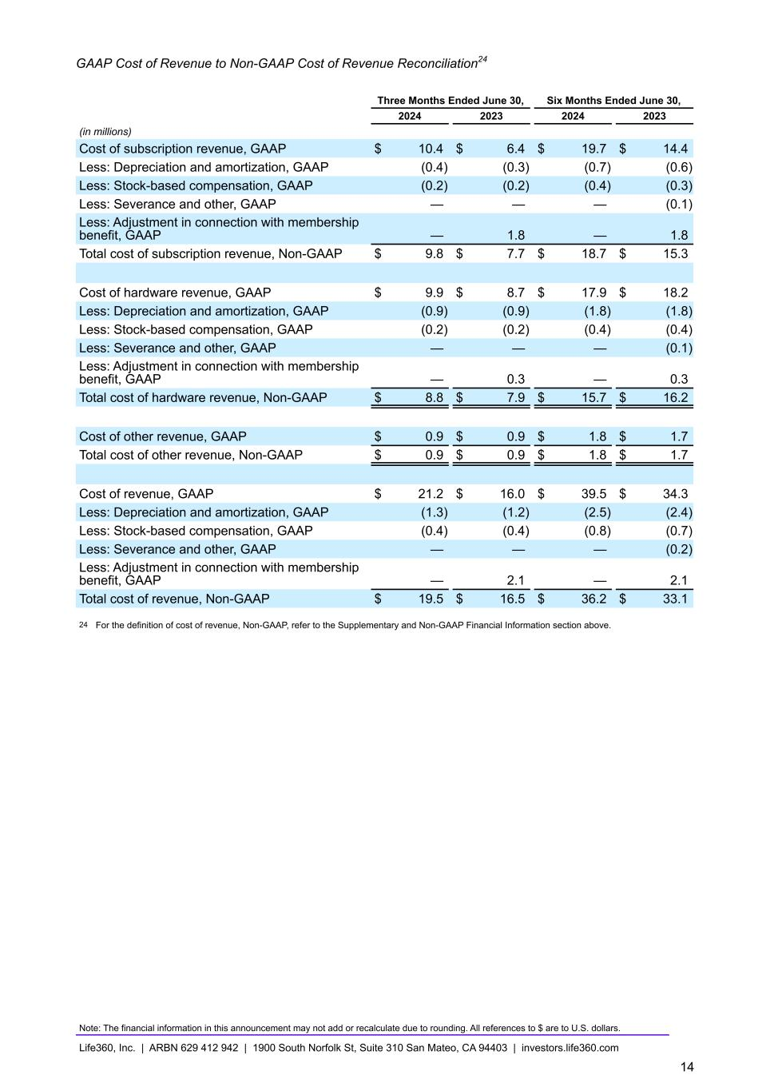
GAAP Cost of Revenue to Non-GAAP Cost of Revenue Reconciliation24 Three Months Ended June 30, Six Months Ended June 30, 2024 2023 2024 2023 (in millions) Cost of subscription revenue, GAAP $ 10.4 $ 6.4 $ 19.7 $ 14.4 Less: Depreciation and amortization, GAAP (0.4) (0.3) (0.7) (0.6) Less: Stock-based compensation, GAAP (0.2) (0.2) (0.4) (0.3) Less: Severance and other, GAAP — — — (0.1) Less: Adjustment in connection with membership benefit, GAAP — 1.8 — 1.8 Total cost of subscription revenue, Non-GAAP $ 9.8 $ 7.7 $ 18.7 $ 15.3 Cost of hardware revenue, GAAP $ 9.9 $ 8.7 $ 17.9 $ 18.2 Less: Depreciation and amortization, GAAP (0.9) (0.9) (1.8) (1.8) Less: Stock-based compensation, GAAP (0.2) (0.2) (0.4) (0.4) Less: Severance and other, GAAP — — — (0.1) Less: Adjustment in connection with membership benefit, GAAP — 0.3 — 0.3 Total cost of hardware revenue, Non-GAAP $ 8.8 $ 7.9 $ 15.7 $ 16.2 Cost of other revenue, GAAP $ 0.9 $ 0.9 $ 1.8 $ 1.7 Total cost of other revenue, Non-GAAP $ 0.9 $ 0.9 $ 1.8 $ 1.7 Cost of revenue, GAAP $ 21.2 $ 16.0 $ 39.5 $ 34.3 Less: Depreciation and amortization, GAAP (1.3) (1.2) (2.5) (2.4) Less: Stock-based compensation, GAAP (0.4) (0.4) (0.8) (0.7) Less: Severance and other, GAAP — — — (0.2) Less: Adjustment in connection with membership benefit, GAAP — 2.1 — 2.1 Total cost of revenue, Non-GAAP $ 19.5 $ 16.5 $ 36.2 $ 33.1 24 For the definition of cost of revenue, Non-GAAP, refer to the Supplementary and Non-GAAP Financial Information section above. Note: The financial information in this announcement may not add or recalculate due to rounding. All references to $ are to U.S. dollars. Life360, Inc. | ARBN 629 412 942 | 1900 South Norfolk St, Suite 310 San Mateo, CA 94403 | investors.life360.com 14

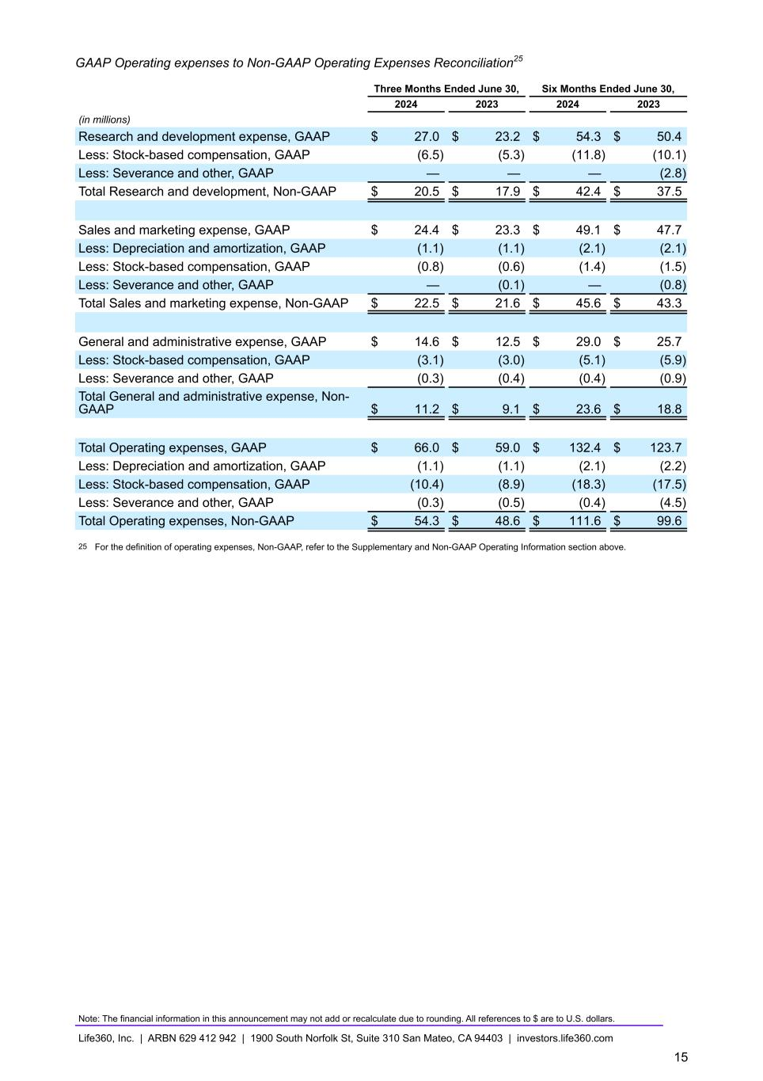
GAAP Operating expenses to Non-GAAP Operating Expenses Reconciliation25 Three Months Ended June 30, Six Months Ended June 30, 2024 2023 2024 2023 (in millions) Research and development expense, GAAP $ 27.0 $ 23.2 $ 54.3 $ 50.4 Less: Stock-based compensation, GAAP (6.5) (5.3) (11.8) (10.1) Less: Severance and other, GAAP — — — (2.8) Total Research and development, Non-GAAP $ 20.5 $ 17.9 $ 42.4 $ 37.5 Sales and marketing expense, GAAP $ 24.4 $ 23.3 $ 49.1 $ 47.7 Less: Depreciation and amortization, GAAP (1.1) (1.1) (2.1) (2.1) Less: Stock-based compensation, GAAP (0.8) (0.6) (1.4) (1.5) Less: Severance and other, GAAP — (0.1) — (0.8) Total Sales and marketing expense, Non-GAAP $ 22.5 $ 21.6 $ 45.6 $ 43.3 General and administrative expense, GAAP $ 14.6 $ 12.5 $ 29.0 $ 25.7 Less: Stock-based compensation, GAAP (3.1) (3.0) (5.1) (5.9) Less: Severance and other, GAAP (0.3) (0.4) (0.4) (0.9) Total General and administrative expense, Non- GAAP $ 11.2 $ 9.1 $ 23.6 $ 18.8 Total Operating expenses, GAAP $ 66.0 $ 59.0 $ 132.4 $ 123.7 Less: Depreciation and amortization, GAAP (1.1) (1.1) (2.1) (2.2) Less: Stock-based compensation, GAAP (10.4) (8.9) (18.3) (17.5) Less: Severance and other, GAAP (0.3) (0.5) (0.4) (4.5) Total Operating expenses, Non-GAAP $ 54.3 $ 48.6 $ 111.6 $ 99.6 25 For the definition of operating expenses, Non-GAAP, refer to the Supplementary and Non-GAAP Operating Information section above. Note: The financial information in this announcement may not add or recalculate due to rounding. All references to $ are to U.S. dollars. Life360, Inc. | ARBN 629 412 942 | 1900 South Norfolk St, Suite 310 San Mateo, CA 94403 | investors.life360.com 15


Investor Presentation | August 2024 Investor Presentation 8 August 2024 US PT 9 August 2024 AEST Q2’24


Investor Presentation | August 2024 Disclaimer These materials and the accompanying oral presentation have been prepared by Life360, Inc. (ARBN 629 412 942) (“Company”) on a confidential and non-reliance basis, and may not be reproduced in whole or in part, nor may any of its contents be disclosed, to any other person, without the prior written consent of the Company. These materials are for informational purposes only. This presentation contains summary information about the Company and its activities and is current as of the date of this presentation. This presentation does not purport to be all-inclusive or to contain all of the information you may desire. It should be read in conjunction with the Company’s periodic and continuous disclosure announcements filed with the Australian Securities Exchange and the U.S. Securities and Exchange Commission (“SEC”), available at www.asx.com.au and www.sec.gov, respectively. These materials do not constitute an offer, invitation, solicitation or recommendation with respect to the purchase or sale of any security in the Company or interest therein nor does it constitute financial product advice. These materials are not a prospectus, product disclosure statement or other offer document under Australian law or under any other law. These materials have not been filed, registered or approved by regulatory authorities in any jurisdiction. This communication is restricted by law; it is not intended for distribution to, or use by any person in, any jurisdiction where such distribution or use would be contrary to local law or regulation. The information contained in these materials is not intended to be relied upon as advice or a recommendation to investors and is not intended to form the basis of any investment decision in the Company’s securities. The information does not take into account the investment objectives, financial situation, taxation situation or needs of any particular investor. An investor must not act on the basis of any matter contained in these materials but must make its own assessment of the Company and conduct its own investigations and analysis. Investors should assess their own individual financial circumstances and consider talking to a financial adviser, professional adviser or consultant before making any investment decision. By reading these materials you agree to be bound by the limitations set out in these materials. No representation or warranty, express or implied, is made as to the accuracy, reliability, completeness or fairness of the information, opinions, forecasts, reports, estimates and conclusions contained in these materials. The Company does not undertake any obligation to provide any additional information nor update or revise the information in these materials nor correct any inaccuracies or omissions. To the maximum extent permitted by law, none of the Company and its related bodies corporate, or their respective directors, employees or agents, nor any other person accepts any responsibility nor any liability for loss arising from the use of or reliance on information contained in these materials or otherwise arising in connection with it, nor in relation to any other written or oral information or opinions provided now or in the future to the recipient or its advisers and representatives, including without limitation any liability from fault of negligence. Past performance is not indicative of future performance and no guarantee of future returns is implied or given. Nothing contained in these materials nor any information made available to you is, or shall be relied upon as, a promise, representation, warranty or guarantee as to the past, present or the future performance of the Company. Certain statements in these materials constitute forward-looking statements within the meaning of the Private Securities Litigation Reform Act of 1995 (“PLSRA”), Section 27A of the Securities Act of 1933, as amended, and Section 21E of the Securities Exchange Act of 1934, as amended (the “Exchange Act”). Statements that are not historical in nature, including the words “anticipate”, “expect”, “suggests”, “plan”, “believe”, “intend”, “estimates”, “targets”, “projects”, “should”, “could”, “would”, “may”, “will”, “forecast,” “opportunity,” “goal,” “vision,” “outlook” and other similar expressions are intended to identify forward-looking statements. These forward- looking statements include, but are not limited to, statements regarding: the Company’s growth strategy and business plan and the Company’s ability to effectively manage its growth and meet future capital requirements; the Company’s expectations regarding future financial performance, including its expectations regarding its revenue, revenue growth, adjusted EBITDA, and operating cash flow, and the Company’s ability to achieve or maintain future profitability; the Company’s ability to further penetrate its existing member base, maintain and expand its member base and increase monetization of its member base; the Company’s ability to expand internationally and the significance of its global opportunity; the Company’s ability to anticipate market needs or develop new products and services or enhance existing products and services to meet those needs; and the Company’s ability to increase sales of its products and services. Such forward-looking statements are prediction, projections and other statements about future events that are based on current expectations and assumptions and, as a result, involve known and unknown risks, uncertainties, assumptions and other important factors, many of which are beyond the control of the Company and which may cause actual results, performance or achievements to differ materially from those expressed or implied by such statements. Forward-looking statements are provided as a general guide only, and should not be relied on as an indication or guarantee of future performance. They can be affected by inaccurate assumptions we might make or by known or unknown risks or uncertainties. Given these uncertainties, recipients are cautioned to not place undue reliance on any forward- looking statement. Forward-looking statements speak only as of the date they are made. Subject to any continuing obligations under applicable law the Company disclaims any obligation or undertaking to disseminate any updates or revisions to any forward-looking statements in these materials to reflect any change in expectations in relation to such forward-looking statements or any change in events, conditions or circumstances on which any such statement is based. This presentation contains certain measures of financial performance not determined in accordance with U.S. generally accepted accounting principles (“GAAP”), including EBITDA, Adjusted EBITDA, Adjusted EBITDA margin, and non- GAAP Operating Expenses (the “non-GAAP financial measures”). The non-GAAP financial measures are used by Company management to evaluate financial performance of, and determine resource allocation for, each of the Company's operating segments. Items excluded from each of the non-GAAP financial measures are significant components in understanding and assessing financial performance. The non-GAAP financial measures should not be considered in isolation, or as alternatives to, or substitutes for, net income, net income margin, income from operations, cash flows generated by operations, investing or financing activities, or other financial statement data presented in the Company's consolidated financial statements as indicators of financial performance or liquidity. Because the non- GAAP financial measures are not measurements determined in accordance with GAAP and are thus susceptible to varying definitions, the non-GAAP financial measurements as presented may not be comparable to other similarly titled measures of other companies. Please refer to the Appendix beginning on slide 42 of this presentation for a reconciliation of these financial measures to the most directly comparable financial measure prepared in accordance with GAAP. This presentation includes our trademarks and trade names that we own or license and our logo. This presentation also includes trademarks, trade names and service marks that are the property of other organizations. Solely for convenience, trademarks and trade names referred to in this prospectus appear without any “TM” or “®” symbol, but those references are not intended to indicate, in any way, that we will not assert, to the fullest extent under applicable law, our rights to these trademarks, trade names and service marks. We do not intend our use or display of other parties' trademarks, trade names or service marks to imply, and such use or display should not be construed to imply, a relationship with, or endorsement or sponsorship of us by, these other parties. This presentation includes industry and market data derived from internal analyses based upon publicly available data or other proprietary research and analysis, surveys or studies conducted by third parties and industry and general publications. Unless otherwise indicated, information contained in this presentation concerning our industry and the markets in which we operate, including our general expectations and market position, market opportunity and market size, is based on these various sources. Because this information involves a number of assumptions and limitations, you are cautioned not to give undue weight to such information. We have not independently verified market data and industry forecasts provided by any of these or any other third-party sources referred to in this presentation. All values are stated in US dollars unless otherwise stated.


Investor Presentation | August 2024 01 Life360 Overview (4 – 28) 02 Financial Update Q2’24 (29 – 39) Contents 03 2024 Outlook (40 – 41) 04 1. 2. 3. Appendix (42 – 48) Operating metrics Financials GAAP to Non-GAAP reconciliations & Non-GAAP financial measures 3


Investor Presentation | August 2024 01 Life360 Overview 4

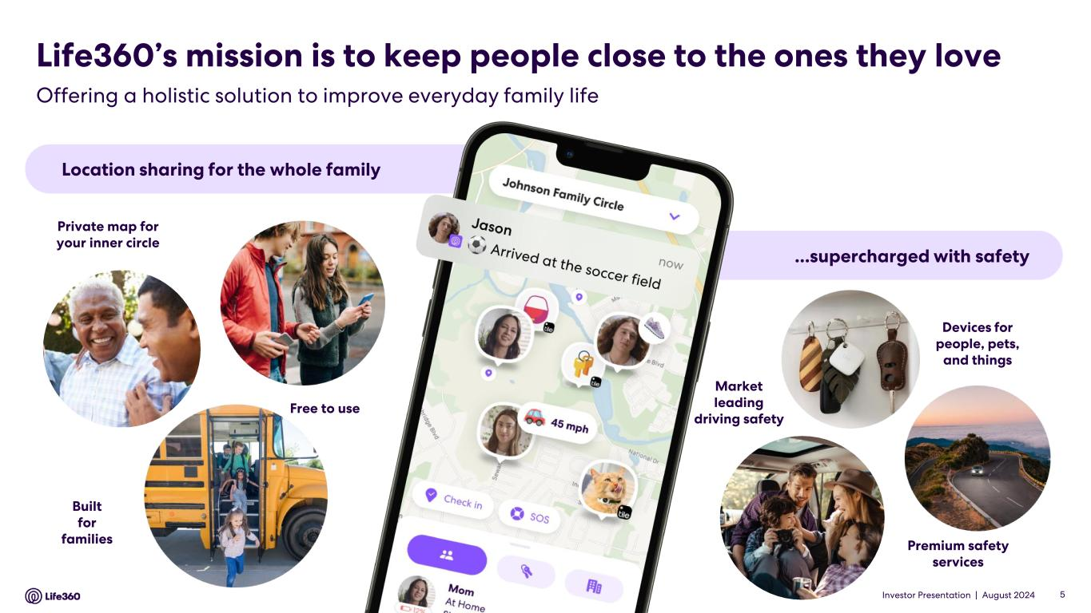
Investor Presentation | August 2024 Offering a holistic solution to improve everyday family life Location sharing for the whole family ...supercharged with safety Private map for your inner circle Free to use Built for families Devices for people, pets, and things Premium safety services Market leading driving safety Life360’s mission is to keep people close to the ones they love 5

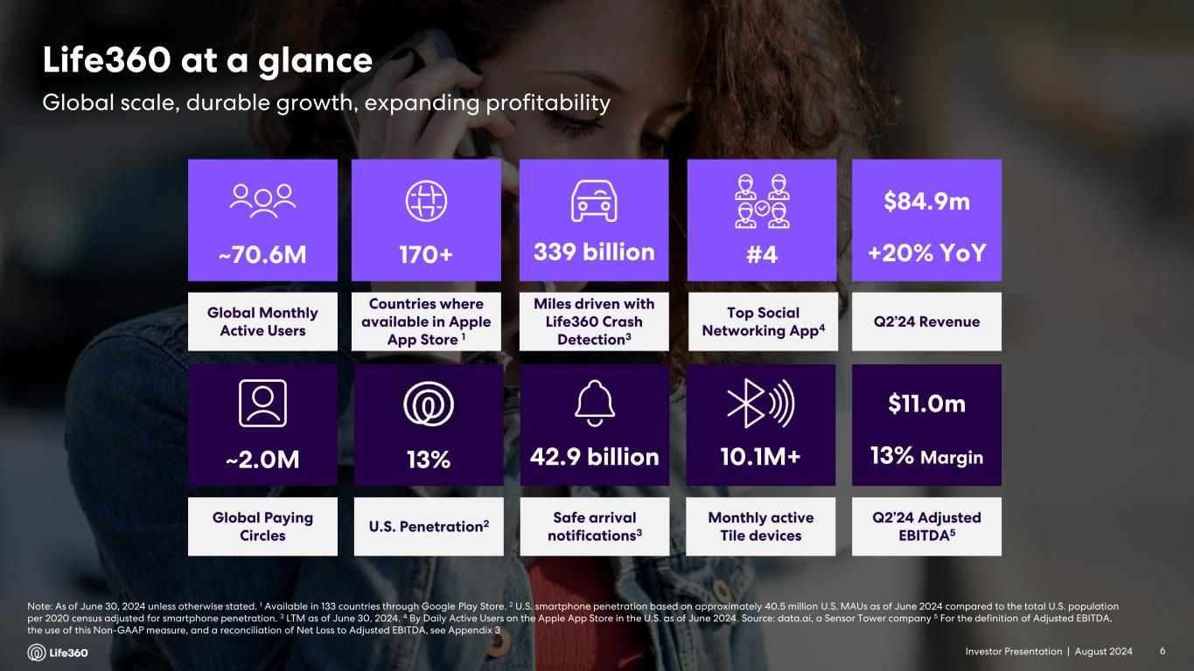
Investor Presentation | August 2024 Note: As of June 30, 2024 unless otherwise stated. 1 Available in 133 countries through Google Play Store. 2 U.S. smartphone penetration based on approximately 40.5 million U.S. MAUs as of June 2024 compared to the total U.S. population per 2020 census adjusted for smartphone penetration. 3 LTM as of June 30, 2024. 4 By Daily Active Users on the Apple App Store in the U.S. as of June 2024. Source: data.ai, a Sensor Tower company 5 For the definition of Adjusted EBITDA, the use of this Non-GAAP measure, and a reconciliation of Net Loss to Adjusted EBITDA, see Appendix 3 Global Paying Circles ~2.0M Safe arrival notifications3 42.9 billion U.S. Penetration2 13% 10.1M+ Monthly active Tile devices Global Monthly Active Users ~70.6M Miles driven with Life360 Crash Detection3 339 billion Countries where available in Apple App Store 1 170+ Top Social Networking App4 #4 Q2’24 Revenue $84.9m +20% YoY Q2’24 Adjusted EBITDA5 $11.0m 13% Margin Global scale, durable growth, expanding profitability Life360 at a glance 6

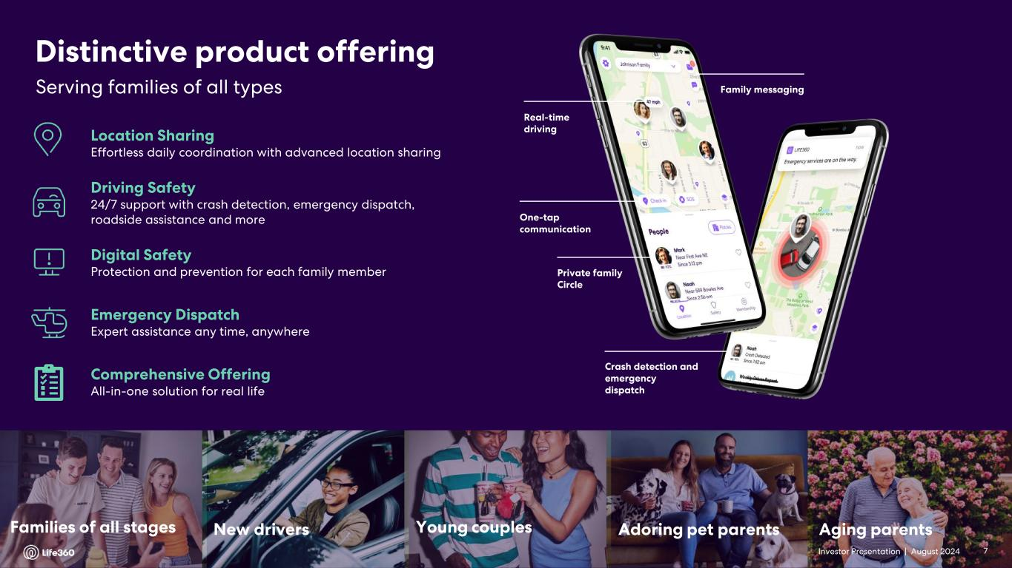
Investor Presentation | August 2024 7 Family messaging Real-time driving One-tap communication Private family Circle Crash detection and emergency dispatch Driving Safety 24/7 support with crash detection, emergency dispatch, roadside assistance and more Digital Safety Protection and prevention for each family member Location Sharing Effortless daily coordination with advanced location sharing Emergency Dispatch Expert assistance any time, anywhere Comprehensive Offering All-in-one solution for real life Young couplesNew driversFamilies of all stages Aging parentsAdoring pet parents Serving families of all types Distinctive product offering 7

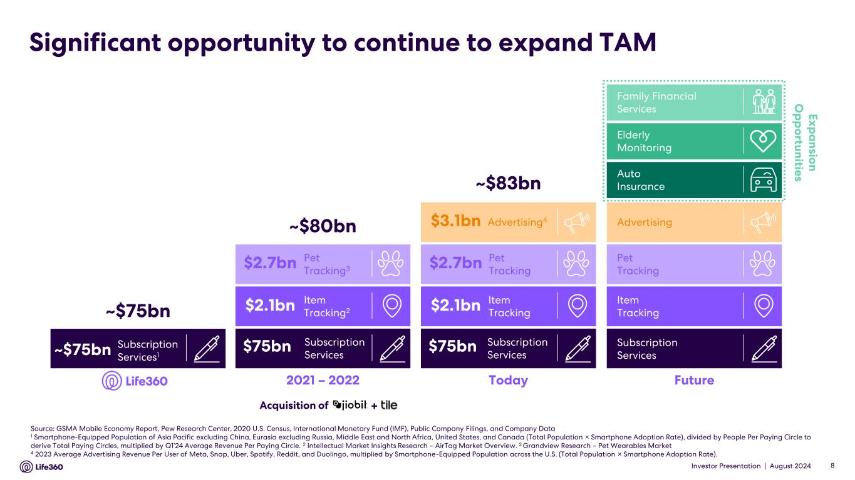
Investor Presentation | August 2024 Significant opportunity to continue to expand TAM Source: GSMA Mobile Economy Report, Pew Research Center, 2020 U.S. Census, International Monetary Fund (IMF), Public Company Filings, and Company Data 1 Smartphone-Equipped Population of Asia Pacific excluding China, Eurasia excluding Russia, Middle East and North Africa, United States, and Canada (Total Population × Smartphone Adoption Rate), divided by People Per Paying Circle to derive Total Paying Circles, multiplied by Q1’24 Average Revenue Per Paying Circle. 2 Intellectual Market Insights Research – AirTag Market Overview. 3 Grandview Research – Pet Wearables Market 4 2023 Average Advertising Revenue Per User of Meta, Snap, Uber, Spotify, Reddit, and Duolingo, multiplied by Smartphone-Equipped Population across the U.S. (Total Population × Smartphone Adoption Rate). 8 2021 – 2022 ~$80bn Item Tracking2 Pet Tracking3 Subscription Services $2.7bn $2.1bn $75bn Today ~$83bn Advertising4 Item Tracking Pet Tracking Subscription Services $2.7bn $2.1bn $75bn $3.1bn Future E x p a n sio n O p p o rtu n itie s Family Financial Services Auto Insurance Elderly Monitoring Advertising Item Tracking Pet Tracking Subscription Services Subscription Services1 ~$75bn ~$75bn Acquisition of +

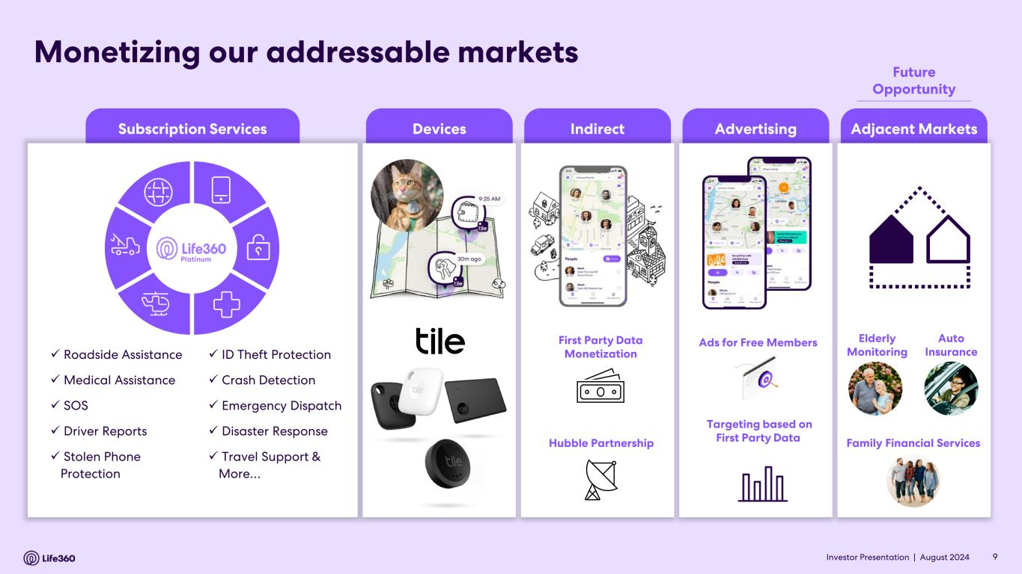
Investor Presentation | August 2024 Subscription Services IndirectDevices Advertising Adjacent Markets Monetizing our addressable markets ✓ Roadside Assistance ✓ Medical Assistance ✓ SOS ✓ Driver Reports ✓ Stolen Phone Protection ✓ ID Theft Protection ✓ Crash Detection ✓ Emergency Dispatch ✓ Disaster Response ✓ Travel Support & More… Platinum Ads for Free Members Targeting based on First Party Data Elderly Monitoring Family Financial Services Auto Insurance First Party Data Monetization Hubble Partnership 9 Future Opportunity

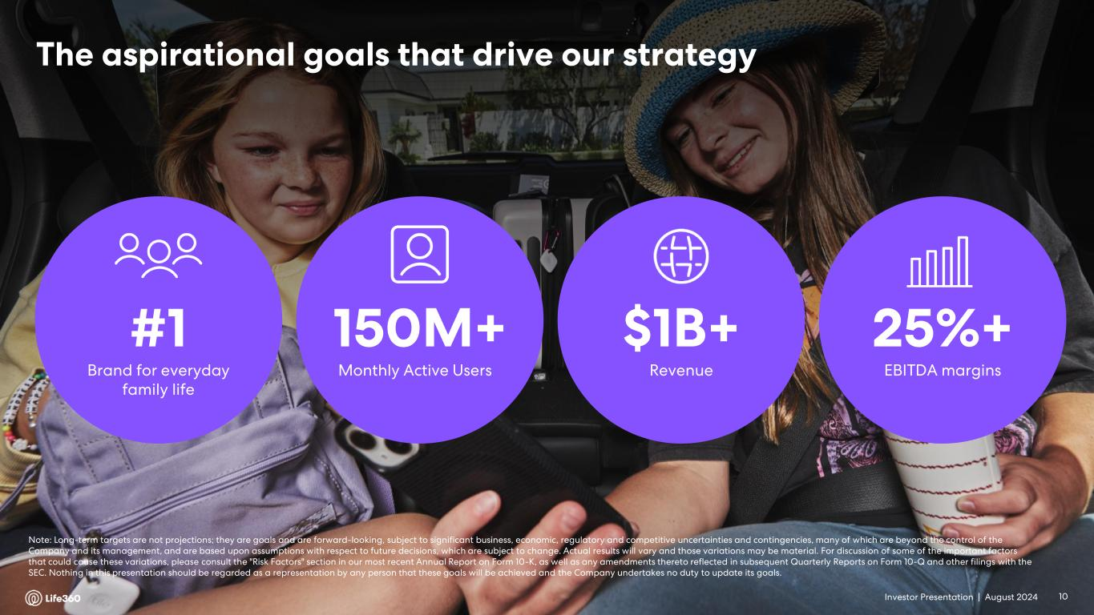
Investor Presentation | August 2024 The aspirational goals that drive our strategy #1 Brand for everyday family life 150M+ Monthly Active Users $1B+ Revenue 25%+ EBITDA margins Note: Long-term targets are not projections; they are goals and are forward-looking, subject to significant business, economic, regulatory and competitive uncertainties and contingencies, many of which are beyond the control of the Company and its management, and are based upon assumptions with respect to future decisions, which are subject to change. Actual results will vary and those variations may be material. For discussion of some of the important factors that could cause these variations, please consult the "Risk Factors" section in our most recent Annual Report on Form 10-K, as well as any amendments thereto reflected in subsequent Quarterly Reports on Form 10-Q and other filings with the SEC. Nothing in this presentation should be regarded as a representation by any person that these goals will be achieved and the Company undertakes no duty to update its goals. 10

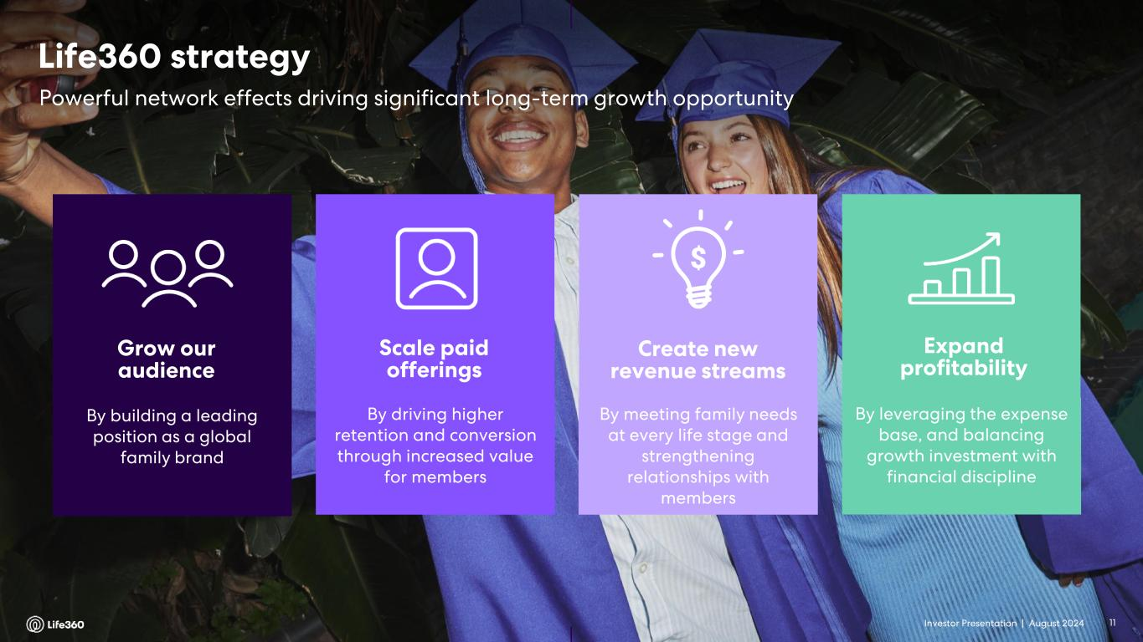
Investor Presentation | August 2024 Grow our audience By building a leading position as a global family brand Scale paid offerings By driving higher retention and conversion through increased value for members Create new revenue streams By meeting family needs at every life stage and strengthening relationships with members Expand profitability By leveraging the expense base, and balancing growth investment with financial discipline Powerful network effects driving significant long-term growth opportunity Life360 strategy 11

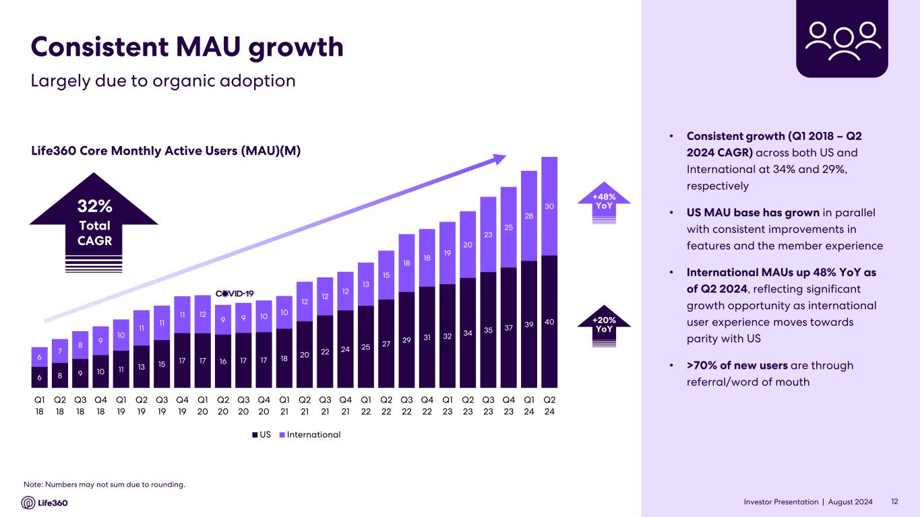
Investor Presentation | August 2024 Consistent MAU growth • Consistent growth (Q1 2018 – Q2 2024 CAGR) across both US and International at 34% and 29%, respectively • US MAU base has grown in parallel with consistent improvements in features and the member experience • International MAUs up 48% YoY as of Q2 2024, reflecting significant growth opportunity as international user experience moves towards parity with US • >70% of new users are through referral/word of mouth Life360 Core Monthly Active Users (MAU)(M) Note: Numbers may not sum due to rounding. 12 Largely due to organic adoption 32% Total CAGR 6 8 9 10 11 13 15 17 17 16 17 17 18 20 22 24 25 27 29 31 32 34 35 37 39 40 6 7 8 9 10 11 11 11 12 9 9 10 10 12 12 12 13 15 18 18 19 20 23 25 28 30 Q1 18 Q2 18 Q3 18 Q4 18 Q1 19 Q2 19 Q3 19 Q4 19 Q1 20 Q2 20 Q3 20 Q4 20 Q1 21 Q2 21 Q3 21 Q4 21 Q1 22 Q2 22 Q3 22 Q4 22 Q1 23 Q2 23 Q3 23 Q4 23 Q1 24 Q2 24 US International +48% YoY +20% YoY

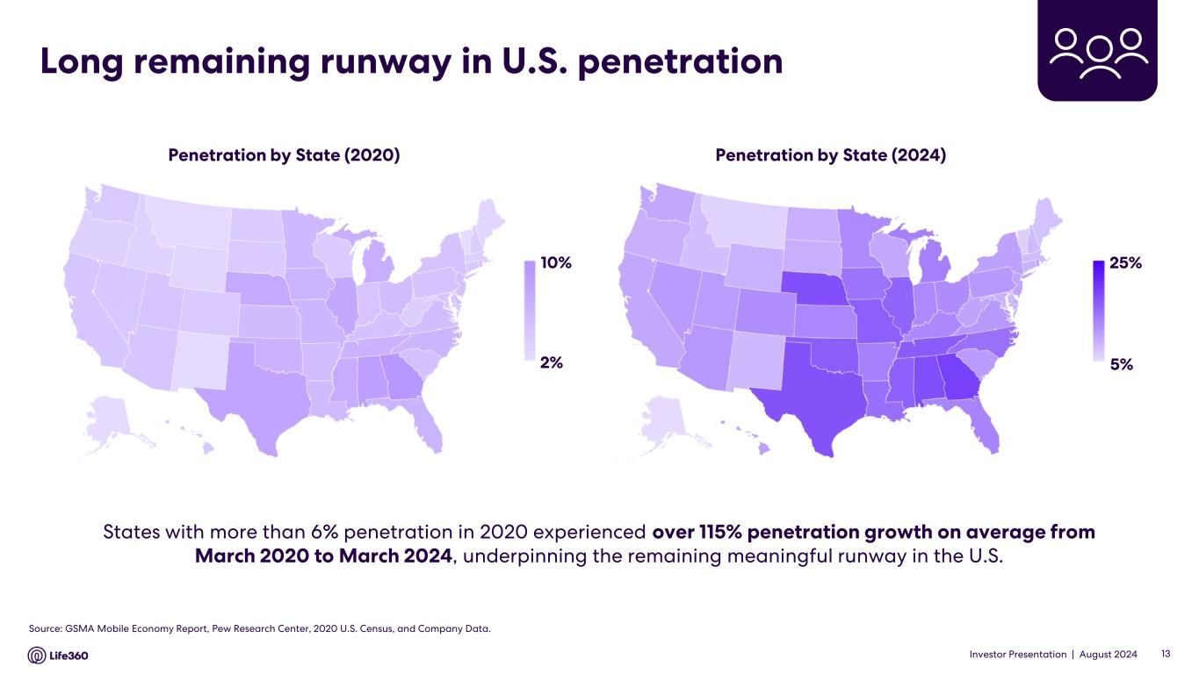
Investor Presentation | August 2024 Long remaining runway in U.S. penetration Penetration by State (2024)Penetration by State (2020) States with more than 6% penetration in 2020 experienced over 115% penetration growth on average from March 2020 to March 2024, underpinning the remaining meaningful runway in the U.S. 10% 2% 25% 5% Source: GSMA Mobile Economy Report, Pew Research Center, 2020 U.S. Census, and Company Data. 13

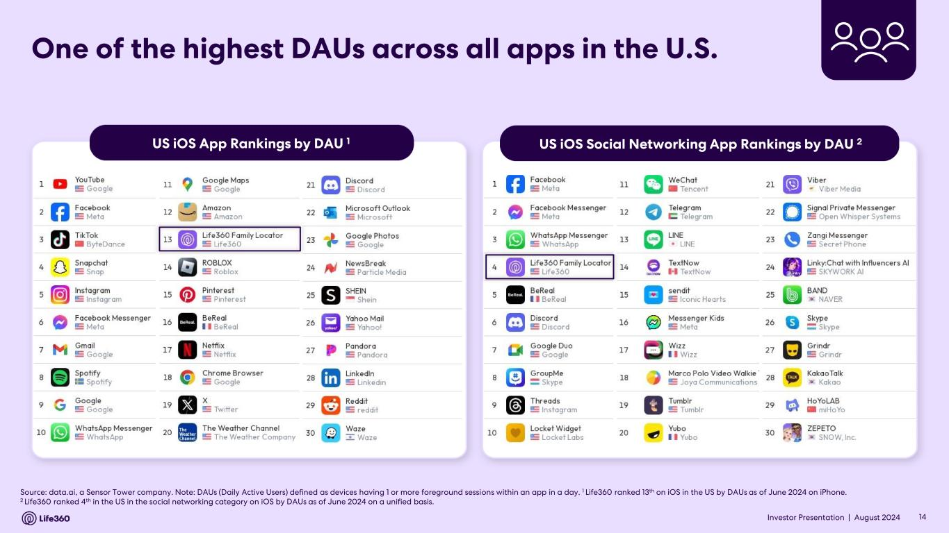
Investor Presentation | August 2024 US iOS App Rankings by DAU 1 US iOS Social Networking App Rankings by DAU 2 One of the highest DAUs across all apps in the U.S. Source: data.ai, a Sensor Tower company. Note: DAUs (Daily Active Users) defined as devices having 1 or more foreground sessions within an app in a day. 1 Life360 ranked 13th on iOS in the US by DAUs as of June 2024 on iPhone. 2 Life360 ranked 4th in the US in the social networking category on iOS by DAUs as of June 2024 on a unified basis. 14

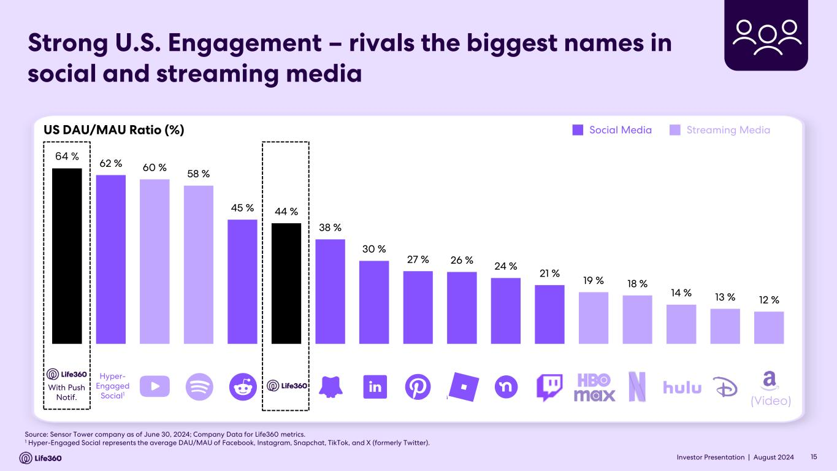
Investor Presentation | August 2024 Strong U.S. Engagement – rivals the biggest names in social and streaming media US DAU/MAU Ratio (%) Source: Sensor Tower company as of June 30, 2024; Company Data for Life360 metrics. 1 Hyper-Engaged Social represents the average DAU/MAU of Facebook, Instagram, Snapchat, TikTok, and X (formerly Twitter). (Video) Social Media Streaming Media Hyper- Engaged Social1 With Push Notif. 64 % 62 % 60 % 58 % 45 % 44 % 38 % 30 % 27 % 26 % 24 % 21 % 19 % 18 % 14 % 13 % 12 % 15

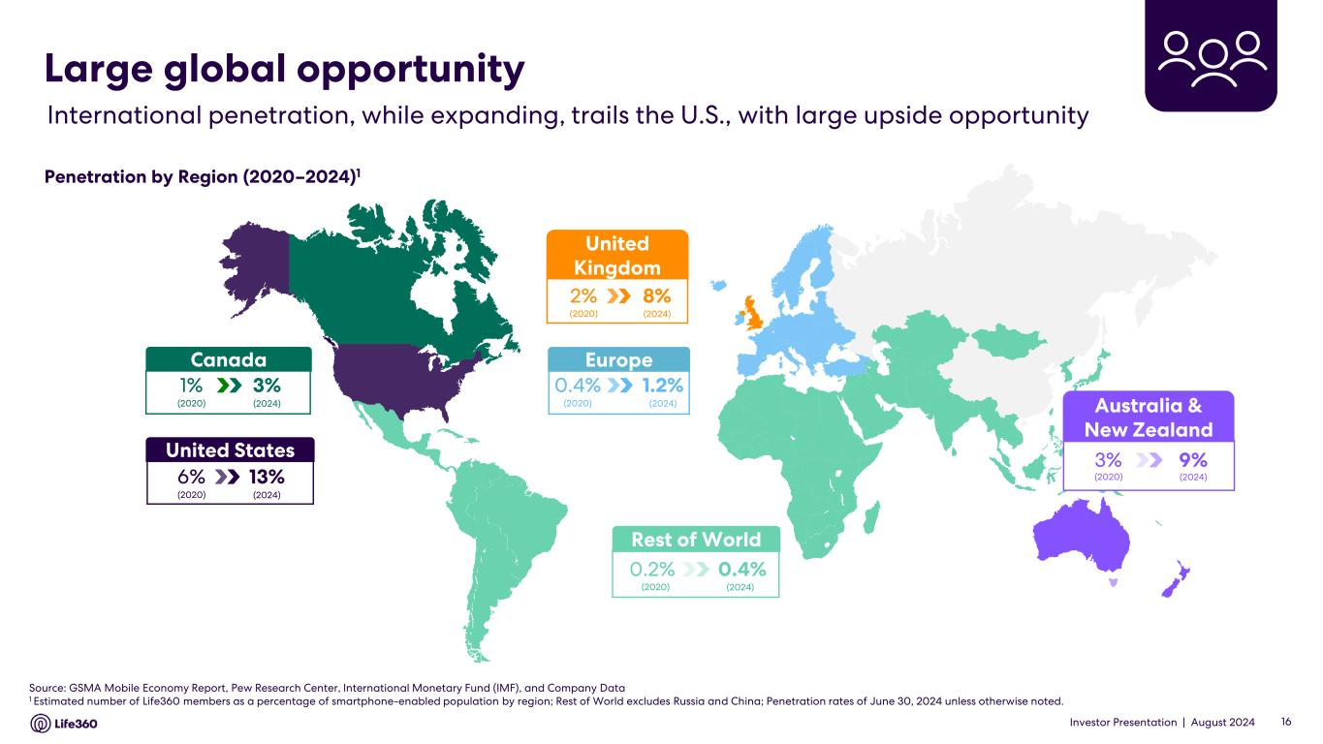
Investor Presentation | August 2024 Source: GSMA Mobile Economy Report, Pew Research Center, International Monetary Fund (IMF), and Company Data 1 Estimated number of Life360 members as a percentage of smartphone-enabled population by region; Rest of World excludes Russia and China; Penetration rates of June 30, 2024 unless otherwise noted. Canada 3%1% (2020) (2024) United States 13%6% (2020) (2024) United Kingdom 8%2% (2020) (2024) Rest of World 0.4%0.2% (2020) (2024) Europe 1.2%0.4% (2020) (2024) International penetration, while expanding, trails the U.S., with large upside opportunity Large global opportunity Penetration by Region (2020–2024)1 Australia & New Zealand 9%3% (2020) (2024) 16

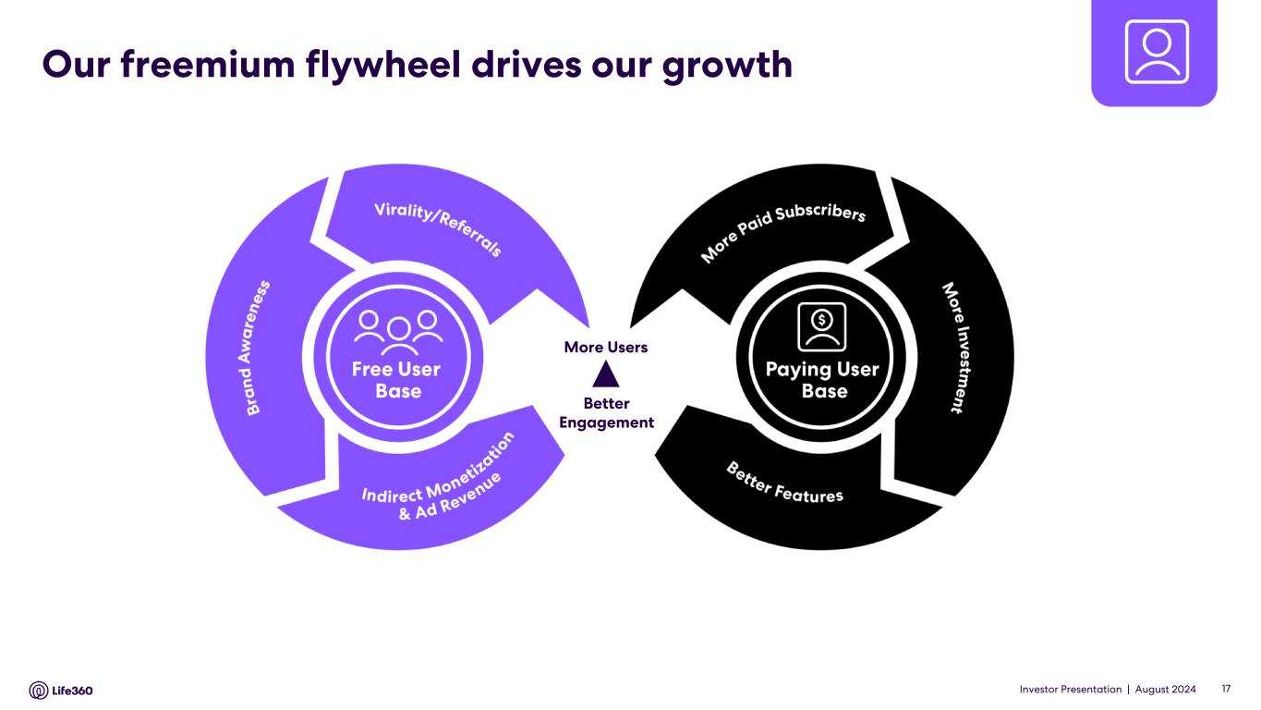
Investor Presentation | August 2024 Our freemium flywheel drives our growth Better Engagement More Users 17

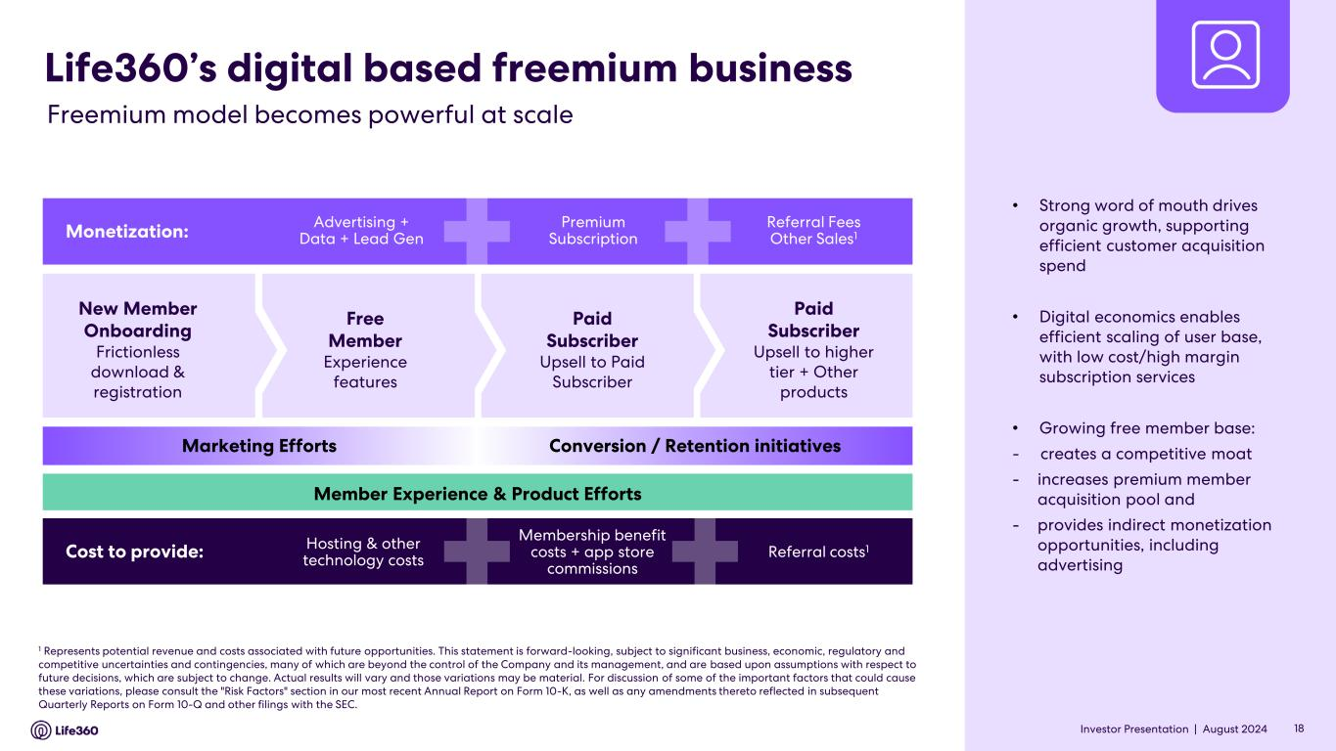
Investor Presentation | August 2024 New Member Onboarding Frictionless download & registration Free Member Experience features Paid Subscriber Upsell to Paid Subscriber Paid Subscriber Upsell to higher tier + Other products Life360’s digital based freemium business Monetization: Advertising + Data + Lead Gen Premium Subscription Referral Fees Other Sales1 Cost to provide: Hosting & other technology costs Membership benefit costs + app store commissions Referral costs1 Marketing Efforts Conversion / Retention initiatives Member Experience & Product Efforts 1 Represents potential revenue and costs associated with future opportunities. This statement is forward-looking, subject to significant business, economic, regulatory and competitive uncertainties and contingencies, many of which are beyond the control of the Company and its management, and are based upon assumptions with respect to future decisions, which are subject to change. Actual results will vary and those variations may be material. For discussion of some of the important factors that could cause these variations, please consult the "Risk Factors" section in our most recent Annual Report on Form 10-K, as well as any amendments thereto reflected in subsequent Quarterly Reports on Form 10-Q and other filings with the SEC. 18 Freemium model becomes powerful at scale • Strong word of mouth drives organic growth, supporting efficient customer acquisition spend • Digital economics enables efficient scaling of user base, with low cost/high margin subscription services • Growing free member base: - creates a competitive moat - increases premium member acquisition pool and - provides indirect monetization opportunities, including advertising

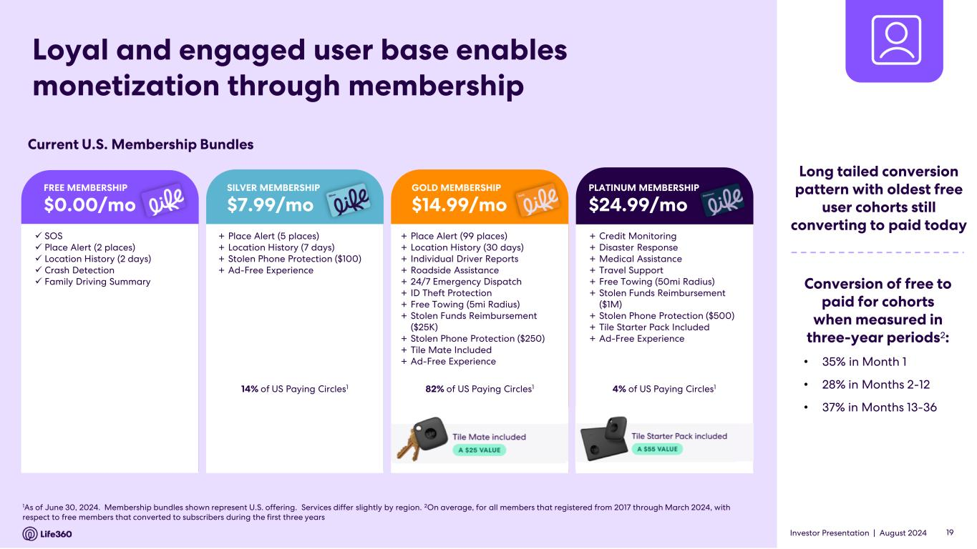
Investor Presentation | August 2024 1As of June 30, 2024. Membership bundles shown represent U.S. offering. Services differ slightly by region. 2On average, for all members that registered from 2017 through March 2024, with respect to free members that converted to subscribers during the first three years ✓ SOS ✓ Place Alert (2 places) ✓ Location History (2 days) ✓ Crash Detection ✓ Family Driving Summary + Place Alert (5 places) + Location History (7 days) + Stolen Phone Protection ($100) + Ad-Free Experience + Place Alert (99 places) + Location History (30 days) + Individual Driver Reports + Roadside Assistance + 24/7 Emergency Dispatch + ID Theft Protection + Free Towing (5mi Radius) + Stolen Funds Reimbursement ($25K) + Stolen Phone Protection ($250) + Tile Mate Included + Ad-Free Experience + Credit Monitoring + Disaster Response + Medical Assistance + Travel Support + Free Towing (50mi Radius) + Stolen Funds Reimbursement ($1M) + Stolen Phone Protection ($500) + Tile Starter Pack Included + Ad-Free Experience 14% of US Paying Circles1 4% of US Paying Circles182% of US Paying Circles1 Loyal and engaged user base enables monetization through membership Current U.S. Membership Bundles Conversion of free to paid for cohorts when measured in three-year periods2: • 35% in Month 1 • 28% in Months 2-12 • 37% in Months 13-36 FREE MEMBERSHIP $0.00/mo SILVER MEMBERSHIP $7.99/mo GOLD MEMBERSHIP $14.99/mo PLATINUM MEMBERSHIP $24.99/mo 19 Long tailed conversion pattern with oldest free user cohorts still converting to paid today

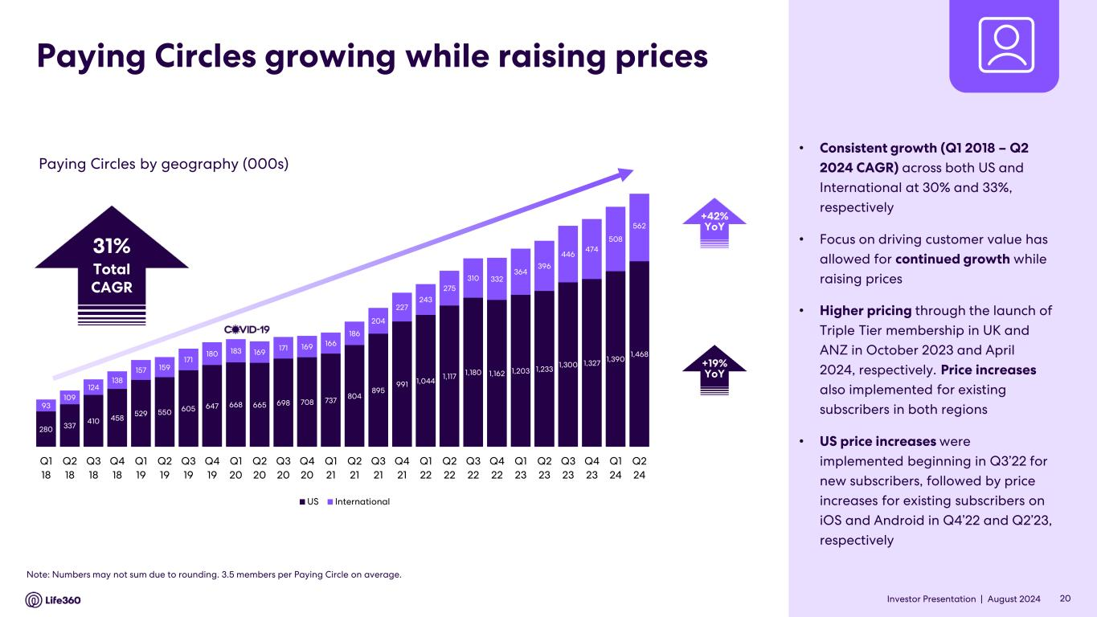
Investor Presentation | August 2024 Paying Circles growing while raising prices Paying Circles by geography (000s) • Consistent growth (Q1 2018 – Q2 2024 CAGR) across both US and International at 30% and 33%, respectively • Focus on driving customer value has allowed for continued growth while raising prices • Higher pricing through the launch of Triple Tier membership in UK and ANZ in October 2023 and April 2024, respectively. Price increases also implemented for existing subscribers in both regions • US price increases were implemented beginning in Q3’22 for new subscribers, followed by price increases for existing subscribers on iOS and Android in Q4’22 and Q2’23, respectively Note: Numbers may not sum due to rounding. 3.5 members per Paying Circle on average. 20 +42% YoY +19% YoY 280 337 410 458 529 550 605 647 668 665 698 708 737 804 895 991 1,044 1,117 1,180 1,162 1,203 1,233 1,300 1,327 1,390 1,468 93 109 124 138 157 159 171 180 183 169 171 169 166 186 204 227 243 275 310 332 364 396 446 474 508 562 Q1 18 Q2 18 Q3 18 Q4 18 Q1 19 Q2 19 Q3 19 Q4 19 Q1 20 Q2 20 Q3 20 Q4 20 Q1 21 Q2 21 Q3 21 Q4 21 Q1 22 Q2 22 Q3 22 Q4 22 Q1 23 Q2 23 Q3 23 Q4 23 Q1 24 Q2 24 US International 31% Total CAGR

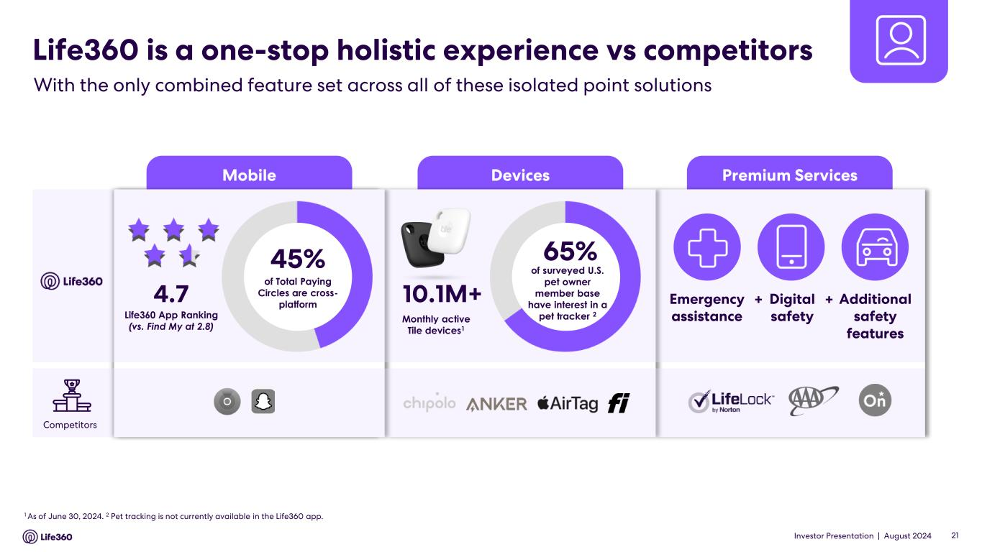
Investor Presentation | August 2024 Premium ServicesDevicesMobile Life360 is a one-stop holistic experience vs competitors With the only combined feature set across all of these isolated point solutions 1 As of June 30, 2024. 2 Pet tracking is not currently available in the Life360 app. 10.1M+ 65% of surveyed U.S. pet owner member base have interest in a pet tracker 2 Monthly active Tile devices1 Emergency assistance Digital safety Additional safety features + +4.7 Life360 App Ranking (vs. Find My at 2.8) Competitors 21 45% of Total Paying Circles are cross- platform

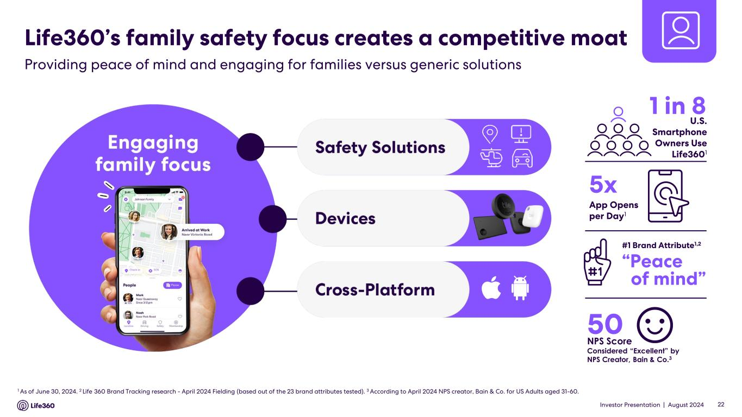
Investor Presentation | August 2024 22 Life360’s family safety focus creates a competitive moat Providing peace of mind and engaging for families versus generic solutions 50 NPS Score Considered “Excellent” by NPS Creator, Bain & Co.3 #1 Brand Attribute1,2 4.6 4.7 “Peace of mind” 1 As of June 30, 2024. 2 Life 360 Brand Tracking research - April 2024 Fielding (based out of the 23 brand attributes tested). 3 According to April 2024 NPS creator, Bain & Co. for US Adults aged 31-60. 1 in 8 5x App Opens per Day1 U.S. Smartphone Owners Use Life3601

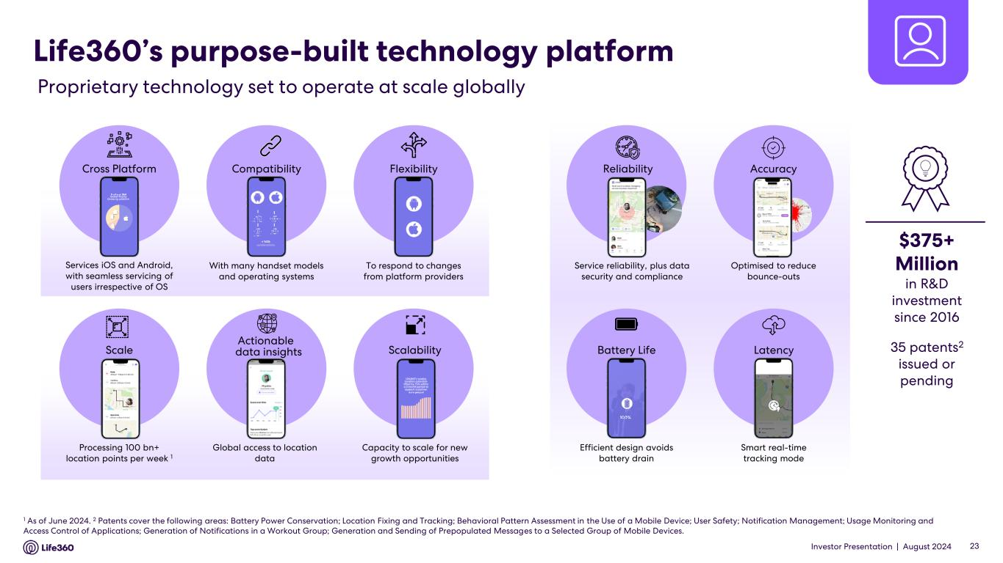
Investor Presentation | August 2024 Life360’s purpose-built technology platform Proprietary technology set to operate at scale globally 1 As of June 2024. 2 Patents cover the following areas: Battery Power Conservation; Location Fixing and Tracking; Behavioral Pattern Assessment in the Use of a Mobile Device; User Safety; Notification Management; Usage Monitoring and Access Control of Applications; Generation of Notifications in a Workout Group; Generation and Sending of Prepopulated Messages to a Selected Group of Mobile Devices. 23 $375+ Million in R&D investment since 2016 35 patents2 issued or pending Processing 100 bn+ location points per week 1 Scale Services iOS and Android, with seamless servicing of users irrespective of OS Cross Platform Global access to location data Actionable data insights With many handset models and operating systems Compatibility Capacity to scale for new growth opportunities Scalability To respond to changes from platform providers Flexibility Smart real-time tracking mode Latency Optimised to reduce bounce-outs Accuracy Service reliability, plus data security and compliance Reliability Efficient design avoids battery drain Battery Life

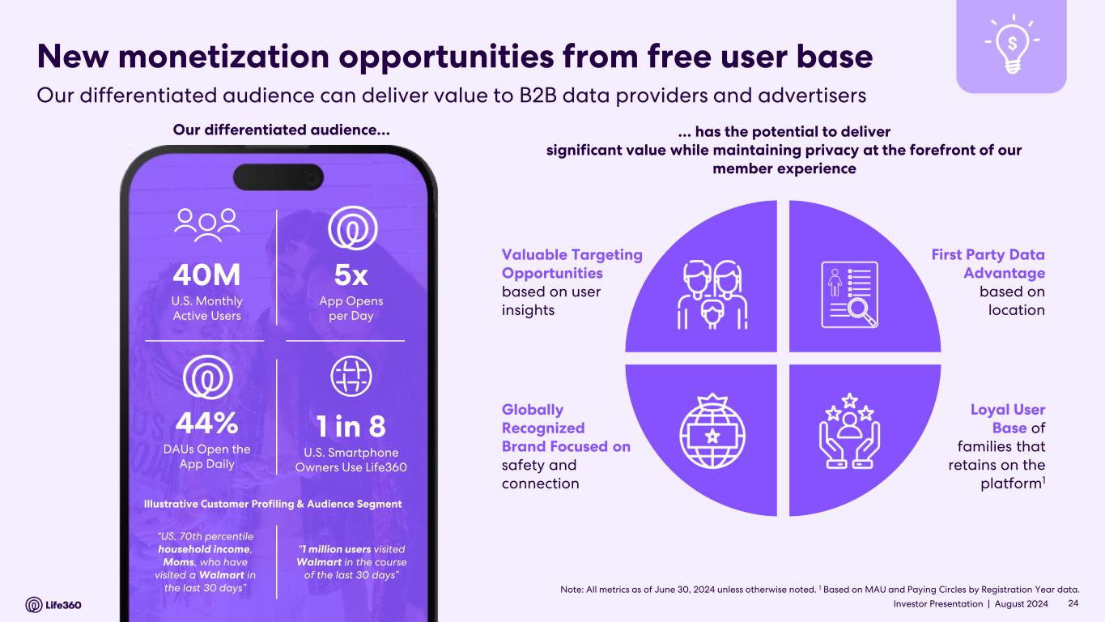
Investor Presentation | August 2024 New monetization opportunities from free user base Loyal User Base of families that retains on the platform1 Globally Recognized Brand Focused on safety and connection First Party Data Advantage based on location Valuable Targeting Opportunities based on user insights … has the potential to deliver significant value while maintaining privacy at the forefront of our member experience Note: All metrics as of June 30, 2024 unless otherwise noted. 1 Based on MAU and Paying Circles by Registration Year data. 40M U.S. Monthly Active Users 1 in 8 U.S. Smartphone Owners Use Life360 5x App Opens per Day 44% DAUs Open the App Daily “US, 70th percentile household income, Moms, who have visited a Walmart in the last 30 days” Illustrative Customer Profiling & Audience Segment “1 million users visited Walmart in the course of the last 30 days” Our differentiated audience… 24 Our differentiated audience can deliver value to B2B data providers and advertisers

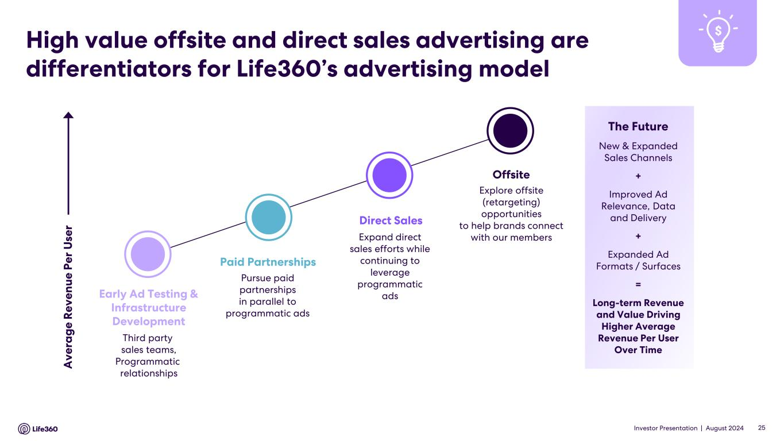
Investor Presentation | August 2024 High value offsite and direct sales advertising are differentiators for Life360’s advertising model A v e ra g e R e v e n u e P e r U se r The Future New & Expanded Sales Channels + Improved Ad Relevance, Data and Delivery + Expanded Ad Formats / Surfaces = Long-term Revenue and Value Driving Higher Average Revenue Per User Over Time Third party sales teams, Programmatic relationships Early Ad Testing & Infrastructure Development Paid Partnerships Pursue paid partnerships in parallel to programmatic ads Direct Sales Expand direct sales efforts while continuing to leverage programmatic ads Offsite Explore offsite (retargeting) opportunities to help brands connect with our members 25

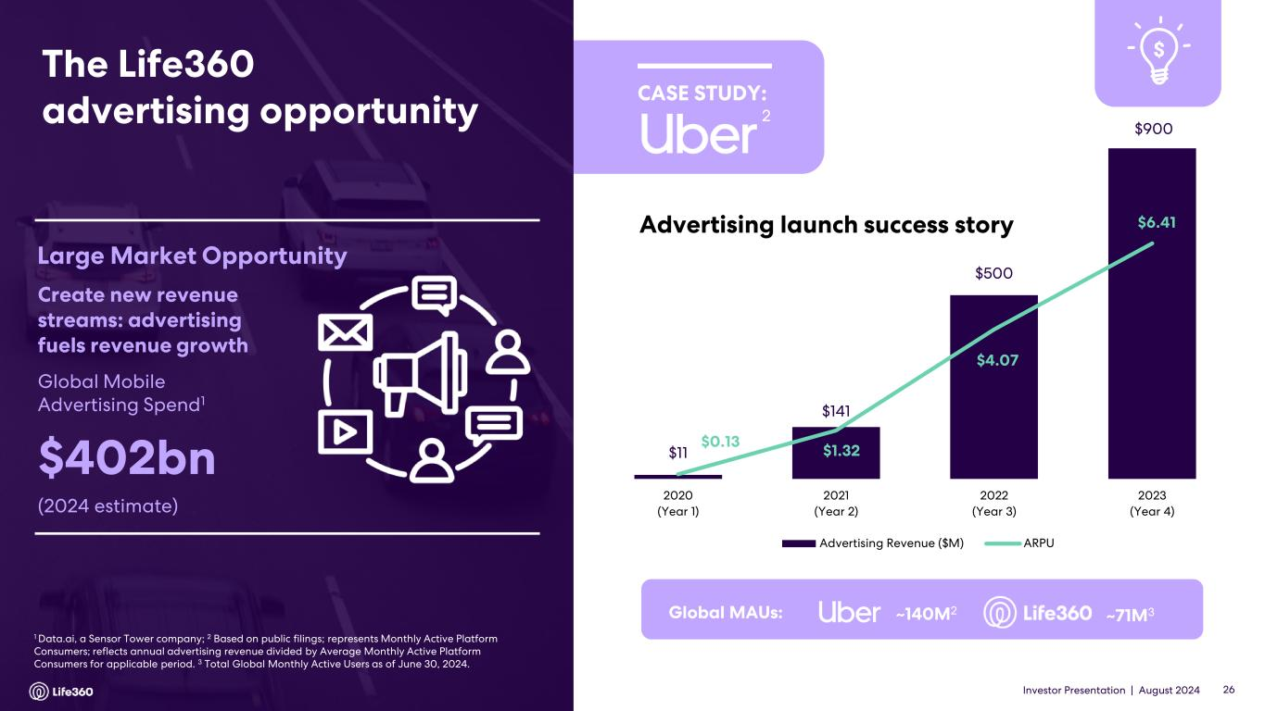
Investor Presentation | August 2024 1 Data.ai, a Sensor Tower company; 2 Based on public filings; represents Monthly Active Platform Consumers; reflects annual advertising revenue divided by Average Monthly Active Platform Consumers for applicable period. 3 Total Global Monthly Active Users as of June 30, 2024. Global Mobile Advertising Spend1 $402bn (2024 estimate) Large Market Opportunity Create new revenue streams: advertising fuels revenue growth $11 $141 $500 $900 $0.13 $1.32 $4.07 $6.41 2020 (Year 1) 2021 (Year 2) 2022 (Year 3) 2023 (Year 4) Advertising Revenue ($M) ARPU Global MAUs: ~140M2 ~71M3 2 The Life360 advertising opportunity 26 Advertising launch success story CASE STUDY:

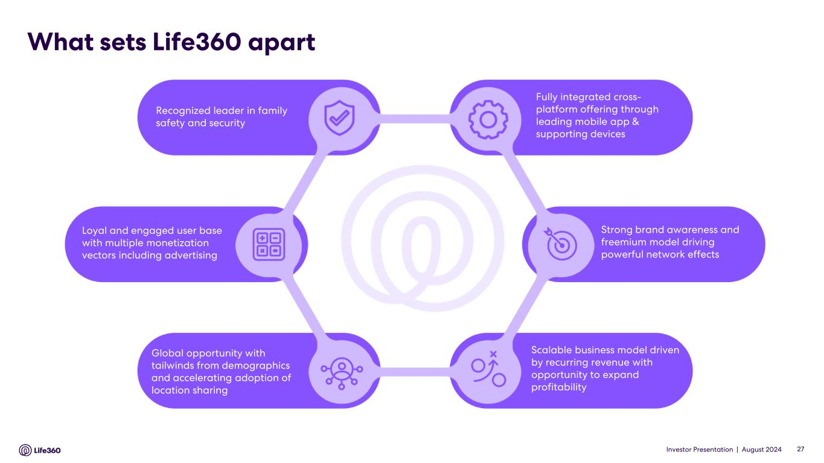
Investor Presentation | August 2024 Recognized leader in family safety and security Fully integrated cross- platform offering through leading mobile app & supporting devices Loyal and engaged user base with multiple monetization vectors including advertising Global opportunity with tailwinds from demographics and accelerating adoption of location sharing Scalable business model driven by recurring revenue with opportunity to expand profitability Strong brand awareness and freemium model driving powerful network effects What sets Life360 apart 27

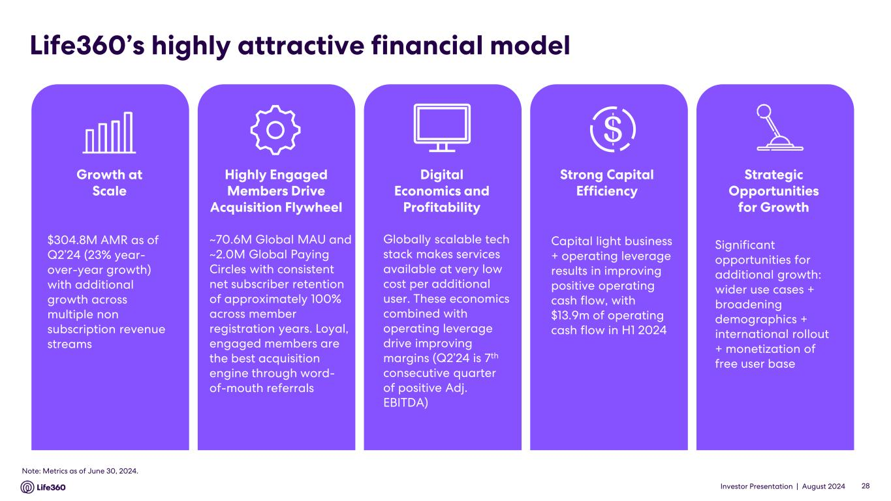
Investor Presentation | August 2024 Life360’s highly attractive financial model $304.8M AMR as of Q2’24 (23% year- over-year growth) with additional growth across multiple non subscription revenue streams Growth at Scale Capital light business + operating leverage results in improving positive operating cash flow, with $13.9m of operating cash flow in H1 2024 Strong Capital Efficiency Significant opportunities for additional growth: wider use cases + broadening demographics + international rollout + monetization of free user base Strategic Opportunities for Growth ~70.6M Global MAU and ~2.0M Global Paying Circles with consistent net subscriber retention of approximately 100% across member registration years. Loyal, engaged members are the best acquisition engine through word- of-mouth referrals Highly Engaged Members Drive Acquisition Flywheel Globally scalable tech stack makes services available at very low cost per additional user. These economics combined with operating leverage drive improving margins (Q2’24 is 7th consecutive quarter of positive Adj. EBITDA) Digital Economics and Profitability Note: Metrics as of June 30, 2024. 28


Investor Presentation | August 2024 Financial Update Q2’24 02 29

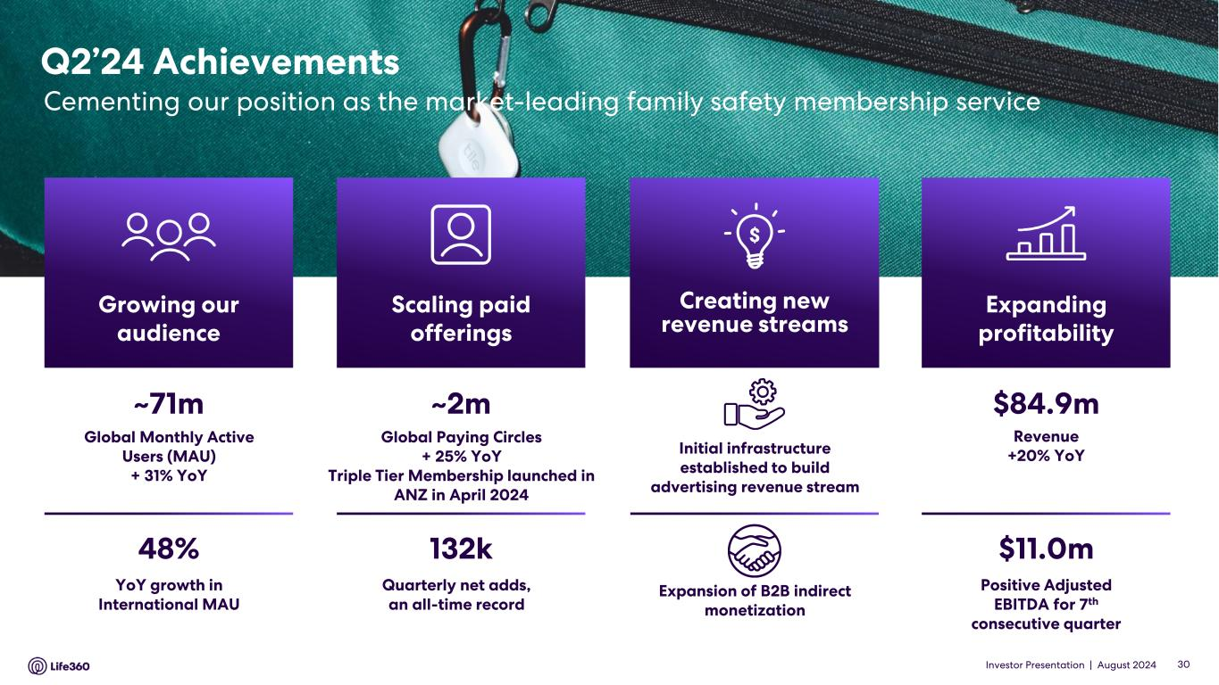
Investor Presentation | August 2024 Q2’24 Achievements Cementing our position as the market-leading family safety membership service $84.9m Revenue +20% YoY $11.0m Positive Adjusted EBITDA for 7th consecutive quarter Expanding profitability ~2m Global Paying Circles + 25% YoY Triple Tier Membership launched in ANZ in April 2024 132k Quarterly net adds, an all-time record Scaling paid offerings ~71m Global Monthly Active Users (MAU) + 31% YoY 48% YoY growth in International MAU Growing our audience Expansion of B2B indirect monetization Initial infrastructure established to build advertising revenue stream Creating new revenue streams 30

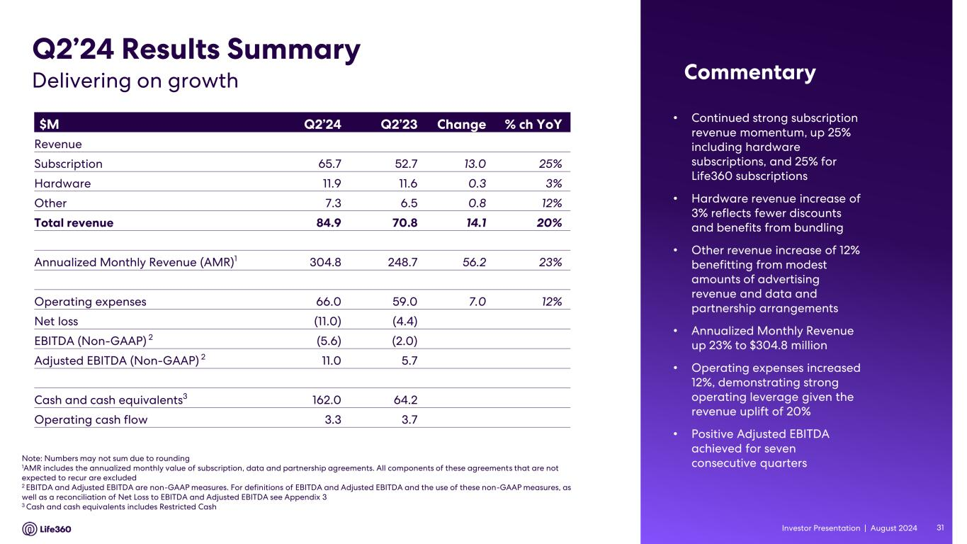
Investor Presentation | August 2024 • Continued strong subscription revenue momentum, up 25% including hardware subscriptions, and 25% for Life360 subscriptions • Hardware revenue increase of 3% reflects fewer discounts and benefits from bundling • Other revenue increase of 12% benefitting from modest amounts of advertising revenue and data and partnership arrangements • Annualized Monthly Revenue up 23% to $304.8 million • Operating expenses increased 12%, demonstrating strong operating leverage given the revenue uplift of 20% • Positive Adjusted EBITDA achieved for seven consecutive quarters $M Q2’24 Q2’23 Change % ch YoY Revenue Subscription 65.7 52.7 13.0 25% Hardware 11.9 11.6 0.3 3% Other 7.3 6.5 0.8 12% Total revenue 84.9 70.8 14.1 20% Annualized Monthly Revenue (AMR)1 304.8 248.7 56.2 23% Operating expenses 66.0 59.0 7.0 12% Net loss (11.0) (4.4) EBITDA (Non-GAAP) 2 (5.6) (2.0) Adjusted EBITDA (Non-GAAP) 2 11.0 5.7 Cash and cash equivalents3 162.0 64.2 Operating cash flow 3.3 3.7 Note: Numbers may not sum due to rounding 1AMR includes the annualized monthly value of subscription, data and partnership agreements. All components of these agreements that are not expected to recur are excluded 2 EBITDA and Adjusted EBITDA are non-GAAP measures. For definitions of EBITDA and Adjusted EBITDA and the use of these non-GAAP measures, as well as a reconciliation of Net Loss to EBITDA and Adjusted EBITDA see Appendix 3 3 Cash and cash equivalents includes Restricted Cash Q2’24 Results Summary CommentaryDelivering on growth 31

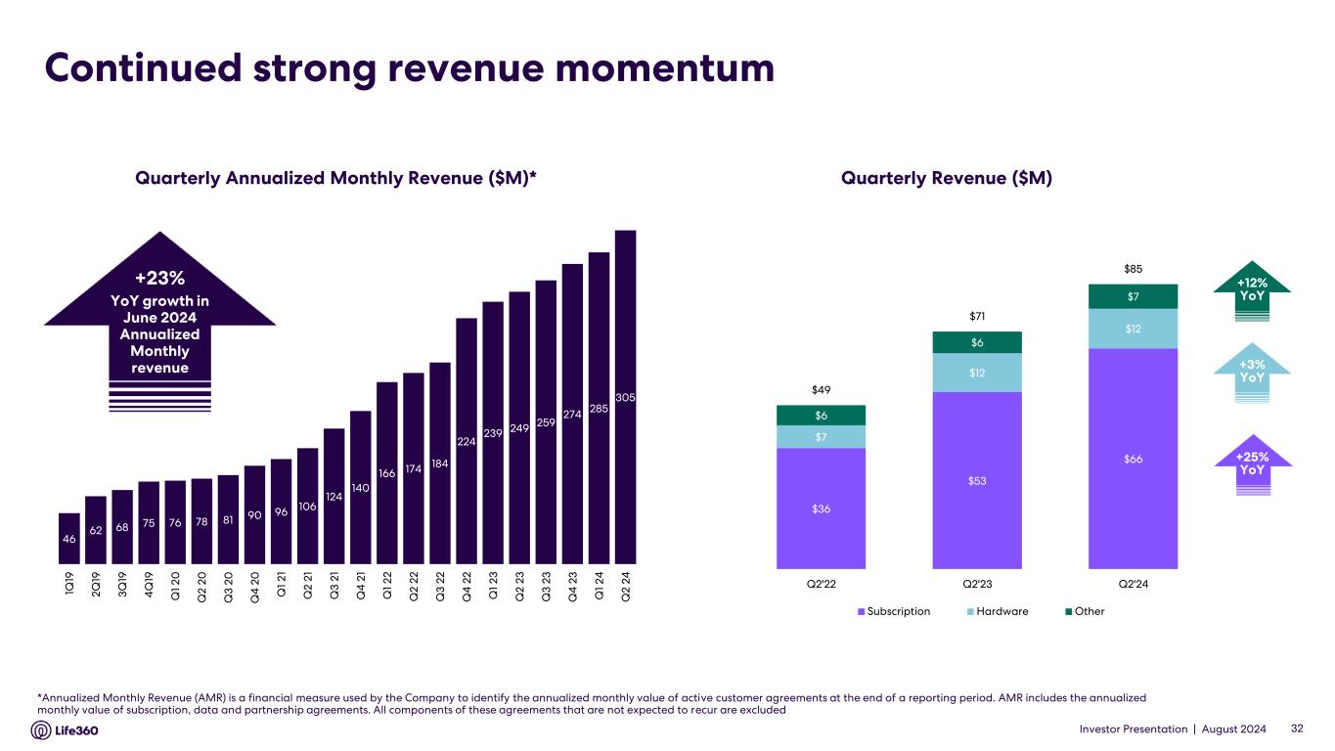
Investor Presentation | August 2024 Continued strong revenue momentum *Annualized Monthly Revenue (AMR) is a financial measure used by the Company to identify the annualized monthly value of active customer agreements at the end of a reporting period. AMR includes the annualized monthly value of subscription, data and partnership agreements. All components of these agreements that are not expected to recur are excluded Quarterly Annualized Monthly Revenue ($M)* Quarterly Revenue ($M) +12% YoY +3% YoY +25% YoY +23% YoY growth in June 2024 Annualized Monthly revenue 32 46 62 68 75 76 78 81 90 96 106 124 140 166 174 184 224 239 249 259 274 285 305 1Q 19 2 Q 19 3 Q 19 4 Q 19 Q 1 2 0 Q 2 2 0 Q 3 2 0 Q 4 2 0 Q 1 2 1 Q 2 2 1 Q 3 2 1 Q 4 2 1 Q 1 2 2 Q 2 2 2 Q 3 2 2 Q 4 2 2 Q 1 2 3 Q 2 2 3 Q 3 2 3 Q 4 2 3 Q 1 2 4 Q 2 2 4 $36 $53 $66 $7 $12 $12 $6 $6 $7 $49 $71 $85 Q2'22 Q2'23 Q2'24 Subscription Hardware Other

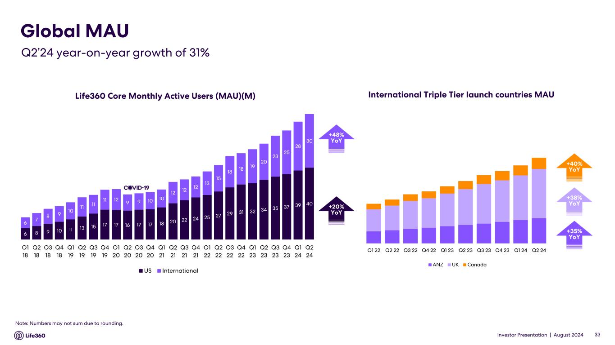
Investor Presentation | August 2024 Life360 Core Monthly Active Users (MAU)(M) Note: Numbers may not sum due to rounding. Global MAU Q2’24 year-on-year growth of 31% International Triple Tier launch countries MAU +38% YoY +40% YoY +35% YoY +48% YoY +20% YoY 33 6 8 9 10 11 13 15 17 17 16 17 17 18 20 22 24 25 27 29 31 32 34 35 37 39 40 6 7 8 9 10 11 11 11 12 9 9 10 10 12 12 12 13 15 18 18 19 20 23 25 28 30 Q1 18 Q2 18 Q3 18 Q4 18 Q1 19 Q2 19 Q3 19 Q4 19 Q1 20 Q2 20 Q3 20 Q4 20 Q1 21 Q2 21 Q3 21 Q4 21 Q1 22 Q2 22 Q3 22 Q4 22 Q1 23 Q2 23 Q3 23 Q4 23 Q1 24 Q2 24 US International Q1 22 Q2 22 Q3 22 Q4 22 Q1 23 Q2 23 Q3 23 Q4 23 Q1 24 Q2 24 ANZ UK Canada

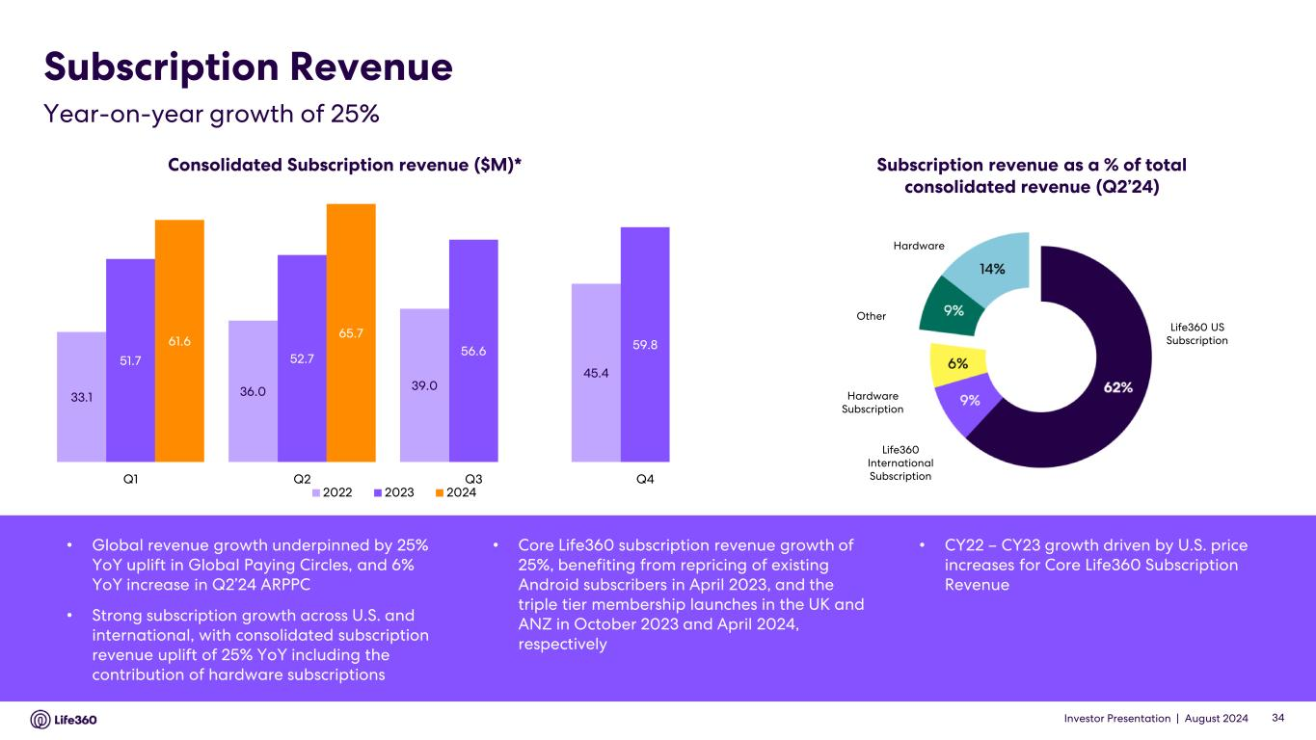
Investor Presentation | August 2024 Subscription Revenue Consolidated Subscription revenue ($M)* Subscription revenue as a % of total consolidated revenue (Q2’24) Hardware Life360 US Subscription Life360 International Subscription Hardware Subscription Other • Global revenue growth underpinned by 25% YoY uplift in Global Paying Circles, and 6% YoY increase in Q2’24 ARPPC • Strong subscription growth across U.S. and international, with consolidated subscription revenue uplift of 25% YoY including the contribution of hardware subscriptions • Core Life360 subscription revenue growth of 25%, benefiting from repricing of existing Android subscribers in April 2023, and the triple tier membership launches in the UK and ANZ in October 2023 and April 2024, respectively • CY22 – CY23 growth driven by U.S. price increases for Core Life360 Subscription Revenue Year-on-year growth of 25% 34 33.1 36.0 39.0 45.4 51.7 52.7 56.6 59.861.6 65.7 Q1 Q2 Q3 Q4 2022 2023 2024

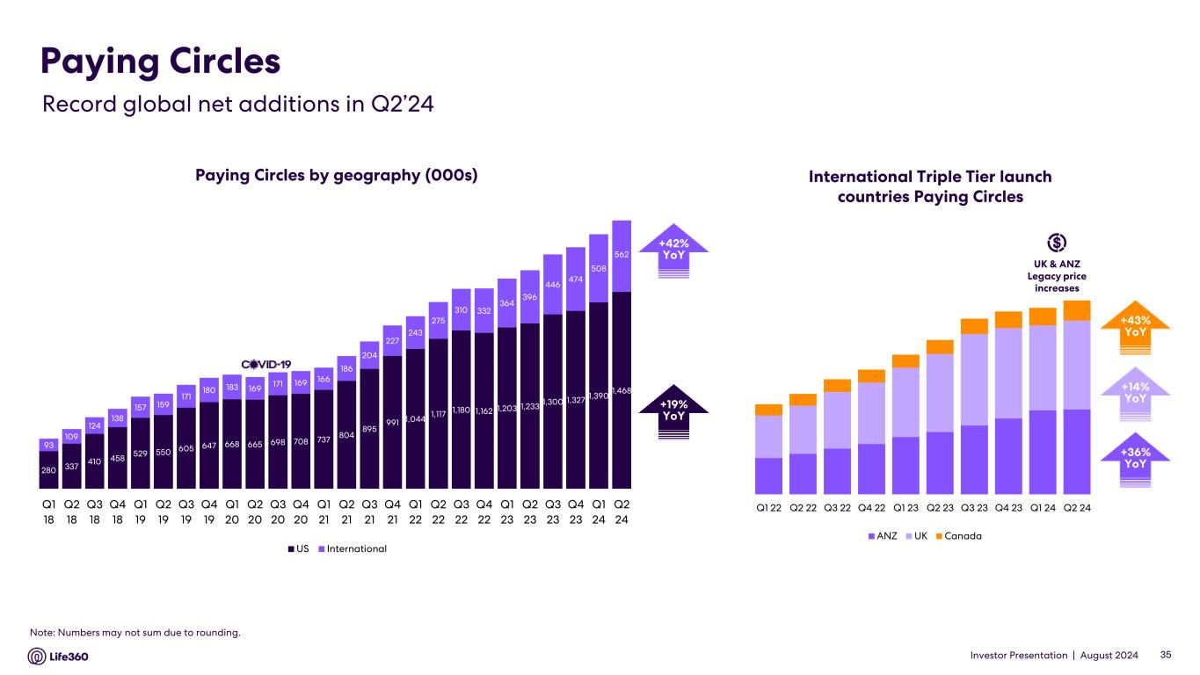
Investor Presentation | August 2024 Paying Circles by geography (000s) Paying Circles $140 $1398 +42% YoY$38 +42% YoYInternational Triple Tier launch countries Paying Circles Record global net additions in Q2’24 +14% YoY +43% YoY +36% YoY +42% YoY +19% YoY 35 280 337 410 458 529 550 605 647 668 665 698 708 737 804 895 991 1,044 1,117 1,180 1,162 1,203 1,233 1,300 1,327 1,390 1,468 93 109 124 138 157 159 171 180 183 169 171 169 166 186 204 227 243 275 310 332 364 396 446 474 508 562 Q1 18 Q2 18 Q3 18 Q4 18 Q1 19 Q2 19 Q3 19 Q4 19 Q1 20 Q2 20 Q3 20 Q4 20 Q1 21 Q2 21 Q3 21 Q4 21 Q1 22 Q2 22 Q3 22 Q4 22 Q1 23 Q2 23 Q3 23 Q4 23 Q1 24 Q2 24 US International Q1 22 Q2 22 Q3 22 Q4 22 Q1 23 Q2 23 Q3 23 Q4 23 Q1 24 Q2 24 ANZ UK Canada UK & ANZ Legacy price increases Note: Numbers may not sum due to rounding.

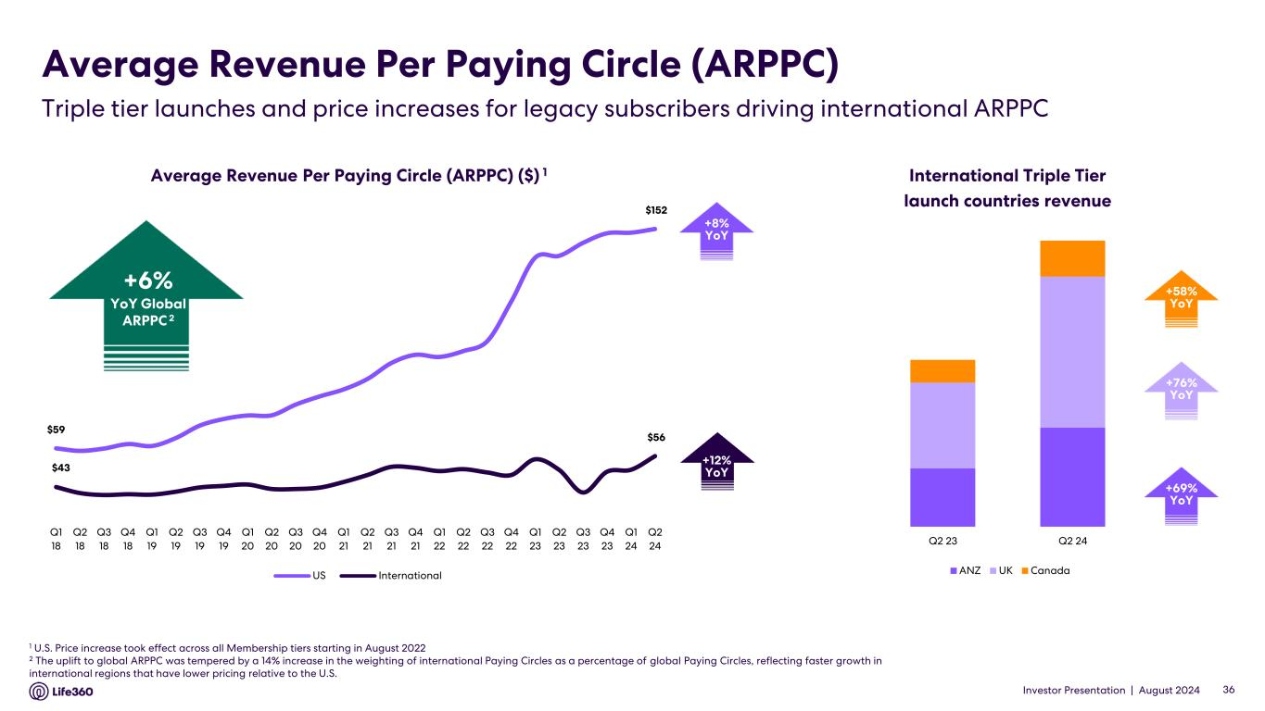
Investor Presentation | August 2024 $59 $152 $43 $56 Q1 18 Q2 18 Q3 18 Q4 18 Q1 19 Q2 19 Q3 19 Q4 19 Q1 20 Q2 20 Q3 20 Q4 20 Q1 21 Q2 21 Q3 21 Q4 21 Q1 22 Q2 22 Q3 22 Q4 22 Q1 23 Q2 23 Q3 23 Q4 23 Q1 24 Q2 24 US International Average Revenue Per Paying Circle (ARPPC) 1 U.S. Price increase took effect across all Membership tiers starting in August 2022 2 The uplift to global ARPPC was tempered by a 14% increase in the weighting of international Paying Circles as a percentage of global Paying Circles, reflecting faster growth in international regions that have lower pricing relative to the U.S. International Triple Tier launch countries revenue Triple tier launches and price increases for legacy subscribers driving international ARPPC Average Revenue Per Paying Circle (ARPPC) ($) 1 +12% YoY +76% YoY +58% YoY +69% YoY 36 Q2 23 Q2 24 ANZ UK Canada +6% YoY Global ARPPC 2 +8% YoY

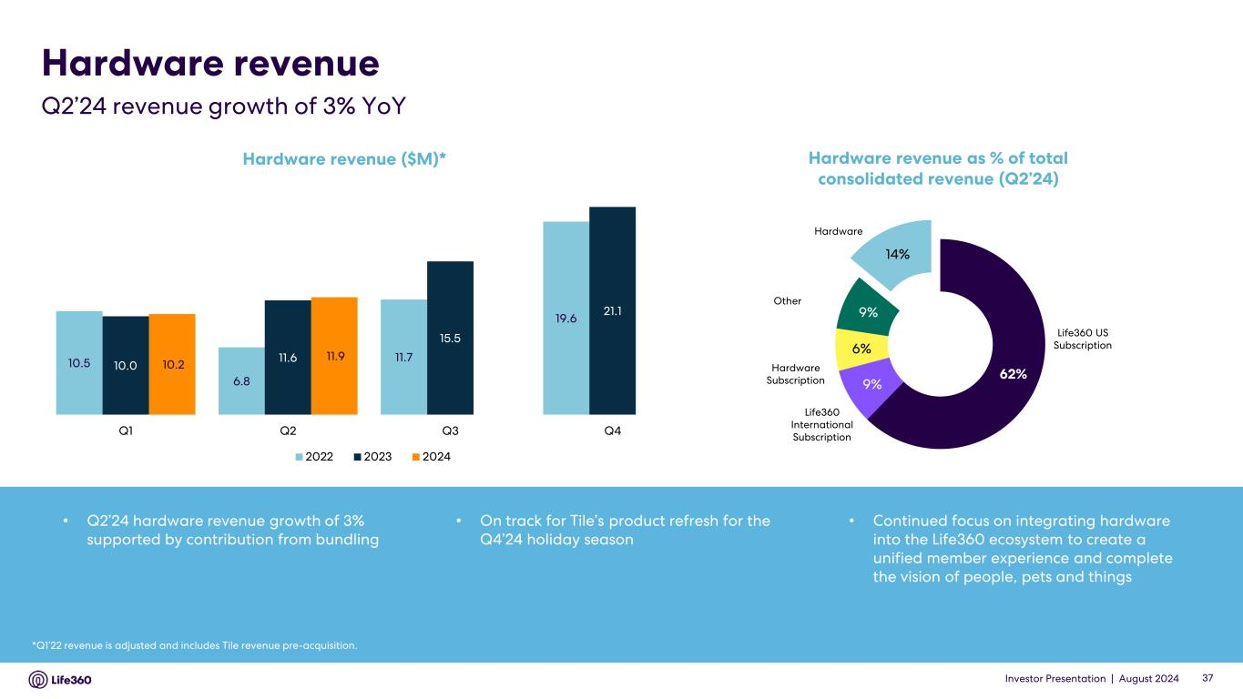
Investor Presentation | August 2024 Hardware revenue Hardware Life360 US Subscription Life360 International Subscription Hardware Subscription Other Q2’24 revenue growth of 3% YoY *Q1’22 revenue is adjusted and includes Tile revenue pre-acquisition. Hardware revenue ($M)* Hardware revenue as % of total consolidated revenue (Q2’24) 37 10.5 6.8 11.7 19.6 10.0 11.6 15.5 21.1 10.2 11.9 Q1 Q2 Q3 Q4 2022 2023 2024 62% 9% 6% 9% 14% *Includes non-recurring adjustment of approximately $0.9 million in relation to deferral • Q2’24 hardware revenue growth of 3% supported by contribution from bundling • On track for Tile’s product refresh for the Q4’24 holiday season • Continued focus on integrating hardware into the Life360 ecosystem to create a unified member experience and complete the vision of people, pets and things

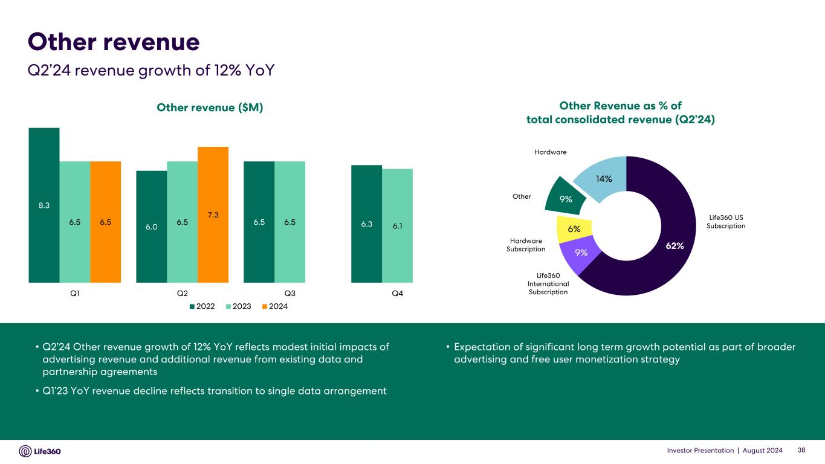
Investor Presentation | August 2024 • Q2’24 Other revenue growth of 12% YoY reflects modest initial impacts of advertising revenue and additional revenue from existing data and partnership agreements • Q1’23 YoY revenue decline reflects transition to single data arrangement • Expectation of significant long term growth potential as part of broader advertising and free user monetization strategy Other revenue ($M) Other Revenue as % of total consolidated revenue (Q2’24) Hardware Life360 US Subscription Life360 International Subscription Hardware Subscription Other Other revenue Q2’24 revenue growth of 12% YoY 38 8.3 6.0 6.5 6.36.5 6.5 6.5 6.16.5 7.3 Q1 Q2 Q3 Q4 2022 2023 2024 62% 9% 6% 9% 14% *Includes non-recurring adjustment of approximately $0.9 million in relation to deferral I l recu ring adjustment of roximately $0.9 millio in relation to

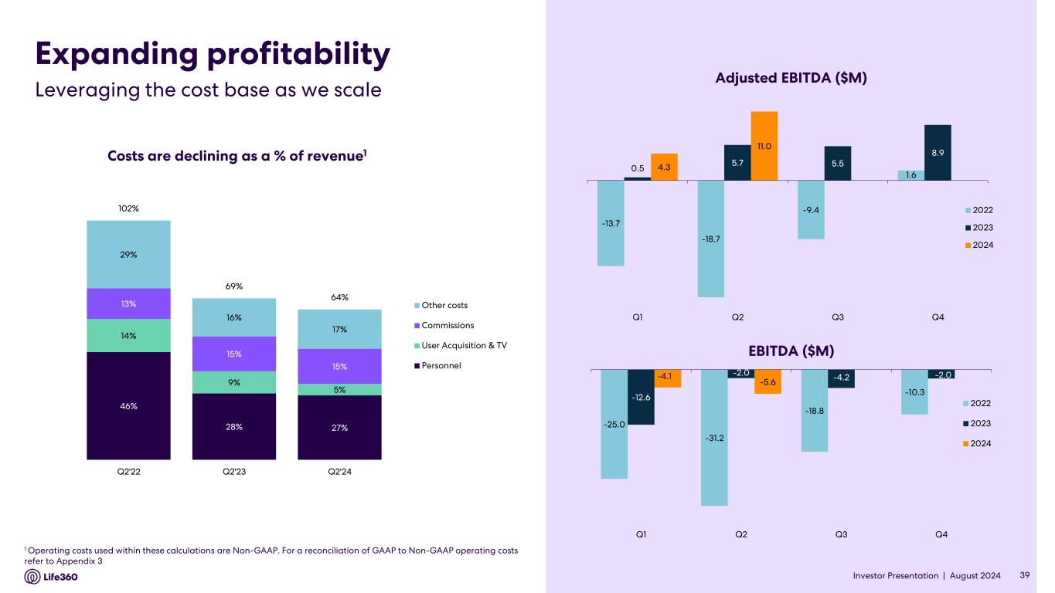
Investor Presentation | August 2024 Expanding profitability Leveraging the cost base as we scale Costs are declining as a % of revenue1 Adjusted EBITDA ($M) EBITDA ($M) 39 -13.7 -18.7 -9.4 1.6 0.5 5.7 5.5 8.9 4.3 11.0 Q1 Q2 Q3 Q4 2022 2023 2024 -25.0 -31.2 -18.8 -10.3 -12.6 -2.0 -4.2 -2.0-4.1 -5.6 Q1 Q2 Q3 Q4 2022 2023 2024 46% 28% 27% 14% 9% 5% 13% 15% 15% 29% 16% 17% 102% 69% 64% Q2'22 Q2'23 Q2'24 Other costs Commissions User Acquisition & TV Personnel 1 Operating costs used within these calculations are Non-GAAP. For a reconciliation of GAAP to Non-GAAP operating costs refer to Appendix 3


Investor Presentation | August 2024 2024 Outlook 03 40

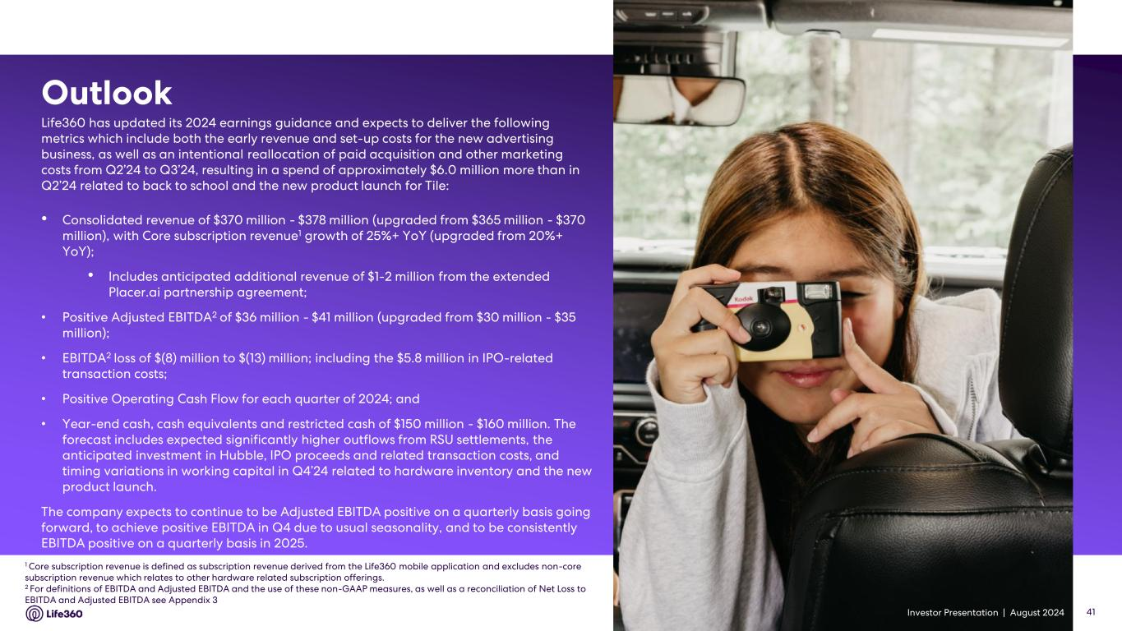
Investor Presentation | August 2024 1 Core subscription revenue is defined as subscription revenue derived from the Life360 mobile application and excludes non-core subscription revenue which relates to other hardware related subscription offerings. 2 For definitions of EBITDA and Adjusted EBITDA and the use of these non-GAAP measures, as well as a reconciliation of Net Loss to EBITDA and Adjusted EBITDA see Appendix 3 Life360 has updated its 2024 earnings guidance and expects to deliver the following metrics which include both the early revenue and set-up costs for the new advertising business, as well as an intentional reallocation of paid acquisition and other marketing costs from Q2’24 to Q3’24, resulting in a spend of approximately $6.0 million more than in Q2’24 related to back to school and the new product launch for Tile: • Consolidated revenue of $370 million - $378 million (upgraded from $365 million - $370 million), with Core subscription revenue1 growth of 25%+ YoY (upgraded from 20%+ YoY); • Includes anticipated additional revenue of $1-2 million from the extended Placer.ai partnership agreement; • Positive Adjusted EBITDA2 of $36 million - $41 million (upgraded from $30 million - $35 million); • EBITDA2 loss of $(8) million to $(13) million; including the $5.8 million in IPO-related transaction costs; • Positive Operating Cash Flow for each quarter of 2024; and • Year-end cash, cash equivalents and restricted cash of $150 million - $160 million. The forecast includes expected significantly higher outflows from RSU settlements, the anticipated investment in Hubble, IPO proceeds and related transaction costs, and timing variations in working capital in Q4’24 related to hardware inventory and the new product launch. The company expects to continue to be Adjusted EBITDA positive on a quarterly basis going forward, to achieve positive EBITDA in Q4 due to usual seasonality, and to be consistently EBITDA positive on a quarterly basis in 2025. Outlook 41


Investor Presentation | August 2024 04 Appendix 42

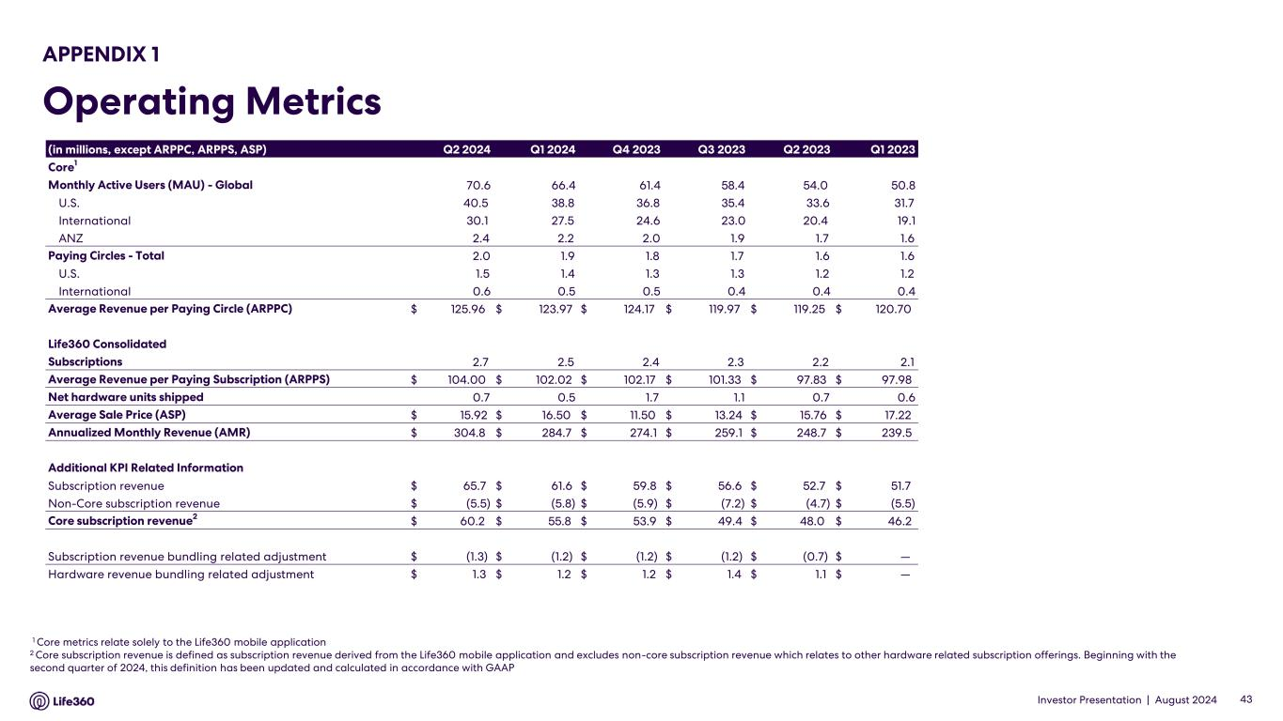
Investor Presentation | August 2024 APPENDIX 1 Operating Metrics 1 Core metrics relate solely to the Life360 mobile application 2 Core subscription revenue is defined as subscription revenue derived from the Life360 mobile application and excludes non-core subscription revenue which relates to other hardware related subscription offerings. Beginning with the second quarter of 2024, this definition has been updated and calculated in accordance with GAAP 43 (in millions, except ARPPC, ARPPS, ASP) Q2 2024 Q1 2024 Q4 2023 Q3 2023 Q2 2023 Q1 2023 Core1 Monthly Active Users (MAU) - Global 70.6 66.4 61.4 58.4 54.0 50.8 U.S. 40.5 38.8 36.8 35.4 33.6 31.7 International 30.1 27.5 24.6 23.0 20.4 19.1 ANZ 2.4 2.2 2.0 1.9 1.7 1.6 Paying Circles - Total 2.0 1.9 1.8 1.7 1.6 1.6 U.S. 1.5 1.4 1.3 1.3 1.2 1.2 International 0.6 0.5 0.5 0.4 0.4 0.4 Average Revenue per Paying Circle (ARPPC) $ 125.96 $ 123.97 $ 124.17 $ 119.97 $ 119.25 $ 120.70 Life360 Consolidated Subscriptions 2.7 2.5 2.4 2.3 2.2 2.1 Average Revenue per Paying Subscription (ARPPS) $ 104.00 $ 102.02 $ 102.17 $ 101.33 $ 97.83 $ 97.98 Net hardware units shipped 0.7 0.5 1.7 1.1 0.7 0.6 Average Sale Price (ASP) $ 15.92 $ 16.50 $ 11.50 $ 13.24 $ 15.76 $ 17.22 Annualized Monthly Revenue (AMR) $ 304.8 $ 284.7 $ 274.1 $ 259.1 $ 248.7 $ 239.5 Additional KPI Related Information Subscription revenue $ 65.7 $ 61.6 $ 59.8 $ 56.6 $ 52.7 $ 51.7 Non-Core subscription revenue $ (5.5) $ (5.8) $ (5.9) $ (7.2) $ (4.7) $ (5.5) Core subscription revenue2 $ 60.2 $ 55.8 $ 53.9 $ 49.4 $ 48.0 $ 46.2 Subscription revenue bundling related adjustment $ (1.3) $ (1.2) $ (1.2) $ (1.2) $ (0.7) $ — Hardware revenue bundling related adjustment $ 1.3 $ 1.2 $ 1.2 $ 1.4 $ 1.1 $ —

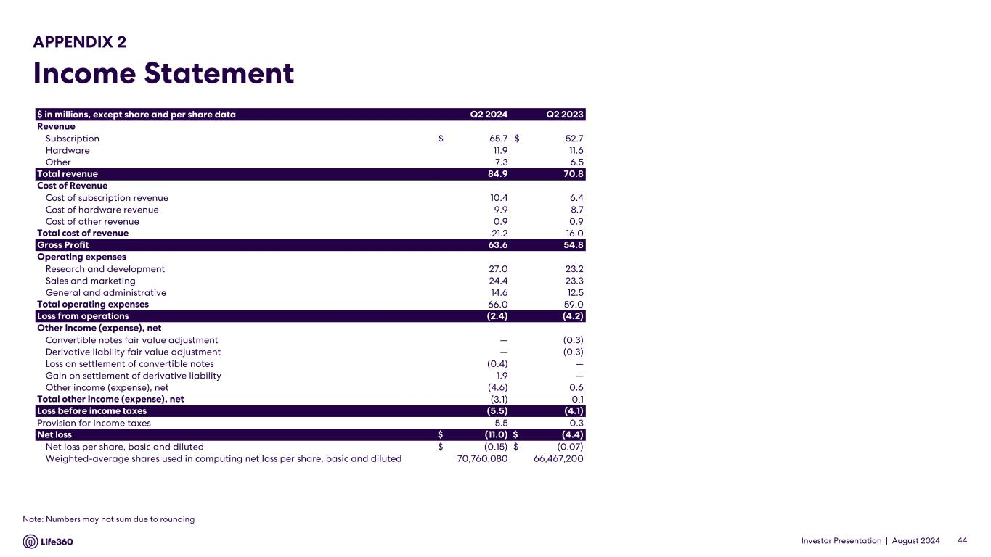
Investor Presentation | August 2024 APPENDIX 2 Income Statement 44 $ in millions, except share and per share data Q2 2024 Q2 2023 Revenue Subscription $ 65.7 $ 52.7 Hardware 11.9 11.6 Other 7.3 6.5 Total revenue 84.9 70.8 Cost of Revenue Cost of subscription revenue 10.4 6.4 Cost of hardware revenue 9.9 8.7 Cost of other revenue 0.9 0.9 Total cost of revenue 21.2 16.0 Gross Profit 63.6 54.8 Operating expenses Research and development 27.0 23.2 Sales and marketing 24.4 23.3 General and administrative 14.6 12.5 Total operating expenses 66.0 59.0 Loss from operations (2.4) (4.2) Other income (expense), net Convertible notes fair value adjustment — (0.3) Derivative liability fair value adjustment — (0.3) Loss on settlement of convertible notes (0.4) — Gain on settlement of derivative liability 1.9 — Other income (expense), net (4.6) 0.6 Total other income (expense), net (3.1) 0.1 Loss before income taxes (5.5) (4.1) Provision for income taxes 5.5 0.3 Net loss $ (11.0) $ (4.4) Net loss per share, basic and diluted $ (0.15) $ (0.07) Weighted-average shares used in computing net loss per share, basic and diluted 70,760,080 66,467,200 Note: Numbers may not sum due to rounding

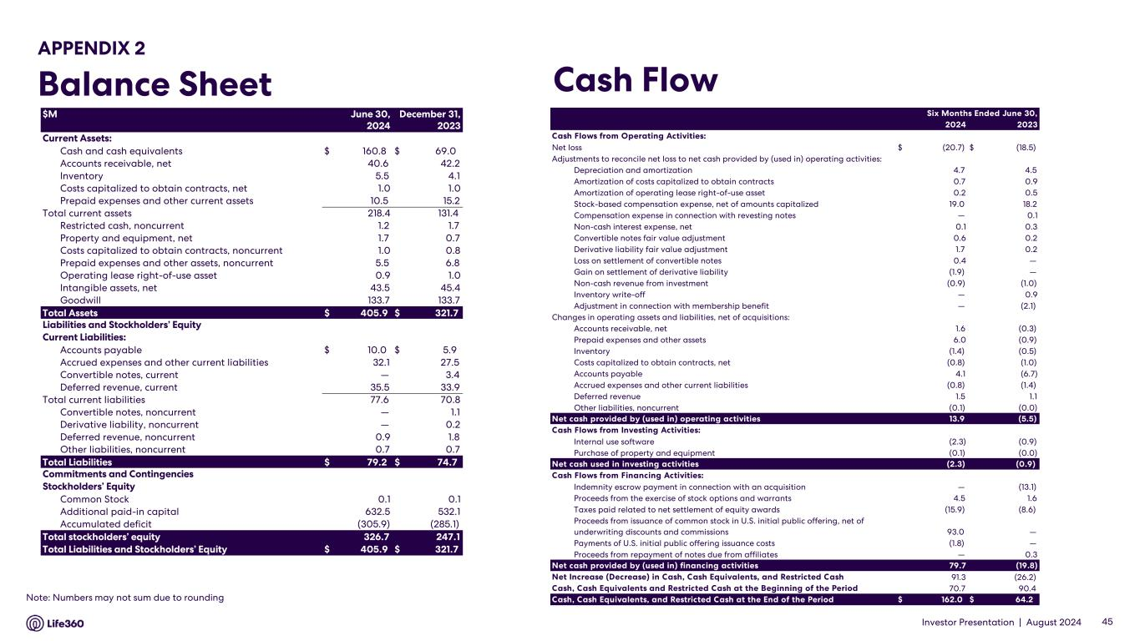
Investor Presentation | August 2024 APPENDIX 2 Balance Sheet Cash Flow 45 2024 2023 Cash Flows from Operating Activities: Net loss $ (20.7) $ (18.5) Adjustments to reconcile net loss to net cash provided by (used in) operating activities: Depreciation and amortization 4.7 4.5 Amortization of costs capitalized to obtain contracts 0.7 0.9 Amortization of operating lease right-of-use asset 0.2 0.5 Stock-based compensation expense, net of amounts capitalized 19.0 18.2 Compensation expense in connection with revesting notes — 0.1 Non-cash interest expense, net 0.1 0.3 Convertible notes fair value adjustment 0.6 0.2 Derivative liability fair value adjustment 1.7 0.2 Loss on settlement of convertible notes 0.4 — Gain on settlement of derivative liability (1.9) — Non-cash revenue from investment (0.9) (1.0) Inventory write-off — 0.9 Adjustment in connection with membership benefit — (2.1) Changes in operating assets and liabilities, net of acquisitions: Accounts receivable, net 1.6 (0.3) Prepaid expenses and other assets 6.0 (0.9) Inventory (1.4) (0.5) Costs capitalized to obtain contracts, net (0.8) (1.0) Accounts payable 4.1 (6.7) Accrued expenses and other current liabilities (0.8) (1.4) Deferred revenue 1.5 1.1 Other liabilities, noncurrent (0.1) (0.0) Net cash provided by (used in) operating activities 13.9 (5.5) Cash Flows from Investing Activities: Internal use software (2.3) (0.9) Purchase of property and equipment (0.1) (0.0) Net cash used in investing activities (2.3) (0.9) Cash Flows from Financing Activities: Indemnity escrow payment in connection with an acquisition — (13.1) Proceeds from the exercise of stock options and warrants 4.5 1.6 Taxes paid related to net settlement of equity awards (15.9) (8.6) Proceeds from issuance of common stock in U.S. initial public offering, net of underwriting discounts and commissions 93.0 — Payments of U.S. initial public offering issuance costs (1.8) — Proceeds from repayment of notes due from affiliates — 0.3 Net cash provided by (used in) financing activities 79.7 (19.8) Net Increase (Decrease) in Cash, Cash Equivalents, and Restricted Cash 91.3 (26.2) Cash, Cash Equivalents and Restricted Cash at the Beginning of the Period 70.7 90.4 Cash, Cash Equivalents, and Restricted Cash at the End of the Period $ 162.0 $ 64.2 Six Months Ended June 30,$M June 30, December 31, 2024 2023 Current Assets: Cash and cash equivalents $ 160.8 $ 69.0 Accounts receivable, net 40.6 42.2 Inventory 5.5 4.1 Costs capitalized to obtain contracts, net 1.0 1.0 Prepaid expenses and other current assets 10.5 15.2 Total current assets 218.4 131.4 Restricted cash, noncurrent 1.2 1.7 Property and equipment, net 1.7 0.7 Costs capitalized to obtain contracts, noncurrent 1.0 0.8 Prepaid expenses and other assets, noncurrent 5.5 6.8 Operating lease right-of-use asset 0.9 1.0 Intangible assets, net 43.5 45.4 Goodwill 133.7 133.7 Total Assets $ 405.9 $ 321.7 Liabilities and Stockholders’ Equity Current Liabilities: Accounts payable $ 10.0 $ 5.9 Accrued expenses and other current liabilities 32.1 27.5 Convertible notes, current — 3.4 Deferred revenue, current 35.5 33.9 Total current liabilities 77.6 70.8 Convertible notes, noncurrent — 1.1 Derivative liability, noncurrent — 0.2 Deferred revenue, noncurrent 0.9 1.8 Other liabilities, noncurrent 0.7 0.7 Total Liabilities $ 79.2 $ 74.7 Commitments and Contingencies Stockholders’ Equity Common Stock 0.1 0.1 Additional paid-in capital 632.5 532.1 Accumulated deficit (305.9) (285.1) Total stockholders’ equity 326.7 247.1 Total Liabilities and Stockholders’ Equity $ 405.9 $ 321.7 Note: Numbers may not sum due to rounding

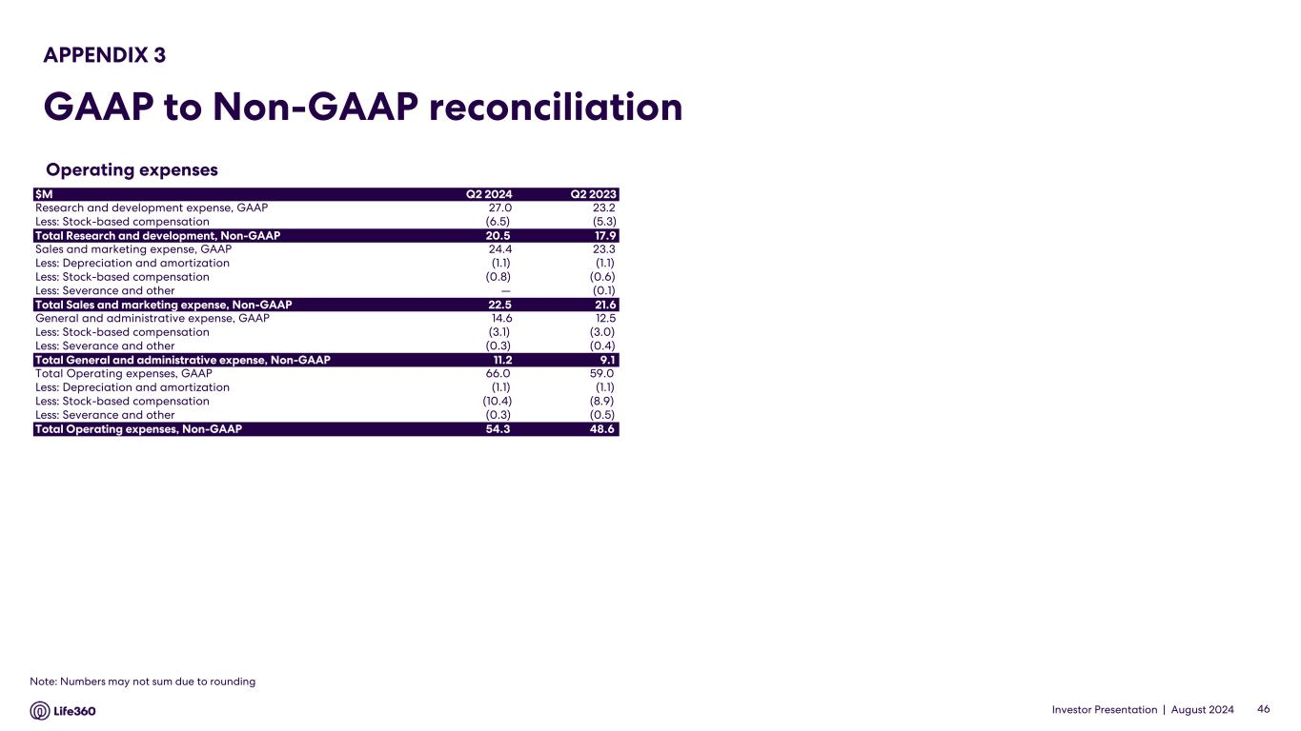
Investor Presentation | August 2024 Operating expenses APPENDIX 3 GAAP to Non-GAAP reconciliation 46 $M Q2 2024 Q2 2023 Research and development expense, GAAP 27.0 23.2 Less: Stock-based compensation (6.5) (5.3) Total Research and development, Non-GAAP 20.5 17.9 Sales and marketing expense, GAAP 24.4 23.3 Less: Depreciation and amortization (1.1) (1.1) Less: Stock-based compensation (0.8) (0.6) Less: Severance and other — (0.1) Total Sales and marketing expense, Non-GAAP 22.5 21.6 General and administrative expense, GAAP 14.6 12.5 Less: Stock-based compensation (3.1) (3.0) Less: Severance and other (0.3) (0.4) Total General and administrative expense, Non-GAAP 11.2 9.1 Total Operating expenses, GAAP 66.0 59.0 Less: Depreciation and amortization (1.1) (1.1) Less: Stock-based compensation (10.4) (8.9) Less: Severance and other (0.3) (0.5) Total Operating expenses, Non-GAAP 54.3 48.6 Note: Numbers may not sum due to rounding

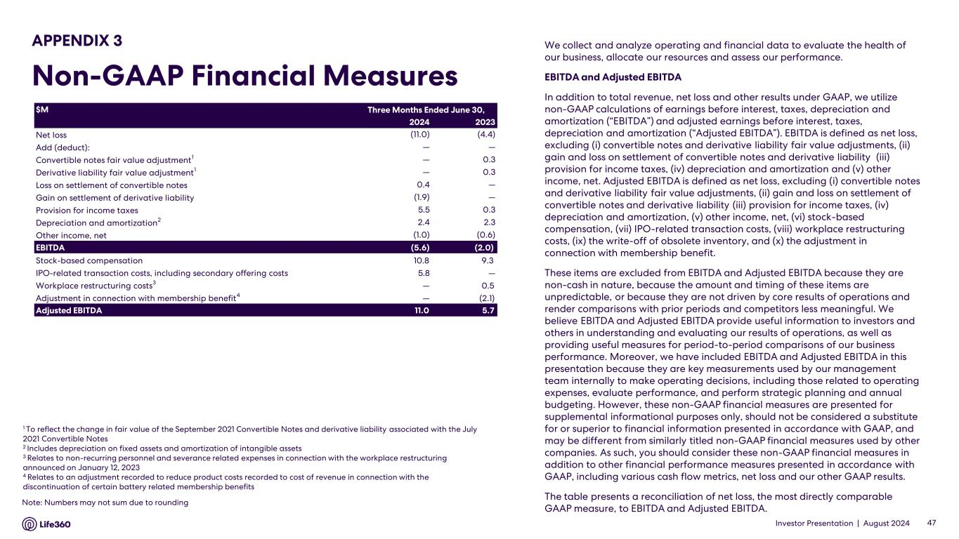
Investor Presentation | August 2024 We collect and analyze operating and financial data to evaluate the health of our business, allocate our resources and assess our performance. EBITDA and Adjusted EBITDA In addition to total revenue, net loss and other results under GAAP, we utilize non-GAAP calculations of earnings before interest, taxes, depreciation and amortization (“EBITDA”) and adjusted earnings before interest, taxes, depreciation and amortization (“Adjusted EBITDA”). EBITDA is defined as net loss, excluding (i) convertible notes and derivative liability fair value adjustments, (ii) gain and loss on settlement of convertible notes and derivative liability (iii) provision for income taxes, (iv) depreciation and amortization and (v) other income, net. Adjusted EBITDA is defined as net loss, excluding (i) convertible notes and derivative liability fair value adjustments, (ii) gain and loss on settlement of convertible notes and derivative liability (iii) provision for income taxes, (iv) depreciation and amortization, (v) other income, net, (vi) stock-based compensation, (vii) IPO-related transaction costs, (viii) workplace restructuring costs, (ix) the write-off of obsolete inventory, and (x) the adjustment in connection with membership benefit. These items are excluded from EBITDA and Adjusted EBITDA because they are non-cash in nature, because the amount and timing of these items are unpredictable, or because they are not driven by core results of operations and render comparisons with prior periods and competitors less meaningful. We believe EBITDA and Adjusted EBITDA provide useful information to investors and others in understanding and evaluating our results of operations, as well as providing useful measures for period-to-period comparisons of our business performance. Moreover, we have included EBITDA and Adjusted EBITDA in this presentation because they are key measurements used by our management team internally to make operating decisions, including those related to operating expenses, evaluate performance, and perform strategic planning and annual budgeting. However, these non-GAAP financial measures are presented for supplemental informational purposes only, should not be considered a substitute for or superior to financial information presented in accordance with GAAP, and may be different from similarly titled non-GAAP financial measures used by other companies. As such, you should consider these non-GAAP financial measures in addition to other financial performance measures presented in accordance with GAAP, including various cash flow metrics, net loss and our other GAAP results. The table presents a reconciliation of net loss, the most directly comparable GAAP measure, to EBITDA and Adjusted EBITDA. 1 To reflect the change in fair value of the September 2021 Convertible Notes and derivative liability associated with the July 2021 Convertible Notes 2 Includes depreciation on fixed assets and amortization of intangible assets 3 Relates to non-recurring personnel and severance related expenses in connection with the workplace restructuring announced on January 12, 2023 4 Relates to an adjustment recorded to reduce product costs recorded to cost of revenue in connection with the discontinuation of certain battery related membership benefits 47 APPENDIX 3 Non-GAAP Financial Measures $M 2024 2023 Net loss (11.0) (4.4) Add (deduct): — — Convertible notes fair value adjustment1 — 0.3 Derivative liability fair value adjustment1 — 0.3 Loss on settlement of convertible notes 0.4 — Gain on settlement of derivative liability (1.9) — Provision for income taxes 5.5 0.3 Depreciation and amortization2 2.4 2.3 Other income, net (1.0) (0.6) EBITDA (5.6) (2.0) Stock-based compensation 10.8 9.3 IPO-related transaction costs, including secondary offering costs 5.8 — Workplace restructuring costs3 — 0.5 Adjustment in connection with membership benefit4 — (2.1) Adjusted EBITDA 11.0 5.7 Three Months Ended June 30, Note: Numbers may not sum due to rounding

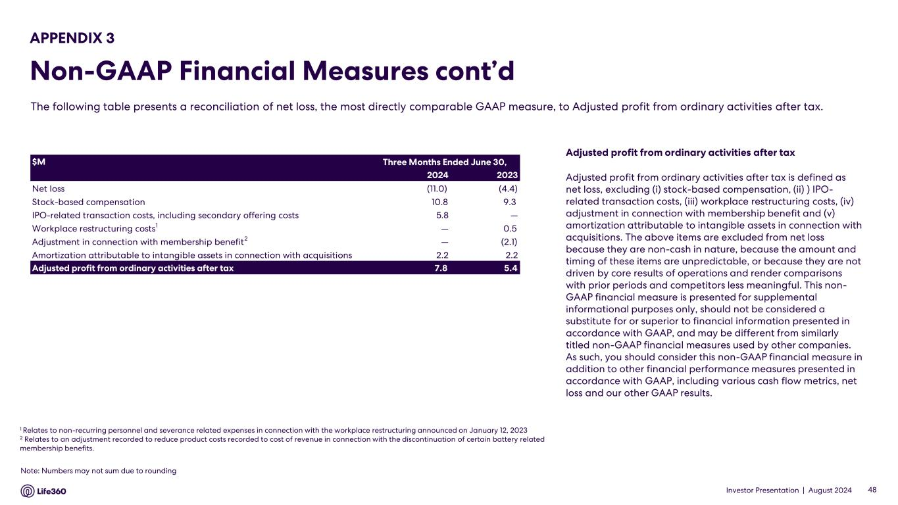
Investor Presentation | August 2024 Adjusted profit from ordinary activities after tax Adjusted profit from ordinary activities after tax is defined as net loss, excluding (i) stock-based compensation, (ii) ) IPO- related transaction costs, (iii) workplace restructuring costs, (iv) adjustment in connection with membership benefit and (v) amortization attributable to intangible assets in connection with acquisitions. The above items are excluded from net loss because they are non-cash in nature, because the amount and timing of these items are unpredictable, or because they are not driven by core results of operations and render comparisons with prior periods and competitors less meaningful. This non- GAAP financial measure is presented for supplemental informational purposes only, should not be considered a substitute for or superior to financial information presented in accordance with GAAP, and may be different from similarly titled non-GAAP financial measures used by other companies. As such, you should consider this non-GAAP financial measure in addition to other financial performance measures presented in accordance with GAAP, including various cash flow metrics, net loss and our other GAAP results. APPENDIX 3 Non-GAAP Financial Measures cont’d The following table presents a reconciliation of net loss, the most directly comparable GAAP measure, to Adjusted profit from ordinary activities after tax. 1 Relates to non-recurring personnel and severance related expenses in connection with the workplace restructuring announced on January 12, 2023 2 Relates to an adjustment recorded to reduce product costs recorded to cost of revenue in connection with the discontinuation of certain battery related membership benefits. 48 $M 2024 2023 Net loss (11.0) (4.4) Stock-based compensation 10.8 9.3 IPO-related transaction costs, including secondary offering costs 5.8 — Workplace restructuring costs1 — 0.5 Adjustment in connection with membership benefit2 — (2.1) Amortization attributable to intangible assets in connection with acquisitions 2.2 2.2 Adjusted profit from ordinary activities after tax 7.8 5.4 Three Months Ended June 30, Note: Numbers may not sum due to rounding


Investor Presentation | August 2024 Thank you

