SCHEDULE 14A
Proxy Statement Pursuant to Section 14(a) of the
Securities Exchange Act of 1934

Filed by the Registrant ☒
Filed by a party other than the Registrant ☐
Check the appropriate box:

☐ | Preliminary Proxy Statement

☐ | Confidential, for Use of the Commission Only (as permitted by Rule 14a-6(e)(2))

☐ | Definitive Proxy Statement

☒ | Definitive Additional Materials

☐ | Soliciting Material under § 240.14a-12
Life360, Inc.
(Name of Registrant as Specified In Its Charter)
(Name of Person(s) Filing Proxy Statement, if other than the Registrant)
Payment of Filing Fee (Check all boxes that apply):

☒ | No fee required

☐ | Fee paid previously with preliminary materials

☐ | Fee computed on table in exhibit required by Item 25(b) per Exchange Act Rules 14a-6(i)(1) and 0-11

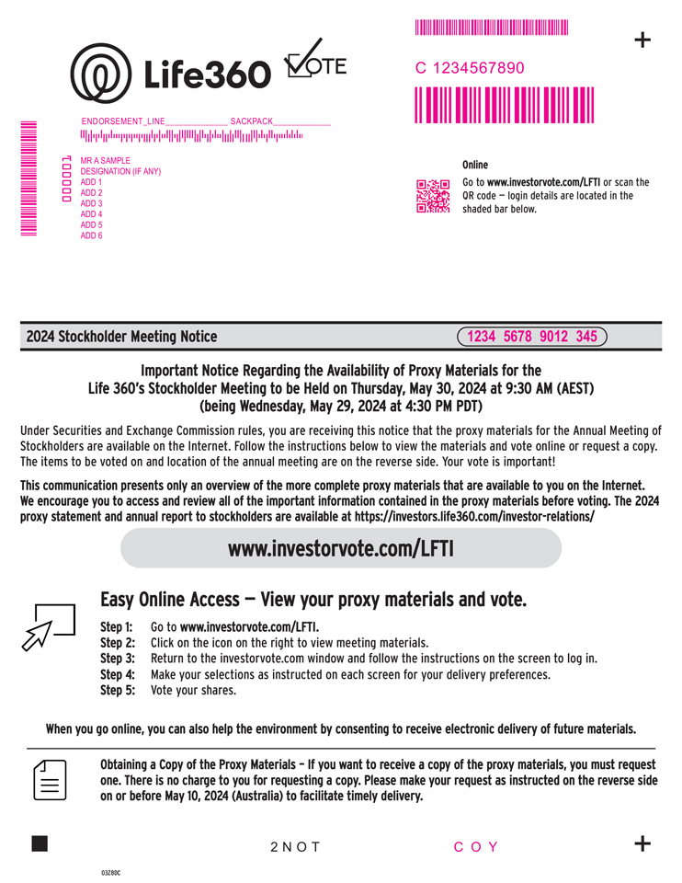
heading 1; MMMMMMMMMMMM + MMMMMMC 1234567890 ENDORSEMENT_LINE______________ SACKPACK_____________ MR A SAMPLE Online DESIGNATION (IF ANY) ADD 1 Go to www.investorvote.com/LFTI or scan the 000001 ADD 2 QR code  login details are located in the ADD 3 shaded bar below. ADD 4 MMMMMMMMM ADD 5 ADD 6 2024 Stockholder Meeting Notice 1234 5678 9012 345 Important Notice Regarding the Availability of Proxy Materials for the Life 360s Stockholder Meeting to be Held on Thursday, May 30, 2024 at 9:30 AM (AEST) (being Wednesday, May 29, 2024 at 4:30 PM PDT) Under Securities and Exchange Commission rules, you are receiving this notice that the proxy materials for the Annual Meeting of Stockholders are available on the Internet. Follow the instructions below to view the materials and vote online or request a copy. The items to be voted on and location of the annual meeting are on the reverse side. Your vote is important! This communication presents only an overview of the more complete proxy materials that are available to you on the Internet. We encourage you to access and review all of the important information contained in the proxy materials before voting. The 2024 proxy statement and annual report to stockholders are available at https://investors.life360.com/investor-relations/ www.investorvote.com/LFTI Easy Online Access  View your proxy materials and vote. Step 1: Go to www.investorvote.com/LFTI. Step 2: Click on the icon on the right to view meeting materials. Step 3: Return to the investorvote.com window and follow the instructions on the screen to log in. Step 4: Make your selections as instructed on each screen for your delivery preferences. Step 5: Vote your shares. When you go online, you can also help the environment by consenting to receive electronic delivery of future materials. Obtaining a Copy of the Proxy Materials  If you want to receive a copy of the proxy materials, you must request one. There is no charge to you for requesting a copy. Please make your request as instructed on the reverse side on or before May 10, 2024 (Australia) to facilitate timely delivery. 2NOT COY + 03Z8DC

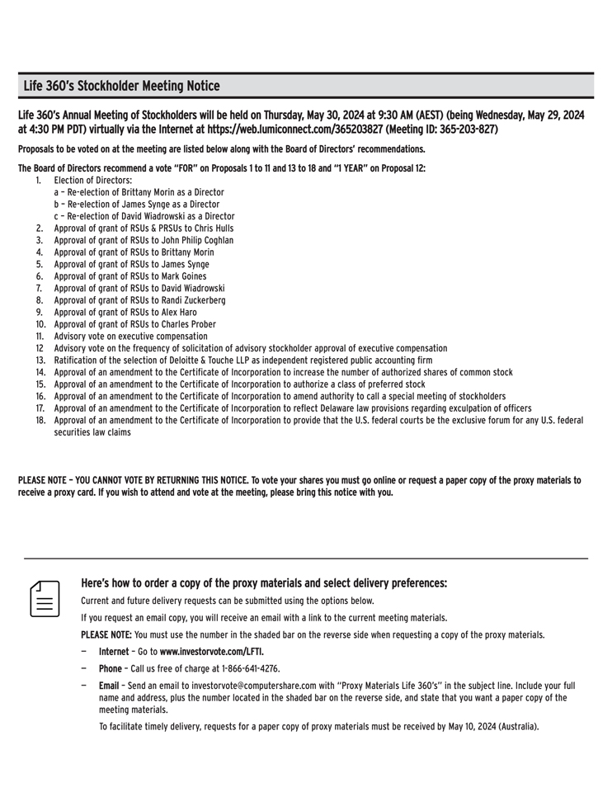
Life 360s Stockholder Meeting Notice Life 360s Annual Meeting of Stockholders will be held on Thursday, May 30, 2024 at 9:30 AM (AEST) (being Wednesday, May 29, 2024 at 4:30 PM PDT) virtually via the Internet at https://web.lumiconnect.com/365203827 (Meeting ID: 365-203-827) Proposals to be voted on at the meeting are listed below along with the Board of Directors recommendations. The Board of Directors recommend a vote FOR on Proposals 1 to 11 and 13 to 18 and 1 YEAR on Proposal 12: 1. Election of Directors: a  Re-election of Brittany Morin as a Director b  Re-election of James Synge as a Director c  Re-election of David Wiadrowski as a Director 2. Approval of grant of RSUs & PRSUs to Chris Hulls 3. Approval of grant of RSUs to John Philip Coghlan 4. Approval of grant of RSUs to Brittany Morin 5. Approval of grant of RSUs to James Synge 6. Approval of grant of RSUs to Mark Goines 7. Approval of grant of RSUs to David Wiadrowski 8. Approval of grant of RSUs to Randi Zuckerberg 9. Approval of grant of RSUs to Alex Haro 10. Approval of grant of RSUs to Charles Prober 11. Advisory vote on executive compensation 12 Advisory vote on the frequency of solicitation of advisory stockholder approval of executive compensation 13. Ratification of the selection of Deloitte & Touche LLP as independent registered public accounting firm 14. Approval of an amendment to the Certificate of Incorporation to increase the number of authorized shares of common stock 15. Approval of an amendment to the Certificate of Incorporation to authorize a class of preferred stock 16. Approval of an amendment to the Certificate of Incorporation to amend authority to call a special meeting of stockholders 17. Approval of an amendment to the Certificate of Incorporation to reflect Delaware law provisions regarding exculpation of officers 18. Approval of an amendment to the Certificate of Incorporation to provide that the U.S. federal courts be the exclusive forum for any U.S. federal securities law claims PLEASE NOTE  YOU CANNOT VOTE BY RETURNING THIS NOTICE. To vote your shares you must go online or request a paper copy of the proxy materials to receive a proxy card. If you wish to attend and vote at the meeting, please bring this notice with you. Heres how to order a copy of the proxy materials and select delivery preferences: Current and future delivery requests can be submitted using the options below. If you request an email copy, you will receive an email with a link to the current meeting materials. PLEASE NOTE: You must use the number in the shaded bar on the reverse side when requesting a copy of the proxy materials.  Internet  Go to www.investorvote.com/LFTI.  Phone  Call us free of charge at 1-866-641-4276.  Email  Send an email to investorvote@computershare.com with Proxy Materials Life 360s in the subject line. Include your full name and address, plus the number located in the shaded bar on the reverse side, and state that you want a paper copy of the meeting materials. To facilitate timely delivery, requests for a paper copy of proxy materials must be received by May 10, 2024 (Australia).

